COMP 1412 INTRODUCTION TO CS 2 CODE ASSIGNMENT

|  |  |
| --- | --- |
| ***Assignment Name:*** *Java RV Designing* | ***Student Name :****Azamat Salamatov* |
| ***Assignment Date:*** *2/27/2023* | ***Student id :*** *#10002837* |

# Problem

Write a graphical application that contains a class named RV whose objects are the recreational vehicle designed and digitized as described in Knowledge Exercises 20 and 21 (you can design your version as well.

The class’s private data members should be the vehicle’s body color and (x, y) location.

a) Give the UML diagram for the class. It should include a three-parameter constructor, a toString method, a method to input the values of all of an object’s data members, and a show method to draw the RV at its current (x, y) location.

b) Progressively implement and test the RV class by adding a method and verifying it before adding the next method. A good order to add the methods to the class is the three-parameter constructor, followed by the toString method, the show method, and finally the input method.

The client code should create an RV object using the three-parameter constructor to test all of the methods as they are progressively added to the class.

c) After all of the methods are verified, comment out the test code in the client application and add two RV instances to the program whose location and color are passed to the three-parameter constructor. Output these vehicles to the system console and the game board and then output them again after the user inputs a new color and a new (x, y) location for each vehicle.

# Challenges

* Understanding the Graphics Class in Java
* Understanding JFrame and JPanel in Java
* Showing 2 vehicles, instead of only one
* Defining show() method, instead of paint() methon in JPanel

# Code

# ***Main.java***

package CS2_RV_copy;

import java.util.Scanner;

public class Main{

    //Creating private varibles, data for the vehicles;

    private static String userColor1, userColor2;

    private static int x1, y1, x2, y2;

    /*

     * Asks the user to input the color preference and location of the vehicles

     */

    public static void input(){

        System.out.print("Input the color of the First RV's body\n>> ");

        Scanner scan = new Scanner(System.in);

        userColor1 = scan.next();

        System.out.print("Input the X-Position of the first vehicle\n>> ");

        x1 = scan.nextInt();

        System.out.print("Now, input the Y-Position of the first vehicle\n>> ");

        y1 = scan.nextInt();

        System.out.print("Input the color of the Second RV's body\n>> ");

        userColor2 = scan.next();

        System.out.print("Input the X-Position of the second vehicle\n>> ");

        x2 = scan.nextInt();

        System.out.print("Now, input the Y-Position of the second vehicle\n>> ");

        y2 = scan.nextInt();

        scan.close();

    }

    public static void main(String[] args) {

        input();

        /*

         * Creating 2 objects of RV Class

         */

        RV car1 = new RV(userColor1, x1, y1);

        RV car2 = new RV(userColor2, x2, y2);

        /*

         * Printing the color and location of the 2 vehicle objects

         */

        System.out.println(car1.toString());

        System.out.println(car2.toString());

        /*

         * Displaying these 2 vehicles onto the frame/screen

         */

        car1.show();

        try{Thread.sleep(3000);}  //without this exception handling, the code throws an error;

        catch(Exception e) {}

        car2.show();

    }

  }

# ***RV.java***

package CS2_RV_copy;

import java.awt.*;

import javax.swing.*;

import java.util.Scanner;

public class RV{

    /*

     * Private values:

     *  x, y = location

     *  bodyColor : a Color object, which is returned from String inputColor

     *  color : a Color object used in the switch case

     *  printColor : a String, just a copy of user's color choice, it is used in toString() method

     */

    private int x = 50;

    private int y = 50;

    private Color bodyColor;

    private Color color;

    private String printColor;

    String userColor;

    /*

     * input:  get's user color preference, and location of the vehicle

     */

    public String input(){

        System.out.print("Input the color of the RV's body\n>> ");

        Scanner scan = new Scanner(System.in);

        userColor = scan.next();

        System.out.print("Input the X-Position of the vehicle\n>> ");

        x = scan.nextInt();

        System.out.print("Now, input the Y-Position of the vehicle\n>> ");

        y = scan.nextInt();

        scan.close();

        return userColor;

    }

    /*

     * I used this getColor() Function to convert String color to an object Color (datatype Color)

     * I tried to use other methods to converst String directly to a Color object, but it did not work

     * This function has many popular colors, if non of them is chosen, a default color "#E8D2A6" will be returned

     */

    public Color getColor(String inputtedColor) {

        switch (inputtedColor.toLowerCase()) {

        case "black":

            color = Color.BLACK;

            break;

        case "blue":

            color = Color.BLUE;

            break;

        case "cyan":

            color = Color.CYAN;

            break;

        case "darkgray":

            color = Color.DARK_GRAY;

            break;

        case "gray":

            color = Color.GRAY;

            break;

        case "green":

            color = Color.GREEN;

            break;

        case "yellow":

            color = Color.YELLOW;

            break;

        case "lightgray":

            color = Color.LIGHT_GRAY;

            break;

        case "magenta":

            color = Color.MAGENTA;

            break;

        case "orange":

            color = Color.ORANGE;

            break;

        case "pink":

            color = Color.PINK;

            break;

        case "red":

            color = Color.RED;

            break;

        case "white":

            color = Color.WHITE;

            break;

        default:

            color = Color.decode("#E8D2A6");

            }

        return color;

        }

    /*

     * Constructor RV:

     *  3 params: user's color choice, x, y

     */

    public RV(String bodyInputColor, int position_x, int position_y){

      bodyColor = this.getColor(bodyInputColor);

      printColor = bodyInputColor;

      x = position_x;

      y = position_y;

    }

    //toString method returns the text with color and the location of (x,y)

    public String toString(){

      return ("The color of the RV is " + printColor + ".\nThe x and y-positions are : (" + x + "," + y+").");

    }

    /*

     * Show() method:

     * displays the vehicle on the frame

     * need to use JFrame, and JPanel

     */

    public void show(){

        JFrame myJFrame = new JFrame();

        myJFrame.setDefaultCloseOperation(JFrame.EXIT_ON_CLOSE);

        myJFrame.setSize(500,500);

        myJFrame.setVisible(true);

        JPanel panel = new JPanel(){

            @Override

            public void paint(Graphics g){

                Graphics2D g2D = (Graphics2D) g;

                // g2D.drawImage(image,0,0,null);

                // private Color bodyColor;

                // bodyColor = decode("#E8D2A6");

                // g2D.setPaint(Color.decode("#E8D2A6"));

                g2D.setPaint(bodyColor);

                //outline thickness 5 px

                g2D.setStroke(new BasicStroke(5));

                //drawing a body of the car

                g2D.fillRect(x,y,150,90);

                //drawing the nose of the car

                g2D.fillRect(x+150,y+60,50, 30);

                //drawing the door with different pink

                g2D.setColor(Color.decode("#F48484"));

                g2D.fillRect(x+110, y+20, 25, 50);

                //drawing the outline of the door with grey

                g2D.setColor(Color.decode("#86A3B8"));

                g2D.drawRect(x+110,y+20,25, 50);

                //drawing the windows of the car with grey

                g2D.fillRect(x+15, y+15, 30,30);

                g2D.fillRect(x+60, y+15, 30, 30);

                //drawing the tires

                g2D.setColor(Color.black);

                g2D.fillOval(x+30, y+85, 30,30);

                g2D.fillOval(x+140, y+85, 30,30);

            }

        };

        //adding the Jpanel object to the JFrame object: inserting picture on the screen

        myJFrame.add(panel);

    }

}

# Pseudo Code

**Class RV**{

Private: x, y, bodyColor

Input(){

Input color

Input x position

Input y position

}

toString(){

print the body color and the location of the vehicle

}

// constructor

RV(inputtedColor, x_position, y_position){

bodycolor = inputtedColor;

x = x_position;

y = y_position;

}

Show(){

Create a frame;

Create a panel;

On the panel paint the vehicle{

Paint the body;

Paint two windows;

Paint two tires;

Paint the door;

}

Add the painted vehicle onto the frame;

}

}

**Class Main** {

Private:vehicleOneColor, vehicleTwoColor, x-y positions;

Call the input() method;

Public static void main(String[] args){

RV object1;

RV object2;

Print(info of object1);

Print(info of object2);

Object1.show();

Object2.show();

}

}

# UML Diagram

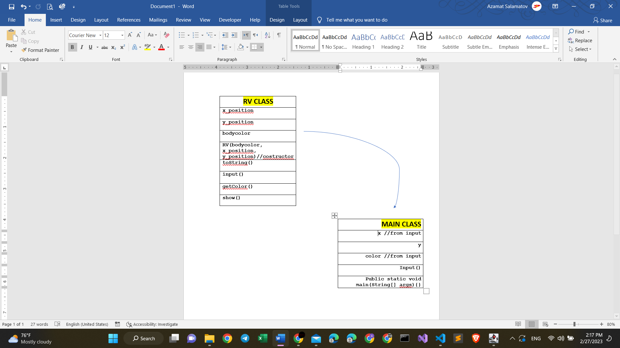

Figure 1: UML-diagram of the RV Project;

# Outputs

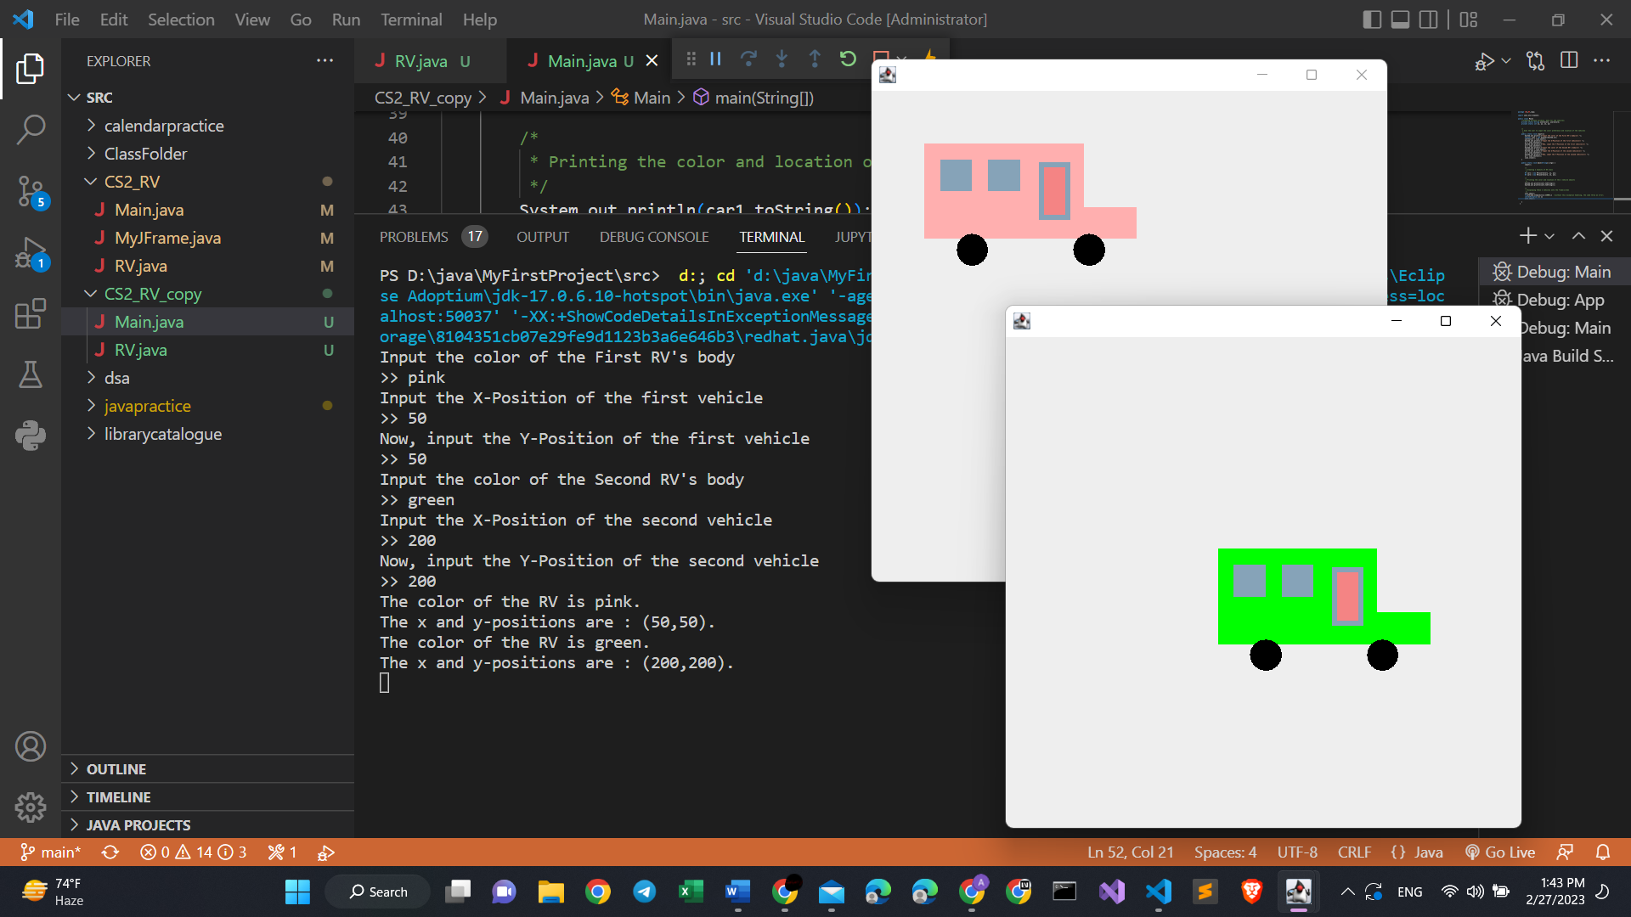Figure 2: input-output of the Main.java class with output of 2 different vehicles;

# REPL.IT LINK

<https://replit.com/@UnnecessaryAcco/CodingAssignment1AzamatSalamatov?v=1>