COMP 1412 INTRODUCTION TO CS 2 CODE ASSIGNMENT

|  |  |
| --- | --- |
| ***Assignment Name:*** *File Handling* | ***Student Name :****Azamat Salamatov* |
| ***Assignment Date:*** *3/7/2023* | ***Student id :*** *#10002837* |

# Problem

Write a program to accept a given number of names, input by the program user, and write the names in sorted order to a disk file named Students.txt. Then, ask the user which name should be eliminated from the file and eliminate that name from the file. Finally, read all of the names from the modified file and output them in reverse alphabetical order.

Challenges

* Choosing the best way to open and write to a file using *Files class*
* Finding file location
* Saving the names into a container *ArrayList*
* Reversing the name list
* Removing a name from the list

# Code

package CS2_A2;  
import java.nio.file.Files;  
import java.nio.file.Path;  
import java.nio.file.Paths;  
import java.util.Scanner;  
import java.io.*;  
import java.util.ArrayList;  
import java.util.Collections;  
  
public class StudentNames{  
 static final String *pathOfStudentsFile* = "D:\\java\\MyFirstProject\\src\\javapractice\\CS2_A2\\Students.txt";  
 public static void main(String[] args) throws IOException{  
// get N number of students, and ask their names N times  
 System.*out*.print("\n\n\n\nEnter the number of student names:\n>> ");  
 Scanner sc = new Scanner(System.*in*);  
 int numStudents = sc.nextInt();  
// Used ArrayList because it is mutable, and extra objects can be added  
 ArrayList<String> list = new ArrayList<String>();  
// get the names of the students and append to the ArrayList  
 for (int i=0; i<numStudents; i++){  
 System.*out*.print("Enter the name of a student(no spaces):>> ");  
 list.add(sc.next());  
 }  
  
// Using Files-Path method to access the external File  
 Path fileName = Paths.*get*(*pathOfStudentsFile*);  
// Sort the list in alphabetical order and print them out  
 Collections.*sort*(list);  
 System.*out*.println("\n*******All Names******\n");  
 for (String n : list){  
 System.*out*.println(n);  
 }  
// write to the file the contents of the list(names)  
 Files.*write*(fileName, list);  
// ask which name to remove  
 System.*out*.print("\nWhich name to remove?\n>>");  
 String name2Remove = sc.next();  
 list.remove(name2Remove);  
// sort the list in reverse order  
 Collections.*reverse*(list);  
// and write to the file  
 Files.*write*(fileName, list);  
// read from the file  
 String textInFile = Files.*readString*(fileName);  
 System.*out*.println("*****Names in reverse order******");  
 System.*out*.println(textInFile);  
// close the scanner, there is no need to close the file, because we only got the path to the file  
 sc.close();  
 }  
}

# Pseudo Code

CLASS StudentNames

DEFINE main()

PRINT "Enter the number of student names:"

READ numStudents FROM USER

DECLARE list AS NEW ArrayList<String>()

ASK THE NAMES OF THE STUDENT WITH FOR LOOP

SORT list

PRINT All Names

WRITE list TO file

PRINT "Which name to remove?"

READ name2Remove FROM USER

REMOVE name2Remove FROM list

SORT list IN REVERSE ORDER

WRITE list TO file

SET textInFile AS READ ALL FROM file

PRINT Names in reverse order

CLOSE USER INPUT

END main

END CLASS

# Outputs

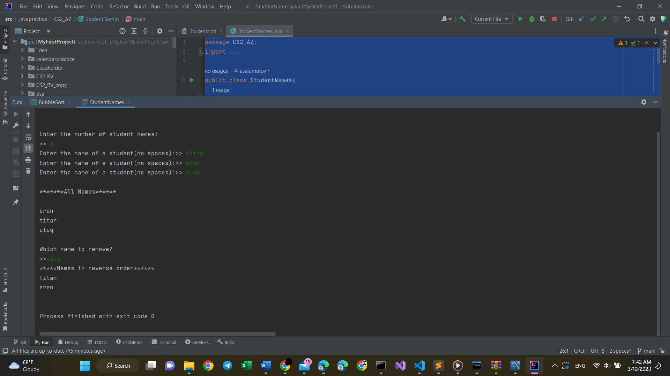

Figure 1 Output Screen of the StudentNames.java on IntelliJ IDE

Outputs Students.txt file:

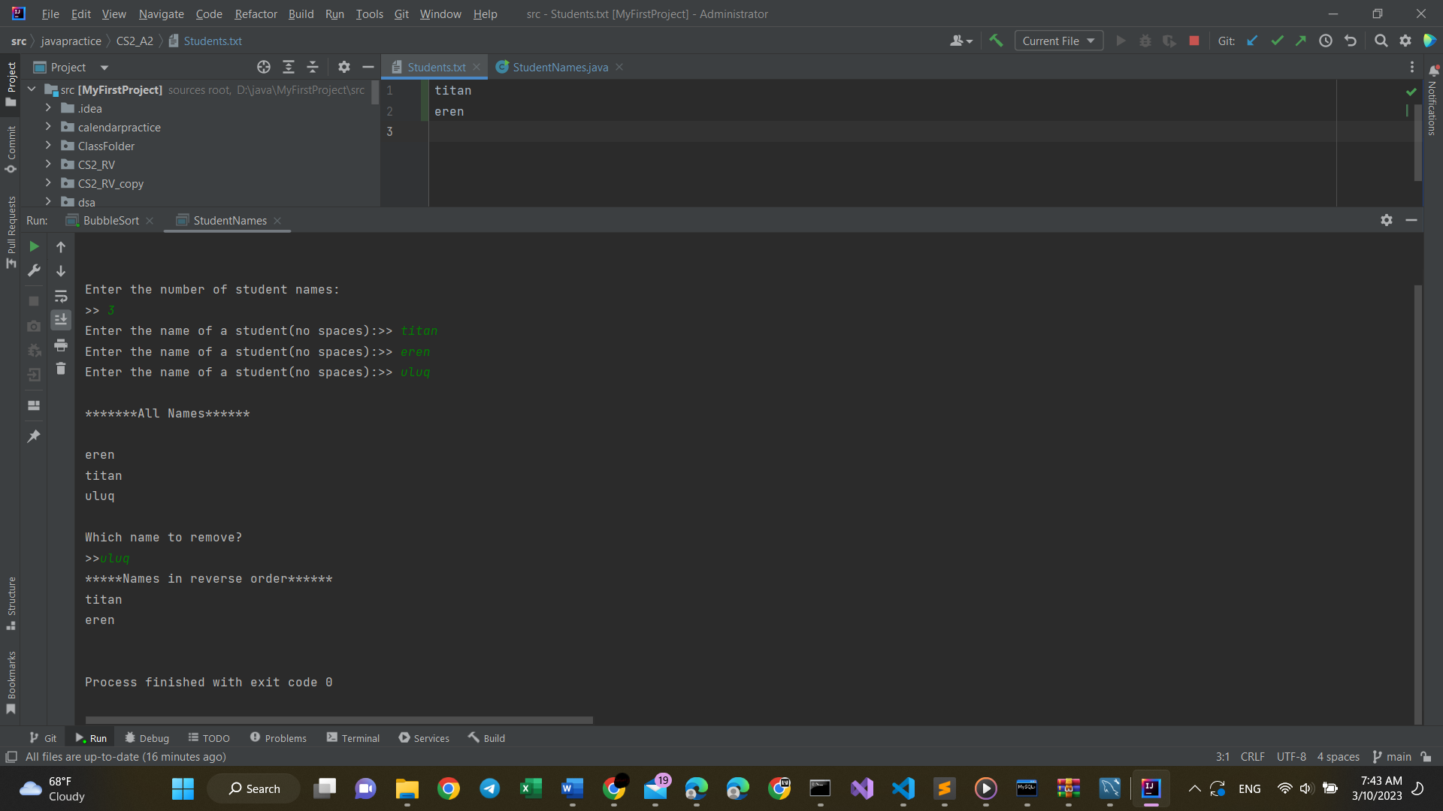

Figure 1 Output Screen of the StudentNames.java on IntelliJ IDE

# REPL.IT LINK

<https://replit.com/@UnnecessaryAcco/CodingAssignment2AzamatSalamatov#Main.java>