MATH 1312 - 1

***Correlation and Linear Regression***

**Azamat Salamatov**

Professor: Marvin Johnson

Date Performed: April 17, 2023

1. **Discuss the concept of correlation and linear regression.**

In statistics, correlation measures the relationship between two variables. It is a measure of the strength and direction of the relationship between the two variables. On the other hand, linear regression is a statistical method used to model the relationship between two variables by fitting a linear equation to the observed data. The linear equation is represented by ***y = mx + b***, where ***y*** is the dependent variable, ***x*** is the independent variable, ***m*** is the slope of the line and ***b*** is the ***y***-intercept.

1. **Discuss the the questions below and insert calculations as required.**
   1. **Calculate the correlation coefficient from the data below.**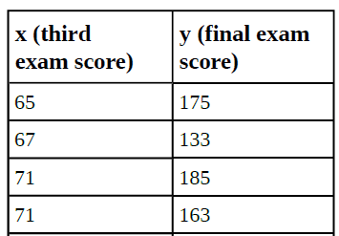

To calculate the correlation coefficient, we need to use the formula: 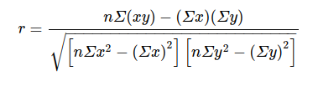

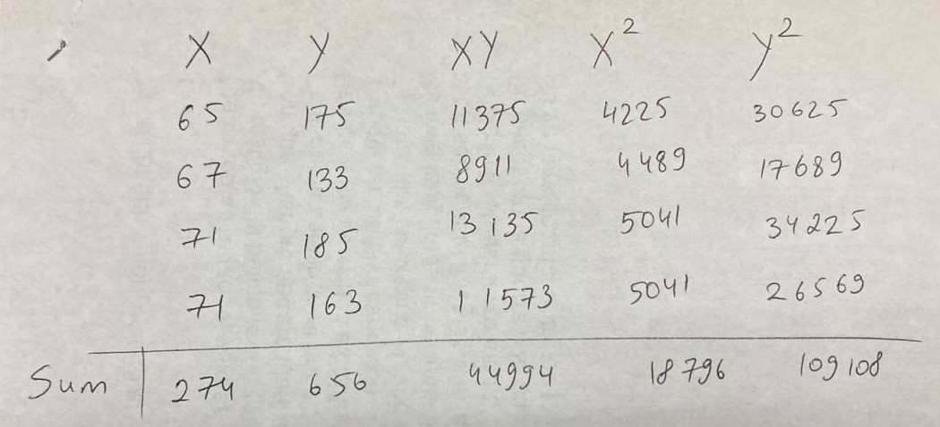

Using the given data, we get

*n* = 4,

*∑x* = 274,

*∑y* = 656,

*∑xy* = 44994,

*∑x2* = 18796, and

*∑y2* = 109108.

Plugging these values into the formula, we get

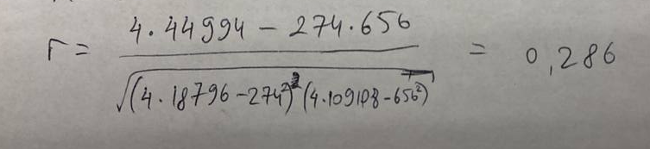

*r* = 0.286 ,

indicating a *weak positive correlation* between the third exam score and the final exam score.

* 1. **Calculate the linear regression equation from the data below.**

To calculate the linear regression equation, we need to use the formulas:

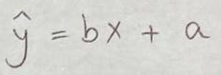

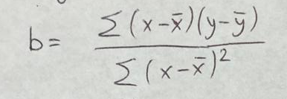

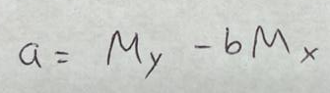

Using the same data, we get:

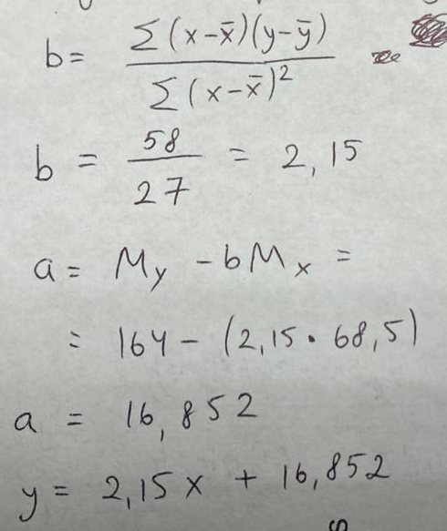

Therefore, the linear regression equation is

*y = 2.15x + 16.852*.

* 1. **What will be the final exam score based on a third exam score of 70.**

If the third exam score is 70, we can use the linear regression equation to predict the final exam score.

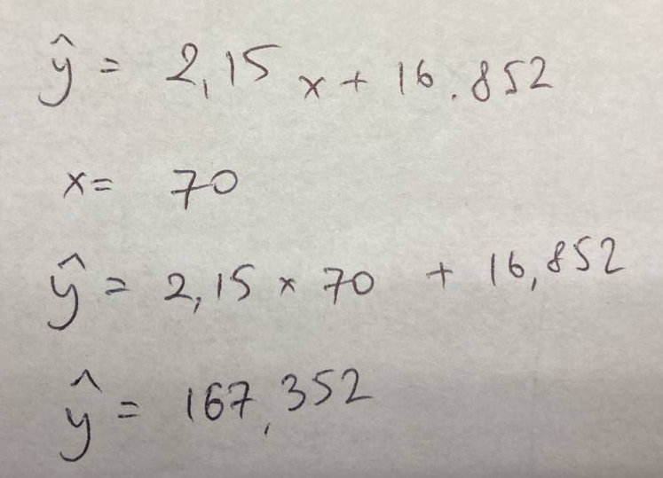

Plugging x=70 into the equation, we get

*y* = *167,352*.

* 1. **Interpret the correlation coefficient and regression equation.**

The correlation coefficient is 0.286. This value indicates that there is a weak positive correlation between the third exam score and the final exam score.

The regression equation y = 2.15x + 16.852 is an equation that represents a straight line that best fits the data. The slope of the line is 2.15, which means that for every one-unit increase in x, y is expected to increase by 2.15 units. The y-intercept of the line is 16.852, which means that when x is equal to zero, y is expected to be 16.852.

Together, the correlation coefficient and regression equation provide information about the relationship between the two variables. The weak positive correlation indicates that as x increases, y tends to increase, but the relationship is not very strong. The regression equation provides a more specific relationship between the variables, showing the expected increase in y for each increase in x, as well as the starting point when x is zero.

* 1. **Discuss determining a final exam score based on a score of 95.**

To determine a final exam score based on a score of 95, we can use the linear regression equation.

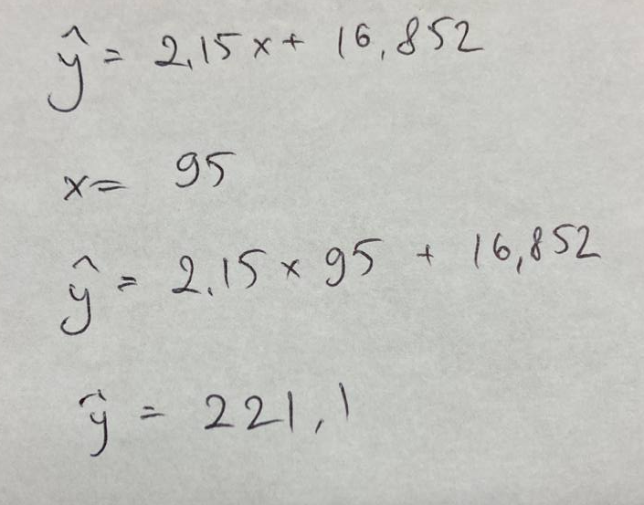

Plugging x=95 into the equation, we get

*y = 221,102*.

1. **Conclusion of Report**

In conclusion, we have analyzed the relationship between the third exam score and the final exam score using correlation and linear regression. The analysis showed a weak positive correlation between the two variables, and we were able to use the linear regression equation to predict the final exam score based on a given third exam score. These statistical tools can be useful in predicting future outcomes and making data-driven decisions.