Interface report
The system interfaces is being built in “Tkinter” tool , which is compatible with python programming language.
To know more about it you can see this reference:
https://dzone.com/articles/python-gui-examples-tkinter-tutorial-like-geeks

The system consist of multiple interfaces in different places :
The first one is the LOGIN page for the Instructors, the user must enter the user name and password to login to the system, that done by communicating with the server database to insure that.

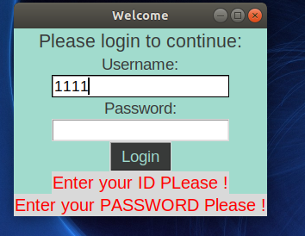

After the instructor login to the system, he/she can start prepare his exams questions to be classified, encrypted,then sent to the server.

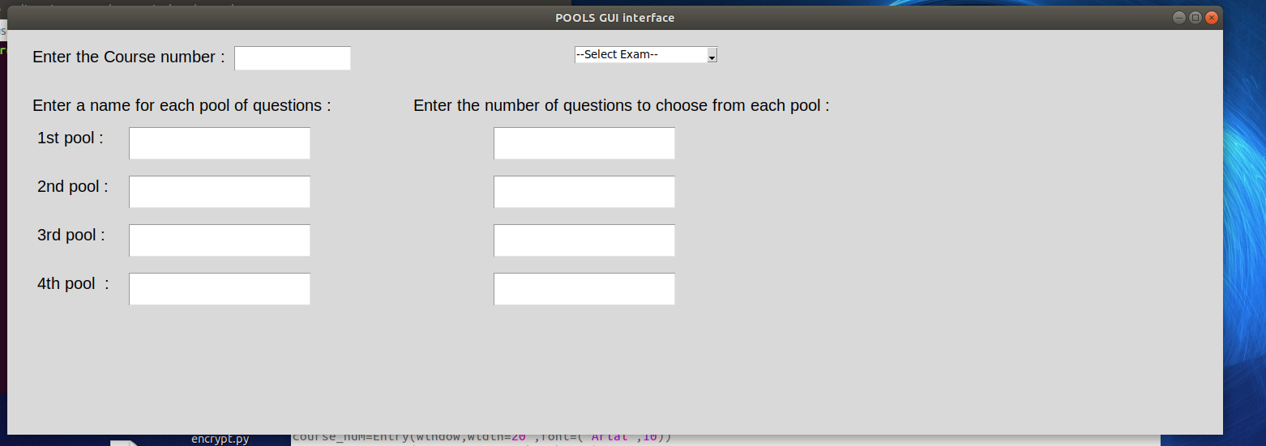
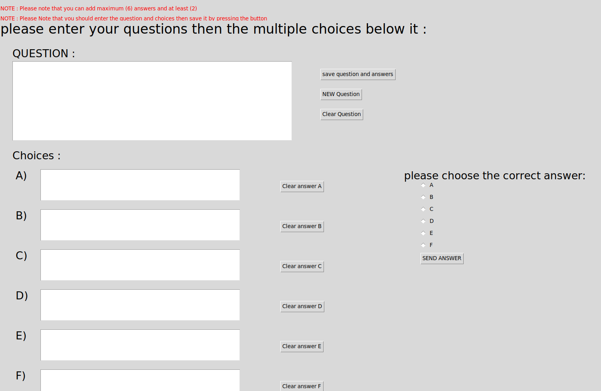

The second one is at the server side, and this will be the main interface, the Admin will be responsible on that part, it will be used to add new Instructors and Students
to the database.
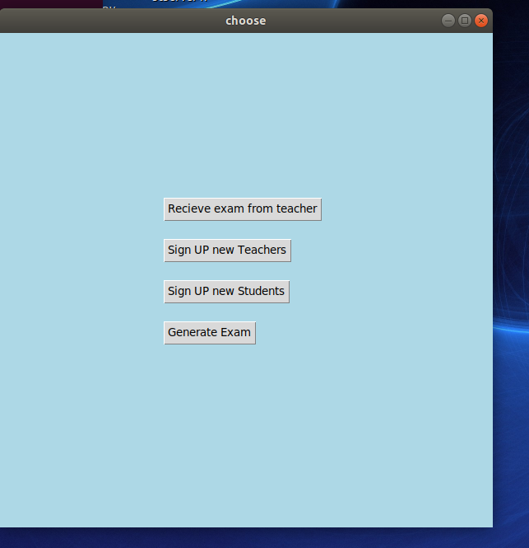
Also it will be used to receive and store exams from instructors, and to generate exams to the students.

