CROWNLESS

Terrain & Environment
Asset Change Record
From static cutouts to authored, living environments
48 generated sprites • 14 live terrain passes • 20 new dev-preview terrains
28-29 July 2026

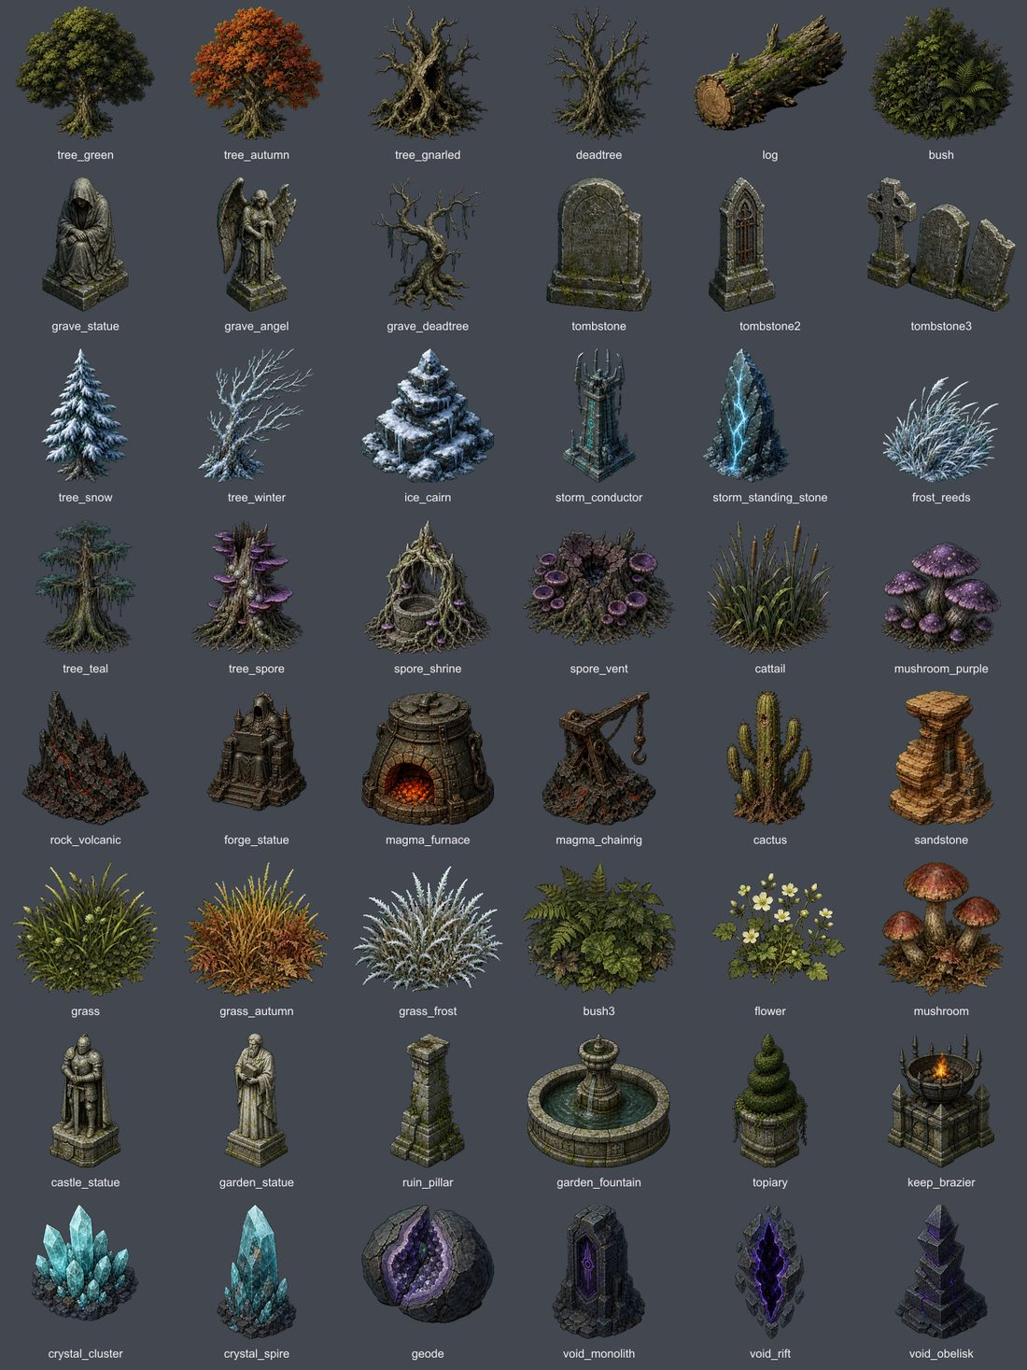
The generated 48-piece environment kit installed by this pass.

EXECUTIVE SUMMARY

Outcome
This was a full environment pass, not a shared-prop cleanup. The source art itself was regenerated, and every live terrain now receives an authored ecology composition, more natural clustering, grounded scale, animated foliage and corrected floor values.
Measure | Delivered
Generated terrain sprites | 48 total — 46 replacements, 2 new
Existing live terrains | 14 improved in place
New terrain concepts | 20 non-placeholder dev previews
Chapter 3–7 assignments | 0

Design response
- Replaced low-detail trees, the giant gnarled tree, grave statuary, grass, reeds, mushrooms, elemental formations and other weak terrain pieces.
- Added one coherent landmark ecology per live terrain: groves, hollows, islets, courtyards, memorials, arrays, sanctums, shrines and breaches.
- Made ecology additive so a zone-authored forge, well or building no longer erases the biome’s environment identity.
- Extended restrained wind motion to grass, reeds, bushes, mushrooms, flowers and every tree family.
- Added authored display widths, bottom anchoring, seeded scale variation, natural clumps, multi-part collision, lights and fire audio.
- Raised forest, marsh, bog, basalt, void and spore ground values where silhouettes previously disappeared.

Scope boundary
The 20 new terrain IDs are marked preview_isolated: true and remain visible in the dev panel / Future → Terrains gallery. They are not placeholder entries, none is referenced by Story.CHAPTERS, and no Chapter 3–7 zone was reassigned.

VISUAL QA

Before / after — selected live terrains
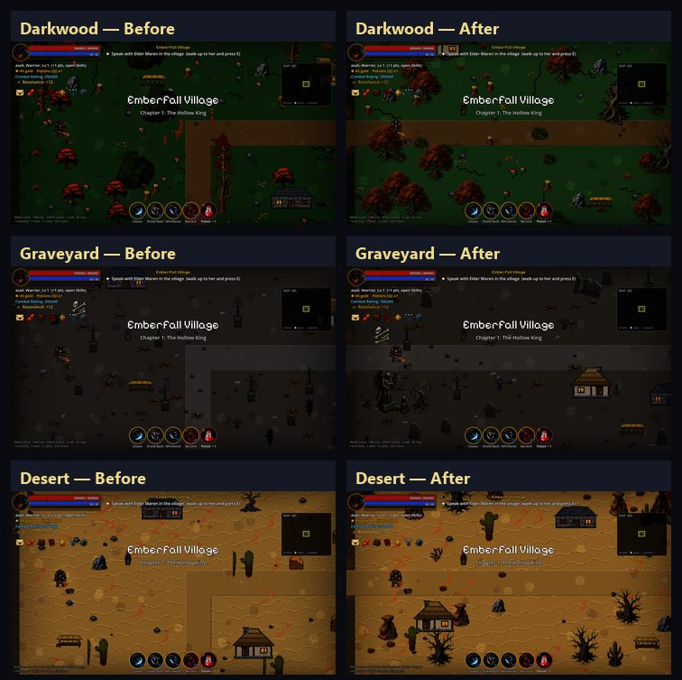
Darkwood, Graveyard and Desert: old source treatment on the left; installed pass on the right.

VISUAL QA

Before / after — selected live terrains
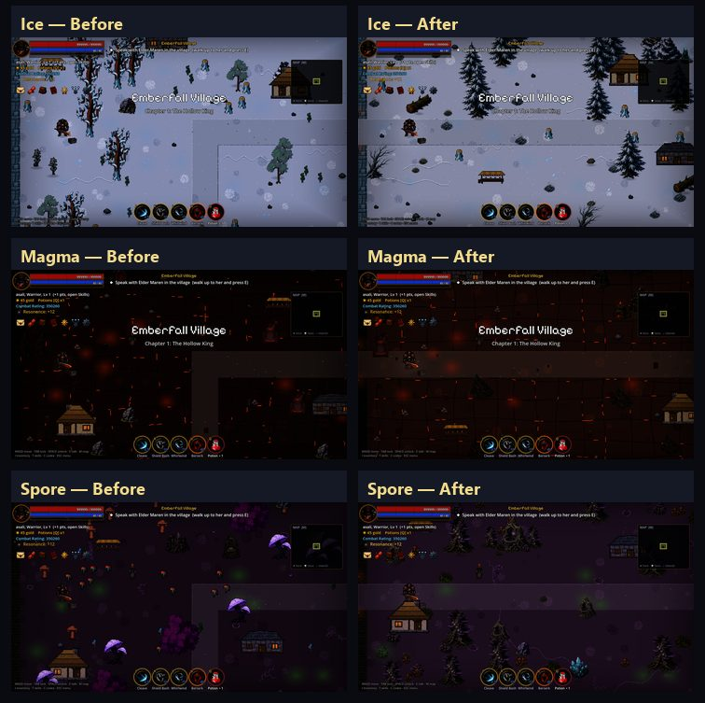
Ice, Magma and Spore: old source treatment on the left; installed pass on the right.

14 SHIPPING PROFILES

Live terrain environment passes
Terrain | Composition | Environment result
Village | village_grove | Civic grove: green tree, statue, shrubs and grass.
Darkwood | darkwood_hollow | Gnarled hollow backed by autumn growth, log and fungi.
Blightmarsh | marsh_islet | Wetland islet with teal tree, deadwood, reeds and vent.
Vargoth’s Keep | keep_courtyard | Sentinel statue, ruined pillars and lit braziers.
Scorched Wastes | magma_judgment | Forge idol, furnace, volcanic rock and chain rig.
Frozen Expanse | ice_waymarker | Snow pine, cairn, crystal and wind-bent reeds.
Restless Graveyard | grave_memorial | Angel, mourner, dead tree, headstone and pale grass.
Scorching Dunes | desert_hoodoo | Layered sandstone, cactus and dry grass habitat.
Poison Bog | bog_rootwell | Root well, shrine, purple fungi, reeds and vents.
Crystal Caverns | crystal_garden | Luminous spire, crystal beds and split geode.
Thunder Plains | storm_array | Conductor, paired stones and wind-tossed growth.
The Void | void_breach | Rift, monolith, obelisk and crystal beacon.
Sanctified Ruins | holy_sanctum | Fountain, angel, statue, pillar, flowers and warm light.
Spore Glade | spore_cathedral | Twin spore trees frame a shrine, vents and mushrooms.

DEV-PANEL TERRAIN PREVIEWS

Twenty new terrain types
Each profile has its own floor material family, ecology, ambience, wall mapping and—where appropriate—an existing terrain mechanic. The plate below comes from the real in-game terrain switcher.
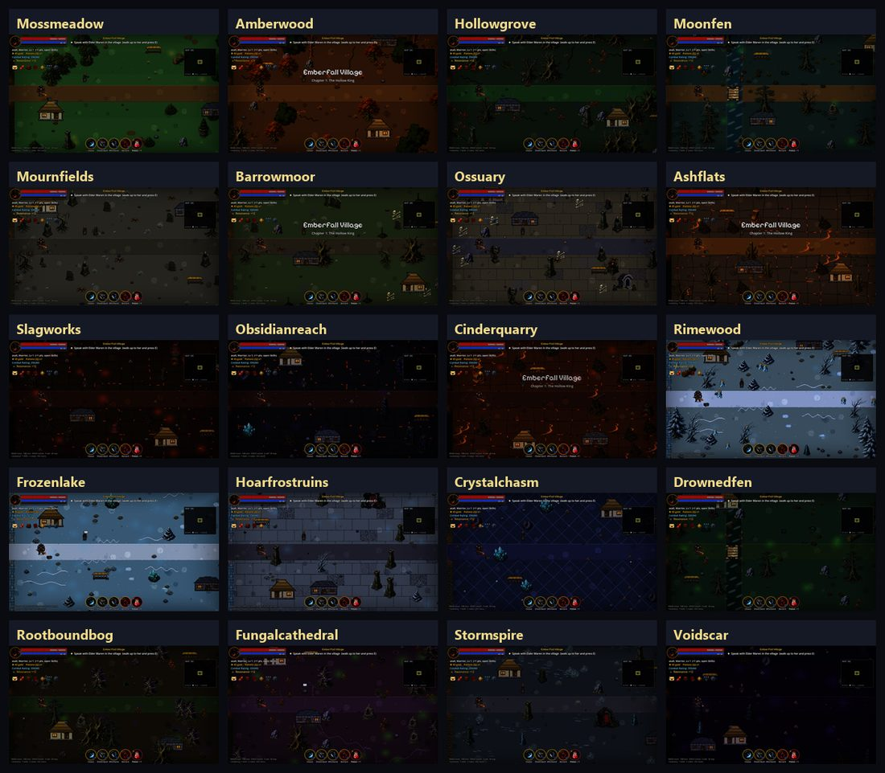
The 20 new non-placeholder terrain previews, kept separate from the 16 older placeholder profiles.

ALL 20 IDS

Dev-preview terrain register
ID | Display name | Mechanic | Identity
ph_mossmeadow | Mosslight Meadow | Heal | Moss and flowers
ph_amberwood | Amberwood | — | Amber canopy
ph_hollowgrove | Hollow Grove | Slow | Gnarled ruins
ph_moonfen | Moonmirror Fen | Poison + river | Reflective mire
ph_mournfields | Mourners’ Fields | Grave spawn | Open memorials
ph_barrowmoor | Weeping Barrowmoor | Slow | Wet burial moor
ph_ossuary | The Open Ossuary | — | Bone flagstones
ph_ashflats | Ashen Flats | Gust | Scorched windplain
ph_slagworks | The Slagworks | Lava + rain | Industrial slag
ph_obsidianreach | Obsidian Reach | Slow | Dark glass geology
ph_cinderquarry | Cinder Quarry | Lava | Excavated cinder
ph_rimewood | Rimewood | Ice | Frozen forest
ph_frozenlake | Frozen Mirror | Dense ice | Blue-ice field
ph_hoarfrostruins | Hoarfrost Ruins | Ice | Frozen civic ruins
ph_crystalchasm | Crystal Chasm | Shard + MP | Deep mineral field
ph_drownedfen | Drowned Fen | Poison + river | Flooded green soil
ph_rootboundbog | Rootbound Bog | Poison | Root-torn wetland
ph_fungalcathedral | Fungal Cathedral | Drift poison | Spore-tree nave
ph_stormspire | Stormspire Heights | Lightning | Conductors and stone
ph_voidscar | The Voidscar | Slow | Sparse void fracture

48 SPRITE CHANGES

Complete generated asset register
All files live under game/assets/sprites/ and are mirrored under mobile/game/assets/sprites/. Every item is a replacement except frost_reeds.png and ruin_pillar.png, which are new.

Woodland & trees
tree_green.png, tree_autumn.png, tree_gnarled.png, tree_teal.png, tree_snow.png, tree_winter.png, tree_spore.png, deadtree.png, grave_deadtree.png, log.png

Ground growth
bush.png, bush3.png, grass.png, grass_autumn.png, grass_frost.png, flower.png, mushroom.png, mushroom_purple.png, cattail.png, frost_reeds.png [NEW]

Grave, civic & ruin
tombstone.png, tombstone2.png, tombstone3.png, grave_statue.png, grave_angel.png, castle_statue.png, garden_statue.png, garden_fountain.png, topiary.png, ruin_pillar.png [NEW]

Magma & desert
cactus.png, sandstone.png, rock_volcanic.png, forge_statue.png, magma_chainrig.png, magma_furnace.png, keep_brazier.png

Ice, crystal & spore
ice_cairn.png, crystal_cluster.png, crystal_spire.png, geode.png, spore_shrine.png, spore_vent.png

Storm & void
storm_conductor.png, storm_standing_stone.png, void_monolith.png, void_obelisk.png, void_rift.png

Final transparent sprite contact sheet after chroma cleanup and binary-alpha verification.

CHANGE RECORD

Implementation and validation
Area | Change
terrains.gd | 20 dev-preview definitions; 14 ecology keys; 14 multi-part landmark definitions; prop pools, ambience and wall mappings.
art.gd | 20 floor palettes, macro-ground routing and live-biome value correction.
balance.gd | Authored generated-scenery widths and scale variation.
game_world.gd | Bottom anchoring, width normalization, wind, clustering and additive ecology placement.
shot_audit.gd | Terrain-only and placeholder-only visual-audit switches.
assets/sprites | 48 generated PNGs; 46 replacements, 2 new.
mobile/game | Terrain pass mirrored; existing platform deltas preserved.

Validation results
Check | Result | Evidence
Godot asset import | PASS | All 48 assets reimported.
Art verification | PASS | 0 failures; 2 pre-existing direction warnings.
Desktop quick | PASS | 92 scripts + core suite.
Desktop full | PASS | AUTOTEST PASS; exit 0.
Mobile compile | PASS | 92 scripts.
Mobile quick | PASS | Core suite passed.
Live visual audit | PASS | 14/14 captured and reviewed.
Dev-preview audit | PASS | 20 new concepts separately reviewed.

Sourcing and boundary confirmation
The raster art was generated specifically for Crownless with the built-in image-generation workflow, then locally extracted, chroma-cleaned and integrated. No third-party asset pack was added. Source atlases and QA sheets live under tmp/terrain_art_generation/ and are not runtime dependencies.
- No new placeholder ID appears in Chapters 3–7.
- No current chapter zone was reassigned.
- All 20 new terrain concepts are non-placeholder, isolated dev-preview entries.
- Existing live terrains are improved in place.

Second-generation stylized terrain pass
Correction applied after visual review. The first placeholder implementation solved naming and palette coverage, but it did not yet solve material reuse or repeated silhouettes. This pass replaces that shortcut with complete authored room surfaces and genuine prop families, while pulling the art direction back from realism into Crownless' chunky pixel language.

Art-direction lock
- Strict 16-bit-inspired pixel art with crisp square edges, broad clusters and controlled 16?24 color palettes.
- No photographic texture, PBR response, painterly micro-detail, anti-aliased material noise or realistic lighting gradients.
- Nearest-neighbor processing from generated source through the 704 ? 416 room asset and at runtime for non-default room sizes.
- Room floors remain readable combat spaces: large calm traversal zones, restrained motifs and no collision-implying painted props.

Representative authored room surfaces
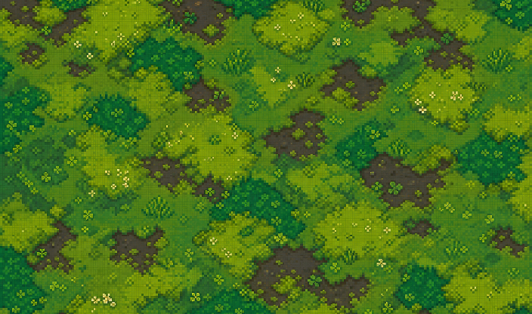  Mosslight Meadow | 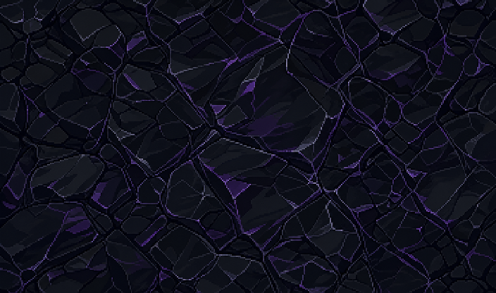  Obsidian Shelf
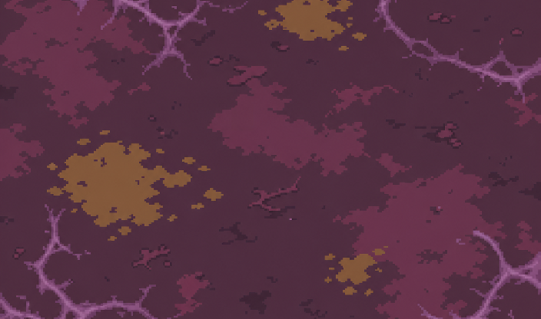  Fungal Humus | 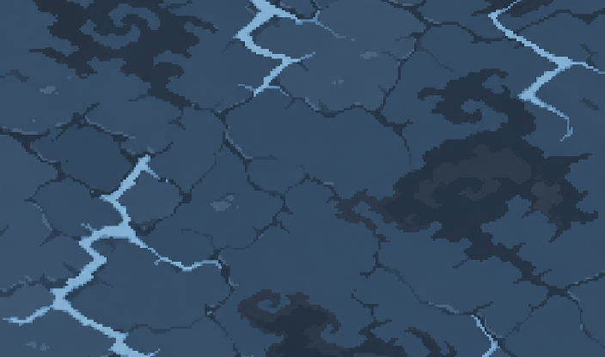  Stormstone

Twenty full-room terrain assets
Each dev-preview terrain now resolves to a dedicated non-repeating room image before dynamic paths, door arms, wall shadows and boundary walls are composited:
Terrain | Asset key | Terrain | Asset key
Mosslight Meadow | ground_room_mossmeadow.png | Amberleaf Wood | ground_room_amberleaf.png
Hollow Soil | ground_room_hollowsoil.png | Moonmire | ground_room_moonmire.png
Mournearth | ground_room_mournearth.png | Barrow Grass | ground_room_barrowgrass.png
Bone Floor | ground_room_bonefloor.png | Ash Soil | ground_room_ashsoil.png
Slagstone | ground_room_slagstone.png | Obsidian Shelf | ground_room_obsidian.png
Cinderstone | ground_room_cinderstone.png | Rimegrass | ground_room_rimegrass.png
Blue Ice | ground_room_blueice.png | Hoarfrost | ground_room_hoarfrost.png
Deep Crystal | ground_room_deepcrystal.png | Drowned Soil | ground_room_drownedsoil.png
Root Soil | ground_room_rootsoil.png | Fungal Humus | ground_room_fungalhumus.png
Stormstone | ground_room_stormstone.png | The Voidscar | ground_room_voidscar.png

Authored prop variation families
Twenty-seven variants were generated or rebuilt at high resolution. The runtime chooses a member deterministically per placement, then applies only subtle mirroring, lean and value drift. Collision and canonical world width remain family-based, so visual variety does not change gameplay footprint.
  Windswept green | 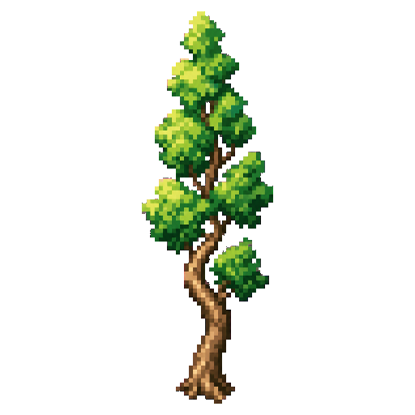  Tall green | 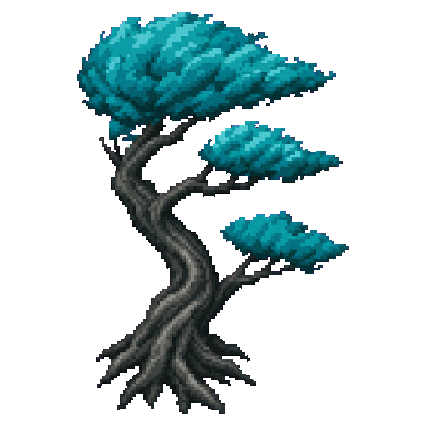  Teal fan
  Snow fir | 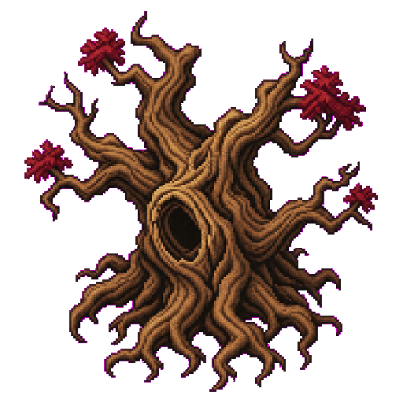  Ancient gnarled | 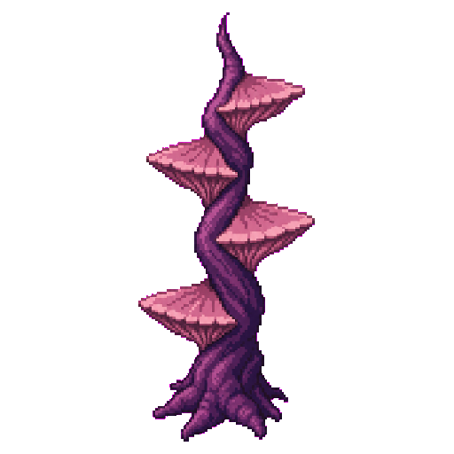  Fungal shelf

Variant register
Family | Installed authored members | Added/rebuilt
Green tree | tree_green2, tree_green3, tree_green4 | +3
Autumn tree | tree_autumn2, tree_autumn3 | +2
Teal tree | tree_teal2, tree_teal3 | +2
Snow tree | tree_snow2, tree_snow3 | +2
Winter tree | tree_winter2, tree_winter3 | +2
Spore tree | tree_spore2, tree_spore3 | +2
Gnarled tree | tree_gnarled2, tree_gnarled3 | +2
Dead tree | deadtree2, deadtree3 | +2
Bush | bush2 | +1
Grass | grass2, grass3 | +2
Cattail | cattail2, cattail3 | +2
Mushroom | mushroom2, mushroom3 | +2
Rock | rock2, rock3 | +2
Boulder | boulder2 | +1

Runtime and integration changes
- Art.ground now checks ground_room_<kind>.png first; authored surfaces replace only the base material, while roads, door-aware arms, walls and shadows remain dynamic.
- Terrains.PROP_VARIANT_GROUPS defines 15 canonical families. Prop selection is seeded from placement coordinates, so rooms rebuild identically.
- GameWorld renders every chosen member at its canonical family width and keeps collision family-based. New high-resolution rocks are capped at 64 px; boulders remain capped at 78 px.
- Twenty terrain IDs are non-placeholder dev-preview entries exposed for terrain repainting; no Chapters 3–7 zone was reassigned.
- Desktop and mobile copies were updated together; the room loader preserves hard pixel edges with nearest-neighbor resizing.

Validation ? second-generation pass
Check | Result | Evidence
Godot import | PASS | 47 second-generation terrain/variation assets imported in desktop and mobile projects.
Art verifier | PASS | All 47 files pass; verifier now correctly exempts rectangular ground_room_* surfaces from animation-strip geometry.
Compile gate | PASS | Desktop: COMPILE OK (92 scripts). Mobile: COMPILE OK (92 scripts).
Quick suite | PASS | Desktop and mobile both reached AUTOTEST QUICK PASS.
Runtime audit | PASS | 20 authored room surfaces compose through Art.ground; all members of 15 prop families are reachable deterministically.

Generation prompt set
Built-in image generation mode: stylized-concept. New room surfaces were prompted as complete non-repeating top-down RPG floors in strict chunky 16-bit pixel art, limited 16?24 color palettes, broad calm clusters, crisp square edges, flat stepped lighting, no realism/PBR/photographic texture, and no painted collision props. Prop prompts used the same style with a uniform #ff00ff key background and required distinct silhouette, trunk/canopy or profile architecture per member.
Report revision: v2 ? 28 July 2026

KINETIC-PROP ADDENDUM

Living assets and logical boundaries
A fountain playtest exposed two systemic problems at once: the supposed water animation was four opaque blue squares, and a roughly 150-165 px stone basin was protected by only one 30 px-radius collider. This addendum records the direct asset replacements and the shared runtime rules added after that report.
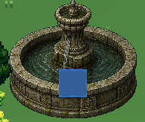
Reported defect: the old animated overlay was an opaque blue square.
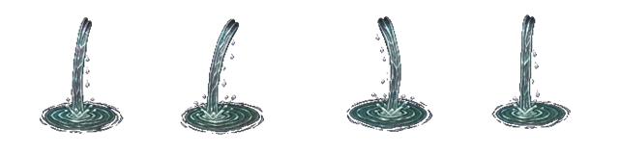
Replacement fountain_flow_anim.png: four transparent cascade and ripple frames.

Generated raster changes
Fountain water - replacement
fountain_flow.png; fountain_flow_anim.png. Transparent cascade, droplets and basin ripples; no rectangular field.
Spore vent - new
spore_puff.png; spore_puff_anim.png. A compact vent-local puff that gathers, blooms, rises and disperses.
Void rift - new
void_energy.png; void_energy_anim.png. Coiling inner energy and restrained crawling arcs inside the stable stone shell.
Storm conductor - new
storm_arcs.png; storm_arcs_anim.png. Four changing cyan-white connections between the upper metal prongs.

VISUAL QA

In-engine motion proof
The captures below are separated by 0.35 seconds in the real game. The authored shells remain stable while their active elements change frame.
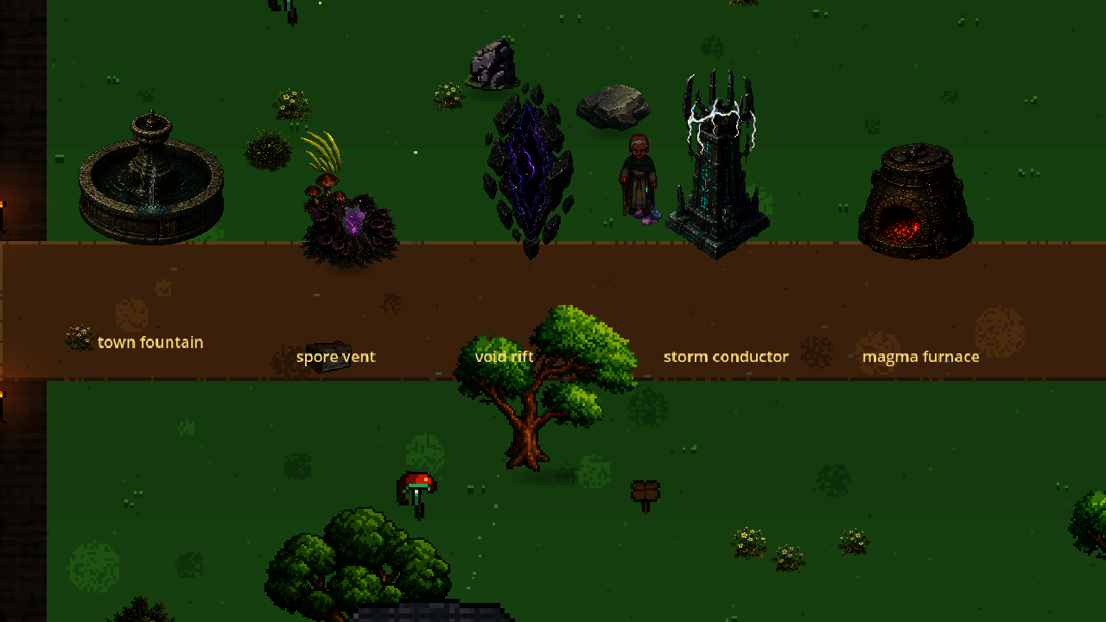
Frame A: fountain cascade/ripple, spore bloom, void energy and conductor arcs.
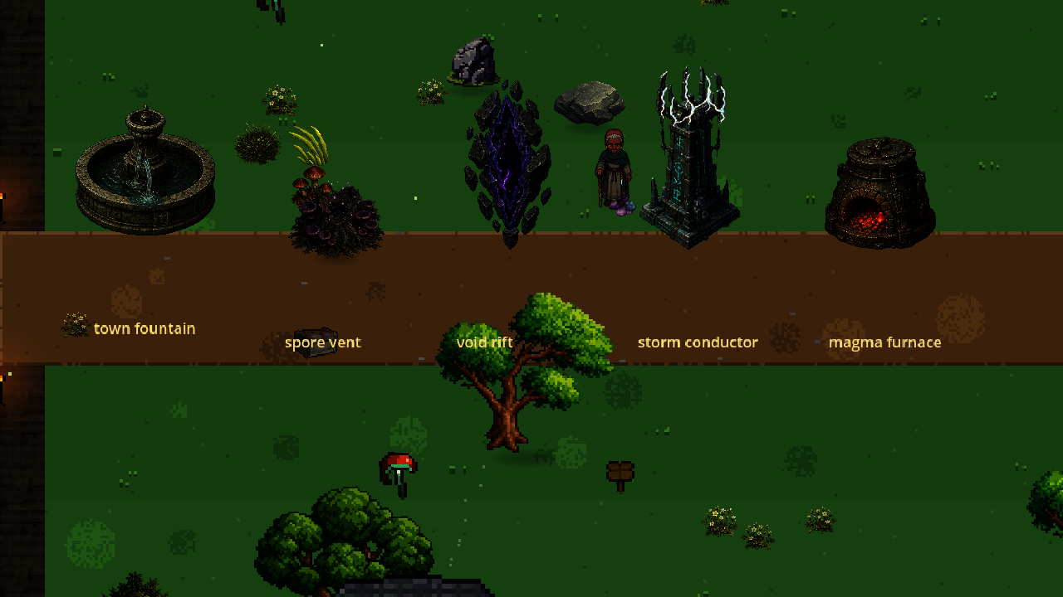
Frame B: the same staged assets after 0.35 seconds; active elements have advanced.
IMPLEMENTATION

Runtime and collision changes

Motion architecture
Superseded on 29 July: PROP_MOTION and its child-overlay runtime were removed. Every affected prop now loads one complete <name>_anim.png strip through the shared prop renderer.
- Furnace, cauldron and brazier families now contain their fire inside four complete, footprint-anchored object frames.
- town_fountain, garden_fountain and holy_sanctum now share the same complete animated fountain base; no fountain_flow decal is used.
- Standalone magma furnaces, storm conductors, void rifts and spore shrines have explicit structure footprints rather than generic fallback strips.

Physical-footprint contract
The legacy obstacle path gave every non-tree prop the same 11 px circle, regardless of the visible asset. Balance.SCENERY_COLLIDER_RADIUS now authors the ground footprint by family. Large rocks, boulders, logs, shrines, furnaces, crystals, statues and similar solids block the space their bases occupy. Trees intentionally remain trunk-blocking so a canopy does not become an invisible wall.
- Fountains use two overlapping broad circles to approximate the full elliptical rim: 42 px lobes for town_fountain and 46 px lobes for the 165 px variants, offset toward the back edge.
- Representative large-solid regression checks reject a return to the legacy undersized radius.

Generation prompt and validation
Built-in image generation was used in stylized-concept mode with the existing regenerated prop as a style reference. Prompts required polished dark-fantasy game sprites with lightly pixel-stepped edges, muted palettes and no photorealism. Each four-frame source was isolated on a flat green or magenta chroma field, locally chroma-cleaned, alpha-validated and assembled as a horizontal square-frame strip.
- Godot import: PASS for all eight changed/new PNG files.
- Desktop compile: PASS (92 scripts).
- Desktop quick suite: PASS, including motion attachment, fountain footprint and large-solid collider regressions.
- Two-frame windowed visual review: PASS; no opaque blue rectangle remains.
Report addendum: kinetic props and collision - 28 July 2026

DISTINCT ENVIRONMENT PASS

Room-scale terrain follow-up
The initial placeholder set had unique ground keys, but legacy roads, room overlays and story-zone dressing still made the rooms read as variants of existing biomes. This follow-up replaces all twenty placeholder floors with new full-room compositions and changes the runtime compositor so those compositions survive intact in the dev preview.
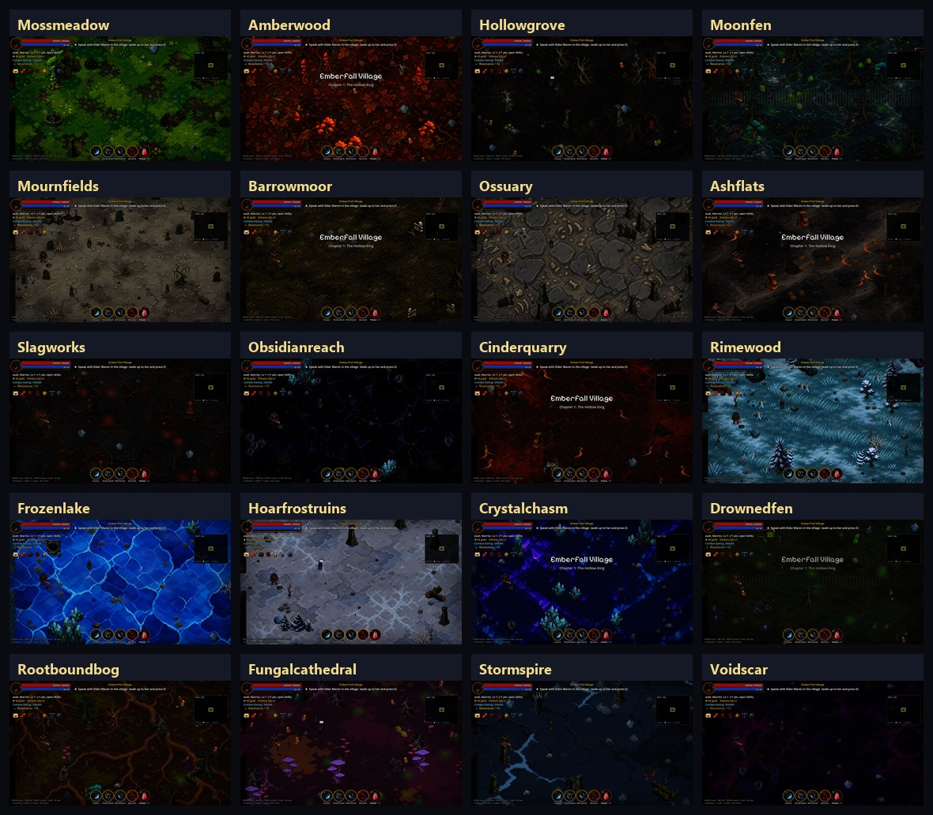
Current in-game captures of the twenty dev-only terrain rooms after removing inherited Emberfall buildings and generic path overlays.

What changed in the renderer
- Twenty independent 704 x 416 room surfaces now provide macro composition rather than a repeating material swatch.
- Authored surfaces retain their terrain-specific geography under every real doorway connection.
- Each biome has a bespoke route grammar: boardwalk, rail, root rib, procession track, rune inlay, ice seam, mycelium branch or void flow.
- Boundary construction and subtle wall finish are selected per terrain instead of sharing one generic family treatment.
- Dev previews ignore the current story room's buildings, civic landmarks, furniture and scatter overrides.
- Moonmirror Fen and Drowned Fen no longer receive a second generic river over their authored water composition.
SURFACE REGISTER

Twenty distinct room compositions
Terrain | Room-scale grammar | Route and boundary
Mosslight Meadow | Moss islands, spring rills | Stepping clearings / hedge
Amberwood | Leaf windrows, root fans | Leaf-wind route / timber
Hollow Grove | Hollow-root basins | Root ribs / moss stone
Moonmirror Fen | Silver pools, peat islands | Boardwalk / wet timber
Mourners' Fields | Pale grave furrows | Procession track / grave
Weeping Barrowmoor | Low barrows, ring scars | Moor tracks / grave
The Open Ossuary | Bone-and-stone mosaics | Bone inlay / masonry
Ashen Flats | Ash dunes, glass veins | Wind streaks / sandstone
The Slagworks | Clinker plates, molten gutters | Twin rails / volcanic
Obsidian Reach | Black glass, violet seams | Glass fractures / volcanic
Cinder Quarry | Flat extraction cuts, survey marks | Quarry route / volcanic
Rimewood | Snow roots, pine litter | Snow tracks / timber
Frozen Mirror | Blue ice, pressure cracks | Ice ridge / ice
Hoarfrost Ruins | Frozen ceremonial masonry | Rune route / castle
Crystal Chasm | Faceted mineral strata | Mineral vein / ice
Drowned Fen | Blackwater channels, peat | Sunken planks / sewer stone
Rootbound Bog | Root causeways, dark pools | Root ribs / timber
Fungal Cathedral | Mycelium webs, spore rings | Mycelium route / moss
Stormspire Plateau | Scoured slate, lightning scars | Storm seam / castle
The Voidscar | Gravity ripples, starless scars | Void flow / volcanic

IMPLEMENTATION RECORD

Integration, taxonomy and validation
Area | Delivered change
assets/sprites | 20 regenerated ground_room_*.png files, palette reduced and nearest-neighbor processed for the game's stylized pixel scale.
art.gd | Full-room loading plus 20 bespoke route specifications; legacy dirt, stone and snow bands no longer overwrite authored rooms.
terrains.gd | Twenty local five-candidate landmark ecologies, distinct wall families and wall grades; all IDs are non-placeholder dev previews.
game_world.gd | Dev previews isolate terrain composition from the story zone being repainted; terrain-specific wall finish applies live.
autotest.gd | Checks all twenty room surfaces, route grammars, boundary finishes, preview-isolation status and fen overlay contract.
Visual QA | All twenty profiles captured through the real terrain switcher and reviewed as a single comparison plate.
Desktop full suite | 92 scripts compile; all 57 terrains apply; Chapters 1-7 and the complete AUTOTEST suite pass.

Asset sourcing
All twenty full-room surfaces were generated specifically for Crownless with the built-in image-generation workflow, using the prior local room texture only as a pixel-scale and framing reference. They were then cropped, palette reduced, nearest-neighbor processed and installed locally. No third-party environment pack was introduced by this follow-up.

Scope confirmation
- No placeholder terrain is assigned to Chapters 3-7.
- All twenty remain visible through the development terrain panel as non-placeholder, isolated previews.
- The checkpoint before this follow-up is commit 6749f2a.
- This room-scale follow-up is packaged as a separate commit after that checkpoint.

FULL-OBJECT ANIMATION CORRECTION

Integrated motion assets
The earlier kinetic-prop addendum solved missing motion but still composited separate water, flame, void, spore and lightning sprites over static bodies. That architecture caused the fountain spout to shift and made active elements look pasted on. This correction regenerates every affected asset as four complete object frames.
Measure | Delivered
Complete regenerated props | 14 static sources + 14 four-frame strips
Independent motion decals removed | PROP_MOTION, fountain_flow and sewer_flow paths
Frame anchoring | Identical baseline; centre variance at most 2 px

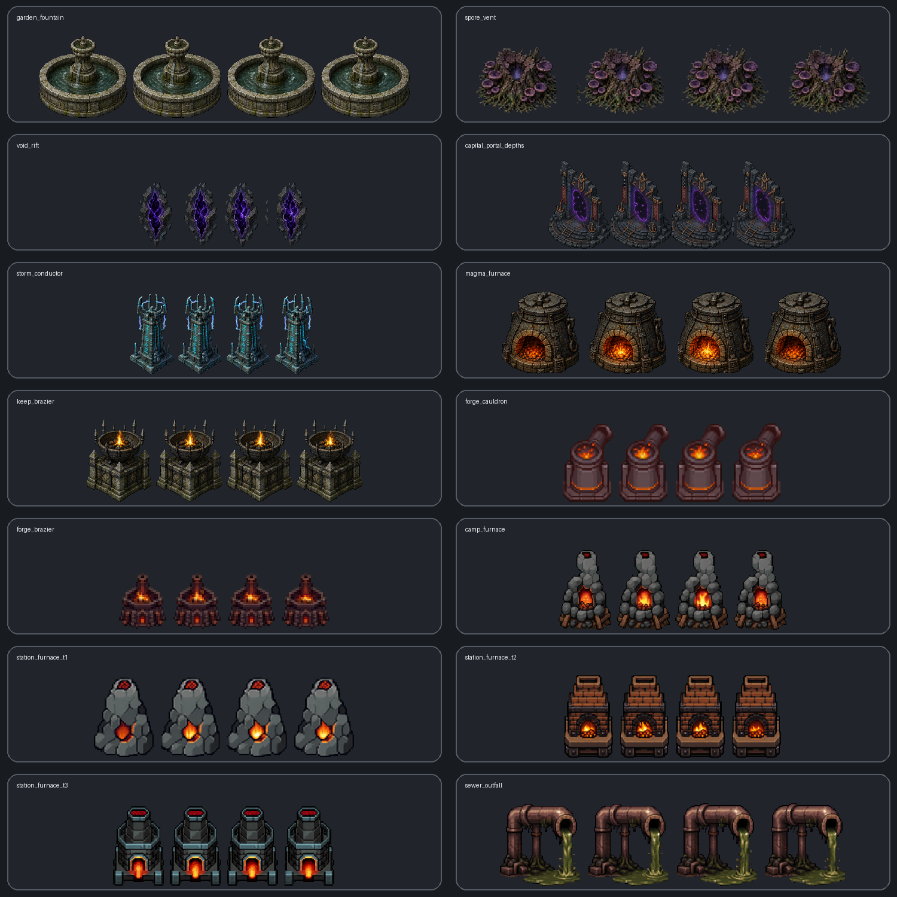
Production contact sheet: every cell shows all four complete frames, not a detached effect layer.

Regenerated asset register
Asset | Integrated motion | Installation
garden_fountain.png | Water spout, streams and basin ripples | garden_fountain_anim.png (4 complete frames)
spore_vent.png | Inner violet pulse and spores | spore_vent_anim.png (4 complete frames)
void_rift.png | Contained void field and energy veins | void_rift_anim.png (4 complete frames)
capital_portal_depths.png | Portal field and restrained motes | capital_portal_depths_anim.png (4 complete frames)
storm_conductor.png | Attached cyan electrical arcs | storm_conductor_anim.png (4 complete frames)
magma_furnace.png | Coals and fire inside the furnace mouth | magma_furnace_anim.png (4 complete frames)
keep_brazier.png | Integrated brazier flame and coals | keep_brazier_anim.png (4 complete frames)
forge_cauldron.png | Integrated crucible fire | forge_cauldron_anim.png (4 complete frames)
forge_brazier.png | Integrated small-brazier fire | forge_brazier_anim.png (4 complete frames)
camp_furnace.png | Integrated field-furnace fire | camp_furnace_anim.png (4 complete frames)
station_furnace_t1.png | Tier-one furnace fire | station_furnace_t1_anim.png (4 complete frames)
station_furnace_t2.png | Tier-two furnace fire | station_furnace_t2_anim.png (4 complete frames)
station_furnace_t3.png | Tier-three furnace fire | station_furnace_t3_anim.png (4 complete frames)
sewer_outfall.png | Pipe-connected wastewater and puddle | sewer_outfall_anim.png (4 complete frames)

Runtime and physical integration
- GameWorld._prop_visual now chooses either one full AnimatedSprite2D or one static Sprite2D; it never adds a child motion overlay.
- Fountain water is painted into the complete fountain strip. The town, garden and holy variants retain their two-lobe basin blockers.
- The sewer outfall now uses a dedicated full pipe + wastewater asset and a wider authored footprint instead of sewer_pipe + sewer_flow.
- Keep and magma landmark lighting is preserved through light-only sockets, without restoring flame or smoke sprites.
- Tiny legacy crafting furnaces received higher-resolution canvases while explicit render widths preserve their previous world scale.
- The reproducible build path is tools/art/build_terrain_prop_anims.py; original keyed sources and transparent masters are archived under art_src/terrain_prop_anims_2026-07-29/.

Generation prompt and validation
Built-in image generation was used in image-edit mode with each existing in-repo prop as the visual reference. Every prompt required exactly four equal horizontal frames, the complete prop in every frame, one stable baseline and position, rigid stone/metal/wood, only the physically active material changing, and chunky limited-palette dark-fantasy pixel art on a flat chroma background.
Check | Result | Evidence
Godot import | PASS | 28 desktop + 28 mobile sprite files imported
Desktop compile / quick suite | PASS | 93 scripts; full-object seam regressions green
Mobile compile / quick suite | PASS | 93 scripts; same asset seam tests green
Geometry regression | PASS | 4 frames; matching static size; anchored baseline/centre
Overlay regression | PASS | No nested AnimatedSprite2D on all 14 props
Report revision: v4 — 29 July 2026

