CROWNLESS

Terrain & Environment
Asset Change Record
From static cutouts to authored, living environments
48 generated sprites • 14 live terrain passes • 20 new placeholders
28 July 2026

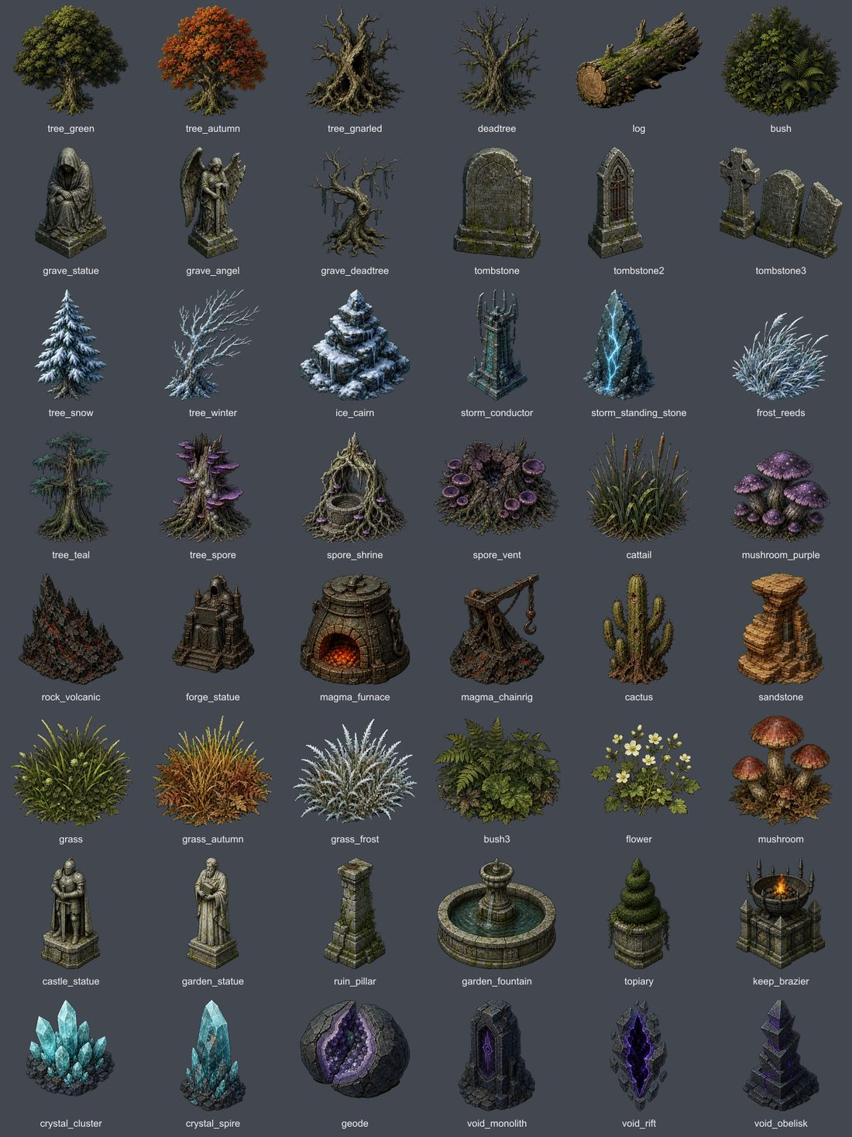
The generated 48-piece environment kit installed by this pass.

EXECUTIVE SUMMARY

Outcome
This was a full environment pass, not a shared-prop cleanup. The source art itself was regenerated, and every live terrain now receives an authored ecology composition, more natural clustering, grounded scale, animated foliage and corrected floor values.
Measure | Delivered
Generated terrain sprites | 48 total — 46 replacements, 2 new
Existing live terrains | 14 improved in place
New terrain concepts | 20 dev-panel placeholders
Chapter 3–7 assignments | 0

Design response
- Replaced low-detail trees, the giant gnarled tree, grave statuary, grass, reeds, mushrooms, elemental formations and other weak terrain pieces.
- Added one coherent landmark ecology per live terrain: groves, hollows, islets, courtyards, memorials, arrays, sanctums, shrines and breaches.
- Made ecology additive so a zone-authored forge, well or building no longer erases the biome’s environment identity.
- Extended restrained wind motion to grass, reeds, bushes, mushrooms, flowers and every tree family.
- Added authored display widths, bottom anchoring, seeded scale variation, natural clumps, multi-part collision, lights and fire audio.
- Raised forest, marsh, bog, basalt, void and spore ground values where silhouettes previously disappeared.

Scope boundary
The 20 new terrain IDs are tagged placeholder: true and visible in the dev panel / Future → Terrains gallery. None is referenced by Story.CHAPTERS, and no Chapter 3–7 zone was reassigned.

VISUAL QA

Before / after — selected live terrains
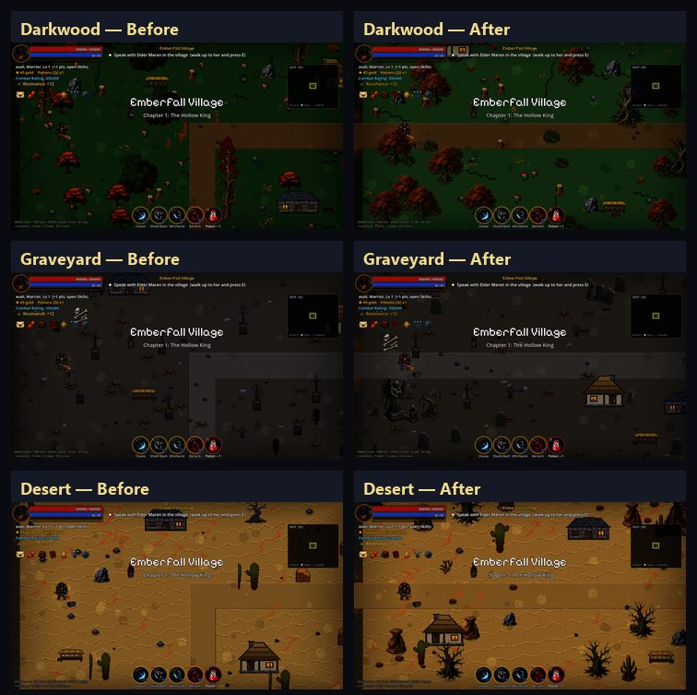
Darkwood, Graveyard and Desert: old source treatment on the left; installed pass on the right.

VISUAL QA

Before / after — selected live terrains
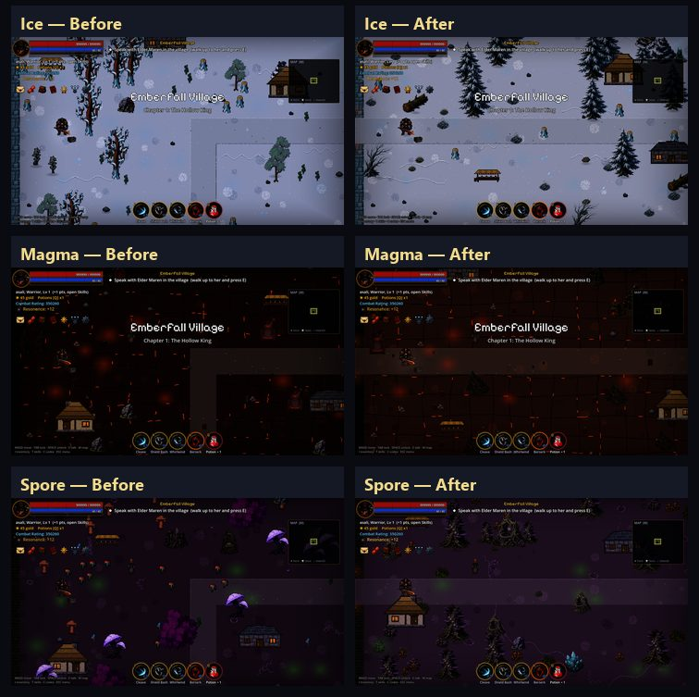
Ice, Magma and Spore: old source treatment on the left; installed pass on the right.

14 SHIPPING PROFILES

Live terrain environment passes
Terrain | Composition | Environment result
Village | village_grove | Civic grove: green tree, statue, shrubs and grass.
Darkwood | darkwood_hollow | Gnarled hollow backed by autumn growth, log and fungi.
Blightmarsh | marsh_islet | Wetland islet with teal tree, deadwood, reeds and vent.
Vargoth’s Keep | keep_courtyard | Sentinel statue, ruined pillars and lit braziers.
Scorched Wastes | magma_judgment | Forge idol, furnace, volcanic rock and chain rig.
Frozen Expanse | ice_waymarker | Snow pine, cairn, crystal and wind-bent reeds.
Restless Graveyard | grave_memorial | Angel, mourner, dead tree, headstone and pale grass.
Scorching Dunes | desert_hoodoo | Layered sandstone, cactus and dry grass habitat.
Poison Bog | bog_rootwell | Root well, shrine, purple fungi, reeds and vents.
Crystal Caverns | crystal_garden | Luminous spire, crystal beds and split geode.
Thunder Plains | storm_array | Conductor, paired stones and wind-tossed growth.
The Void | void_breach | Rift, monolith, obelisk and crystal beacon.
Sanctified Ruins | holy_sanctum | Fountain, angel, statue, pillar, flowers and warm light.
Spore Glade | spore_cathedral | Twin spore trees frame a shrine, vents and mushrooms.

DEV-PANEL PLACEHOLDERS

Twenty new terrain types
Each profile has its own floor material family, ecology, ambience, wall mapping and—where appropriate—an existing terrain mechanic. The plate below comes from the real in-game terrain switcher.
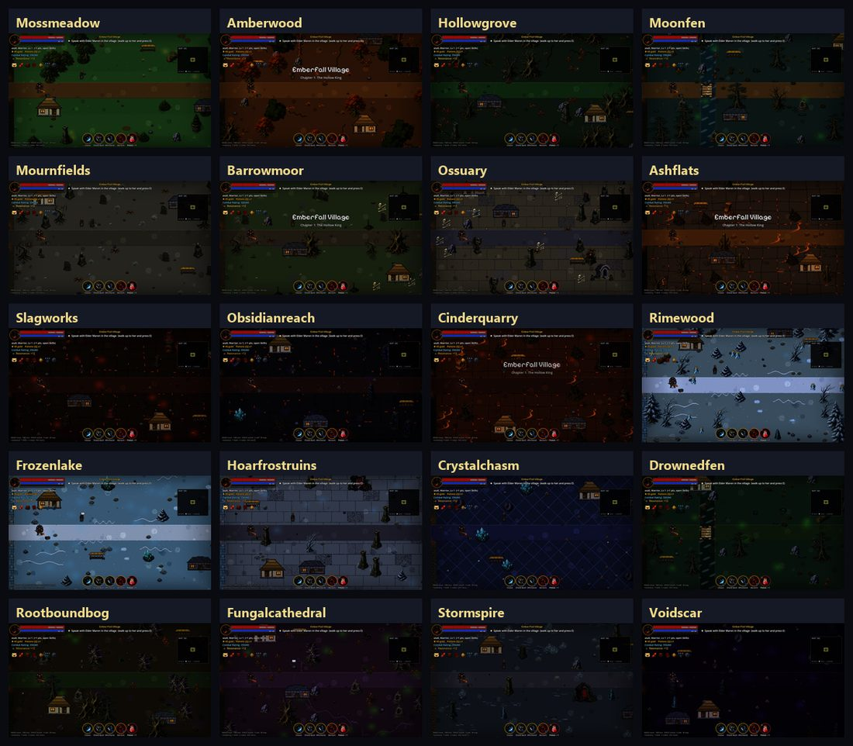
The 20 new terrain placeholders, kept separate from the 16 older placeholder profiles.

ALL 20 IDS

Placeholder register
ID | Display name | Mechanic | Identity
ph_mossmeadow | Mosslight Meadow | Heal | Moss and flowers
ph_amberwood | Amberwood | — | Amber canopy
ph_hollowgrove | Hollow Grove | Slow | Gnarled ruins
ph_moonfen | Moonmirror Fen | Poison + river | Reflective mire
ph_mournfields | Mourners’ Fields | Grave spawn | Open memorials
ph_barrowmoor | Weeping Barrowmoor | Slow | Wet burial moor
ph_ossuary | The Open Ossuary | — | Bone flagstones
ph_ashflats | Ashen Flats | Gust | Scorched windplain
ph_slagworks | The Slagworks | Lava + rain | Industrial slag
ph_obsidianreach | Obsidian Reach | Slow | Dark glass geology
ph_cinderquarry | Cinder Quarry | Lava | Excavated cinder
ph_rimewood | Rimewood | Ice | Frozen forest
ph_frozenlake | Frozen Mirror | Dense ice | Blue-ice field
ph_hoarfrostruins | Hoarfrost Ruins | Ice | Frozen civic ruins
ph_crystalchasm | Crystal Chasm | Shard + MP | Deep mineral field
ph_drownedfen | Drowned Fen | Poison + river | Flooded green soil
ph_rootboundbog | Rootbound Bog | Poison | Root-torn wetland
ph_fungalcathedral | Fungal Cathedral | Drift poison | Spore-tree nave
ph_stormspire | Stormspire Heights | Lightning | Conductors and stone
ph_voidscar | The Voidscar | Slow | Sparse void fracture

48 SPRITE CHANGES

Complete generated asset register
All files live under game/assets/sprites/ and are mirrored under mobile/game/assets/sprites/. Every item is a replacement except frost_reeds.png and ruin_pillar.png, which are new.

Woodland & trees
tree_green.png, tree_autumn.png, tree_gnarled.png, tree_teal.png, tree_snow.png, tree_winter.png, tree_spore.png, deadtree.png, grave_deadtree.png, log.png

Ground growth
bush.png, bush3.png, grass.png, grass_autumn.png, grass_frost.png, flower.png, mushroom.png, mushroom_purple.png, cattail.png, frost_reeds.png [NEW]

Grave, civic & ruin
tombstone.png, tombstone2.png, tombstone3.png, grave_statue.png, grave_angel.png, castle_statue.png, garden_statue.png, garden_fountain.png, topiary.png, ruin_pillar.png [NEW]

Magma & desert
cactus.png, sandstone.png, rock_volcanic.png, forge_statue.png, magma_chainrig.png, magma_furnace.png, keep_brazier.png

Ice, crystal & spore
ice_cairn.png, crystal_cluster.png, crystal_spire.png, geode.png, spore_shrine.png, spore_vent.png

Storm & void
storm_conductor.png, storm_standing_stone.png, void_monolith.png, void_obelisk.png, void_rift.png

Final transparent sprite contact sheet after chroma cleanup and binary-alpha verification.

CHANGE RECORD

Implementation and validation
Area | Change
terrains.gd | 20 placeholder definitions; 14 ecology keys; 14 multi-part landmark definitions; prop pools, ambience and wall mappings.
art.gd | 20 floor palettes, macro-ground routing and live-biome value correction.
balance.gd | Authored generated-scenery widths and scale variation.
game_world.gd | Bottom anchoring, width normalization, wind, clustering and additive ecology placement.
shot_audit.gd | Terrain-only and placeholder-only visual-audit switches.
assets/sprites | 48 generated PNGs; 46 replacements, 2 new.
mobile/game | Terrain pass mirrored; existing platform deltas preserved.

Validation results
Check | Result | Evidence
Godot asset import | PASS | All 48 assets reimported.
Art verification | PASS | 0 failures; 2 pre-existing direction warnings.
Desktop quick | PASS | 92 scripts + core suite.
Desktop full | PASS | AUTOTEST PASS; exit 0.
Mobile compile | PASS | 92 scripts.
Mobile quick | PASS | Core suite passed.
Live visual audit | PASS | 14/14 captured and reviewed.
Placeholder audit | PASS | 20 new concepts separately reviewed.

Sourcing and boundary confirmation
The raster art was generated specifically for Crownless with the built-in image-generation workflow, then locally extracted, chroma-cleaned and integrated. No third-party asset pack was added. Source atlases and QA sheets live under tmp/terrain_art_generation/ and are not runtime dependencies.
- No new placeholder ID appears in Chapters 3–7.
- No current chapter zone was reassigned.
- All new terrain concepts remain placeholder: true.
- Existing live terrains are improved in place.

Second-generation stylized terrain pass
Correction applied after visual review. The first placeholder implementation solved naming and palette coverage, but it did not yet solve material reuse or repeated silhouettes. This pass replaces that shortcut with complete authored room surfaces and genuine prop families, while pulling the art direction back from realism into Crownless' chunky pixel language.

Art-direction lock
- Strict 16-bit-inspired pixel art with crisp square edges, broad clusters and controlled 16?24 color palettes.
- No photographic texture, PBR response, painterly micro-detail, anti-aliased material noise or realistic lighting gradients.
- Nearest-neighbor processing from generated source through the 704 ? 416 room asset and at runtime for non-default room sizes.
- Room floors remain readable combat spaces: large calm traversal zones, restrained motifs and no collision-implying painted props.

Representative authored room surfaces
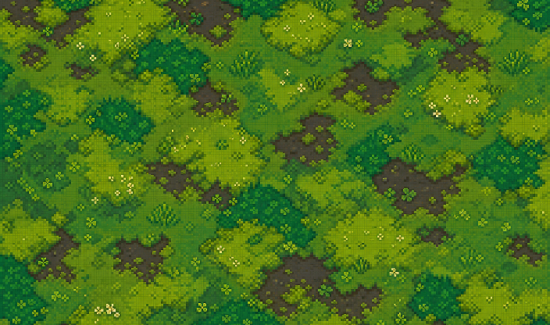  Mosslight Meadow | 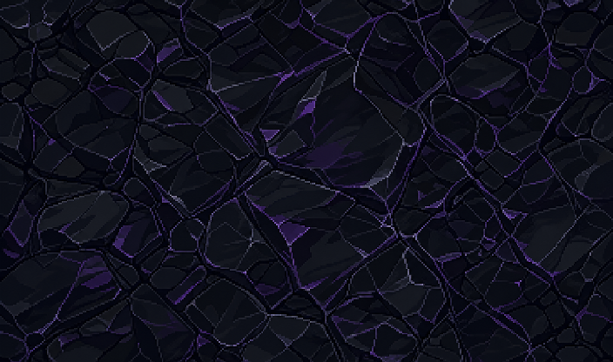  Obsidian Shelf
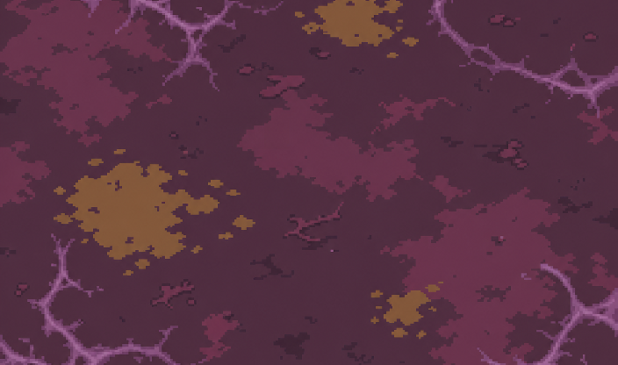  Fungal Humus | 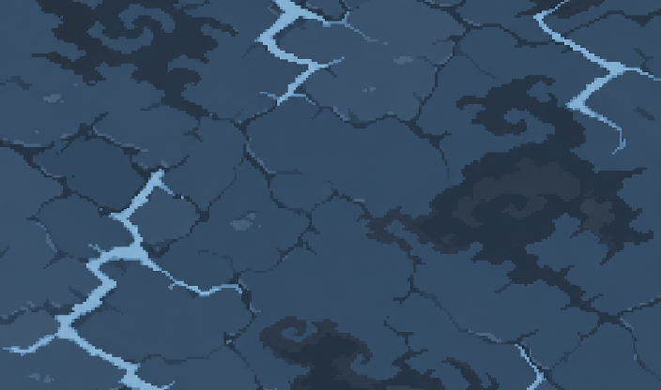  Stormstone

Twenty full-room terrain assets
Each placeholder now resolves to a dedicated non-repeating room image before dynamic paths, door arms, wall shadows and boundary walls are composited:
Terrain | Asset key | Terrain | Asset key
Mosslight Meadow | ground_room_mossmeadow.png | Amberleaf Wood | ground_room_amberleaf.png
Hollow Soil | ground_room_hollowsoil.png | Moonmire | ground_room_moonmire.png
Mournearth | ground_room_mournearth.png | Barrow Grass | ground_room_barrowgrass.png
Bone Floor | ground_room_bonefloor.png | Ash Soil | ground_room_ashsoil.png
Slagstone | ground_room_slagstone.png | Obsidian Shelf | ground_room_obsidian.png
Cinderstone | ground_room_cinderstone.png | Rimegrass | ground_room_rimegrass.png
Blue Ice | ground_room_blueice.png | Hoarfrost | ground_room_hoarfrost.png
Deep Crystal | ground_room_deepcrystal.png | Drowned Soil | ground_room_drownedsoil.png
Root Soil | ground_room_rootsoil.png | Fungal Humus | ground_room_fungalhumus.png
Stormstone | ground_room_stormstone.png | The Voidscar | ground_room_voidscar.png

Authored prop variation families
Twenty-seven variants were generated or rebuilt at high resolution. The runtime chooses a member deterministically per placement, then applies only subtle mirroring, lean and value drift. Collision and canonical world width remain family-based, so visual variety does not change gameplay footprint.
  Windswept green | 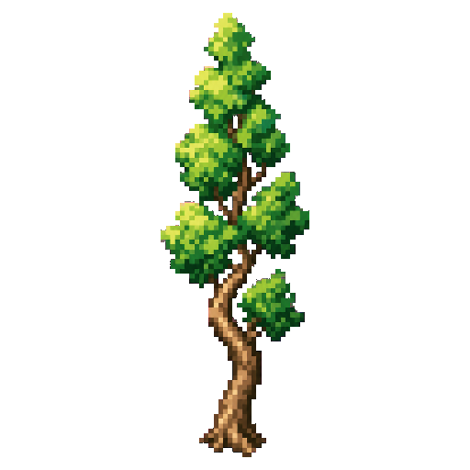  Tall green | 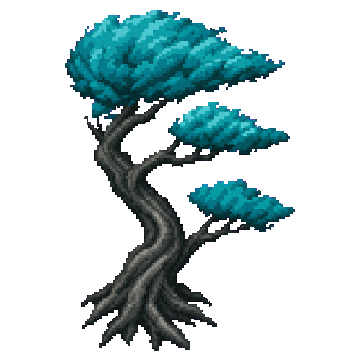  Teal fan
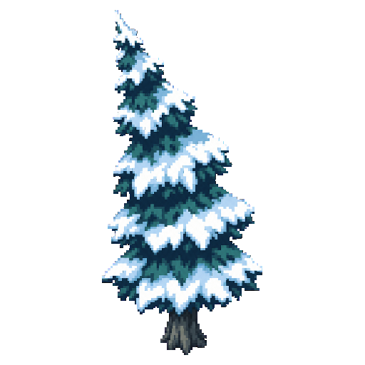  Snow fir | 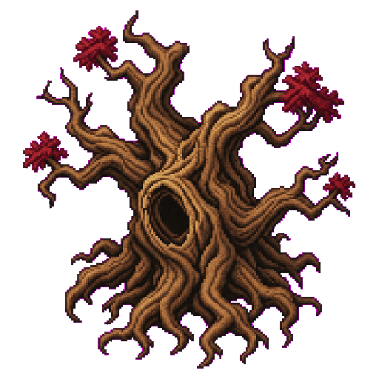  Ancient gnarled | 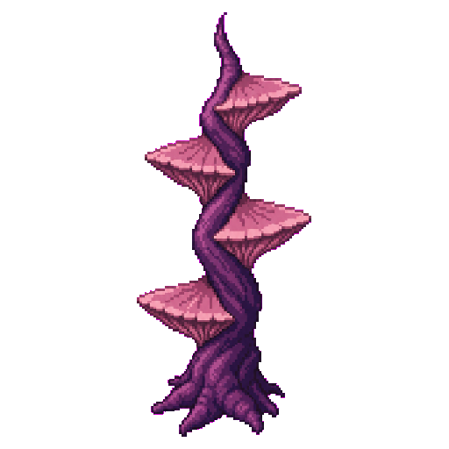  Fungal shelf

Variant register
Family | Installed authored members | Added/rebuilt
Green tree | tree_green2, tree_green3, tree_green4 | +3
Autumn tree | tree_autumn2, tree_autumn3 | +2
Teal tree | tree_teal2, tree_teal3 | +2
Snow tree | tree_snow2, tree_snow3 | +2
Winter tree | tree_winter2, tree_winter3 | +2
Spore tree | tree_spore2, tree_spore3 | +2
Gnarled tree | tree_gnarled2, tree_gnarled3 | +2
Dead tree | deadtree2, deadtree3 | +2
Bush | bush2 | +1
Grass | grass2, grass3 | +2
Cattail | cattail2, cattail3 | +2
Mushroom | mushroom2, mushroom3 | +2
Rock | rock2, rock3 | +2
Boulder | boulder2 | +1

Runtime and integration changes
- Art.ground now checks ground_room_<kind>.png first; authored surfaces replace only the base material, while roads, door-aware arms, walls and shadows remain dynamic.
- Terrains.PROP_VARIANT_GROUPS defines 15 canonical families. Prop selection is seeded from placement coordinates, so rooms rebuild identically.
- GameWorld renders every chosen member at its canonical family width and keeps collision family-based. New high-resolution rocks are capped at 64 px; boulders remain capped at 78 px.
- Twenty terrain IDs remain placeholder: true and are exposed for dev-panel repainting only. No Chapters 3?7 zone was reassigned.
- Desktop and mobile copies were updated together; the room loader preserves hard pixel edges with nearest-neighbor resizing.

Validation ? second-generation pass
Check | Result | Evidence
Godot import | PASS | 47 second-generation terrain/variation assets imported in desktop and mobile projects.
Art verifier | PASS | All 47 files pass; verifier now correctly exempts rectangular ground_room_* surfaces from animation-strip geometry.
Compile gate | PASS | Desktop: COMPILE OK (92 scripts). Mobile: COMPILE OK (92 scripts).
Quick suite | PASS | Desktop and mobile both reached AUTOTEST QUICK PASS.
Runtime audit | PASS | 20 authored room surfaces compose through Art.ground; all members of 15 prop families are reachable deterministically.

Generation prompt set
Built-in image generation mode: stylized-concept. New room surfaces were prompted as complete non-repeating top-down RPG floors in strict chunky 16-bit pixel art, limited 16?24 color palettes, broad calm clusters, crisp square edges, flat stepped lighting, no realism/PBR/photographic texture, and no painted collision props. Prop prompts used the same style with a uniform #ff00ff key background and required distinct silhouette, trunk/canopy or profile architecture per member.
Report revision: v2 ? 28 July 2026

KINETIC-PROP ADDENDUM

Living assets and logical boundaries
A fountain playtest exposed two systemic problems at once: the supposed water animation was four opaque blue squares, and a roughly 150-165 px stone basin was protected by only one 30 px-radius collider. This addendum records the direct asset replacements and the shared runtime rules added after that report.
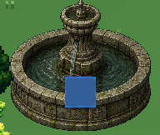
Reported defect: the old animated overlay was an opaque blue square.
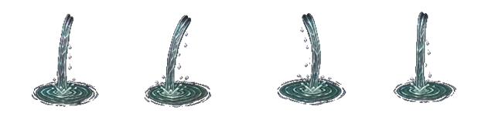
Replacement fountain_flow_anim.png: four transparent cascade and ripple frames.

Generated raster changes
Fountain water - replacement
fountain_flow.png; fountain_flow_anim.png. Transparent cascade, droplets and basin ripples; no rectangular field.
Spore vent - new
spore_puff.png; spore_puff_anim.png. A compact vent-local puff that gathers, blooms, rises and disperses.
Void rift - new
void_energy.png; void_energy_anim.png. Coiling inner energy and restrained crawling arcs inside the stable stone shell.
Storm conductor - new
storm_arcs.png; storm_arcs_anim.png. Four changing cyan-white connections between the upper metal prongs.

VISUAL QA

In-engine motion proof
The captures below are separated by 0.35 seconds in the real game. The authored shells remain stable while their active elements change frame.
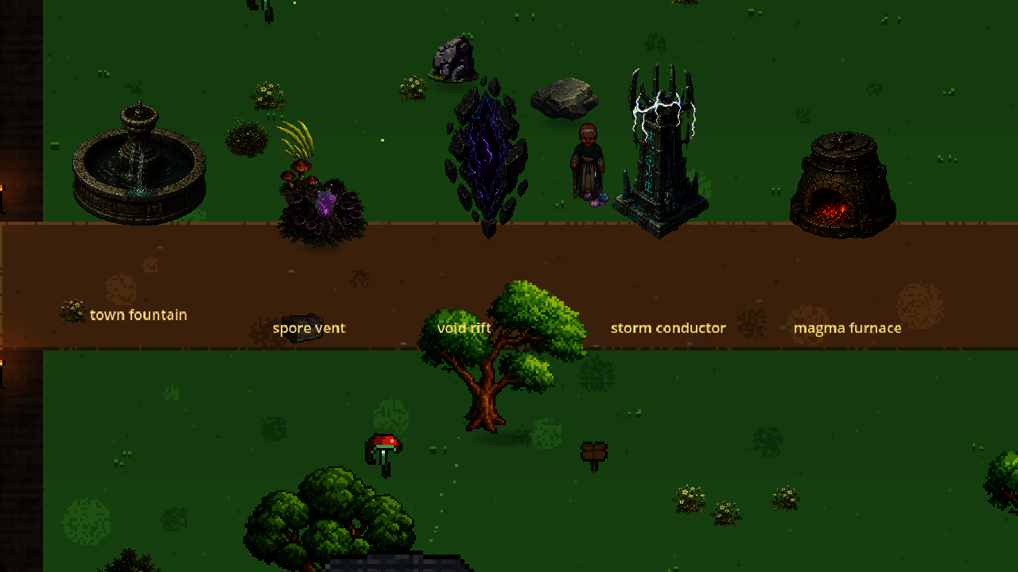
Frame A: fountain cascade/ripple, spore bloom, void energy and conductor arcs.
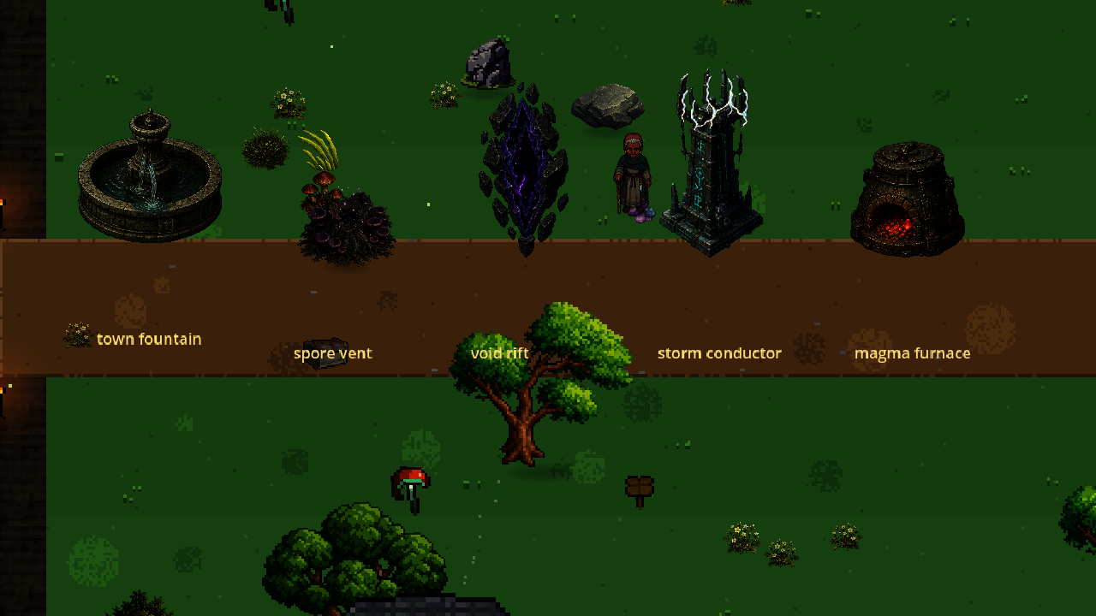
Frame B: the same staged assets after 0.35 seconds; active elements have advanced.

IMPLEMENTATION

Runtime and collision changes

Motion architecture
Terrains.PROP_MOTION now describes local active-element overlays. GameWorld attaches the overlay through the shared prop renderer, so the same motion appears when an asset is used as a scatter obstacle, accent, structure base or structure part. The stone, roots and metal do not wobble to fake animation; only water, spores, void energy, electricity or fire move. The previously static Waking Depths capital gate now reuses the local void-energy loop inside its authored arch; the Story and Crucible gates already had integrated animation strips.
- Furnace, cauldron and brazier families receive animated fire; standalone magma furnaces also emit animated ember smoke and positional fire audio.
- town_fountain, garden_fountain and holy_sanctum share the same transparent water behavior.
- Standalone magma furnaces, storm conductors, void rifts and spore shrines have explicit structure footprints rather than generic fallback strips.

Physical-footprint contract
The legacy obstacle path gave every non-tree prop the same 11 px circle, regardless of the visible asset. Balance.SCENERY_COLLIDER_RADIUS now authors the ground footprint by family. Large rocks, boulders, logs, shrines, furnaces, crystals, statues and similar solids block the space their bases occupy. Trees intentionally remain trunk-blocking so a canopy does not become an invisible wall.
- Fountains use two overlapping broad circles to approximate the full elliptical rim: 42 px lobes for town_fountain and 46 px lobes for the 165 px variants, offset toward the back edge.
- Representative large-solid regression checks reject a return to the legacy undersized radius.

Generation prompt and validation
Built-in image generation was used in stylized-concept mode with the existing regenerated prop as a style reference. Prompts required polished dark-fantasy game sprites with lightly pixel-stepped edges, muted palettes and no photorealism. Each four-frame source was isolated on a flat green or magenta chroma field, locally chroma-cleaned, alpha-validated and assembled as a horizontal square-frame strip.
- Godot import: PASS for all eight changed/new PNG files.
- Desktop compile: PASS (92 scripts).
- Desktop quick suite: PASS, including motion attachment, fountain footprint and large-solid collider regressions.
- Two-frame windowed visual review: PASS; no opaque blue rectangle remains.
Report addendum: kinetic props and collision - 28 July 2026

