CROWNLESS

Terrain & Environment
Asset Change Record
From static cutouts to authored, living environments
48 generated sprites • 14 live terrain passes • 20 new placeholders
28 July 2026

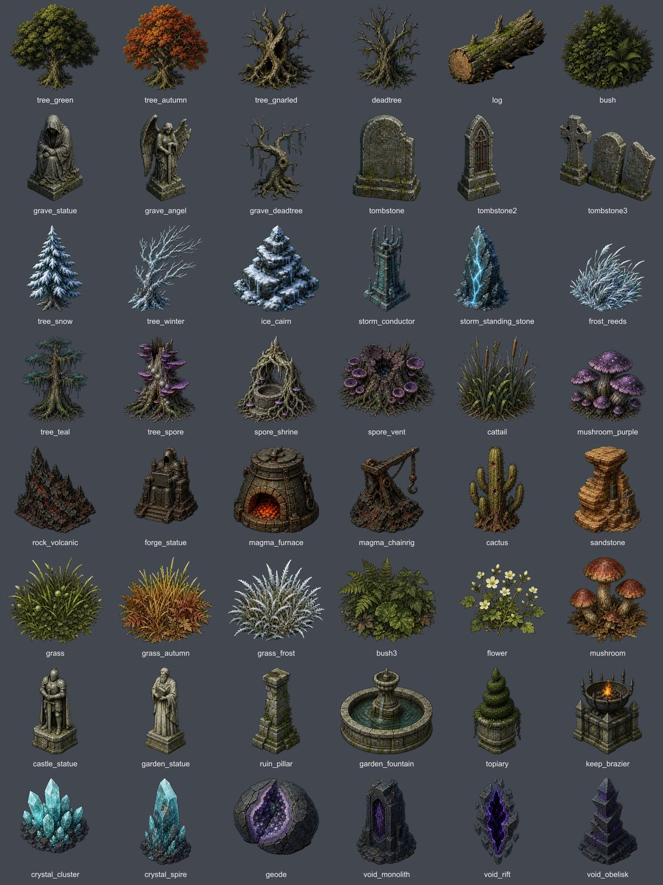
The generated 48-piece environment kit installed by this pass.

EXECUTIVE SUMMARY

Outcome
This was a full environment pass, not a shared-prop cleanup. The source art itself was regenerated, and every live terrain now receives an authored ecology composition, more natural clustering, grounded scale, animated foliage and corrected floor values.
Measure | Delivered
Generated terrain sprites | 48 total — 46 replacements, 2 new
Existing live terrains | 14 improved in place
New terrain concepts | 20 dev-panel placeholders
Chapter 3–7 assignments | 0

Design response
- Replaced low-detail trees, the giant gnarled tree, grave statuary, grass, reeds, mushrooms, elemental formations and other weak terrain pieces.
- Added one coherent landmark ecology per live terrain: groves, hollows, islets, courtyards, memorials, arrays, sanctums, shrines and breaches.
- Made ecology additive so a zone-authored forge, well or building no longer erases the biome’s environment identity.
- Extended restrained wind motion to grass, reeds, bushes, mushrooms, flowers and every tree family.
- Added authored display widths, bottom anchoring, seeded scale variation, natural clumps, multi-part collision, lights and fire audio.
- Raised forest, marsh, bog, basalt, void and spore ground values where silhouettes previously disappeared.

Scope boundary
The 20 new terrain IDs are tagged placeholder: true and visible in the dev panel / Future → Terrains gallery. None is referenced by Story.CHAPTERS, and no Chapter 3–7 zone was reassigned.

VISUAL QA

Before / after — selected live terrains
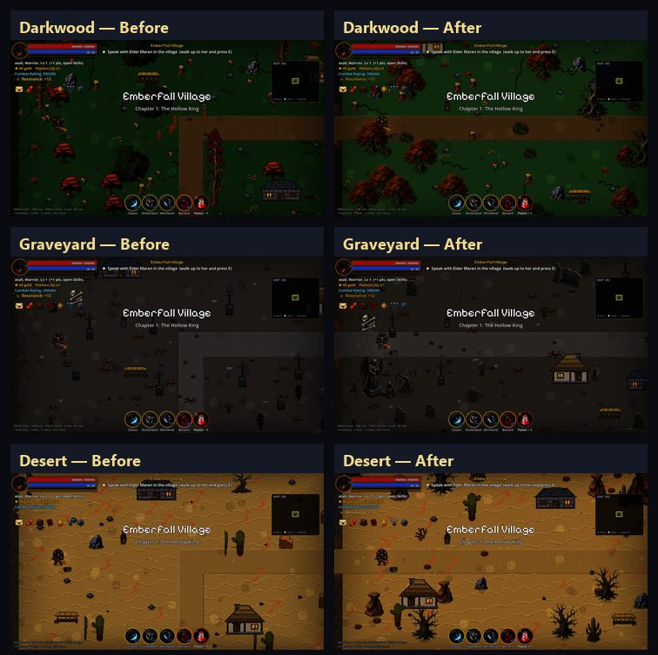
Darkwood, Graveyard and Desert: old source treatment on the left; installed pass on the right.

VISUAL QA

Before / after — selected live terrains
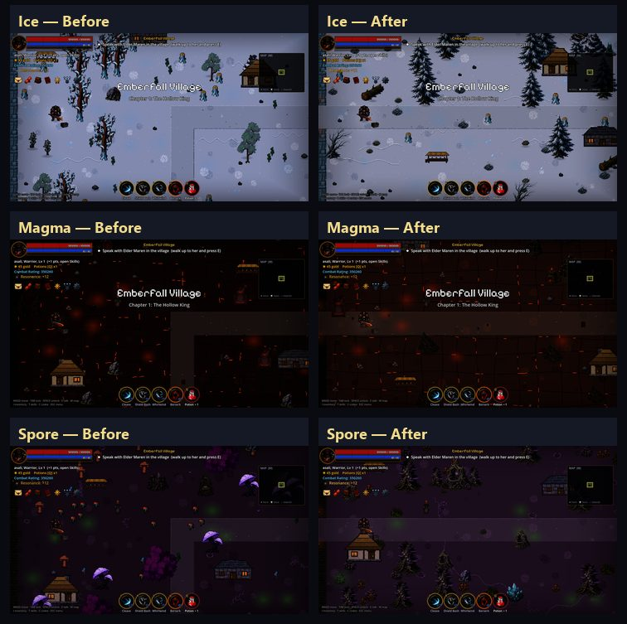
Ice, Magma and Spore: old source treatment on the left; installed pass on the right.

14 SHIPPING PROFILES

Live terrain environment passes
Terrain | Composition | Environment result
Village | village_grove | Civic grove: green tree, statue, shrubs and grass.
Darkwood | darkwood_hollow | Gnarled hollow backed by autumn growth, log and fungi.
Blightmarsh | marsh_islet | Wetland islet with teal tree, deadwood, reeds and vent.
Vargoth’s Keep | keep_courtyard | Sentinel statue, ruined pillars and lit braziers.
Scorched Wastes | magma_judgment | Forge idol, furnace, volcanic rock and chain rig.
Frozen Expanse | ice_waymarker | Snow pine, cairn, crystal and wind-bent reeds.
Restless Graveyard | grave_memorial | Angel, mourner, dead tree, headstone and pale grass.
Scorching Dunes | desert_hoodoo | Layered sandstone, cactus and dry grass habitat.
Poison Bog | bog_rootwell | Root well, shrine, purple fungi, reeds and vents.
Crystal Caverns | crystal_garden | Luminous spire, crystal beds and split geode.
Thunder Plains | storm_array | Conductor, paired stones and wind-tossed growth.
The Void | void_breach | Rift, monolith, obelisk and crystal beacon.
Sanctified Ruins | holy_sanctum | Fountain, angel, statue, pillar, flowers and warm light.
Spore Glade | spore_cathedral | Twin spore trees frame a shrine, vents and mushrooms.

DEV-PANEL PLACEHOLDERS

Twenty new terrain types
Each profile has its own floor material family, ecology, ambience, wall mapping and—where appropriate—an existing terrain mechanic. The plate below comes from the real in-game terrain switcher.
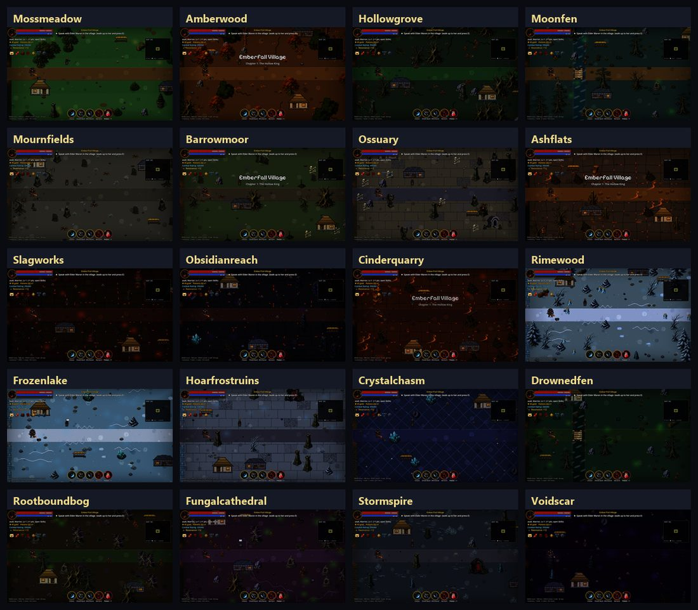
The 20 new terrain placeholders, kept separate from the 16 older placeholder profiles.

ALL 20 IDS

Placeholder register
ID | Display name | Mechanic | Identity
ph_mossmeadow | Mosslight Meadow | Heal | Moss and flowers
ph_amberwood | Amberwood | — | Amber canopy
ph_hollowgrove | Hollow Grove | Slow | Gnarled ruins
ph_moonfen | Moonmirror Fen | Poison + river | Reflective mire
ph_mournfields | Mourners’ Fields | Grave spawn | Open memorials
ph_barrowmoor | Weeping Barrowmoor | Slow | Wet burial moor
ph_ossuary | The Open Ossuary | — | Bone flagstones
ph_ashflats | Ashen Flats | Gust | Scorched windplain
ph_slagworks | The Slagworks | Lava + rain | Industrial slag
ph_obsidianreach | Obsidian Reach | Slow | Dark glass geology
ph_cinderquarry | Cinder Quarry | Lava | Excavated cinder
ph_rimewood | Rimewood | Ice | Frozen forest
ph_frozenlake | Frozen Mirror | Dense ice | Blue-ice field
ph_hoarfrostruins | Hoarfrost Ruins | Ice | Frozen civic ruins
ph_crystalchasm | Crystal Chasm | Shard + MP | Deep mineral field
ph_drownedfen | Drowned Fen | Poison + river | Flooded green soil
ph_rootboundbog | Rootbound Bog | Poison | Root-torn wetland
ph_fungalcathedral | Fungal Cathedral | Drift poison | Spore-tree nave
ph_stormspire | Stormspire Heights | Lightning | Conductors and stone
ph_voidscar | The Voidscar | Slow | Sparse void fracture

48 SPRITE CHANGES

Complete generated asset register
All files live under game/assets/sprites/ and are mirrored under mobile/game/assets/sprites/. Every item is a replacement except frost_reeds.png and ruin_pillar.png, which are new.

Woodland & trees
tree_green.png, tree_autumn.png, tree_gnarled.png, tree_teal.png, tree_snow.png, tree_winter.png, tree_spore.png, deadtree.png, grave_deadtree.png, log.png

Ground growth
bush.png, bush3.png, grass.png, grass_autumn.png, grass_frost.png, flower.png, mushroom.png, mushroom_purple.png, cattail.png, frost_reeds.png [NEW]

Grave, civic & ruin
tombstone.png, tombstone2.png, tombstone3.png, grave_statue.png, grave_angel.png, castle_statue.png, garden_statue.png, garden_fountain.png, topiary.png, ruin_pillar.png [NEW]

Magma & desert
cactus.png, sandstone.png, rock_volcanic.png, forge_statue.png, magma_chainrig.png, magma_furnace.png, keep_brazier.png

Ice, crystal & spore
ice_cairn.png, crystal_cluster.png, crystal_spire.png, geode.png, spore_shrine.png, spore_vent.png

Storm & void
storm_conductor.png, storm_standing_stone.png, void_monolith.png, void_obelisk.png, void_rift.png

Final transparent sprite contact sheet after chroma cleanup and binary-alpha verification.

CHANGE RECORD

Implementation and validation
Area | Change
terrains.gd | 20 placeholder definitions; 14 ecology keys; 14 multi-part landmark definitions; prop pools, ambience and wall mappings.
art.gd | 20 floor palettes, macro-ground routing and live-biome value correction.
balance.gd | Authored generated-scenery widths and scale variation.
game_world.gd | Bottom anchoring, width normalization, wind, clustering and additive ecology placement.
shot_audit.gd | Terrain-only and placeholder-only visual-audit switches.
assets/sprites | 48 generated PNGs; 46 replacements, 2 new.
mobile/game | Terrain pass mirrored; existing platform deltas preserved.

Validation results
Check | Result | Evidence
Godot asset import | PASS | All 48 assets reimported.
Art verification | PASS | 0 failures; 2 pre-existing direction warnings.
Desktop quick | PASS | 92 scripts + core suite.
Desktop full | PASS | AUTOTEST PASS; exit 0.
Mobile compile | PASS | 92 scripts.
Mobile quick | PASS | Core suite passed.
Live visual audit | PASS | 14/14 captured and reviewed.
Placeholder audit | PASS | 20 new concepts separately reviewed.

Sourcing and boundary confirmation
The raster art was generated specifically for Crownless with the built-in image-generation workflow, then locally extracted, chroma-cleaned and integrated. No third-party asset pack was added. Source atlases and QA sheets live under tmp/terrain_art_generation/ and are not runtime dependencies.
- No new placeholder ID appears in Chapters 3–7.
- No current chapter zone was reassigned.
- All new terrain concepts remain placeholder: true.
- Existing live terrains are improved in place.

