UK Trial-Based Economic Evaluation: AMIGOS
Preliminary exploratory analysis — geriatrician-led case management vs. usual care

1. Overview
This is a preliminary trial-based economic evaluation using publicly available patient-level data from the AMIGOS randomised controlled trial, which compared a geriatrician-led case management intervention against usual care for older people discharged from an acute medical unit. The evaluation follows patients for 90 days post-discharge, estimating incremental cost, incremental quality-adjusted life years (QALYs), and the resulting incremental cost-effectiveness ratio (ICER).
This is an independent, self-directed replication exercise for methods practice, not the original trial publication.

2. Methods summary
EQ-5D-3L dimensions (mobility, self-care, usual activities, pain/discomfort, anxiety/depression) recorded at baseline and 90-day follow-up were scored using the UK time-trade-off value set. QALYs were calculated via the area-under-the-curve method: a trapezoid between baseline and follow-up utility for patients alive at follow-up, and a linear decline from baseline utility to zero at date of death for patients who died during the study.
Resource use was costed component-by-component: inpatient/daycase episodes using HRG-level unit costs from the NHS National Schedule of Reference Costs 2011-12 (the last year using the HRG4 currency, matching the trial period); outpatient attendances using treatment-function-code-level attendance tariffs from the same source; social care and primary/tertiary care costs as recorded directly in the dataset; and intervention delivery time costed at a fixed hourly wage rate. All costs and QALYs were aggregated to one total per patient and analysed on a complete-case basis.
Uncertainty was quantified using a non-parametric bootstrap (2,000 replicates, resampled within each arm), producing a cost-effectiveness plane and a cost-effectiveness acceptability curve (CEAC) across willingness-to-pay thresholds from £0 to £50,000 per QALY.

3. Baseline characteristics
Arm | n | Mean age | % female | Mean Charlson score | Mean baseline utility
Usual care | 212 | 82.7 | 64.2% | 1.56 | 0.499
Geriatrician intervention | 205 | 82.9 | 60.0% | 1.55 | 0.525
Full randomised sample (n = 417). Arms are reasonably balanced on age and comorbidity; baseline EQ-5D utility is modestly higher in the intervention arm (0.525 vs 0.499), which is why an adjusted analysis is reported alongside the unadjusted one.

4. Results

4.1 Cost and QALY summary (complete cases)
Arm | n | Mean total cost | Mean QALY (90 days)
Usual care | 127 | £3,755.57 | 0.1149
Geriatrician intervention | 127 | £5,149.00 | 0.1192
Only 254 of the 417 randomised patients (61%) had complete cost and QALY data and are included here — see Limitations (Section 5).

4.2 Incremental cost-effectiveness
Analysis | Incremental cost | Incremental QALY | ICER (£/QALY)
Unadjusted (mean difference) | £1,393.43 | 0.0042 | £328,856
Adjusted (regression, baseline utility) | £1,403.96 | 0.0024 | £581,326
In both the unadjusted and baseline-adjusted analyses, the geriatrician intervention costs more than usual care (~£1,390-1,400 per patient over 90 days) for a very small and imprecisely estimated QALY gain. The resulting ICERs (£329k-£581k per QALY) are far above conventional UK cost-effectiveness thresholds (£20,000-£30,000/QALY).

4.3 Cost-effectiveness plane
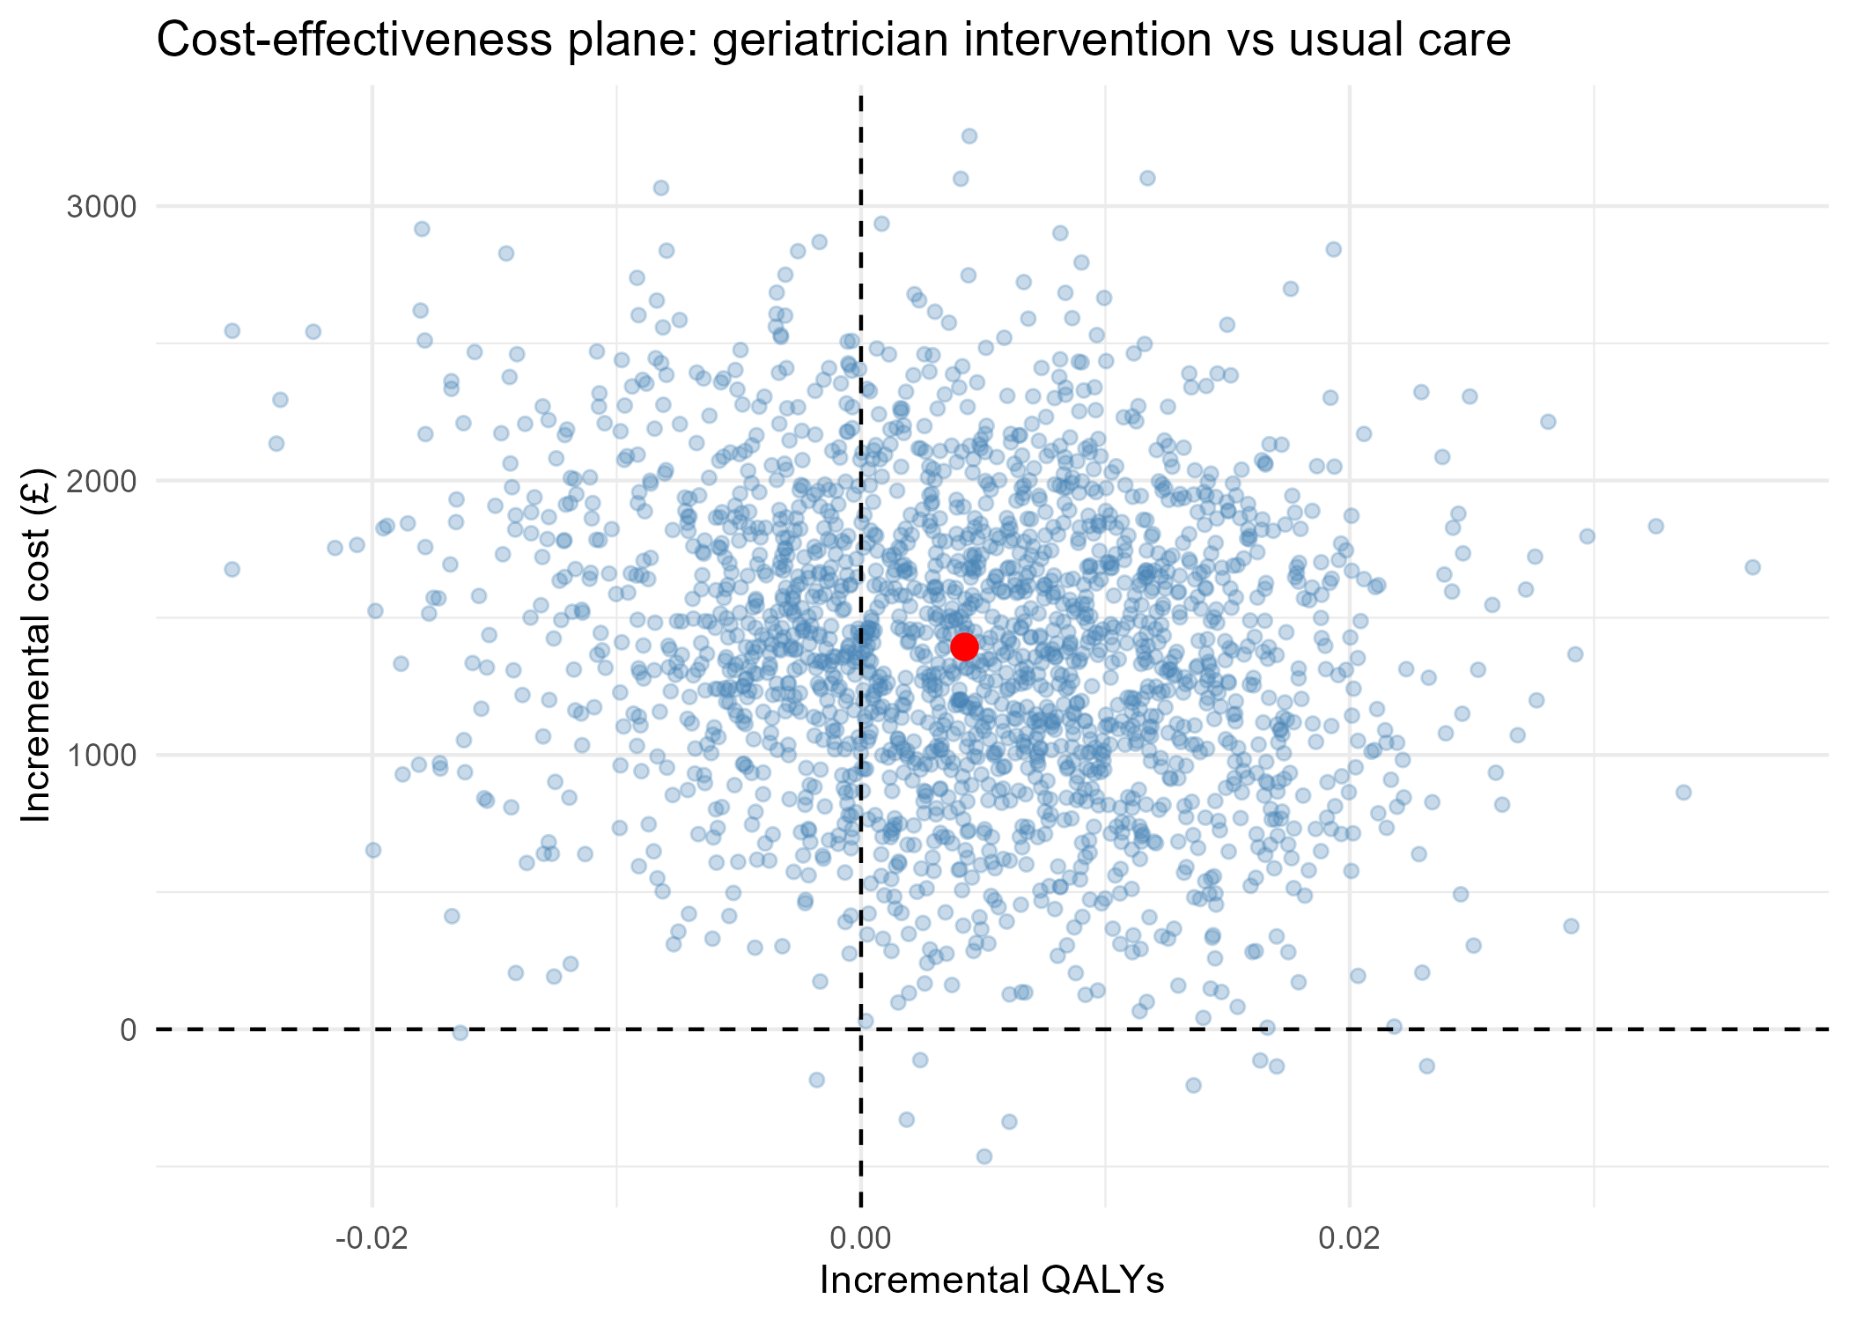
2,000 bootstrap replicates (resampled within arm). Red point = base-case estimate. Nearly all replicates fall with incremental cost above £0, while incremental QALYs straddle zero — the intervention reliably costs more, with an uncertain, small QALY effect.

4.4 Cost-effectiveness acceptability curve
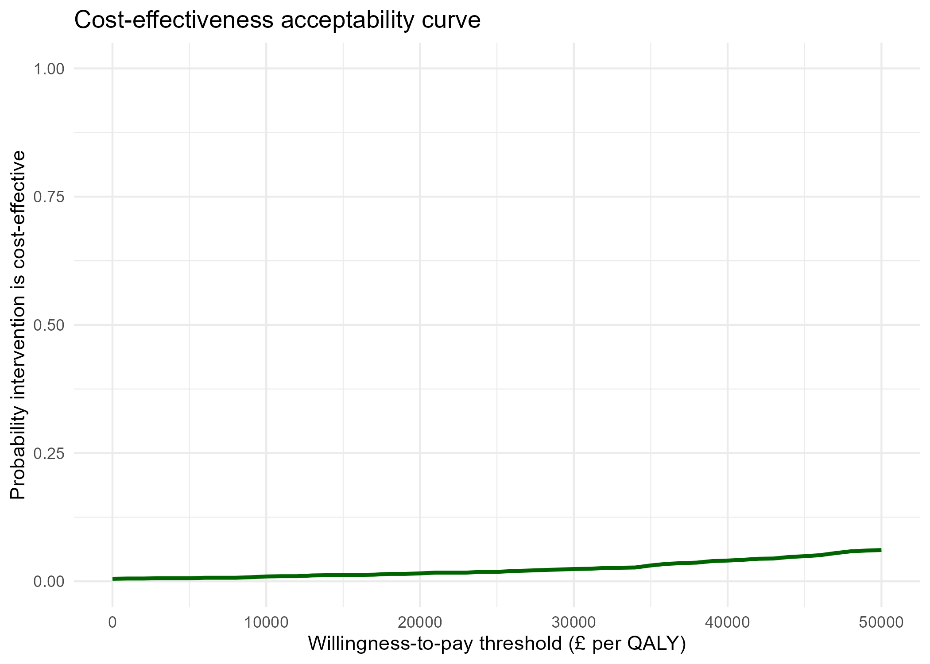
Probability the intervention is cost-effective stays below ~6% across the entire £0-£50,000/QALY range — consistent with the ICERs in Section 4.2.

5. Limitations
• Sample size for the cost/QALY analysis (n = 254) is substantially smaller than the randomised sample (n = 417) due to complete-case handling of missing follow-up EQ-5D data. This is a material limitation: multiple imputation would be the standard next step rather than complete-case analysis, and the dropped patients should be checked for systematic differences (e.g. frailty, mortality) that could bias the estimate.
• QALYs for patients who died during follow-up assume a linear decline in utility from the baseline value to zero at date of death — a standard simplifying assumption, but one that was not varied in a sensitivity analysis here.
• Costs are priced using the NHS National Schedule of Reference Costs 2011-12, matching the trial's HRG4-era codes; two HRG codes (affecting ~2.7% of inpatient episodes) could not be matched and are costed as £0.
• The intervention hourly wage rate is applied as a single fixed value across all patients rather than using patient-level variation in delivery time and grade of staff.
• This analysis has not been adjusted for multiplicity, clustering, or other trial design features beyond a single baseline-utility covariate.

6. Interpretation
On this preliminary, complete-case analysis, geriatrician-led case management does not appear cost-effective relative to usual care at conventional UK thresholds over a 90-day horizon: it costs more with a QALY gain too small and uncertain to justify the additional expenditure. This should be treated as an exploratory finding pending the data-completeness and imputation work noted above, not a definitive replication of the original trial's economic evaluation.

