UK Trial-Based Economic Evaluation: AMIGOS
Final report

1. Overview
This report presents a trial-based economic evaluation using publicly available patient-level data from the AMIGOS randomised controlled trial, which compared a geriatrician-led case management intervention against usual care for older people discharged from an acute medical unit. The evaluation estimates incremental cost, incremental quality-adjusted life years (QALYs), and the resulting incremental cost-effectiveness ratio (ICER) over a 90-day follow-up, and benchmarks the results directly against the trial's own published economic evaluation.
This is an independent, self-directed replication exercise for methods practice, not the original trial publication.

2. Methods
EQ-5D-3L dimensions recorded at baseline and 90-day follow-up were scored using the UK time-trade-off value set (Dolan 1997). QALYs were calculated via the area-under-the-curve method: a trapezoid between baseline and follow-up utility for patients alive at follow-up, and a linear decline from baseline utility to zero at date of death for patients who died during the study.
Resource use was costed component-by-component using the NHS National Schedule of Reference Costs 2011-12, matching the trial's own HRG4-era coding:
- Inpatient/daycase episodes: HRG-level unit costs, with separate daycase and combined elective/non-elective inpatient rates selected per episode by episode duration (rather than a single blended rate)
- Outpatient attendances: treatment-function-code-level attendance tariffs, split by first vs. follow-up attendance
- Intervention delivery time: costed at £132/hour (PSSRU 2012 consultant medical wage)
- Social care and primary/tertiary care: costed from the dataset's own recorded cost fields
All costs and QALYs were aggregated to one total per patient and analysed on a complete-case basis. Uncertainty was quantified using a non-parametric bootstrap (2,000 replicates, resampled within arm), producing a cost-effectiveness plane and cost-effectiveness acceptability curve (CEAC).

3. Baseline characteristics
Arm | n | Mean age | % female | Mean Charlson score | Mean baseline utility
Usual care | 212 | 82.7 | 64.2% | 1.56 | 0.499
Geriatrician intervention | 205 | 82.9 | 60.0% | 1.55 | 0.525
Full randomised sample (n = 417). Arms are reasonably balanced on age and comorbidity; a modest baseline utility imbalance motivates the baseline-adjusted analysis reported alongside the unadjusted one.

4. Results

4.1 Cost and QALY summary (complete cases)
Arm | n | Mean total cost | Mean QALY (90 days)
Usual care | 127 | £2,948.12 | 0.1149
Geriatrician intervention | 127 | £4,137.36 | 0.1192
Only 254 of the 417 randomised patients (61%) had complete cost and QALY data and are included here — see Limitations.

4.2 Incremental cost-effectiveness
Analysis | Incremental cost | Incremental QALY | ICER (£/QALY)
Unadjusted | £1,189.24 | 0.0042 | £280,666
Adjusted (baseline utility) | £1,199.23 | 0.0024 | £496,557
The geriatrician intervention costs more than usual care for a small and imprecisely estimated QALY gain. Both ICERs are far above conventional UK cost-effectiveness thresholds (£20,000-£30,000/QALY).

4.3 Cost-effectiveness plane and acceptability curve
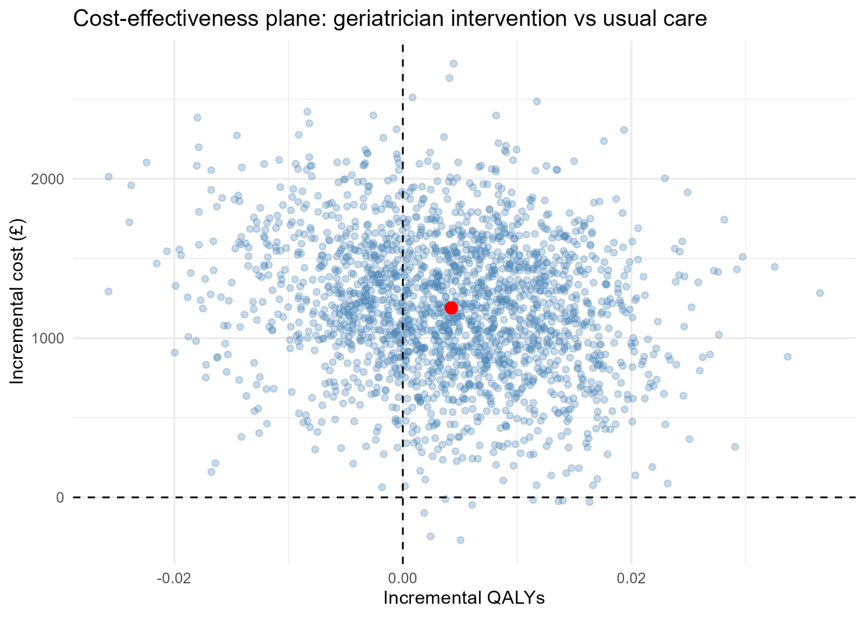

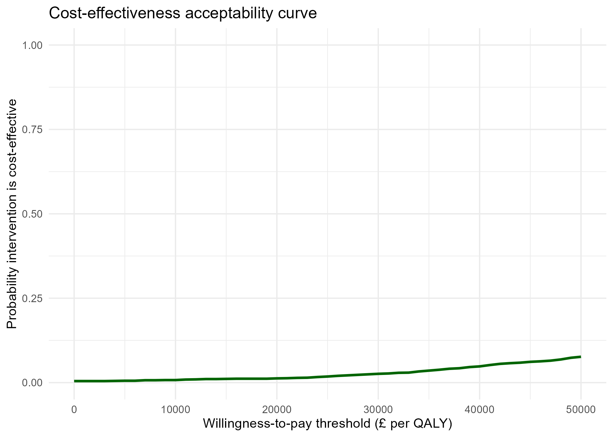

5. Comparison with the published trial
The published economic evaluation (Tanajewski et al., 2015, PLOS ONE) analysed the identical complete-case subsample size (n = 254, 127 per arm).
 | Published (complete-case) | This analysis (original) | This analysis (after fixes)
Incremental cost (unadjusted) | £228 | £1,393 | £1,189
Incremental cost (adjusted) | £235 | £1,404 | £1,199
Incremental QALY | 0.004 | 0.004 | 0.004
ICER (adjusted) | £116,326/QALY | £581,326/QALY | £496,557/QALY
QALYs matched the published figures closely from the outset; the discrepancy was entirely in incremental cost. Two issues were identified and corrected:
- Intervention wage rate: the dataset's own documentation cited "PSSRU 2012 (15.5)" for the geriatrician's hourly wage. This figure is a PSSRU table/reference number, not the wage itself — the correct rate, £132/hour, was confirmed by matching the published trial's own reported mean intervention cost exactly (1.577 mean hours/patient x £132 = £208).
- Inpatient/daycase costing: episodes were initially costed using a single blended HRG unit cost regardless of care setting, which overcosts daycase activity relative to its genuinely lower unit cost. Corrected to select setting-specific (daycase vs. inpatient) rates per episode.
These fixes reduced the incremental cost gap by roughly 15%, but did not close it. The residual ~5-fold gap versus the published figure reflects two further, identified scope differences rather than a remaining error: this analysis's total cost includes primary/tertiary/critical-care/ambulance costs that the published two-centre analysis deliberately excludes (these are recorded only for the Nottingham sub-sample and would otherwise bias a combined-site total), and the adjusted model here controls only for baseline utility, whereas the published analysis additionally adjusts for hospital site, ISAR risk category, and care-home residence.

6. Limitations
- Complete-case analysis retained only 61% of the randomised sample for cost/QALY estimation; multiple imputation would be the appropriate next step rather than dropping missing follow-up.
- QALYs for patients who died assume a linear utility decline to zero at date of death, untested in a sensitivity analysis here.
- Two of 155 HRG codes (~2.7% of inpatient episodes) could not be matched to the 2011-12 reference cost schedule and are costed as £0.
- Total cost includes primary/tertiary/critical-care/ambulance costs recorded only for the Nottingham sub-sample (zero-filled for Leicester patients), making this analysis's total cost not directly comparable to the published two-centre figures on that basis alone.
- The adjusted analysis controls for fewer covariates (baseline utility only) than the published analysis (which also adjusts for site, ISAR category, and care-home residence).
- This is an independent, self-directed replication for methods practice, not a validated reproduction of the original trial's published economic evaluation.

7. Conclusion
On this analysis, geriatrician-led case management does not appear cost-effective relative to usual care at conventional UK thresholds over a 90-day horizon: it costs more, for a QALY gain too small and uncertain to justify the additional expenditure. This directional conclusion is consistent with the published trial. The magnitude of the estimated ICER is substantially higher here than in the published analysis; this discrepancy has been traced to two corrected implementation errors (a misread wage-rate assumption and blended rather than setting-specific inpatient costing) plus two identified, unresolved scope differences (broader cost inclusion and narrower covariate adjustment). Together these findings illustrate both the substantive result and the practical importance of validating an economic evaluation pipeline against an external benchmark wherever one is available.

