Project: |  | OpenCRG® |  |  |  | Document No. | Issue:
Title: |  | User Manual |  |  |  | VI2009.050 | M
 | Date: |  | November 8, 2026 |  |  | no. of pages: | 72
 | Issuing Party: |  | VIRES Simulationstechnologie GmbH
 | Author: |  | various
 | Distribution List: |  | public

OpenCRG® Licensing

The following license terms apply to this document, the OpenCRG tools and libraries

Copyright 2017 VIRES Simulationstechnologie GmbH

Licensed under the Apache License, Version 2.0 (the "License");
you may not use this file except in compliance with the License.
You may obtain a copy of the License at

http://www.apache.org/licenses/LICENSE-2.0

Unless required by applicable law or agreed to in writing, software
distributed under the License is distributed on an "AS IS" BASIS,
WITHOUT WARRANTIES OR CONDITIONS OF ANY KIND, either express or implied.
See the License for the specific language governing permissions and
limitations under the License.
Printed in Germany
June 2017
Table of Contents

Introduction 5
1.1 Scope 5
1.2 The OpenCRG® C-API 5
1.2.1 Platforms 5
1.2.2 Status 5
1.3 The OpenCRG® Matlab Tools 5
1.3.1 Status 5
1.4 Point of Contact 6
2 OpenCRG® 7
2.1 Motivation 7
2.2 The CRG Idea 7
2.3 Reference Line Data Representation 7
2.3.1 Reference Line Path Integration 7
3 OpenCRG® Data Files 8
3.1 The Basics 8
3.2 Comments 9
3.3 The Sections in Detail 9
3.3.1 Header Information 9
3.3.2 Road Parameters 10
3.3.3 Data Definition 11
3.3.4 Modifiers and Options 12
3.3.5 File Reference 12
3.3.6 Road Data 13
3.4 Sample Files 13
4 The OpenCRG® C-API 14
4.1 Getting Started 14
4.1.1 Downloading the Software Package 14
4.1.2 Release Notes 14
4.1.3 Contents of the Package 15
4.1.4 Compiling the Package 15
4.1.4.1 Method A – makefiles 15
4.1.4.2 Method B – script 16
4.1.4.3 Method C – command line 16
4.1.5 Basic Tests 16
4.2 The Base Library 17
4.2.1 Overview 17
4.2.2 Include Files 17
4.2.3 Source Files 17
4.2.4 Working with Data Files 18
4.2.4.1 Simple Use Case 18
4.2.4.2 Data Sets and Contact Points 18
4.2.4.3 Multi-Thread Applications 18
4.2.4.4 Modifiers and Options 18
4.2.4.5 Sequence of Actions 19
4.2.5 Evaluating Data 20
4.2.6 Message Printing 20
4.2.7 Modifiers 21
4.2.7.1 Default Modifiers 21
4.2.7.2 Transforming Data by Reference Point 23
4.2.7.3 Transforming Data by Offset Position 24
4.2.7.4 Scaling of Elevation Data 25
4.2.7.5 Scaling of Data Set Extents 27
4.2.7.6 Scaling of Curvature 28
4.2.7.7 NaN handling in v Direction 29
4.2.8 Options 30
4.2.8.1 Border Modes in u and v Directions 30
4.2.8.2 Smoothing Zones 37
4.2.8.3 Continuation of Reference Line 38
4.2.8.4 Curvature Evaluation 39
4.2.8.5 History Manipulation 39
4.2.8.6 History Search Criteria 39
4.3 The Tools 40
4.3.1 Overview 40
4.3.2 Simple 40
4.3.3 Reader 40
4.3.4 Co-ordinate conversion x/y and u/v 40
4.3.5 Evaluation of z Data 41
4.3.6 Application of Options and Modifiers 41
5 The OpenCRG® Matlab Tools 42
5.1 Getting Started 42
5.1.1 Downloading the Software Package 42
5.1.2 Release Notes 42
5.1.3 Contents of the Package 42
5.1.4 Working with OpenCRG® Matlab Tools 43
5.1.4.1 Initialization 43
5.1.4.2 Getting Help 43
5.1.5 Formatting M-File Comments 43
5.1.6 Demos 43
5.1.7 Basic Tests 43
5.1.8 Publishing script files 43
5.1.8.1 Extensible stylesheet language (xsl) 43
5.1.8.2 Publish to pdf ( Linux ) 44
5.1.8.3 Hint on memory limitations 44
5.2 The Base Library 45
5.2.1 Overview 45
5.2.2 Demo Files 45
5.2.3 Test Files 45
5.2.4 Library Files 45
5.2.4.1 Analysis tools: 45
5.2.4.2 Evaluation tools: 46
5.2.4.3 Generation tools: 46
5.2.4.4 Modification tools: 46
5.2.4.5 Io-files tools: 46
5.2.4.6 Visualization tools: 47
5.2.5 Working with Data Files 48
5.2.5.1 Simple Use Case 48
5.2.5.2 CRG data structure 48
5.2.5.3 Modifiers and Options 49
5.2.6 Modifiers 50
5.2.7 Options 51
5.3 Tools 51
5.3.1 crg_gen_csb2crg0: Generate synthetic roads 51
5.3.1.1 Cross sections 52
5.3.1.1.1 Create profile(s) 52
5.3.1.1.2 Create profile vector 52
5.3.1.2 Curvature 53
5.3.1.3 Slope 53
5.3.1.4 Banking 53
5.3.1.5 Coherence of azimuth direction angle alteration, curve radius and clothoid parameter 54

Introduction

Scope
Thís document provides an overview of the APIs (C, Matlab) which can be used for evaluating and manipulating OpenCRG® data sets. It also contains a brief description of data formats used for storing OpenCRG® data.

The OpenCRG® C-API
The OpenCRG® C-API consists of a library and a set of tools. The latter also serves as a collection of examples for the usage of the library. All routines are provided in full source code.

The library can be used for reading, modifying and evaluating OpenCRG® data sets.

The API may be used free of charge in accordance with the licensing terms listed at the beginning of this document.

Platforms
The OpenCRG® C-API is written in ANSI-C and is supposed to be independent of hard- and software platforms. It was successfully tested in the following environments:

- Linux on PC
- MS Windows XP on PC
- Irix on sgi workstations

Big and little endian encoding of a given processor is detected automatically in the API.

Status
The OpenCRG® C-API is in release status. This implies that
- all available routines were tested on simplified examples
- performance optimization is in advanced state

The OpenCRG® Matlab Tools
The OpenCRG® Matlab Tools are provided on any system distributions including Matlab ( R14 ) or higher. No Toolbox or additional extensions are required. It is successfully tested in the following environments:

- Linux on PC ( incl. Matlab R 14 or higher )
- MS Windows XP on PC ( incl. Matlab R 14 or higher )

Status
The OpenCRG® Matlab Tools are in release status.. This implies that
- all available routines were tested on simplified examples

Point of Contact
Further assistance concerning OpenCRG® and the C-API is provided

via the OpenCRG® website www.opencrg.org

via email opencrg@opencrg.org

and via the "classic style" of direct contact with human beings:

VIRES Simulationstechnologie GmbH
Grassinger Strasse 8
83043 Bad Aibling
Germany
phone +49.8061.939093-0
fax +49.8061.939093-13

OpenCRG®

Motivation
OpenCRG® is a complete open source project including a tool-suite for the creation, modification and evaluation of road surfaces, and an open file format specification CRG (curved regular grid).
Its objective is to standardize a detailed road surface description and it may be used for applications like tire-, vibration- or driving-simulation.

The CRG Idea
A curved regular grid (CRG) represents road elevation data close to an arbitrary road centre line. The reference line may be complemented by slope or superelevation and is defined by consecutive heading angles.

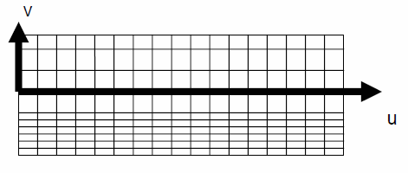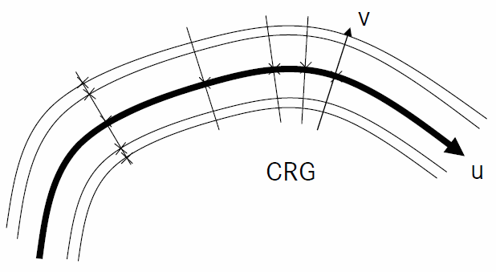
Lateral CRG cuts are orthogonal to the reference line (figures Rauh@all 2008, s.4)

The regular grid defines the elevation in proximity of the reference line. Columns are longitudinal cuts that are parallel to the reference line. Each row represent a lateral cut which is orthogonal to the reference line.

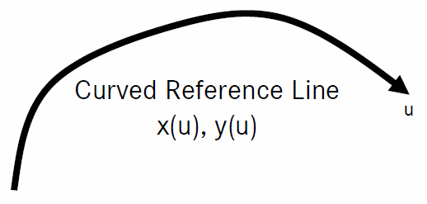
Reference Line Data Representation
The curved reference line is defined by a high precision start
position and low precision heading angles. A potential drift due
to path integration is prevented by redundant high precision end
location of the reference line (Rauh@all 2008, s.6).

Reference Line Path Integration
High precision start-position, ending-position and consecutively heading angles allow to determine accurate reference line position data x(u), y(u). 'Insufficient data precision leads to locally bad curvature representations achieved by simple 3-point-evaluations' (Rauh@all 2008, s6).

Both OpenCRG® tools-suite APIs operate with a backward/forward integration to determine reference line position data. The given high precision start and end positions are compared to the integration results to determine whether the input describes a smooth track.

Dr. Rauh, J./ Schindler, H./ Lothar, W./ Dr. Kersten, T./ Zipperer, W.: OpenCRG A unified approach to represent 3D road data in tyre simulation. Presentation from the AK 6.1.3 Tire Models for Vehicle Dynamics, Ride Comfort and Uneven Roads, 11/12/2008, Slide 4,6

OpenCRG® Data Files

The Basics
OpenCRG® data files consist of various sections which are each enclosed by a line containing the corresponding keyword and a line with a terminating character set. Data files may contain road data in user-readable (i.e. ASCII) format or as binary stream (recommended for large data sets).

The keywords distinguishing the sections start with the $ character followed by the keyword itself. Keywords must be placed at the beginning of a new line and must not be followed by any data but some sort of comment. A section is terminated with a simple $ character at the beginning of a new line.

The possible sections within an OpenCRG® data file are shown in the following figure:
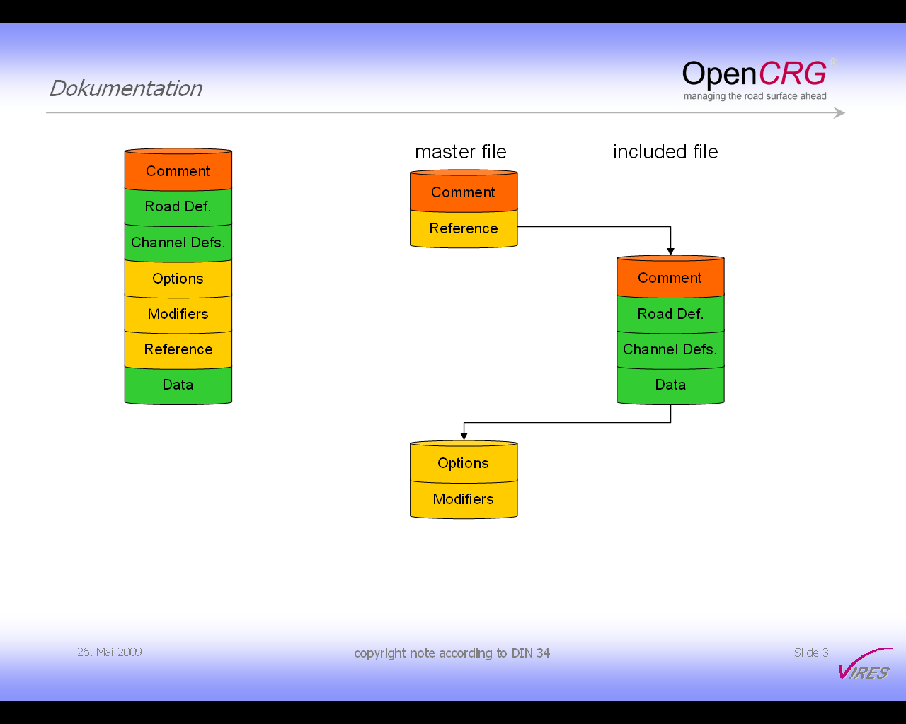

$CT: mandatory comment about file's contents

$ROAD_CRG: information about centerline;
mandatory if file contains Data section,
$KD_Definition: definition of individual channel parameters;
mandatory if file contains Data section

$ROAD_CRG_OPTS: evaluation options

$ROAD_CRG_MODS: data set modifiers

$ROAD_CRG_FILE: references to other data files

the actual OpenCRG® data

The sequence of the sections within an OpenCRG® file is irrelevant, except for the Comment block which has to be the first section within the file and the Data block which, if present, has to be the last. However, it is recommended to use the above scheme for the creation of new files (for user readability).

An OpenCRG® file may contain reference directives pointing to other files. This is usually the case when a control file is used for defining options and modifiers (see below) and the actual data is contained in a separate file. A typical application for referring to other files is shown in the following figure.

Comments
Comments may be defined in two ways:
- the * character at the beginning of a line makes the entire line a comment
- the ! character within a line will cause all following characters to be treated as comment (until the end of the line)

The Sections in Detail

Header Information
Each data file MUST start with a comment block (header information) giving some information about the file's contents (preferably) etc.

The keyword is: $CT

Example:
$CT ! comment text block
CRG file example for road surface description (width: 3m, length: 22m)
with sloped referenceline and grid of (0.25m...1.0m) x 1.0m

Copyright 2005-2017 OpenCRG - Daimler AG - Jochen Rauh

Licensed under the Apache License, Version 2.0 (the "License");
you may not use this file except in compliance with the License.
You may obtain a copy of the License at

http://www.apache.org/licenses/LICENSE-2.0

Unless required by applicable law or agreed to in writing, software
distributed under the License is distributed on an "AS IS" BASIS,
WITHOUT WARRANTIES OR CONDITIONS OF ANY KIND, either express or implied.
See the License for the specific language governing permissions and
limitations under the License.

More Information on OpenCRG open file formats and tools can be found at

http://www.opencrg.org

$!**********************************************************************

Note that in the example, the header information block is terminated by the $ character in the bottom line. The ! character labels all following characters to be treated as comment and thus to be ignored by the data loader. They have just been added for user-readability of the data file.

Road Parameters
The road parameter section defines various parameters for the reference line and the overall configuration of the longitudinal sections. The minimum content that must be defined is the distance between lateral cross sections (REFERENCE_LINE_INCREMENT). All other parameters are optional.
A complete road parameter list including MATLAB-API equivalents and descriptions is listed at ‘./matlab/lib/crg_intro.m’ (see ‘head’ section).

The keyword is: $ROAD_CRG

Example 1:

$ROAD_CRG ! crg road parameters
REFERENCE_LINE_START_U = 0.0
REFERENCE_LINE_START_X = 0.0
REFERENCE_LINE_START_Y = 0.0
REFERENCE_LINE_START_PHI = 0.0
REFERENCE_LINE_END_U = 22.0 !mandatory content
REFERENCE_LINE_END_PHI = 0.0
REFERENCE_LINE_INCREMENT = 1.0
LONG_SECTION_V_RIGHT =-1.50 ! with explicit definition below
LONG_SECTION_V_LEFT = 1.50 ! with explicit definition below
$!**********************************************************************

Example 2: To avoid potential problems in reference line reconstruction, it is recommended to add
start and end positions in the header:

$CRG_ROAD
...
REFERENCE_LINE_START_X = 0.0
REFERENCE_LINE_START_Y = 0.0
REFERENCE_LINE_END_X = 220.0
REFERENCE_LINE_END_Y = 324.0
$

Example 3: If GPS (WGS84) co-ordinates of the start and end position are available, these should
be provided additionally in the road parameter section (not yet supported by C-API):

$CRG_ROAD
...
reference_line_start_lon = 9.12345
reference_line_start_lat = 4.98765
reference_line_end_lon = 9.22345
reference_line_end_lat = 4.88765
$

Data Definition
The data definition block defines the data format (ASCII / binary) and the sequence of data which is to be expected in the trailing data block. Each definition starts with a D: identifier. Reference line and grid data may be defined within the data definition block (again, depending on the contents of the actual data block). Further details can be retrieved from the Matlab routines available for writing OpenCRG® data.

The keyword is: $KD_Definition

Example 1: sloped dataset with seven longitudinal sections

$KD_Definition ! data definition block
#:LRFI ! one of the men readable IPLOS formats
D:reference line slope,m/m ! longitudinal slope
D:long section at v = -1.500,m ! 1.50m right of reference line
D:long section at v = -1.250,m ! 1.25m right of reference line
D:long section at v = -1.000,m ! 1.00m right of reference line
D:long section at v = 0.000,m ! on reference line
D:long section at v = 1.000,m ! 1.00m left of reference line
D:long section at v = 1.250,m ! 1.25m left of reference line
D:long section at v = 1.500,m ! 1.50m left of reference line
$!**********************************************************************

Example 2: curved data set with heading angle defined as first item of each data entry

$KD_Definition
#:LDFI
D:reference line phi,rad ! heading angle -pi <= phi <= +pi
D:long section at v = -1.500,m ! longitudinal cuts with position
D:long section at v = -1.250,m
D:long section at v = -1.000,m
...
$
$$$$$$$

Example 3: longitudinal sections in fixed lateral spacing (lateral spacing 0.1m, surface width 3m);
this example also shows the interaction between the blocks $CRG_ROAD and
$KD_Definition

$CRG_ROAD ! minimal header
REFERENCE_LINE_INCREMENT = 0.01 ! 1cm spacing of lateral cuts
LONG_SECTION_V_RIGHT =-1.50 ! right surface border
LONG_SECTION_V_LEFT = 1.50 ! left surface border
LONG_SECTION_V_INCREMENT = 0.10 ! 10cm spacing of longitudinal cuts
$
$KD_Definition
#:LDFI
D:reference line phi,rad ! heading angle -pi <= phi <= +pi
D:long section 1,m ! 1.5m right of reference line
D:long section 2,m ! 1.4m right of reference line
...
D:long section 31,m ! 1.5m left of reference line

Modifiers and Options
As shown in the figure at the beginning of this chapter, OpenCRG® data files may also contain information about data evaluation options and data set modifiers. Both may, alternatively, be defined in run-time using the APIs.

The details of options and modifiers are described in the chapters below. Here, it shall only be stated that the keywords are:

Options: $ROAD_CRG_OPTS
Modifiers: $ROAD_CRG_MODS

Example:
$$ROAD_CRG_OPTS ! crg runtime evaluation options
*
* BORDER_MODE_U = 0 ! return NaN
* BORDER_MODE_U = 1 ! set zero
* BORDER_MODE_U = 2 ! keep last (default)
* BORDER_MODE_U = 3 ! repeat
* BORDER_OFFSET_U = 1.0 ! z offset beyond border (default: 0)
*
* BORDER_MODE_V = 0 ! return NaN
* BORDER_MODE_V = 1 ! set zero
BORDER_MODE_V = 2 ! keep last (default)
* BORDER_MODE_V = 3 ! repeat
BORDER_OFFSET_V = 1.0 ! z offset beyond border (default: 0)
$!**********************************************************************

NOTE: In the API routines, default modifiers and options are defined. Options provided in an
individual data file may alter the default values of the respective options. Defining a modifier
block in the data file will trigger the removal of ALL default modifiers. The user-defined
modifiers will be set according to the information provided in the data file. If the user provides
an empty "$ROAD_CRG_MODS" block, then no modifiers will remain at all (for default modifiers see
also 4.2.7.1)

File Reference
OpenCRG® files may contain references to other files, typically containing the actual data. In the "master" file, conventions for modifiers and options will typically be defined. File references may contain absolute or relative paths and environment variables

The keyword is: $ROAD_CRG_FILE

Example:
$ROAD_CRG_FILE ! crg file reference
* The file name may be split to multiple lines, which must not contain
* leading/trailing blanks, *, or ! to be considered as part of the name.
* Each line length must not exceed 72 characters.
* If a relative path is given, it is evaluated relative to the current
* directory of the reader process.
* If the first character is a $, subsequent characters will be replaced
* by the contents of the equivalent environment variable.
*
* > /home/name/crg-files/handmade_straight.crg ! absolute path
*
* > /home/name/crg-files/hand ! absolute path
* > made_straight.crg ! split in 2 lines
*
* > $crgpath/handmade_straight.crg ! replace $crgpath by
* > ! it's envvar contents
*
./hand ! look in current dir
made_straight_opts.crg ! look in current dir
$!**********************************************************************

Road Data
The road data section MUST ALWAYS be the last section of an OpenCRG® data file. It contains the actual road data (typically: elevation). Its formatting depends on the data format defined in the Data Definition section (see above). Since OpenCRG® files will typically be written using the Matlab routines, a further discussion of the various data formats is omitted (for the moment).

Sample Files

OpenCRG® sample data files are located in the directories

OpenCRG/crg-txt
OpenCRG/crg-bin

A distinction is made between human-readable text files and binary data files. Each type is located in its respective sub-directory.

The following files are available:

|----crg-bin
| |----belgian_road.crg...binary data set for tests complex tests
| |----country_road.crg...............a larger stretch of binary test data (*)
|----crg-txt
| |----fileref.crg...................user-readable data set referring CRG file
| |----fileref_mods.crg..............user-readable data set referring CRG file w. modifier
| |----fileref_opts.crg..............user-readable data set referring CRG file w. options| |----handmade_arc.crg..............user-readable data set for a ~180deg arc
| |----handmade_banked.crg...........user-readable data set for banked road data
| |----handmade_circle.crg...........user-readable data set for closed refline| |----handmade_curved.crg...........user-readable data set for curved refline
| |----handmade_curved_banked_sloped.crg.........” data set for curved refline w. opts/mod
| |----handmade_curved_minimalist.crg............” data set for minimalist curved refline
| |----handmade_platform.crg.........user-readable data set for constantly elevated road
| |----handmade_sloped.crg...........user-readable data set for sloped data set
| |----handmade_sloped_opt.crg.......user-readable data set for sloped data set w. options
| |----handmade_straight.crg.........user-readable data set for straight refline
| |----handmade_straight_double.crg..user-readable data set for st. refline in double prec.
| |----handmade straight_minimalist.crg..........” data set for minimalist straight refline
| |----handmade_vtest.crg............user-readable data set for tests relating to v-options
| |----testOptionBorderMode.crg......master file including data file and setting options
* Available as additional sample at www.opencrg.org/download.htm

Other files may be added to the data directories without further notice or explicit description in this documentation.

The OpenCRG® C-API

Getting Started

Downloading the Software Package
The latest stable version of the OpenCRG® C-API may be retrieved via the website

www.opencrg.org

Go to the Downloads area and look for the section Packages and Tools. There, you will find a package containing the C-API, MATLAB routines, documentation and sample files. Download this package and unpack it into a dedicated directory on your machine.

The C-API is located in the sub-directory

OpenCRG/c-api

The latest developer version may be retrieved via the OpenCRG® project managing and issue tracking-system. You can reach this system by going to

http://tracking.vires.com (registration required)

Release Notes
The release notes are part of the software package and will not be transferred to this document. Please look for the "readme.txt" files in the root directory of the OpenCRG package and in the API's sub-directory.

Contents of the Package
The OpenCRG® C-API is delivered as a zipped package which, after unpacking, provides the following file structure (for additional / updated contents, see the readme.txt file):

|----baselib................OpenCRG basic library - the core of the toolset
| |----lib...............location of the compiled OpenCRG library
| |----inc...............include files providing the interface to the library
| |----makefile..........sample makefile for users preferring the make mechanism
| |----obj...............target directory for sources compiled with the make mechanism
| |----src...............the library's sources
|----compileScript.sh.......script for the compilation of all demos and tools,
| based on simple compiler calls; this is an alternative to
| using the make mechanism; all files of the base library are
| also compiled with this script, so there is no need for a
| separate compilation of the library files.
|----demo...................demo sources showing the usage of the basic library
| |----Simple............a really simple application covering all basics of the API,
| | runs with fix data sample "handmade_straight.crg"
| |----EvalOptions.......a set of routines demonstrating the usage of various options
| |----EvalXYnUV.........a set of routines for the evaluation of OpenCRG reference lines
| |----EvalZ.............an advanced example for the evaluation of OpenCRG data
| |----Reader............a sample application for a CRG file reader
| |----bin
| | |----crgSimple....executable of the very simple example
| | |----crgEvalxyuv..executable of the reference line evaluator
| | |----crgReader....executable of the sample reader
| | |----crgEvalz.....executable of the complex z data evaluator
| | |----crgEvalOpts..executable of the option usage example
| |----makefile..........makefile for all demos (alternative to "compileScript.sh")
|----makefile
|----readme.txt
|----test
| |----PerfTest................test tool for evaluating the performance of the library
| |----bin
| | |----testModifiers.sh...script for performing a series of tests using the
| | | modifier mechanisms; requires gnuplot
| | |----testOptions.sh.....script for performing a series of tests using the
| | | evaluation option mechanisms; requires gnuplot
| | |----crgPerfTest........performance test tool; may not run on all platforms
| |----makefile................makefile for all tests (alternative to "compileScript.sh")

Compiling the Package

Method A – makefiles
On machines with gcc and standard make environment, just type

make

in the root directory. This should result in a series of executable files in the directories

demo/bin/
test/bin/

In addition, a library containing all object files of the baselib/ sources is created in

baselib/lib

Method B – script
On machines having trouble with the provided makefiles, either adapt those files or use the very basic fallback solution which is a compile script. The script "compileScript.sh" is located in the root directory

OpenCRG/c-api/

Open the script, set the compiler variable "COMP" to the name of your compiler, re-save the script and execute it. The results should - again - be found in

demo/bin/
test/bin/

In contrast to the makefile mechanism, no library is explicitly created from the baselib/ files.

Method C – command line
If you don't like makefiles and our scripts, you may just write your own simple compile instruction at command line level.

For this purpose, please note the following hints:

In order to compile a demo, set your include file search path to
baselib/inc

Always compile in combination with all .c-files in
baselib/src

Example: For the compilation of EvalXYnUV, use:

cc -lm -o EvalXYnUV -I baselib/inc demo/EvalXYnUV/src/main.c baselib/src/*.c

Basic Tests
On machines providing a shell environment and gnuplot (e.g. Linux systems), a series of very brief tests can be run. These are also used for acceptance tests of the C-API and have generated the figures in this document showing the various options and modifiers.

In order to run all tests for evaluation options, use the script

testOptions.sh

In order to run all tests for data set modifiers, use the script

testModifiers.sh

The Base Library

Overview
As mentioned above, the base library contains a large set of routines for
- reading
- modifying
- evaluating

OpenCRG® data. If you’re looking for tools for creating data sets, please refer to the Matlab routines also available via the OpenCRG® website.

The base library is contained completely in the subdirectory

baselib/

of the OpenCRG® software package. It has the following structure:

inc/ all include files
obj/ objects and library resulting from compilation
src/ all source files
makefile the makefile for compiling the library

Once compiled with the provided makefiles, the library is stored as archive in the directory

lib/

below the OpenCRG/ root directory.

Include Files
The API comes with two include files

baselib/inc/crgBaseLib.h
baselib/inc/crgBaseLibPrivate.h

The first include file will typically be used when writing own applications featuring the OpenCRG® library. The second include file is used internally by the library’s components and, therefore, can be ignored in most cases. It includes itself the first library, so when working with the “private” header, you don’t have to include the “public” header explicitly.

Source Files
The library is composed of the following source files which are located in baselib/src:
crgMgr.c overall data management
crgMsg.c message / data log handling
crgStatistics.c calculation of data set statistics
crgContactPoint.c contact point management
crgEvalxy2uv.c routines for evaluating x/y -> u/v
crgEvaluv2xy.c routines for evaluating u/v -> x/y
crgEvalz.c routines for evaluating x/y -> z, u/v -> z
crgEvalpk.c routines for evaluating x/y -> phi / kappa, u/v -> phi / kappa
crgLoader.c data file decoder and data loader
crgOptionMgmt.c management of options and modifiers
crgPortability.c collection of routines which might be subject to portability
issues (e.g. when integrating the library within FORTRAN)

The interface to the methods in all source files is given in the include files listed in the previous chapter. The actual location of a method within the set of source files is irrelevant to the standard use of the library.

Working with Data Files

Simple Use Case
There are many operations that may be applied to OpenCRG® data sets. However, the simple way of using OpenCRG® data files is split into just three stages:
- load the file
- create a contact point
- call the evaluation methods

This use case is shown in a programming example which is located at

demo/Simple/

Data Sets and Contact Points
This document and the entire C-API use two terms which shall be explained here:

Data Set a data set is the instance of data read from an OpenCRG® file into memory. It
is identified by a unique integer ID which is returned by the data loader
method.

Contact Point a contact point is a "tool" to query data of a given data set. The user must
instantiate at least one contact point per data set in order to be able to query
its contents. Contact points are identified with unique integer IDs which are
returned by the contact point creation method. The number of contact points
per data set is not limited.

Multi-Thread Applications
To parallelize C-API evaluation calls, contact points MUST NOT be shared between threads. Doing this will destroy history and other data stored within the contact point “object”.

Modifiers and Options
In simple cases, data sets will be read from file and evaluations may take place immediately. However, the user may want to vary the way a specific data set is evaluated without having to modify the original data (i.e. the data file) itself.

For this purpose, modifiers and options have been introduced.

- Modifiers modify the copy of OpenCRG® data which is stored in memory and, therefore, provide the modified data for all subsequent evaluation requests

- Options influence the way a specific query is performed without modifying any of the data stored in memory.

In the data files, modifiers are found in the section $CRG_MODS and options are found in $CRG_OPTS. The API provides discrete calls for setting modifiers directly and for applying them and the ones defined in the data file to the data set. For reasons of enhanced user control, modifiers defined in a data file are NOT applied automatically to the data set. It is the user's responsibility to apply them explicitly (see below).

The API also provides calls for setting options on a contact point level. When setting an option, its data type is taken into account, resulting in different methods for double and integer modifiers/options.

The set of available modifiers and options is defined as symbolic constants in the include file crgBaseLib.h.

Modifiers are set on a data set level by means of the routines

crgDataSetModifierSetInt( dataset, … )
crgDataSetModifierSetDouble( dataset, … )

After complete definition of all modifiers, they must be applied explicitly to the data set using the method
crgDataSetModifiersApply( dataset )

NOTE: This routine must also be called after reading the modifiers from a CRG file.
Only defining the section $ROAD_CRG_MODS in a CRG files will NOT trigger
the application of the modifiers to the data set.

In contrast to modifiers, options are applied implicitly each time an evaluation is performed. Therefore, they only have to be defined on a contact point level using the methods

crgContactPointOptionSetInt( contactPoint )
crgContactPointOptionSetDouble( contactPoint )

Sequence of Actions
The following figure gives an overview of the sequence of actions that may be performed when working with OpenCRG® data files.

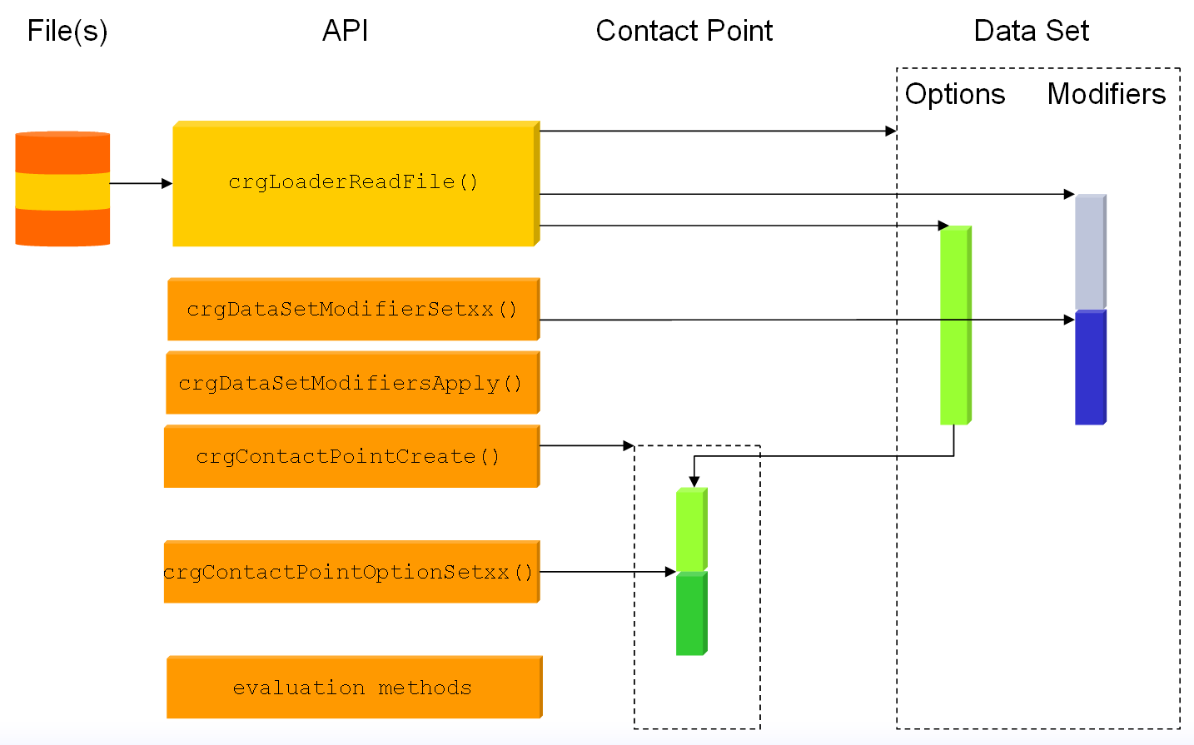

- first, the user loads a file; the file may already contain definitions for evaluation options and data set modifiers.
- upon reading the file, a data set with a unique ID (returned by the loader method) is created where actual OpenCRG® data is stored as well as modifiers and options defined within the file.
- after reading the file, the modifiers of the data set may be replaced, deleted, extended by means of API calls referring to the data set.
- in order to evaluate data of the data set, the user needs to create a so-called “contact point”; this contact point is dedicated to a given data set; the library creates and returns a unique ID for each contact point
- the contact point inherits all evaluation options from the respective data set
- the user may specify further evaluation options, modify existing ones or delete all evaluation options inherited from the data set
- finally, evaluation of data may begin

Evaluating Data
Once a data set is loaded and a contact point is created, data can be evaluated in various ways (full prototypes of the referenced methods are in crgBaseLib.h)

- compute the x/y position of a given u/v position

crgEvaluv2xy( int cpId, double u, double v, double* x, double* y )

- compute the u/v position of a given x/y position

crgEvalxy2uv( int cpId, double x, double y, double* u, double* v )

- compute the z value at a given u/v position

crgEvaluv2z( int cpId, double u, double v, double* z )

- compute the z value at a given x/y position

crgEvalxy2z( int cpId, double x, double y, double* z )

- compute heading angle and curvature at a given u/v position

crgEvaluv2pk( int cpId, double u, double v, double* phi, double* curv )

Message Printing
The API provides a series of methods for controlling verbosity of the library. Also, the user may use these methods to provide / control own messages which are to be printed to shell output (here: stderr).

The system knows the following message levels (in increasing order) which are controlled by symbolic constants in crgBaseLib.h

dCrgMsgLevelNone
dCrgMsgLevelFatal
dCrgMsgLevelWarn
dCrgMsgLevelNotice
dCrgMsgLevelInfo
dCrgMsgLevelDebug

The current message level is set by

crgMsgSetLevel( int level );

A message to be printed at or below a certain level is defined in standard printf() syntax via

crgMsgPrint( int level, const char *format, ...);

If a user wants to perform custom message handling, a callback may be defined which is invoked instead of the internal print routines. The syntax for setting the callback is: printf() syntax via

crgMsgSetCallback( int ( *func )( int level, char* message ) );

An example for custom message handling is given in the demo/EvalOptions/src/main.c. Look for the method myMsgHandler( ... ).

Modifiers
As mentioned above, the OpenCRG® data set stored in memory may be globally modified by means of so-called “modifiers”.

The C-API provides a series of methods for defining, querying, and printing modifiers of a data set. These are described in further detail in the header file crgBaseLib.h and are following the naming pattern
crgDataSetModifierxxx( dataSetId, … );

The following tables and figures give an overview of all applicable modifiers with their respective definitions within OpenCRG® data files and with their addressing from the API. All examples have been computed using the test tool located in Tools/EvalOptions via the script testModifiers.sh in Tools/bin.

Default Modifiers
The C-API (similar to the Matlab API) defines a set of default modifiers which are applied to the data set if no other modifiers have been defined in the OpenCRG® data file. However, as pointed out above, application of the modifiers must explicitly be triggered by calling the routine

crgDataSetModifiersApply( dataset )

The default modifiers may be altered and extended in the following ways:

- Block "$ROAD_CRG_MODS" in the OpenCRG® data file
Upon first occurrence of this block ALL default modifiers will be deleted (i.e. even the ones you might have wished to keep). These are replaced with the modifiers defined in the corresponding data block. The removal of all modifiers by means of an OpenCRG® data file is achieved by providing an empty block "$ROAD_CRG_MODS"

- Calls to C-API
By explicitly setting / removing modifiers via the C-API routines
crgDataSetModifierSetInt( dataset, … )
crgDataSetModifierSetDouble( dataset, … )
crgDataSetModifierRemoveAll( dataset )
crgDataSetModifierSetDefault( dataset )
the user may further customize the list of applicable modifiers

- Combination of both methods

The default modifiers are (details see below):

C-API |  |  | data file
symbolic constant | data type | value | name | value
dCrgModRefPointUFrac | double | 0.0 | REFPOINT_U_FRACTION | 0.0
dCrgModRefPointUOffset | double | 0.0 | REFPOINT_U_OFFSET | 0.0
dCrgModRefPointVFrac | double | 0.0 | REFPOINT_V_FRACTION | 0.0
dCrgModRefPointVOffset | double | 0.0 | REFPOINT_V_OFFSET | 0.0
dCrgModRefPointX | double | 0.0 | REFPOINT_X | 0.0
dCrgModRefPointY | double | 0.0 | REFPOINT_Y | 0.0
dCrgModRefPointZ | double | 0.0 | REFPOINT_Z | 0.0
dCrgModRefPointPhi | double | 0.0 | REFPOINT_PHI | 0.0
dCrgModGridNaNMode | int | dCrgGridNaNKeepLast | GRID_NAN_MODE | 2

Transforming Data by Reference Point
The data set may be “re-located” by defining a reference point in the u/v grid and an inertial target position and orientation.

The reference point may be defined using explicit u/v values:

C-API |  |  | data file, section $CRG_MODS
symbolic constant | data type | values | name | values
dCrgModRefPointU | double |  | REFPOINT_U
dCrgModRefPointV | double |  | REFPOINT_V

It may also be defined using relative u/v values and explicit offsets (in [m]) from these relative positions (or by mixing the former position mode with the current one):

C-API |  |  | data file
symbolic constant | data type | values | name | values
dCrgModRefPointUFrac | double | 0.0..1.0 | REFPOINT_U_FRACTION | 0.0..1.0
dCrgModRefPointUOffset | double |  | REFPOINT_U_OFFSET
dCrgModRefPointVFrac | double | 0.0..1.0 | REFPOINT_V_FRACTION | 0.0..1.0
dCrgModRefPointVOffset | double |  | REFPOINT_V_OFFSET

The target position of the data set must be defined in inertial co-ordinates and with absolute heading angle.

C-API |  |  | data file
symbolic constant | data type | values | name | values
dCrgModRefPointX | double |  | REFPOINT_X
dCrgModRefPointY | double |  | REFPOINT_Y
dCrgModRefPointZ | double |  | REFPOINT_Z
dCrgModRefPointPhi | double |  | REFPOINT_PHI

Example 1:
modifier: refpoint u=5.0, v=1.5 to position x=100.0, y=200.0, z=10.0
file: handmade_straight.crg

original data set modified data set
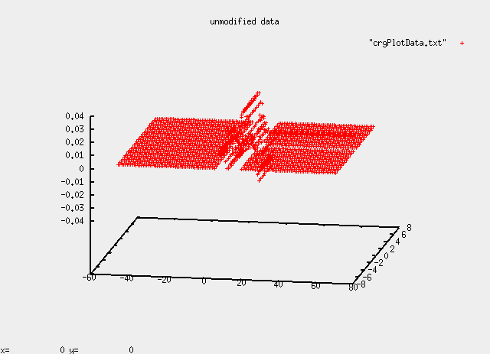
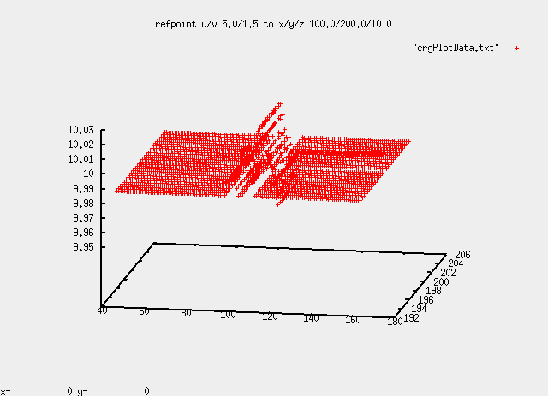

Transforming Data by Offset Position
Instead of defining a reference point and its target location, the data set may be shifted and rotated using translation and angle offsets which are applied to the origin of the data set’s reference line. At first, the rotation is applied before the reference line translation. If not defined, the default rotation center will be the starting position (x,y).
C-API |  |  | data file
symbolic constant | data type | values | name | values
dCrgModRefLineRotCenterX | double |  | REFLINE_ROTCENTER_X
dCrgModRefLineRotCenterY | double |  | REFLINE_ROTCENTER_Y
dCrgModRefLineOffsetPhi | double |  | REFLINE_OFFSET_PHI
dCrgModRefLineOffsetX | double |  | REFLINE_OFFSET_X
dCrgModRefLineOffsetY | double |  | REFLINE_OFFSET_Y
dCrgModRefLineOffsetZ | double |  | REFLINE_OFFSET_Z

Example 1:
modifier: translation of reference line by x=100.0, y=200.0, z=10.0
file: handmade_straight.crg

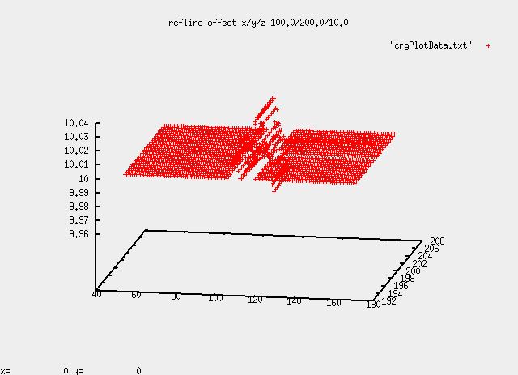
original data set modified data set

Example 2:
modifier: translation of reference line by x=100.0, y=100.0, z=100.0
rotation by 1.57 (rad)
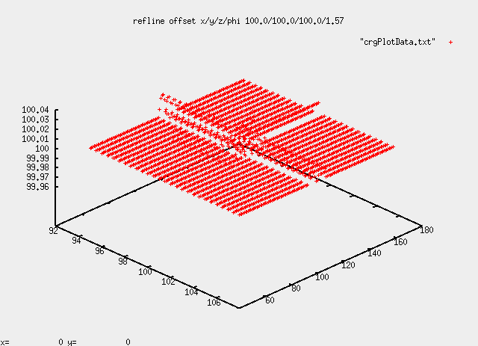
file: handmade_straight.crg

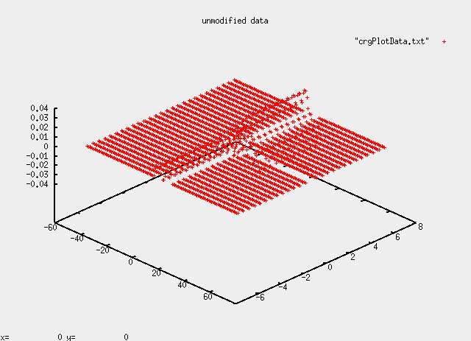
original data set modified data set

Scaling of Elevation Data
Various properties influencing the elevation of the data set may be scaled. These are listed in the following table. A scale value of 0 will lead to ignoring the respective property.

C-API |  |  | data file
symbolic constant | data type | values | name | values
dCrgModScaleZ | double |  | SCALE_Z
dCrgModScaleSlope | double |  | SCALE_SLOPE
dCrgModScaleBank | double |  | SCALE_BANK

Example 1:
modifier: z scale 10.0
file: handmade_straight.crg

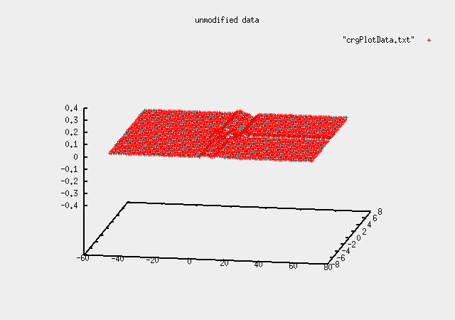
original data set modified data set
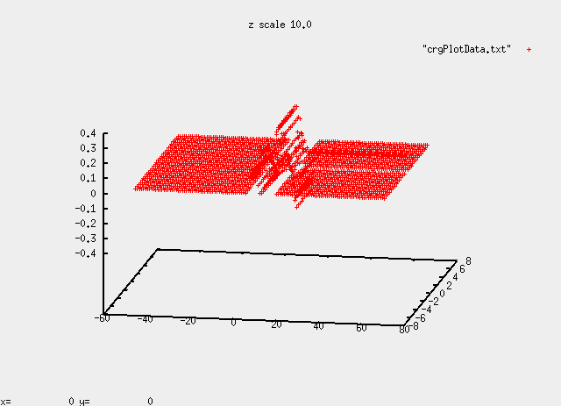

Example 2:
modifier: slope scale 10.0
file: handmade_sloped.crg

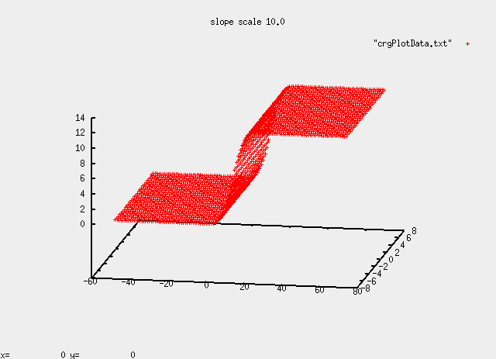
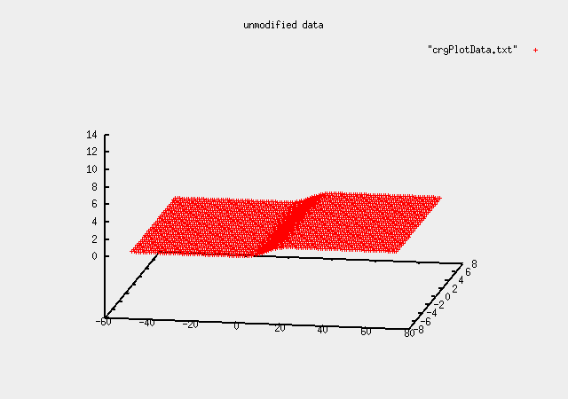
original data set modified data set

Example 3:
modifier: bank scale 10.0
file: handmade_banked.crg

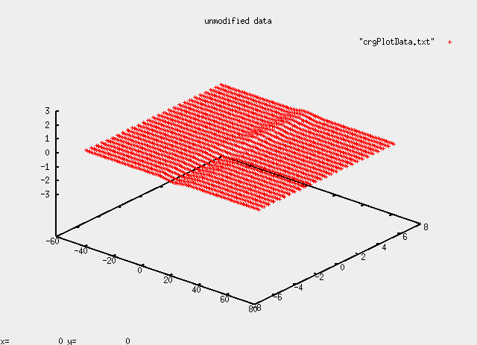
original data set modified data set

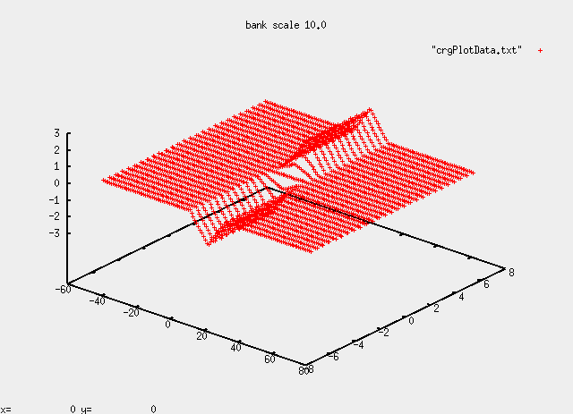

Scaling of Data Set Extents
The length and width of the data set may be scaled. Only values greater than zero are valid

C-API |  |  | data file
symbolic constant | data type | values | name | values
dCrgModScaleLength | double | ]0.0..] | SCALE_LENGTH | ]0.0..]
dCrgModScaleWidth | double | ]0.0..] | SCALE_WIDTH | ]0.0..]

Example 1:
modifier: length scale 10.0
file: handmade_sloped.crg

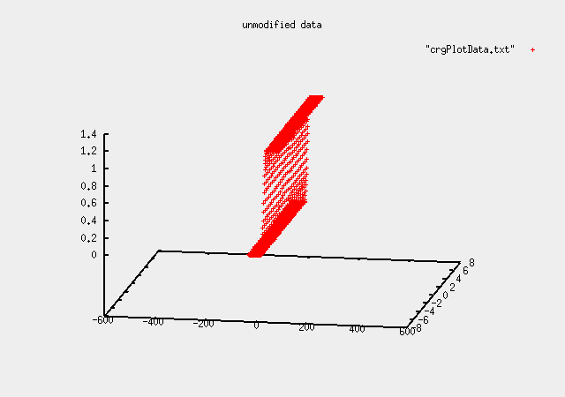
original data set modified data set
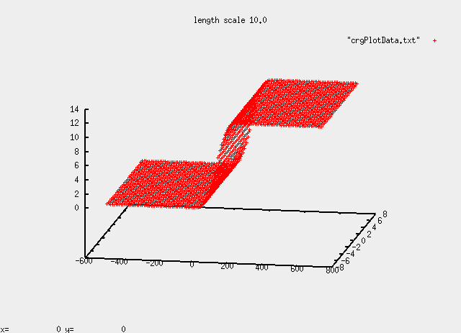

Example 2:
modifier: width scale 2.0
file: handmade_banked.crg

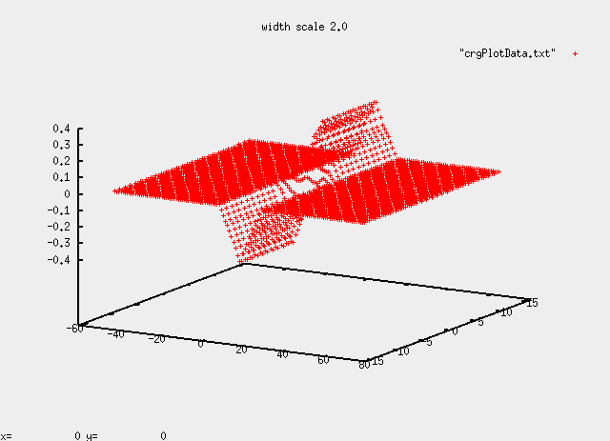
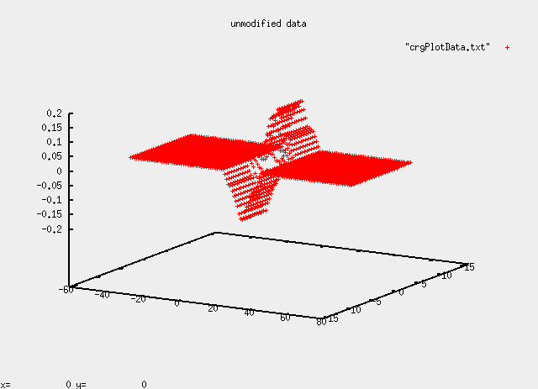
original data set modified data set

Scaling of Curvature
The reference line curvature may be scaled resulting in a modified end point. Scaling by a value of zero will result in a straight reference line.

C-API |  |  | data file
symbolic constant | data type | values | name | values
dCrgModScaleCurvature | double |  | SCALE_CURVATURE

Example 1:
modifier: curvature scale 0.50
file: handmade_arc.crg

original data set modified data set
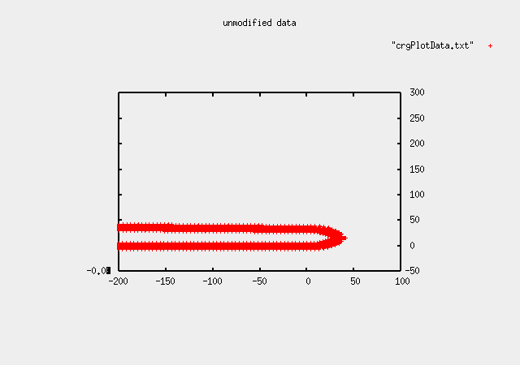
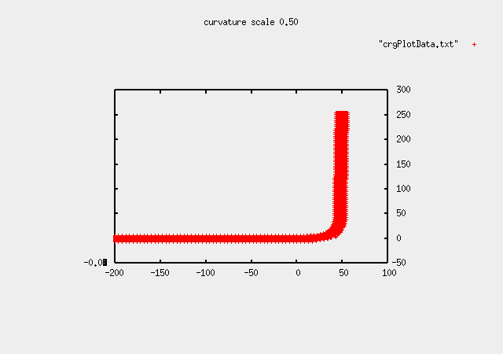

Example 2:
modifier: curvature scale 0.00
file: handmade_arc.crg

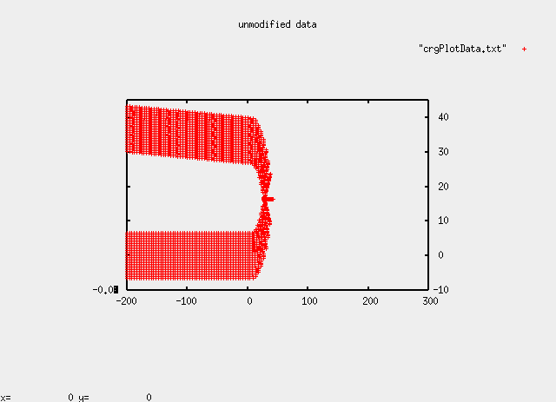
original data set modified data set
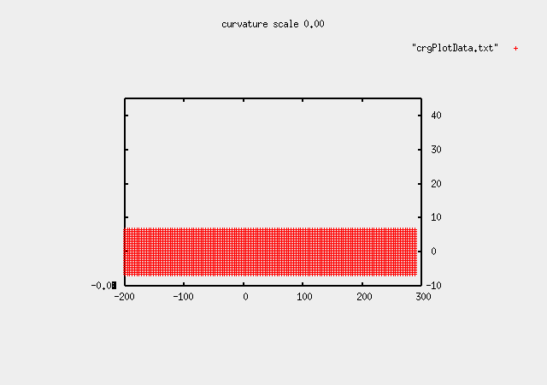

NaN handling in v Direction
When preparing the data set for queries, the v border values are checked for NaNs. The mode of treating these values can be set by the user.

C-API |  |  | data file
symbolic constant | data type | values | name | values
dCrgModGridNaNMode | int | dCrgGridNaNKeep  dCrgGridNaNSetZero  dCrgGridNaNKeepLast | GRID_NAN_MODE | 0  1  2

When using mode dCrgGridNanKeep/0, the option dCrgCpOptionBorderModeV /BORDER_MODE_V must also be set to dCrgBorderModeNone/0.

Unless NaN is being kept, an explicit offset may be applied to former NaN values in the grid.

C-API |  |  | data file
symbolic constant | data type | values | name | values
dCrgModGridNaNOffset | double |  | GRID_NAN_OFFSET

Options
As mentioned above, the evaluation methods per contact point may be influenced by so-called “options”. This means that options are applied per evaluation, not on a global level.

The C-API provides a series of methods for defining, querying, and printing options of a contact point. These are described in further detail in the header file crgBaseLib.h and are following the naming pattern

crgContactPointOptionxxx( contactPointId, … );

The following tables and figures give an overview of all applicable options with their respective definitions within OpenCRG® data files and with their addressing from the API. All examples have been computed using the test tool located in Tools/EvalOptions via the script testOptions.sh in Tools/bin.

Border Modes in u and v Directions
The border modes influence (per direction) the z value returned when the original definition area (i.e. within the min. and max. u- and v-co-ordinates) is exceeded by a query.

For each border, the following behaviors may be defined:
- return NaN/error, i.e. refuse the query
- set the value to zero
- keep the last value
- repeat the core area data
- reflect the core area data

In order to mark the border itself, a z-offset may be applied when the border is crossed in either direction. The interface for defining the respective modes is as follows (default values are highlighted):

C-API |  |  | data file
symbolic constant | data type | values | name | values
dCrgCpOptionBorderModeU | int | dCrgBorderModeNone  dCrgBorderModeExZero  dCrgBorderModeExKeep  dCrgBorderModeRepeat  dCrgBorderModeReflect | BORDER_MODE_U | 0  1  2  3  4
dCrgCpOptionBorderModeV | int | dCrgBorderModeNone  dCrgBorderModeExZero  dCrgBorderModeExKeep  dCrgBorderModeRepeat  dCrgBorderModeReflect | BORDER_MODE_V | 0  1  2  3  4
dCrgCpOptionBorderOffsetU | double |  | BORDER_OFFSET_U
dCrgCpOptionBorderOffsetV | double |  | BORDER_OFFSET_U
Example 1:
options: border mode U = dCrgBorderModeNone
file: handmade_sloped.crg

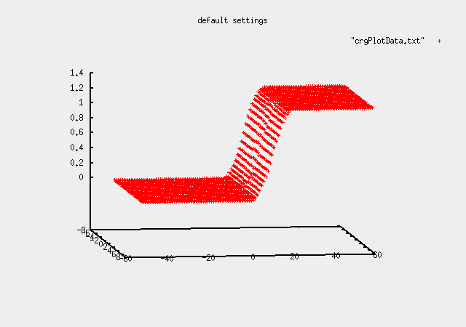
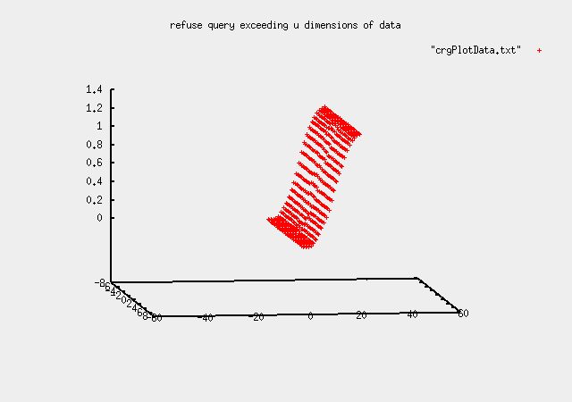
default settings option settings

Example 2:
options: border mode U = dCrgBorderModeExZero
border mode V = dCrgBorderModeExZero
border offset U = -1[m]
file: handmade_sloped.crg

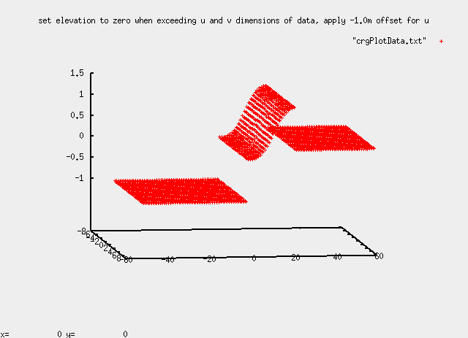
default settings option settings

Example 3:
options: border mode U = dCrgBorderModeExKeep
file: handmade_sloped.crg

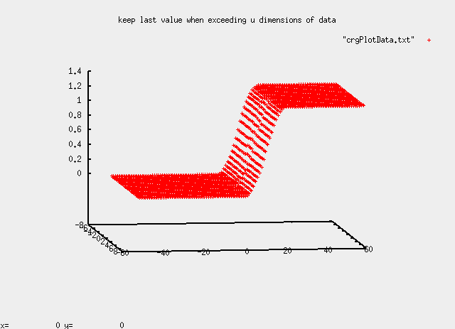
default settings option settings

Example 4:
options: border mode U = dCrgBorderModeExRepeat
file: handmade_sloped.crg

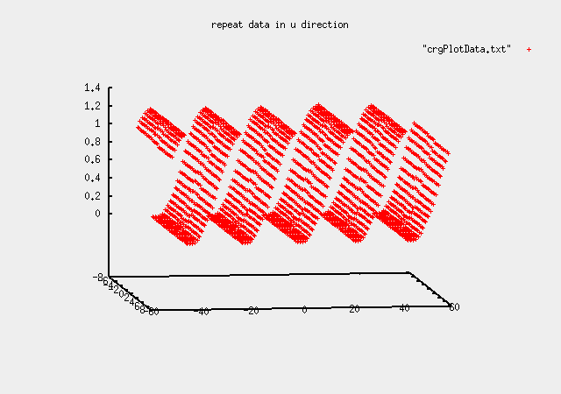
default settings option settings

Example 5:
options: border mode U = dCrgBorderModeExReflect
file: handmade_sloped.crg

default settings option settings
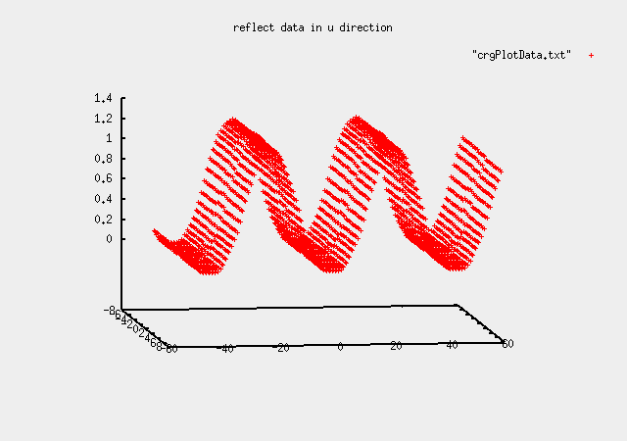

Example 6:
options: border mode U = dCrgBorderModeExRepeat
border offset U = 1[m]
file: handmade_sloped.crg

default settings option settings
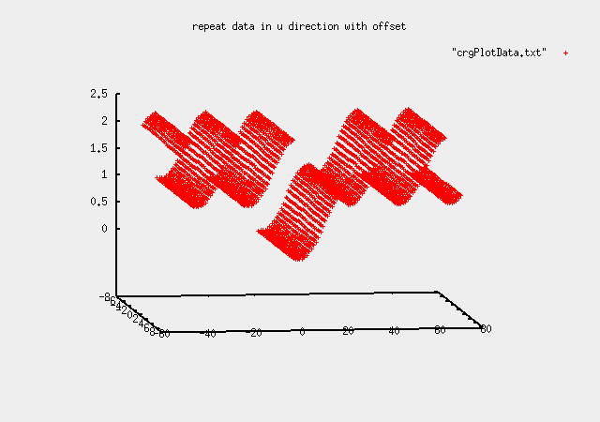

Example 7:
options: border mode V = dCrgBorderModeNone
file: handmade_vtest.crg

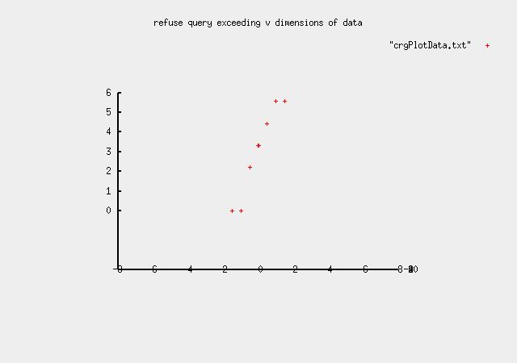
default settings option settings
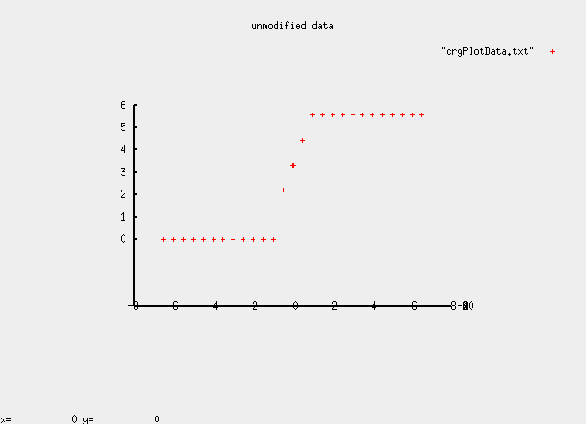

Example 8:
options: border mode V = dCrgBorderModeExZero
file: handmade_vtest.crg

default settings option settings
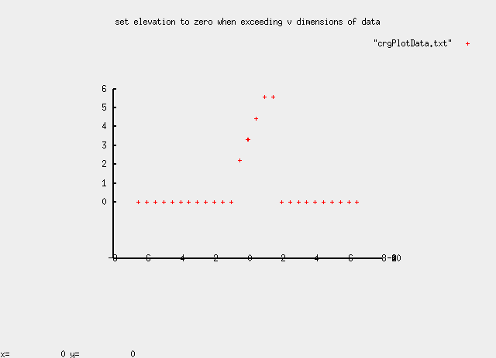

Example 9:
options: border mode V = dCrgBorderModeExKeep
file: handmade_vtest.crg

default settings option settings
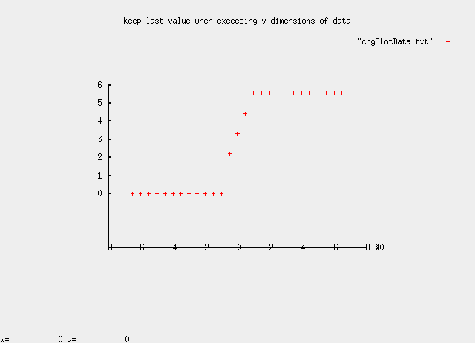

Example 10:
options: border mode V = dCrgBorderModeExRepeat
file: handmade_vtest.crg

default settings option settings
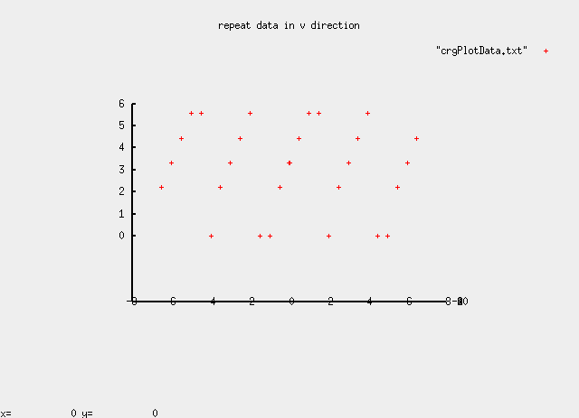

Example 11:
options: border mode V = dCrgBorderModeExReflect
file: handmade_vtest.crg

default settings option settings
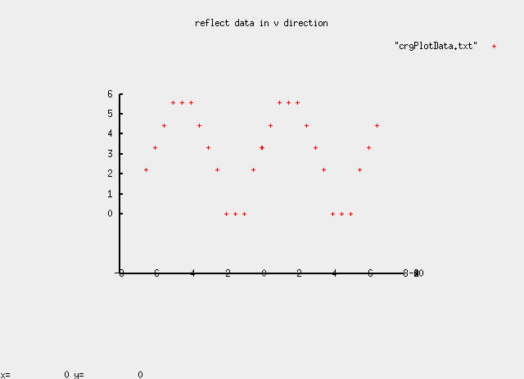

Example 12:
options: border mode V = dCrgBorderModeExRepeat
border offset V = 1[m]
file: handmade_vtest.crg

default settings option settings
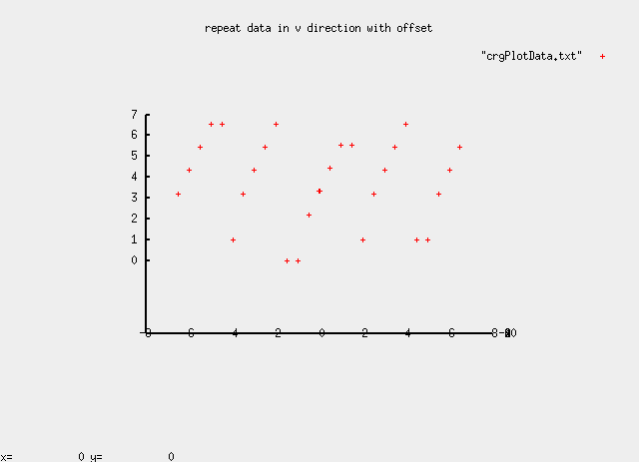

Smoothing Zones
In order to provide a smooth on-set and/or off-set of z data, the begin and end of the data (including slope and bank) may be scaled linearly from zero to full size within a user-defined range at either end of the core area. Again, core area is the original data extent defined in the data file which is not subject to the evaluation via one of the border modes described in the previous chapter.

The parameters of the smoothing zone may be defined via the following interfaces:

C-API |  |  | data file
symbolic constant | data type | values | name | values
dCrgCpOptionSmoothUBegin | double | 0.0..u_{max} | BORDER_SMOOTH_UBEG | 0.0..u_{max}
dCrgCpOptionSmoothUEnd | double | 0.0..u_{max} | BORDER_SMOOTH_UEND | 0.0..u_{max}

Example 1:
options: smoothing zone at begin = 5[m]
file: handmade_platform.crg

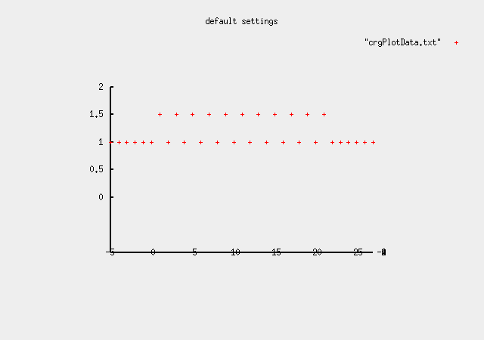
default settings option settings
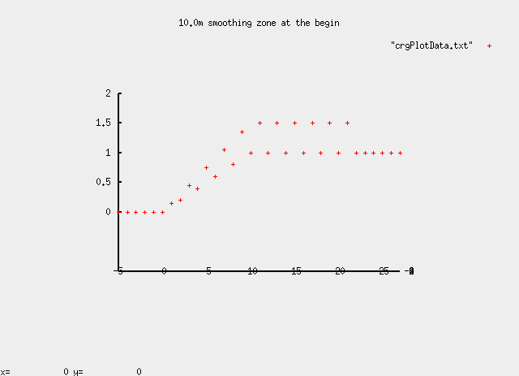

Example 2:
options: smoothing zone at end = 5[m]
file: handmade_platform.crg
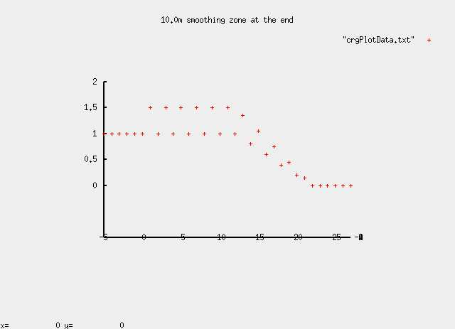
default settings option settings
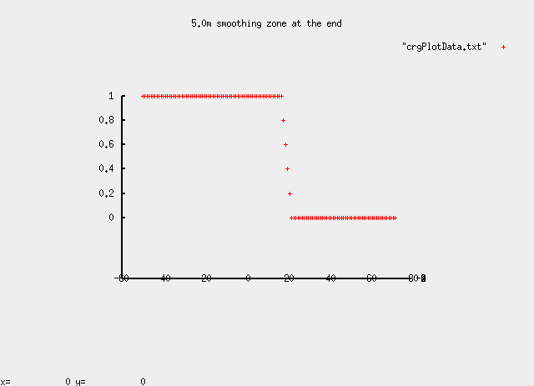

Continuation of Reference Line
For points whose u position exceeds the data set’s valid range (i.e. the original reference line), the corresponding x/y position is usually computed by extrapolating the reference line at the respective end. However, reference lines representing a closed track, the extrapolation of the u position may be achieved by trying to close the reference line and, thus, position the point (again) within the core area of the data set.

“Track can be closed if both extrapolated lines intersect with bend angle < 60deg
• each other
• refline orthogonals at begin and end
• Indicator: data.dved.ulex > 0

Track cannot be closed in all other cases.
• Indicator: data.dved.ulex = 0

For closed CRG track evaluation, the above condition has to be fulfilled, and the closing parameter has to be set.” (Rauh 2012, s.3)

The parameters controlling this behavior are:

C-API |  |  | data file
symbolic constant | data type | values | name | values
dCrgCpOptionRefLineContinue | int | dCrgRefLineExtrapolate  dCrgRefLineCloseTrack | REFLINE_CONTINUATION | 0  1

Dr. Rauh, J.: “Disclosing some more OpenCRG secrets ...”. Presentation from the 2nd OpenCRG Workshop in Munich, 14/03/2012, Slide 3

Example 1:
options: reference line continuation = dCrgRefLineExtrapolate
file: handmade_circle.crg

default settings option settings
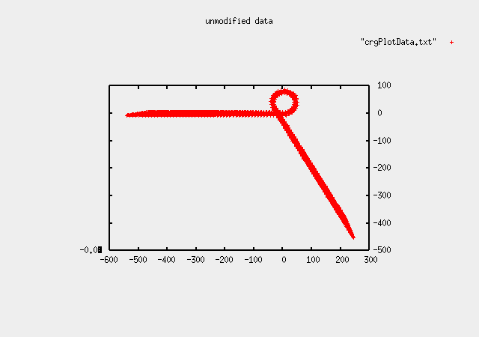

Example 2:
options: reference line continuation = dCrgRefLineCloseTrack
file: handmade_circle.crg

default settings option settings
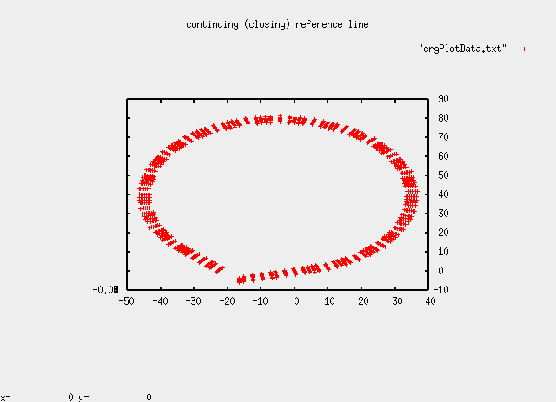

Curvature Evaluation
When computing the curvature at a given u/v-position, the resulting value is, per default, the actual curvature at the position. An option is available which, when enabled, returns the curvature at the corresponding reference line position instead of the curvature at the actual position.

The parameters controlling this behavior are:

C-API |  |  | data file
symbolic constant | data type | values | name | values
dCrgCpOptionCurvMode | int | dCrgCurvLateral dCrgCurvRefLine | n/a

History Manipulation
The performance of data evaluation is increased by using internally a history of recently queried points. It is assumed that new queries typically occur in the vicinity of previous queries.

If the user has more knowledge about the u-positions of the reference line where the next queries will occur, he may pre-load the history with this information and, thereby, increase the performance of the next queries significantly.

The parameters controlling this behavior are:

C-API |  |  | data file
symbolic constant | data type | values | name | values
dCrgCpOptionRefLineSearchU | double | 0.0..u_{max} | REFLINE_SEARCH_INIT_U | 0.0..u_{max}
dCrgCpOptionRefLineSearchUFrac | double | 0.0..1.0 | REFLINE_SEARCH_INIT_U_FRACTION | 0.0..1.0

History Search Criteria
While evaluating history information, the algorithms check for two distances of an actual position to a position stored in the history. Depending on whether a point is within a close or a far range of a point in history, the algorithm may simplify the search and, thus, return much faster with the correct result.

The parameters controlling this behavior are:

C-API |  |  | data file
symbolic constant | data type | values | name | values
dCrgCpOptionRefLineClose | double | default: 0.3 | REFLINE_SEARCH_CLOSE | default: 0.3
dCrgCpOptionRefLineFar | double | default: 2.2 | REFLINE_SEARCH_Far | default: 2.2

The Tools

Overview

In the Tools/ directory, a set of samples for the usage of the C-API is provided as source code. The tools and their purposes are shown in the following list:

+--Tools .............collection of tools for an easy entry into the OpenCRG programming
+--EvalOptions.....a set of routines demonstrating the usage of various options
+--EvalXYnUV.......a set of routines for the evaluation of OpenCRG reference lines
+--EvalZ...........an advanced example for the evaluation of OpenCRG data
+--Reader..........a sample application for a CRG file reader
+--Simple..........a really simple application covering all basics of the API,

Each tool's sub-directory is of identical structure:

+--ToolName ....sub-directory of a tool
| +--src .......all source files required for the tool
| +--inc .......all include files required for the tool (except for BaseLib includes)
| +--obj .......the resulting object files
| +--Makefile ..the makefile for compilation of the tool

Once a tool is compiled, its executable file will be located in Tools/bin.

Simple
This is a very simple example for the usage of the C-API.

executable: crgSimple

command line: crgSimple [options] <CRG data file>

options: -h show online help

Reader
Read a file and print some debug information.

executable: crgReader

command line: crgReader [options] <CRG data file>

options: -h show online help

Co-ordinate conversion x/y and u/v
Perform a series of conversions between x/y and u/v co-ordinate and check for consistency. The routines adapt automatically to the contents (i.e. extents) of the data file.

executable: crgEvalxyuv

command line: crgEvalxyuv [options] <CRG data file>

options: -h show online help

Evaluation of z Data
Perform a series of z data queries. The routines adapt automatically to the contents (i.e. extents) of the data file.

executable: crgEvalz

command line: crgEvalz [options] <CRG data file>

options: -h show online help

Application of Options and Modifiers
Perform a single test or series of tests involving data set modifiers or evaluation options. This test program is used for acceptance tests before a new version of the C-API is released.

executable: crgEvalOpts

command line: crgEvalOpts [options] <CRG data file>

options: -h show online help
-t <n> run the single test with the given number
(please check the source code for the numbers
and the corresponding test routines)
-p write the results (x/y/z data) into the file
"crgPlotFile.txt" which may be used as input
to gnuplot or other data visualizers

In order to facilitate the execution of various tests involving modifiers and options, two scripts are provided in the Tools/bin directory.

testOptions.sh
testModifiers.sh

These scripts run all available tests for modifiers and options, asking the user for confirmation of each test. The results are stored in a file named testReport.txt. The test tool used by the scripts is crgEvalOpts.

The OpenCRG® Matlab Tools

Getting Started

Downloading the Software Package
The latest version of the OpenCRG® Matlab Tools may be retrieved via the website

www.opencrg.org

Go to the Downloads area and look for the section Packages and Tools. There, you will find a package containing the C-API, MATLAB routines, documentation and sample files. Download this package and unpack it into a dedicated directory on your machine.

The Matlab Tools are located in the sub-directory

OpenCRG/matlab

The latest developer version may be retrieved via the OpenCRG® project managing and issue tracking-system. You can reach this system by going to

http://tracking.vires.com (registration required)

Release Notes
The release notes are part of the software package and will not be transferred to this document. Please look for the "readme.txt" files in the root directory of the OpenCRG package and in the Matlab Tools sub-directory.

Contents of the Package
The OpenCRG® Matlab Tools are delivered as a zipped package which, after unpacking, provides the following file structure:

|----crg_init.m.............initializes the CRG Matlab environment
|----crg_intro.m............introduction to the basic CRG concept and data structure
|----demo...................demo sources explaining the usage of the basic library
|----lib....................base library including functionality to read, evaluate,
| visualize, analyse, generate, modificate and write CRG data files.
|----test...................test sources to validate the basic library

Working with OpenCRG® Matlab Tools

Initialization
Start OpenCRG environment by running crg_init.m form the Matlab command line

run <path-to-OpenCRG>/matlab/crg_init

To run the tests and demos, it is recommended to change to the work directory for temporary data

cd <path-to-OpenCRG>/temp

Getting Help
The OpenCRG® Matlab files contain the Matlab specific help header as well a copyright notices. Use help to view declaration and explanation of the methods.

help <OpenCRG-method>

To get an overview on CRG data organization, run the 'crg_intro' command.

crg_intro

Formatting M-File Comments
OpenCRG® uses the same formatting comments like Matlab does for publishing. Please refer to the Matlab product help of 'Formatting M-File Comments for Publishing' for detailed information.

Demos
Several demo scripts are provided in '<path-to-OpenCRG>/matlab/demo'. Running the crg_demo command will generate some CRG data structures, write them to disk, read them again, and optionally visualizes some contents. It may be useful to look into crg_demo to get some first examples how to use the OpenCRG Matlab functions and tools suite. For quite all basic test it is necessary to generate the sample demos by:

crg_demos

Basic Tests
Several test scripts are provided under '<path-to-OpenCRG>/matlab/tests'. A series of very brief tests can be run. These are also used for acceptance tests of the OpenCRG® Matlab Tools as well as benchmark tests for the C-API. CRG demo files are used to test the functionality. Make sure all sample demos are generated by running crg_demos.

crg_demos % if not done before once
crg_test_<functionname>

Publishing script files
The OpenCRG® Tool suites script files are written and comment in Matlab style for publishing. This publishing functionality should be used to produce adequate output. Since R2008a Matlab's “publish configurations” was introduced by Mathworks. It allows to publish to latex, doc and HTML style.

Extensible stylesheet language (xsl)
A sample xsl-file is located in '<path-to-OpenCRG>/docsrc/xsl/'. Publishing to latex using the xsl file produces the same formated output like the OpenCRG® tool suite pdf’s.

Publish to pdf ( Linux )
A simple makefile is provided to generate pdf's from Matlab files in

'<path-to-OpenCRG>/docsrc/make/'.

Publish your scripts to latex output using the OpenCRG® extensible stylesheet language file

'<path-to-OpenCRG>/docsrc/xsl/openCRG_mxdom2latex.xsl'

. Make sure you select ‘.jpg’ as image type. Copy the makefile into your destination folder and execute it by :

make <function_name>.pdf

The Makefile will copy the pdf in a subdirectory '../pdf'. Make sure 'pdflatex' is installed.

Use make clean to delete all latex generated files beside the Makefile.

Hint on memory limitations
With 32bit Matlab available memory is sometimes rather limited, especially on WIN32 systems, see Matlab help on memory.

On a typical WIN32 installation with 4GB, only 440MB of continuous memory was available (use feature('memstats') to show on your system). This allows to work on 220MB CRG files, with e.g. 1cm x 1cm resolution, 4m with and 1.4km length. On Linux32, at least double file sizes can be handled. On all 64bit installations, there is virtually no limitations in CRG size.

The Base Library

Overview
The base library contains a large set of routines similar to the C-API for

- reading
- modifying
- evaluating

and is extended by methods to

- visualize
- generate
- analyse

OpenCRG® data.

Demo Files
The Tool suite comes with basic script files

matlab/demo/crg_demo.m
matlab/demo/crg_demo_gen*.m

Run 'crg_demo.m' to generate a set of simple crg-files. These are used to execute the test files. The second set of demo files show how to generate a crg-file with a smooth refline and surface data.

Test Files
A set of test files are provided to verify the functionality of the tool suite and are located in ‘/matlab/test’:

crg_test_append.m concatenate two crg files
crg_test_continuesTrack.m road continuation
crg_test_eval_uv2iuiv.m cut crg file
crg_test_ext_sb.m extract slope and/or banking
crg_test_filter.m filter crg file
crg_test_gen_csb2crg.m additional synthetically generated crg files
crg_test_gen_road.m generate and write synthetically crg file
crg_test_isequal.m compare two crg files if equal
crg_test_limiter.m limits crg z-values
crg_test_map_uv2uvAxy2xy.m uv and inertial mapping
crg_test_options.m add options
crg_test_peakfinder.m find peaks
crg_test_rerender.m re-render crg-file

Library Files
The library is composed of the following Matlab files which are located in 'matlab/lib'.

Analysis tools:

crg_isequal.m comparison if two crg files are equal
crg_peakfinder.m find peaks

Evaluation tools:

crg_eval_u2crv.m evaluate curvature crv in reference line u position
crg_eval_u2phi.m evaluate heading phi in reference line u position
crg_eval_uv2iuiv.m evaluate index iu, iv of distance u,v crg_eval_uv2xy.m transform point in uv to xy
crg_eval_uv2z.m evaluate z at grid position uv
crg_eval_xy2uv.m transform point in xy to uv
crg_eval_xy2z.m evaluate z at position xy
crg_wgs84_crg2html.m generate HTML file to show wgs info in Google maps
crg_wgs84_dist.m evaluate distance and bearing between WGS84 positions
crg_wgs84_invdist.m calculate WGS84 position by distance and bearing
crg_wgs84_setend.m set WGS84 end coordinate
crg_wgs84_wgs2url.m generate url string to show wgs info
crg_wgs84_wgsxy2wgs.m transform point in xy to WGS84 using 2 references
crg_wgs84_xy2wgs.m transform point in xy to WGS84

Generation tools:

crg_check_uv_descript.m creates a cross section (v-) profile.
crg_gen_csb2crg0.m generate synthetically crg data
crg_gen_ppxy2phi.m generate refline heading out of polynomial
crg_gen_pxy2ppxy.m generates (smooth) polynomial through ref-points
crg_perform2surface.m add cell array to surface data

Modification tools:

crg_append.m appends two crg data sets
crg_b2z.m add banking to z-values of crgdata
crg_cut_iuiv.m separate a crg file
crg_ext_banking.m extract banking
crg_ext_slope.m extract slope
crg_filter.m filter crg data
crg_flip.m flips the crg contents
crg_generate_sb.m finds and generates sloope and banking
crg_limiter.m limit crg data
crg_map_uv2uv.m map crg data in uv
crg_map_xy2xy.m inertial mapping
crg_mods.m apply modifiers on data
crg_rerender.m re-render crg data
crg_s2z.m add slope to z-values of crg data

Io-files tools:

crg_check.m base check class
crg_check_data.m check, fix and complement data
crg_check_head.m verifies crg struct head data
crg_check_mods.m verifies crg struct modification data
crg_check_opts.m verifies crg struct options data
crg_check_single.m single type check of core data
crg_read.m read crg file
crg_single.m single type conversion of core data
crg_wrap.m re-wraps heading angles to +/- pi range
crg_write.m road file writer
ipl_demo.m IPLOS write/read demonstration
ipl_read.m IPLOS file reader
ipl_write.m IPLOS file writer
sdf_add.m (structured data file) block add
sdf_cut.m (structured data file) block cut
str_num2strn.m convert number to string of given length

Visualization tools:

copy_ax2fig.m copy current axes object to new figure
crg_figure.m figure setup
crg_plot_elgrid_cross_sect.m plot road elevation grid cross sections
crg_plot_elgrid_limits.m plot road elevation grid limits
crg_plot_elgrid_long_sect.m plot road elevation grid long sections
crg_plot_elgrid_uvz_map.m plot road elevation grid UVZ map
crg_plot_elgrid_xyz_map.m plot road elevation grid XYZ map
crg_plot_refline_curvature.m road refline curvature plot
crg_plot_refline_elevation.m road refline elevation plot
crg_plot_refline_heading.m road refline heading plot
crg_plot_refline_slope_bank.m road refline slope and banking plot
crg_plot_refline_xy_map_and_curv.m road refline XY map and curv plot
crg_plot_refline_xy_overview_map.m road refline XY overview map plot
crg_plot_refline_xyz_map.m road refline XYZ map 3D plot
crg_plot_refpnt_distance.m road refpoint distance plot
crg_plot_road_uv2uvz_map.m plot road UVZ map
crg_plot_road_uv2xyz_map.m plot road XYZ map
crg_plot_road_uvz_map.m road UVZ map
crg_plot_road_xyz_map.m road XYZ map
crg_show.m road visualizer
crg_show_elgrid_cuts_and_limits.m road elevation grid 2D visualizer
crg_show_elgrid_surface.m road elevation grid 3D surface visualizer
crg_show_isequal.m comparison of two crg_files data core visualizer
crg_show_info.m read text info visualizer
crg_show_peaks.m peak visualizer
crg_show_refline_elevation.m road refline elevation visualizer
crg_show_refline_map.m road refline map visualizer
crg_show_refpnts_and_refline.m road refpnts and refline visualizer
crg_show_road_surface.m road 3D surface visualizer
crg_show_road_uv2surface.m road 3D surface visualizer by u,v grid
crg_surf.m 3D surface plot

Working with Data Files

Simple Use Case
There are many operations that may be applied to OpenCRG® data sets. However, a simple way of using OpenCRG® data files is shown in just 2 stages:

- load a crg file
- call the evaluation methods

crg_demo % if not done before once
data = crg_read('demo1.crg'); % load crg file
pz = crg_eval_uv2z(data, [100 0]); % z-elevation on (u,v) = [100 0]

CRG data structure
This Matlab tools suite uses one structure which shall be briefly explained here. For further explanation run crg_intro.

|data = ....................variable name
|----head...................struct array of data scalars
|----mods...................data, which defines further CRG modifiers
|----opts...................data, which defines further CRG processing options
|----ct.....................cell array of comment text, required for file output
|----struct.................(optional) cell array of further structured data, used
|...........................for file output, may contain opts data for later CRG
|...........................file processing.
|----filenm.................name of read crg data file
|----z......................array(nu, nv) of z (height) values (single)
|----v......................vector of v values (single)
|----b......................(optional) vector of banking values (single)
|----u......................vector of u values (single)
|----p......................(optional) vector of phi values (single)
|----s......................(optional) vector of slope values (single)

Not all structure fields are required and some are derived by ‘crg_check_*’ routines. A minimum CRG content consist of struct fields u,v and z. All necessary extended data can than be derived by the ‘crg_check’ routine.

data = struct; % empty struct
data.z = single(repmat(0.01*peaks(101), 2, 1)); % z values
data.u = 2.01; % set u-space
data.v = 0.5; % set v-space

data = crg_check(data); % get derived data
crg_show(data); % display result
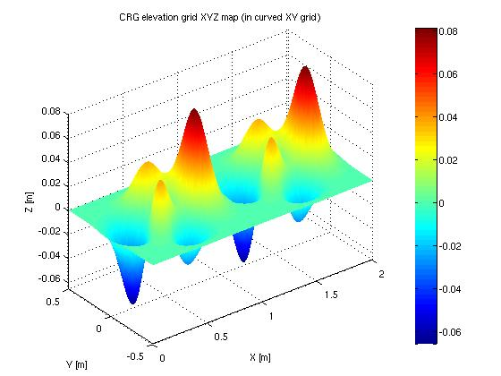
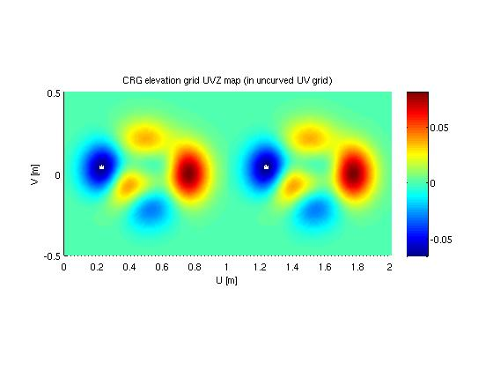

Modifiers and Options
In simple cases, data sets will be read from file and evaluations may take place immediately. However, the user may want to vary the way a specific data set is evaluated without having to modify the original data (i.e. the data file) itself.

For this purpose, modifiers and options have been introduced.

- Modifiers modify a copy of OpenCRG® data which is stored in memory and, therefore, provide the modified data for all subsequent evaluation requests

- Options influence the way a specific query is performed without modifying any of the data stored in memory.

In the data struct, modifiers are found in the substructure crg.mods and options are found in crg.opts. The tool suite provides discrete calls for setting modifiers and options. Evaluation methods take account if options are set..

Modifiers have to be executed by calling the crg_mods() routine, which will affect the modifier settings on crg-data.

Modifiers
As mentioned above, the OpenCRG® data struct contains the so called 'modifiers' which globally modify the crg-data. All modifier functionalities are equal to the C-API and explained there. Further details about the Matlab API are located in crg_intro or in the help content of the function..

CRG scaling (default: no scaling)
- scale elevation data
szgd scale elevation grid
sslp scale slope information
sbkg scale banking information

- scale refline data (resets refline position to origin)
slth scale u information
swth scale v information
scrv scale reference line's curvature
CRG elevation grid NaN handling
gnan how to handle NaN values (default: 2)
= 0: keep NaN
= 1: set zero
= 2: keep last value in cross section
gnao z offset to be applied at NaN positions (default: 0)
CRG re-positioning: refline by offset (default: "by refpoint")
rlox translate by rlox
rloy translate by rloy
rloz translate by rloz
rlop rotate by rlop around (xbeg, ybeg)
CRG re-positioning: refline by refpoint (overwrites "by offset")
- position (u,v) on reference line:
rpfu relative u (default: 0)
or: rptu absolute u
[with optional: rpou (default: 0)]
rptv absolute v (default: 0)
or: rpfv relative v
[with optional rpov (default: 0)]
- position (x,y,z) and orientation (phi) in inertial frame:
rptx target position (default: 0)
rpty target position (default: 0)
rptz target position (default: 0)
rptp target orientation (default: 0)

Modifiers are evaluated by the ‘crg_mods()’ routine. The mods are evaluated in sequence as they appear below, and are cleared after they are applied. An empty mods array inhibits any default settings. Make sure that you create a new struct for a new modifier set. The example below shows how to set up a modification.

data = crg_read('demo1.crg'); % read crg file
data.mods = struct; % create new struct
data.mods.gnan = 1; % set modifier
data = crg_mods(data); % apply mods on crg data

Options
As mentioned above, the OpenCRG® data struct contains also the so called 'options' which are applied during evaluation, not globally. All modifier functionalities are equal to the C-API and explained there. Further details about the Matlab API are located in ‘crg_intro’ or in the help content of the function.

CRG elevation grid border modes in u and v directions
bdmu at beginning and end (default: 2)
bdmv at left and right side (default: 2)
= 0: return NaN
= 1: set zero
= 2: keep last
= 3: repeat
= 4: reflect
bdou z offset beyond border (default: 0)
bdov z offset beyond border (default: 0)
bdss smoothing zone length at start
bdse smoothing zone length at end
CRG reference line continuation
rflc how to extrapolate (default: 0)
= 0: follow linear extrapolation
= 1: close track
CRG reference line search strategy
sfar far value (default: 1.5)
scls close value (default: sfar/5)
CRG message options
wmsg warning messages (default: -1)
wcvl local curvature limit exceeded (d:-1)
wcvg global curvature limit exceeded (d:-1)
lmsg log messages (default: -1)
leva evaluation inputs and results (default: 20)
levf how often (default: 1)
lhst refline search history (default: -1)
lhsf how often (default: 100000)
lsta evaluation statistics (default: -1)
lstf how often (default: 100000)
CRG check options
ceps expected min. accuracy (default: 1e-6)
cinc expected min. increment (default: 1e-3)
ctol expected abs. tolerance (default: 0.1*cinc)

Tools

crg_gen_csb2crg0: Generate synthetic roads
‘crg_gen_csb2crg0’_allows to simple generate crg-files including slope [s], banking [b] and curvature [c] in MATLAB.

crg_gen_csb2crg0( inc, u, v, c, s, b )

The minimal input parameter are increment [inc] and length information in u,v direction.

data = crg_gen_csb2crg0( [1,0.5], 100, 2);

Please also see ‘crg_test_gen_csb2crg0’, ‘crg_test_gen_road’, ‘crg_demo_gen_sl*’ and ‘crg_demo_gen_syntheticStraight’ for additional examples handling synthetic road generation.

Cross sections

Creating non equidistant cross sections (v) is up to the developer. Nevertheless the OpenCRG – Matlab Api provides several demonstrations ( ‘crg_demo_gen_sl*’ ) how a readable v-profile could be set up.

The task is devided into two steps.

  - Create readable profiles ( yourself )
  - Generate v-profile for crg_gen_csb2crg0.m ( ‘crg_check_uv_descript.m’ )

Create profile(s)
The next example shows one possibility to create profiles. Please note the comments for explanation.
%% STEP 1: create longitudinal and lateral profile(s) like this

% u ----> coordinate begin middle sections end
% v ----> coordinate left origin right
% l ---> left hand side
% r ---> right hand side
% w ---> width of whole road
% c ---> center of road
% p --> profile
% r --> raughness
% _ -> name_sect
% _ -> name_prof
% offset or amplitude to origin
% |
uwp_road_sect = [ ubeg uend ]; % road width u sections
uwp_road_prof = [ 1 1 ];
vwp_road_sect = 0 + [ 3 : -0.5 : -3 ]; % road width v sect
vwp_road_prof = 1 * [ ones(size(vwp_road_sect)) ];

ulp_lane_sect = [ ubeg uend ]; % left lane u sections
ulp_lane_prof = [ 1 1 ];
vlp_lane_sect = 1.25 + [ 1 : -0.2 : -1 ]; % left lane v sect
vlp_lane_prof = 1 * [ 1 0.8 0.8 0.6 0.6 0.6 0.6 0.6 0.8 0.8 1 ];

ulr_lane_sect = 100 + [ 0 10 50 60 ]; % left lane u sections
ulr_lane_prof = [ 1 0.8 0.8 1 ];
vlr_lane_sect = 1.25 + [ 1 : -0.2 : -1 ]; % left lane v sect
vlr_lane_prof = 1 * [ ones(size(vlr_lane_sect)) ];

urp_lane_sect = [ ubeg 30 40 50 80 90 uend ]; % right lane u sections
urp_lane_prof = [ 1 1 0.6 0.8 0.5 1 1 ];
vrp_lane_sect = -1.25 + [ 1 -1 ]; % right lane v sect
vrp_lane_prof = 1 * [ 1 1 ];

% mode one of {'Profile' 'Random' 'Ignore' }
% | u section u profile v section v profile valid only for random profile(s)
% | | | | | /----------^----------\
uv_mue = { ...
; { 'Profile' [ uwp_road_sect ; uwp_road_prof ] [ vwp_road_sect ; vwp_road_prof ] } ...
; { 'Random' [ ulr_lane_sect ; ulr_lane_prof ] [ vlr_lane_sect ; vlr_lane_prof ] 2010 0.5 1 0.4 0.4 } ...
; { 'Profile' [ ulp_lane_sect ; ulp_lane_prof ] [ vlp_lane_sect ; vlp_lane_prof ] } ...
; { 'Profile' [ urp_lane_sect ; urp_lane_prof ] [ vrp_lane_sect ; vrp_lane_prof ] } ...
};
% ^ ^ ^ ^ ^
% | | | | |
% | | | | v_smooth (random) in range 0..1
% | | | u_smooth (random) in range 0..1
% | | max amplithude random
% | min amplithude random
% initialize state of random generator

%% end of user settings

%% STEP 2: create and check lateral profile vector

v = crg_check_uv_descript(uv_mue, {'Ignore' 'Profile' 'Random'});

Create profile vector
OpenCRG provides a functionality to extract the cross section vector defined above. For further details see ‘crg_check_uv_descript.m’.

Curvature

Curvature can be divided into sections independent of banking and slope. It is described by a polynomial of grade 2. The following represents a possible curvature matrix definition.

c = { LC1 { 1/R1s (1/R1e - 1/R1s) / LC1 } …
; LC2 { 1/R2s (1/R2e - 1/R2s) / LC2 } …
; ……………
};

LC1, LC2 : section length
R1s, R2s : section starting radius
R1e, R2e : section ending radius

See also: ‘crg_test_gen_csb2crg0’

Slope

Slope can be divided into sections independent of banking and curvature. It is described by a polynomial of grade 2. The following represents a possible slope matrix definition.

s = { LS1 { S1s (S1e - S1s) / LS1 } …
; LS2 { S2s (S2e - S2s) / LS2 } …
; ……………
};

LS1, LS2 : section length
S1s, S2s : section starting slope
S1e, S2e : section ending slope

See also: ‘crg_test_gen_csb2crg0’

Banking

Banking can be divided into sections independent of slope and curvature. It is described by a polynomial of grade 2 or grade 3. The following represent possible slope matrix definitions.

b = { LB1 { B1s (B1e - B1s) / LB1 } …
; LB2 { B2s (B2e - B2s) / LB2 } …
; ……………
};

or ( non-linear for section LB2 )

b = { LB1 { B1s (B1e - B1s) / LB1 } …
; LB2 { B2_a B2_b B2_c B2_d } …
; ……………
};

LB1, LB2 : section length
B1s, B2s : section starting banking
B1e, B2e : section ending banking
B2_a, B2_b, B2_c , B2_d: section polynomial coefficients

See also: ‘crg_test_gen_csb2crg0’

Coherence of azimuth direction angle alteration, curve radius and clothoid parameter
( Based on Dr. Klaus Müller (Daimler AG) considerations to calculate sensible parameter for road construction )

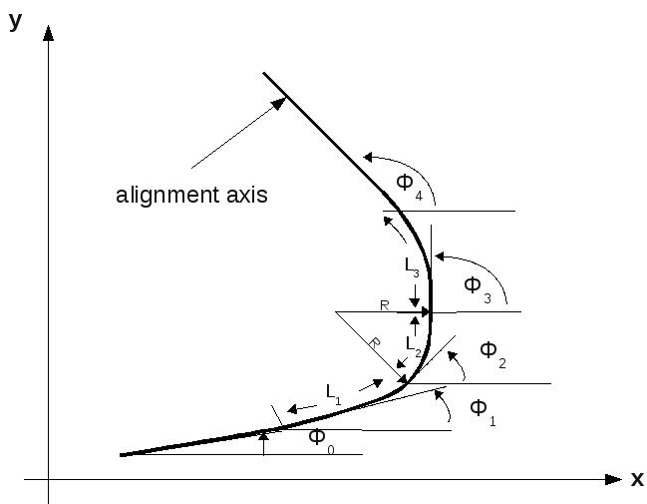

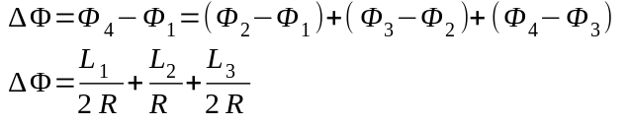

with R = radius
L₁ = length clothoid 1
L₂ = length circular arc
L₃ = length clothoid 2

common in road construction:

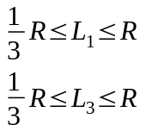

hence L_{1,2} = f_{1,2} * R
choose 0 <= f_{1,2}
yields to

