**ASAM CheckerLib for OpenDRIVE**

**Documentation**

# Base checks

## check_file_exist

* Short description

checks whether the file exists on the hard disc.

* how to test

checks whether the file exists on the hard disc at the folder and whether it is a file.

* Format Versionen

any version

* check file

base_checks\check_file_exist.py

* Output
  + Issue: Level: Error
  + causes check cancellation

## check_xml_parsing

* Short description

checks if xml file can be parsed

* how to test

checks if xml file can be opened and parsed

Prerequisite: file must exist and be readable as xml

* Format Versionen

any version

* check file

base_checks\check_xml_parsing.py

* Output

Issue: Level: Error

causes check cancellation

# Schema checks

## check_version

* Short description

reads the version number from the OpenScenario file

* how to test

reads the version number from the tags "revMajor", "revMinor" from the OpenScenario file

* Format Versionen

Schema file of versions 1.1, 1.2, 1.3, 1.4, 1.5, 1.6.1, 1.7.0 are available.

* check file

schema_checks\check_schema.py

* Output
  + Issue: Level: Error
  + causes check cancellation

## check_schema

* Short description

The XML tree is tested against the XML schema (xsd) according to the version of the OpenDrive file.

* how to test

The OpenDrive version is determined from the header. The schema file corresponding to this version is then loaded and the XML tree is validated against it.

Prerequisite: The file must have been read in correctly first.

* Format Versionen

Schema file of versions 1.1, 1.2, 1.3, 1.4, 1.5, 1.6.1, 1.7.0 are available.

* check file

schema_checks\check_schema.py

* Todos
  + ObjektReferenzen produzieren Issue wegen doppelter ID
    - core.xsd falsch?
    - <xs:key name="k_road_objects_objectReferenceId">
    - <xs:selector xpath="road/objects/objectReference"/>
    - <xs:field xpath="@id"/>
    - </xs:key>
* Output
  + Issue: output of schema validation process
    - Level: Error
    - Location: xml , file
* example
  + examples\Schema\InvalidSchemaRoad.xodr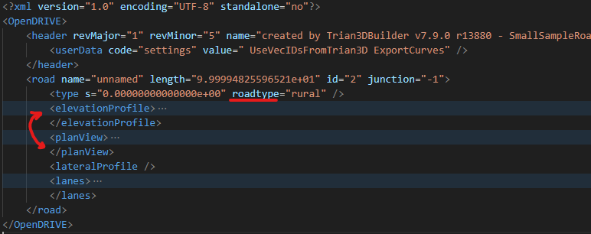
    - Element 'type', attribute 'roadtype': The attribute 'roadtype' is not allowed.
    - Element 'elevationProfile': This element is not expected. Expected is one of ( type, planView ).
  + examples\Schema\InvalidUniqueIDOfRoad.xodr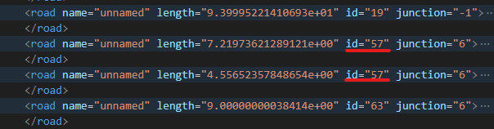
    - Element 'road': Duplicate key-sequence ['57'] in key identity-constraint 'k_roadId'.

## check_ID_type

* Short description

It is checked whether the IDs are of type unsigned int 32.

* how to test

For elements (road, signal, signalReference, object, objectReference, tunnel, bridge, junction) the id attribute is checked to see whether it is greater than 0 and less than unsigned int 32 max (4294967295).

* Format Versionen
  + 1.7.0
* check file

schema_checks\check_ID_type.py

* Todos
  + other versions
* Output
  + Issue: Output if id not in valid range.
    - Level: Error
    - Location: xml , file
* example
  + examples\Schema\InvalidIDTypeRoad.xodr
    - road has invalid id -2

## check_lane_ID_type

* Short description

It is checked whether the IDs of the lanes are of type int 8.

* how to test

For IDs of lanes (left, center, right), the id attribute is checked to see whether they are greater than -127 and less than +127.

* Format Versionen
  + 1.7.0
* check file

schema_checks\check_lane_ID_type

* Todos
  + other versions
* Output
  + Issue: Output if id not in valid range.
    - Level: Error
    - Location: xml , file
* example
  + examples\Schema\InvalidIDTypeRoad.xodr

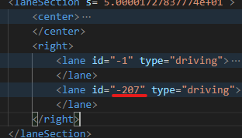

* + - road 2 lane has invalid id -207

# Semantic checks

## check_road_linkage

* Short description

checks if linked Predecessor/Successor road/junction exists

* how to test

For each street, the ID and element type of the predecessor/successor is checked to see whether it refers to a valid road or junction.

* Format Versionen
  + 1.1-1.7
* check file

semantic_checks\check_road_linkage.py

* Todos
* Output
  + Issue: Output of the road/junction ID, that could not be found in other streets or intersections.
    - Level: Error
    - Location: xml , file, road
* example
  + examples/Semantic/check_road_linkage.xodr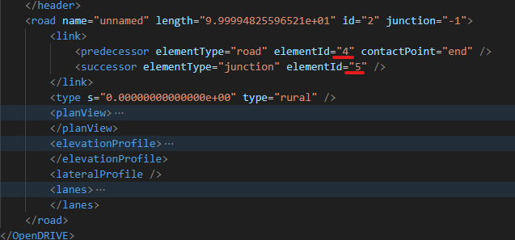
    - predecessor road (id=4) of road 2 not found!
    - successor junction (id=5) of road 2 not found!

## check_road_linkage_backward

* Short description

check if linked elements are also linked to original element

* how to test

For each linked element (see check_road_linkage), it is checked if this element is also linked by predecessor/successor to the original element. If road A is connected to the front of road B at its end, than road B also has to be connected to the end of road A at its front.

* Format Versionen
  + 1.1-1.7
* check file

semantic_checks\check_road_linkage_backward.py

* Todos
* Output
  + Issue: Output of TODO
    - Level: Error
    - Location: xml , file, road
* example
  + examples/Semantic/check_road_linkage_backward.xodr
  + 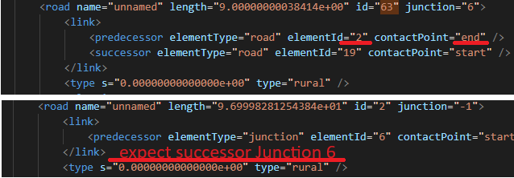
    - road 63 is linked to road 2, but reverse link does not exist!

## check_lane_type

* Short description

check lane type "none" is allowed, but has no information content

* how to test

for each lane in each lanesection in each road the lanetype is checked

* Format Versionen
  + 1.1-1.7
* check file

semantic_checks\check_lane_type.py

* Output
  + Issue: Output of TODO
    - Level: Info
    - Location: xml , file
* example
  + examples/Semantic/check_lane_type.xodr
  + 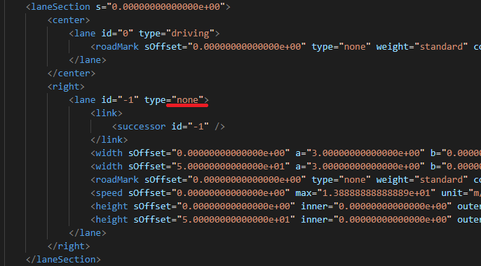
    - road 2 has invalid lanetype none in laneSection s=0.0 lane=-1

## check_lane_valid_width

Short description

check width values of lanes

how to test

For each width polynom it is checked if its width is always greater or equal to zero in its range.

* Format Versionen
  + 1.1-1.7
* check file

semantic_checks\check_lane_valid_width.py

* Todo
  + darf die lane in der mitte der lanesection breite 0 haben?
* Output
  + Issue: Output of TODO
    - Level: Warning
    - Location: xml , file
* example
  + examples/Semantic/check_lane_valid_width.xodr
  + 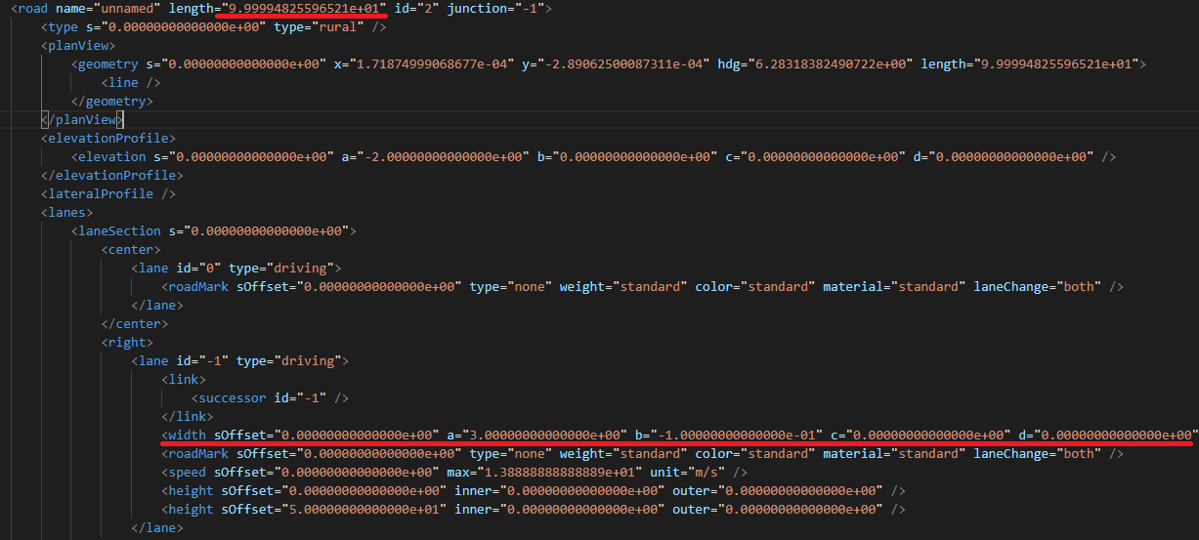
    - road 2 has invalid width:-1.9999993809797916 in laneSection s=0.0 lane=-1 sOffset=0.0

## check_lane_valid_sOffset

* Short description

check lane sOffsets (must be ascending, not too high) and sometimes be zero

* how to test

checked sOffset Properties for all lanes: border, height, roadMark, rule

checked sOffset Properties for all lanes except center: width, material, speed, access

checks if sOffset is greater than previous sOffset (except for access)

checks if first sOffset is zero (only for width, border)

checks if sOffset is not too high in respect of length of lanesection

* Format Versionen
  + 1.1-1.5 - additional visibility
  + 1.6., 1.7
* check file

semantic_checks\check_lane_valid_sOffset.py

* Todos
  + 1.1-1.5 - additional visibility
* Output
  + Issue: Output of TODO
    - Level: Warning
    - Location: xml , file
* example
  + examples/Semantic/check_lane_valid_sOffset.xodr
  + 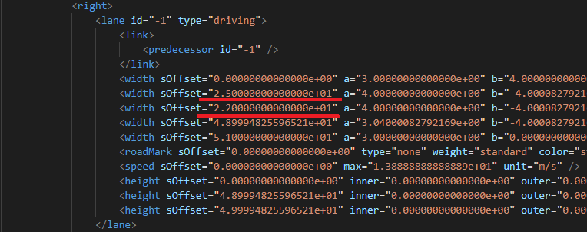
    - road 2 has invalid (not ascending) sOffset:22.0 in laneSection s=50.0 lane=-1 width

## check_lanes_id_linkage

* Short description

check if lane links point to existing lanes

* how to test

For each lane it is checked if their predecessor and successor point to valid lanes in the neighbour lanesection or road

* Format Versionen
  + 1.1-1.7
* check file

semantic_checks\check_lanes_id_linkage.py

* Todos
  + Seite bestimmen oder wie bisher aus ID nehmen?
    - Darf Lane +1 als pred/succ Lane -1 haben? bei bidirectional lanes evtl?
  + get lanesection of main road at virtual junctions
    - not front/back -> get by s
* Output
  + Issue: Output of TODO
    - Level: Warning
    - Location: xml , file
* example
  + examples/Semantic/check_lanes_id_linkage.xodr
  + TODO Bild
    - TODO TestOutput

## check_lanes_order

* Short description

check if lanes are ordered correctly

* how to test

For each lane it is checked if its id is exactly one smaller than the id of its left neighbour

* Format Versionen
  + 1.1-1.7
* check file

semantic_checks\check_lanes_order.py

* Todos
* Output
  + Issue: Output of TODO
    - Level: Warning
    - Location: xml , file
* example
  + examples/Semantic/check_lanes_order.xodr
  + TODO Bild
    - TODO TestOutput

## check_signal_position

* Short description

check if signal position is valid

* how to test

For each signal it is checked if its s value is in range of road length, if its t value is in range of (-max_range_signal_t, max_range_signal_t) and if its zOffset value is in range of (-max_range_signal_zOffset, max_range_signal_zOffset)

* Format Versionen
  + 1.1-1.7
* check file

semantic_checks\check_signal_position.py

* Todos
* Output
  + Issue: Output of TODO
    - Level: Warning
    - Location: xml , file
* example
  + examples/Semantic/check_signal_position.xodr
  + TODO Bild
    - TODO TestOutput

## check_signal_size

* Short description

check if signal size is valid

* how to test

For each signal it is checked if its width and height values are not too high

* Format Versionen
  + 1.1-1.7
* check file

semantic_checks\check_signal_size.py

* Todos
* Output
  + Issue: Output of TODO
    - Level: Warning
    - Location: xml , file
* example
  + examples/Semantic/check_signal_size.xodr
  + TODO Bild
    - TODO TestOutput

## check_lane_validity

* Short description

check if signal/object validity lanes are valid

* how to test

For each signal/object validity entry it is checked if the refenrenced lanes exist, are not zero and are on the correct side of the road if orientation is + or -

* Format Versionen
  + 1.1-1.7
* check file

semantic_checks\check_lane_validity.py

* Todos
  + from immer kleiner? oder abs(from) kleiner? Was wenn orientation both?
  + was zurückgeben, wenn bei s eine LaneSection startet/endet
* Output
  + Issue: Output of TODO
    - Level: Warning
    - Location: xml , file
* example
  + examples/Semantic/check_lane_validity.xodr
  + TODO Bild
    - TODO TestOutput

## check_object_position

* Short description

check if object position is valid

* how to test

For each object it is checked if its s value is in range of road length, if its t value is in range of (-max_range_object_t, max_range_object_t) and if its zOffset value is in range of (-max_range_object_zOffset, max_range_object_zOffset)

For bridge/tunnel objects it is checked if the bridge/tunnel does no go beyond the roads end

* Format Versionen
  + 1.1-1.7
* check file

semantic_checks\check_object_position.py

* Todos
* Output
  + Issue: Output of TODO
    - Level: Warning
    - Location: xml , file
* example
  + examples/Semantic/check_object_position.xodr
  + TODO Bild
    - TODO TestOutput

## check_object_size

* Short description

check if object size is valid

* how to test

For each object it is checked if its radius, width and length values are not too high. Also it is checked if there is either a radius or width and length provided. There shall be only one of them defined.

* Format Versionen
  + 1.1-1.7
* check file

semantic_checks\check_object_size.py

* Todos
  + check auf < 0 eingebaut, da im schema nicht gecheckt (sollte es aber)
* Output
  + Issue: Output of TODO
    - Level: Warning
    - Location: xml , file
* example
  + examples/Semantic/check_object_size.xodr
  + TODO Bild
    - TODO TestOutput

## check_junction_connections

* Short description

check if junction connection exists for connecting road

* how to test

For each connection road it is checked if has a pedecessor and a successor

For each connection road with driving lanes it is checked, if at least one junction connection entry exists that is connected with this connection road

For each connection it is checked if the given connection road is linked to the given incoming road at the given contact point

* Format Versionen
  + 1.1-1.7
* check file

semantic_checks\check_junction_connections.py

* Todos
* Output
  + Issue: Output of TODO
    - Level: Error
    - Location: xml , file
* example
  + examples/Semantic/check_junction_connections.xodr
  + TODO Bild
    - TODO TestOutput

## check_driving_lanes_continue_in_junction

* Short description

check if all drivable lanes towards junction are connected with the junction

* how to test

For each drivable lane of each incomingRoad that leads towards a junction, it is checked, if the lane is connected with a crossing road by a junction connection

It is also checked if there is at least one driving lane the leads towards the junction

* Format Versionen
  + 1.1-1.7
* check file

semantic_checks\check_driving_lanes_continue_in_junction.py

* Todos
  + Check ob Zeile 28 durch anderen Check erschlagen wird - nein - neuer Check
  + Welche laneTypen sind noch relevant? In config packen?
  + DirectJunctions
* Output
  + Issue: Output of TODO
    - Level: Warning
    - Location: xml , file
* example
  + examples/Semantic/check_driving_lanes_continue_in_junction.xodr
  + TODO Bild
    - TODO TestOutput

## check_junction_lane_linkage

* Short description

check if linked lanes of junction exist in linked road

* how to test

For each incomingRoad and each connectionRoad of a junction, it is checked, if the provided linked lanes exists in these roads

* Format Versionen
  + 1.1-1.7
* check file

semantic_checks\check_junction_lane_linkage.py

* Todos
  + Breite der Lane gültig prüfen? Bei Breite = 0 sollte sollte keinen LaneLink existieren
  + Lanes mit Breite 0 sollte keinen Pred/Succ haben -> separater Check (evtl der Fall oben da mit rein)
  + Stimmen die Profile am Übergang (Straße zu Straße)
  + Ist eine IncomingRoad einer Kreuzung auch mit der Kreuzung verbunden (pred/succ/beides?)
    - Je Junction
      * collect all incoming roads from connections
      * for each incomingroad -> road muss auf der entsprechenden Seite (pred/succ oder beides je nach linkedLanes) mit junction verbunden sein
  + Und eine Straße die als pred/succ eine junction hat sollte auch mit einer der junction roads verbunden sein - neuer Check?
    - Je Junction
      * collect all roads that have this junction as pred/succ
      * collect all connection roads
      * for each road -> mindestens eine connection road muss als pred/succ diese road haben
* Output
  + Issue: Output of TODO
    - Level: Error
    - Location: xml , file
* example
  + examples/Semantic/check_junction_lane_linkage.xodr
  + TODO Bild
    - TODO TestOutput

## check_junction_lane_linkage_order

* Short description

check if linked lanes of junction connection are ordered correctly

* how to test

For each connection of a junction, it is checked, if the provided linked lanes are ordered

* Format Versionen
  + 1.1-1.7
* check file

semantic_checks\check_junction_lane_linkage_order.py

* Todos
  + Sprünge dürfen nur sein, wenn Breite 0 und müssen dann auch sein! Separater Check?
  + müssen die wirklich sortiert sein? in der spec nichts dazu gefunden
    - wie sortiert? bei LHT evtl anders herum?
* Output
  + Issue: Output of TODO
    - Level: Warning
    - Location: xml , file
* example
  + examples/Semantic/check_junction_lane_linkage_order.xodr
  + TODO Bild
    - TODO TestOutput

## check_laneSection_valid_s

* Short description

check if LaneSection has valid s

* how to test

For each LaneSection it is checked, if its s value is not higher than the roads length. It is also checked if the s value is higher than the s value of the previous LaneSection and if it is zero for the first LaneSection.

* Format Versionen
  + 1.1-1.7
* check file

semantic_checks\check_laneSection_valid_s.py

* Output
  + Issue: Output of TODO
    - Level: Warning
    - Location: xml , file
* example
  + examples/Semantic/check_laneSection_valid_s.xodr
  + TODO Bild
    - TODO TestOutput

## check_laneSection_min_length

* Short description

checks the length of LaneSections

* how to test

For each LaneSection it is checked, if its length is bigger than a defined epsilon

* Format Versionen
  + 1.1-1.7
* check file

semantic_checks\check_lanesection_min_length.py

* Output
  + Issue: Output of TODO
    - Level: Information
    - Location: xml , file
* example
  + examples/Semantic/check_lanesection_min_length.xodr
  + TODO Bild
    - TODO TestOutput

# Geometry checks

## check_road_min_length

* Short description

checks the length of roads

* how to test

For each road it is checked, if its length is bigger than a defined epsilon

* Format Versionen
  + 1.1-1.7
* check file

semantic_checks\check_road_min_length.py

* Output
  + Issue: Output of TODO
    - Level: Information
    - Location: xml , file
* example
  + examples/Semantic/check_road_min_length.xodr
  + TODO Bild
    - TODO TestOutput

## check_road_geometry_length

* Short description

checks the length of geometry elements

* how to test

For each geometry element it is checked, if its length matches the distance of its start and end s (given by start s of next geometry element or length of road for last geometry element). Also it is checked if the length is bigger than a defined epsilon

* Format Versionen
  + 1.1-1.7
* check file

semantic_checks\check_road_geometry_length.py

* Output
  + Issue: Output of TODO
    - Level: Warning
    - Location: xml , file
* example
  + examples/Semantic/check_road_geometry_length.xodr
  + TODO Bild
    - TODO TestOutput

## check_paramPoly3

* Short description

checks the values of parampoly3 elements

* how to test

For each parampoly3 it is checked, if its aU and aV are zero, it its bV is smaller the a defined epsilon and if its bU is greater than zero

* Format Versionen
  + 1.1-1.7
* check file

semantic_checks\check_paramPoly3.py

* Output
  + Issue: Output of TODO
    - Level: Warning
    - Location: xml , file
* example
  + examples/Semantic/check_paramPoly3.xodr
  + TODO Bild
    - TODO TestOutput