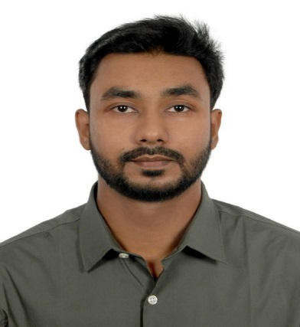

|  |  |
| --- | --- |
| **TOOLS USED** | **SKILL** |
| * MS Word | * Video Editing |
| * MS Excels | * Content Writing |
| * Power Point | * Planning and Execution |
| * Premier Pro | * Event Management |
| * Quark Express | * News Editing |

**EXPERIENCE**  
 **Amar Ekushey Book Fair. (2020)** Bangla Academy, Dhaka.  
 Worked as Bookkeeper.

**Daffodil International University. (2022)** JMC MEDIA LAB, Dhaka.  
 Intern as a Video editor.

**PERSONAL INFORMATION**

**NAME:** Md. Saddam Hossain

**Location:** Munshiganj, Dhaka

**Gender:** Male

**Nationality:** Bangladeshi

**Religion:** Islam

**Blood Group:** “O” Positive

**Marital Status:** Unmarried

**LANGUAGE:** Bangla (native), English

**EXTRA CURRICULUM ACTIVITIES**

* Participated in “WORKSHOP ON CINEMATOGRAPHY” by “PANKAJ PALIT”
* Member of DIU Communication Club
* Organized a webinar on SPORTS JOURNALISM

**CONTACT**

 Notun polton line, Azimpur.  
 Dhaka 1205.

 Mob no. 01857088510

 [saddam24-646@diu.edu.bd](mailto:saddam24-646@diu.edu.bd)

**EDUCATION**  
 **Bachelor of social sciences (B.S.S)**  
 Daffodil International University, Dhaka.  
 Journalism Media and Communication.  
 Passing year 2022 | CG-PA: 3.0

**Higher secondary school certificate (H.S.C)**  
 Dhaka Imperial college, Dhaka.  
 Passing year: 2013 | GPA: 3.70

**Secondary school certificate (S.S.C)**   
 University Laboratory School and college, Dhaka.  
 Passing year: 2011 | GPA: 4.31

**MD. SADDAM HOSSAIN**

**PROFILE**I am an adaptive as well as quick learner to learn from every aspect and improve myself on daily basis. I like to gather experience from each and possible opportunity I get in order to portray a better version of myself.