**The First Function**

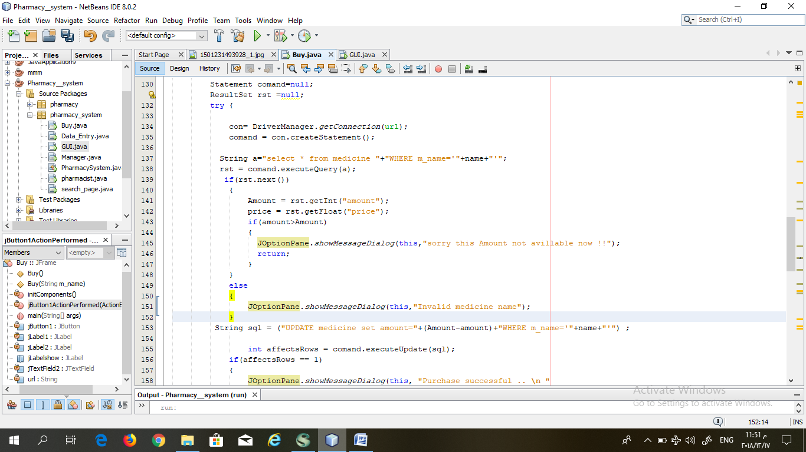

**1. the Flow Graph:-**

**2. the V(G) = P+1 = 1+1 =2 ; V(G) = closed area + 1 = 1+1 2 ; V(G) = 16-15+1= 2**

**3. the path : 1**- ( 137,138,139,149,150,151,152)

**2-** (137,138,139,140,141,142,143,144,145,146,147,148,152)