* There should be a way to reset stars / cancel
* Add “Account Manager” and “Recruitment Support” in top ratings.
* Please make same exact formatting and alignment as below.
* Check results should be connected to CURRENT AM if done by someone else.

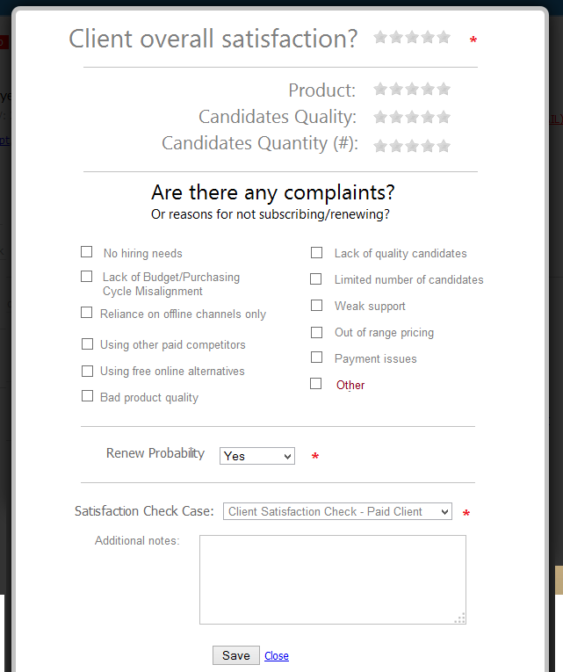

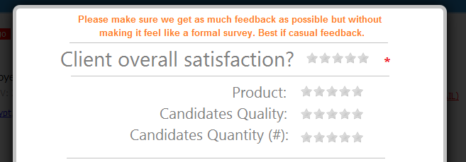

**Please make sure we get as much feedback as possible but without making it feel like a formal survey. Best if casual feedback.**

This is note by admin name:

[Client Satisfaction Check – Paid Client: 5 Stars](sad)

Additional notes go here…

Clicking the link opens same satisfaction check preview.