Edits in job post to make it more usable and improve for sales positions.

In job post:

1. We will add new copy with salary:
   * (*including* bonuses and commissions)
2. We will (?) beside salary
   * Example, if this job offers a net basic salary of $1,000 to $2,000 plus expected commissions ranging from $500 to $2,000 >> you should put a salary range of $1,500 to $4,000.
   * Even if you keep the salary hidden/confidential, this data will be used to promote your job to candidates with the right salary range.

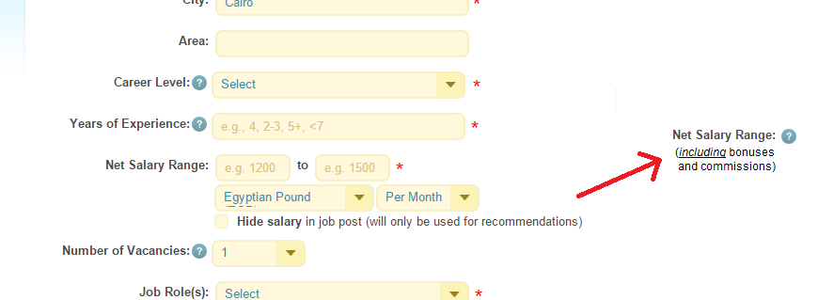

1. Job title, Job description, and job responsibilities must have spell checking… please show me options!
2. Move the additional salary details to the top, right after salary:

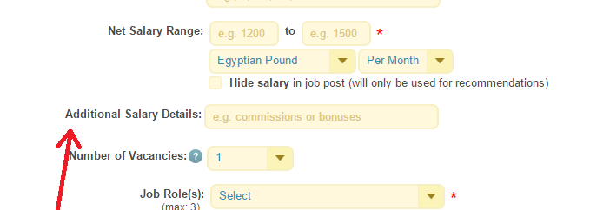

1. If the job role = sales, check career level. If == Entry Level >> **uncheck** the “ask applicants to answer – why should we hire you for this position?”
   * This should be javascript check when user selects job role = sales or career level = entry level. If unchecked auto, then user changes this option, check it again. UNLESS user intentionally unchecked it!
2. Don’t close story till Ameer sees it.