- Meta Description

Consulta las webcams en directo de Baqueira Beret y planifica tus clases de esquí con Alpine Ski Academy. Conoce el estado actual de las pistas.

Put this text on the box and linke it to clases de esquí: clases de esquí en Baqueira
https://alpineskiacademy.com/clases-de-esqui-baqueira
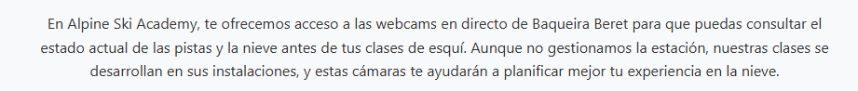

The box are not working may be if they send you dawner when the cameras link to baqueira is enougth
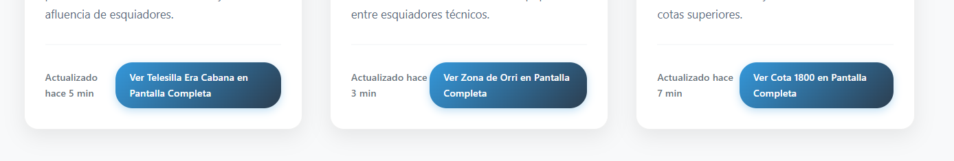

That one is not conecting anywhere take it off with the other 3 its ok I think ( the picture is not Baciver is BAqueira )
