6 images without alt text

Link that text to:
https://alpineskiacademy.com/clases-de-esqui-baqueira
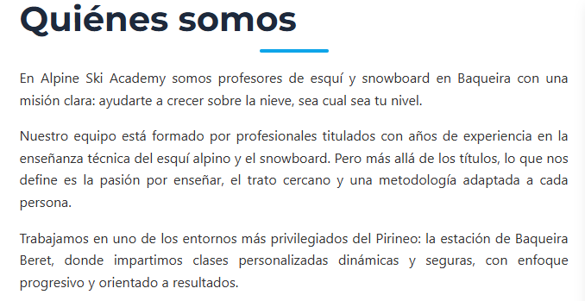

Link with and anchor tis text bot to the home:
https://alpineskiacademy.com/
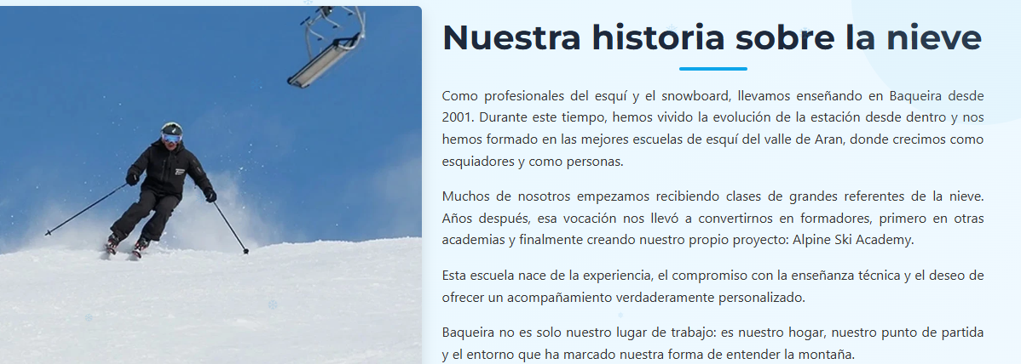

This text is not well aligned:
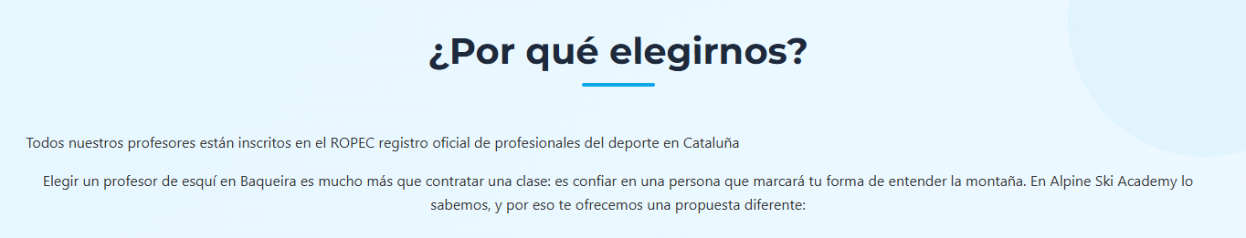

Put the official title to! The diploma!
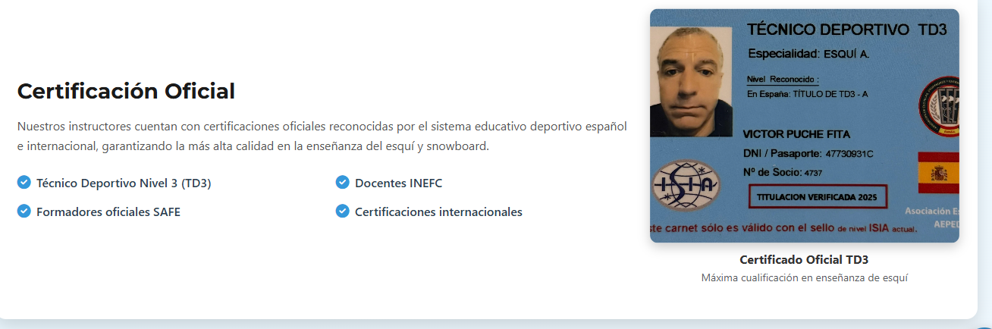

Is not sending to the mail reserva@alpineskiacademy.com
