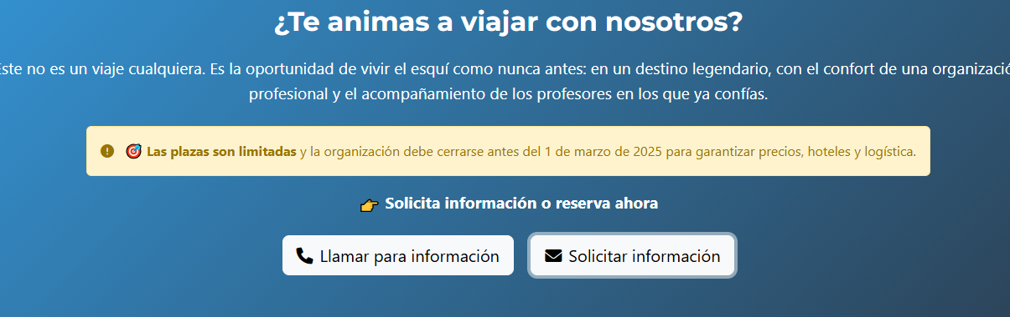

The box is not sending to the mail reservas@

