- Meta Description
Descubre los mejores restaurantes en el Valle de Arán. De la cocina tradicional a la gourmet, nuestras recomendaciones para que disfrutes de tu viaje.
5 images without alt text.

Link that book to the home page.
https://alpineskiacademy.com/

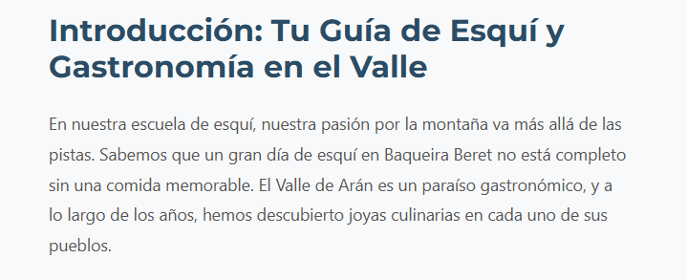

All the boxes have to say: Ver en Google Profile
And link to the Google every Restaurant noon of them is well linked
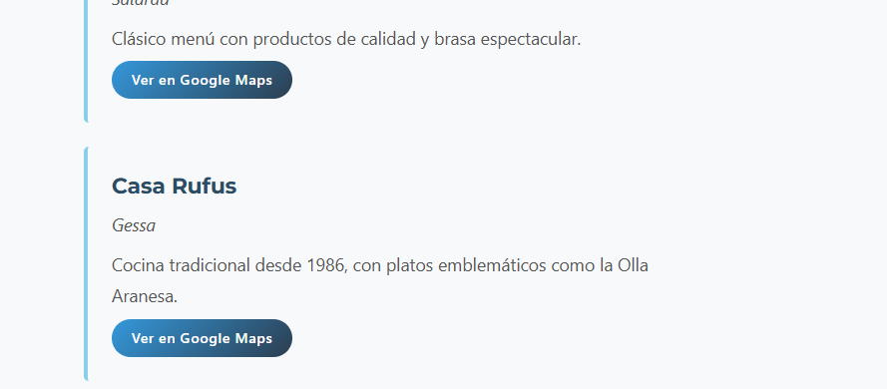

The links are not sending to the correct articles
