Meta description.
Clases de esquí particulares con tecnología Carv en Baqueira. Sensores que analizan tu técnica en tiempo real para mejorar precisión y rendimiento.

Need to check headings structure to have some h3 if there are 4,5,and6

5 Images without alt text

Bread crumbs is not sending to clases de esquí
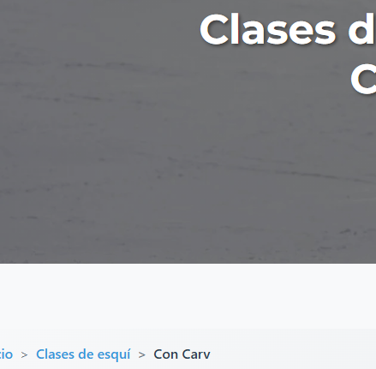

Link the box to Nosotros as an anchor text:
https://alpineskiacademy.com/sobre-nosotros
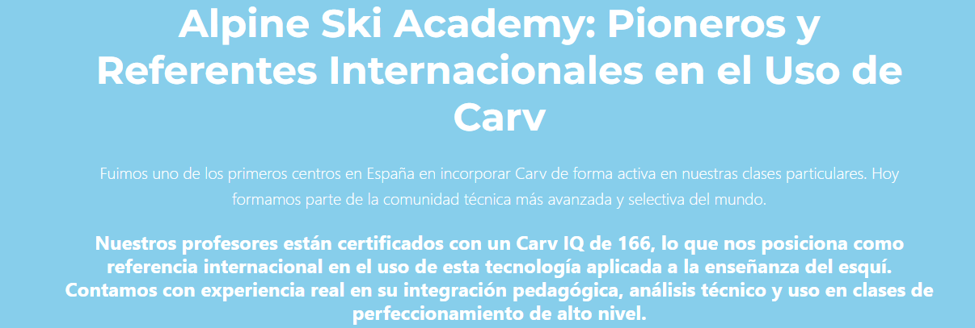

Put that text in front of Alpine ski Academy and linked it as an anchor to home page: https://alpineskiacademy.com/
En la escuela de esquí de Baqueira,
