KLAO PLATFORM ARCHITECTURAL SPECIFICATION MANUAL
Ignite Idea Operating System (KLAO) Engine & Console PWA
Document Version: 1.0.0
Status: System Baseline Reference
Author: Antigravity AI Architect & Platform Engineering Team
Date: July 2026
Classification: CONFIDENTIAL - INTERNAL USE ONLY

1. Executive Summary & Platform Identity
The KLAO Platform is a custom, multi-tenant enterprise engine designed exclusively to power internal operations at Ignite Idea. It centralizes and automates core operational processes, including Sales Lead Management, Project Delivery tracking, Case resolution, and Timesheet recording.
The platform is structured with a clean monorepo architecture built as a Bun Workspace. KLAO separates concerns between its decoupled subsystems: a headless backend API layer (KLAO Core), a premium progressive web app interface (KLAO Console), and a shared kernel type library (KLAO Shared).
1.1 Core Architecture Highlights
- KLAO Core — Headless Backend: packages/core runs on Bun runtime and compiles schemas dynamically via Next.js API Routes.
- KLAO Console — Progressive Web App: packages/console is built with Vite, React, and TypeScript. It utilizes a custom, premium design system and loads configurations dynamically from metadata.
- KLAO Shared — Shared Kernel: packages/shared maps type boundaries, API requests/responses, and metadata definitions globally, maintaining type safety.
- AlchemaEngine — Dynamic Metaprogramming: Tables and fields are stored as metadata templates in PostgreSQL and synthesized on the fly into native physical tables.
Below is the structural view of the KLAO Monorepo, outlining the relationships between packages and the central database:
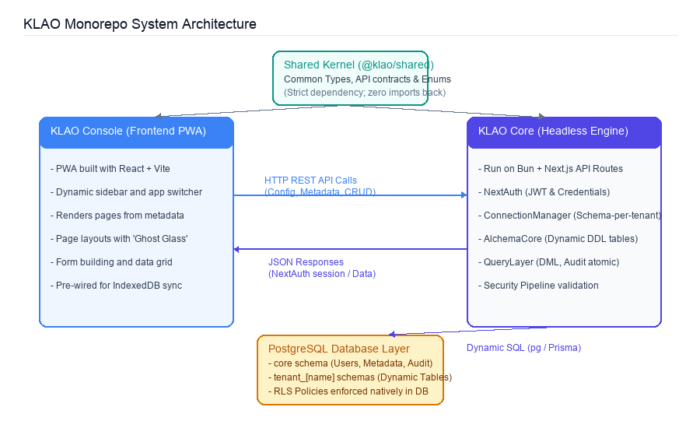
Figure 1.1: KLAO Platform Monorepo & System Architecture
2. Core Database Architecture & Multi-Tenancy
Multi-tenancy in KLAO is isolated at the PostgreSQL schema layer. This strategy avoids complex global table filtering constraints, isolates raw data operations, and provides a clear path for future expansion to database-per-tenant architecture.
2.1 Schema Segregation Rule
The database architecture strictly enforces logical boundaries between metadata definitions and tenant transaction data:
- Core Schema (core): Contains system configuration (Apps, Navigation Menus, Capabilities), user accounts, permission registries, table definitions, and audit logs. The core schema is managed via Prisma.
- Tenant Schemas (tenant_{schemaName}): Contains physical tables generated dynamically. Each department or business unit (Tenant) at Ignite Idea is allocated an isolated schema (e.g. tenant_sales, tenant_delivery). Raw staff members are denied direct access to this data.
2.2 ConnectionManager Abstraction
The ConnectionManager class serves as a centralized abstraction layer. It caches Postgres database pools based on the configured isolation strategy:
export type IsolationStrategy = 'SCHEMA_PER_TENANT' | 'DATABASE_PER_TENANT';
// ConnectionManager resolves the tenant pool dynamically
getTenantPool(schemaName: string): Pool {
if (this.strategy === 'SCHEMA_PER_TENANT') {
return this.corePool; // Share database, split schemas
}
return this.tenantPools.get(schemaName); // Future: Dedicated database pools
}
2.3 Dynamic Table Lifecycle & DDL Synthesis
KLAO does not rely on static migration files for tenant data structures. Instead, when an admin defines a table via the platform studio, AlchemaCore translates the definition and applies physical schema migrations dynamically:
- Metadata Write: User creates a Table definition in KLAO Studio.
- Registry Sync: TranslatorLayer.ts maps the configuration and writes it to the core.tables and core.fields metadata registries.
- DDL Execution: AlchemaCore.ts compiles the definition into standard PostgreSQL DDL statements (e.g. CREATE TABLE) and executes it on the tenant's schema.
- Policy Binding: Row-Level Security (RLS) is automatically enabled and forced, and a default ownership security policy is bound to the new table.
Table Minimum Column Requirements
Every dynamically created table in a tenant schema is synthesized with a standard audit and isolation header. The following columns are mandatory for all custom entities:
Column Name | PostgreSQL Type | Constraint / Default | Purpose
id | UUID | PRIMARY KEY DEFAULT gen_random_uuid() | Unique identifier generated client or server side.
tenant_id | UUID | NOT NULL DEFAULT app.current_tenant_id | Filters query results automatically via RLS.
created_at | TIMESTAMPTZ | DEFAULT NOW() | Automated timestamp of record creation.
updated_at | TIMESTAMPTZ | DEFAULT NOW() | Automated timestamp of last write.
owner_id | UUID | NOT NULL DEFAULT app.current_user_id | Binds the record to the creating User.
owner_team_id | UUID | DEFAULT app.current_team_id | Binds the record to the active Team for group ownership.
created_by | UUID | NULL | Tracks the user ID who initialized the row.
updated_by | UUID | NULL | Tracks the user ID who updated the row.
2.4 PostgreSQL Row-Level Security (RLS)
To prevent cross-tenant data leakage or unauthorized access to sensitive records, the database enforces RLS natively at the connection level. AlchemaCore binds a comprehensive policy formula during table compilation:
CREATE POLICY {tableName}_owner_policy ON {schemaName}.{tableName}
FOR ALL USING (
tenant_id = NULLIF(current_setting('app.current_tenant_id', true), '')::uuid
AND (
owner_id = NULLIF(current_setting('app.current_user_id', true), '')::uuid
OR owner_team_id = NULLIF(current_setting('app.current_team_id', true), '')::uuid
OR EXISTS (
SELECT 1 FROM core.user_teams ut
LEFT JOIN core.object_permissions p ON ut.team_id = p.team_id AND p.object_name = {objectName}
LEFT JOIN core.teams t ON ut.team_id = t.id
WHERE ut.user_id = NULLIF(current_setting('app.current_user_id', true), '')::uuid
AND t.tenant_id = tenant_id
AND (p.view_all_data = true OR t.is_system_admin = true)
)
OR owner_id IN ( -- Manager visibility of subordinates
SELECT user_id FROM core.user_teams ut
JOIN core.teams t ON ut.team_id = t.id
WHERE t.parent_id IN (
SELECT team_id FROM core.user_teams WHERE user_id = NULLIF(current_setting('app.current_user_id', true), '')::uuid
) AND t.tenant_id = tenant_id
)
)
)
[RLS SECURITY RULE] PostgreSQL session configurations are injected dynamically using SET LOCAL statements inside TransactionContext.ts. This binds session values within a single database transaction context, preventing thread bleeding.
3. Headless Backend API & Security Pipeline
KLAO Core acts as a stateless, headless JSON API. Security is built into the request pipeline rather than individual endpoints. The platform enforces a strict sequence of checks before executing queries or returning data:
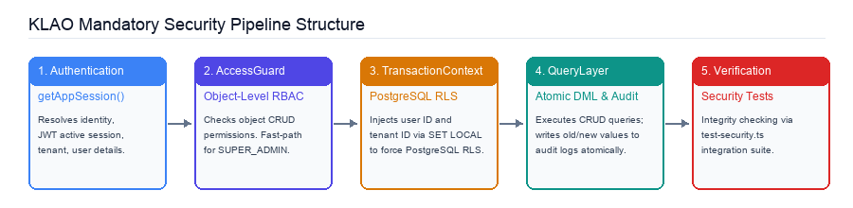
Figure 3.1: Core API Request Execution and Security Validation Pipeline
3.1 Core Pipeline Stages
- Stage 1: Identity Resolution (Auth). Invokes getAppSession() which lazy-loads NextAuth context. It extracts the JWT containing tenantId, role, and the teams array. If no session is present, it returns an HTTP 401 error.
- Stage 2: Access Control (AccessGuard). Enforces functional and object permissions. It checks user capabilities using AccessGuard.checkPermission. If the role is SUPER_ADMIN, it triggers a fast-path bypass. Otherwise, it aggregates permissions from the user's teams.
- Stage 3: PostgreSQL Injection (TransactionContext). Wraps DB queries in TransactionContext.executeWithUserContext. It issues BEGIN, executes SET ROLE rls_user, and injects session configurations (app.current_user_id, app.current_tenant_id, app.current_team_id) to activate RLS policies.
- Stage 4: Mutation & Auditing (QueryLayer). Executes DML queries. It wraps inserts, updates, and deletes in the transaction and logs the mutation context (old vs. new JSON values) directly to core.audit_logs.
- Stage 5: Verification & Safety (Cleanup). Ensures that the database context resets (RESET ROLE, RESET configuration) to return cleanly to the pool. Next, test-security.ts validates the isolation guarantees.
3.2 Extensible FieldRegistry System
To handle data serialization and validation, KLAO implements an extensible FieldRegistry. This decouples logical input representations (UI components) from physical types (PostgreSQL columns). Adding new inputs (like Address, Citizen ID, or GeoJSON) is resolved in registry files:
- Physical Types: text, number, boolean, date, relation, jsonb.
- Logical Types: short_text, long_text, email, phone, currency, lookup, lat_lng, select.
The backend dynamically evaluates these mappings to compile Zod schemas on the fly using zodGenerator.ts, validating input payloads before executing inserts or updates:
// zodGenerator.ts creates validation rules dynamically based on Field registry definitions
export function generateZodSchema(fields: FieldDefinition[]): z.ZodObject<any> {
const shape: Record<string, z.ZodTypeAny> = {};
for (const f of fields) {
let rule = mapLogicalTypeToZodRule(f.logicalType);
if (f.isRequired) rule = rule.nonempty();
shape[f.fieldName] = rule;
}
return z.object(shape);
}
4. Console PWA & Design System
The KLAO Console frontend is developed as an offline-capable Progressive Web Application (PWA). It features a modern, high-contrast, semi-transparent user interface styled with the KLAO 'Ghost Glass' design system.
4.1 Layout Architecture
The Console layout is responsive and adapts between mobile and desktop configurations:
- Mobile Triple-Dock: App Switcher drawer (Left), Main Context Navigation (Middle), and Profile & Notification Dock (Right).
- Desktop Sidebar: Expanded accordion menu (default) or collapsed flyout icon rail (mini-mode). Only one drawer or flyout panel may be active at any given time.
- Action hit-box Safety: Header actions are styled with container overlays. Hit-boxes use pointer-events: none on container wrappers and pointer-events: auto on operational buttons to prevent empty clicks from blocking interaction.
- Overlay Portaling: To prevent React re-mount glitches during application context switches, global overlays and drawer slides use React Portals to render directly at the document root node.
4.2 'Ghost Glass' Design Tokens
The visual aesthetic utilizes backdrop filters and subtle borders to define depth. The design guidelines specify strict rules for styling main panels, headers, and inputs:
Design Token | Desktop / Panel Value | Overlay / Modal Value | Purpose
Backdrop Blur | backdrop-filter: blur(24px) | backdrop-filter: blur(20px) | Separates panels from backgrounds.
Light Background | rgba(255, 255, 255, 0.12) | rgba(255, 255, 255, 0.08) | Glassmorphic overlay contrast.
Dark Background | rgba(0, 0, 0, 0.2) | rgba(0, 0, 0, 0.4) | Dark mode panel depth.
Border Stroke | 1px solid rgba(255, 255, 255, 0.2) | 1px solid rgba(255, 255, 255, 0.1) | Defines border boundaries.
Radius: Panels | border-radius: 24px | border-radius: 24px | Softens outer container corners.
Radius: Cards | border-radius: 16px | border-radius: 12px | Defines child component bounds.
Radius: Items | border-radius: 12px | border-radius: 8px | Applied to sub-menu and button tags.
Active State | transform: scale(0.9) translateY(2px) | N/A | A visual 'squeeze' micro-animation.
4.3 Dynamic Navigation & Universal Routing
KLAO Console does not hardcode its sidebar or topbar navigation structures. Instead, it extracts the routing patterns dynamically. When a user authenticates, the client fetches the layout configuration:
GET /api/console/config
The application maps paths dynamically using the route pattern:
/:appSlug/:path*
Based on the resolved actionType in the metadata, the client renders the page:
- actionType === 'table' — Renders DynamicTablePage.tsx, a database-driven grid component that handles listing, search, filtering, and CRUD operations.
- actionType === 'plugin' — Loads the custom module component registered in the console's registry via React.lazy and Suspense, wrapping the component in AppPluginShell.tsx.
5. Shared Kernel & Extensibility
To maintain synchronization across the decoupled packages, KLAO enforces a Shared-First policy. The shared package defines type definitions and API contracts that unify the client and server interfaces.
5.1 Monorepo Dependency Rules
The Shared Kernel (@klao/shared) is positioned as a leaf node in the monorepo dependency hierarchy:
- Zero-Inward Imports: All common structures (User interfaces, Tenant profiles, Table structures, Audit profiles, API response shapes) must be defined in packages/shared/src/index.ts.
- Downstream Consumption: Console and Core import structures using path mappings (@/shared or @klao/shared). The shared package is prohibited from importing dependencies from core or console.
5.2 Custom Plugins (BYOC) Integration
Developers can extend KLAO by writing custom plugins. The registration process utilizes three steps:
1. UI Implementation: Create a custom component containing the plugin's frontend logic, focusing on the interface content. The parent layout shell manages the topbar and sidebar.
packages/console/src/pages/custom/[PluginName].tsx
2. Component Registry Mapping: Register the component in the registry.tsx file by mapping a component key to a lazy-loaded dynamic import:
// packages/console/src/features/admin/registry.tsx
export const AdminPluginRegistry = {
MyCustomTool: lazy(() => import('../../pages/custom/MyCustomTool')),
// ... existing plugins
};
3. Menu Link Configuration: Link the custom plugin to the navigation menu via the Console UI (/admin/settings). Set the actionType to 'Custom Plugin' and enter the matching component key (e.g. MyCustomTool).
6. Future Roadmap & Security Constraints
The roadmap outlines the strategic phases of KLAO's development, detailing the integration of advanced identity federation and offline sync protocols.
6.1 Strategic Architecture Phases
- Phase A: Identity & Database Foundation — Establishes NextAuth credential bridging, schema structures, transaction boundaries, and RLS validation checks. (Completed)
- Phase B: Enterprise IAM Federation — Integrates Google Workspace SSO discovery, domain matching, and automatic provisioning. (In Progress)
- Phase C: Advanced Governance & FLS — Implements Field-Level Security filtering at the QueryLayer, along with granular sharing policies. (Pending)
- Phase D: PWA Offline-First Ops — Integrates offline-first synchronization using Service Workers and local IndexedDB tables. (Pending)
6.2 Offline-First Design Constraints
[CRITICAL ARCHITECTURAL BINDING] Architectural decisions made today must not block the offline synchronization pipeline planned for Phase D. Developers must follow these requirements when designing models or endpoints.
Requirement | Offline Client Constraint | Backend API Constraint | Sync & Conflict Logic
Primary Keys | Generate UUIDv4 client-side before write (crypto.randomUUID()). | Accept client-supplied ID arrays in all CRUD dynamic routes. | Prevent server-generated key conflicts during sync.
updatedAt Header | Binds the local clock timestamp when executing mutations. | Must allow client to supply updatedAt values during sync. | Determines which write takes precedence.
Idempotent CREATE | Write changes to a local Dexie.js mutation table (SyncQueue). | Inserting a record whose ID already exists must execute a no-op. | Avoids errors if the sync queue retries after a network drop.
Conflict Resolution | Dexie.js database acts as the single source of truth locally. | Enforce Last Write Wins: clientUpdatedAt > serverUpdatedAt -> apply. | If server is newer, reject client write and return server row.

