**Steel frame benchmark (UGR)**

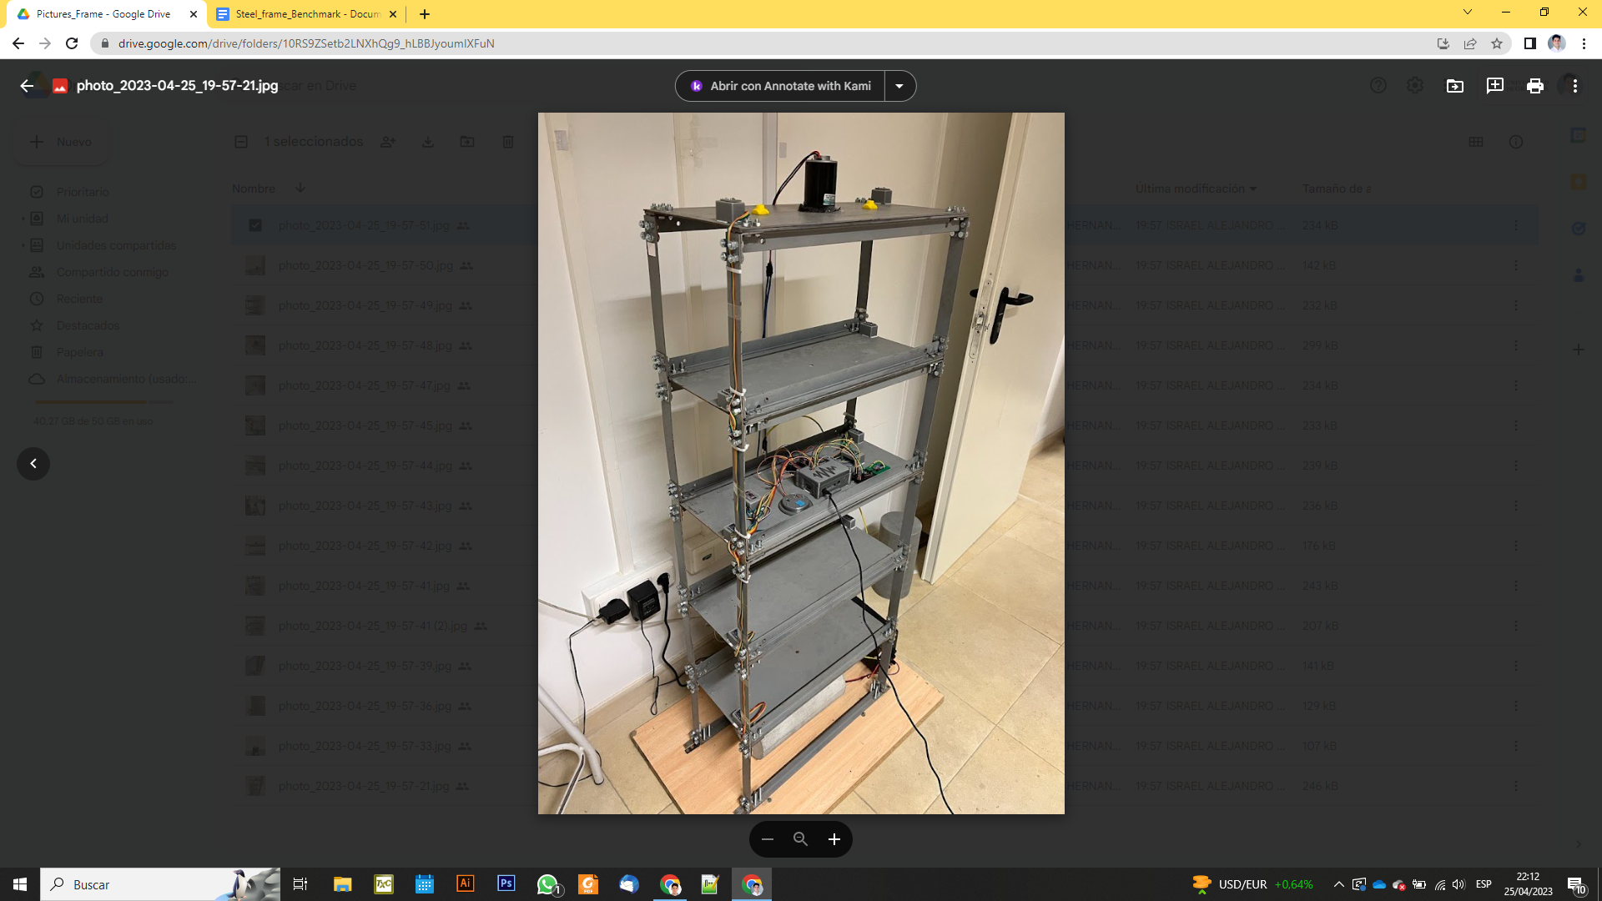

**Index**

**1.** **Description:** 1

**2.** **Initial Identification:** 3

# **Description:**

The benchmark case study is a five floors steel frame with (semi) rigid joints located in the lab of Sustainable Structural Engineering Lab. The monitoring system involves 10 MEMS accelerometers monitoring 15 different channels labelled C1 to C15. The sensors layout follows a classical 3ch per floor distribution to characterize the motion of the floors as rigid diaphragms. The measurements are collected with a raspberry pi 3 located in the third level, and complemented with one analog temperature sensor and one digital temperature/humidity sensor. Given the low ambient excitation levels registered in the laboratory, a 12V DC motor with an eccentric mass located in the upper floor of the structure and controlled with an independent Arduino nano microcontroller. The motor is activated and deactivated randomly to simulate random excitation, and the speed of the motor is also altered randomly.

Geometry:

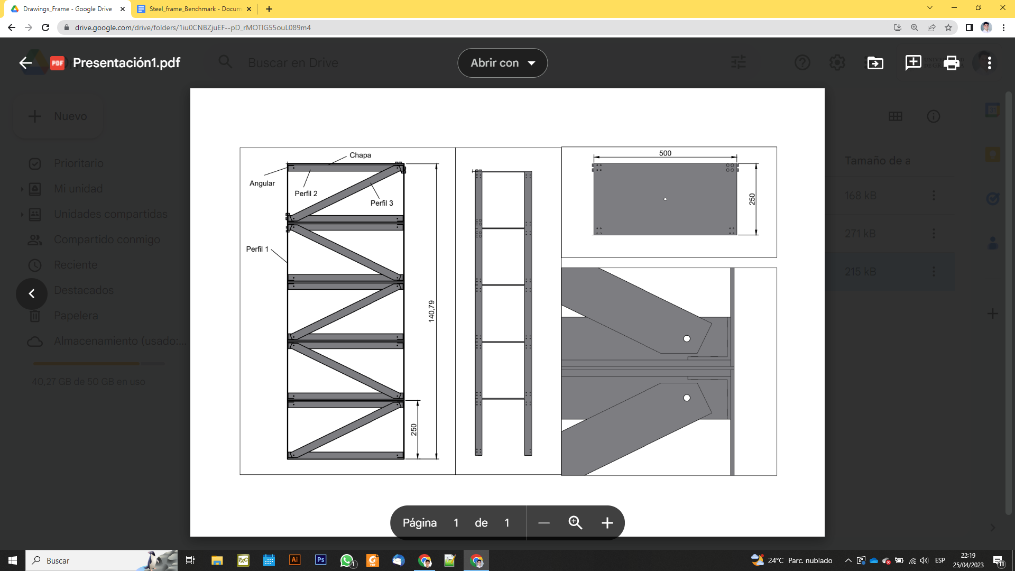

Monitoring system:

* 10 digital accelerometers MPU9250
* 1 analog temperature sensor TMP36
* 1 digital temperature/humidity sensor DHT11
* The system records accelerations with a sampling frequency of 100 Hz every 30 min.
* The environmental data is acquired with a frequency of 30 min.
* The monitoring data are stored in separate files and sent automatically to the cloud.

# **Initial Identification:**

Figure 7. Mode 1 - First order bending along x-axis.

Figure 8. Mode 2 - First order bending along y-axis.

Figure 9. Mode 3 - First order torsion.

Figure 10. Mode 4 - Second order bending along x-axis.

Figure 11. Mode 5 - Third order bending along x-axis.

Figure 12. Mode 6 - Fourth order bending along x-axis.

Figure 13. Mode 7 - Fifth order bending along x-axis.

Figure 12. Mode 8 - Second order bending along y-axis.

Table 1. Identification results (Undamaged Condition)

|  |  |  |  |  |
| --- | --- | --- | --- | --- |
| **Mode No.** | **Description** | **Frequency [Hz]** | **Damping [%]** | **Cluster's Size** |
| 1 | First order bending along x-axis | 2.6991 | 0.3814 | 11 |
| 2 | First order bending along y-axis | 4.3576 | 0.9964 | 11 |
| 3 | First order torsion | 7.7753 | 0.8706 | 8 |
| 4 | Second order bending along x-axis. | 8.1849 | 0.5555 | 11 |
| 5 | Third order bending along x-axis. | 12.8513 | 0.4639 | 11 |
| 6 | Fourth order bending along x-axis | 16.5965 | 0.4183 | 11 |
| 7 | Fifth order bending along x-axis. | 18.9604 | 0.4616 | 11 |
| 8 | Second order bending along y-axis | 20.6779 | 0.5231 | 11 |