Bioequivalence Test Result

Table of Contents
Update Field (right-click in MS Word) to show Table of Contents

AUClast
$`Analysis of Variance (log scale)`
SS DF MS F p
SUBJECT 2.875497e+00 32 8.985928e-02 3.183942248 0.0008742828
GROUP 1.024607e-01 1 1.024607e-01 1.145416548 0.2927731856
SUBJECT(GROUP) 2.773036e+00 31 8.945279e-02 3.169539016 0.0009544080
PERIOD 3.027399e-05 1 3.027399e-05 0.001072684 0.9740824428
DRUG 3.643467e-02 1 3.643467e-02 1.290972690 0.2645764201
ERROR 8.749021e-01 31 2.822265e-02
TOTAL 3.786834e+00 65

$`Between and Within Subject Variability`
Between Subject Within Subject
Variance Estimate 0.03061507 0.02822265
Coefficient of Variation, CV(%) 17.63193968 16.91883011

$`Least Square Means (geometric mean)`
Reference Drug Test Drug
Geometric Means 5092.098 4858.245

$`90% Confidence Interval of Geometric Mean Ratio (T/R)`
Lower Limit Point Estimate Upper Limit
90% CI for Ratio 0.889436 0.9540753 1.023412

$`Sample Size`
True Ratio=1 True Ratio=Point Estimate
80% Power Sample Size 6 7

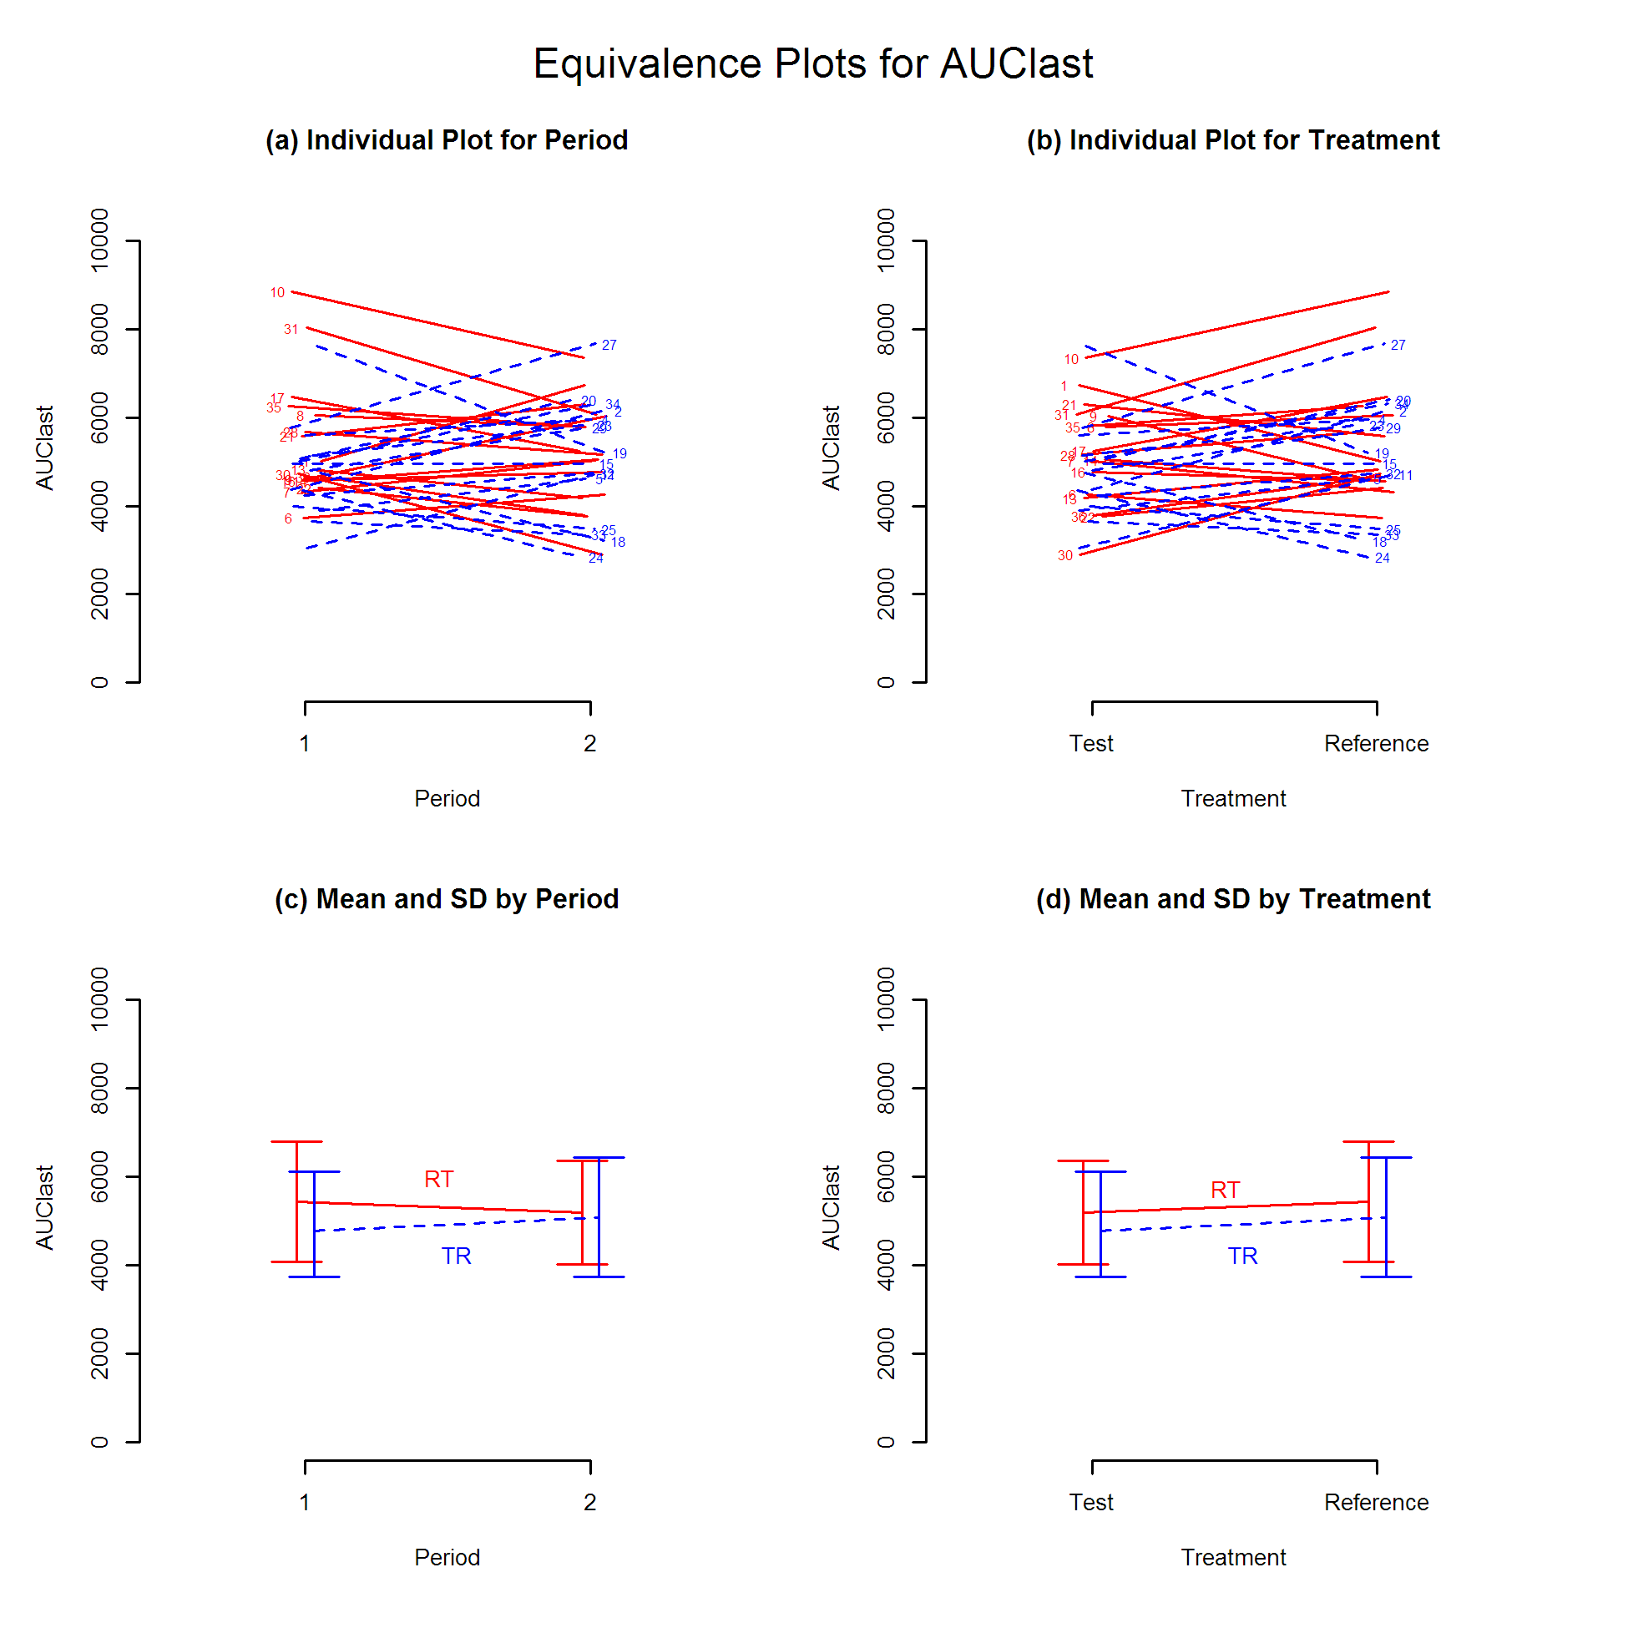
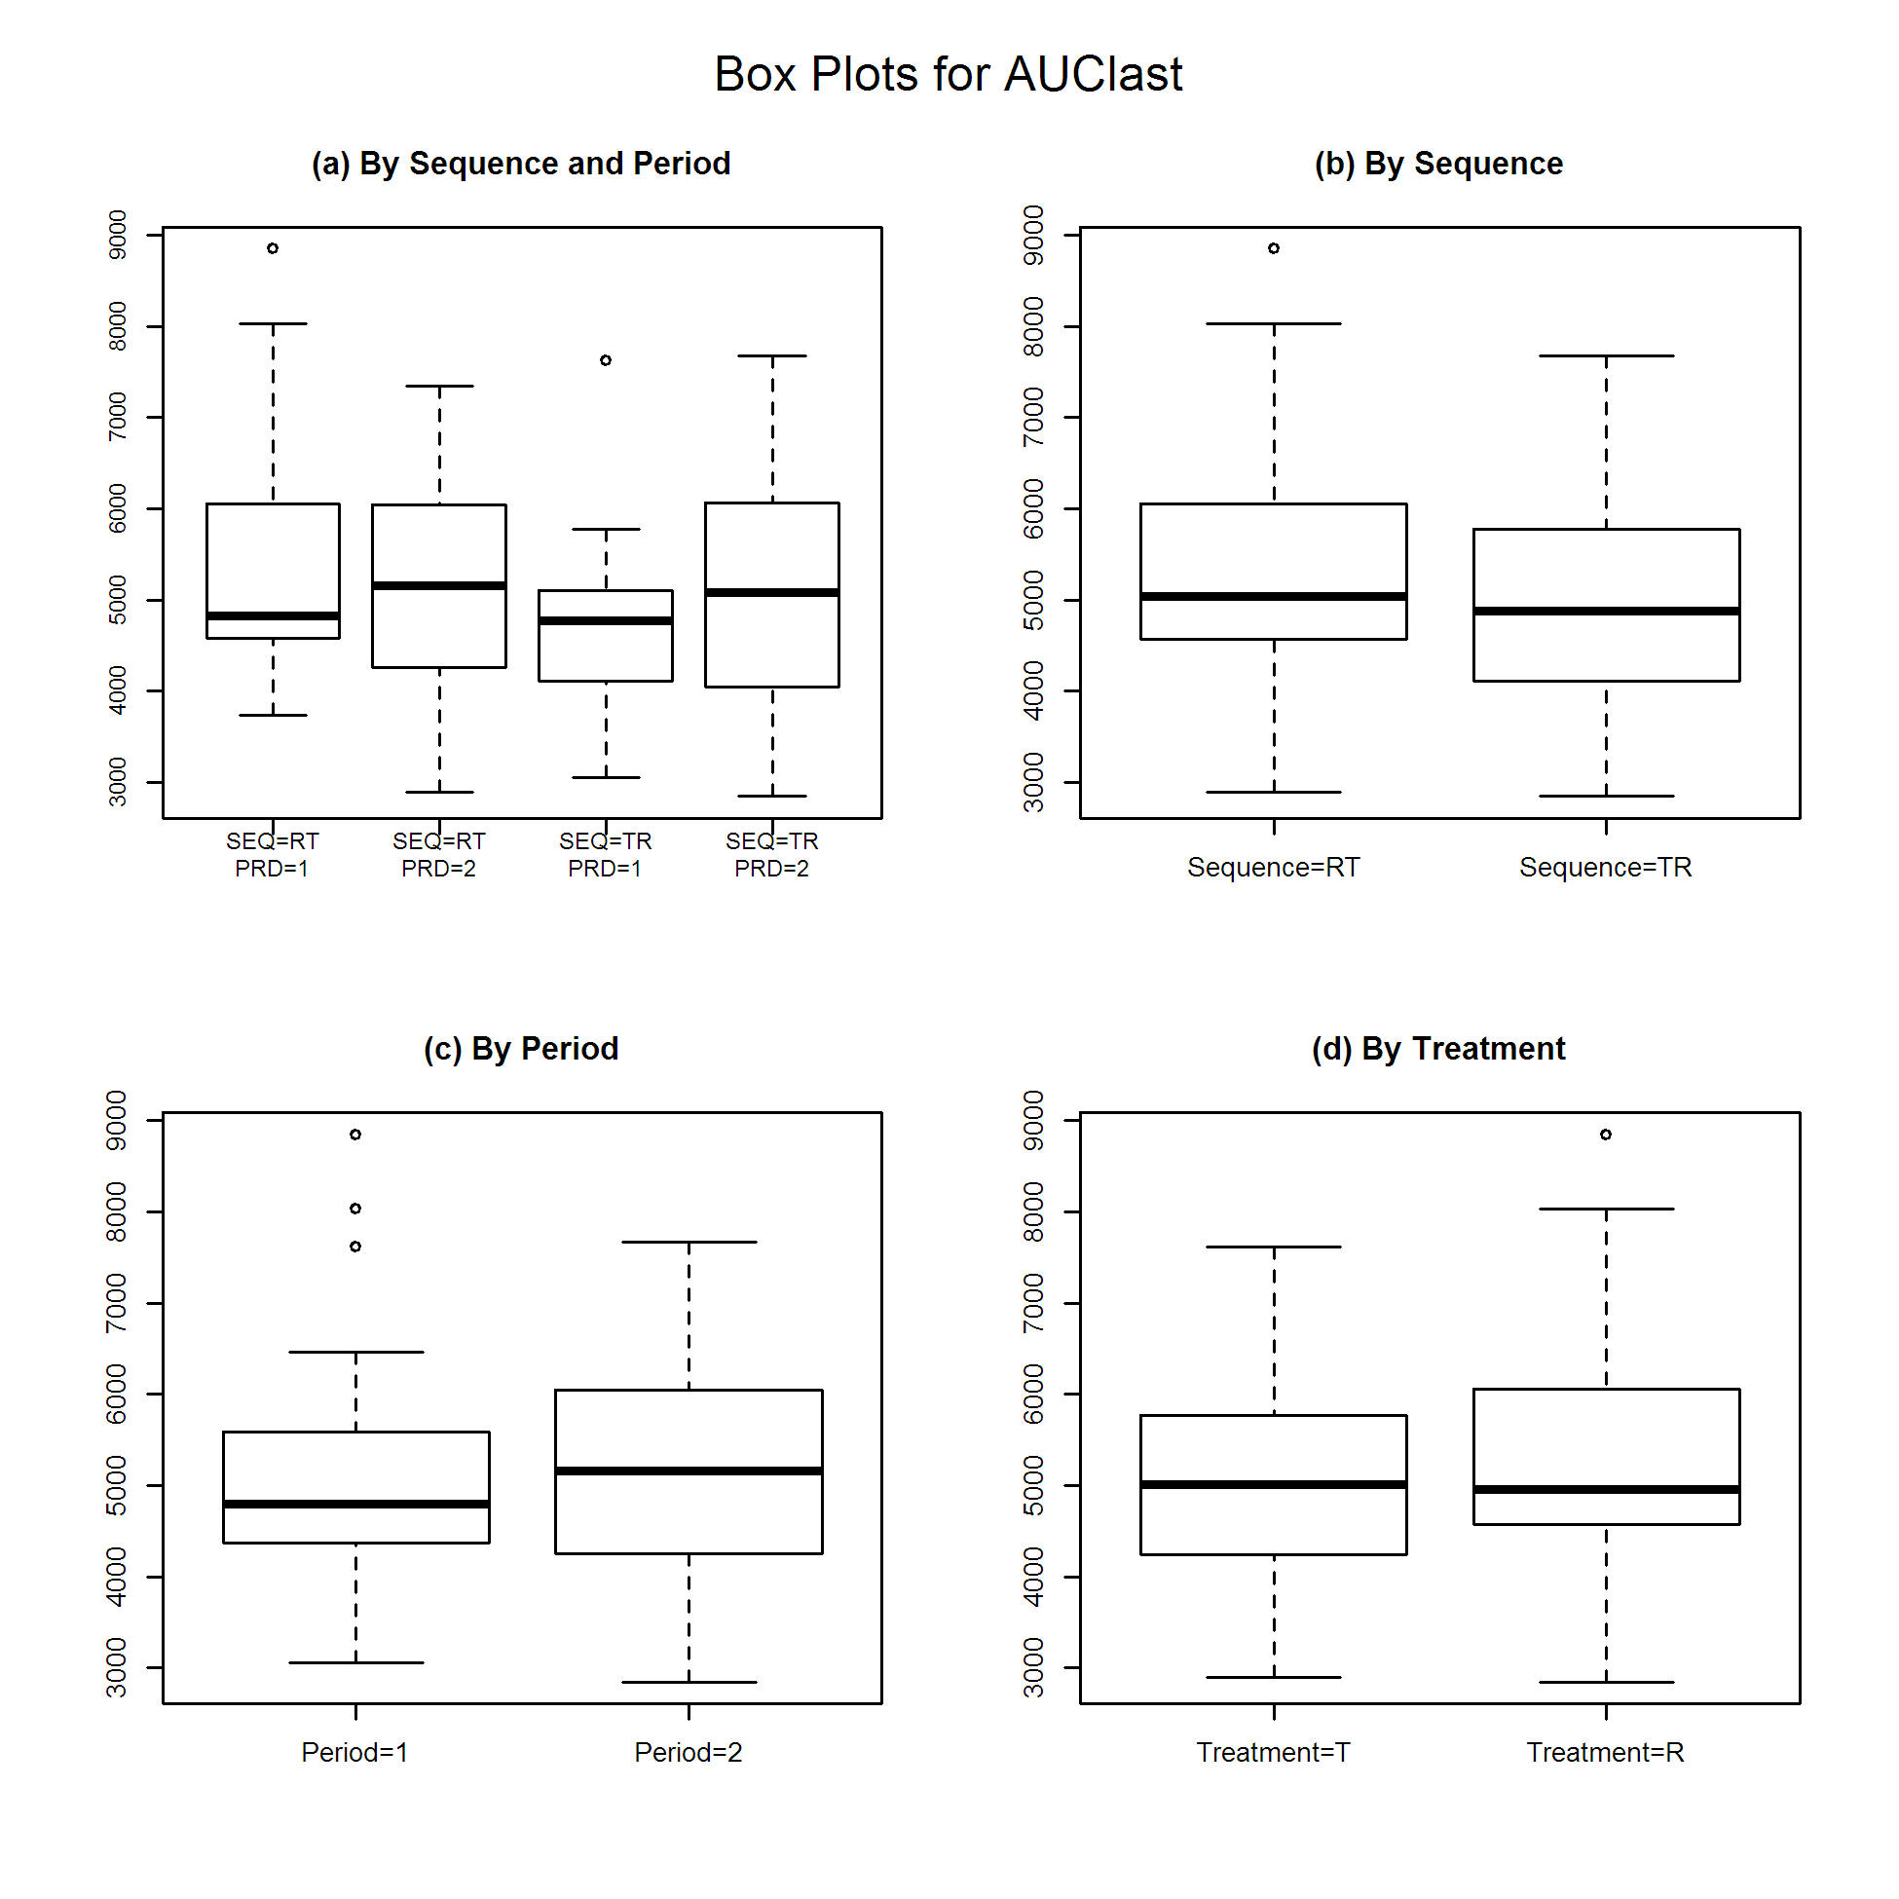
Cmax
$`Analysis of Variance (log scale)`
SS DF MS F p
SUBJECT 2.861492e+00 32 8.942162e-02 2.237604579 0.01367095
GROUP 9.735789e-05 1 9.735789e-05 0.001054764 0.97429977
SUBJECT(GROUP) 2.861394e+00 31 9.230304e-02 2.309706785 0.01131826
PERIOD 4.717497e-03 1 4.717497e-03 0.118046317 0.73348258
DRUG 6.837756e-03 1 6.837756e-03 0.171101730 0.68198228
ERROR 1.238856e+00 31 3.996310e-02
TOTAL 4.112258e+00 65

$`Between and Within Subject Variability`
Between Subject Within Subject
Variance Estimate 0.02616997 0.0399631
Coefficient of Variation, CV(%) 16.28355371 20.1921690

$`Least Square Means (geometric mean)`
Reference Drug Test Drug
Geometric Means 825.5206 808.8778

$`90% Confidence Interval of Geometric Mean Ratio (T/R)`
Lower Limit Point Estimate Upper Limit
90% CI for Ratio 0.9013625 0.9798396 1.065149

$`Sample Size`
True Ratio=1 True Ratio=Point Estimate
80% Power Sample Size 8 8

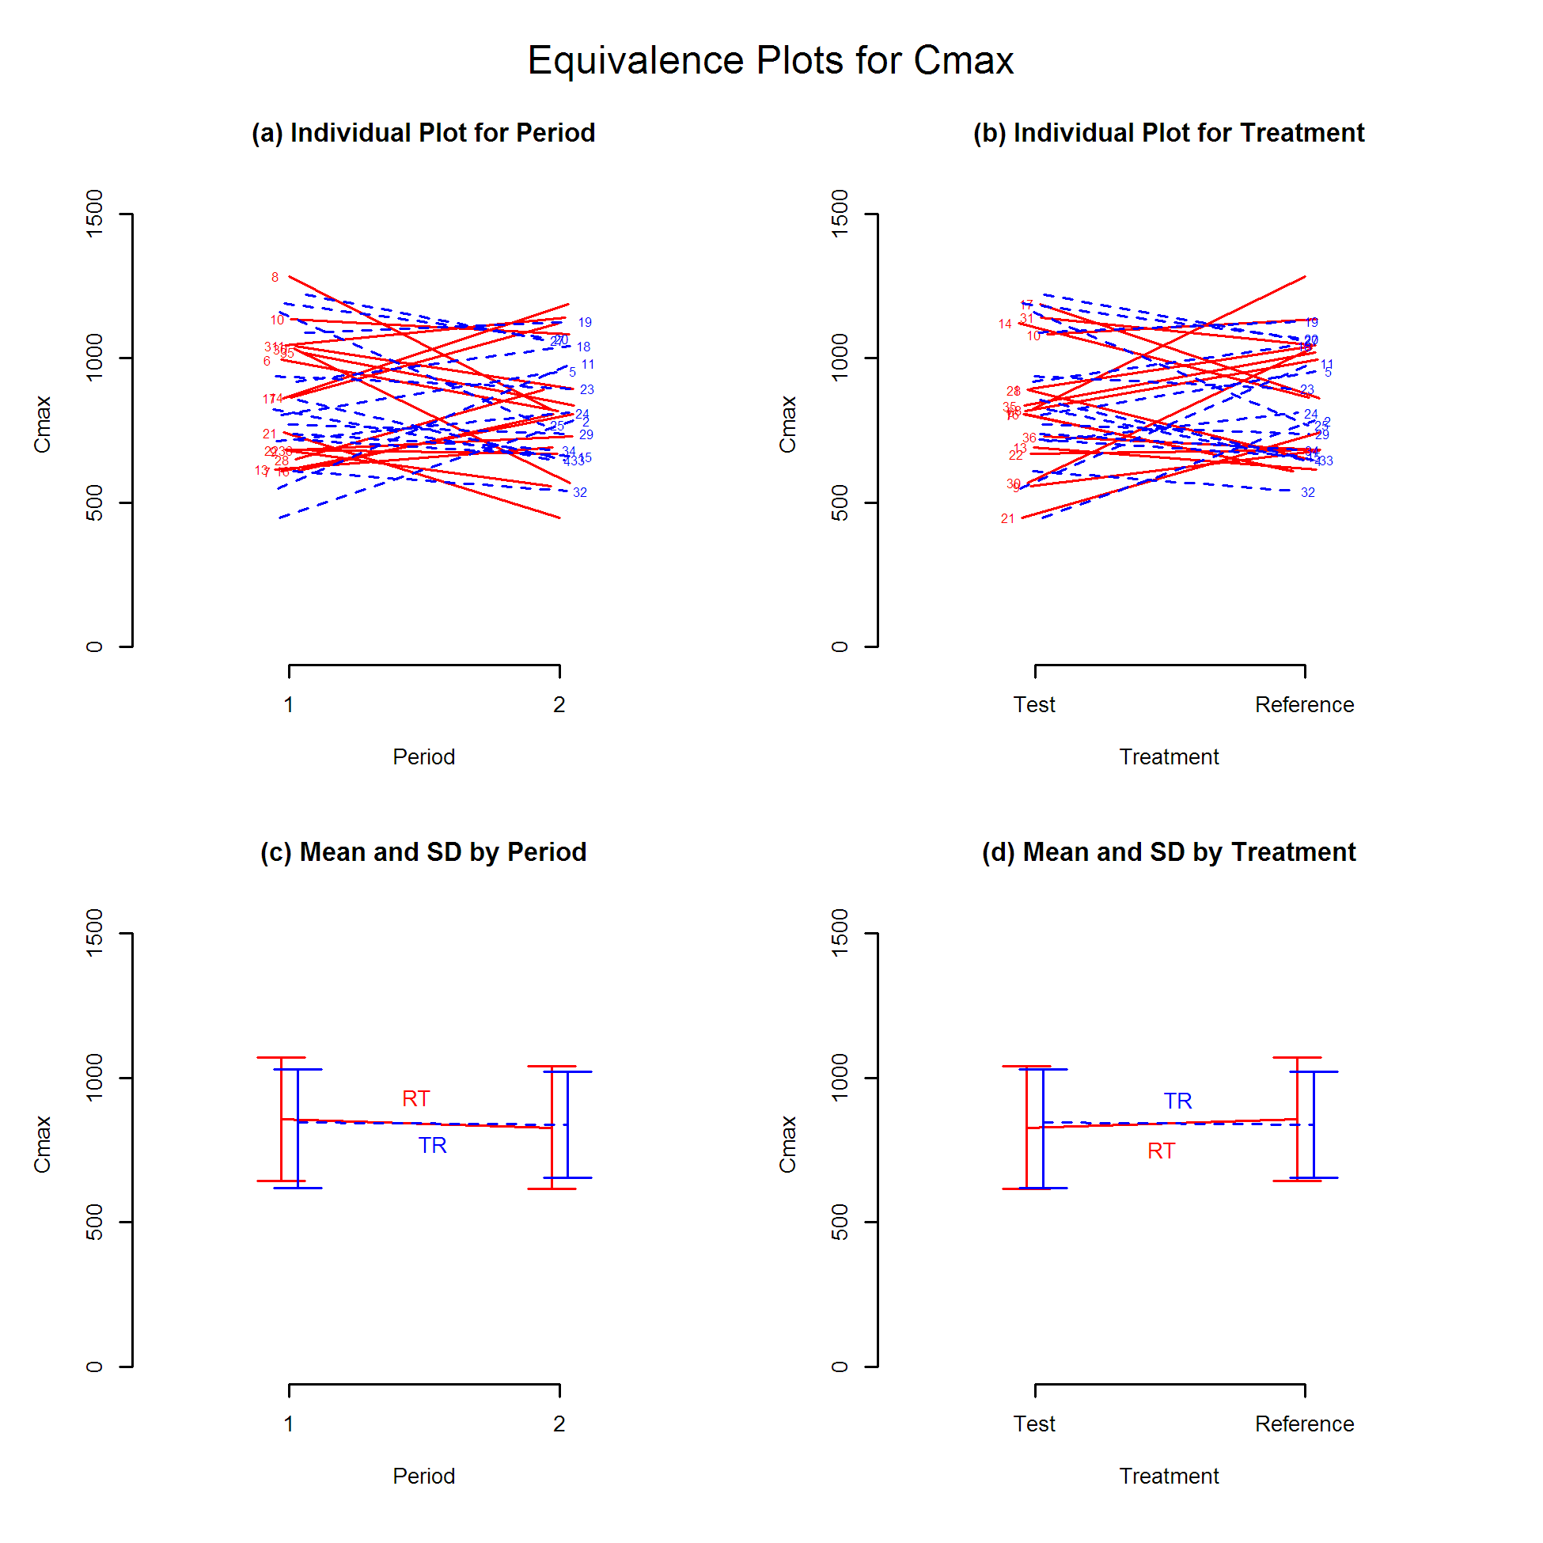
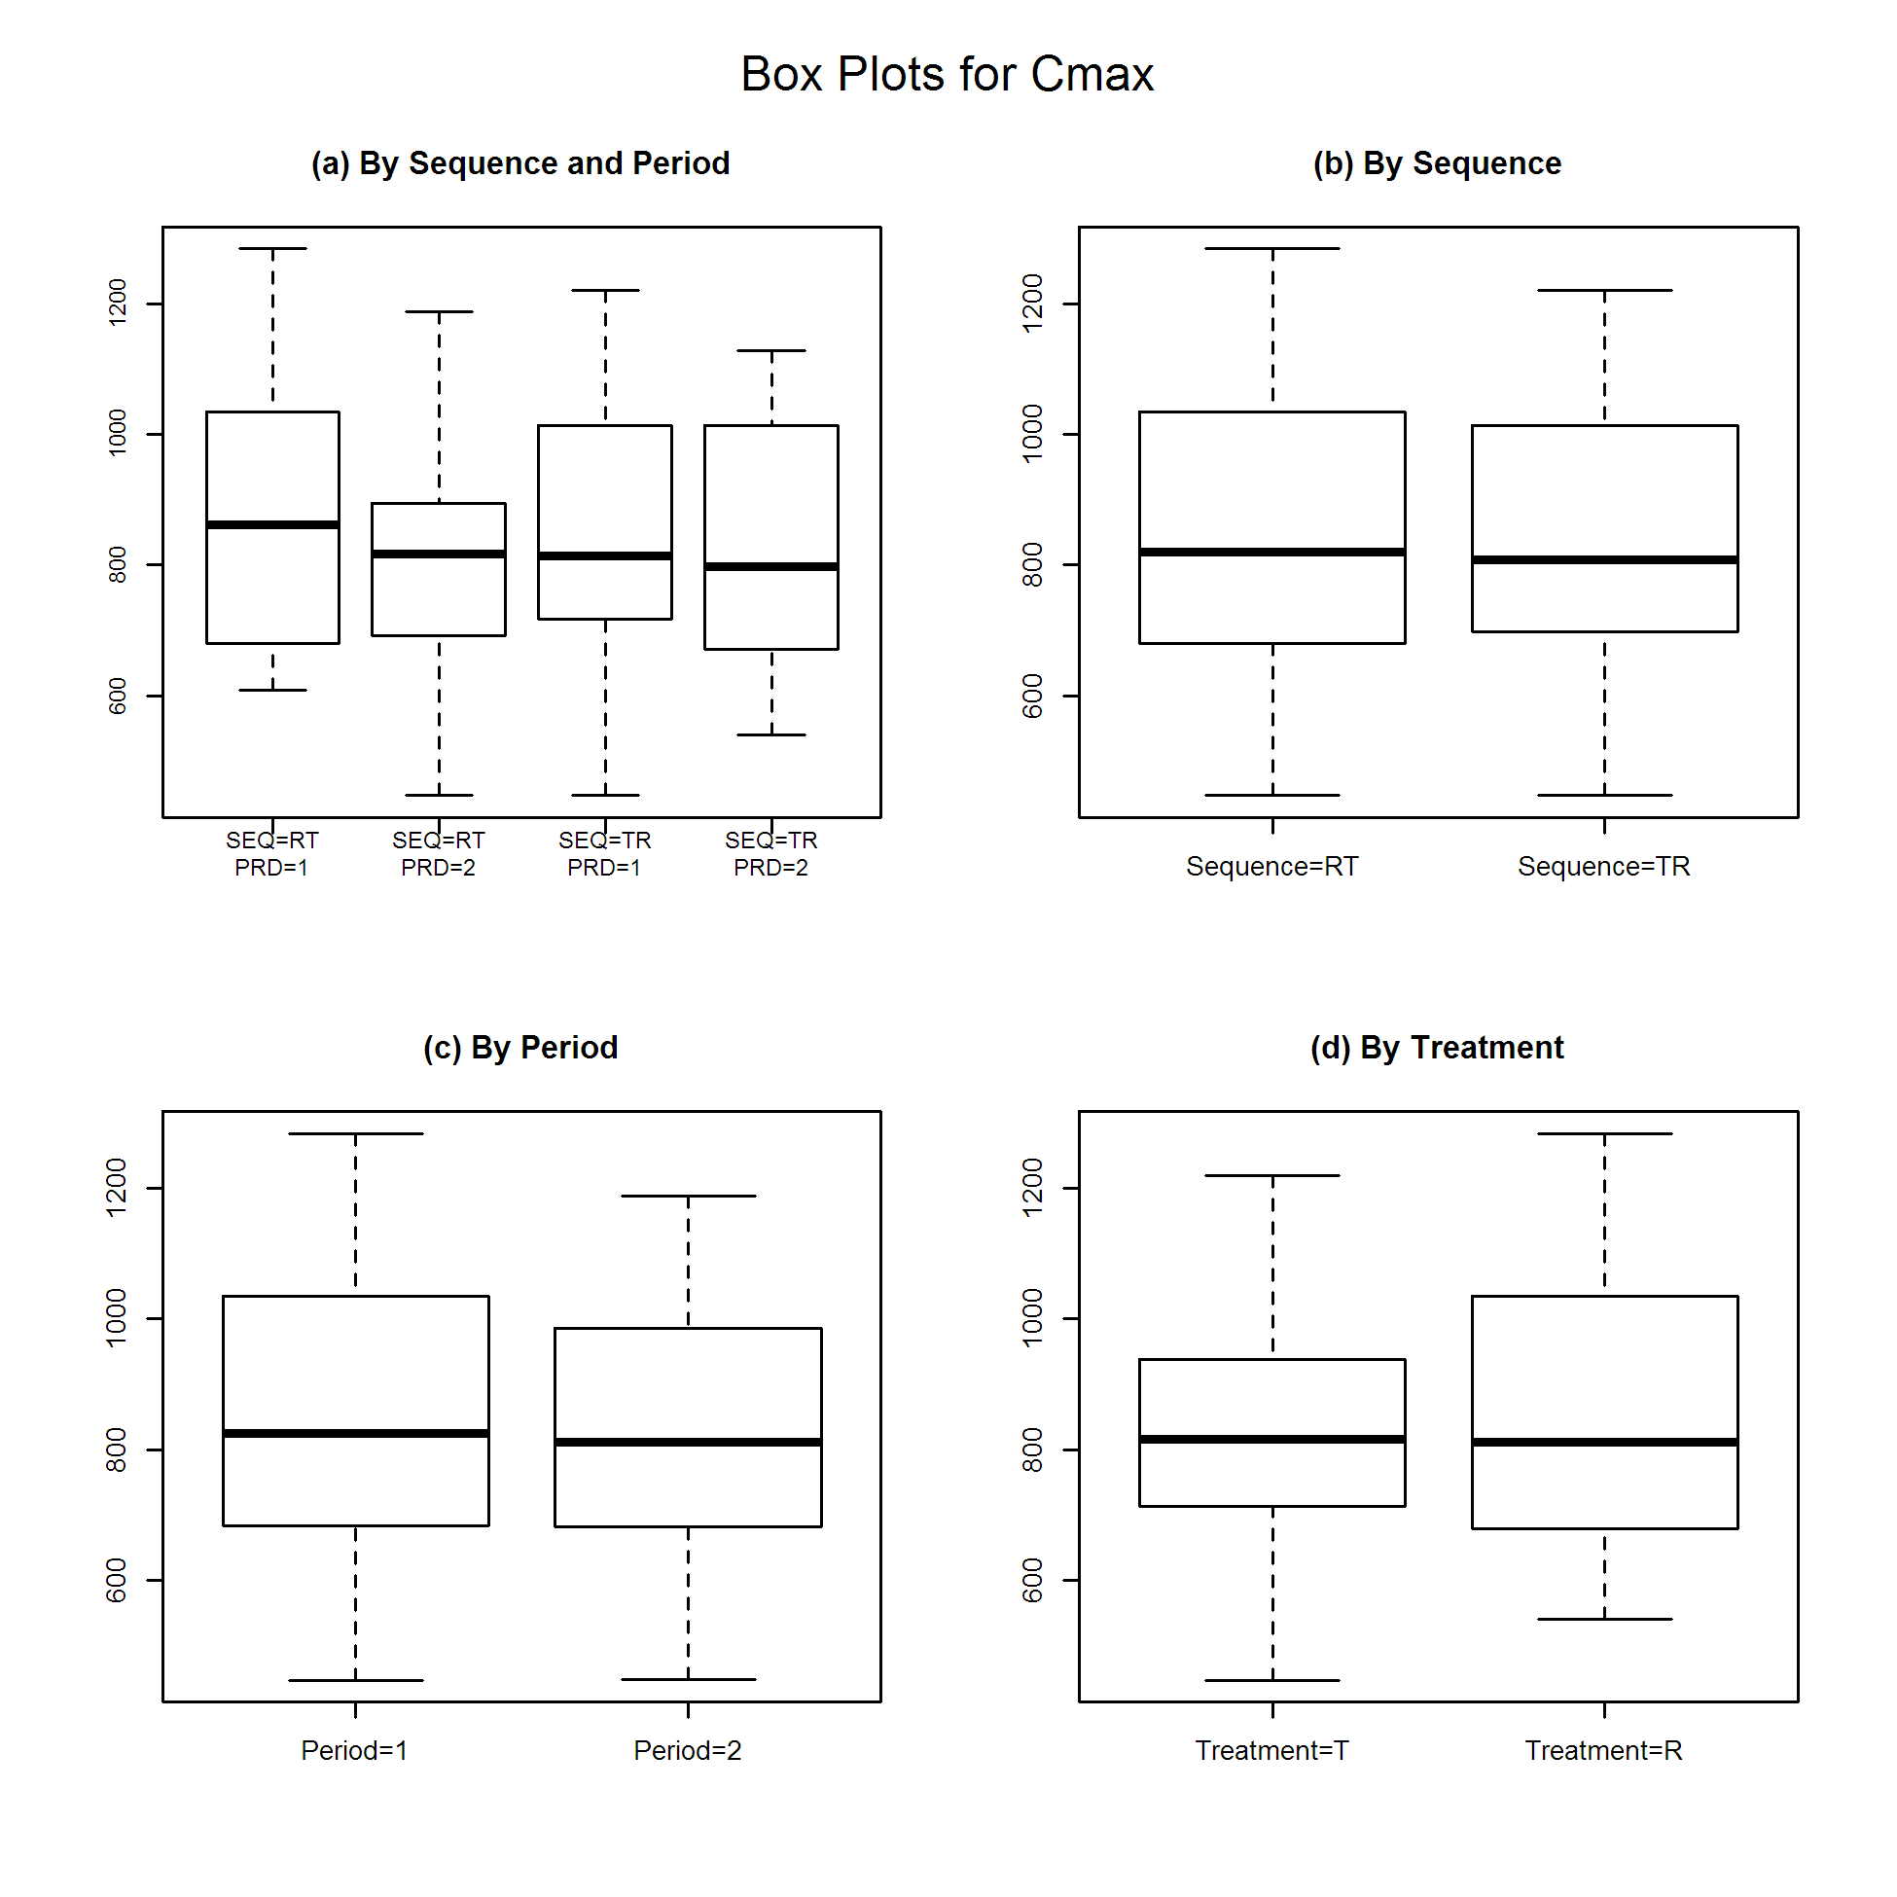
Tmax
$`Wilcoxon Signed-Rank Test`
p-value
0.2326894

$`Hodges-Lehmann Estimate`
Lower Limit Point Estimate Upper Limit
90% Confidence Interval -0.33000 -0.03500 0.1050
90% Confidence Interval(%) 74.37661 97.28237 108.1529

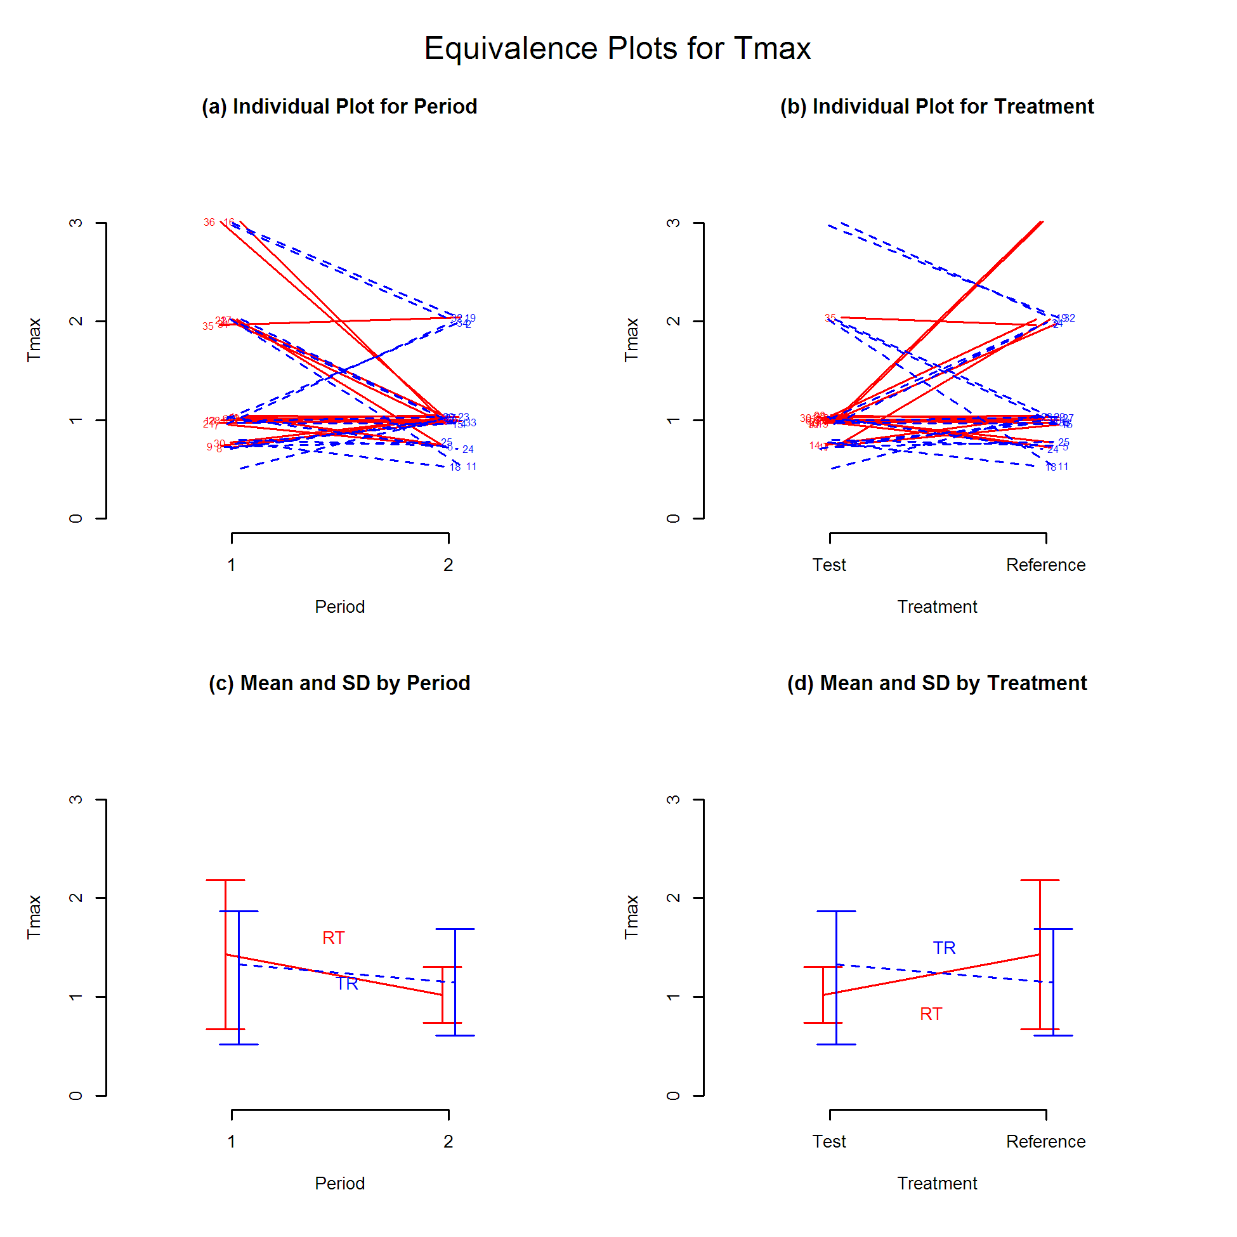
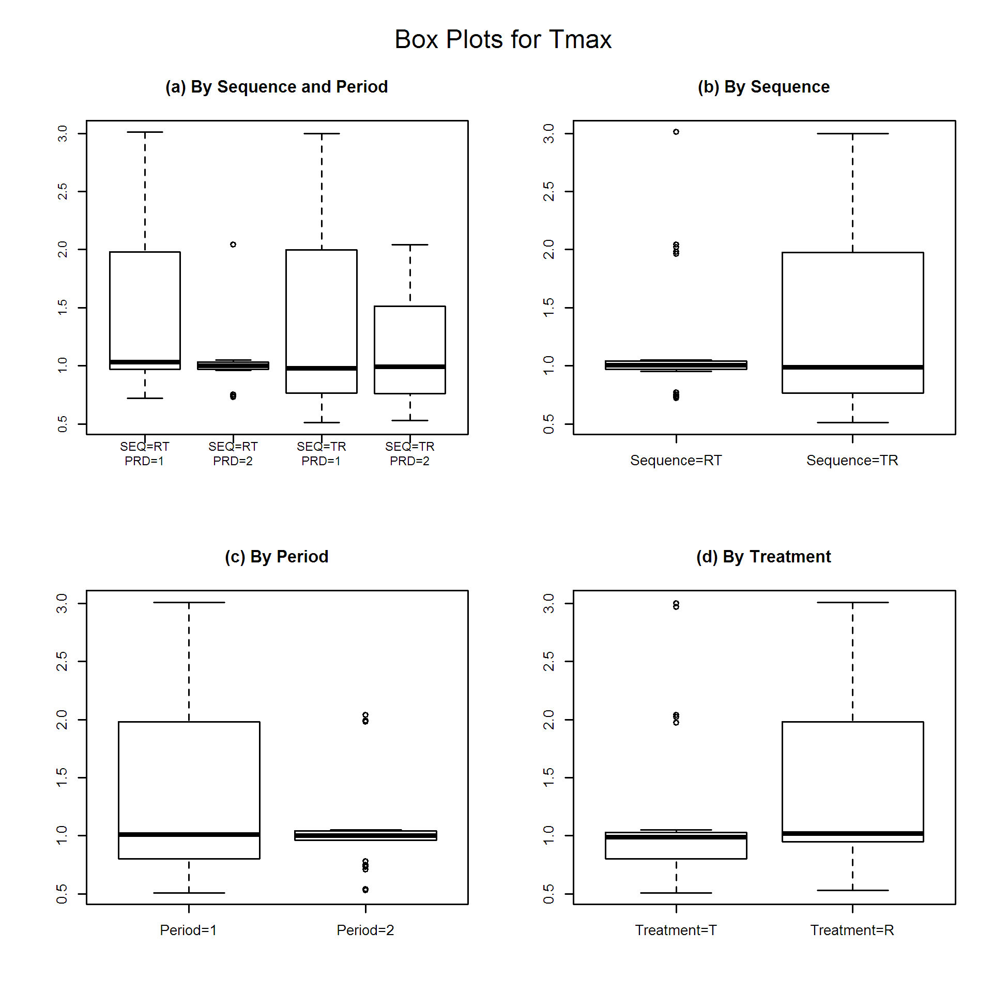
Session Information
R version 3.5.1 (2018-07-02)
Platform: x86_64-w64-mingw32
Locale: LC_COLLATE=Korean_Korea.949;LC_CTYPE=Korean_Korea.949;LC_MONETARY=Korean_Korea.949;LC_NUMERIC=C;LC_TIME=Korean_Korea.949
Packages
Base: base, datasets, graphics, grDevices, methods, stats, utils
Other: BE (v0.1.1), rtf (v0.4-13)
Loaded (not attached): compiler (v3.5.1), digest (v0.6.17), htmltools (v0.3.6), htmlwidgets (v1.3), jsonlite (v1.5), knitr (v1.20), magrittr (v1.5), packrat (v0.4.9-3), profvis (v0.3.5), R.methodsS3 (v1.7.1), R.oo (v1.22.0), Rcpp (v0.12.19), stringi (v1.2.4), stringr (v1.3.1), tools (v3.5.1), yaml (v2.2.0)
Session Details
Working directory: C:/Users/mdlhs/asancpt/BEreport
Output file: docs/report.rtf

