**Bioequivalence Test and Individual Noncompartmental Analysis Result**

**Table of Contents**

**Bioequivalence Test Result** 5

**AUClast** 5

**Cmax** 8

**Tmax** 11

**Individual Noncompartmental Analysis Result** 13

**SUBJ 1, GRP RT, PRD 1, TRT R** 14

**SUBJ 1, GRP RT, PRD 2, TRT T** 17

**SUBJ 2, GRP TR, PRD 1, TRT T** 20

**SUBJ 2, GRP TR, PRD 2, TRT R** 23

**SUBJ 3, GRP TR, PRD 1, TRT T** 26

**SUBJ 3, GRP TR, PRD 2, TRT R** 29

**SUBJ 4, GRP TR, PRD 1, TRT T** 32

**SUBJ 4, GRP TR, PRD 2, TRT R** 35

**SUBJ 5, GRP TR, PRD 1, TRT T** 38

**SUBJ 5, GRP TR, PRD 2, TRT R** 41

**SUBJ 6, GRP RT, PRD 1, TRT R** 44

**SUBJ 6, GRP RT, PRD 2, TRT T** 47

**SUBJ 7, GRP RT, PRD 1, TRT R** 50

**SUBJ 7, GRP RT, PRD 2, TRT T** 53

**SUBJ 8, GRP RT, PRD 1, TRT R** 56

**SUBJ 8, GRP RT, PRD 2, TRT T** 59

**SUBJ 9, GRP RT, PRD 1, TRT R** 62

**SUBJ 9, GRP RT, PRD 2, TRT T** 65

**SUBJ 10, GRP RT, PRD 1, TRT R** 68

**SUBJ 10, GRP RT, PRD 2, TRT T** 71

**SUBJ 11, GRP TR, PRD 1, TRT T** 74

**SUBJ 11, GRP TR, PRD 2, TRT R** 77

**SUBJ 12, GRP TR, PRD 1, TRT T** 80

**SUBJ 12, GRP TR, PRD 2, TRT R** 83

**SUBJ 13, GRP RT, PRD 1, TRT R** 86

**SUBJ 13, GRP RT, PRD 2, TRT T** 89

**SUBJ 14, GRP RT, PRD 1, TRT R** 92

**SUBJ 14, GRP RT, PRD 2, TRT T** 95

**SUBJ 15, GRP TR, PRD 1, TRT T** 98

**SUBJ 15, GRP TR, PRD 2, TRT R** 101

**SUBJ 16, GRP RT, PRD 1, TRT R** 104

**SUBJ 16, GRP RT, PRD 2, TRT T** 107

**SUBJ 17, GRP RT, PRD 1, TRT R** 110

**SUBJ 17, GRP RT, PRD 2, TRT T** 113

**SUBJ 18, GRP TR, PRD 1, TRT T** 116

**SUBJ 18, GRP TR, PRD 2, TRT R** 119

**SUBJ 19, GRP TR, PRD 1, TRT T** 122

**SUBJ 19, GRP TR, PRD 2, TRT R** 125

**SUBJ 20, GRP TR, PRD 1, TRT T** 128

**SUBJ 20, GRP TR, PRD 2, TRT R** 131

**SUBJ 21, GRP RT, PRD 1, TRT R** 134

**SUBJ 21, GRP RT, PRD 2, TRT T** 137

**SUBJ 22, GRP RT, PRD 1, TRT R** 140

**SUBJ 22, GRP RT, PRD 2, TRT T** 143

**SUBJ 23, GRP TR, PRD 1, TRT T** 146

**SUBJ 23, GRP TR, PRD 2, TRT R** 149

**SUBJ 24, GRP TR, PRD 1, TRT T** 152

**SUBJ 24, GRP TR, PRD 2, TRT R** 155

**SUBJ 25, GRP TR, PRD 1, TRT T** 158

**SUBJ 25, GRP TR, PRD 2, TRT R** 161

**SUBJ 26, GRP TR, PRD 1, TRT T** 164

**SUBJ 26, GRP TR, PRD 2, TRT R** 167

**SUBJ 27, GRP TR, PRD 1, TRT T** 170

**SUBJ 27, GRP TR, PRD 2, TRT R** 173

**SUBJ 28, GRP RT, PRD 1, TRT R** 176

**SUBJ 28, GRP RT, PRD 2, TRT T** 179

**SUBJ 29, GRP TR, PRD 1, TRT T** 182

**SUBJ 29, GRP TR, PRD 2, TRT R** 185

**SUBJ 30, GRP RT, PRD 1, TRT R** 188

**SUBJ 30, GRP RT, PRD 2, TRT T** 191

**SUBJ 31, GRP RT, PRD 1, TRT R** 194

**SUBJ 31, GRP RT, PRD 2, TRT T** 197

**SUBJ 32, GRP TR, PRD 1, TRT T** 200

**SUBJ 32, GRP TR, PRD 2, TRT R** 203

**SUBJ 33, GRP TR, PRD 1, TRT T** 206

**SUBJ 33, GRP TR, PRD 2, TRT R** 209

**SUBJ 34, GRP TR, PRD 1, TRT T** 212

**SUBJ 34, GRP TR, PRD 2, TRT R** 215

**SUBJ 35, GRP RT, PRD 1, TRT R** 218

**SUBJ 35, GRP RT, PRD 2, TRT T** 221

**SUBJ 36, GRP RT, PRD 1, TRT R** 224

**SUBJ 36, GRP RT, PRD 2, TRT T** 227

**Bioequivalence Test Result**

**AUClast**

$`Analysis of Variance (log scale)`

SS DF MS F p

SUBJECT 3.1250288476 35 0.0892865385 3.259673678 0.0004158433

GROUP 0.1809601306 1 0.1809601306 2.089844032 0.1574364448

SUBJECT(GROUP) 2.9440687171 34 0.0865902564 3.161237788 0.0005851733

PERIOD 0.0002043986 1 0.0002043986 0.007462187 0.9316679341

DRUG 0.0431417975 1 0.0431417975 1.575021097 0.2180373541

ERROR 0.9313025197 34 0.0273912506 NA NA

TOTAL 4.1001427318 71 NA NA NA

$`Between and Within Subject Variability`

Between Subject Within Subject

Variance Estimate 0.0295995 0.02739125

Coefficient of Variation, CV(%) 17.3326058 16.66428506

$`Least Square Means (geometric mean)`

Reference Drug Test Drug

Geometric Means 5042.531 4801.247

$`90% Confidence Interval of Geometric Mean Ratio (T/R)`

Lower Limit Point Estimate Upper Limit

90% CI for Ratio 0.8912801 0.9521502 1.017177

$`Sample Size`

True Ratio=1 True Ratio=Point Estimate

80% Power Sample Size 6 7

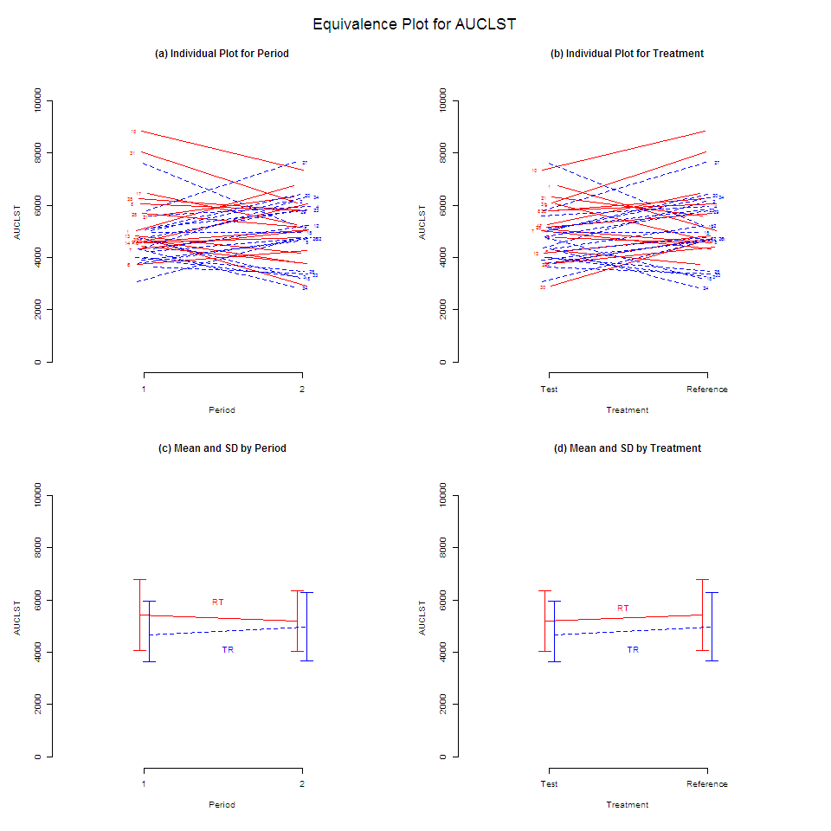

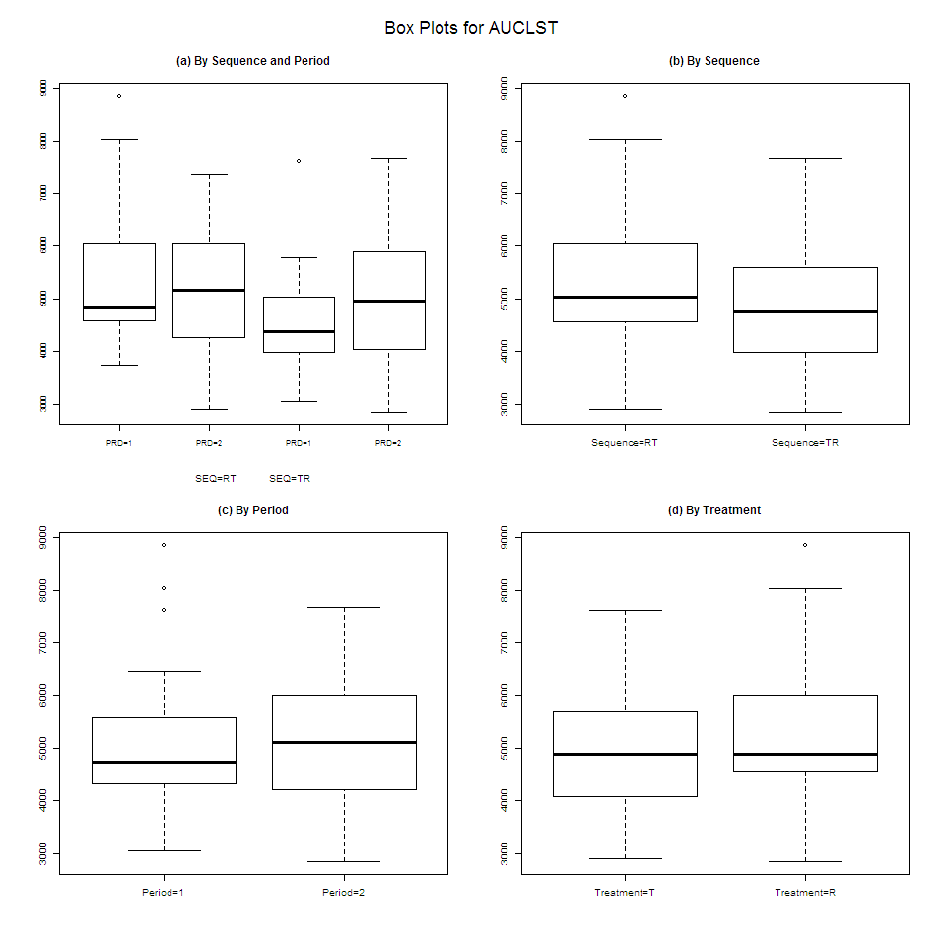

**Cmax**

$`Analysis of Variance (log scale)`

SS DF MS F p

SUBJECT 3.247065921 35 0.092773312 2.39062322 0.006281881

GROUP 0.026067303 1 0.026067303 0.27515948 0.603295134

SUBJECT(GROUP) 3.220998618 34 0.094735253 2.44117939 0.005507677

PERIOD 0.003661945 1 0.003661945 0.09436261 0.760576271

DRUG 0.009490680 1 0.009490680 0.24455998 0.624112311

ERROR 1.319443641 34 0.038807166 NA NA

TOTAL 4.579045848 71 NA NA NA

$`Between and Within Subject Variability`

Between Subject Within Subject

Variance Estimate 0.02796404 0.03880717

Coefficient of Variation, CV(%) 16.84004390 19.89220947

$`Least Square Means (geometric mean)`

Reference Drug Test Drug

Geometric Means 810.0191 791.6031

$`90% Confidence Interval of Geometric Mean Ratio (T/R)`

Lower Limit Point Estimate Upper Limit

90% CI for Ratio 0.9033615 0.9772648 1.057214

$`Sample Size`

True Ratio=1 True Ratio=Point Estimate

80% Power Sample Size 8 8

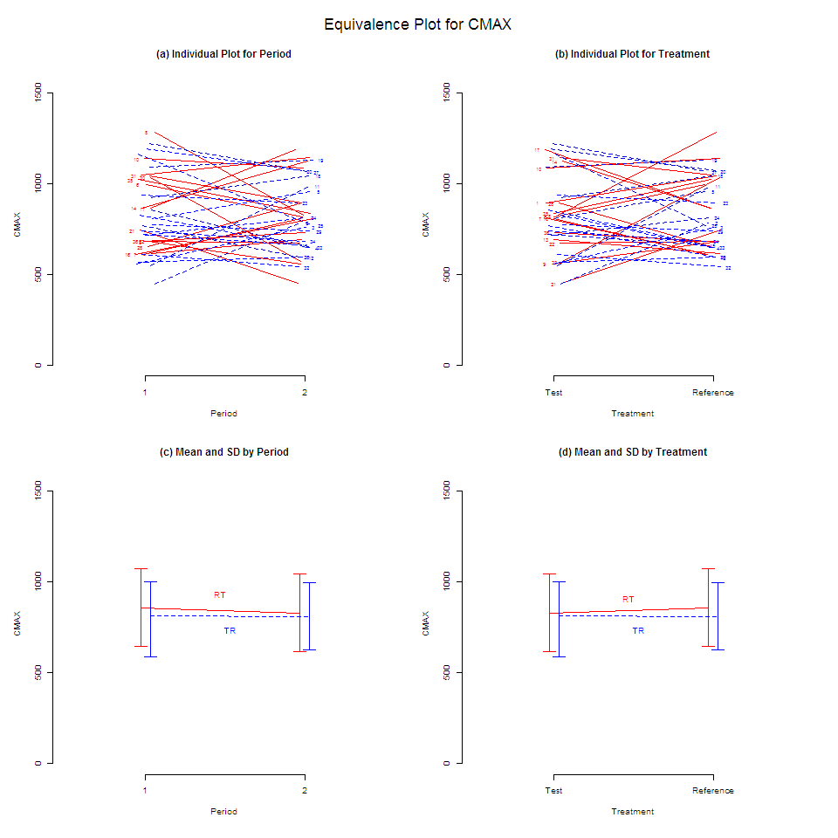

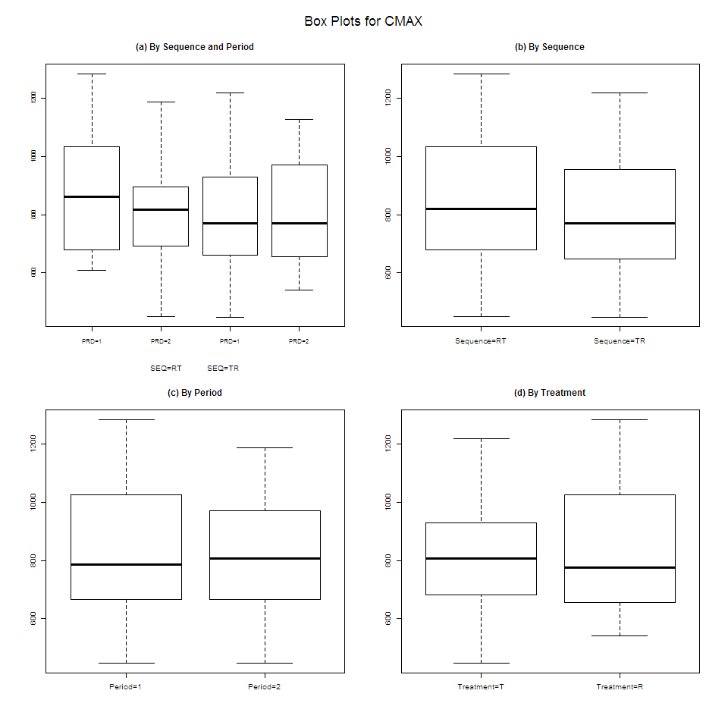

**Tmax**

$`Wilcoxon Signed-Rank Test`

p-value

0.2073376

$`Hodges-Lehmann Estimate`

Lower Limit Point Estimate Upper Limit

90% Confidence Interval -0.35500 -0.04000 0.0700

90% Confidence Interval(%) 73.26876 96.98803 105.2709

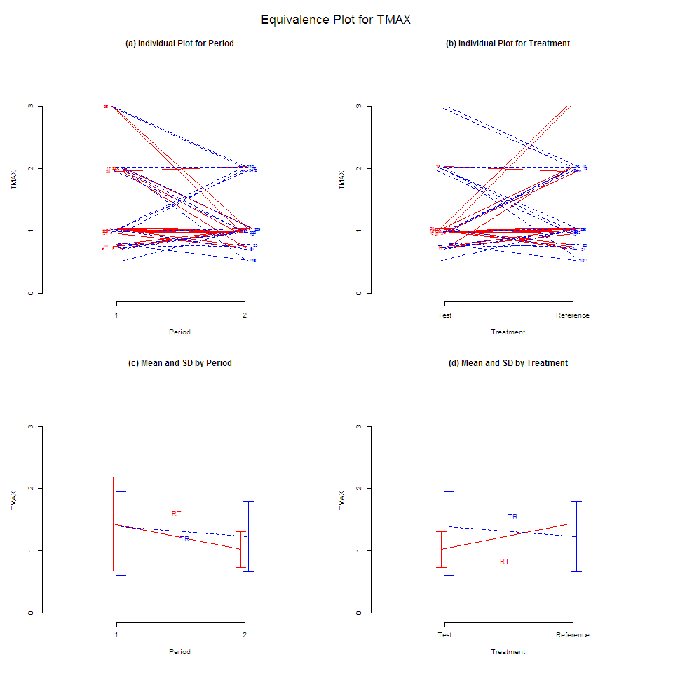

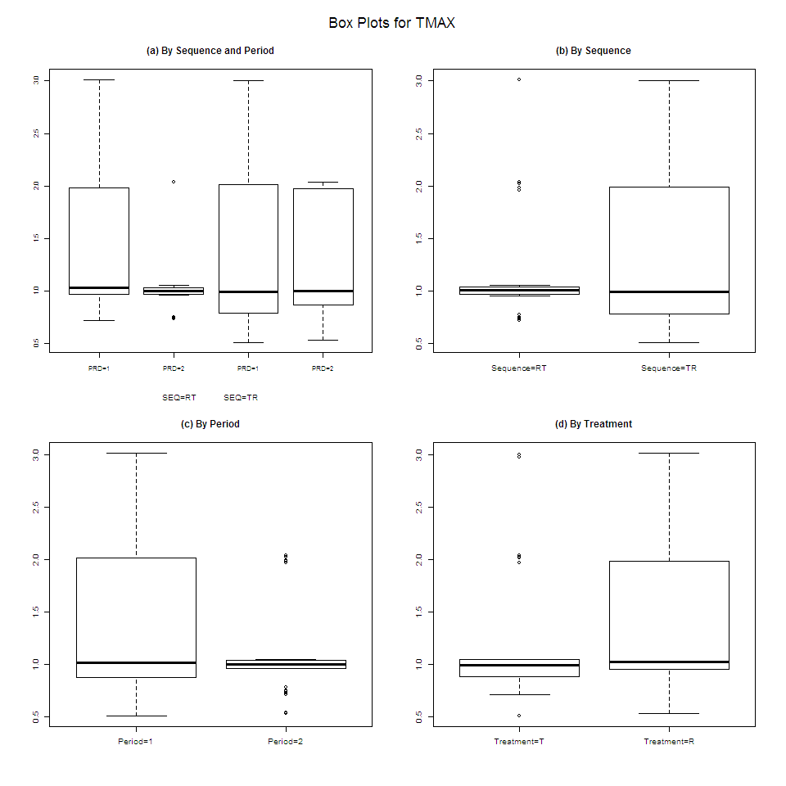

**Individual Noncompartmental Analysis Result**

**SUBJ 1, GRP RT, PRD 1, TRT R**

NONCOMPARTMENTAL ANALYSIS REPORT

Package version 0.3.9 (2018-05-10 KST)

R version 3.5.0 (2018-04-23)

Date and Time: 2018-06-19 09:49:35 Asia/Seoul

Calculation Setting

-------------------

Drug Administration: Extravascular

Observation count excluding trailing zero: 13

Dose at time 0: 0 mg

AUC Calculation Method: Linear-up Linear-down

Weighting for lambda z: Uniform (Ordinary Least Square, OLS)

Lambda z selection criterion: Heighest adjusted R-squared value with precision=1e-4

Fitting, AUC, AUMC Result

-------------------------

Time Conc. Pred. Residual AUC AUMC

---------------------------------------------------------------------

0.0000 0.0000 0.0000 0.0000

0.2600 511.3000 66.4690 17.2819

0.4600 678.7900 185.4780 61.8001

0.7300 825.1200 388.5058 185.2685

1.0400 1043.1300 678.0846 446.7834

1.9900 753.4300 1531.4506 1674.2693

3.0000 557.7400 2193.5915 3276.4049

4.0100 411.1300 2682.8708 4953.9398

6.0200 287.7100 3385.2050 8351.4885

7.9900 * 220.1800 215.7847 +4.395e+00 3885.4767 11790.3722

10.0100 * 126.4600 135.1744 -8.714e+00 4235.5831 14845.7260

12.0300 * 89.1000 84.6776 +4.422e+00 4453.2987 17206.8410

24.0200 * 5.2500 5.2733 -2.332e-02 5018.9269 24388.7191

*: Used for the calculation of Lambda z.

Calculated Values

-----------------

CMAX Max Conc 1043.1300 ug/L

TMAX Time of CMAX 1.0400 h

TLAG Time Until First Nonzero Conc 0.0000 h

CLST Last Nonzero Conc 5.2500 ug/L

CLSTP Last Nonzero Conc Pred 5.2733 ug/L

TLST Time of Last Nonzero Conc 24.0200 h

LAMZHL Half-Life Lambda z 2.9936 h

LAMZ Lambda z 0.2315 /h

LAMZLL Lambda z Lower Limit 7.9900 h

LAMZUL Lambda z Upper Limit 24.0200 h

LAMZNPT Number of Points for Lambda z 4

CORRXY Correlation Between TimeX and Log ConcY -0.9996

R2 R Squared 0.9991

R2ADJ R Squared Adjusted 0.9987

AUCLST AUC to Last Nonzero Conc 5018.9269 h*ug/L

AUCALL AUC All 5018.9269 h*ug/L

AUCIFO AUC Infinity Obs 5041.6010 h*ug/L

AUCIFP AUC Infinity Pred 5041.7017 h*ug/L

AUCPEO AUC %Extrapolation Obs 0.4497 %

AUCPEP AUC %Extrapolation Pred 0.4517 %

AUMCLST AUMC to Last Nonzero Conc 24388.7191 h2*ug/L

AUMCIFO AUMC Infinity Obs 25031.2763 h2*ug/L

AUMCIFP AUMC Infinity Pred 25034.1309 h2*ug/L

AUMCPEO AUMC %Extrapolation Obs 2.5670 %

AUMCPEP AUMC % Extrapolation Pred 2.5781 %

VZFO Vz Obs by F 0.0000 L

VZFP Vz Pred by F 0.0000 L

CLFO Total CL Obs by F 0.0000 L/h

CLFP Total CL Pred by F 0.0000 L/h

MRTEVLST MRT Extravasc to Last Nonzero Conc 4.8593 h

MRTEVIFO MRT Extravasc Infinity Obs 4.9649 h

MRTEVIFP MRT Extravasc Infinity Pred 4.9654 h

**SUBJ 1, GRP RT, PRD 1, TRT R**

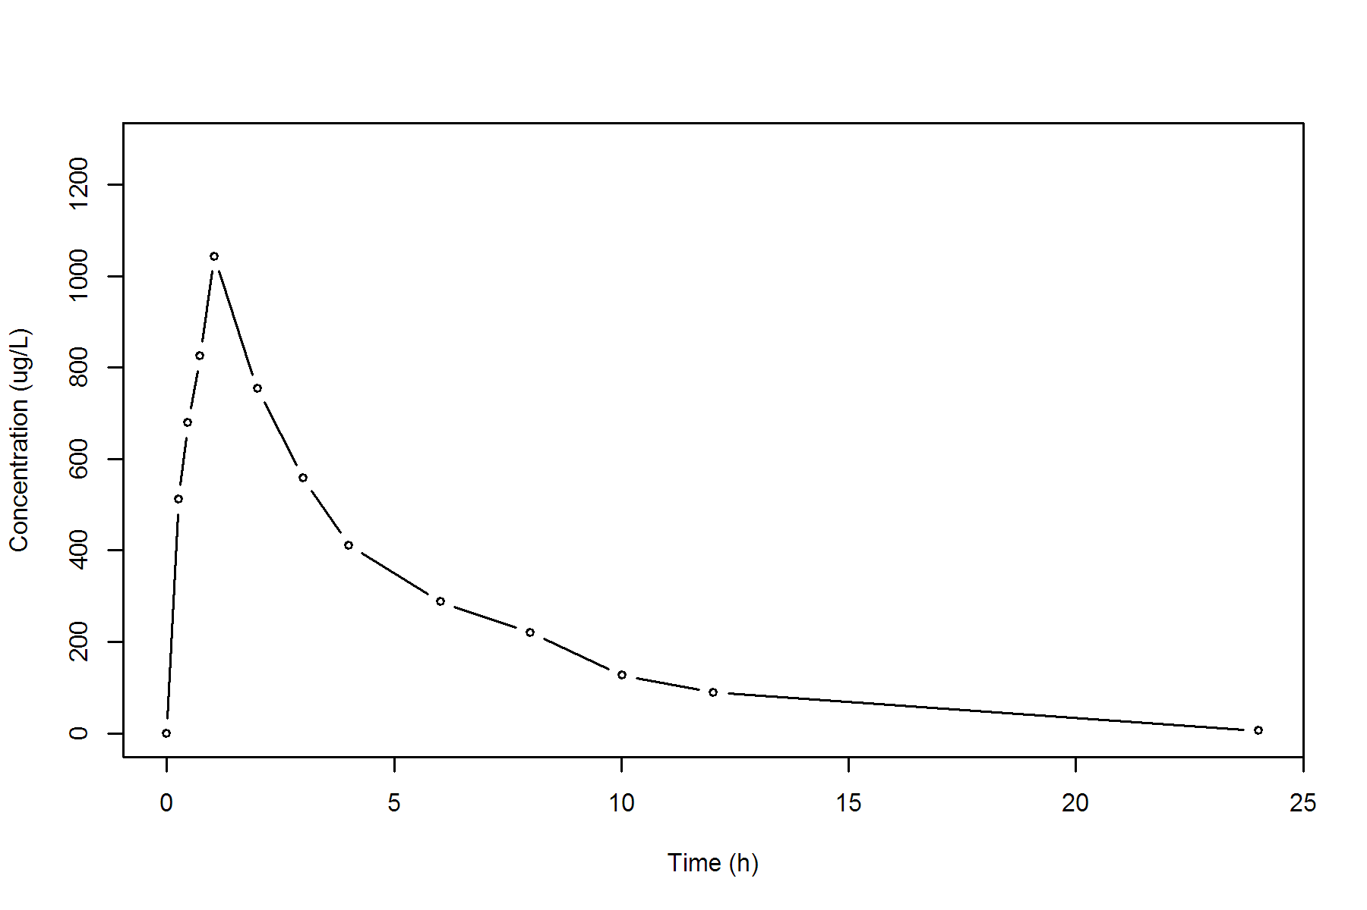

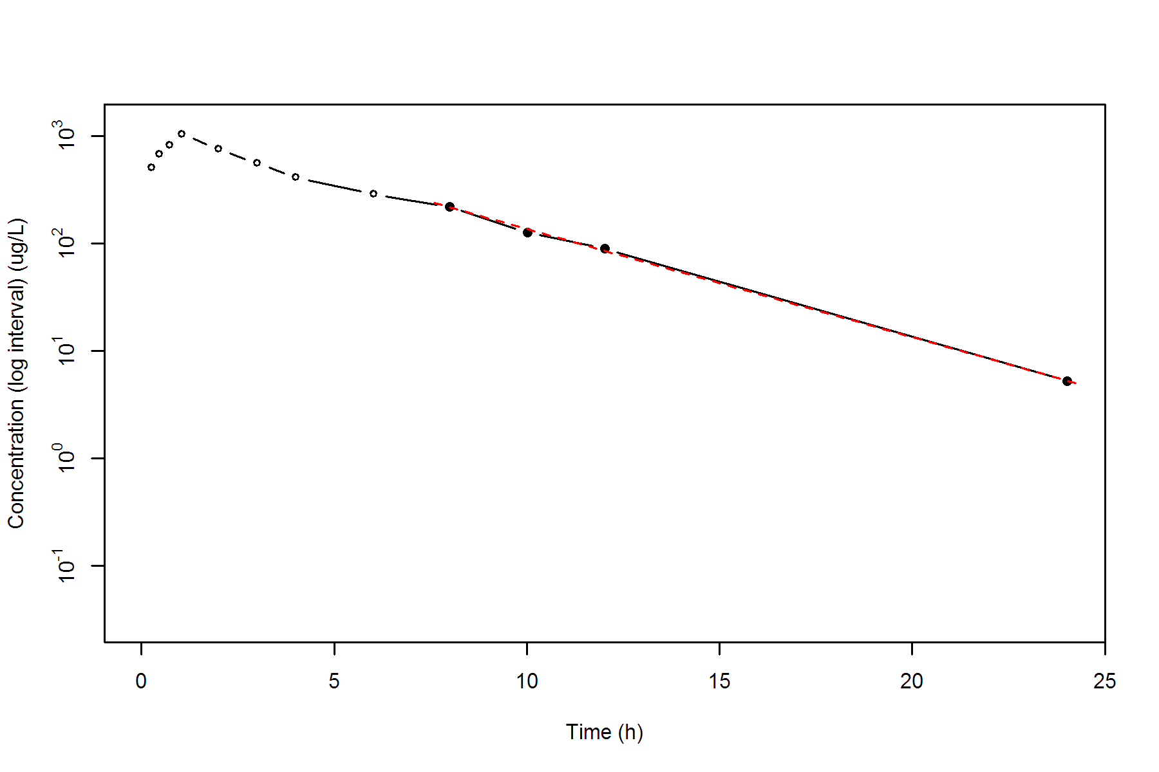

**SUBJ 1, GRP RT, PRD 2, TRT T**

NONCOMPARTMENTAL ANALYSIS REPORT

Package version 0.3.9 (2018-05-10 KST)

R version 3.5.0 (2018-04-23)

Date and Time: 2018-06-19 09:49:35 Asia/Seoul

Calculation Setting

-------------------

Drug Administration: Extravascular

Observation count excluding trailing zero: 13

Dose at time 0: 0 mg

AUC Calculation Method: Linear-up Linear-down

Weighting for lambda z: Uniform (Ordinary Least Square, OLS)

Lambda z selection criterion: Heighest adjusted R-squared value with precision=1e-4

Fitting, AUC, AUMC Result

-------------------------

Time Conc. Pred. Residual AUC AUMC

---------------------------------------------------------------------

0.0000 0.0000 0.0000 0.0000

0.2500 487.6200 60.9525 15.2381

0.4800 769.6000 205.5328 71.7391

0.7800 865.8100 450.8443 228.4501

1.0300 894.2100 670.8468 427.9961

2.0400 788.0300 1520.3780 1704.9479

2.9800 664.5600 2203.0953 3391.2938

3.9700 571.9500 2815.1678 5495.5538

5.9700 405.8900 3793.0078 10189.3586

7.9600 307.6300 4502.9602 15036.8972

9.9700 * 238.8100 241.9423 -3.132e+00 5052.1324 19890.7161

11.9500 * 181.6000 178.8671 +2.733e+00 5468.3383 24396.2612

24.0500 * 28.1800 28.2402 -6.015e-02 6737.5073 41625.7477

*: Used for the calculation of Lambda z.

Calculated Values

-----------------

CMAX Max Conc 894.2100 ug/L

TMAX Time of CMAX 1.0300 h

TLAG Time Until First Nonzero Conc 0.0000 h

CLST Last Nonzero Conc 28.1800 ug/L

CLSTP Last Nonzero Conc Pred 28.2402 ug/L

TLST Time of Last Nonzero Conc 24.0500 h

LAMZHL Half-Life Lambda z 4.5436 h

LAMZ Lambda z 0.1526 /h

LAMZLL Lambda z Lower Limit 9.9700 h

LAMZUL Lambda z Upper Limit 24.0500 h

LAMZNPT Number of Points for Lambda z 3

CORRXY Correlation Between TimeX and Log ConcY -0.9999

R2 R Squared 0.9999

R2ADJ R Squared Adjusted 0.9997

AUCLST AUC to Last Nonzero Conc 6737.5073 h*ug/L

AUCALL AUC All 6737.5073 h*ug/L

AUCIFO AUC Infinity Obs 6922.2292 h*ug/L

AUCIFP AUC Infinity Pred 6922.6235 h*ug/L

AUCPEO AUC %Extrapolation Obs 2.6685 %

AUCPEP AUC %Extrapolation Pred 2.6741 %

AUMCLST AUMC to Last Nonzero Conc 41625.7477 h2*ug/L

AUMCIFO AUMC Infinity Obs 47279.1778 h2*ug/L

AUMCIFP AUMC Infinity Pred 47291.2457 h2*ug/L

AUMCPEO AUMC %Extrapolation Obs 11.9575 %

AUMCPEP AUMC % Extrapolation Pred 11.9800 %

VZFO Vz Obs by F 0.0000 L

VZFP Vz Pred by F 0.0000 L

CLFO Total CL Obs by F 0.0000 L/h

CLFP Total CL Pred by F 0.0000 L/h

MRTEVLST MRT Extravasc to Last Nonzero Conc 6.1782 h

MRTEVIFO MRT Extravasc Infinity Obs 6.8301 h

MRTEVIFP MRT Extravasc Infinity Pred 6.8314 h

**SUBJ 1, GRP RT, PRD 2, TRT T**

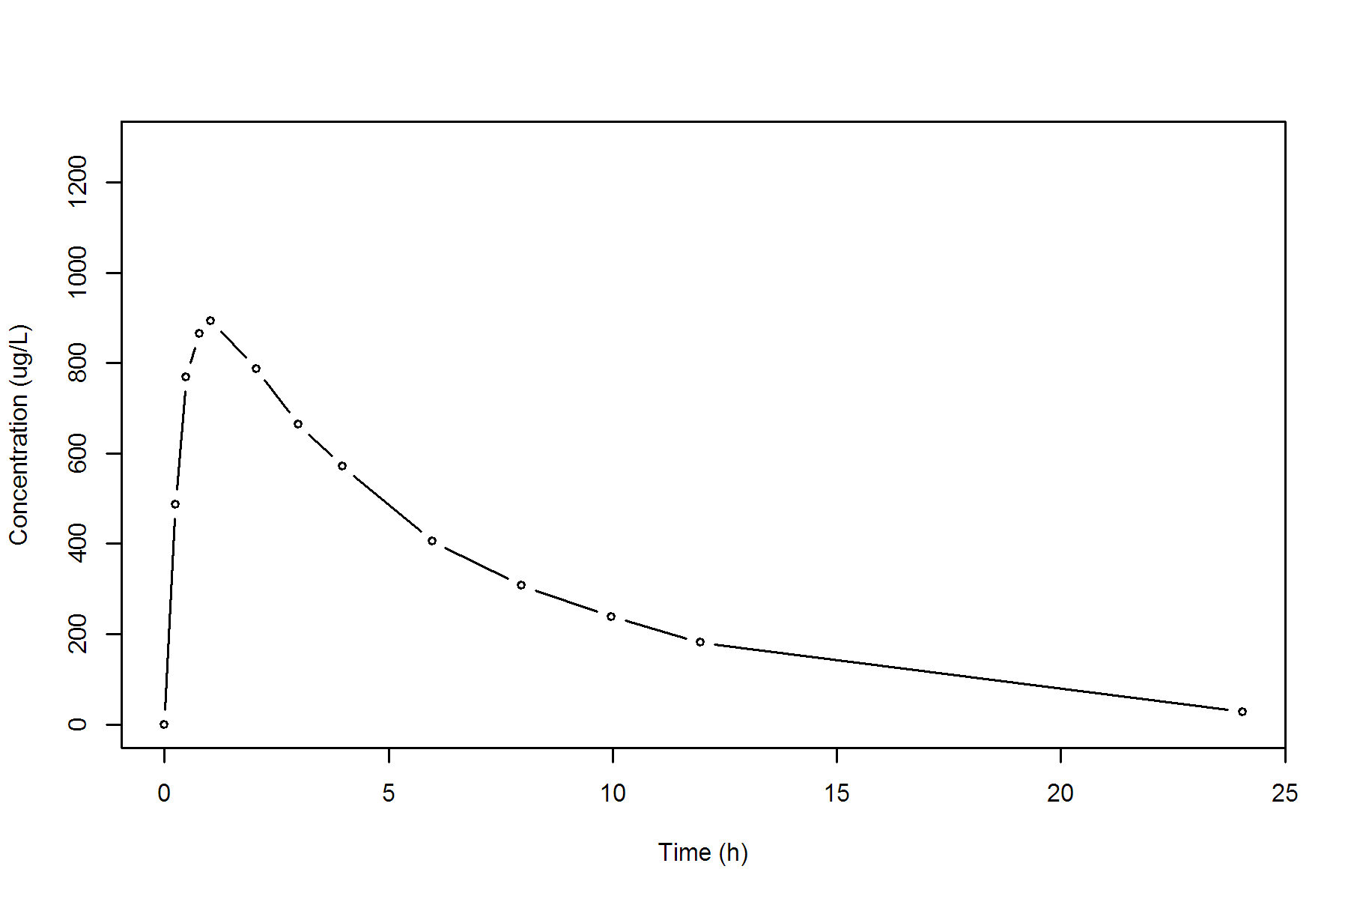

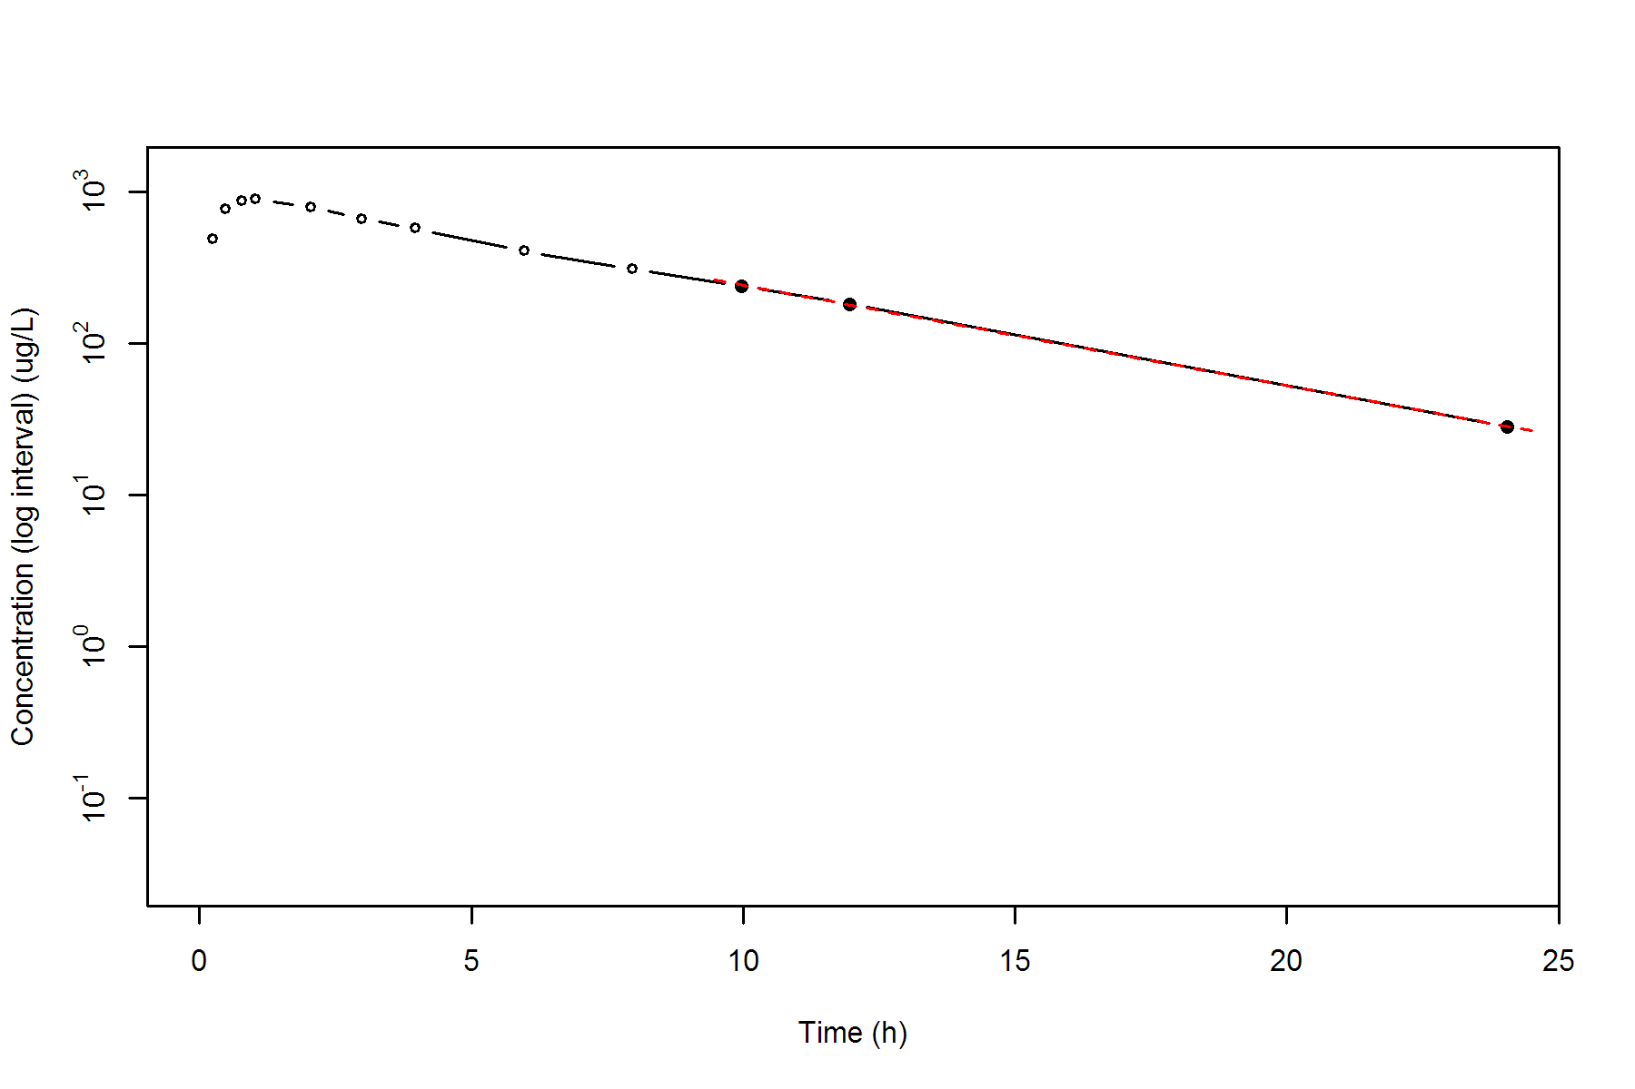

**SUBJ 2, GRP TR, PRD 1, TRT T**

NONCOMPARTMENTAL ANALYSIS REPORT

Package version 0.3.9 (2018-05-10 KST)

R version 3.5.0 (2018-04-23)

Date and Time: 2018-06-19 09:49:35 Asia/Seoul

Calculation Setting

-------------------

Drug Administration: Extravascular

Observation count excluding trailing zero: 13

Dose at time 0: 0 mg

AUC Calculation Method: Linear-up Linear-down

Weighting for lambda z: Uniform (Ordinary Least Square, OLS)

Lambda z selection criterion: Heighest adjusted R-squared value with precision=1e-4

Fitting, AUC, AUMC Result

-------------------------

Time Conc. Pred. Residual AUC AUMC

---------------------------------------------------------------------

0.0000 0.1200 0.0000 0.0000

0.2900 221.0100 32.0638 9.2935

0.4600 272.8200 74.0394 25.4086

0.7200 408.3500 162.5915 79.9448

1.0100 447.2600 286.6550 188.0778

2.0200 349.3000 688.9178 772.5237

2.9800 376.4100 1037.2586 1649.6218

4.0100 370.3900 1421.8605 2992.2092

6.0400 226.6800 2027.8866 5889.4364

7.9900 * 239.4500 243.4327 -3.983e+00 2482.3634 9089.7303

9.9600 * 182.7300 189.7085 -6.978e+00 2898.2107 12766.9287

12.0400 * 155.7500 145.7968 +9.953e+00 3250.2298 16609.9583

24.0400 * 31.5400 31.9228 -3.828e-01 4373.9698 32410.6679

*: Used for the calculation of Lambda z.

Calculated Values

-----------------

CMAX Max Conc 447.2600 ug/L

TMAX Time of CMAX 1.0100 h

TLAG Time Until First Nonzero Conc 0.0000 h

CLST Last Nonzero Conc 31.5400 ug/L

CLSTP Last Nonzero Conc Pred 31.9228 ug/L

TLST Time of Last Nonzero Conc 24.0400 h

LAMZHL Half-Life Lambda z 5.4762 h

LAMZ Lambda z 0.1266 /h

LAMZLL Lambda z Lower Limit 7.9900 h

LAMZUL Lambda z Upper Limit 24.0400 h

LAMZNPT Number of Points for Lambda z 4

CORRXY Correlation Between TimeX and Log ConcY -0.9988

R2 R Squared 0.9975

R2ADJ R Squared Adjusted 0.9963

AUCLST AUC to Last Nonzero Conc 4373.9698 h*ug/L

AUCALL AUC All 4373.9698 h*ug/L

AUCIFO AUC Infinity Obs 4623.1512 h*ug/L

AUCIFP AUC Infinity Pred 4626.1755 h*ug/L

AUCPEO AUC %Extrapolation Obs 5.3899 %

AUCPEP AUC %Extrapolation Pred 5.4517 %

AUMCLST AUMC to Last Nonzero Conc 32410.6679 h2*ug/L

AUMCIFO AUMC Infinity Obs 40369.6431 h2*ug/L

AUMCIFP AUMC Infinity Pred 40466.2389 h2*ug/L

AUMCPEO AUMC %Extrapolation Obs 19.7152 %

AUMCPEP AUMC % Extrapolation Pred 19.9069 %

VZFO Vz Obs by F 0.0000 L

VZFP Vz Pred by F 0.0000 L

CLFO Total CL Obs by F 0.0000 L/h

CLFP Total CL Pred by F 0.0000 L/h

MRTEVLST MRT Extravasc to Last Nonzero Conc 7.4099 h

MRTEVIFO MRT Extravasc Infinity Obs 8.7321 h

MRTEVIFP MRT Extravasc Infinity Pred 8.7472 h

**SUBJ 2, GRP TR, PRD 1, TRT T**

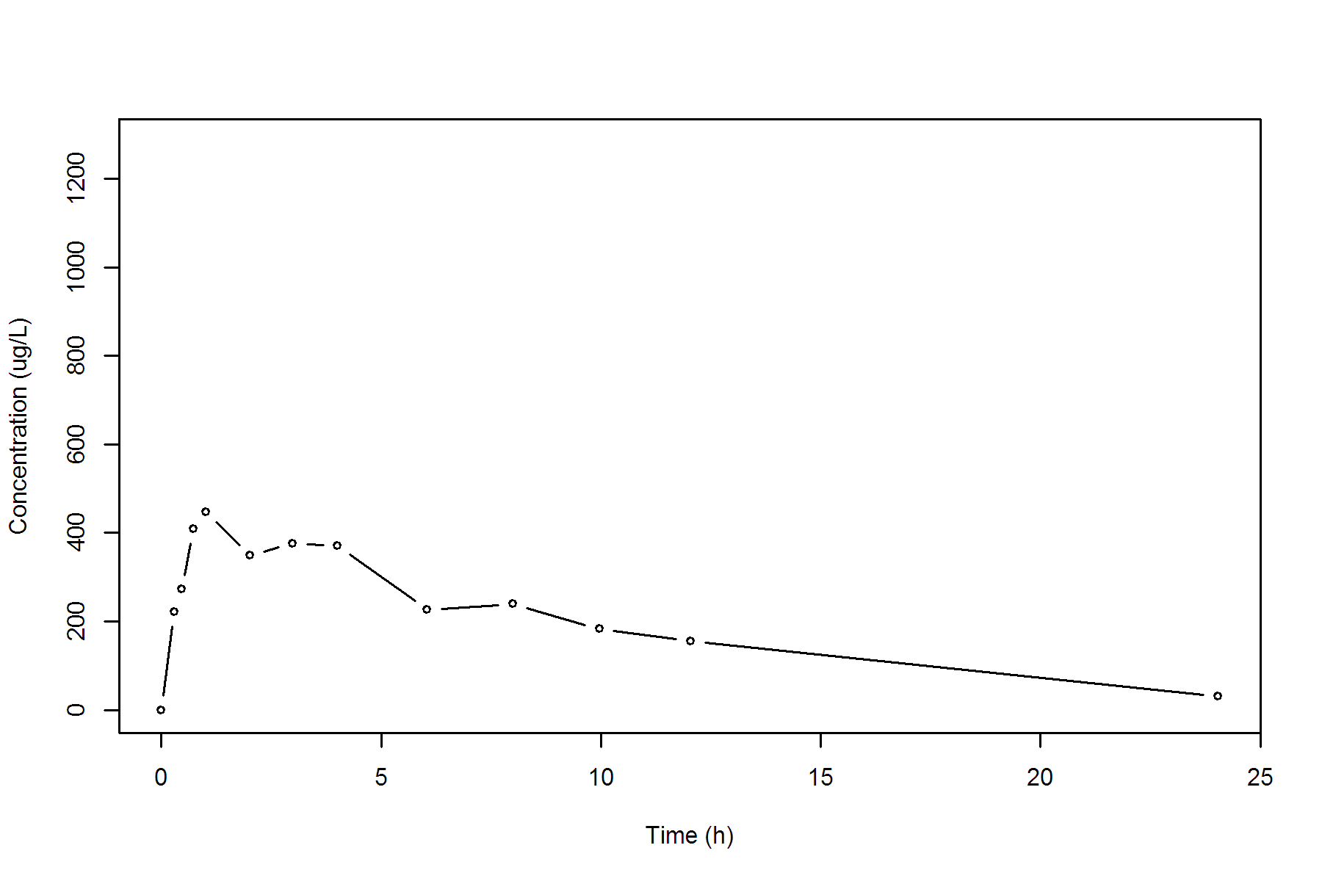

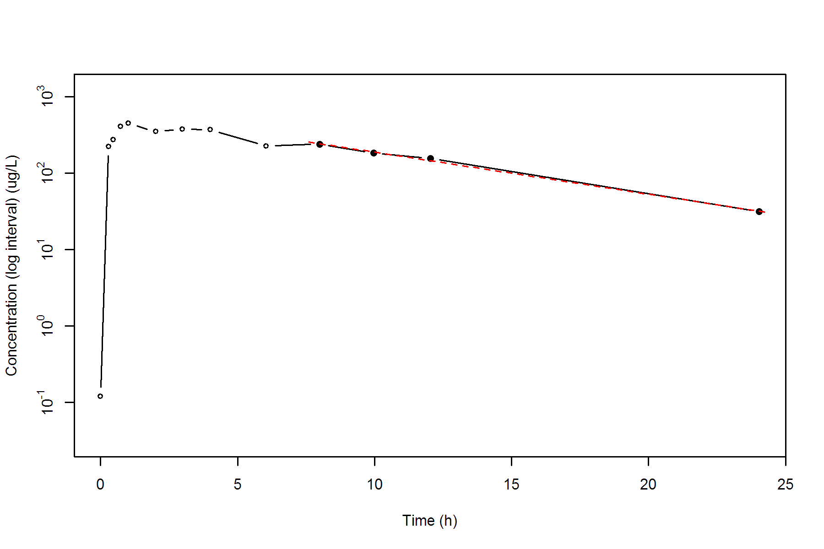

**SUBJ 2, GRP TR, PRD 2, TRT R**

NONCOMPARTMENTAL ANALYSIS REPORT

Package version 0.3.9 (2018-05-10 KST)

R version 3.5.0 (2018-04-23)

Date and Time: 2018-06-19 09:49:35 Asia/Seoul

Calculation Setting

-------------------

Drug Administration: Extravascular

Observation count excluding trailing zero: 13

Dose at time 0: 0 mg

AUC Calculation Method: Linear-up Linear-down

Weighting for lambda z: Uniform (Ordinary Least Square, OLS)

Lambda z selection criterion: Heighest adjusted R-squared value with precision=1e-4

Fitting, AUC, AUMC Result

-------------------------

Time Conc. Pred. Residual AUC AUMC

---------------------------------------------------------------------

0.0000 0.0000 0.0000 0.0000

0.2500 331.4300 41.4288 10.3572

0.5300 567.3200 167.2538 64.0524

0.7200 524.7800 271.0033 128.5119

0.9700 567.5200 407.5408 244.5539

1.9800 783.9200 1090.0180 1306.3952

2.9900 486.9800 1731.8225 2825.5522

4.0400 * 509.0200 506.0084 +3.012e+00 2254.7225 4669.6205

6.0200 * 397.4600 395.6395 +1.820e+00 3152.1376 9074.2790

7.9900 * 287.1000 309.7286 -2.263e+01 3826.4293 13690.6176

10.0200 * 271.0400 240.6716 +3.037e+01 4392.9414 18775.5137

11.9800 * 178.7500 188.6454 -9.895e+00 4833.7356 23535.6146

24.0200 * 42.2700 42.2536 +1.645e-02 6164.2760 42539.2520

*: Used for the calculation of Lambda z.

Calculated Values

-----------------

CMAX Max Conc 783.9200 ug/L

TMAX Time of CMAX 1.9800 h

TLAG Time Until First Nonzero Conc 0.0000 h

CLST Last Nonzero Conc 42.2700 ug/L

CLSTP Last Nonzero Conc Pred 42.2536 ug/L

TLST Time of Last Nonzero Conc 24.0200 h

LAMZHL Half-Life Lambda z 5.5779 h

LAMZ Lambda z 0.1243 /h

LAMZLL Lambda z Lower Limit 4.0400 h

LAMZUL Lambda z Upper Limit 24.0200 h

LAMZNPT Number of Points for Lambda z 6

CORRXY Correlation Between TimeX and Log ConcY -0.9971

R2 R Squared 0.9942

R2ADJ R Squared Adjusted 0.9927

AUCLST AUC to Last Nonzero Conc 6164.2760 h*ug/L

AUCALL AUC All 6164.2760 h*ug/L

AUCIFO AUC Infinity Obs 6504.4292 h*ug/L

AUCIFP AUC Infinity Pred 6504.2969 h*ug/L

AUCPEO AUC %Extrapolation Obs 5.2296 %

AUCPEP AUC %Extrapolation Pred 5.2276 %

AUMCLST AUMC to Last Nonzero Conc 42539.2520 h2*ug/L

AUMCIFO AUMC Infinity Obs 53447.0006 h2*ug/L

AUMCIFP AUMC Infinity Pred 53442.7567 h2*ug/L

AUMCPEO AUMC %Extrapolation Obs 20.4085 %

AUMCPEP AUMC % Extrapolation Pred 20.4022 %

VZFO Vz Obs by F 0.0000 L

VZFP Vz Pred by F 0.0000 L

CLFO Total CL Obs by F 0.0000 L/h

CLFP Total CL Pred by F 0.0000 L/h

MRTEVLST MRT Extravasc to Last Nonzero Conc 6.9009 h

MRTEVIFO MRT Extravasc Infinity Obs 8.2170 h

MRTEVIFP MRT Extravasc Infinity Pred 8.2165 h

**SUBJ 2, GRP TR, PRD 2, TRT R**

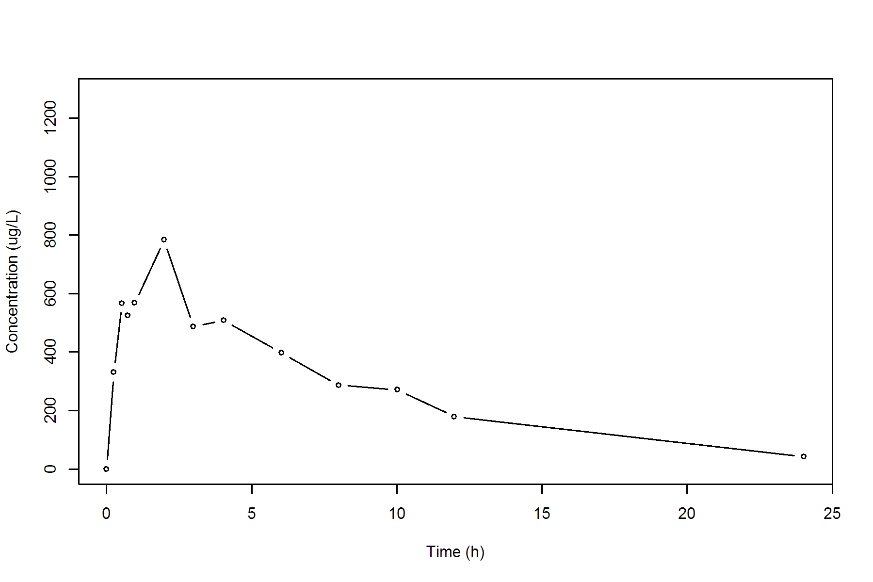

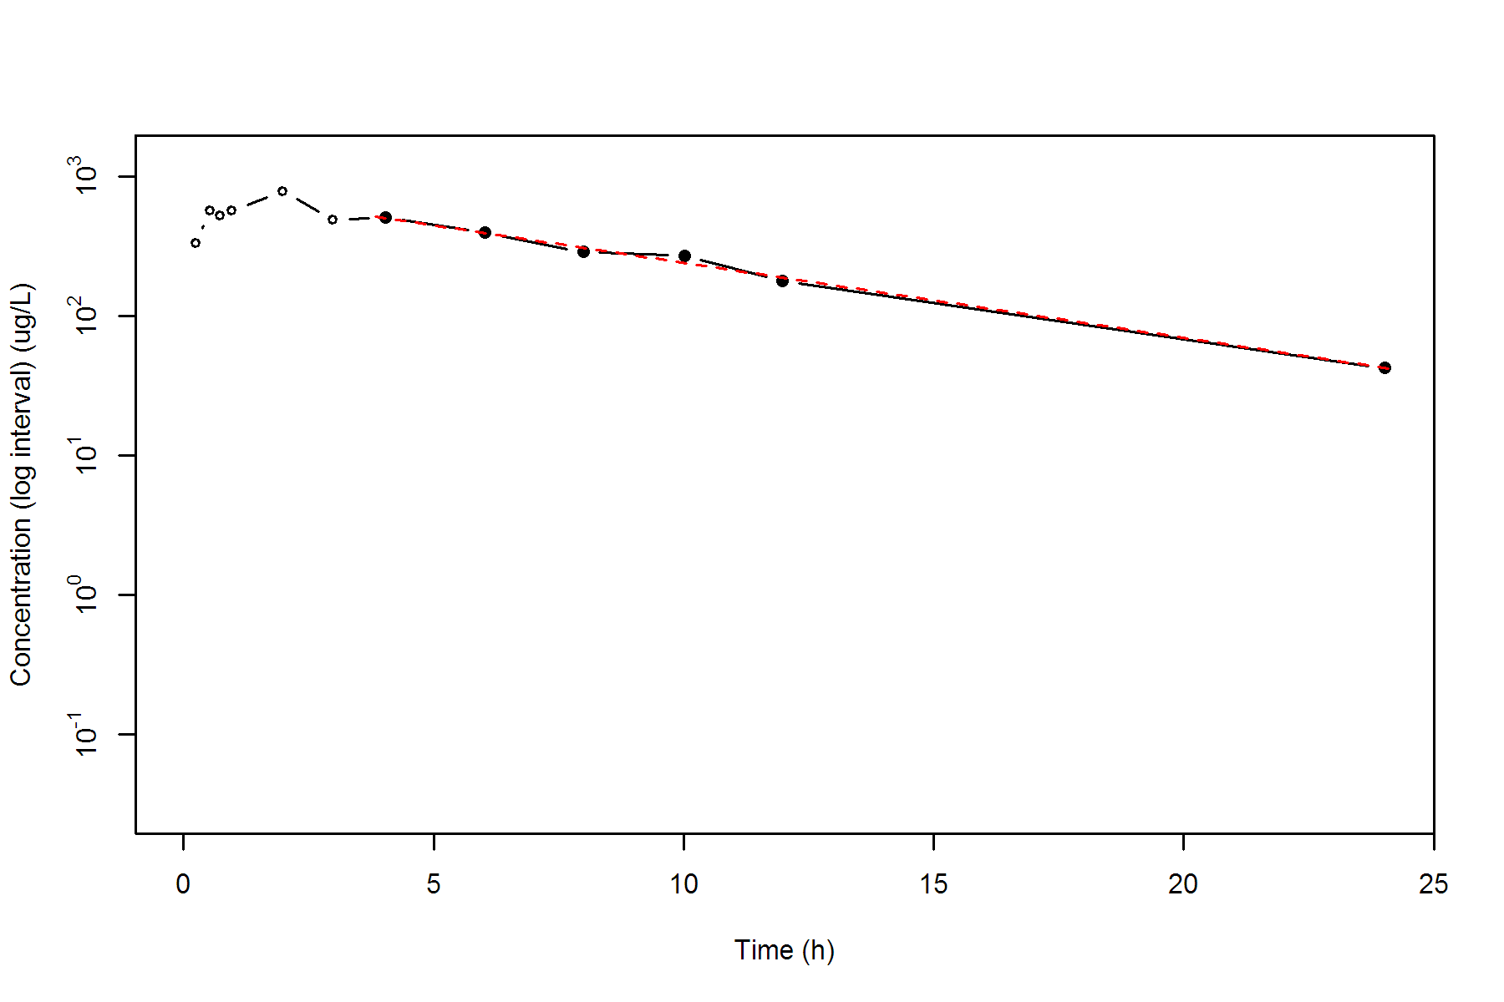

**SUBJ 3, GRP TR, PRD 1, TRT T**

NONCOMPARTMENTAL ANALYSIS REPORT

Package version 0.3.9 (2018-05-10 KST)

R version 3.5.0 (2018-04-23)

Date and Time: 2018-06-19 09:49:35 Asia/Seoul

Calculation Setting

-------------------

Drug Administration: Extravascular

Observation count excluding trailing zero: 13

Dose at time 0: 0 mg

AUC Calculation Method: Linear-up Linear-down

Weighting for lambda z: Uniform (Ordinary Least Square, OLS)

Lambda z selection criterion: Heighest adjusted R-squared value with precision=1e-4

Fitting, AUC, AUMC Result

-------------------------

Time Conc. Pred. Residual AUC AUMC

---------------------------------------------------------------------

0.0000 0.2300 0.0000 0.0000

0.2500 288.3100 36.0675 9.0097

0.5300 444.4700 138.6567 52.0802

0.7300 507.6200 233.8657 112.6934

0.9800 459.6800 354.7782 215.3245

2.0100 555.9800 877.8431 1022.8477

3.0000 444.8300 1373.2441 2236.5926

3.9800 379.0300 1776.9355 3629.6770

5.9600 306.2500 2455.3627 6930.1285

8.0400 * 181.6900 177.3527 +4.337e+00 2962.8202 10347.6076

9.9900 * 113.9300 119.6727 -5.743e+00 3251.0497 12881.5822

11.9800 * 82.1500 80.1028 +2.047e+00 3446.1494 14993.2883

24.0400 * 7.0300 7.0316 -1.553e-03 3983.9048 21946.8322

*: Used for the calculation of Lambda z.

Calculated Values

-----------------

CMAX Max Conc 555.9800 ug/L

TMAX Time of CMAX 2.0100 h

TLAG Time Until First Nonzero Conc 0.0000 h

CLST Last Nonzero Conc 7.0300 ug/L

CLSTP Last Nonzero Conc Pred 7.0316 ug/L

TLST Time of Last Nonzero Conc 24.0400 h

LAMZHL Half-Life Lambda z 3.4360 h

LAMZ Lambda z 0.2017 /h

LAMZLL Lambda z Lower Limit 8.0400 h

LAMZUL Lambda z Upper Limit 24.0400 h

LAMZNPT Number of Points for Lambda z 4

CORRXY Correlation Between TimeX and Log ConcY -0.9997

R2 R Squared 0.9994

R2ADJ R Squared Adjusted 0.9991

AUCLST AUC to Last Nonzero Conc 3983.9048 h*ug/L

AUCALL AUC All 3983.9048 h*ug/L

AUCIFO AUC Infinity Obs 4018.7527 h*ug/L

AUCIFP AUC Infinity Pred 4018.7604 h*ug/L

AUCPEO AUC %Extrapolation Obs 0.8671 %

AUCPEP AUC %Extrapolation Pred 0.8673 %

AUMCLST AUMC to Last Nonzero Conc 21946.8322 h2*ug/L

AUMCIFO AUMC Infinity Obs 22957.3208 h2*ug/L

AUMCIFP AUMC Infinity Pred 22957.5440 h2*ug/L

AUMCPEO AUMC %Extrapolation Obs 4.4016 %

AUMCPEP AUMC % Extrapolation Pred 4.4025 %

VZFO Vz Obs by F 0.0000 L

VZFP Vz Pred by F 0.0000 L

CLFO Total CL Obs by F 0.0000 L/h

CLFP Total CL Pred by F 0.0000 L/h

MRTEVLST MRT Extravasc to Last Nonzero Conc 5.5089 h

MRTEVIFO MRT Extravasc Infinity Obs 5.7125 h

MRTEVIFP MRT Extravasc Infinity Pred 5.7126 h

**SUBJ 3, GRP TR, PRD 1, TRT T**

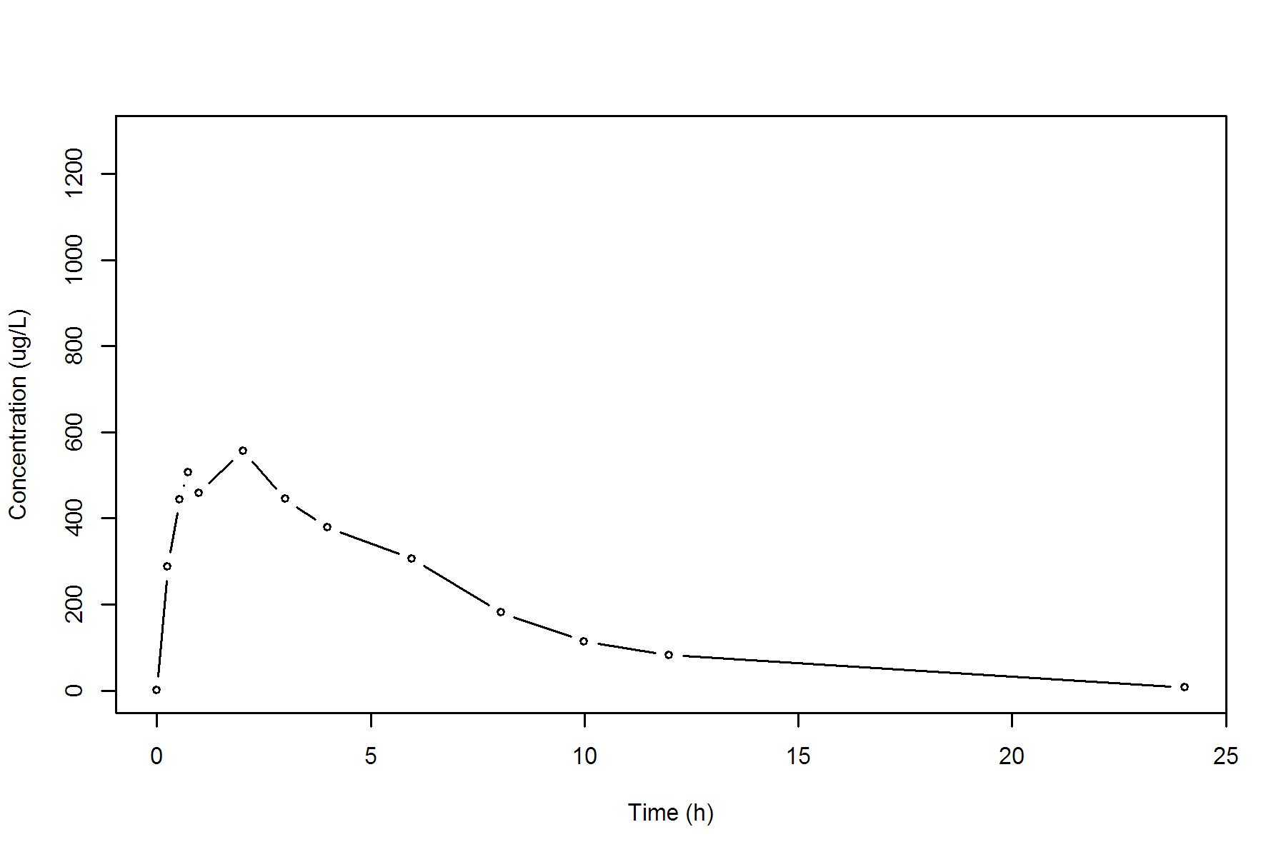

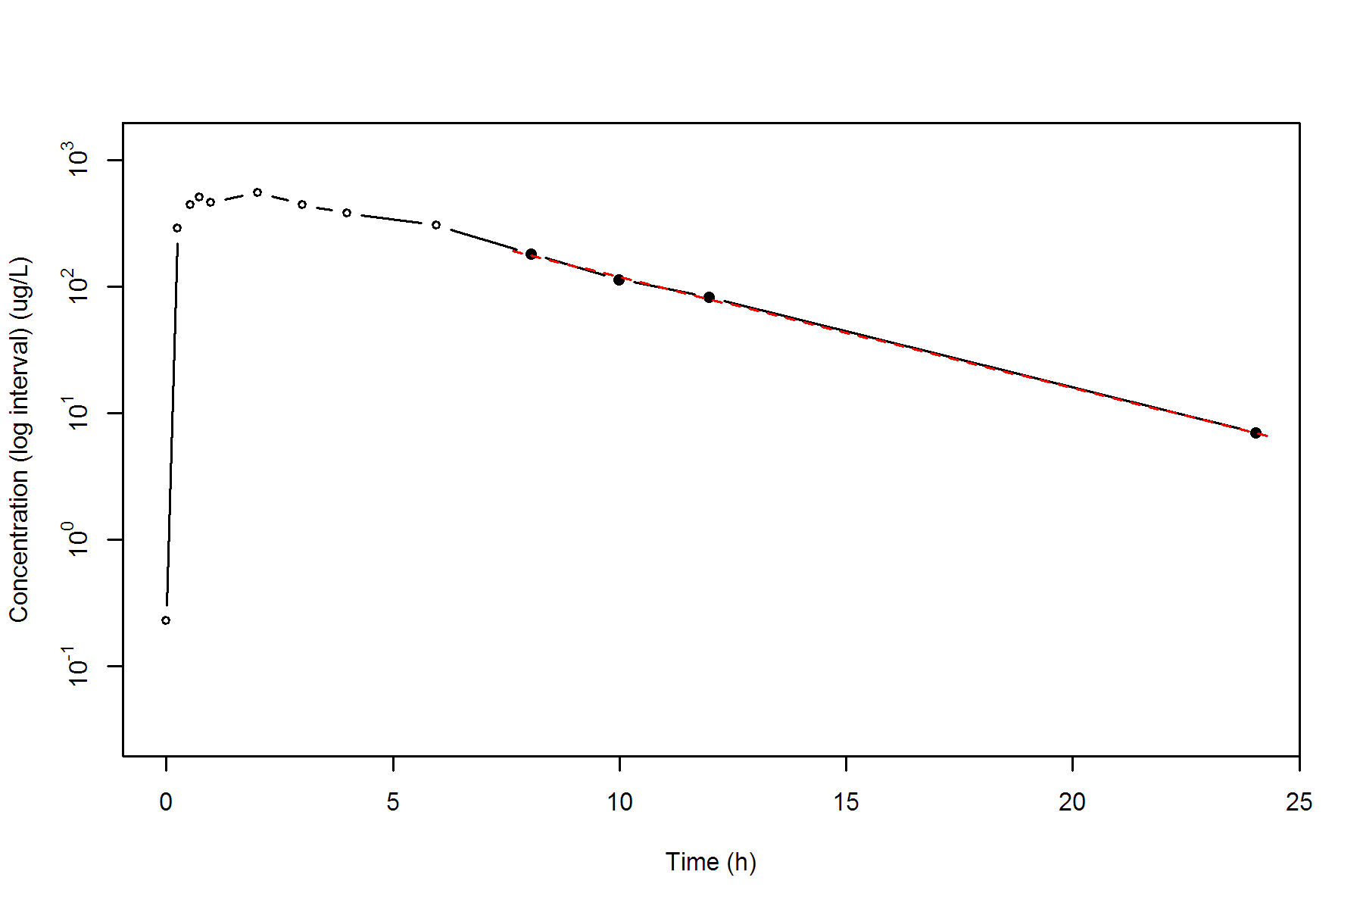

**SUBJ 3, GRP TR, PRD 2, TRT R**

NONCOMPARTMENTAL ANALYSIS REPORT

Package version 0.3.9 (2018-05-10 KST)

R version 3.5.0 (2018-04-23)

Date and Time: 2018-06-19 09:49:35 Asia/Seoul

Calculation Setting

-------------------

Drug Administration: Extravascular

Observation count excluding trailing zero: 13

Dose at time 0: 0 mg

AUC Calculation Method: Linear-up Linear-down

Weighting for lambda z: Uniform (Ordinary Least Square, OLS)

Lambda z selection criterion: Heighest adjusted R-squared value with precision=1e-4

Fitting, AUC, AUMC Result

-------------------------

Time Conc. Pred. Residual AUC AUMC

---------------------------------------------------------------------

0.0000 0.0000 0.0000 0.0000

0.2300 503.6800 57.9232 13.3223

0.4800 684.3100 206.4219 68.8617

0.7700 659.1800 401.2280 190.0872

0.9800 758.6400 550.0991 321.4459

2.0000 552.4500 1218.7550 1264.1132

3.0400 454.8200 1742.5354 2557.6406

4.0100 363.6500 2139.4933 3935.4720

5.9700 * 152.2700 139.1189 +1.315e+01 2645.0949 6255.4146

7.9700 * 89.3800 84.8394 +4.541e+00 2886.7449 7876.8251

9.9700 * 51.4300 51.7380 -3.080e-01 3027.5549 9101.9408

11.9600 * 25.9500 31.6297 -5.680e+00 3104.5481 9920.9443

23.9600 * 1.7300 1.6269 +1.031e-01 3270.6280 12031.8211

*: Used for the calculation of Lambda z.

Calculated Values

-----------------

CMAX Max Conc 758.6400 ug/L

TMAX Time of CMAX 0.9800 h

TLAG Time Until First Nonzero Conc 0.0000 h

CLST Last Nonzero Conc 1.7300 ug/L

CLSTP Last Nonzero Conc Pred 1.6269 ug/L

TLST Time of Last Nonzero Conc 23.9600 h

LAMZHL Half-Life Lambda z 2.8030 h

LAMZ Lambda z 0.2473 /h

LAMZLL Lambda z Lower Limit 5.9700 h

LAMZUL Lambda z Upper Limit 23.9600 h

LAMZNPT Number of Points for Lambda z 5

CORRXY Correlation Between TimeX and Log ConcY -0.9978

R2 R Squared 0.9956

R2ADJ R Squared Adjusted 0.9941

AUCLST AUC to Last Nonzero Conc 3270.6280 h*ug/L

AUCALL AUC All 3270.6280 h*ug/L

AUCIFO AUC Infinity Obs 3277.6241 h*ug/L

AUCIFP AUC Infinity Pred 3277.2072 h*ug/L

AUCPEO AUC %Extrapolation Obs 0.2134 %

AUCPEP AUC %Extrapolation Pred 0.2008 %

AUMCLST AUMC to Last Nonzero Conc 12031.8211 h2*ug/L

AUMCIFO AUMC Infinity Obs 12227.7367 h2*ug/L

AUMCIFP AUMC Infinity Pred 12216.0632 h2*ug/L

AUMCPEO AUMC %Extrapolation Obs 1.6022 %

AUMCPEP AUMC % Extrapolation Pred 1.5082 %

VZFO Vz Obs by F 0.0000 L

VZFP Vz Pred by F 0.0000 L

CLFO Total CL Obs by F 0.0000 L/h

CLFP Total CL Pred by F 0.0000 L/h

MRTEVLST MRT Extravasc to Last Nonzero Conc 3.6787 h

MRTEVIFO MRT Extravasc Infinity Obs 3.7307 h

MRTEVIFP MRT Extravasc Infinity Pred 3.7276 h

**SUBJ 3, GRP TR, PRD 2, TRT R**

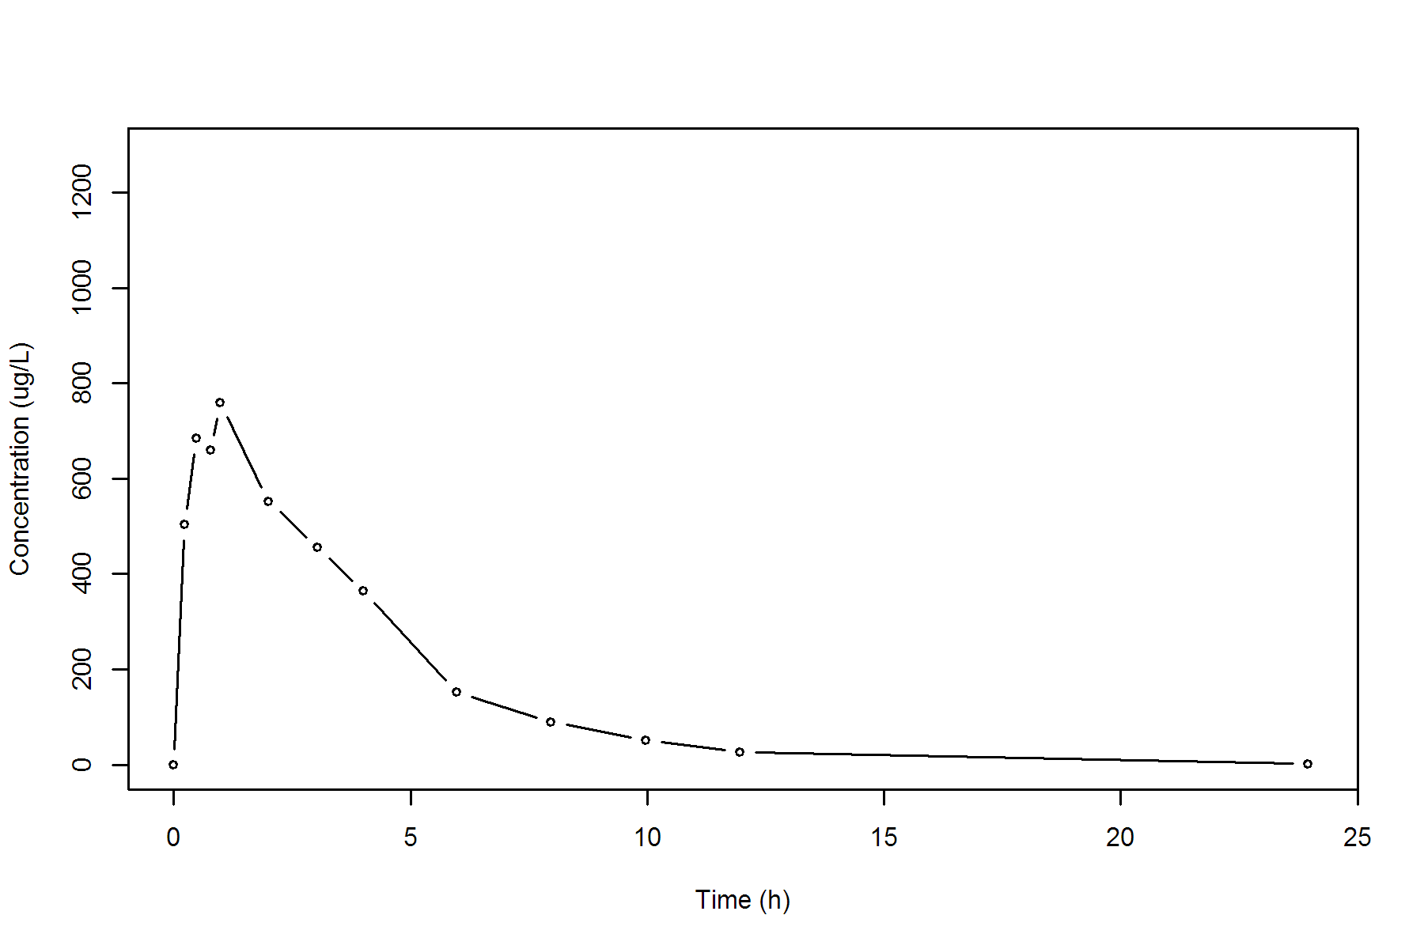

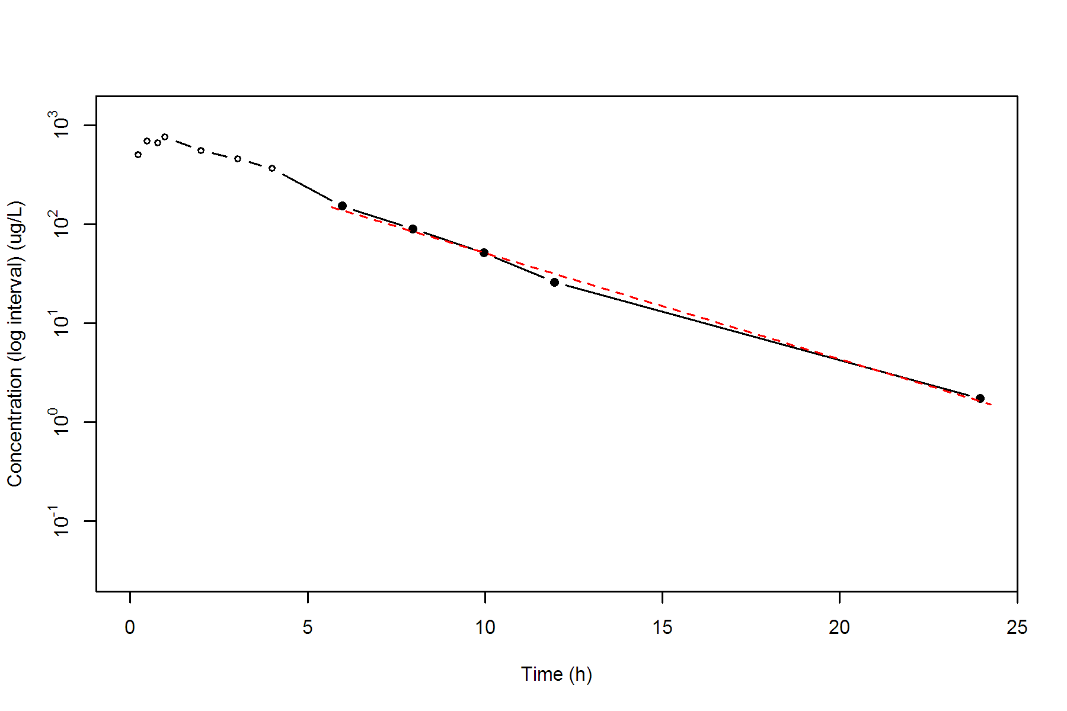

**SUBJ 4, GRP TR, PRD 1, TRT T**

NONCOMPARTMENTAL ANALYSIS REPORT

Package version 0.3.9 (2018-05-10 KST)

R version 3.5.0 (2018-04-23)

Date and Time: 2018-06-19 09:49:35 Asia/Seoul

Calculation Setting

-------------------

Drug Administration: Extravascular

Observation count excluding trailing zero: 13

Dose at time 0: 0 mg

AUC Calculation Method: Linear-up Linear-down

Weighting for lambda z: Uniform (Ordinary Least Square, OLS)

Lambda z selection criterion: Heighest adjusted R-squared value with precision=1e-4

Fitting, AUC, AUMC Result

-------------------------

Time Conc. Pred. Residual AUC AUMC

---------------------------------------------------------------------

0.0000 0.0000 0.0000 0.0000

0.2400 475.0300 57.0036 13.6809

0.5400 708.1800 234.4851 88.1445

0.7800 706.0500 404.1927 200.1209

0.9700 686.6500 536.4992 315.7140

1.9700 824.4200 1292.0342 1460.7929

2.9600 * 611.1000 598.8248 +1.228e+01 2002.6166 3160.1098

3.9600 * 517.9000 502.6741 +1.523e+01 2567.1166 5089.9798

6.0500 * 355.5800 348.6733 +6.907e+00 3479.9032 9481.2192

7.9600 * 239.1300 249.5935 -1.046e+01 4047.8513 13353.4900

10.0400 * 161.5200 173.4306 -1.191e+01 4464.5273 17019.6310

12.0300 * 125.5600 122.4219 +3.138e+00 4750.1719 20136.1179

23.9900 * 15.3800 15.0918 +2.882e-01 5592.9931 31375.2468

*: Used for the calculation of Lambda z.

Calculated Values

-----------------

CMAX Max Conc 824.4200 ug/L

TMAX Time of CMAX 1.9700 h

TLAG Time Until First Nonzero Conc 0.0000 h

CLST Last Nonzero Conc 15.3800 ug/L

CLSTP Last Nonzero Conc Pred 15.0918 ug/L

TLST Time of Last Nonzero Conc 23.9900 h

LAMZHL Half-Life Lambda z 3.9602 h

LAMZ Lambda z 0.1750 /h

LAMZLL Lambda z Lower Limit 2.9600 h

LAMZUL Lambda z Upper Limit 23.9900 h

LAMZNPT Number of Points for Lambda z 7

CORRXY Correlation Between TimeX and Log ConcY -0.9995

R2 R Squared 0.9990

R2ADJ R Squared Adjusted 0.9988

AUCLST AUC to Last Nonzero Conc 5592.9931 h*ug/L

AUCALL AUC All 5592.9931 h*ug/L

AUCIFO AUC Infinity Obs 5680.8652 h*ug/L

AUCIFP AUC Infinity Pred 5679.2184 h*ug/L

AUCPEO AUC %Extrapolation Obs 1.5468 %

AUCPEP AUC %Extrapolation Pred 1.5183 %

AUMCLST AUMC to Last Nonzero Conc 31375.2468 h2*ug/L

AUMCIFO AUMC Infinity Obs 33985.3477 h2*ug/L

AUMCIFP AUMC Infinity Pred 33936.4335 h2*ug/L

AUMCPEO AUMC %Extrapolation Obs 7.6801 %

AUMCPEP AUMC % Extrapolation Pred 7.5470 %

VZFO Vz Obs by F 0.0000 L

VZFP Vz Pred by F 0.0000 L

CLFO Total CL Obs by F 0.0000 L/h

CLFP Total CL Pred by F 0.0000 L/h

MRTEVLST MRT Extravasc to Last Nonzero Conc 5.6097 h

MRTEVIFO MRT Extravasc Infinity Obs 5.9824 h

MRTEVIFP MRT Extravasc Infinity Pred 5.9755 h

**SUBJ 4, GRP TR, PRD 1, TRT T**

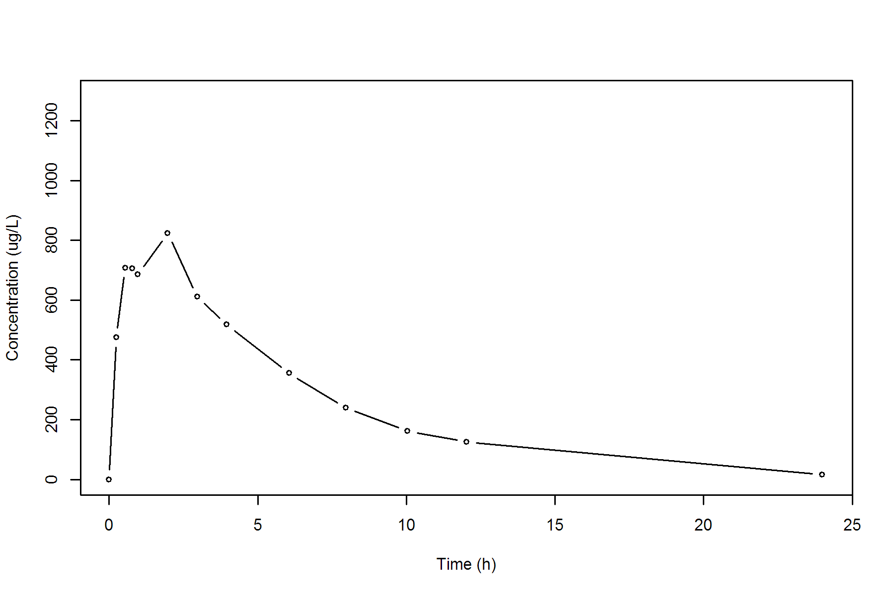

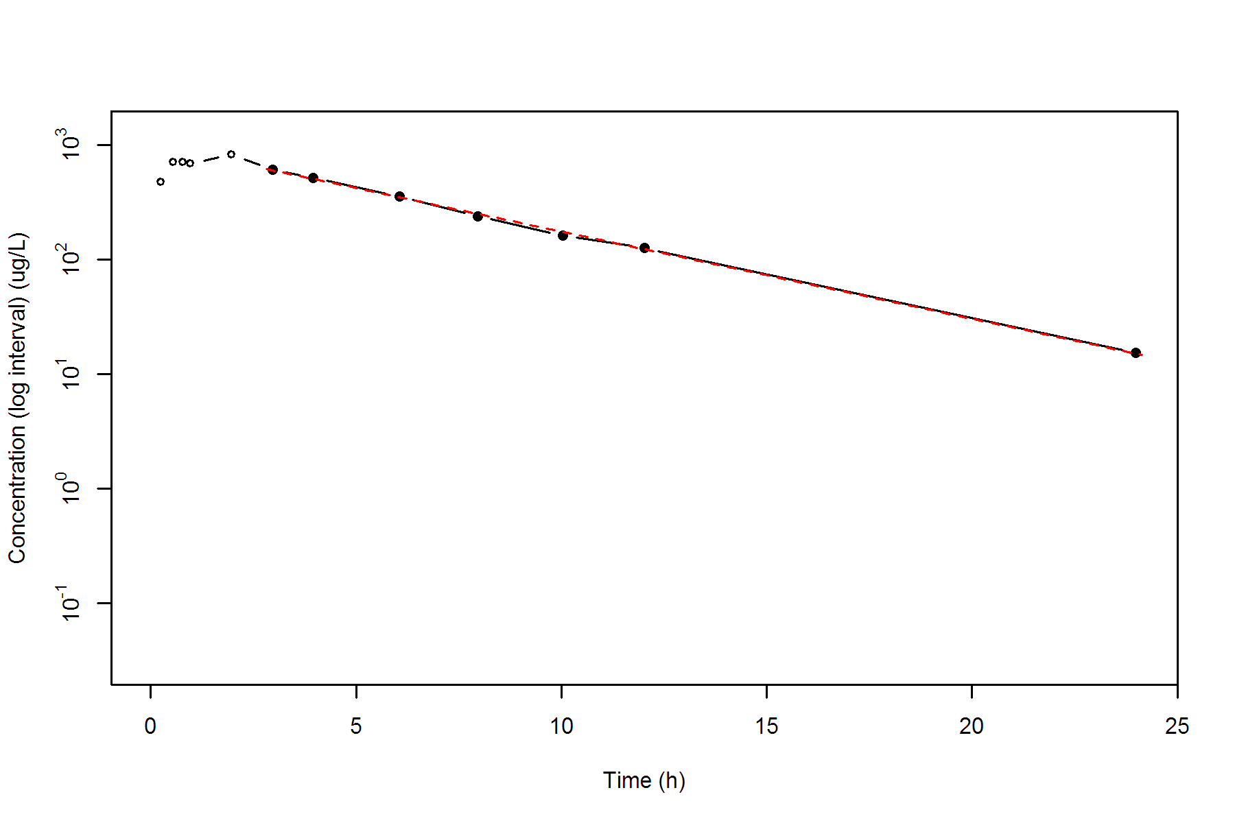

**SUBJ 4, GRP TR, PRD 2, TRT R**

NONCOMPARTMENTAL ANALYSIS REPORT

Package version 0.3.9 (2018-05-10 KST)

R version 3.5.0 (2018-04-23)

Date and Time: 2018-06-19 09:49:35 Asia/Seoul

Calculation Setting

-------------------

Drug Administration: Extravascular

Observation count excluding trailing zero: 13

Dose at time 0: 0 mg

AUC Calculation Method: Linear-up Linear-down

Weighting for lambda z: Uniform (Ordinary Least Square, OLS)

Lambda z selection criterion: Heighest adjusted R-squared value with precision=1e-4

Fitting, AUC, AUMC Result

-------------------------

Time Conc. Pred. Residual AUC AUMC

---------------------------------------------------------------------

0.0000 0.0000 0.0000 0.0000

0.2500 451.0400 56.3800 14.0950

0.4800 597.3300 176.9426 60.0350

0.7200 642.1200 325.6766 149.9204

0.9700 646.3100 486.7303 286.0763

1.9800 588.1100 1110.1124 1190.7224

3.0400 493.2300 1683.2226 2602.5772

3.9600 505.0300 2142.4222 4212.2727

6.0400 382.5700 3065.5262 8695.3400

8.0200 298.1100 3739.3994 13349.8893

10.0100 * 223.1000 222.7981 +3.019e-01 4258.0034 17950.8422

12.0100 * 175.2500 175.5272 -2.772e-01 4656.3534 22288.8257

23.9900 * 42.0800 42.0705 +9.513e-03 5958.1600 40943.1933

*: Used for the calculation of Lambda z.

Calculated Values

-----------------

CMAX Max Conc 646.3100 ug/L

TMAX Time of CMAX 0.9700 h

TLAG Time Until First Nonzero Conc 0.0000 h

CLST Last Nonzero Conc 42.0800 ug/L

CLSTP Last Nonzero Conc Pred 42.0705 ug/L

TLST Time of Last Nonzero Conc 23.9900 h

LAMZHL Half-Life Lambda z 5.8132 h

LAMZ Lambda z 0.1192 /h

LAMZLL Lambda z Lower Limit 10.0100 h

LAMZUL Lambda z Upper Limit 23.9900 h

LAMZNPT Number of Points for Lambda z 3

CORRXY Correlation Between TimeX and Log ConcY -1.0000

R2 R Squared 1.0000

R2ADJ R Squared Adjusted 1.0000

AUCLST AUC to Last Nonzero Conc 5958.1600 h*ug/L

AUCALL AUC All 5958.1600 h*ug/L

AUCIFO AUC Infinity Obs 6311.0736 h*ug/L

AUCIFP AUC Infinity Pred 6310.9938 h*ug/L

AUCPEO AUC %Extrapolation Obs 5.5920 %

AUCPEP AUC %Extrapolation Pred 5.5908 %

AUMCLST AUMC to Last Nonzero Conc 40943.1933 h2*ug/L

AUMCIFO AUMC Infinity Obs 52369.3788 h2*ug/L

AUMCIFP AUMC Infinity Pred 52366.7958 h2*ug/L

AUMCPEO AUMC %Extrapolation Obs 21.8184 %

AUMCPEP AUMC % Extrapolation Pred 21.8146 %

VZFO Vz Obs by F 0.0000 L

VZFP Vz Pred by F 0.0000 L

CLFO Total CL Obs by F 0.0000 L/h

CLFP Total CL Pred by F 0.0000 L/h

MRTEVLST MRT Extravasc to Last Nonzero Conc 6.8718 h

MRTEVIFO MRT Extravasc Infinity Obs 8.2980 h

MRTEVIFP MRT Extravasc Infinity Pred 8.2977 h

**SUBJ 4, GRP TR, PRD 2, TRT R**

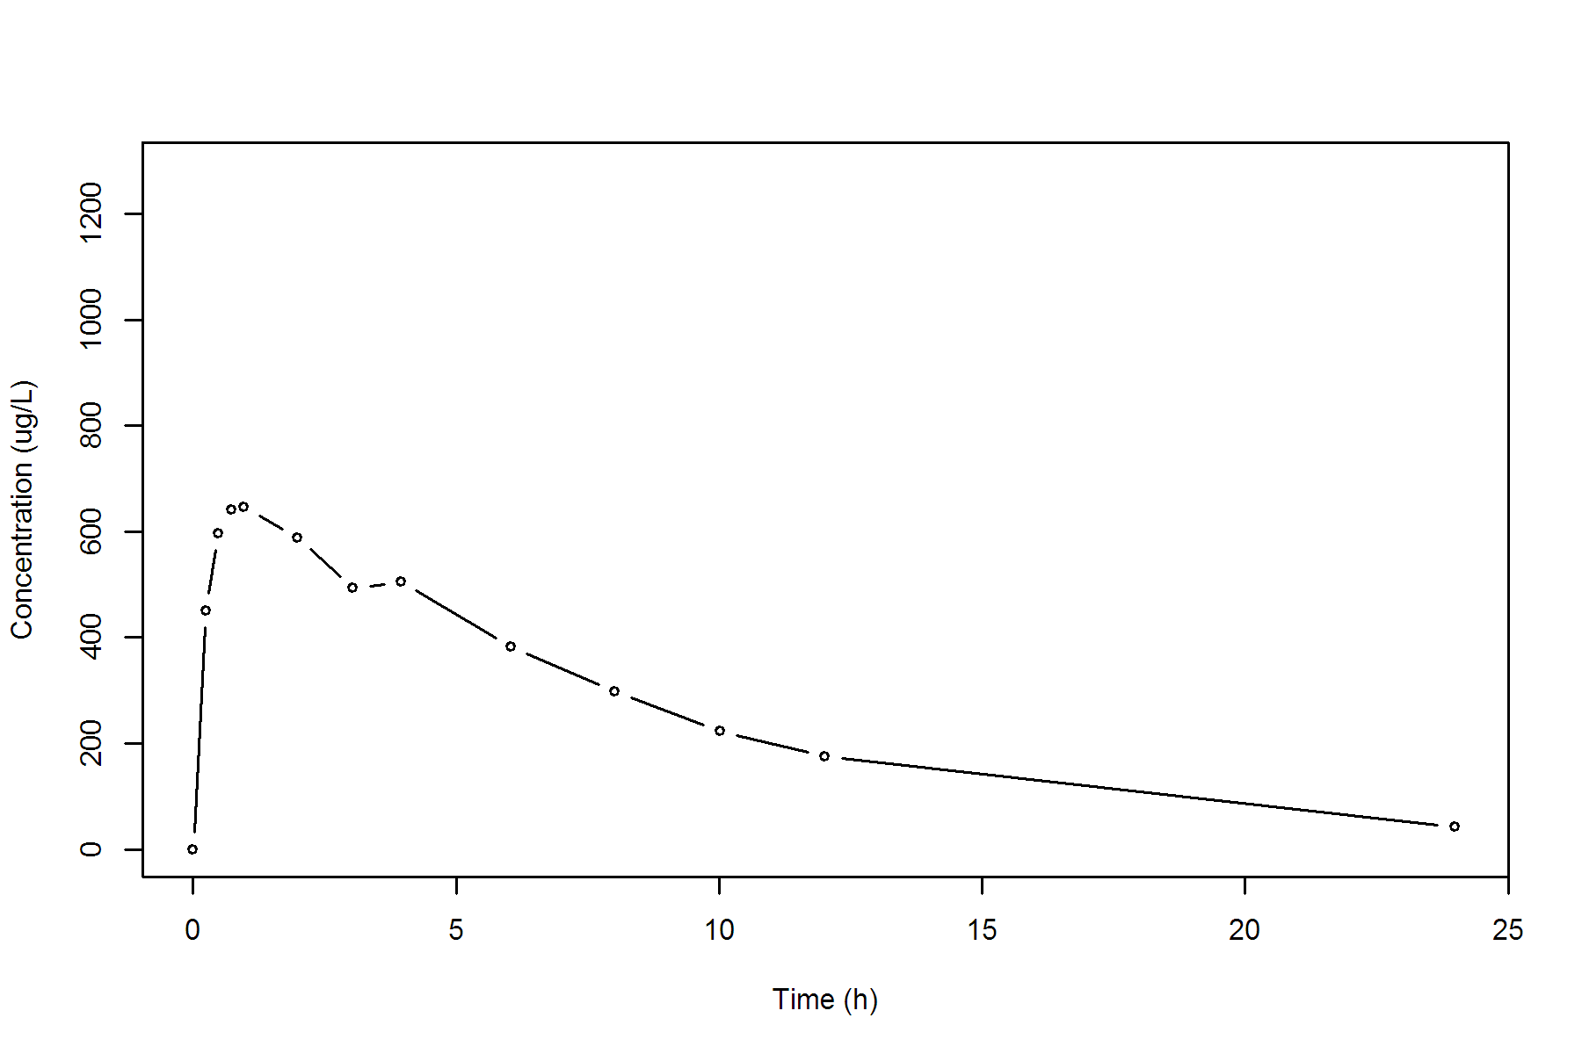

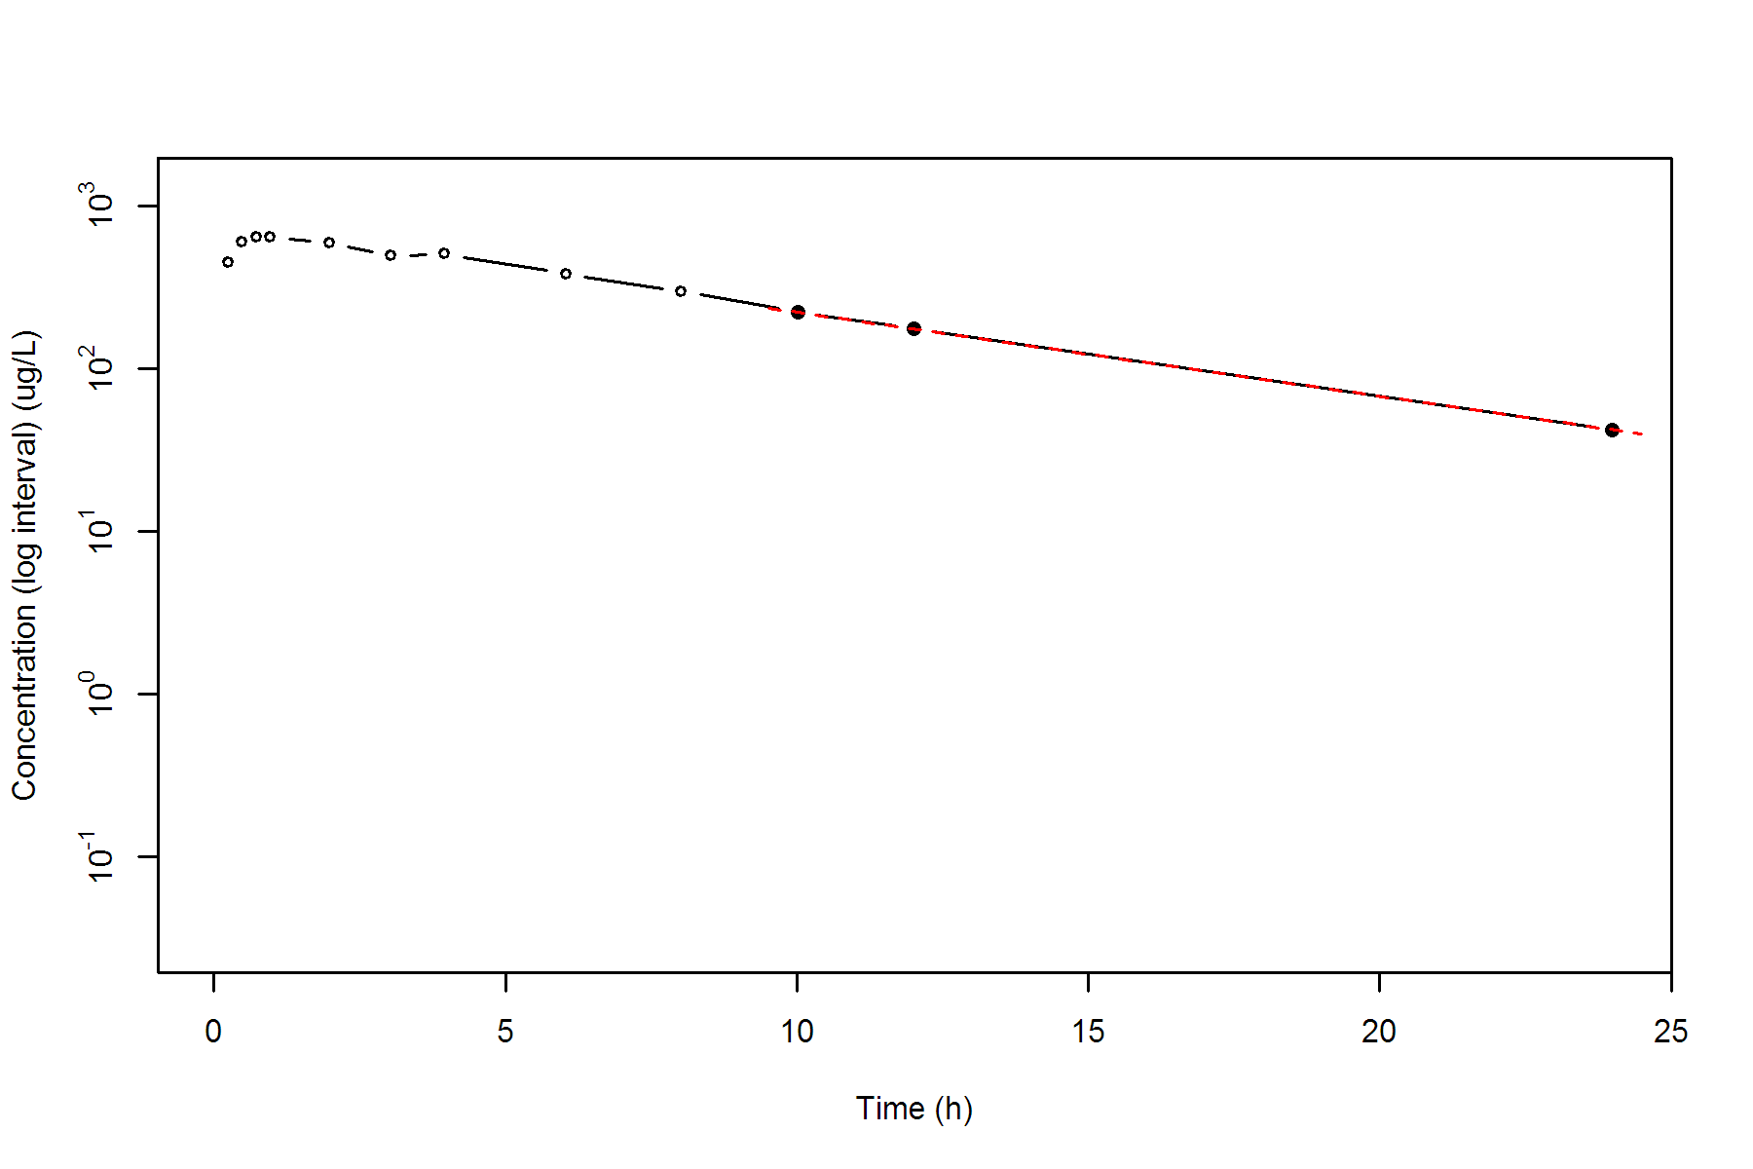

**SUBJ 5, GRP TR, PRD 1, TRT T**

NONCOMPARTMENTAL ANALYSIS REPORT

Package version 0.3.9 (2018-05-10 KST)

R version 3.5.0 (2018-04-23)

Date and Time: 2018-06-19 09:49:35 Asia/Seoul

Calculation Setting

-------------------

Drug Administration: Extravascular

Observation count excluding trailing zero: 13

Dose at time 0: 0 mg

AUC Calculation Method: Linear-up Linear-down

Weighting for lambda z: Uniform (Ordinary Least Square, OLS)

Lambda z selection criterion: Heighest adjusted R-squared value with precision=1e-4

Fitting, AUC, AUMC Result

-------------------------

Time Conc. Pred. Residual AUC AUMC

---------------------------------------------------------------------

0.0000 0.0000 0.0000 0.0000

0.2300 382.7900 44.0209 10.1248

0.4500 477.0300 138.6010 43.4224

0.8000 803.7000 362.7288 193.5065

1.0200 692.0300 527.2591 341.8778

2.0400 516.7500 1143.7369 1239.4986

3.0000 474.4800 1619.5273 2428.7514

3.9800 496.7200 2095.4153 4094.9403

5.9800 220.4800 2812.6153 7390.3563

8.0200 121.2300 3161.1595 9726.9060

9.9700 * 99.9600 94.6625 +5.297e+00 3376.8198 11646.5502

12.0000 * 56.7300 60.4581 -3.728e+00 3535.8601 13349.0718

24.0200 * 4.2900 4.2507 +3.927e-02 3902.5903 18059.7446

*: Used for the calculation of Lambda z.

Calculated Values

-----------------

CMAX Max Conc 803.7000 ug/L

TMAX Time of CMAX 0.8000 h

TLAG Time Until First Nonzero Conc 0.0000 h

CLST Last Nonzero Conc 4.2900 ug/L

CLSTP Last Nonzero Conc Pred 4.2507 ug/L

TLST Time of Last Nonzero Conc 24.0200 h

LAMZHL Half-Life Lambda z 3.1383 h

LAMZ Lambda z 0.2209 /h

LAMZLL Lambda z Lower Limit 9.9700 h

LAMZUL Lambda z Upper Limit 24.0200 h

LAMZNPT Number of Points for Lambda z 3

CORRXY Correlation Between TimeX and Log ConcY -0.9994

R2 R Squared 0.9987

R2ADJ R Squared Adjusted 0.9975

AUCLST AUC to Last Nonzero Conc 3902.5903 h*ug/L

AUCALL AUC All 3902.5903 h*ug/L

AUCIFO AUC Infinity Obs 3922.0135 h*ug/L

AUCIFP AUC Infinity Pred 3921.8357 h*ug/L

AUCPEO AUC %Extrapolation Obs 0.4952 %

AUCPEP AUC %Extrapolation Pred 0.4907 %

AUMCLST AUMC to Last Nonzero Conc 18059.7446 h2*ug/L

AUMCIFO AUMC Infinity Obs 18614.2283 h2*ug/L

AUMCIFP AUMC Infinity Pred 18609.1526 h2*ug/L

AUMCPEO AUMC %Extrapolation Obs 2.9788 %

AUMCPEP AUMC % Extrapolation Pred 2.9524 %

VZFO Vz Obs by F 0.0000 L

VZFP Vz Pred by F 0.0000 L

CLFO Total CL Obs by F 0.0000 L/h

CLFP Total CL Pred by F 0.0000 L/h

MRTEVLST MRT Extravasc to Last Nonzero Conc 4.6276 h

MRTEVIFO MRT Extravasc Infinity Obs 4.7461 h

MRTEVIFP MRT Extravasc Infinity Pred 4.7450 h

**SUBJ 5, GRP TR, PRD 1, TRT T**

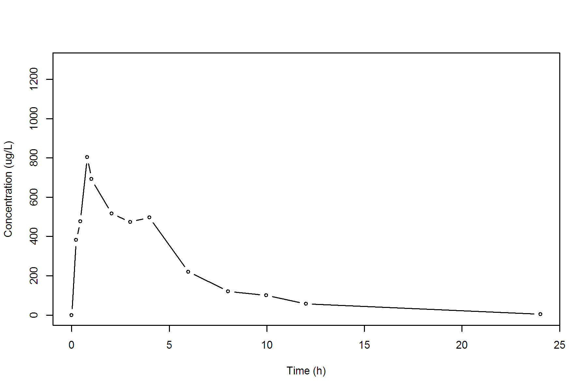

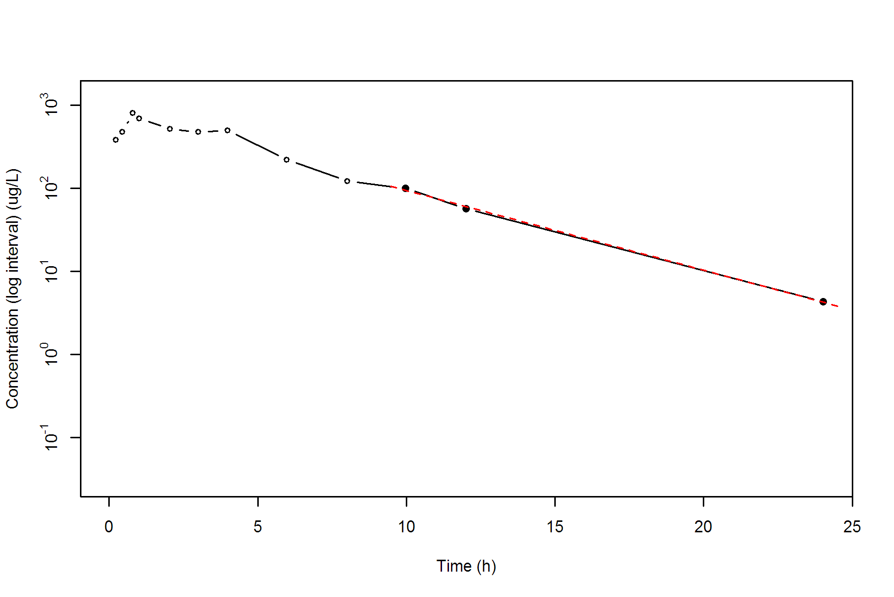

**SUBJ 5, GRP TR, PRD 2, TRT R**

NONCOMPARTMENTAL ANALYSIS REPORT

Package version 0.3.9 (2018-05-10 KST)

R version 3.5.0 (2018-04-23)

Date and Time: 2018-06-19 09:49:35 Asia/Seoul

Calculation Setting

-------------------

Drug Administration: Extravascular

Observation count excluding trailing zero: 13

Dose at time 0: 0 mg

AUC Calculation Method: Linear-up Linear-down

Weighting for lambda z: Uniform (Ordinary Least Square, OLS)

Lambda z selection criterion: Heighest adjusted R-squared value with precision=1e-4

Fitting, AUC, AUMC Result

-------------------------

Time Conc. Pred. Residual AUC AUMC

---------------------------------------------------------------------

0.0000 0.0000 0.0000 0.0000

0.2800 596.9800 83.5772 23.4016

0.4700 832.7600 219.4025 76.4640

0.7400 955.3000 460.7906 224.7371

1.0000 * 798.7000 799.6722 -9.722e-01 688.8106 420.4680

1.9900 * 669.5400 648.9864 +2.055e+01 1415.5894 1475.3548

3.0300 * 581.2800 521.1702 +6.011e+01 2066.0158 3084.0596

4.0000 * 428.1600 424.7516 +3.408e+00 2555.5942 4768.9100

5.9600 * 252.9600 280.9404 -2.798e+01 3223.0918 7924.7860

7.9500 * 173.5800 184.6484 -1.107e+01 3647.4991 10797.9506

9.9600 * 131.0500 120.8495 +1.020e+01 3953.6523 13496.5957

12.0200 * 69.8800 78.2645 -8.384e+00 4160.6102 15706.1677

24.0500 * 6.5200 6.1903 +3.297e-01 4620.1562 21701.7008

*: Used for the calculation of Lambda z.

Calculated Values

-----------------

CMAX Max Conc 955.3000 ug/L

TMAX Time of CMAX 0.7400 h

TLAG Time Until First Nonzero Conc 0.0000 h

CLST Last Nonzero Conc 6.5200 ug/L

CLSTP Last Nonzero Conc Pred 6.1903 ug/L

TLST Time of Last Nonzero Conc 24.0500 h

LAMZHL Half-Life Lambda z 3.2866 h

LAMZ Lambda z 0.2109 /h

LAMZLL Lambda z Lower Limit 1.0000 h

LAMZUL Lambda z Upper Limit 24.0500 h

LAMZNPT Number of Points for Lambda z 9

CORRXY Correlation Between TimeX and Log ConcY -0.9986

R2 R Squared 0.9973

R2ADJ R Squared Adjusted 0.9969

AUCLST AUC to Last Nonzero Conc 4620.1562 h*ug/L

AUCALL AUC All 4620.1562 h*ug/L

AUCIFO AUC Infinity Obs 4651.0714 h*ug/L

AUCIFP AUC Infinity Pred 4649.5079 h*ug/L

AUCPEO AUC %Extrapolation Obs 0.6647 %

AUCPEP AUC %Extrapolation Pred 0.6313 %

AUMCLST AUMC to Last Nonzero Conc 21701.7008 h2*ug/L

AUMCIFO AUMC Infinity Obs 22591.8007 h2*ug/L

AUMCIFP AUMC Infinity Pred 22546.7860 h2*ug/L

AUMCPEO AUMC %Extrapolation Obs 3.9399 %

AUMCPEP AUMC % Extrapolation Pred 3.7481 %

VZFO Vz Obs by F 0.0000 L

VZFP Vz Pred by F 0.0000 L

CLFO Total CL Obs by F 0.0000 L/h

CLFP Total CL Pred by F 0.0000 L/h

MRTEVLST MRT Extravasc to Last Nonzero Conc 4.6972 h

MRTEVIFO MRT Extravasc Infinity Obs 4.8573 h

MRTEVIFP MRT Extravasc Infinity Pred 4.8493 h

**SUBJ 5, GRP TR, PRD 2, TRT R**

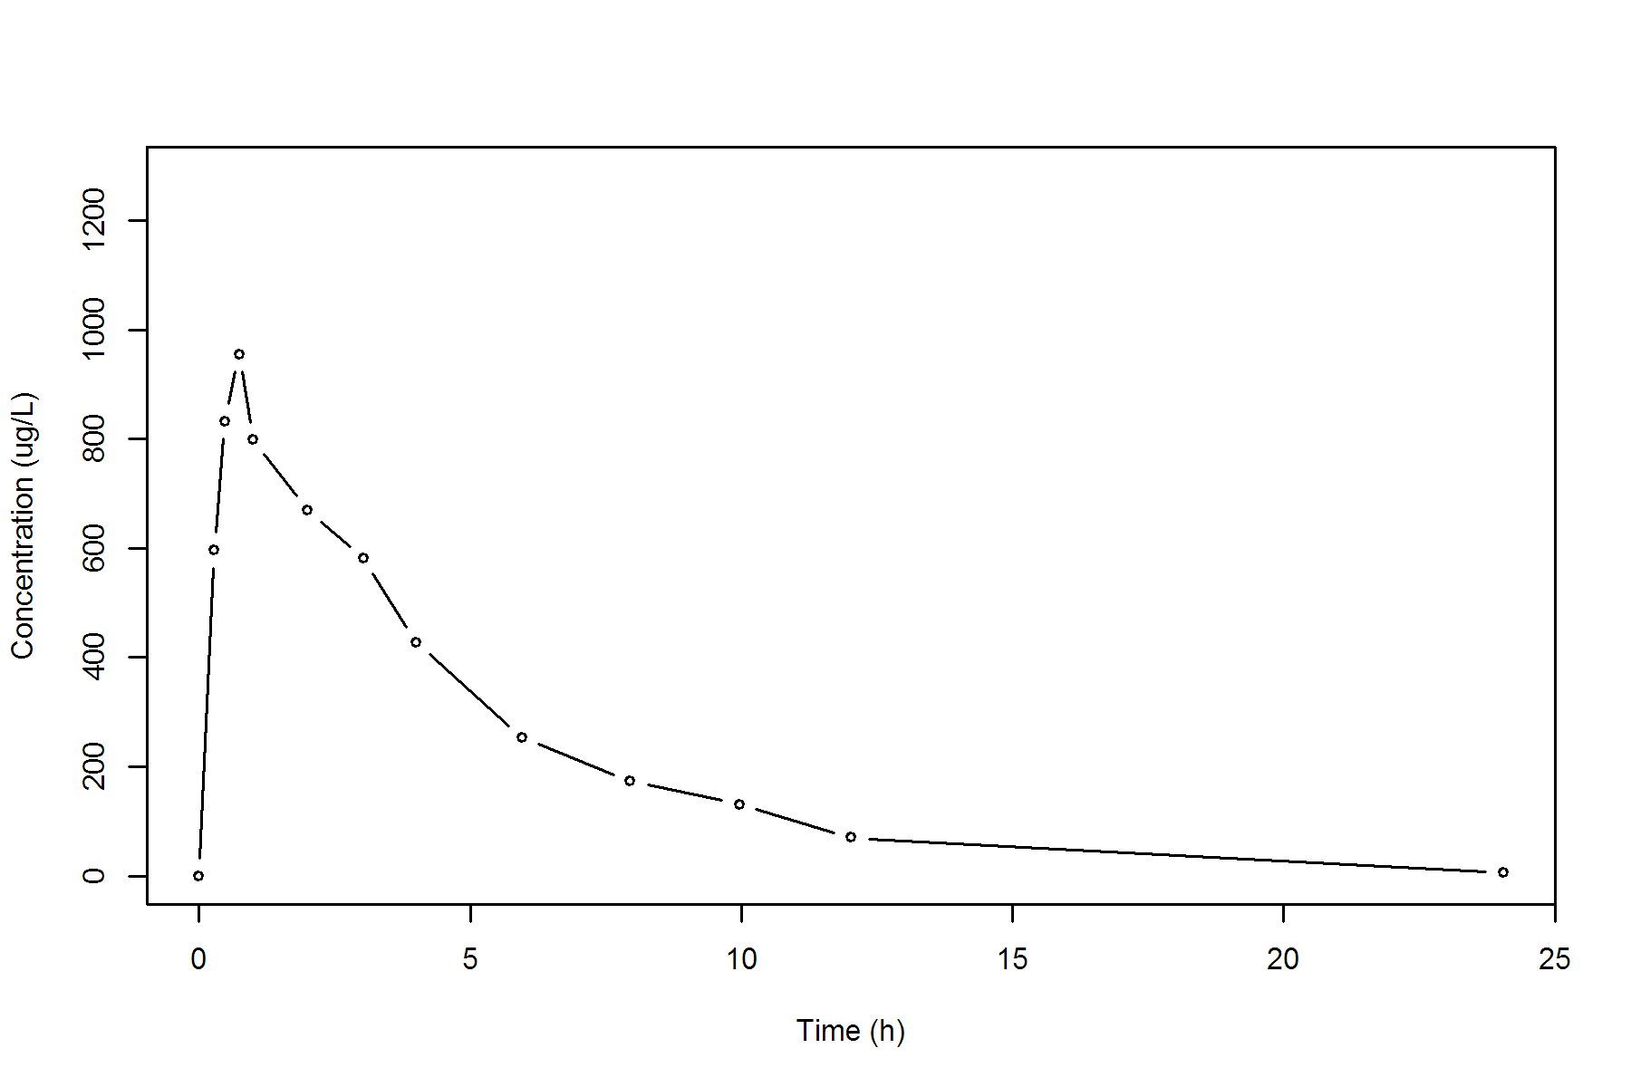

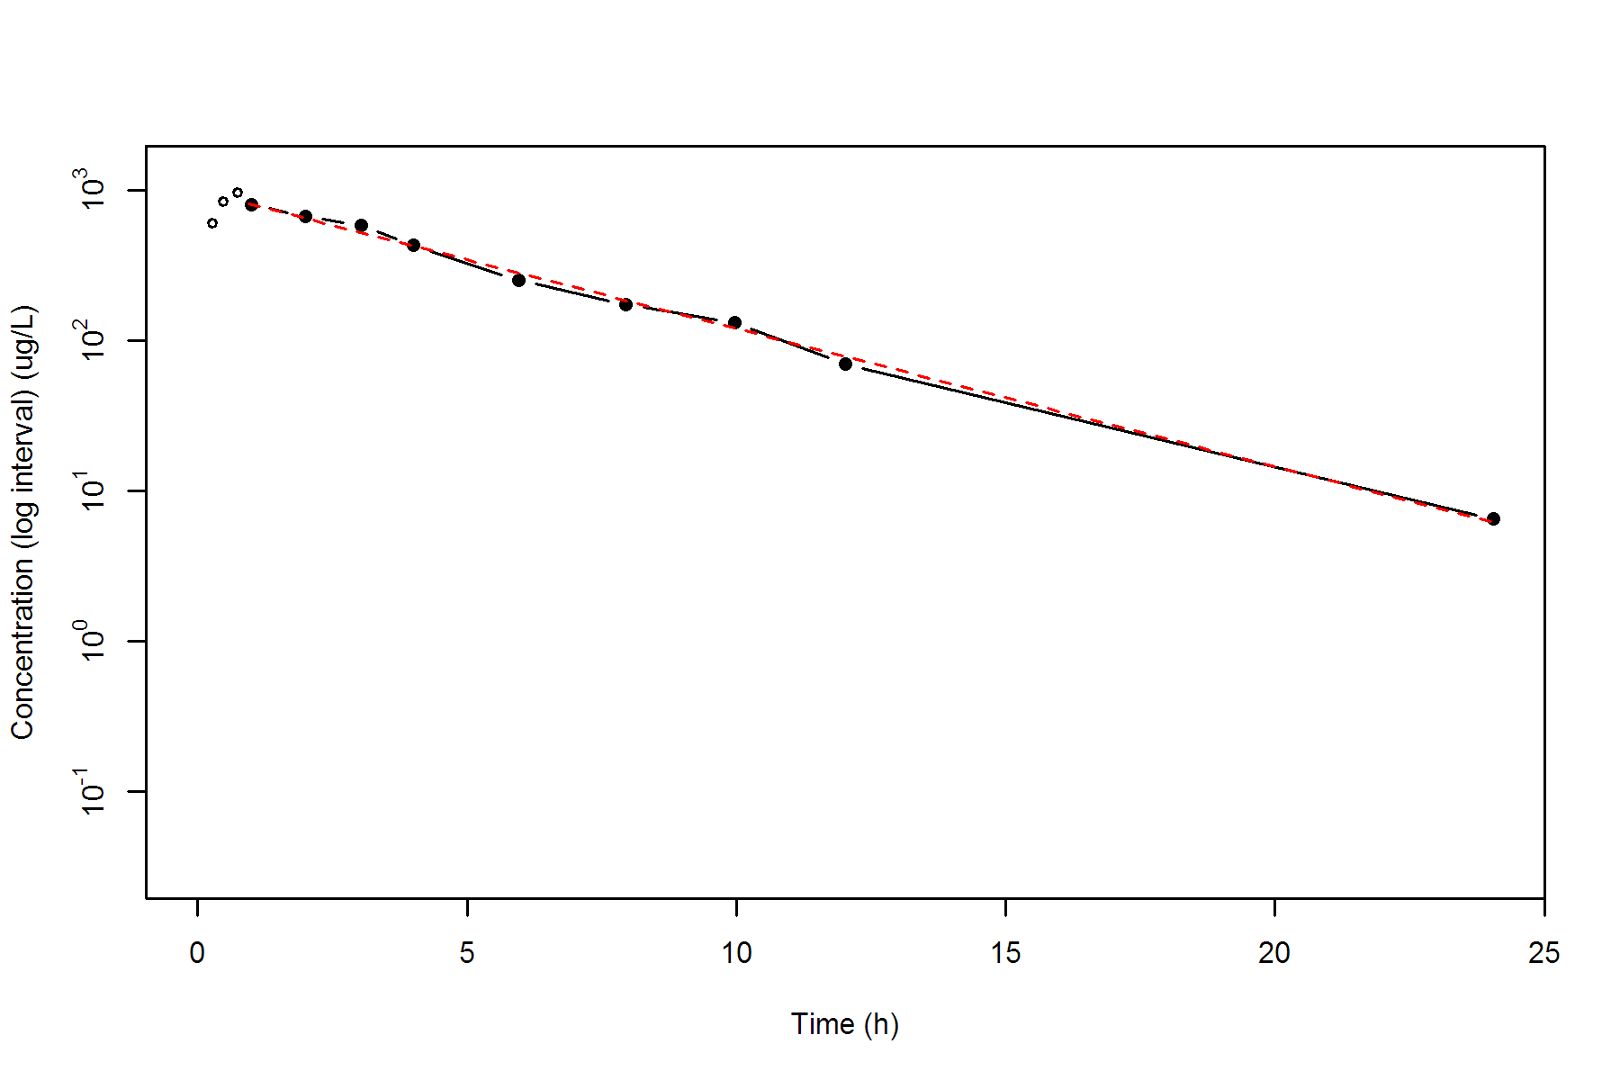

**SUBJ 6, GRP RT, PRD 1, TRT R**

NONCOMPARTMENTAL ANALYSIS REPORT

Package version 0.3.9 (2018-05-10 KST)

R version 3.5.0 (2018-04-23)

Date and Time: 2018-06-19 09:49:35 Asia/Seoul

Calculation Setting

-------------------

Drug Administration: Extravascular

Observation count excluding trailing zero: 12

Dose at time 0: 0 mg

AUC Calculation Method: Linear-up Linear-down

Weighting for lambda z: Uniform (Ordinary Least Square, OLS)

Lambda z selection criterion: Heighest adjusted R-squared value with precision=1e-4

Fitting, AUC, AUMC Result

-------------------------

Time Conc. Pred. Residual AUC AUMC

---------------------------------------------------------------------

0.0000 1.3800 0.0000 0.0000

0.2800 801.9500 112.4662 31.4364

0.4800 915.3800 284.1992 97.8293

0.7600 861.2800 532.9316 250.9830

1.0200 995.3400 774.2922 468.0596

1.9900 * 782.7900 771.2530 +1.154e+01 1636.6853 1715.9640

2.9700 * 584.9000 538.0006 +4.690e+01 2306.8534 3330.4675

4.0100 * 314.0700 367.1067 -5.304e+01 2774.3178 4888.6858

6.0400 * 191.3500 174.0971 +1.725e+01 3287.3191 7340.0882

7.9900 * 79.1100 85.0275 -5.918e+00 3551.0176 9083.2350

10.0100 * 41.9100 40.4720 +1.438e+00 3673.2478 10145.3591

12.0400 * 19.2000 19.1935 +6.499e-03 3735.2744 10805.8065

*: Used for the calculation of Lambda z.

Calculated Values

-----------------

CMAX Max Conc 995.3400 ug/L

TMAX Time of CMAX 1.0200 h

TLAG Time Until First Nonzero Conc 0.0000 h

CLST Last Nonzero Conc 19.2000 ug/L

CLSTP Last Nonzero Conc Pred 19.1935 ug/L

TLST Time of Last Nonzero Conc 12.0400 h

LAMZHL Half-Life Lambda z 1.8861 h

LAMZ Lambda z 0.3675 /h

LAMZLL Lambda z Lower Limit 1.9900 h

LAMZUL Lambda z Upper Limit 12.0400 h

LAMZNPT Number of Points for Lambda z 7

CORRXY Correlation Between TimeX and Log ConcY -0.9979

R2 R Squared 0.9959

R2ADJ R Squared Adjusted 0.9951

AUCLST AUC to Last Nonzero Conc 3735.2744 h*ug/L

AUCALL AUC All 3849.9944 h*ug/L

AUCIFO AUC Infinity Obs 3787.5183 h*ug/L

AUCIFP AUC Infinity Pred 3787.5006 h*ug/L

AUCPEO AUC %Extrapolation Obs 1.3794 %

AUCPEP AUC %Extrapolation Pred 1.3789 %

AUMCLST AUMC to Last Nonzero Conc 10805.8065 h2*ug/L

AUMCIFO AUMC Infinity Obs 11576.9808 h2*ug/L

AUMCIFP AUMC Infinity Pred 11576.7197 h2*ug/L

AUMCPEO AUMC %Extrapolation Obs 6.6613 %

AUMCPEP AUMC % Extrapolation Pred 6.6592 %

VZFO Vz Obs by F 0.0000 L

VZFP Vz Pred by F 0.0000 L

CLFO Total CL Obs by F 0.0000 L/h

CLFP Total CL Pred by F 0.0000 L/h

MRTEVLST MRT Extravasc to Last Nonzero Conc 2.8929 h

MRTEVIFO MRT Extravasc Infinity Obs 3.0566 h

MRTEVIFP MRT Extravasc Infinity Pred 3.0566 h

**SUBJ 6, GRP RT, PRD 1, TRT R**

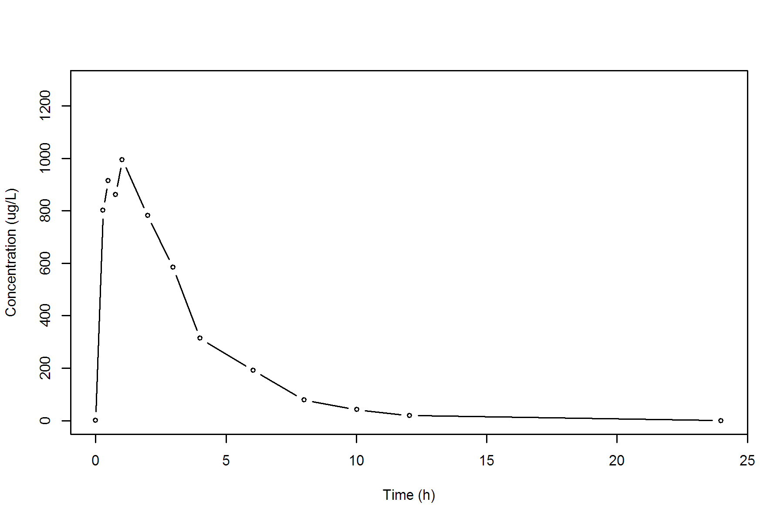

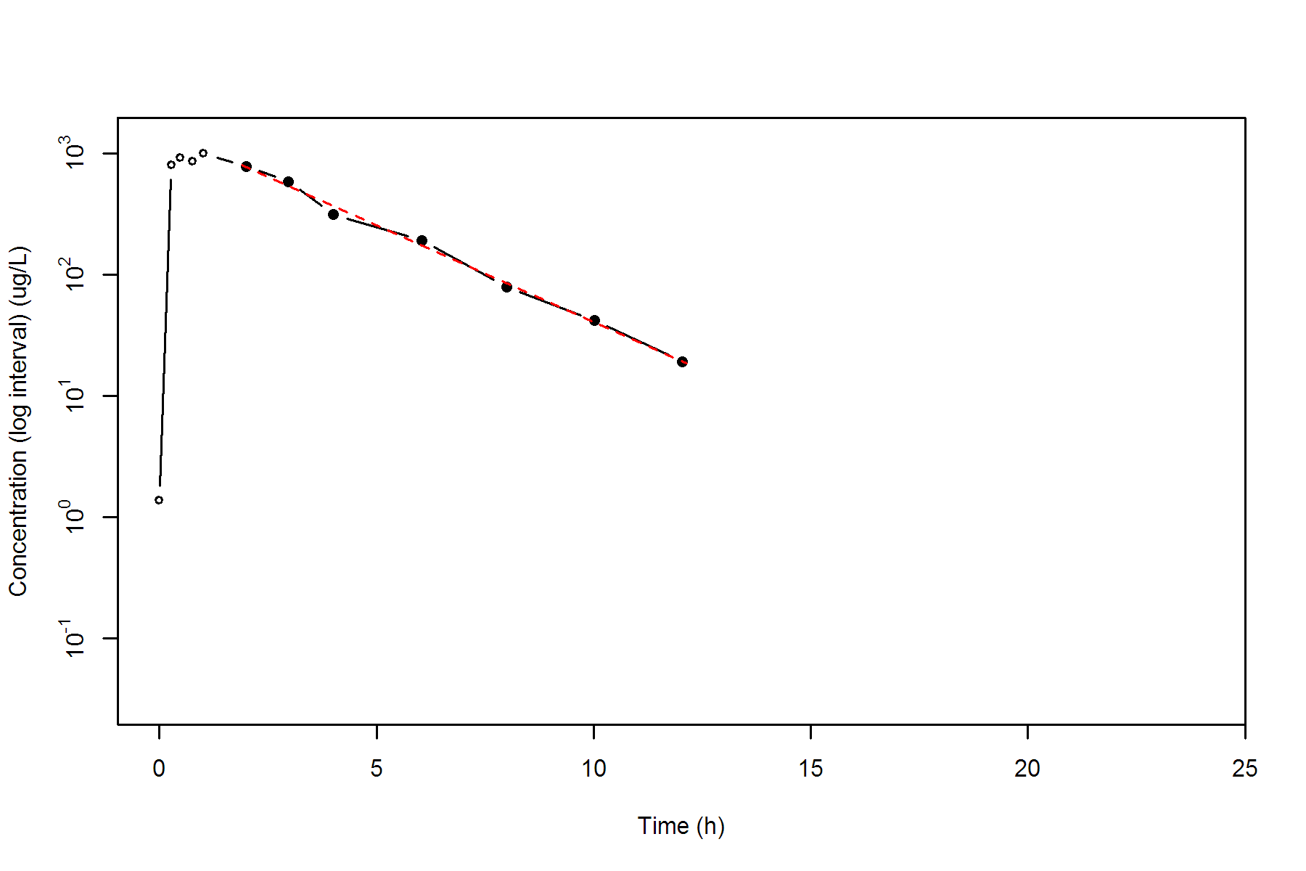

**SUBJ 6, GRP RT, PRD 2, TRT T**

NONCOMPARTMENTAL ANALYSIS REPORT

Package version 0.3.9 (2018-05-10 KST)

R version 3.5.0 (2018-04-23)

Date and Time: 2018-06-19 09:49:35 Asia/Seoul

Calculation Setting

-------------------

Drug Administration: Extravascular

Observation count excluding trailing zero: 13

Dose at time 0: 0 mg

AUC Calculation Method: Linear-up Linear-down

Weighting for lambda z: Uniform (Ordinary Least Square, OLS)

Lambda z selection criterion: Heighest adjusted R-squared value with precision=1e-4

Fitting, AUC, AUMC Result

-------------------------

Time Conc. Pred. Residual AUC AUMC

---------------------------------------------------------------------

0.0000 1.6300 0.0000 0.0000

0.2000 448.4500 45.0080 8.9690

0.4600 686.8500 192.5970 61.7023

0.7600 808.0800 416.8365 201.2161

1.0000 816.3300 611.7657 372.8726

1.9600 * 589.5500 630.9887 -4.144e+01 1286.5881 1319.3596

2.9900 * 444.7200 496.4368 -5.172e+01 1819.2372 2599.2535

3.9600 * 442.3800 396.0716 +4.631e+01 2249.4807 4093.7992

6.0000 * 268.0100 246.3094 +2.170e+01 2974.0785 7520.8817

8.0400 * 160.5000 153.1751 +7.325e+00 3411.1587 10477.3313

9.9800 * 78.8600 97.5007 -1.864e+01 3643.3379 12492.4508

12.0400 * 73.1700 60.3521 +1.282e+01 3799.9288 14210.4801

23.9700 * 3.5900 3.7522 -1.622e-01 4257.8021 19978.7491

*: Used for the calculation of Lambda z.

Calculated Values

-----------------

CMAX Max Conc 816.3300 ug/L

TMAX Time of CMAX 1.0000 h

TLAG Time Until First Nonzero Conc 0.0000 h

CLST Last Nonzero Conc 3.5900 ug/L

CLSTP Last Nonzero Conc Pred 3.7522 ug/L

TLST Time of Last Nonzero Conc 23.9700 h

LAMZHL Half-Life Lambda z 2.9768 h

LAMZ Lambda z 0.2328 /h

LAMZLL Lambda z Lower Limit 1.9600 h

LAMZUL Lambda z Upper Limit 23.9700 h

LAMZNPT Number of Points for Lambda z 8

CORRXY Correlation Between TimeX and Log ConcY -0.9968

R2 R Squared 0.9937

R2ADJ R Squared Adjusted 0.9926

AUCLST AUC to Last Nonzero Conc 4257.8021 h*ug/L

AUCALL AUC All 4257.8021 h*ug/L

AUCIFO AUC Infinity Obs 4273.2200 h*ug/L

AUCIFP AUC Infinity Pred 4273.9166 h*ug/L

AUCPEO AUC %Extrapolation Obs 0.3608 %

AUCPEP AUC %Extrapolation Pred 0.3770 %

AUMCLST AUMC to Last Nonzero Conc 19978.7491 h2*ug/L

AUMCIFO AUMC Infinity Obs 20414.5307 h2*ug/L

AUMCIFP AUMC Infinity Pred 20434.2180 h2*ug/L

AUMCPEO AUMC %Extrapolation Obs 2.1347 %

AUMCPEP AUMC % Extrapolation Pred 2.2290 %

VZFO Vz Obs by F 0.0000 L

VZFP Vz Pred by F 0.0000 L

CLFO Total CL Obs by F 0.0000 L/h

CLFP Total CL Pred by F 0.0000 L/h

MRTEVLST MRT Extravasc to Last Nonzero Conc 4.6923 h

MRTEVIFO MRT Extravasc Infinity Obs 4.7773 h

MRTEVIFP MRT Extravasc Infinity Pred 4.7811 h

**SUBJ 6, GRP RT, PRD 2, TRT T**

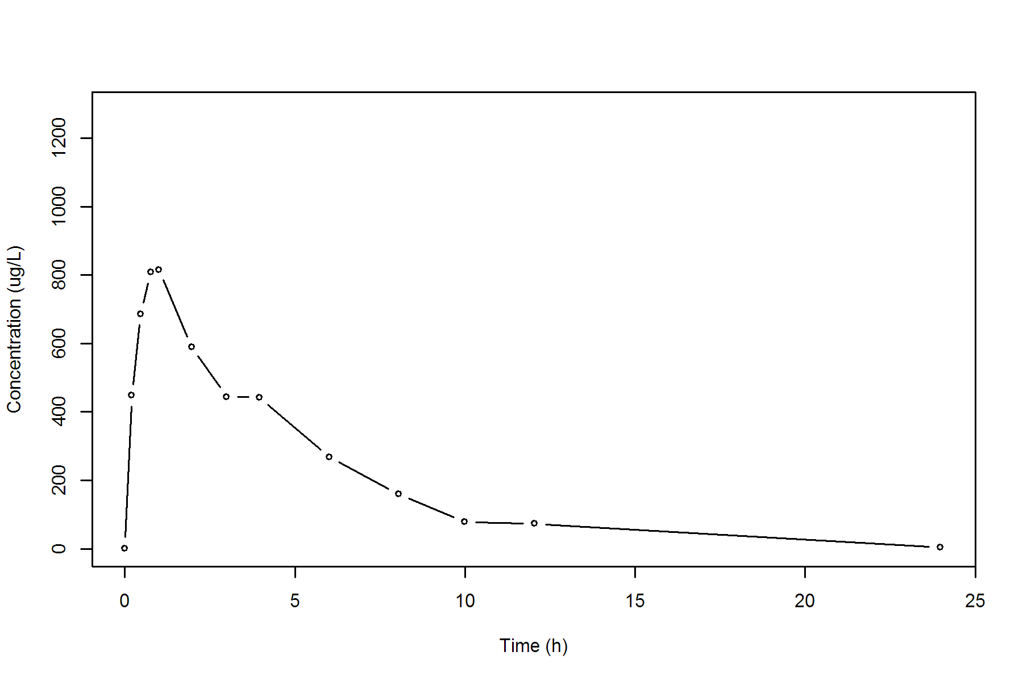

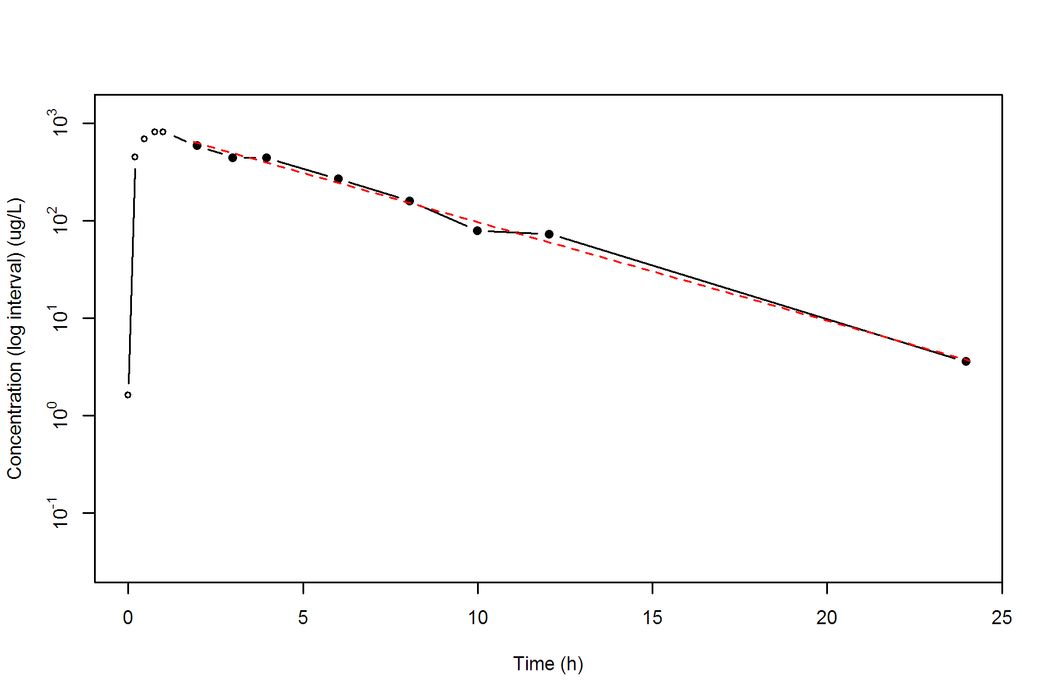

**SUBJ 7, GRP RT, PRD 1, TRT R**

NONCOMPARTMENTAL ANALYSIS REPORT

Package version 0.3.9 (2018-05-10 KST)

R version 3.5.0 (2018-04-23)

Date and Time: 2018-06-19 09:49:35 Asia/Seoul

Calculation Setting

-------------------

Drug Administration: Extravascular

Observation count excluding trailing zero: 13

Dose at time 0: 0 mg

AUC Calculation Method: Linear-up Linear-down

Weighting for lambda z: Uniform (Ordinary Least Square, OLS)

Lambda z selection criterion: Heighest adjusted R-squared value with precision=1e-4

Fitting, AUC, AUMC Result

-------------------------

Time Conc. Pred. Residual AUC AUMC

---------------------------------------------------------------------

0.0000 0.0000 0.0000 0.0000

0.2100 283.5000 29.7675 6.2512

0.4600 503.7300 128.1712 42.6575

0.7100 550.1200 259.9025 120.4452

0.9500 608.9900 398.9957 236.7402

1.9700 546.4500 988.2701 1080.8142

2.9800 467.0700 1500.0977 2327.3436

4.0500 375.5000 1950.8726 3885.6080

5.9500 259.8800 2554.4837 6799.3159

8.0300 198.6300 3031.3341 10066.2522

10.0300 * 135.1500 135.8184 -6.684e-01 3365.1141 13016.8056

11.9700 * 102.4100 101.8251 +5.849e-01 3595.5473 15520.7657

24.0200 * 17.0000 17.0135 -1.351e-02 4314.9925 25366.7466

*: Used for the calculation of Lambda z.

Calculated Values

-----------------

CMAX Max Conc 608.9900 ug/L

TMAX Time of CMAX 0.9500 h

TLAG Time Until First Nonzero Conc 0.0000 h

CLST Last Nonzero Conc 17.0000 ug/L

CLSTP Last Nonzero Conc Pred 17.0135 ug/L

TLST Time of Last Nonzero Conc 24.0200 h

LAMZHL Half-Life Lambda z 4.6681 h

LAMZ Lambda z 0.1485 /h

LAMZLL Lambda z Lower Limit 10.0300 h

LAMZUL Lambda z Upper Limit 24.0200 h

LAMZNPT Number of Points for Lambda z 3

CORRXY Correlation Between TimeX and Log ConcY -1.0000

R2 R Squared 1.0000

R2ADJ R Squared Adjusted 1.0000

AUCLST AUC to Last Nonzero Conc 4314.9925 h*ug/L

AUCALL AUC All 4314.9925 h*ug/L

AUCIFO AUC Infinity Obs 4429.4819 h*ug/L

AUCIFP AUC Infinity Pred 4429.5728 h*ug/L

AUCPEO AUC %Extrapolation Obs 2.5847 %

AUCPEP AUC %Extrapolation Pred 2.5867 %

AUMCLST AUMC to Last Nonzero Conc 25366.7466 h2*ug/L

AUMCIFO AUMC Infinity Obs 28887.8288 h2*ug/L

AUMCIFP AUMC Infinity Pred 28890.6265 h2*ug/L

AUMCPEO AUMC %Extrapolation Obs 12.1888 %

AUMCPEP AUMC % Extrapolation Pred 12.1973 %

VZFO Vz Obs by F 0.0000 L

VZFP Vz Pred by F 0.0000 L

CLFO Total CL Obs by F 0.0000 L/h

CLFP Total CL Pred by F 0.0000 L/h

MRTEVLST MRT Extravasc to Last Nonzero Conc 5.8787 h

MRTEVIFO MRT Extravasc Infinity Obs 6.5217 h

MRTEVIFP MRT Extravasc Infinity Pred 6.5222 h

**SUBJ 7, GRP RT, PRD 1, TRT R**

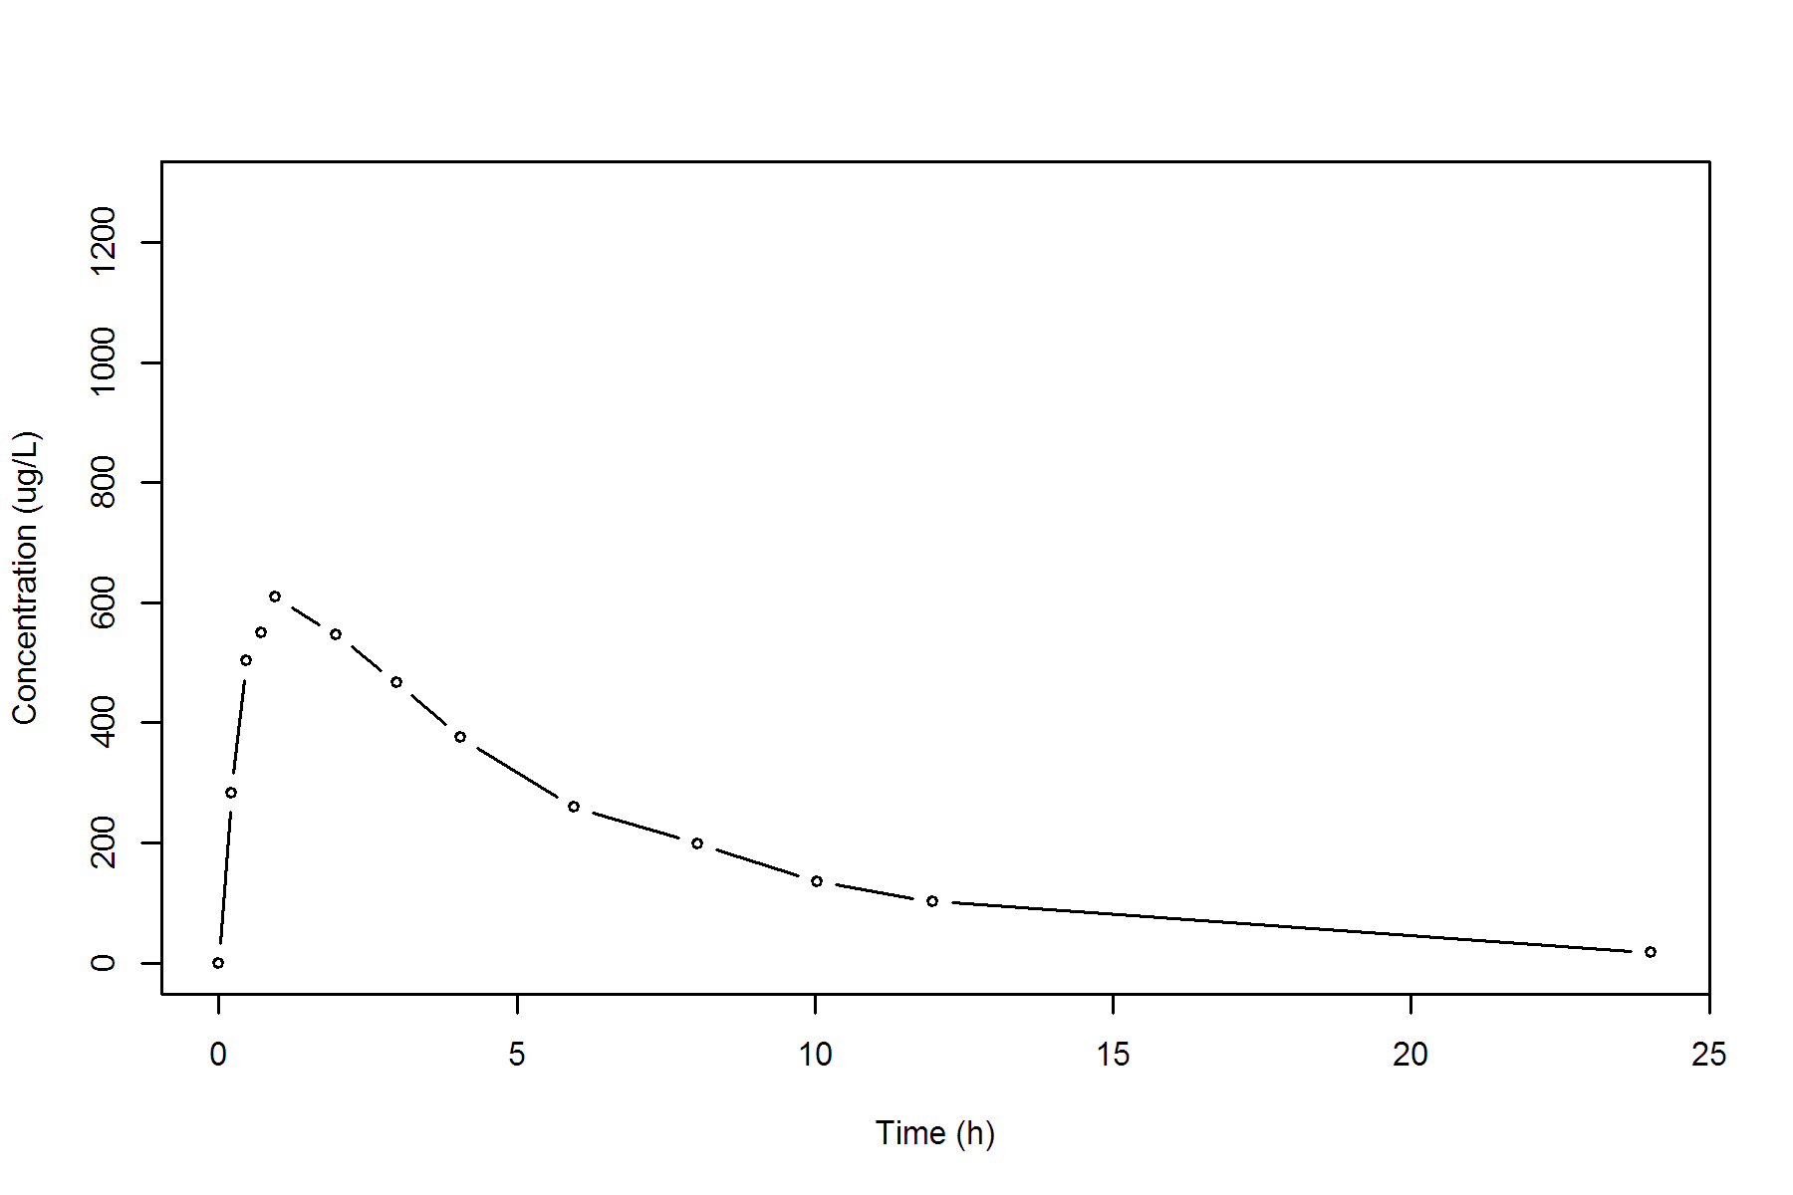

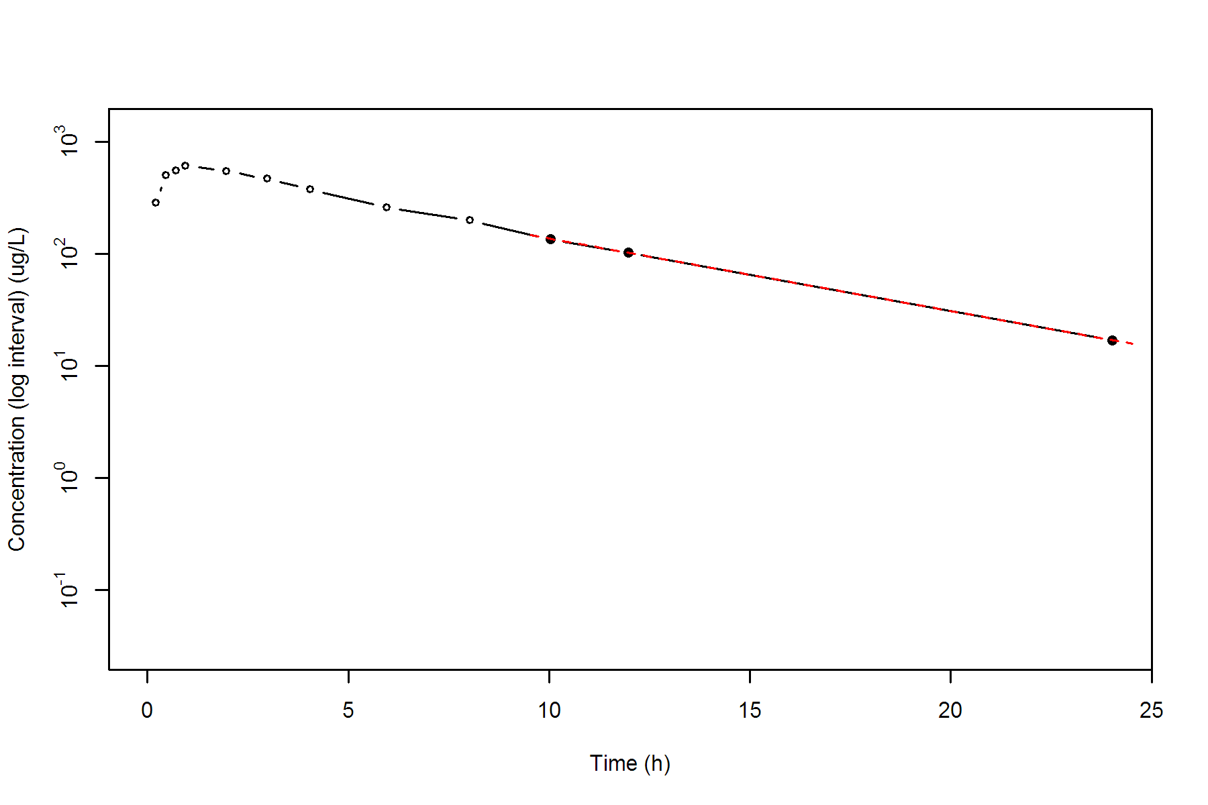

**SUBJ 7, GRP RT, PRD 2, TRT T**

NONCOMPARTMENTAL ANALYSIS REPORT

Package version 0.3.9 (2018-05-10 KST)

R version 3.5.0 (2018-04-23)

Date and Time: 2018-06-19 09:49:35 Asia/Seoul

Calculation Setting

-------------------

Drug Administration: Extravascular

Observation count excluding trailing zero: 13

Dose at time 0: 0 mg

AUC Calculation Method: Linear-up Linear-down

Weighting for lambda z: Uniform (Ordinary Least Square, OLS)

Lambda z selection criterion: Heighest adjusted R-squared value with precision=1e-4

Fitting, AUC, AUMC Result

-------------------------

Time Conc. Pred. Residual AUC AUMC

---------------------------------------------------------------------

0.0000 0.4400 0.0000 0.0000

0.2100 400.2400 42.0714 8.8253

0.4600 488.4700 153.1601 47.4186

0.7400 806.5700 334.4657 162.4367

0.9800 * 724.6300 760.7265 -3.610e+01 518.2098 319.2766

2.0400 * 650.1200 633.0475 +1.707e+01 1246.8273 1398.5592

3.0200 * 509.1900 534.1536 -2.496e+01 1814.8892 2801.9185

3.9800 * 465.1600 452.2738 +1.289e+01 2282.5772 4428.6820

6.0200 * 343.1200 317.5697 +2.555e+01 3107.0227 8423.9396

7.9600 * 242.1800 226.8842 +1.530e+01 3674.7637 12297.4747

9.9900 * 159.3400 159.5859 -2.459e-01 4082.3066 15869.8275

11.9500 * 100.8200 113.6198 -1.280e+01 4337.2634 18610.5010

23.9800 * 14.4100 14.1217 +2.883e-01 5030.3718 27935.8611

*: Used for the calculation of Lambda z.

Calculated Values

-----------------

CMAX Max Conc 806.5700 ug/L

TMAX Time of CMAX 0.7400 h

TLAG Time Until First Nonzero Conc 0.0000 h

CLST Last Nonzero Conc 14.4100 ug/L

CLSTP Last Nonzero Conc Pred 14.1217 ug/L

TLST Time of Last Nonzero Conc 23.9800 h

LAMZHL Half-Life Lambda z 3.9990 h

LAMZ Lambda z 0.1733 /h

LAMZLL Lambda z Lower Limit 0.9800 h

LAMZUL Lambda z Upper Limit 23.9800 h

LAMZNPT Number of Points for Lambda z 9

CORRXY Correlation Between TimeX and Log ConcY -0.9987

R2 R Squared 0.9974

R2ADJ R Squared Adjusted 0.9971

AUCLST AUC to Last Nonzero Conc 5030.3718 h*ug/L

AUCALL AUC All 5030.3718 h*ug/L

AUCIFO AUC Infinity Obs 5113.5086 h*ug/L

AUCIFP AUC Infinity Pred 5111.8454 h*ug/L

AUCPEO AUC %Extrapolation Obs 1.6258 %

AUCPEP AUC %Extrapolation Pred 1.5938 %

AUMCLST AUMC to Last Nonzero Conc 27935.8611 h2*ug/L

AUMCIFO AUMC Infinity Obs 30409.1309 h2*ug/L

AUMCIFP AUMC Infinity Pred 30359.6515 h2*ug/L

AUMCPEO AUMC %Extrapolation Obs 8.1333 %

AUMCPEP AUMC % Extrapolation Pred 7.9836 %

VZFO Vz Obs by F 0.0000 L

VZFP Vz Pred by F 0.0000 L

CLFO Total CL Obs by F 0.0000 L/h

CLFP Total CL Pred by F 0.0000 L/h

MRTEVLST MRT Extravasc to Last Nonzero Conc 5.5534 h

MRTEVIFO MRT Extravasc Infinity Obs 5.9468 h

MRTEVIFP MRT Extravasc Infinity Pred 5.9391 h

**SUBJ 7, GRP RT, PRD 2, TRT T**

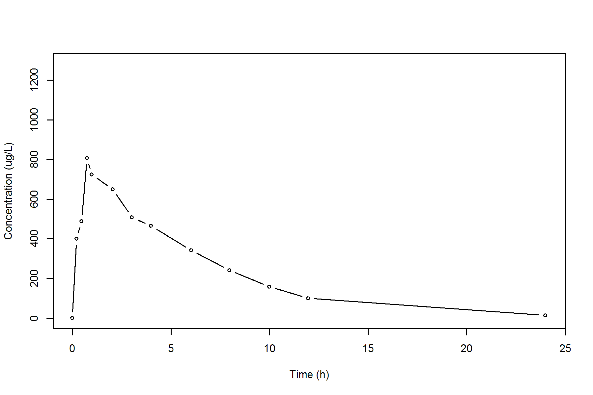

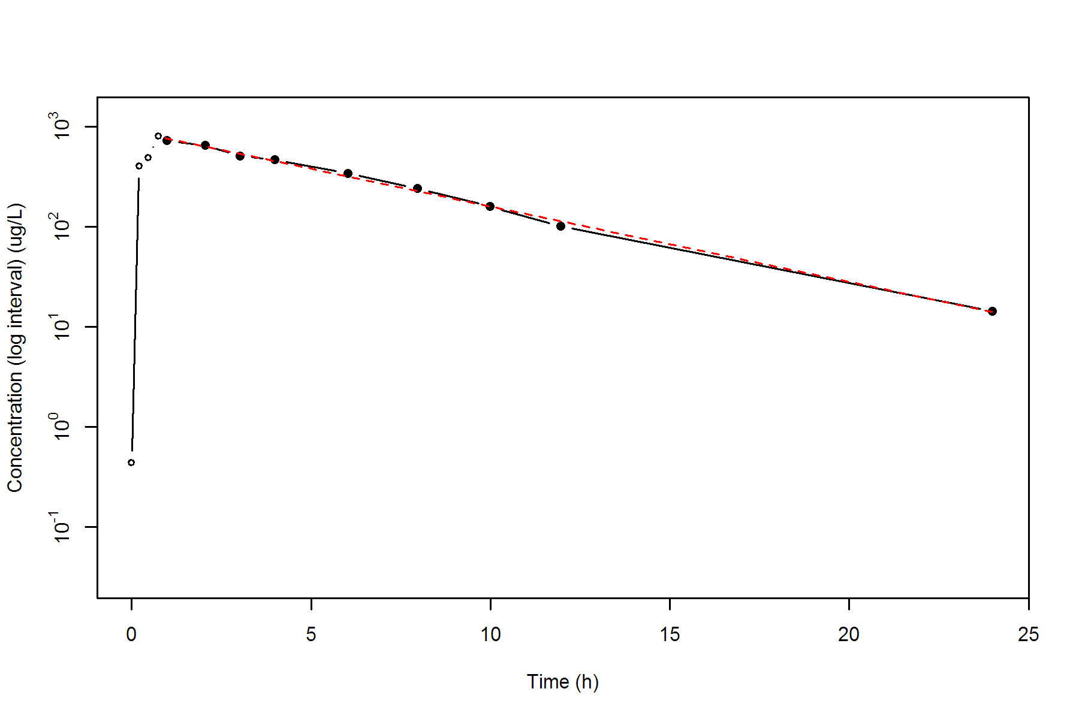

**SUBJ 8, GRP RT, PRD 1, TRT R**

NONCOMPARTMENTAL ANALYSIS REPORT

Package version 0.3.9 (2018-05-10 KST)

R version 3.5.0 (2018-04-23)

Date and Time: 2018-06-19 09:49:35 Asia/Seoul

Calculation Setting

-------------------

Drug Administration: Extravascular

Observation count excluding trailing zero: 13

Dose at time 0: 0 mg

AUC Calculation Method: Linear-up Linear-down

Weighting for lambda z: Uniform (Ordinary Least Square, OLS)

Lambda z selection criterion: Heighest adjusted R-squared value with precision=1e-4

Fitting, AUC, AUMC Result

-------------------------

Time Conc. Pred. Residual AUC AUMC

---------------------------------------------------------------------

0.0000 1.0200 0.0000 0.0000

0.2800 672.5800 94.3040 26.3651

0.4700 773.2600 231.6588 78.7818

0.7200 1283.6700 488.7751 239.7411

0.9900 1201.9200 824.3297 525.1505

1.9600 1235.0200 2006.2456 2276.2624

2.9700 923.4200 3096.2578 4883.6767

3.9600 654.0200 3877.0906 7523.2526

6.0500 293.5000 4867.2490 12085.2985

8.0100 * 176.9000 173.6758 +3.224e+00 5328.2410 15214.0896

9.9500 * 97.6000 96.5316 +1.068e+00 5594.5060 17530.5360

12.0000 * 49.9900 51.8963 -1.906e+00 5745.7858 19140.8110

23.9600 * 1.4000 1.3888 +1.119e-02 6053.0980 22928.6865

*: Used for the calculation of Lambda z.

Calculated Values

-----------------

CMAX Max Conc 1283.6700 ug/L

TMAX Time of CMAX 0.7200 h

TLAG Time Until First Nonzero Conc 0.0000 h

CLST Last Nonzero Conc 1.4000 ug/L

CLSTP Last Nonzero Conc Pred 1.3888 ug/L

TLST Time of Last Nonzero Conc 23.9600 h

LAMZHL Half-Life Lambda z 2.2896 h

LAMZ Lambda z 0.3027 /h

LAMZLL Lambda z Lower Limit 8.0100 h

LAMZUL Lambda z Upper Limit 23.9600 h

LAMZNPT Number of Points for Lambda z 4

CORRXY Correlation Between TimeX and Log ConcY -0.9999

R2 R Squared 0.9999

R2ADJ R Squared Adjusted 0.9998

AUCLST AUC to Last Nonzero Conc 6053.0980 h*ug/L

AUCALL AUC All 6053.0980 h*ug/L

AUCIFO AUC Infinity Obs 6057.7223 h*ug/L

AUCIFP AUC Infinity Pred 6057.6854 h*ug/L

AUCPEO AUC %Extrapolation Obs 0.0763 %

AUCPEP AUC %Extrapolation Pred 0.0757 %

AUMCLST AUMC to Last Nonzero Conc 22928.6865 h2*ug/L

AUMCIFO AUMC Infinity Obs 23054.7620 h2*ug/L

AUMCIFP AUMC Infinity Pred 23053.7545 h2*ug/L

AUMCPEO AUMC %Extrapolation Obs 0.5469 %

AUMCPEP AUMC % Extrapolation Pred 0.5425 %

VZFO Vz Obs by F 0.0000 L

VZFP Vz Pred by F 0.0000 L

CLFO Total CL Obs by F 0.0000 L/h

CLFP Total CL Pred by F 0.0000 L/h

MRTEVLST MRT Extravasc to Last Nonzero Conc 3.7879 h

MRTEVIFO MRT Extravasc Infinity Obs 3.8058 h

MRTEVIFP MRT Extravasc Infinity Pred 3.8057 h

**SUBJ 8, GRP RT, PRD 1, TRT R**

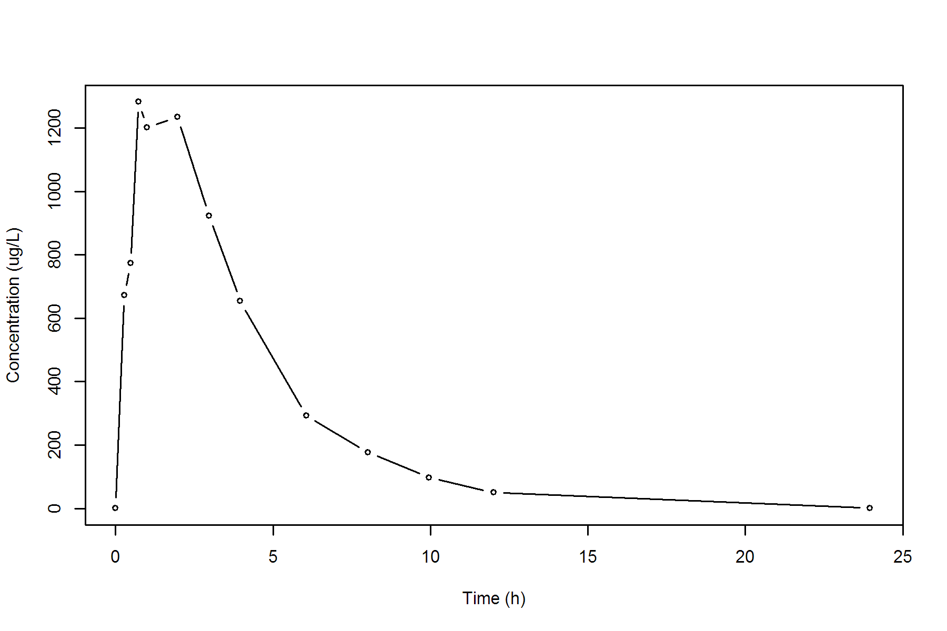

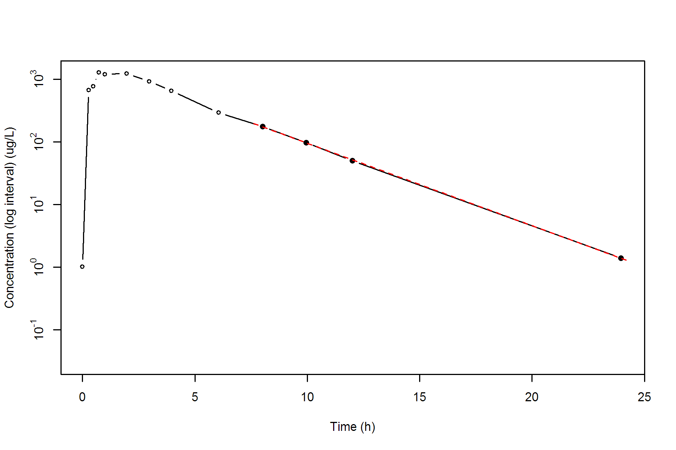

**SUBJ 8, GRP RT, PRD 2, TRT T**

NONCOMPARTMENTAL ANALYSIS REPORT

Package version 0.3.9 (2018-05-10 KST)

R version 3.5.0 (2018-04-23)

Date and Time: 2018-06-19 09:49:35 Asia/Seoul

Calculation Setting

-------------------

Drug Administration: Extravascular

Observation count excluding trailing zero: 13

Dose at time 0: 0 mg

AUC Calculation Method: Linear-up Linear-down

Weighting for lambda z: Uniform (Ordinary Least Square, OLS)

Lambda z selection criterion: Heighest adjusted R-squared value with precision=1e-4

Fitting, AUC, AUMC Result

-------------------------

Time Conc. Pred. Residual AUC AUMC

---------------------------------------------------------------------

0.0000 0.0000 0.0000 0.0000

0.2500 390.9200 48.8650 12.2163

0.4800 600.7700 162.9094 56.6177

0.7500 719.2800 341.1161 168.3747

1.0300 822.9500 557.0283 362.5685

2.0200 812.6400 1366.6454 1594.7083

2.9800 594.5500 2042.0966 3233.0883

4.0400 * 590.6900 616.2040 -2.551e+01 2670.2738 5436.9060

6.0300 * 414.9800 404.9326 +1.005e+01 3670.9154 10301.1795

8.0100 * 274.1000 266.6596 +7.440e+00 4353.1046 14952.0712

10.0400 * 187.5100 173.7602 +1.375e+01 4821.6388 19091.3847

12.0200 * 104.3900 114.4260 -1.004e+01 5110.6198 22197.3792

23.9800 * 9.2300 9.1757 +5.425e-02 5790.0674 31024.4763

*: Used for the calculation of Lambda z.

Calculated Values

-----------------

CMAX Max Conc 822.9500 ug/L

TMAX Time of CMAX 1.0300 h

TLAG Time Until First Nonzero Conc 0.0000 h

CLST Last Nonzero Conc 9.2300 ug/L

CLSTP Last Nonzero Conc Pred 9.1757 ug/L

TLST Time of Last Nonzero Conc 23.9800 h

LAMZHL Half-Life Lambda z 3.2853 h

LAMZ Lambda z 0.2110 /h

LAMZLL Lambda z Lower Limit 4.0400 h

LAMZUL Lambda z Upper Limit 23.9800 h

LAMZNPT Number of Points for Lambda z 6

CORRXY Correlation Between TimeX and Log ConcY -0.9992

R2 R Squared 0.9985

R2ADJ R Squared Adjusted 0.9981

AUCLST AUC to Last Nonzero Conc 5790.0674 h*ug/L

AUCALL AUC All 5790.0674 h*ug/L

AUCIFO AUC Infinity Obs 5833.8148 h*ug/L

AUCIFP AUC Infinity Pred 5833.5577 h*ug/L

AUCPEO AUC %Extrapolation Obs 0.7499 %

AUCPEP AUC %Extrapolation Pred 0.7455 %

AUMCLST AUMC to Last Nonzero Conc 31024.4763 h2*ug/L

AUMCIFO AUMC Infinity Obs 32280.8904 h2*ug/L

AUMCIFP AUMC Infinity Pred 32273.5051 h2*ug/L

AUMCPEO AUMC %Extrapolation Obs 3.8921 %

AUMCPEP AUMC % Extrapolation Pred 3.8701 %

VZFO Vz Obs by F 0.0000 L

VZFP Vz Pred by F 0.0000 L

CLFO Total CL Obs by F 0.0000 L/h

CLFP Total CL Pred by F 0.0000 L/h

MRTEVLST MRT Extravasc to Last Nonzero Conc 5.3582 h

MRTEVIFO MRT Extravasc Infinity Obs 5.5334 h

MRTEVIFP MRT Extravasc Infinity Pred 5.5324 h

**SUBJ 8, GRP RT, PRD 2, TRT T**

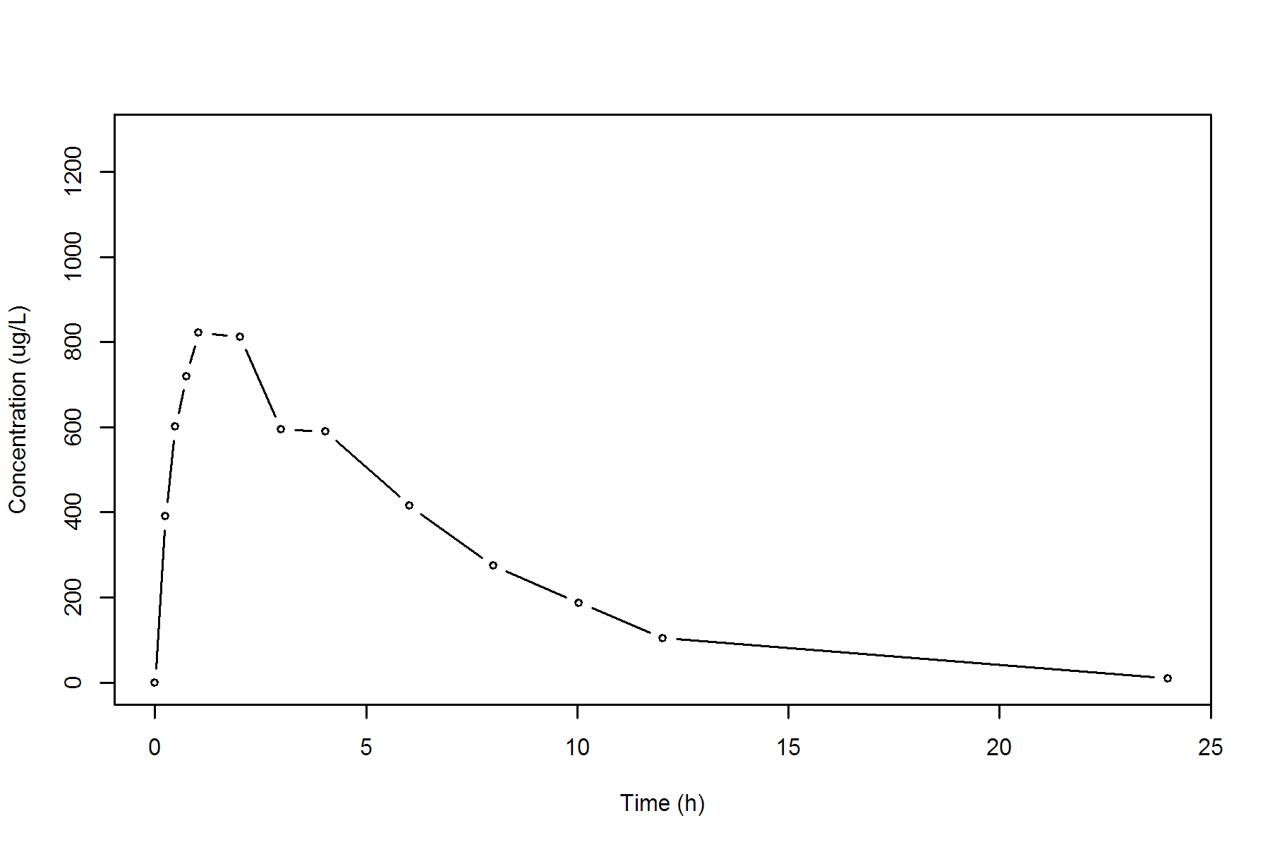

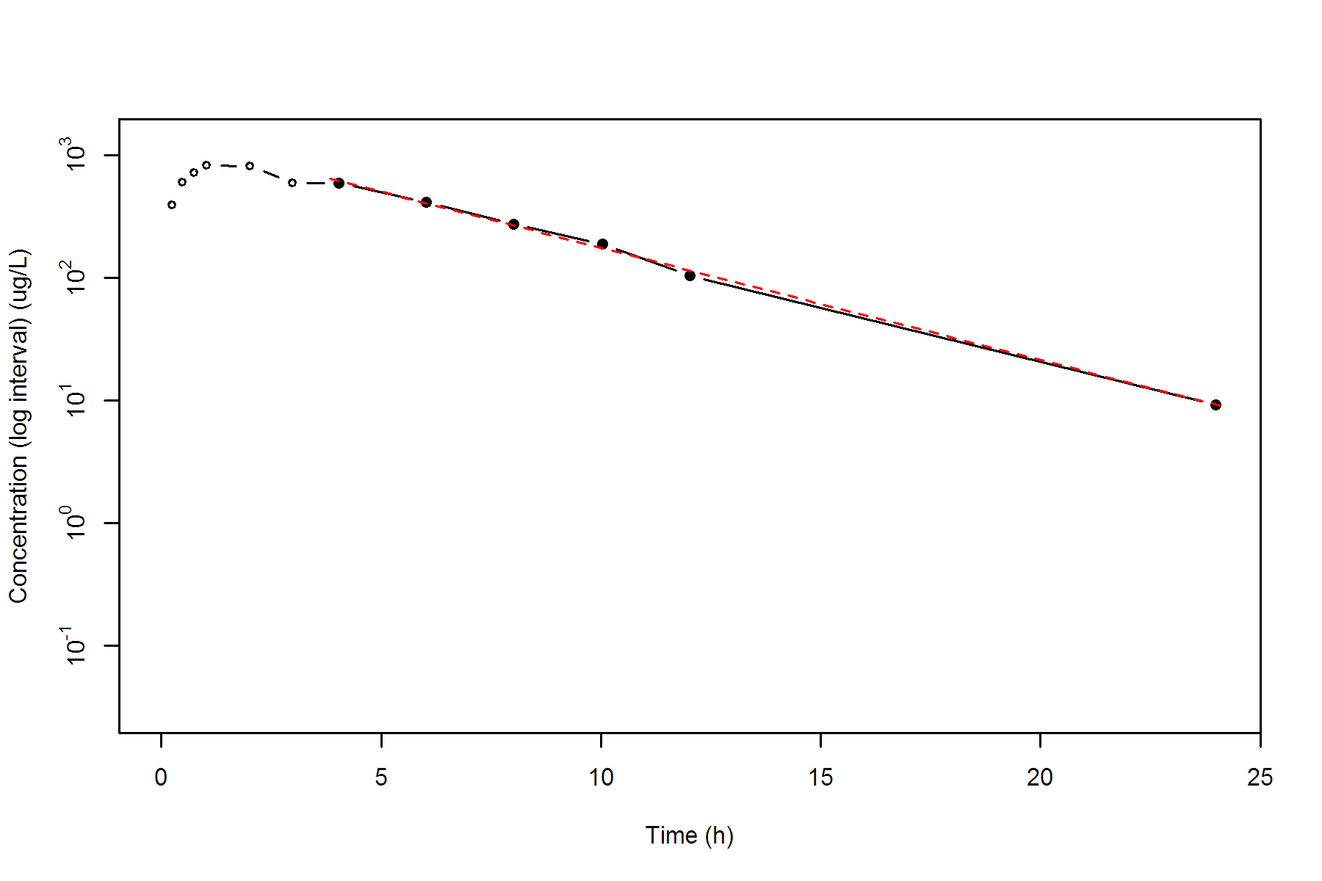

**SUBJ 9, GRP RT, PRD 1, TRT R**

NONCOMPARTMENTAL ANALYSIS REPORT

Package version 0.3.9 (2018-05-10 KST)

R version 3.5.0 (2018-04-23)

Date and Time: 2018-06-19 09:49:35 Asia/Seoul

Calculation Setting

-------------------

Drug Administration: Extravascular

Observation count excluding trailing zero: 13

Dose at time 0: 0 mg

AUC Calculation Method: Linear-up Linear-down

Weighting for lambda z: Uniform (Ordinary Least Square, OLS)

Lambda z selection criterion: Heighest adjusted R-squared value with precision=1e-4

Fitting, AUC, AUMC Result

-------------------------

Time Conc. Pred. Residual AUC AUMC

---------------------------------------------------------------------

0.0000 0.0000 0.0000 0.0000

0.2400 399.6600 47.9592 11.5102

0.5300 608.2600 194.1076 72.1632

0.7400 679.3900 329.3109 158.8014

1.0300 573.7900 511.0220 317.3955

2.0300 631.5300 1113.6820 1253.9003

3.0400 533.9200 1702.2342 2720.9873

3.9600 * 381.5000 374.9116 +6.588e+00 2123.3274 4162.5614

5.9600 * 279.2800 276.7017 +2.578e+00 2784.1074 7337.8102

7.9800 * 205.0100 203.5989 +1.411e+00 3273.2403 10671.3037

10.0000 * 157.1900 149.8094 +7.381e+00 3639.0623 13911.2623

12.0000 * 99.2200 110.5661 -1.135e+01 3895.4723 16673.8023

24.0400 * 18.2400 17.7616 +4.784e-01 4602.5815 26481.1625

*: Used for the calculation of Lambda z.

Calculated Values

-----------------

CMAX Max Conc 679.3900 ug/L

TMAX Time of CMAX 0.7400 h

TLAG Time Until First Nonzero Conc 0.0000 h

CLST Last Nonzero Conc 18.2400 ug/L

CLSTP Last Nonzero Conc Pred 17.7616 ug/L

TLST Time of Last Nonzero Conc 24.0400 h

LAMZHL Half-Life Lambda z 4.5639 h

LAMZ Lambda z 0.1519 /h

LAMZLL Lambda z Lower Limit 3.9600 h

LAMZUL Lambda z Upper Limit 24.0400 h

LAMZNPT Number of Points for Lambda z 6

CORRXY Correlation Between TimeX and Log ConcY -0.9987

R2 R Squared 0.9974

R2ADJ R Squared Adjusted 0.9968

AUCLST AUC to Last Nonzero Conc 4602.5815 h*ug/L

AUCALL AUC All 4602.5815 h*ug/L

AUCIFO AUC Infinity Obs 4722.6801 h*ug/L

AUCIFP AUC Infinity Pred 4719.5299 h*ug/L

AUCPEO AUC %Extrapolation Obs 2.5430 %

AUCPEP AUC %Extrapolation Pred 2.4780 %

AUMCLST AUMC to Last Nonzero Conc 26481.1625 h2*ug/L

AUMCIFO AUMC Infinity Obs 30159.1049 h2*ug/L

AUMCIFP AUMC Infinity Pred 30062.6310 h2*ug/L

AUMCPEO AUMC %Extrapolation Obs 12.1951 %

AUMCPEP AUMC % Extrapolation Pred 11.9134 %

VZFO Vz Obs by F 0.0000 L

VZFP Vz Pred by F 0.0000 L

CLFO Total CL Obs by F 0.0000 L/h

CLFP Total CL Pred by F 0.0000 L/h

MRTEVLST MRT Extravasc to Last Nonzero Conc 5.7535 h

MRTEVIFO MRT Extravasc Infinity Obs 6.3860 h

MRTEVIFP MRT Extravasc Infinity Pred 6.3698 h

**SUBJ 9, GRP RT, PRD 1, TRT R**

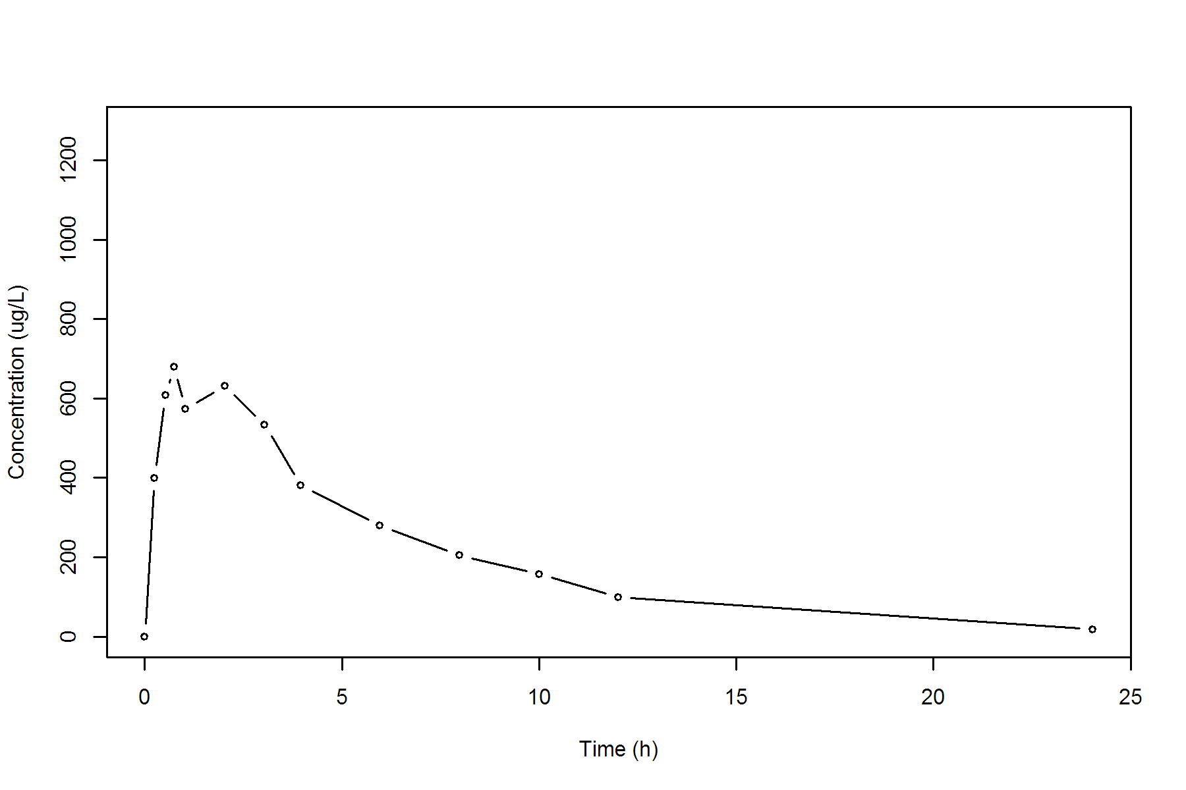

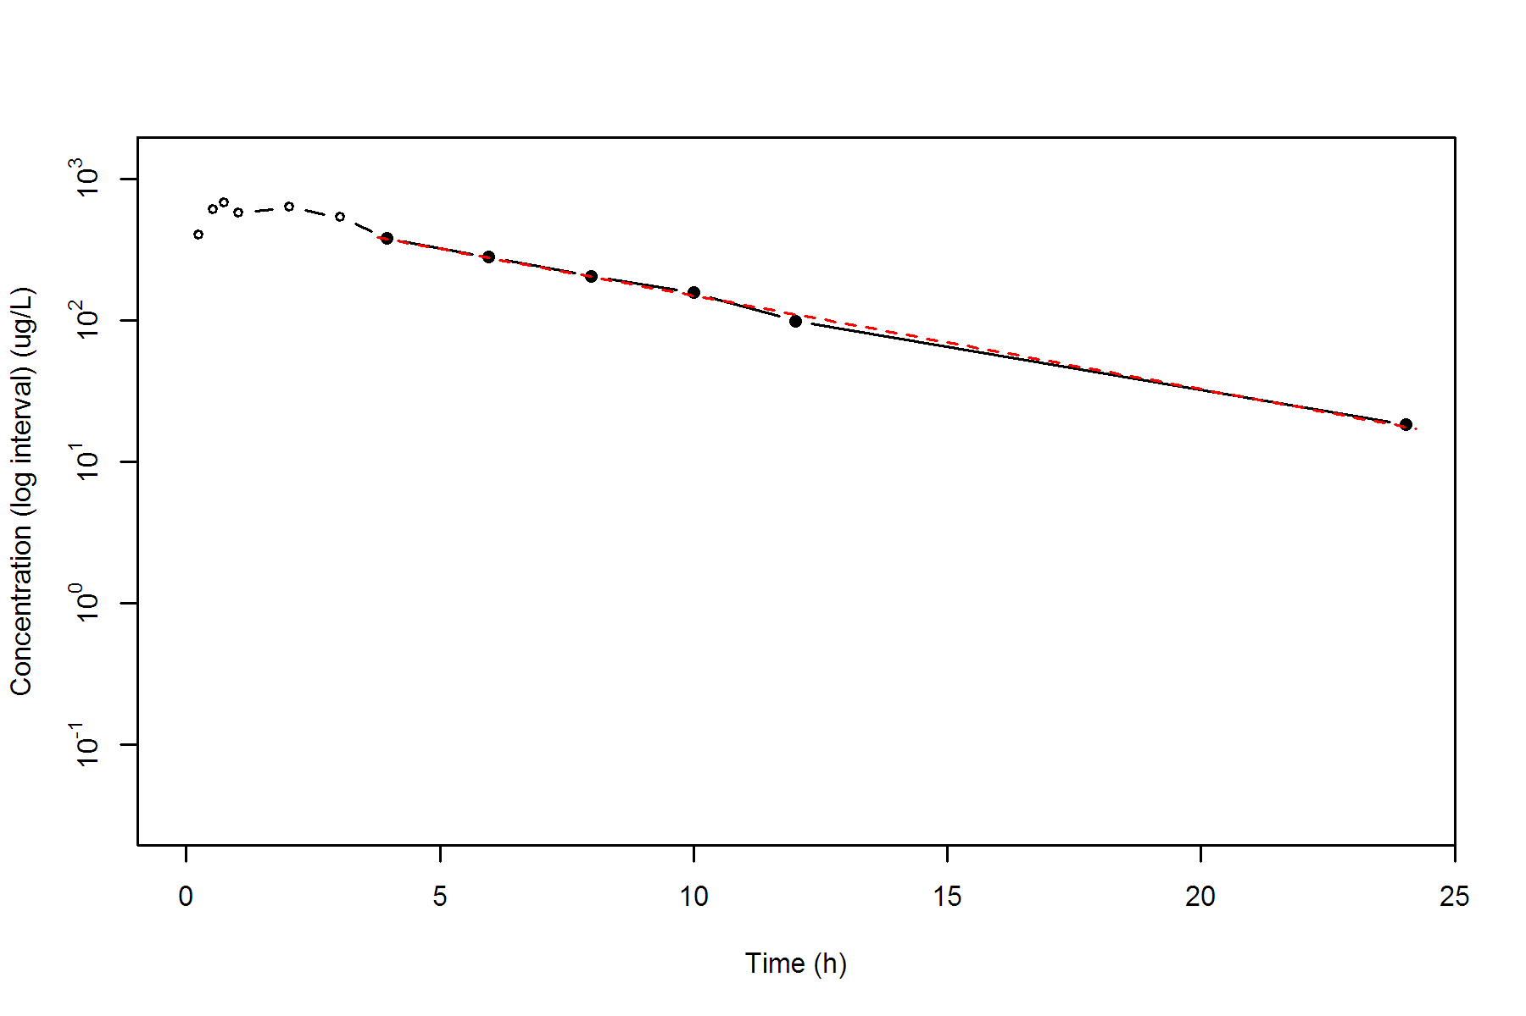

**SUBJ 9, GRP RT, PRD 2, TRT T**

NONCOMPARTMENTAL ANALYSIS REPORT

Package version 0.3.9 (2018-05-10 KST)

R version 3.5.0 (2018-04-23)

Date and Time: 2018-06-19 09:49:35 Asia/Seoul

Calculation Setting

-------------------

Drug Administration: Extravascular

Observation count excluding trailing zero: 13

Dose at time 0: 0 mg

AUC Calculation Method: Linear-up Linear-down

Weighting for lambda z: Uniform (Ordinary Least Square, OLS)

Lambda z selection criterion: Heighest adjusted R-squared value with precision=1e-4

Fitting, AUC, AUMC Result

-------------------------

Time Conc. Pred. Residual AUC AUMC

---------------------------------------------------------------------

0.0000 0.0000 0.0000 0.0000

0.2500 274.9500 34.3688 8.5922

0.4800 412.2200 113.3933 39.2515

0.7200 456.1300 217.5953 102.4050

0.9800 556.5500 349.2437 216.0033

2.0300 521.8000 915.3774 1058.4566

2.9600 371.2900 1330.6643 2062.0533

4.0200 * 398.6700 415.3928 -1.672e+01 1738.7431 3493.9393

5.9600 * 393.4500 358.5254 +3.492e+01 2507.0995 7323.1263

7.9600 * 318.4600 308.0374 +1.042e+01 3219.0095 12203.0299

9.9900 * 267.7200 264.0573 +3.663e+00 3813.9822 17490.6362

12.0000 * 198.7000 226.7003 -2.800e+01 4282.7343 22574.8536

24.0200 * 94.1000 91.0529 +3.047e+00 6042.4623 50489.3925

*: Used for the calculation of Lambda z.

Calculated Values

-----------------

CMAX Max Conc 556.5500 ug/L

TMAX Time of CMAX 0.9800 h

TLAG Time Until First Nonzero Conc 0.0000 h

CLST Last Nonzero Conc 94.1000 ug/L

CLSTP Last Nonzero Conc Pred 91.0529 ug/L

TLST Time of Last Nonzero Conc 24.0200 h

LAMZHL Half-Life Lambda z 9.1337 h

LAMZ Lambda z 0.0759 /h

LAMZLL Lambda z Lower Limit 4.0200 h

LAMZUL Lambda z Upper Limit 24.0200 h

LAMZNPT Number of Points for Lambda z 6

CORRXY Correlation Between TimeX and Log ConcY -0.9899

R2 R Squared 0.9799

R2ADJ R Squared Adjusted 0.9748

AUCLST AUC to Last Nonzero Conc 6042.4623 h*ug/L

AUCALL AUC All 6042.4623 h*ug/L

AUCIFO AUC Infinity Obs 7282.4281 h*ug/L

AUCIFP AUC Infinity Pred 7242.2763 h*ug/L

AUCPEO AUC %Extrapolation Obs 17.0268 %

AUCPEP AUC %Extrapolation Pred 16.5668 %

AUMCLST AUMC to Last Nonzero Conc 50489.3925 h2*ug/L

AUMCIFO AUMC Infinity Obs 96612.5345 h2*ug/L

AUMCIFP AUMC Infinity Pred 95119.0016 h2*ug/L

AUMCPEO AUMC %Extrapolation Obs 47.7403 %

AUMCPEP AUMC % Extrapolation Pred 46.9198 %

VZFO Vz Obs by F 0.0000 L

VZFP Vz Pred by F 0.0000 L

CLFO Total CL Obs by F 0.0000 L/h

CLFP Total CL Pred by F 0.0000 L/h

MRTEVLST MRT Extravasc to Last Nonzero Conc 8.3558 h

MRTEVIFO MRT Extravasc Infinity Obs 13.2665 h

MRTEVIFP MRT Extravasc Infinity Pred 13.1339 h

**SUBJ 9, GRP RT, PRD 2, TRT T**

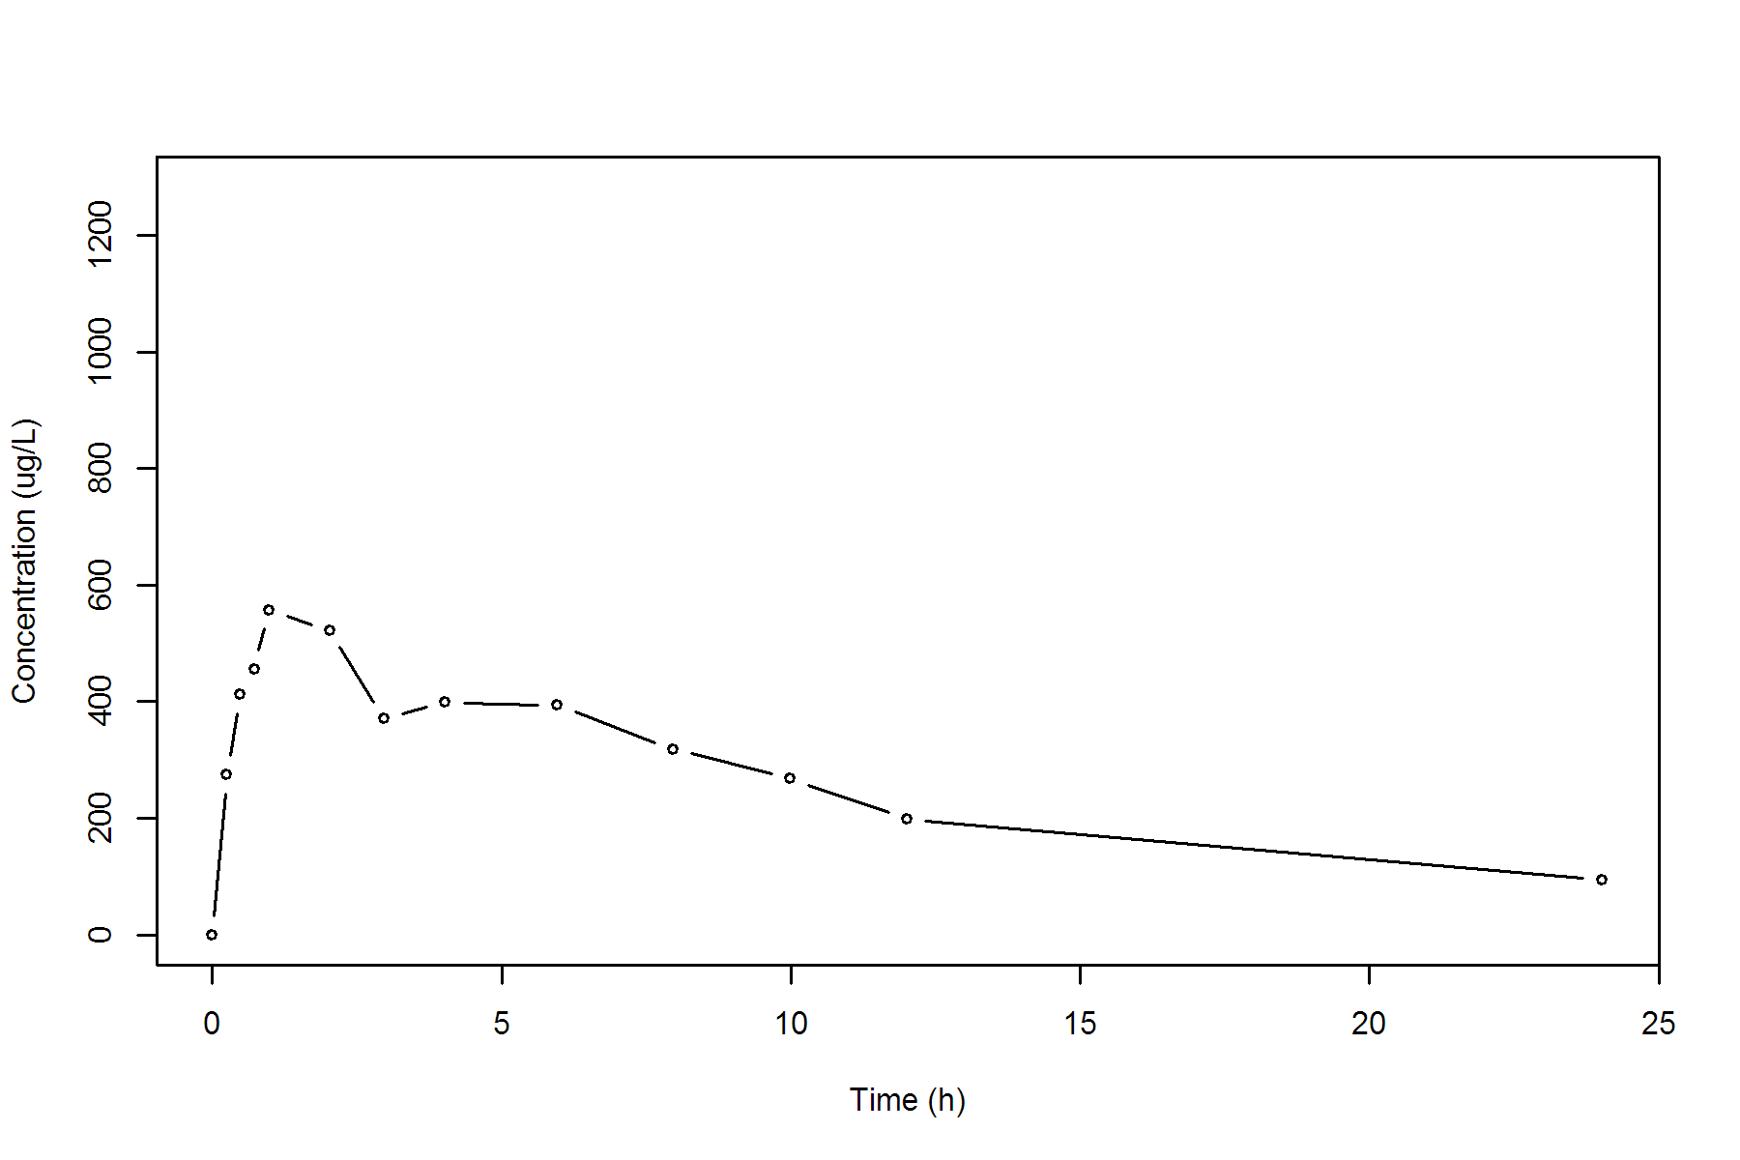

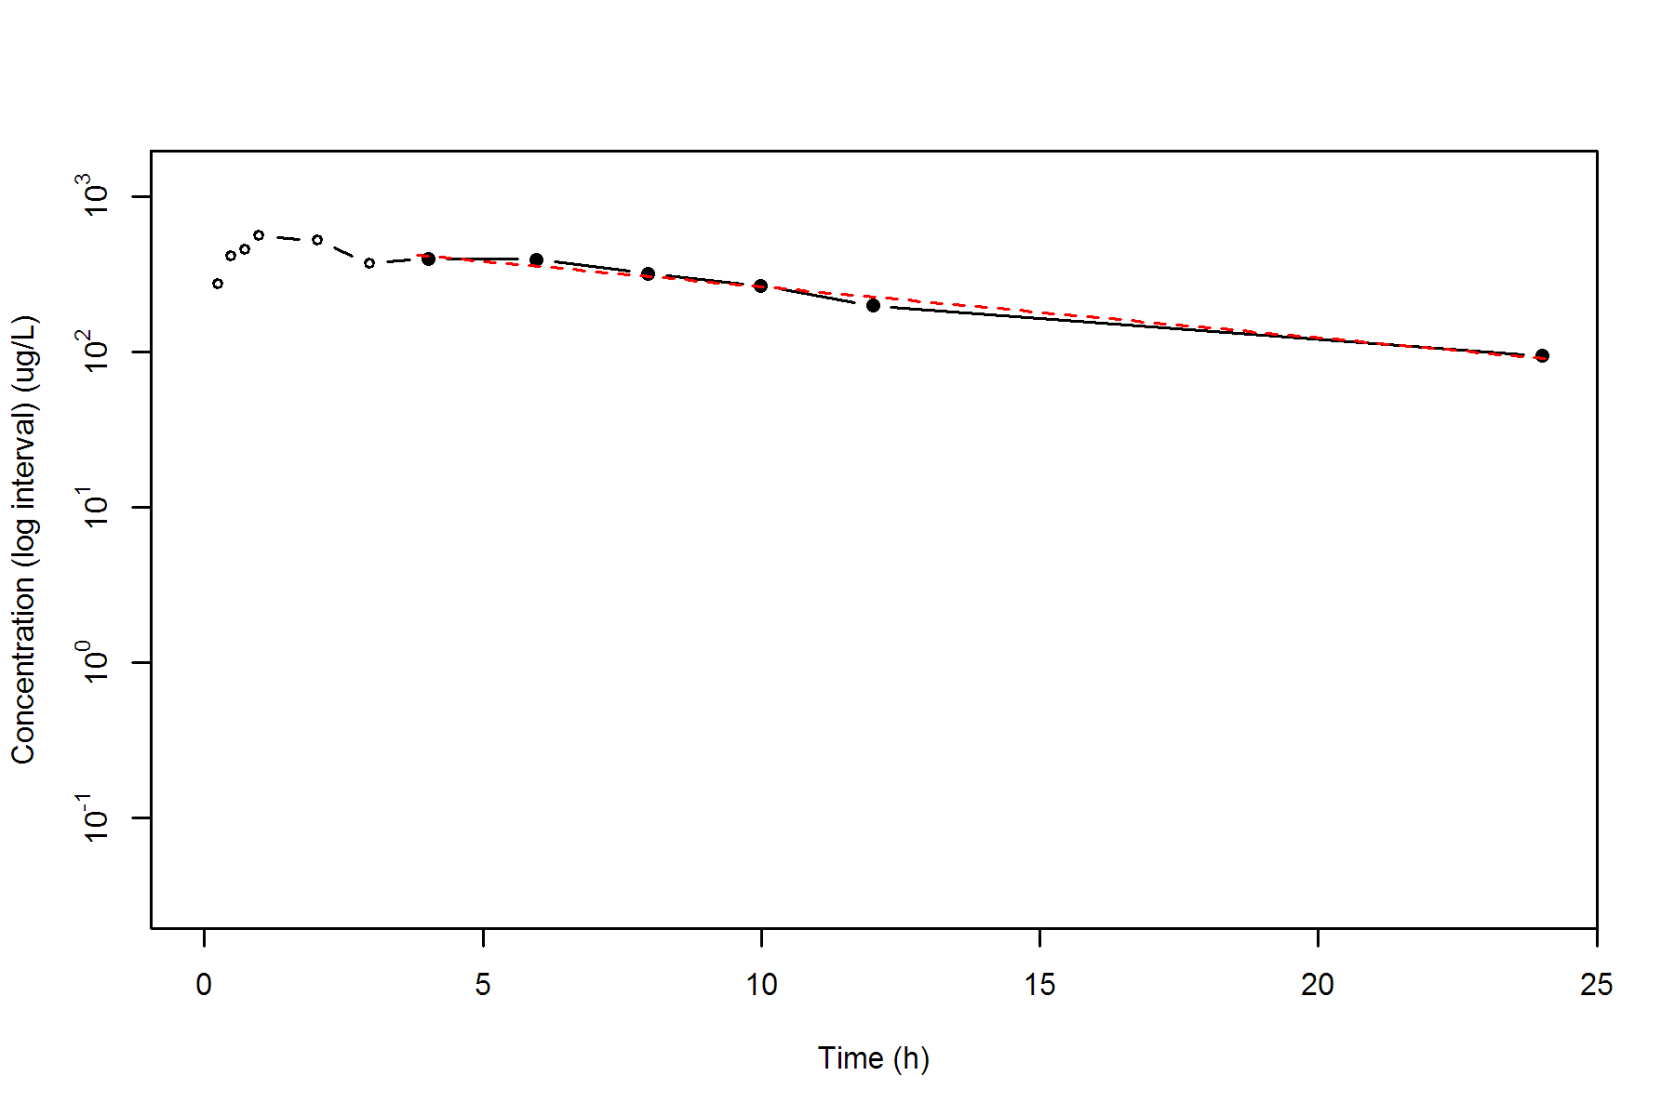

**SUBJ 10, GRP RT, PRD 1, TRT R**

NONCOMPARTMENTAL ANALYSIS REPORT

Package version 0.3.9 (2018-05-10 KST)

R version 3.5.0 (2018-04-23)

Date and Time: 2018-06-19 09:49:35 Asia/Seoul

Calculation Setting

-------------------

Drug Administration: Extravascular

Observation count excluding trailing zero: 13

Dose at time 0: 0 mg

AUC Calculation Method: Linear-up Linear-down

Weighting for lambda z: Uniform (Ordinary Least Square, OLS)

Lambda z selection criterion: Heighest adjusted R-squared value with precision=1e-4

Fitting, AUC, AUMC Result

-------------------------

Time Conc. Pred. Residual AUC AUMC

---------------------------------------------------------------------

0.0000 0.0000 0.0000 0.0000

0.2700 466.0300 62.9141 16.9868

0.5200 686.1600 206.9378 77.3157

0.7600 906.4100 398.0462 202.7967

1.0300 1136.9100 673.8944 453.8817

2.0200 889.9500 1677.1901 1923.3963

3.0300 1045.7500 2654.7186 4431.3886

4.0300 866.8600 3611.0236 7762.4228

5.9900 585.1700 5034.0130 14621.0646

7.9600 * 451.8900 467.0282 -1.514e+01 6055.5171 21616.7441

10.0300 * 289.3700 308.1932 -1.882e+01 6822.7212 28343.6495

11.9900 * 233.8000 207.9199 +2.588e+01 7335.4278 33935.1797

24.0000 * 18.2500 18.6437 -3.937e-01 8848.9881 53398.9580

*: Used for the calculation of Lambda z.

Calculated Values

-----------------

CMAX Max Conc 1136.9100 ug/L

TMAX Time of CMAX 1.0300 h

TLAG Time Until First Nonzero Conc 0.0000 h

CLST Last Nonzero Conc 18.2500 ug/L

CLSTP Last Nonzero Conc Pred 18.6437 ug/L

TLST Time of Last Nonzero Conc 24.0000 h

LAMZHL Half-Life Lambda z 3.4519 h

LAMZ Lambda z 0.2008 /h

LAMZLL Lambda z Lower Limit 7.9600 h

LAMZUL Lambda z Upper Limit 24.0000 h

LAMZNPT Number of Points for Lambda z 4

CORRXY Correlation Between TimeX and Log ConcY -0.9985

R2 R Squared 0.9969

R2ADJ R Squared Adjusted 0.9954

AUCLST AUC to Last Nonzero Conc 8848.9881 h*ug/L

AUCALL AUC All 8848.9881 h*ug/L

AUCIFO AUC Infinity Obs 8939.8731 h*ug/L

AUCIFP AUC Infinity Pred 8941.8335 h*ug/L

AUCPEO AUC %Extrapolation Obs 1.0166 %

AUCPEP AUC %Extrapolation Pred 1.0383 %

AUMCLST AUMC to Last Nonzero Conc 53398.9580 h2*ug/L

AUMCIFO AUMC Infinity Obs 56032.8059 h2*ug/L

AUMCIFP AUMC Infinity Pred 56089.6206 h2*ug/L

AUMCPEO AUMC %Extrapolation Obs 4.7005 %

AUMCPEP AUMC % Extrapolation Pred 4.7971 %

VZFO Vz Obs by F 0.0000 L

VZFP Vz Pred by F 0.0000 L

CLFO Total CL Obs by F 0.0000 L/h

CLFP Total CL Pred by F 0.0000 L/h

MRTEVLST MRT Extravasc to Last Nonzero Conc 6.0345 h

MRTEVIFO MRT Extravasc Infinity Obs 6.2677 h

MRTEVIFP MRT Extravasc Infinity Pred 6.2727 h

**SUBJ 10, GRP RT, PRD 1, TRT R**

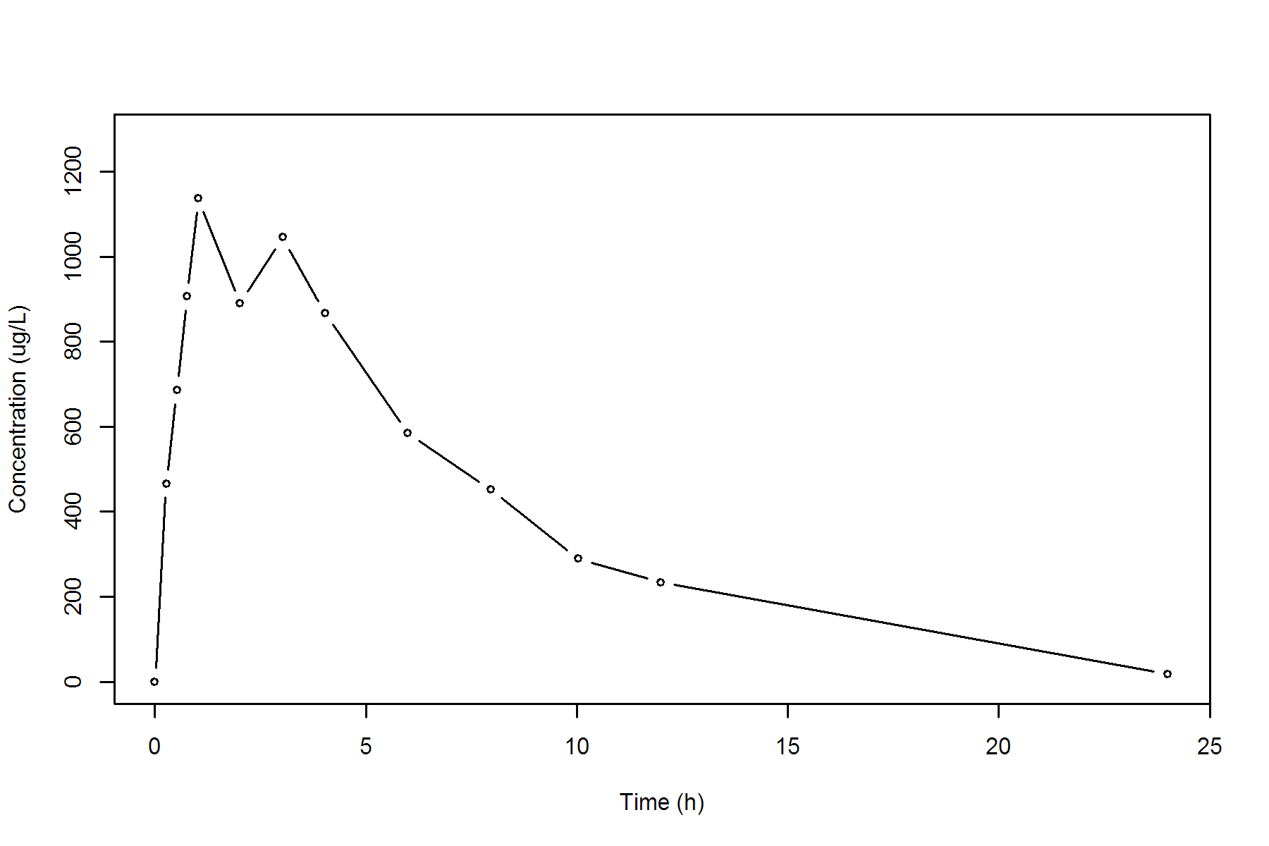

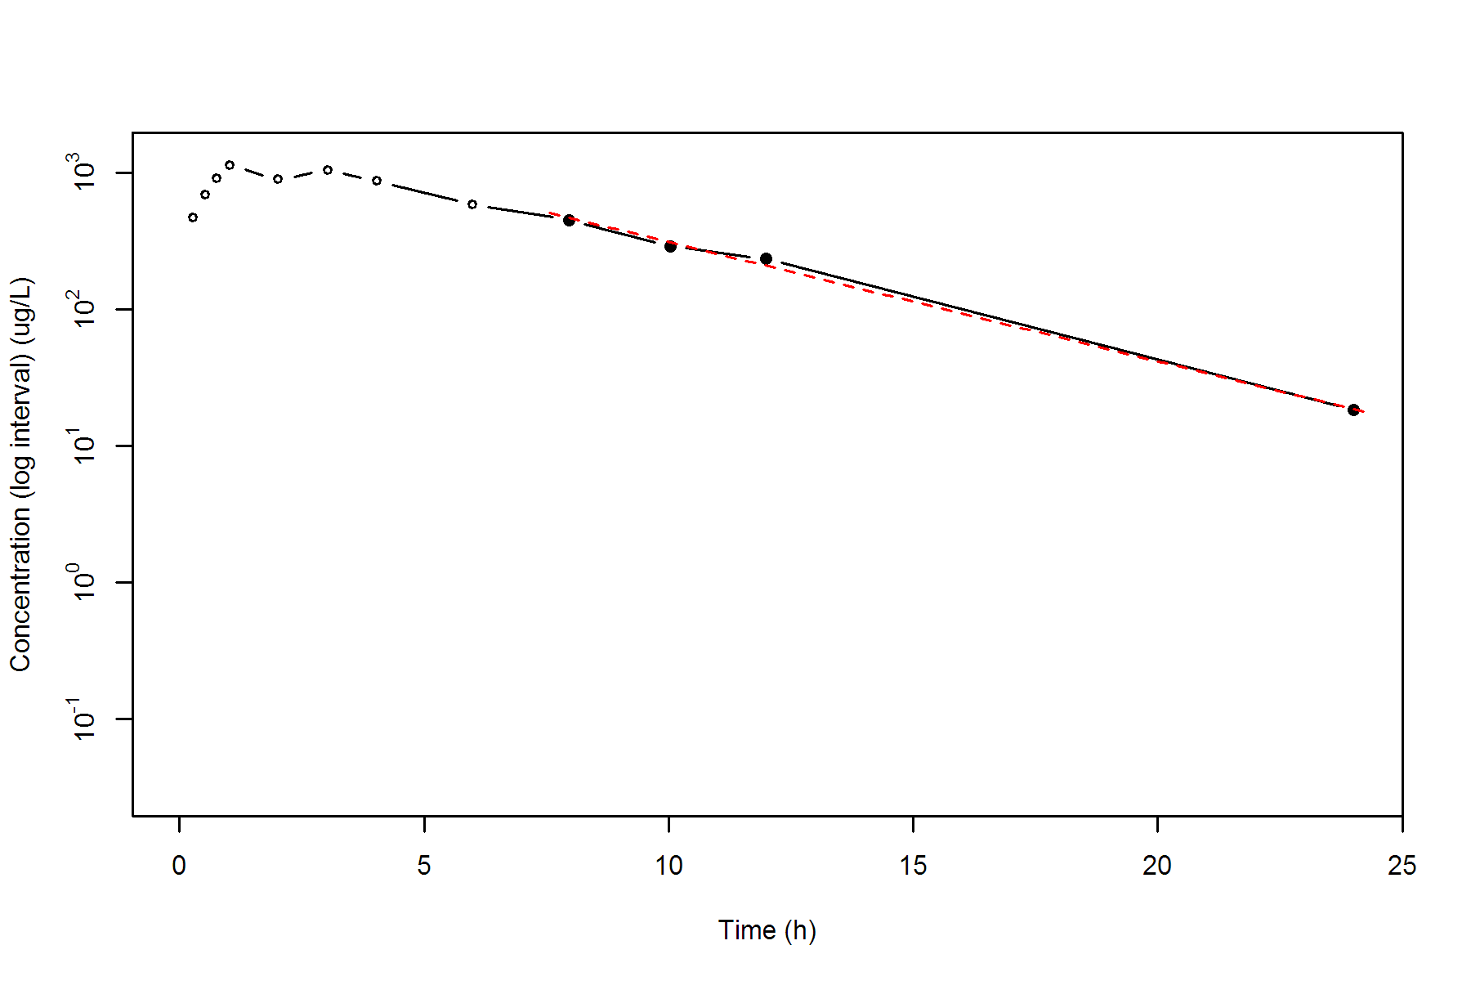

**SUBJ 10, GRP RT, PRD 2, TRT T**

NONCOMPARTMENTAL ANALYSIS REPORT

Package version 0.3.9 (2018-05-10 KST)

R version 3.5.0 (2018-04-23)

Date and Time: 2018-06-19 09:49:35 Asia/Seoul

Calculation Setting

-------------------

Drug Administration: Extravascular

Observation count excluding trailing zero: 13

Dose at time 0: 0 mg

AUC Calculation Method: Linear-up Linear-down

Weighting for lambda z: Uniform (Ordinary Least Square, OLS)

Lambda z selection criterion: Heighest adjusted R-squared value with precision=1e-4

Fitting, AUC, AUMC Result

-------------------------

Time Conc. Pred. Residual AUC AUMC

---------------------------------------------------------------------

0.0000 0.0000 0.0000 0.0000

0.2800 489.8000 68.5720 19.2002

0.4700 611.8900 173.2325 59.5497

0.7600 965.8800 402.0092 207.6900

0.9700 1082.7900 617.1196 395.0494

2.0500 1071.6800 1780.5334 2148.5646

2.9900 * 1008.4600 1018.3229 -9.863e+00 2758.1992 4598.3171

4.0000 * 724.2200 798.0039 -7.378e+01 3633.2026 7583.9657

6.0300 * 540.1900 488.8726 +5.132e+01 4916.5787 13830.5047

8.0400 * 288.6000 300.9421 -1.234e+01 5749.5127 19436.0829

9.9900 * 179.3600 187.9577 -8.598e+00 6205.7737 23445.4295

12.0200 * 132.4500 115.1465 +1.730e+01 6522.2608 26880.0428

23.9600 * 6.1700 6.4499 -2.799e-01 7349.8222 37267.1395

*: Used for the calculation of Lambda z.

Calculated Values

-----------------

CMAX Max Conc 1082.7900 ug/L

TMAX Time of CMAX 0.9700 h

TLAG Time Until First Nonzero Conc 0.0000 h

CLST Last Nonzero Conc 6.1700 ug/L

CLSTP Last Nonzero Conc Pred 6.4499 ug/L

TLST Time of Last Nonzero Conc 23.9600 h

LAMZHL Half-Life Lambda z 2.8715 h

LAMZ Lambda z 0.2414 /h

LAMZLL Lambda z Lower Limit 2.9900 h

LAMZUL Lambda z Upper Limit 23.9600 h

LAMZNPT Number of Points for Lambda z 7

CORRXY Correlation Between TimeX and Log ConcY -0.9987

R2 R Squared 0.9975

R2ADJ R Squared Adjusted 0.9969

AUCLST AUC to Last Nonzero Conc 7349.8222 h*ug/L

AUCALL AUC All 7349.8222 h*ug/L

AUCIFO AUC Infinity Obs 7375.3830 h*ug/L

AUCIFP AUC Infinity Pred 7376.5427 h*ug/L

AUCPEO AUC %Extrapolation Obs 0.3466 %

AUCPEP AUC %Extrapolation Pred 0.3622 %

AUMCLST AUMC to Last Nonzero Conc 37267.1395 h2*ug/L

AUMCIFO AUMC Infinity Obs 37985.4692 h2*ug/L

AUMCIFP AUMC Infinity Pred 38018.0587 h2*ug/L

AUMCPEO AUMC %Extrapolation Obs 1.8911 %

AUMCPEP AUMC % Extrapolation Pred 1.9752 %

VZFO Vz Obs by F 0.0000 L

VZFP Vz Pred by F 0.0000 L

CLFO Total CL Obs by F 0.0000 L/h

CLFP Total CL Pred by F 0.0000 L/h

MRTEVLST MRT Extravasc to Last Nonzero Conc 5.0705 h

MRTEVIFO MRT Extravasc Infinity Obs 5.1503 h

MRTEVIFP MRT Extravasc Infinity Pred 5.1539 h

**SUBJ 10, GRP RT, PRD 2, TRT T**

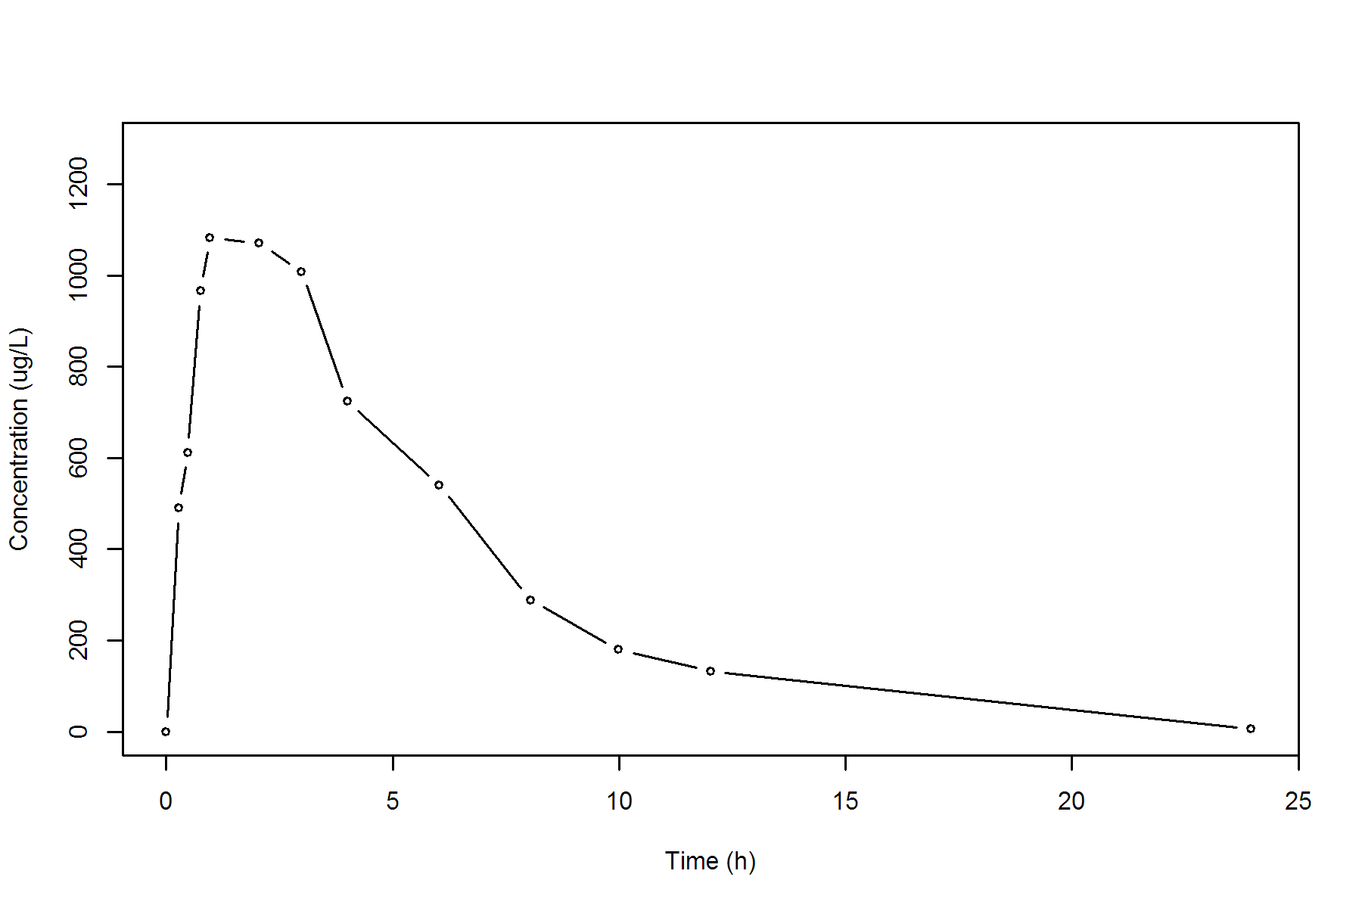

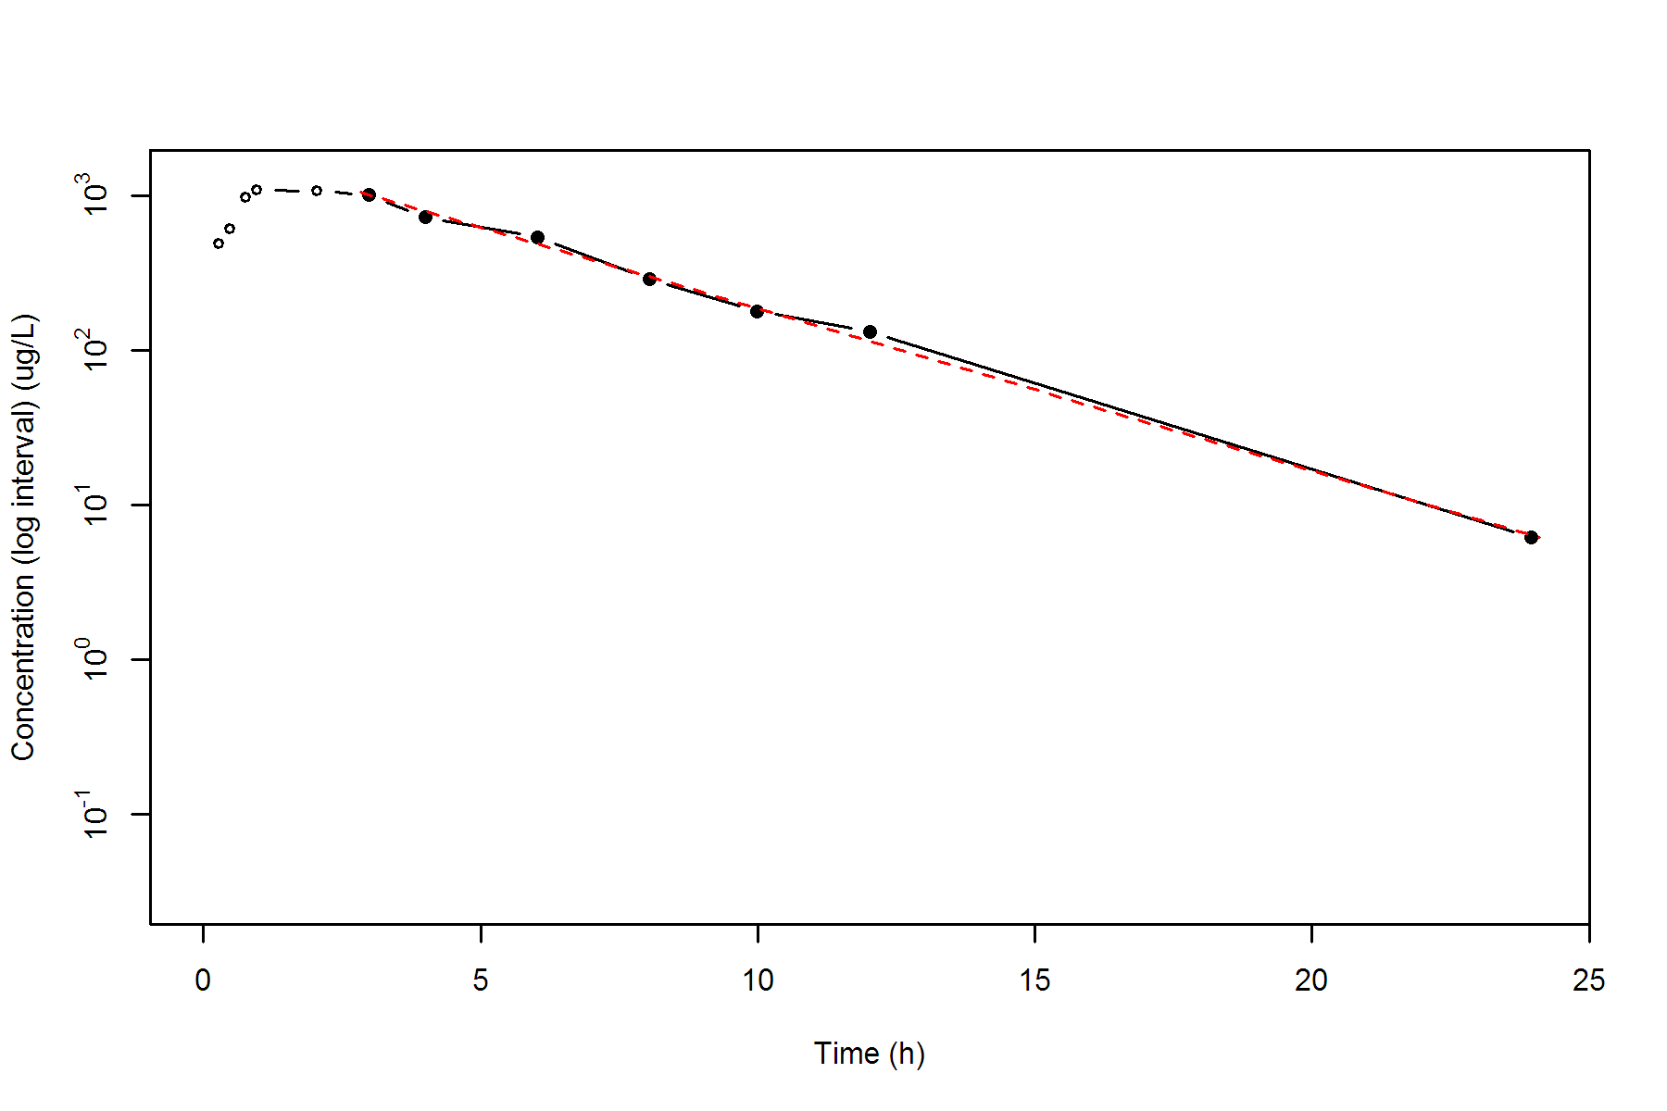

**SUBJ 11, GRP TR, PRD 1, TRT T**

NONCOMPARTMENTAL ANALYSIS REPORT

Package version 0.3.9 (2018-05-10 KST)

R version 3.5.0 (2018-04-23)

Date and Time: 2018-06-19 09:49:35 Asia/Seoul

Calculation Setting

-------------------

Drug Administration: Extravascular

Observation count excluding trailing zero: 13

Dose at time 0: 0 mg

AUC Calculation Method: Linear-up Linear-down

Weighting for lambda z: Uniform (Ordinary Least Square, OLS)

Lambda z selection criterion: Heighest adjusted R-squared value with precision=1e-4

Fitting, AUC, AUMC Result

-------------------------

Time Conc. Pred. Residual AUC AUMC

---------------------------------------------------------------------

0.0000 0.0000 0.0000 0.0000

0.2300 210.2600 24.1799 5.5614

0.4900 332.6800 94.7621 33.0399

0.7400 378.4500 183.6534 88.4231

0.9900 533.7400 297.6771 189.4801

2.0200 547.7300 854.6342 1031.4110

2.9600 301.8100 1253.9180 1971.3039

3.9700 290.4200 1552.9941 3004.6980

6.0000 234.7700 2086.0620 5604.7092

7.9600 140.7200 2454.0422 8082.8854

10.0100 * 76.3800 72.6299 +3.750e+00 2676.5697 10014.6978

12.0000 * 41.3500 43.8502 -2.500e+00 2793.7110 11269.1578

23.9800 * 2.1200 2.1023 +1.765e-02 3054.0963 14545.9130

*: Used for the calculation of Lambda z.

Calculated Values

-----------------

CMAX Max Conc 547.7300 ug/L

TMAX Time of CMAX 2.0200 h

TLAG Time Until First Nonzero Conc 0.0000 h

CLST Last Nonzero Conc 2.1200 ug/L

CLSTP Last Nonzero Conc Pred 2.1023 ug/L

TLST Time of Last Nonzero Conc 23.9800 h

LAMZHL Half-Life Lambda z 2.7336 h

LAMZ Lambda z 0.2536 /h

LAMZLL Lambda z Lower Limit 10.0100 h

LAMZUL Lambda z Upper Limit 23.9800 h

LAMZNPT Number of Points for Lambda z 3

CORRXY Correlation Between TimeX and Log ConcY -0.9996

R2 R Squared 0.9992

R2ADJ R Squared Adjusted 0.9984

AUCLST AUC to Last Nonzero Conc 3054.0963 h*ug/L

AUCALL AUC All 3054.0963 h*ug/L

AUCIFO AUC Infinity Obs 3062.4570 h*ug/L

AUCIFP AUC Infinity Pred 3062.3874 h*ug/L

AUCPEO AUC %Extrapolation Obs 0.2730 %

AUCPEP AUC %Extrapolation Pred 0.2707 %

AUMCLST AUMC to Last Nonzero Conc 14545.9130 h2*ug/L

AUMCIFO AUMC Infinity Obs 14779.3758 h2*ug/L

AUMCIFP AUMC Infinity Pred 14777.4315 h2*ug/L

AUMCPEO AUMC %Extrapolation Obs 1.5797 %

AUMCPEP AUMC % Extrapolation Pred 1.5667 %

VZFO Vz Obs by F 0.0000 L

VZFP Vz Pred by F 0.0000 L

CLFO Total CL Obs by F 0.0000 L/h

CLFP Total CL Pred by F 0.0000 L/h

MRTEVLST MRT Extravasc to Last Nonzero Conc 4.7628 h

MRTEVIFO MRT Extravasc Infinity Obs 4.8260 h

MRTEVIFP MRT Extravasc Infinity Pred 4.8255 h

**SUBJ 11, GRP TR, PRD 1, TRT T**

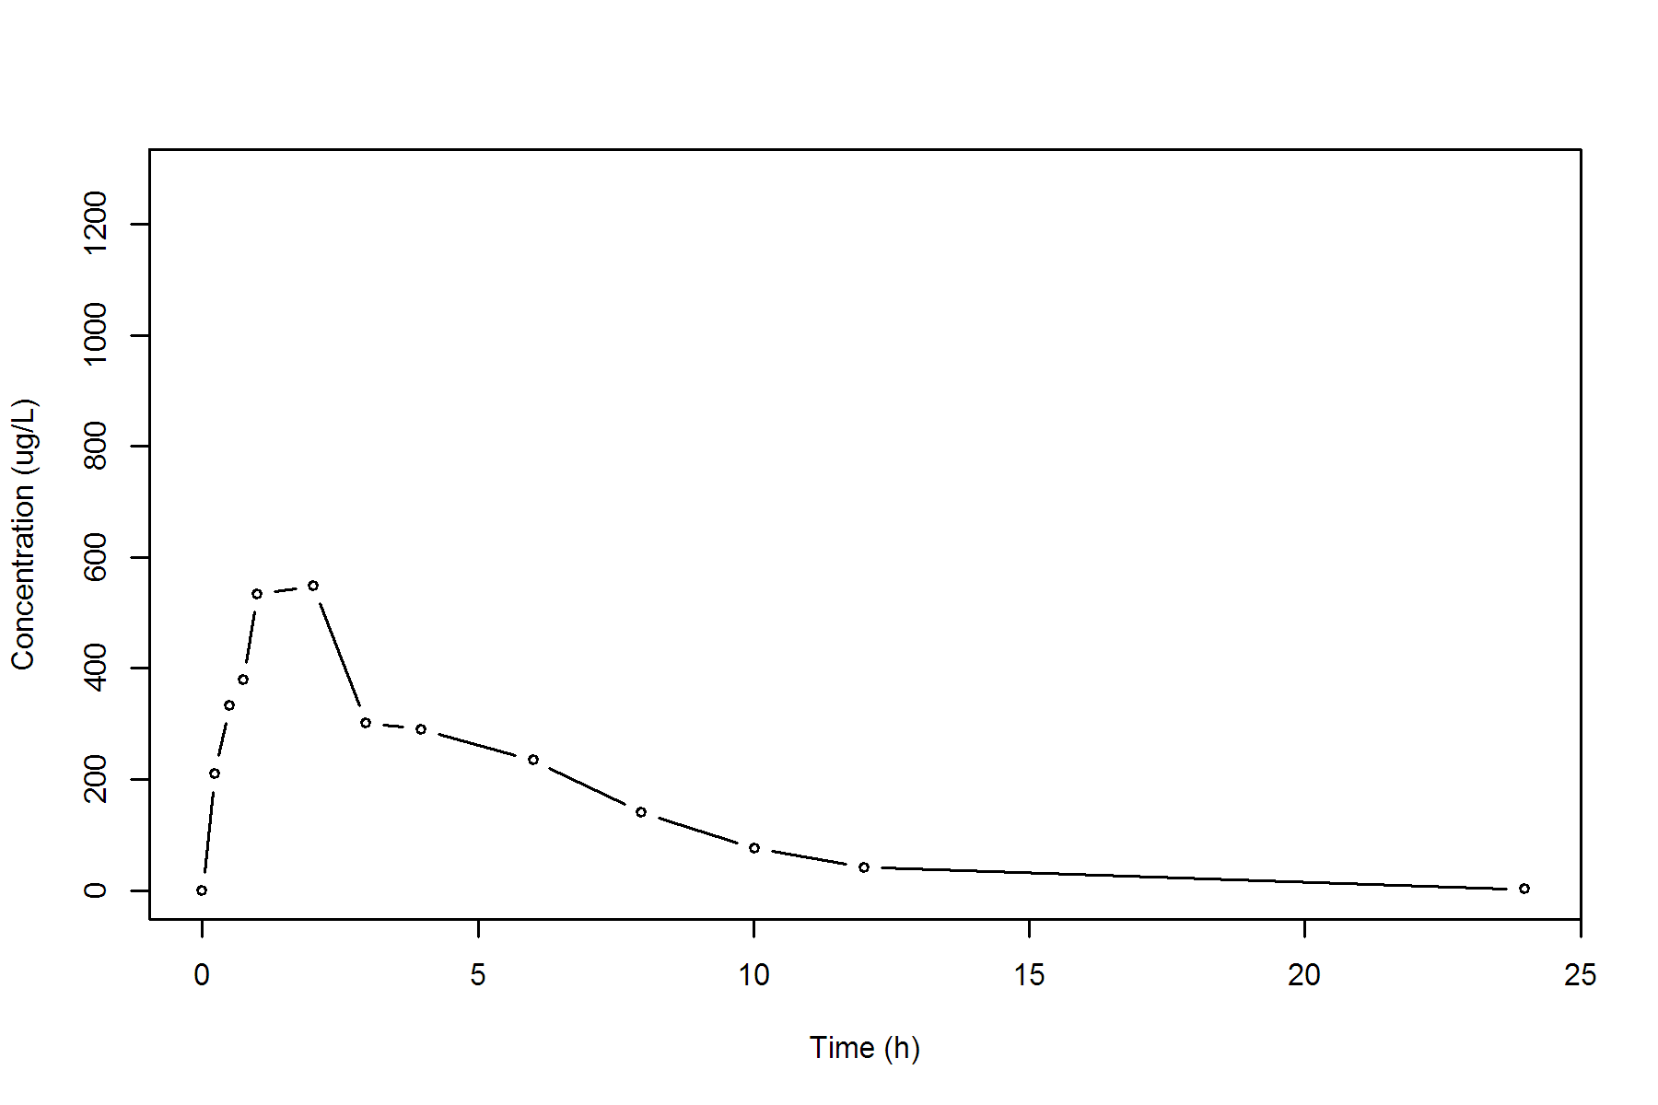

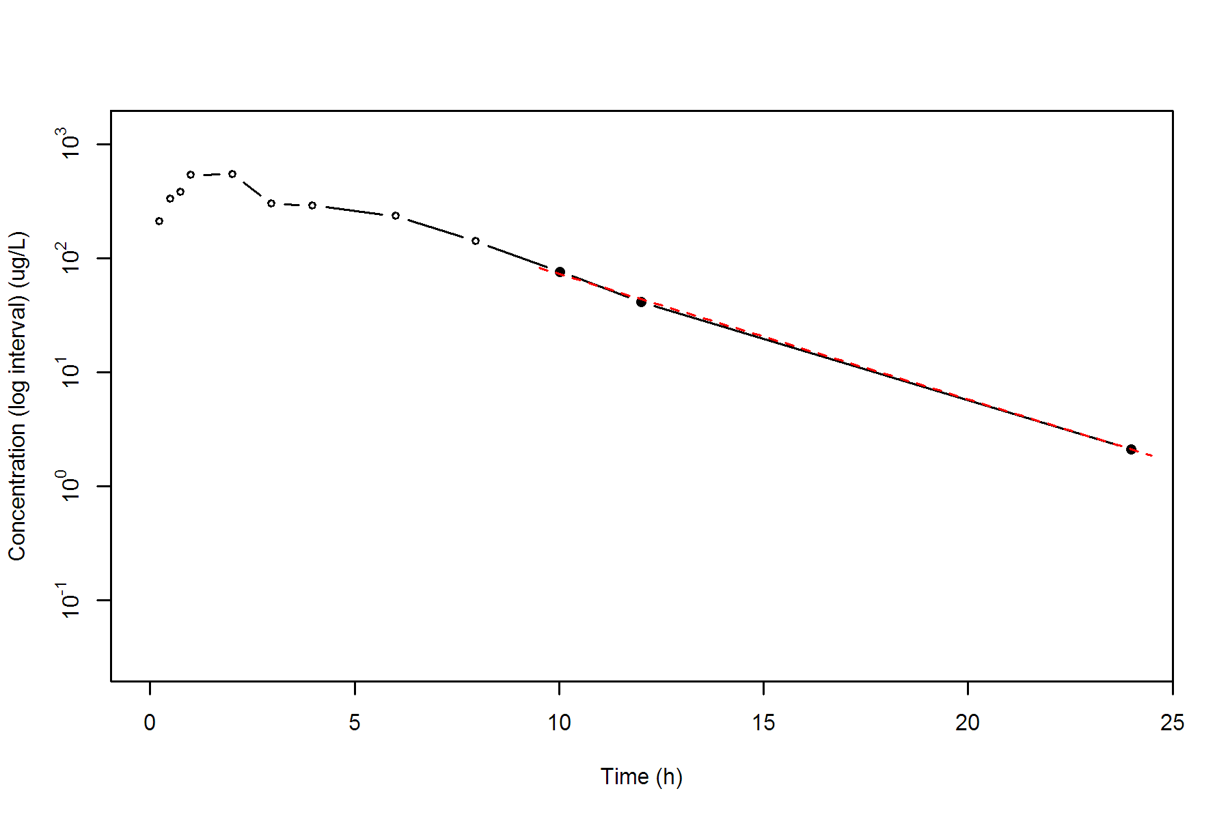

**SUBJ 11, GRP TR, PRD 2, TRT R**

NONCOMPARTMENTAL ANALYSIS REPORT

Package version 0.3.9 (2018-05-10 KST)

R version 3.5.0 (2018-04-23)

Date and Time: 2018-06-19 09:49:35 Asia/Seoul

Calculation Setting

-------------------

Drug Administration: Extravascular

Observation count excluding trailing zero: 13

Dose at time 0: 0 mg

AUC Calculation Method: Linear-up Linear-down

Weighting for lambda z: Uniform (Ordinary Least Square, OLS)

Lambda z selection criterion: Heighest adjusted R-squared value with precision=1e-4

Fitting, AUC, AUMC Result

-------------------------

Time Conc. Pred. Residual AUC AUMC

---------------------------------------------------------------------

0.0000 0.5300 0.0000 0.0000

0.2200 669.3800 73.6901 16.1990

0.5400 984.6900 338.3413 124.8384

0.7000 970.5100 494.7573 221.7256

0.9500 960.1700 736.0923 420.6654

1.9700 870.4400 1669.7034 1760.3988

3.0000 623.9300 2439.3040 3607.4756

4.0100 417.1600 2965.0544 5397.4994

5.9700 * 268.2500 270.7705 -2.520e+00 3636.7562 8606.2782

7.9800 * 159.4900 150.1251 +9.365e+00 4066.6349 11494.8318

9.9600 * 77.8200 83.9708 -6.151e+00 4301.5718 13522.1710

12.0100 * 47.0500 46.0132 +1.037e+00 4429.5636 14895.8327

23.9700 * 1.3800 1.3764 +3.622e-03 4719.1750 18472.7643

*: Used for the calculation of Lambda z.

Calculated Values

-----------------

CMAX Max Conc 984.6900 ug/L

TMAX Time of CMAX 0.5400 h

TLAG Time Until First Nonzero Conc 0.0000 h

CLST Last Nonzero Conc 1.3800 ug/L

CLSTP Last Nonzero Conc Pred 1.3764 ug/L

TLST Time of Last Nonzero Conc 23.9700 h

LAMZHL Half-Life Lambda z 2.3622 h

LAMZ Lambda z 0.2934 /h

LAMZLL Lambda z Lower Limit 5.9700 h

LAMZUL Lambda z Upper Limit 23.9700 h

LAMZNPT Number of Points for Lambda z 5

CORRXY Correlation Between TimeX and Log ConcY -0.9997

R2 R Squared 0.9994

R2ADJ R Squared Adjusted 0.9992

AUCLST AUC to Last Nonzero Conc 4719.1750 h*ug/L

AUCALL AUC All 4719.1750 h*ug/L

AUCIFO AUC Infinity Obs 4723.8779 h*ug/L

AUCIFP AUC Infinity Pred 4723.8655 h*ug/L

AUCPEO AUC %Extrapolation Obs 0.0996 %

AUCPEP AUC %Extrapolation Pred 0.0993 %

AUMCLST AUMC to Last Nonzero Conc 18472.7643 h2*ug/L

AUMCIFO AUMC Infinity Obs 18601.5207 h2*ug/L

AUMCIFP AUMC Infinity Pred 18601.1827 h2*ug/L

AUMCPEO AUMC %Extrapolation Obs 0.6922 %

AUMCPEP AUMC % Extrapolation Pred 0.6904 %

VZFO Vz Obs by F 0.0000 L

VZFP Vz Pred by F 0.0000 L

CLFO Total CL Obs by F 0.0000 L/h

CLFP Total CL Pred by F 0.0000 L/h

MRTEVLST MRT Extravasc to Last Nonzero Conc 3.9144 h

MRTEVIFO MRT Extravasc Infinity Obs 3.9378 h

MRTEVIFP MRT Extravasc Infinity Pred 3.9377 h

**SUBJ 11, GRP TR, PRD 2, TRT R**

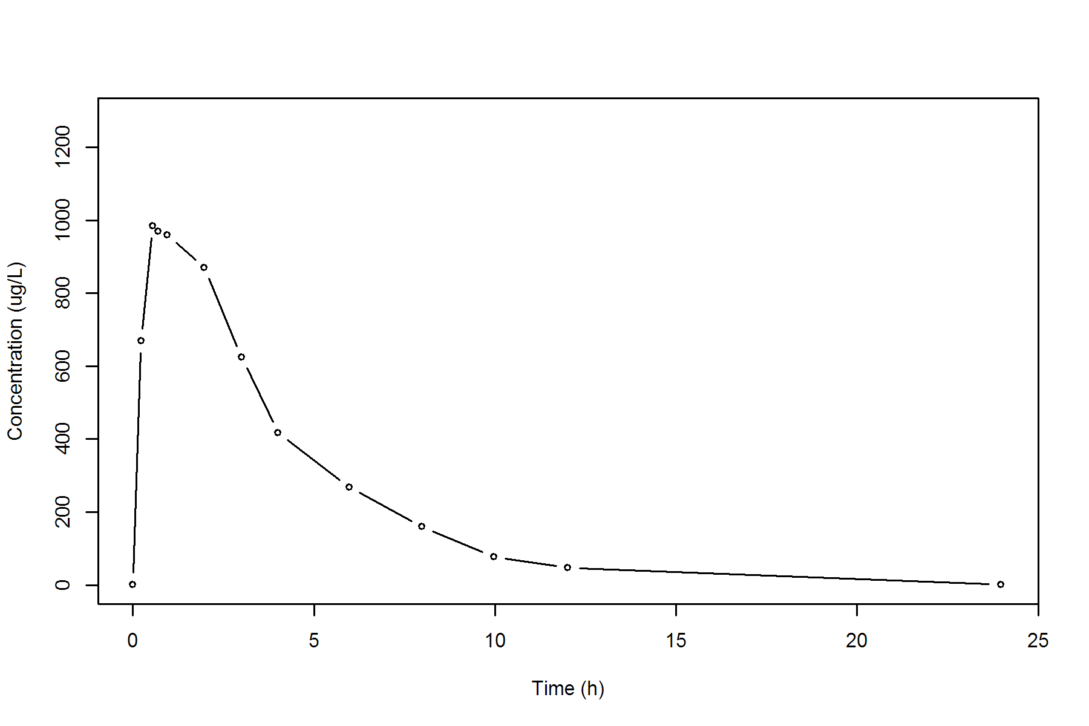

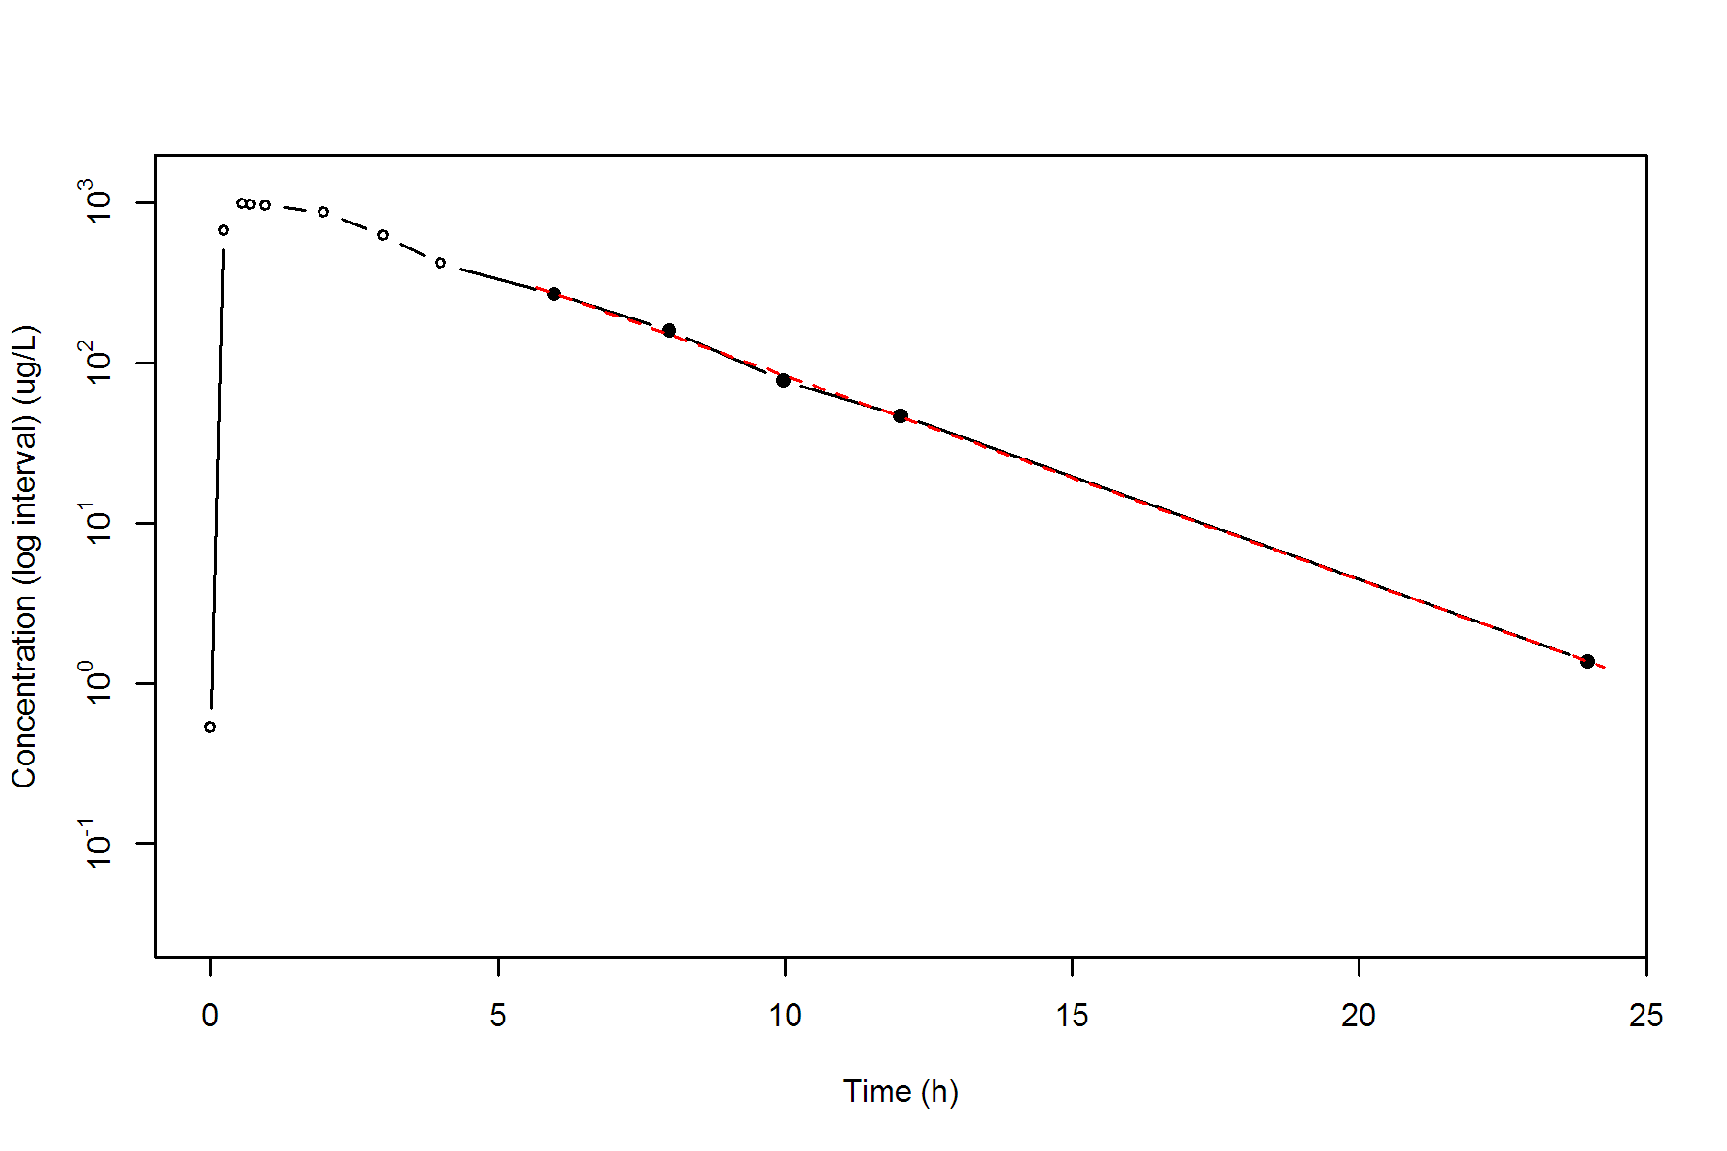

**SUBJ 12, GRP TR, PRD 1, TRT T**

NONCOMPARTMENTAL ANALYSIS REPORT

Package version 0.3.9 (2018-05-10 KST)

R version 3.5.0 (2018-04-23)

Date and Time: 2018-06-19 09:49:35 Asia/Seoul

Calculation Setting

-------------------

Drug Administration: Extravascular

Observation count excluding trailing zero: 13

Dose at time 0: 0 mg

AUC Calculation Method: Linear-up Linear-down

Weighting for lambda z: Uniform (Ordinary Least Square, OLS)

Lambda z selection criterion: Heighest adjusted R-squared value with precision=1e-4

Fitting, AUC, AUMC Result

-------------------------

Time Conc. Pred. Residual AUC AUMC

---------------------------------------------------------------------

0.0000 0.0000 0.0000 0.0000

0.2200 265.5000 29.2050 6.4251

0.4600 430.2100 112.6902 37.1819

0.7400 542.1800 248.8248 121.0573

1.0000 531.3200 388.3798 242.2866

2.0200 563.2100 946.5901 1093.4787

3.0100 556.1800 1500.6882 2485.3128

4.0300 * 397.4200 415.0829 -1.766e+01 1987.0242 4155.9220

6.0400 * 282.4600 285.1377 -2.678e+00 2670.3036 7480.1213

8.0400 * 213.8400 196.2392 +1.760e+01 3166.6036 10905.4533

9.9700 * 142.1600 136.8347 +5.325e+00 3510.1436 13932.2808

12.0100 * 86.9400 93.4721 -6.532e+00 3743.8256 16442.9951

24.0400 * 9.8900 9.8772 +1.277e-02 4326.2580 24153.6537

*: Used for the calculation of Lambda z.

Calculated Values

-----------------

CMAX Max Conc 563.2100 ug/L

TMAX Time of CMAX 2.0200 h

TLAG Time Until First Nonzero Conc 0.0000 h

CLST Last Nonzero Conc 9.8900 ug/L

CLSTP Last Nonzero Conc Pred 9.8772 ug/L

TLST Time of Last Nonzero Conc 24.0400 h

LAMZHL Half-Life Lambda z 3.7103 h

LAMZ Lambda z 0.1868 /h

LAMZLL Lambda z Lower Limit 4.0300 h

LAMZUL Lambda z Upper Limit 24.0400 h

LAMZNPT Number of Points for Lambda z 6

CORRXY Correlation Between TimeX and Log ConcY -0.9991

R2 R Squared 0.9982

R2ADJ R Squared Adjusted 0.9977

AUCLST AUC to Last Nonzero Conc 4326.2580 h*ug/L

AUCALL AUC All 4326.2580 h*ug/L

AUCIFO AUC Infinity Obs 4379.1970 h*ug/L

AUCIFP AUC Infinity Pred 4379.1286 h*ug/L

AUCPEO AUC %Extrapolation Obs 1.2089 %

AUCPEP AUC %Extrapolation Pred 1.2073 %

AUMCLST AUMC to Last Nonzero Conc 24153.6537 h2*ug/L

AUMCIFO AUMC Infinity Obs 25709.6769 h2*ug/L

AUMCIFP AUMC Infinity Pred 25707.6673 h2*ug/L

AUMCPEO AUMC %Extrapolation Obs 6.0523 %

AUMCPEP AUMC % Extrapolation Pred 6.0449 %

VZFO Vz Obs by F 0.0000 L

VZFP Vz Pred by F 0.0000 L

CLFO Total CL Obs by F 0.0000 L/h

CLFP Total CL Pred by F 0.0000 L/h

MRTEVLST MRT Extravasc to Last Nonzero Conc 5.5830 h

MRTEVIFO MRT Extravasc Infinity Obs 5.8709 h

MRTEVIFP MRT Extravasc Infinity Pred 5.8705 h

**SUBJ 12, GRP TR, PRD 1, TRT T**

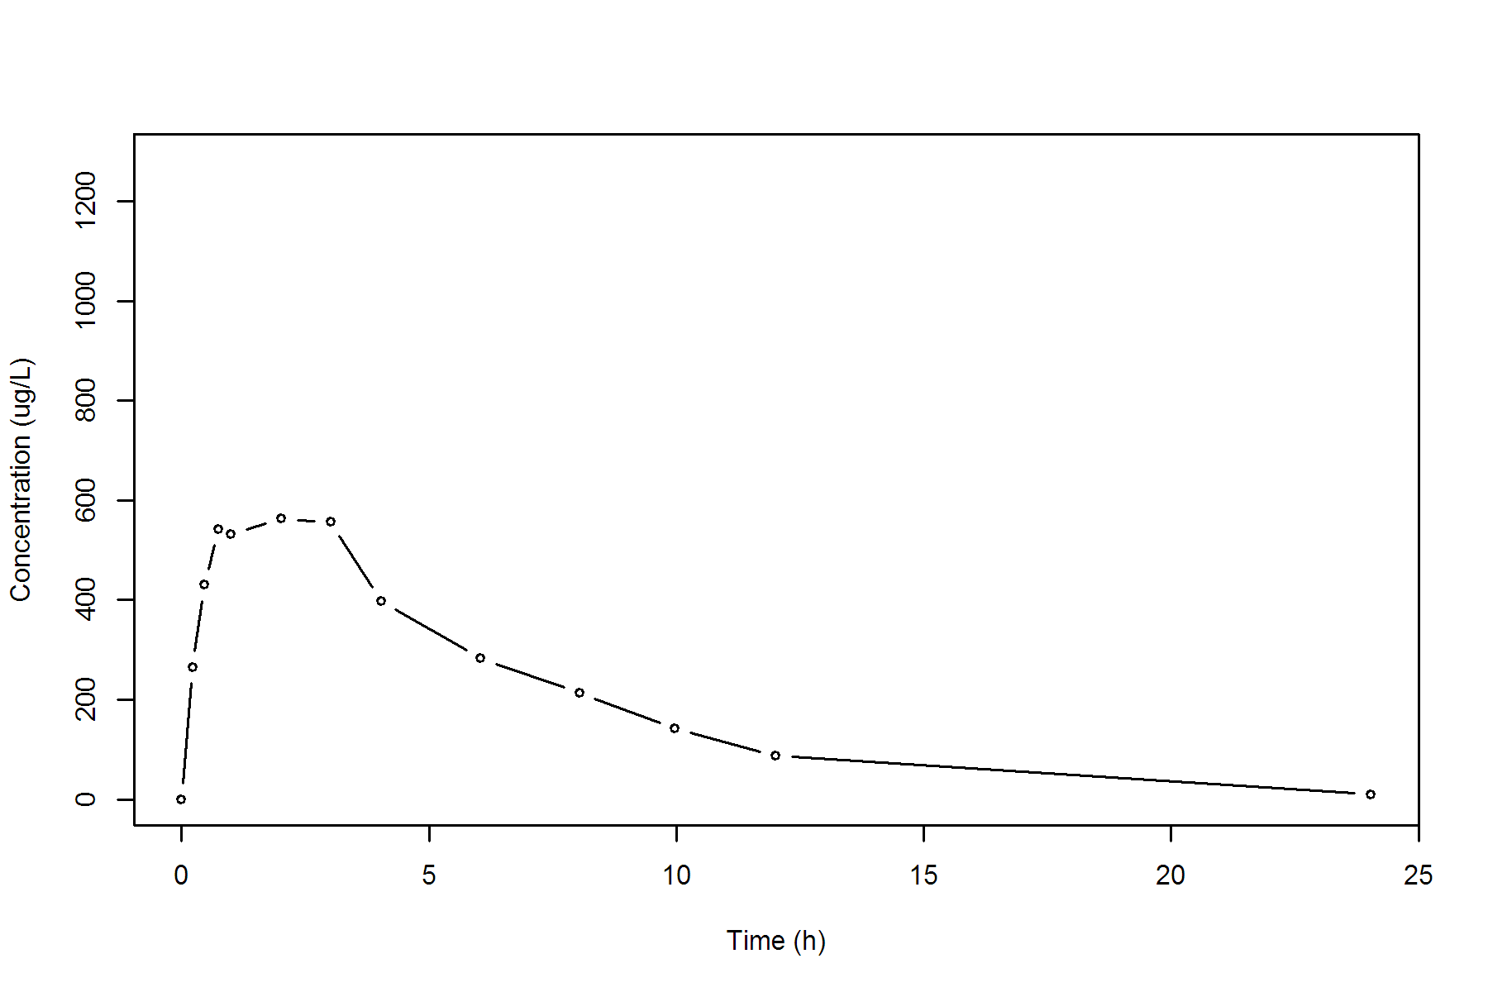

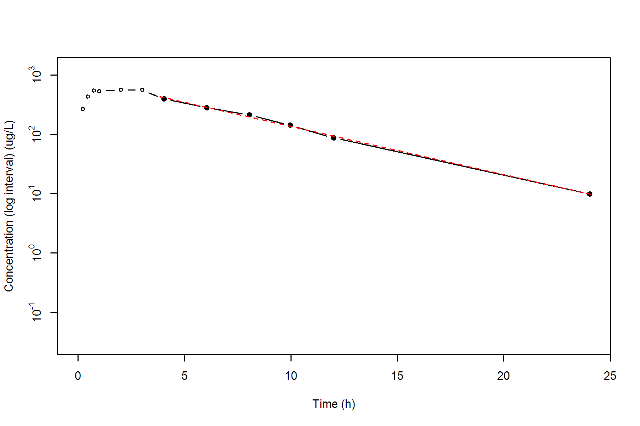

**SUBJ 12, GRP TR, PRD 2, TRT R**

NONCOMPARTMENTAL ANALYSIS REPORT

Package version 0.3.9 (2018-05-10 KST)

R version 3.5.0 (2018-04-23)

Date and Time: 2018-06-19 09:49:35 Asia/Seoul

Calculation Setting

-------------------

Drug Administration: Extravascular

Observation count excluding trailing zero: 13

Dose at time 0: 0 mg

AUC Calculation Method: Linear-up Linear-down

Weighting for lambda z: Uniform (Ordinary Least Square, OLS)

Lambda z selection criterion: Heighest adjusted R-squared value with precision=1e-4

Fitting, AUC, AUMC Result

-------------------------

Time Conc. Pred. Residual AUC AUMC

---------------------------------------------------------------------

0.0000 0.0000 0.0000 0.0000

0.2900 197.2400 28.5998 8.2939

0.5100 308.2400 84.2026 31.8782

0.7800 434.2700 184.4415 98.8291

0.9800 426.5400 270.5225 174.5031

2.0200 592.6800 800.5169 1014.4190

3.0000 498.2500 1335.0725 2333.4811

3.9600 516.6200 1822.2102 4032.9524

6.0100 334.7400 2694.8541 8191.9951

8.0400 249.9800 3288.3449 12273.9461

9.9600 * 222.1100 218.0794 +4.031e+00 3741.5514 16327.1187

12.0100 * 156.8200 160.2189 -3.399e+00 4129.9546 20525.1331

24.0100 * 26.4400 26.3574 +8.259e-02 5229.5146 35634.5287

*: Used for the calculation of Lambda z.

Calculated Values

-----------------

CMAX Max Conc 592.6800 ug/L

TMAX Time of CMAX 2.0200 h

TLAG Time Until First Nonzero Conc 0.0000 h

CLST Last Nonzero Conc 26.4400 ug/L

CLSTP Last Nonzero Conc Pred 26.3574 ug/L

TLST Time of Last Nonzero Conc 24.0100 h

LAMZHL Half-Life Lambda z 4.6087 h

LAMZ Lambda z 0.1504 /h

LAMZLL Lambda z Lower Limit 9.9600 h

LAMZUL Lambda z Upper Limit 24.0100 h

LAMZNPT Number of Points for Lambda z 3

CORRXY Correlation Between TimeX and Log ConcY -0.9998

R2 R Squared 0.9997

R2ADJ R Squared Adjusted 0.9994

AUCLST AUC to Last Nonzero Conc 5229.5146 h*ug/L

AUCALL AUC All 5229.5146 h*ug/L

AUCIFO AUC Infinity Obs 5405.3133 h*ug/L

AUCIFP AUC Infinity Pred 5404.7642 h*ug/L

AUCPEO AUC %Extrapolation Obs 3.2523 %

AUCPEP AUC %Extrapolation Pred 3.2425 %

AUMCLST AUMC to Last Nonzero Conc 35634.5287 h2*ug/L

AUMCIFO AUMC Infinity Obs 41024.3361 h2*ug/L

AUMCIFP AUMC Infinity Pred 41007.5002 h2*ug/L

AUMCPEO AUMC %Extrapolation Obs 13.1381 %

AUMCPEP AUMC % Extrapolation Pred 13.1024 %

VZFO Vz Obs by F 0.0000 L

VZFP Vz Pred by F 0.0000 L

CLFO Total CL Obs by F 0.0000 L/h

CLFP Total CL Pred by F 0.0000 L/h

MRTEVLST MRT Extravasc to Last Nonzero Conc 6.8141 h

MRTEVIFO MRT Extravasc Infinity Obs 7.5896 h

MRTEVIFP MRT Extravasc Infinity Pred 7.5873 h

**SUBJ 12, GRP TR, PRD 2, TRT R**

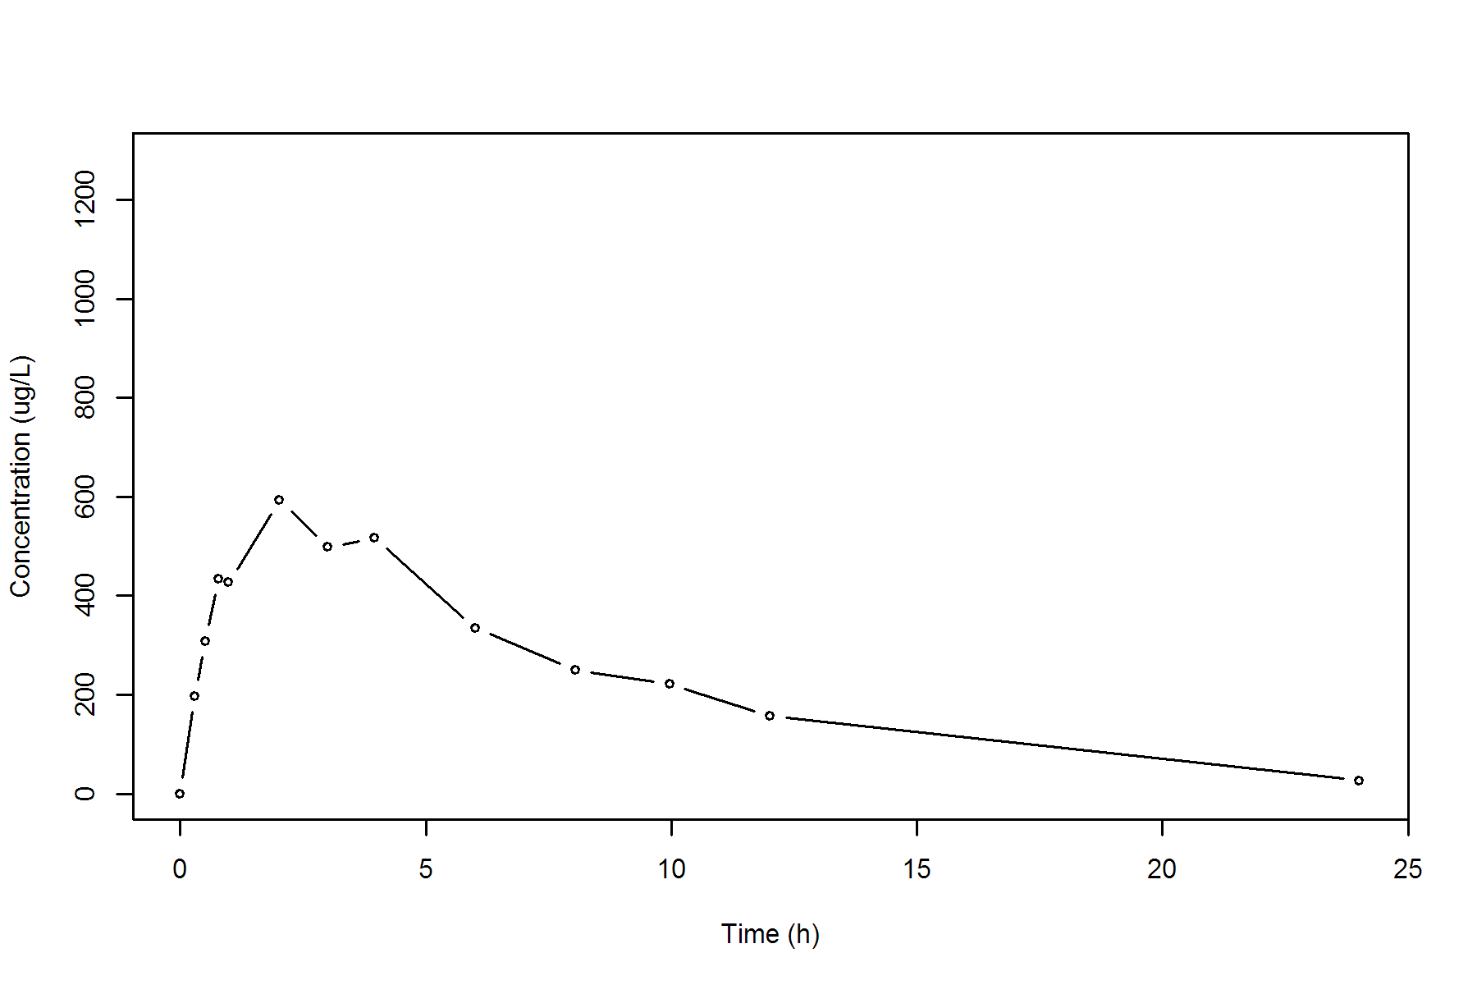

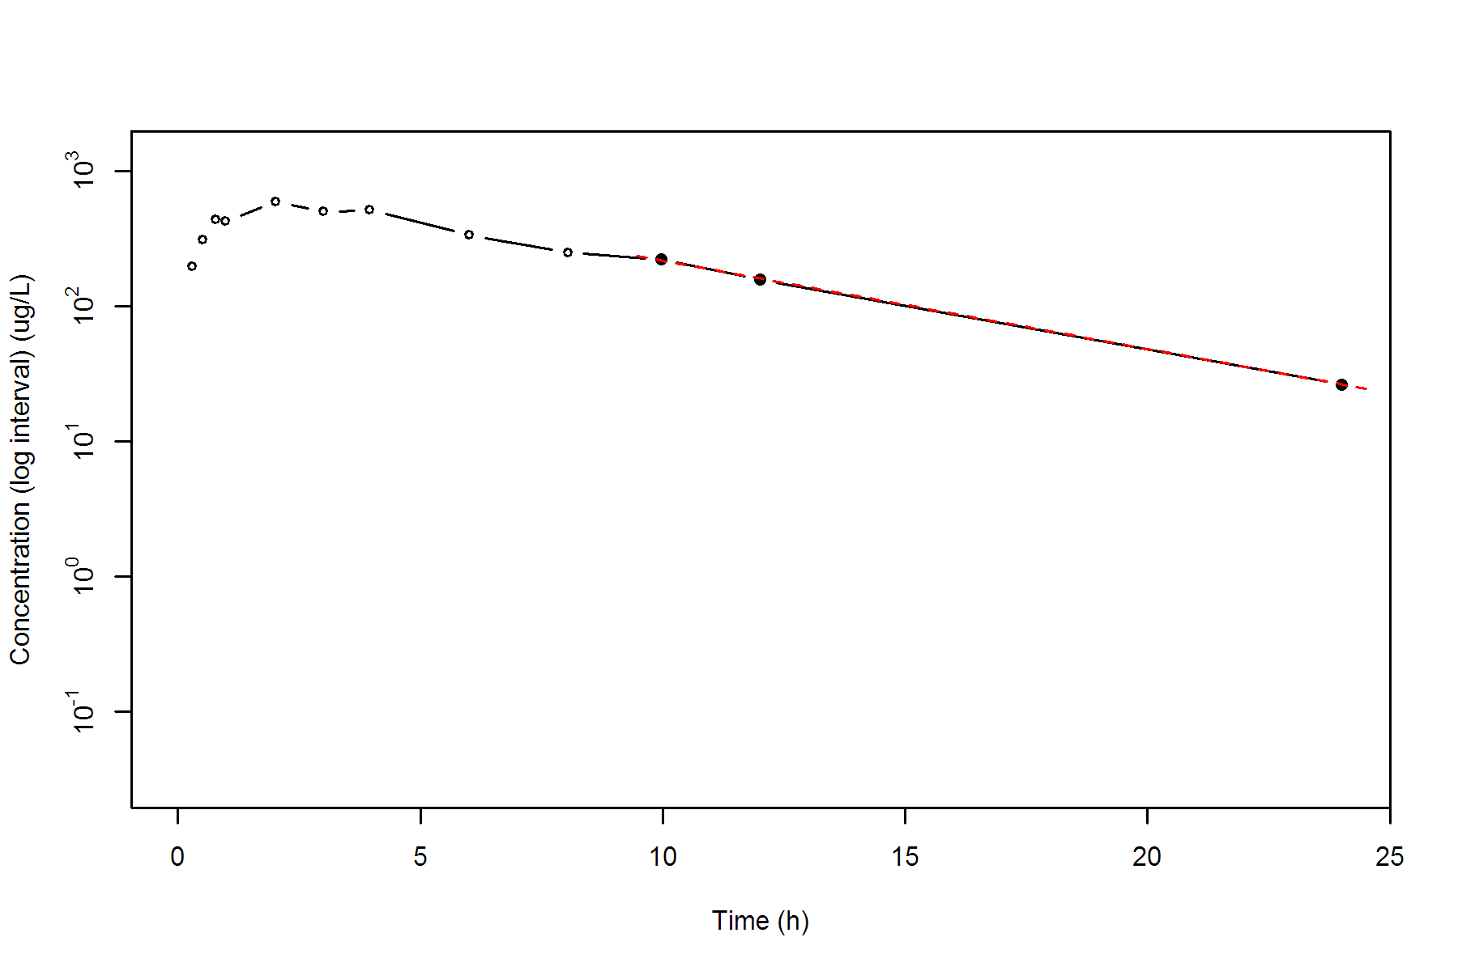

**SUBJ 13, GRP RT, PRD 1, TRT R**

NONCOMPARTMENTAL ANALYSIS REPORT

Package version 0.3.9 (2018-05-10 KST)

R version 3.5.0 (2018-04-23)

Date and Time: 2018-06-19 09:49:35 Asia/Seoul

Calculation Setting

-------------------

Drug Administration: Extravascular

Observation count excluding trailing zero: 13

Dose at time 0: 0 mg

AUC Calculation Method: Linear-up Linear-down

Weighting for lambda z: Uniform (Ordinary Least Square, OLS)

Lambda z selection criterion: Heighest adjusted R-squared value with precision=1e-4

Fitting, AUC, AUMC Result

-------------------------

Time Conc. Pred. Residual AUC AUMC

---------------------------------------------------------------------

0.0000 0.0000 0.0000 0.0000

0.2400 319.6400 38.3568 9.2056

0.5500 529.8400 170.0262 66.2651

0.7200 599.4900 266.0193 127.7239

1.0000 615.1700 436.0717 274.2763

1.9800 516.3800 990.5312 1076.7015

2.9600 505.0700 1491.0416 2310.2469

3.9900 364.4000 1938.8187 3828.9629

5.9900 290.3100 2593.5287 7021.8758

7.9900 * 237.0800 240.8662 -3.786e+00 3120.9187 10655.1019

9.9500 * 180.4900 181.2352 -7.452e-01 3530.1373 14271.4437

11.9600 * 138.9300 135.3811 +3.549e+00 3851.1544 17746.2094

24.0000 * 23.4500 23.5891 -1.391e-01 4828.6820 31137.1143

*: Used for the calculation of Lambda z.

Calculated Values

-----------------

CMAX Max Conc 615.1700 ug/L

TMAX Time of CMAX 1.0000 h

TLAG Time Until First Nonzero Conc 0.0000 h

CLST Last Nonzero Conc 23.4500 ug/L

CLSTP Last Nonzero Conc Pred 23.5891 ug/L

TLST Time of Last Nonzero Conc 24.0000 h

LAMZHL Half-Life Lambda z 4.7762 h

LAMZ Lambda z 0.1451 /h

LAMZLL Lambda z Lower Limit 7.9900 h

LAMZUL Lambda z Upper Limit 24.0000 h

LAMZNPT Number of Points for Lambda z 4

CORRXY Correlation Between TimeX and Log ConcY -0.9999

R2 R Squared 0.9997

R2ADJ R Squared Adjusted 0.9996

AUCLST AUC to Last Nonzero Conc 4828.6820 h*ug/L

AUCALL AUC All 4828.6820 h*ug/L

AUCIFO AUC Infinity Obs 4990.2663 h*ug/L

AUCIFP AUC Infinity Pred 4991.2245 h*ug/L

AUCPEO AUC %Extrapolation Obs 3.2380 %

AUCPEP AUC %Extrapolation Pred 3.2566 %

AUMCLST AUMC to Last Nonzero Conc 31137.1143 h2*ug/L

AUMCIFO AUMC Infinity Obs 36128.5484 h2*ug/L

AUMCIFP AUMC Infinity Pred 36158.1462 h2*ug/L

AUMCPEO AUMC %Extrapolation Obs 13.8158 %

AUMCPEP AUMC % Extrapolation Pred 13.8863 %

VZFO Vz Obs by F 0.0000 L

VZFP Vz Pred by F 0.0000 L

CLFO Total CL Obs by F 0.0000 L/h

CLFP Total CL Pred by F 0.0000 L/h

MRTEVLST MRT Extravasc to Last Nonzero Conc 6.4484 h

MRTEVIFO MRT Extravasc Infinity Obs 7.2398 h

MRTEVIFP MRT Extravasc Infinity Pred 7.2443 h

**SUBJ 13, GRP RT, PRD 1, TRT R**

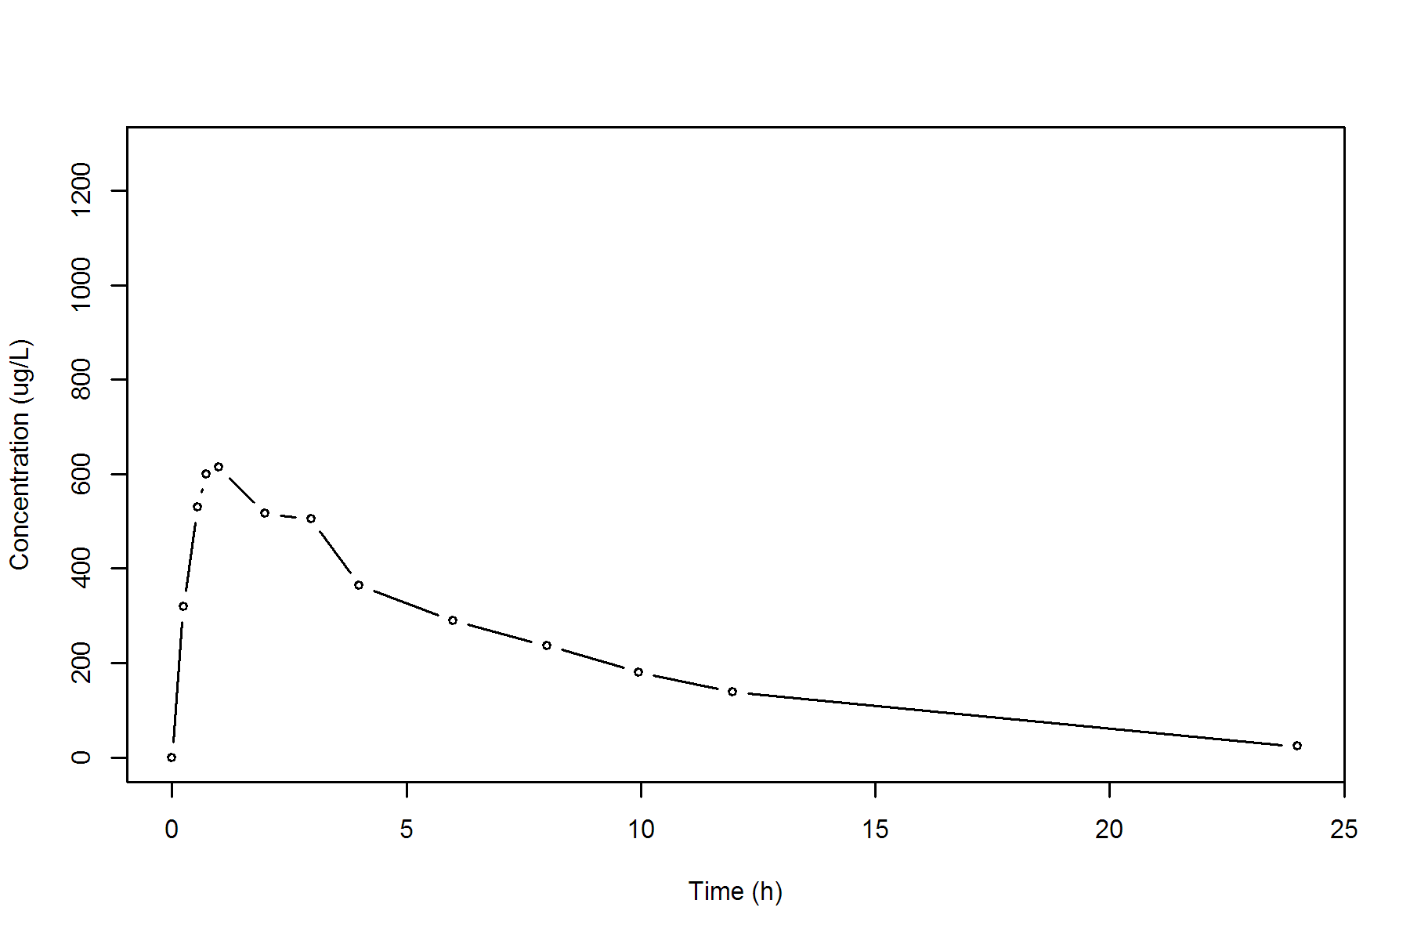

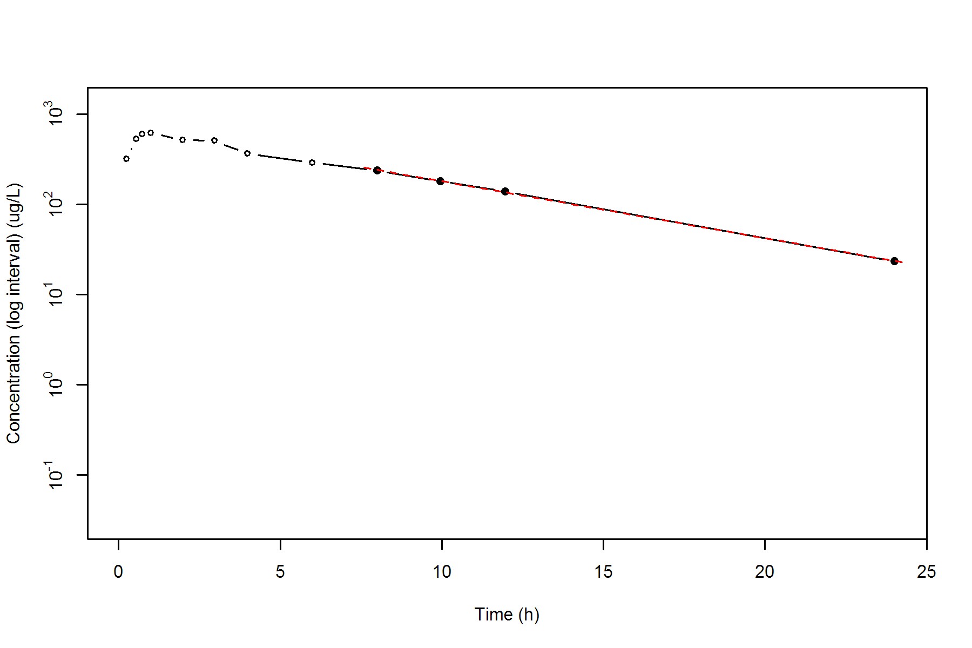

**SUBJ 13, GRP RT, PRD 2, TRT T**

NONCOMPARTMENTAL ANALYSIS REPORT

Package version 0.3.9 (2018-05-10 KST)

R version 3.5.0 (2018-04-23)

Date and Time: 2018-06-19 09:49:35 Asia/Seoul

Calculation Setting

-------------------

Drug Administration: Extravascular

Observation count excluding trailing zero: 13

Dose at time 0: 0 mg

AUC Calculation Method: Linear-up Linear-down

Weighting for lambda z: Uniform (Ordinary Least Square, OLS)

Lambda z selection criterion: Heighest adjusted R-squared value with precision=1e-4

Fitting, AUC, AUMC Result

-------------------------

Time Conc. Pred. Residual AUC AUMC

---------------------------------------------------------------------

0.0000 0.0000 0.0000 0.0000

0.2900 331.9100 48.1270 13.9568

0.5200 431.7000 135.9421 50.8417

0.7000 457.3400 215.9557 99.8577

0.9700 692.2600 371.1517 233.7277

2.0400 460.3500 987.7981 1095.4020

2.9800 395.2400 1389.9254 2090.3588

4.0000 375.0500 1782.7733 3456.1465

5.9700 280.1400 2428.1354 6581.1928

7.9900 220.6800 2933.9636 10051.2185

9.9900 * 131.1600 132.1652 -1.005e+00 3285.8036 13124.7401

11.9900 * 96.5500 95.6939 +8.561e-01 3513.5136 15592.6630

23.9900 * 13.7700 13.7875 -1.753e-02 4175.4336 24520.5238

*: Used for the calculation of Lambda z.

Calculated Values

-----------------

CMAX Max Conc 692.2600 ug/L

TMAX Time of CMAX 0.9700 h

TLAG Time Until First Nonzero Conc 0.0000 h

CLST Last Nonzero Conc 13.7700 ug/L

CLSTP Last Nonzero Conc Pred 13.7875 ug/L

TLST Time of Last Nonzero Conc 23.9900 h

LAMZHL Half-Life Lambda z 4.2933 h

LAMZ Lambda z 0.1614 /h

LAMZLL Lambda z Lower Limit 9.9900 h

LAMZUL Lambda z Upper Limit 23.9900 h

LAMZNPT Number of Points for Lambda z 3

CORRXY Correlation Between TimeX and Log ConcY -1.0000

R2 R Squared 1.0000

R2ADJ R Squared Adjusted 0.9999

AUCLST AUC to Last Nonzero Conc 4175.4336 h*ug/L

AUCALL AUC All 4175.4336 h*ug/L

AUCIFO AUC Infinity Obs 4260.7236 h*ug/L

AUCIFP AUC Infinity Pred 4260.8322 h*ug/L

AUCPEO AUC %Extrapolation Obs 2.0018 %

AUCPEP AUC %Extrapolation Pred 2.0043 %

AUMCLST AUMC to Last Nonzero Conc 24520.5238 h2*ug/L

AUMCIFO AUMC Infinity Obs 27094.9096 h2*ug/L

AUMCIFP AUMC Infinity Pred 27098.1874 h2*ug/L

AUMCPEO AUMC %Extrapolation Obs 9.5014 %

AUMCPEP AUMC % Extrapolation Pred 9.5123 %

VZFO Vz Obs by F 0.0000 L

VZFP Vz Pred by F 0.0000 L

CLFO Total CL Obs by F 0.0000 L/h

CLFP Total CL Pred by F 0.0000 L/h

MRTEVLST MRT Extravasc to Last Nonzero Conc 5.8726 h

MRTEVIFO MRT Extravasc Infinity Obs 6.3592 h

MRTEVIFP MRT Extravasc Infinity Pred 6.3598 h

**SUBJ 13, GRP RT, PRD 2, TRT T**

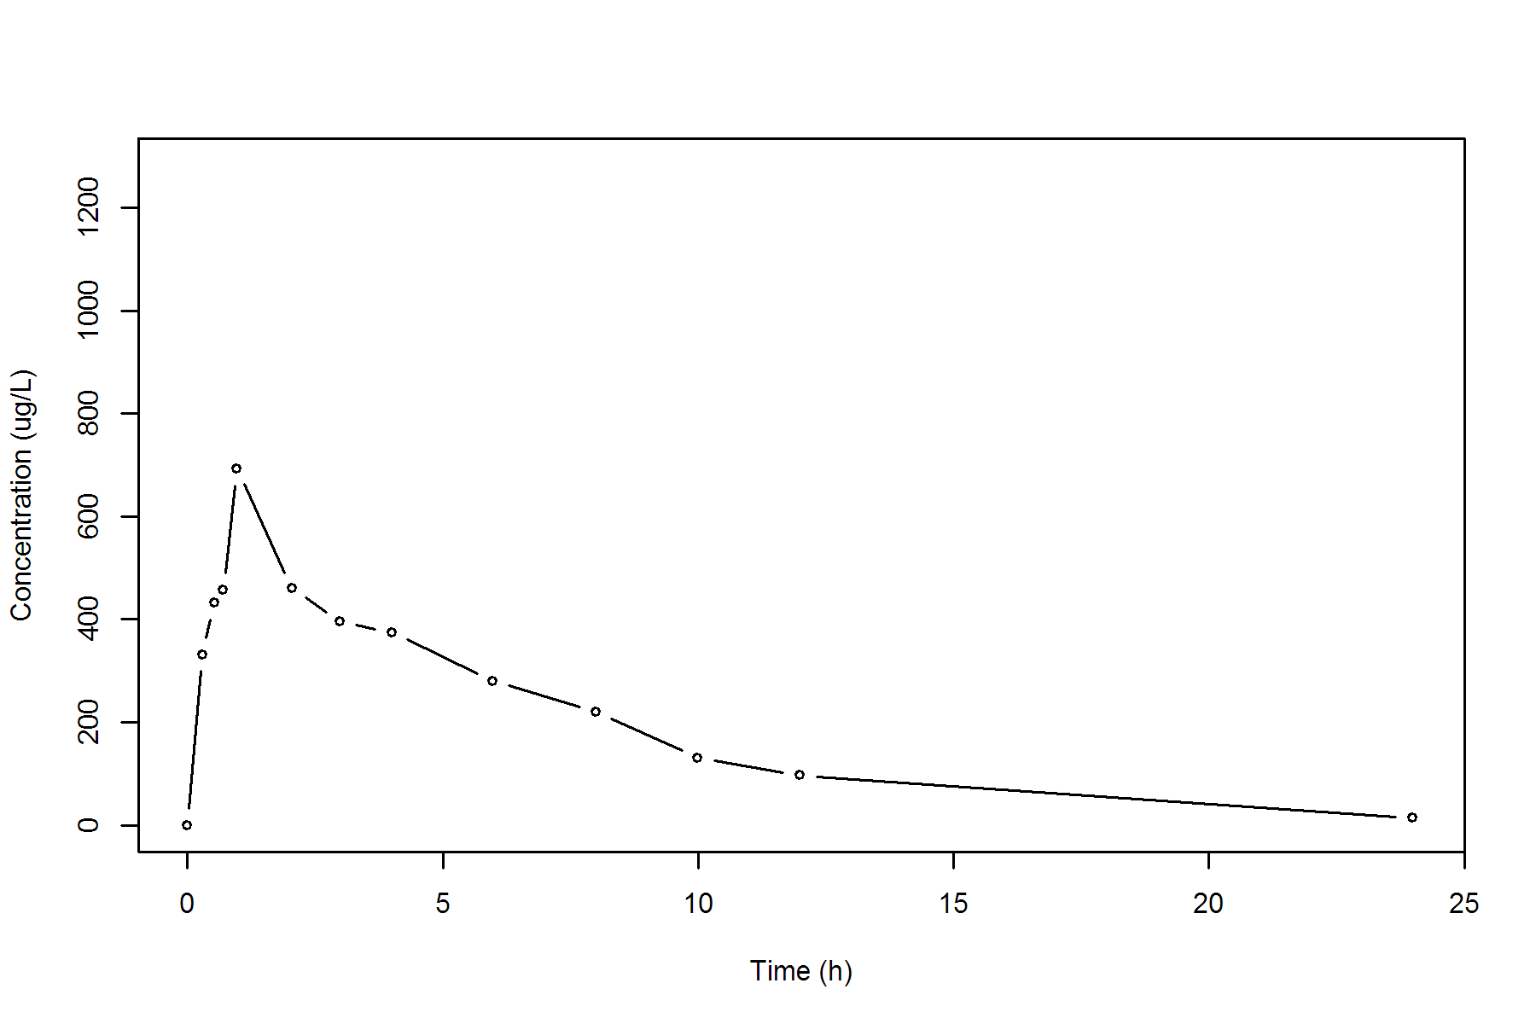

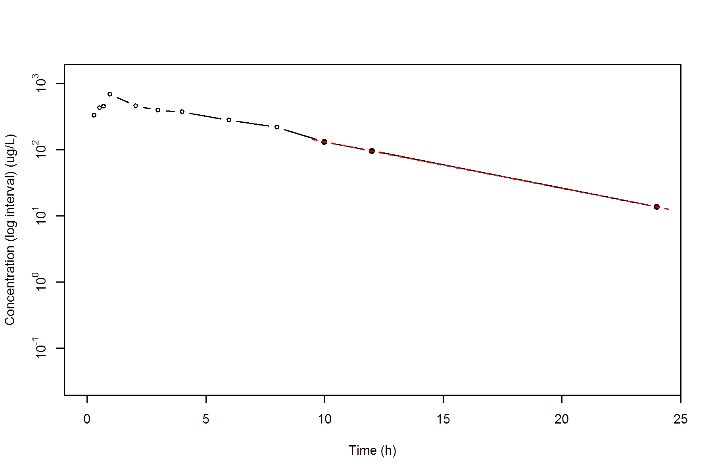

**SUBJ 14, GRP RT, PRD 1, TRT R**

NONCOMPARTMENTAL ANALYSIS REPORT

Package version 0.3.9 (2018-05-10 KST)

R version 3.5.0 (2018-04-23)

Date and Time: 2018-06-19 09:49:35 Asia/Seoul

Calculation Setting

-------------------

Drug Administration: Extravascular

Observation count excluding trailing zero: 13

Dose at time 0: 0 mg

AUC Calculation Method: Linear-up Linear-down

Weighting for lambda z: Uniform (Ordinary Least Square, OLS)

Lambda z selection criterion: Heighest adjusted R-squared value with precision=1e-4

Fitting, AUC, AUMC Result

-------------------------

Time Conc. Pred. Residual AUC AUMC

---------------------------------------------------------------------

0.0000 0.1800 0.0000 0.0000

0.2300 269.7500 31.0420 7.1349

0.4600 682.6800 140.5714 50.3835

0.7400 792.7200 347.1274 176.4739

1.0300 864.5600 587.4330 390.6548

2.0300 707.6700 1373.5480 1554.1883

3.0000 562.8200 1989.7357 3069.8279

3.9900 * 497.0400 525.7790 -2.874e+01 2514.3664 4887.2944

5.9800 * 312.7100 301.0650 +1.164e+01 3320.0676 8721.2238

8.0200 * 178.2400 169.9939 +8.246e+00 3820.8366 12086.7043

10.0000 * 104.8400 97.6129 +7.227e+00 4101.0858 14539.8102

12.0200 * 49.6600 55.4260 -5.766e+00 4257.1308 16201.5765

24.0000 * 1.9500 1.9319 +1.808e-02 4566.2747 20057.4186

*: Used for the calculation of Lambda z.

Calculated Values

-----------------

CMAX Max Conc 864.5600 ug/L

TMAX Time of CMAX 1.0300 h

TLAG Time Until First Nonzero Conc 0.0000 h

CLST Last Nonzero Conc 1.9500 ug/L

CLSTP Last Nonzero Conc Pred 1.9319 ug/L

TLST Time of Last Nonzero Conc 24.0000 h

LAMZHL Half-Life Lambda z 2.4740 h

LAMZ Lambda z 0.2802 /h

LAMZLL Lambda z Lower Limit 3.9900 h

LAMZUL Lambda z Upper Limit 24.0000 h

LAMZNPT Number of Points for Lambda z 6

CORRXY Correlation Between TimeX and Log ConcY -0.9994

R2 R Squared 0.9988

R2ADJ R Squared Adjusted 0.9985

AUCLST AUC to Last Nonzero Conc 4566.2747 h*ug/L

AUCALL AUC All 4566.2747 h*ug/L

AUCIFO AUC Infinity Obs 4573.2346 h*ug/L

AUCIFP AUC Infinity Pred 4573.1700 h*ug/L

AUCPEO AUC %Extrapolation Obs 0.1522 %

AUCPEP AUC %Extrapolation Pred 0.1508 %

AUMCLST AUMC to Last Nonzero Conc 20057.4186 h2*ug/L

AUMCIFO AUMC Infinity Obs 20249.2959 h2*ug/L

AUMCIFP AUMC Infinity Pred 20247.5167 h2*ug/L

AUMCPEO AUMC %Extrapolation Obs 0.9476 %

AUMCPEP AUMC % Extrapolation Pred 0.9389 %

VZFO Vz Obs by F 0.0000 L

VZFP Vz Pred by F 0.0000 L

CLFO Total CL Obs by F 0.0000 L/h

CLFP Total CL Pred by F 0.0000 L/h

MRTEVLST MRT Extravasc to Last Nonzero Conc 4.3925 h

MRTEVIFO MRT Extravasc Infinity Obs 4.4278 h

MRTEVIFP MRT Extravasc Infinity Pred 4.4275 h

**SUBJ 14, GRP RT, PRD 1, TRT R**

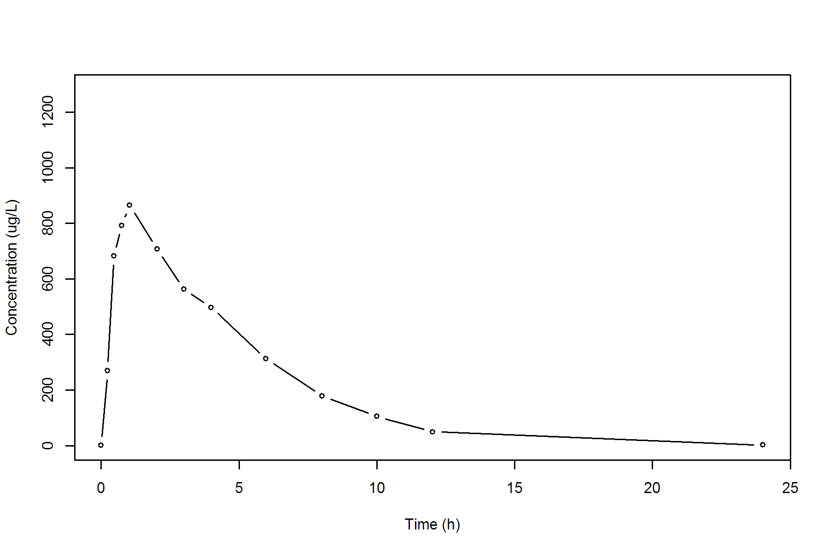

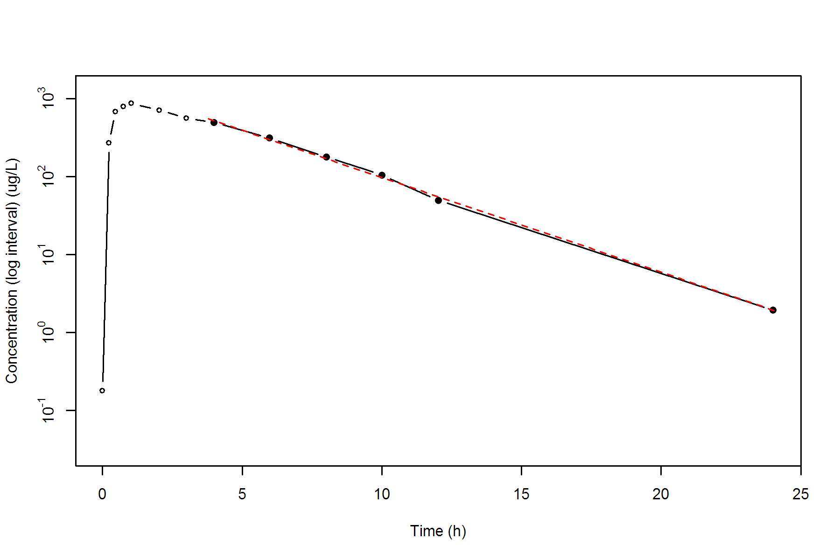

**SUBJ 14, GRP RT, PRD 2, TRT T**

NONCOMPARTMENTAL ANALYSIS REPORT

Package version 0.3.9 (2018-05-10 KST)

R version 3.5.0 (2018-04-23)

Date and Time: 2018-06-19 09:49:35 Asia/Seoul

Calculation Setting

-------------------

Drug Administration: Extravascular

Observation count excluding trailing zero: 13

Dose at time 0: 0 mg

AUC Calculation Method: Linear-up Linear-down

Weighting for lambda z: Uniform (Ordinary Least Square, OLS)

Lambda z selection criterion: Heighest adjusted R-squared value with precision=1e-4

Fitting, AUC, AUMC Result

-------------------------

Time Conc. Pred. Residual AUC AUMC

---------------------------------------------------------------------

0.0000 1.0200 0.0000 0.0000

0.2200 417.2000 46.0042 10.0962

0.5200 729.8900 218.0677 80.7953

0.7500 1122.7500 431.1213 221.2799

0.9800 934.3700 667.6901 423.4206

2.0200 741.9200 1539.3609 1678.8883

3.0400 730.4500 2290.2696 3575.7039

4.0100 476.3300 2875.5579 5579.0698

6.0100 290.8500 3642.7379 9237.1616

8.0300 190.7400 4129.1438 12549.6088

10.0400 * 110.6700 109.1065 +1.563e+00 4432.0609 15205.5917

12.0300 * 67.7900 68.9237 -1.134e+00 4609.6285 17122.5990

24.0400 * 4.3200 4.3098 +1.017e-02 5042.6491 22643.3948

*: Used for the calculation of Lambda z.

Calculated Values

-----------------

CMAX Max Conc 1122.7500 ug/L

TMAX Time of CMAX 0.7500 h

TLAG Time Until First Nonzero Conc 0.0000 h

CLST Last Nonzero Conc 4.3200 ug/L

CLSTP Last Nonzero Conc Pred 4.3098 ug/L

TLST Time of Last Nonzero Conc 24.0400 h

LAMZHL Half-Life Lambda z 3.0030 h

LAMZ Lambda z 0.2308 /h

LAMZLL Lambda z Lower Limit 10.0400 h

LAMZUL Lambda z Upper Limit 24.0400 h

LAMZNPT Number of Points for Lambda z 3

CORRXY Correlation Between TimeX and Log ConcY -1.0000

R2 R Squared 0.9999

R2ADJ R Squared Adjusted 0.9998

AUCLST AUC to Last Nonzero Conc 5042.6491 h*ug/L

AUCALL AUC All 5042.6491 h*ug/L

AUCIFO AUC Infinity Obs 5061.3653 h*ug/L

AUCIFP AUC Infinity Pred 5061.3212 h*ug/L

AUCPEO AUC %Extrapolation Obs 0.3698 %

AUCPEP AUC %Extrapolation Pred 0.3689 %

AUMCLST AUMC to Last Nonzero Conc 22643.3948 h2*ug/L

AUMCIFO AUMC Infinity Obs 23174.4190 h2*ug/L

AUMCIFP AUMC Infinity Pred 23173.1686 h2*ug/L

AUMCPEO AUMC %Extrapolation Obs 2.2914 %

AUMCPEP AUMC % Extrapolation Pred 2.2862 %

VZFO Vz Obs by F 0.0000 L

VZFP Vz Pred by F 0.0000 L

CLFO Total CL Obs by F 0.0000 L/h

CLFP Total CL Pred by F 0.0000 L/h

MRTEVLST MRT Extravasc to Last Nonzero Conc 4.4904 h

MRTEVIFO MRT Extravasc Infinity Obs 4.5787 h

MRTEVIFP MRT Extravasc Infinity Pred 4.5785 h

**SUBJ 14, GRP RT, PRD 2, TRT T**

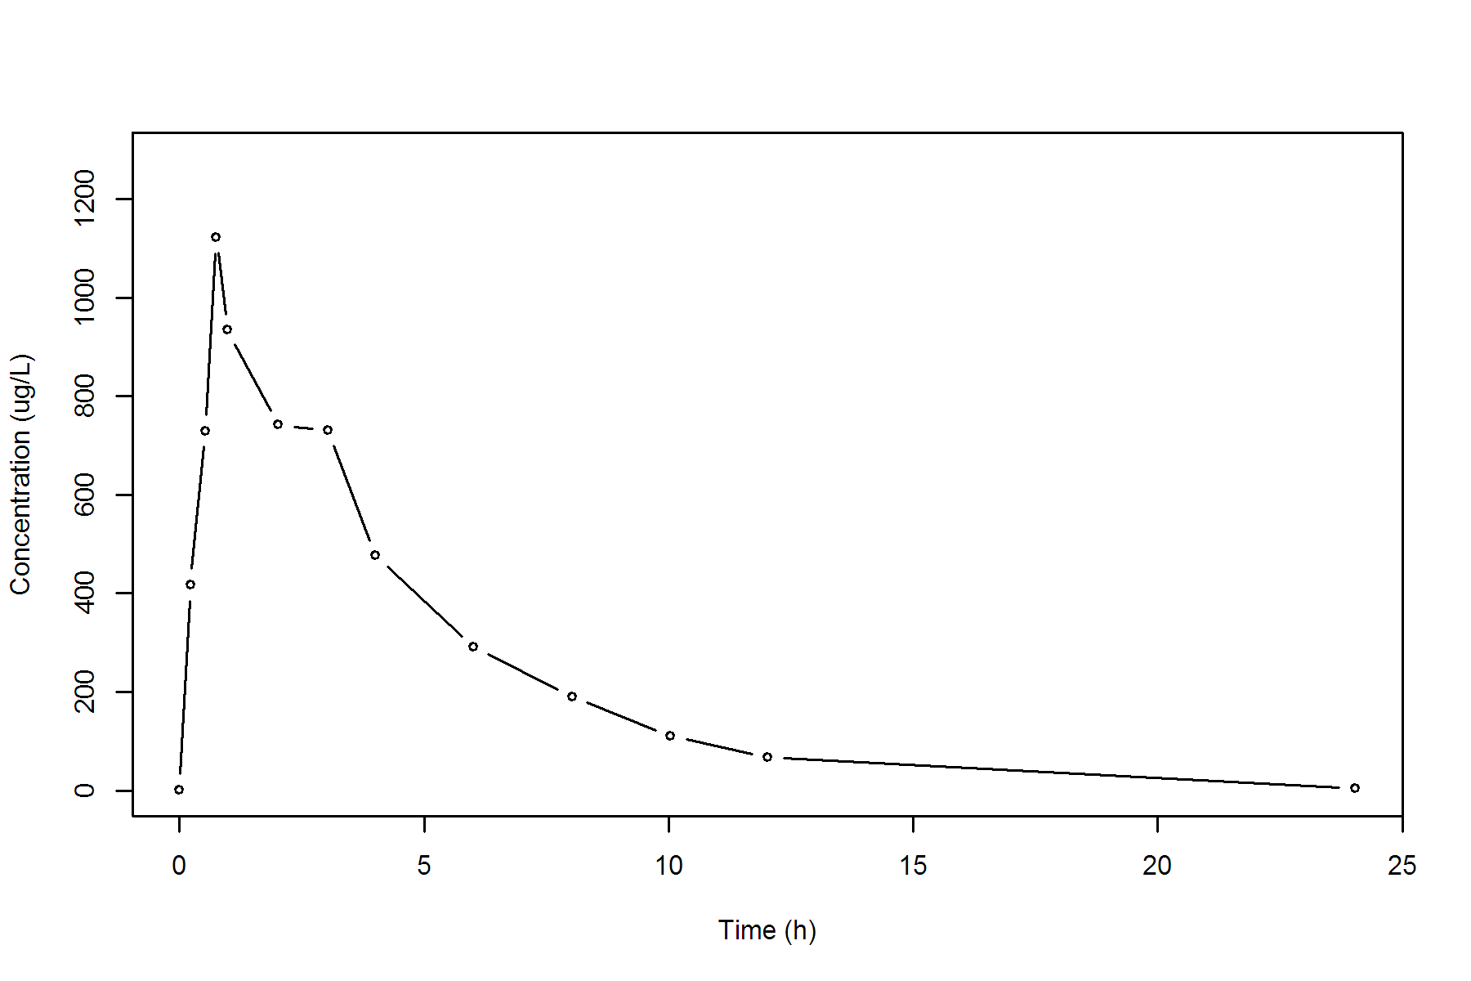

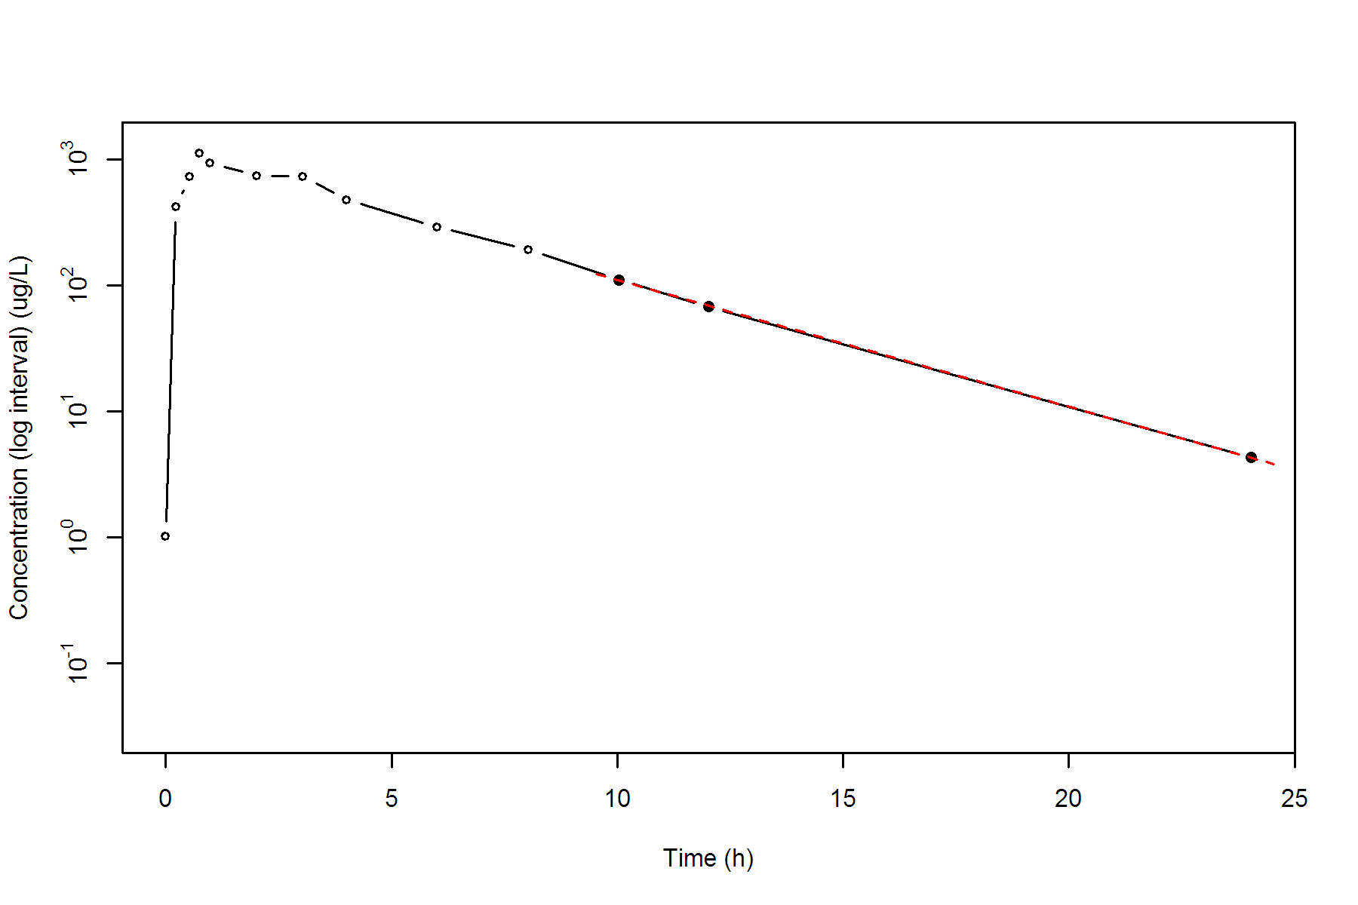

**SUBJ 15, GRP TR, PRD 1, TRT T**

NONCOMPARTMENTAL ANALYSIS REPORT

Package version 0.3.9 (2018-05-10 KST)

R version 3.5.0 (2018-04-23)

Date and Time: 2018-06-19 09:49:35 Asia/Seoul

Calculation Setting

-------------------

Drug Administration: Extravascular

Observation count excluding trailing zero: 13

Dose at time 0: 0 mg

AUC Calculation Method: Linear-up Linear-down

Weighting for lambda z: Uniform (Ordinary Least Square, OLS)

Lambda z selection criterion: Heighest adjusted R-squared value with precision=1e-4

Fitting, AUC, AUMC Result

-------------------------

Time Conc. Pred. Residual AUC AUMC

---------------------------------------------------------------------

0.0000 0.0000 0.0000 0.0000

0.2400 351.2900 42.1548 10.1172

0.5400 715.5500 202.1808 80.7231

0.7800 711.5300 373.4304 193.6900

0.9700 719.4000 509.3688 312.7071

1.9700 634.9800 1186.5588 1287.0714

2.9700 532.8300 1770.4638 2703.7792

4.0200 505.1600 2315.4085 4600.7346

5.9600 321.6800 3117.4433 8430.2519

8.0100 253.6700 3707.1771 12478.0891

9.9900 * 126.6100 130.9085 -4.299e+00 4083.6543 15741.8524

11.9500 * 96.4700 92.7974 +3.673e+00 4302.2727 18111.1498

24.0100 * 11.1100 11.1704 -6.045e-02 4950.9801 26671.1425

*: Used for the calculation of Lambda z.

Calculated Values

-----------------

CMAX Max Conc 719.4000 ug/L

TMAX Time of CMAX 0.9700 h

TLAG Time Until First Nonzero Conc 0.0000 h

CLST Last Nonzero Conc 11.1100 ug/L

CLSTP Last Nonzero Conc Pred 11.1704 ug/L

TLST Time of Last Nonzero Conc 24.0100 h

LAMZHL Half-Life Lambda z 3.9484 h

LAMZ Lambda z 0.1756 /h

LAMZLL Lambda z Lower Limit 9.9900 h

LAMZUL Lambda z Upper Limit 24.0100 h

LAMZNPT Number of Points for Lambda z 3

CORRXY Correlation Between TimeX and Log ConcY -0.9996

R2 R Squared 0.9993

R2ADJ R Squared Adjusted 0.9985

AUCLST AUC to Last Nonzero Conc 4950.9801 h*ug/L

AUCALL AUC All 4950.9801 h*ug/L

AUCIFO AUC Infinity Obs 5014.2664 h*ug/L

AUCIFP AUC Infinity Pred 5014.6108 h*ug/L

AUCPEO AUC %Extrapolation Obs 1.2621 %

AUCPEP AUC %Extrapolation Pred 1.2689 %

AUMCLST AUMC to Last Nonzero Conc 26671.1425 h2*ug/L

AUMCIFO AUMC Infinity Obs 28551.1501 h2*ug/L

AUMCIFP AUMC Infinity Pred 28561.3790 h2*ug/L

AUMCPEO AUMC %Extrapolation Obs 6.5847 %

AUMCPEP AUMC % Extrapolation Pred 6.6182 %

VZFO Vz Obs by F 0.0000 L

VZFP Vz Pred by F 0.0000 L

CLFO Total CL Obs by F 0.0000 L/h

CLFP Total CL Pred by F 0.0000 L/h

MRTEVLST MRT Extravasc to Last Nonzero Conc 5.3870 h

MRTEVIFO MRT Extravasc Infinity Obs 5.6940 h

MRTEVIFP MRT Extravasc Infinity Pred 5.6956 h

**SUBJ 15, GRP TR, PRD 1, TRT T**

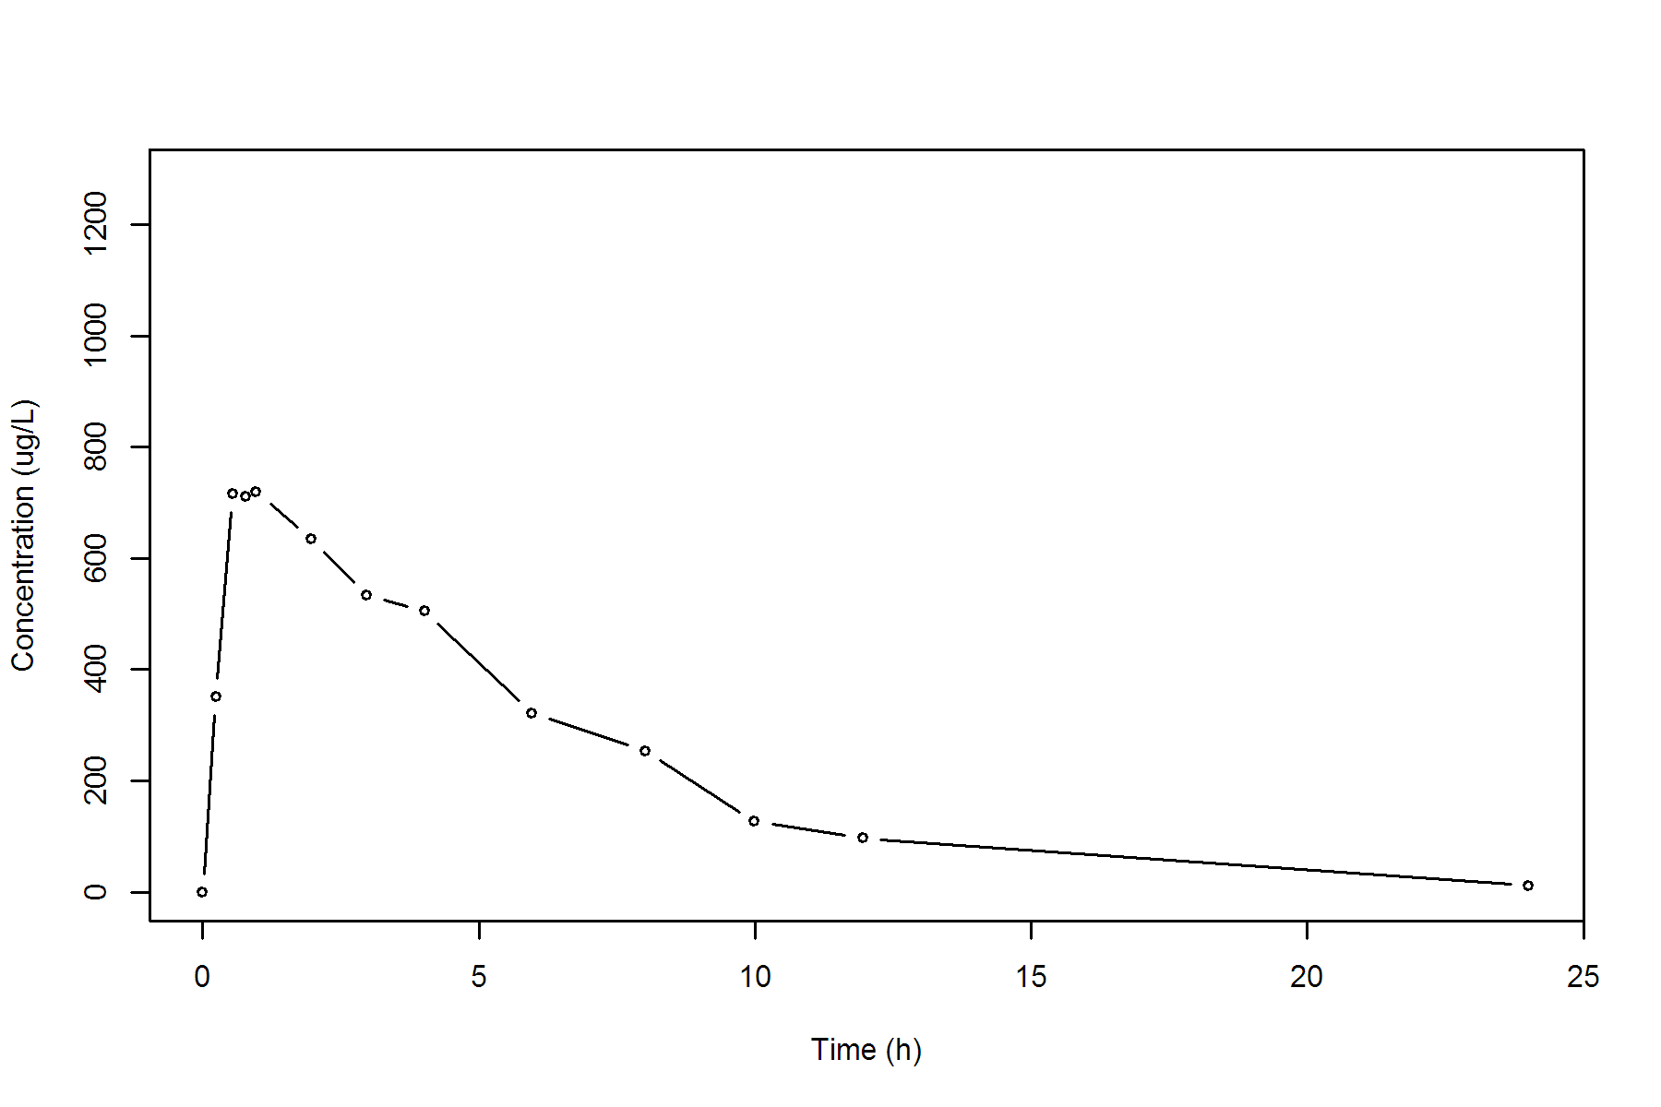

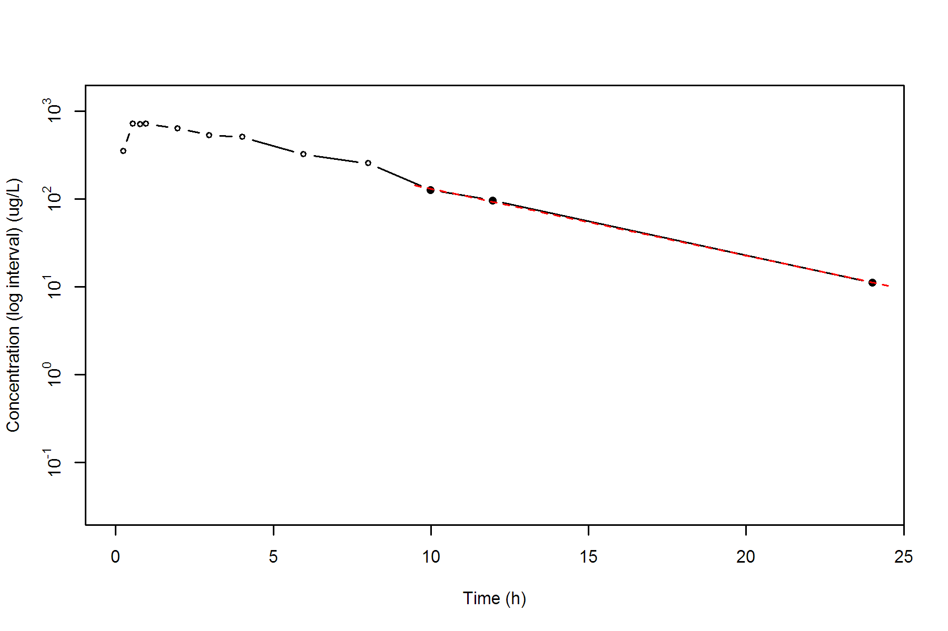

**SUBJ 15, GRP TR, PRD 2, TRT R**

NONCOMPARTMENTAL ANALYSIS REPORT

Package version 0.3.9 (2018-05-10 KST)

R version 3.5.0 (2018-04-23)

Date and Time: 2018-06-19 09:49:35 Asia/Seoul

Calculation Setting

-------------------

Drug Administration: Extravascular

Observation count excluding trailing zero: 13

Dose at time 0: 0 mg

AUC Calculation Method: Linear-up Linear-down

Weighting for lambda z: Uniform (Ordinary Least Square, OLS)

Lambda z selection criterion: Heighest adjusted R-squared value with precision=1e-4

Fitting, AUC, AUMC Result

-------------------------

Time Conc. Pred. Residual AUC AUMC

---------------------------------------------------------------------

0.0000 0.4300 0.0000 0.0000

0.2100 220.0400 23.1493 4.8519

0.4700 359.5900 98.5013 32.8299

0.7600 564.1300 232.4407 119.5031

0.9600 660.1700 354.8706 225.7533

2.0300 633.1800 1046.8129 1252.4818

3.0300 557.3900 1642.0979 2739.6053

3.9600 * 542.8000 540.1650 +2.635e+00 2153.6862 4524.4519

5.9700 * 389.1200 359.0686 +3.005e+01 3090.2658 9019.3489

7.9700 * 244.1500 239.1722 +4.978e+00 3723.5359 13288.2708

9.9600 * 167.2800 159.6344 +7.646e+00 4132.9087 16882.1952

12.0100 * 85.1900 105.2563 -2.007e+01 4391.6905 19638.6669

23.9600 * 9.8500 9.2867 +5.633e-01 4959.5545 27162.0159

*: Used for the calculation of Lambda z.

Calculated Values

-----------------

CMAX Max Conc 660.1700 ug/L

TMAX Time of CMAX 0.9600 h

TLAG Time Until First Nonzero Conc 0.0000 h

CLST Last Nonzero Conc 9.8500 ug/L

CLSTP Last Nonzero Conc Pred 9.2867 ug/L

TLST Time of Last Nonzero Conc 23.9600 h

LAMZHL Half-Life Lambda z 3.4117 h

LAMZ Lambda z 0.2032 /h

LAMZLL Lambda z Lower Limit 3.9600 h

LAMZUL Lambda z Upper Limit 23.9600 h

LAMZNPT Number of Points for Lambda z 6

CORRXY Correlation Between TimeX and Log ConcY -0.9973

R2 R Squared 0.9945

R2ADJ R Squared Adjusted 0.9932

AUCLST AUC to Last Nonzero Conc 4959.5545 h*ug/L

AUCALL AUC All 4959.5545 h*ug/L

AUCIFO AUC Infinity Obs 5008.0373 h*ug/L

AUCIFP AUC Infinity Pred 5005.2645 h*ug/L

AUCPEO AUC %Extrapolation Obs 0.9681 %

AUCPEP AUC %Extrapolation Pred 0.9132 %

AUMCLST AUMC to Last Nonzero Conc 27162.0159 h2*ug/L

AUMCIFO AUMC Infinity Obs 28562.3022 h2*ug/L

AUMCIFP AUMC Infinity Pred 28482.2179 h2*ug/L

AUMCPEO AUMC %Extrapolation Obs 4.9026 %

AUMCPEP AUMC % Extrapolation Pred 4.6352 %

VZFO Vz Obs by F 0.0000 L

VZFP Vz Pred by F 0.0000 L

CLFO Total CL Obs by F 0.0000 L/h

CLFP Total CL Pred by F 0.0000 L/h

MRTEVLST MRT Extravasc to Last Nonzero Conc 5.4767 h

MRTEVIFO MRT Extravasc Infinity Obs 5.7033 h

MRTEVIFP MRT Extravasc Infinity Pred 5.6905 h

**SUBJ 15, GRP TR, PRD 2, TRT R**

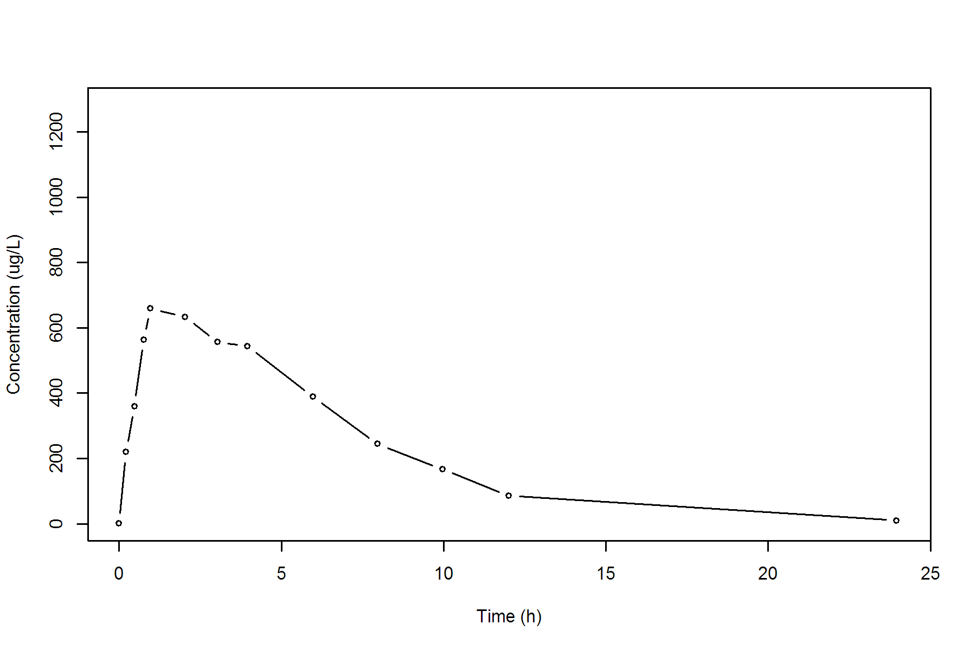

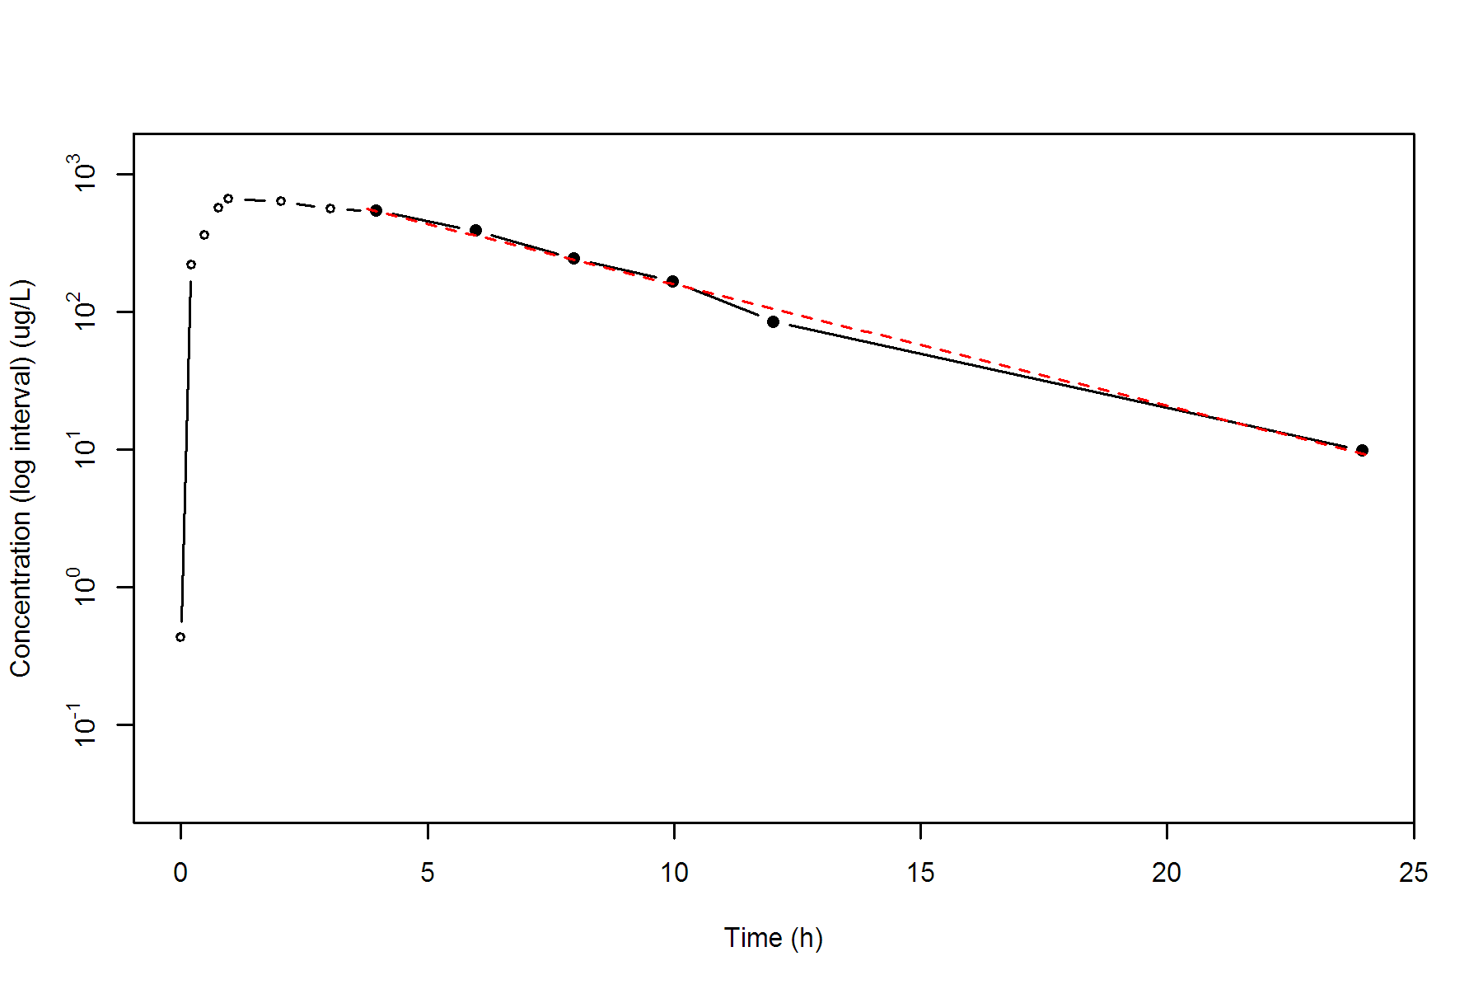

**SUBJ 16, GRP RT, PRD 1, TRT R**

NONCOMPARTMENTAL ANALYSIS REPORT

Package version 0.3.9 (2018-05-10 KST)

R version 3.5.0 (2018-04-23)

Date and Time: 2018-06-19 09:49:35 Asia/Seoul

Calculation Setting

-------------------

Drug Administration: Extravascular

Observation count excluding trailing zero: 13

Dose at time 0: 0 mg

AUC Calculation Method: Linear-up Linear-down

Weighting for lambda z: Uniform (Ordinary Least Square, OLS)

Lambda z selection criterion: Heighest adjusted R-squared value with precision=1e-4

Fitting, AUC, AUMC Result

-------------------------

Time Conc. Pred. Residual AUC AUMC

---------------------------------------------------------------------

0.0000 0.1300 0.0000 0.0000

0.2700 163.4900 22.0887 5.9592

0.5100 322.2100 80.3727 30.9755

0.7900 410.3500 182.9311 99.3660

0.9600 390.5500 251.0076 158.7899

1.9700 589.7800 746.0743 934.8712

3.0100 609.6400 1369.7726 2493.2504

4.0200 530.5500 1945.5686 4497.0032

6.0000 334.4700 2801.9384 8595.2379

8.0400 252.4300 3400.5764 12712.3222

10.0400 * 144.0600 135.9291 +8.131e+00 3797.0664 16188.2218

11.9700 * 85.2100 91.1513 -5.941e+00 4018.3120 18568.2265

24.0200 * 7.5900 7.5197 +7.030e-02 4577.4320 25811.9364

*: Used for the calculation of Lambda z.

Calculated Values

-----------------

CMAX Max Conc 609.6400 ug/L

TMAX Time of CMAX 3.0100 h

TLAG Time Until First Nonzero Conc 0.0000 h

CLST Last Nonzero Conc 7.5900 ug/L

CLSTP Last Nonzero Conc Pred 7.5197 ug/L

TLST Time of Last Nonzero Conc 24.0200 h

LAMZHL Half-Life Lambda z 3.3477 h

LAMZ Lambda z 0.2071 /h

LAMZLL Lambda z Lower Limit 10.0400 h

LAMZUL Lambda z Upper Limit 24.0200 h

LAMZNPT Number of Points for Lambda z 3

CORRXY Correlation Between TimeX and Log ConcY -0.9992

R2 R Squared 0.9984

R2ADJ R Squared Adjusted 0.9968

AUCLST AUC to Last Nonzero Conc 4577.4320 h*ug/L

AUCALL AUC All 4577.4320 h*ug/L

AUCIFO AUC Infinity Obs 4614.0892 h*ug/L

AUCIFP AUC Infinity Pred 4613.7496 h*ug/L

AUCPEO AUC %Extrapolation Obs 0.7945 %

AUCPEP AUC %Extrapolation Pred 0.7872 %

AUMCLST AUMC to Last Nonzero Conc 25811.9364 h2*ug/L

AUMCIFO AUMC Infinity Obs 26869.4847 h2*ug/L

AUMCIFP AUMC Infinity Pred 26859.6898 h2*ug/L

AUMCPEO AUMC %Extrapolation Obs 3.9359 %

AUMCPEP AUMC % Extrapolation Pred 3.9008 %

VZFO Vz Obs by F 0.0000 L

VZFP Vz Pred by F 0.0000 L

CLFO Total CL Obs by F 0.0000 L/h

CLFP Total CL Pred by F 0.0000 L/h

MRTEVLST MRT Extravasc to Last Nonzero Conc 5.6390 h

MRTEVIFO MRT Extravasc Infinity Obs 5.8234 h

MRTEVIFP MRT Extravasc Infinity Pred 5.8217 h

**SUBJ 16, GRP RT, PRD 1, TRT R**

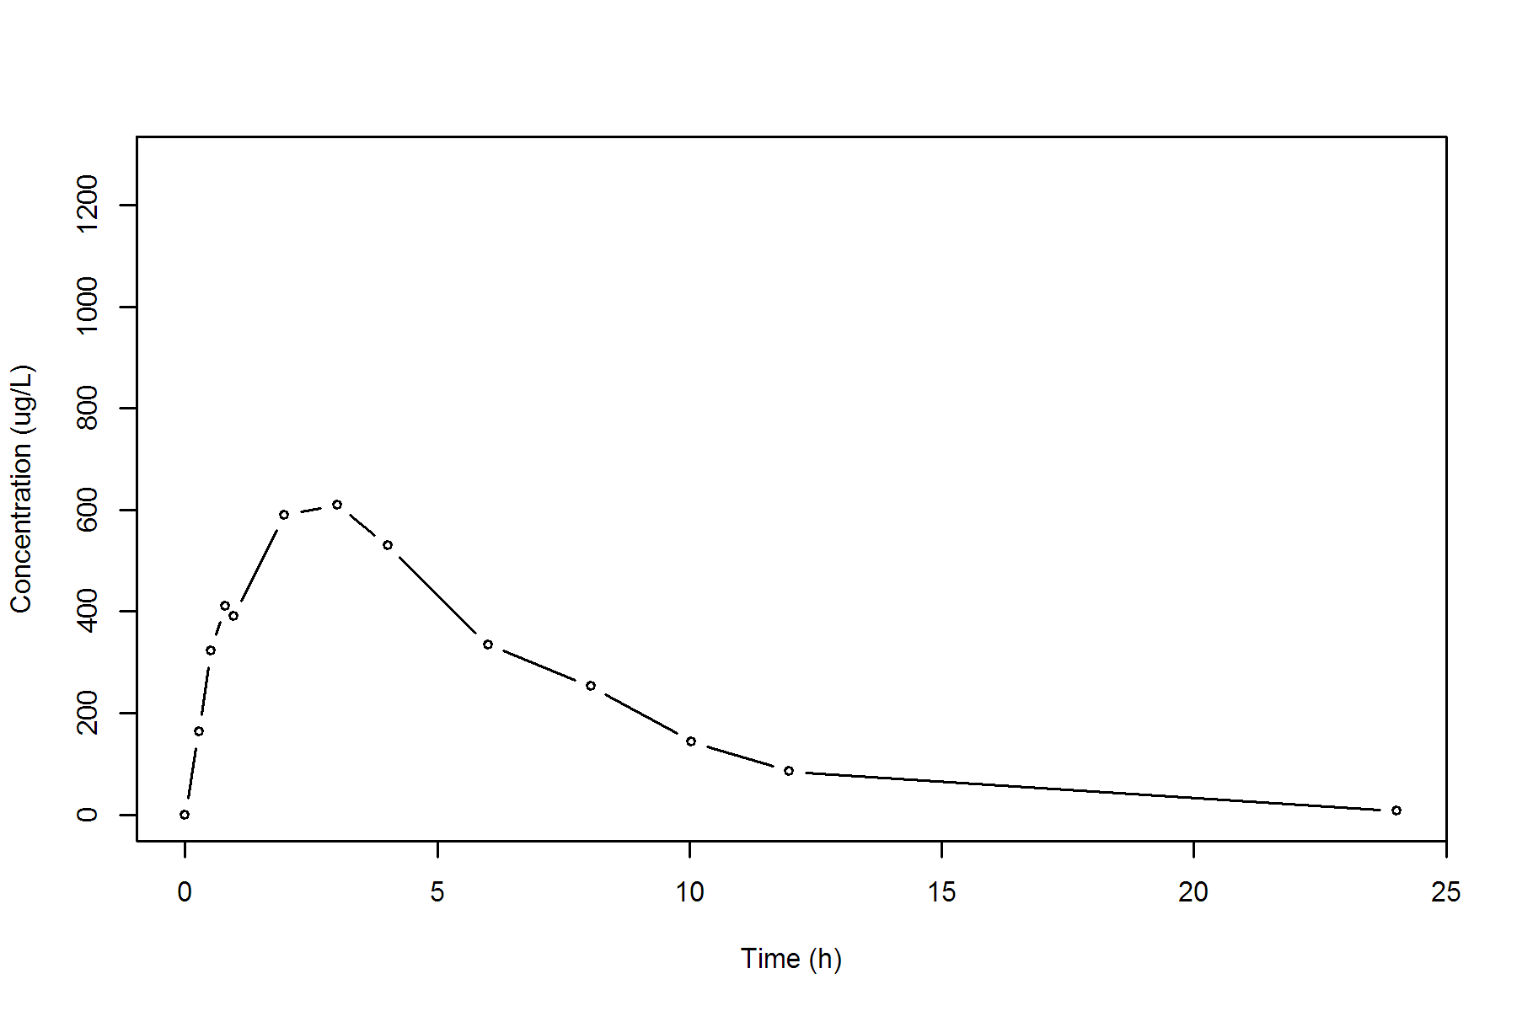

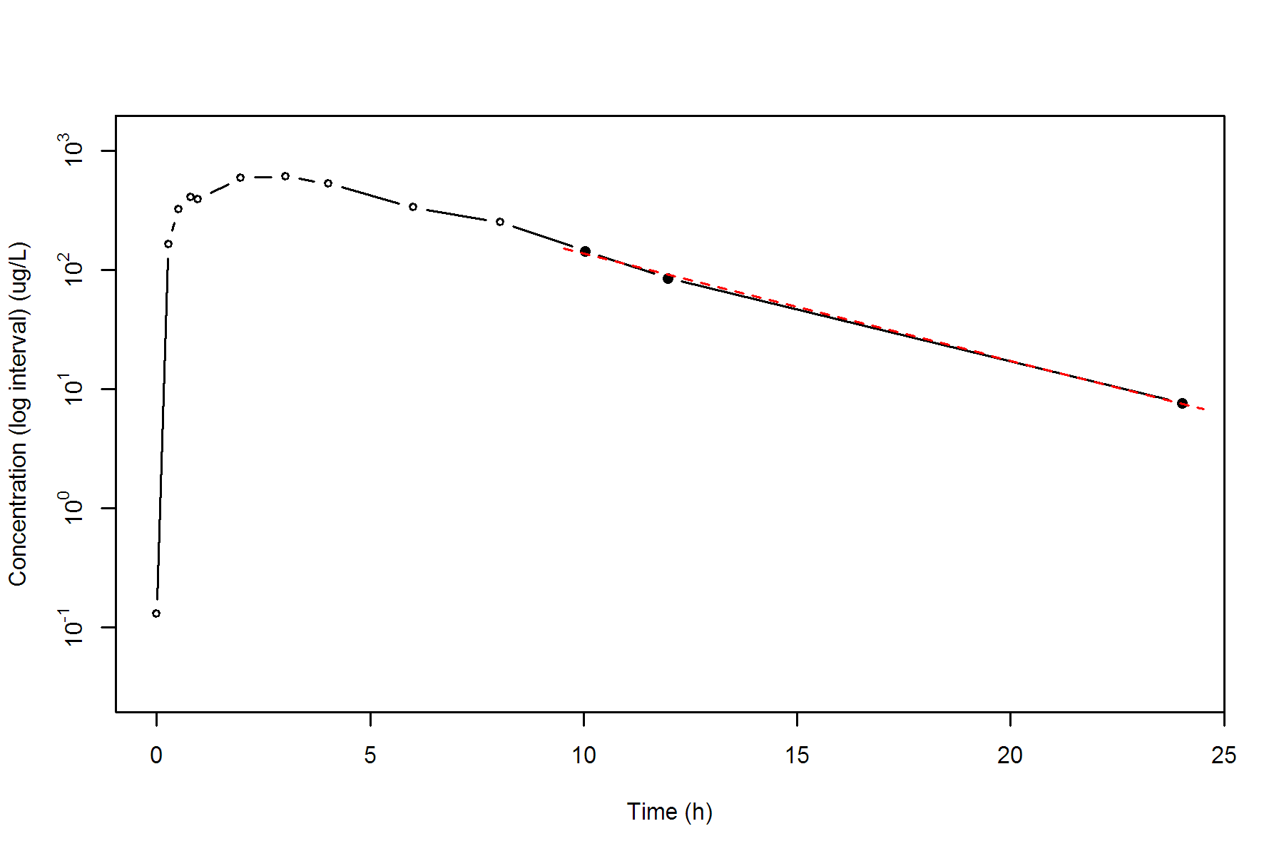

**SUBJ 16, GRP RT, PRD 2, TRT T**

NONCOMPARTMENTAL ANALYSIS REPORT

Package version 0.3.9 (2018-05-10 KST)

R version 3.5.0 (2018-04-23)

Date and Time: 2018-06-19 09:49:35 Asia/Seoul

Calculation Setting

-------------------

Drug Administration: Extravascular

Observation count excluding trailing zero: 13

Dose at time 0: 0 mg

AUC Calculation Method: Linear-up Linear-down

Weighting for lambda z: Uniform (Ordinary Least Square, OLS)

Lambda z selection criterion: Heighest adjusted R-squared value with precision=1e-4

Fitting, AUC, AUMC Result

-------------------------

Time Conc. Pred. Residual AUC AUMC

---------------------------------------------------------------------

0.0000 0.2400 0.0000 0.0000

0.2100 429.5600 45.1290 9.4718

0.4800 600.2800 184.1574 60.5480

0.7400 597.0100 339.8051 155.4378

1.0100 807.6500 529.4342 325.2022

1.9800 633.0500 1228.1737 1328.7474

2.9900 539.9400 1820.5337 2777.0165

3.9600 419.5600 2285.8912 4365.8175

6.0300 283.6400 3013.7032 7855.6375

7.9800 166.3300 3452.4239 10817.3585

9.9800 * 161.1300 156.0053 +5.125e+00 3779.8839 13752.7493

11.9700 * 106.5900 110.6792 -4.089e+00 4046.2653 16622.2892

24.0500 * 13.8500 13.7765 +7.355e-02 4773.7229 26340.4970

*: Used for the calculation of Lambda z.

Calculated Values

-----------------

CMAX Max Conc 807.6500 ug/L

TMAX Time of CMAX 1.0100 h

TLAG Time Until First Nonzero Conc 0.0000 h

CLST Last Nonzero Conc 13.8500 ug/L

CLSTP Last Nonzero Conc Pred 13.7765 ug/L

TLST Time of Last Nonzero Conc 24.0500 h

LAMZHL Half-Life Lambda z 4.0185 h

LAMZ Lambda z 0.1725 /h

LAMZLL Lambda z Lower Limit 9.9800 h

LAMZUL Lambda z Upper Limit 24.0500 h

LAMZNPT Number of Points for Lambda z 3

CORRXY Correlation Between TimeX and Log ConcY -0.9996

R2 R Squared 0.9993

R2ADJ R Squared Adjusted 0.9986

AUCLST AUC to Last Nonzero Conc 4773.7229 h*ug/L

AUCALL AUC All 4773.7229 h*ug/L

AUCIFO AUC Infinity Obs 4854.0176 h*ug/L

AUCIFP AUC Infinity Pred 4853.5912 h*ug/L

AUCPEO AUC %Extrapolation Obs 1.6542 %

AUCPEP AUC %Extrapolation Pred 1.6456 %

AUMCLST AUMC to Last Nonzero Conc 26340.4970 h2*ug/L

AUMCIFO AUMC Infinity Obs 28737.0883 h2*ug/L

AUMCIFP AUMC Infinity Pred 28724.3616 h2*ug/L

AUMCPEO AUMC %Extrapolation Obs 8.3397 %

AUMCPEP AUMC % Extrapolation Pred 8.2991 %

VZFO Vz Obs by F 0.0000 L

VZFP Vz Pred by F 0.0000 L

CLFO Total CL Obs by F 0.0000 L/h

CLFP Total CL Pred by F 0.0000 L/h

MRTEVLST MRT Extravasc to Last Nonzero Conc 5.5178 h

MRTEVIFO MRT Extravasc Infinity Obs 5.9203 h

MRTEVIFP MRT Extravasc Infinity Pred 5.9182 h

**SUBJ 16, GRP RT, PRD 2, TRT T**

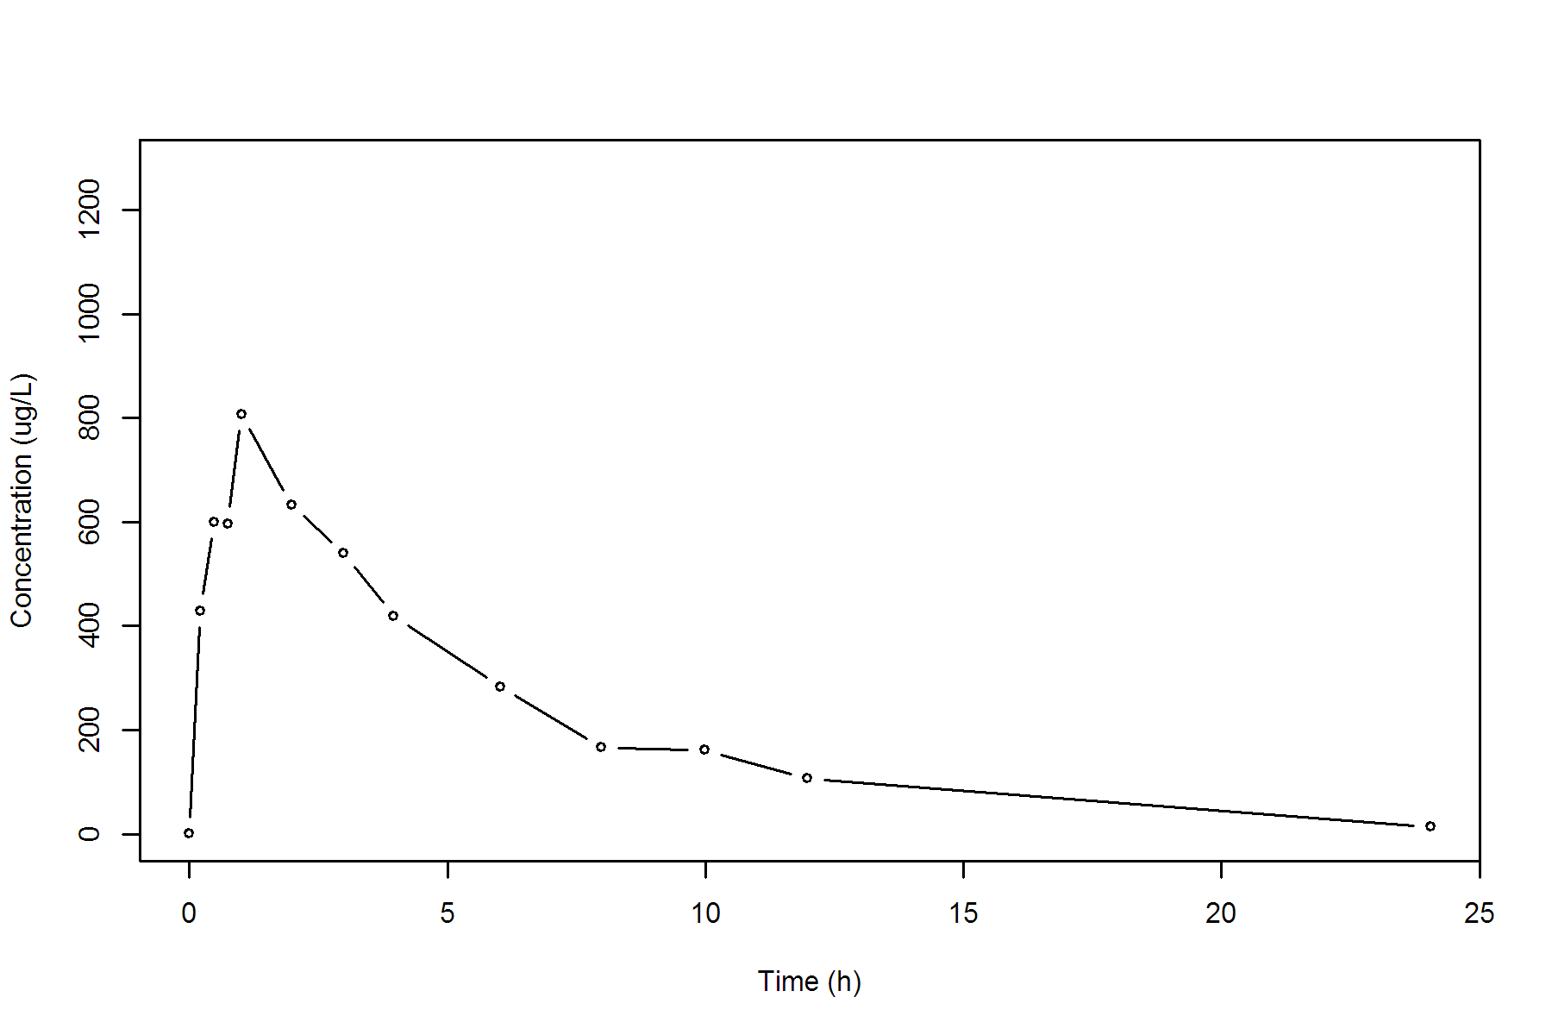

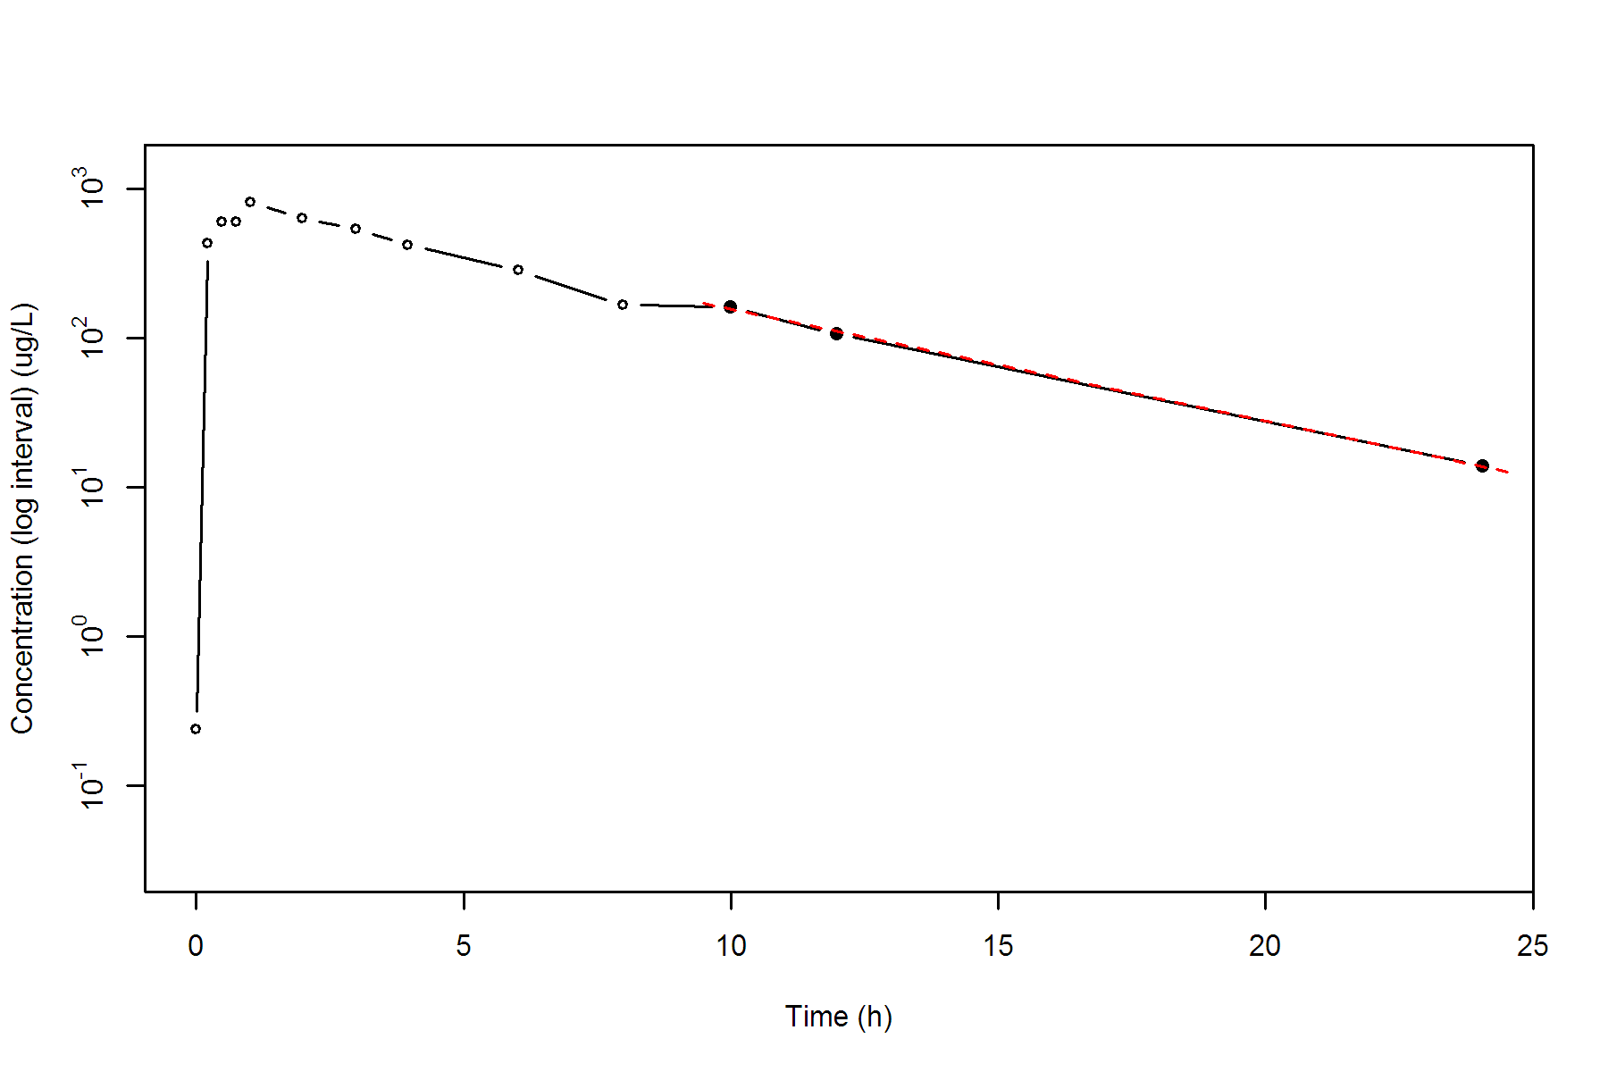

**SUBJ 17, GRP RT, PRD 1, TRT R**

NONCOMPARTMENTAL ANALYSIS REPORT

Package version 0.3.9 (2018-05-10 KST)

R version 3.5.0 (2018-04-23)

Date and Time: 2018-06-19 09:49:35 Asia/Seoul

Calculation Setting

-------------------

Drug Administration: Extravascular

Observation count excluding trailing zero: 13

Dose at time 0: 0 mg

AUC Calculation Method: Linear-up Linear-down

Weighting for lambda z: Uniform (Ordinary Least Square, OLS)

Lambda z selection criterion: Heighest adjusted R-squared value with precision=1e-4

Fitting, AUC, AUMC Result

-------------------------

Time Conc. Pred. Residual AUC AUMC

---------------------------------------------------------------------

0.0000 1.7200 0.0000 0.0000

0.2500 299.6500 37.6713 9.3641

0.5100 519.0100 144.0971 53.5131

0.7400 617.2500 274.7669 136.4810

0.9700 655.9400 421.1838 262.1790

2.0200 861.5600 1217.8713 1509.9009

2.9600 * 803.3000 787.4006 +1.590e+01 2000.3555 3445.4169

4.0300 * 709.6300 642.8060 +6.682e+01 2809.7730 6247.5205

6.0000 * 482.6400 442.4334 +4.021e+01 3984.1590 11916.8347

7.9700 * 323.1500 304.5201 +1.863e+01 4777.8622 17306.1100

10.0300 * 150.0600 206.0499 -5.599e+01 5265.2684 21509.1355

11.9700 * 136.9900 142.6300 -5.640e+00 5543.7070 24559.6615

23.9800 * 16.0400 14.6276 +1.412e+00 6462.6521 36716.2405

*: Used for the calculation of Lambda z.

Calculated Values

-----------------

CMAX Max Conc 861.5600 ug/L

TMAX Time of CMAX 2.0200 h

TLAG Time Until First Nonzero Conc 0.0000 h

CLST Last Nonzero Conc 16.0400 ug/L

CLSTP Last Nonzero Conc Pred 14.6276 ug/L

TLST Time of Last Nonzero Conc 23.9800 h

LAMZHL Half-Life Lambda z 3.6554 h

LAMZ Lambda z 0.1896 /h

LAMZLL Lambda z Lower Limit 2.9600 h

LAMZUL Lambda z Upper Limit 23.9800 h

LAMZNPT Number of Points for Lambda z 7

CORRXY Correlation Between TimeX and Log ConcY -0.9940

R2 R Squared 0.9880

R2ADJ R Squared Adjusted 0.9857

AUCLST AUC to Last Nonzero Conc 6462.6521 h*ug/L

AUCALL AUC All 6462.6521 h*ug/L

AUCIFO AUC Infinity Obs 6547.2420 h*ug/L

AUCIFP AUC Infinity Pred 6539.7933 h*ug/L

AUCPEO AUC %Extrapolation Obs 1.2920 %

AUCPEP AUC %Extrapolation Pred 1.1796 %

AUMCLST AUMC to Last Nonzero Conc 36716.2405 h2*ug/L

AUMCIFO AUMC Infinity Obs 39190.8065 h2*ug/L

AUMCIFP AUMC Infinity Pred 38972.9056 h2*ug/L

AUMCPEO AUMC %Extrapolation Obs 6.3141 %

AUMCPEP AUMC % Extrapolation Pred 5.7903 %

VZFO Vz Obs by F 0.0000 L

VZFP Vz Pred by F 0.0000 L

CLFO Total CL Obs by F 0.0000 L/h

CLFP Total CL Pred by F 0.0000 L/h

MRTEVLST MRT Extravasc to Last Nonzero Conc 5.6813 h

MRTEVIFO MRT Extravasc Infinity Obs 5.9858 h

MRTEVIFP MRT Extravasc Infinity Pred 5.9593 h

**SUBJ 17, GRP RT, PRD 1, TRT R**

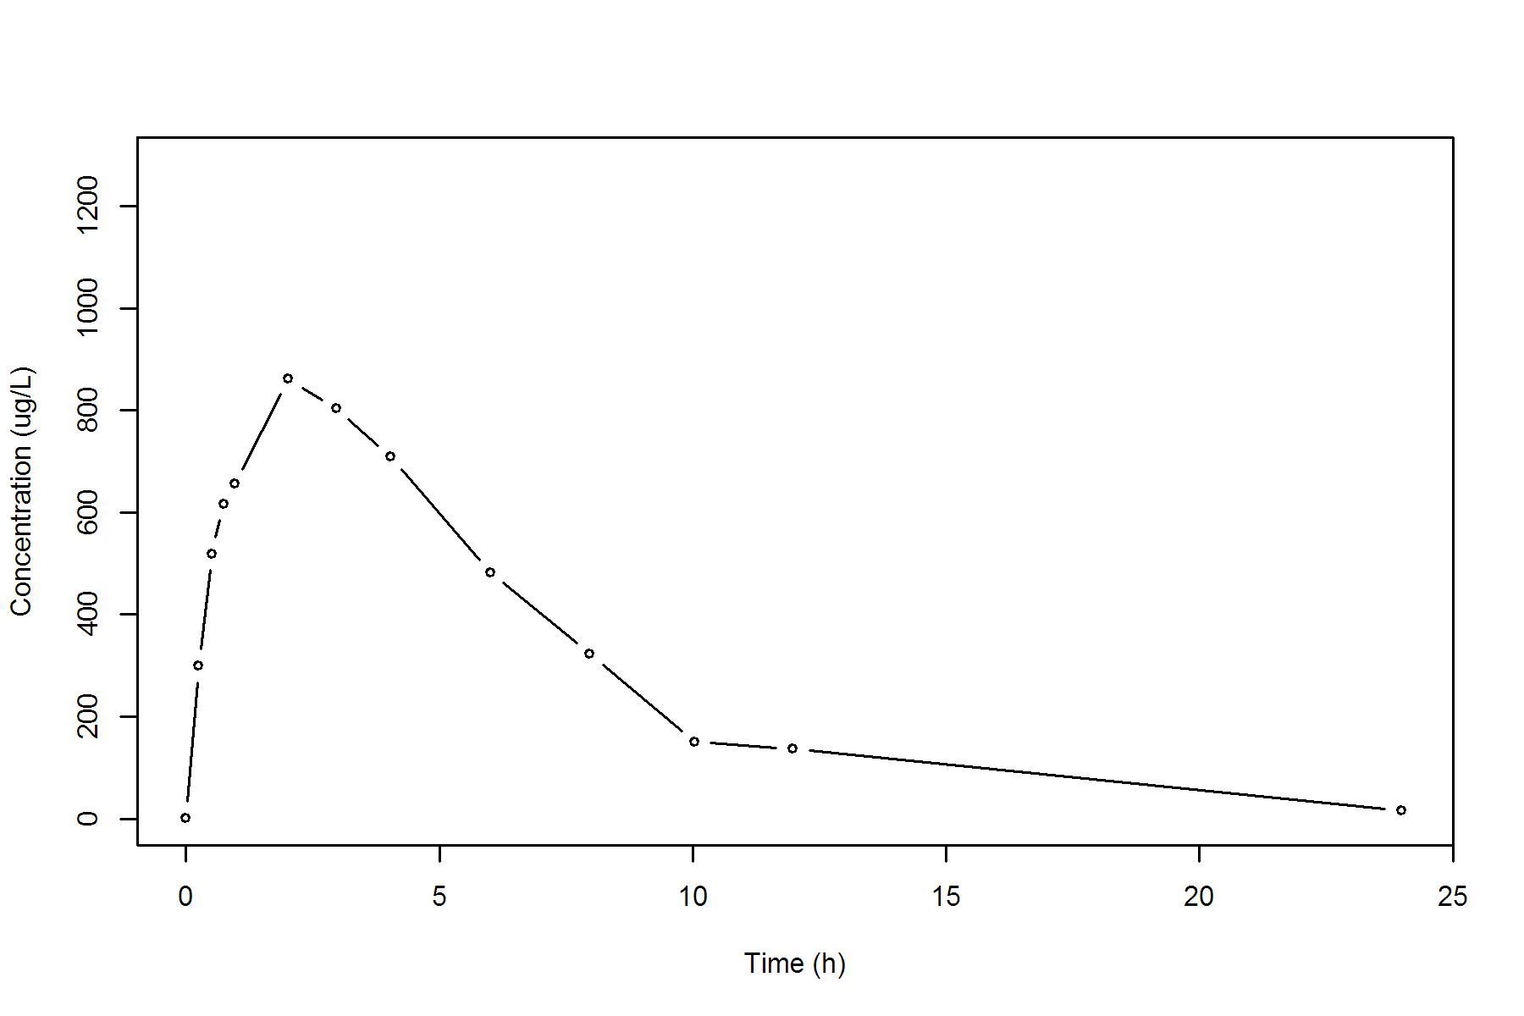

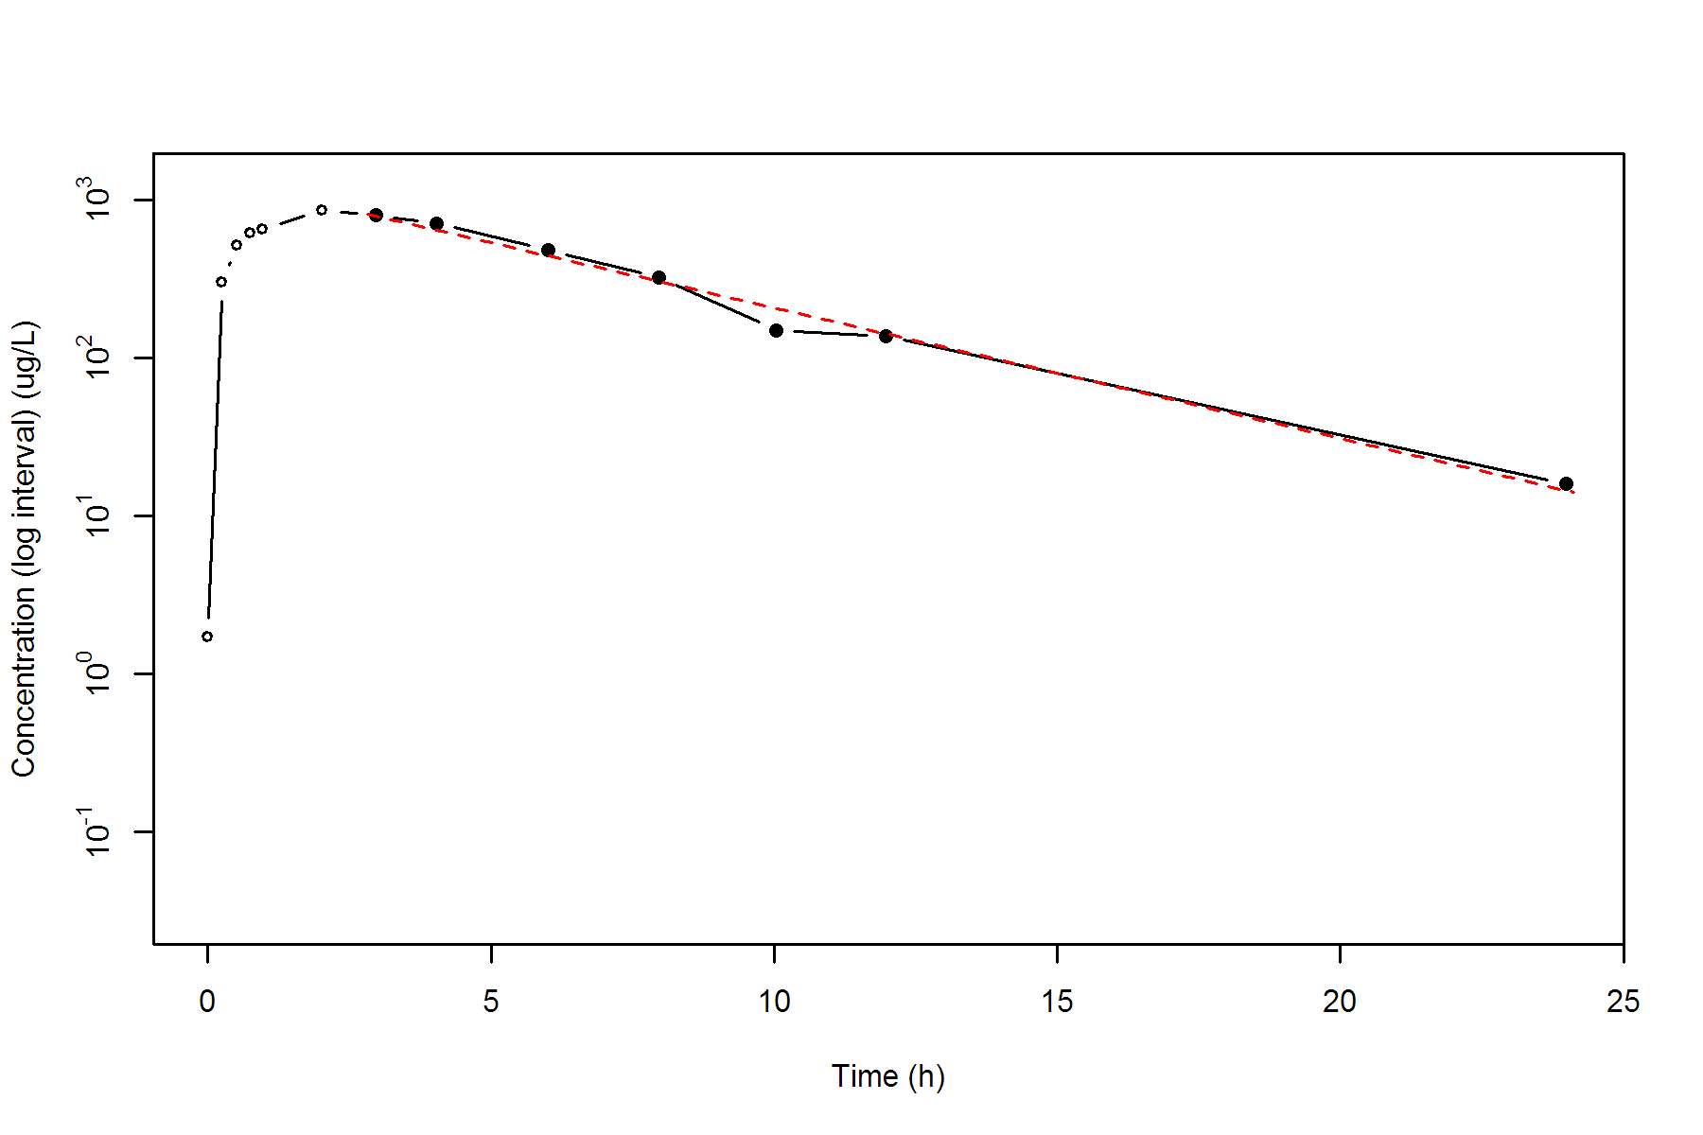

**SUBJ 17, GRP RT, PRD 2, TRT T**

NONCOMPARTMENTAL ANALYSIS REPORT

Package version 0.3.9 (2018-05-10 KST)

R version 3.5.0 (2018-04-23)

Date and Time: 2018-06-19 09:49:35 Asia/Seoul

Calculation Setting

-------------------

Drug Administration: Extravascular

Observation count excluding trailing zero: 13

Dose at time 0: 0 mg

AUC Calculation Method: Linear-up Linear-down

Weighting for lambda z: Uniform (Ordinary Least Square, OLS)

Lambda z selection criterion: Heighest adjusted R-squared value with precision=1e-4

Fitting, AUC, AUMC Result

-------------------------

Time Conc. Pred. Residual AUC AUMC

---------------------------------------------------------------------

0.0000 0.0000 0.0000 0.0000

0.2500 710.2000 88.7750 22.1938

0.5200 922.4200 309.1787 110.9169

0.7300 1187.7500 530.7466 252.3221

1.0200 924.9200 837.0837 514.8411

1.9600 865.2100 1678.4448 1755.2792

2.9900 641.6700 2454.4880 3616.6977

4.0400 406.8500 3004.9610 5486.8880

5.9800 309.5000 3699.8205 8876.5375

7.9900 204.3800 4216.2699 12377.7627

9.9900 * 123.4600 122.3877 +1.072e+00 4544.1099 15244.1243

12.0300 * 77.5000 78.2956 -7.956e-01 4749.0891 17453.1285

23.9700 * 5.7400 5.7315 +8.549e-03 5246.0319 23840.5080

*: Used for the calculation of Lambda z.

Calculated Values

-----------------

CMAX Max Conc 1187.7500 ug/L

TMAX Time of CMAX 0.7300 h

TLAG Time Until First Nonzero Conc 0.0000 h

CLST Last Nonzero Conc 5.7400 ug/L

CLSTP Last Nonzero Conc Pred 5.7315 ug/L

TLST Time of Last Nonzero Conc 23.9700 h

LAMZHL Half-Life Lambda z 3.1655 h

LAMZ Lambda z 0.2190 /h

LAMZLL Lambda z Lower Limit 9.9900 h

LAMZUL Lambda z Upper Limit 23.9700 h

LAMZNPT Number of Points for Lambda z 3

CORRXY Correlation Between TimeX and Log ConcY -1.0000

R2 R Squared 1.0000

R2ADJ R Squared Adjusted 0.9999

AUCLST AUC to Last Nonzero Conc 5246.0319 h*ug/L

AUCALL AUC All 5246.0319 h*ug/L

AUCIFO AUC Infinity Obs 5272.2453 h*ug/L

AUCIFP AUC Infinity Pred 5272.2063 h*ug/L

AUCPEO AUC %Extrapolation Obs 0.4972 %

AUCPEP AUC %Extrapolation Pred 0.4965 %

AUMCLST AUMC to Last Nonzero Conc 23840.5080 h2*ug/L

AUMCIFO AUMC Infinity Obs 24588.5552 h2*ug/L

AUMCIFP AUMC Infinity Pred 24587.4412 h2*ug/L

AUMCPEO AUMC %Extrapolation Obs 3.0423 %

AUMCPEP AUMC % Extrapolation Pred 3.0379 %

VZFO Vz Obs by F 0.0000 L

VZFP Vz Pred by F 0.0000 L

CLFO Total CL Obs by F 0.0000 L/h

CLFP Total CL Pred by F 0.0000 L/h

MRTEVLST MRT Extravasc to Last Nonzero Conc 4.5445 h

MRTEVIFO MRT Extravasc Infinity Obs 4.6638 h

MRTEVIFP MRT Extravasc Infinity Pred 4.6636 h

**SUBJ 17, GRP RT, PRD 2, TRT T**

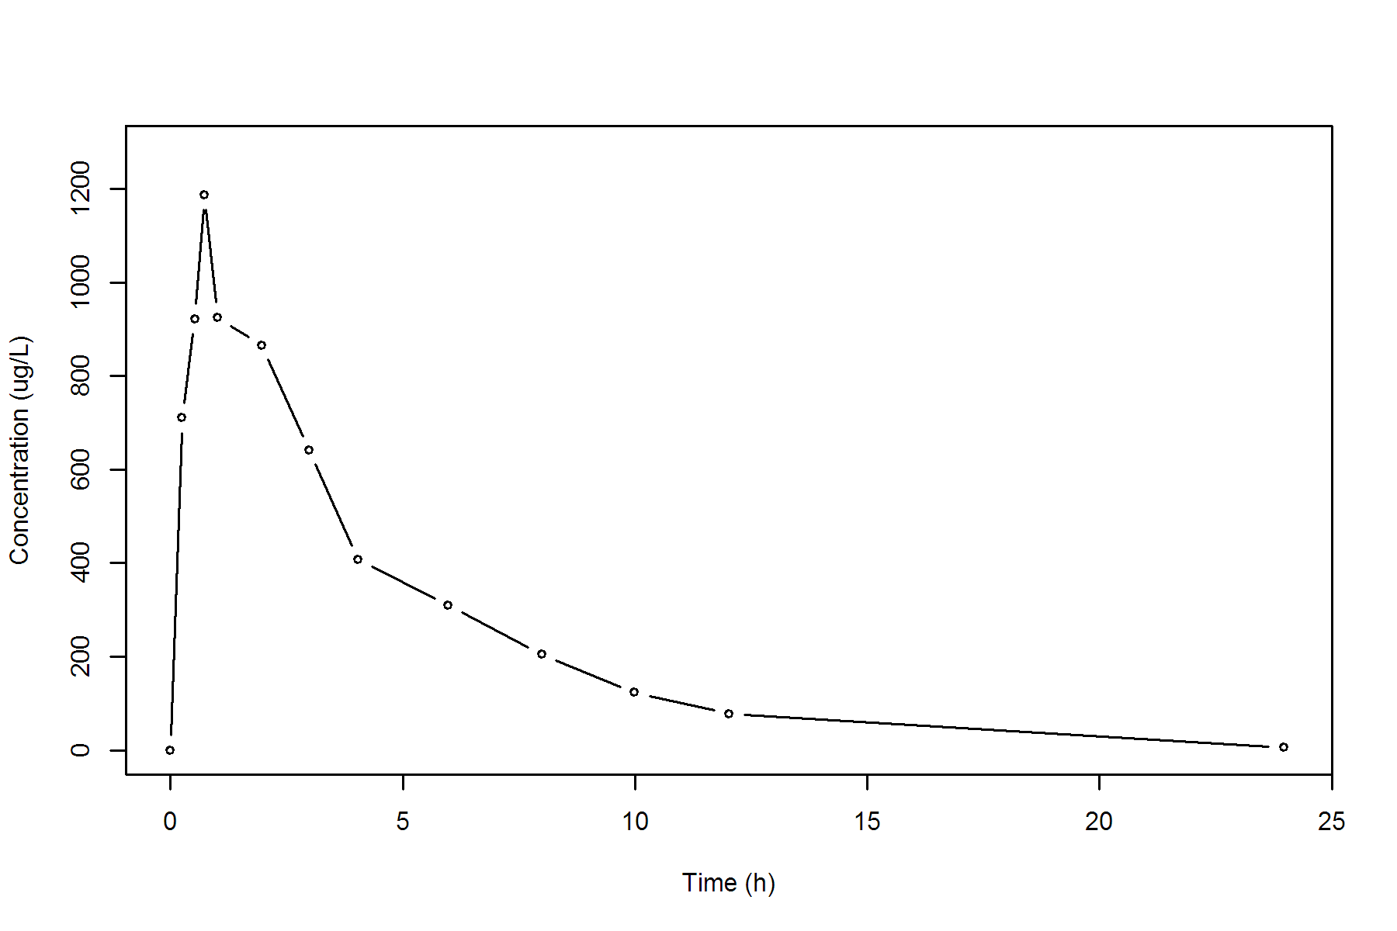

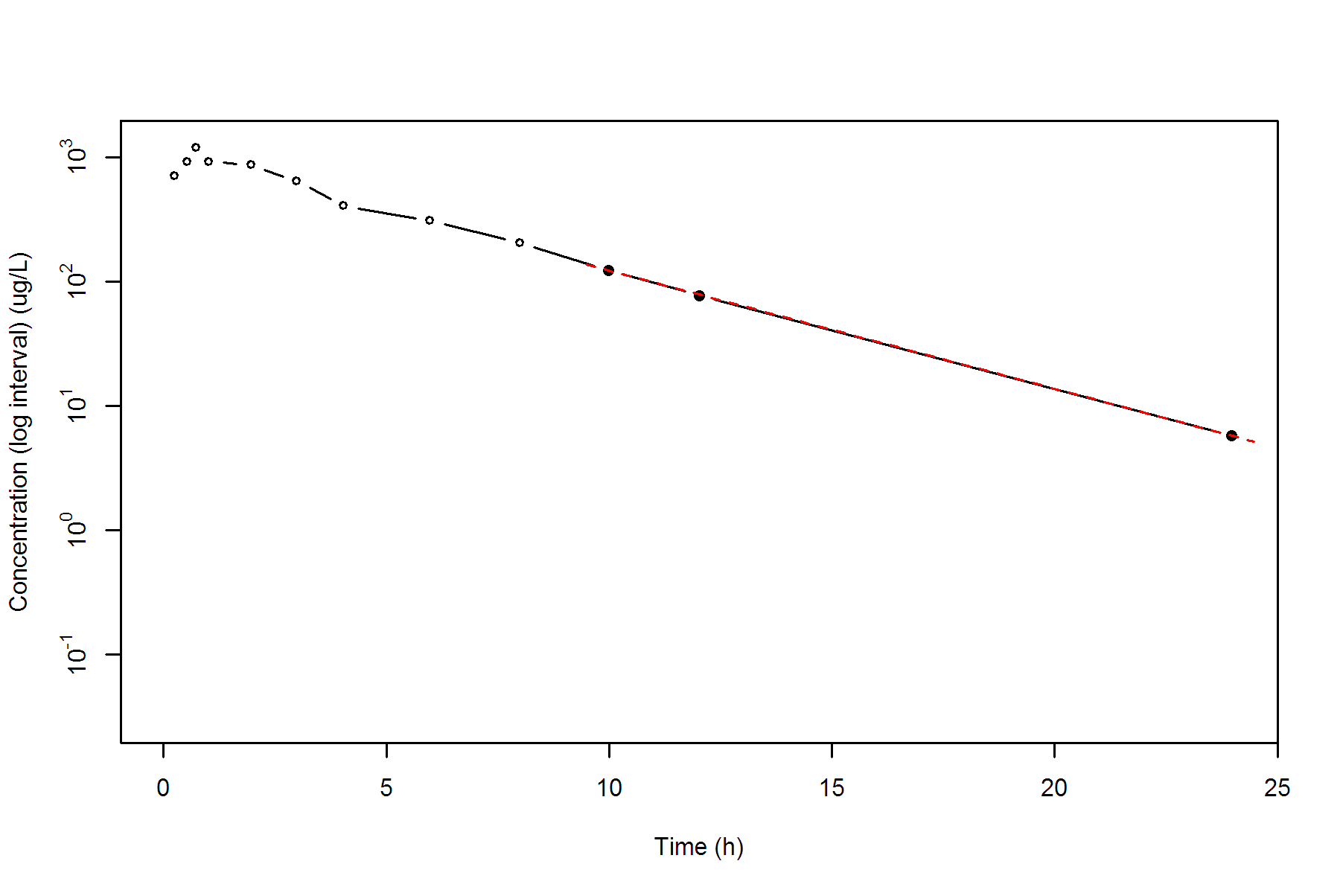

**SUBJ 18, GRP TR, PRD 1, TRT T**

NONCOMPARTMENTAL ANALYSIS REPORT

Package version 0.3.9 (2018-05-10 KST)

R version 3.5.0 (2018-04-23)

Date and Time: 2018-06-19 09:49:35 Asia/Seoul

Calculation Setting

-------------------

Drug Administration: Extravascular

Observation count excluding trailing zero: 13

Dose at time 0: 0 mg

AUC Calculation Method: Linear-up Linear-down

Weighting for lambda z: Uniform (Ordinary Least Square, OLS)

Lambda z selection criterion: Heighest adjusted R-squared value with precision=1e-4

Fitting, AUC, AUMC Result

-------------------------

Time Conc. Pred. Residual AUC AUMC

---------------------------------------------------------------------

0.0000 1.8200 0.0000 0.0000

0.2300 404.3300 46.7073 10.6945

0.5000 712.2000 197.4388 71.3225

0.7700 919.8700 417.7683 215.0165

0.9600 762.8500 577.6267 351.8769

1.9700 900.7500 1417.7446 1617.8177

3.0000 * 612.4200 587.6293 +2.479e+01 2197.0272 3477.8625

4.0000 * 509.7600 460.0907 +4.967e+01 2758.1172 5416.0125

5.9700 * 257.5500 284.1262 -2.658e+01 3513.9176 8938.9768

8.0200 * 168.9600 172.0593 -3.099e+00 3951.0903 11903.9253

9.9600 * 115.1400 107.0370 +8.103e+00 4226.6673 14330.7233

12.0300 * 55.1200 64.5024 -9.382e+00 4402.8864 16203.9574

24.0000 * 3.6500 3.4486 +2.014e-01 4754.6249 20696.8586

*: Used for the calculation of Lambda z.

Calculated Values

-----------------

CMAX Max Conc 919.8700 ug/L

TMAX Time of CMAX 0.7700 h

TLAG Time Until First Nonzero Conc 0.0000 h

CLST Last Nonzero Conc 3.6500 ug/L

CLSTP Last Nonzero Conc Pred 3.4486 ug/L

TLST Time of Last Nonzero Conc 24.0000 h

LAMZHL Half-Life Lambda z 2.8330 h

LAMZ Lambda z 0.2447 /h

LAMZLL Lambda z Lower Limit 3.0000 h

LAMZUL Lambda z Upper Limit 24.0000 h

LAMZNPT Number of Points for Lambda z 7

CORRXY Correlation Between TimeX and Log ConcY -0.9985

R2 R Squared 0.9970

R2ADJ R Squared Adjusted 0.9964

AUCLST AUC to Last Nonzero Conc 4754.6249 h*ug/L

AUCALL AUC All 4754.6249 h*ug/L

AUCIFO AUC Infinity Obs 4769.5427 h*ug/L

AUCIFP AUC Infinity Pred 4768.7196 h*ug/L

AUCPEO AUC %Extrapolation Obs 0.3128 %

AUCPEP AUC %Extrapolation Pred 0.2956 %

AUMCLST AUMC to Last Nonzero Conc 20696.8586 h2*ug/L

AUMCIFO AUMC Infinity Obs 21115.8587 h2*ug/L

AUMCIFP AUMC Infinity Pred 21092.7394 h2*ug/L

AUMCPEO AUMC %Extrapolation Obs 1.9843 %

AUMCPEP AUMC % Extrapolation Pred 1.8769 %

VZFO Vz Obs by F 0.0000 L

VZFP Vz Pred by F 0.0000 L

CLFO Total CL Obs by F 0.0000 L/h

CLFP Total CL Pred by F 0.0000 L/h

MRTEVLST MRT Extravasc to Last Nonzero Conc 4.3530 h

MRTEVIFO MRT Extravasc Infinity Obs 4.4272 h

MRTEVIFP MRT Extravasc Infinity Pred 4.4231 h

**SUBJ 18, GRP TR, PRD 1, TRT T**

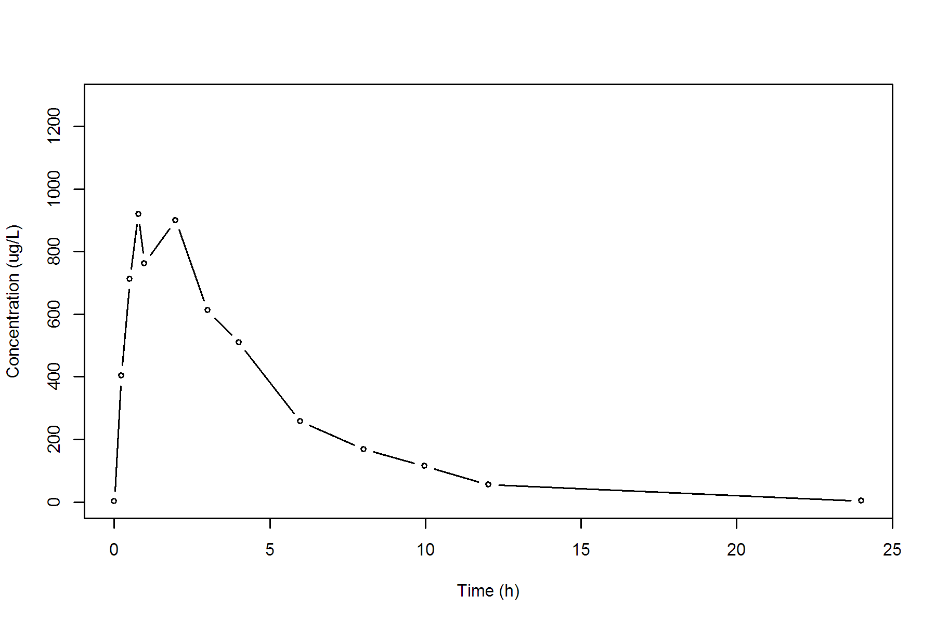

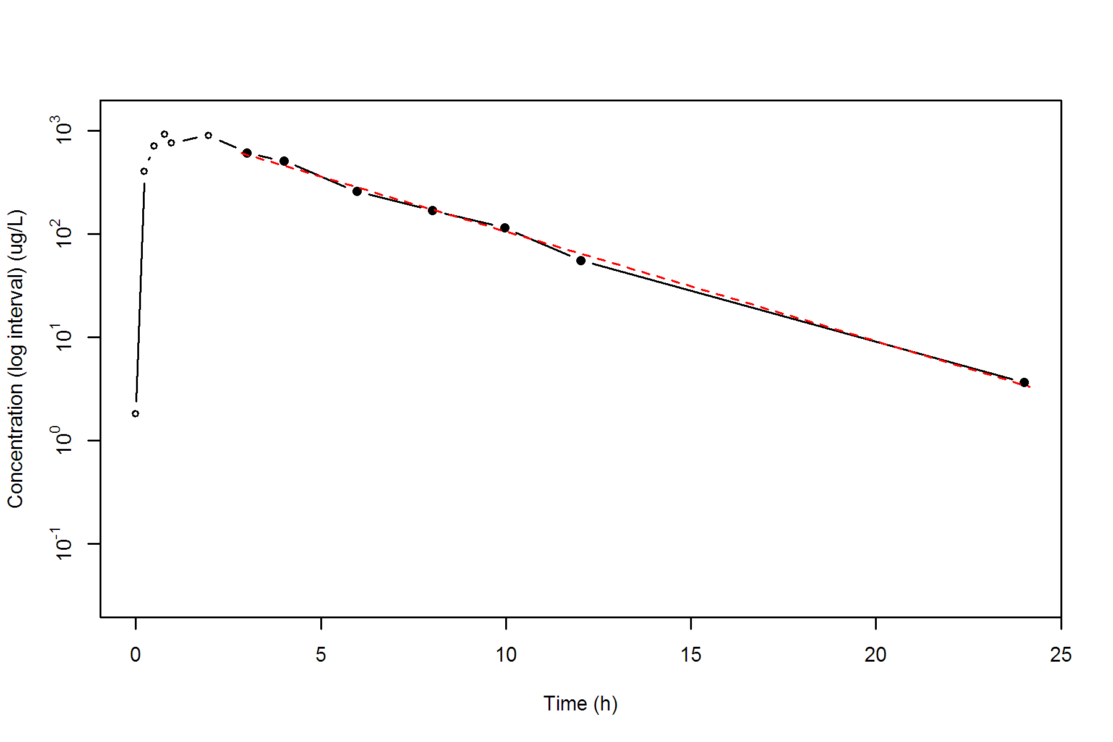

**SUBJ 18, GRP TR, PRD 2, TRT R**

NONCOMPARTMENTAL ANALYSIS REPORT

Package version 0.3.9 (2018-05-10 KST)

R version 3.5.0 (2018-04-23)

Date and Time: 2018-06-19 09:49:35 Asia/Seoul

Calculation Setting

-------------------

Drug Administration: Extravascular

Observation count excluding trailing zero: 13

Dose at time 0: 0 mg

AUC Calculation Method: Linear-up Linear-down

Weighting for lambda z: Uniform (Ordinary Least Square, OLS)

Lambda z selection criterion: Heighest adjusted R-squared value with precision=1e-4

Fitting, AUC, AUMC Result

-------------------------

Time Conc. Pred. Residual AUC AUMC

---------------------------------------------------------------------

0.0000 0.0300 0.0000 0.0000

0.2300 588.7600 67.7108 15.5727

0.5300 1042.8400 312.4509 118.7907

0.7000 880.2000 475.9092 218.1425

0.9900 932.5400 738.7565 441.3490

2.0300 665.4600 1569.7165 1623.8801

3.0200 478.7800 2136.1154 3008.2958

3.9800 252.9000 2487.3218 4185.4755

5.9700 122.8000 2861.1433 5916.4352

7.9800 * 48.5900 39.5796 +9.010e+00 3033.3902 7042.9037

9.9900 * 26.8600 24.5557 +2.304e+00 3109.2175 7702.2637

12.0000 * 10.4300 15.2346 -4.805e+00 3146.6939 8097.7226

23.9500 * 0.9700 0.8918 +7.823e-02 3214.8089 8984.3618

*: Used for the calculation of Lambda z.

Calculated Values

-----------------

CMAX Max Conc 1042.8400 ug/L

TMAX Time of CMAX 0.5300 h

TLAG Time Until First Nonzero Conc 0.0000 h

CLST Last Nonzero Conc 0.9700 ug/L

CLSTP Last Nonzero Conc Pred 0.8918 ug/L

TLST Time of Last Nonzero Conc 23.9500 h

LAMZHL Half-Life Lambda z 2.9185 h

LAMZ Lambda z 0.2375 /h

LAMZLL Lambda z Lower Limit 7.9800 h

LAMZUL Lambda z Upper Limit 23.9500 h

LAMZNPT Number of Points for Lambda z 4

CORRXY Correlation Between TimeX and Log ConcY -0.9887

R2 R Squared 0.9774

R2ADJ R Squared Adjusted 0.9662

AUCLST AUC to Last Nonzero Conc 3214.8089 h*ug/L

AUCALL AUC All 3214.8089 h*ug/L

AUCIFO AUC Infinity Obs 3218.8931 h*ug/L

AUCIFP AUC Infinity Pred 3218.5638 h*ug/L

AUCPEO AUC %Extrapolation Obs 0.1269 %

AUCPEP AUC %Extrapolation Pred 0.1167 %

AUMCLST AUMC to Last Nonzero Conc 8984.3618 h2*ug/L

AUMCIFO AUMC Infinity Obs 9099.3759 h2*ug/L

AUMCIFP AUMC Infinity Pred 9090.1005 h2*ug/L

AUMCPEO AUMC %Extrapolation Obs 1.2640 %

AUMCPEP AUMC % Extrapolation Pred 1.1632 %

VZFO Vz Obs by F 0.0000 L

VZFP Vz Pred by F 0.0000 L

CLFO Total CL Obs by F 0.0000 L/h

CLFP Total CL Pred by F 0.0000 L/h

MRTEVLST MRT Extravasc to Last Nonzero Conc 2.7947 h

MRTEVIFO MRT Extravasc Infinity Obs 2.8269 h

MRTEVIFP MRT Extravasc Infinity Pred 2.8243 h

**SUBJ 18, GRP TR, PRD 2, TRT R**

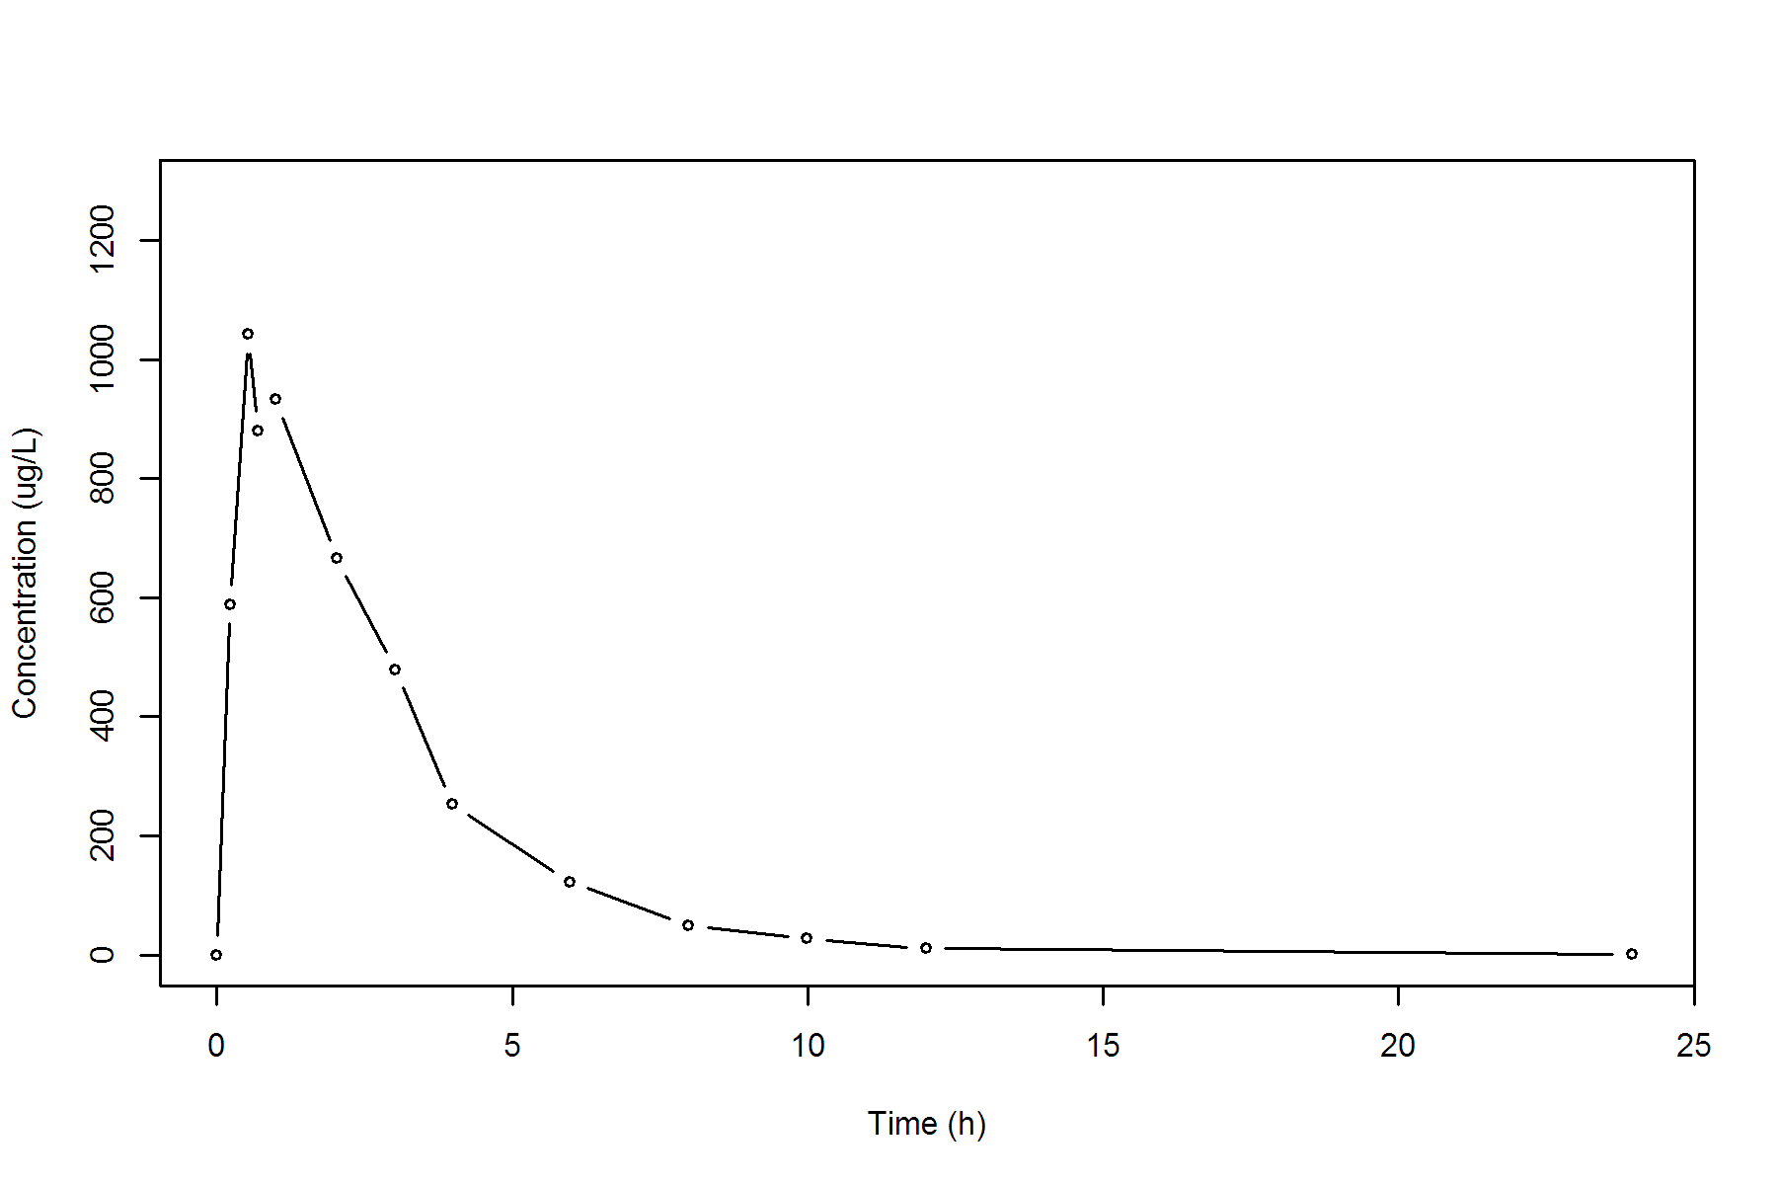

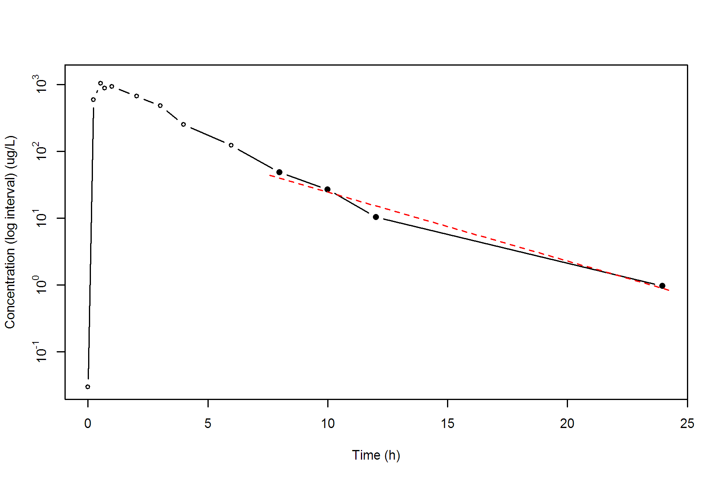

**SUBJ 19, GRP TR, PRD 1, TRT T**

NONCOMPARTMENTAL ANALYSIS REPORT

Package version 0.3.9 (2018-05-10 KST)

R version 3.5.0 (2018-04-23)

Date and Time: 2018-06-19 09:49:35 Asia/Seoul

Calculation Setting

-------------------

Drug Administration: Extravascular

Observation count excluding trailing zero: 13

Dose at time 0: 0 mg

AUC Calculation Method: Linear-up Linear-down

Weighting for lambda z: Uniform (Ordinary Least Square, OLS)

Lambda z selection criterion: Heighest adjusted R-squared value with precision=1e-4

Fitting, AUC, AUMC Result

-------------------------

Time Conc. Pred. Residual AUC AUMC

---------------------------------------------------------------------

0.0000 0.0000 0.0000 0.0000

0.2300 405.6500 46.6498 10.7294

0.5100 614.7500 189.5058 67.6845

0.7200 770.2400 334.9297 158.8345

1.0400 944.6500 609.3121 404.7559

1.9700 937.7400 1484.6234 1720.6054

3.0000 1089.8400 2528.8272 4355.7923

3.9800 * 802.6400 849.4204 -4.678e+01 3456.1424 7523.1656

6.0400 * 602.0400 542.3115 +5.973e+01 4902.9628 14558.9193

7.9600 * 354.2500 356.9594 -2.709e+00 5821.0012 20756.8248

9.9600 * 263.4000 230.8984 +3.250e+01 6438.6512 26200.1188

12.0500 * 119.1300 146.4567 -2.733e+01 6838.3950 30441.7535

24.0400 * 11.1300 10.7515 +3.785e-01 7619.3037 40651.7283

*: Used for the calculation of Lambda z.

Calculated Values

-----------------

CMAX Max Conc 1089.8400 ug/L

TMAX Time of CMAX 3.0000 h

TLAG Time Until First Nonzero Conc 0.0000 h

CLST Last Nonzero Conc 11.1300 ug/L

CLSTP Last Nonzero Conc Pred 10.7515 ug/L

TLST Time of Last Nonzero Conc 24.0400 h

LAMZHL Half-Life Lambda z 3.1822 h

LAMZ Lambda z 0.2178 /h

LAMZLL Lambda z Lower Limit 3.9800 h

LAMZUL Lambda z Upper Limit 24.0400 h

LAMZNPT Number of Points for Lambda z 6

CORRXY Correlation Between TimeX and Log ConcY -0.9969

R2 R Squared 0.9938

R2ADJ R Squared Adjusted 0.9923

AUCLST AUC to Last Nonzero Conc 7619.3037 h*ug/L

AUCALL AUC All 7619.3037 h*ug/L

AUCIFO AUC Infinity Obs 7670.4004 h*ug/L

AUCIFP AUC Infinity Pred 7668.6626 h*ug/L

AUCPEO AUC %Extrapolation Obs 0.6662 %

AUCPEP AUC %Extrapolation Pred 0.6436 %

AUMCLST AUMC to Last Nonzero Conc 40651.7283 h2*ug/L

AUMCIFO AUMC Infinity Obs 42114.6739 h2*ug/L

AUMCIFP AUMC Infinity Pred 42064.9188 h2*ug/L

AUMCPEO AUMC %Extrapolation Obs 3.4737 %

AUMCPEP AUMC % Extrapolation Pred 3.3595 %

VZFO Vz Obs by F 0.0000 L

VZFP Vz Pred by F 0.0000 L

CLFO Total CL Obs by F 0.0000 L/h

CLFP Total CL Pred by F 0.0000 L/h

MRTEVLST MRT Extravasc to Last Nonzero Conc 5.3354 h

MRTEVIFO MRT Extravasc Infinity Obs 5.4905 h

MRTEVIFP MRT Extravasc Infinity Pred 5.4853 h

**SUBJ 19, GRP TR, PRD 1, TRT T**

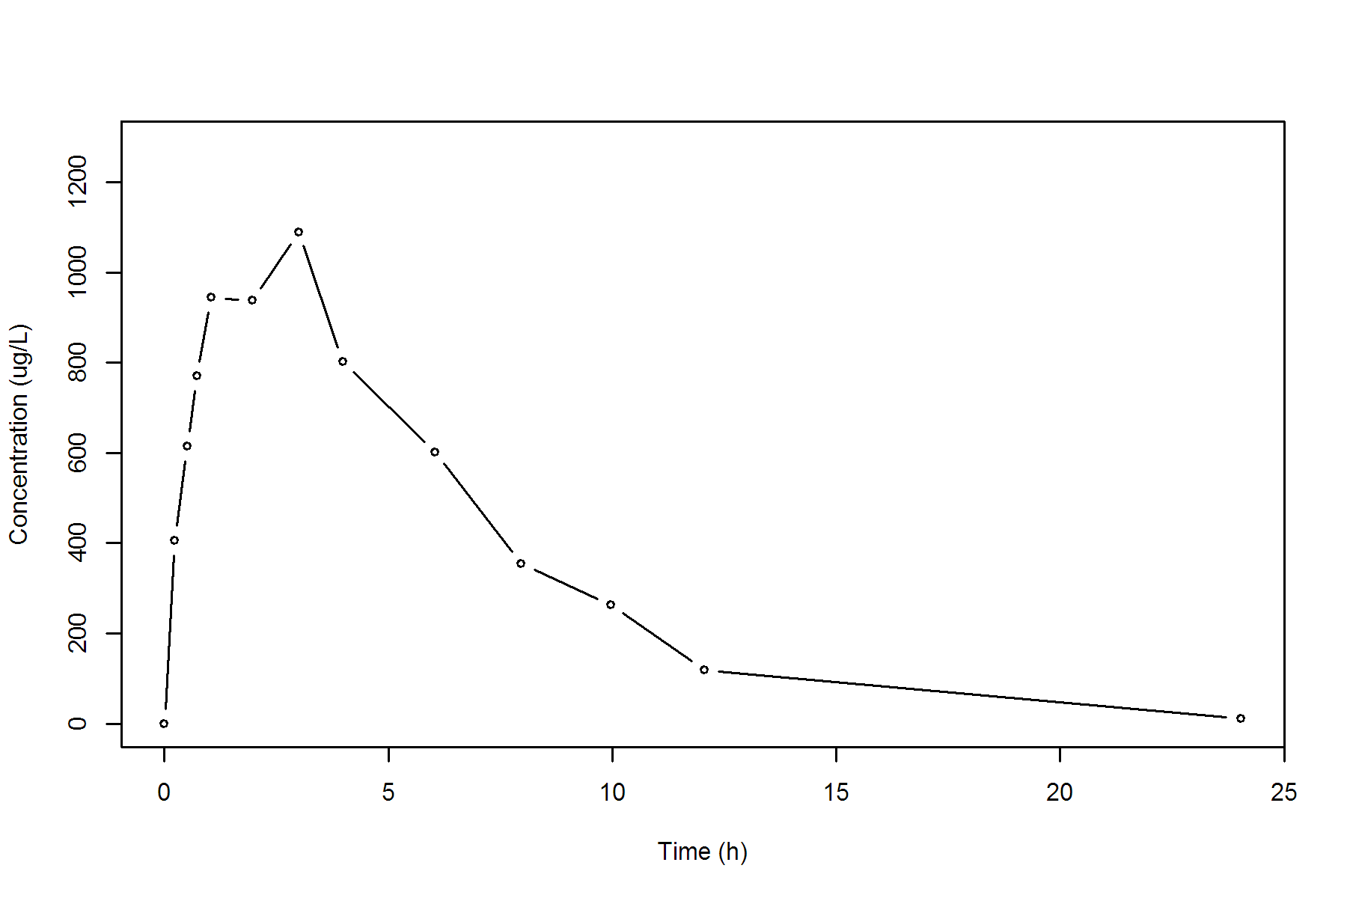

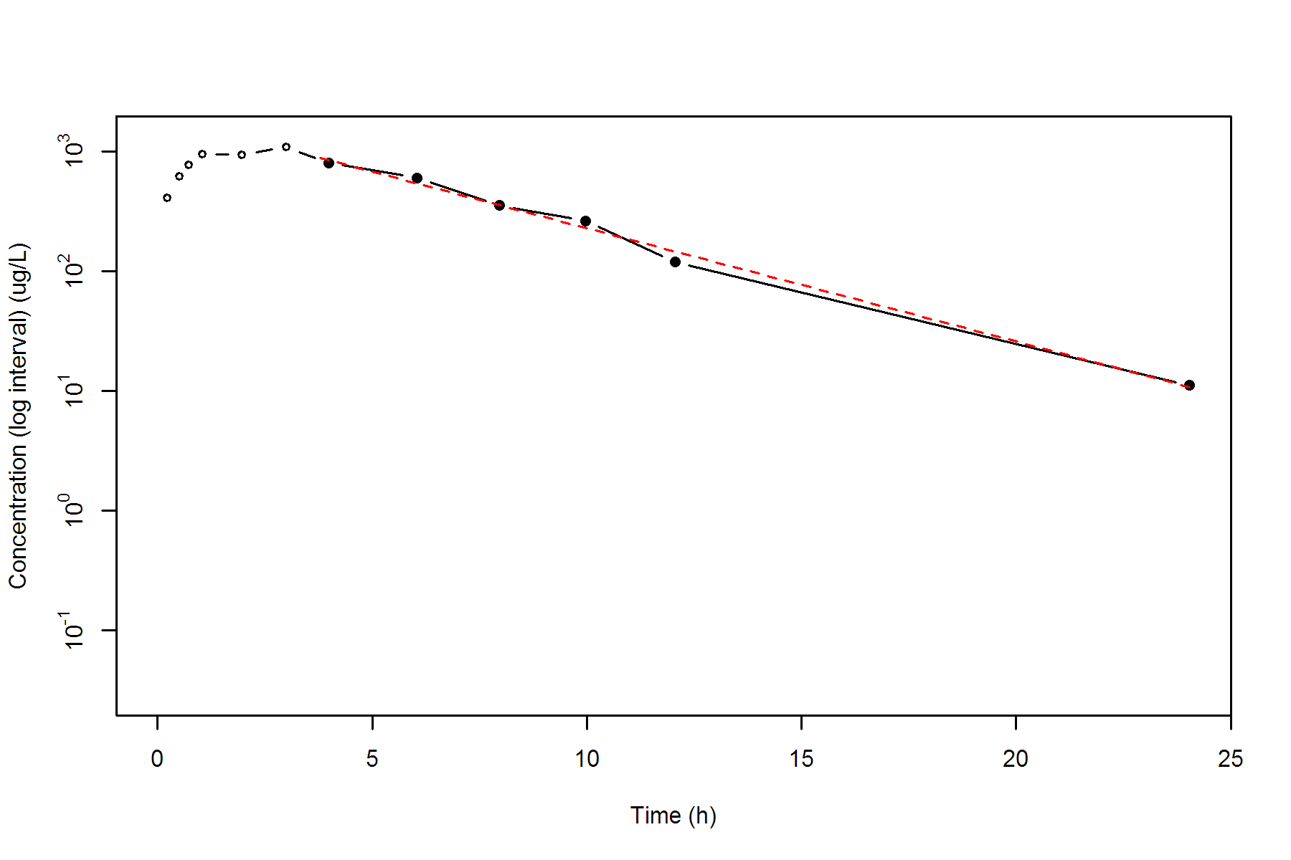

**SUBJ 19, GRP TR, PRD 2, TRT R**

NONCOMPARTMENTAL ANALYSIS REPORT

Package version 0.3.9 (2018-05-10 KST)

R version 3.5.0 (2018-04-23)

Date and Time: 2018-06-19 09:49:35 Asia/Seoul

Calculation Setting

-------------------

Drug Administration: Extravascular

Observation count excluding trailing zero: 13

Dose at time 0: 0 mg

AUC Calculation Method: Linear-up Linear-down

Weighting for lambda z: Uniform (Ordinary Least Square, OLS)

Lambda z selection criterion: Heighest adjusted R-squared value with precision=1e-4

Fitting, AUC, AUMC Result

-------------------------

Time Conc. Pred. Residual AUC AUMC

---------------------------------------------------------------------

0.0000 0.3600 0.0000 0.0000

0.2700 612.8000 82.7766 22.3366

0.5000 908.1500 257.6858 93.5826

0.7900 1089.7200 547.3770 284.2509

1.0100 981.9000 775.2552 488.0367

2.0400 1127.9400 1861.8228 2183.7857

2.9900 702.3100 2731.1916 4274.2154

3.9700 595.9300 3367.3292 6462.4324

6.0400 252.9100 4245.8786 10492.1205

7.9700 152.9000 4637.4852 13142.1933

10.0100 * 75.7400 78.1705 -2.430e+00 4870.6980 15158.4991

12.0100 * 37.4600 36.1046 +1.355e+00 4983.8980 16366.5511

24.0000 * 0.3500 0.3518 -1.849e-03 5210.5690 19114.0272

*: Used for the calculation of Lambda z.

Calculated Values

-----------------

CMAX Max Conc 1127.9400 ug/L

TMAX Time of CMAX 2.0400 h

TLAG Time Until First Nonzero Conc 0.0000 h

CLST Last Nonzero Conc 0.3500 ug/L

CLSTP Last Nonzero Conc Pred 0.3518 ug/L

TLST Time of Last Nonzero Conc 24.0000 h

LAMZHL Half-Life Lambda z 1.7946 h

LAMZ Lambda z 0.3862 /h

LAMZLL Lambda z Lower Limit 10.0100 h

LAMZUL Lambda z Upper Limit 24.0000 h

LAMZNPT Number of Points for Lambda z 3

CORRXY Correlation Between TimeX and Log ConcY -0.9999

R2 R Squared 0.9999

R2ADJ R Squared Adjusted 0.9997

AUCLST AUC to Last Nonzero Conc 5210.5690 h*ug/L

AUCALL AUC All 5210.5690 h*ug/L

AUCIFO AUC Infinity Obs 5211.4751 h*ug/L

AUCIFP AUC Infinity Pred 5211.4799 h*ug/L

AUCPEO AUC %Extrapolation Obs 0.0174 %

AUCPEP AUC %Extrapolation Pred 0.0175 %

AUMCLST AUMC to Last Nonzero Conc 19114.0272 h2*ug/L

AUMCIFO AUMC Infinity Obs 19138.1218 h2*ug/L

AUMCIFP AUMC Infinity Pred 19138.2490 h2*ug/L

AUMCPEO AUMC %Extrapolation Obs 0.1259 %

AUMCPEP AUMC % Extrapolation Pred 0.1266 %

VZFO Vz Obs by F 0.0000 L

VZFP Vz Pred by F 0.0000 L

CLFO Total CL Obs by F 0.0000 L/h

CLFP Total CL Pred by F 0.0000 L/h

MRTEVLST MRT Extravasc to Last Nonzero Conc 3.6683 h

MRTEVIFO MRT Extravasc Infinity Obs 3.6723 h

MRTEVIFP MRT Extravasc Infinity Pred 3.6723 h

**SUBJ 19, GRP TR, PRD 2, TRT R**

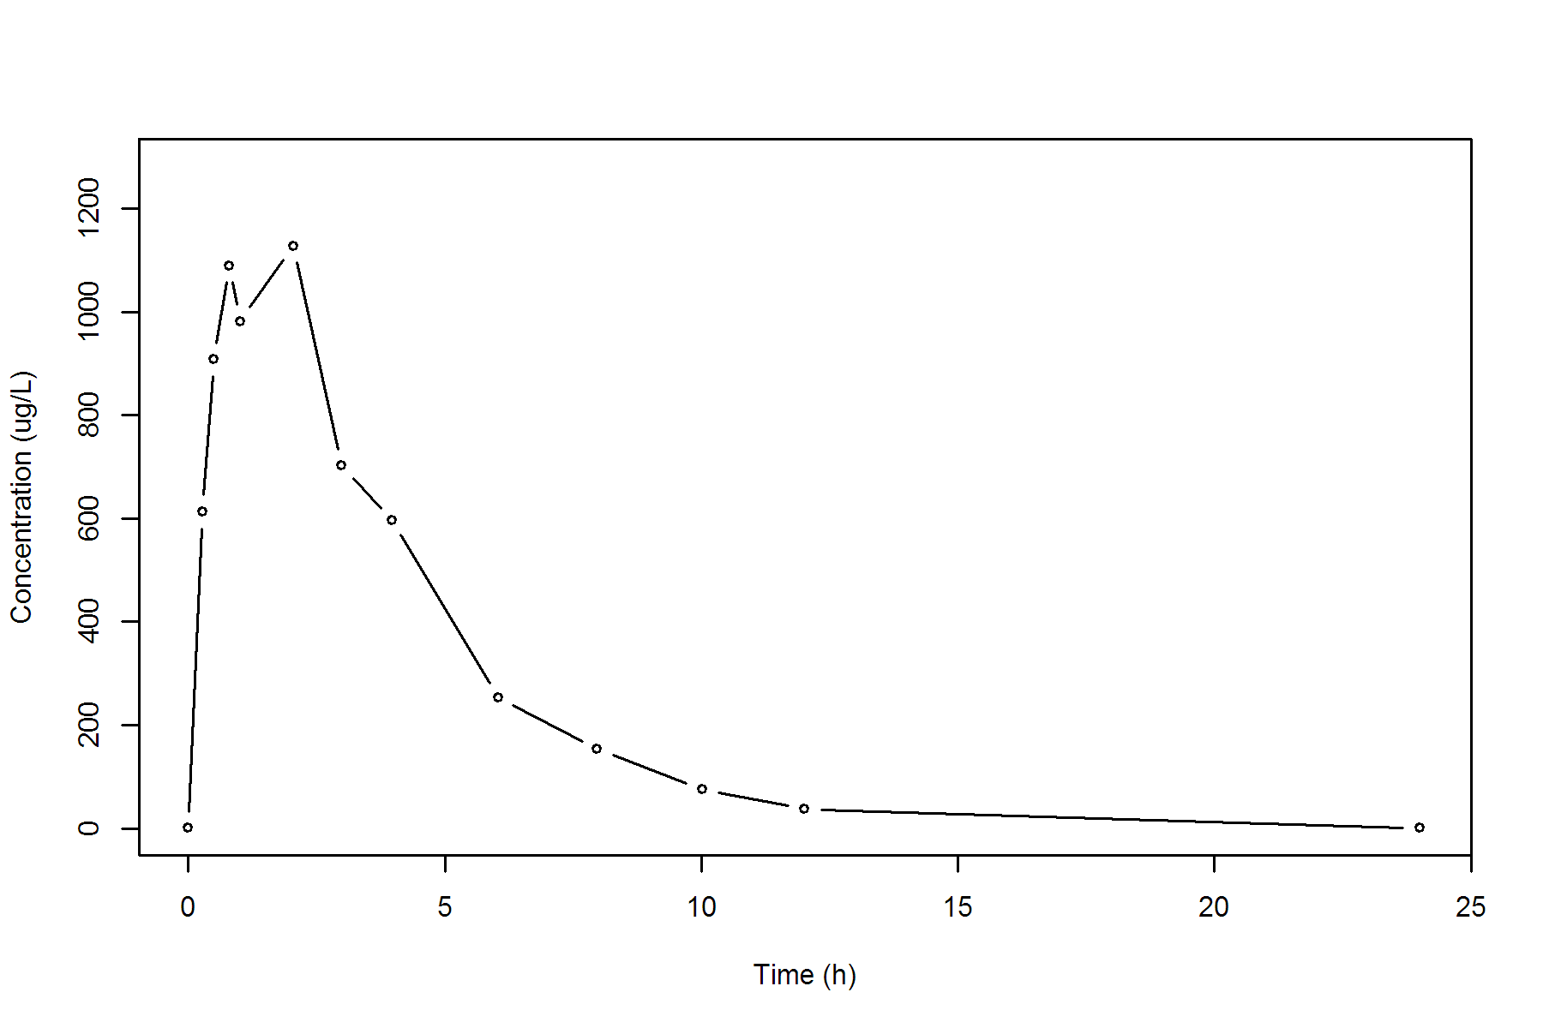

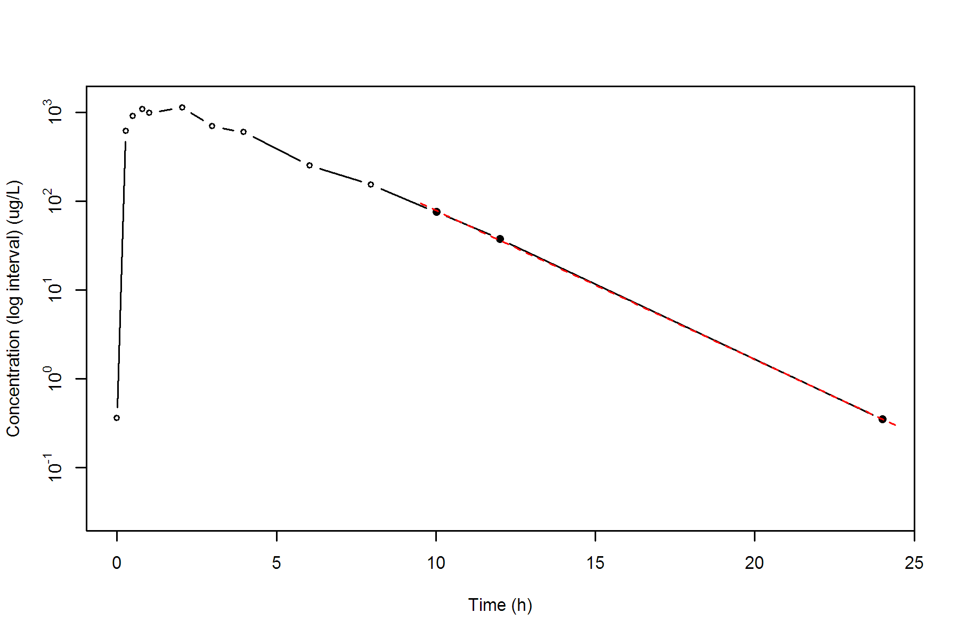

**SUBJ 20, GRP TR, PRD 1, TRT T**

NONCOMPARTMENTAL ANALYSIS REPORT

Package version 0.3.9 (2018-05-10 KST)

R version 3.5.0 (2018-04-23)

Date and Time: 2018-06-19 09:49:35 Asia/Seoul

Calculation Setting

-------------------

Drug Administration: Extravascular

Observation count excluding trailing zero: 13

Dose at time 0: 0 mg

AUC Calculation Method: Linear-up Linear-down

Weighting for lambda z: Uniform (Ordinary Least Square, OLS)

Lambda z selection criterion: Heighest adjusted R-squared value with precision=1e-4

Fitting, AUC, AUMC Result

-------------------------

Time Conc. Pred. Residual AUC AUMC

---------------------------------------------------------------------

0.0000 0.0000 0.0000 0.0000

0.2700 686.9300 92.7356 25.0386

0.4900 889.3900 266.1308 93.3785

0.7100 1191.4600 495.0242 234.3697

1.0100 913.6000 810.7832 499.6706

1.9600 * 818.2100 887.6061 -6.940e+01 1633.3930 1699.7237

3.0500 * 559.4300 653.3531 -9.392e+01 2384.2068 3503.6481

3.9700 * 550.7500 504.4638 +4.629e+01 2894.8896 5294.3081

5.9700 * 297.7400 287.5150 +1.022e+01 3743.3796 9258.2934

8.0300 * 192.3000 161.1261 +3.117e+01 4248.1208 12679.6205

9.9600 * 74.7400 93.6575 -1.892e+01 4505.8144 14888.0996

12.0400 * 67.0900 52.1923 +1.490e+01 4653.3176 16502.3606

23.9700 * 1.6700 1.8245 -1.545e-01 5063.4710 21559.4488

*: Used for the calculation of Lambda z.

Calculated Values

-----------------

CMAX Max Conc 1191.4600 ug/L

TMAX Time of CMAX 0.7100 h

TLAG Time Until First Nonzero Conc 0.0000 h

CLST Last Nonzero Conc 1.6700 ug/L

CLSTP Last Nonzero Conc Pred 1.8245 ug/L

TLST Time of Last Nonzero Conc 23.9700 h

LAMZHL Half-Life Lambda z 2.4657 h

LAMZ Lambda z 0.2811 /h

LAMZLL Lambda z Lower Limit 1.9600 h

LAMZUL Lambda z Upper Limit 23.9700 h

LAMZNPT Number of Points for Lambda z 8

CORRXY Correlation Between TimeX and Log ConcY -0.9966

R2 R Squared 0.9931

R2ADJ R Squared Adjusted 0.9920

AUCLST AUC to Last Nonzero Conc 5063.4710 h*ug/L

AUCALL AUC All 5063.4710 h*ug/L

AUCIFO AUC Infinity Obs 5069.4117 h*ug/L

AUCIFP AUC Infinity Pred 5069.9612 h*ug/L

AUCPEO AUC %Extrapolation Obs 0.1172 %

AUCPEP AUC %Extrapolation Pred 0.1280 %

AUMCLST AUMC to Last Nonzero Conc 21559.4488 h2*ug/L

AUMCIFO AUMC Infinity Obs 21722.9810 h2*ug/L

AUMCIFP AUMC Infinity Pred 21738.1067 h2*ug/L

AUMCPEO AUMC %Extrapolation Obs 0.7528 %

AUMCPEP AUMC % Extrapolation Pred 0.8219 %

VZFO Vz Obs by F 0.0000 L

VZFP Vz Pred by F 0.0000 L

CLFO Total CL Obs by F 0.0000 L/h

CLFP Total CL Pred by F 0.0000 L/h

MRTEVLST MRT Extravasc to Last Nonzero Conc 4.2578 h

MRTEVIFO MRT Extravasc Infinity Obs 4.2851 h

MRTEVIFP MRT Extravasc Infinity Pred 4.2876 h

**SUBJ 20, GRP TR, PRD 1, TRT T**

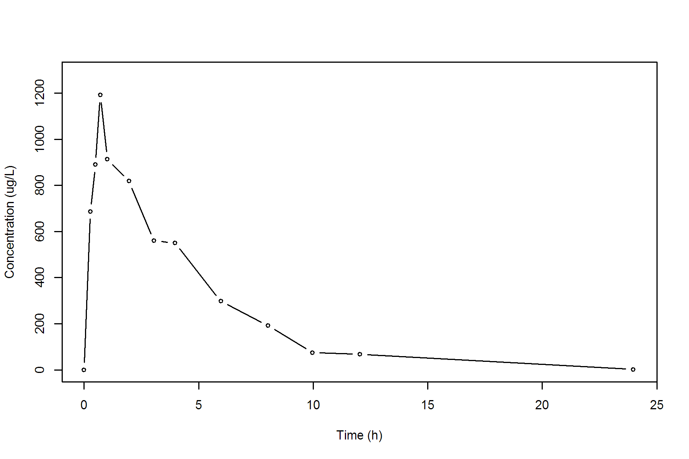

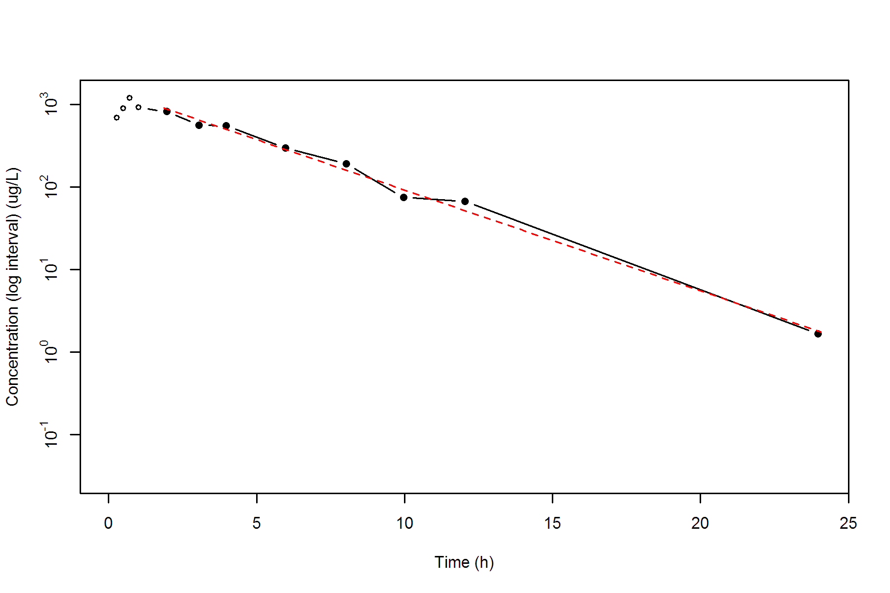

**SUBJ 20, GRP TR, PRD 2, TRT R**

NONCOMPARTMENTAL ANALYSIS REPORT

Package version 0.3.9 (2018-05-10 KST)

R version 3.5.0 (2018-04-23)

Date and Time: 2018-06-19 09:49:35 Asia/Seoul

Calculation Setting

-------------------

Drug Administration: Extravascular

Observation count excluding trailing zero: 13

Dose at time 0: 0 mg

AUC Calculation Method: Linear-up Linear-down

Weighting for lambda z: Uniform (Ordinary Least Square, OLS)

Lambda z selection criterion: Heighest adjusted R-squared value with precision=1e-4

Fitting, AUC, AUMC Result

-------------------------

Time Conc. Pred. Residual AUC AUMC

---------------------------------------------------------------------

0.0000 0.6200 0.0000 0.0000

0.2500 494.4500 61.8838 15.4516

0.5300 725.0500 232.6138 86.5560

0.7400 917.5500 405.0868 198.1987

1.0000 1069.1900 663.3630 425.4617

2.0400 877.5200 1675.6522 1912.3137

3.0300 * 799.6300 799.1149 +5.151e-01 2505.8414 3997.7585

3.9500 * 624.7100 654.6438 -2.993e+01 3161.0378 6247.3808

6.0000 * 418.0600 419.7865 -1.726e+00 4229.8771 11347.7444

7.9800 * 254.2900 273.3010 -1.901e+01 4895.5036 15839.9627

10.0400 * 208.3200 174.8732 +3.345e+01 5371.9919 20084.3527

11.9600 * 112.6100 115.3411 -2.731e+00 5680.0847 23385.1672

23.9800 * 8.2800 8.5208 -2.408e-01 6406.6336 32672.8409

*: Used for the calculation of Lambda z.

Calculated Values

-----------------

CMAX Max Conc 1069.1900 ug/L

TMAX Time of CMAX 1.0000 h

TLAG Time Until First Nonzero Conc 0.0000 h

CLST Last Nonzero Conc 8.2800 ug/L

CLSTP Last Nonzero Conc Pred 8.5208 ug/L

TLST Time of Last Nonzero Conc 23.9800 h

LAMZHL Half-Life Lambda z 3.1979 h

LAMZ Lambda z 0.2168 /h

LAMZLL Lambda z Lower Limit 3.0300 h

LAMZUL Lambda z Upper Limit 23.9800 h

LAMZNPT Number of Points for Lambda z 7

CORRXY Correlation Between TimeX and Log ConcY -0.9986

R2 R Squared 0.9972

R2ADJ R Squared Adjusted 0.9967

AUCLST AUC to Last Nonzero Conc 6406.6336 h*ug/L

AUCALL AUC All 6406.6336 h*ug/L

AUCIFO AUC Infinity Obs 6444.8336 h*ug/L

AUCIFP AUC Infinity Pred 6445.9447 h*ug/L

AUCPEO AUC %Extrapolation Obs 0.5927 %

AUCPEP AUC %Extrapolation Pred 0.6099 %

AUMCLST AUMC to Last Nonzero Conc 32672.8409 h2*ug/L

AUMCIFO AUMC Infinity Obs 33765.1148 h2*ug/L

AUMCIFP AUMC Infinity Pred 33796.8852 h2*ug/L

AUMCPEO AUMC %Extrapolation Obs 3.2349 %

AUMCPEP AUMC % Extrapolation Pred 3.3259 %

VZFO Vz Obs by F 0.0000 L

VZFP Vz Pred by F 0.0000 L

CLFO Total CL Obs by F 0.0000 L/h

CLFP Total CL Pred by F 0.0000 L/h

MRTEVLST MRT Extravasc to Last Nonzero Conc 5.0998 h

MRTEVIFO MRT Extravasc Infinity Obs 5.2391 h

MRTEVIFP MRT Extravasc Infinity Pred 5.2431 h

**SUBJ 20, GRP TR, PRD 2, TRT R**

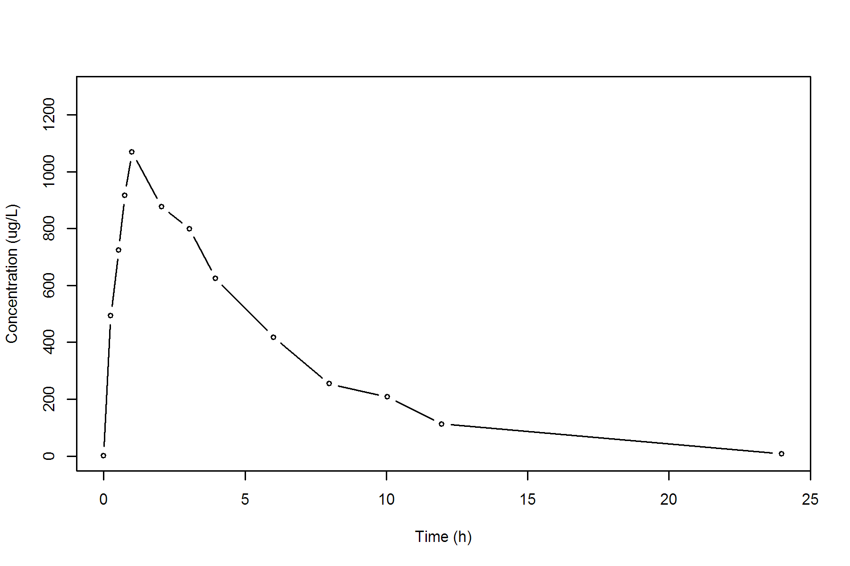

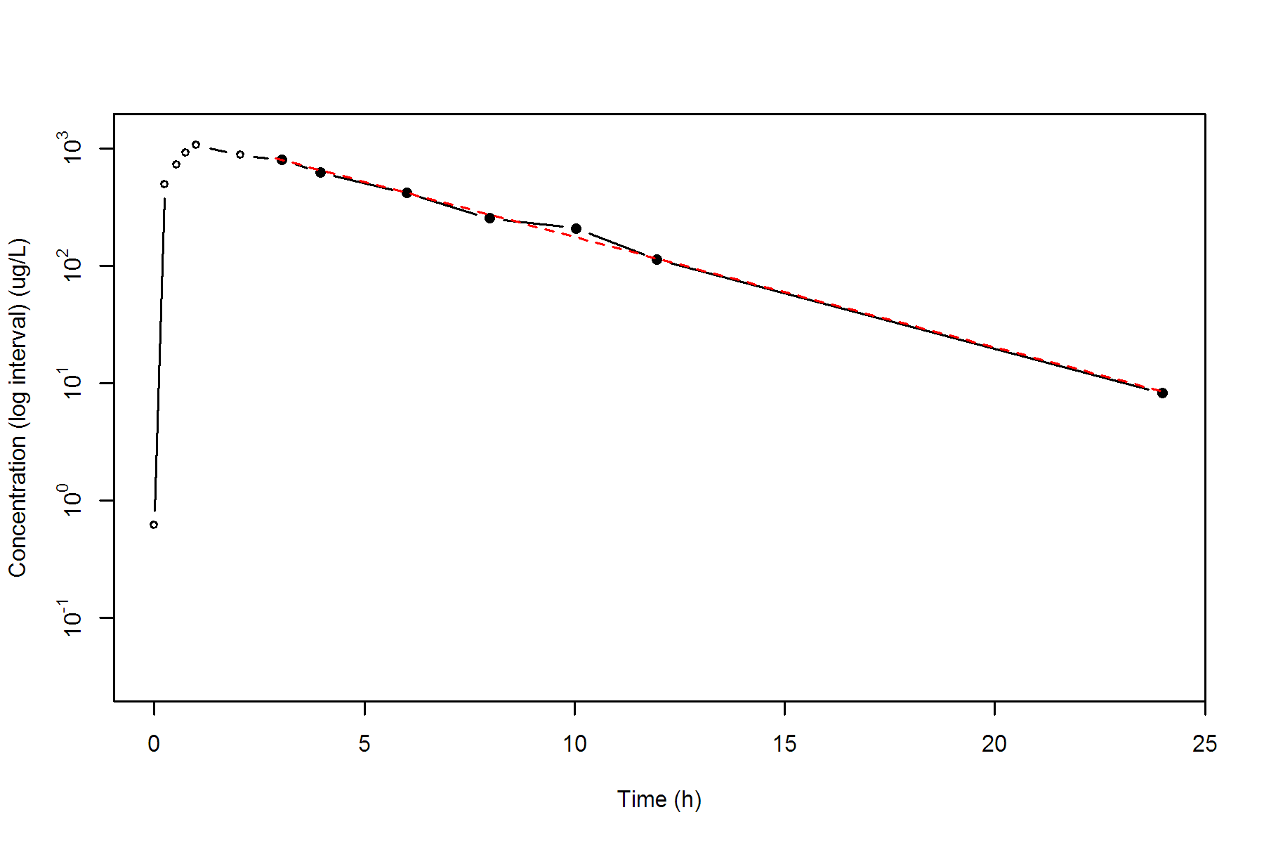

**SUBJ 21, GRP RT, PRD 1, TRT R**

NONCOMPARTMENTAL ANALYSIS REPORT

Package version 0.3.9 (2018-05-10 KST)

R version 3.5.0 (2018-04-23)

Date and Time: 2018-06-19 09:49:35 Asia/Seoul

Calculation Setting

-------------------

Drug Administration: Extravascular

Observation count excluding trailing zero: 13

Dose at time 0: 0 mg

AUC Calculation Method: Linear-up Linear-down

Weighting for lambda z: Uniform (Ordinary Least Square, OLS)

Lambda z selection criterion: Heighest adjusted R-squared value with precision=1e-4

Fitting, AUC, AUMC Result

-------------------------

Time Conc. Pred. Residual AUC AUMC

---------------------------------------------------------------------

0.0000 0.0000 0.0000 0.0000

0.2600 640.3600 83.2468 21.6442

0.5300 597.2600 250.3255 86.8548

0.7500 665.2600 389.2027 176.5590

0.9700 742.6700 544.0750 310.6858

2.0400 712.3200 1322.4947 1473.5204

2.9800 467.4100 1876.9678 2811.1473

4.0200 * 504.3100 478.4633 +2.585e+01 2382.2621 4589.6555

6.0200 * 310.4600 347.3735 -3.691e+01 3197.0321 8485.9509

7.9700 * 270.8500 254.2266 +1.662e+01 3763.8094 12412.9035

9.9700 * 159.1600 184.5734 -2.541e+01 4193.8194 16158.4032

12.0100 * 157.7200 133.1484 +2.457e+01 4517.0370 19709.0664

24.0500 * 18.9000 19.3751 -4.751e-01 5580.2894 33848.6149

*: Used for the calculation of Lambda z.

Calculated Values

-----------------

CMAX Max Conc 742.6700 ug/L

TMAX Time of CMAX 0.9700 h

TLAG Time Until First Nonzero Conc 0.0000 h

CLST Last Nonzero Conc 18.9000 ug/L

CLSTP Last Nonzero Conc Pred 19.3751 ug/L

TLST Time of Last Nonzero Conc 24.0500 h

LAMZHL Half-Life Lambda z 4.3297 h

LAMZ Lambda z 0.1601 /h

LAMZLL Lambda z Lower Limit 4.0200 h

LAMZUL Lambda z Upper Limit 24.0500 h

LAMZNPT Number of Points for Lambda z 6

CORRXY Correlation Between TimeX and Log ConcY -0.9946

R2 R Squared 0.9893

R2ADJ R Squared Adjusted 0.9866

AUCLST AUC to Last Nonzero Conc 5580.2894 h*ug/L

AUCALL AUC All 5580.2894 h*ug/L

AUCIFO AUC Infinity Obs 5698.3484 h*ug/L

AUCIFP AUC Infinity Pred 5701.3159 h*ug/L

AUCPEO AUC %Extrapolation Obs 2.0718 %

AUCPEP AUC %Extrapolation Pred 2.1228 %

AUMCLST AUMC to Last Nonzero Conc 33848.6149 h2*ug/L

AUMCIFO AUMC Infinity Obs 37425.3889 h2*ug/L

AUMCIFP AUMC Infinity Pred 37515.2935 h2*ug/L

AUMCPEO AUMC %Extrapolation Obs 9.5571 %

AUMCPEP AUMC % Extrapolation Pred 9.7738 %

VZFO Vz Obs by F 0.0000 L

VZFP Vz Pred by F 0.0000 L

CLFO Total CL Obs by F 0.0000 L/h

CLFP Total CL Pred by F 0.0000 L/h

MRTEVLST MRT Extravasc to Last Nonzero Conc 6.0657 h

MRTEVIFO MRT Extravasc Infinity Obs 6.5678 h

MRTEVIFP MRT Extravasc Infinity Pred 6.5801 h

**SUBJ 21, GRP RT, PRD 1, TRT R**

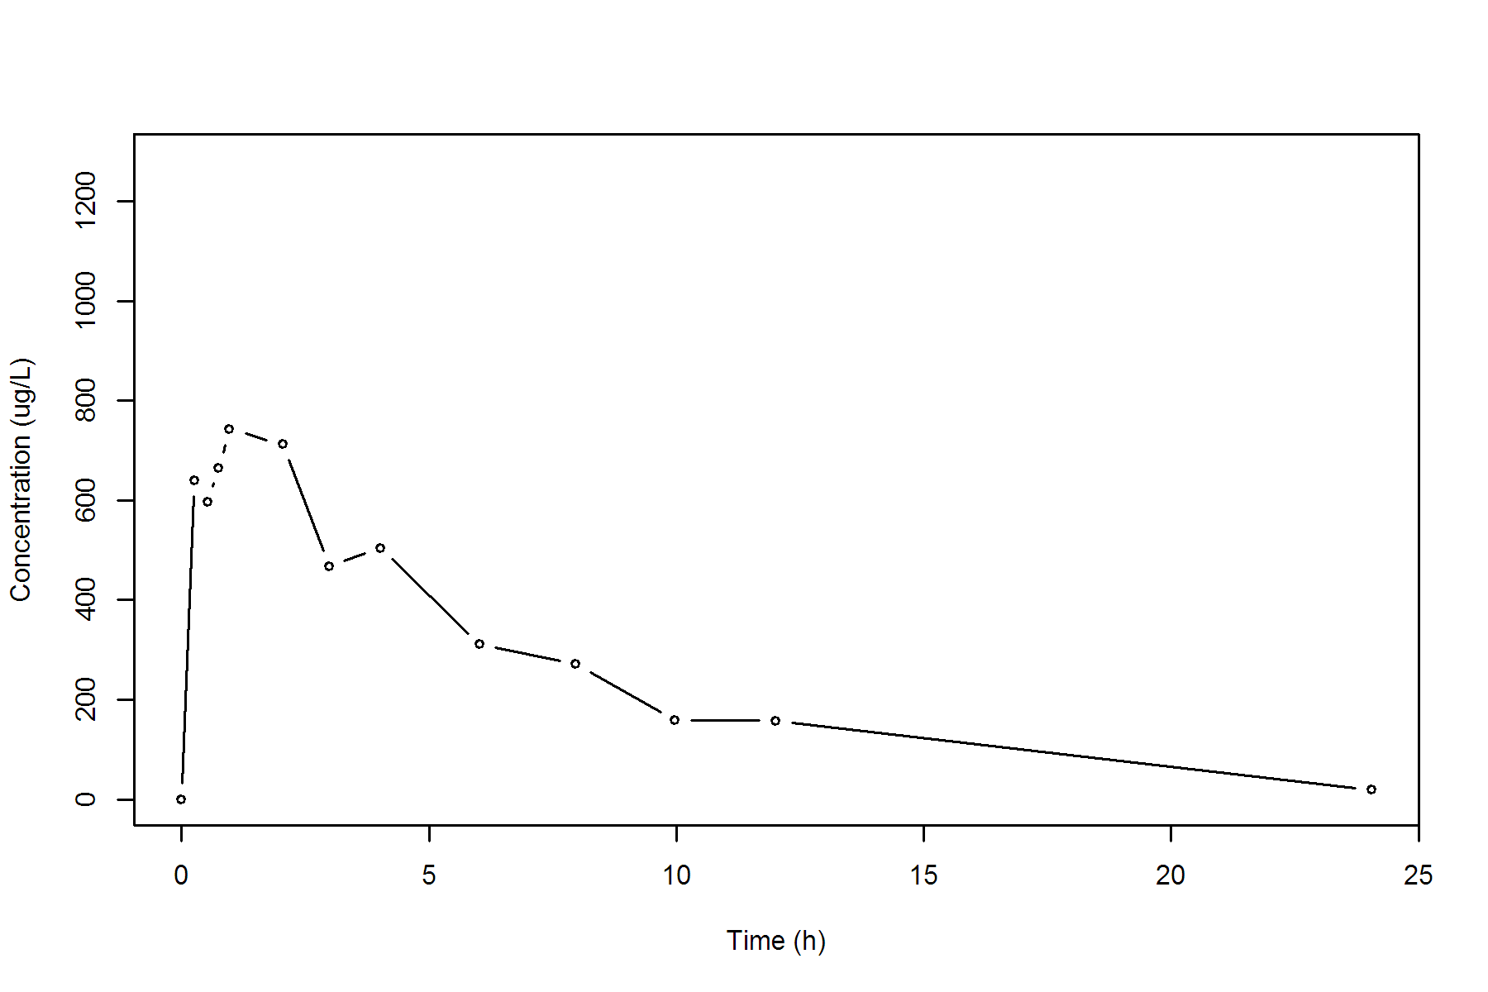

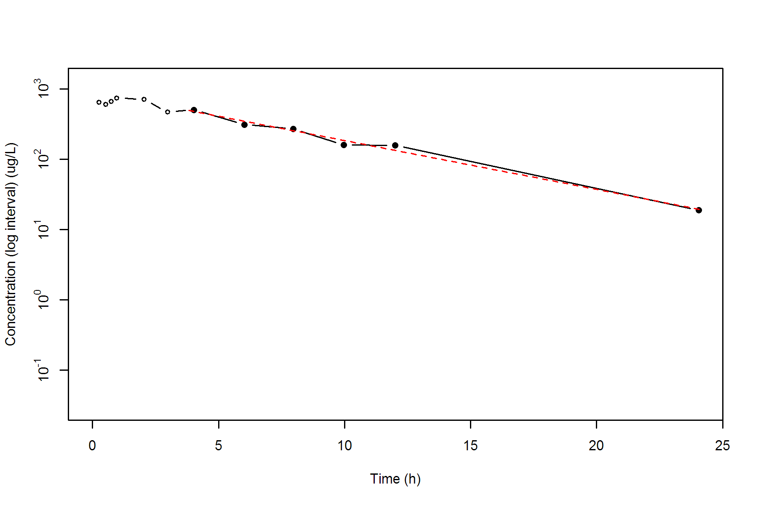

**SUBJ 21, GRP RT, PRD 2, TRT T**

NONCOMPARTMENTAL ANALYSIS REPORT

Package version 0.3.9 (2018-05-10 KST)

R version 3.5.0 (2018-04-23)

Date and Time: 2018-06-19 09:49:35 Asia/Seoul

Calculation Setting

-------------------

Drug Administration: Extravascular

Observation count excluding trailing zero: 13

Dose at time 0: 0 mg

AUC Calculation Method: Linear-up Linear-down

Weighting for lambda z: Uniform (Ordinary Least Square, OLS)

Lambda z selection criterion: Heighest adjusted R-squared value with precision=1e-4

Fitting, AUC, AUMC Result

-------------------------

Time Conc. Pred. Residual AUC AUMC

---------------------------------------------------------------------

0.0000 0.0000 0.0000 0.0000

0.3000 290.5900 43.5885 13.0765

0.5500 419.0000 132.2873 52.7799

0.7100 432.4200 200.4009 95.7774

0.9900 447.8500 323.6387 200.8319

2.0100 359.0000 735.1321 794.9623

3.0200 446.5600 1141.9400 1840.4139

4.0300 379.6700 1559.1861 3294.1480

5.9600 347.5500 2260.9534 6769.5647

8.0400 267.0700 2900.1582 11156.9511

9.9800 * 266.5000 277.6436 -1.114e+01 3417.7211 15819.6565

12.0100 * 261.3600 249.1375 +1.222e+01 3953.4990 21705.2392

24.0100 * 130.4100 131.3168 -9.068e-01 6304.1190 59325.7054

*: Used for the calculation of Lambda z.

Calculated Values

-----------------

CMAX Max Conc 447.8500 ug/L

TMAX Time of CMAX 0.9900 h

TLAG Time Until First Nonzero Conc 0.0000 h

CLST Last Nonzero Conc 130.4100 ug/L

CLSTP Last Nonzero Conc Pred 131.3168 ug/L

TLST Time of Last Nonzero Conc 24.0100 h

LAMZHL Half-Life Lambda z 12.9886 h

LAMZ Lambda z 0.0534 /h

LAMZLL Lambda z Lower Limit 9.9800 h

LAMZUL Lambda z Upper Limit 24.0100 h

LAMZNPT Number of Points for Lambda z 3

CORRXY Correlation Between TimeX and Log ConcY -0.9939

R2 R Squared 0.9879

R2ADJ R Squared Adjusted 0.9757

AUCLST AUC to Last Nonzero Conc 6304.1190 h*ug/L

AUCALL AUC All 6304.1190 h*ug/L

AUCIFO AUC Infinity Obs 8747.8094 h*ug/L

AUCIFP AUC Infinity Pred 8764.8023 h*ug/L

AUCPEO AUC %Extrapolation Obs 27.9349 %

AUCPEP AUC %Extrapolation Pred 28.0746 %

AUMCLST AUMC to Last Nonzero Conc 59325.7054 h2*ug/L

AUMCIFO AUMC Infinity Obs 163789.8542 h2*ug/L

AUMCIFP AUMC Infinity Pred 164516.2761 h2*ug/L

AUMCPEO AUMC %Extrapolation Obs 63.7794 %

AUMCPEP AUMC % Extrapolation Pred 63.9393 %

VZFO Vz Obs by F 0.0000 L

VZFP Vz Pred by F 0.0000 L

CLFO Total CL Obs by F 0.0000 L/h

CLFP Total CL Pred by F 0.0000 L/h

MRTEVLST MRT Extravasc to Last Nonzero Conc 9.4106 h

MRTEVIFO MRT Extravasc Infinity Obs 18.7235 h

MRTEVIFP MRT Extravasc Infinity Pred 18.7701 h

**SUBJ 21, GRP RT, PRD 2, TRT T**

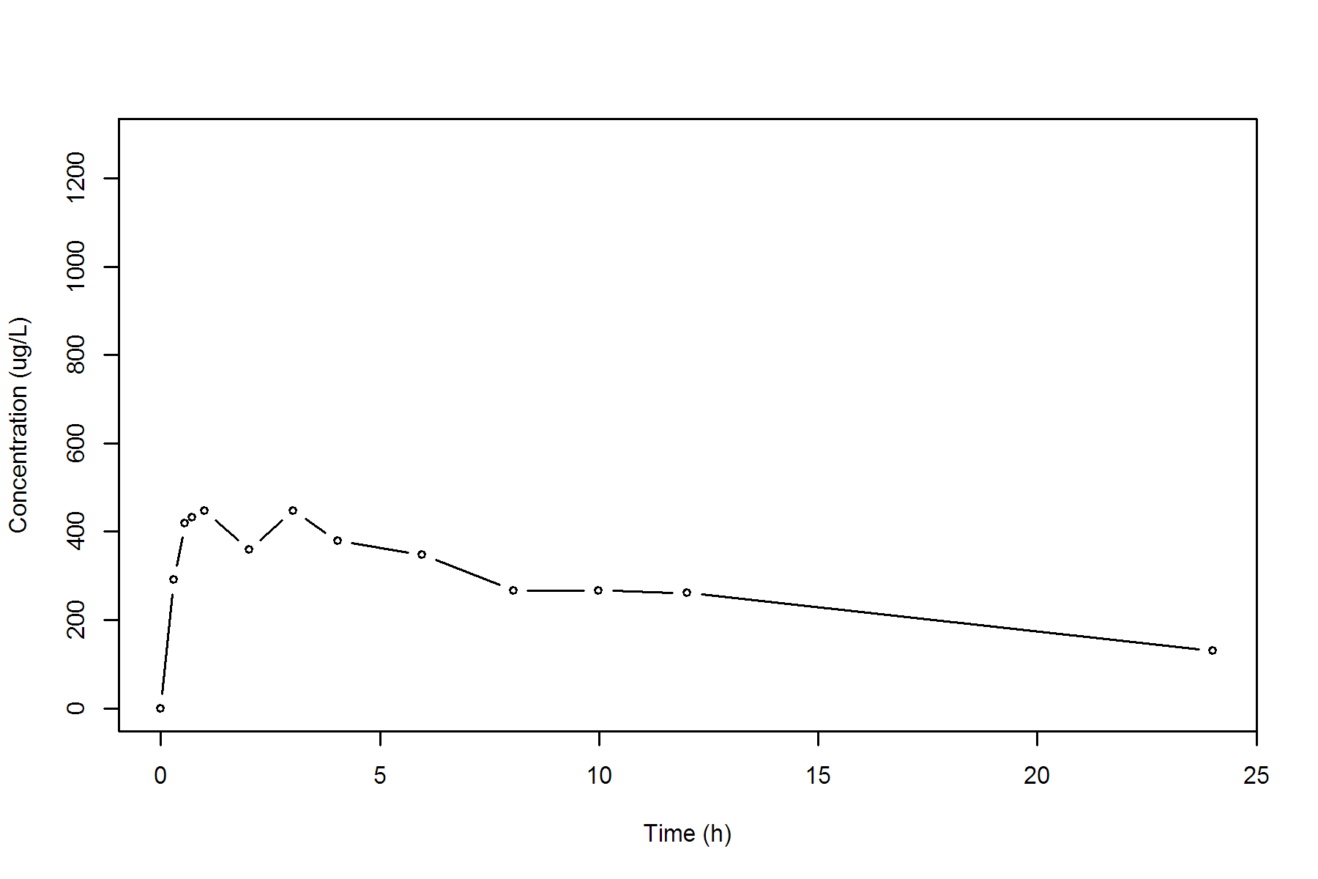

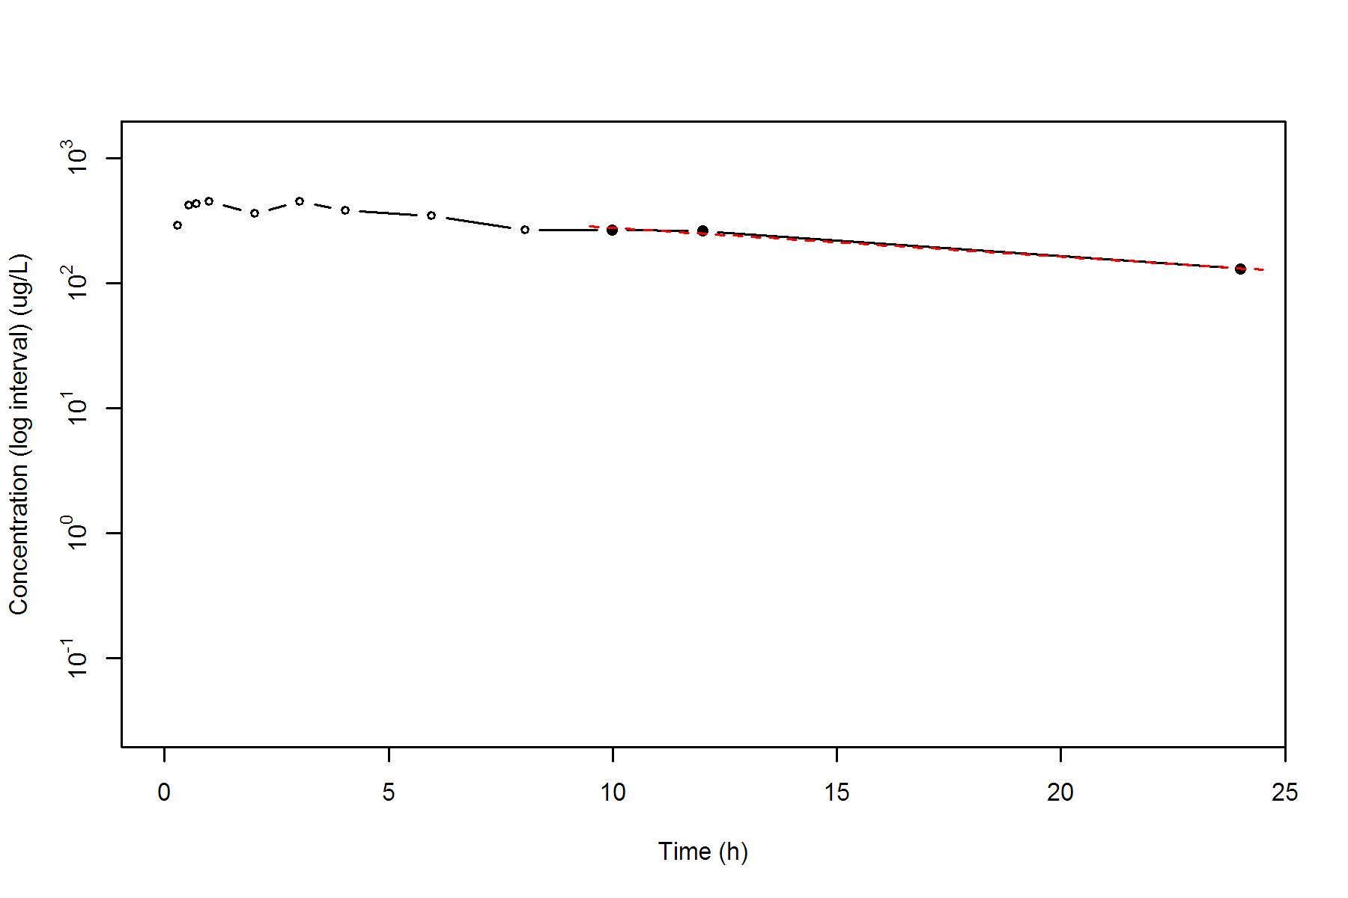

**SUBJ 22, GRP RT, PRD 1, TRT R**

NONCOMPARTMENTAL ANALYSIS REPORT

Package version 0.3.9 (2018-05-10 KST)

R version 3.5.0 (2018-04-23)

Date and Time: 2018-06-19 09:49:35 Asia/Seoul

Calculation Setting

-------------------

Drug Administration: Extravascular

Observation count excluding trailing zero: 13

Dose at time 0: 0 mg

AUC Calculation Method: Linear-up Linear-down

Weighting for lambda z: Uniform (Ordinary Least Square, OLS)

Lambda z selection criterion: Heighest adjusted R-squared value with precision=1e-4

Fitting, AUC, AUMC Result

-------------------------

Time Conc. Pred. Residual AUC AUMC

---------------------------------------------------------------------

0.0000 0.0000 0.0000 0.0000

0.2300 208.3300 23.9580 5.5103

0.5500 366.1700 115.8780 45.3998

0.7300 475.2800 191.6085 94.7511

1.0000 494.7500 322.5625 208.3812

2.0200 682.7300 923.0773 1164.0522

2.9700 429.4000 1451.3391 2424.9077

4.0100 442.0300 1904.4827 4009.7940

5.9900 310.3600 2649.3488 7605.0747

8.0400 173.8400 3145.6538 10943.2230

10.0100 * 139.4400 146.1666 -6.727e+00 3454.2346 13694.7889

11.9500 * 106.8500 101.1631 +5.687e+00 3693.1359 16287.2613

24.0100 * 10.1900 10.2675 -7.752e-02 4398.8871 25462.0233

*: Used for the calculation of Lambda z.

Calculated Values

-----------------

CMAX Max Conc 682.7300 ug/L

TMAX Time of CMAX 2.0200 h

TLAG Time Until First Nonzero Conc 0.0000 h

CLST Last Nonzero Conc 10.1900 ug/L

CLSTP Last Nonzero Conc Pred 10.2675 ug/L

TLST Time of Last Nonzero Conc 24.0100 h

LAMZHL Half-Life Lambda z 3.6540 h

LAMZ Lambda z 0.1897 /h

LAMZLL Lambda z Lower Limit 10.0100 h

LAMZUL Lambda z Upper Limit 24.0100 h

LAMZNPT Number of Points for Lambda z 3

CORRXY Correlation Between TimeX and Log ConcY -0.9994

R2 R Squared 0.9987

R2ADJ R Squared Adjusted 0.9975

AUCLST AUC to Last Nonzero Conc 4398.8871 h*ug/L

AUCALL AUC All 4398.8871 h*ug/L

AUCIFO AUC Infinity Obs 4452.6042 h*ug/L

AUCIFP AUC Infinity Pred 4453.0129 h*ug/L

AUCPEO AUC %Extrapolation Obs 1.2064 %

AUCPEP AUC %Extrapolation Pred 1.2155 %

AUMCLST AUMC to Last Nonzero Conc 25462.0233 h2*ug/L

AUMCIFO AUMC Infinity Obs 27034.9457 h2*ug/L

AUMCIFP AUMC Infinity Pred 27046.9116 h2*ug/L

AUMCPEO AUMC %Extrapolation Obs 5.8181 %

AUMCPEP AUMC % Extrapolation Pred 5.8598 %

VZFO Vz Obs by F 0.0000 L

VZFP Vz Pred by F 0.0000 L

CLFO Total CL Obs by F 0.0000 L/h

CLFP Total CL Pred by F 0.0000 L/h

MRTEVLST MRT Extravasc to Last Nonzero Conc 5.7883 h

MRTEVIFO MRT Extravasc Infinity Obs 6.0717 h

MRTEVIFP MRT Extravasc Infinity Pred 6.0738 h

**SUBJ 22, GRP RT, PRD 1, TRT R**

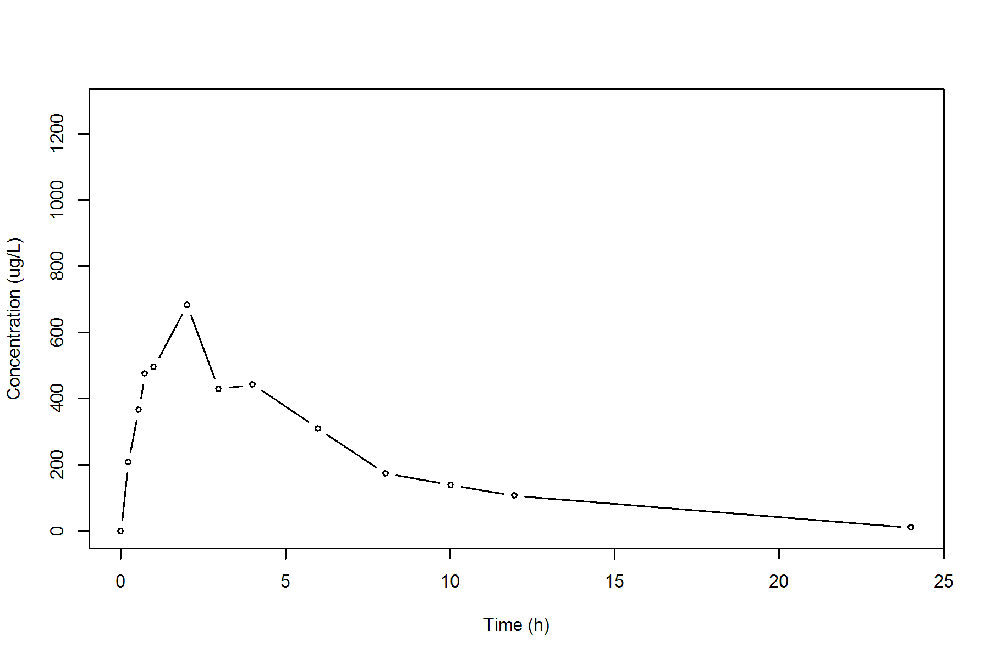

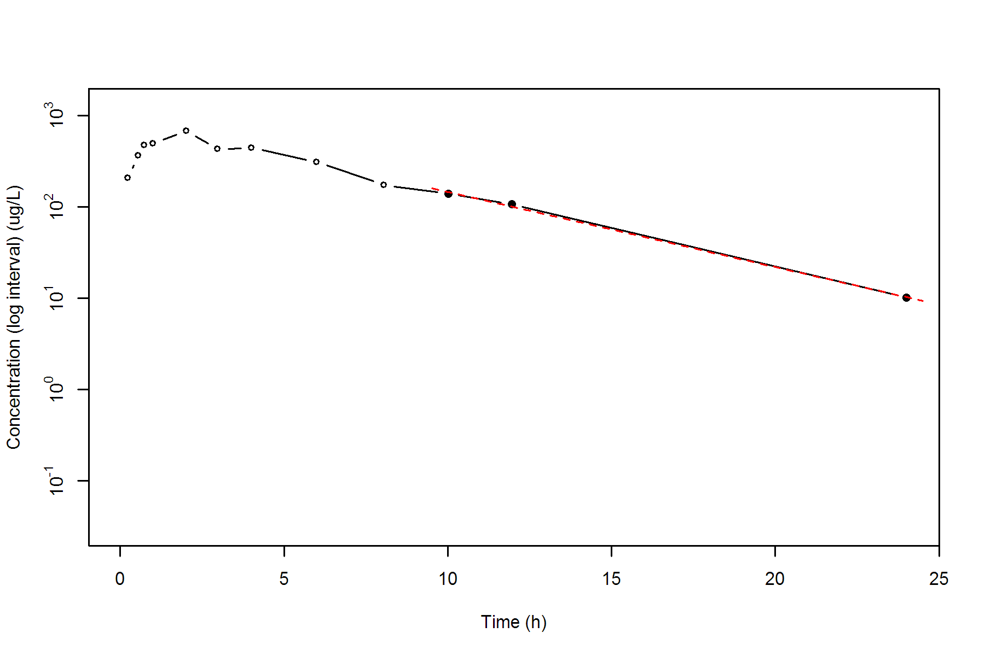

**SUBJ 22, GRP RT, PRD 2, TRT T**

NONCOMPARTMENTAL ANALYSIS REPORT

Package version 0.3.9 (2018-05-10 KST)

R version 3.5.0 (2018-04-23)

Date and Time: 2018-06-19 09:49:35 Asia/Seoul

Calculation Setting

-------------------

Drug Administration: Extravascular

Observation count excluding trailing zero: 13

Dose at time 0: 0 mg

AUC Calculation Method: Linear-up Linear-down

Weighting for lambda z: Uniform (Ordinary Least Square, OLS)

Lambda z selection criterion: Heighest adjusted R-squared value with precision=1e-4

Fitting, AUC, AUMC Result

-------------------------

Time Conc. Pred. Residual AUC AUMC

---------------------------------------------------------------------

0.0000 0.0000 0.0000 0.0000

0.2300 419.2300 48.2115 11.0886

0.5200 663.8400 205.2566 75.1235

0.7100 593.5300 324.7068 147.9508

1.0400 669.0100 533.0259 332.2849

2.0400 524.7000 1129.8809 1215.3641

3.0200 * 440.0600 476.2529 -3.619e+01 1602.6133 2391.0550

3.9500 * 355.2300 380.3502 -2.512e+01 1972.4231 3661.5000

5.9600 * 239.2700 233.9510 +5.319e+00 2569.8956 6504.8537

8.0100 * 142.7100 142.5168 +1.932e-01 2961.4251 9138.2390

9.9600 * 90.1600 88.9422 +1.218e+00 3188.4734 11128.3121

12.0500 * 65.6400 53.6598 +1.198e+01 3351.2844 12893.2707

24.0200 * 2.7100 2.9699 -2.599e-01 3760.3591 18016.7671

*: Used for the calculation of Lambda z.

Calculated Values

-----------------

CMAX Max Conc 669.0100 ug/L

TMAX Time of CMAX 1.0400 h

TLAG Time Until First Nonzero Conc 0.0000 h

CLST Last Nonzero Conc 2.7100 ug/L

CLSTP Last Nonzero Conc Pred 2.9699 ug/L

TLST Time of Last Nonzero Conc 24.0200 h

LAMZHL Half-Life Lambda z 2.8668 h

LAMZ Lambda z 0.2418 /h

LAMZLL Lambda z Lower Limit 3.0200 h

LAMZUL Lambda z Upper Limit 24.0200 h

LAMZNPT Number of Points for Lambda z 7

CORRXY Correlation Between TimeX and Log ConcY -0.9983

R2 R Squared 0.9966

R2ADJ R Squared Adjusted 0.9959

AUCLST AUC to Last Nonzero Conc 3760.3591 h*ug/L

AUCALL AUC All 3760.3591 h*ug/L

AUCIFO AUC Infinity Obs 3771.5676 h*ug/L

AUCIFP AUC Infinity Pred 3772.6427 h*ug/L

AUCPEO AUC %Extrapolation Obs 0.2972 %

AUCPEP AUC %Extrapolation Pred 0.3256 %

AUMCLST AUMC to Last Nonzero Conc 18016.7671 h2*ug/L

AUMCIFO AUMC Infinity Obs 18332.3525 h2*ug/L

AUMCIFP AUMC Infinity Pred 18362.6227 h2*ug/L

AUMCPEO AUMC %Extrapolation Obs 1.7215 %

AUMCPEP AUMC % Extrapolation Pred 1.8835 %

VZFO Vz Obs by F 0.0000 L

VZFP Vz Pred by F 0.0000 L

CLFO Total CL Obs by F 0.0000 L/h

CLFP Total CL Pred by F 0.0000 L/h

MRTEVLST MRT Extravasc to Last Nonzero Conc 4.7912 h

MRTEVIFO MRT Extravasc Infinity Obs 4.8607 h

MRTEVIFP MRT Extravasc Infinity Pred 4.8673 h

**SUBJ 22, GRP RT, PRD 2, TRT T**

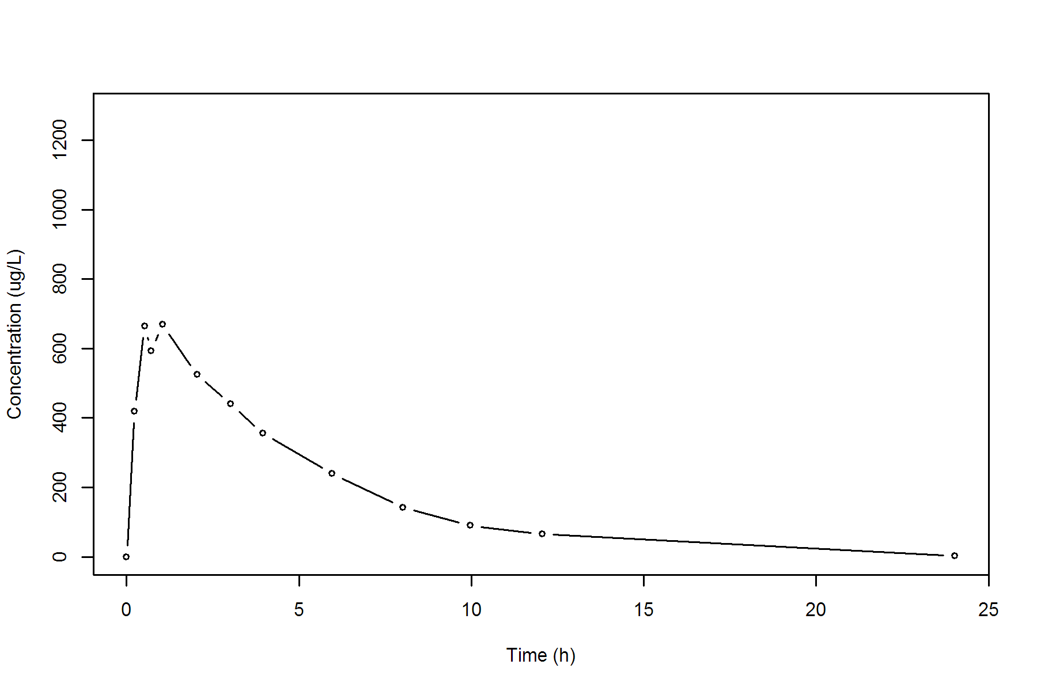

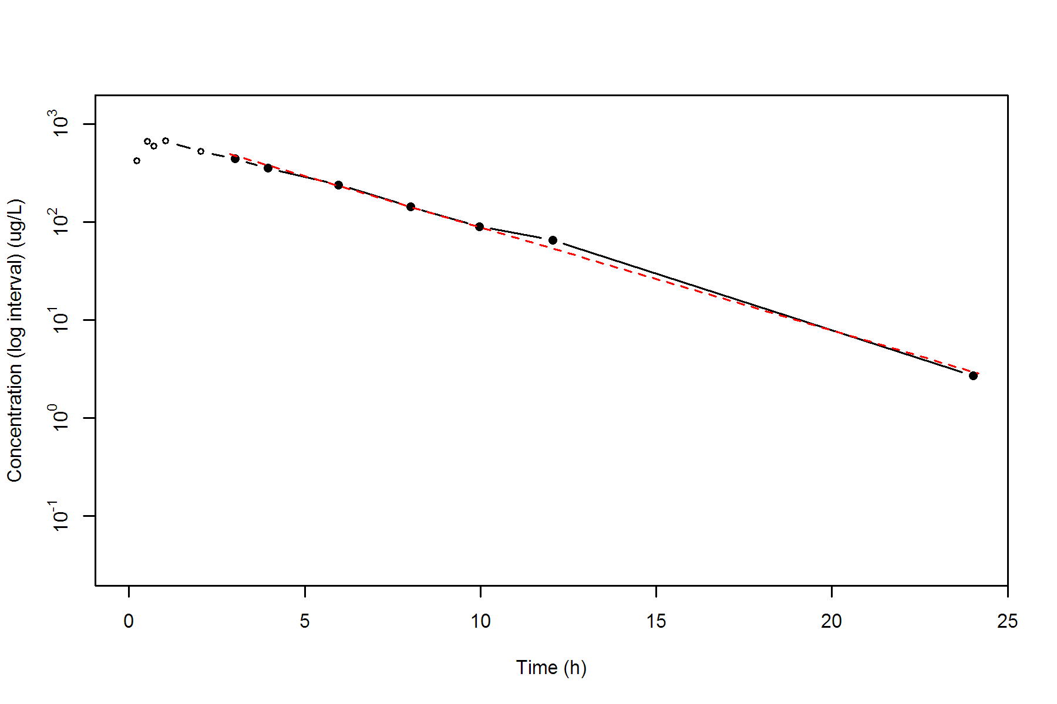

**SUBJ 23, GRP TR, PRD 1, TRT T**

NONCOMPARTMENTAL ANALYSIS REPORT

Package version 0.3.9 (2018-05-10 KST)

R version 3.5.0 (2018-04-23)

Date and Time: 2018-06-19 09:49:35 Asia/Seoul

Calculation Setting

-------------------

Drug Administration: Extravascular

Observation count excluding trailing zero: 13

Dose at time 0: 0 mg

AUC Calculation Method: Linear-up Linear-down

Weighting for lambda z: Uniform (Ordinary Least Square, OLS)

Lambda z selection criterion: Heighest adjusted R-squared value with precision=1e-4

Fitting, AUC, AUMC Result

-------------------------

Time Conc. Pred. Residual AUC AUMC

---------------------------------------------------------------------

0.0000 0.0000 0.0000 0.0000

0.2300 595.3600 68.4664 15.7473

0.5100 937.0200 282.9996 101.8211

0.7200 894.0700 475.2641 219.5902

1.0200 625.3200 703.1726 411.8237

2.0100 660.3400 1339.5742 1384.5531

3.0200 553.5100 1952.5685 2898.9893

3.9900 497.1400 2462.1338 4671.7559

5.9700 326.8500 3277.8839 8567.2901

8.0100 251.9500 3868.2599 12616.0924

9.9700 * 149.4100 143.0590 +6.351e+00 4261.5927 16053.6749

11.9700 * 94.4500 99.3573 -4.907e+00 4505.4527 18673.8591

24.0100 * 11.1500 11.0698 +8.016e-02 5141.1647 27091.4926

*: Used for the calculation of Lambda z.

Calculated Values

-----------------

CMAX Max Conc 937.0200 ug/L

TMAX Time of CMAX 0.5100 h

TLAG Time Until First Nonzero Conc 0.0000 h

CLST Last Nonzero Conc 11.1500 ug/L

CLSTP Last Nonzero Conc Pred 11.0698 ug/L

TLST Time of Last Nonzero Conc 24.0100 h

LAMZHL Half-Life Lambda z 3.8029 h

LAMZ Lambda z 0.1823 /h

LAMZLL Lambda z Lower Limit 9.9700 h

LAMZUL Lambda z Upper Limit 24.0100 h

LAMZNPT Number of Points for Lambda z 3

CORRXY Correlation Between TimeX and Log ConcY -0.9994

R2 R Squared 0.9988

R2ADJ R Squared Adjusted 0.9977

AUCLST AUC to Last Nonzero Conc 5141.1647 h*ug/L

AUCALL AUC All 5141.1647 h*ug/L

AUCIFO AUC Infinity Obs 5202.3385 h*ug/L

AUCIFP AUC Infinity Pred 5201.8987 h*ug/L

AUCPEO AUC %Extrapolation Obs 1.1759 %

AUCPEP AUC %Extrapolation Pred 1.1675 %

AUMCLST AUMC to Last Nonzero Conc 27091.4926 h2*ug/L

AUMCIFO AUMC Infinity Obs 28895.9047 h2*ug/L

AUMCIFP AUMC Infinity Pred 28882.9320 h2*ug/L

AUMCPEO AUMC %Extrapolation Obs 6.2445 %

AUMCPEP AUMC % Extrapolation Pred 6.2024 %

VZFO Vz Obs by F 0.0000 L

VZFP Vz Pred by F 0.0000 L

CLFO Total CL Obs by F 0.0000 L/h

CLFP Total CL Pred by F 0.0000 L/h

MRTEVLST MRT Extravasc to Last Nonzero Conc 5.2695 h

MRTEVIFO MRT Extravasc Infinity Obs 5.5544 h

MRTEVIFP MRT Extravasc Infinity Pred 5.5524 h

**SUBJ 23, GRP TR, PRD 1, TRT T**

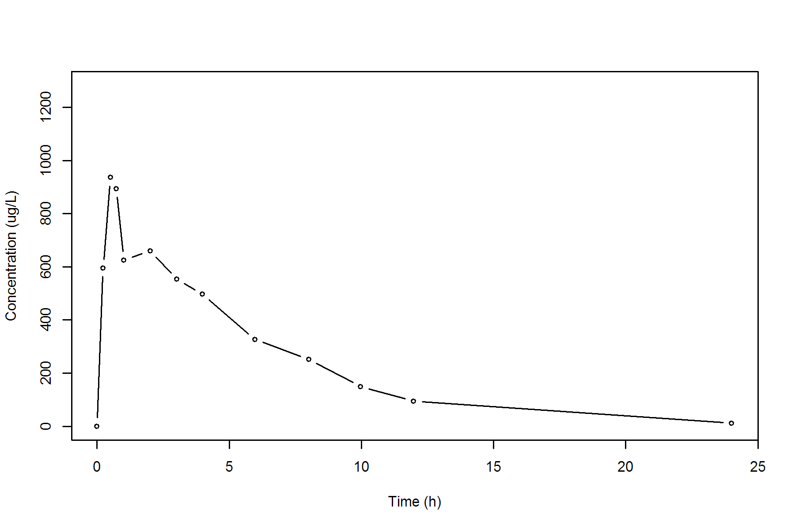

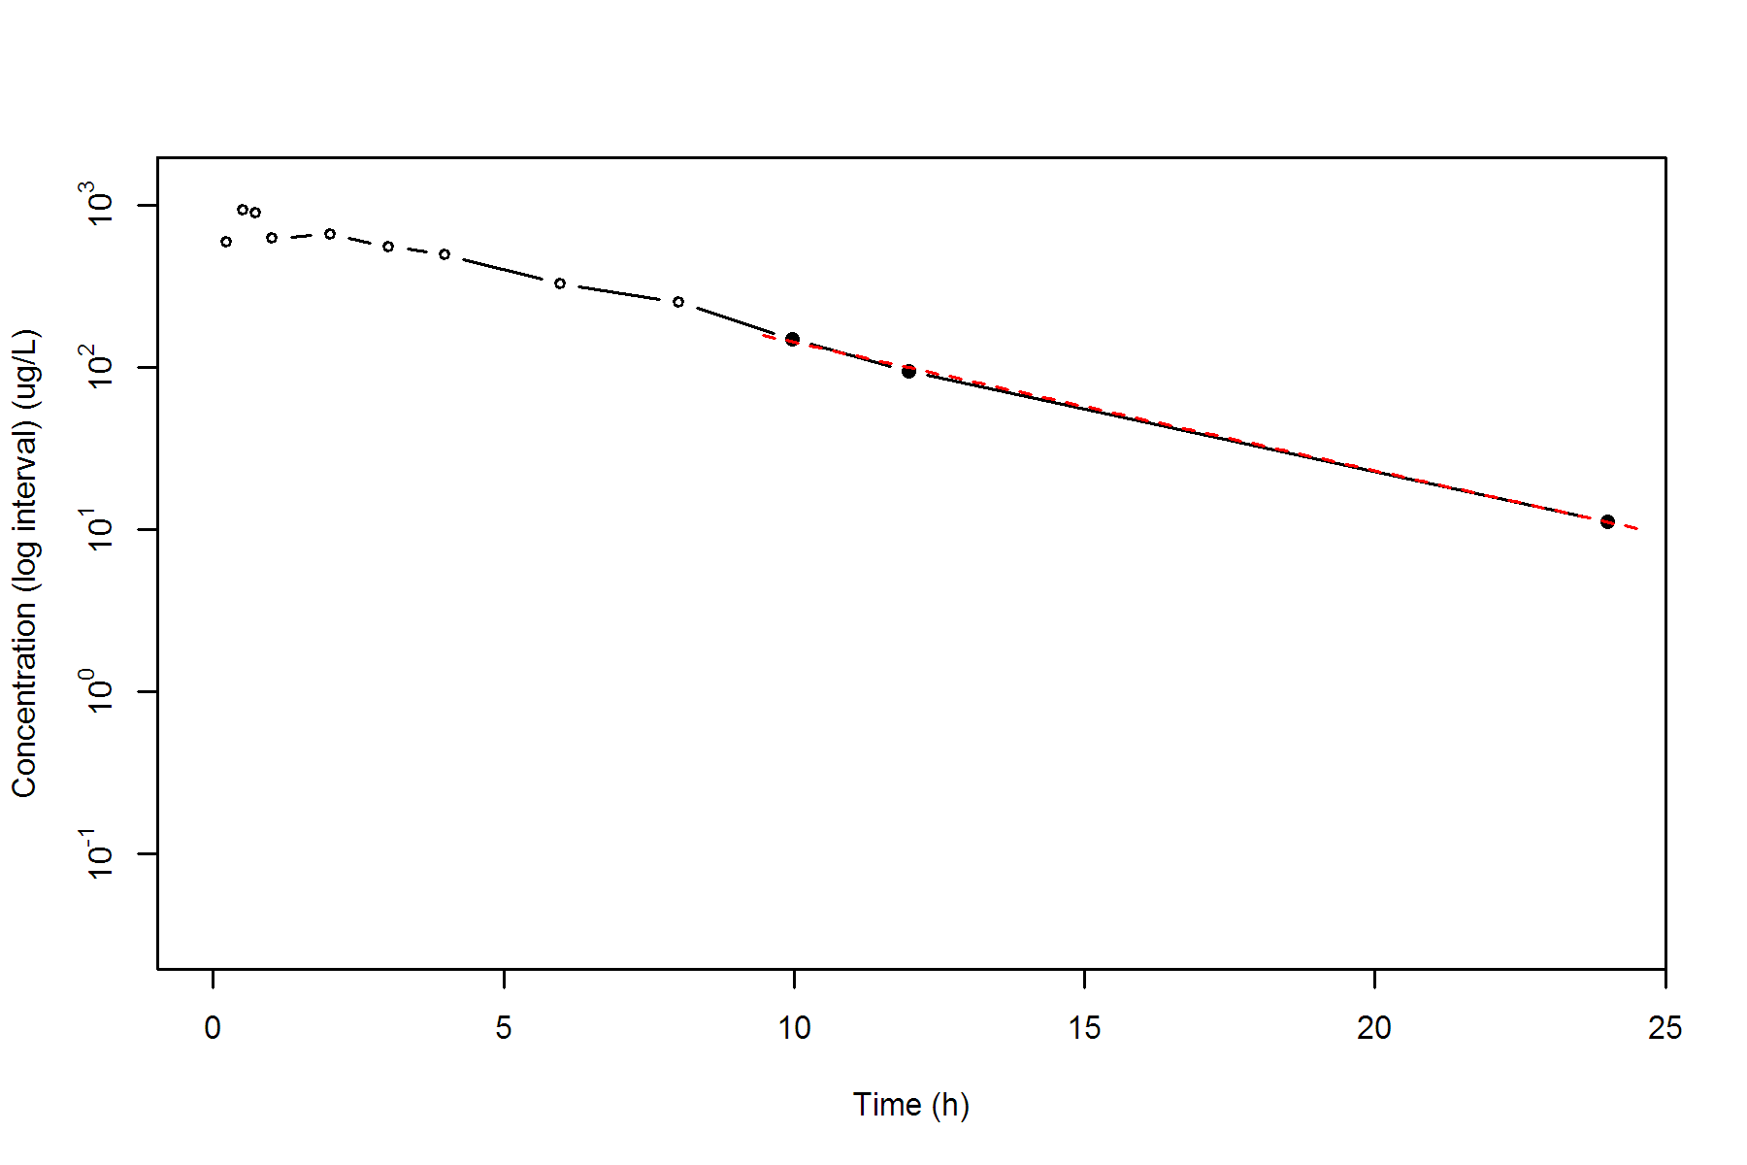

**SUBJ 23, GRP TR, PRD 2, TRT R**

NONCOMPARTMENTAL ANALYSIS REPORT

Package version 0.3.9 (2018-05-10 KST)

R version 3.5.0 (2018-04-23)

Date and Time: 2018-06-19 09:49:36 Asia/Seoul

Calculation Setting

-------------------

Drug Administration: Extravascular

Observation count excluding trailing zero: 13

Dose at time 0: 0 mg

AUC Calculation Method: Linear-up Linear-down

Weighting for lambda z: Uniform (Ordinary Least Square, OLS)

Lambda z selection criterion: Heighest adjusted R-squared value with precision=1e-4

Fitting, AUC, AUMC Result

-------------------------

Time Conc. Pred. Residual AUC AUMC

---------------------------------------------------------------------

0.0000 0.0000 0.0000 0.0000

0.2500 389.6800 48.7100 12.1775

0.4700 608.0100 158.4559 54.3278

0.7000 757.8100 315.5252 148.1945

1.0400 894.7200 596.4553 396.5603

1.9900 808.7600 1405.6083 1603.0324

2.9900 666.9500 2143.4633 3404.8389

4.0400 716.5400 2869.7956 5971.5650

5.9700 402.2900 3949.4665 11082.6806

8.0200 205.3900 4572.3385 15232.8022

9.9800 * 160.8500 170.4617 -9.612e+00 4931.2537 18420.2628

11.9900 * 103.0100 96.2644 +6.746e+00 5196.4330 21274.8375

24.0300 * 3.1100 3.1403 -3.028e-02 5835.2754 29159.9732

*: Used for the calculation of Lambda z.

Calculated Values

-----------------

CMAX Max Conc 894.7200 ug/L

TMAX Time of CMAX 1.0400 h

TLAG Time Until First Nonzero Conc 0.0000 h

CLST Last Nonzero Conc 3.1100 ug/L

CLSTP Last Nonzero Conc Pred 3.1403 ug/L

TLST Time of Last Nonzero Conc 24.0300 h

LAMZHL Half-Life Lambda z 2.4382 h

LAMZ Lambda z 0.2843 /h

LAMZLL Lambda z Lower Limit 9.9800 h

LAMZUL Lambda z Upper Limit 24.0300 h

LAMZNPT Number of Points for Lambda z 3

CORRXY Correlation Between TimeX and Log ConcY -0.9996

R2 R Squared 0.9991

R2ADJ R Squared Adjusted 0.9983

AUCLST AUC to Last Nonzero Conc 5835.2754 h*ug/L

AUCALL AUC All 5835.2754 h*ug/L

AUCIFO AUC Infinity Obs 5846.2151 h*ug/L

AUCIFP AUC Infinity Pred 5846.3217 h*ug/L

AUCPEO AUC %Extrapolation Obs 0.1871 %

AUCPEP AUC %Extrapolation Pred 0.1889 %

AUMCLST AUMC to Last Nonzero Conc 29159.9732 h2*ug/L

AUMCIFO AUMC Infinity Obs 29461.3368 h2*ug/L

AUMCIFP AUMC Infinity Pred 29464.2710 h2*ug/L

AUMCPEO AUMC %Extrapolation Obs 1.0229 %

AUMCPEP AUMC % Extrapolation Pred 1.0328 %

VZFO Vz Obs by F 0.0000 L

VZFP Vz Pred by F 0.0000 L

CLFO Total CL Obs by F 0.0000 L/h

CLFP Total CL Pred by F 0.0000 L/h

MRTEVLST MRT Extravasc to Last Nonzero Conc 4.9972 h

MRTEVIFO MRT Extravasc Infinity Obs 5.0394 h

MRTEVIFP MRT Extravasc Infinity Pred 5.0398 h

**SUBJ 23, GRP TR, PRD 2, TRT R**

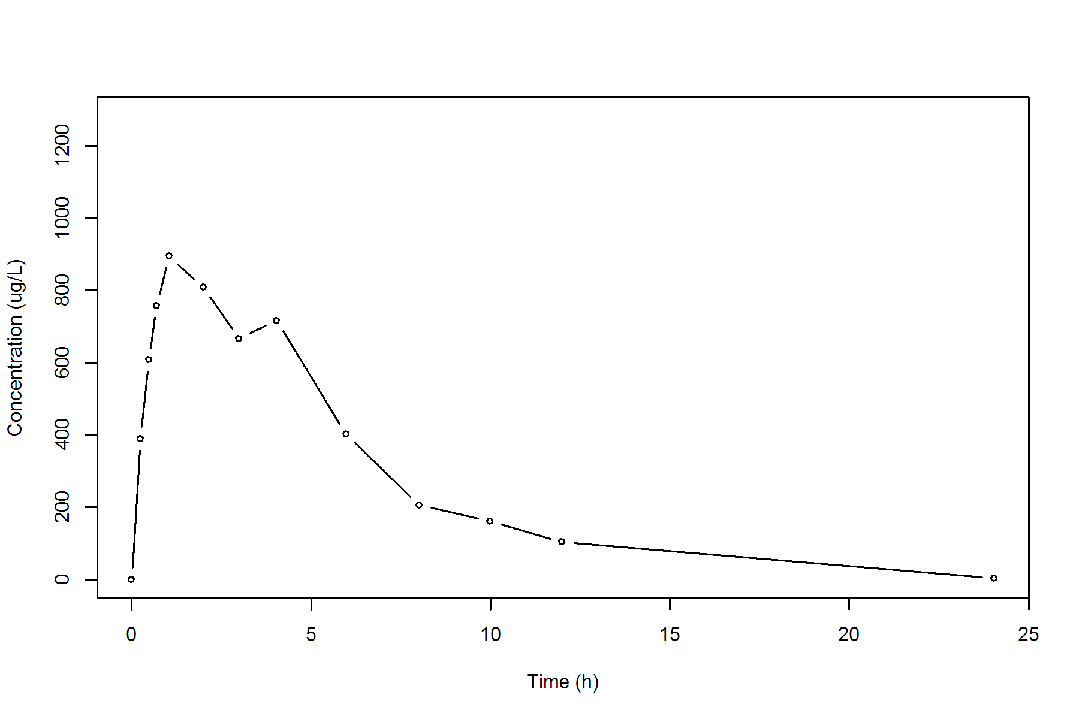

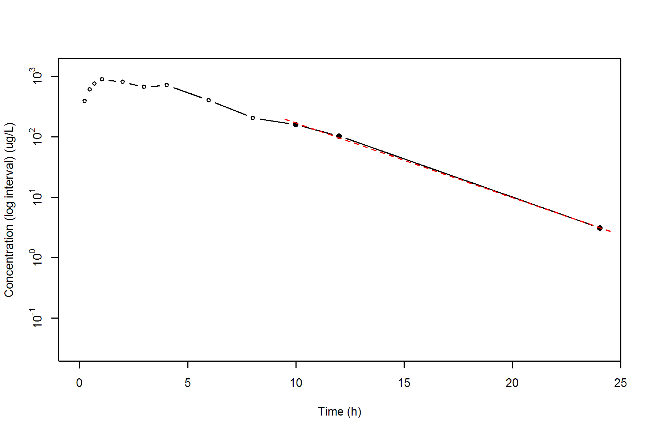

**SUBJ 24, GRP TR, PRD 1, TRT T**

NONCOMPARTMENTAL ANALYSIS REPORT

Package version 0.3.9 (2018-05-10 KST)

R version 3.5.0 (2018-04-23)

Date and Time: 2018-06-19 09:49:36 Asia/Seoul

Calculation Setting

-------------------

Drug Administration: Extravascular

Observation count excluding trailing zero: 13

Dose at time 0: 0 mg

AUC Calculation Method: Linear-up Linear-down

Weighting for lambda z: Uniform (Ordinary Least Square, OLS)

Lambda z selection criterion: Heighest adjusted R-squared value with precision=1e-4

Fitting, AUC, AUMC Result

-------------------------

Time Conc. Pred. Residual AUC AUMC

---------------------------------------------------------------------

0.0000 1.1600 0.0000 0.0000

0.2100 520.7000 54.7953 11.4814

0.5200 711.9600 245.8576 85.8142

0.7800 656.7200 423.7860 200.5341

1.0300 713.5700 595.0723 356.4364

2.0300 518.7400 1211.2273 1250.4461

3.0400 493.0000 1722.1560 2539.0860

4.0500 450.0300 2198.3861 4216.3635

5.9800 258.1800 2881.8088 7465.0725

8.0100 191.1900 3337.9193 10586.5511

10.0000 * 122.7100 118.4971 +4.213e+00 3650.2498 13331.2903

12.0500 * 75.1500 78.2903 -3.140e+00 3853.0563 15517.2642

23.9800 * 7.0600 7.0177 +4.225e-02 4343.4390 21928.7821

*: Used for the calculation of Lambda z.

Calculated Values

-----------------

CMAX Max Conc 713.5700 ug/L

TMAX Time of CMAX 1.0300 h

TLAG Time Until First Nonzero Conc 0.0000 h

CLST Last Nonzero Conc 7.0600 ug/L

CLSTP Last Nonzero Conc Pred 7.0177 ug/L

TLST Time of Last Nonzero Conc 23.9800 h

LAMZHL Half-Life Lambda z 3.4284 h

LAMZ Lambda z 0.2022 /h

LAMZLL Lambda z Lower Limit 10.0000 h

LAMZUL Lambda z Upper Limit 23.9800 h

LAMZNPT Number of Points for Lambda z 3

CORRXY Correlation Between TimeX and Log ConcY -0.9997

R2 R Squared 0.9994

R2ADJ R Squared Adjusted 0.9987

AUCLST AUC to Last Nonzero Conc 4343.4390 h*ug/L

AUCALL AUC All 4343.4390 h*ug/L

AUCIFO AUC Infinity Obs 4378.3587 h*ug/L

AUCIFP AUC Infinity Pred 4378.1497 h*ug/L

AUCPEO AUC %Extrapolation Obs 0.7976 %

AUCPEP AUC %Extrapolation Pred 0.7928 %

AUMCLST AUMC to Last Nonzero Conc 21928.7821 h2*ug/L

AUMCIFO AUMC Infinity Obs 22938.8754 h2*ug/L

AUMCIFP AUMC Infinity Pred 22932.8299 h2*ug/L

AUMCPEO AUMC %Extrapolation Obs 4.4034 %

AUMCPEP AUMC % Extrapolation Pred 4.3782 %

VZFO Vz Obs by F 0.0000 L

VZFP Vz Pred by F 0.0000 L

CLFO Total CL Obs by F 0.0000 L/h

CLFP Total CL Pred by F 0.0000 L/h

MRTEVLST MRT Extravasc to Last Nonzero Conc 5.0487 h

MRTEVIFO MRT Extravasc Infinity Obs 5.2391 h

MRTEVIFP MRT Extravasc Infinity Pred 5.2380 h

**SUBJ 24, GRP TR, PRD 1, TRT T**

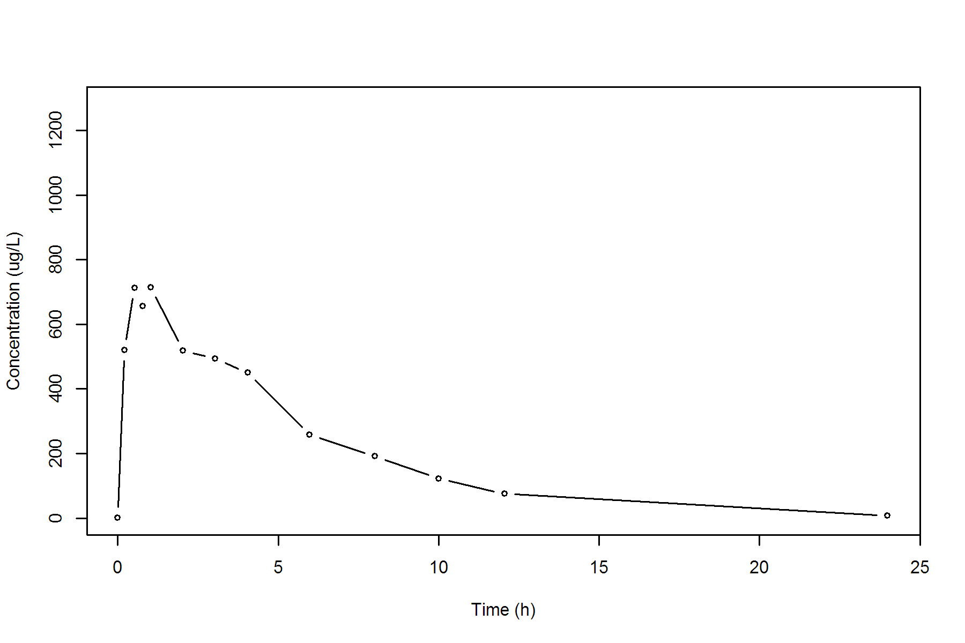

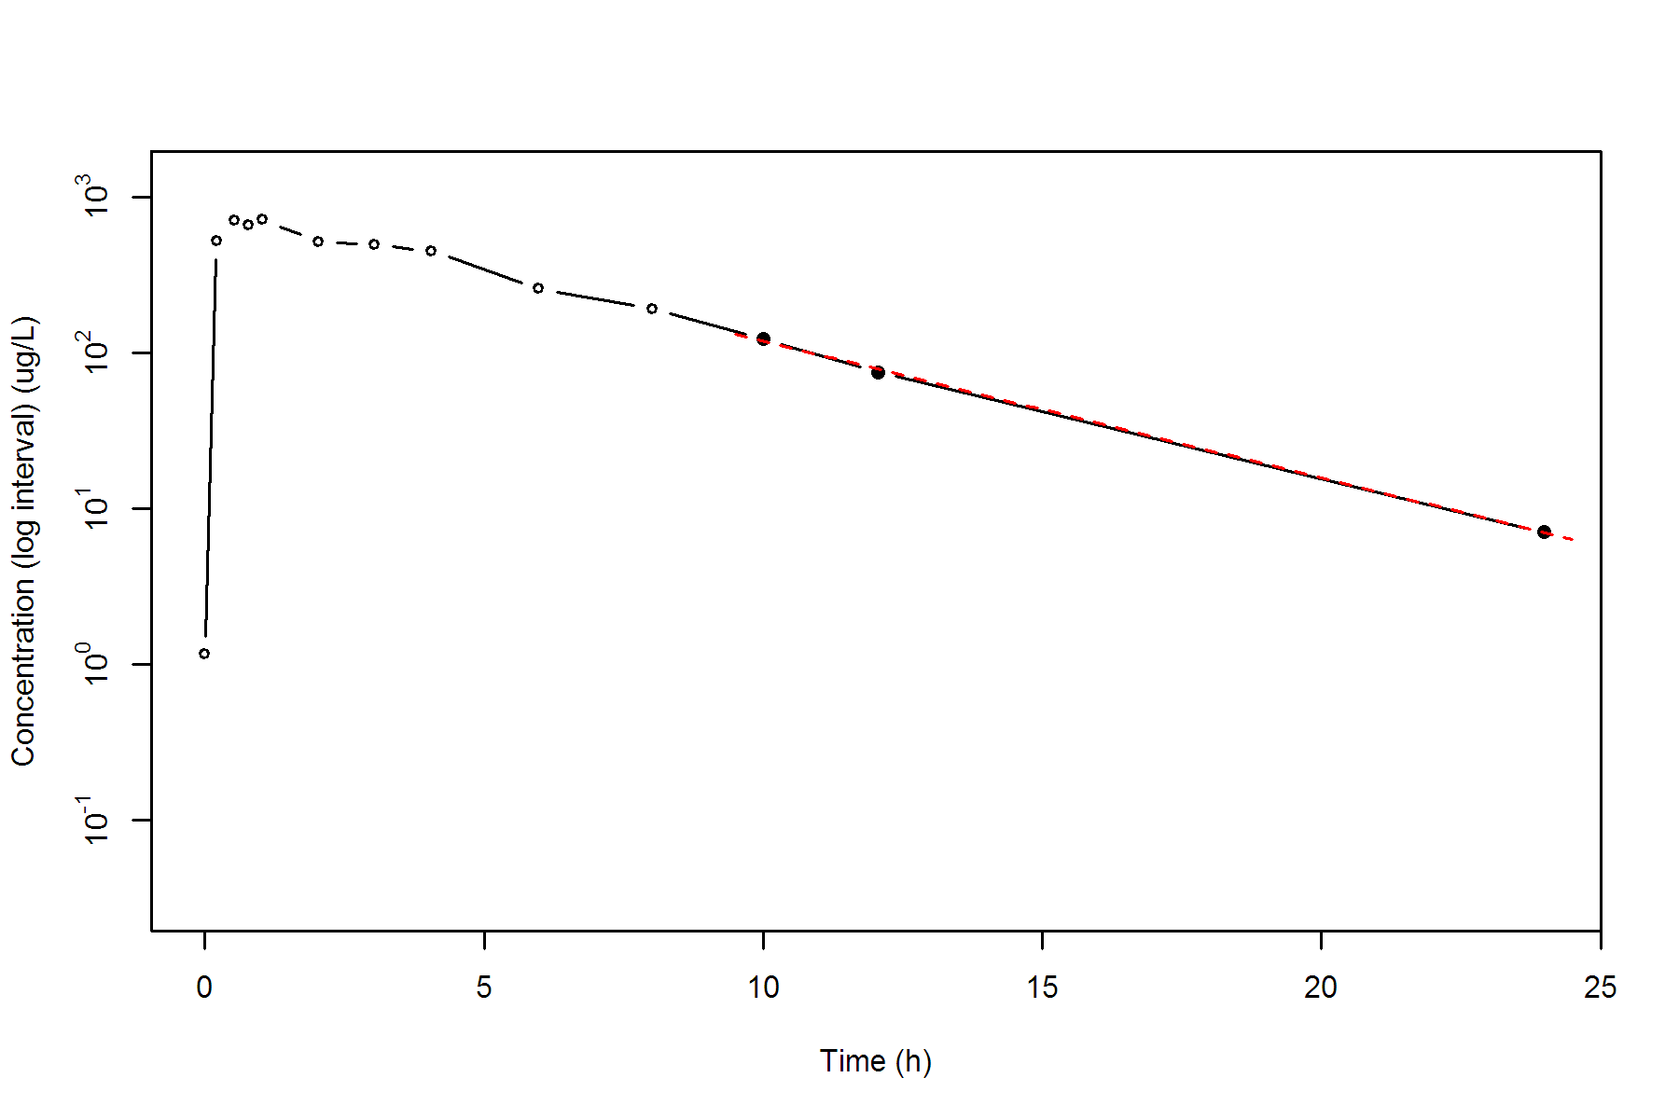

**SUBJ 24, GRP TR, PRD 2, TRT R**

NONCOMPARTMENTAL ANALYSIS REPORT

Package version 0.3.9 (2018-05-10 KST)

R version 3.5.0 (2018-04-23)

Date and Time: 2018-06-19 09:49:36 Asia/Seoul

Calculation Setting

-------------------

Drug Administration: Extravascular

Observation count excluding trailing zero: 12

Dose at time 0: 0 mg

AUC Calculation Method: Linear-up Linear-down

Weighting for lambda z: Uniform (Ordinary Least Square, OLS)

Lambda z selection criterion: Heighest adjusted R-squared value with precision=1e-4

Fitting, AUC, AUMC Result

-------------------------

Time Conc. Pred. Residual AUC AUMC

---------------------------------------------------------------------

0.0000 1.4600 0.0000 0.0000

0.2100 344.5800 36.3342 7.5980

0.5300 603.7800 188.0718 70.3764

0.7100 811.8300 315.4767 151.0527

1.0400 580.0000 545.1287 345.6865

1.9900 532.7900 1073.7039 1135.8263

2.9600 * 467.4400 472.5248 -5.085e+00 1558.8155 2321.1054

3.9900 * 333.5500 323.7207 +9.829e+00 1971.3253 3719.0662

6.0200 * 148.8000 153.6195 -4.820e+00 2460.9106 5979.1063

8.0200 * 79.3900 73.7066 +5.683e+00 2689.1006 7511.5901

10.0200 * 31.2100 35.3644 -4.154e+00 2799.7006 8461.0221

11.9900 * 18.2800 17.1558 +1.124e+00 2848.4482 8984.9450

*: Used for the calculation of Lambda z.

Calculated Values

-----------------

CMAX Max Conc 811.8300 ug/L

TMAX Time of CMAX 0.7100 h

TLAG Time Until First Nonzero Conc 0.0000 h

CLST Last Nonzero Conc 18.2800 ug/L

CLSTP Last Nonzero Conc Pred 17.1558 ug/L

TLST Time of Last Nonzero Conc 11.9900 h

LAMZHL Half-Life Lambda z 1.8877 h

LAMZ Lambda z 0.3672 /h

LAMZLL Lambda z Lower Limit 2.9600 h

LAMZUL Lambda z Upper Limit 11.9900 h

LAMZNPT Number of Points for Lambda z 6

CORRXY Correlation Between TimeX and Log ConcY -0.9984

R2 R Squared 0.9967

R2ADJ R Squared Adjusted 0.9959

AUCLST AUC to Last Nonzero Conc 2848.4482 h*ug/L

AUCALL AUC All 2958.3110 h*ug/L

AUCIFO AUC Infinity Obs 2898.2313 h*ug/L

AUCIFP AUC Infinity Pred 2895.1696 h*ug/L

AUCPEO AUC %Extrapolation Obs 1.7177 %

AUCPEP AUC %Extrapolation Pred 1.6138 %

AUMCLST AUMC to Last Nonzero Conc 8984.9450 h2*ug/L

AUMCIFO AUMC Infinity Obs 9717.4212 h2*ug/L

AUMCIFP AUMC Infinity Pred 9672.3744 h2*ug/L

AUMCPEO AUMC %Extrapolation Obs 7.5378 %

AUMCPEP AUMC % Extrapolation Pred 7.1071 %

VZFO Vz Obs by F 0.0000 L

VZFP Vz Pred by F 0.0000 L

CLFO Total CL Obs by F 0.0000 L/h

CLFP Total CL Pred by F 0.0000 L/h

MRTEVLST MRT Extravasc to Last Nonzero Conc 3.1543 h

MRTEVIFO MRT Extravasc Infinity Obs 3.3529 h

MRTEVIFP MRT Extravasc Infinity Pred 3.3409 h

**SUBJ 24, GRP TR, PRD 2, TRT R**

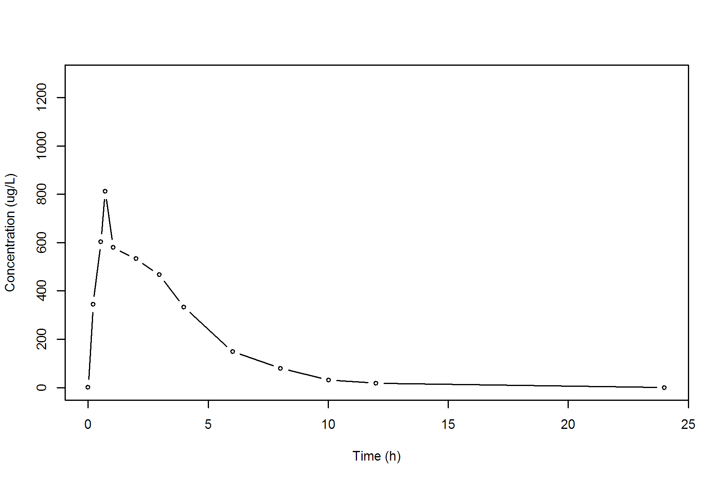

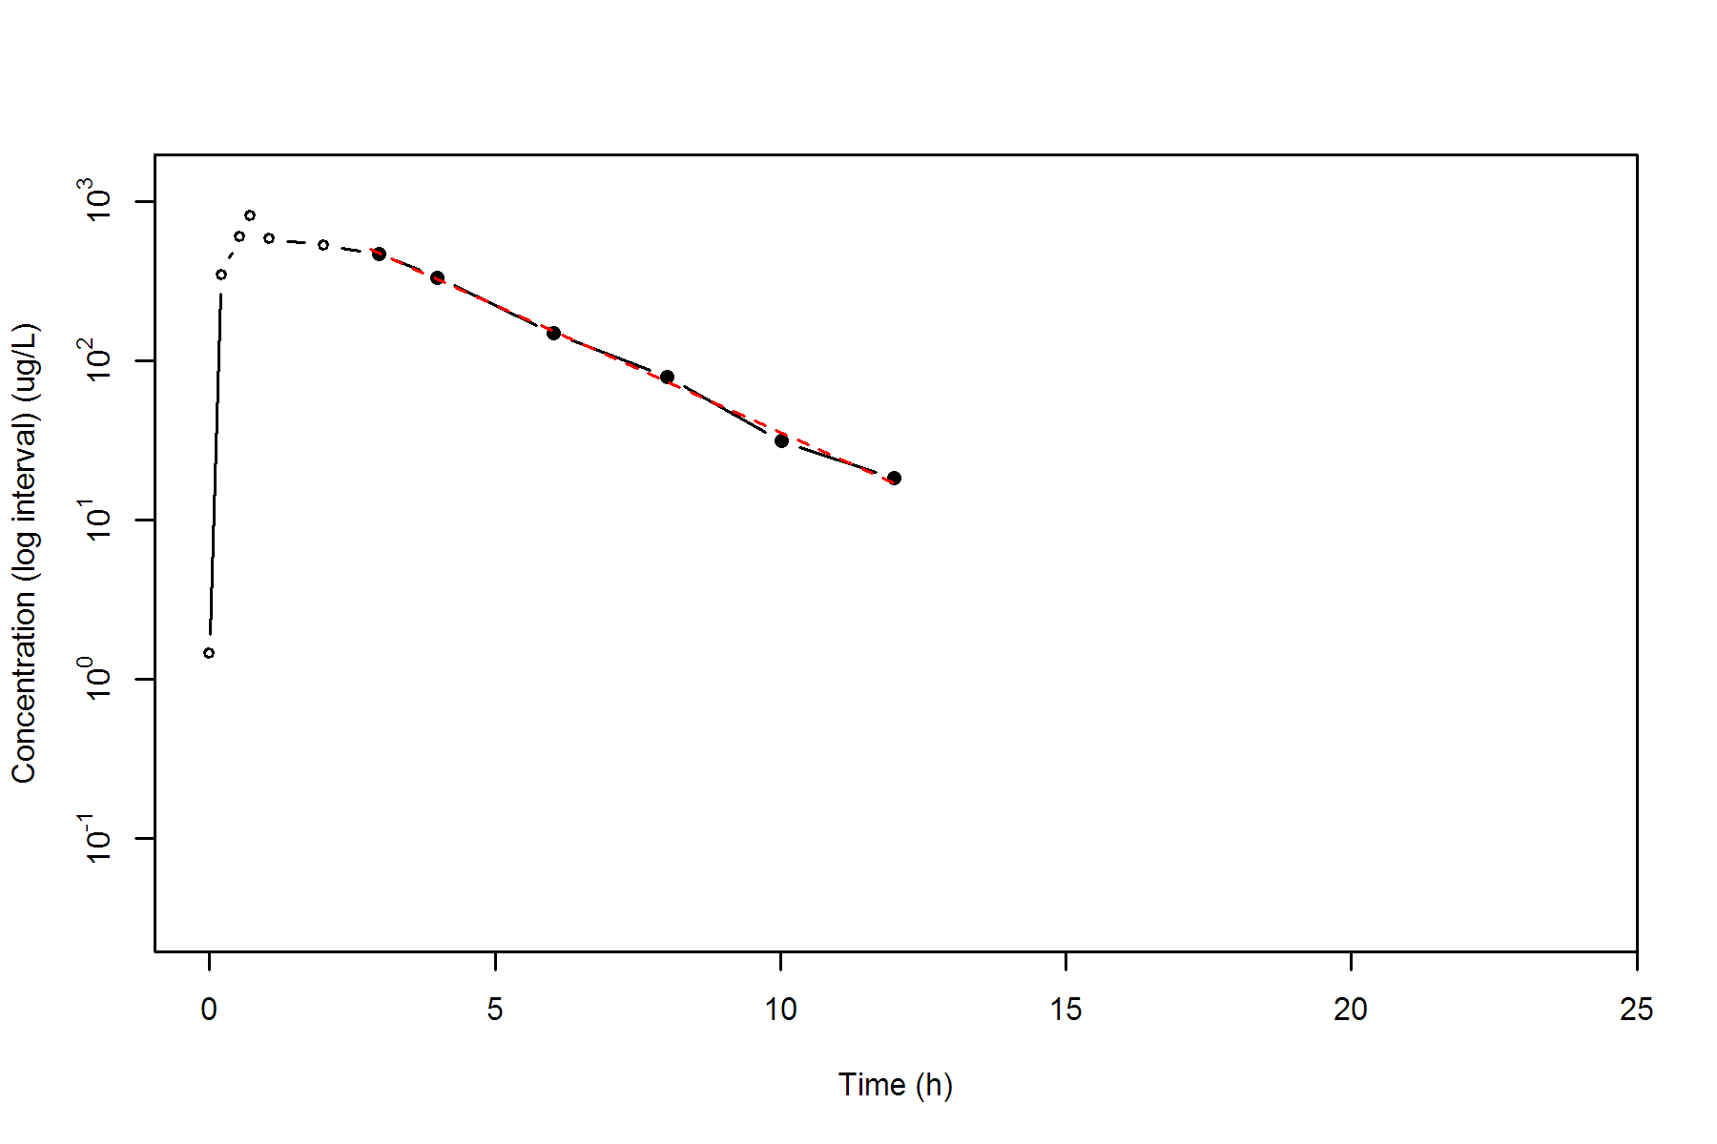

**SUBJ 25, GRP TR, PRD 1, TRT T**

NONCOMPARTMENTAL ANALYSIS REPORT

Package version 0.3.9 (2018-05-10 KST)

R version 3.5.0 (2018-04-23)

Date and Time: 2018-06-19 09:49:36 Asia/Seoul

Calculation Setting

-------------------

Drug Administration: Extravascular

Observation count excluding trailing zero: 13

Dose at time 0: 0 mg

AUC Calculation Method: Linear-up Linear-down

Weighting for lambda z: Uniform (Ordinary Least Square, OLS)

Lambda z selection criterion: Heighest adjusted R-squared value with precision=1e-4

Fitting, AUC, AUMC Result

-------------------------

Time Conc. Pred. Residual AUC AUMC

---------------------------------------------------------------------

0.0000 0.0000 0.0000 0.0000

0.2100 579.2000 60.8160 12.7714

0.5100 882.9300 280.1355 98.5603

0.7300 1160.3200 504.8930 241.2664

0.9800 822.5500 752.7518 447.9079

2.0000 724.0800 1541.5331 1597.5800

3.0500 520.0300 2194.6908 3190.5621

4.0200 389.0000 2635.5704 4718.2498

5.9500 204.8900 3208.6742 7403.7246

7.9600 103.2200 3518.3248 9454.6549

10.0000 * 59.5500 55.3039 +4.246e+00 3684.3502 10900.1288

11.9600 * 32.3800 35.2877 -2.908e+00 3774.4416 11863.2383

24.0200 * 2.2500 2.2231 +2.689e-02 3983.2605 14524.3364

*: Used for the calculation of Lambda z.

Calculated Values

-----------------

CMAX Max Conc 1160.3200 ug/L

TMAX Time of CMAX 0.7300 h

TLAG Time Until First Nonzero Conc 0.0000 h

CLST Last Nonzero Conc 2.2500 ug/L

CLSTP Last Nonzero Conc Pred 2.2231 ug/L

TLST Time of Last Nonzero Conc 24.0200 h

LAMZHL Half-Life Lambda z 3.0237 h

LAMZ Lambda z 0.2292 /h

LAMZLL Lambda z Lower Limit 10.0000 h

LAMZUL Lambda z Upper Limit 24.0200 h

LAMZNPT Number of Points for Lambda z 3

CORRXY Correlation Between TimeX and Log ConcY -0.9989

R2 R Squared 0.9979

R2ADJ R Squared Adjusted 0.9957

AUCLST AUC to Last Nonzero Conc 3983.2605 h*ug/L

AUCALL AUC All 3983.2605 h*ug/L

AUCIFO AUC Infinity Obs 3993.0755 h*ug/L

AUCIFP AUC Infinity Pred 3992.9582 h*ug/L

AUCPEO AUC %Extrapolation Obs 0.2458 %

AUCPEP AUC %Extrapolation Pred 0.2429 %

AUMCLST AUMC to Last Nonzero Conc 14524.3364 h2*ug/L

AUMCIFO AUMC Infinity Obs 14802.9101 h2*ug/L

AUMCIFP AUMC Infinity Pred 14799.5811 h2*ug/L

AUMCPEO AUMC %Extrapolation Obs 1.8819 %

AUMCPEP AUMC % Extrapolation Pred 1.8598 %

VZFO Vz Obs by F 0.0000 L

VZFP Vz Pred by F 0.0000 L

CLFO Total CL Obs by F 0.0000 L/h

CLFP Total CL Pred by F 0.0000 L/h

MRTEVLST MRT Extravasc to Last Nonzero Conc 3.6463 h

MRTEVIFO MRT Extravasc Infinity Obs 3.7071 h

MRTEVIFP MRT Extravasc Infinity Pred 3.7064 h

**SUBJ 25, GRP TR, PRD 1, TRT T**

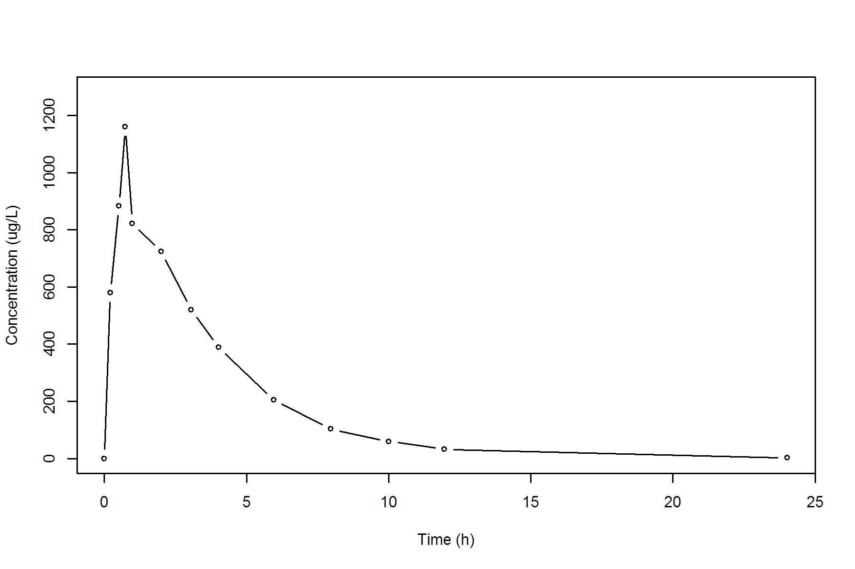

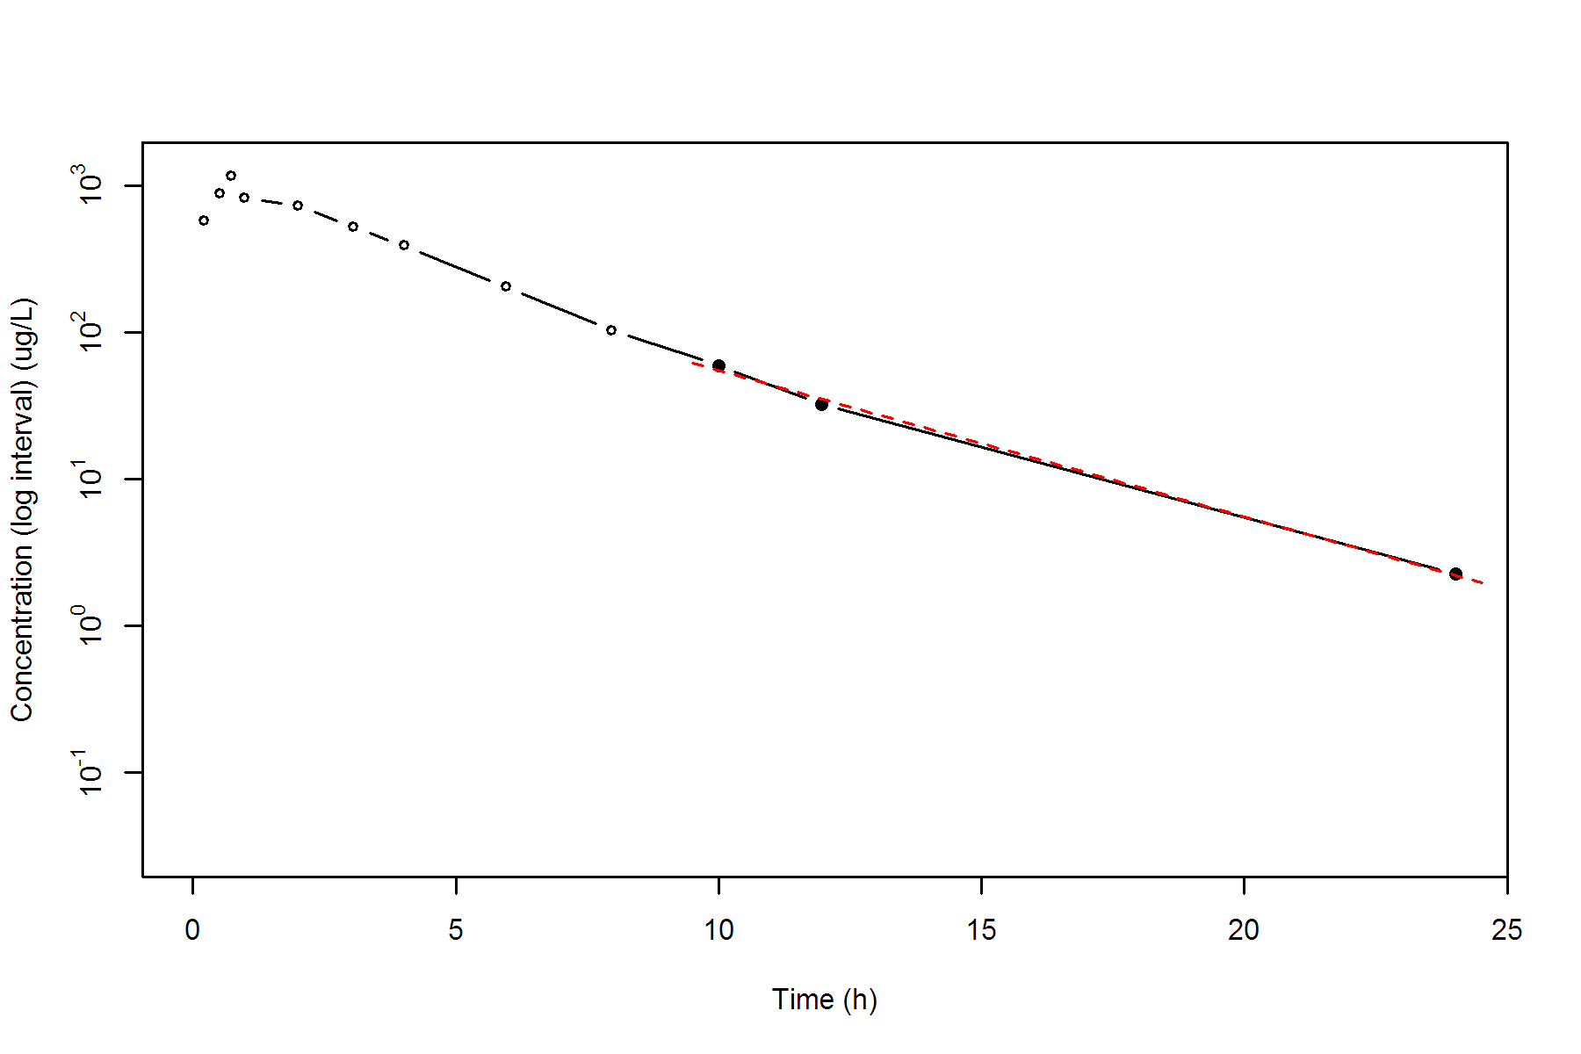

**SUBJ 25, GRP TR, PRD 2, TRT R**

NONCOMPARTMENTAL ANALYSIS REPORT

Package version 0.3.9 (2018-05-10 KST)

R version 3.5.0 (2018-04-23)

Date and Time: 2018-06-19 09:49:36 Asia/Seoul

Calculation Setting

-------------------

Drug Administration: Extravascular

Observation count excluding trailing zero: 13

Dose at time 0: 0 mg

AUC Calculation Method: Linear-up Linear-down

Weighting for lambda z: Uniform (Ordinary Least Square, OLS)

Lambda z selection criterion: Heighest adjusted R-squared value with precision=1e-4

Fitting, AUC, AUMC Result

-------------------------

Time Conc. Pred. Residual AUC AUMC

---------------------------------------------------------------------

0.0000 0.0000 0.0000 0.0000

0.2300 394.4500 45.3618 10.4332

0.5200 711.8200 205.7709 77.2593

0.7800 769.6300 398.3594 203.4189

1.0100 673.4200 564.3102 350.6724

2.0400 496.6700 1166.9065 1222.7533

2.9900 451.2000 1617.1448 2344.8433

4.0400 343.9600 2034.6038 3782.6537

6.0400 220.5400 2599.1038 6504.3137

7.9800 99.1200 2909.1740 8563.6617

10.0300 * 67.6800 71.5996 -3.920e+00 3080.1440 10070.2149

12.0000 * 45.5700 42.6797 +2.890e+00 3191.6952 11277.5003

24.0200 * 1.8000 1.8167 -1.669e-02 3476.3889 14823.8570

*: Used for the calculation of Lambda z.

Calculated Values

-----------------

CMAX Max Conc 769.6300 ug/L

TMAX Time of CMAX 0.7800 h

TLAG Time Until First Nonzero Conc 0.0000 h

CLST Last Nonzero Conc 1.8000 ug/L

CLSTP Last Nonzero Conc Pred 1.8167 ug/L

TLST Time of Last Nonzero Conc 24.0200 h

LAMZHL Half-Life Lambda z 2.6393 h

LAMZ Lambda z 0.2626 /h

LAMZLL Lambda z Lower Limit 10.0300 h

LAMZUL Lambda z Upper Limit 24.0200 h

LAMZNPT Number of Points for Lambda z 3

CORRXY Correlation Between TimeX and Log ConcY -0.9995

R2 R Squared 0.9990

R2ADJ R Squared Adjusted 0.9981

AUCLST AUC to Last Nonzero Conc 3476.3889 h*ug/L

AUCALL AUC All 3476.3889 h*ug/L

AUCIFO AUC Infinity Obs 3483.2429 h*ug/L

AUCIFP AUC Infinity Pred 3483.3064 h*ug/L

AUCPEO AUC %Extrapolation Obs 0.1968 %

AUCPEP AUC %Extrapolation Pred 0.1986 %

AUMCLST AUMC to Last Nonzero Conc 14823.8570 h2*ug/L

AUMCIFO AUMC Infinity Obs 15014.5876 h2*ug/L

AUMCIFP AUMC Infinity Pred 15016.3556 h2*ug/L

AUMCPEO AUMC %Extrapolation Obs 1.2703 %

AUMCPEP AUMC % Extrapolation Pred 1.2819 %

VZFO Vz Obs by F 0.0000 L

VZFP Vz Pred by F 0.0000 L

CLFO Total CL Obs by F 0.0000 L/h

CLFP Total CL Pred by F 0.0000 L/h

MRTEVLST MRT Extravasc to Last Nonzero Conc 4.2642 h

MRTEVIFO MRT Extravasc Infinity Obs 4.3105 h

MRTEVIFP MRT Extravasc Infinity Pred 4.3109 h

**SUBJ 25, GRP TR, PRD 2, TRT R**

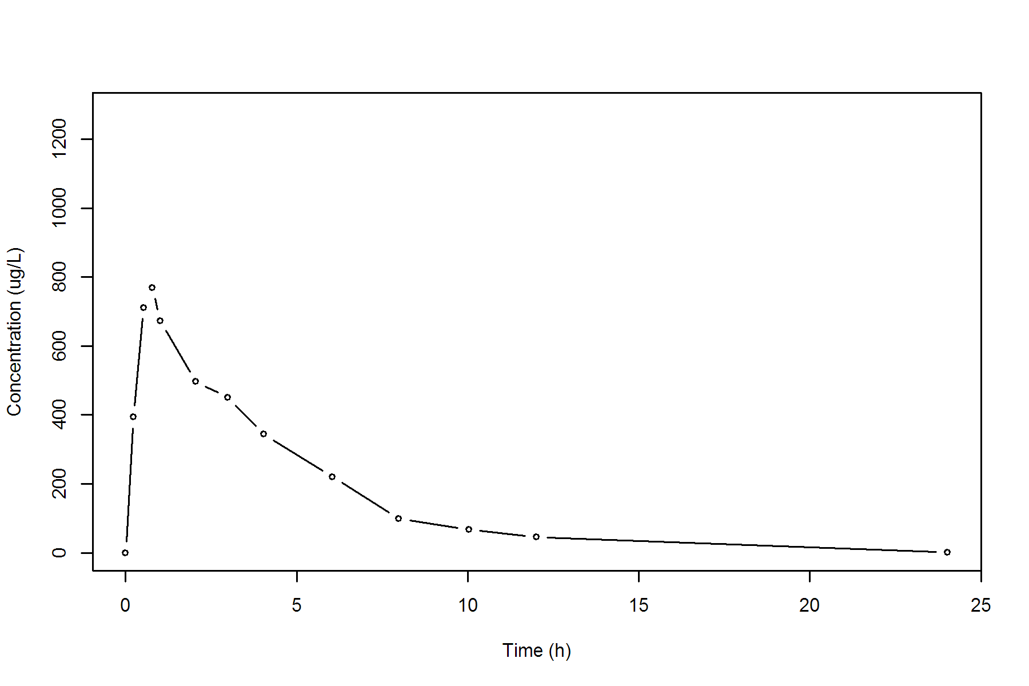

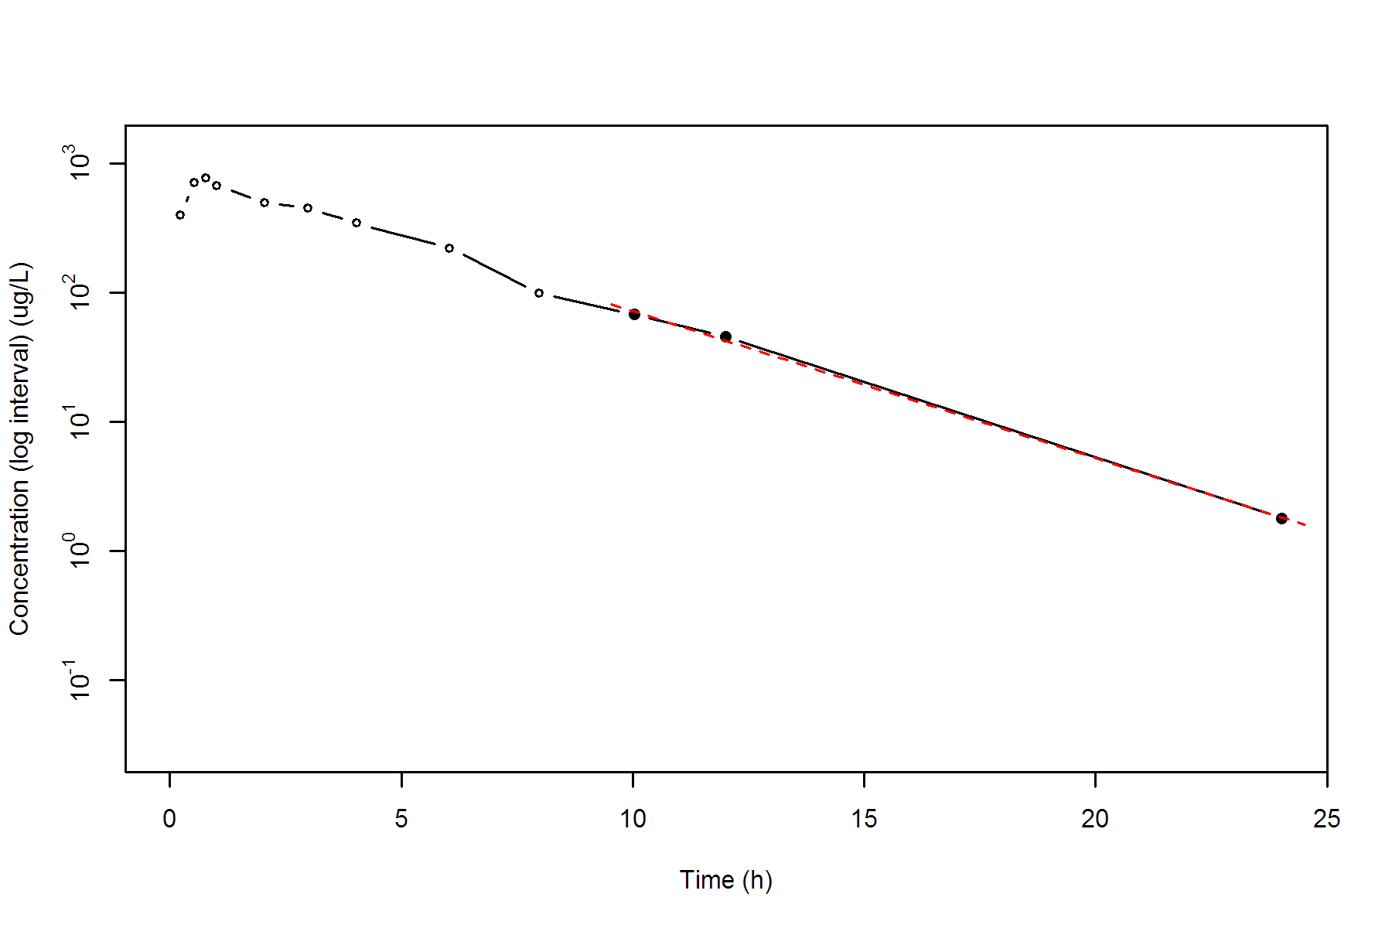

**SUBJ 26, GRP TR, PRD 1, TRT T**

NONCOMPARTMENTAL ANALYSIS REPORT

Package version 0.3.9 (2018-05-10 KST)

R version 3.5.0 (2018-04-23)

Date and Time: 2018-06-19 09:49:36 Asia/Seoul

Calculation Setting

-------------------

Drug Administration: Extravascular

Observation count excluding trailing zero: 13

Dose at time 0: 0 mg

AUC Calculation Method: Linear-up Linear-down

Weighting for lambda z: Uniform (Ordinary Least Square, OLS)

Lambda z selection criterion: Heighest adjusted R-squared value with precision=1e-4

Fitting, AUC, AUMC Result

-------------------------

Time Conc. Pred. Residual AUC AUMC

---------------------------------------------------------------------

0.0000 0.8900 0.0000 0.0000

0.2800 624.5900 87.5672 24.4839

0.5100 622.9500 231.0343 81.1317

0.7400 714.3300 384.8215 178.4572

0.9600 766.0500 547.6633 317.4986

2.0200 585.8400 1264.1650 1334.4651

3.0100 469.8000 1786.7068 2620.2251

4.0500 324.4300 2199.7064 4038.8056

6.0300 171.2700 2690.4494 6362.0382

8.0000 * 148.2800 150.0219 -1.742e+00 3005.2062 8547.7513

9.9800 * 85.1300 91.5261 -6.396e+00 3236.2821 10563.2304

11.9800 * 61.4100 55.5607 +5.849e+00 3382.8221 12148.5196

23.9600 * 2.7500 2.7943 -4.428e-02 3767.1405 16949.9945

*: Used for the calculation of Lambda z.

Calculated Values

-----------------

CMAX Max Conc 766.0500 ug/L

TMAX Time of CMAX 0.9600 h

TLAG Time Until First Nonzero Conc 0.0000 h

CLST Last Nonzero Conc 2.7500 ug/L

CLSTP Last Nonzero Conc Pred 2.7943 ug/L

TLST Time of Last Nonzero Conc 23.9600 h

LAMZHL Half-Life Lambda z 2.7773 h

LAMZ Lambda z 0.2496 /h

LAMZLL Lambda z Lower Limit 8.0000 h

LAMZUL Lambda z Upper Limit 23.9600 h

LAMZNPT Number of Points for Lambda z 4

CORRXY Correlation Between TimeX and Log ConcY -0.9992

R2 R Squared 0.9984

R2ADJ R Squared Adjusted 0.9976

AUCLST AUC to Last Nonzero Conc 3767.1405 h*ug/L

AUCALL AUC All 3767.1405 h*ug/L

AUCIFO AUC Infinity Obs 3778.1592 h*ug/L

AUCIFP AUC Infinity Pred 3778.3366 h*ug/L

AUCPEO AUC %Extrapolation Obs 0.2916 %

AUCPEP AUC %Extrapolation Pred 0.2963 %

AUMCLST AUMC to Last Nonzero Conc 16949.9945 h2*ug/L

AUMCIFO AUMC Infinity Obs 17258.1543 h2*ug/L

AUMCIFP AUMC Infinity Pred 17263.1164 h2*ug/L

AUMCPEO AUMC %Extrapolation Obs 1.7856 %

AUMCPEP AUMC % Extrapolation Pred 1.8138 %

VZFO Vz Obs by F 0.0000 L

VZFP Vz Pred by F 0.0000 L

CLFO Total CL Obs by F 0.0000 L/h

CLFP Total CL Pred by F 0.0000 L/h

MRTEVLST MRT Extravasc to Last Nonzero Conc 4.4994 h

MRTEVIFO MRT Extravasc Infinity Obs 4.5679 h

MRTEVIFP MRT Extravasc Infinity Pred 4.5690 h

**SUBJ 26, GRP TR, PRD 1, TRT T**

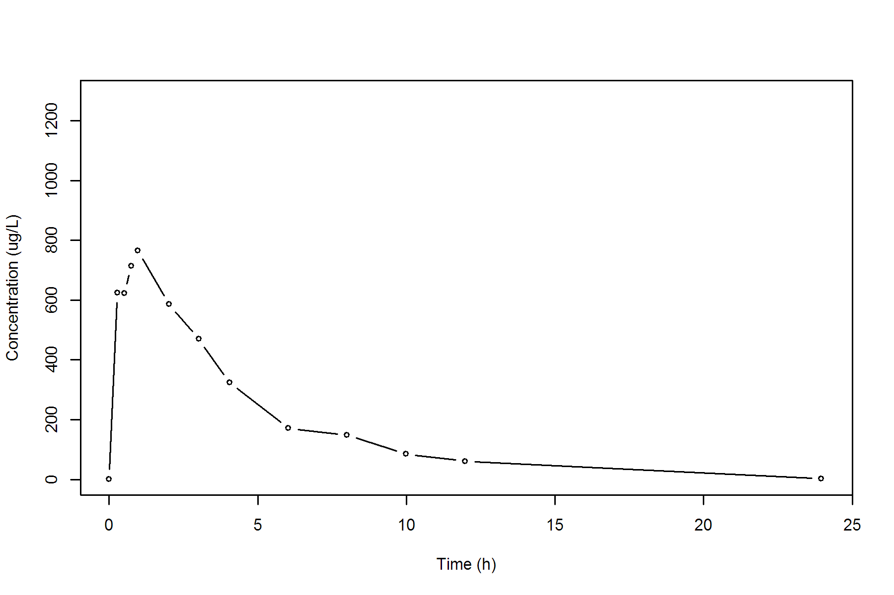

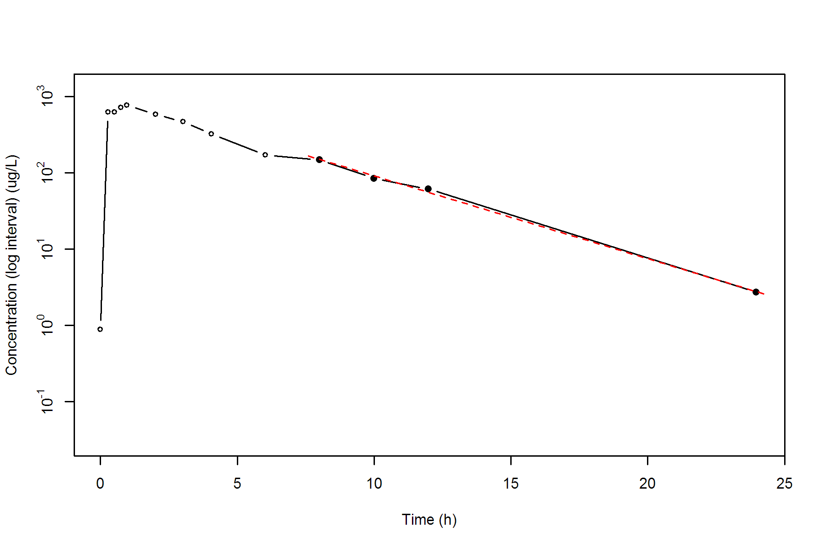

**SUBJ 26, GRP TR, PRD 2, TRT R**

NONCOMPARTMENTAL ANALYSIS REPORT

Package version 0.3.9 (2018-05-10 KST)

R version 3.5.0 (2018-04-23)

Date and Time: 2018-06-19 09:49:36 Asia/Seoul

Calculation Setting

-------------------

Drug Administration: Extravascular

Observation count excluding trailing zero: 13

Dose at time 0: 0 mg

AUC Calculation Method: Linear-up Linear-down

Weighting for lambda z: Uniform (Ordinary Least Square, OLS)

Lambda z selection criterion: Heighest adjusted R-squared value with precision=1e-4

Fitting, AUC, AUMC Result

-------------------------

Time Conc. Pred. Residual AUC AUMC

---------------------------------------------------------------------

0.0000 0.0000 0.0000 0.0000

0.2800 350.7600 49.1064 13.7498

0.5200 467.9000 147.3456 54.7323

0.7800 543.2900 278.8003 141.4519

0.9500 558.4500 372.4482 222.5669

1.9700 595.7300 961.0800 1091.6659

3.0100 369.0100 1462.7448 2279.5061

3.9800 431.9700 1851.2201 3652.0371

5.9900 306.8200 2593.7041 7226.9149

7.9600 * 213.2200 216.4148 -3.195e+00 3105.9434 10708.9717

9.9900 * 165.6100 166.3247 -7.147e-01 3490.4559 14110.9219

11.9900 * 131.5600 128.3264 +3.234e+00 3787.6259 17342.7702

24.0000 * 26.8800 27.0339 -1.539e-01 4739.0581 30689.0292

*: Used for the calculation of Lambda z.

Calculated Values

-----------------

CMAX Max Conc 595.7300 ug/L

TMAX Time of CMAX 1.9700 h

TLAG Time Until First Nonzero Conc 0.0000 h

CLST Last Nonzero Conc 26.8800 ug/L

CLSTP Last Nonzero Conc Pred 27.0339 ug/L

TLST Time of Last Nonzero Conc 24.0000 h

LAMZHL Half-Life Lambda z 5.3450 h

LAMZ Lambda z 0.1297 /h

LAMZLL Lambda z Lower Limit 7.9600 h

LAMZUL Lambda z Upper Limit 24.0000 h

LAMZNPT Number of Points for Lambda z 4

CORRXY Correlation Between TimeX and Log ConcY -0.9998

R2 R Squared 0.9997

R2ADJ R Squared Adjusted 0.9995

AUCLST AUC to Last Nonzero Conc 4739.0581 h*ug/L

AUCALL AUC All 4739.0581 h*ug/L

AUCIFO AUC Infinity Obs 4946.3336 h*ug/L

AUCIFP AUC Infinity Pred 4947.5200 h*ug/L

AUCPEO AUC %Extrapolation Obs 4.1905 %

AUCPEP AUC %Extrapolation Pred 4.2135 %

AUMCLST AUMC to Last Nonzero Conc 30689.0292 h2*ug/L

AUMCIFO AUMC Infinity Obs 37261.9719 h2*ug/L

AUMCIFP AUMC Infinity Pred 37299.5951 h2*ug/L

AUMCPEO AUMC %Extrapolation Obs 17.6398 %

AUMCPEP AUMC % Extrapolation Pred 17.7229 %

VZFO Vz Obs by F 0.0000 L

VZFP Vz Pred by F 0.0000 L

CLFO Total CL Obs by F 0.0000 L/h

CLFP Total CL Pred by F 0.0000 L/h

MRTEVLST MRT Extravasc to Last Nonzero Conc 6.4758 h

MRTEVIFO MRT Extravasc Infinity Obs 7.5333 h

MRTEVIFP MRT Extravasc Infinity Pred 7.5390 h

**SUBJ 26, GRP TR, PRD 2, TRT R**

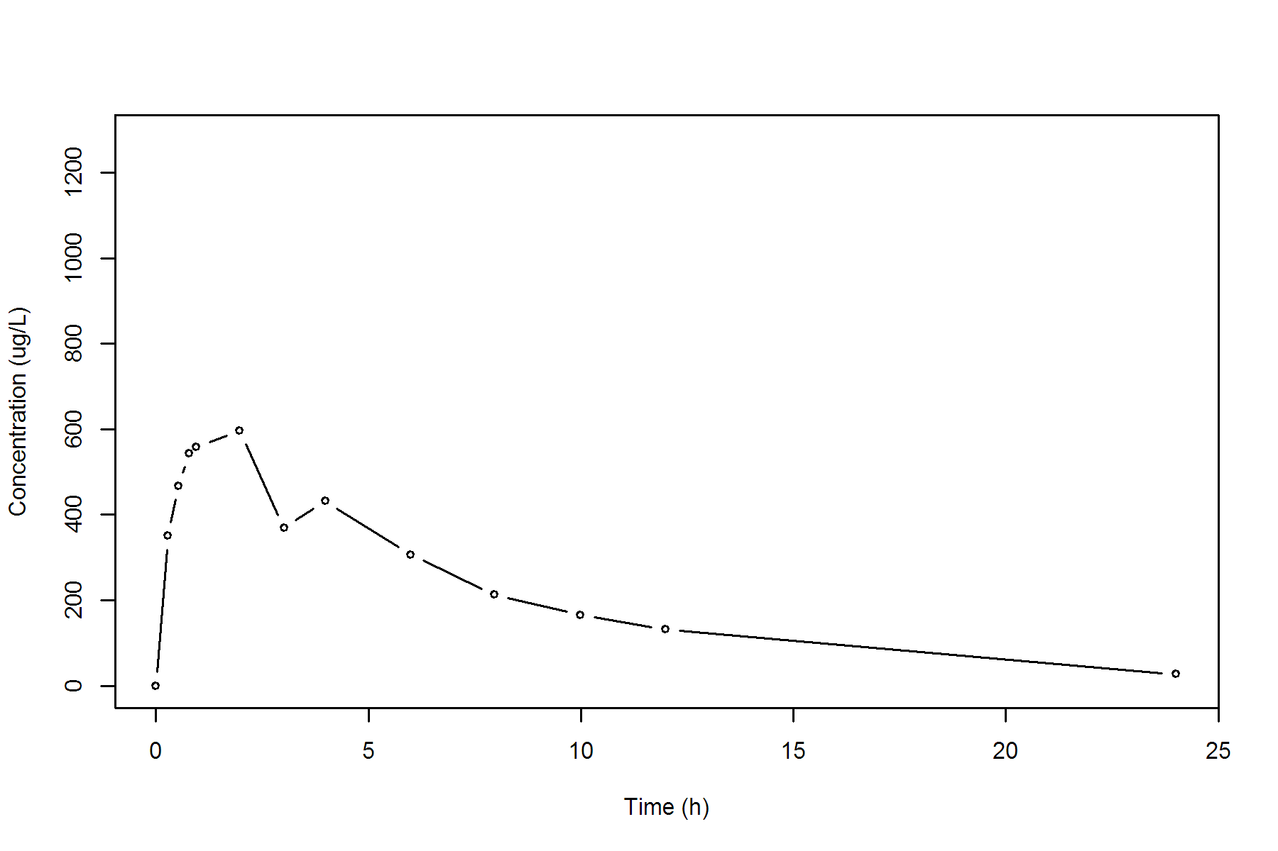

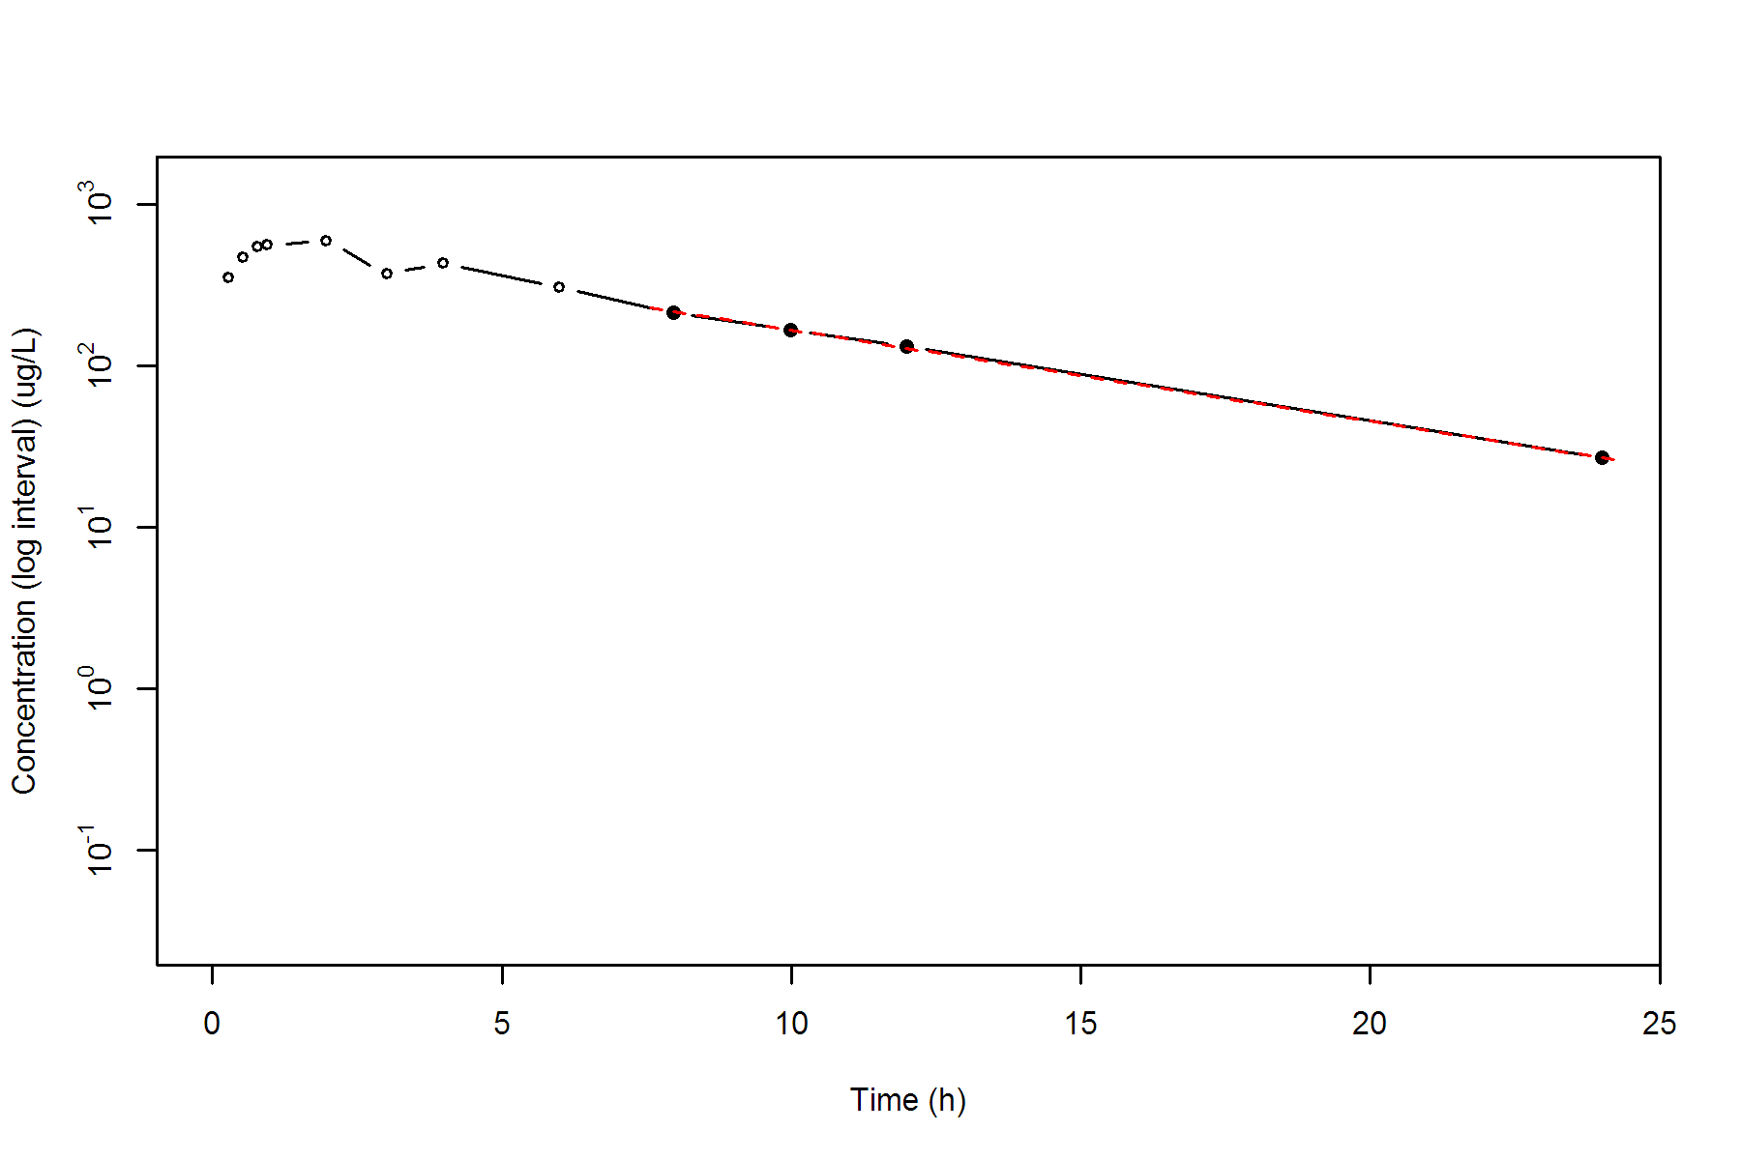

**SUBJ 27, GRP TR, PRD 1, TRT T**

NONCOMPARTMENTAL ANALYSIS REPORT

Package version 0.3.9 (2018-05-10 KST)

R version 3.5.0 (2018-04-23)

Date and Time: 2018-06-19 09:49:36 Asia/Seoul

Calculation Setting

-------------------

Drug Administration: Extravascular

Observation count excluding trailing zero: 13

Dose at time 0: 0 mg

AUC Calculation Method: Linear-up Linear-down

Weighting for lambda z: Uniform (Ordinary Least Square, OLS)

Lambda z selection criterion: Heighest adjusted R-squared value with precision=1e-4

Fitting, AUC, AUMC Result

-------------------------

Time Conc. Pred. Residual AUC AUMC

---------------------------------------------------------------------

0.0000 2.0100 0.0000 0.0000

0.2900 831.5000 120.8590 34.9646

0.4800 991.5900 294.0525 103.0889

0.7100 1032.6300 526.8378 242.1389

0.9900 1219.5600 842.1444 513.8133

2.0400 932.9200 1972.1964 2146.8370

2.9800 932.1000 2848.7558 4346.8199

4.0400 467.4700 3590.5279 6819.9254

6.0000 355.6800 4397.2149 10762.1311

7.9600 178.6600 4920.8681 14247.2204

10.0200 * 106.5200 107.8904 -1.370e+00 5214.6035 16811.3683

11.9800 * 63.2300 62.2965 +9.335e-01 5380.9585 18599.6976

23.9700 * 2.1600 2.1645 -4.518e-03 5772.9716 23451.2748

*: Used for the calculation of Lambda z.

Calculated Values

-----------------

CMAX Max Conc 1219.5600 ug/L

TMAX Time of CMAX 0.9900 h

TLAG Time Until First Nonzero Conc 0.0000 h

CLST Last Nonzero Conc 2.1600 ug/L

CLSTP Last Nonzero Conc Pred 2.1645 ug/L

TLST Time of Last Nonzero Conc 23.9700 h

LAMZHL Half-Life Lambda z 2.4737 h

LAMZ Lambda z 0.2802 /h

LAMZLL Lambda z Lower Limit 10.0200 h

LAMZUL Lambda z Upper Limit 23.9700 h

LAMZNPT Number of Points for Lambda z 3

CORRXY Correlation Between TimeX and Log ConcY -1.0000

R2 R Squared 1.0000

R2ADJ R Squared Adjusted 0.9999

AUCLST AUC to Last Nonzero Conc 5772.9716 h*ug/L

AUCALL AUC All 5772.9716 h*ug/L

AUCIFO AUC Infinity Obs 5780.6801 h*ug/L

AUCIFP AUC Infinity Pred 5780.6962 h*ug/L

AUCPEO AUC %Extrapolation Obs 0.1333 %

AUCPEP AUC %Extrapolation Pred 0.1336 %

AUMCLST AUMC to Last Nonzero Conc 23451.2748 h2*ug/L

AUMCIFO AUMC Infinity Obs 23663.5581 h2*ug/L

AUMCIFP AUMC Infinity Pred 23664.0022 h2*ug/L

AUMCPEO AUMC %Extrapolation Obs 0.8971 %

AUMCPEP AUMC % Extrapolation Pred 0.8989 %

VZFO Vz Obs by F 0.0000 L

VZFP Vz Pred by F 0.0000 L

CLFO Total CL Obs by F 0.0000 L/h

CLFP Total CL Pred by F 0.0000 L/h

MRTEVLST MRT Extravasc to Last Nonzero Conc 4.0623 h

MRTEVIFO MRT Extravasc Infinity Obs 4.0936 h

MRTEVIFP MRT Extravasc Infinity Pred 4.0936 h

**SUBJ 27, GRP TR, PRD 1, TRT T**

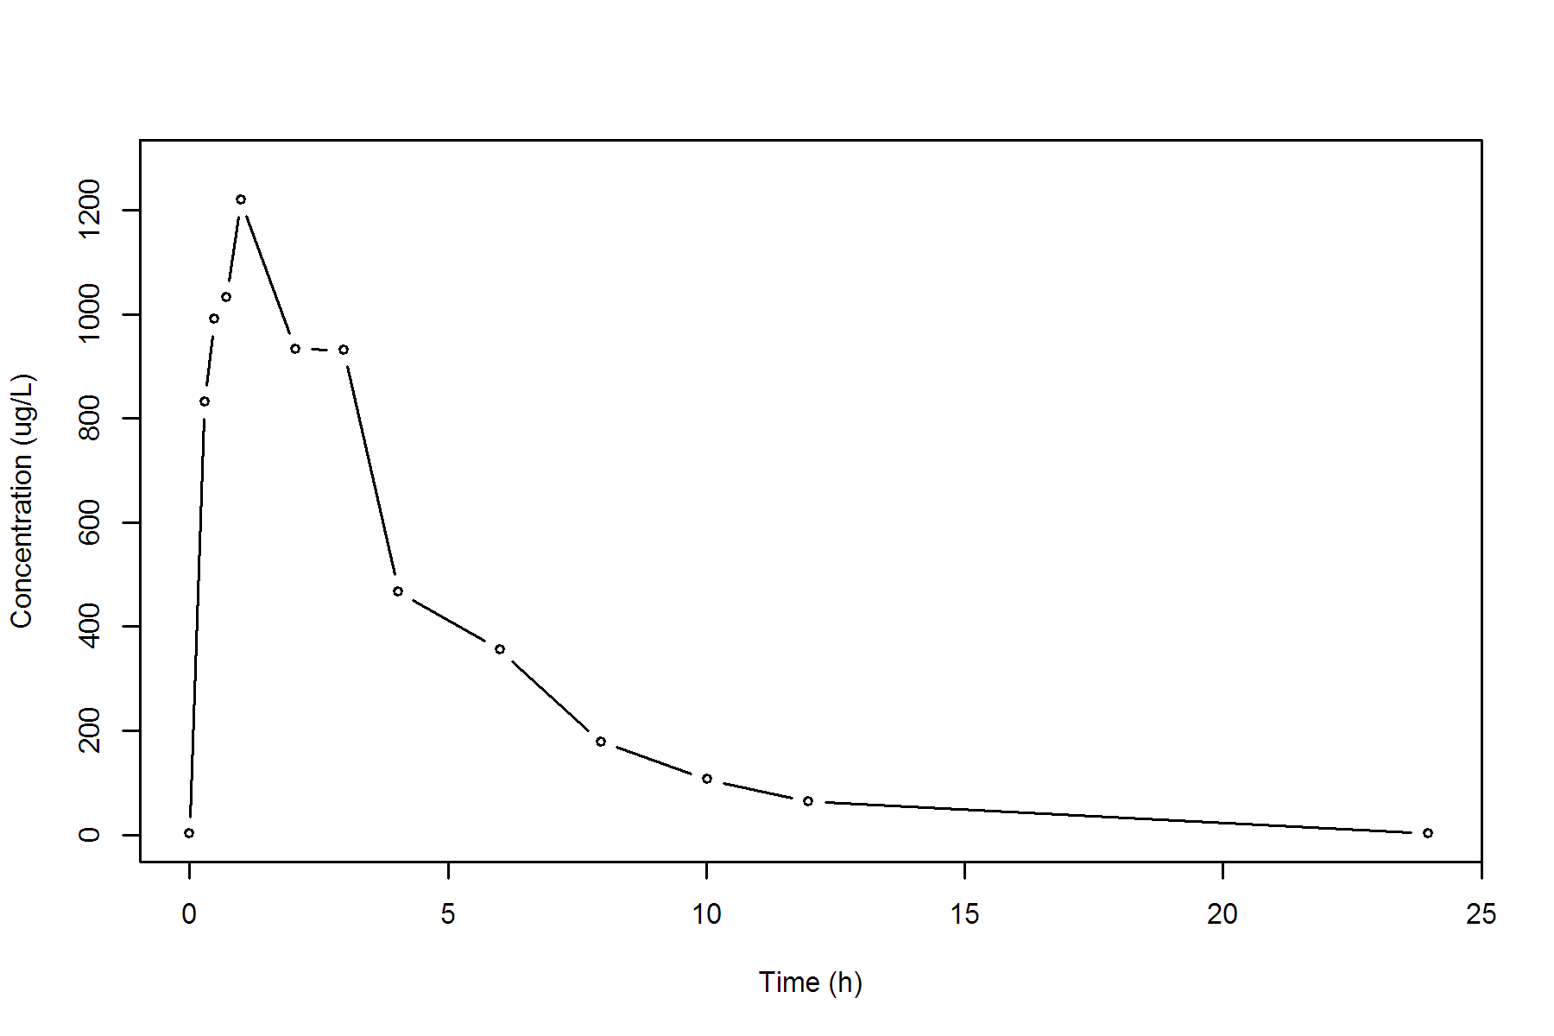

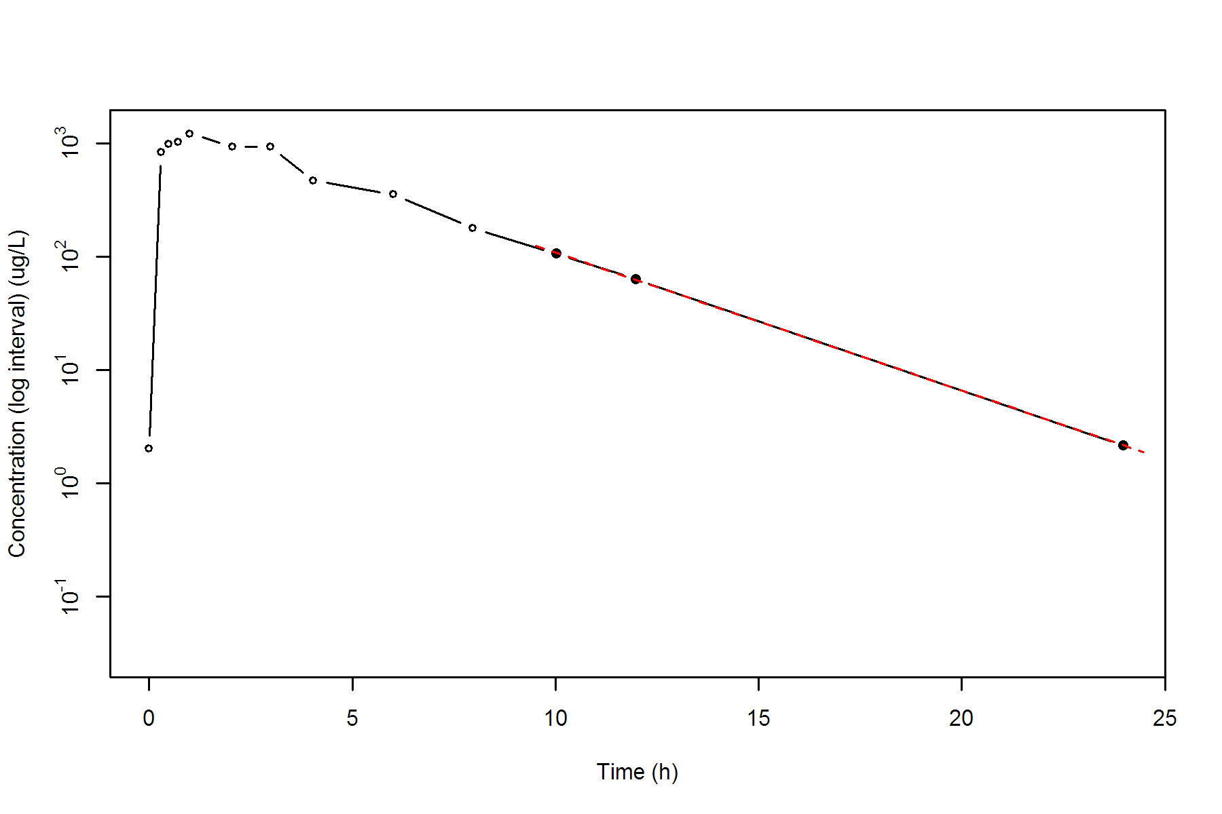

**SUBJ 27, GRP TR, PRD 2, TRT R**

NONCOMPARTMENTAL ANALYSIS REPORT

Package version 0.3.9 (2018-05-10 KST)

R version 3.5.0 (2018-04-23)

Date and Time: 2018-06-19 09:49:36 Asia/Seoul

Calculation Setting

-------------------

Drug Administration: Extravascular

Observation count excluding trailing zero: 13

Dose at time 0: 0 mg

AUC Calculation Method: Linear-up Linear-down

Weighting for lambda z: Uniform (Ordinary Least Square, OLS)

Lambda z selection criterion: Heighest adjusted R-squared value with precision=1e-4

Fitting, AUC, AUMC Result

-------------------------

Time Conc. Pred. Residual AUC AUMC

---------------------------------------------------------------------

0.0000 1.1500 0.0000 0.0000

0.2200 211.3300 23.3728 5.1142

0.4700 442.3100 105.0778 36.9115

0.7600 868.2700 295.1119 162.7383

1.0300 1063.2900 555.8725 399.6732

2.0200 998.6200 1576.5180 1940.3118

3.0100 902.1800 2517.4139 4283.0350

3.9700 867.3500 3366.7884 7239.3268

6.0400 * 491.3400 500.3012 -8.961e+00 4773.0325 13874.7875

8.0200 * 337.1400 342.4490 -5.309e+00 5593.2277 19489.6283

9.9900 * 231.5900 234.8506 -3.261e+00 6153.4268 24431.8135

12.0200 * 169.7900 159.2204 +1.057e+01 6560.8275 28851.5903

24.0100 * 15.7700 16.0339 -2.639e-01 7673.2597 43356.5738

*: Used for the calculation of Lambda z.

Calculated Values

-----------------

CMAX Max Conc 1063.2900 ug/L

TMAX Time of CMAX 1.0300 h

TLAG Time Until First Nonzero Conc 0.0000 h

CLST Last Nonzero Conc 15.7700 ug/L

CLSTP Last Nonzero Conc Pred 16.0339 ug/L

TLST Time of Last Nonzero Conc 24.0100 h

LAMZHL Half-Life Lambda z 3.6204 h

LAMZ Lambda z 0.1915 /h

LAMZLL Lambda z Lower Limit 6.0400 h

LAMZUL Lambda z Upper Limit 24.0100 h

LAMZNPT Number of Points for Lambda z 5

CORRXY Correlation Between TimeX and Log ConcY -0.9996

R2 R Squared 0.9993

R2ADJ R Squared Adjusted 0.9991

AUCLST AUC to Last Nonzero Conc 7673.2597 h*ug/L

AUCALL AUC All 7673.2597 h*ug/L

AUCIFO AUC Infinity Obs 7755.6274 h*ug/L

AUCIFP AUC Infinity Pred 7757.0056 h*ug/L

AUCPEO AUC %Extrapolation Obs 1.0620 %

AUCPEP AUC %Extrapolation Pred 1.0796 %

AUMCLST AUMC to Last Nonzero Conc 43356.5738 h2*ug/L

AUMCIFO AUMC Infinity Obs 45764.4365 h2*ug/L

AUMCIFP AUMC Infinity Pred 45804.7257 h2*ug/L

AUMCPEO AUMC %Extrapolation Obs 5.2614 %

AUMCPEP AUMC % Extrapolation Pred 5.3448 %

VZFO Vz Obs by F 0.0000 L

VZFP Vz Pred by F 0.0000 L

CLFO Total CL Obs by F 0.0000 L/h

CLFP Total CL Pred by F 0.0000 L/h

MRTEVLST MRT Extravasc to Last Nonzero Conc 5.6503 h

MRTEVIFO MRT Extravasc Infinity Obs 5.9008 h

MRTEVIFP MRT Extravasc Infinity Pred 5.9049 h

**SUBJ 27, GRP TR, PRD 2, TRT R**

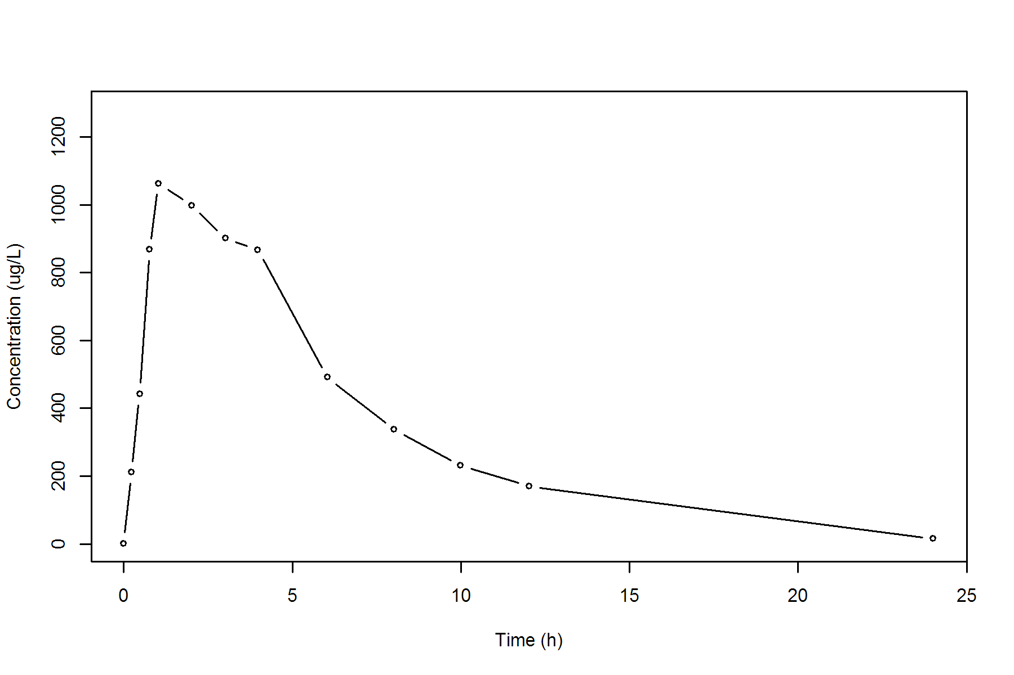

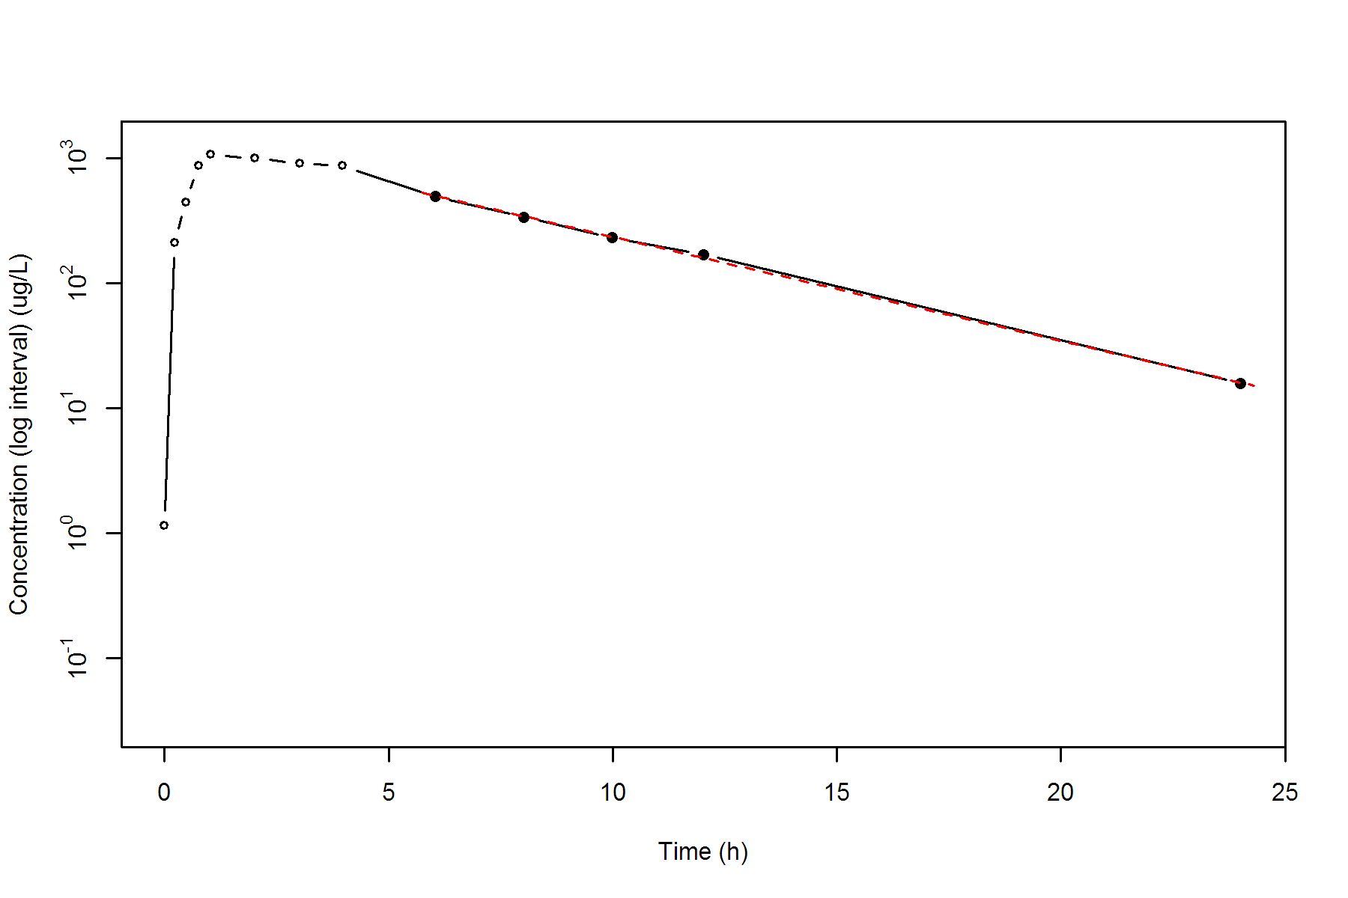

**SUBJ 28, GRP RT, PRD 1, TRT R**

NONCOMPARTMENTAL ANALYSIS REPORT

Package version 0.3.9 (2018-05-10 KST)

R version 3.5.0 (2018-04-23)

Date and Time: 2018-06-19 09:49:36 Asia/Seoul

Calculation Setting

-------------------

Drug Administration: Extravascular

Observation count excluding trailing zero: 13

Dose at time 0: 0 mg

AUC Calculation Method: Linear-up Linear-down

Weighting for lambda z: Uniform (Ordinary Least Square, OLS)

Lambda z selection criterion: Heighest adjusted R-squared value with precision=1e-4

Fitting, AUC, AUMC Result

-------------------------

Time Conc. Pred. Residual AUC AUMC

---------------------------------------------------------------------

0.0000 0.0000 0.0000 0.0000

0.2800 344.2700 48.1978 13.4954

0.4600 423.8500 117.3286 39.7184

0.7300 572.7700 251.8723 122.4859

1.0000 650.2400 416.9787 266.7148

1.9500 550.8100 987.4774 1085.7666

3.0400 * 626.7200 590.9212 +3.580e+01 1629.2313 2709.4896

4.0500 * 550.4500 512.7724 +3.768e+01 2223.7021 4797.4380

5.9600 * 379.1500 392.1248 -1.297e+01 3111.4701 9084.4870

7.9800 * 284.2600 295.2668 -1.101e+01 3781.5142 13657.8971

10.0200 * 251.8200 221.7098 +3.011e+01 4328.3158 18545.3609

11.9600 * 129.2900 168.8320 -3.954e+01 4697.9925 22492.8193

23.9900 * 33.8100 31.1663 +2.644e+00 5679.0390 36672.6423

*: Used for the calculation of Lambda z.

Calculated Values

-----------------

CMAX Max Conc 650.2400 ug/L

TMAX Time of CMAX 1.0000 h

TLAG Time Until First Nonzero Conc 0.0000 h

CLST Last Nonzero Conc 33.8100 ug/L

CLSTP Last Nonzero Conc Pred 31.1663 ug/L

TLST Time of Last Nonzero Conc 23.9900 h

LAMZHL Half-Life Lambda z 4.9353 h

LAMZ Lambda z 0.1404 /h

LAMZLL Lambda z Lower Limit 3.0400 h

LAMZUL Lambda z Upper Limit 23.9900 h

LAMZNPT Number of Points for Lambda z 7

CORRXY Correlation Between TimeX and Log ConcY -0.9913

R2 R Squared 0.9827

R2ADJ R Squared Adjusted 0.9792

AUCLST AUC to Last Nonzero Conc 5679.0390 h*ug/L

AUCALL AUC All 5679.0390 h*ug/L

AUCIFO AUC Infinity Obs 5919.7721 h*ug/L

AUCIFP AUC Infinity Pred 5900.9487 h*ug/L

AUCPEO AUC %Extrapolation Obs 4.0666 %

AUCPEP AUC %Extrapolation Pred 3.7606 %

AUMCLST AUMC to Last Nonzero Conc 36672.6423 h2*ug/L

AUMCIFO AUMC Infinity Obs 44161.8895 h2*ug/L

AUMCIFP AUMC Infinity Pred 43576.2917 h2*ug/L

AUMCPEO AUMC %Extrapolation Obs 16.9586 %

AUMCPEP AUMC % Extrapolation Pred 15.8427 %

VZFO Vz Obs by F 0.0000 L

VZFP Vz Pred by F 0.0000 L

CLFO Total CL Obs by F 0.0000 L/h

CLFP Total CL Pred by F 0.0000 L/h

MRTEVLST MRT Extravasc to Last Nonzero Conc 6.4575 h

MRTEVIFO MRT Extravasc Infinity Obs 7.4601 h

MRTEVIFP MRT Extravasc Infinity Pred 7.3846 h

**SUBJ 28, GRP RT, PRD 1, TRT R**

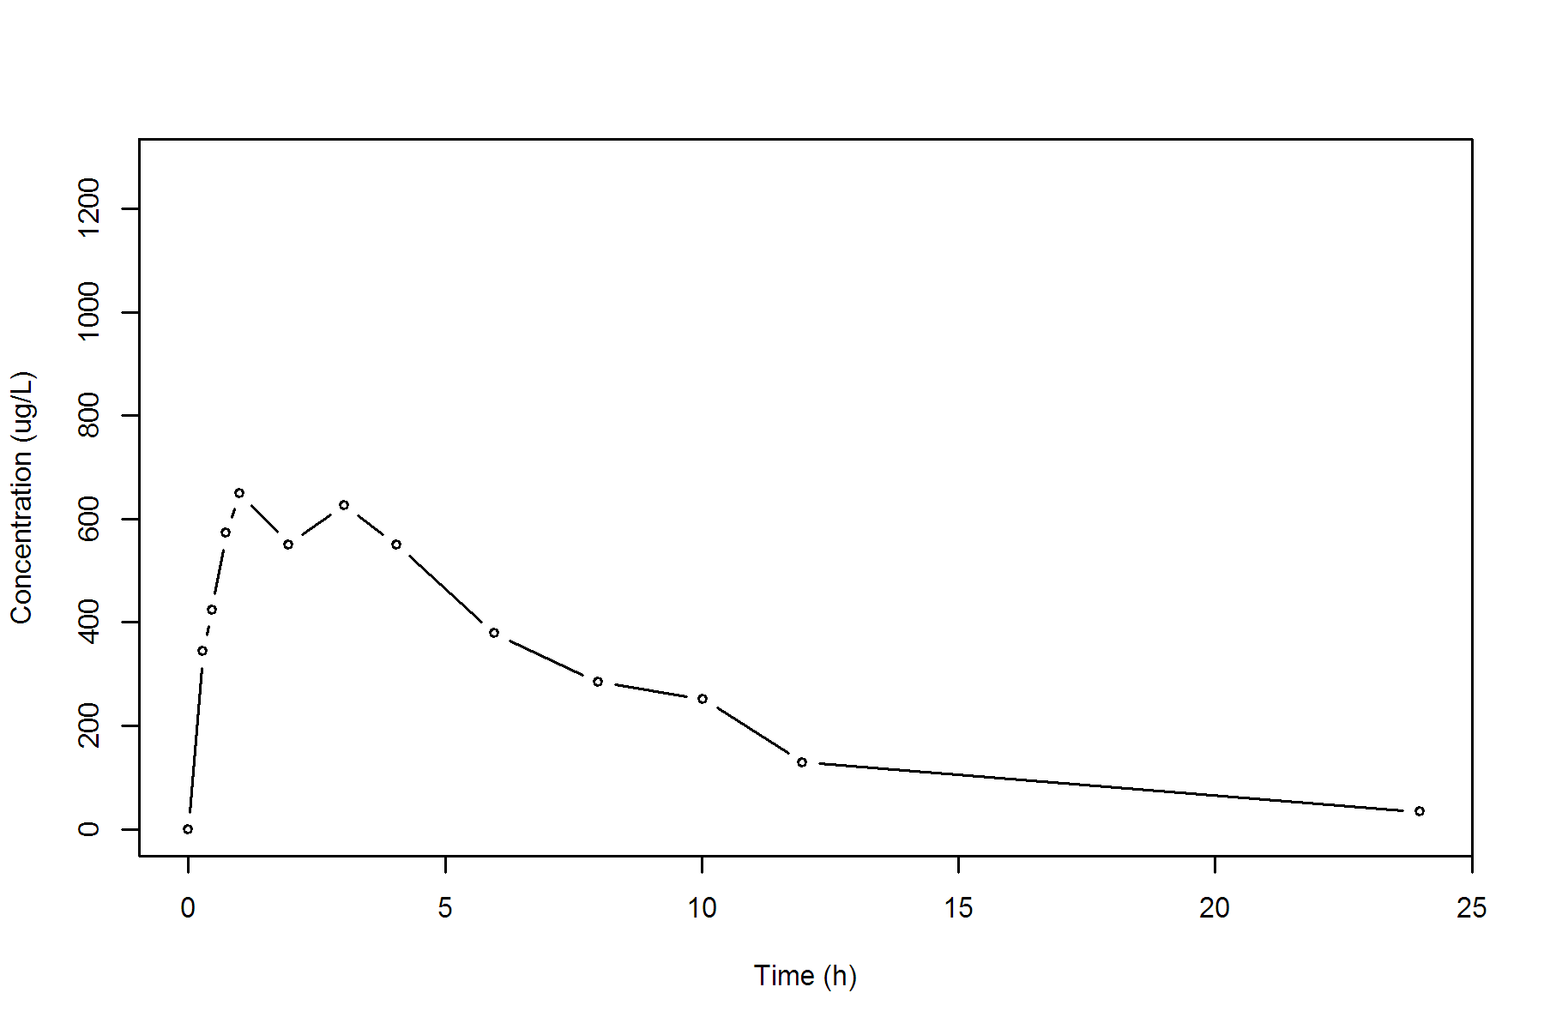

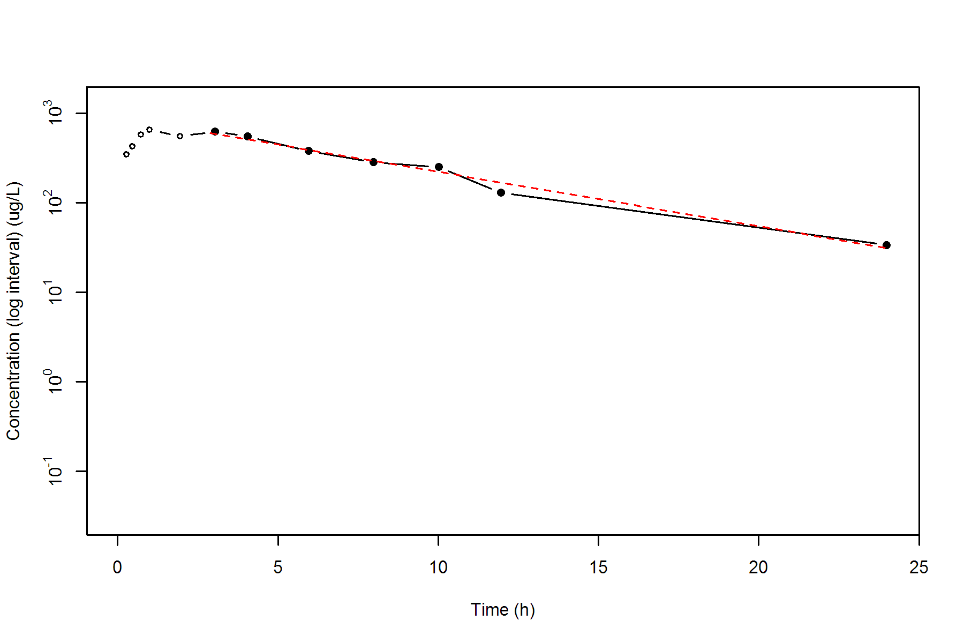

**SUBJ 28, GRP RT, PRD 2, TRT T**

NONCOMPARTMENTAL ANALYSIS REPORT

Package version 0.3.9 (2018-05-10 KST)

R version 3.5.0 (2018-04-23)

Date and Time: 2018-06-19 09:49:36 Asia/Seoul

Calculation Setting

-------------------

Drug Administration: Extravascular

Observation count excluding trailing zero: 13

Dose at time 0: 0 mg

AUC Calculation Method: Linear-up Linear-down

Weighting for lambda z: Uniform (Ordinary Least Square, OLS)

Lambda z selection criterion: Heighest adjusted R-squared value with precision=1e-4

Fitting, AUC, AUMC Result

-------------------------

Time Conc. Pred. Residual AUC AUMC

---------------------------------------------------------------------

0.0000 0.3200 0.0000 0.0000

0.2500 431.2300 53.9438 13.4759

0.5200 716.9600 208.9494 78.3605

0.7400 662.0800 360.6438 173.2640

1.0500 891.6300 601.4689 394.3173

1.9800 666.9900 1326.2272 1443.7534

2.9500 555.4100 1919.0912 2878.9167

4.0000 498.0200 2472.1419 4784.9500

6.0100 353.4800 3327.8994 8922.0272

7.9800 192.2000 3865.3942 12525.3255

10.0200 * 161.4900 154.8996 +6.590e+00 4226.1580 15740.2490

11.9800 * 101.6000 106.6436 -5.044e+00 4483.9862 18518.8408

24.0200 * 10.8400 10.7667 +7.328e-02 5160.8750 27413.6605

*: Used for the calculation of Lambda z.

Calculated Values

-----------------

CMAX Max Conc 891.6300 ug/L

TMAX Time of CMAX 1.0500 h

TLAG Time Until First Nonzero Conc 0.0000 h

CLST Last Nonzero Conc 10.8400 ug/L

CLSTP Last Nonzero Conc Pred 10.7667 ug/L

TLST Time of Last Nonzero Conc 24.0200 h

LAMZHL Half-Life Lambda z 3.6395 h

LAMZ Lambda z 0.1905 /h

LAMZLL Lambda z Lower Limit 10.0200 h

LAMZUL Lambda z Upper Limit 24.0200 h

LAMZNPT Number of Points for Lambda z 3

CORRXY Correlation Between TimeX and Log ConcY -0.9995

R2 R Squared 0.9990

R2ADJ R Squared Adjusted 0.9980

AUCLST AUC to Last Nonzero Conc 5160.8750 h*ug/L

AUCALL AUC All 5160.8750 h*ug/L

AUCIFO AUC Infinity Obs 5217.7925 h*ug/L

AUCIFP AUC Infinity Pred 5217.4077 h*ug/L

AUCPEO AUC %Extrapolation Obs 1.0908 %

AUCPEP AUC %Extrapolation Pred 1.0835 %

AUMCLST AUMC to Last Nonzero Conc 27413.6605 h2*ug/L

AUMCIFO AUMC Infinity Obs 29079.6740 h2*ug/L

AUMCIFP AUMC Infinity Pred 29068.4118 h2*ug/L

AUMCPEO AUMC %Extrapolation Obs 5.7291 %

AUMCPEP AUMC % Extrapolation Pred 5.6926 %

VZFO Vz Obs by F 0.0000 L

VZFP Vz Pred by F 0.0000 L

CLFO Total CL Obs by F 0.0000 L/h

CLFP Total CL Pred by F 0.0000 L/h

MRTEVLST MRT Extravasc to Last Nonzero Conc 5.3118 h

MRTEVIFO MRT Extravasc Infinity Obs 5.5732 h

MRTEVIFP MRT Extravasc Infinity Pred 5.5714 h

**SUBJ 28, GRP RT, PRD 2, TRT T**

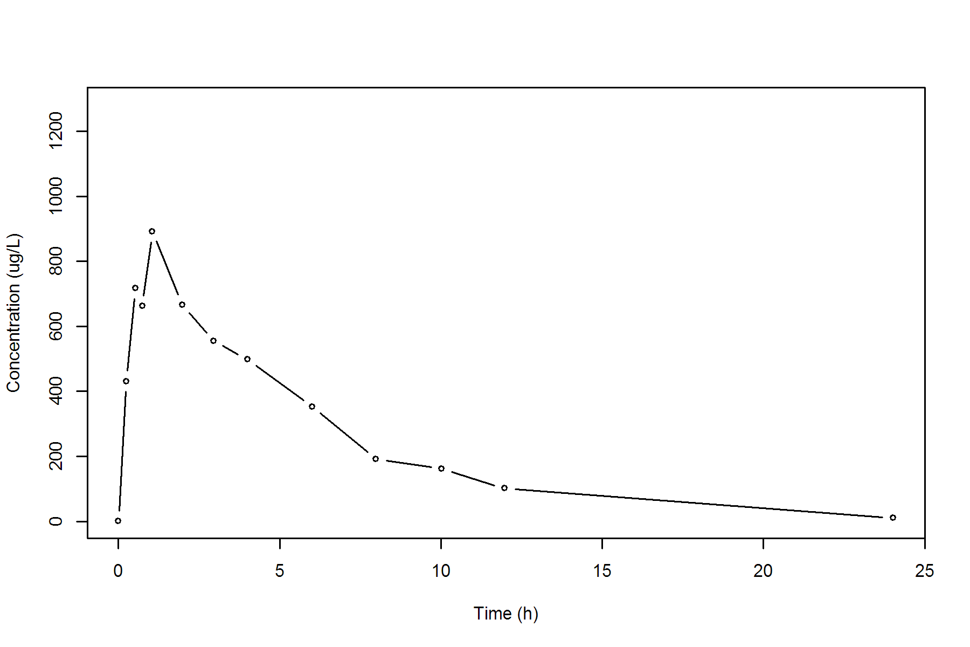

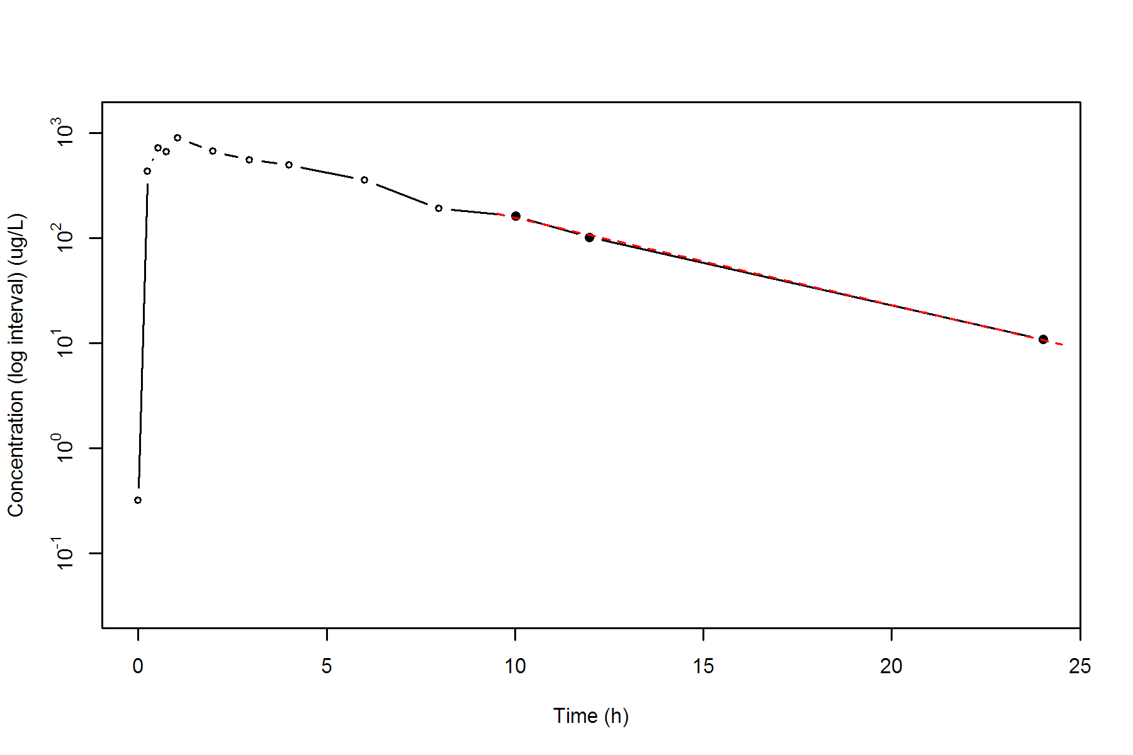

**SUBJ 29, GRP TR, PRD 1, TRT T**

NONCOMPARTMENTAL ANALYSIS REPORT

Package version 0.3.9 (2018-05-10 KST)

R version 3.5.0 (2018-04-23)

Date and Time: 2018-06-19 09:49:36 Asia/Seoul

Calculation Setting

-------------------

Drug Administration: Extravascular

Observation count excluding trailing zero: 13

Dose at time 0: 0 mg

AUC Calculation Method: Linear-up Linear-down

Weighting for lambda z: Uniform (Ordinary Least Square, OLS)

Lambda z selection criterion: Heighest adjusted R-squared value with precision=1e-4

Fitting, AUC, AUMC Result

-------------------------

Time Conc. Pred. Residual AUC AUMC

---------------------------------------------------------------------

0.0000 0.0000 0.0000 0.0000

0.2000 277.2600 27.7260 5.5452

0.5200 505.0000 152.8876 56.4335

0.7300 573.4000 266.1196 127.9576

1.0200 764.5300 460.1195 301.7260

2.0200 770.6300 1227.6994 1469.9726

3.0500 548.7100 1907.1596 3133.5452

4.0200 486.2500 2409.1151 4893.2661

6.0400 295.2800 3198.4605 8668.8645

7.9900 175.5600 3657.5295 11775.4247

9.9800 * 134.5100 138.2047 -3.695e+00 3966.0491 14506.8332

11.9800 * 93.5400 90.6308 +2.909e+00 4194.0991 16969.8522

24.0300 * 7.1000 7.1320 -3.200e-02 4800.4551 24749.4660

*: Used for the calculation of Lambda z.

Calculated Values

-----------------

CMAX Max Conc 770.6300 ug/L

TMAX Time of CMAX 2.0200 h

TLAG Time Until First Nonzero Conc 0.0000 h

CLST Last Nonzero Conc 7.1000 ug/L

CLSTP Last Nonzero Conc Pred 7.1320 ug/L

TLST Time of Last Nonzero Conc 24.0300 h

LAMZHL Half-Life Lambda z 3.2855 h

LAMZ Lambda z 0.2110 /h

LAMZLL Lambda z Lower Limit 9.9800 h

LAMZUL Lambda z Upper Limit 24.0300 h

LAMZNPT Number of Points for Lambda z 3

CORRXY Correlation Between TimeX and Log ConcY -0.9998

R2 R Squared 0.9997

R2ADJ R Squared Adjusted 0.9993

AUCLST AUC to Last Nonzero Conc 4800.4551 h*ug/L

AUCALL AUC All 4800.4551 h*ug/L

AUCIFO AUC Infinity Obs 4834.1090 h*ug/L

AUCIFP AUC Infinity Pred 4834.2607 h*ug/L

AUCPEO AUC %Extrapolation Obs 0.6962 %

AUCPEP AUC %Extrapolation Pred 0.6993 %

AUMCLST AUMC to Last Nonzero Conc 24749.4660 h2*ug/L

AUMCIFO AUMC Infinity Obs 25717.6882 h2*ug/L

AUMCIFP AUMC Infinity Pred 25722.0526 h2*ug/L

AUMCPEO AUMC %Extrapolation Obs 3.7648 %

AUMCPEP AUMC % Extrapolation Pred 3.7811 %

VZFO Vz Obs by F 0.0000 L

VZFP Vz Pred by F 0.0000 L

CLFO Total CL Obs by F 0.0000 L/h

CLFP Total CL Pred by F 0.0000 L/h

MRTEVLST MRT Extravasc to Last Nonzero Conc 5.1556 h

MRTEVIFO MRT Extravasc Infinity Obs 5.3200 h

MRTEVIFP MRT Extravasc Infinity Pred 5.3208 h

**SUBJ 29, GRP TR, PRD 1, TRT T**

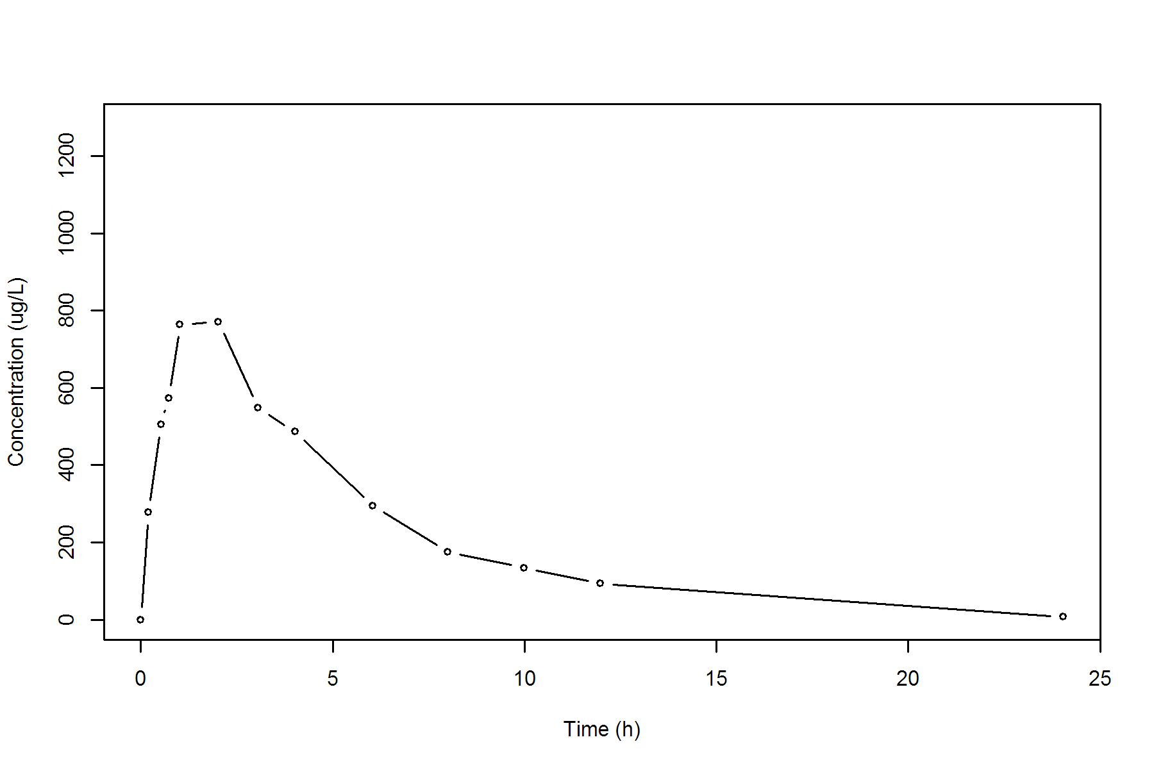

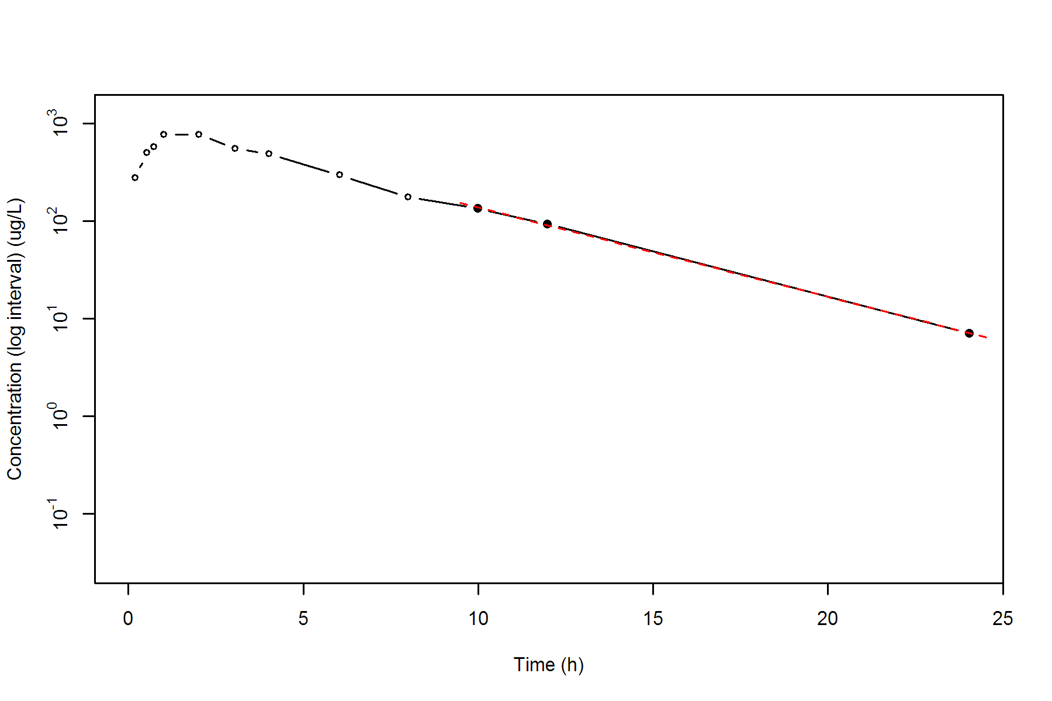

**SUBJ 29, GRP TR, PRD 2, TRT R**

NONCOMPARTMENTAL ANALYSIS REPORT

Package version 0.3.9 (2018-05-10 KST)

R version 3.5.0 (2018-04-23)

Date and Time: 2018-06-19 09:49:36 Asia/Seoul

Calculation Setting

-------------------

Drug Administration: Extravascular

Observation count excluding trailing zero: 13

Dose at time 0: 0 mg

AUC Calculation Method: Linear-up Linear-down

Weighting for lambda z: Uniform (Ordinary Least Square, OLS)

Lambda z selection criterion: Heighest adjusted R-squared value with precision=1e-4

Fitting, AUC, AUMC Result

-------------------------

Time Conc. Pred. Residual AUC AUMC

---------------------------------------------------------------------

0.0000 0.0000 0.0000 0.0000

0.2700 423.2800 57.1428 15.4286

0.5300 586.1800 188.3726 70.6735

0.7500 729.7000 333.1194 165.0480

1.0400 738.1700 545.9606 355.7189

1.9500 683.3200 1192.7385 1311.2967

2.9600 503.0100 1791.8352 2736.0954

4.0300 475.5100 2315.3434 4557.8853

5.9800 426.9500 3195.2419 8915.6150

8.0100 249.6900 3882.0315 13537.0906

10.0200 * 227.9200 215.1216 +1.280e+01 4362.0295 17842.2847

12.0000 * 148.2200 158.5465 -1.033e+01 4734.4081 21864.0591

23.9700 * 25.3000 25.0593 +2.407e-01 5772.9253 36138.7689

*: Used for the calculation of Lambda z.

Calculated Values

-----------------

CMAX Max Conc 738.1700 ug/L

TMAX Time of CMAX 1.0400 h

TLAG Time Until First Nonzero Conc 0.0000 h

CLST Last Nonzero Conc 25.3000 ug/L

CLSTP Last Nonzero Conc Pred 25.0593 ug/L

TLST Time of Last Nonzero Conc 23.9700 h

LAMZHL Half-Life Lambda z 4.4975 h

LAMZ Lambda z 0.1541 /h

LAMZLL Lambda z Lower Limit 10.0200 h

LAMZUL Lambda z Upper Limit 23.9700 h

LAMZNPT Number of Points for Lambda z 3

CORRXY Correlation Between TimeX and Log ConcY -0.9985

R2 R Squared 0.9971

R2ADJ R Squared Adjusted 0.9941

AUCLST AUC to Last Nonzero Conc 5772.9253 h*ug/L

AUCALL AUC All 5772.9253 h*ug/L

AUCIFO AUC Infinity Obs 5937.0843 h*ug/L

AUCIFP AUC Infinity Pred 5935.5225 h*ug/L

AUCPEO AUC %Extrapolation Obs 2.7650 %

AUCPEP AUC %Extrapolation Pred 2.7394 %

AUMCLST AUMC to Last Nonzero Conc 36138.7689 h2*ug/L

AUMCIFO AUMC Infinity Obs 41138.8045 h2*ug/L

AUMCIFP AUMC Infinity Pred 41091.2347 h2*ug/L

AUMCPEO AUMC %Extrapolation Obs 12.1541 %

AUMCPEP AUMC % Extrapolation Pred 12.0524 %

VZFO Vz Obs by F 0.0000 L

VZFP Vz Pred by F 0.0000 L

CLFO Total CL Obs by F 0.0000 L/h

CLFP Total CL Pred by F 0.0000 L/h

MRTEVLST MRT Extravasc to Last Nonzero Conc 6.2600 h

MRTEVIFO MRT Extravasc Infinity Obs 6.9291 h

MRTEVIFP MRT Extravasc Infinity Pred 6.9229 h

**SUBJ 29, GRP TR, PRD 2, TRT R**

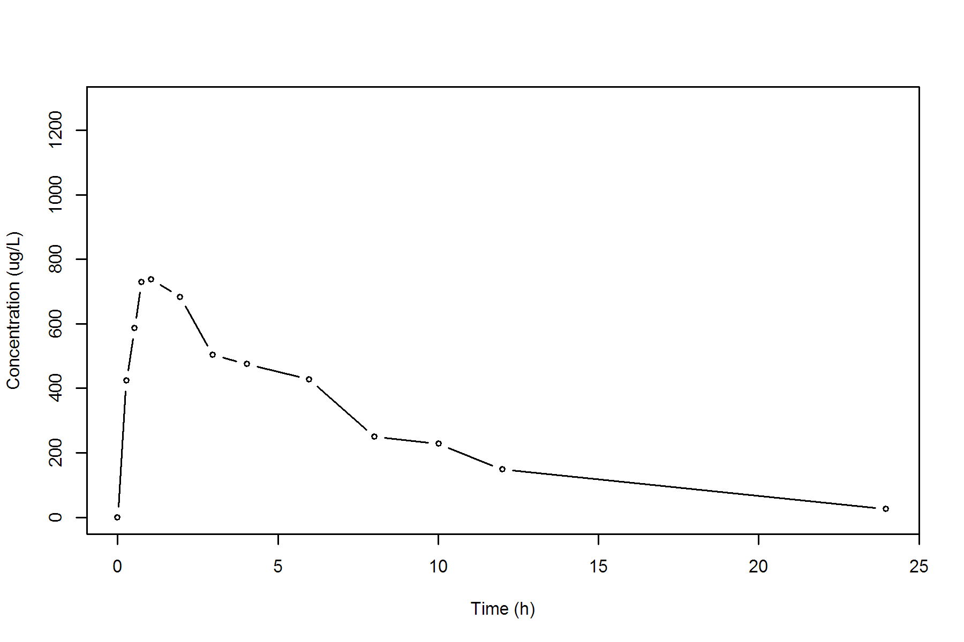

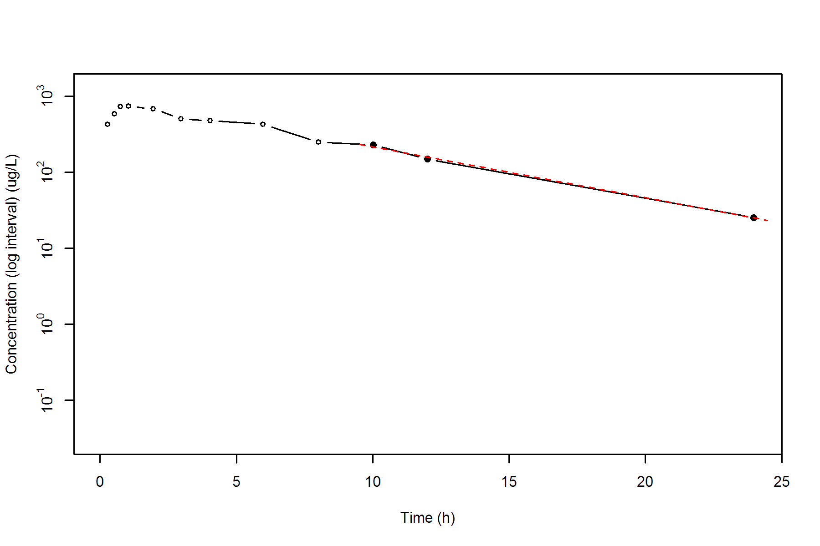

**SUBJ 30, GRP RT, PRD 1, TRT R**

NONCOMPARTMENTAL ANALYSIS REPORT

Package version 0.3.9 (2018-05-10 KST)

R version 3.5.0 (2018-04-23)

Date and Time: 2018-06-19 09:49:36 Asia/Seoul

Calculation Setting

-------------------

Drug Administration: Extravascular

Observation count excluding trailing zero: 13

Dose at time 0: 0 mg

AUC Calculation Method: Linear-up Linear-down

Weighting for lambda z: Uniform (Ordinary Least Square, OLS)

Lambda z selection criterion: Heighest adjusted R-squared value with precision=1e-4

Fitting, AUC, AUMC Result

-------------------------

Time Conc. Pred. Residual AUC AUMC

---------------------------------------------------------------------

0.0000 0.0000 0.0000 0.0000

0.2000 357.1700 35.7170 7.1434

0.4600 709.6900 174.4088 58.8693

0.7700 1034.1100 444.6978 232.8912

0.9500 * 807.3700 897.4828 -9.011e+01 610.4310 373.5852

2.0500 * 743.8500 692.9147 +5.094e+01 1463.6020 1634.1269

2.9800 * 525.0100 556.7958 -3.179e+01 2053.6219 3070.7082

4.0400 * 534.2400 433.9452 +1.003e+02 2615.0244 5043.8237

6.0300 * 288.5100 271.7628 +1.675e+01 3433.6607 8922.3784

7.9700 * 178.8500 172.2074 +6.643e+00 3886.9999 11992.5737

10.0000 * 82.1400 106.8370 -2.470e+01 4151.9047 14273.1107

12.0400 * 65.9400 66.1257 -1.857e-01 4302.9463 15920.7347

24.0000 * 4.1900 3.9706 +2.194e-01 4722.3237 21269.7107

*: Used for the calculation of Lambda z.

Calculated Values

-----------------

CMAX Max Conc 1034.1100 ug/L

TMAX Time of CMAX 0.7700 h

TLAG Time Until First Nonzero Conc 0.0000 h

CLST Last Nonzero Conc 4.1900 ug/L

CLSTP Last Nonzero Conc Pred 3.9706 ug/L

TLST Time of Last Nonzero Conc 24.0000 h

LAMZHL Half-Life Lambda z 2.9474 h

LAMZ Lambda z 0.2352 /h

LAMZLL Lambda z Lower Limit 0.9500 h

LAMZUL Lambda z Upper Limit 24.0000 h

LAMZNPT Number of Points for Lambda z 9

CORRXY Correlation Between TimeX and Log ConcY -0.9969

R2 R Squared 0.9938

R2ADJ R Squared Adjusted 0.9929

AUCLST AUC to Last Nonzero Conc 4722.3237 h*ug/L

AUCALL AUC All 4722.3237 h*ug/L

AUCIFO AUC Infinity Obs 4740.1406 h*ug/L

AUCIFP AUC Infinity Pred 4739.2077 h*ug/L

AUCPEO AUC %Extrapolation Obs 0.3759 %

AUCPEP AUC %Extrapolation Pred 0.3563 %

AUMCLST AUMC to Last Nonzero Conc 21269.7107 h2*ug/L

AUMCIFO AUMC Infinity Obs 21773.0778 h2*ug/L

AUMCIFP AUMC Infinity Pred 21746.7228 h2*ug/L

AUMCPEO AUMC %Extrapolation Obs 2.3119 %

AUMCPEP AUMC % Extrapolation Pred 2.1935 %

VZFO Vz Obs by F 0.0000 L

VZFP Vz Pred by F 0.0000 L

CLFO Total CL Obs by F 0.0000 L/h

CLFP Total CL Pred by F 0.0000 L/h

MRTEVLST MRT Extravasc to Last Nonzero Conc 4.5041 h

MRTEVIFO MRT Extravasc Infinity Obs 4.5933 h

MRTEVIFP MRT Extravasc Infinity Pred 4.5887 h

**SUBJ 30, GRP RT, PRD 1, TRT R**

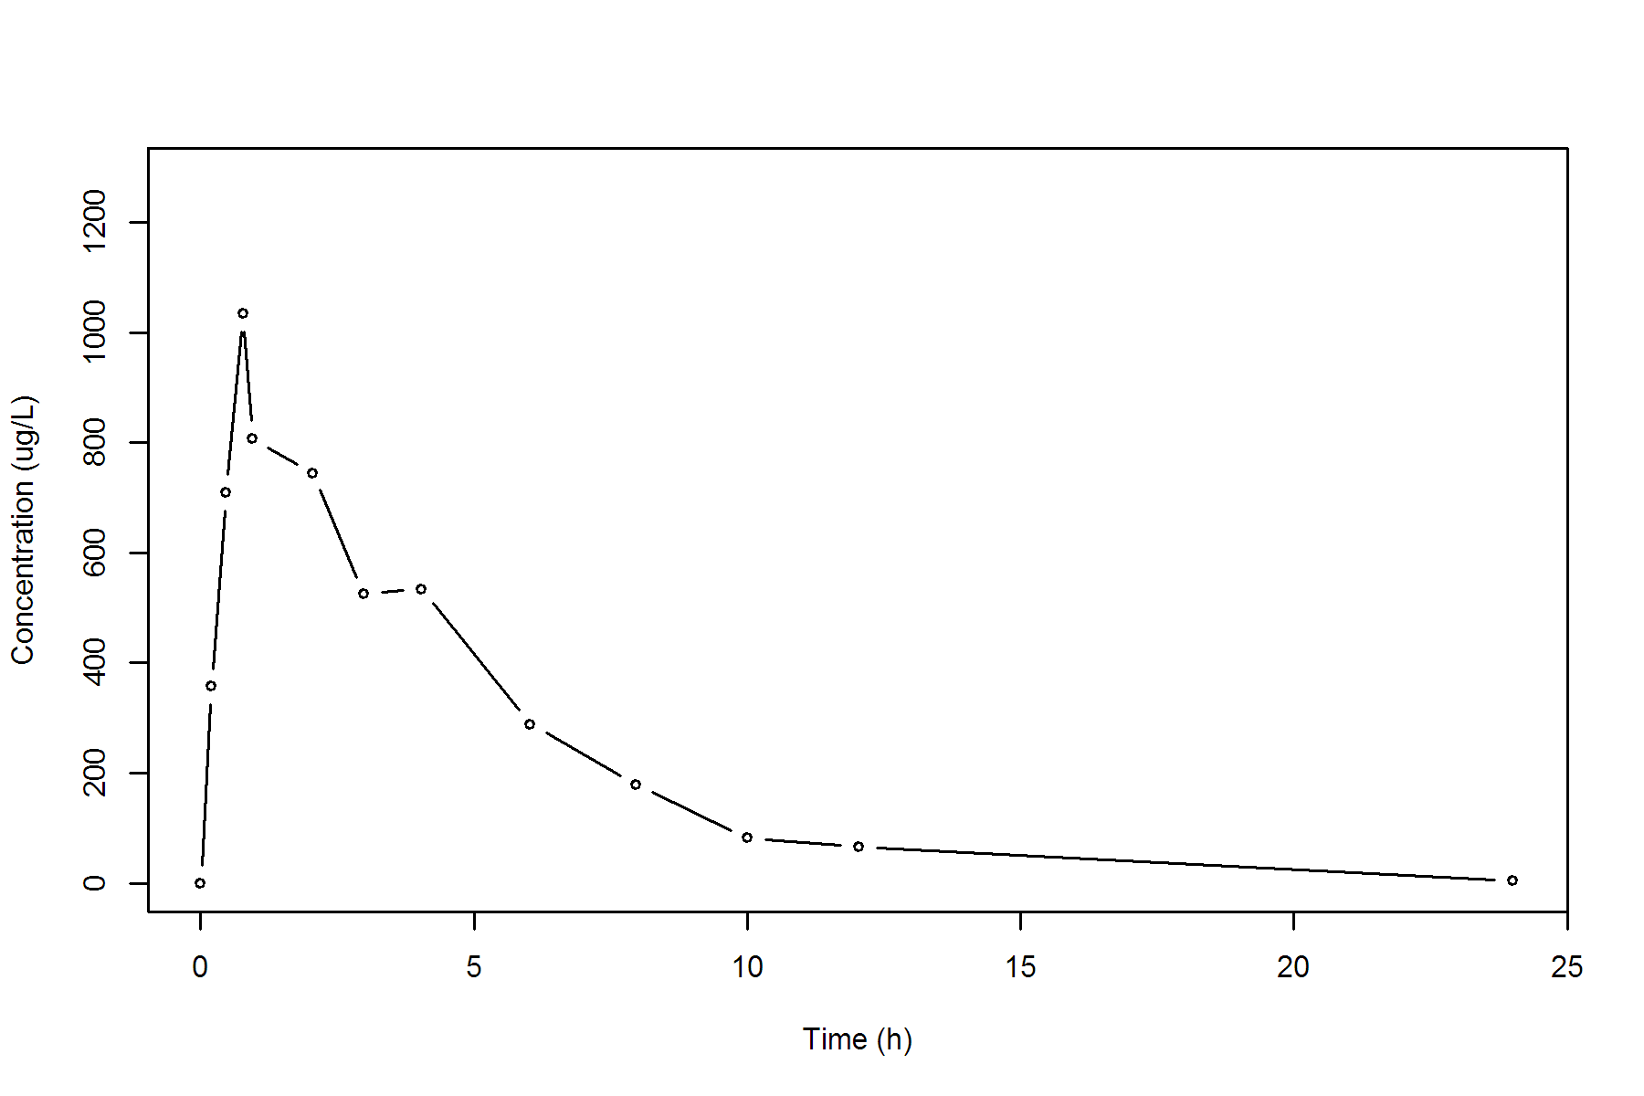

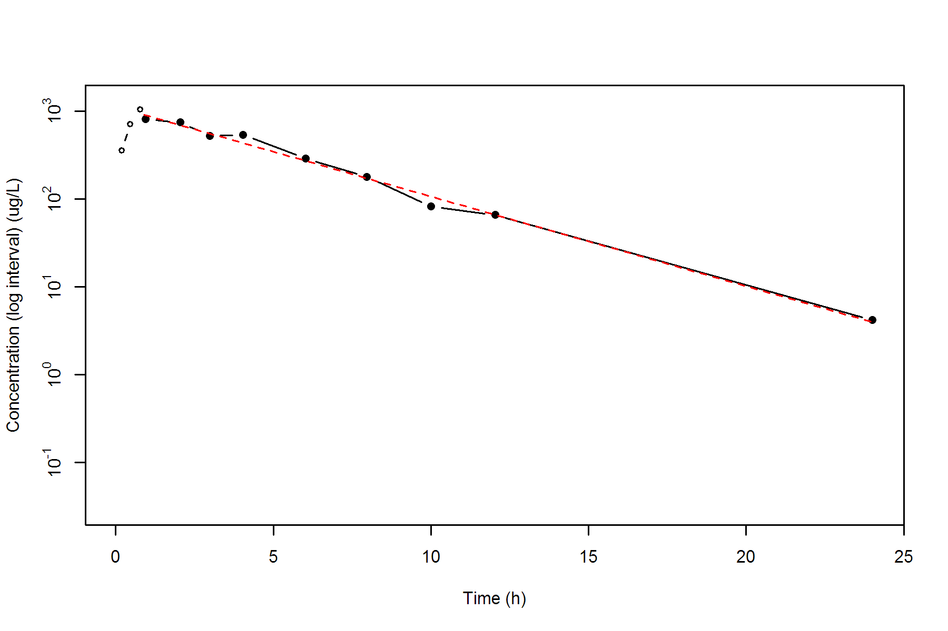

**SUBJ 30, GRP RT, PRD 2, TRT T**

NONCOMPARTMENTAL ANALYSIS REPORT

Package version 0.3.9 (2018-05-10 KST)

R version 3.5.0 (2018-04-23)

Date and Time: 2018-06-19 09:49:36 Asia/Seoul

Calculation Setting

-------------------

Drug Administration: Extravascular

Observation count excluding trailing zero: 13

Dose at time 0: 0 mg

AUC Calculation Method: Linear-up Linear-down

Weighting for lambda z: Uniform (Ordinary Least Square, OLS)

Lambda z selection criterion: Heighest adjusted R-squared value with precision=1e-4

Fitting, AUC, AUMC Result

-------------------------

Time Conc. Pred. Residual AUC AUMC

---------------------------------------------------------------------

0.0000 0.0000 0.0000 0.0000

0.2400 398.5100 47.8212 11.4771

0.5200 461.4100 168.2100 58.4577

0.7400 527.8600 277.0297 127.8181

1.0300 569.2200 436.1063 269.4705

2.0100 467.3900 944.0452 1017.0883

2.9700 280.5500 1303.0564 1867.9782

4.0400 301.0100 1614.1910 2964.3611

5.9800 140.6800 2042.6303 4959.9875

7.9700 101.7000 2283.7984 6603.5439

9.9700 * 78.7700 77.1956 +1.574e+00 2464.2684 8199.4298

11.9700 * 47.7100 48.8464 -1.136e+00 2590.7484 9555.8554

24.0200 * 3.1100 3.0996 +1.040e-02 2896.9389 13446.7455

*: Used for the calculation of Lambda z.

Calculated Values

-----------------

CMAX Max Conc 569.2200 ug/L

TMAX Time of CMAX 1.0300 h

TLAG Time Until First Nonzero Conc 0.0000 h

CLST Last Nonzero Conc 3.1100 ug/L

CLSTP Last Nonzero Conc Pred 3.0996 ug/L

TLST Time of Last Nonzero Conc 24.0200 h

LAMZHL Half-Life Lambda z 3.0291 h

LAMZ Lambda z 0.2288 /h

LAMZLL Lambda z Lower Limit 9.9700 h

LAMZUL Lambda z Upper Limit 24.0200 h

LAMZNPT Number of Points for Lambda z 3

CORRXY Correlation Between TimeX and Log ConcY -0.9999

R2 R Squared 0.9998

R2ADJ R Squared Adjusted 0.9997

AUCLST AUC to Last Nonzero Conc 2896.9389 h*ug/L

AUCALL AUC All 2896.9389 h*ug/L

AUCIFO AUC Infinity Obs 2910.5297 h*ug/L

AUCIFP AUC Infinity Pred 2910.4843 h*ug/L

AUCPEO AUC %Extrapolation Obs 0.4670 %

AUCPEP AUC %Extrapolation Pred 0.4654 %

AUMCLST AUMC to Last Nonzero Conc 13446.7455 h2*ug/L

AUMCIFO AUMC Infinity Obs 13832.5899 h2*ug/L

AUMCIFP AUMC Infinity Pred 13831.2992 h2*ug/L

AUMCPEO AUMC %Extrapolation Obs 2.7894 %

AUMCPEP AUMC % Extrapolation Pred 2.7803 %

VZFO Vz Obs by F 0.0000 L

VZFP Vz Pred by F 0.0000 L

CLFO Total CL Obs by F 0.0000 L/h

CLFP Total CL Pred by F 0.0000 L/h

MRTEVLST MRT Extravasc to Last Nonzero Conc 4.6417 h

MRTEVIFO MRT Extravasc Infinity Obs 4.7526 h

MRTEVIFP MRT Extravasc Infinity Pred 4.7522 h

**SUBJ 30, GRP RT, PRD 2, TRT T**

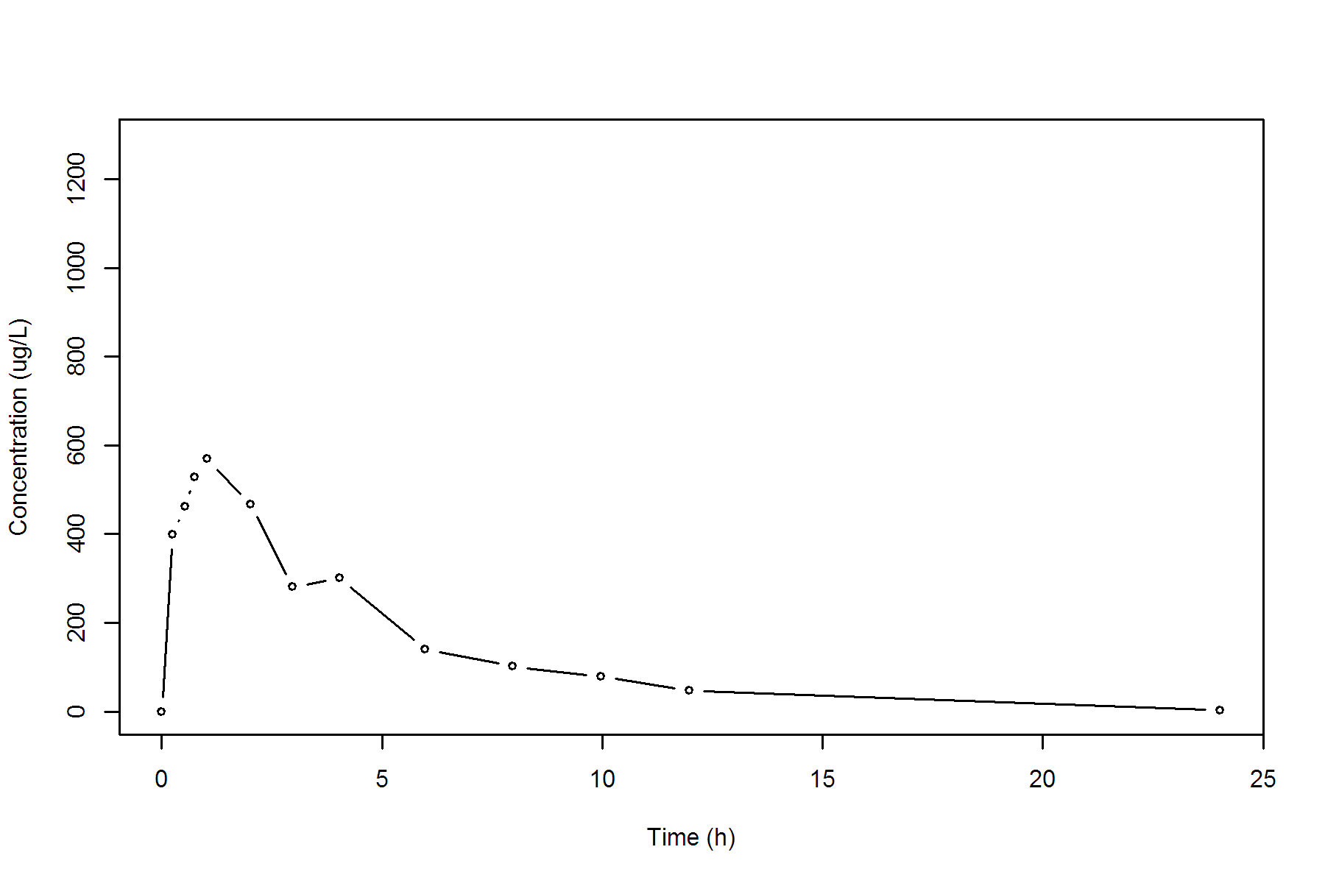

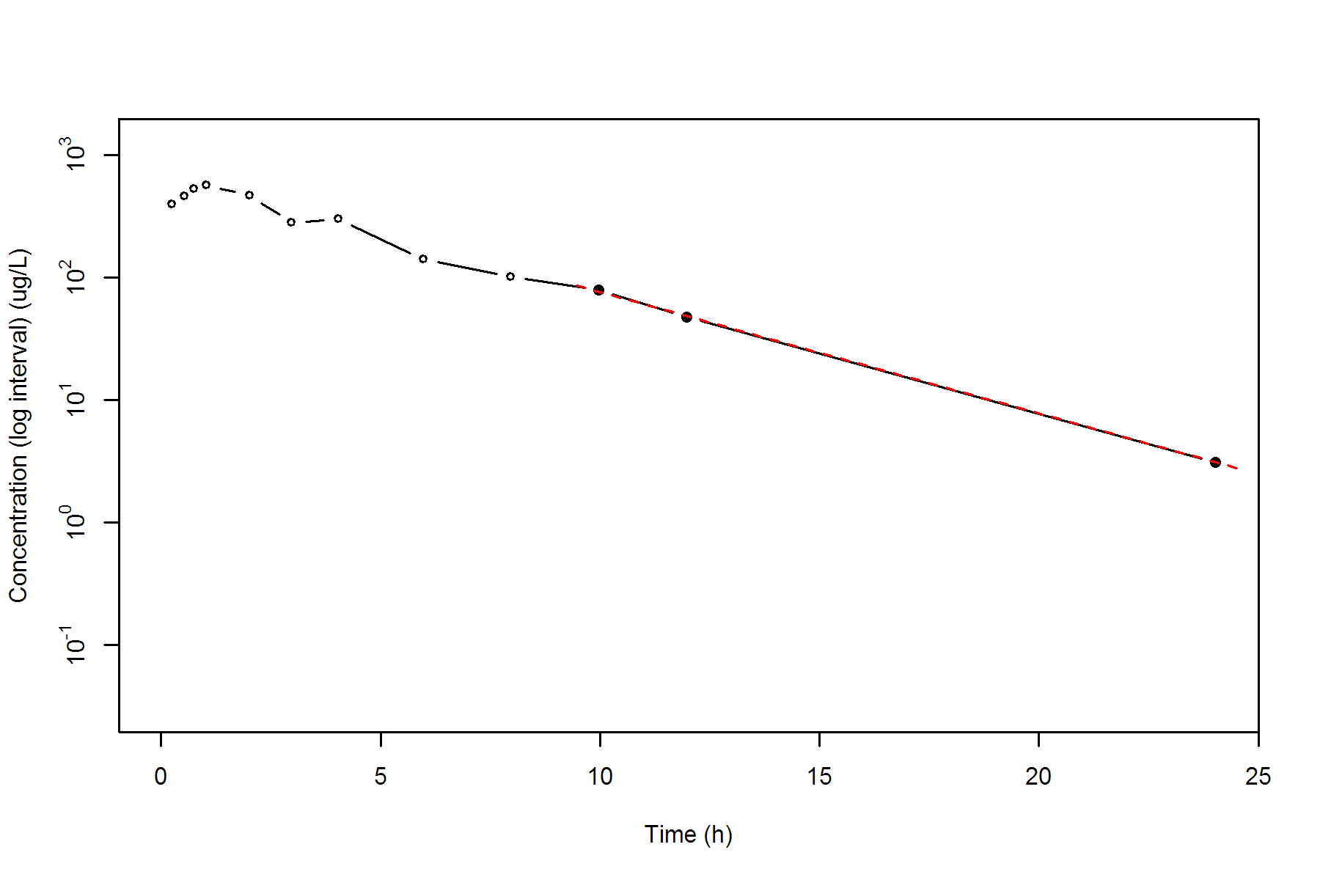

**SUBJ 31, GRP RT, PRD 1, TRT R**

NONCOMPARTMENTAL ANALYSIS REPORT

Package version 0.3.9 (2018-05-10 KST)

R version 3.5.0 (2018-04-23)

Date and Time: 2018-06-19 09:49:36 Asia/Seoul

Calculation Setting

-------------------

Drug Administration: Extravascular

Observation count excluding trailing zero: 13

Dose at time 0: 0 mg

AUC Calculation Method: Linear-up Linear-down

Weighting for lambda z: Uniform (Ordinary Least Square, OLS)

Lambda z selection criterion: Heighest adjusted R-squared value with precision=1e-4

Fitting, AUC, AUMC Result

-------------------------

Time Conc. Pred. Residual AUC AUMC

---------------------------------------------------------------------

0.0000 0.2400 0.0000 0.0000

0.2700 435.1400 58.7763 15.8609

0.4800 593.4700 166.7804 58.1080

0.7400 777.3200 344.9831 169.9187

1.0100 863.8700 566.5437 365.3616

1.9800 1043.8200 1491.7734 1790.9087

3.0300 930.2600 2528.1653 4355.7707

4.0500 784.1300 3402.5043 7412.9220

5.9500 593.3000 4711.0628 13783.4904

7.9800 * 358.3100 351.9613 +6.349e+00 5676.9469 20268.7809

9.9800 * 265.1300 259.8239 +5.306e+00 6300.3869 25774.0921

11.9800 * 182.9200 191.8064 -8.886e+00 6748.4369 30611.4711

23.9600 * 31.4300 31.1377 +2.923e-01 8032.3934 48248.6931

*: Used for the calculation of Lambda z.

Calculated Values

-----------------

CMAX Max Conc 1043.8200 ug/L

TMAX Time of CMAX 1.9800 h

TLAG Time Until First Nonzero Conc 0.0000 h

CLST Last Nonzero Conc 31.4300 ug/L

CLSTP Last Nonzero Conc Pred 31.1377 ug/L

TLST Time of Last Nonzero Conc 23.9600 h

LAMZHL Half-Life Lambda z 4.5674 h

LAMZ Lambda z 0.1518 /h

LAMZLL Lambda z Lower Limit 7.9800 h

LAMZUL Lambda z Upper Limit 23.9600 h

LAMZNPT Number of Points for Lambda z 4

CORRXY Correlation Between TimeX and Log ConcY -0.9996

R2 R Squared 0.9991

R2ADJ R Squared Adjusted 0.9987

AUCLST AUC to Last Nonzero Conc 8032.3934 h*ug/L

AUCALL AUC All 8032.3934 h*ug/L

AUCIFO AUC Infinity Obs 8239.4986 h*ug/L

AUCIFP AUC Infinity Pred 8237.5724 h*ug/L

AUCPEO AUC %Extrapolation Obs 2.5136 %

AUCPEP AUC %Extrapolation Pred 2.4908 %

AUMCLST AUMC to Last Nonzero Conc 48248.6931 h2*ug/L

AUMCIFO AUMC Infinity Obs 54575.6364 h2*ug/L

AUMCIFP AUMC Infinity Pred 54516.7921 h2*ug/L

AUMCPEO AUMC %Extrapolation Obs 11.5930 %

AUMCPEP AUMC % Extrapolation Pred 11.4976 %

VZFO Vz Obs by F 0.0000 L

VZFP Vz Pred by F 0.0000 L

CLFO Total CL Obs by F 0.0000 L/h

CLFP Total CL Pred by F 0.0000 L/h

MRTEVLST MRT Extravasc to Last Nonzero Conc 6.0068 h

MRTEVIFO MRT Extravasc Infinity Obs 6.6237 h

MRTEVIFP MRT Extravasc Infinity Pred 6.6181 h

**SUBJ 31, GRP RT, PRD 1, TRT R**

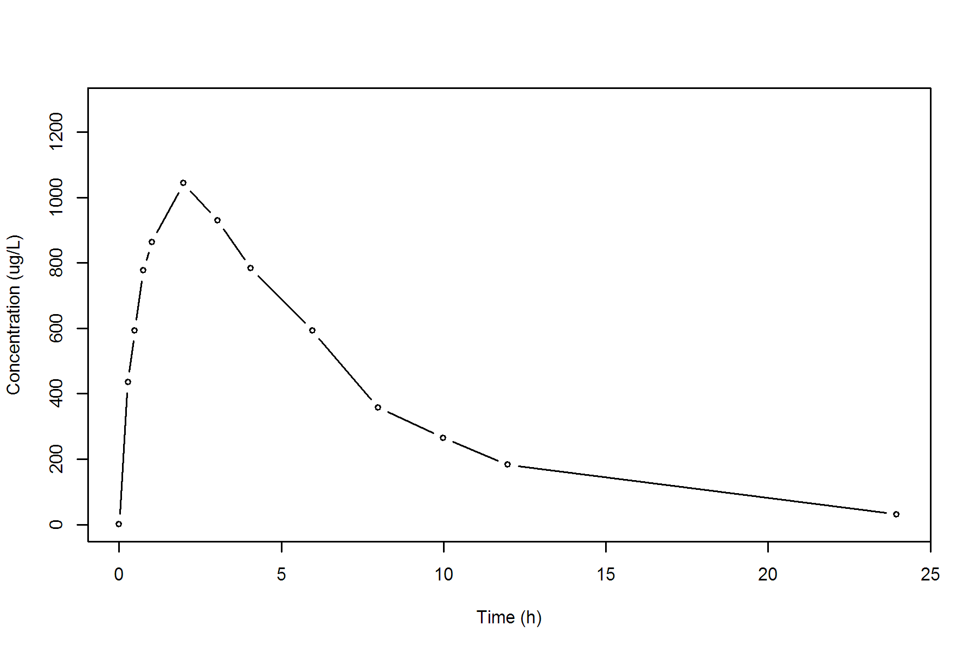

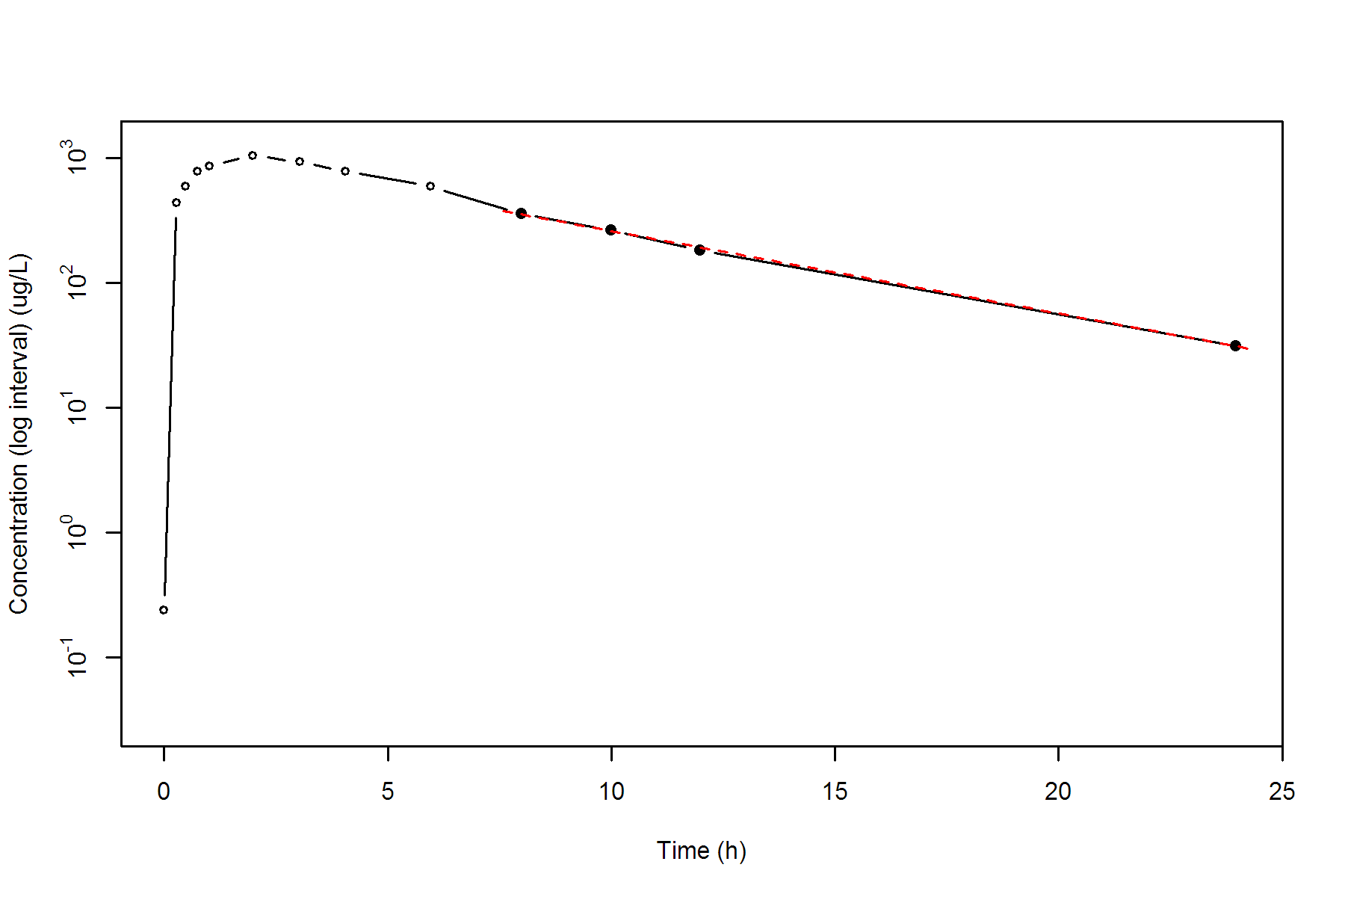

**SUBJ 31, GRP RT, PRD 2, TRT T**

NONCOMPARTMENTAL ANALYSIS REPORT

Package version 0.3.9 (2018-05-10 KST)

R version 3.5.0 (2018-04-23)

Date and Time: 2018-06-19 09:49:36 Asia/Seoul

Calculation Setting

-------------------

Drug Administration: Extravascular

Observation count excluding trailing zero: 13

Dose at time 0: 0 mg

AUC Calculation Method: Linear-up Linear-down

Weighting for lambda z: Uniform (Ordinary Least Square, OLS)

Lambda z selection criterion: Heighest adjusted R-squared value with precision=1e-4

Fitting, AUC, AUMC Result

-------------------------

Time Conc. Pred. Residual AUC AUMC

---------------------------------------------------------------------

0.0000 0.0000 0.0000 0.0000

0.2100 435.4500 45.7222 9.6017

0.5400 974.6700 278.3921 111.5331

0.7100 1043.0800 449.9008 219.2203

0.9600 1141.4300 722.9646 448.7653

1.9900 1066.1800 1859.8837 2105.7629

3.0000 805.4500 2805.0569 4397.4772

3.9600 650.5400 3503.9321 6793.8716

6.0400 418.5500 4615.7857 12102.2192

7.9800 * 200.7300 203.0888 -2.359e+00 5216.4873 16108.1906

10.0000 * 112.9000 110.4374 +2.463e+00 5533.2536 18866.3243

11.9900 * 59.9900 60.6005 -6.105e-01 5705.2791 20705.3630

24.0400 * 1.6000 1.6004 -3.933e-04 6076.3589 25270.7712

*: Used for the calculation of Lambda z.

Calculated Values

-----------------

CMAX Max Conc 1141.4300 ug/L

TMAX Time of CMAX 0.9600 h

TLAG Time Until First Nonzero Conc 0.0000 h

CLST Last Nonzero Conc 1.6000 ug/L

CLSTP Last Nonzero Conc Pred 1.6004 ug/L

TLST Time of Last Nonzero Conc 24.0400 h

LAMZHL Half-Life Lambda z 2.2984 h

LAMZ Lambda z 0.3016 /h

LAMZLL Lambda z Lower Limit 7.9800 h

LAMZUL Lambda z Upper Limit 24.0400 h

LAMZNPT Number of Points for Lambda z 4

CORRXY Correlation Between TimeX and Log ConcY -1.0000

R2 R Squared 0.9999

R2ADJ R Squared Adjusted 0.9999

AUCLST AUC to Last Nonzero Conc 6076.3589 h*ug/L

AUCALL AUC All 6076.3589 h*ug/L

AUCIFO AUC Infinity Obs 6081.6642 h*ug/L

AUCIFP AUC Infinity Pred 6081.6655 h*ug/L

AUCPEO AUC %Extrapolation Obs 0.0872 %

AUCPEP AUC %Extrapolation Pred 0.0873 %

AUMCLST AUMC to Last Nonzero Conc 25270.7712 h2*ug/L

AUMCIFO AUMC Infinity Obs 25415.9041 h2*ug/L

AUMCIFP AUMC Infinity Pred 25415.9398 h2*ug/L

AUMCPEO AUMC %Extrapolation Obs 0.5710 %

AUMCPEP AUMC % Extrapolation Pred 0.5712 %

VZFO Vz Obs by F 0.0000 L

VZFP Vz Pred by F 0.0000 L

CLFO Total CL Obs by F 0.0000 L/h

CLFP Total CL Pred by F 0.0000 L/h

MRTEVLST MRT Extravasc to Last Nonzero Conc 4.1589 h

MRTEVIFO MRT Extravasc Infinity Obs 4.1791 h

MRTEVIFP MRT Extravasc Infinity Pred 4.1791 h

**SUBJ 31, GRP RT, PRD 2, TRT T**

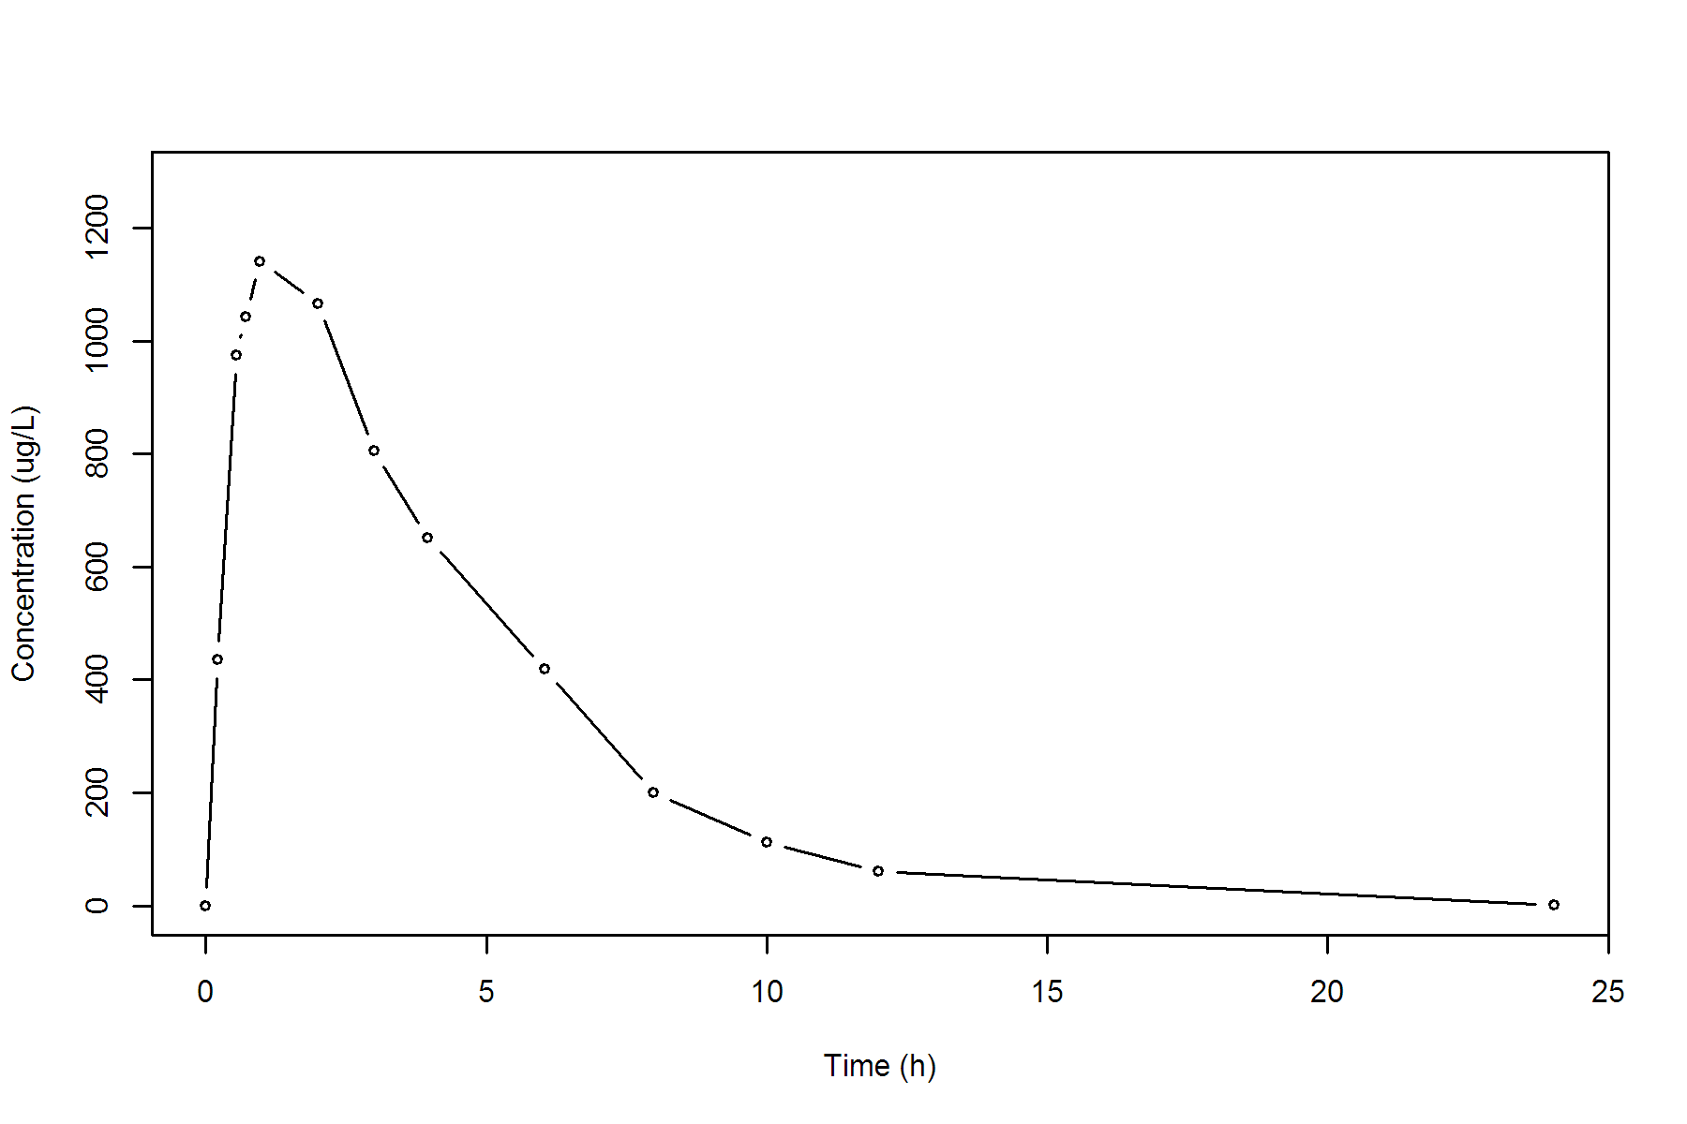

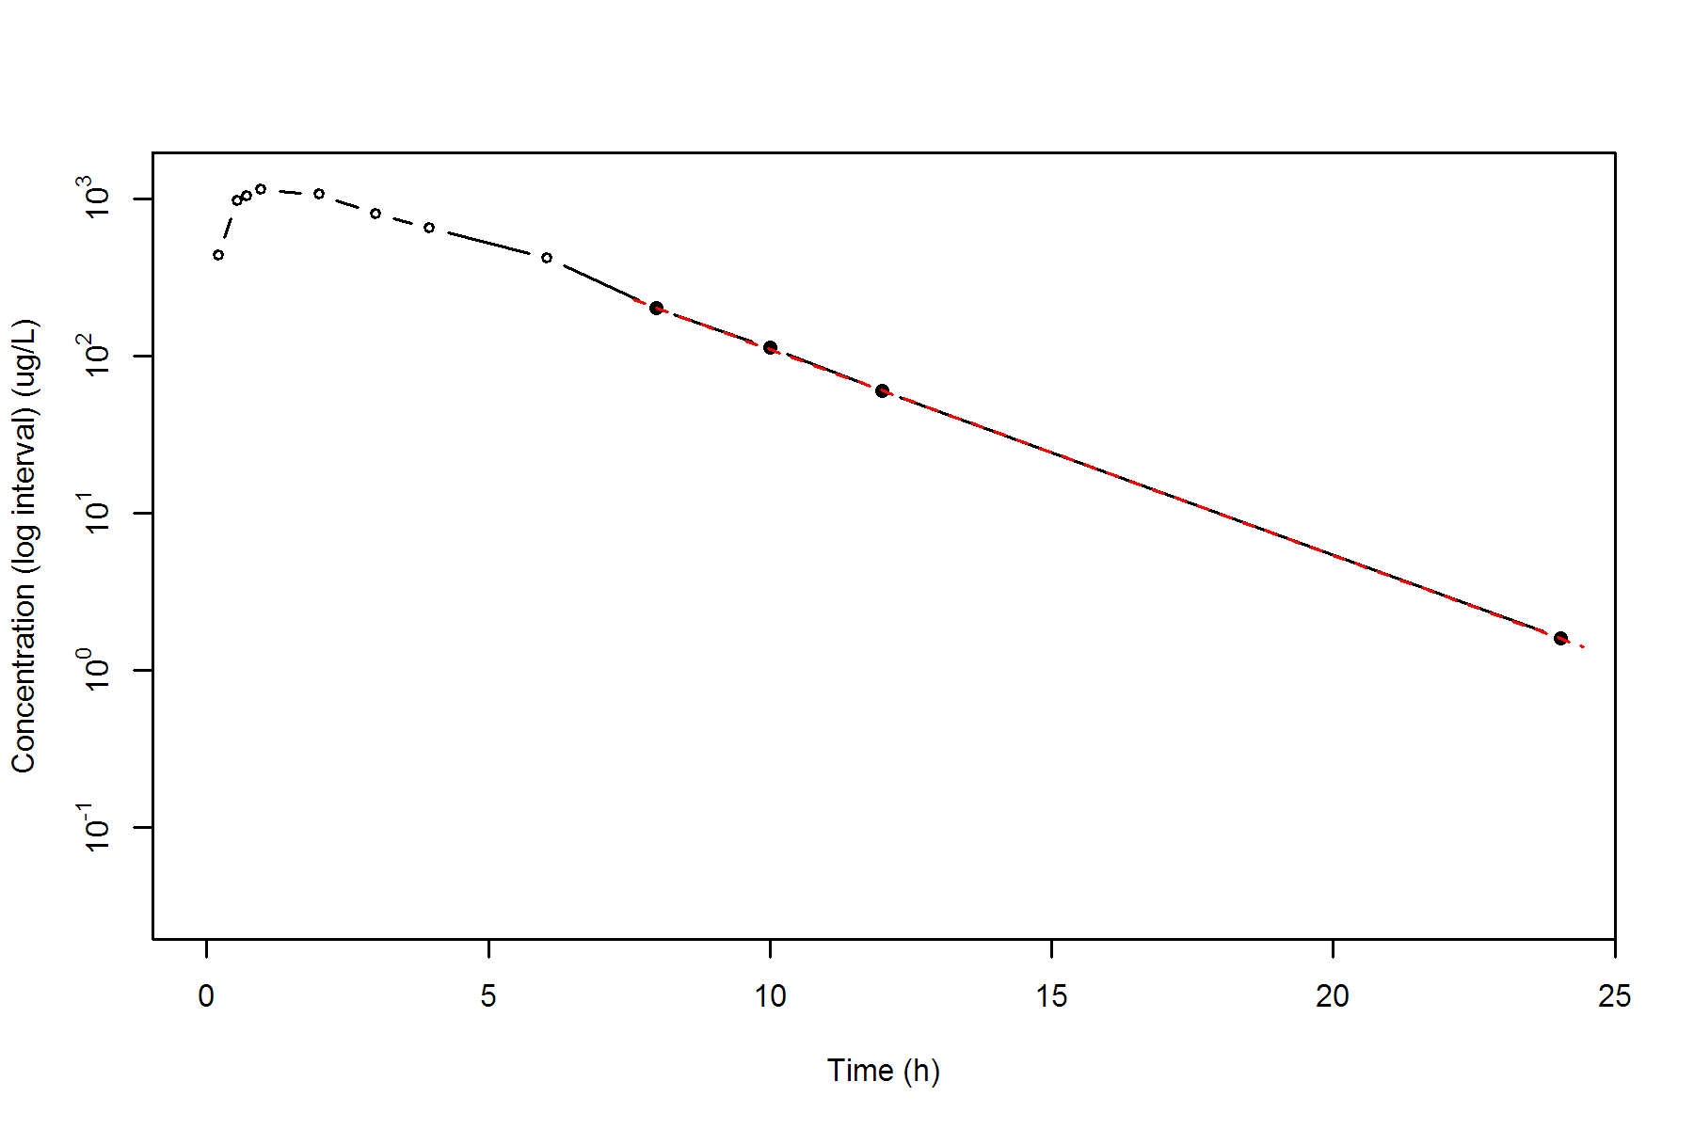

**SUBJ 32, GRP TR, PRD 1, TRT T**

NONCOMPARTMENTAL ANALYSIS REPORT

Package version 0.3.9 (2018-05-10 KST)

R version 3.5.0 (2018-04-23)

Date and Time: 2018-06-19 09:49:36 Asia/Seoul

Calculation Setting

-------------------

Drug Administration: Extravascular

Observation count excluding trailing zero: 13

Dose at time 0: 0 mg

AUC Calculation Method: Linear-up Linear-down

Weighting for lambda z: Uniform (Ordinary Least Square, OLS)

Lambda z selection criterion: Heighest adjusted R-squared value with precision=1e-4

Fitting, AUC, AUMC Result

-------------------------

Time Conc. Pred. Residual AUC AUMC

---------------------------------------------------------------------

0.0000 0.1700 0.0000 0.0000

0.2200 175.9400 19.3721 4.2577

0.5000 363.2800 94.8629 35.1063

0.7500 341.9000 183.0104 89.8644

1.0300 463.3700 295.7482 192.5819

2.0300 606.1100 830.4882 1046.4191

2.9700 608.9300 1401.5570 2474.7140

3.9700 * 458.8700 445.3766 +1.349e+01 1935.4570 4289.8320

5.9600 * 318.4700 292.0968 +2.637e+01 2708.9103 7991.0281

7.9600 * 208.7200 191.1638 +1.756e+01 3236.1003 11550.5205

9.9700 * 98.0600 124.8430 -2.678e+01 3544.4142 14202.7853

11.9900 * 80.1500 81.3583 -1.208e+00 3724.4063 16160.8286

23.9800 * 6.7500 6.4061 +3.439e-01 4245.3718 22892.3952

*: Used for the calculation of Lambda z.

Calculated Values

-----------------

CMAX Max Conc 608.9300 ug/L

TMAX Time of CMAX 2.9700 h

TLAG Time Until First Nonzero Conc 0.0000 h

CLST Last Nonzero Conc 6.7500 ug/L

CLSTP Last Nonzero Conc Pred 6.4061 ug/L

TLST Time of Last Nonzero Conc 23.9800 h

LAMZHL Half-Life Lambda z 3.2699 h

LAMZ Lambda z 0.2120 /h

LAMZLL Lambda z Lower Limit 3.9700 h

LAMZUL Lambda z Upper Limit 23.9800 h

LAMZNPT Number of Points for Lambda z 6

CORRXY Correlation Between TimeX and Log ConcY -0.9966

R2 R Squared 0.9933

R2ADJ R Squared Adjusted 0.9916

AUCLST AUC to Last Nonzero Conc 4245.3718 h*ug/L

AUCALL AUC All 4245.3718 h*ug/L

AUCIFO AUC Infinity Obs 4277.2148 h*ug/L

AUCIFP AUC Infinity Pred 4275.5926 h*ug/L

AUCPEO AUC %Extrapolation Obs 0.7445 %

AUCPEP AUC %Extrapolation Pred 0.7068 %

AUMCLST AUMC to Last Nonzero Conc 22892.3952 h2*ug/L

AUMCIFO AUMC Infinity Obs 23806.2104 h2*ug/L

AUMCIFP AUMC Infinity Pred 23759.6572 h2*ug/L

AUMCPEO AUMC %Extrapolation Obs 3.8386 %

AUMCPEP AUMC % Extrapolation Pred 3.6501 %

VZFO Vz Obs by F 0.0000 L

VZFP Vz Pred by F 0.0000 L

CLFO Total CL Obs by F 0.0000 L/h

CLFP Total CL Pred by F 0.0000 L/h

MRTEVLST MRT Extravasc to Last Nonzero Conc 5.3923 h

MRTEVIFO MRT Extravasc Infinity Obs 5.5658 h

MRTEVIFP MRT Extravasc Infinity Pred 5.5570 h

**SUBJ 32, GRP TR, PRD 1, TRT T**

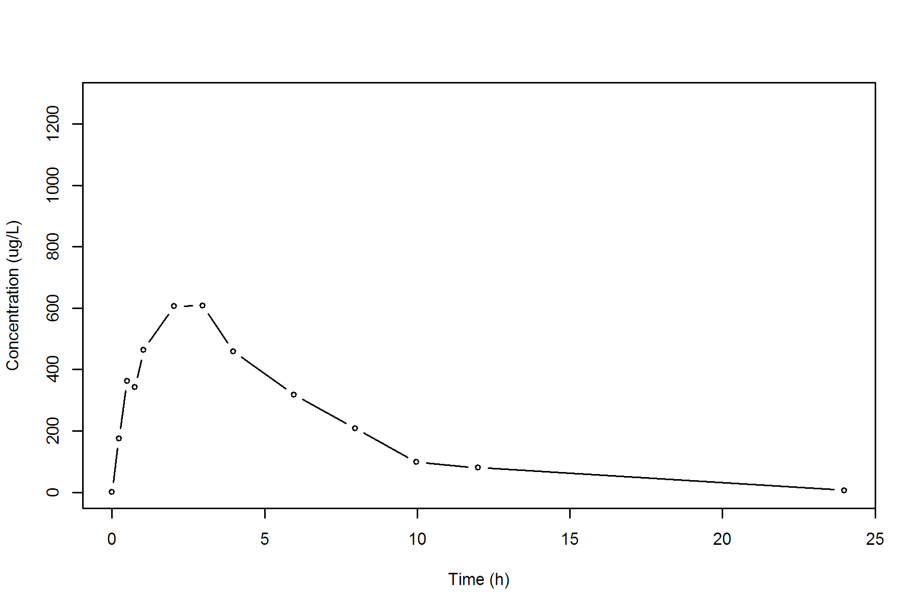

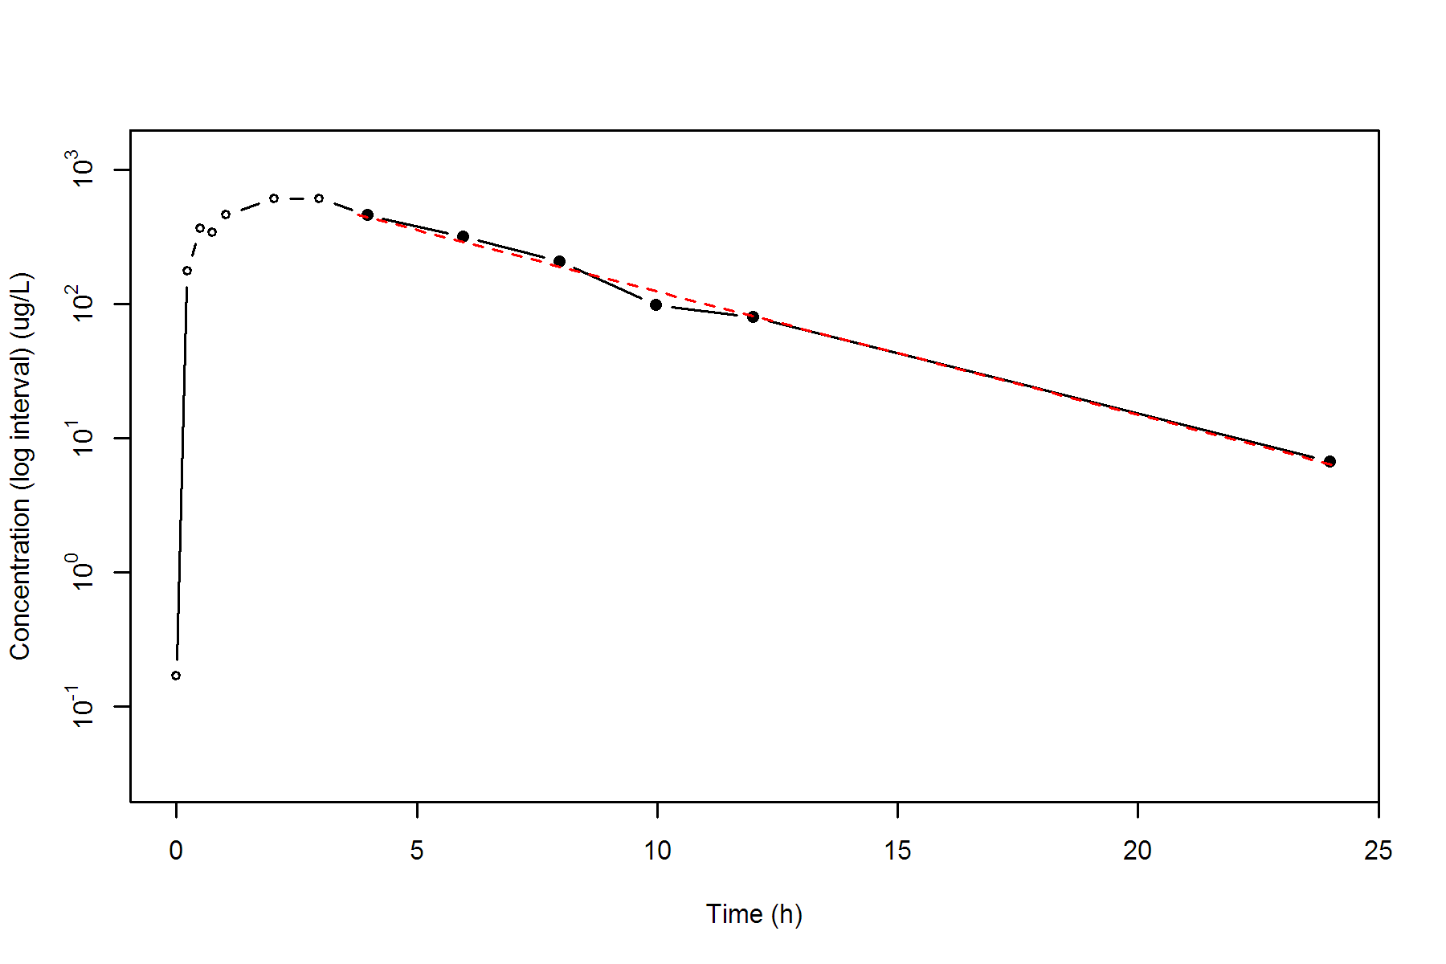

**SUBJ 32, GRP TR, PRD 2, TRT R**

NONCOMPARTMENTAL ANALYSIS REPORT

Package version 0.3.9 (2018-05-10 KST)

R version 3.5.0 (2018-04-23)

Date and Time: 2018-06-19 09:49:36 Asia/Seoul

Calculation Setting

-------------------

Drug Administration: Extravascular

Observation count excluding trailing zero: 13

Dose at time 0: 0 mg

AUC Calculation Method: Linear-up Linear-down

Weighting for lambda z: Uniform (Ordinary Least Square, OLS)

Lambda z selection criterion: Heighest adjusted R-squared value with precision=1e-4

Fitting, AUC, AUMC Result

-------------------------

Time Conc. Pred. Residual AUC AUMC

---------------------------------------------------------------------

0.0000 0.4500 0.0000 0.0000

0.2700 206.6400 27.9572 7.5320

0.4500 325.9900 75.8938 25.7560

0.7300 391.1200 176.2892 86.2658

0.9600 476.2800 276.0402 171.6816

2.0400 539.6600 824.6479 1013.0747

3.0200 523.6300 1345.6600 2327.3865

3.9700 * 385.4700 401.0341 -1.556e+01 1777.4825 3805.4338

6.0200 * 329.2300 306.3963 +2.283e+01 2510.0499 7405.5213

8.0300 * 244.1600 235.3242 +8.836e+00 3086.3069 11367.8035

10.0400 * 184.5300 180.7381 +3.792e+00 3517.1404 15200.1559

12.0400 * 123.8800 138.9963 -1.512e+01 3825.5503 18544.3523

24.0400 * 29.4900 28.7557 +7.343e-01 4745.7704 31747.0811

*: Used for the calculation of Lambda z.

Calculated Values

-----------------

CMAX Max Conc 539.6600 ug/L

TMAX Time of CMAX 2.0400 h

TLAG Time Until First Nonzero Conc 0.0000 h

CLST Last Nonzero Conc 29.4900 ug/L

CLSTP Last Nonzero Conc Pred 28.7557 ug/L

TLST Time of Last Nonzero Conc 24.0400 h

LAMZHL Half-Life Lambda z 5.2791 h

LAMZ Lambda z 0.1313 /h

LAMZLL Lambda z Lower Limit 3.9700 h

LAMZUL Lambda z Upper Limit 24.0400 h

LAMZNPT Number of Points for Lambda z 6

CORRXY Correlation Between TimeX and Log ConcY -0.9975

R2 R Squared 0.9949

R2ADJ R Squared Adjusted 0.9936

AUCLST AUC to Last Nonzero Conc 4745.7704 h*ug/L

AUCALL AUC All 4745.7704 h*ug/L

AUCIFO AUC Infinity Obs 4970.3687 h*ug/L

AUCIFP AUC Infinity Pred 4964.7759 h*ug/L

AUCPEO AUC %Extrapolation Obs 4.5187 %

AUCPEP AUC %Extrapolation Pred 4.4112 %

AUMCLST AUMC to Last Nonzero Conc 31747.0811 h2*ug/L

AUMCIFO AUMC Infinity Obs 38856.9868 h2*ug/L

AUMCIFP AUMC Infinity Pred 38679.9403 h2*ug/L

AUMCPEO AUMC %Extrapolation Obs 18.2976 %

AUMCPEP AUMC % Extrapolation Pred 17.9237 %

VZFO Vz Obs by F 0.0000 L

VZFP Vz Pred by F 0.0000 L

CLFO Total CL Obs by F 0.0000 L/h

CLFP Total CL Pred by F 0.0000 L/h

MRTEVLST MRT Extravasc to Last Nonzero Conc 6.6896 h

MRTEVIFO MRT Extravasc Infinity Obs 7.8177 h

MRTEVIFP MRT Extravasc Infinity Pred 7.7909 h

**SUBJ 32, GRP TR, PRD 2, TRT R**

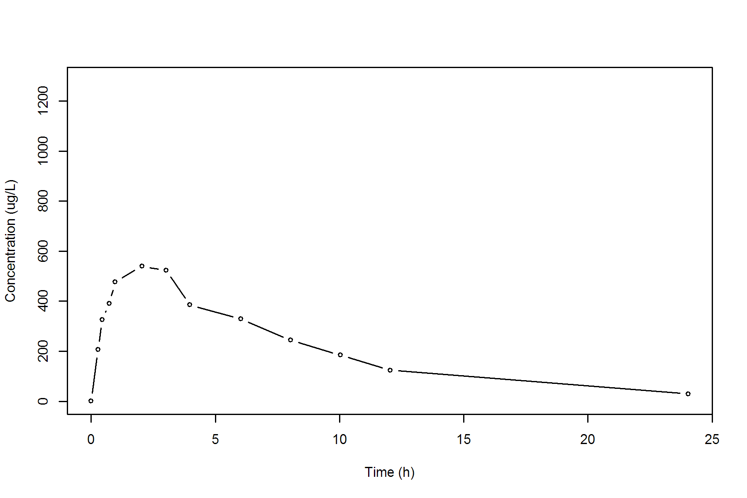

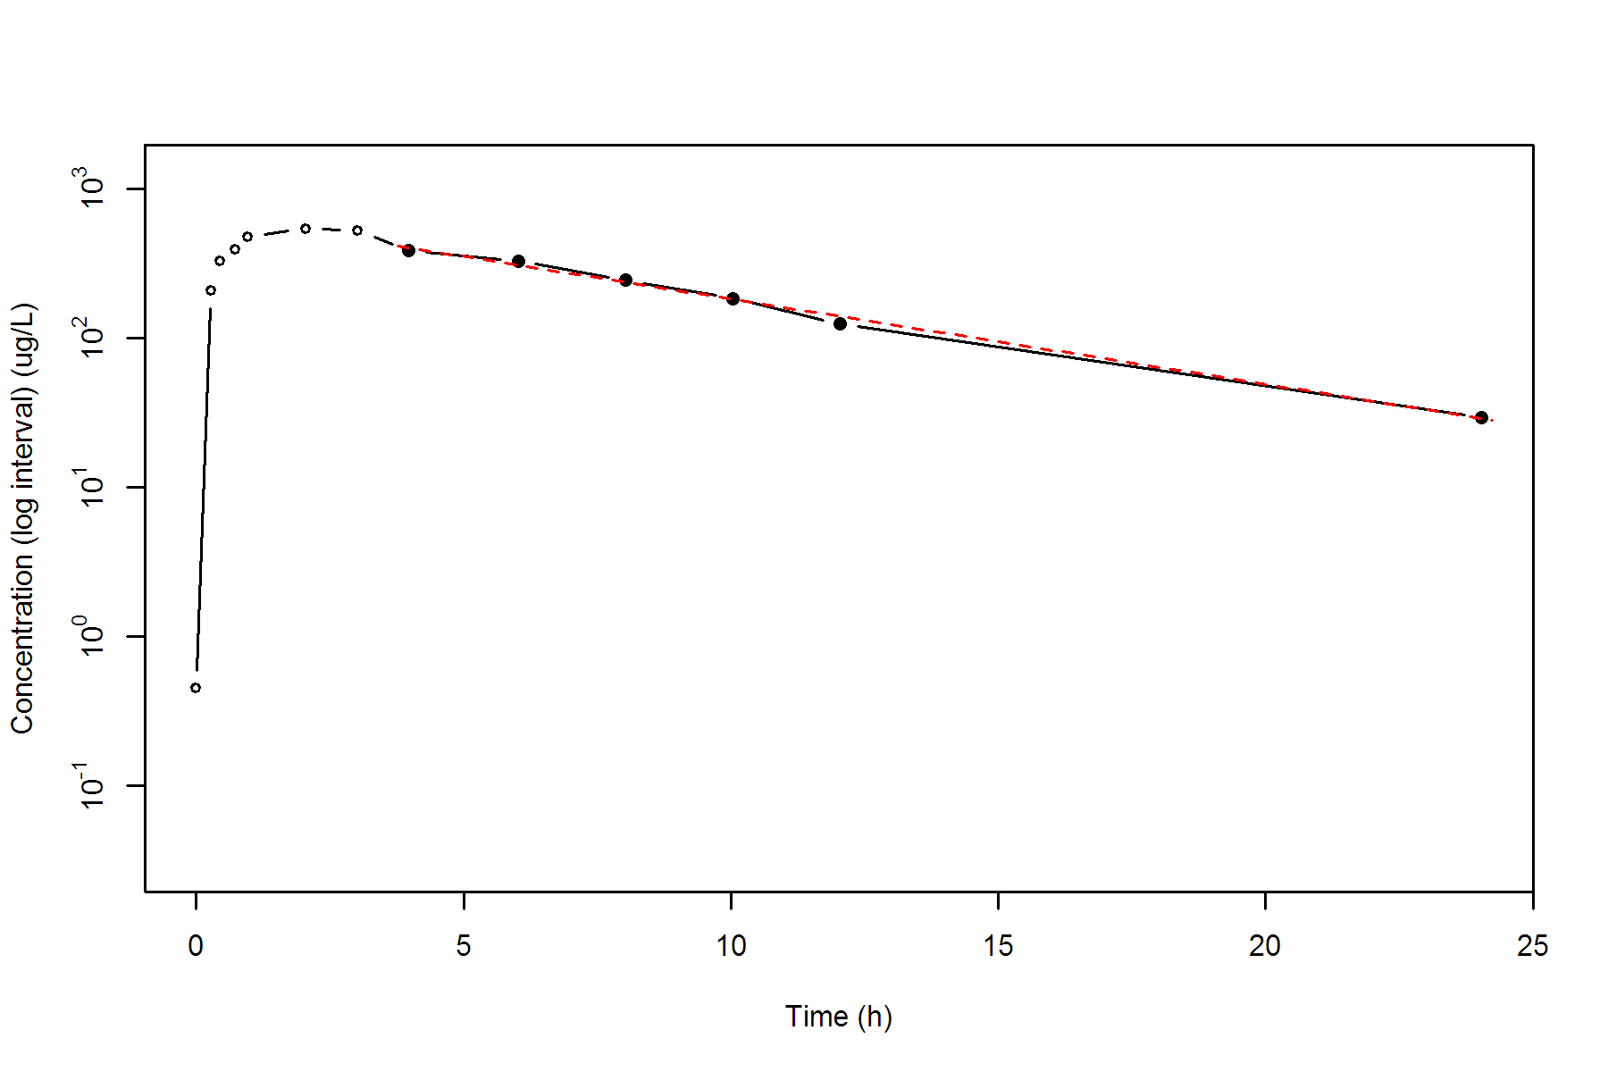

**SUBJ 33, GRP TR, PRD 1, TRT T**

NONCOMPARTMENTAL ANALYSIS REPORT

Package version 0.3.9 (2018-05-10 KST)

R version 3.5.0 (2018-04-23)

Date and Time: 2018-06-19 09:49:36 Asia/Seoul

Calculation Setting

-------------------

Drug Administration: Extravascular

Observation count excluding trailing zero: 13

Dose at time 0: 0 mg

AUC Calculation Method: Linear-up Linear-down

Weighting for lambda z: Uniform (Ordinary Least Square, OLS)

Lambda z selection criterion: Heighest adjusted R-squared value with precision=1e-4

Fitting, AUC, AUMC Result

-------------------------

Time Conc. Pred. Residual AUC AUMC

---------------------------------------------------------------------

0.0000 0.1900 0.0000 0.0000

0.2100 587.2800 61.6844 12.9495

0.5400 771.0100 285.8022 101.9958

0.7600 856.1800 464.7931 219.3704

1.0300 * 813.7700 883.3038 -6.953e+01 690.2364 420.3692

1.9500 * 738.8200 657.2058 +8.161e+01 1404.4278 1468.6550

3.0300 * 453.0400 464.4732 -1.143e+01 2048.0322 2987.8965

3.9600 * 381.1100 344.4738 +3.664e+01 2435.9119 4327.9831

5.9500 * 173.5300 181.7199 -8.190e+00 2987.7787 6856.9737

8.0000 * 102.6800 94.0317 +8.648e+00 3270.8940 8757.2658

9.9600 * 38.4400 50.0850 -1.165e+01 3409.1916 9937.4822

12.0200 * 27.9400 25.8335 +2.106e+00 3477.5630 10677.7444

23.9900 * 0.5700 0.5514 +1.859e-02 3648.1953 12769.5803

*: Used for the calculation of Lambda z.

Calculated Values

-----------------

CMAX Max Conc 856.1800 ug/L

TMAX Time of CMAX 0.7600 h

TLAG Time Until First Nonzero Conc 0.0000 h

CLST Last Nonzero Conc 0.5700 ug/L

CLSTP Last Nonzero Conc Pred 0.5514 ug/L

TLST Time of Last Nonzero Conc 23.9900 h

LAMZHL Half-Life Lambda z 2.1568 h

LAMZ Lambda z 0.3214 /h

LAMZLL Lambda z Lower Limit 1.0300 h

LAMZUL Lambda z Upper Limit 23.9900 h

LAMZNPT Number of Points for Lambda z 9

CORRXY Correlation Between TimeX and Log ConcY -0.9986

R2 R Squared 0.9972

R2ADJ R Squared Adjusted 0.9968

AUCLST AUC to Last Nonzero Conc 3648.1953 h*ug/L

AUCALL AUC All 3648.1953 h*ug/L

AUCIFO AUC Infinity Obs 3649.9689 h*ug/L

AUCIFP AUC Infinity Pred 3649.9110 h*ug/L

AUCPEO AUC %Extrapolation Obs 0.0486 %

AUCPEP AUC %Extrapolation Pred 0.0470 %

AUMCLST AUMC to Last Nonzero Conc 12769.5803 h2*ug/L

AUMCIFO AUMC Infinity Obs 12817.6473 h2*ug/L

AUMCIFP AUMC Infinity Pred 12816.0796 h2*ug/L

AUMCPEO AUMC %Extrapolation Obs 0.3750 %

AUMCPEP AUMC % Extrapolation Pred 0.3628 %

VZFO Vz Obs by F 0.0000 L

VZFP Vz Pred by F 0.0000 L

CLFO Total CL Obs by F 0.0000 L/h

CLFP Total CL Pred by F 0.0000 L/h

MRTEVLST MRT Extravasc to Last Nonzero Conc 3.5002 h

MRTEVIFO MRT Extravasc Infinity Obs 3.5117 h

MRTEVIFP MRT Extravasc Infinity Pred 3.5113 h

**SUBJ 33, GRP TR, PRD 1, TRT T**

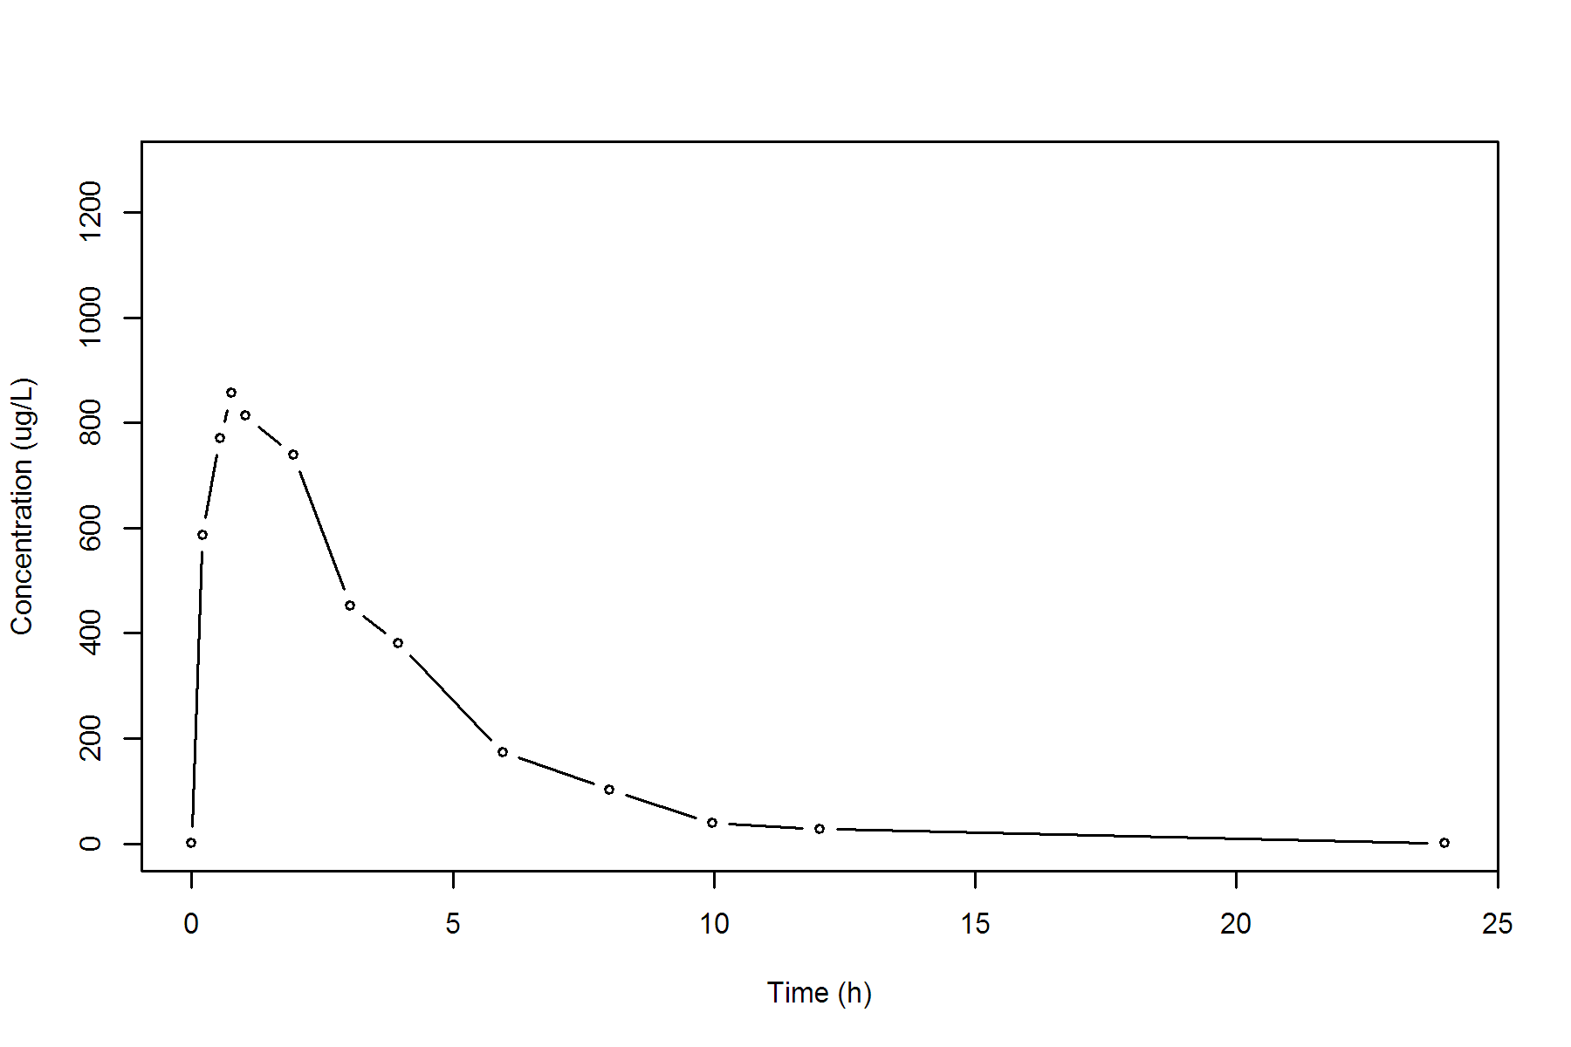

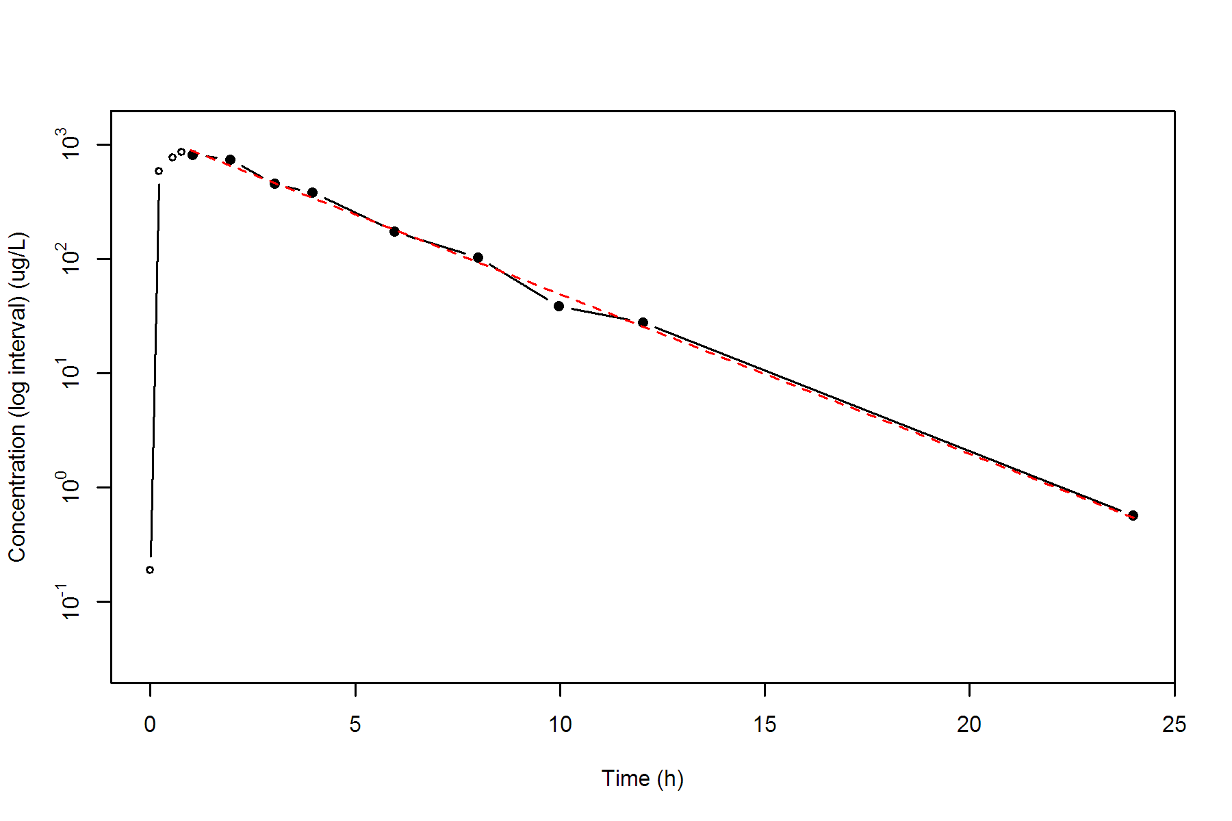

**SUBJ 33, GRP TR, PRD 2, TRT R**

NONCOMPARTMENTAL ANALYSIS REPORT

Package version 0.3.9 (2018-05-10 KST)

R version 3.5.0 (2018-04-23)

Date and Time: 2018-06-19 09:49:36 Asia/Seoul

Calculation Setting

-------------------

Drug Administration: Extravascular

Observation count excluding trailing zero: 13

Dose at time 0: 0 mg

AUC Calculation Method: Linear-up Linear-down

Weighting for lambda z: Uniform (Ordinary Least Square, OLS)

Lambda z selection criterion: Heighest adjusted R-squared value with precision=1e-4

Fitting, AUC, AUMC Result

-------------------------

Time Conc. Pred. Residual AUC AUMC

---------------------------------------------------------------------

0.0000 2.2000 0.0000 0.0000

0.2600 375.1400 49.0542 12.6797

0.5100 557.9100 165.6855 60.4385

0.7400 560.9300 294.3520 140.8951

0.9800 647.9500 439.4177 266.9046

2.0200 508.1700 1040.6001 1130.8817

3.0200 424.5300 1506.9501 2285.1737

4.0300 292.8600 1869.2320 3528.6384

6.0500 182.7900 2349.6385 5837.6048

8.0400 130.4500 2661.3123 7981.5288

10.0100 * 87.0100 88.1758 -1.166e+00 2875.5104 9872.5201

11.9700 * 54.5800 53.7412 +8.388e-01 3014.2686 11366.3269

23.9500 * 2.6000 2.6057 -5.668e-03 3356.7768 15652.7266

*: Used for the calculation of Lambda z.

Calculated Values

-----------------

CMAX Max Conc 647.9500 ug/L

TMAX Time of CMAX 0.9800 h

TLAG Time Until First Nonzero Conc 0.0000 h

CLST Last Nonzero Conc 2.6000 ug/L

CLSTP Last Nonzero Conc Pred 2.6057 ug/L

TLST Time of Last Nonzero Conc 23.9500 h

LAMZHL Half-Life Lambda z 2.7437 h

LAMZ Lambda z 0.2526 /h

LAMZLL Lambda z Lower Limit 10.0100 h

LAMZUL Lambda z Upper Limit 23.9500 h

LAMZNPT Number of Points for Lambda z 3

CORRXY Correlation Between TimeX and Log ConcY -1.0000

R2 R Squared 0.9999

R2ADJ R Squared Adjusted 0.9999

AUCLST AUC to Last Nonzero Conc 3356.7768 h*ug/L

AUCALL AUC All 3356.7768 h*ug/L

AUCIFO AUC Infinity Obs 3367.0686 h*ug/L

AUCIFP AUC Infinity Pred 3367.0910 h*ug/L

AUCPEO AUC %Extrapolation Obs 0.3057 %

AUCPEP AUC %Extrapolation Pred 0.3063 %

AUMCLST AUMC to Last Nonzero Conc 15652.7266 h2*ug/L

AUMCIFO AUMC Infinity Obs 15939.9536 h2*ug/L

AUMCIFP AUMC Infinity Pred 15940.5798 h2*ug/L

AUMCPEO AUMC %Extrapolation Obs 1.8019 %

AUMCPEP AUMC % Extrapolation Pred 1.8058 %

VZFO Vz Obs by F 0.0000 L

VZFP Vz Pred by F 0.0000 L

CLFO Total CL Obs by F 0.0000 L/h

CLFP Total CL Pred by F 0.0000 L/h

MRTEVLST MRT Extravasc to Last Nonzero Conc 4.6630 h

MRTEVIFO MRT Extravasc Infinity Obs 4.7341 h

MRTEVIFP MRT Extravasc Infinity Pred 4.7342 h

**SUBJ 33, GRP TR, PRD 2, TRT R**

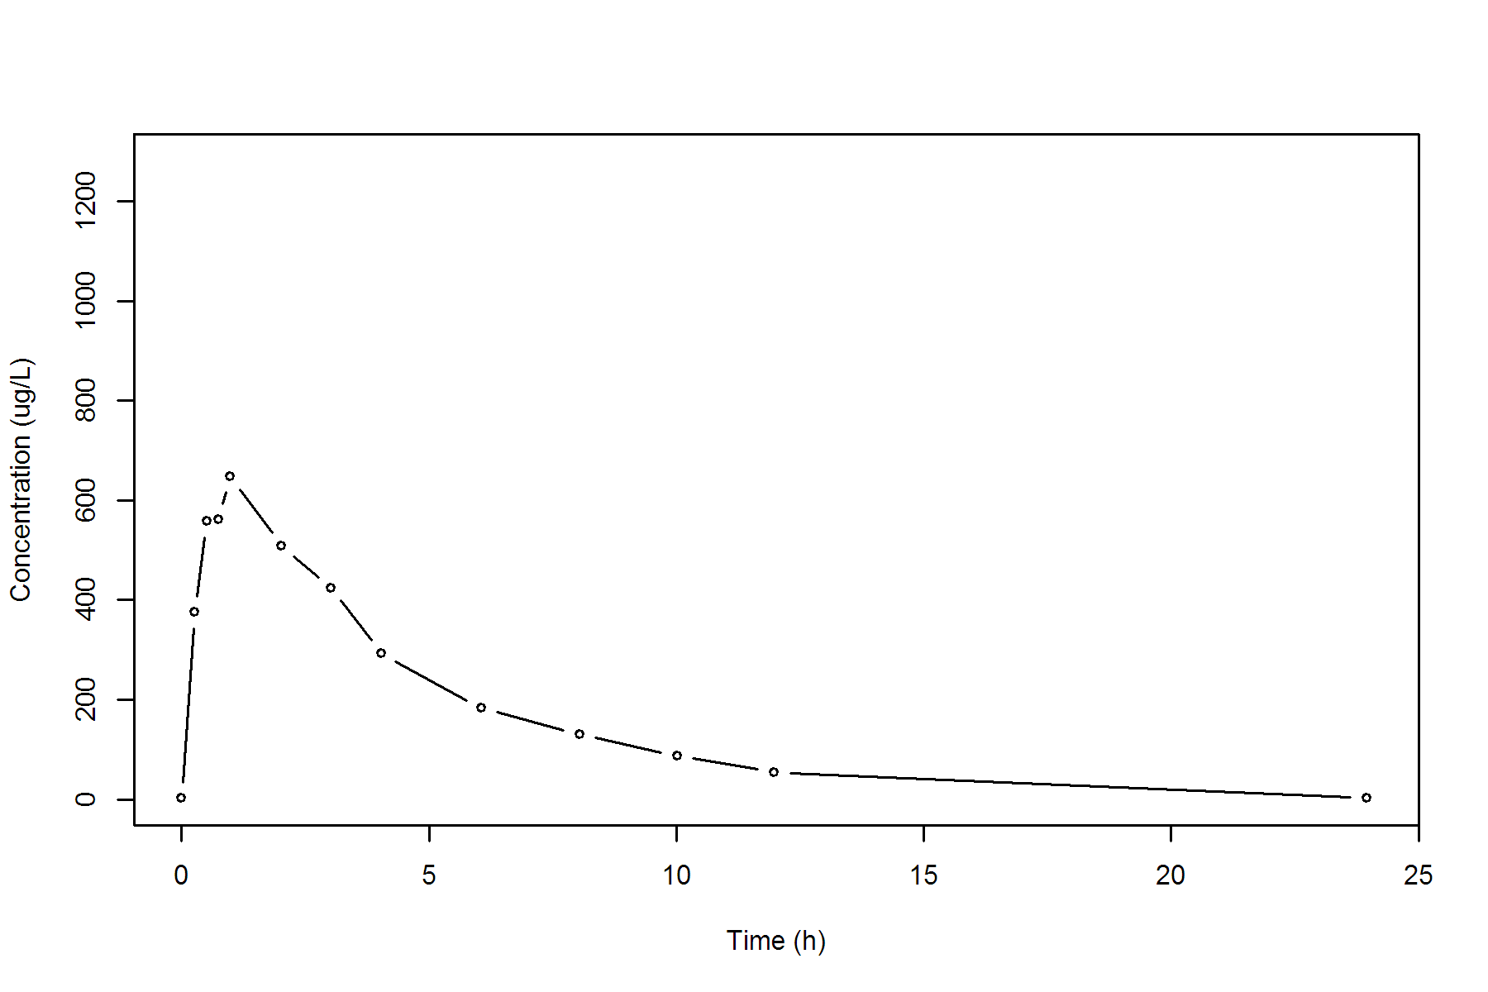

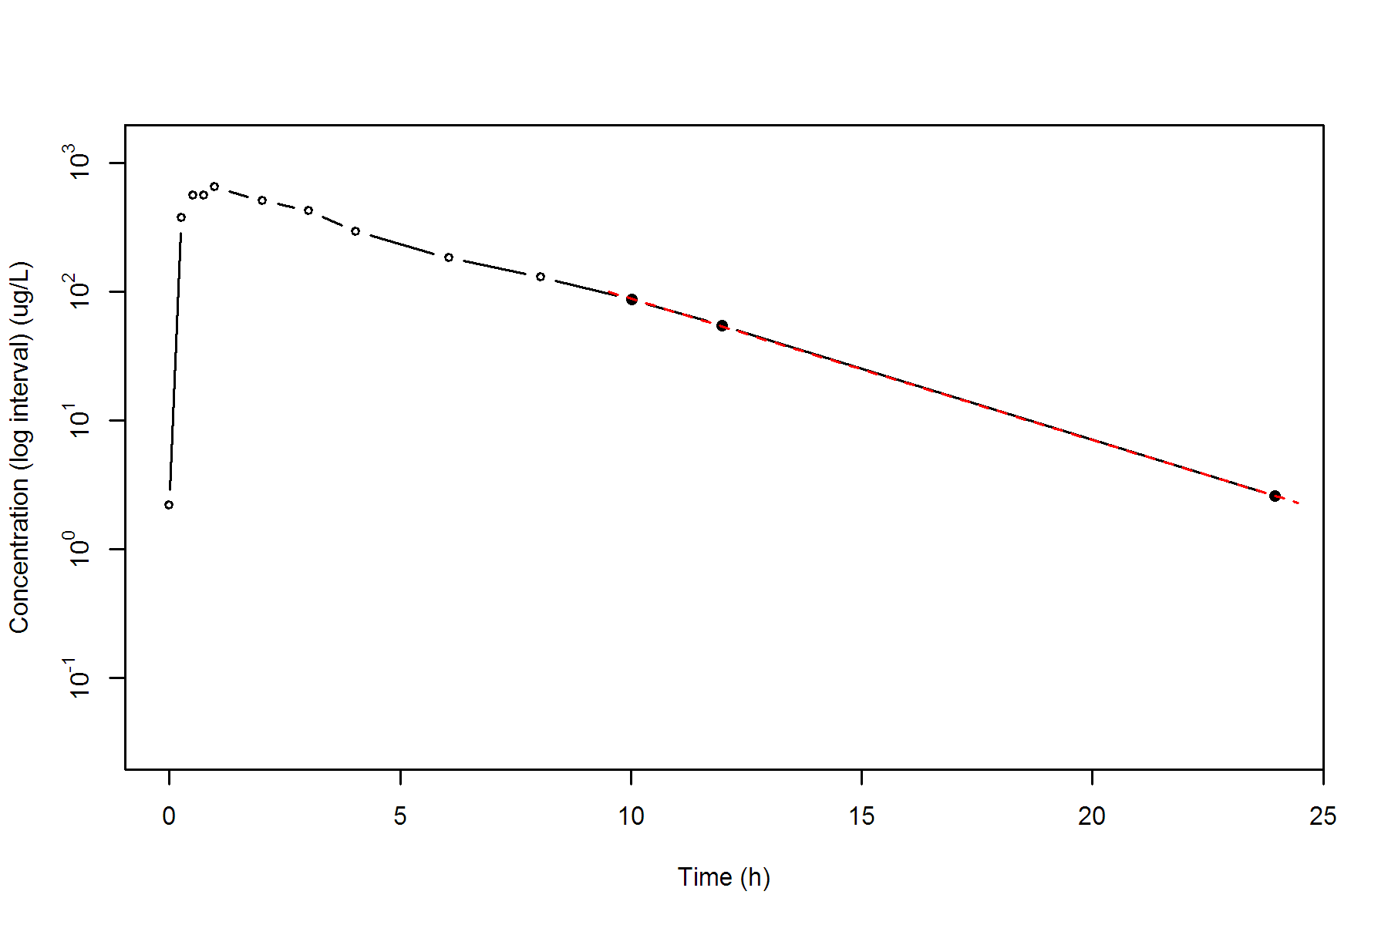

**SUBJ 34, GRP TR, PRD 1, TRT T**

NONCOMPARTMENTAL ANALYSIS REPORT

Package version 0.3.9 (2018-05-10 KST)

R version 3.5.0 (2018-04-23)

Date and Time: 2018-06-19 09:49:36 Asia/Seoul

Calculation Setting

-------------------

Drug Administration: Extravascular

Observation count excluding trailing zero: 13

Dose at time 0: 0 mg

AUC Calculation Method: Linear-up Linear-down

Weighting for lambda z: Uniform (Ordinary Least Square, OLS)

Lambda z selection criterion: Heighest adjusted R-squared value with precision=1e-4

Fitting, AUC, AUMC Result

-------------------------

Time Conc. Pred. Residual AUC AUMC

---------------------------------------------------------------------

0.0000 0.0000 0.0000 0.0000

0.2300 281.8000 32.4070 7.4536

0.5100 388.3600 126.2294 44.2565

0.7800 601.4200 259.8497 134.3246

0.9600 739.4200 380.5253 240.4302

2.0400 657.0200 1134.6029 1347.5187

3.0100 636.7000 1762.0571 2927.0608

4.0300 * 575.7300 592.0491 -1.632e+01 2380.3964 5087.7568

6.0300 * 341.5500 358.9381 -1.739e+01 3297.6764 9467.4952

7.9700 * 238.1700 220.9030 +1.727e+01 3860.0048 13306.5238

9.9600 * 122.1000 134.2611 -1.216e+01 4218.4735 16405.2830

11.9700 * 92.5600 81.1942 +1.137e+01 4434.2068 18740.9625

24.0300 * 3.8400 3.9717 -1.317e-01 5015.4988 25978.2795

*: Used for the calculation of Lambda z.

Calculated Values

-----------------

CMAX Max Conc 739.4200 ug/L

TMAX Time of CMAX 0.9600 h

TLAG Time Until First Nonzero Conc 0.0000 h

CLST Last Nonzero Conc 3.8400 ug/L

CLSTP Last Nonzero Conc Pred 3.9717 ug/L

TLST Time of Last Nonzero Conc 24.0300 h

LAMZHL Half-Life Lambda z 2.7702 h

LAMZ Lambda z 0.2502 /h

LAMZLL Lambda z Lower Limit 4.0300 h

LAMZUL Lambda z Upper Limit 24.0300 h

LAMZNPT Number of Points for Lambda z 6

CORRXY Correlation Between TimeX and Log ConcY -0.9989

R2 R Squared 0.9977

R2ADJ R Squared Adjusted 0.9972

AUCLST AUC to Last Nonzero Conc 5015.4988 h*ug/L

AUCALL AUC All 5015.4988 h*ug/L

AUCIFO AUC Infinity Obs 5030.8453 h*ug/L

AUCIFP AUC Infinity Pred 5031.3716 h*ug/L

AUCPEO AUC %Extrapolation Obs 0.3050 %

AUCPEP AUC %Extrapolation Pred 0.3155 %

AUMCLST AUMC to Last Nonzero Conc 25978.2795 h2*ug/L

AUMCIFO AUMC Infinity Obs 26408.3882 h2*ug/L

AUMCIFP AUMC Infinity Pred 26423.1394 h2*ug/L

AUMCPEO AUMC %Extrapolation Obs 1.6287 %

AUMCPEP AUMC % Extrapolation Pred 1.6836 %

VZFO Vz Obs by F 0.0000 L

VZFP Vz Pred by F 0.0000 L

CLFO Total CL Obs by F 0.0000 L/h

CLFP Total CL Pred by F 0.0000 L/h

MRTEVLST MRT Extravasc to Last Nonzero Conc 5.1796 h

MRTEVIFO MRT Extravasc Infinity Obs 5.2493 h

MRTEVIFP MRT Extravasc Infinity Pred 5.2517 h

**SUBJ 34, GRP TR, PRD 1, TRT T**

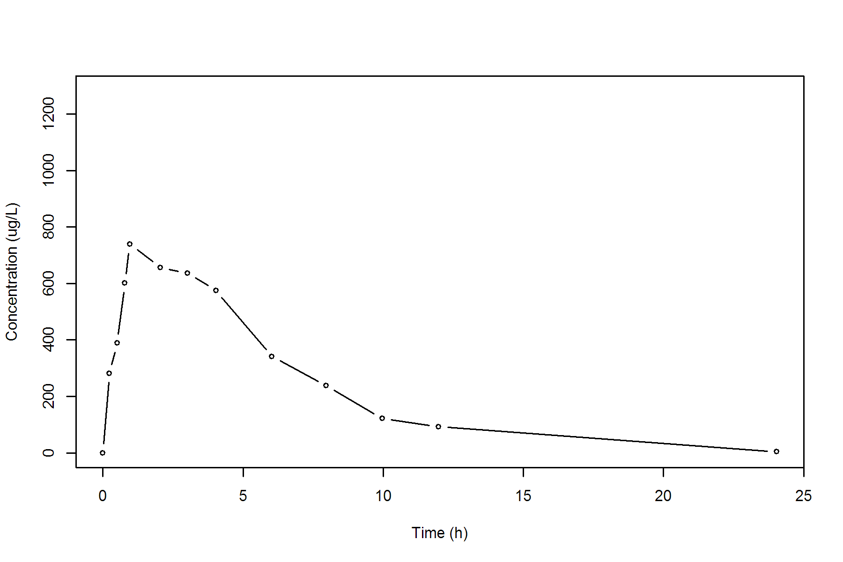

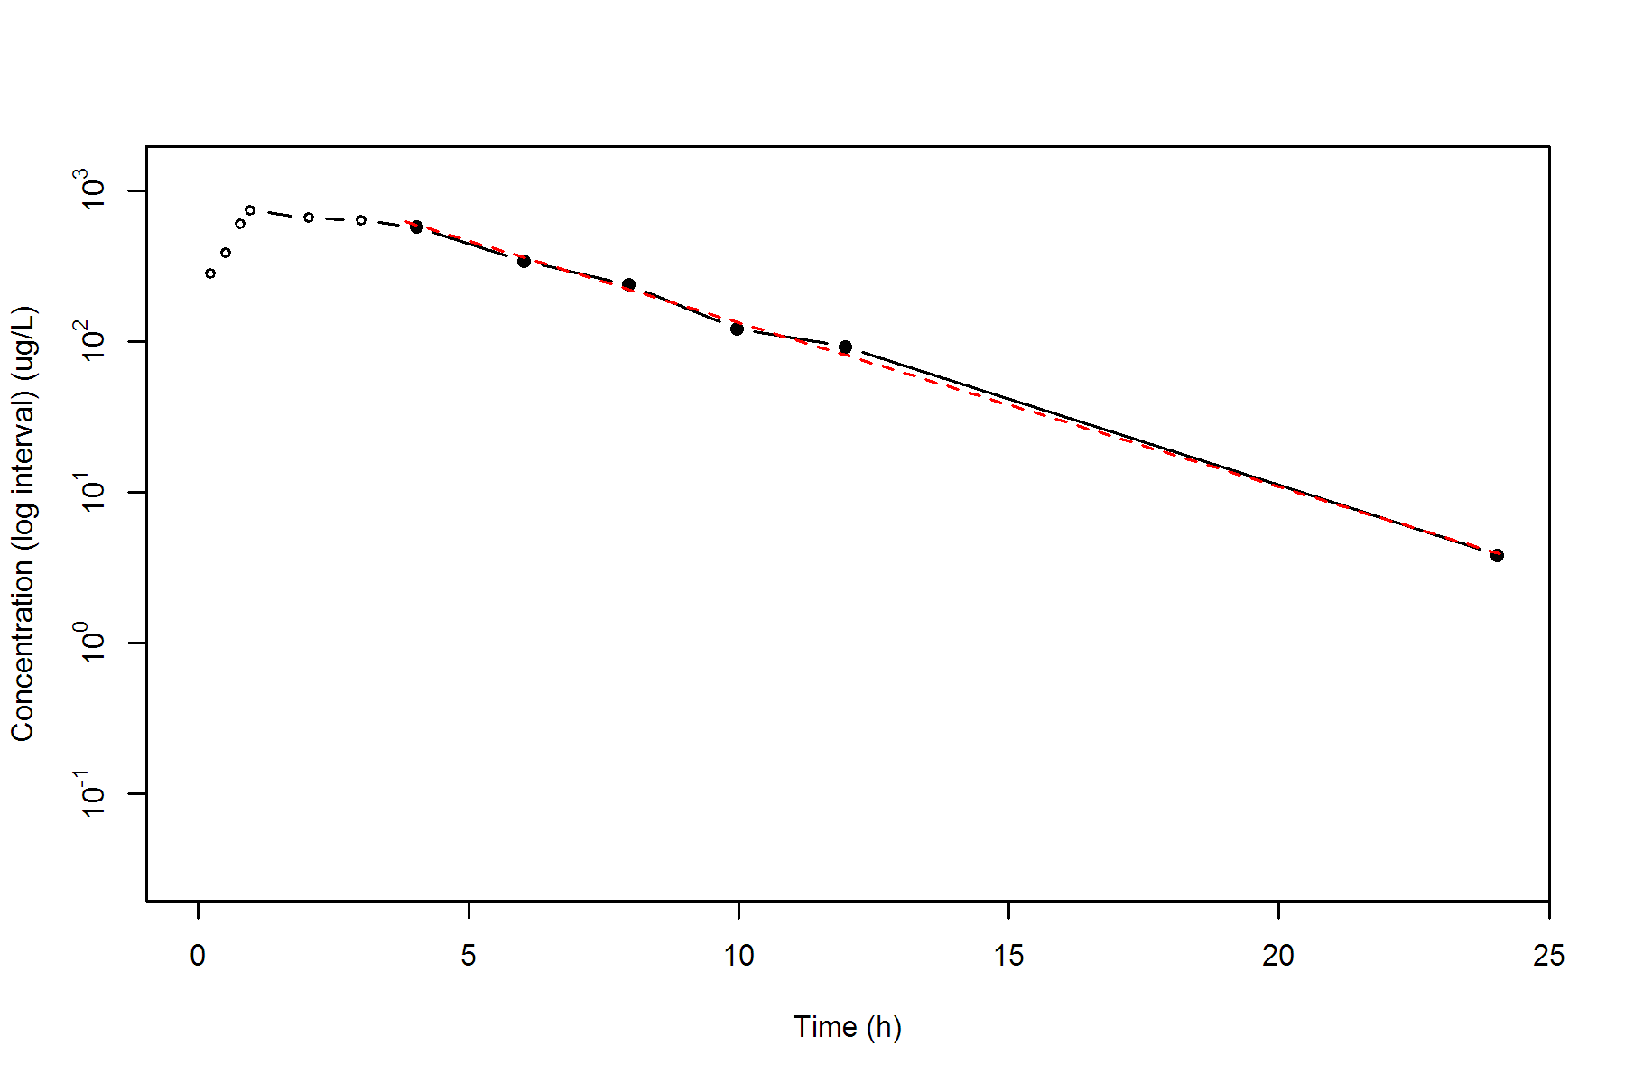

**SUBJ 34, GRP TR, PRD 2, TRT R**

NONCOMPARTMENTAL ANALYSIS REPORT

Package version 0.3.9 (2018-05-10 KST)

R version 3.5.0 (2018-04-23)

Date and Time: 2018-06-19 09:49:36 Asia/Seoul

Calculation Setting

-------------------

Drug Administration: Extravascular

Observation count excluding trailing zero: 13

Dose at time 0: 0 mg

AUC Calculation Method: Linear-up Linear-down

Weighting for lambda z: Uniform (Ordinary Least Square, OLS)

Lambda z selection criterion: Heighest adjusted R-squared value with precision=1e-4

Fitting, AUC, AUMC Result

-------------------------

Time Conc. Pred. Residual AUC AUMC

---------------------------------------------------------------------

0.0000 1.1800 0.0000 0.0000

0.2300 263.9400 30.4888 6.9812

0.4700 430.1200 113.7760 38.5247

0.7200 575.6200 239.4935 115.6001

1.0200 538.4000 406.5965 260.1422

1.9900 682.4100 998.6894 1185.1167

2.9800 614.6100 1640.7143 2763.9359

4.0100 579.4500 2255.6552 4903.8290

6.0200 409.6300 3249.6806 9717.3440

8.0400 259.3300 3925.3302 14313.8396

10.0200 * 244.5200 256.3578 -1.184e+01 4424.1416 18803.5922

11.9600 * 206.5200 195.4936 +1.103e+01 4861.6505 23576.0597

24.0400 * 35.8800 36.1535 -2.735e-01 6325.7465 43704.5675

*: Used for the calculation of Lambda z.

Calculated Values

-----------------

CMAX Max Conc 682.4100 ug/L

TMAX Time of CMAX 1.9900 h

TLAG Time Until First Nonzero Conc 0.0000 h

CLST Last Nonzero Conc 35.8800 ug/L

CLSTP Last Nonzero Conc Pred 36.1535 ug/L

TLST Time of Last Nonzero Conc 24.0400 h

LAMZHL Half-Life Lambda z 4.9612 h

LAMZ Lambda z 0.1397 /h

LAMZLL Lambda z Lower Limit 10.0200 h

LAMZUL Lambda z Upper Limit 24.0400 h

LAMZNPT Number of Points for Lambda z 3

CORRXY Correlation Between TimeX and Log ConcY -0.9988

R2 R Squared 0.9977

R2ADJ R Squared Adjusted 0.9953

AUCLST AUC to Last Nonzero Conc 6325.7465 h*ug/L

AUCALL AUC All 6325.7465 h*ug/L

AUCIFO AUC Infinity Obs 6582.5553 h*ug/L

AUCIFP AUC Infinity Pred 6584.5125 h*ug/L

AUCPEO AUC %Extrapolation Obs 3.9014 %

AUCPEP AUC %Extrapolation Pred 3.9299 %

AUMCLST AUMC to Last Nonzero Conc 43704.5675 h2*ug/L

AUMCIFO AUMC Infinity Obs 51716.3451 h2*ug/L

AUMCIFP AUMC Infinity Pred 51777.4063 h2*ug/L

AUMCPEO AUMC %Extrapolation Obs 15.4918 %

AUMCPEP AUMC % Extrapolation Pred 15.5914 %

VZFO Vz Obs by F 0.0000 L

VZFP Vz Pred by F 0.0000 L

CLFO Total CL Obs by F 0.0000 L/h

CLFP Total CL Pred by F 0.0000 L/h

MRTEVLST MRT Extravasc to Last Nonzero Conc 6.9090 h

MRTEVIFO MRT Extravasc Infinity Obs 7.8566 h

MRTEVIFP MRT Extravasc Infinity Pred 7.8635 h

**SUBJ 34, GRP TR, PRD 2, TRT R**

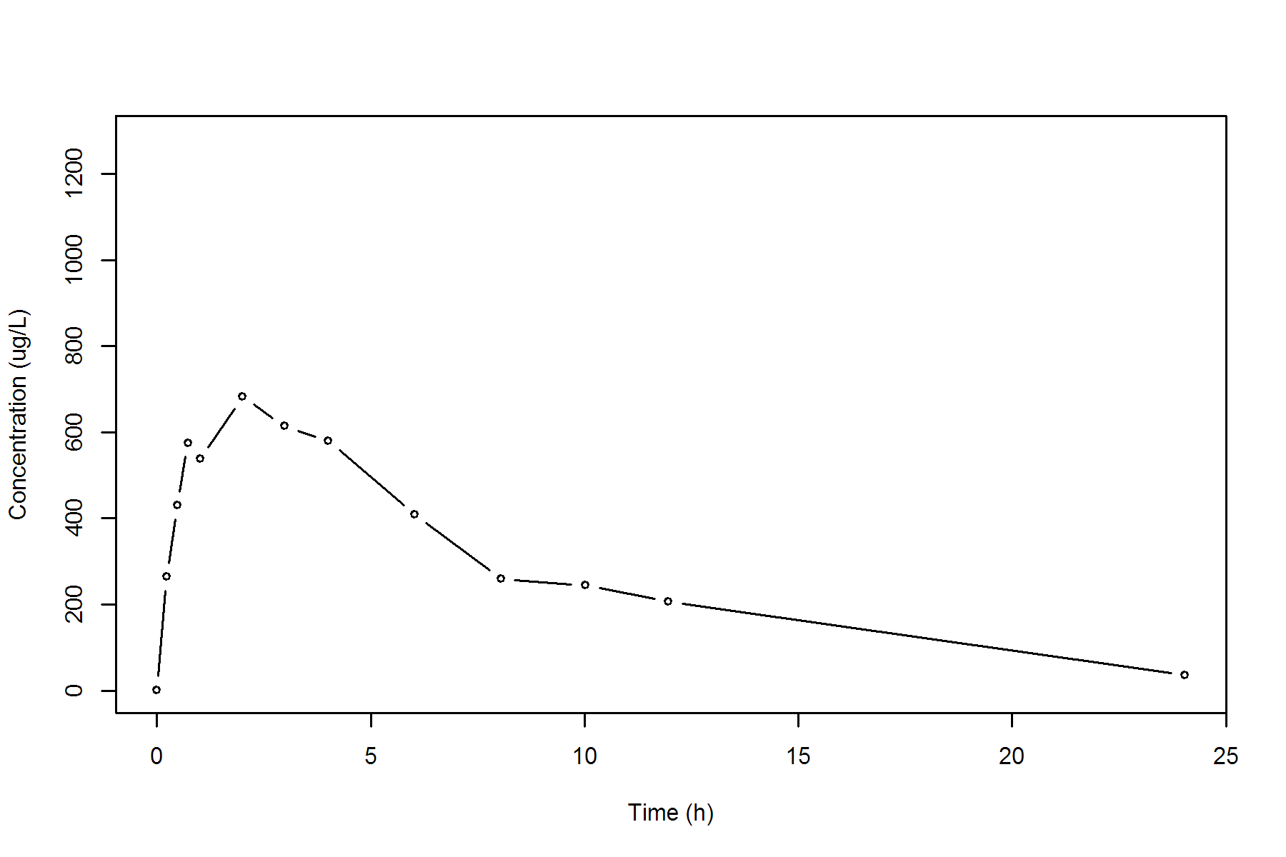

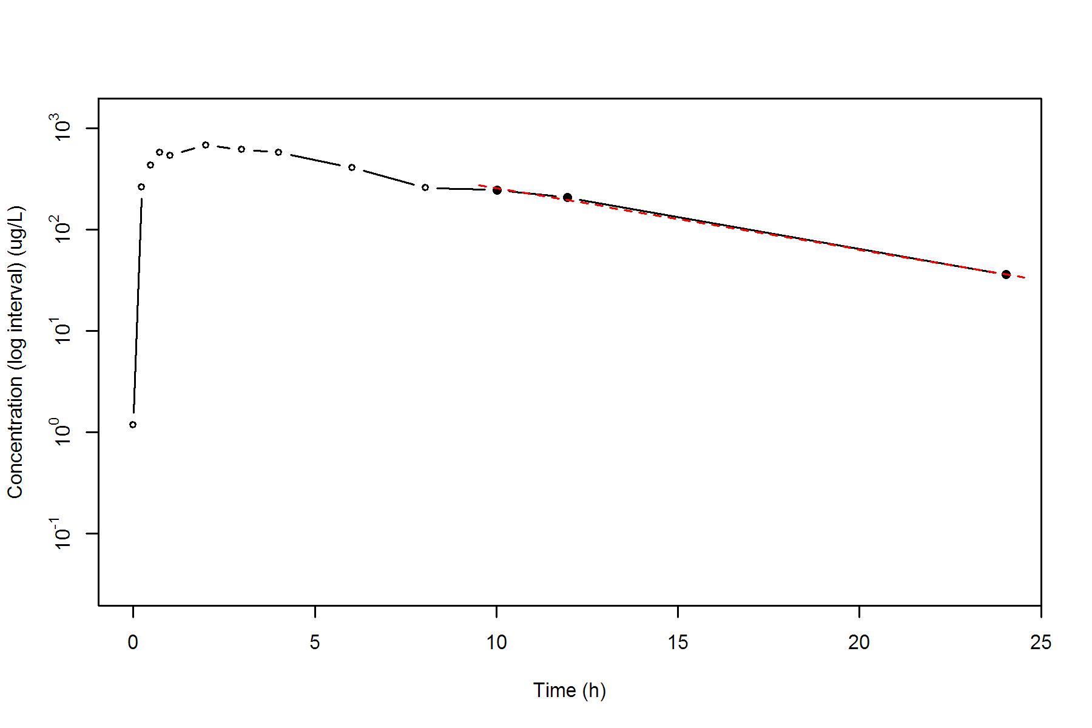

**SUBJ 35, GRP RT, PRD 1, TRT R**

NONCOMPARTMENTAL ANALYSIS REPORT

Package version 0.3.9 (2018-05-10 KST)

R version 3.5.0 (2018-04-23)

Date and Time: 2018-06-19 09:49:36 Asia/Seoul

Calculation Setting

-------------------

Drug Administration: Extravascular

Observation count excluding trailing zero: 13

Dose at time 0: 0 mg

AUC Calculation Method: Linear-up Linear-down

Weighting for lambda z: Uniform (Ordinary Least Square, OLS)

Lambda z selection criterion: Heighest adjusted R-squared value with precision=1e-4

Fitting, AUC, AUMC Result

-------------------------

Time Conc. Pred. Residual AUC AUMC

---------------------------------------------------------------------

0.0000 0.6200 0.0000 0.0000

0.2700 299.0800 40.4595 10.9015

0.5100 376.6300 121.5447 43.6414

0.7100 562.0200 215.4097 102.7530

0.9700 785.6000 390.6003 253.6916

1.9600 1020.5500 1284.6446 1621.0350

2.9700 819.5800 2213.9102 3860.4225

3.9900 565.3700 2920.2347 6252.3117

6.0100 * 505.1800 499.0430 +6.137e+00 4001.4902 11597.1894

7.9800 * 295.6100 301.2994 -5.689e+00 4790.2684 16911.3625

10.0100 * 173.1700 179.1366 -5.967e+00 5266.0801 21065.1480

11.9900 * 113.0200 107.8778 +5.142e+00 5549.4082 24122.8041

24.0300 * 4.9100 4.9388 -2.880e-02 6259.3468 32990.8486

*: Used for the calculation of Lambda z.

Calculated Values

-----------------

CMAX Max Conc 1020.5500 ug/L

TMAX Time of CMAX 1.9600 h

TLAG Time Until First Nonzero Conc 0.0000 h

CLST Last Nonzero Conc 4.9100 ug/L

CLSTP Last Nonzero Conc Pred 4.9388 ug/L

TLST Time of Last Nonzero Conc 24.0300 h

LAMZHL Half-Life Lambda z 2.7062 h

LAMZ Lambda z 0.2561 /h

LAMZLL Lambda z Lower Limit 6.0100 h

LAMZUL Lambda z Upper Limit 24.0300 h

LAMZNPT Number of Points for Lambda z 5

CORRXY Correlation Between TimeX and Log ConcY -0.9999

R2 R Squared 0.9997

R2ADJ R Squared Adjusted 0.9996

AUCLST AUC to Last Nonzero Conc 6259.3468 h*ug/L

AUCALL AUC All 6259.3468 h*ug/L

AUCIFO AUC Infinity Obs 6278.5163 h*ug/L

AUCIFP AUC Infinity Pred 6278.6287 h*ug/L

AUCPEO AUC %Extrapolation Obs 0.3053 %

AUCPEP AUC %Extrapolation Pred 0.3071 %

AUMCLST AUMC to Last Nonzero Conc 32990.8486 h2*ug/L

AUMCIFO AUMC Infinity Obs 33526.3331 h2*ug/L

AUMCIFP AUMC Infinity Pred 33529.4746 h2*ug/L

AUMCPEO AUMC %Extrapolation Obs 1.5972 %

AUMCPEP AUMC % Extrapolation Pred 1.6064 %

VZFO Vz Obs by F 0.0000 L

VZFP Vz Pred by F 0.0000 L

CLFO Total CL Obs by F 0.0000 L/h

CLFP Total CL Pred by F 0.0000 L/h

MRTEVLST MRT Extravasc to Last Nonzero Conc 5.2707 h

MRTEVIFO MRT Extravasc Infinity Obs 5.3398 h

MRTEVIFP MRT Extravasc Infinity Pred 5.3403 h

**SUBJ 35, GRP RT, PRD 1, TRT R**

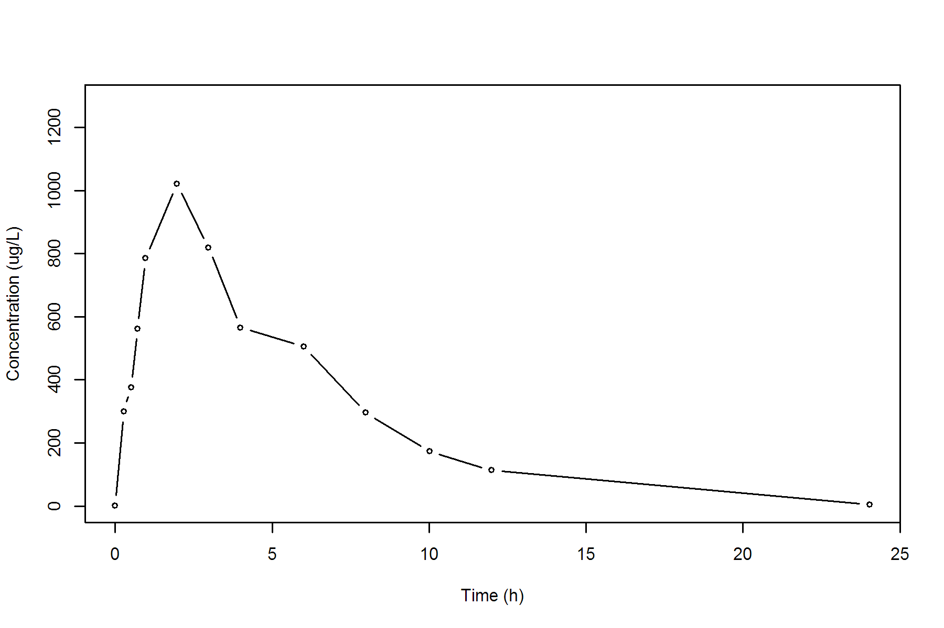

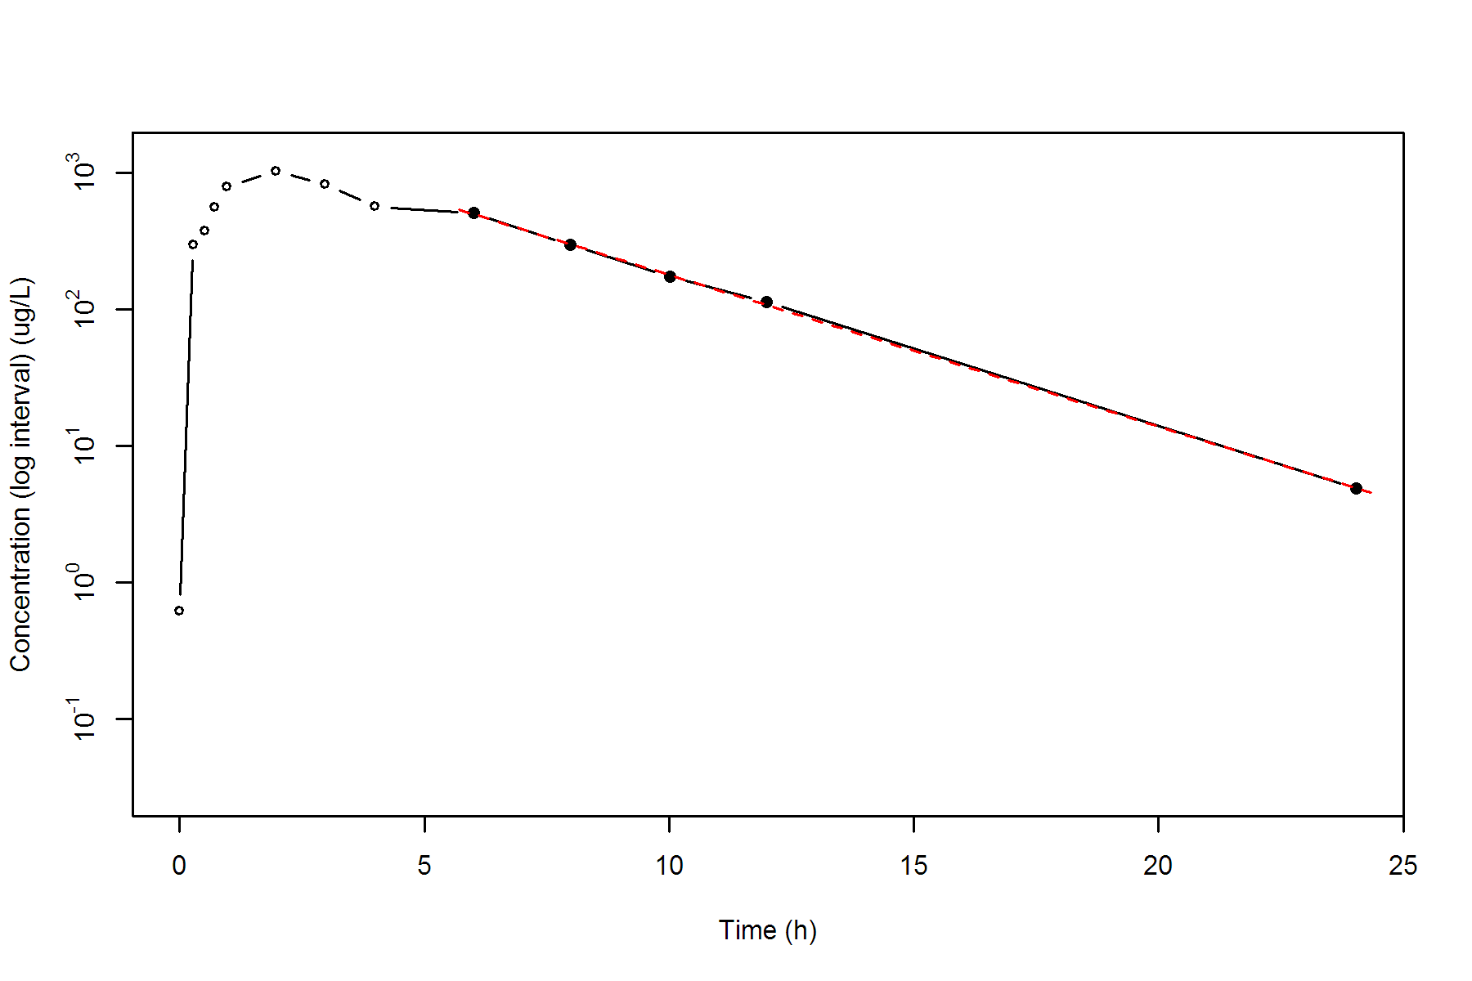

**SUBJ 35, GRP RT, PRD 2, TRT T**

NONCOMPARTMENTAL ANALYSIS REPORT

Package version 0.3.9 (2018-05-10 KST)

R version 3.5.0 (2018-04-23)

Date and Time: 2018-06-19 09:49:36 Asia/Seoul

Calculation Setting

-------------------

Drug Administration: Extravascular

Observation count excluding trailing zero: 13

Dose at time 0: 0 mg

AUC Calculation Method: Linear-up Linear-down

Weighting for lambda z: Uniform (Ordinary Least Square, OLS)

Lambda z selection criterion: Heighest adjusted R-squared value with precision=1e-4

Fitting, AUC, AUMC Result

-------------------------

Time Conc. Pred. Residual AUC AUMC

---------------------------------------------------------------------

0.0000 0.0000 0.0000 0.0000

0.2800 290.9700 40.7358 11.4060

0.5300 676.8900 161.7183 66.4339

0.7700 598.8700 314.8095 164.8197

1.0000 738.8900 468.6519 302.8220

2.0400 835.8700 1287.5271 1573.7357

3.0200 561.6300 1972.3021 3240.3714

3.9900 601.1800 2536.2650 5226.3644

5.9900 400.6000 3538.0450 10024.6666

8.0000 * 256.5400 246.8677 +9.672e+00 4198.4707 14498.8401

10.0000 * 191.6200 181.5215 +1.010e+01 4646.6307 18467.3601

12.0000 * 119.0500 133.4725 -1.442e+01 4957.3007 21812.1601

24.0300 * 21.4600 20.9977 +4.623e-01 5802.4683 33507.0272

*: Used for the calculation of Lambda z.

Calculated Values

-----------------

CMAX Max Conc 835.8700 ug/L

TMAX Time of CMAX 2.0400 h

TLAG Time Until First Nonzero Conc 0.0000 h

CLST Last Nonzero Conc 21.4600 ug/L

CLSTP Last Nonzero Conc Pred 20.9977 ug/L

TLST Time of Last Nonzero Conc 24.0300 h

LAMZHL Half-Life Lambda z 4.5086 h

LAMZ Lambda z 0.1537 /h

LAMZLL Lambda z Lower Limit 8.0000 h

LAMZUL Lambda z Upper Limit 24.0300 h

LAMZNPT Number of Points for Lambda z 4

CORRXY Correlation Between TimeX and Log ConcY -0.9976

R2 R Squared 0.9951

R2ADJ R Squared Adjusted 0.9927

AUCLST AUC to Last Nonzero Conc 5802.4683 h*ug/L

AUCALL AUC All 5802.4683 h*ug/L

AUCIFO AUC Infinity Obs 5942.0552 h*ug/L

AUCIFP AUC Infinity Pred 5939.0479 h*ug/L

AUCPEO AUC %Extrapolation Obs 2.3491 %

AUCPEP AUC %Extrapolation Pred 2.2997 %

AUMCLST AUMC to Last Nonzero Conc 33507.0272 h2*ug/L

AUMCIFO AUMC Infinity Obs 37769.2463 h2*ug/L

AUMCIFP AUMC Infinity Pred 37677.4206 h2*ug/L

AUMCPEO AUMC %Extrapolation Obs 11.2849 %

AUMCPEP AUMC % Extrapolation Pred 11.0687 %

VZFO Vz Obs by F 0.0000 L

VZFP Vz Pred by F 0.0000 L

CLFO Total CL Obs by F 0.0000 L/h

CLFP Total CL Pred by F 0.0000 L/h

MRTEVLST MRT Extravasc to Last Nonzero Conc 5.7746 h

MRTEVIFO MRT Extravasc Infinity Obs 6.3563 h

MRTEVIFP MRT Extravasc Infinity Pred 6.3440 h

**SUBJ 35, GRP RT, PRD 2, TRT T**

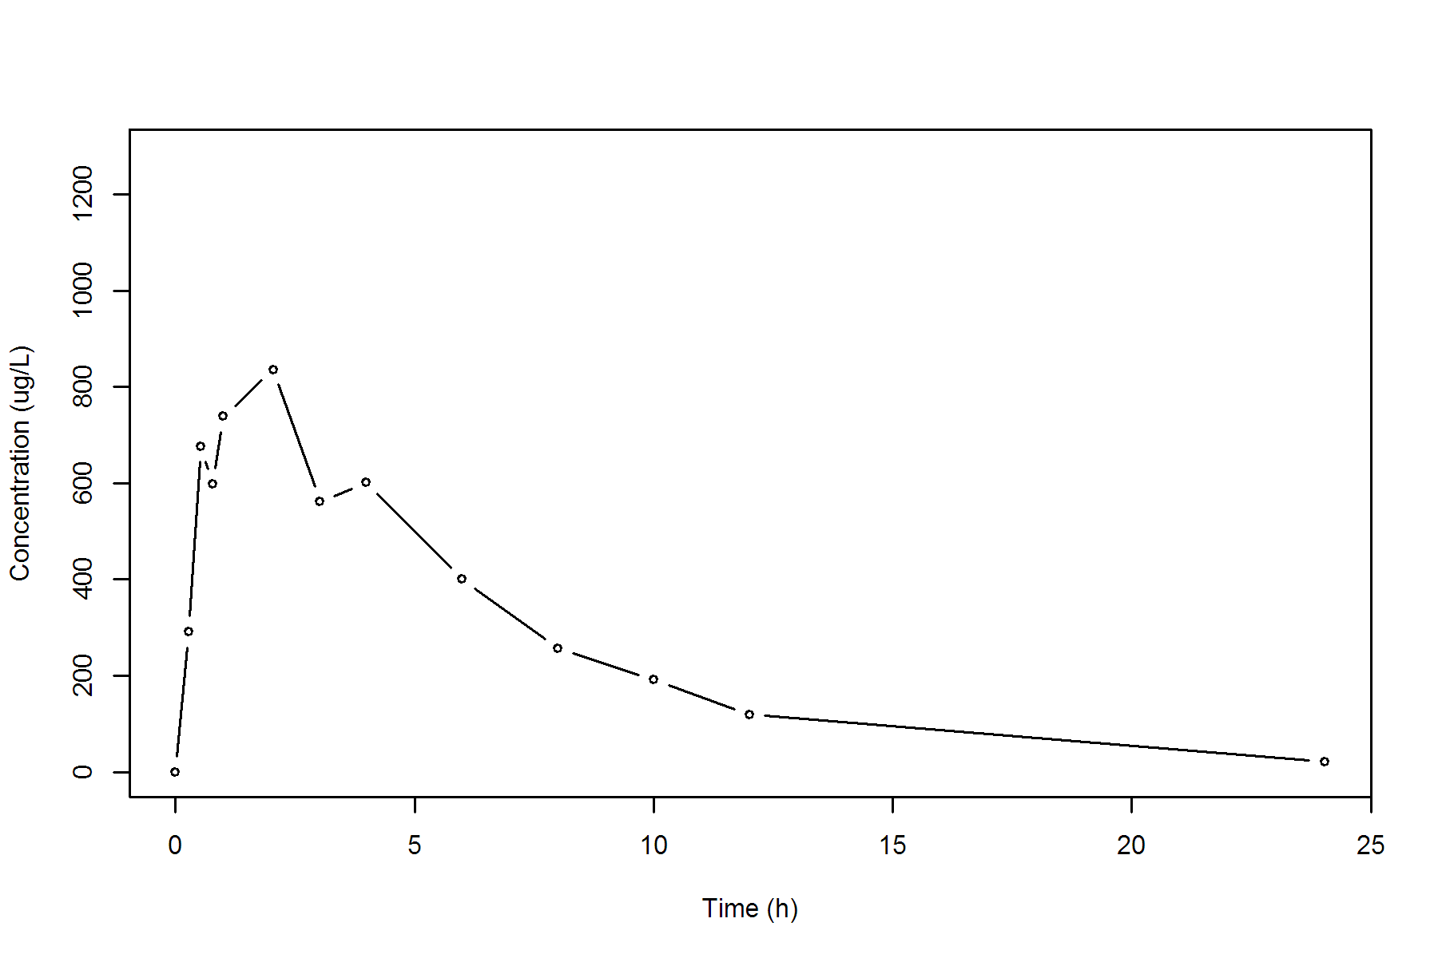

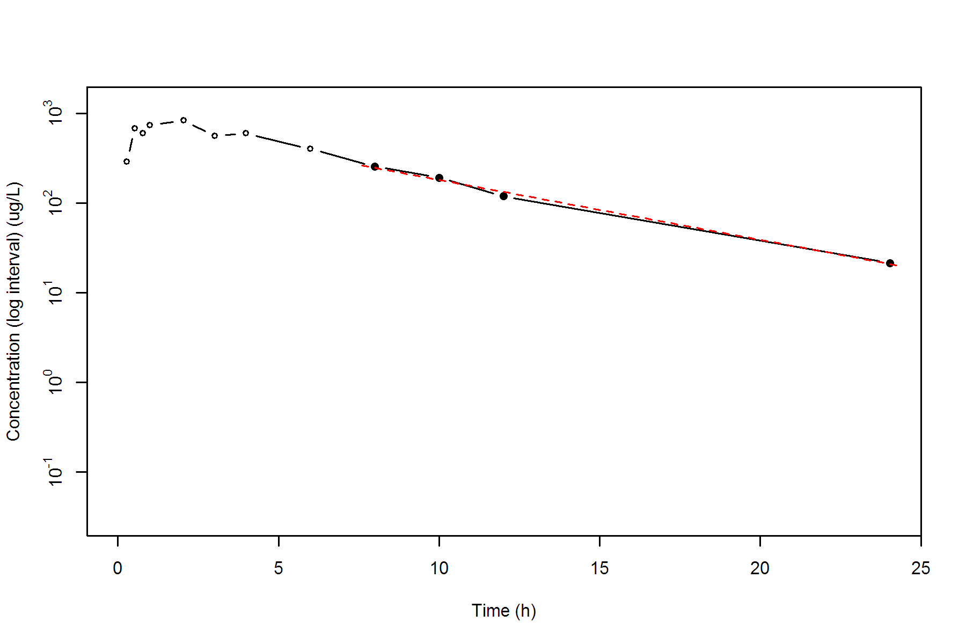

**SUBJ 36, GRP RT, PRD 1, TRT R**

NONCOMPARTMENTAL ANALYSIS REPORT

Package version 0.3.9 (2018-05-10 KST)

R version 3.5.0 (2018-04-23)

Date and Time: 2018-06-19 09:49:36 Asia/Seoul

Calculation Setting

-------------------

Drug Administration: Extravascular

Observation count excluding trailing zero: 13

Dose at time 0: 0 mg

AUC Calculation Method: Linear-up Linear-down

Weighting for lambda z: Uniform (Ordinary Least Square, OLS)

Lambda z selection criterion: Heighest adjusted R-squared value with precision=1e-4

Fitting, AUC, AUMC Result

-------------------------

Time Conc. Pred. Residual AUC AUMC

---------------------------------------------------------------------

0.0000 0.2000 0.0000 0.0000

0.2700 313.7100 42.3778 11.4347

0.4500 403.8800 106.9609 35.4150

0.7000 511.3400 221.3634 102.8755

0.9900 656.6200 390.7177 249.0343

2.0100 646.4400 1055.2782 1243.2274

3.0100 682.8700 1719.9333 2920.6190

3.9500 494.3200 2273.2126 4804.3802

5.9600 285.6400 3057.0724 8477.6335

7.9900 193.5900 3543.4908 11775.5700

10.0400 * 130.0800 135.4101 -5.330e+00 3875.2526 14699.6770

12.0100 * 90.5200 86.3860 +4.134e+00 4092.5436 17056.9282

24.0200 * 5.5400 5.5766 -3.661e-02 4669.3839 24384.3252

*: Used for the calculation of Lambda z.

Calculated Values

-----------------

CMAX Max Conc 682.8700 ug/L

TMAX Time of CMAX 3.0100 h

TLAG Time Until First Nonzero Conc 0.0000 h

CLST Last Nonzero Conc 5.5400 ug/L

CLSTP Last Nonzero Conc Pred 5.5766 ug/L

TLST Time of Last Nonzero Conc 24.0200 h

LAMZHL Half-Life Lambda z 3.0379 h

LAMZ Lambda z 0.2282 /h

LAMZLL Lambda z Lower Limit 10.0400 h

LAMZUL Lambda z Upper Limit 24.0200 h

LAMZNPT Number of Points for Lambda z 3

CORRXY Correlation Between TimeX and Log ConcY -0.9997

R2 R Squared 0.9994

R2ADJ R Squared Adjusted 0.9987

AUCLST AUC to Last Nonzero Conc 4669.3839 h*ug/L

AUCALL AUC All 4669.3839 h*ug/L

AUCIFO AUC Infinity Obs 4693.6647 h*ug/L

AUCIFP AUC Infinity Pred 4693.8251 h*ug/L

AUCPEO AUC %Extrapolation Obs 0.5173 %

AUCPEP AUC %Extrapolation Pred 0.5207 %

AUMCLST AUMC to Last Nonzero Conc 24384.3252 h2*ug/L

AUMCIFO AUMC Infinity Obs 25073.9693 h2*ug/L

AUMCIFP AUMC Infinity Pred 25078.5271 h2*ug/L

AUMCPEO AUMC %Extrapolation Obs 2.7504 %

AUMCPEP AUMC % Extrapolation Pred 2.7681 %

VZFO Vz Obs by F 0.0000 L

VZFP Vz Pred by F 0.0000 L

CLFO Total CL Obs by F 0.0000 L/h

CLFP Total CL Pred by F 0.0000 L/h

MRTEVLST MRT Extravasc to Last Nonzero Conc 5.2222 h

MRTEVIFO MRT Extravasc Infinity Obs 5.3421 h

MRTEVIFP MRT Extravasc Infinity Pred 5.3429 h

**SUBJ 36, GRP RT, PRD 1, TRT R**

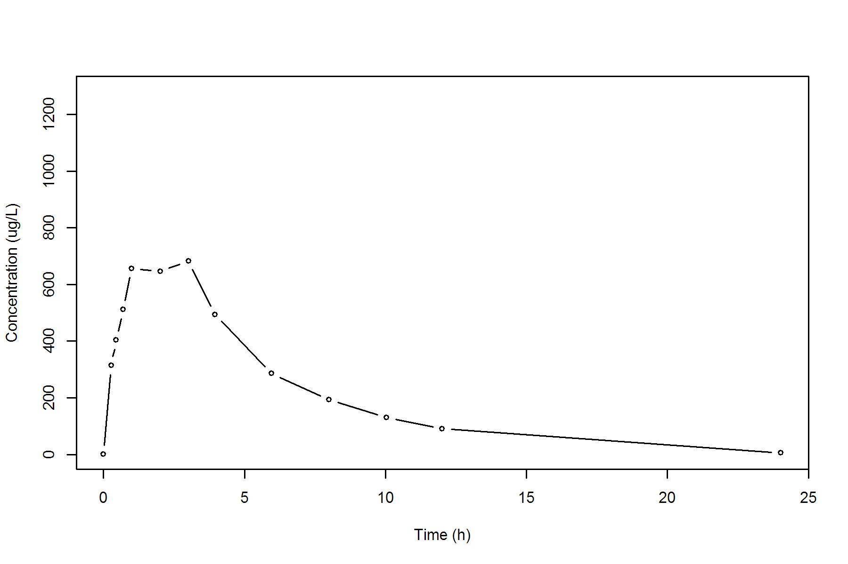

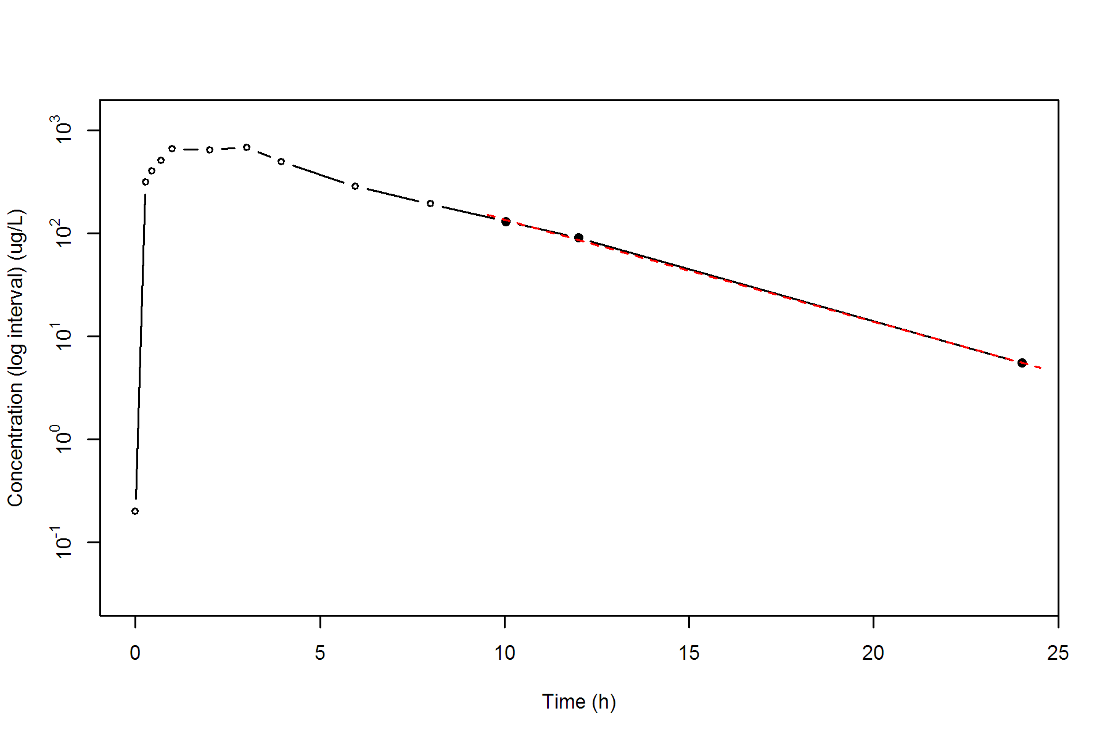

**SUBJ 36, GRP RT, PRD 2, TRT T**

NONCOMPARTMENTAL ANALYSIS REPORT

Package version 0.3.9 (2018-05-10 KST)

R version 3.5.0 (2018-04-23)

Date and Time: 2018-06-19 09:49:36 Asia/Seoul

Calculation Setting

-------------------

Drug Administration: Extravascular

Observation count excluding trailing zero: 13

Dose at time 0: 0 mg

AUC Calculation Method: Linear-up Linear-down

Weighting for lambda z: Uniform (Ordinary Least Square, OLS)

Lambda z selection criterion: Heighest adjusted R-squared value with precision=1e-4

Fitting, AUC, AUMC Result

-------------------------

Time Conc. Pred. Residual AUC AUMC

---------------------------------------------------------------------

0.0000 0.5500 0.0000 0.0000

0.2500 423.0500 52.9500 13.2203

0.4700 510.5900 155.6504 51.2517

0.7700 659.4800 331.1609 163.4182

1.0000 729.6300 490.9086 305.7226

1.9900 679.9900 1188.6705 1336.7136

3.0000 434.7100 1751.5940 2678.6552

4.0500 368.8900 2173.4840 4147.6758

5.9900 242.9000 2766.9203 7008.1821

7.9500 122.7600 3125.2671 9390.4768

9.9800 * 91.6100 91.9878 -3.778e-01 3342.8526 11309.0398

12.0200 * 48.7100 48.4759 +2.341e-01 3485.9790 12838.7970

23.9600 * 1.1400 1.1408 -8.018e-04 3783.5835 16497.2643

*: Used for the calculation of Lambda z.

Calculated Values

-----------------

CMAX Max Conc 729.6300 ug/L

TMAX Time of CMAX 1.0000 h

TLAG Time Until First Nonzero Conc 0.0000 h

CLST Last Nonzero Conc 1.1400 ug/L

CLSTP Last Nonzero Conc Pred 1.1408 ug/L

TLST Time of Last Nonzero Conc 23.9600 h

LAMZHL Half-Life Lambda z 2.2074 h

LAMZ Lambda z 0.3140 /h

LAMZLL Lambda z Lower Limit 9.9800 h

LAMZUL Lambda z Upper Limit 23.9600 h

LAMZNPT Number of Points for Lambda z 3

CORRXY Correlation Between TimeX and Log ConcY -1.0000

R2 R Squared 1.0000

R2ADJ R Squared Adjusted 1.0000

AUCLST AUC to Last Nonzero Conc 3783.5835 h*ug/L

AUCALL AUC All 3783.5835 h*ug/L

AUCIFO AUC Infinity Obs 3787.2139 h*ug/L

AUCIFP AUC Infinity Pred 3787.2165 h*ug/L

AUCPEO AUC %Extrapolation Obs 0.0959 %

AUCPEP AUC %Extrapolation Pred 0.0959 %

AUMCLST AUMC to Last Nonzero Conc 16497.2643 h2*ug/L

AUMCIFO AUMC Infinity Obs 16595.8101 h2*ug/L

AUMCIFP AUMC Infinity Pred 16595.8794 h2*ug/L

AUMCPEO AUMC %Extrapolation Obs 0.5938 %

AUMCPEP AUMC % Extrapolation Pred 0.5942 %

VZFO Vz Obs by F 0.0000 L

VZFP Vz Pred by F 0.0000 L

CLFO Total CL Obs by F 0.0000 L/h

CLFP Total CL Pred by F 0.0000 L/h

MRTEVLST MRT Extravasc to Last Nonzero Conc 4.3602 h

MRTEVIFO MRT Extravasc Infinity Obs 4.3821 h

MRTEVIFP MRT Extravasc Infinity Pred 4.3821 h

**SUBJ 36, GRP RT, PRD 2, TRT T**

