Noncompartmental analysis (NCA) using R packages : ‘*ncar’,* ‘pkr’, ‘NonCompart’

Hyungsub Kim, Sungpil Han, Yong-Soon Cho, Seok-Kyu Yoon, and Kyun-Seop Bae*

Department of Clinical Pharmacology and Therapeutics, Asan Medical Center, University of Ulsan, Seoul, Republic of Korea

*Correspondence to:

K. S. Bae

Department of Clinical Pharmacology and Therapeutics, Asan Medical Center, University of Ulsan, Olympic-ro 43-gil, Songpa-gu, Seoul 05505, Republic of Korea

Tel: +82-2-3010-4611, Fax: +82-2-3010-4623, Email: ksbae@amc.seoul.kr

Running title: R packages for NCA  
Key words: ncar, pkr, NonCompart, R, noncompartmental analysis (NCA)

# Abstract

In this article, we introduce newly developed R packages, *pkr* (Pharmacokinetics in R)*, NonCompart* (NonCompartmental analysis for pharmacokinetic data)*,* and *ncar* (NonCompartmental Analysis for pharmacokinetic Report), which can perform a noncompartmental analysis (NCA), and produce a complete NCA report simultaneously in PDF and RTF format. We demonstrate how similarily results of WinNonlin® were reproduced and how easily an NCA report can be obtained by these packages. We hope that this article helps many researchers carry out NCA with these R packages and utilize. These packages support CDISC SDTM terms and datasets and conversion after analysis is not needed. the output for the early stage of drug discovery process. These R packages are freely available for download through CRAN repository.

# Introduction

The aim of pharmacokinetics (PK) studies is to examine the kinetics of a drug with regard to absorption, distribution, metabolism and elimination in the body. When analyzing PK data, it can be classified into noncompartmental analysis (NCA) and nonlinear regression analysis. [1, 2] NCA, which uses the trapezoidal rule for measurements of the area under the concentration-time curve (AUC), requires fewer assumptions than model-based analysis. [2] In NCA, we can estimate various PK parameters such as AUC, peak observed drug concentration (Cmax), time of peak concentration (Tmax), elimination half-life and other metrics. In particular, AUC and Cmax are often accepted as the criteria of the approval for bioequivalent drugs.

R, widely-used computer language, is a suite of libraries for statistical and mathematical computation. [3] In spite of its relatively small base system compared with other commercial software for NCA such as WinNonlin®, [4] and Kinetica, [5] R has robust functions for scientific computation and many add-in packages for specific fields such as pharmacokinetics. [6] Until now, many efforts are being made to make an R package to replace commercial software.

In this article, we introduce *ncar, pkr,* and *NonCompart* packages written in R programming language that provides an easy-to-use and practical method to produce a complete NCA report. Thus, these packages can potentially facilitate the early stage of drug discovery process by performing NCA even for researchers who are not available for commercial software such as WinNonlin®.

# Methods

## Software

WinNonlin® (Pharsight, Mountain View, CA, USA) [4] under MS-Windows 7 (64 bit) was used for the computation. For the R software, R 3.4.1 under MS-Windows 7 was used for the comparison of calculated values.

## Dataset

R itself contains two pharmacokinetic datasets, called Theoph and Indometh. In this tutorial we will use these datasets. (Figure 6.3) In NCA R packages, the input dataset should be prepared as a long format as Theoph dataset shown in Table 3.1, and if a dataset is in a wide format, it can be easily converted using gather() function in tidyr package. Data preparation is one of the most important parts in accurate NCA process, therefore using trackable and reproducible code scripts like R, SAS, or python is highly recommended. Using R for data preparation and NCA together will significantly reduce time and efforts for performing NCA.

For the comparison of output between by Rpackage and by WinNonlin®, we used ‘Theoph’ dataset obtained from R software inside. The ‘Theoph’ dataset has 132 observations from 12 subjects.

## R packages

Three R packages (ncar, pkr, and NonCompart) for NCA were developed in the open-source R programming language in order to allow public to use freely. R packages can be installed and loaded by the scripts below.

install.packages(“ncar”, “NonCompart”, “pkr”)

library(NonCompart)

library(ncar)

library(pkr)

Detailed documentation and examples for each package can be found on the online user manual on the CRAN repository ([http://cran.r-project.org/web/packages/ncar/index.html](http://cran.r-project.org/web/packages/ncar/%20index.html), <http://cran.r-project.org/web/packages/pkr/index.html>, [http://cran.r-project.org/web/packages/ NonCompart/index.html](http://cran.r-project.org/web/packages/%20NonCompart/index.html)) or directly within the R console by entering ?function (e.g. ?pkr, ?NonCompart, ?ncar) after installation. These three R packages are implemented in R and accept a set of input arguments, resulting in processing of data and output production. The names of most of NCA metrics estimated by the function of these packages are consistent with those used in WinNonlin® (Table 1).

# Results

## NonCompart:

A function tblNCA() of NonCompart package generates a simple table-format output of NCA with an attribute of units. tblNCA() contains several function arguments as shown below.

tblNCA(Theoph, key = "Subject", colTime = "Time", colConc = "conc", dose = 320, adm = "Extravascular", dur = 0, doseUnit = "mg", timeUnit = "h", concUnit = "ug/L", down = "Log", MW = 0)

One can input several keys such as subject demographics, information regarding dose, period, or sequence and the result of tblNCA( ) will print the keys and the carried keys can be further used for additional statistical analysis (i.e. descriptive statistics, bioequivalence test, t-test or ANOVA). The adm argument can be 'Extravascular', 'Bolus', or 'Infusion'. The down argument can be 'Linear' or 'Log'.

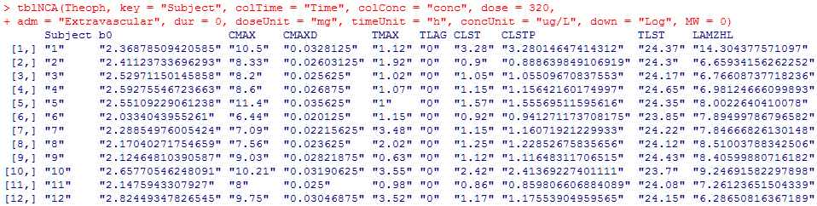

This package also conducts a NCA as closely as *pkr*, however, this package gives a tablular form in contrast to *pkr* package. In this package, there are two main functions which are tblNCA and sNCA for many subjects and for one subject, respectively. 이 패키지를 통해 생성된 결과는 CDISC SDTM의 PPTESTCD를 사용한 것이 장점이다.

## ncar: generating reports of NCA

비구획분석의 정확한 계산 뿐만 아니라, 일관적이고 체계적인 결과를 생성하여 스폰서와 규제기관이 알아보기 쉽도록 하는 것이 communication에 중요하다. Ncar은 NonCompart를 통해 계산된 수치를 보고서 형태로 만들어 주고 rtfNCA()를 사용할 경우 워드 형태로 변환하여 전달하기 용이할 것이며 pdfNCA()를 사용할 경우 indi plot과 터미널슬로프 계산시 사용된 점들을 이어서 보여준다. 이 보고서는 상용 소프트웨어의 보고서와 유사하나 NonCompart와 마찬가지로 CDISC SDTM의 PPTESTCD를 사용한 것이 장점이다.

Particularly, this package can produce a complete NCA report (PDF and rtf file format). Two main functions are pdfNCA and rtfNCA, which can generate a PDF file format and rtf file format, respectively. If you enter pdfNCA instead of rtfNCA, you can generate a PDF file.

rtfNCA(fileName="rtfNCA-Theoph.rtf", Theoph, colSubj="Subject", colTime="Time", colConc="conc", dose=320, doseUnit="mg", timeUnit="h", concUnit="mg/L")

## *pkr* package: visualizing NCA results and supporting SDTM-formatted clinical trial data

This package conducts a NCA as closely as possible to the most widely used commercial PK analysis software. The main functions are NCA and IndNCA() to perfom NCA for many subjects and for to perform for one subject, respectively. An example of these two functions is below.

이 패키지는 FDA 등에서 임상시험 자료의 제출 시 표준으로 쓰고 있는 CDISC SDTM (reference 필요하므로 찾아서 달아주십시오.) 형태의 자료 형식을 지원한다. EX, PC 도메인의 xpt 포맷 자료를 별도의 처리 없이 읽어와 NCA를 시행한다. 이것은 자료를 SDTM으로 만들어 표준화된 NCA를 시행할 수 있게 됨을 의미한다. 또한 이 패키지를 통해 용량 군별 forest plot 등을 생성할 수 있다.

NCA(Theoph, "Subject", "Time", "conc", dose=320, uConc="mg/L")

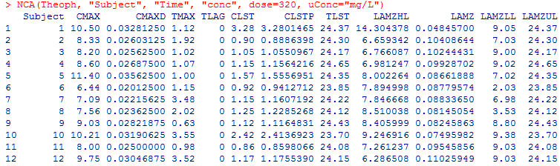

IndiNCA(Theoph[Theoph$Subject==8,"Time"], Theoph[Theoph$Subject==8, "conc"], dose=320, uConc="mg/L")

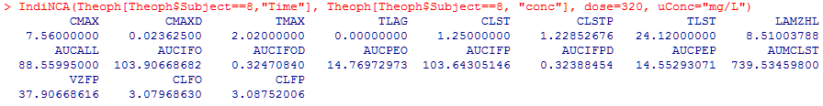

## Comparison of NCA results between R package (ncar) and WinNonlin®

A comparison of NCA metrics obtained by *ncar* package and WinNonlin® showed no discrepancies as shown in Table 2 (a randomized subject, Subject ID = 8).

# Discussion

We developed three R packages: *ncar, pkr,* and *NonCompart* for NCA. In these packages, we aimed to imple­ment the following functionalities to perform NCA: 1) automatic slope selection with the same criterion of WinNonlin®; 2) supporting both 'linear-up linear-down' and 'linear-up log-down' method; 3) interval (partial) AUCs with 'linear' or 'log' interpolation method. Based on our results, we think that the *ncar* package meets the objectives described above.

As shown in Table 2, comparison of NCA metrics obtained by *ncar* package and WinNonlin® showed no discrepancies. These three Rpackage are fast and easy-to-use tool-set written in R programming language that successfully perform NCA with the concentration–time data. Especially, *ncar* package can produce a comprehensive set of graphical and tabular output to summarize NCA results, which is a complete report in PDF or RTF format. We hope that our newly-developed *ncar, pkr, and NonCompart* packages enable many researchers to use NCA easily without any cost and can contribute to facilitation for the drug discovery process.

# Acknowledgements

We thank Dr. Joon Seo Lim from the Scientific Publications Team at Asan Medical Center for his editorial assistance in preparing this manuscript.

# Conflicts of interests

* Authors: The authors declare that they have no conflict of interests
* Reviewers: Nothing to declare
* Editors: Nothing to declare

# References

1. Acharya C, Hooker AC, Turkyilmaz GY, Jonsson S, Karlsson MO. A diagnostic tool for population models using non-compartmental analysis: The *ncappc* package for R. Comput Methods Programs Biomed 2016;127:83-93.
2. Gabrielsson J, Weiner D. Non-compartmental analysis. Methods. Mol Biol 2012;929:377–389.
3. R Core Team, R: A Language and Environment for Statistical Computing, R Foundation for Statistical Computing, Vienna, Austria, 2013, URL <http://www.R-project.org/>
4. Kinetica (Thermo Fisher Scientific, Waltham, MA, USA).
5. Phoenix WinNonlin® (Certara, Pinceton, NJ, USA).
6. Kim MG, Yim DS, Bae KS. R-based reproduction of the estimation process hidden behind NONMEN Part 1: first-order approximation method. Transl Clin Pharmacol 2015;23(1):1-7.

# Tables

## Table 1.

|  |  |  |  |  |
| --- | --- | --- | --- | --- |
| Subject | Wt | Dose | Time | conc |
| 1 | 79.6 | 4.02 | 0 | 0.74 |
| 1 | 79.6 | 4.02 | 0.25 | 2.84 |
| 1 | 79.6 | 4.02 | 0.57 | 6.57 |
| 1 | 79.6 | 4.02 | 1.12 | 10.5 |
| 1 | 79.6 | 4.02 | 2.02 | 9.66 |
| 1 | 79.6 | 4.02 | 3.82 | 8.58 |
| 1 | 79.6 | 4.02 | 5.1 | 8.36 |
| 1 | 79.6 | 4.02 | 7.03 | 7.47 |
| 1 | 79.6 | 4.02 | 9.05 | 6.89 |
| 1 | 79.6 | 4.02 | 12.12 | 5.94 |

## Table 2. Description of the *ncar* arguments

|  |  |
| --- | --- |
| Name | Description |
| CMAX | Max Conc |
| CMAXD | Max Conc Norm by Dose |
| TMAX | Time of CMAX |
| TLAG | Time Until First Nonzero Conc |
| CLST | Last Nonzero Conc |
| CLSTP | Last Nonzero Conc Pred |
| TLST | Time of Last Nonzero Conc |
| LAMZHL | Half-Life Lambda z |
| LAMZ | Lambda z |
| LAMZLL | Lambda z Lower Limit |
| LAMZUL | Lambda z Upper Limit |
| LAMZNPT | Number of Points for Lambda z |
| CORRXY | Correlation Between TimeX and Log ConcY |
| R2 | R Squared |
| R2ADJ | R Squared Adjusted |
| AUCLST | AUC to Last Nonzero Conc |
| AUCALL | AUC All |
| AUCIFO | AUC Infinity Obs |
| AUCIFOD | AUC Infinity Obs Norm by Dose |
| AUCIFP | AUC Infinity Pred |
| AUCIFPD | AUC Infinity Pred Norm by Dose |
| AUCPEO | AUC %Extrapolation Obs |
| AUCPEP | AUC %Extrapolation Pred |
| AUMCLST | AUMC to Last Nonzero Conc |
| AUMCIFO | AUMC Infinity Obs |
| AUMCIFP | AUMC Infinity Pred |
| AUMCPEO | AUMC %Extrapolation Obs |
| AUMCPEP | AUMC % Extrapolation Pred |
| VZFO | Vz Obs by F |
| VZFP | Vz Pred by F |
| CLFO | Total CL Obs by F |
| CLFP | Total CL Pred by F |
| MRTEVLST | MRT Extravasc to Last Nonzero Conc |
| MRTEVIFO | MRT Extravasc Infinity Obs |
| MRTEVIFP | MRT Extravasc Infinity Pred |

## Table 3. Comparison of NCA parameter results between WinNonlin® and *ncar* package

|  |  |  |
| --- | --- | --- |
| parameter | WinNonlin® | ncar |
| CMAX  CMAXD  TMAX  TLAG  CLST  CLSTP  TLST  LAMZHL  LAMZ  LAMZLL  LAMZUL  LAMZNPT  CORRXY  R2  R2ADJ  AUCLST  AUCALL  AUCIFO  AUCIFOD  AUCIFP  AUCIFPD  AUCPEO  AUCPEP  AUMCLST  AUMCIFO  AUMCIFP  AUMCPEO  AUMCPEP  VZFO  VZFP  CLFO  CLFP  MRTEVLST  MRTEVIFO  MRTEVIFP | 7.56 mg/L  -  2.02 h  0 h  1.25 mg/L  -  24.12 h  8.5100379 h  0.08145054 h  3.53 h  24.12 h  6  -0.99549605  0.99101239  0.98876549  88.55995 h*mg/L  88.55995 h*mg/L  103.906687 h*mg/L  -  103.643051 h*mg/L  -  14.769730 %  14.552931 %  739.534598 h2*mg/L  1298.115755 h2*mg/L  1288.520116 h2*mg/L  42.479491 %  42.056657 %  37.81051 L  37.90669 L  3.079686 L  3.087520 L  8.350066 h  12.493092 h  12.432287 h | 7.5600 mg/L  0.0236 mg/L/mg  2.0200 h  0.0000 h  1.2500 mg/L  1.2285 mg/L  24.1200 h  8.5100 h  0.0815 h  3.5300 h  24.1200 h  6  -0.9955  0.9910  0.9888  88.5600 h*mg/L  88.5600 h*mg/L  103.9067 h*mg/L  0.3247 h*mg/L/mg  103.6431 h*mg/L  0.3239 h*mg/L/mg  14.7697 %  14.5529 %  739.5346 h2*mg/L  1298.1158 h2*mg/L  1288.5201 h2*mg/L  43.0302 %  42.6059 %  37.8105 L  37.9067 L  3.0797 L/h  3.0875 L/h  8.3507 h  12.4931 h  12.4323 h |

# Figures

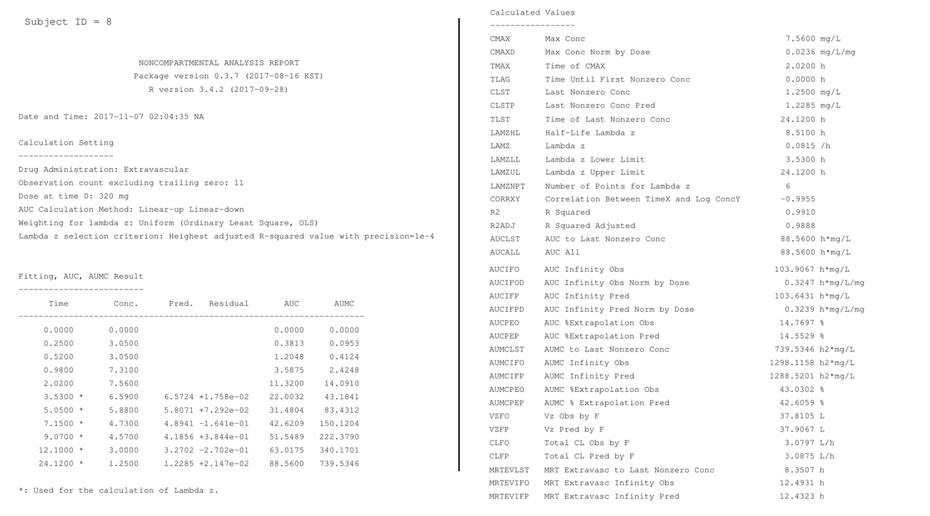

## Figure 1. Example of ncar results (Subject ID 8) using Theoph data included in R programming. (A) rtf report, (B) plots (upper: linear scale, lower: log-linear scale)

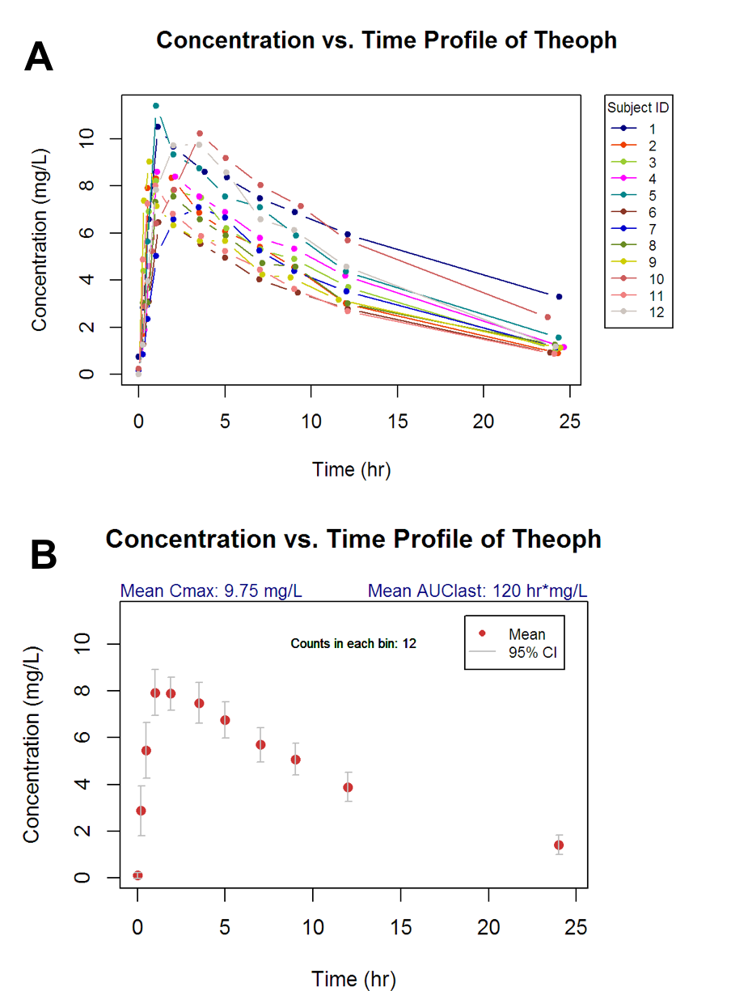

## Figure 2. Individual and group concerntration-time curves of Theoph dataset generated by pkr package

# Supplementary

