**R-based reproduction of WinNonlin: *ncar* package for noncompartmental analysis (NCA) for pharmacokinetic report**

…………………………………………., Kyun-Seop Bae

Department of Clinical Pharmacology and Therapeutics, Asan Medical Center, University of Ulsan, Seoul, Republic of Korea

**Correspondence to:**

K. S. Bae

Department of Clinical Pharmacology and Therapeutics, Asan Medical Center, University of Ulsan, Olympic-ro 43-gil, Songpa-gu, Seoul 05505, Republic of Korea

Tel: +82-2-3010-4611, Fax: +82-2-3010-4623, Email: ksbae@amc.seoul.kr

Key words: WinNonlin, ncar, R, noncompartmental analysis (NCA)

**Abstract**

WinNonlin is one of the widely used noncompartmental analysis (NCA) software. *ncar* (NonCompartmental Analysis for pharmacokinetic Report), R package conducts a non-compartmental analysis as closely as possible to the most widely used commercial software for pharmacokinetic analysis such as Phoenix and WinNonlin.

In this article, we demonstrated how accurately the results of WinNonlin were reproduced and how easily the NCA report could be obtained by this R package. We hope that this tutorial helps pharmacometricians understand the NCA and carry out NCA with *ncar*.

**Introduction**

The aim of the pharmacokinetics (PK) studies is to understand the kinetics of a drug in terms of absorption, distribution, metabolism and elimination (ADME). When analyzing PK data, analysis can primarily be classified into noncompartmental analysis (NCA) and model-based analysis. [5] In NCA, the area under the concentration-time curve (AUC), peak observed drug concentration (*C*max), time of peak concentration (*T*max), terminal elimination rate constant (Lambda z), terminal half-life (HL Lambda z) and other metrics are estimated to determine the systemic exposure of a drug. The method used involves application of the trapezoidal rule for measurements of the area under a plasma concentration-time curve. [1] In particular, regulatory decisions regarding bioequivalence studies are often based on comparisons of AUC and *C*max. A number of software tools such as Kinetica [2], WinNonlin [3], and PK module in R [4] are available for the NCA.

R, widely-used computer language, is a suite of libraries for statistical and mathematical computation. In spite of its relatively small base system compared with other commercial software, R has robust functions for scientific computation and many add-in packages for particular problems such as pharmacokinetics. [5] Until now, many efforts are being made to make an R package to replace specific software, and it is actually available.

The objective of this tutorial is to demonstrate how to easily obtain an NCA report including plots using the *ncar* package. In this article, we introduced *ncar* package written in R programming language that provides an easy-to-use and practical method to produce an NCA report. Thus, this package can potentially facilitate the early stage of drug discovery process by performing NCA even for researchers who cannot use commercial software such as WinNonlin®.

**Basic principles of the NCA used in *ncar***

The following equations are used for NCA in WinNonlin:

*ncar* package is implemented in R and accepts a set of input arguments, resulting in certain processing of data and output production. The names of most of the NCA metrics estimated by the *ncar* function are consistent with those used in WinNonlin [Table 1].

# R code (slope)

Slope = function(x, y)

{

n = length(x)

if (n != length(y) | !is.numeric(x) | !is.numeric(y)) stop("Bad Input!")

mx = mean(x)

my = mean(y)

Sxx = sum((x - mx)*(x - mx))

Sxy = sum((x - mx)*(y - my))

Syy = sum((y - my)*(y - my))

b1 = Sxy/Sxx

b0 = my - b1*mx

Rsq = b1 * Sxy / Syy

aRsq = 1 - (1 - Rsq)*(n - 1)/(n - 2) # Rsq_adjusted

Corr = sign(b1)*sqrt(Rsq)

LambdaLower = x[1]

LambdaUpper = x[n]

ClastPred = exp(b0 + b1 * x[n])

if (b1 < 0) Result = c(Rsq, aRsq, n, -b1, b0, Corr, LambdaLower, LambdaUpper, ClastPred) # negative slope to positive slope

else Result = c(NA, NA, 0, NA, NA, NA, NA, NA, NA) # positive slope

names(Result) = c("R2", "R2ADJ", "LAMZNPT", "LAMZ", "b0", "CORRXY", "LAMZLL", "LAMZUL", "CLSTP")

return(Result)

}

#R code (best slope)

BestSlope = function(x, y, adm="Extravascular")

{

n = length(x)

if (n != length(y) | !is.numeric(x) | !is.numeric(y)) stop("Bad Input!")

if (toupper(adm) == "BOLUS") {

locStart = which.max(y) # From Tmax (for Bolus)

} else {

locStart = which.max(y) + 1 # From next to Tmax (for the others)

}

locLast = max(which(y > 0)) # Till non-zero concentration

if (locLast - locStart < 2) return(c(NA, NA, 0, NA, NA, NA, NA, NA, NA))

tmpMat = matrix(nrow=(locLast - locStart - 1), ncol=9) # Slope function returns 9 columns

colnames(tmpMat) = c("R2", "R2ADJ", "LAMZNPT", "LAMZ", "b0", "CORRXY", "LAMZLL", "LAMZUL", "CLSTP")

for (i in locStart:(locLast - 2)) {

tmpMat[i - locStart + 1,] = Slope(x[i:locLast], log(y[i:locLast]))

}

maxAdjRsq = max(tmpMat[,"R2ADJ"]) # The second column is "Rsq_adjusted" which is the criterion

OKs = ifelse(abs(maxAdjRsq - tmpMat[,"R2ADJ"]) < 1e-4, TRUE, FALSE) # Tolerance is 1e-4

nMax = max(tmpMat[OKs,"LAMZNPT"]) # Third column is "No_points_lambda_z" or "n"

Res = tmpMat[OKs & tmpMat[,"LAMZNPT"]==nMax,]

if (length(Res) == 0) Res = c(NA, NA, 0, NA, NA, NA, NA, NA, NA)

return(Res)

}

# R code (AUC)

AUC = function(x, y, down="Linear")

{

n = length(x)

if (n != length(y) | !is.numeric(x) | !is.numeric(y)) stop("Bad Input!")

Res = matrix(nrow=n, ncol=2)

Res[1,] = c(0, 0)

for (i in 2:n) {

if (y[i] >= y[i-1]) {

Res[i,1] = (x[i] - x[i-1])*(y[i] + y[i-1])/2

Res[i,2] = (x[i] - x[i-1])*(x[i]*y[i] + x[i-1]*y[i-1])/2

} else if (down == "Linear") {

Res[i,1] = (x[i] - x[i-1])*(y[i] + y[i-1])/2

Res[i,2] = (x[i] - x[i-1])*(x[i]*y[i] + x[i-1]*y[i-1])/2

} else if (down == "Log") {

k = (log(y[i-1]) - log(y[i]))/(x[i] - x[i-1]) # -k slope in y-log scale

Res[i,1] = (y[i-1] - y[i])/k

Res[i,2] = (x[i-1]*y[i-1] - x[i]*y[i])/k + (y[i-1] - y[i])/k/k

} else {

stop("Unknown method!")

}

}

Result = cbind(cumsum(Res[,1]), cumsum(Res[,2]))

colnames(Result) = c("AUC","AUMC")

return(Result)

}

#R code (IntAUC)

IntAUC = function(x, y, t1, t2, Res, down="Linear")

{

n = length(x)

if (n != length(y) | !is.numeric(x) | !is.numeric(y)) stop("Bad Input!")

if (t1 > Res["TLST"]) stop("Start time of interval AUC is after Tlast.")

tL = Res["TLST"]

if (t2 > tL & is.na(Res["LAMZ"])) return(NA)

newSeries = Interpol(x, y, t1, Res["LAMZ"], Res["b0"], down=down)

newSeries = Interpol(newSeries[[1]], newSeries[[2]], t2, Res["LAMZ"], Res["b0"], down=down)

x = newSeries[[1]]

y = newSeries[[2]]

if (down=="Linear") {

if (t2 <= tL) {

ResIntAUC = LinAUC(x[x>=t1 & x<=t2], y[x>=t1 & x<=t2])[[1]]

} else {

ResIntAUC = LinAUC(x[x>=t1 & x<=tL], y[x>=t1 & x<=tL])[[1]] + LogAUC(x[x>=tL & x<=t2], y[x>=tL & x<=t2])[[1]]

}

} else if (down=="Log") {

ResIntAUC = LogAUC(x[x>=t1 & x<=t2], y[x>=t1 & x<=t2])[[1]]

} else stop("Unknown down method!")

return(ResIntAUC)

}

#R code (linAUC)

LinAUC = function(x, y) # down="Linear"

{

n = length(x)

if (n != length(y) | !is.numeric(x) | !is.numeric(y)) stop("Bad Input!")

auc = sum((x[-1] - x[-n])*(y[-1] + y[-n]))/2

aumc = sum((x[-1] - x[-n])*(x[-1]*y[-1] + x[-n]*y[-n]))/2

Result = c(auc, aumc)

names(Result) = c("AUC", "AUMC")

return(Result)

}

# R code (logAUC)

LogAUC = function(x, y) # down="Log" means Linear-Up Log-Down

{

n = length(x)

if (n != length(y) | !is.numeric(x) | !is.numeric(y)) stop("Bad Input!")

auc = 0

aumc = 0

for (i in 2:n) {

if (y[i] < y[i-1] & y[i] > 0) {

k = (log(y[i-1]) - log(y[i]))/(x[i] - x[i-1]) # -k slope in y-log scale

auc = auc + (y[i-1] - y[i])/k

aumc = aumc + (x[i-1]*y[i-1] - x[i]*y[i])/k + (y[i-1] - y[i])/k/k

} else {

auc = auc + (x[i] - x[i-1])*(y[i] + y[i-1])/2

aumc = aumc + (x[i] - x[i-1])*(y[i]*x[i] + y[i-1]*x[i-1])/2

}

}

Result = c(auc, aumc)

names(Result) = c("AUC", "AUMC")

return(Result)

}

**Implementation**

Computing environment

WinNonlin® (Pharsight, Mountain View, CA, USA) under MS-Windows 7 (64 bit) was used for the computation. For the R software, R 3.4.1 for MS-Windows was used.

Dataset

Here we present a case study to illustrate the *ncar* package using the Theoph data obtained from R programming language inside. This dataset is readily available, and its use will make it easy to compare the results from other methods of the future.

**Case study**

1. WinNonlin®

(Example)

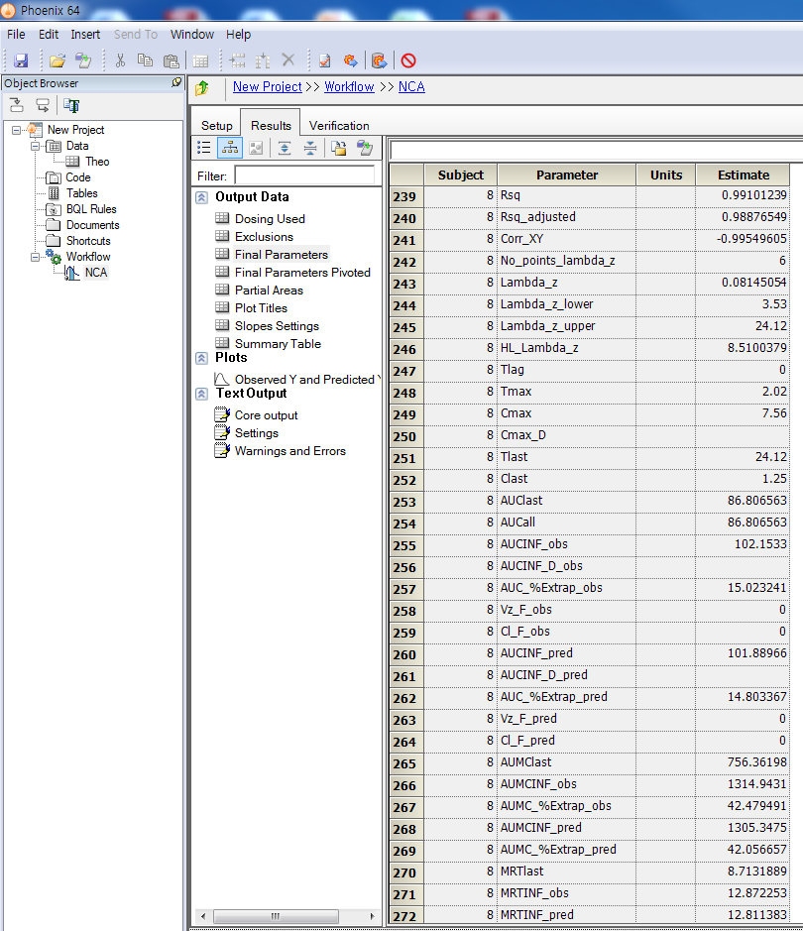

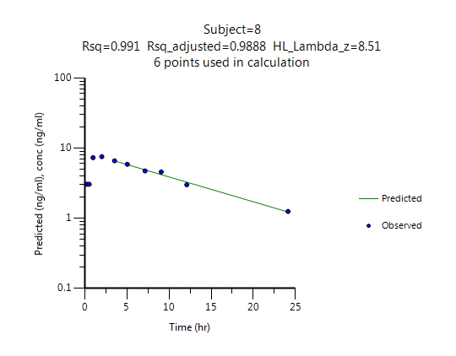

1. *ncar* package

We aimed to imple­ment the following functionalities to perform NCA: 1) CDISC SDTM terms; 2) automatic slope selection with the same criterion of WinNonlin; 3) Supporting both 'linear-up linear-down' and 'linear-up log-down' method; 4) Interval (partial) AUCs with 'linear' or 'log' interpolation method. Based on our results, we think that the *ncar* R package meets the objectives described above.

(Example)

**Subject ID = 8**

NONCOMPARTMENTAL ANALYSIS REPORT

Package version 0.3.7 (2017-08-16 KST)

R version 3.4.1 (2017-06-30)

Date and Time: 2017-09-19 15:42:56 KST

Calculation Setting

-------------------

Drug Administration: Extravascular

Observation count excluding trailing zero: 11

Dose at time 0: 320 mg

AUC Calculation Method: Linear-up Linear-down

Weighting for lambda z: Uniform (Ordinary Least Square, OLS)

Lambda z selection criterion: Heighest adjusted R-squared value with precision=1e-4

Fitting, AUC, AUMC Result

-------------------------

Time Conc. Pred. Residual AUC AUMC

---------------------------------------------------------------------

0.0000 0.0000 0.0000 0.0000

0.2500 3.0500 0.3813 0.0953

0.5200 3.0500 1.2048 0.4124

0.9800 7.3100 3.5875 2.4248

2.0200 7.5600 11.3200 14.0910

3.5300 * 6.5900 6.5724 +1.758e-02 22.0032 43.1841

5.0500 * 5.8800 5.8071 +7.292e-02 31.4804 83.4312

7.1500 * 4.7300 4.8941 -1.641e-01 42.6209 150.1204

9.0700 * 4.5700 4.1856 +3.844e-01 51.5489 222.3790

12.1000 * 3.0000 3.2702 -2.702e-01 63.0175 340.1701

24.1200 * 1.2500 1.2285 +2.147e-02 88.5600 739.5346

*: Used for the calculation of Lambda z.

Calculated Values

-----------------

CMAX Max Conc 7.5600 mg/L

CMAXD Max Conc Norm by Dose 0.0236 mg/L/mg

TMAX Time of CMAX 2.0200 h

TLAG Time Until First Nonzero Conc 0.0000 h

CLST Last Nonzero Conc 1.2500 mg/L

CLSTP Last Nonzero Conc Pred 1.2285 mg/L

TLST Time of Last Nonzero Conc 24.1200 h

LAMZHL Half-Life Lambda z 8.5100 h

LAMZ Lambda z 0.0815 /h

LAMZLL Lambda z Lower Limit 3.5300 h

LAMZUL Lambda z Upper Limit 24.1200 h

LAMZNPT Number of Points for Lambda z 6

CORRXY Correlation Between TimeX and Log ConcY -0.9955

R2 R Squared 0.9910

R2ADJ R Squared Adjusted 0.9888

AUCLST AUC to Last Nonzero Conc 88.5600 h*mg/L

AUCALL AUC All 88.5600 h*mg/L

AUCIFO AUC Infinity Obs 103.9067 h*mg/L

AUCIFOD AUC Infinity Obs Norm by Dose 0.3247 h*mg/L/mg

AUCIFP AUC Infinity Pred 103.6431 h*mg/L

AUCIFPD AUC Infinity Pred Norm by Dose 0.3239 h*mg/L/mg

AUCPEO AUC %Extrapolation Obs 14.7697 %

AUCPEP AUC %Extrapolation Pred 14.5529 %

AUMCLST AUMC to Last Nonzero Conc 739.5346 h2*mg/L

AUMCIFO AUMC Infinity Obs 1298.1158 h2*mg/L

AUMCIFP AUMC Infinity Pred 1288.5201 h2*mg/L

AUMCPEO AUMC %Extrapolation Obs 43.0302 %

AUMCPEP AUMC % Extrapolation Pred 42.6059 %

VZFO Vz Obs by F 37.8105 L

VZFP Vz Pred by F 37.9067 L

CLFO Total CL Obs by F 3.0797 L/h

CLFP Total CL Pred by F 3.0875 L/h

MRTEVLST MRT Extravasc to Last Nonzero Conc 8.3507 h

MRTEVIFO MRT Extravasc Infinity Obs 12.4931 h

MRTEVIFP MRT Extravasc Infinity Pred 12.4323 h

(B)

**Subject ID = 8**

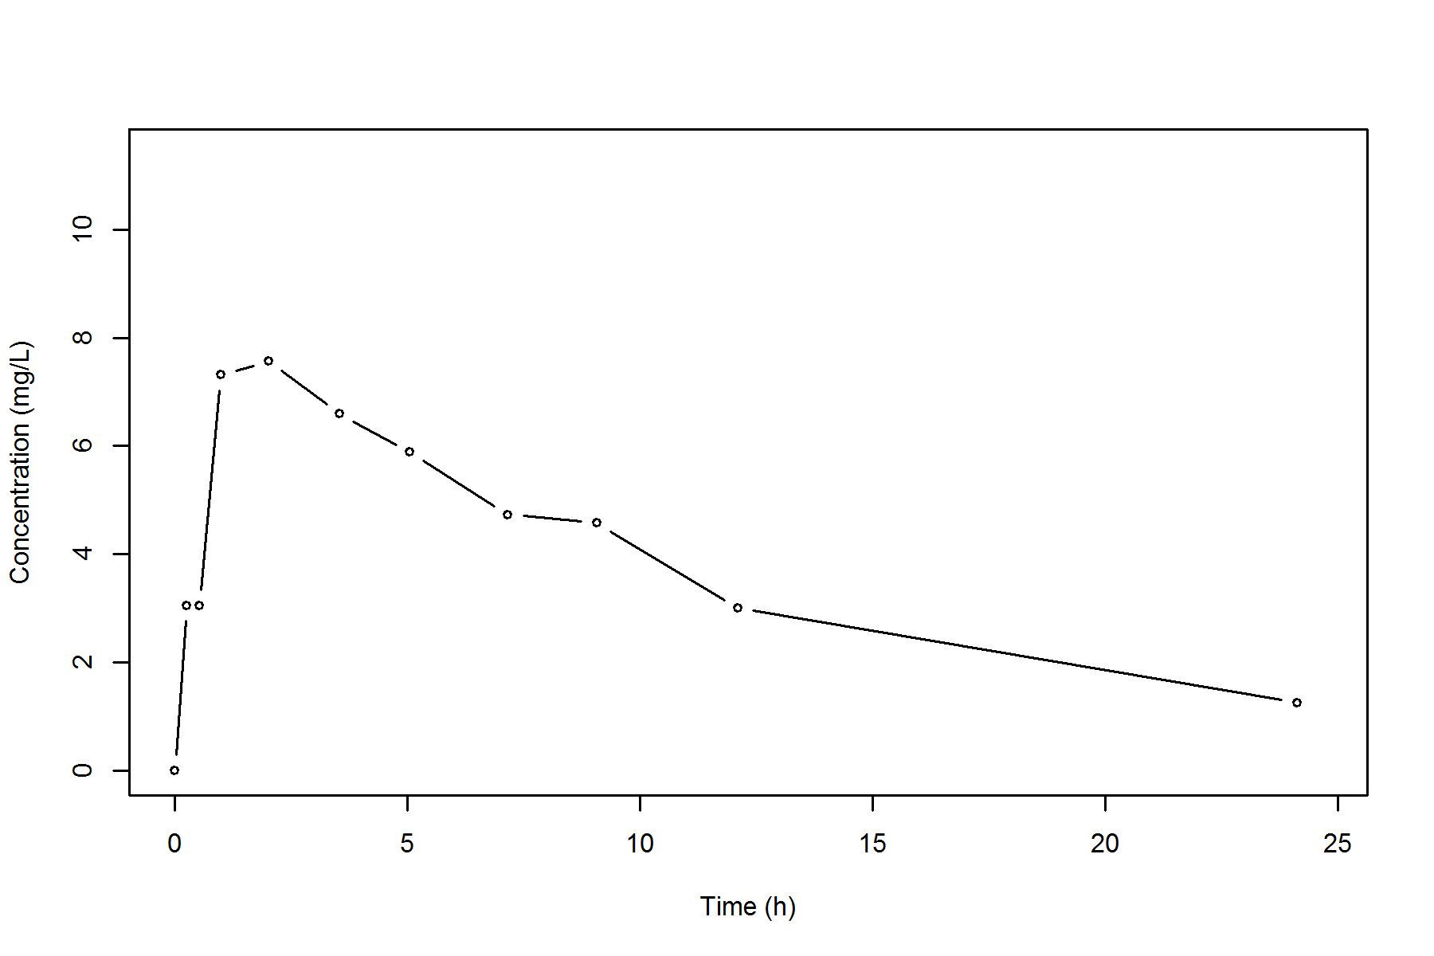

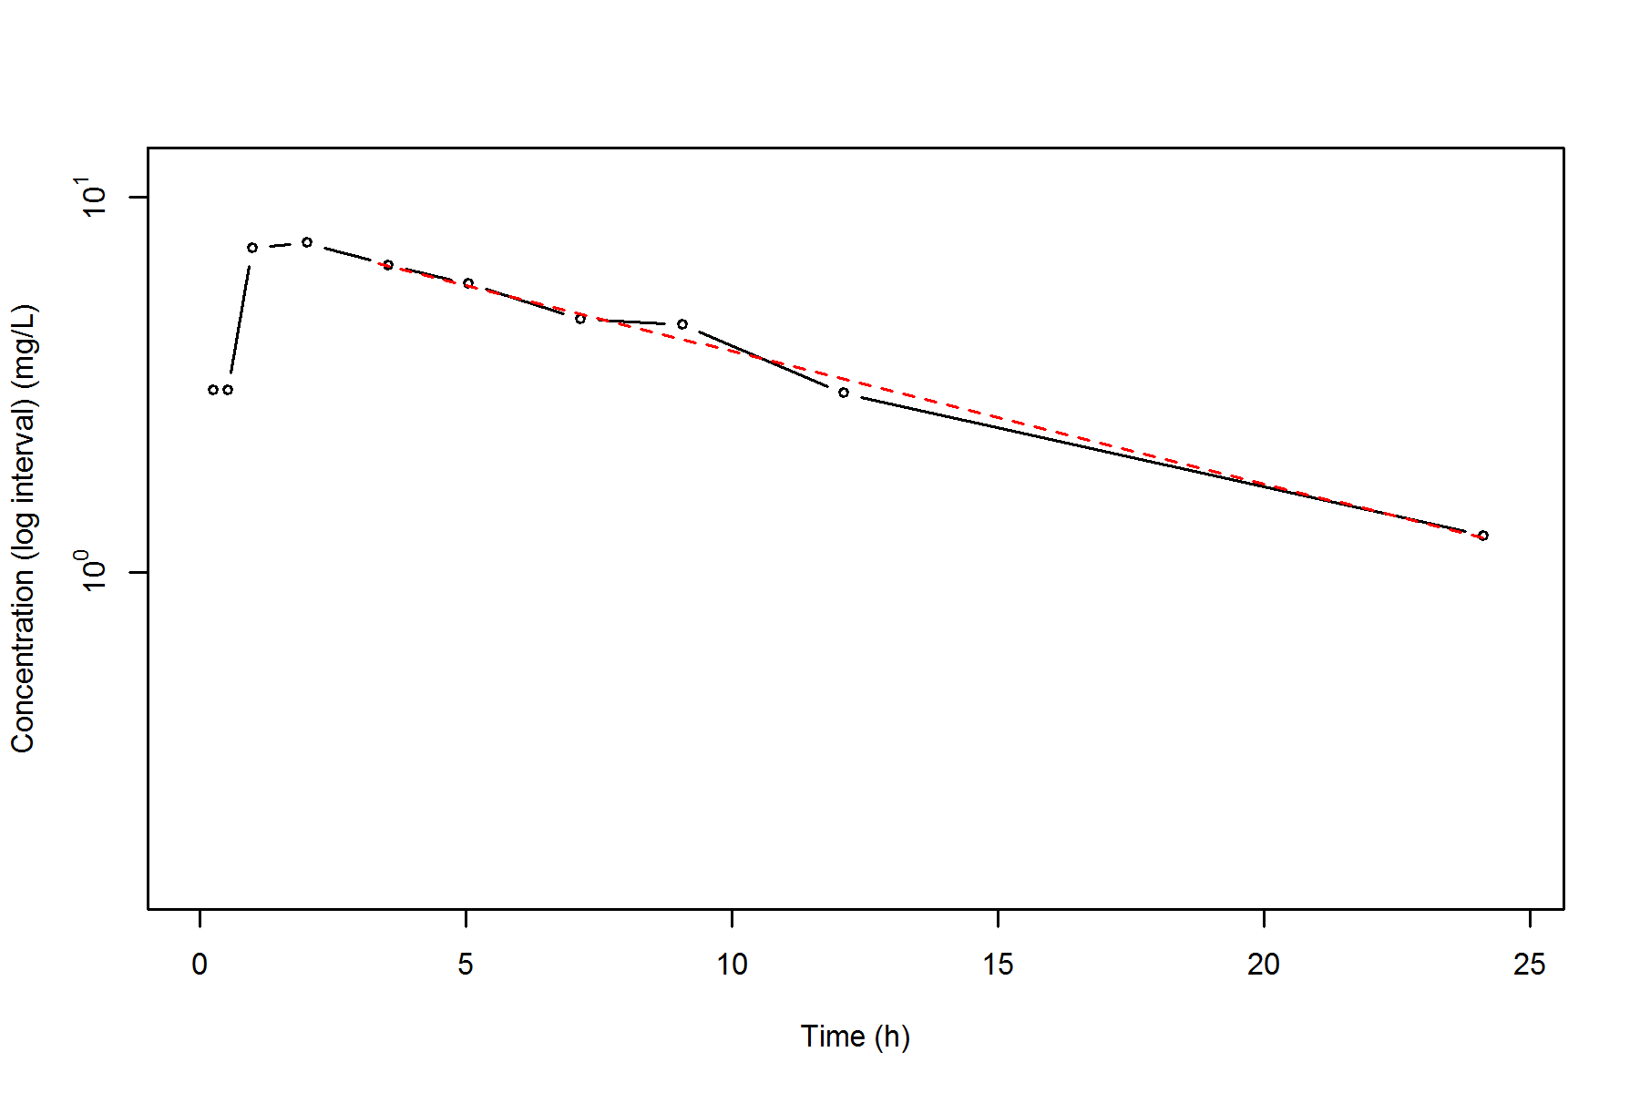

**Summary**

A comparison of NCA metrics obtained by the *ncar* package and WinNonlin showed no discrepancies. The *ncar* package is a fast, easy-to-use and versatile tool-set written in R programming language that successfully perform NCA with the concentration–time data. This R package produces a comprehensive set of graphical and tabular output to summarize the NCA results, which is a complete report in PDF or RTF format. We hope that our newly-developed *ncar* package enables researcher who do not have any experience to use any NCA software for the NCA. The *ncar* package is freely available for download on CRAN repository (http://cran.r-project.org/web/packages/ncar/index.html).

**Acknowledgements**

We thank Dr. Joon Seo Lim from the Scientific Publications Team at Asan Medical Center for his editorial assistance in preparing this manuscript.

**Conflicts of interests**

* Authors: The authors declare that they have no conflict of interests
* Reviewers: Nothing to declare
* Editors: Nothing to declare

**References**

1. Gabrielsson J, Weiner D. Non-compartmental analysis. Methods. Mol Biol 2012;929:377–389.
2. Kinetica (Thermo Fisher Scientific, Waltham, MA, USA).
3. Phoenix WinNonlin (Certara, Pinceton, NJ, USA).
4. Jaki T, Wolfsegger MJ. Estimation of pharmacokinetic parameters with the R package PK. Pharm Stat 2011;10:294–388.
5. Kim MG, Yim DS, Bae KS. R-based reproduction of the estimation process hidden behind NONMEN Part 1: first-order approximation method. Transl Clin Pharmacol 2015;23(1):1-7.
6. Acharya C, Hooker AC, Turkyilmaz GY, Jonsson S, Karlsson MO. A diagnostic tool for population models using non-compartmental analysis: The *ncappc* package for R. Comput Methods Programs Biomed 2016;127:83-93
7. Y. Yano, S.L. Beal, L.B. Sheiner, Evaluating pharmacokinetic/pharmacodynamic models using the posterior predictive check. J Pharmacokinet Pharmacodyn 2001;28:171–192.
8. R Core Team, R: A Language and Environment for Statistical Computing, R Foundation for Statistical Computing, Vienna, Austria, 2013, URL <http://www.R-project.org/>.
9. Beal S, Sheiner LB, Boeckmann A, Bauer RJ. NONMEM User’s Guides 1989–2009, 2009 (Icon Development Solutions, City).

Figure legends

Figure 1. Example of WinNonlin results (Subject ID = 8) using Theoph data included in R programming.

Figure 2. Example of *ncar* results (Subject ID 8) using Theoph data included in R programming. (A) rtf report, (B) plots (upper: linear scale, lower: log-linear scale)

Figure 1





Figure 2

(A)

**Subject ID = 8**

NONCOMPARTMENTAL ANALYSIS REPORT

Package version 0.3.7 (2017-08-16 KST)

R version 3.4.1 (2017-06-30)

Date and Time: 2017-09-19 15:42:56 KST

Calculation Setting

-------------------

Drug Administration: Extravascular

Observation count excluding trailing zero: 11

Dose at time 0: 320 mg

AUC Calculation Method: Linear-up Linear-down

Weighting for lambda z: Uniform (Ordinary Least Square, OLS)

Lambda z selection criterion: Heighest adjusted R-squared value with precision=1e-4

Fitting, AUC, AUMC Result

-------------------------

Time Conc. Pred. Residual AUC AUMC

---------------------------------------------------------------------

0.0000 0.0000 0.0000 0.0000

0.2500 3.0500 0.3813 0.0953

0.5200 3.0500 1.2048 0.4124

0.9800 7.3100 3.5875 2.4248

2.0200 7.5600 11.3200 14.0910

3.5300 * 6.5900 6.5724 +1.758e-02 22.0032 43.1841

5.0500 * 5.8800 5.8071 +7.292e-02 31.4804 83.4312

7.1500 * 4.7300 4.8941 -1.641e-01 42.6209 150.1204

9.0700 * 4.5700 4.1856 +3.844e-01 51.5489 222.3790

12.1000 * 3.0000 3.2702 -2.702e-01 63.0175 340.1701

24.1200 * 1.2500 1.2285 +2.147e-02 88.5600 739.5346

*: Used for the calculation of Lambda z.

Calculated Values

-----------------

CMAX Max Conc 7.5600 mg/L

CMAXD Max Conc Norm by Dose 0.0236 mg/L/mg

TMAX Time of CMAX 2.0200 h

TLAG Time Until First Nonzero Conc 0.0000 h

CLST Last Nonzero Conc 1.2500 mg/L

CLSTP Last Nonzero Conc Pred 1.2285 mg/L

TLST Time of Last Nonzero Conc 24.1200 h

LAMZHL Half-Life Lambda z 8.5100 h

LAMZ Lambda z 0.0815 /h

LAMZLL Lambda z Lower Limit 3.5300 h

LAMZUL Lambda z Upper Limit 24.1200 h

LAMZNPT Number of Points for Lambda z 6

CORRXY Correlation Between TimeX and Log ConcY -0.9955

R2 R Squared 0.9910

R2ADJ R Squared Adjusted 0.9888

AUCLST AUC to Last Nonzero Conc 88.5600 h*mg/L

AUCALL AUC All 88.5600 h*mg/L

AUCIFO AUC Infinity Obs 103.9067 h*mg/L

AUCIFOD AUC Infinity Obs Norm by Dose 0.3247 h*mg/L/mg

AUCIFP AUC Infinity Pred 103.6431 h*mg/L

AUCIFPD AUC Infinity Pred Norm by Dose 0.3239 h*mg/L/mg

AUCPEO AUC %Extrapolation Obs 14.7697 %

AUCPEP AUC %Extrapolation Pred 14.5529 %

AUMCLST AUMC to Last Nonzero Conc 739.5346 h2*mg/L

AUMCIFO AUMC Infinity Obs 1298.1158 h2*mg/L

AUMCIFP AUMC Infinity Pred 1288.5201 h2*mg/L

AUMCPEO AUMC %Extrapolation Obs 43.0302 %

AUMCPEP AUMC % Extrapolation Pred 42.6059 %

VZFO Vz Obs by F 37.8105 L

VZFP Vz Pred by F 37.9067 L

CLFO Total CL Obs by F 3.0797 L/h

CLFP Total CL Pred by F 3.0875 L/h

MRTEVLST MRT Extravasc to Last Nonzero Conc 8.3507 h

MRTEVIFO MRT Extravasc Infinity Obs 12.4931 h

MRTEVIFP MRT Extravasc Infinity Pred 12.4323 h

(B)

**Subject ID = 8**





Table 1 Description of the *ncar* armuments

|  |  |
| --- | --- |
| **Name** | **Description** |
| CMAX | Max Conc |
| CMAXD | Max Conc Norm by Dose |
| TMAX | Time of CMAX |
| TLAG | Time Until First Nonzero Conc |
| CLST | Last Nonzero Conc |
| CLSTP | Last Nonzero Conc Pred |
| TLST | Time of Last Nonzero Conc |
| LAMZHL | Half-Life Lambda z |
| LAMZ | Lambda z |
| LAMZLL | Lambda z Lower Limit |
| LAMZUL | Lambda z Upper Limit |
| LAMZNPT | Number of Points for Lambda z |
| CORRXY | Correlation Between TimeX and Log ConcY |
| R2 | R Squared |
| R2ADJ | R Squared Adjusted |
| AUCLST | AUC to Last Nonzero Conc |
| AUCALL | AUC All |
| AUCIFO | AUC Infinity Obs |
| AUCIFOD | AUC Infinity Obs Norm by Dose |
| AUCIFP | AUC Infinity Pred |
| AUCIFPD | AUC Infinity Pred Norm by Dose |
| AUCPEO | AUC %Extrapolation Obs |
| AUCPEP | AUC %Extrapolation Pred |
| AUMCLST | AUMC to Last Nonzero Conc |
| AUMCIFO | AUMC Infinity Obs |
| AUMCIFP | AUMC Infinity Pred |
| AUMCPEO | AUMC %Extrapolation Obs |
| AUMCPEP | AUMC % Extrapolation Pred |
| VZFO | Vz Obs by F |
| VZFP | Vz Pred by F |
| CLFO | Total CL Obs by F |
| CLFP | Total CL Pred by F |
| MRTEVLST | MRT Extravasc to Last Nonzero Conc |
| MRTEVIFO | MRT Extravasc Infinity Obs |
| MRTEVIFP | MRT Extravasc Infinity Pred |