# Monte Carlo Simulation of Plasma Caffeine Concentrations by Using Population Pharmacokinetic Model

Sungpil Han1, Yong-Soon Cho1, Seok-Kyu Yoon1, Kyun-Seop Bae1

1 Department of Clinical Pharmacology, Asan Medical Center, University of Ulsan, Seoul, Republic of Korea

E-mail: Sungpil Han [shan@acp.kr](mailto:shan@acp.kr), Kyun-Seop Bae [ksbae@acp.kr](mailto:ksbae@acp.kr)

# Abstract

Caffeine has a long history of human consumption but the consumption of caffeine due to caffeinated energy drinks(CEDs) is rapidly growing. Markeing targets of CED sales are children, adolescents and young adults, possibly caffeine-sensitive groups and its effect for them can be significantly different from healthy adults. Caffeine-related toxicities among these groups are growing in number and a number of countries are recognizing severity of caffeine toxicities. Previous research showed prediction of maximal plasma caffeine concentration profiles after the single CED ingestion and the primary aim of this study is to visually predict plasma caffeine concentration after the single and multiple ingestion of standard servings of CED. Based on the population pharmacokinetic model using Monte Carlo simulation, prediction of caffeine concentration leading to caffeine intoxication in the sensitive groups is quantitatively presented and visualized. This research also broadens the perspective by creating and utilizing diverse open science tools including R package, Edison Science App and Shiny apps.

# 

# Introduction

Caffeine is a naturally occuring mild central nervous stimulant found in plant constituents including coffee, cocoa beans, and tea leaves and has a long history of human consumption. It is consumed by millions of people to increase wakefulness, alleviate fatigue, and improve concentration and focus. It is generally accepted that 400 mg of caffeine per day seems to be safe for most healthy adults and it is approximately the amount of caffeine in four cups of brewed coffee, 10 cans of cola or two caffeinated drinks [1].

Caffeinated energy drinks (CEDs) typically contain high concentrations of caffeine, stimulants and additives. Red Bull® contains 80 mg of caffeine, Monster® and Rockstar® contain 160 mg of caffeine, and 5 h Energy Extra Strength® contains 242 mg of caffeines per serving. The consumption of CEDs is rapidly growing and it is mainly due to the fact that the markeing targets of CED sales are children, adolescents and young adults, possibly caffeine-sensitive groups. Although typical caffeine use may be safe for adults, its effect can be significantly different in low-weighted people including children, adolescents or elderly people. It is suggested that adolescents should limit themselves to no more than 100 mg of caffeine a day and even for adults, heavy caffeine use may lead to side effects [1].

In this regard, caffeine-related toxicities among these groups are growing in number and a number of countries are recognizing severity of caffeine toxicities. Reported caffeine intoxication includes hallucinations, seizures, metabolic acidosis, rhabdomyolysis, and arrhythmias [2] and several reports associate CED ingestion with serious caffeine intoxication [3,4]. Recently, a series of investigations of high caffeine exposure to adolescents revealing behavioral consequences including sleep pattern change [5,6] were reported. Previous research showed prediction of maximal plasma caffeine concentration profiles after the single CED ingestion [7]. They presented an overlap with the ingested caffeine concentrations obtained from documented fatalities.

This is a follow-up research of Lee et al. [7] and the primary aim of this study is to visually predict plasma caffeine concentration after the single and multiple ingestion of standard servings of CED. Based on the population pharmacokinetic model using Monte Carlo simulation, prediction of caffeine concentration leading to caffeine intoxication in the sensitive groups is quantitatively presented and visualized.

# Methods

## Pharmacokinetic model of caffeine

This study employed a population pharmacokinetic model of oral caffeine derived from a study of 30 healthy adult male volunteers (mean age 24.0 years) of South Asian and European ancestry [8,9]. The population pharmacokinetic analysis was established using non-linear, mixed-effects modeling and NONMEM 7.3 ADVAN2 software (Icon Development Solutions, Ellicott City, MD, USA) [7]. A one-compartment model with first-order absorption kinetics and first-order elimination kinetics was well fitted to the pharmacokinetic data (Figure 1).

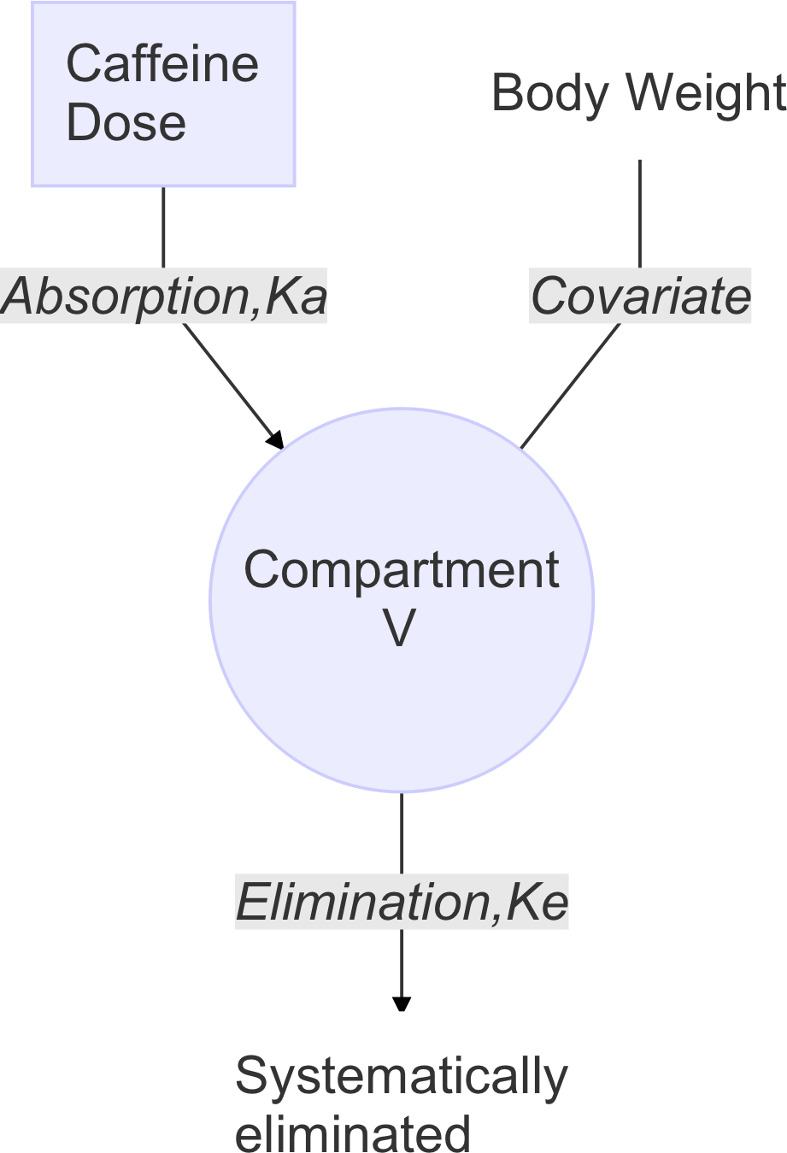

FIGURE 1 **One-compartment model of caffeine with first-order absorption kinetics and first-order elimination kinetics.** K_a, absorption rate constant; K_e, elimination rate constant; V, Volume of distribution (apparent) based on drug concentration in plasma

The following equation for the prediction of maximum plasma caffeine concentration (Cmax) values, the time at which Cmax is observed (tmax) and the other pharmacokinetic parameters where V is the volume of distribution and ke is the elimination rate constant.

The only covariate in the final model was body weight, which incorporated linearly, and it was better than other non-linearly combined models. The final model was internally validated. The final pharmacokinetic parameters were derived as follows where CL is the clearance, η is the interindividual random variability parameter, and MVN is the multivariate normal distribution:

The multiple dose pharmacokinetic parameters of caffeine were derived as follows where Cav,ss is the average drug concentration in plasma during a dosing interval at steady state on administering a fixed dose at equal dosing intervals and Rac is accumulation ratio (index).

Formulas to calculate the pharmacokinetic paramters shown above are adopted or derived from the textbooks of clinical pharmacology [10,11].

## Monte Carlo simulation

Monte Carlo simulation was performed by using the final population model parameters and NONMEM software. The final model was chosen based on goodness of fit and objective function value. [7]

Individual Cmax profiles following CED-mediated intake of 100, 200, 300, or 400 mg caffeine were simulated based on caffeine content in one or two servings of popular CEDs. Each Monte Carlo simulation generated Cmax, Tmax, AUC, half-life, CL, V, ka, ke profiles for 1000 subjects per each body weight group (body weight = 20–90 kg). Correlations between the pharmacokinetic variables, CL, V, ka, ke, were reflected in the simulation by using the variance-covariance matrix generated from the estimation.

## Edison Science App and open science tools

To simulate the pharmacokinetic data, Edison Science App, CaffeineEdison: Caffeine Concentration Simulation (<https://www.edison.re.kr/web/cmed/run_simulation>) were used [12] and the development process is also summarized in Figure 12. The source scripts of the Edison Science App is open to public. (<https://github.com/shanmdphd/CaffeineEdison>) To responsively simultate the data, Caffeine Concentration Predictor shiny application (<https://asan.shinyapps.io/caff>) was also created and used for this research [13]. The R package, caffsim [14] is developed for the Monte Carlo simulation of caffeine concentration so that everyone interested in the research can contribute the project and the entire data of this paper (<https://asancpt.github.io/CaffeineEdison>) is fully reproducible by the package. The major R pacakges to build the caffsim R packages include ggplot2 [15], dplyr [16], and mgcv [17]. The installation and initial function call for the creation of datasets are shown below.

install.pacakges("devtools")  
devtools::install_github("asancpt/caffsim")  
  
# Single dose dataset  
caffsim::Dataset(Weight = 20, Dose = 200, N = 1000)   
  
# Multiple dose dataset  
caffsim::DatasetMulti(Weight = 20, Dose = 200, N = 1000, Tau = 12)

# Results

## Body weight and pharmacokinetics of caffeine after single dosing

The concentration-time profiles of caffeine following single oral dose of 400 mg ( n = 200 ) with respect to the body weight is shown in Figure 2 and the lower body weight subjects have, the significantly higher Cav,ss was shown. However, subjects with body weight > 60kg generally maintain Cav,ss levels low (< 10 mg/L). Table 1 shows The summary of Predicted pharmacokinetic parameters following single oral dose of 400 mg ( n = 200 ) with respect to the body weight and Cmax is 24.5 ± 5.7 mg/L in subjects of 20 kg and 6.3 ± 1.4 mg/L in subjects of 80 kg and Tmax is 1.1 ± 0.8 hr in subjects of 20 kg and 1.1 ± 1.0 hr in subjects of 80 kg. AUC is 215.8 ± 88.9 mg*hr/L in subjects of 20 kg and 55.1 ± 22.4 mg*hr/L in subjects of 80 kg, and clearance (CL) is 2.2 ± 0.9 L/hr in subjects of 20 kg and 8.3 ± 3.0 L/hr in subjects of 80 kg. The volume of distribution (V) is 14.9 ± 3.4 L in subjects of 20 kg and 58.3 ± 12.3 L in subjects of 80 kg The difference of Cmax, AUC, CL, and V showed statistical significance among groups when evaluated with one-way ANOVA test. The Trellis plots of pharmacokinetic parameters that display the relationship between the dosing interval and the other variables following single oral dose of 400 mg ( n = 200 ) with respect to the body weight are plotted, and conditioned on linear regression model fitting in Figure 3. There was strong inverse correlation between the body weight and Cmax or AUC respectively and inverse correlation between the body weight and CL or V respectively (Pearson’s correlation coefficient, p < 0.001).

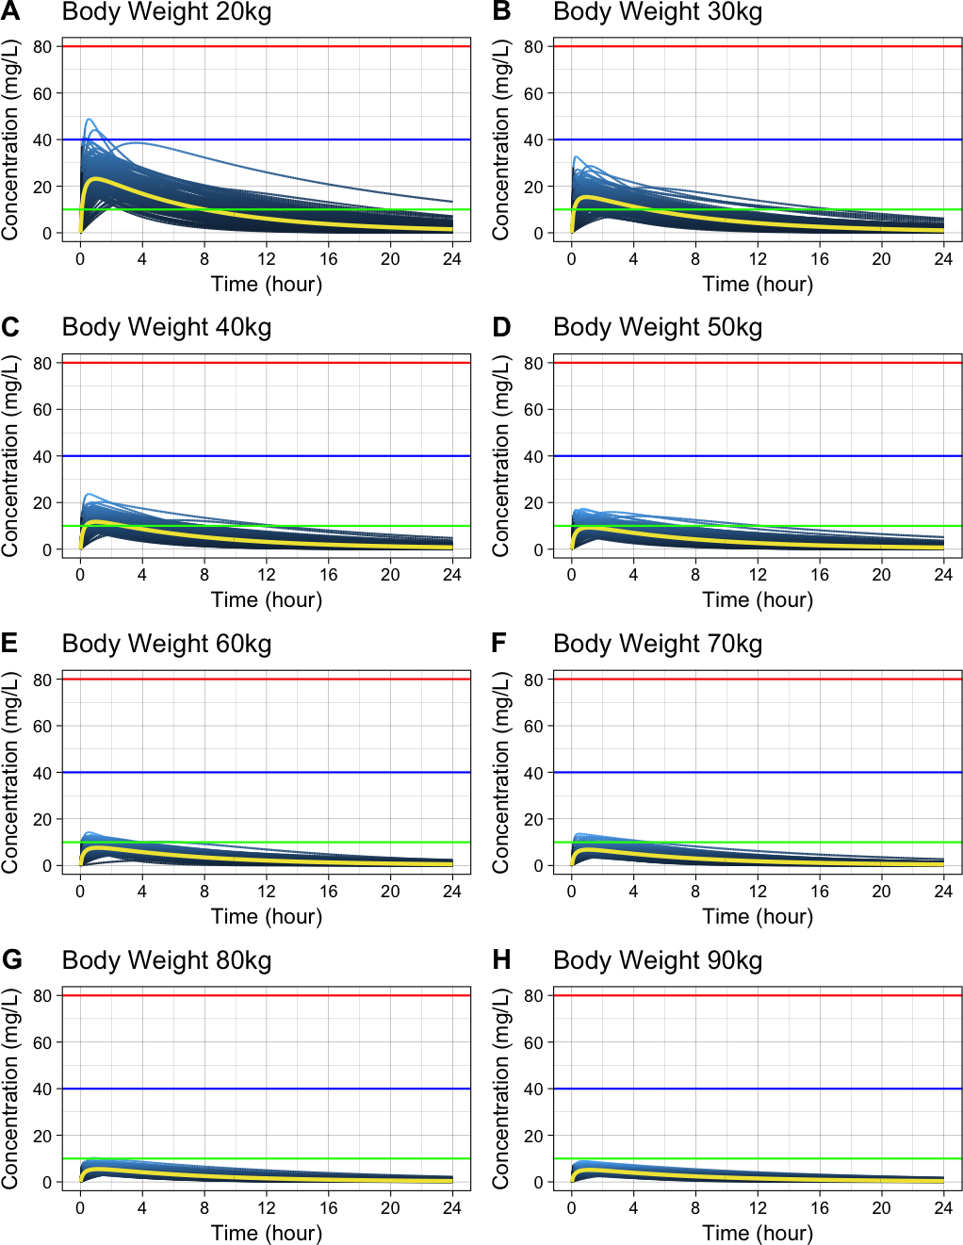

FIGURE 2 **Concentration-time profiles of caffeine following single oral dose of 400 mg ( n = 200 ) with respect to the body weight.** Below 10 mg/L: generally considered safe (Green horizontal line); Over 40 mg/L: several fatalities (Blue horizontal line); Over 80 mg/L: fatal caffeine poisoning (Red horizontal line)

TABLE 1 **Summary of Predicted pharmacokinetic parameters following single oral dose of 400 mg ( n = 200 ) with respect to the body weight.** The data are presented as mean ± SD. The statistical analysis using ANOVA was performed and p values are presented. , time at ; , the highest drug concentration observed in plasma; , area under the plasma drug concentration-time curve; , total clearance of drug from plasma; , Volume of distribution (apparent) based on drug concentration in plasma; , elimination rate constant; , absorption rate constant

|  |  |  |  |  |  |
| --- | --- | --- | --- | --- | --- |
| Parameter | 20 kg (n=200) | 40 kg (n=200) | 60 kg (n=200) | 80 kg (n=200) | p |
| Tmax (hr) | 1.1 ± 0.8 | 1.1 ± 0.9 | 1.0 ± 0.8 | 1.1 ± 1.0 | 0.791 |
| Cmax (mg/L) | 24.5 ± 5.7 | 12.3 ± 2.9 | 8.2 ± 1.9 | 6.3 ± 1.4 | 0.000 |
| AUC (mg*hr/L) | 215.8 ± 88.9 | 112.9 ± 48.6 | 72.1 ± 29.6 | 55.1 ± 22.4 | 0.000 |
| Half-life (hr) | 5.2 ± 1.5 | 5.4 ± 1.6 | 5.2 ± 1.5 | 5.3 ± 1.5 | 0.383 |
| CL (L/hr) | 2.2 ± 0.9 | 4.1 ± 1.7 | 6.4 ± 2.5 | 8.3 ± 3.0 | 0.000 |
| V (L) | 14.9 ± 3.4 | 29.6 ± 6.4 | 44.2 ± 9.1 | 58.3 ± 12.3 | 0.000 |
| Ka (1/hr) | 6.7 ± 7.6 | 7.0 ± 9.5 | 7.0 ± 15.1 | 7.3 ± 9.1 | 0.951 |
| Ke (1/hr) | 0.1 ± 0.0 | 0.1 ± 0.0 | 0.1 ± 0.0 | 0.1 ± 0.0 | 0.438 |

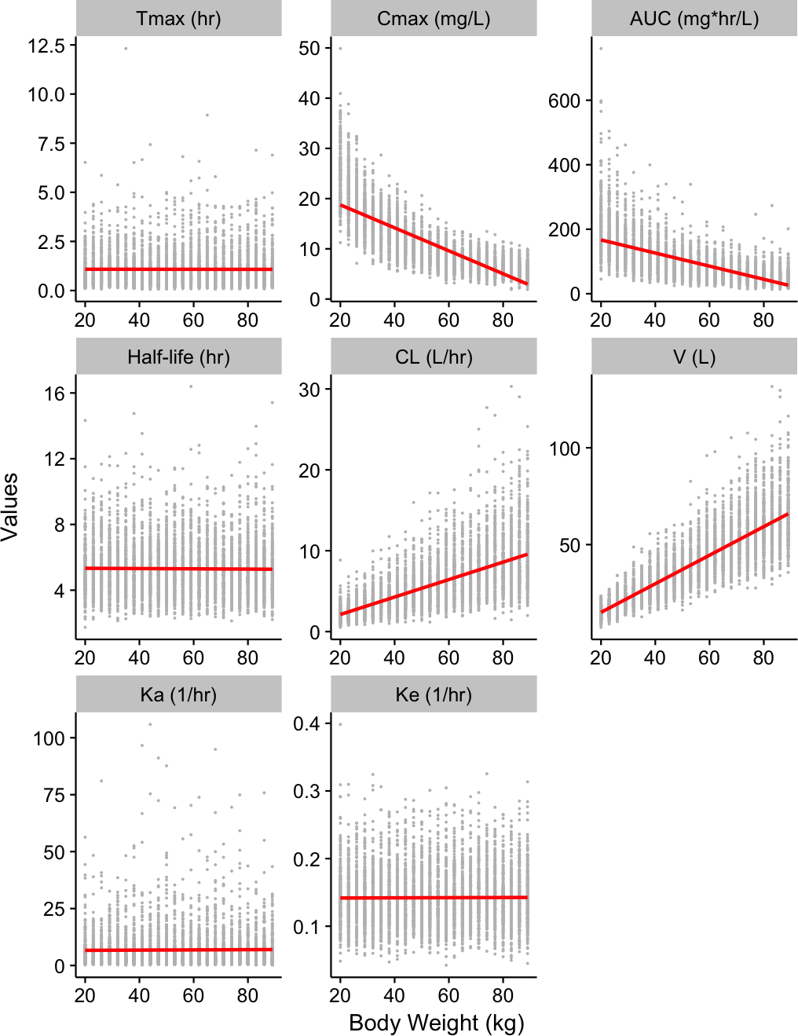

FIGURE 3 **Trellis plot of pharmacokinetic parameters that display the relationship between the dosing interval and the other variables following single oral dose of 400 mg ( n = 200 ) with respect to the body weight.** The plots are conditioned on linear regression model (red line). , time at ; , the highest drug concentration observed in plasma; , area under the plasma drug concentration-time curve; , total clearance of drug from plasma; , Volume of distribution (apparent) based on drug concentration in plasma; , elimination rate constant; , absorption rate constant

## Amount of caffeine and pharmacokinetics of caffeine after single dosing

The concentration-time profiles of caffeine following single oral dose in subjects of 20 kg ( n = 200 ) with respect to the amount of caffeine is shown in Figure 4 and the higher amount of caffeine intake definitely leads elevated plasma concentration of caffeine. Table 2 shows The summary of Predicted pharmacokinetic parameters following single oral dose in subjects of 20 kg ( n = 200 ) with respect to the amount of caffeine and Cmax is 6.4 ± 1.6 mg/L with single dose of 100 mg and 33.3 ± 7.8 mg/L with single dose of 550 mg and AUC is 57.1 ± 21.5 mg/L with single dose of 100 mg and 295.1 ± 106.9 mg/L with single dose of 550 mg. As expected, the difference of Tmax, half-life, CL, V, ka, and ke showed no statistical significance among groups when evaluated with one-way ANOVA test. The Trellis plot of pharmacokinetic parameters that display the relationship between the dosing interval and the other variables following single oral dose in subjects of 20 kg ( n = 200 ) with respect to the amount of caffeine are plotted, and conditioned on linear regression model fitting in Figure 5. There was strong positive correlation between the dosed amount of caffeine and Cmax or AUC respectively (Pearson’s correlation coefficient, p < 0.001).

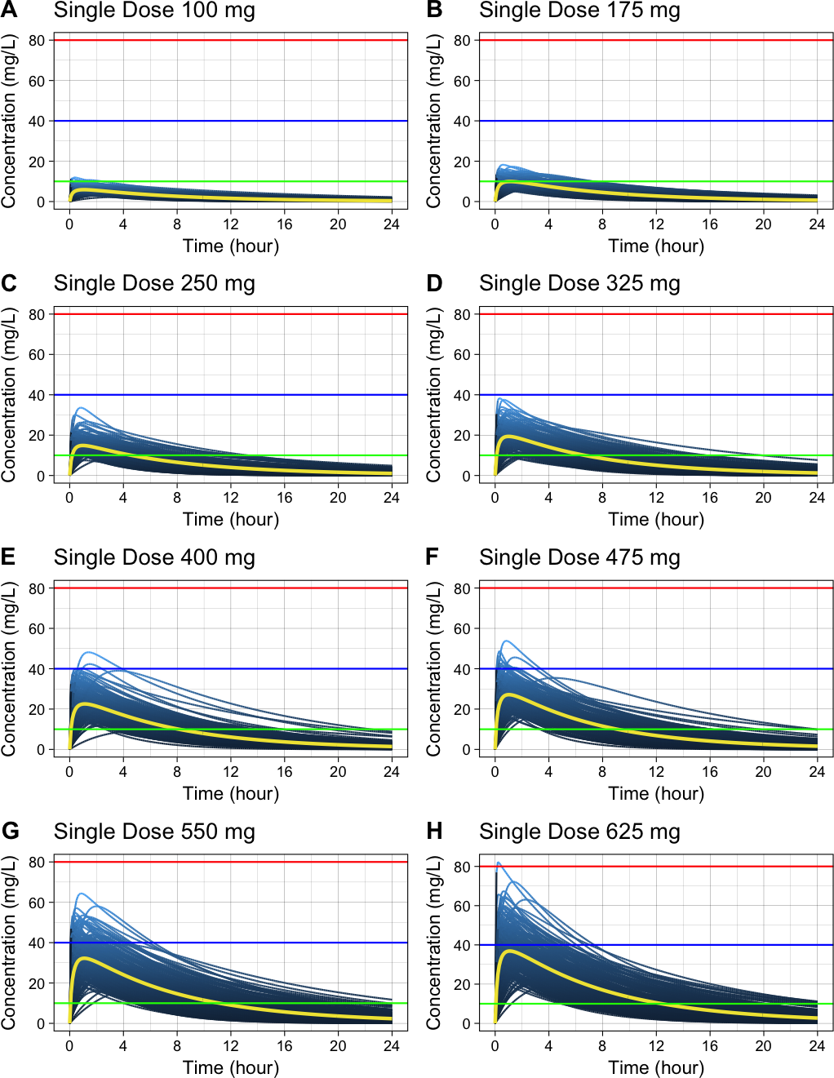

FIGURE 4 **Concentration-time profiles of caffeine following single oral dose in subjects of 20 kg ( n = 200 ) with respect to the amount of caffeine.** Below 10 mg/L: generally considered safe (Green horizontal line); Over 40 mg/L: several fatalities (Blue horizontal line); Over 80 mg/L: fatal caffeine poisoning (Red horizontal line)

TABLE 2 **Summary of Predicted pharmacokinetic parameters following single oral dose in subjects of 20 kg ( n = 200 ) with respect to the amount of caffeine.** The data are presented as mean ± SD. The statistical analysis using ANOVA was performed and p values are presented. , time at ; , the highest drug concentration observed in plasma; , area under the plasma drug concentration-time curve; , total clearance of drug from plasma; , Volume of distribution (apparent) based on drug concentration in plasma; , elimination rate constant; , absorption rate constant

|  |  |  |  |  |  |
| --- | --- | --- | --- | --- | --- |
| Parameter | 100 mg (n=200) | 250 mg (n=200) | 400 mg (n=200) | 550 mg (n=200) | p |
| Tmax (hr) | 1.1 ± 0.9 | 0.9 ± 0.7 | 1.1 ± 0.9 | 1.1 ± 0.9 | 0.143 |
| Cmax (mg/L) | 6.4 ± 1.6 | 15.6 ± 3.9 | 25.2 ± 6.0 | 33.3 ± 7.8 | 0.000 |
| AUC (mg*hr/L) | 57.1 ± 21.5 | 133.5 ± 58.4 | 222.7 ± 95.5 | 295.1 ± 106.9 | 0.000 |
| Half-life (hr) | 5.3 ± 1.4 | 5.1 ± 1.5 | 5.3 ± 1.6 | 5.3 ± 1.5 | 0.548 |
| CL (L/hr) | 2.0 ± 0.8 | 2.2 ± 0.9 | 2.1 ± 0.9 | 2.1 ± 0.9 | 0.134 |
| V (L) | 14.3 ± 2.8 | 14.9 ± 3.4 | 14.6 ± 3.2 | 15.0 ± 3.1 | 0.094 |
| Ka (1/hr) | 6.6 ± 6.5 | 8.0 ± 9.4 | 7.6 ± 8.3 | 7.4 ± 9.3 | 0.412 |
| Ke (1/hr) | 0.1 ± 0.0 | 0.1 ± 0.0 | 0.1 ± 0.0 | 0.1 ± 0.0 | 0.342 |

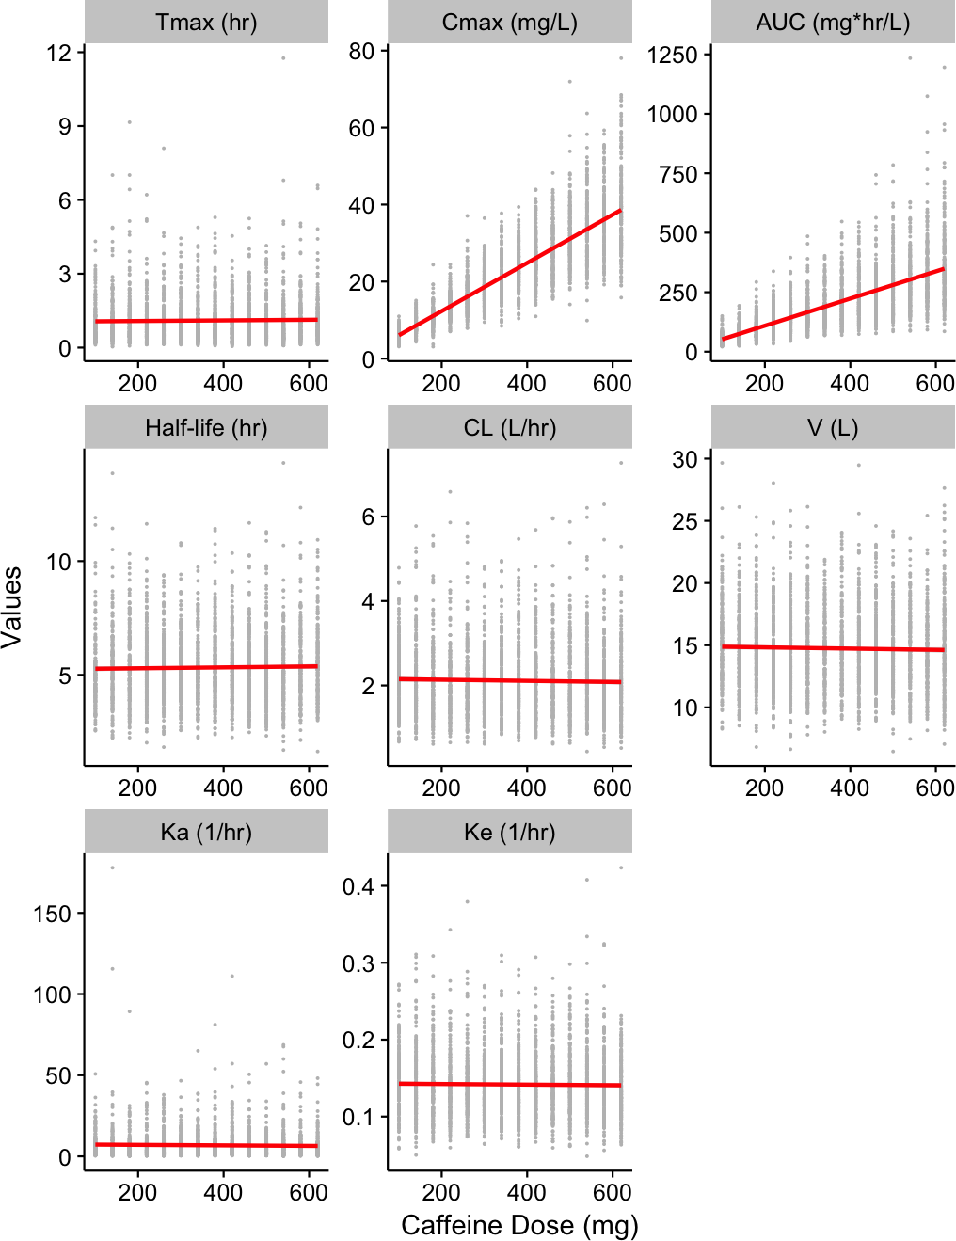

FIGURE 5 **Trellis plot of pharmacokinetic parameters that display the relationship between the dosing interval and the other variables following single oral dose in subjects of 20 kg ( n = 200 ) with respect to the amount of caffeine.** The plots are conditioned on linear regression model (red line). , time at after single dose; , the highest drug concentration observed in plasma after single dose; , area under the plasma drug concentration-time curve after single dose; , accumulation ratio (index); , average amount of drug at steady state; , average drug concentration in plasma during a dosing interval at steady state; and , maximum and minimum concentrations of drug in plasma at steady state

## Body weight and pharmacokinetics of caffeine after multiple dosing

The concentration-time profiles of caffeine following multiple oral doses of 400 mg with the interval of 12 hour ( n = 200 ) with respect to the body weight is shown in Figure 6 and the lower body weight subjects have, the significantly higher Cav,ss was shown. However, subjects with body weight > 60kg generally maintain Cav,ss levels low (< 10 mg/L). Table 3 shows The summary of Predicted pharmacokinetic parameters following multiple oral doses of 400 mg with the interval of 12 hour ( n = 200 ) with respect to the body weight and Cav,ss is 17.9 ± 7.0 mg/L in subjects of 20 kg and 4.7 ± 1.8 mg/L in subjects of 80 kg and Cmax,ss is 35.7 ± 9.2 mg/L in subjects of 20 kg and 9.2 ± 2.3 mg/L in subjects of 80 kg. Rac is 1.3 ± 0.2 mg/L in subjects of 20 kg and 1.3 ± 0.2 mg/L in subjects of 80 kg. The difference of Cav,ss, Cmax,ss and Cmin,ss showed statistical significance among groups when evaluated with one-way ANOVA test. The Trellis plots of pharmacokinetic parameters that display the relationship between the dosing interval and the other variables following multiple oral doses of 400 mg with the interval of 12 hour ( n = 200 ) with respect to the body weight are plotted, and conditioned on linear regression model fitting in Figure 7. There was strong inverse correlation between the body weight and Cav,ss, Cmax,ss or Cmin,ss respectively (Pearson’s correlation coefficient, p < 0.001).

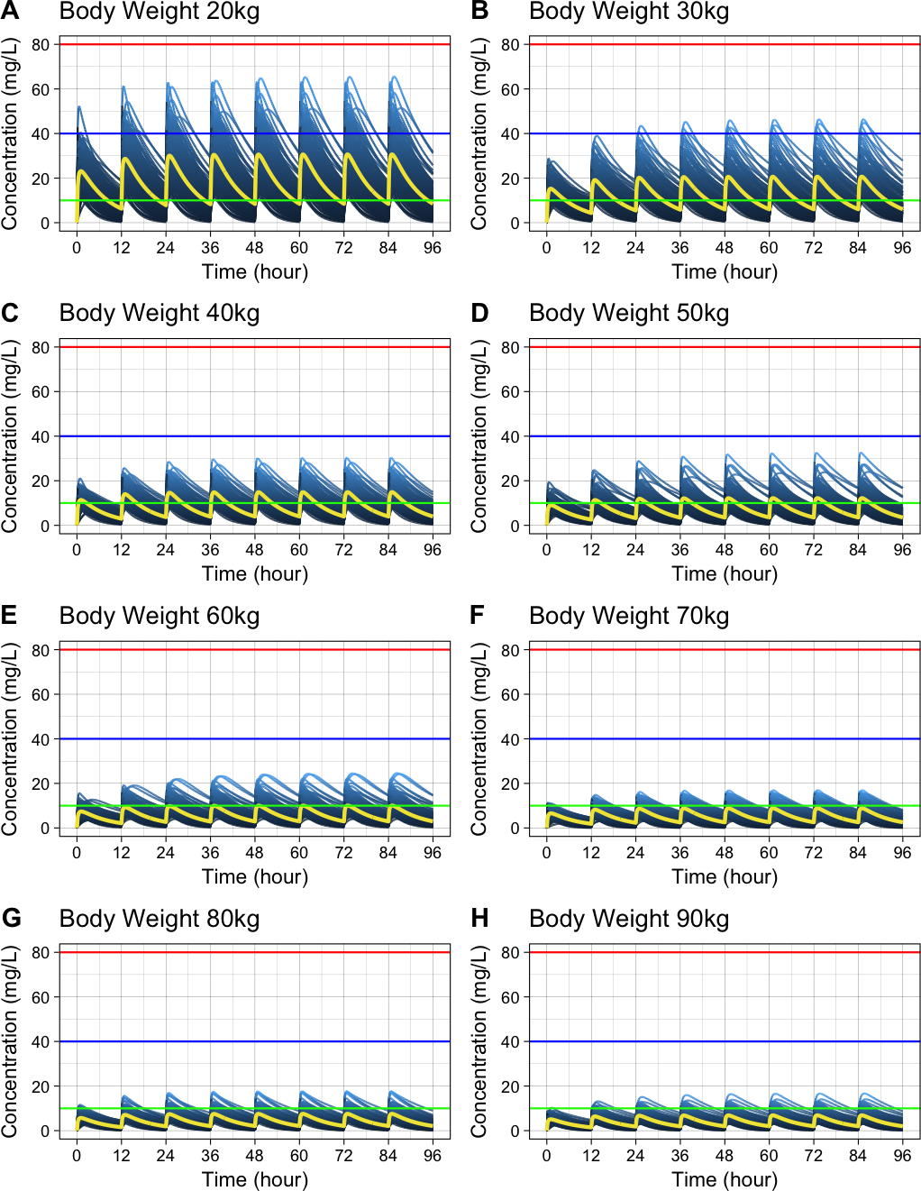

FIGURE 6 **Concentration-time profiles of caffeine following multiple oral doses of 400 mg with the interval of 12 hour ( n = 200 ) with respect to the body weight.** Below 10 mg/L: generally considered safe (Green horizontal line); Over 40 mg/L: several fatalities (Blue horizontal line); Over 80 mg/L: fatal caffeine poisoning (Red horizontal line)

TABLE 3 **Summary of Predicted pharmacokinetic parameters following multiple oral doses of 400 mg with the interval of 12 hour ( n = 200 ) with respect to the body weight.** The data are presented as mean ± SD. The statistical analysis using ANOVA was performed and p values are presented. , time at after single dose; , the highest drug concentration observed in plasma after single dose; , area under the plasma drug concentration-time curve after single dose; , accumulation ratio (index); , average amount of drug at steady state; , average drug concentration in plasma during a dosing interval at steady state; and , maximum and minimum concentrations of drug in plasma at steady state

|  |  |  |  |  |  |
| --- | --- | --- | --- | --- | --- |
| Parameter | 20 kg (n=200) | 40 kg (n=200) | 60 kg (n=200) | 80 kg (n=200) | p |
| Tmax,single (hr) | 1.1 ± 0.9 | 1.2 ± 1.0 | 1.0 ± 0.8 | 1.0 ± 0.8 | 0.267 |
| Cmax,single (mg/L) | 24.4 ± 5.7 | 12.2 ± 3.1 | 8.5 ± 2.0 | 6.3 ± 1.4 | 0.000 |
| AUCsingle (mg*hr/L) | 215.4 ± 84.3 | 109.6 ± 47.9 | 75.1 ± 31.1 | 56.8 ± 21.1 | 0.000 |
| Rac (1/hr) | 1.3 ± 0.2 | 1.3 ± 0.2 | 1.3 ± 0.2 | 1.3 ± 0.2 | 0.552 |
| Aav,ss (mg) | 252.7 ± 73.5 | 255.0 ± 79.9 | 254.7 ± 75.5 | 263.3 ± 73.0 | 0.506 |
| Cav,ss (mg/L) | 17.9 ± 7.0 | 9.1 ± 4.0 | 6.3 ± 2.6 | 4.7 ± 1.8 | 0.000 |
| Cmax,ss (mg/L) | 35.7 ± 9.2 | 18.0 ± 5.2 | 12.4 ± 3.5 | 9.2 ± 2.3 | 0.000 |
| Cmin,ss (mg/L) | 7.7 ± 5.0 | 4.0 ± 2.8 | 2.7 ± 1.8 | 2.1 ± 1.2 | 0.000 |

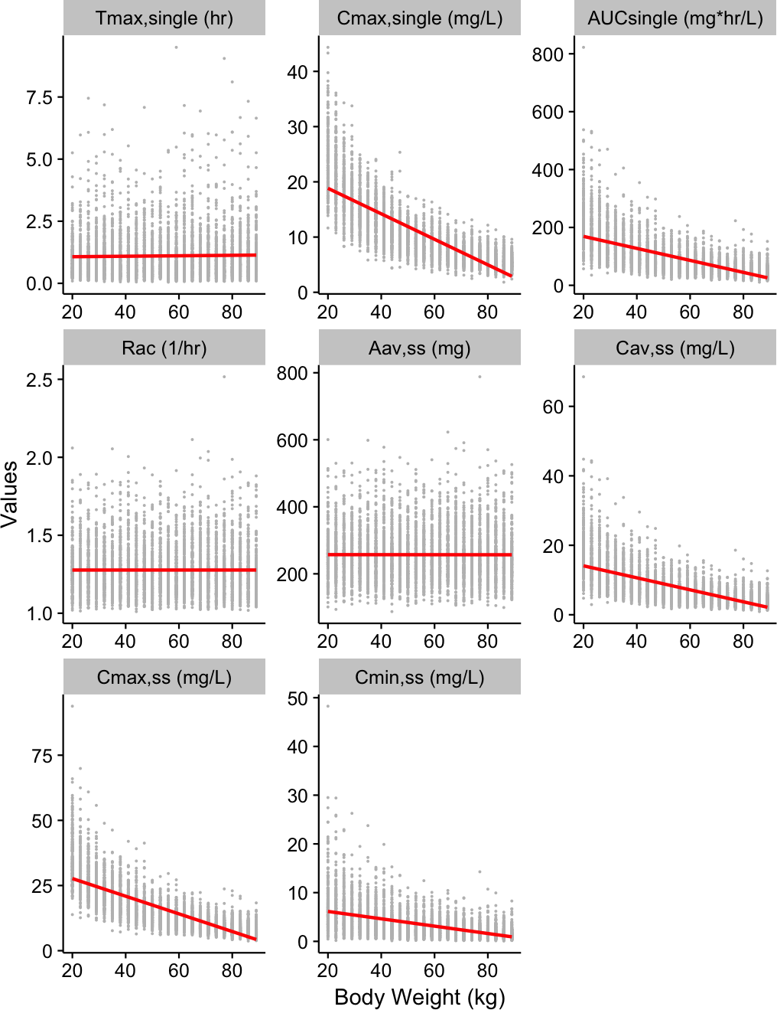

FIGURE 7 **Trellis plot of pharmacokinetic parameters that display the relationship between the dosing interval and the other variables following multiple oral doses of 400 mg with the interval of 12 hour ( n = 200 ) with respect to the body weight.** The plots are conditioned on linear regression model (red line). , time at after single dose; , the highest drug concentration observed in plasma after single dose; , area under the plasma drug concentration-time curve after single dose; , accumulation ratio (index); , average amount of drug at steady state; , average drug concentration in plasma during a dosing interval at steady state; and , maximum and minimum concentrations of drug in plasma at steady state

## Amount of caffeine and pharmacokinetics of caffeine after multiple dosing

The concentration-time profiles of caffeine following multiple oral doses with the interval of 8 hour ( n = 200 ) in subjects of 20 kg with respect to the amount of caffeine is shown in Figure 8 and the higher amount of caffeine dosed increases the steady state concentration of caffeine and the Cav,ss is maintained above 10 mg/L, which is thought to be generally safe from the multiple dosing of 300 mg caffeine. Table 4 shows The summary of Predicted pharmacokinetic parameters following multiple oral doses with the interval of 8 hour ( n = 200 ) in subjects of 20 kg with respect to the amount of caffeine and Cav,ss is 6.8 ± 2.7 mg/L with multiple doses of 100 mg and 38.4 ± 15.7 mg/L with multiple doses of 400 mg and Rac is 1.5 ± 0.2 mg/L with multiple doses of 100 mg and 1.6 ± 0.2 mg/L with multiple doses of 400 mg. The difference of Rac, Aav,ss, Cav,ss, Cmax,ss and Cmin,ss showed statistical significance among groups when evaluated with one-way ANOVA test and contrary to the effects of body weight, difference of Rac and Aav,ss among groups were statistically significant. The Trellis plots of pharmacokinetic parameters that display the relationship between the dosing interval and the other variables following multiple oral doses with the interval of 8 hour ( n = 200 ) in subjects of 20 kg with respect to the amount of caffeine are plotted, and conditioned on linear regression model fitting in Figure 9. There was strong positive correlation between the amount of multiple and Rac, Aav,ss, Cav,ss, Cmax,ss or Cmin,ss respectively (Pearson’s correlation coefficient, p < 0.001).

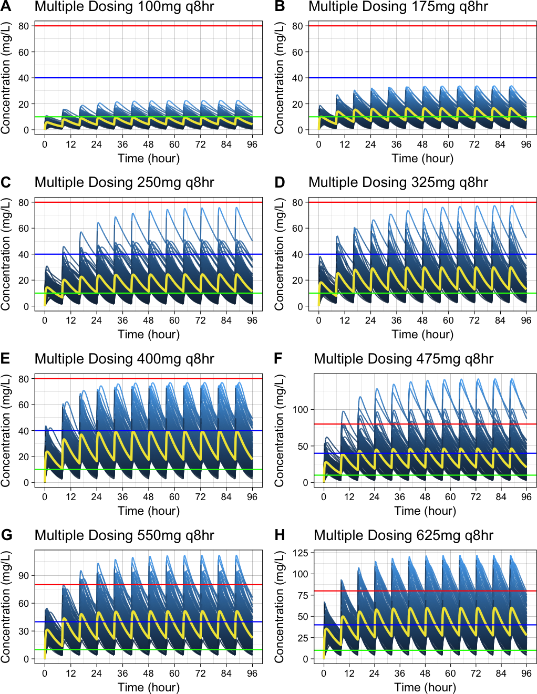

FIGURE 8 **Concentration-time profiles of caffeine following multiple oral doses with the interval of 8 hour ( n = 200 ) in subjects of 20 kg with respect to the amount of caffeine.** Below 10 mg/L: generally considered safe (Green horizontal line); Over 40 mg/L: several fatalities (Blue horizontal line); Over 80 mg/L: fatal caffeine poisoning (Red horizontal line)

TABLE 4 **Summary of Predicted pharmacokinetic parameters following multiple oral doses with the interval of 8 hour ( n = 200 ) in subjects of 20 kg with respect to the amount of caffeine.** The data are presented as mean ± SD. The statistical analysis using ANOVA was performed and p values are presented. , time at after single dose; , the highest drug concentration observed in plasma after single dose; , area under the plasma drug concentration-time curve after single dose; , accumulation ratio (index); , average amount of drug at steady state; , average drug concentration in plasma during a dosing interval at steady state; and , maximum and minimum concentrations of drug in plasma at steady state

|  |  |  |  |  |  |
| --- | --- | --- | --- | --- | --- |
| Parameter | 100 kg (n=200) | 250 kg (n=200) | 400 kg (n=200) | 550 kg (n=200) | p |
| Tmax,single (hr) | 1.0 ± 0.7 | 1.1 ± 0.9 | 1.1 ± 1.0 | 1.2 ± 0.9 | 0.258 |
| Cmax,single (mg/L) | 6.3 ± 1.5 | 16.0 ± 3.8 | 24.6 ± 6.1 | 34.0 ± 8.5 | 0.000 |
| AUCsingle (mg*hr/L) | 54.0 ± 21.8 | 141.4 ± 53.9 | 214.2 ± 89.1 | 307.0 ± 125.3 | 0.000 |
| Rac (1/hr) | 1.5 ± 0.2 | 1.6 ± 0.3 | 1.5 ± 0.3 | 1.6 ± 0.2 | 0.506 |
| Aav,ss (mg) | 92.9 ± 26.5 | 239.5 ± 68.2 | 371.6 ± 112.4 | 528.5 ± 148.6 | 0.000 |
| Cav,ss (mg/L) | 6.8 ± 2.7 | 17.7 ± 6.7 | 26.8 ± 11.1 | 38.4 ± 15.7 | 0.000 |
| Cmax,ss (mg/L) | 11.0 ± 3.3 | 28.4 ± 8.2 | 43.7 ± 13.4 | 61.6 ± 19.2 | 0.000 |
| Cmin,ss (mg/L) | 3.8 ± 2.1 | 10.2 ± 5.4 | 15.3 ± 8.9 | 22.2 ± 12.4 | 0.000 |

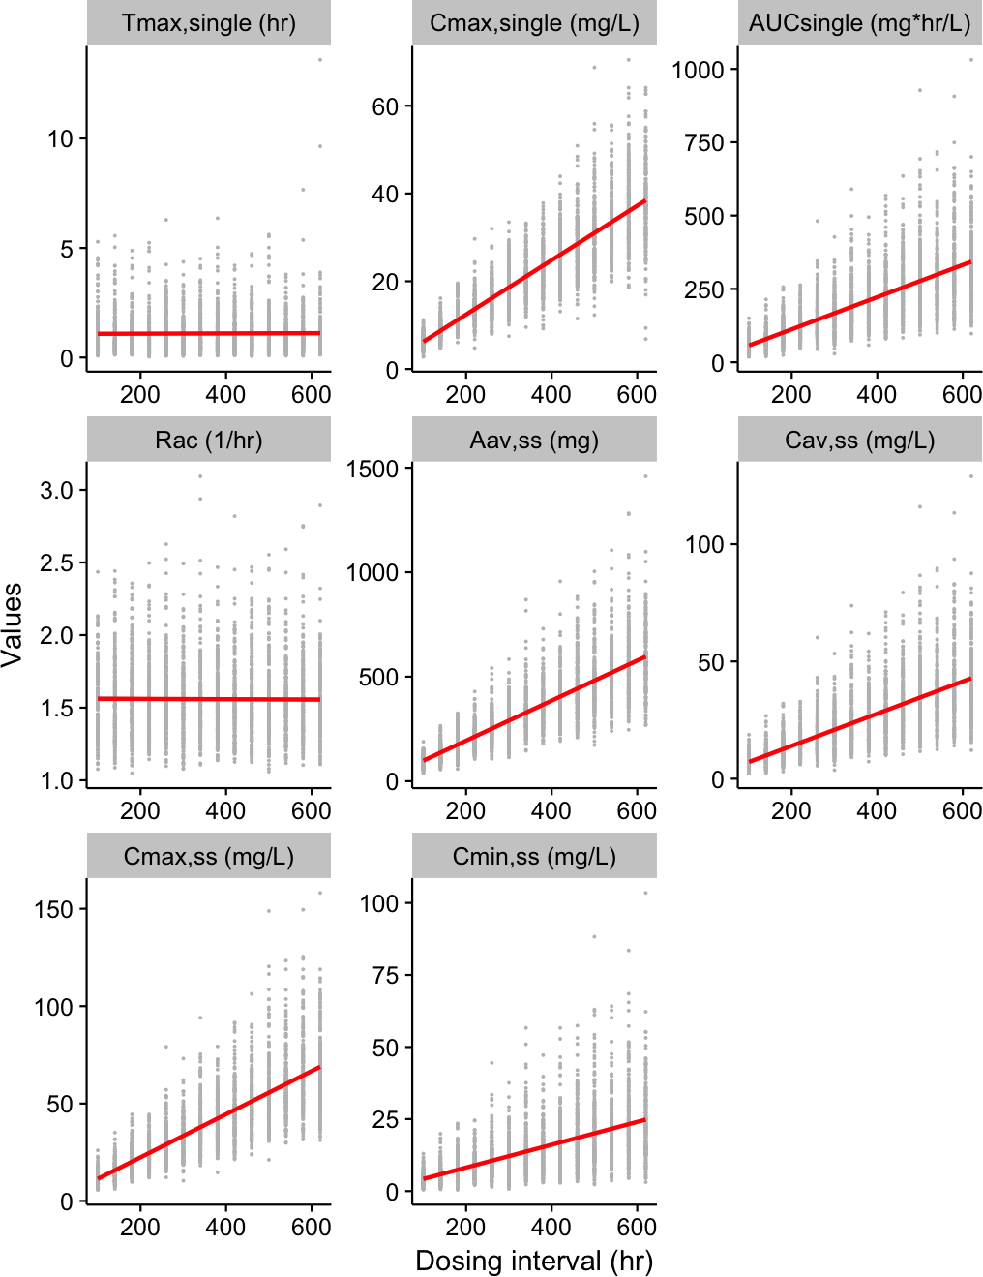

FIGURE 9 **Trellis plot of pharmacokinetic parameters that display the relationship between the dosing interval and the other variables following multiple oral doses with the interval of 8 hour ( n = 200 ) in subjects of 20 kg with respect to the amount of caffeine.** The plots are conditioned on linear regression model (red line). , time at after single dose; , the highest drug concentration observed in plasma after single dose; , area under the plasma drug concentration-time curve after single dose; , accumulation ratio (index); , average amount of drug at steady state; , average drug concentration in plasma during a dosing interval at steady state; and , maximum and minimum concentrations of drug in plasma at steady state

## Dosing interval and pharmacokinetics of caffeine after multiple dosing

Concentration-time profiles of caffeine following multiple oral doses of 400 mg ( n = 200 ) in subjects of 20 kg with respect to dosing interval is shown in Figure 10 and obviously the shorter dosing interval significantly increases the steady state concentration of caffeine and this situation may lead to serious toxicities when introduced to sensitive populations. Table 5 shows predicted pharmacokinetic parameters following caffeinated energy drink (CED) containing 400 mg of caffeine intake in subjects of 20 kg and Cav,ss is 9.5 ± 3.9 mg/L with the dosing interval of 24 hours and is 54.9 ± 22.8 mg/L with the dosing interval of 4 hours and Rac is 1.1 ± 0.0 mg/L with the dosing interval of 24 hours and is 2.4 ± 0.5 mg/L with the dosing interval of 24 hours. Trellis plots of pharmacokinetic parameters that display the relationship between the dosing interval and the other variables are plotted, conditioned on linear regression model and LOWESS (locally weighted scatterplot smoothing) [18] fittings in Figure 11. There was strong inverse correlation between the dosing interval and Rac, Aav,ss, Cav,ss, Cmax,ss or Cmin,ss respectively (Pearson’s correlation coefficient, p < 0.001) and this is more eveident in the LOWESS model (Figure 11, blue line).

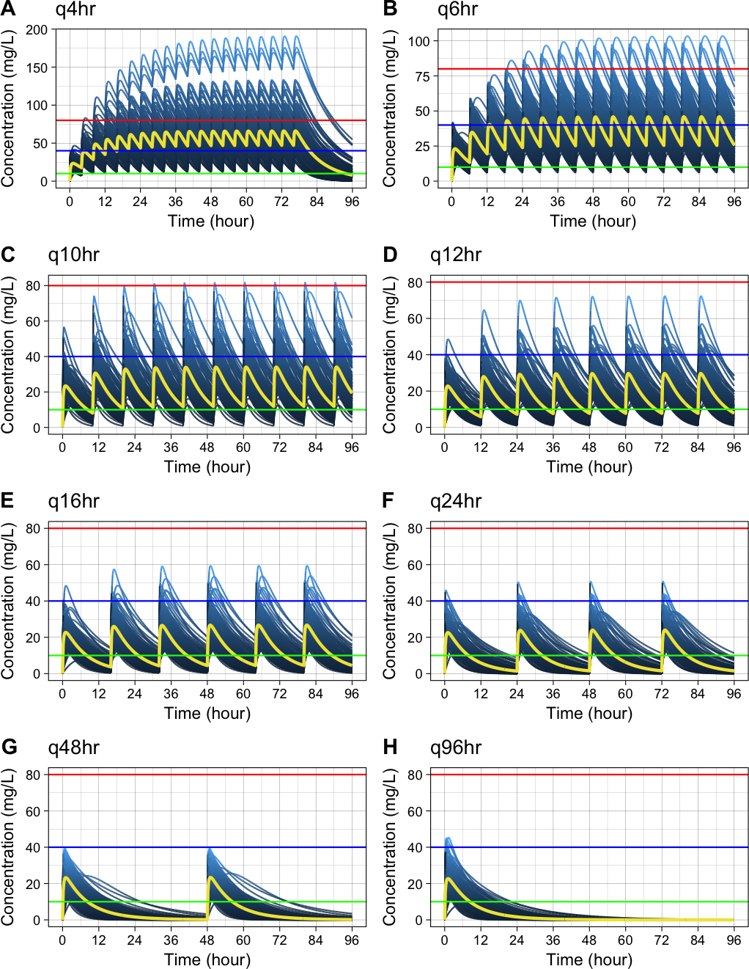

FIGURE 10 **Concentration-time profiles of caffeine following multiple oral doses of 400 mg of caffeine ( n = 200 ) in subjects of 20 kg with respect to dosing interval.** Below 10 mg/L: generally considered safe (Green horizontal line); Over 40 mg/L: several fatalities (Blue horizontal line); Over 80 mg/L: fatal caffeine poisoning (Red horizontal line)

TABLE 5 **Summary of Predicted pharmacokinetic parameters following multiple oral doses of 400 mg of caffeine ( n = 200 ) in subjects of 20 kg with respect to dosing interval.** The data are presented as mean ± SD. The statistical analysis using ANOVA was performed and p values are presented. , time at after single dose; , the highest drug concentration observed in plasma after single dose; , area under the plasma drug concentration-time curve after single dose; , accumulation ratio (index); , average amount of drug at steady state; , average drug concentration in plasma during a dosing interval at steady state; and , maximum and minimum concentrations of drug in plasma at steady state

|  |  |  |  |  |  |
| --- | --- | --- | --- | --- | --- |
| Parameter | 4 hour (n=200) | 8 hour (n=200) | 12 hour (n=200) | 24 hour (n=200) | p |
| Tmax,single (hr) | 1.1 ± 0.8 | 1.0 ± 0.8 | 1.1 ± 0.9 | 1.1 ± 0.9 | 0.988 |
| Cmax,single (mg/L) | 25.4 ± 6.0 | 24.7 ± 6.1 | 25.1 ± 6.5 | 25.2 ± 5.7 | 0.682 |
| AUCsingle (mg*hr/L) | 219.5 ± 91.4 | 218.9 ± 98.6 | 224.7 ± 97.1 | 227.0 ± 93.7 | 0.795 |
| Rac (1/hr) | 2.4 ± 0.5 | 1.6 ± 0.3 | 1.3 ± 0.2 | 1.1 ± 0.0 | 0.000 |
| Aav,ss (mg) | 745.6 ± 219.8 | 382.5 ± 124.7 | 255.8 ± 80.4 | 129.5 ± 37.9 | 0.000 |
| Cav,ss (mg/L) | 54.9 ± 22.8 | 27.4 ± 12.3 | 18.7 ± 8.1 | 9.5 ± 3.9 | 0.000 |
| Cmax,ss (mg/L) | 70.8 ± 24.8 | 44.0 ± 14.4 | 36.9 ± 10.7 | 30.4 ± 7.1 | 0.000 |
| Cmin,ss (mg/L) | 41.7 ± 20.9 | 15.9 ± 10.2 | 8.2 ± 5.7 | 1.7 ± 1.7 | 0.000 |

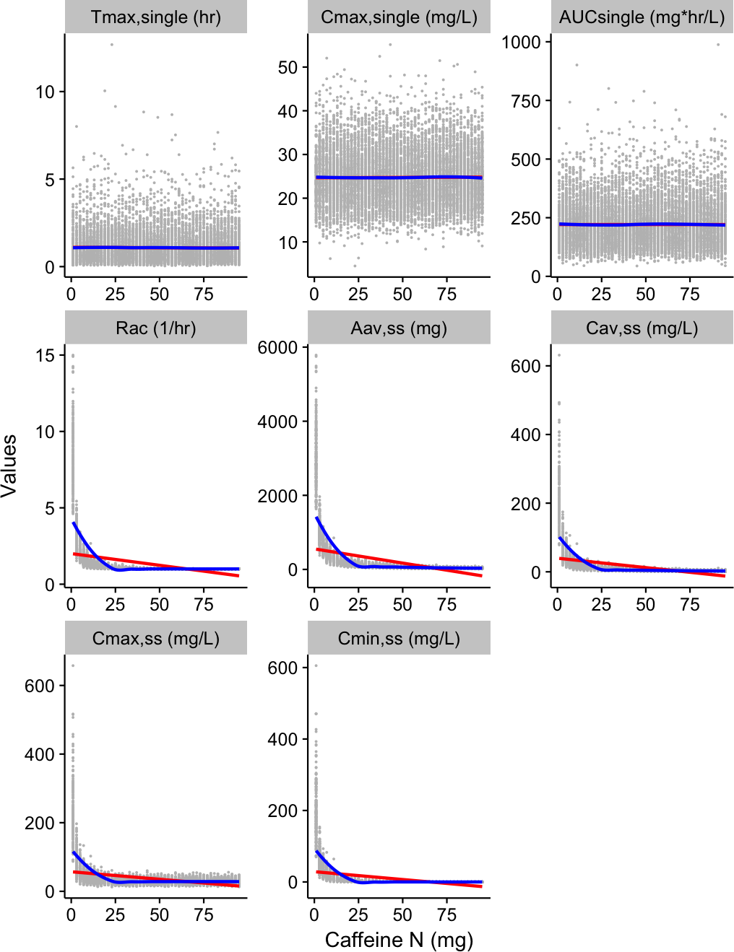

FIGURE 11 **Trellis plot of pharmacokinetic parameters that display the relationship between the dosing interval and the other variables following multiple oral doses of 400 mg of caffeine ( n = 200 ) in subjects of 20 kg with respect to dosing interval.** The plots are conditioned on linear regression model (red line) and locally weighted scatterplot smoothing model (blue line). , time at after single dose; , the highest drug concentration observed in plasma after single dose; , area under the plasma drug concentration-time curve after single dose; , accumulation ratio (index); , average amount of drug at steady state; , average drug concentration in plasma during a dosing interval at steady state; and , maximum and minimum concentrations of drug in plasma at steady state

# Discussion

Although data concerning plasma caffeine concentrations are mainly derived from reports of severe caffeine toxicities, the relevance of these observations with clinical prediction cannot be under-estimated. Quantitative relationship among plasma caffeine concentrations, pharmacokinetics and toxicities is to be concluded but well-documented case reports in terms of caffeine concentration includes these:

1. Plasma caffeine concentration < 10 mg/L is generally accepted as safety margin but caffeine concentrations of > 15 mg/L can sometimes lead to toxicity [3].
2. Fatalities of caffeine intoxication have also been documented with plasma caffeine concentrations of < 40 mg/L [3], and non-fatal toxicities can occur at much lower concentrations.
3. Fatal caffeine poisoning cases are usually reported when the concentration is > 80 mg/L [20–23].

These case reports render valuable insights to understand physiology induced by caffeine ingestion and coupled with this, mathematical modeling by the differential equations and sampling of random variables calculated from previous clinical trials and Monte Carlo simulation pose precise interpretation of plasma caffeine concentration.

Results of the current study can be conceptually divided into two categories.

The first relates to the physiological relationship between the body weight or the amount of caffeine and the pharmacokinetic parameters. Predicting the exact plasma caffeine concentration at the given time is critical to assess the exposure of caffeine to the certain population of sensitive groups including children, adolescents or low-weighted adults. Following single intake of 400 mg caffeine, Cmax is 24.5 ± 5.7 mg/L in subjects of 20 kg and 6.3 ± 1.4 mg/L in subjects of 80 kg. On the other hand, Following multiple intakes of 400 mg caffeine twice a day (*bid*), Cmax,ss is 35.7 ± 9.2 mg/L in subjects of 20 kg and 9.2 ± 2.3 mg/L in subjects of 80 kg. We confirmed 1) strong inverse correlation between the body weight and Cmax or AUC and 2) inverse correlation between the body weight and CL or V and 3) strong positive correlation between the dosed amount of caffeine and Cmax or AUC respectively. We also expand these findings to the predicting and visualizing the situation of multiple caffeine dosing and confirmed 1) strong inverse correlation between the body weight and Cav,ss, Cmax,ss or Cmin,ss 2) strong positive correlation between the amount of multiple dosing and Rac, Aav,ss, Cav,ss, Cmax,ss or Cmin,ss (Pearson’s correlation coefficient, p < 0.001) 3) strong inverse correlation between the dosing interval and Rac, Aav,ss, Cav,ss, Cmax,ss or Cmin,ss respectively.

The second relates to the open science and open source movement. This research also broadens the perspective by creating and utilizing diverse open science tools including R package [14], Edison Science App [12] and Shiny apps [13]. The systematic overview of Edison Science App development process and its effects on scientific community is summarized in Figure 12. Its impact on education and scientific community will be enormous and it will stimulate the development of the open science Edison Apps. This approach opens the innovative and state-of-the-art technologies to the public and students as well as physicians in training can be benefited from it to understand the pharmacokinetics following one compartment model and to recognize the caffeine intoxication or syndrome possibly caused by caffeine.

In conclusion, this research using Edison Science App adating population pharmacokinetic model and monte carlo simulation method showed that plasma caffeine concentrations can be sufficiently high in low-weighted people including children, adolescents, or females after CED ingestion to the level of caffeine intoxication.

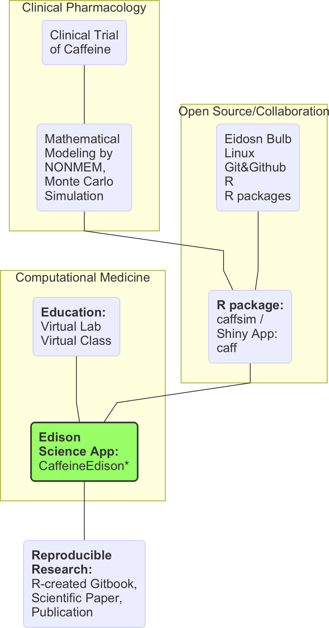

FIGURE 12 **Systematic overview of Edison Science App development process and its effects on scientific community**

# Acknowledgements

This research was supported by the EDISON Program through the National Research Foundation of Korea(NRF) funded by the Ministry of Science, ICT & Future Planning (NRF-2011-0020576). The main idea and intellectual resources were mainly provided by Professor Kyun-Seop Bae [k@acr.kr](mailto:k@acr.kr).

# References

[1] EFSA Panel on Dietetic Products N, (NDA) A. Scientific opinion on the safety of caffeine. EFSA Journal 2015;13:4102–n/a. doi:[10.2903/j.efsa.2015.4102](https://doi.org/10.2903/j.efsa.2015.4102).

[2] Seifert SM, Schaechter JL, Hershorin ER, Lipshultz SE. Health effects of energy drinks on children, adolescents, and young adults. PEDIATRICS 2011;127:511–28. doi:[10.1542/peds.2009-3592](https://doi.org/10.1542/peds.2009-3592).

[3] Banerjee P, Ali Z, Levine B, Fowler DR. Fatal caffeine intoxication: A series of eight cases from 1999 to 2009. Journal of Forensic Sciences 2014;59:865–8. doi:[10.1111/1556-4029.12387](https://doi.org/10.1111/1556-4029.12387).

[4] Trabulo D, Marques S, Pedroso E. Caffeinated energy drink intoxication. Case Reports 2011;2011:bcr0920103322–2. doi:[10.1136/bcr.09.2010.3322](https://doi.org/10.1136/bcr.09.2010.3322).

[5] Jun N, Lee A, Baik I. Associations of caffeinated beverage consumption and screen time with excessive daytime sleepiness in korean high school students. Clinical Nutrition Research 2017;6:55. doi:[10.7762/cnr.2017.6.1.55](https://doi.org/10.7762/cnr.2017.6.1.55).

[6] Temple JL, Ziegler AM, Graczyk AM, Crandall A. Effects of acute and chronic caffeine on risk-taking behavior in children and adolescents. Journal of Psychopharmacology 2017:026988111769156. doi:[10.1177/0269881117691568](https://doi.org/10.1177/0269881117691568).

[7] Lee JW, Kim Y, Perera V, McLachlan AJ, Bae K-S. Prediction of plasma caffeine concentrations in young adolescents following ingestion of caffeinated energy drinks: A monte carlo simulation. European Journal of Pediatrics 2015;174:1671–8. doi:[10.1007/s00431-015-2581-x](https://doi.org/10.1007/s00431-015-2581-x).

[8] Perera V, Gross AS, Forrest A, Landersdorfer CB, Xu H, Ait-Oudhia S, et al. A pharmacometric approach to investigate the impact of methylxanthine abstinence and caffeine consumption on CYP1A2 activity. Drug Metabolism and Disposition 2013;41:1957–66. doi:[10.1124/dmd.113.053074](https://doi.org/10.1124/dmd.113.053074).

[9] Perera V, Gross AS, Xu H, McLachlan AJ. Pharmacokinetics of caffeine in plasma and saliva, and the influence of caffeine abstinence on CYP1A2 metrics. Journal of Pharmacy and Pharmacology 2011;63:1161–8. doi:[10.1111/j.2042-7158.2011.01326.x](https://doi.org/10.1111/j.2042-7158.2011.01326.x).

[10] Rowland M. Clinical pharmacokinetics and pharmacodynamics : Concepts and applications. Philadelphia: Wolters Kluwer Health/Lippincott William & Wilkins; 2011.

[11] Gabrielsson J. Pharmacokinetic and pharmacodynamic data analysis : Concepts and applications. Stockholm: Apotekarsocieteten; 2016.

[12] Han S. CaffeineEdison: Monte carlo simulation of plasma caffeine concentrations by using population pharmacokinetic model. 2017.

[13] Han S. Caff: Caffeine concentration predictor. 2017.

[14] Han S. Caffsim: Monte carlo simulation of plasma caffeine concentrations by using population pharmacokinetic model. 2017.

[15] Wickham H, Chang W. Ggplot2: Create elegant data visualisations using the grammar of graphics. 2016.

[16] Wickham H, Francois R. Dplyr: A grammar of data manipulation. 2016.

[17] Wood S. Mgcv: Mixed gam computation vehicle with gcv/aic/reml smoothness estimation. 2017.

[18] Cleveland WS. LOWESS: A program for smoothing scatterplots by robust locally weighted regression. The American Statistician 1981;35:54. doi:[10.2307/2683591](https://doi.org/10.2307/2683591).

[19] Cannon ME, Cooke CT, McCarthy JS. Caffeine-induced cardiac arrhythmia: an unrecognised danger of healthfood products. Med J Aust 2001;174:520–1.

[20] de Wijkerslooth LRH, Koch BCP, ’e MMM, Smits P, Bartelink AKM. Life-threatening hypokalaemia and lactate accumulation after autointoxication with stacker 2, a “powerful slimming agent”. British Journal of Clinical Pharmacology 2008. doi:[10.1111/j.1365-2125.2008.03279.x](https://doi.org/10.1111/j.1365-2125.2008.03279.x).

[21] Holmgren P, Norden-Pettersson L, Ahlner J. Caffeine fatalities–four case reports. Forensic Sci Int 2004;139:71–3.

[22] Kerrigan S, Lindsey T. Fatal caffeine overdose: two case reports. Forensic Sci Int 2005;153:67–9.

[23] Thelander G, Jönsson AK, Personne M, Forsberg GS, Lundqvist KM, Ahlner J. Caffeine fatalities do sales restrictions prevent intentional intoxications? Clinical Toxicology 2010;48:354–8. doi:[10.3109/15563650903586752](https://doi.org/10.3109/15563650903586752).