Individual Noncompartmental Analysis Result

Table of Contents
Update Field (right-click in MS Word) to show Table of Contents

Subject=1
NONCOMPARTMENTAL ANALYSIS REPORT
Package version 0.4.1 (2018-06-20 KST)
R version 3.5.1 (2018-07-02)

Date and Time: 2018-08-06 17:37:34 Asia/Seoul

Calculation Setting
-------------------
Drug Administration: Extravascular
Observation count excluding trailing zero: 11
Dose at time 0: 320 mg
AUC Calculation Method: Linear-up Linear-down
Weighting for lambda z: Uniform (Ordinary Least Square, OLS)
Lambda z selection criterion: Heighest adjusted R-squared value with precision=1e-4

Fitting, AUC, AUMC Result
-------------------------
Time Conc. Pred. Residual AUC AUMC
---------------------------------------------------------------------
0.0000 0.7400 0.0000 0.0000
0.2500 2.8400 0.4475 0.0888
0.5700 6.5700 1.9531 0.8015
1.1200 10.5000 6.6474 5.0654
2.0200 9.6600 15.7194 19.1383
3.8200 8.5800 32.1354 66.1982
5.1000 8.3600 42.9769 114.4617
7.0300 7.4700 58.2529 206.2815
9.0500 * 6.8900 6.8912 -1.228e-03 72.7565 322.2988
12.1200 * 5.9400 5.9387 +1.324e-03 92.4505 528.5219
24.3700 * 3.2800 3.2801 -1.465e-04 148.9231 1459.0711

*: Used for the calculation of Lambda z.

Calculated Values
-----------------
CMAX Max Conc 10.5000 mg/L
CMAXD Max Conc Norm by Dose 0.0328 mg/L/mg
TMAX Time of CMAX 1.1200 h
TLAG Time Until First Nonzero Conc 0.0000 h
CLST Last Nonzero Conc 3.2800 mg/L
CLSTP Last Nonzero Conc Pred 3.2801 mg/L
TLST Time of Last Nonzero Conc 24.3700 h
LAMZHL Half-Life Lambda z 14.3044 h
LAMZ Lambda z 0.0485 /h
LAMZLL Lambda z Lower Limit 9.0500 h
LAMZUL Lambda z Upper Limit 24.3700 h
LAMZNPT Number of Points for Lambda z 3
CORRXY Correlation Between TimeX and Log ConcY -1.0000
R2 R Squared 1.0000
R2ADJ R Squared Adjusted 1.0000
AUCLST AUC to Last Nonzero Conc 148.9231 h*mg/L
AUCALL AUC All 148.9231 h*mg/L
AUCIFO AUC Infinity Obs 216.6119 h*mg/L
AUCIFOD AUC Infinity Obs Norm by Dose 0.6769 h*mg/L/mg
AUCIFP AUC Infinity Pred 216.6150 h*mg/L
AUCIFPD AUC Infinity Pred Norm by Dose 0.6769 h*mg/L/mg
AUCPEO AUC %Extrapolation Obs 31.2489 %
AUCPEP AUC %Extrapolation Pred 31.2499 %
AUMCLST AUMC to Last Nonzero Conc 1459.0711 h2*mg/L
AUMCIFO AUMC Infinity Obs 4505.5348 h2*mg/L
AUMCIFP AUMC Infinity Pred 4505.6709 h2*mg/L
AUMCPEO AUMC %Extrapolation Obs 67.6160 %
AUMCPEP AUMC % Extrapolation Pred 67.6170 %
VZFO Vz Obs by F 30.4867 L
VZFP Vz Pred by F 30.4863 L
CLFO Total CL Obs by F 1.4773 L/h
CLFP Total CL Pred by F 1.4773 L/h
MRTEVLST MRT Extravasc to Last Nonzero Conc 9.7975 h
MRTEVIFO MRT Extravasc Infinity Obs 20.8000 h
MRTEVIFP MRT Extravasc Infinity Pred 20.8004 h
Subject=1
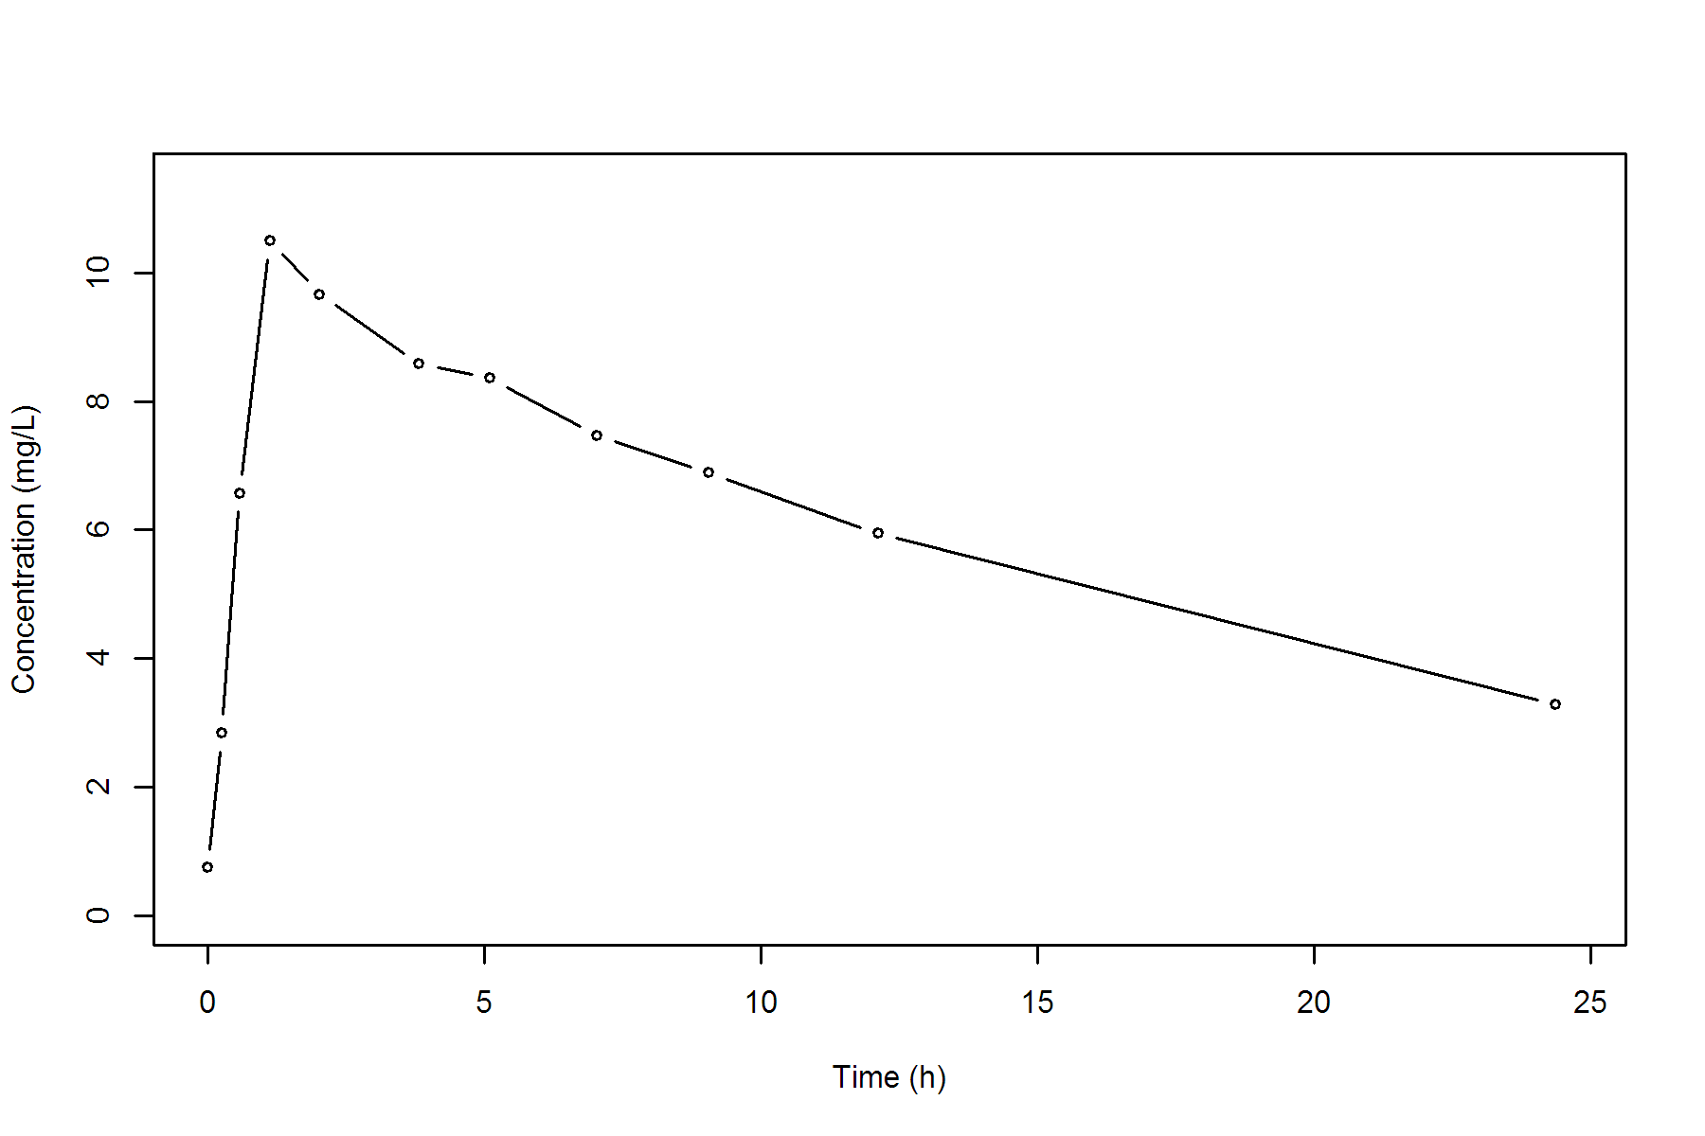
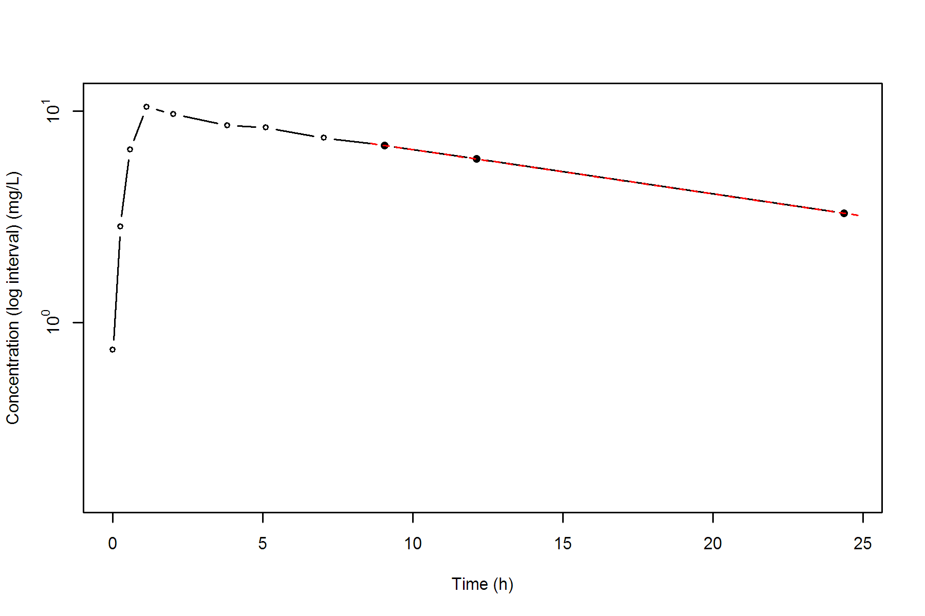
Subject=2
NONCOMPARTMENTAL ANALYSIS REPORT
Package version 0.4.1 (2018-06-20 KST)
R version 3.5.1 (2018-07-02)

Date and Time: 2018-08-06 17:37:34 Asia/Seoul

Calculation Setting
-------------------
Drug Administration: Extravascular
Observation count excluding trailing zero: 11
Dose at time 0: 320 mg
AUC Calculation Method: Linear-up Linear-down
Weighting for lambda z: Uniform (Ordinary Least Square, OLS)
Lambda z selection criterion: Heighest adjusted R-squared value with precision=1e-4

Fitting, AUC, AUMC Result
-------------------------
Time Conc. Pred. Residual AUC AUMC
---------------------------------------------------------------------
0.0000 0.0000 0.0000 0.0000
0.2700 1.7200 0.2322 0.0627
0.5200 7.9100 1.4360 0.6349
1.0000 8.3100 5.3287 3.6165
1.9200 8.3300 12.9832 14.7961
3.5000 6.8500 24.9754 46.3713
5.0200 6.0800 34.8022 87.7887
7.0300 * 5.4000 5.3629 +3.707e-02 46.3396 156.6147
9.0000 * 4.5500 4.3687 +1.813e-01 56.1403 234.3431
12.0000 * 3.0100 3.1970 -1.870e-01 67.4803 349.9481
24.3000 * 0.9000 0.8886 +1.136e-02 91.5268 706.5866

*: Used for the calculation of Lambda z.

Calculated Values
-----------------
CMAX Max Conc 8.3300 mg/L
CMAXD Max Conc Norm by Dose 0.0260 mg/L/mg
TMAX Time of CMAX 1.9200 h
TLAG Time Until First Nonzero Conc 0.0000 h
CLST Last Nonzero Conc 0.9000 mg/L
CLSTP Last Nonzero Conc Pred 0.8886 mg/L
TLST Time of Last Nonzero Conc 24.3000 h
LAMZHL Half-Life Lambda z 6.6593 h
LAMZ Lambda z 0.1041 /h
LAMZLL Lambda z Lower Limit 7.0300 h
LAMZUL Lambda z Upper Limit 24.3000 h
LAMZNPT Number of Points for Lambda z 4
CORRXY Correlation Between TimeX and Log ConcY -0.9986
R2 R Squared 0.9972
R2ADJ R Squared Adjusted 0.9958
AUCLST AUC to Last Nonzero Conc 91.5268 h*mg/L
AUCALL AUC All 91.5268 h*mg/L
AUCIFO AUC Infinity Obs 100.1735 h*mg/L
AUCIFOD AUC Infinity Obs Norm by Dose 0.3130 h*mg/L/mg
AUCIFP AUC Infinity Pred 100.0643 h*mg/L
AUCIFPD AUC Infinity Pred Norm by Dose 0.3127 h*mg/L/mg
AUCPEO AUC %Extrapolation Obs 8.6317 %
AUCPEP AUC %Extrapolation Pred 8.5320 %
AUMCLST AUMC to Last Nonzero Conc 706.5866 h2*mg/L
AUMCIFO AUMC Infinity Obs 999.7723 h2*mg/L
AUMCIFP AUMC Infinity Pred 996.0716 h2*mg/L
AUMCPEO AUMC %Extrapolation Obs 29.3252 %
AUMCPEP AUMC % Extrapolation Pred 29.0627 %
VZFO Vz Obs by F 30.6904 L
VZFP Vz Pred by F 30.7239 L
CLFO Total CL Obs by F 3.1945 L/h
CLFP Total CL Pred by F 3.1979 L/h
MRTEVLST MRT Extravasc to Last Nonzero Conc 7.7200 h
MRTEVIFO MRT Extravasc Infinity Obs 9.9804 h
MRTEVIFP MRT Extravasc Infinity Pred 9.9543 h
Subject=2
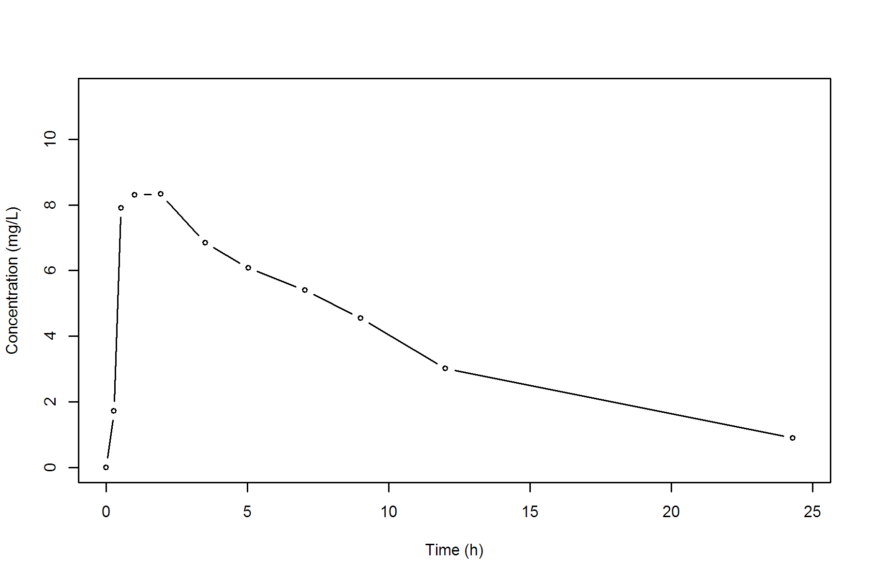
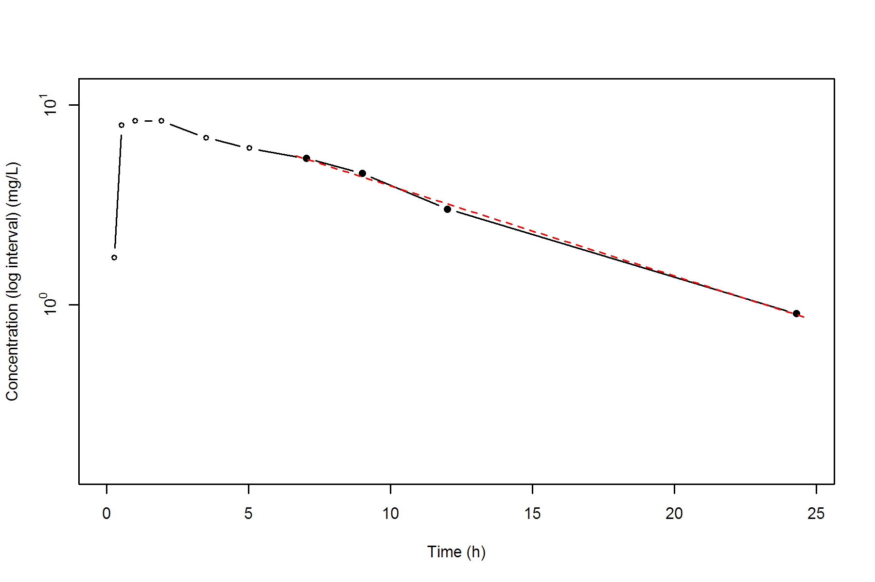
Subject=3
NONCOMPARTMENTAL ANALYSIS REPORT
Package version 0.4.1 (2018-06-20 KST)
R version 3.5.1 (2018-07-02)

Date and Time: 2018-08-06 17:37:35 Asia/Seoul

Calculation Setting
-------------------
Drug Administration: Extravascular
Observation count excluding trailing zero: 11
Dose at time 0: 320 mg
AUC Calculation Method: Linear-up Linear-down
Weighting for lambda z: Uniform (Ordinary Least Square, OLS)
Lambda z selection criterion: Heighest adjusted R-squared value with precision=1e-4

Fitting, AUC, AUMC Result
-------------------------
Time Conc. Pred. Residual AUC AUMC
---------------------------------------------------------------------
0.0000 0.0000 0.0000 0.0000
0.2700 4.4000 0.5940 0.1604
0.5800 6.9000 2.3455 0.9648
1.0200 8.2000 5.6675 3.6854
2.0200 7.8000 13.6675 15.7453
3.6200 7.5000 25.9075 50.0702
5.0800 6.2000 35.9085 92.8817
7.0700 5.3000 47.3510 161.5039
9.0000 * 4.9000 4.9914 -9.138e-02 57.1940 240.2199
12.1500 * 3.7000 3.6147 +8.528e-02 70.7390 380.4815
24.1700 * 1.0500 1.0551 -5.097e-03 99.2865 803.1859

*: Used for the calculation of Lambda z.

Calculated Values
-----------------
CMAX Max Conc 8.2000 mg/L
CMAXD Max Conc Norm by Dose 0.0256 mg/L/mg
TMAX Time of CMAX 1.0200 h
TLAG Time Until First Nonzero Conc 0.0000 h
CLST Last Nonzero Conc 1.0500 mg/L
CLSTP Last Nonzero Conc Pred 1.0551 mg/L
TLST Time of Last Nonzero Conc 24.1700 h
LAMZHL Half-Life Lambda z 6.7661 h
LAMZ Lambda z 0.1024 /h
LAMZLL Lambda z Lower Limit 9.0000 h
LAMZUL Lambda z Upper Limit 24.1700 h
LAMZNPT Number of Points for Lambda z 3
CORRXY Correlation Between TimeX and Log ConcY -0.9997
R2 R Squared 0.9993
R2ADJ R Squared Adjusted 0.9986
AUCLST AUC to Last Nonzero Conc 99.2865 h*mg/L
AUCALL AUC All 99.2865 h*mg/L
AUCIFO AUC Infinity Obs 109.5360 h*mg/L
AUCIFOD AUC Infinity Obs Norm by Dose 0.3423 h*mg/L/mg
AUCIFP AUC Infinity Pred 109.5857 h*mg/L
AUCIFPD AUC Infinity Pred Norm by Dose 0.3425 h*mg/L/mg
AUCPEO AUC %Extrapolation Obs 9.3572 %
AUCPEP AUC %Extrapolation Pred 9.3983 %
AUMCLST AUMC to Last Nonzero Conc 803.1859 h2*mg/L
AUMCIFO AUMC Infinity Obs 1150.9648 h2*mg/L
AUMCIFP AUMC Infinity Pred 1152.6529 h2*mg/L
AUMCPEO AUMC %Extrapolation Obs 30.2163 %
AUMCPEP AUMC % Extrapolation Pred 30.3185 %
VZFO Vz Obs by F 28.5171 L
VZFP Vz Pred by F 28.5042 L
CLFO Total CL Obs by F 2.9214 L/h
CLFP Total CL Pred by F 2.9201 L/h
MRTEVLST MRT Extravasc to Last Nonzero Conc 8.0896 h
MRTEVIFO MRT Extravasc Infinity Obs 10.5076 h
MRTEVIFP MRT Extravasc Infinity Pred 10.5183 h
Subject=3
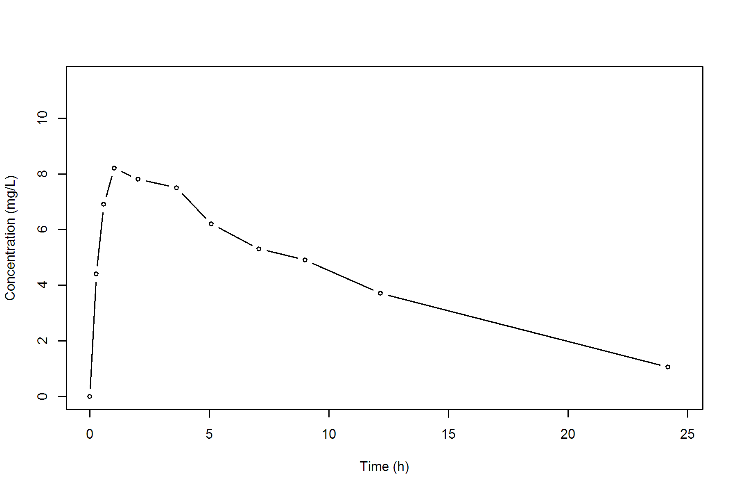
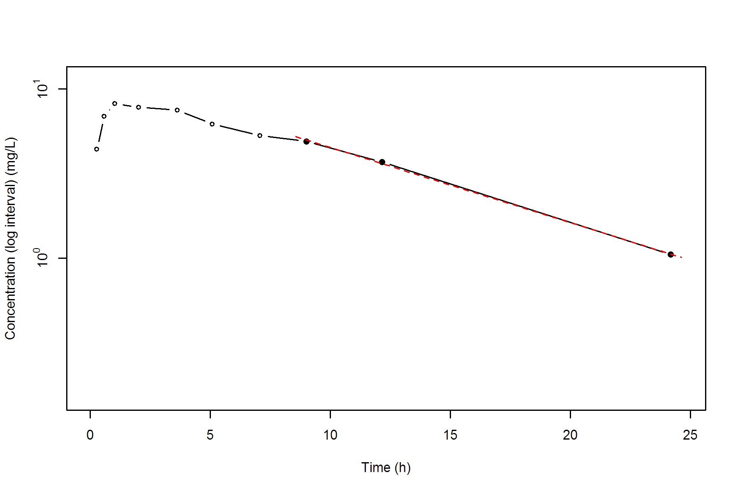
Subject=4
NONCOMPARTMENTAL ANALYSIS REPORT
Package version 0.4.1 (2018-06-20 KST)
R version 3.5.1 (2018-07-02)

Date and Time: 2018-08-06 17:37:35 Asia/Seoul

Calculation Setting
-------------------
Drug Administration: Extravascular
Observation count excluding trailing zero: 11
Dose at time 0: 320 mg
AUC Calculation Method: Linear-up Linear-down
Weighting for lambda z: Uniform (Ordinary Least Square, OLS)
Lambda z selection criterion: Heighest adjusted R-squared value with precision=1e-4

Fitting, AUC, AUMC Result
-------------------------
Time Conc. Pred. Residual AUC AUMC
---------------------------------------------------------------------
0.0000 0.0000 0.0000 0.0000
0.3500 1.8900 0.3308 0.1158
0.6000 4.6000 1.1420 0.5435
1.0700 8.6000 4.2440 3.3545
2.1300 8.3800 13.2434 17.6918
3.5000 7.5400 24.1486 47.9958
5.0200 6.8800 35.1078 94.3007
7.0200 5.7800 47.7678 169.4139
9.0200 * 5.3300 5.4586 -1.286e-01 58.8778 258.0661
11.9800 * 4.1900 4.0686 +1.214e-01 72.9674 403.5099
24.6500 * 1.1500 1.1564 -6.422e-03 106.7963 901.0842

*: Used for the calculation of Lambda z.

Calculated Values
-----------------
CMAX Max Conc 8.6000 mg/L
CMAXD Max Conc Norm by Dose 0.0269 mg/L/mg
TMAX Time of CMAX 1.0700 h
TLAG Time Until First Nonzero Conc 0.0000 h
CLST Last Nonzero Conc 1.1500 mg/L
CLSTP Last Nonzero Conc Pred 1.1564 mg/L
TLST Time of Last Nonzero Conc 24.6500 h
LAMZHL Half-Life Lambda z 6.9812 h
LAMZ Lambda z 0.0993 /h
LAMZLL Lambda z Lower Limit 9.0200 h
LAMZUL Lambda z Upper Limit 24.6500 h
LAMZNPT Number of Points for Lambda z 3
CORRXY Correlation Between TimeX and Log ConcY -0.9995
R2 R Squared 0.9989
R2ADJ R Squared Adjusted 0.9978
AUCLST AUC to Last Nonzero Conc 106.7963 h*mg/L
AUCALL AUC All 106.7963 h*mg/L
AUCIFO AUC Infinity Obs 118.3789 h*mg/L
AUCIFOD AUC Infinity Obs Norm by Dose 0.3699 h*mg/L/mg
AUCIFP AUC Infinity Pred 118.4436 h*mg/L
AUCIFPD AUC Infinity Pred Norm by Dose 0.3701 h*mg/L/mg
AUCPEO AUC %Extrapolation Obs 9.7843 %
AUCPEP AUC %Extrapolation Pred 9.8336 %
AUMCLST AUMC to Last Nonzero Conc 901.0842 h2*mg/L
AUMCIFO AUMC Infinity Obs 1303.2524 h2*mg/L
AUMCIFP AUMC Infinity Pred 1305.4981 h2*mg/L
AUMCPEO AUMC %Extrapolation Obs 30.8588 %
AUMCPEP AUMC % Extrapolation Pred 30.9777 %
VZFO Vz Obs by F 27.2260 L
VZFP Vz Pred by F 27.2111 L
CLFO Total CL Obs by F 2.7032 L/h
CLFP Total CL Pred by F 2.7017 L/h
MRTEVLST MRT Extravasc to Last Nonzero Conc 8.4374 h
MRTEVIFO MRT Extravasc Infinity Obs 11.0092 h
MRTEVIFP MRT Extravasc Infinity Pred 11.0221 h
Subject=4
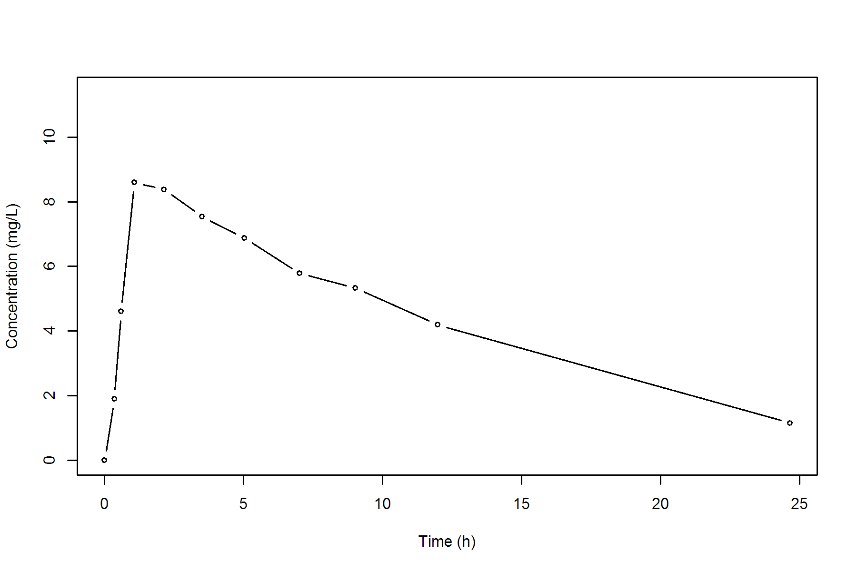
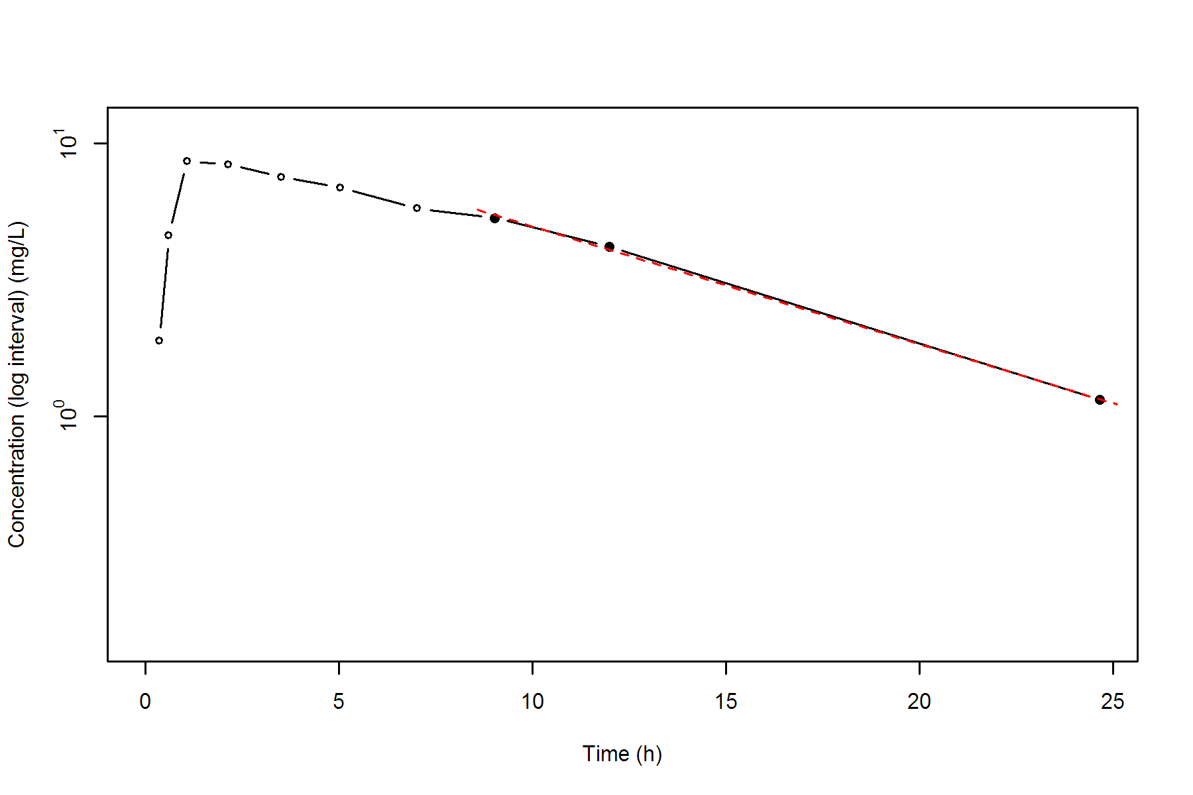
Subject=5
NONCOMPARTMENTAL ANALYSIS REPORT
Package version 0.4.1 (2018-06-20 KST)
R version 3.5.1 (2018-07-02)

Date and Time: 2018-08-06 17:37:36 Asia/Seoul

Calculation Setting
-------------------
Drug Administration: Extravascular
Observation count excluding trailing zero: 11
Dose at time 0: 320 mg
AUC Calculation Method: Linear-up Linear-down
Weighting for lambda z: Uniform (Ordinary Least Square, OLS)
Lambda z selection criterion: Heighest adjusted R-squared value with precision=1e-4

Fitting, AUC, AUMC Result
-------------------------
Time Conc. Pred. Residual AUC AUMC
---------------------------------------------------------------------
0.0000 0.0000 0.0000 0.0000
0.3000 2.0200 0.3030 0.0909
0.5200 5.6300 1.1445 0.4796
1.0000 11.4000 5.2317 3.9182
2.0200 9.3300 15.8040 19.3440
3.5000 8.7400 29.1758 55.9271
5.0200 7.5600 41.5638 108.0184
7.0200 * 7.0900 6.9799 +1.101e-01 56.2138 195.7414
9.1000 * 5.9000 5.8291 +7.091e-02 69.7234 303.3417
12.0000 * 4.3700 4.5343 -1.643e-01 84.6149 457.2302
24.3500 * 1.5700 1.5557 +1.430e-02 121.2944 1017.1143

*: Used for the calculation of Lambda z.

Calculated Values
-----------------
CMAX Max Conc 11.4000 mg/L
CMAXD Max Conc Norm by Dose 0.0356 mg/L/mg
TMAX Time of CMAX 1.0000 h
TLAG Time Until First Nonzero Conc 0.0000 h
CLST Last Nonzero Conc 1.5700 mg/L
CLSTP Last Nonzero Conc Pred 1.5557 mg/L
TLST Time of Last Nonzero Conc 24.3500 h
LAMZHL Half-Life Lambda z 8.0023 h
LAMZ Lambda z 0.0866 /h
LAMZLL Lambda z Lower Limit 7.0200 h
LAMZUL Lambda z Upper Limit 24.3500 h
LAMZNPT Number of Points for Lambda z 4
CORRXY Correlation Between TimeX and Log ConcY -0.9993
R2 R Squared 0.9986
R2ADJ R Squared Adjusted 0.9980
AUCLST AUC to Last Nonzero Conc 121.2944 h*mg/L
AUCALL AUC All 121.2944 h*mg/L
AUCIFO AUC Infinity Obs 139.4198 h*mg/L
AUCIFOD AUC Infinity Obs Norm by Dose 0.4357 h*mg/L/mg
AUCIFP AUC Infinity Pred 139.2546 h*mg/L
AUCIFPD AUC Infinity Pred Norm by Dose 0.4352 h*mg/L/mg
AUCPEO AUC %Extrapolation Obs 13.0006 %
AUCPEP AUC %Extrapolation Pred 12.8974 %
AUMCLST AUMC to Last Nonzero Conc 1017.1143 h2*mg/L
AUMCIFO AUMC Infinity Obs 1667.7216 h2*mg/L
AUMCIFP AUMC Infinity Pred 1661.7937 h2*mg/L
AUMCPEO AUMC %Extrapolation Obs 39.0117 %
AUMCPEP AUMC % Extrapolation Pred 38.7942 %
VZFO Vz Obs by F 26.4980 L
VZFP Vz Pred by F 26.5294 L
CLFO Total CL Obs by F 2.2952 L/h
CLFP Total CL Pred by F 2.2979 L/h
MRTEVLST MRT Extravasc to Last Nonzero Conc 8.3855 h
MRTEVIFO MRT Extravasc Infinity Obs 11.9619 h
MRTEVIFP MRT Extravasc Infinity Pred 11.9335 h
Subject=5
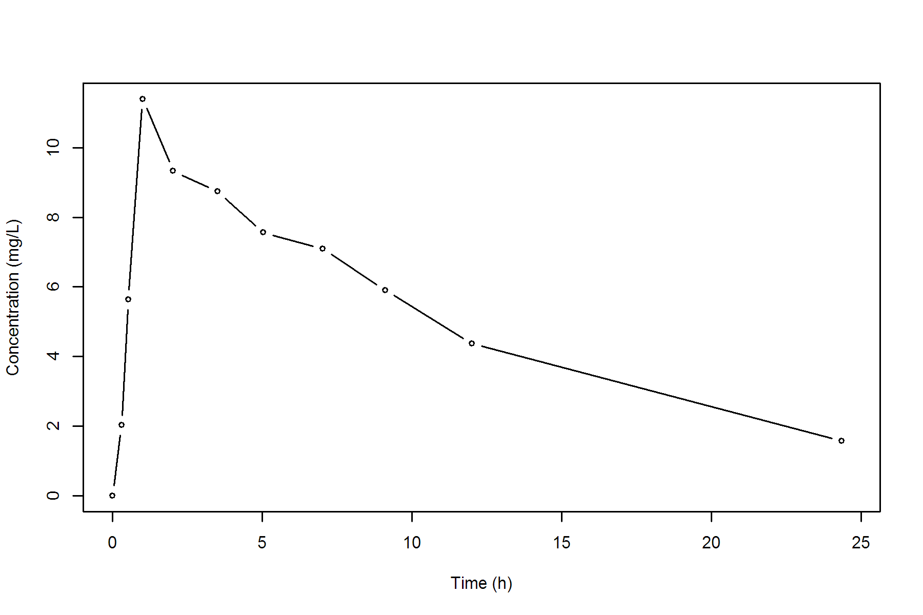
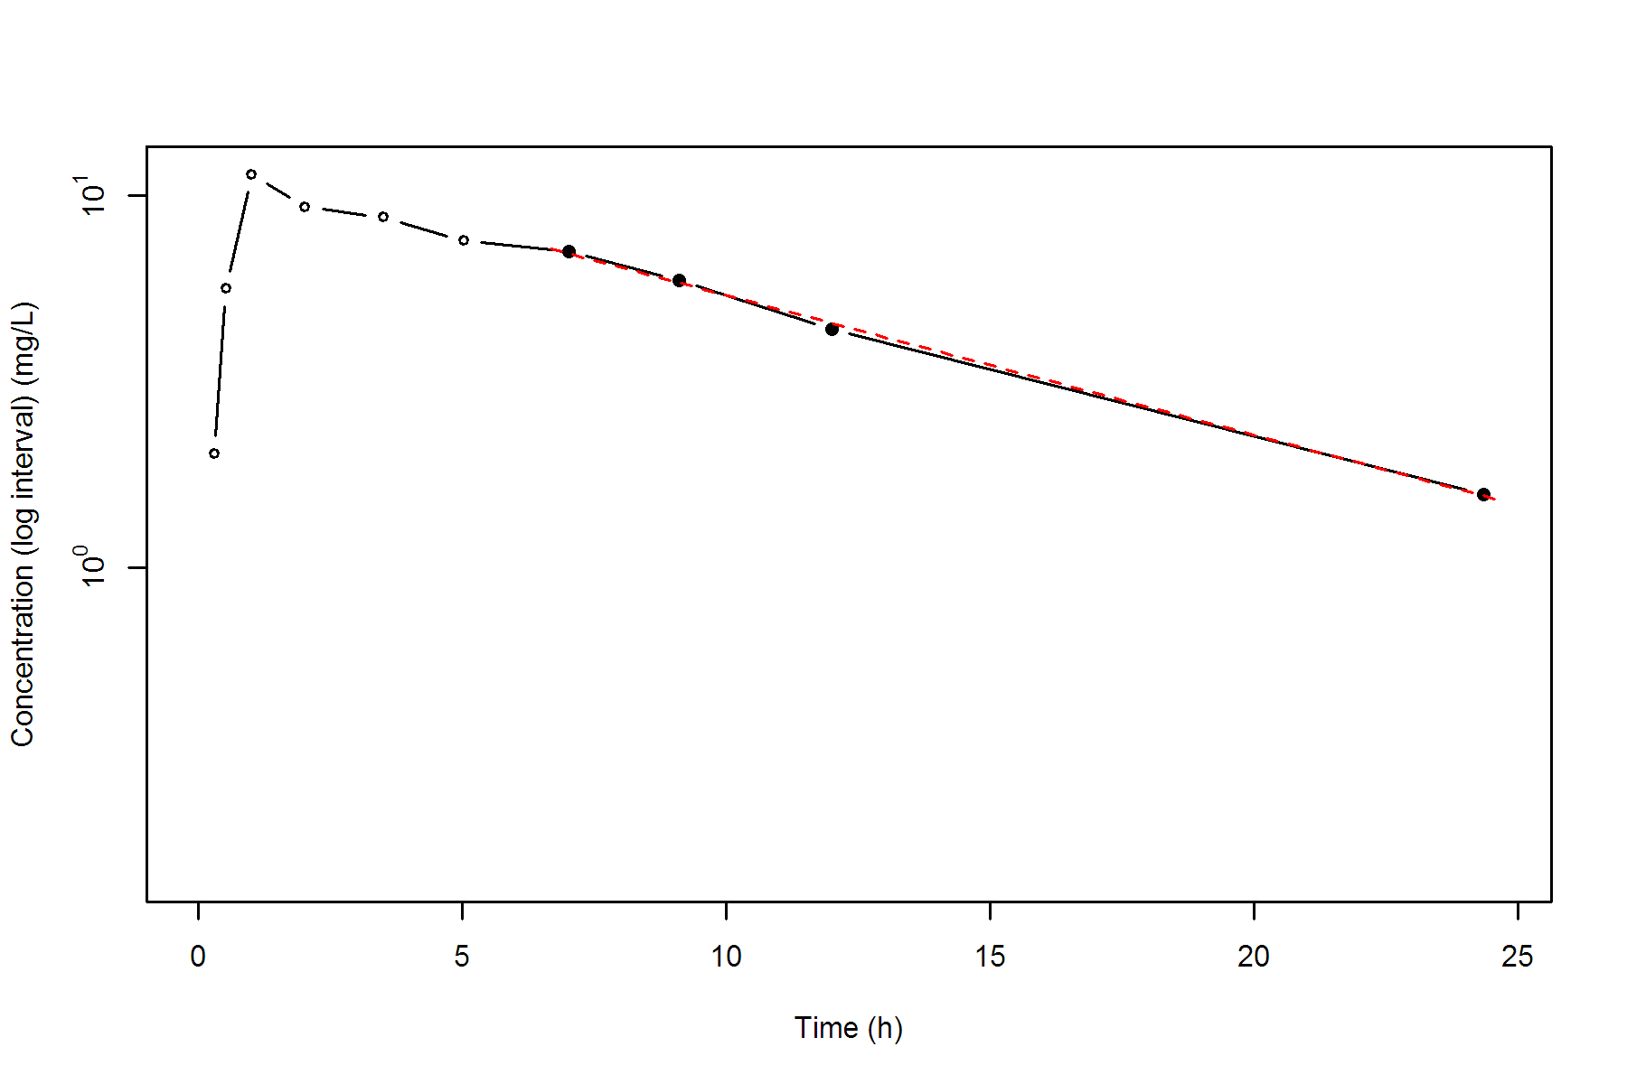
Subject=6
NONCOMPARTMENTAL ANALYSIS REPORT
Package version 0.4.1 (2018-06-20 KST)
R version 3.5.1 (2018-07-02)

Date and Time: 2018-08-06 17:37:36 Asia/Seoul

Calculation Setting
-------------------
Drug Administration: Extravascular
Observation count excluding trailing zero: 11
Dose at time 0: 320 mg
AUC Calculation Method: Linear-up Linear-down
Weighting for lambda z: Uniform (Ordinary Least Square, OLS)
Lambda z selection criterion: Heighest adjusted R-squared value with precision=1e-4

Fitting, AUC, AUMC Result
-------------------------
Time Conc. Pred. Residual AUC AUMC
---------------------------------------------------------------------
0.0000 0.0000 0.0000 0.0000
0.2700 1.2900 0.1742 0.0470
0.5800 3.0800 0.8515 0.3779
1.1500 6.4400 3.5647 2.9977
2.0300 * 6.3200 6.3928 -7.284e-02 9.1791 11.9014
3.5700 * 5.5300 5.5844 -5.438e-02 18.3036 36.9816
5.0000 * 4.9400 4.9255 +1.450e-02 25.7897 68.7577
7.0000 * 4.0200 4.1323 -1.123e-01 34.7497 121.5977
9.2200 * 3.4600 3.4005 +5.948e-02 43.0525 188.2434
12.1000 * 2.7800 2.6408 +1.392e-01 52.0381 282.6199
23.8500 * 0.9200 0.9413 -2.127e-02 73.7756 609.1524

*: Used for the calculation of Lambda z.

Calculated Values
-----------------
CMAX Max Conc 6.4400 mg/L
CMAXD Max Conc Norm by Dose 0.0201 mg/L/mg
TMAX Time of CMAX 1.1500 h
TLAG Time Until First Nonzero Conc 0.0000 h
CLST Last Nonzero Conc 0.9200 mg/L
CLSTP Last Nonzero Conc Pred 0.9413 mg/L
TLST Time of Last Nonzero Conc 23.8500 h
LAMZHL Half-Life Lambda z 7.8950 h
LAMZ Lambda z 0.0878 /h
LAMZLL Lambda z Lower Limit 2.0300 h
LAMZUL Lambda z Upper Limit 23.8500 h
LAMZNPT Number of Points for Lambda z 7
CORRXY Correlation Between TimeX and Log ConcY -0.9991
R2 R Squared 0.9982
R2ADJ R Squared Adjusted 0.9979
AUCLST AUC to Last Nonzero Conc 73.7756 h*mg/L
AUCALL AUC All 73.7756 h*mg/L
AUCIFO AUC Infinity Obs 84.2544 h*mg/L
AUCIFOD AUC Infinity Obs Norm by Dose 0.2633 h*mg/L/mg
AUCIFP AUC Infinity Pred 84.4967 h*mg/L
AUCIFPD AUC Infinity Pred Norm by Dose 0.2641 h*mg/L/mg
AUCPEO AUC %Extrapolation Obs 12.4372 %
AUCPEP AUC %Extrapolation Pred 12.6882 %
AUMCLST AUMC to Last Nonzero Conc 609.1524 h2*mg/L
AUMCIFO AUMC Infinity Obs 978.4285 h2*mg/L
AUMCIFP AUMC Infinity Pred 986.9665 h2*mg/L
AUMCPEO AUMC %Extrapolation Obs 37.7418 %
AUMCPEP AUMC % Extrapolation Pred 38.2803 %
VZFO Vz Obs by F 43.2597 L
VZFP Vz Pred by F 43.1357 L
CLFO Total CL Obs by F 3.7980 L/h
CLFP Total CL Pred by F 3.7871 L/h
MRTEVLST MRT Extravasc to Last Nonzero Conc 8.2568 h
MRTEVIFO MRT Extravasc Infinity Obs 11.6128 h
MRTEVIFP MRT Extravasc Infinity Pred 11.6805 h
Subject=6
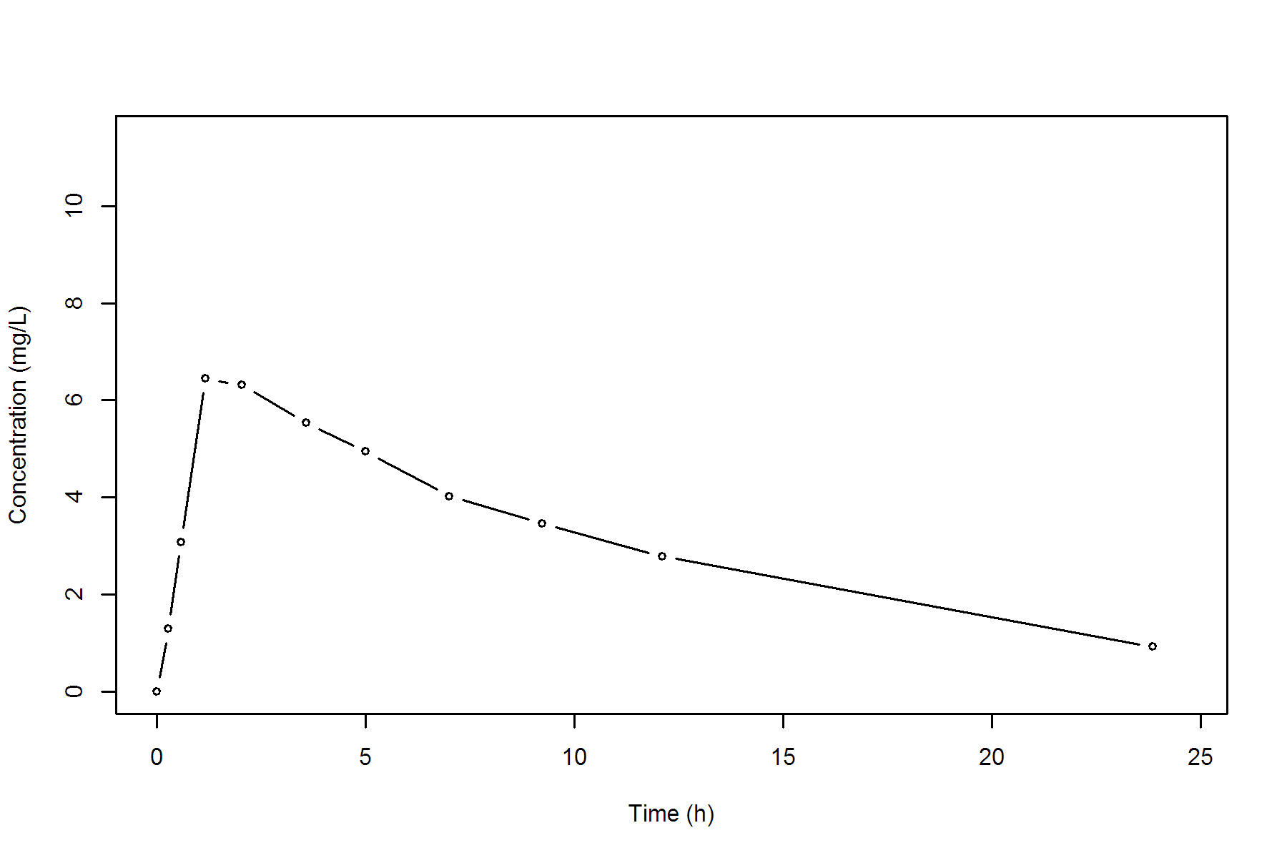
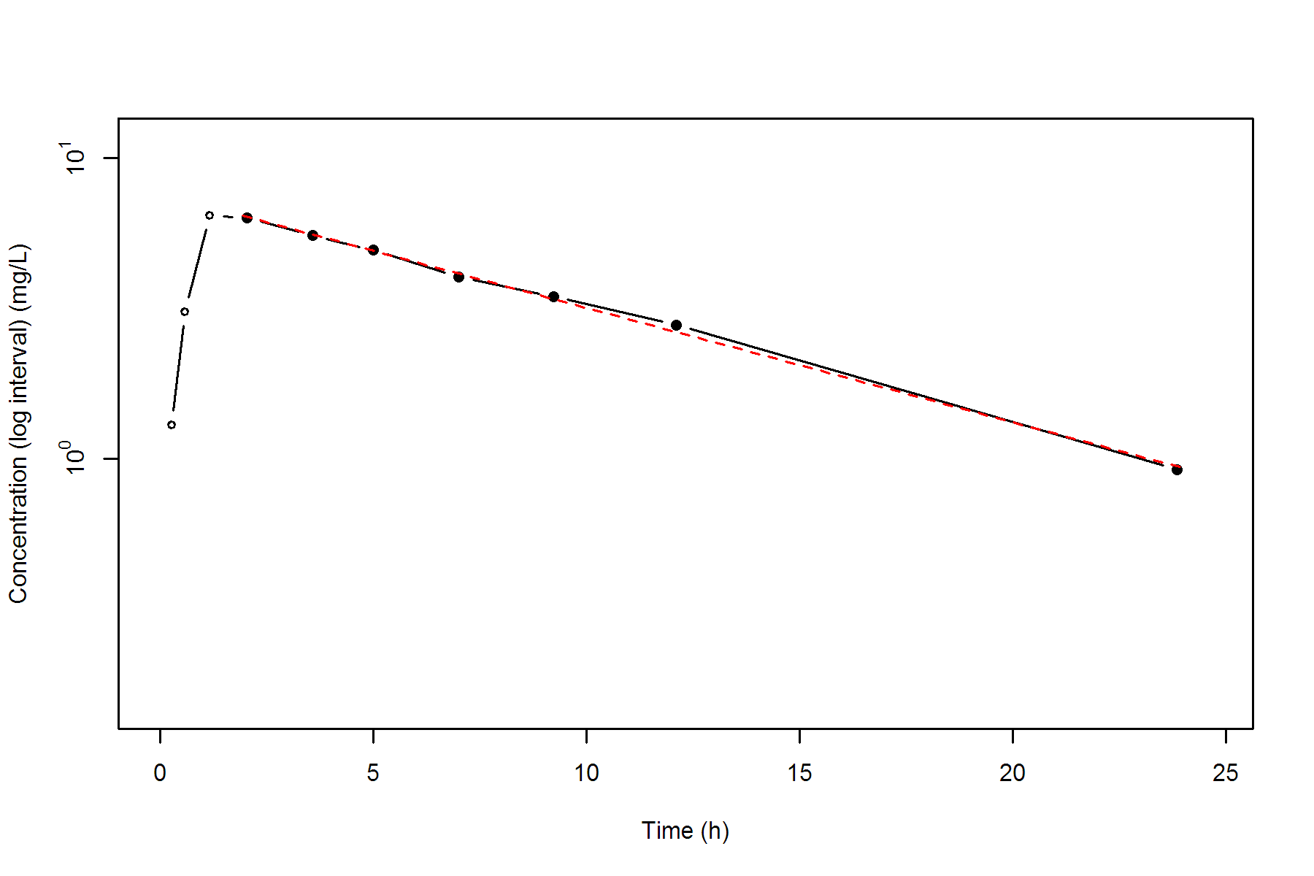
Subject=7
NONCOMPARTMENTAL ANALYSIS REPORT
Package version 0.4.1 (2018-06-20 KST)
R version 3.5.1 (2018-07-02)

Date and Time: 2018-08-06 17:37:37 Asia/Seoul

Calculation Setting
-------------------
Drug Administration: Extravascular
Observation count excluding trailing zero: 11
Dose at time 0: 320 mg
AUC Calculation Method: Linear-up Linear-down
Weighting for lambda z: Uniform (Ordinary Least Square, OLS)
Lambda z selection criterion: Heighest adjusted R-squared value with precision=1e-4

Fitting, AUC, AUMC Result
-------------------------
Time Conc. Pred. Residual AUC AUMC
---------------------------------------------------------------------
0.0000 0.1500 0.0000 0.0000
0.2500 0.8500 0.1250 0.0266
0.5000 2.3500 0.5250 0.2000
1.0200 5.0200 2.4412 1.8368
2.0200 6.5800 8.2412 11.0428
3.4800 7.0900 18.2203 38.7571
5.0000 6.6600 28.6703 82.8167
6.9800 * 5.2500 5.3226 -7.260e-02 40.4612 152.0623
9.0000 * 4.3900 4.4527 -6.275e-02 50.1976 228.9788
12.0500 * 3.5300 3.4011 +1.289e-01 62.2756 354.0998
24.2200 * 1.1500 1.1607 -1.072e-02 90.7534 782.4199

*: Used for the calculation of Lambda z.

Calculated Values
-----------------
CMAX Max Conc 7.0900 mg/L
CMAXD Max Conc Norm by Dose 0.0222 mg/L/mg
TMAX Time of CMAX 3.4800 h
TLAG Time Until First Nonzero Conc 0.0000 h
CLST Last Nonzero Conc 1.1500 mg/L
CLSTP Last Nonzero Conc Pred 1.1607 mg/L
TLST Time of Last Nonzero Conc 24.2200 h
LAMZHL Half-Life Lambda z 7.8467 h
LAMZ Lambda z 0.0883 /h
LAMZLL Lambda z Lower Limit 6.9800 h
LAMZUL Lambda z Upper Limit 24.2200 h
LAMZNPT Number of Points for Lambda z 4
CORRXY Correlation Between TimeX and Log ConcY -0.9993
R2 R Squared 0.9987
R2ADJ R Squared Adjusted 0.9980
AUCLST AUC to Last Nonzero Conc 90.7534 h*mg/L
AUCALL AUC All 90.7534 h*mg/L
AUCIFO AUC Infinity Obs 103.7718 h*mg/L
AUCIFOD AUC Infinity Obs Norm by Dose 0.3243 h*mg/L/mg
AUCIFP AUC Infinity Pred 103.8931 h*mg/L
AUCIFPD AUC Infinity Pred Norm by Dose 0.3247 h*mg/L/mg
AUCPEO AUC %Extrapolation Obs 12.5452 %
AUCPEP AUC %Extrapolation Pred 12.6474 %
AUMCLST AUMC to Last Nonzero Conc 782.4199 h2*mg/L
AUMCIFO AUMC Infinity Obs 1245.0984 h2*mg/L
AUMCIFP AUMC Infinity Pred 1249.4111 h2*mg/L
AUMCPEO AUMC %Extrapolation Obs 37.1600 %
AUMCPEP AUMC % Extrapolation Pred 37.3769 %
VZFO Vz Obs by F 34.9084 L
VZFP Vz Pred by F 34.8677 L
CLFO Total CL Obs by F 3.0837 L/h
CLFP Total CL Pred by F 3.0801 L/h
MRTEVLST MRT Extravasc to Last Nonzero Conc 8.6214 h
MRTEVIFO MRT Extravasc Infinity Obs 11.9984 h
MRTEVIFP MRT Extravasc Infinity Pred 12.0259 h
Subject=7
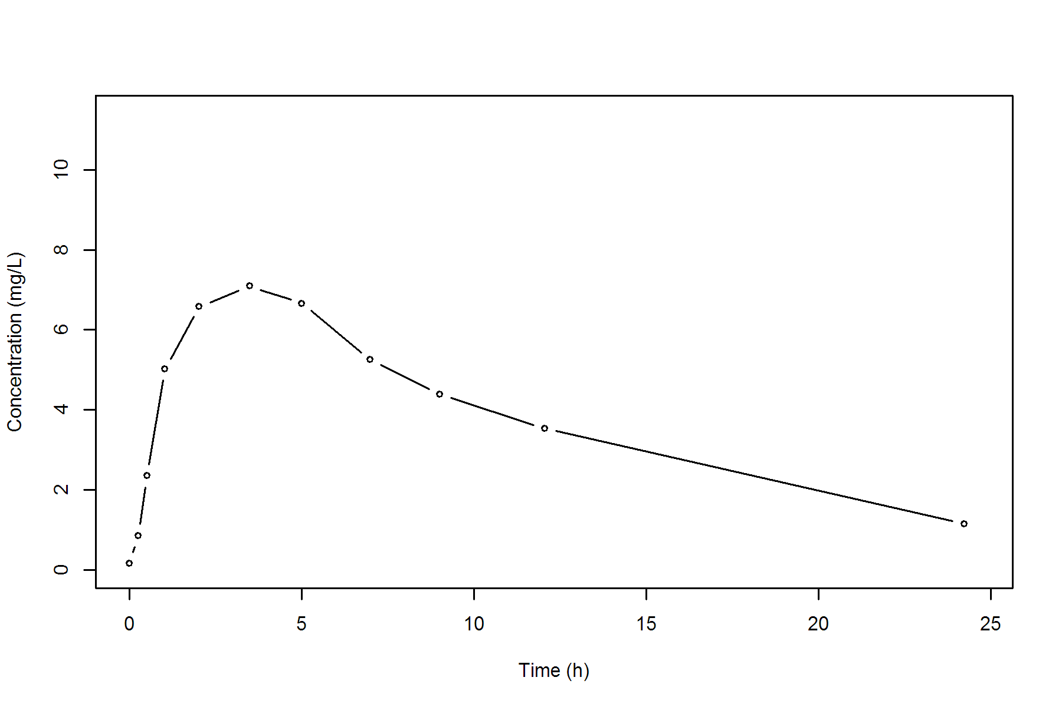
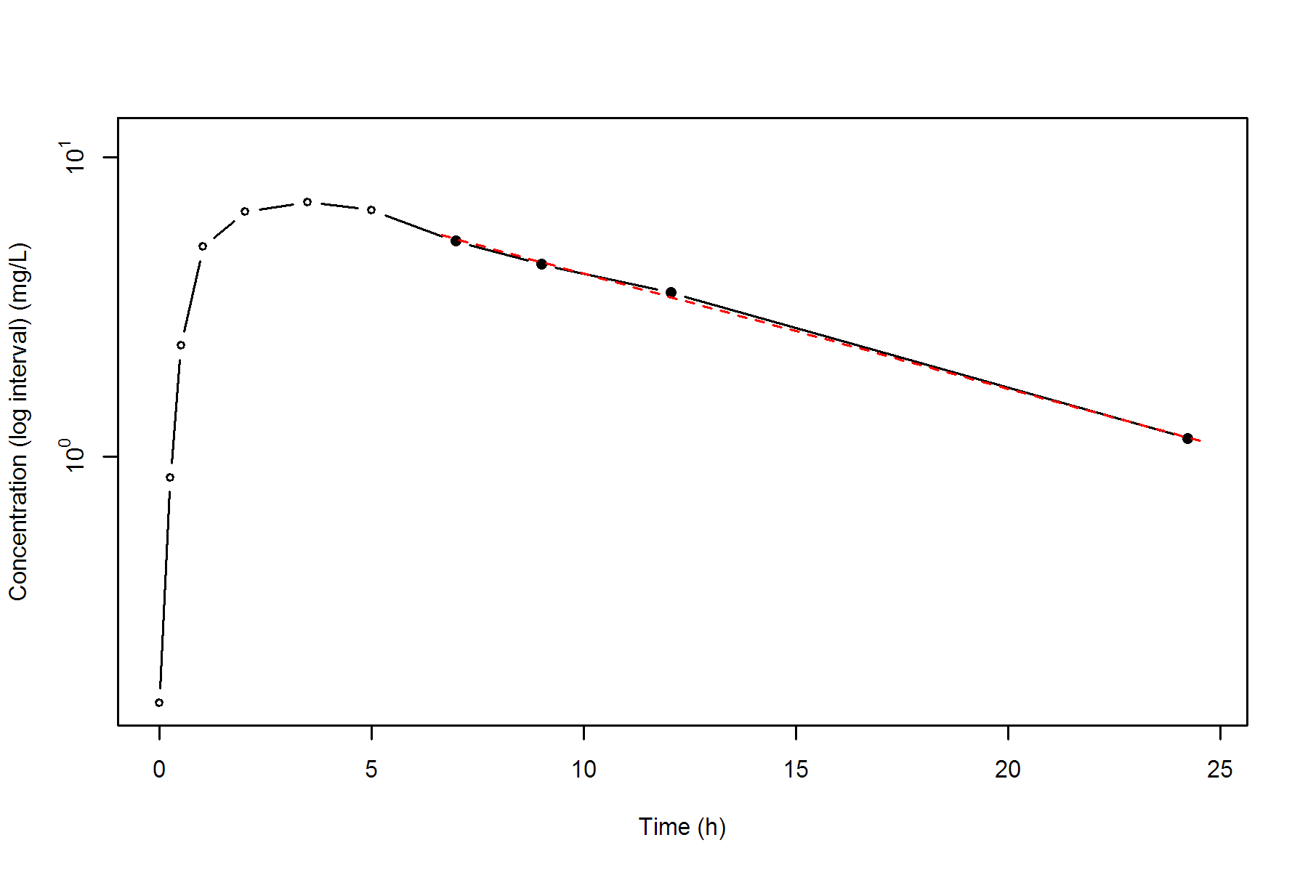
Subject=8
NONCOMPARTMENTAL ANALYSIS REPORT
Package version 0.4.1 (2018-06-20 KST)
R version 3.5.1 (2018-07-02)

Date and Time: 2018-08-06 17:37:37 Asia/Seoul

Calculation Setting
-------------------
Drug Administration: Extravascular
Observation count excluding trailing zero: 11
Dose at time 0: 320 mg
AUC Calculation Method: Linear-up Linear-down
Weighting for lambda z: Uniform (Ordinary Least Square, OLS)
Lambda z selection criterion: Heighest adjusted R-squared value with precision=1e-4

Fitting, AUC, AUMC Result
-------------------------
Time Conc. Pred. Residual AUC AUMC
---------------------------------------------------------------------
0.0000 0.0000 0.0000 0.0000
0.2500 3.0500 0.3813 0.0953
0.5200 3.0500 1.2048 0.4124
0.9800 7.3100 3.5875 2.4248
2.0200 7.5600 11.3200 14.0910
3.5300 * 6.5900 6.5724 +1.758e-02 22.0032 43.1841
5.0500 * 5.8800 5.8071 +7.292e-02 31.4804 83.4312
7.1500 * 4.7300 4.8941 -1.641e-01 42.6209 150.1204
9.0700 * 4.5700 4.1856 +3.844e-01 51.5489 222.3790
12.1000 * 3.0000 3.2702 -2.702e-01 63.0175 340.1701
24.1200 * 1.2500 1.2285 +2.147e-02 88.5600 739.5346

*: Used for the calculation of Lambda z.

Calculated Values
-----------------
CMAX Max Conc 7.5600 mg/L
CMAXD Max Conc Norm by Dose 0.0236 mg/L/mg
TMAX Time of CMAX 2.0200 h
TLAG Time Until First Nonzero Conc 0.0000 h
CLST Last Nonzero Conc 1.2500 mg/L
CLSTP Last Nonzero Conc Pred 1.2285 mg/L
TLST Time of Last Nonzero Conc 24.1200 h
LAMZHL Half-Life Lambda z 8.5100 h
LAMZ Lambda z 0.0815 /h
LAMZLL Lambda z Lower Limit 3.5300 h
LAMZUL Lambda z Upper Limit 24.1200 h
LAMZNPT Number of Points for Lambda z 6
CORRXY Correlation Between TimeX and Log ConcY -0.9955
R2 R Squared 0.9910
R2ADJ R Squared Adjusted 0.9888
AUCLST AUC to Last Nonzero Conc 88.5600 h*mg/L
AUCALL AUC All 88.5600 h*mg/L
AUCIFO AUC Infinity Obs 103.9067 h*mg/L
AUCIFOD AUC Infinity Obs Norm by Dose 0.3247 h*mg/L/mg
AUCIFP AUC Infinity Pred 103.6431 h*mg/L
AUCIFPD AUC Infinity Pred Norm by Dose 0.3239 h*mg/L/mg
AUCPEO AUC %Extrapolation Obs 14.7697 %
AUCPEP AUC %Extrapolation Pred 14.5529 %
AUMCLST AUMC to Last Nonzero Conc 739.5346 h2*mg/L
AUMCIFO AUMC Infinity Obs 1298.1158 h2*mg/L
AUMCIFP AUMC Infinity Pred 1288.5201 h2*mg/L
AUMCPEO AUMC %Extrapolation Obs 43.0302 %
AUMCPEP AUMC % Extrapolation Pred 42.6059 %
VZFO Vz Obs by F 37.8105 L
VZFP Vz Pred by F 37.9067 L
CLFO Total CL Obs by F 3.0797 L/h
CLFP Total CL Pred by F 3.0875 L/h
MRTEVLST MRT Extravasc to Last Nonzero Conc 8.3507 h
MRTEVIFO MRT Extravasc Infinity Obs 12.4931 h
MRTEVIFP MRT Extravasc Infinity Pred 12.4323 h
Subject=8
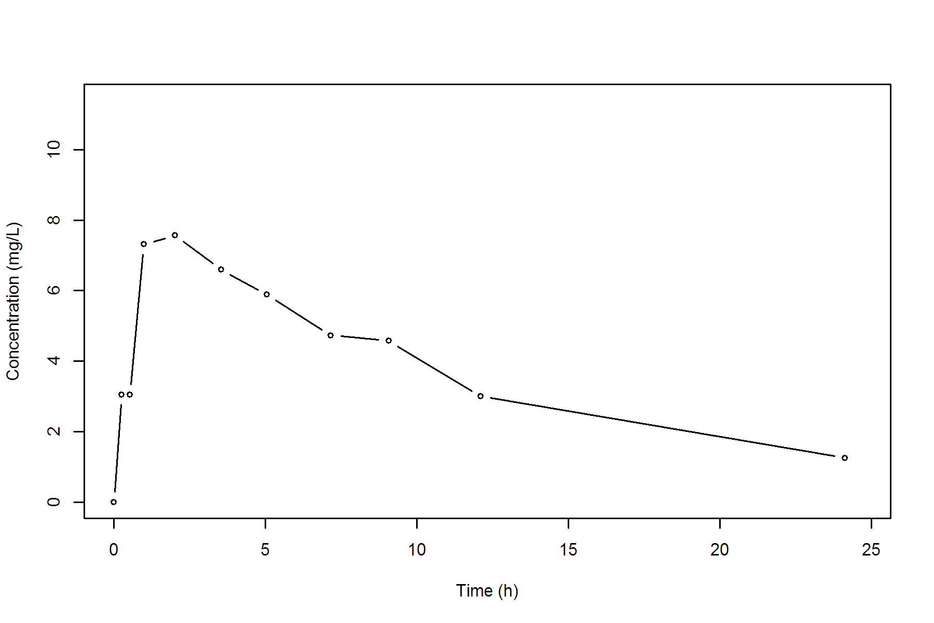
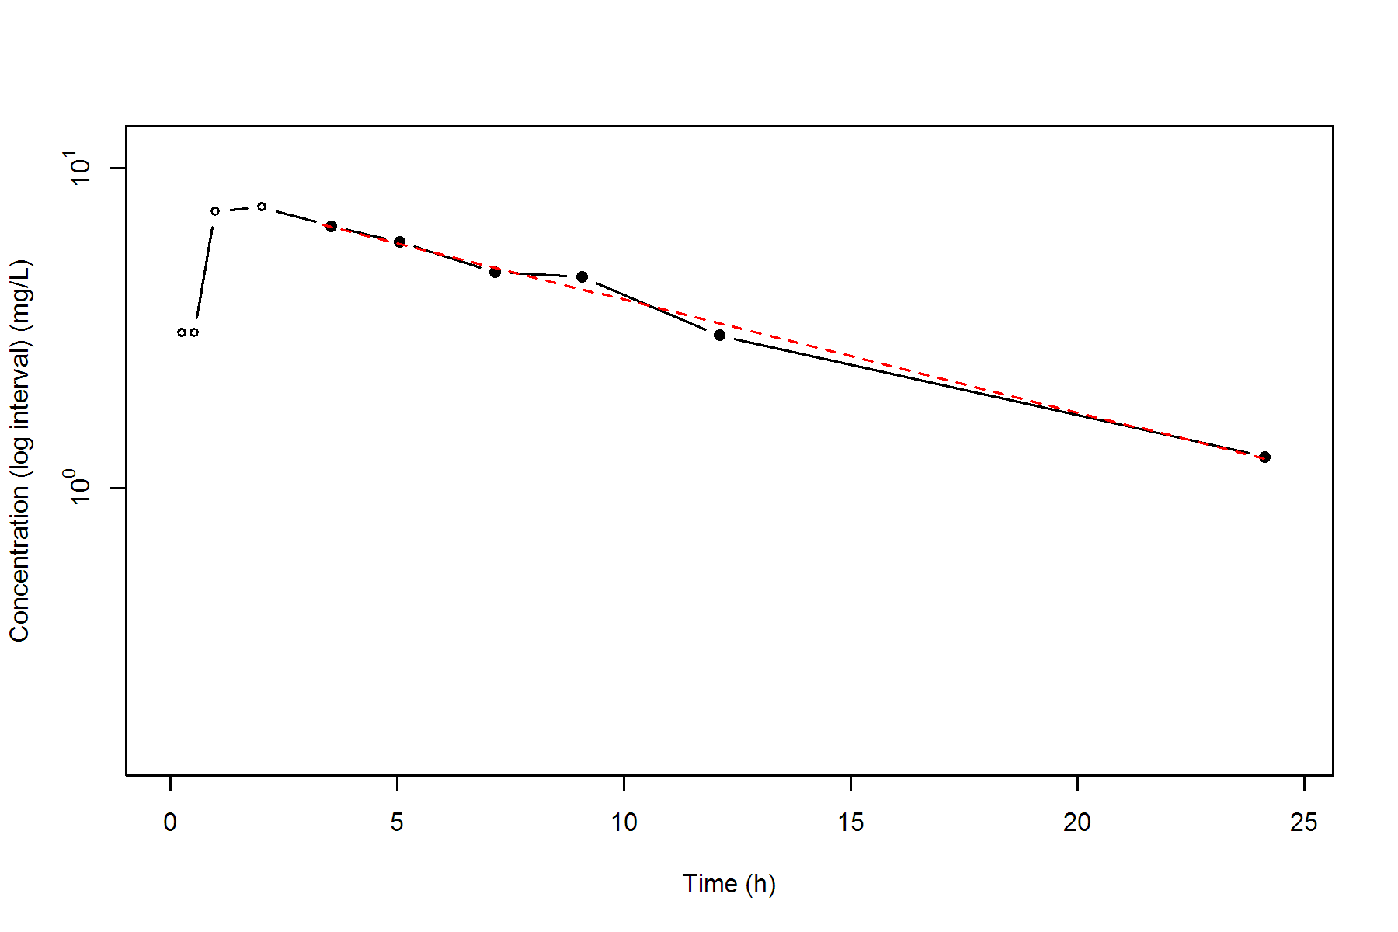
Subject=9
NONCOMPARTMENTAL ANALYSIS REPORT
Package version 0.4.1 (2018-06-20 KST)
R version 3.5.1 (2018-07-02)

Date and Time: 2018-08-06 17:37:38 Asia/Seoul

Calculation Setting
-------------------
Drug Administration: Extravascular
Observation count excluding trailing zero: 11
Dose at time 0: 320 mg
AUC Calculation Method: Linear-up Linear-down
Weighting for lambda z: Uniform (Ordinary Least Square, OLS)
Lambda z selection criterion: Heighest adjusted R-squared value with precision=1e-4

Fitting, AUC, AUMC Result
-------------------------
Time Conc. Pred. Residual AUC AUMC
---------------------------------------------------------------------
0.0000 0.0000 0.0000 0.0000
0.3000 7.3700 1.1055 0.3316
0.6300 9.0300 3.8115 1.6351
1.0500 7.1400 7.2072 4.4042
2.0200 6.3300 13.7402 14.2417
3.5300 5.6600 22.7926 38.9804
5.0200 5.6700 31.2335 75.0705
7.1700 4.2400 41.8867 138.3495
8.8000 * 4.1100 4.0512 +5.880e-02 48.6920 192.6031
11.6000 * 3.1600 3.2160 -5.597e-02 58.8700 294.5567
24.4300 * 1.1200 1.1165 +3.517e-03 86.3262 705.2296

*: Used for the calculation of Lambda z.

Calculated Values
-----------------
CMAX Max Conc 9.0300 mg/L
CMAXD Max Conc Norm by Dose 0.0282 mg/L/mg
TMAX Time of CMAX 0.6300 h
TLAG Time Until First Nonzero Conc 0.0000 h
CLST Last Nonzero Conc 1.1200 mg/L
CLSTP Last Nonzero Conc Pred 1.1165 mg/L
TLST Time of Last Nonzero Conc 24.4300 h
LAMZHL Half-Life Lambda z 8.4060 h
LAMZ Lambda z 0.0825 /h
LAMZLL Lambda z Lower Limit 8.8000 h
LAMZUL Lambda z Upper Limit 24.4300 h
LAMZNPT Number of Points for Lambda z 3
CORRXY Correlation Between TimeX and Log ConcY -0.9997
R2 R Squared 0.9994
R2ADJ R Squared Adjusted 0.9989
AUCLST AUC to Last Nonzero Conc 86.3262 h*mg/L
AUCALL AUC All 86.3262 h*mg/L
AUCIFO AUC Infinity Obs 99.9087 h*mg/L
AUCIFOD AUC Infinity Obs Norm by Dose 0.3122 h*mg/L/mg
AUCIFP AUC Infinity Pred 99.8661 h*mg/L
AUCIFPD AUC Infinity Pred Norm by Dose 0.3121 h*mg/L/mg
AUCPEO AUC %Extrapolation Obs 13.5950 %
AUCPEP AUC %Extrapolation Pred 13.5581 %
AUMCLST AUMC to Last Nonzero Conc 705.2296 h2*mg/L
AUMCIFO AUMC Infinity Obs 1201.7715 h2*mg/L
AUMCIFP AUMC Infinity Pred 1200.2124 h2*mg/L
AUMCPEO AUMC %Extrapolation Obs 41.3175 %
AUMCPEP AUMC % Extrapolation Pred 41.2413 %
VZFO Vz Obs by F 38.8428 L
VZFP Vz Pred by F 38.8594 L
CLFO Total CL Obs by F 3.2029 L/h
CLFP Total CL Pred by F 3.2043 L/h
MRTEVLST MRT Extravasc to Last Nonzero Conc 8.1694 h
MRTEVIFO MRT Extravasc Infinity Obs 12.0287 h
MRTEVIFP MRT Extravasc Infinity Pred 12.0182 h
Subject=9
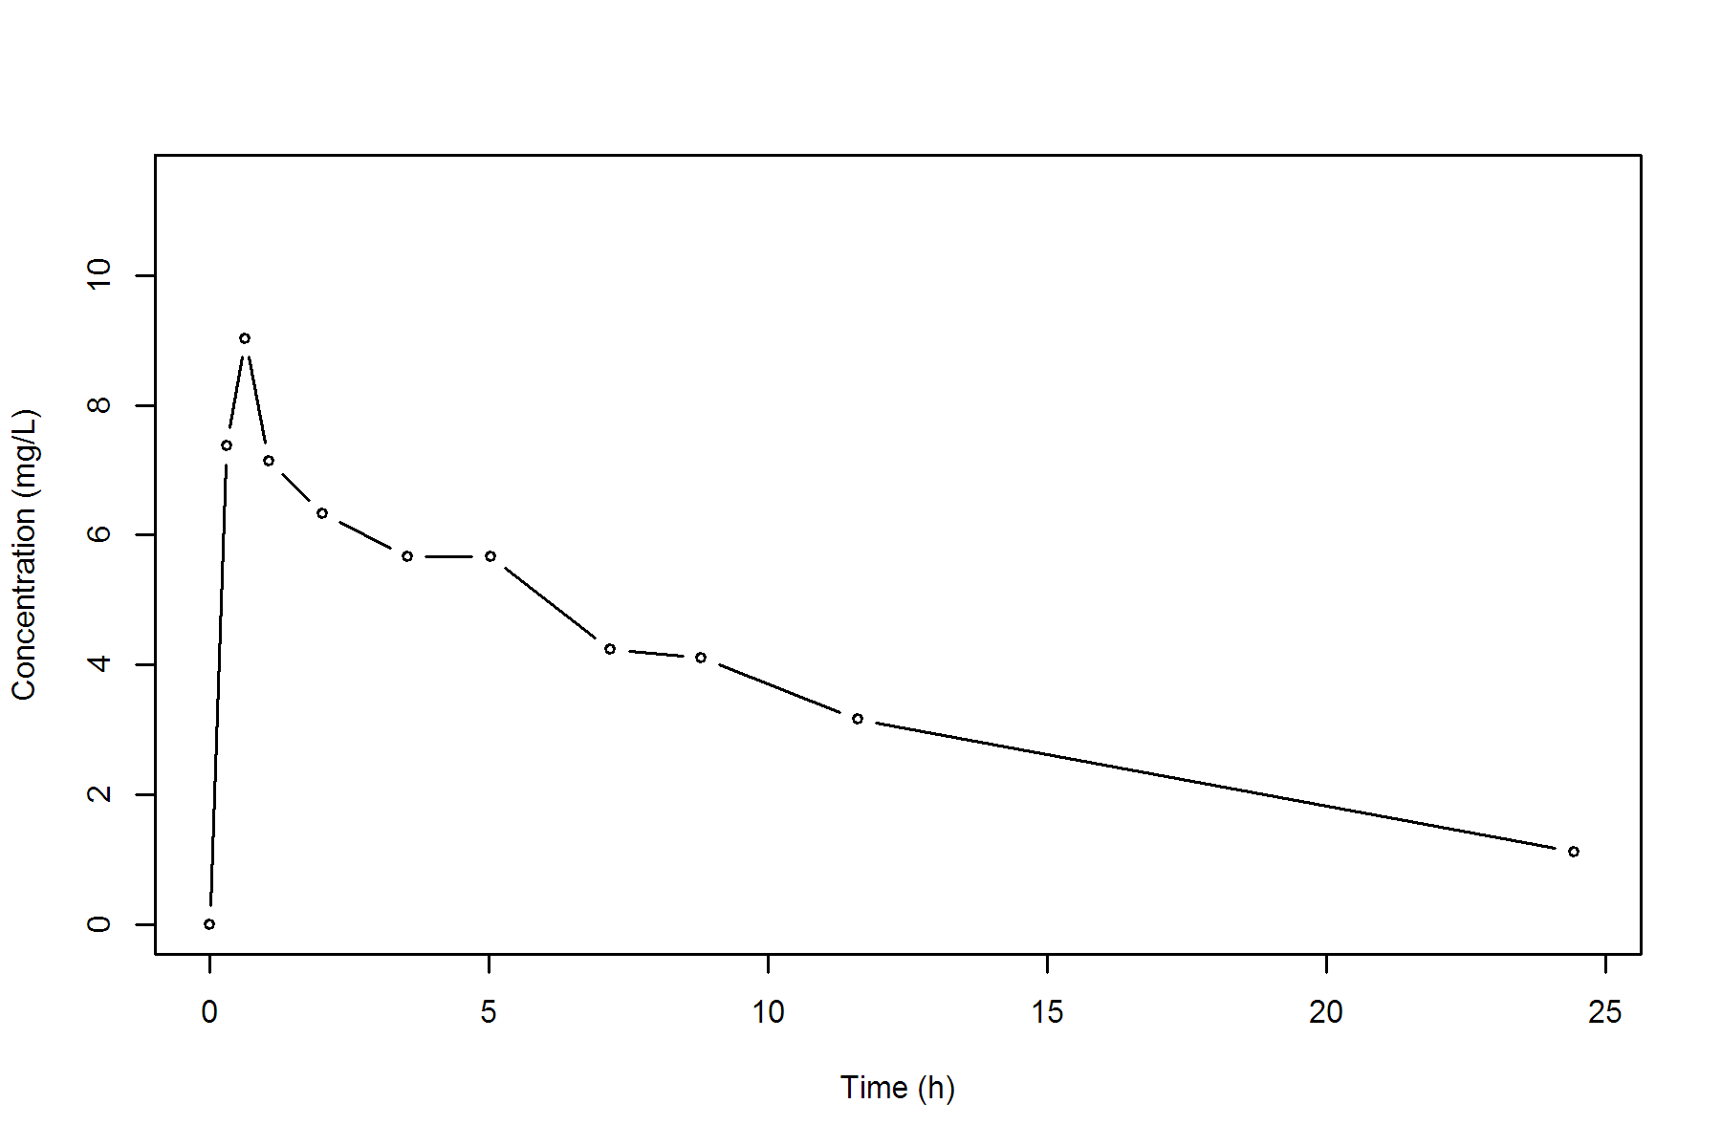
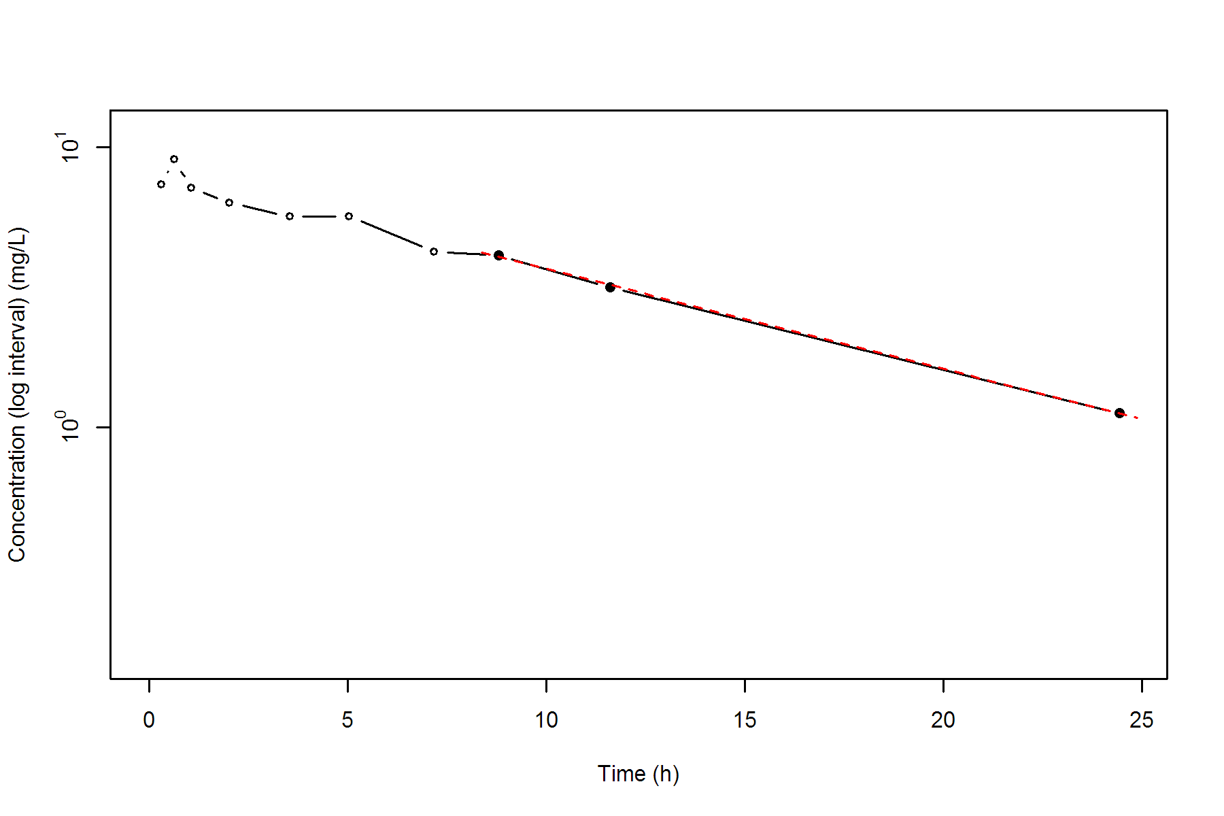
Subject=10
NONCOMPARTMENTAL ANALYSIS REPORT
Package version 0.4.1 (2018-06-20 KST)
R version 3.5.1 (2018-07-02)

Date and Time: 2018-08-06 17:37:38 Asia/Seoul

Calculation Setting
-------------------
Drug Administration: Extravascular
Observation count excluding trailing zero: 11
Dose at time 0: 320 mg
AUC Calculation Method: Linear-up Linear-down
Weighting for lambda z: Uniform (Ordinary Least Square, OLS)
Lambda z selection criterion: Heighest adjusted R-squared value with precision=1e-4

Fitting, AUC, AUMC Result
-------------------------
Time Conc. Pred. Residual AUC AUMC
---------------------------------------------------------------------
0.0000 0.2400 0.0000 0.0000
0.3700 2.8900 0.5790 0.1978
0.7700 5.2200 2.2011 1.2156
1.0200 6.4100 3.6548 2.5353
2.0500 7.8300 10.9884 14.1690
3.5500 10.2100 24.5184 53.3917
5.0500 9.1800 39.0609 115.3451
7.0800 8.0200 56.5189 220.0328
9.3800 * 7.1400 7.0610 +7.903e-02 73.9529 362.3508
12.1000 * 5.6800 5.7586 -7.858e-02 91.3881 546.9044
23.7000 * 2.4200 2.4137 +6.308e-03 138.3681 1278.1800

*: Used for the calculation of Lambda z.

Calculated Values
-----------------
CMAX Max Conc 10.2100 mg/L
CMAXD Max Conc Norm by Dose 0.0319 mg/L/mg
TMAX Time of CMAX 3.5500 h
TLAG Time Until First Nonzero Conc 0.0000 h
CLST Last Nonzero Conc 2.4200 mg/L
CLSTP Last Nonzero Conc Pred 2.4137 mg/L
TLST Time of Last Nonzero Conc 23.7000 h
LAMZHL Half-Life Lambda z 9.2469 h
LAMZ Lambda z 0.0750 /h
LAMZLL Lambda z Lower Limit 9.3800 h
LAMZUL Lambda z Upper Limit 23.7000 h
LAMZNPT Number of Points for Lambda z 3
CORRXY Correlation Between TimeX and Log ConcY -0.9998
R2 R Squared 0.9995
R2ADJ R Squared Adjusted 0.9990
AUCLST AUC to Last Nonzero Conc 138.3681 h*mg/L
AUCALL AUC All 138.3681 h*mg/L
AUCIFO AUC Infinity Obs 170.6521 h*mg/L
AUCIFOD AUC Infinity Obs Norm by Dose 0.5333 h*mg/L/mg
AUCIFP AUC Infinity Pred 170.5679 h*mg/L
AUCIFPD AUC Infinity Pred Norm by Dose 0.5330 h*mg/L/mg
AUCPEO AUC %Extrapolation Obs 18.9180 %
AUCPEP AUC %Extrapolation Pred 18.8780 %
AUMCLST AUMC to Last Nonzero Conc 1278.1800 h2*mg/L
AUMCIFO AUMC Infinity Obs 2473.9934 h2*mg/L
AUMCIFP AUMC Infinity Pred 2470.8765 h2*mg/L
AUMCPEO AUMC %Extrapolation Obs 48.3354 %
AUMCPEP AUMC % Extrapolation Pred 48.2702 %
VZFO Vz Obs by F 25.0155 L
VZFP Vz Pred by F 25.0279 L
CLFO Total CL Obs by F 1.8752 L/h
CLFP Total CL Pred by F 1.8761 L/h
MRTEVLST MRT Extravasc to Last Nonzero Conc 9.2375 h
MRTEVIFO MRT Extravasc Infinity Obs 14.4973 h
MRTEVIFP MRT Extravasc Infinity Pred 14.4862 h
Subject=10
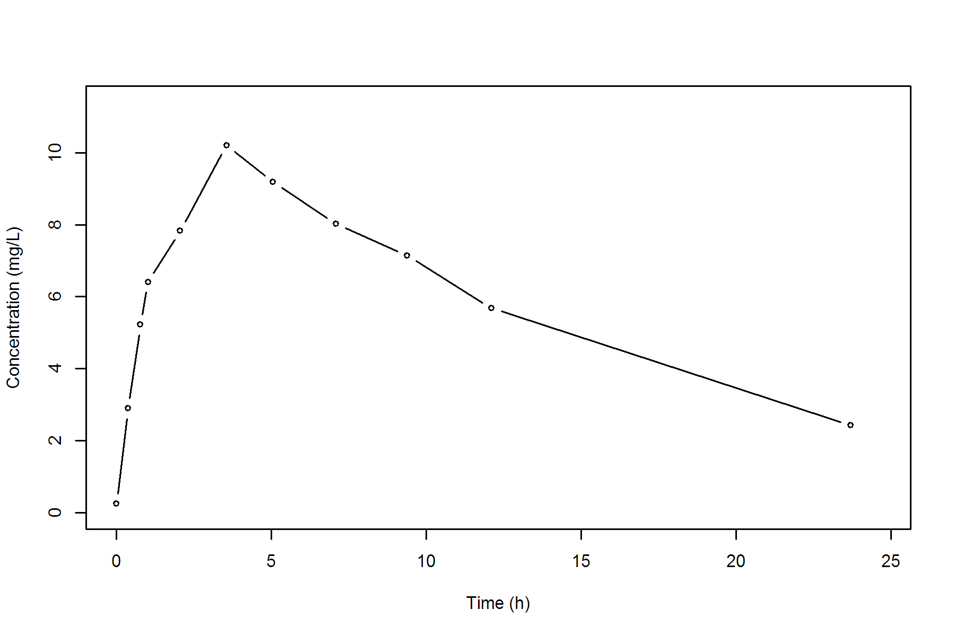
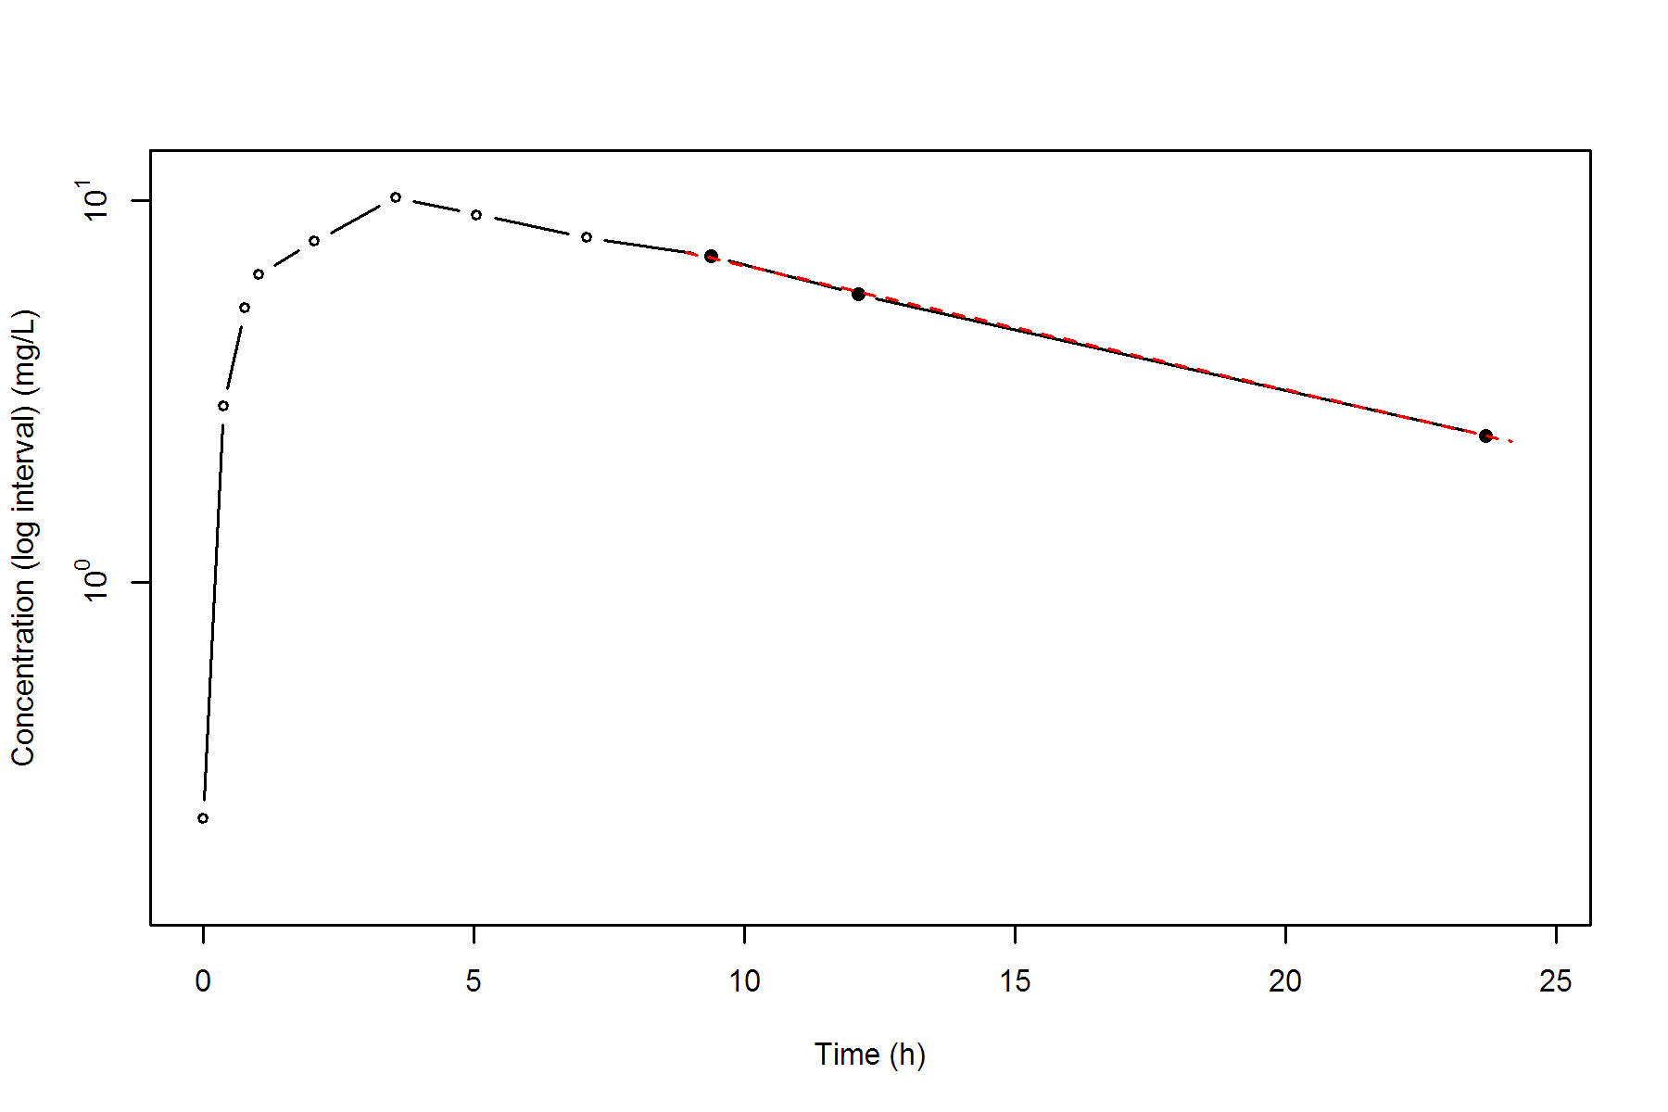
Subject=11
NONCOMPARTMENTAL ANALYSIS REPORT
Package version 0.4.1 (2018-06-20 KST)
R version 3.5.1 (2018-07-02)

Date and Time: 2018-08-06 17:37:39 Asia/Seoul

Calculation Setting
-------------------
Drug Administration: Extravascular
Observation count excluding trailing zero: 11
Dose at time 0: 320 mg
AUC Calculation Method: Linear-up Linear-down
Weighting for lambda z: Uniform (Ordinary Least Square, OLS)
Lambda z selection criterion: Heighest adjusted R-squared value with precision=1e-4

Fitting, AUC, AUMC Result
-------------------------
Time Conc. Pred. Residual AUC AUMC
---------------------------------------------------------------------
0.0000 0.0000 0.0000 0.0000
0.2500 4.8600 0.6075 0.1519
0.5000 7.2400 2.1200 0.7563
0.9800 8.0000 5.7776 3.5067
1.9800 6.8100 13.1826 14.1686
3.6000 5.8700 23.4534 42.2073
5.0200 5.2200 31.3273 75.8162
7.0300 4.4500 41.0457 133.5915
9.0300 * 3.6200 3.6169 +3.150e-03 49.1156 197.5636
12.1200 * 2.6900 2.6929 -2.948e-03 58.8646 298.4388
24.0800 * 0.8600 0.8598 +1.934e-04 80.0936 617.2422

*: Used for the calculation of Lambda z.

Calculated Values
-----------------
CMAX Max Conc 8.0000 mg/L
CMAXD Max Conc Norm by Dose 0.0250 mg/L/mg
TMAX Time of CMAX 0.9800 h
TLAG Time Until First Nonzero Conc 0.0000 h
CLST Last Nonzero Conc 0.8600 mg/L
CLSTP Last Nonzero Conc Pred 0.8598 mg/L
TLST Time of Last Nonzero Conc 24.0800 h
LAMZHL Half-Life Lambda z 7.2612 h
LAMZ Lambda z 0.0955 /h
LAMZLL Lambda z Lower Limit 9.0300 h
LAMZUL Lambda z Upper Limit 24.0800 h
LAMZNPT Number of Points for Lambda z 3
CORRXY Correlation Between TimeX and Log ConcY -1.0000
R2 R Squared 1.0000
R2ADJ R Squared Adjusted 1.0000
AUCLST AUC to Last Nonzero Conc 80.0936 h*mg/L
AUCALL AUC All 80.0936 h*mg/L
AUCIFO AUC Infinity Obs 89.1027 h*mg/L
AUCIFOD AUC Infinity Obs Norm by Dose 0.2784 h*mg/L/mg
AUCIFP AUC Infinity Pred 89.1007 h*mg/L
AUCIFPD AUC Infinity Pred Norm by Dose 0.2784 h*mg/L/mg
AUCPEO AUC %Extrapolation Obs 10.1110 %
AUCPEP AUC %Extrapolation Pred 10.1089 %
AUMCLST AUMC to Last Nonzero Conc 617.2422 h2*mg/L
AUMCIFO AUMC Infinity Obs 928.5600 h2*mg/L
AUMCIFP AUMC Infinity Pred 928.4900 h2*mg/L
AUMCPEO AUMC %Extrapolation Obs 33.5269 %
AUMCPEP AUMC % Extrapolation Pred 33.5219 %
VZFO Vz Obs by F 37.6222 L
VZFP Vz Pred by F 37.6230 L
CLFO Total CL Obs by F 3.5914 L/h
CLFP Total CL Pred by F 3.5914 L/h
MRTEVLST MRT Extravasc to Last Nonzero Conc 7.7065 h
MRTEVIFO MRT Extravasc Infinity Obs 10.4212 h
MRTEVIFP MRT Extravasc Infinity Pred 10.4207 h
Subject=11
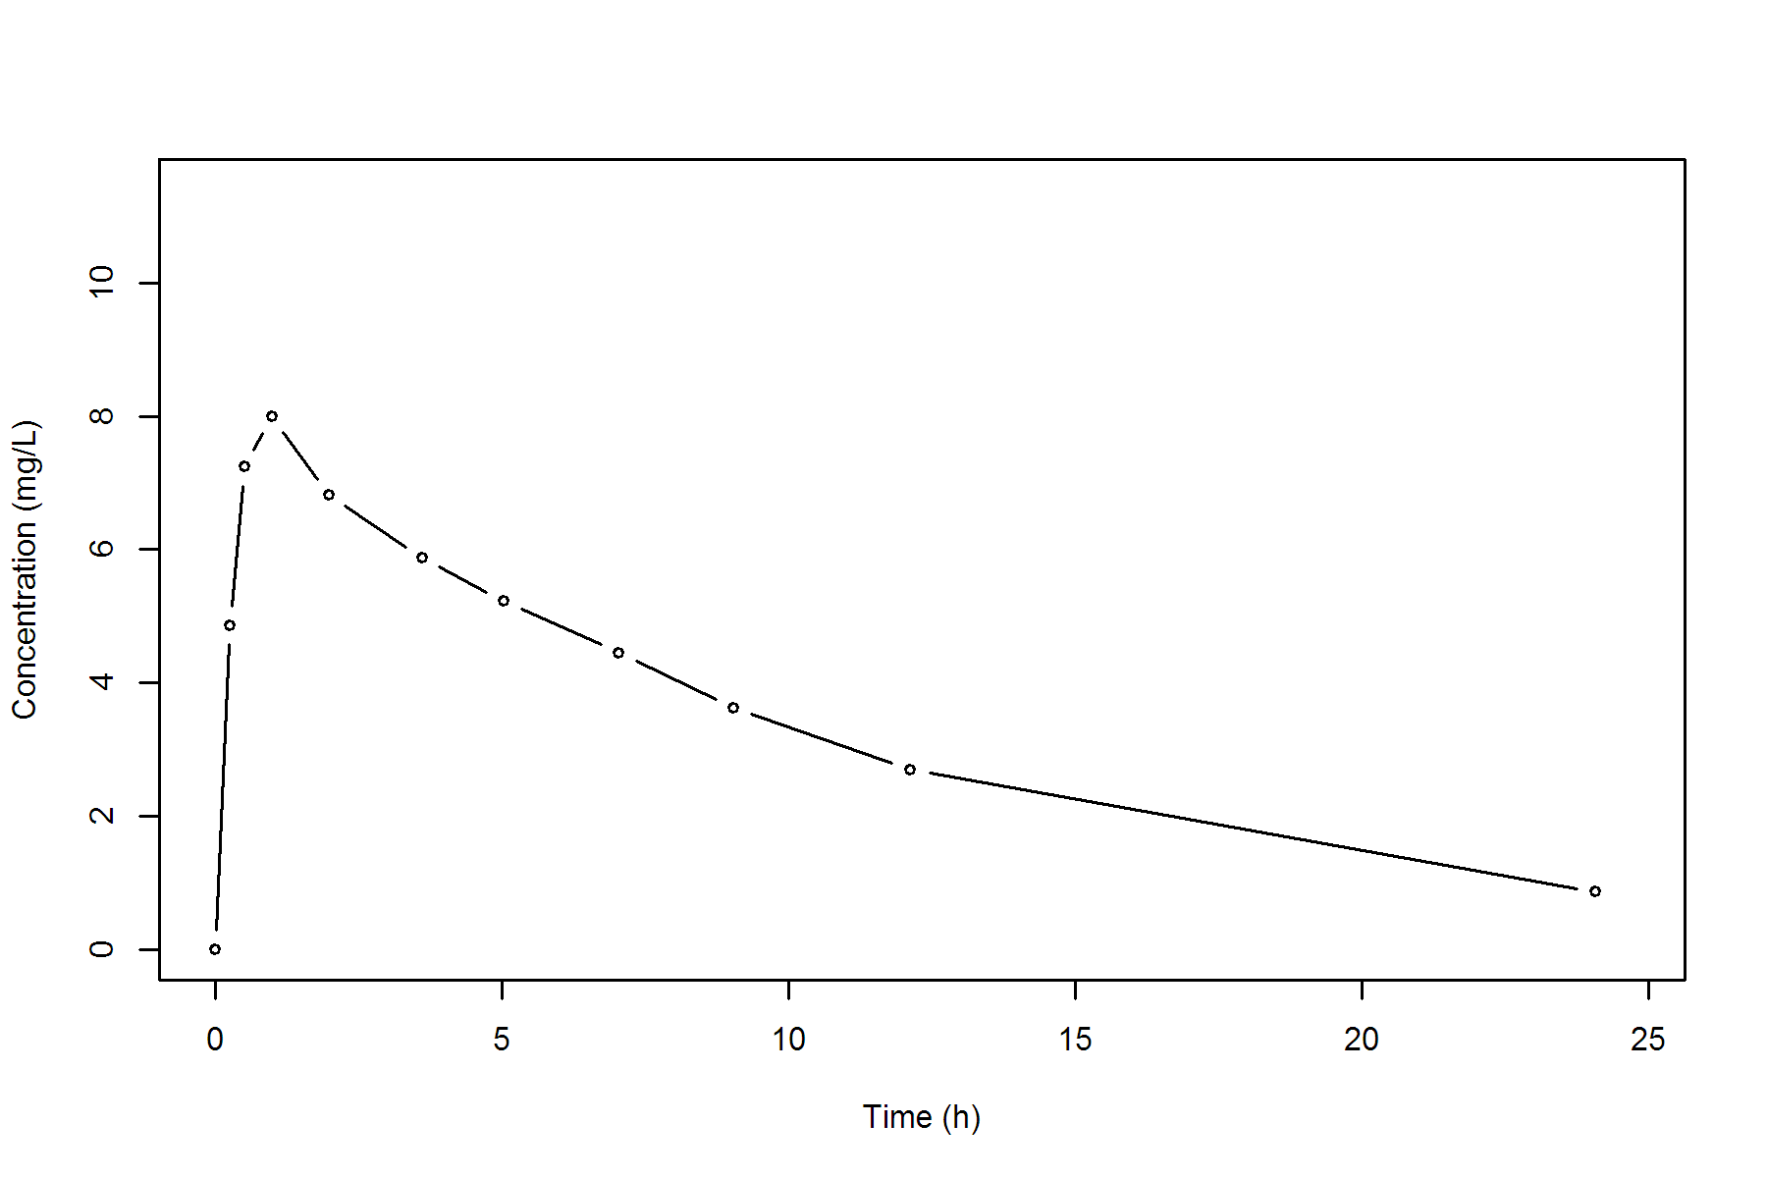
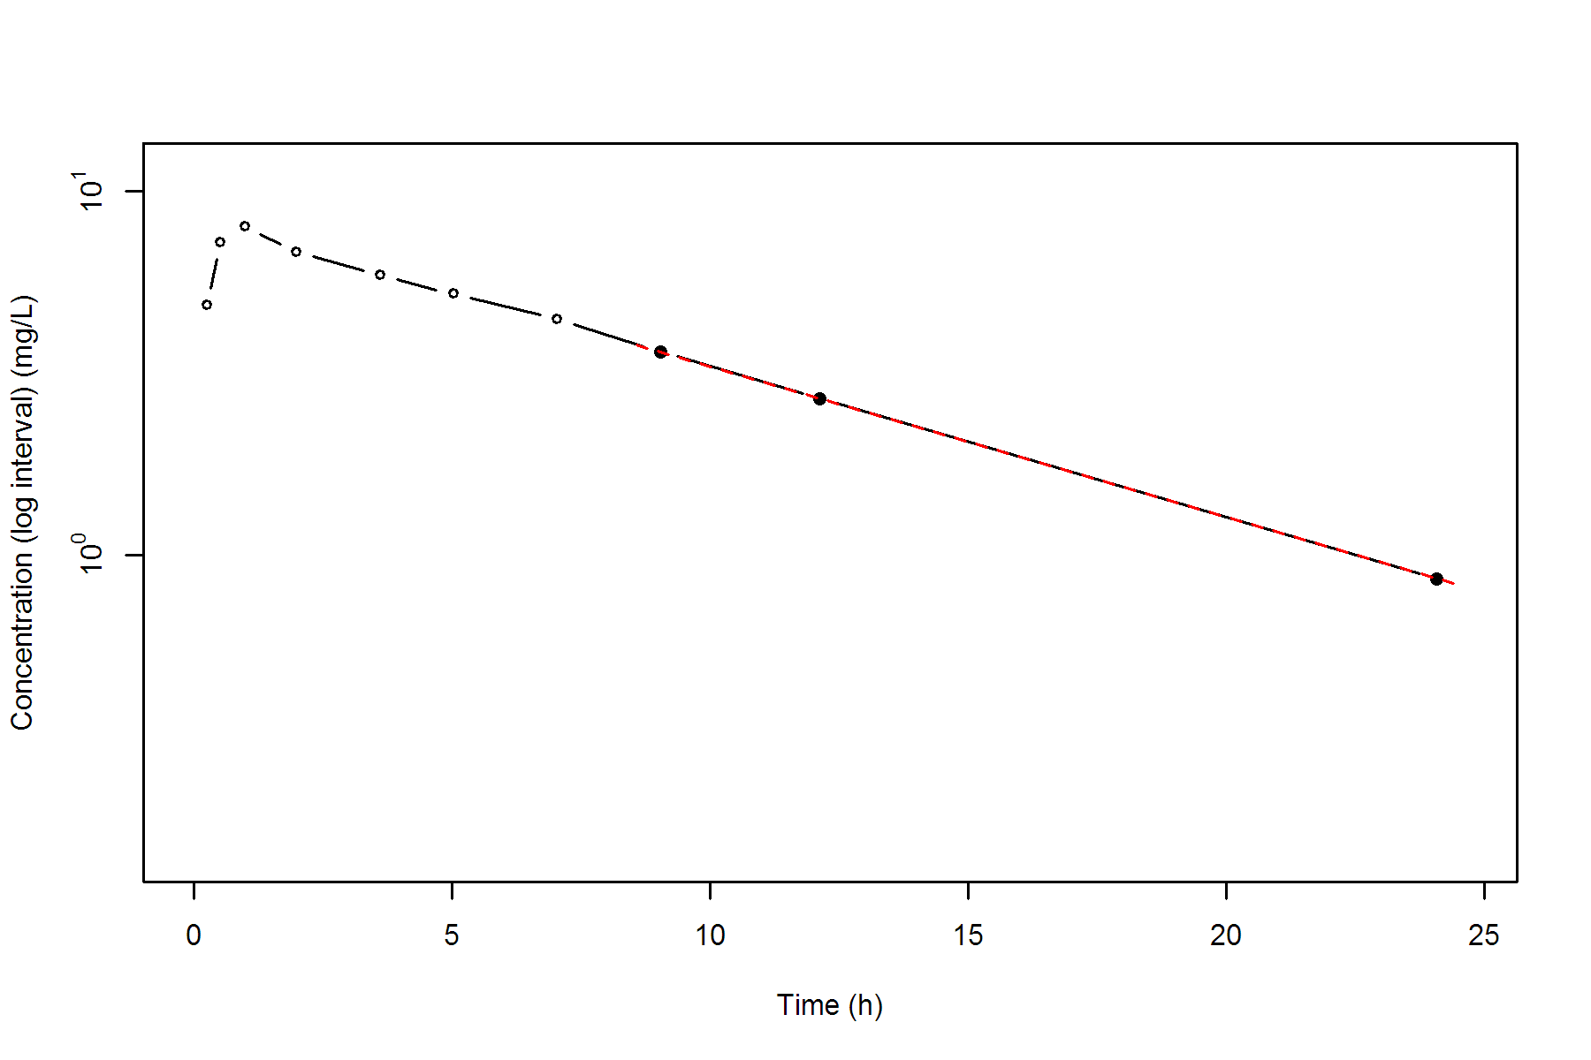
Subject=12
NONCOMPARTMENTAL ANALYSIS REPORT
Package version 0.4.1 (2018-06-20 KST)
R version 3.5.1 (2018-07-02)

Date and Time: 2018-08-06 17:37:40 Asia/Seoul

Calculation Setting
-------------------
Drug Administration: Extravascular
Observation count excluding trailing zero: 11
Dose at time 0: 320 mg
AUC Calculation Method: Linear-up Linear-down
Weighting for lambda z: Uniform (Ordinary Least Square, OLS)
Lambda z selection criterion: Heighest adjusted R-squared value with precision=1e-4

Fitting, AUC, AUMC Result
-------------------------
Time Conc. Pred. Residual AUC AUMC
---------------------------------------------------------------------
0.0000 0.0000 0.0000 0.0000
0.2500 1.2500 0.1563 0.0391
0.5000 3.9600 0.8075 0.3256
1.0000 7.8200 3.7525 2.7756
2.0000 9.7200 12.5225 16.4056
3.5200 9.7500 27.3197 57.2632
5.0700 8.5700 41.5177 117.5349
7.0700 6.5900 56.6777 207.5761
9.0300 * 6.1100 6.2267 -1.167e-01 69.1237 307.3054
12.0500 * 4.5700 4.4632 +1.068e-01 85.2505 473.7705
24.1500 * 1.1700 1.1755 -5.539e-03 119.9775 977.8807

*: Used for the calculation of Lambda z.

Calculated Values
-----------------
CMAX Max Conc 9.7500 mg/L
CMAXD Max Conc Norm by Dose 0.0305 mg/L/mg
TMAX Time of CMAX 3.5200 h
TLAG Time Until First Nonzero Conc 0.0000 h
CLST Last Nonzero Conc 1.1700 mg/L
CLSTP Last Nonzero Conc Pred 1.1755 mg/L
TLST Time of Last Nonzero Conc 24.1500 h
LAMZHL Half-Life Lambda z 6.2865 h
LAMZ Lambda z 0.1103 /h
LAMZLL Lambda z Lower Limit 9.0300 h
LAMZUL Lambda z Upper Limit 24.1500 h
LAMZNPT Number of Points for Lambda z 3
CORRXY Correlation Between TimeX and Log ConcY -0.9997
R2 R Squared 0.9994
R2ADJ R Squared Adjusted 0.9988
AUCLST AUC to Last Nonzero Conc 119.9775 h*mg/L
AUCALL AUC All 119.9775 h*mg/L
AUCIFO AUC Infinity Obs 130.5888 h*mg/L
AUCIFOD AUC Infinity Obs Norm by Dose 0.4081 h*mg/L/mg
AUCIFP AUC Infinity Pred 130.6391 h*mg/L
AUCIFPD AUC Infinity Pred Norm by Dose 0.4082 h*mg/L/mg
AUCPEO AUC %Extrapolation Obs 8.1258 %
AUCPEP AUC %Extrapolation Pred 8.1611 %
AUMCLST AUMC to Last Nonzero Conc 977.8807 h2*mg/L
AUMCIFO AUMC Infinity Obs 1330.3840 h2*mg/L
AUMCIFP AUMC Infinity Pred 1332.0528 h2*mg/L
AUMCPEO AUMC %Extrapolation Obs 26.4964 %
AUMCPEP AUMC % Extrapolation Pred 26.5884 %
VZFO Vz Obs by F 22.2243 L
VZFP Vz Pred by F 22.2157 L
CLFO Total CL Obs by F 2.4504 L/h
CLFP Total CL Pred by F 2.4495 L/h
MRTEVLST MRT Extravasc to Last Nonzero Conc 8.1505 h
MRTEVIFO MRT Extravasc Infinity Obs 10.1876 h
MRTEVIFP MRT Extravasc Infinity Pred 10.1964 h
Subject=12
