How to use R markdown

AMC Subintern

2017-08-02

Table of Contents

# Introduction

이것은 R 마크다운입니다.

# install.packages('tidyverse')  
library(tidyverse)

## Warning: package 'tidyverse' was built under R version 3.4.1

## Loading tidyverse: ggplot2  
## Loading tidyverse: tibble  
## Loading tidyverse: tidyr  
## Loading tidyverse: readr  
## Loading tidyverse: purrr  
## Loading tidyverse: dplyr

## Warning: package 'readr' was built under R version 3.4.1

## Conflicts with tidy packages ----------------------------------------------

## filter(): dplyr, stats  
## lag(): dplyr, stats

# Materials and Methods

Theoph의 앞부분입니다.

head(Theoph)

## Grouped Data: conc ~ Time | Subject  
## Subject Wt Dose Time conc  
## 1 1 79.6 4.02 0.00 0.74  
## 2 1 79.6 4.02 0.25 2.84  
## 3 1 79.6 4.02 0.57 6.57  
## 4 1 79.6 4.02 1.12 10.50  
## 5 1 79.6 4.02 2.02 9.66  
## 6 1 79.6 4.02 3.82 8.58

Theoph의 뒷부분입니다.

tail(Theoph)

## Grouped Data: conc ~ Time | Subject  
## Subject Wt Dose Time conc  
## 127 12 60.5 5.3 3.52 9.75  
## 128 12 60.5 5.3 5.07 8.57  
## 129 12 60.5 5.3 7.07 6.59  
## 130 12 60.5 5.3 9.03 6.11  
## 131 12 60.5 5.3 12.05 4.57  
## 132 12 60.5 5.3 24.15 1.17

# Results

그림을 그려볼까요

plotTheoph <- Theoph %>%   
 ggplot(aes(x = Time, y = conc, group = Subject, color = Subject)) +  
 geom_point() +  
 geom_line()  
plotTheoph

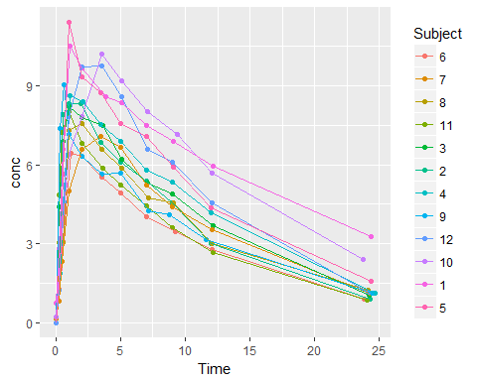

Let's draw individually.

plotTheoph +  
 facet_wrap( ~ Subject, ncol = 4)

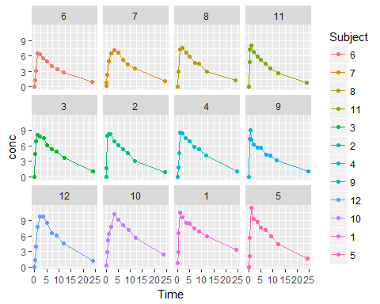

Theoph is used for treating asthma and the other allergic diseases. (Thomson 2017)

Omalizumab is also used for treating asthma (Maltby et al. 2017)

# Discussion

Writing medical papers can be done by Rmarkdown as well as using [Endnote](http://endnote.com/), Mendeley <https://www.mendeley.com/>, refworks, and zotero.

|  |  |  |
| --- | --- | --- |
| 이름 | 메뉴 | 가격 |
| 조하혜 | 카페라떼 | 3500원 |
| 한성필 | 녹차라떼 | 4000원 |
| 배균섭 | 케이크 | 14000원 |
| 임형석 | 아이스아메리카노 | 3000원 |

So now we learned several things.

* R
* R packages - tidyverse, ggplot2
* Drawing figures by R
* Rmarkdown

Next time we will learn these

1. How to use basic NCA R package
2. How to use Phoenix WinNonLin software
3. How to become successful clinical investigator

[Online Figure](http://www.radiokorea.com/images/news/2017/02/17/251890/1.gif)



Online Figure

# Reference

Maltby, Steven, Peter G Gibson, Heather Powell, and Vanessa M McDonald. 2017. “Omalizumab Treatment Response in a Population with Severe Allergic Asthma and Overlapping Copd.” *Chest* 151 (1). Elsevier: 78–89.

Thomson, Neil C. 2017. “New and Developing Non-Adrenoreceptor Small Molecule Drugs for the Treatment of Asthma.” *Expert Opinion on Pharmacotherapy* 18 (3). Taylor & Francis: 283–93.