Tutorial - <https://www.youtube.com/watch?v=DpcM2EdZBNA>

Tutorial - <https://www.youtube.com/watch?v=BiSIAzSZHpY>

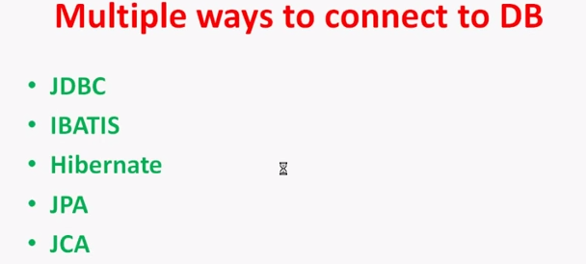

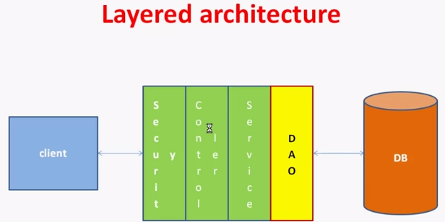

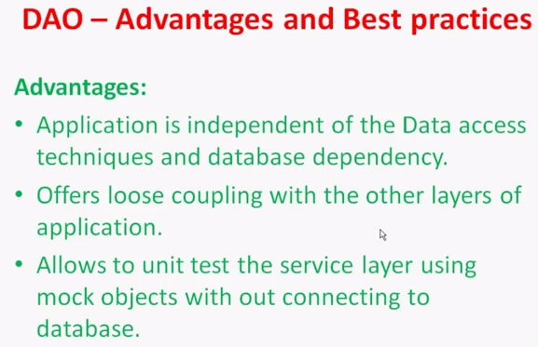

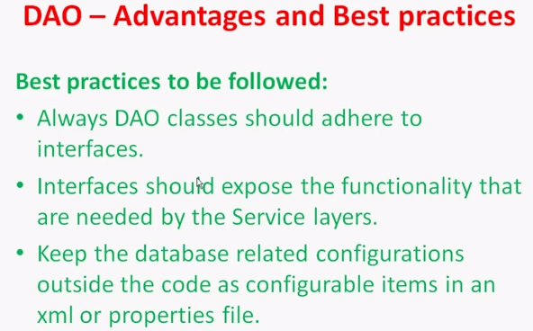

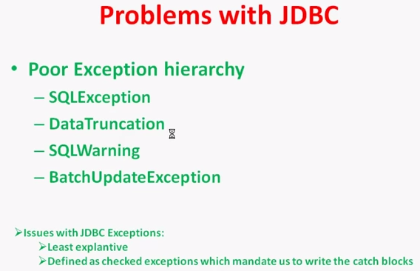

This are all problem to use of JDBC. But if we use Spring-JDBC then we solved all this issue. We will going to use only Spring-Jdbc onward.

In DAO layer jdbc API does not provide powerfull exception handling so always use springJdbc exception.

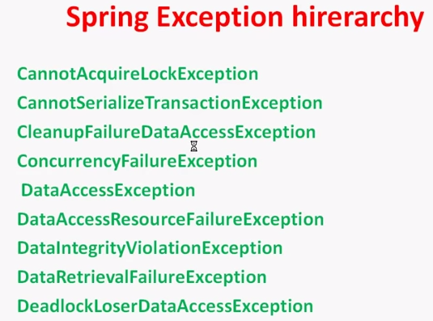

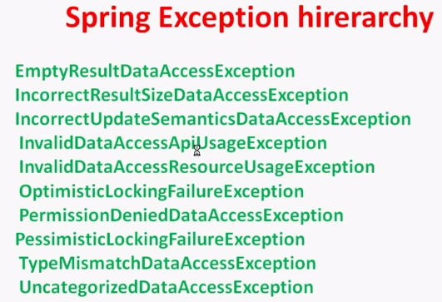

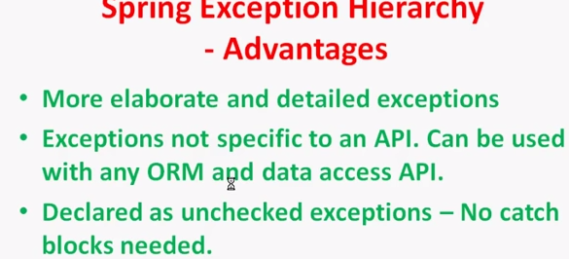

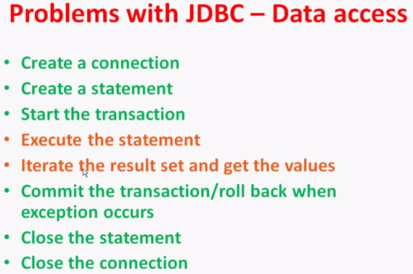

In order to connect database using JDBC without using spring. We have to follow above 8 step among them 6 are common which need to follow in every connection. While 2 which mention in red will different on each database. So, we can say we unnecessarily repeat that 6step which call boilerplate code. We solved that using Spring-JDBC Templates pattern and SpringDaoSupport Classes. We will going to use only SpringDaoSupport classes. Good to have understanding about Spring JDBC Template.

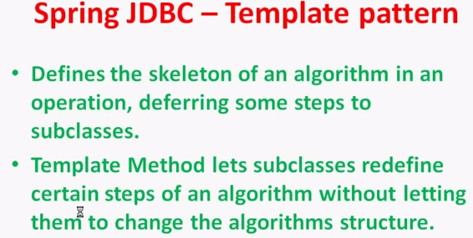

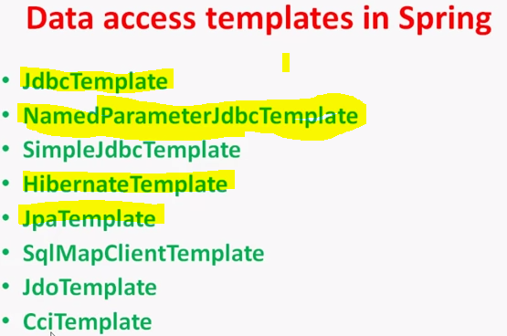

In Realworld we will going to use DaoSupport class.

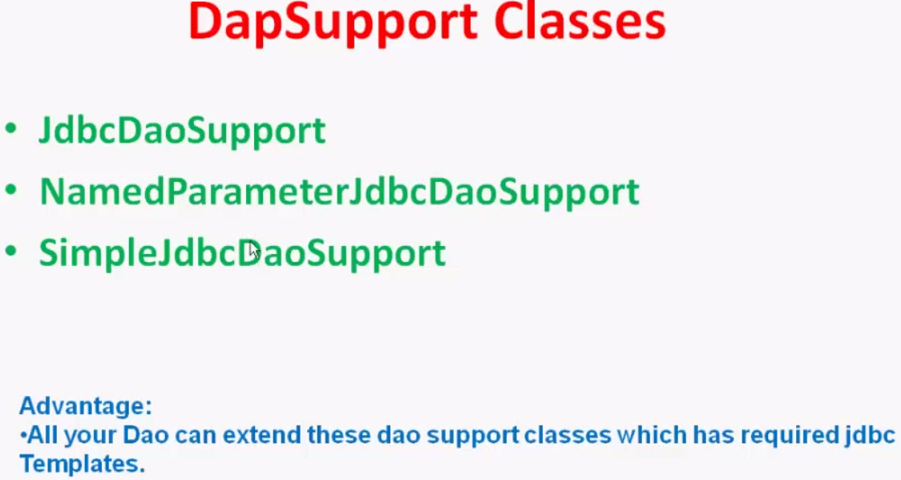

🡪Until right now we understand is, There are two way to connect database using spring-jdbc.

*Using Spring-JdbcTemplates

*Extending Spring-DAO support classes.

🡪In real world good practice is to Extending Spring-DAOSupport class.

Next Three step is only you need to performs to connect database using Spring JDBC Template Pattern.

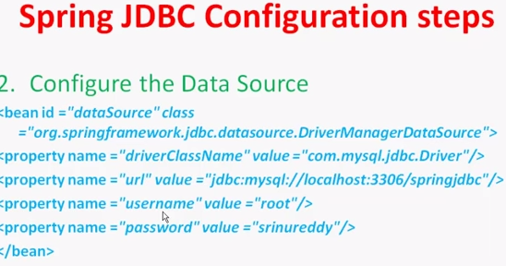

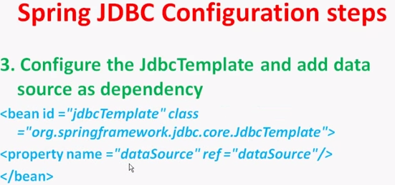

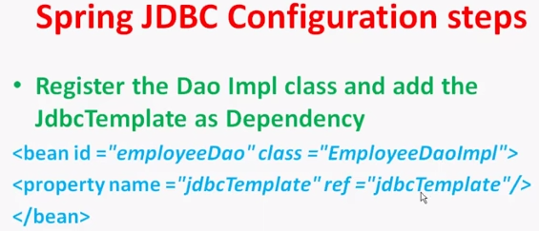

**Now, we will look how to connecting database by extending JdbcDao Support class.**

🡪Think in our application we have many DAO. Example in TRAP ,ClientDAO,ServiceDAO,SequenceDAO ..

🡪This kind of situation we will create one BaseDAO class in which Extended JdbcDaoSupport class. And this class Extended by all other DAO class. ClientDao,ServiceDao……

(1)Create CommonBase Dao class.

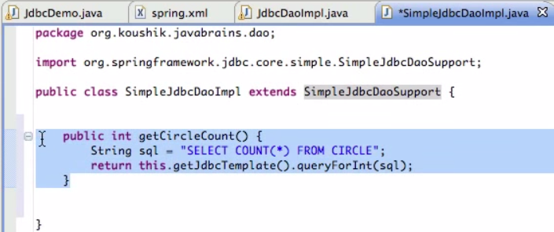

(2)Make Datasoure . Make bean for commonBaseDao. Inject Datasoure into commonBaseDao.

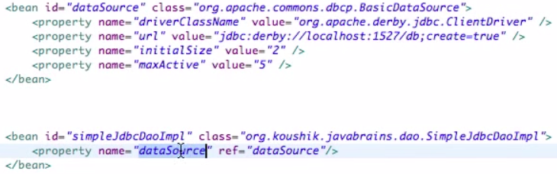

(3) Now extend this commonBaseDao(SimpleJdbcDaoImpl) in all your dao like clientDao, seriveDao, sequeceDao.

🡪we will check Trap Example with ClientDao case.

(1)Create BaseDao .

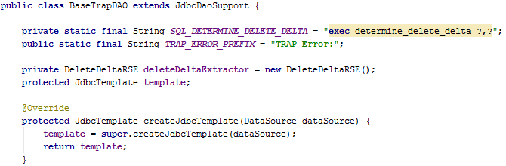

(2)Create Interface for ClientDao class.

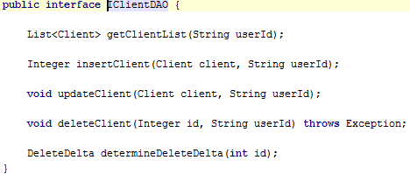

(3)Create Client Dao class.

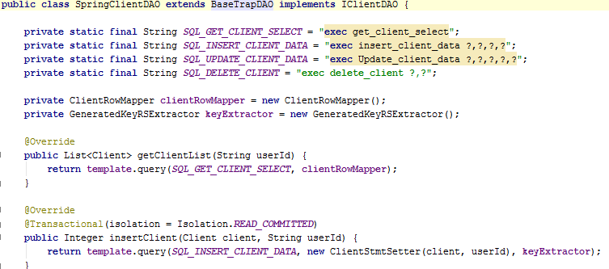

(4).xml file configuration.

