🡪step 2

🡪 creating new react app using react command on front line.

🡪create-react-app ‘appname’.

🡪https://github.com/facebook/create-react-app

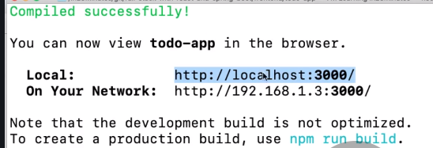

🡪There are two kinds of components in react - Function and Class.

🡪C:\Users\alpeshPC\gitlab1\charter

🡪Main folder and files in react application

-public

-src

-Package.json(Like pom.xml in java)

-react-dom use for window app and reat-native for native apliation.

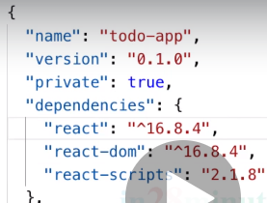

🡪node modules is like target folder

🡪in public folder importan is index.html

🡪in src folder we going to write all code(Java script code)

* Index.js is render index.html file.

Step:5

🡪All fronted is component based. Menu component, footer component so we can reuse component.

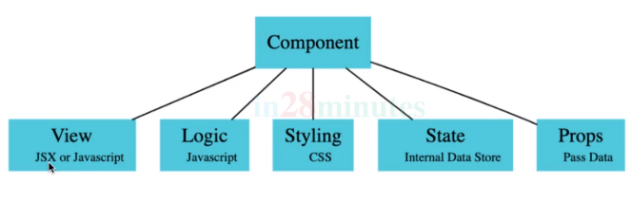

Step;07

Class and function component have little difference. Class component have state.

Step:8 Bable - Bable is conver jsl code to latest javascript code.

<https://babeljs.io>

Step:9