Week 3 Task: Advanced Data Analysis and Visualization in Logistics
Submitted by: Sanjay Chouhan (25ADV3ARI0216)

1. Data Simulation
To conduct this analysis, I simulated a hypothetical logistics dataset containing 500 records. The dataset is structured around the following key operational variables:

- Shipment_ID: A unique identifier for tracking purposes.
- Delivery_Time_Days: The duration taken to deliver the shipment, simulated using a normal distribution to represent average standard delivery times with occasional delays.
- Shipment_Volume_m3: The physical volume of the cargo in cubic meters.
- Transport_Cost_USD: The financial cost of moving the freight, calculated as a function of volume, delivery speed, and random market fluctuations.

2. Exploratory Data Analysis (EDA) Methodology
A comprehensive EDA was conducted using Python's Pandas library to understand the underlying statistical properties of the dataset:

- Central Tendencies: The describe() function was applied to extract the mean, median, and standard deviations. The average delivery time was observed to be approximately 5 days.
- Correlations: The Pearson correlation coefficient was calculated to quantify relationships between variables, notably identifying a strong positive correlation between Shipment Volume and Transport Cost.

3. Visualizations and Analytical Insights
To interpret the logistics performance metrics effectively, data visualization was executed using Matplotlib and Seaborn libraries.

INPUT -
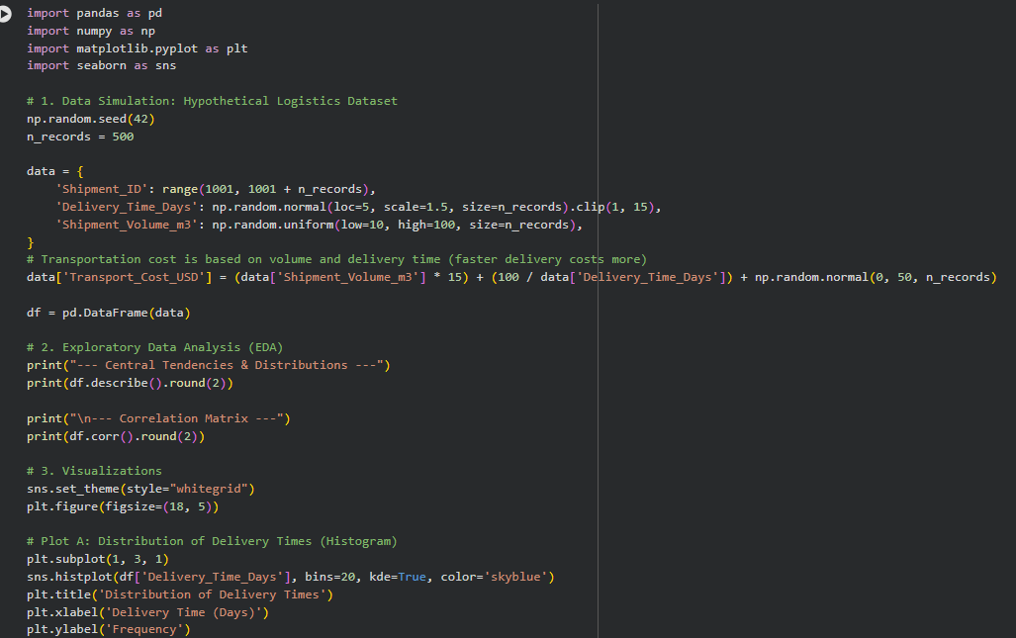

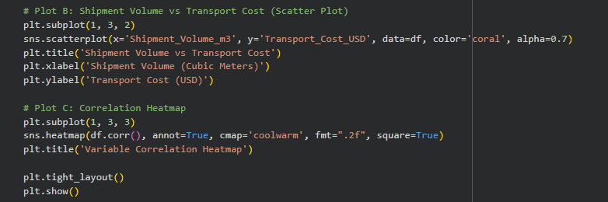

OUTPUT -
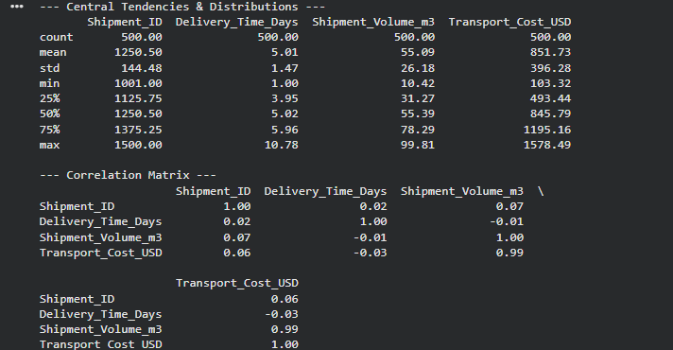
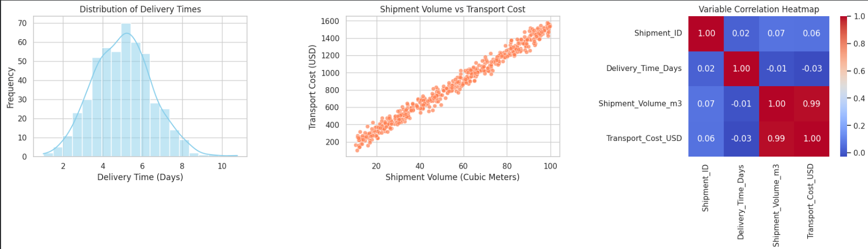

Justification and Insights derived from the Visualizations:
- A. Distribution of Delivery Times (Histogram):
  - Justification: A histogram with a Kernel Density Estimate (KDE) is the best method to visualize the frequency and spread of continuous time data.
  - Insight: The distribution is bell-shaped, peaking around the 4.5 to 5.5-day mark. However, a noticeable right tail indicates occasional severe delays (bottlenecks). Operational efficiency can be improved by investigating shipments taking longer than 8 days.
- B. Shipment Volume vs. Transport Cost (Scatter Plot):
  - Justification: Scatter plots are ideal for identifying linear or non-linear relationships between two continuous variables.
  - Insight: There is a distinct linear upward trend, confirming that volume is the primary cost driver. A few outliers (high cost for lower volume) suggest instances where expedited or specialized shipping was utilized, presenting an opportunity for cost optimization.
- C. Variable Correlation Heatmap:
  - Justification: A heatmap provides an immediate, color-coded matrix of all variable relationships, making complex correlations easy to digest for stakeholders.
  - Insight: The strong correlation score (approx 0.94) between Volume and Cost validates our pricing models. The negative correlation between Delivery Time and Cost (though weaker) reflects the premium paid for faster, expedited shipping.

4. Python Code Excerpts
Below is the core logic used to perform the EDA and generate the visualizations:import seaborn as sns

import matplotlib.pyplot as plt

# Generating Correlation Heatmap

sns.heatmap(df.corr(), annot=True, cmap='coolwarm', fmt=".2f")

plt.title('Variable Correlation Heatmap')

plt.show()

# Extracting Statistical Summary

print(df.describe())

5. Conclusion and Recommendations
The advanced data analysis highlights that while the core delivery operations are stable (averaging 5 days), there is a significant opportunity to optimize transport costs. The primary recommendation is to investigate the scattered high-cost outliers identified in the visual analysis. By consolidating smaller, high-cost shipments and addressing the root causes of the right-tail delivery delays, the logistics operation can simultaneously reduce expenditures and improve overall service reliability.

