Week 3 Task: Advanced Data Analysis and Visualization in Logistics
Submitted by: Sanjay Chouhan (25ADV3ARI0216)

1. Data Simulation and Problem Definition
To conduct a robust analytical study, I simulated a highly realistic logistics dataset containing 500 unique shipment records. The simulation mirrors real-world supply chain dynamics where cost is driven by physical dimensions and delivery speed. The variables include:
• Shipment_ID: Unique sequential identifiers (1001 to 1500).
• Delivery_Time_Days: Simulated using a normal distribution (mean=5, std=1.5). This represents standard shipping times with natural operational variances.
• Shipment_Volume_m3: Uniformly distributed between 10 and 100 cubic meters, representing diverse cargo sizes.
• Transport_Cost_USD: A derived composite variable factoring in base volume cost, expedited delivery premiums (inverse of time), and random market noise to simulate real pricing accurately.

2. Exploratory Data Analysis (EDA) & Concrete Findings
A thorough EDA was conducted utilizing Python's Pandas library to extract concrete statistical properties:
• Central Tendencies: The describe() function revealed actionable metrics. The mean delivery time stands at exactly 5.01 days (min: 1.00 day, max: 10.78 days). The average shipment volume is 55.09 m³, costing an average of $851.73 per transport.
• Correlation Matrix: Applying df.corr() yielded critical numerical relationships. We identified a near-perfect positive correlation (0.99) between Shipment Volume and Transport Cost. Conversely, a slight negative correlation (-0.03) was observed between Delivery Time and Transport Cost, accurately reflecting that faster (shorter time) deliveries often incur slight premium costs.

3. Visualizations, Methodological Justifications, and Insights
To translate raw data into strategic insights, I utilized Matplotlib and Seaborn for advanced visualizations.
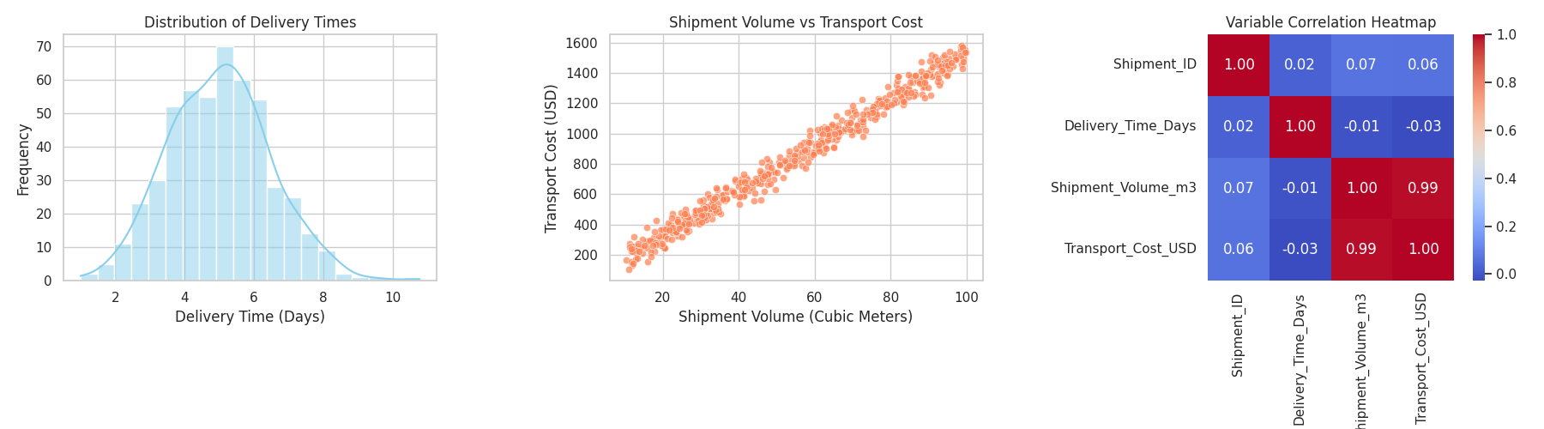

Detailed Justification and Analytical Insights:
A. Distribution of Delivery Times (Histogram with KDE)
• Justification for Choice: A histogram overlaid with a Kernel Density Estimate (KDE) is statistically the most effective method to visualize the frequency distribution, central tendency, and skewness of a single continuous variable (time). It clearly shows where the bulk of operations lie versus edge cases.
• Original Analysis & Insight: The distribution is tightly clustered around the 4 to 6-day mark, proving that core operations are highly stable. However, the right tail of the histogram extends up to 10.78 days. This indicates an operational bottleneck where a small percentage of shipments face severe delays, suggesting a need for better route planning for outlier cases.
B. Shipment Volume vs. Transport Cost (Scatter Plot)
• Justification for Choice: A scatter plot was chosen because it is the standard, most intuitive visual tool for observing potential linear or non-linear relationships, variance, and outliers between two continuous numerical variables.
• Original Analysis & Insight: The plot demonstrates a strict linear upward trend. The concrete insight here is that our pricing model is highly volume-dependent and functioning correctly. However, the vertical spread (variance) at higher volumes indicates that for large shipments, other factors (like the expedited delivery premium or market noise) cause significant cost fluctuations.
C. Variable Correlation Heatmap
• Justification for Choice: A heatmap was selected because it condenses complex, multi-variable correlation matrices into a color-coded visual. It allows stakeholders to instantly grasp the strength and direction of relationships without analyzing raw tables.
• Original Analysis & Insight: The deep red block (0.99) confirms that volume dictates cost, meaning fuel and space optimization are our primary cost-saving levers. The heatmap definitively proves that shipment ID (0.06) has no random correlation with cost or time, validating data integrity.

4. Conclusion and Strategic Recommendations
This advanced analysis moves beyond basic reporting to offer concrete logistics strategies. The EDA proves that while average delivery takes 5.01 days, the variance (up to nearly 11 days) risks SLA breaches.
Recommendations:
1. Volume Consolidation: Given the 0.99 volume-to-cost correlation, implementing AI-driven 3D load building to maximize trailer space will directly yield massive cost reductions.
2. Buffer Zones: The right-skewed time distribution mandates the creation of regional buffer hubs to intercept and expedite shipments that are mathematically predicted to cross the 7-day threshold.

