Assignment 4 Home Theater Facade
Option B | Java | Software Design Patterns

Introduction
The home theater combines a DVD player, amplifier, and projector. Each component has its own state and setup rules. Audio and projection require an active DVD source, so starting a movie involves a sequence of coordinated operations. HomeTheaterFacade makes that sequence available through one call. This implementation is a console simulation.

UML class diagram
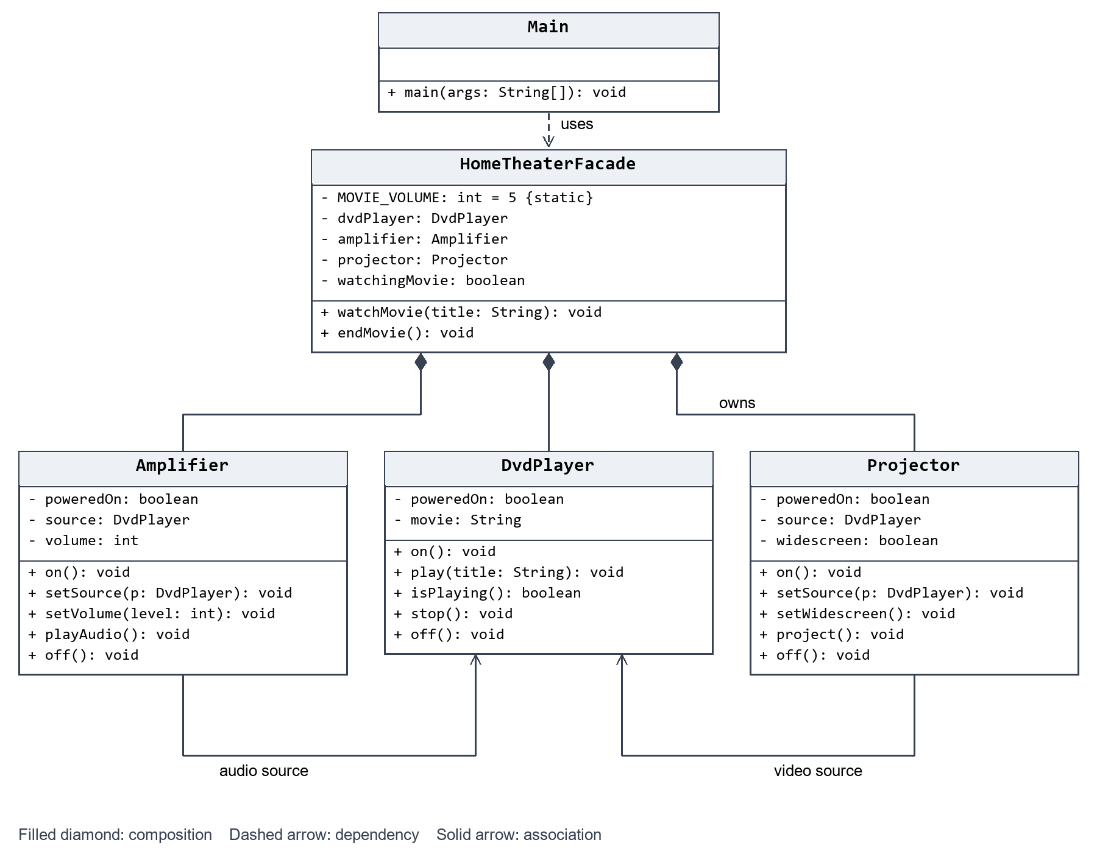
Main uses only the facade. The facade owns the three components; the amplifier and projector reference the DVD player as their source. No subsystem refers back to the facade. The main method and MOVIE_VOLUME constant are static.
Startup powers the devices, connects the sources, sets volume and widescreen mode, and starts DVD playback before audio and projection. Shutdown turns off the outputs before stopping and powering down the DVD player.

Five Clean Code principles

1 Meaningful names
theater.watchMovie(movie); // Expresses the client's goal.
theater.endMovie();
These names describe the operation without requiring knowledge of device commands. The names watchingMovie and MOVIE_VOLUME also communicate their purpose directly.

2 Single Responsibility
dvdPlayer.play(title); // Owns playback state and validation.
amplifier.playAudio(); // Owns audio readiness and volume.
projector.project(); // Owns projection readiness and display mode.
The facade coordinates calls; it does not implement the playback, audio, or projection rules. Each component manages its own state and validation, so changes to its internal rules belong in that class.

3 Encapsulation of subsystem details
// Inside the facade: the device is private.
private final DvdPlayer dvdPlayer = new DvdPlayer();
// In the client: only a movie title is needed.
theater.watchMovie("Interstellar");
The facade exposes watchMovie(String) and endMovie(). It neither returns components nor requires the client to supply them, connect sources, or choose startup order. Advanced clients can still instantiate the public subsystem classes directly.

4 Small focused subsystem classes
public boolean isPlaying() {
// DVD readiness belongs to the DVD player.
return poweredOn && movie != null;
}
The DVD player manages power and playback. The amplifier manages its audio source and volume. The projector manages its video source and display mode. Methods are short and focused; the outputs query source readiness instead of copying the DVD player's state.

5 Proper error handling
if (title == null || title.isBlank()) {
throw new IllegalArgumentException("Movie title must not be blank.");
}
The facade validates input before changing device state and rejects a second movie until the current one ends. The DVD player also validates titles because advanced clients may use it directly.
try {
// Power on, configure, then start playback and outputs.
} catch (RuntimeException failure) {
endMovie(); // Reset components after a partial startup.
throw new IllegalStateException(
"Unable to start the home theater.", failure);
}
If startup fails, the facade shuts down the components and preserves the original exception as the cause. Shutdown is safe to repeat because the simulated components reset their state without throwing. Main displays validation or state errors and uses finally to ensure shutdown.

Conclusion
The facade hides source wiring, volume and display configuration, power sequencing, and failure cleanup. The client only requests that a movie start or end. Subsystem methods remain public and independently usable, with no knowledge of the facade. The design uses three subsystem classes, one facade, and one client, with no packages or external libraries.

GitHub repository
https://github.com/asankhanshyngys/SDP_4th

Defense demonstration
Run Main to demonstrate startup and shutdown. Supply a movie title to change the demo, or a blank title to demonstrate rejection before startup. Explain why playback precedes audio and projection, why Main knows only the facade, and why advanced clients retain direct access to the components.

