Assignment 5 Strategy Pattern

1 Introduction
This project uses Option B, a calculator. Addition, subtraction, and multiplication are interchangeable algorithms behind the OperationStrategy interface. Calculator holds a strategy and delegates the calculation to it. Main selects the operation and changes it at runtime on the same calculator object.

2 UML class diagram
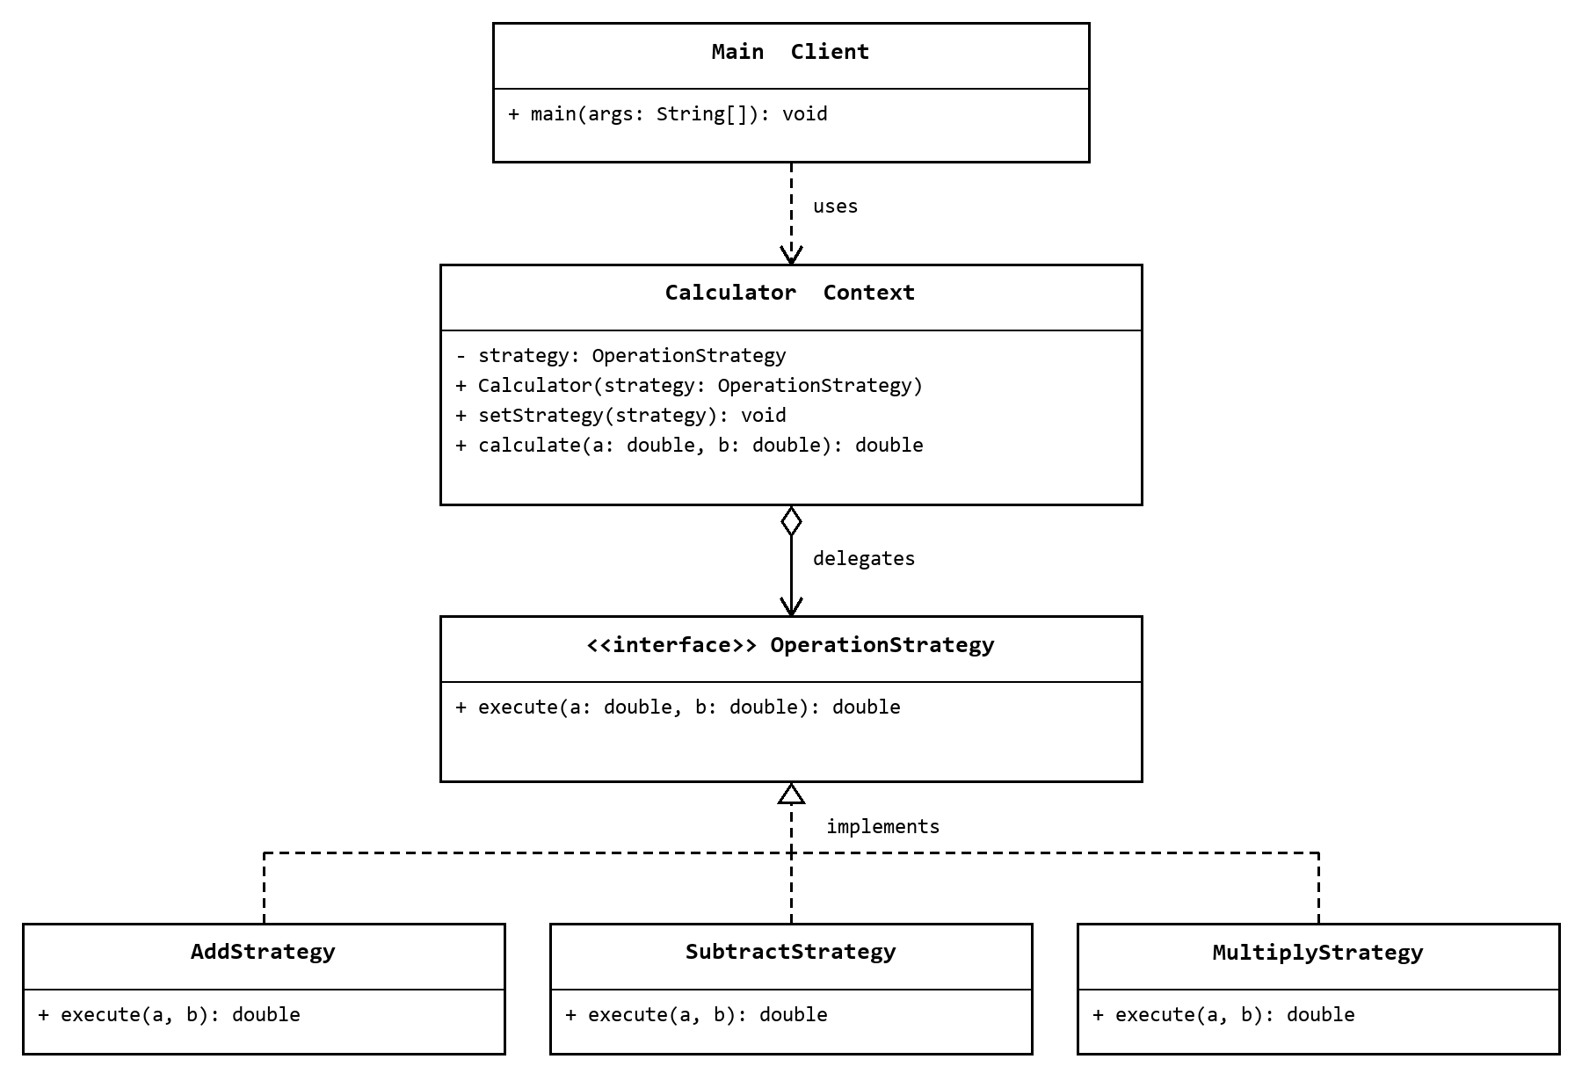
Main creates the concrete strategies and supplies them to Calculator. Dashed lines with a hollow triangle show interface implementation. Calculator holds an OperationStrategy reference and calls its execute method.

3 Clean code principles
Five principles from Chapters 9, 10, and 11 are applied below.

Principle 1 Single concept per test
Chapter 9 Unit Tests. Each test checks one behavior: addition, subtraction, multiplication, or runtime switching. Tests create their own calculator and have one assertion, so they do not share state or depend on execution order. This makes failures easy to locate.
private static void addsTwoNumbers() {
Calculator calculator = new Calculator(new AddStrategy());
assertEquals(15.0, calculator.calculate(10, 5)); // Addition only.
}

Principle 2 Single Responsibility Principle
Chapter 10 Classes. Strategies perform arithmetic, Calculator delegates execution, and Main configures strategies and prints the demo. Each class has a focused reason to change. Changing console output does not require changing an arithmetic class.
// Calculator only delegates the calculation.
public double calculate(double firstNumber, double secondNumber) {
return strategy.execute(firstNumber, secondNumber);
}

Principle 3 Cohesion
Chapter 10 Classes. The constructor, setStrategy, and calculate work with the same private strategy field. The constructor initializes it through the setter, the setter updates it, and calculate uses it. These related methods belong together and support the calculator responsibility.
private OperationStrategy strategy; // Shared state.
public void setStrategy(OperationStrategy strategy) {
this.strategy = Objects.requireNonNull(strategy, "Strategy is required");
}
public double calculate(double firstNumber, double secondNumber) {
return strategy.execute(firstNumber, secondNumber); // Same field.
}

Clean code principles continued

Principle 4 Isolating from change
Chapter 10 Classes. Calculator depends on the OperationStrategy interface, so changing an arithmetic implementation does not require changing the context. Division can be added with a new implementation selected in Main. The existing context and strategies stay unchanged; the client still needs to configure the new operation.
// Calculator depends on an interface, not AddStrategy or MultiplyStrategy.
private OperationStrategy strategy;
// OperationStrategy defines the common contract.
double execute(double firstNumber, double secondNumber);

Principle 5 Separate construction from use
Chapter 11 Systems. Main constructs the concrete strategies and supplies them to Calculator. Calculator uses the interface without creating the algorithms itself. Passing a strategy through a constructor or setter is simple dependency injection and needs no framework.
// Main constructs and supplies the algorithm.
Calculator calculator = new Calculator(new AddStrategy());
// The same context can receive another algorithm at runtime.
calculator.setStrategy(new MultiplyStrategy());

4 Conclusion
The demo adds, subtracts, multiplies, and switches back to addition. Calculator has no if or switch for operation types. A new operation requires another strategy and client code to select it; existing strategies and Calculator stay unchanged. The extra classes add structure to a basic calculator but make algorithms easy to replace. All four tests pass.

5 GitHub repository
https://github.com/asankhanshyngys/SDP_5

