Experimental report 1

Working with a tolerance parameter tr=0.1 and an absolute tolerance of ta=5 we can see in the following graphs the result of applying the evaluation method.

In the following figure we can see the tool used to test BOM algorithm.


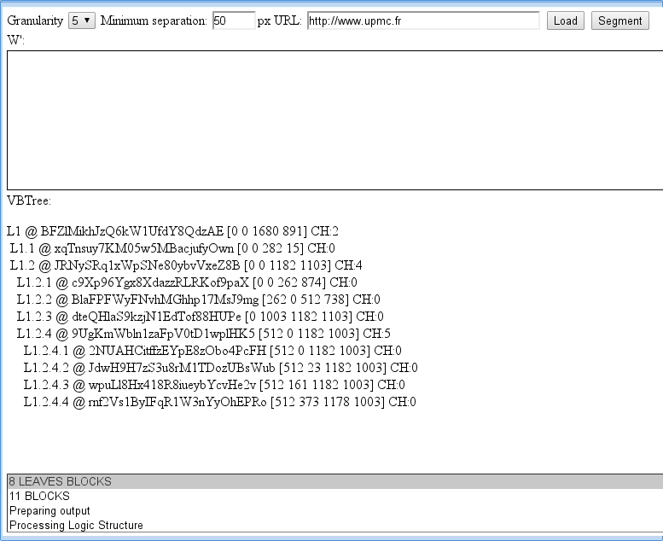

In the folowing figure it can be seen the tool for VIPS algorithm evaluation.

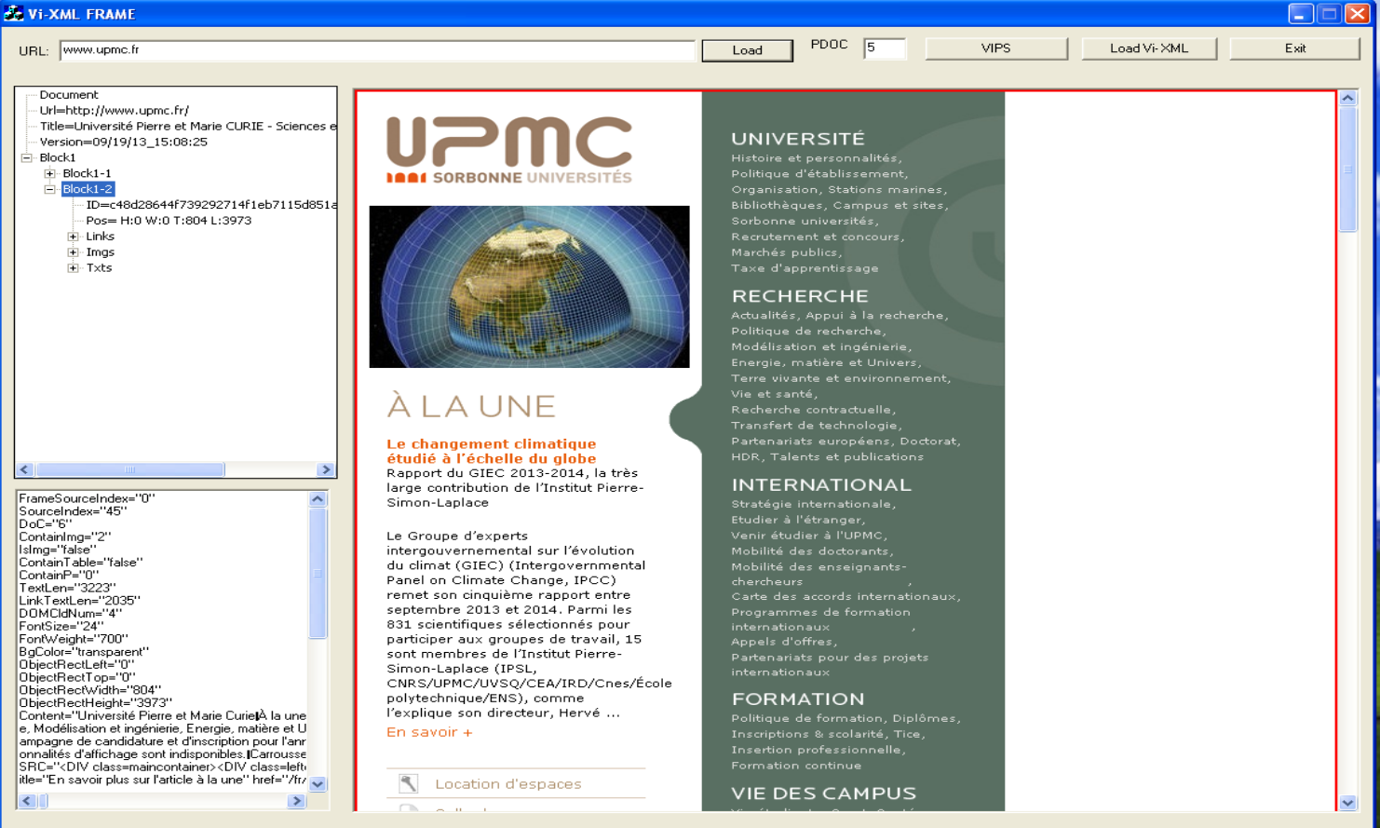
After been done this first iteration with 40 pages we have had the following results

Both VIPS and BOM are very close in all values, but it seems that when the amount of GT blocks are increased BOM approaches but VIPS get lower score, that is more over/under segmentations misses/extra blocks appears.

