Web Page Segmentation Evaluation
Explaining Results

Evaluation Overview

The evaluation is based on the geometric comparison of to blocks. Segmentations algoritms are compared to a ground truth predefined. One pair of blocks can have two possibles states:
- Equal
- Contained
The evaluation algorithm construct a bipartite graph, where the first set of nodes represents those blocks of the ground (G) thuth while the other set represent the blocks found by a segmentation algorithm (S).

Algorithm consideration:
- if the coordinates of a block in G are similar to those of a block in S, we say there is a one-to-one match, and viceversa.
- If the coordinates of a block in G resides into the area of a block in S, we say there is a contaiment, and viceversa.

Evaluation vocabulary
The terms used to understand the evaluation are the following:
- Correct, if between two nodes (one in G and other in S) exists a one-to-one match.
- Oversegmentation, if one node of G has several blocks of S contained.
- Undersegmentation, if one node of S has several blocks of G contained.
- Missed, if a block in G has no relationship with any block in S.
- False alarm, if a block in S has no relationship with any block in G.

Experiment Overview

We have chosen 400 pages from 16 categories taken from dmoz.org Open Directory. The dmoz directory consists in several levels and subleves of categories and results. One subcategory page can have subcategory list, result list or both. The mechanism taken to select pages was the following:
1 For each category:
1.1 If there is a result list
1.1.1 take the first hyperlink found
1.2 If there are subcategories
1.2.1 explore each subcategory sorted by the amount of subcategories it has and return to step 1
1.3 stop if 25 results are taken

Then for for each page the following steps have been done:
1. ground truth segmentation
2. Segmentation using BOM
3. Segmentation using VIPS

For each block found we register:

Browser | Category | Url | Doc width | Doc height | Block x | Block y | Block w | Block h

For example:

GT | chrome | Arts | http://www.drehorgelclub.de | 1009 | 1632 | G0 | 24.5 | 0 | 984.5 | 152
BOM | chrome | Arts | http://www.drehorgelclub.de | 1013 | 1659 | L1.1.1 | 24.5 | 0 | 984.5 | 152
VIPS | Iexplorer | Arts | http://www.drehorgelclub.de | 960 | 1571 | VB1.1 | 98 | 0 | 1058 | 152

These segmentations have been compared independently to the Ground Truth. In the following figure we can see a screenshot taken form the web page http://www.drehorgelclub.de/ using the BOM algorithm. In the same figure we chose the geometric threshold (tt=25px).

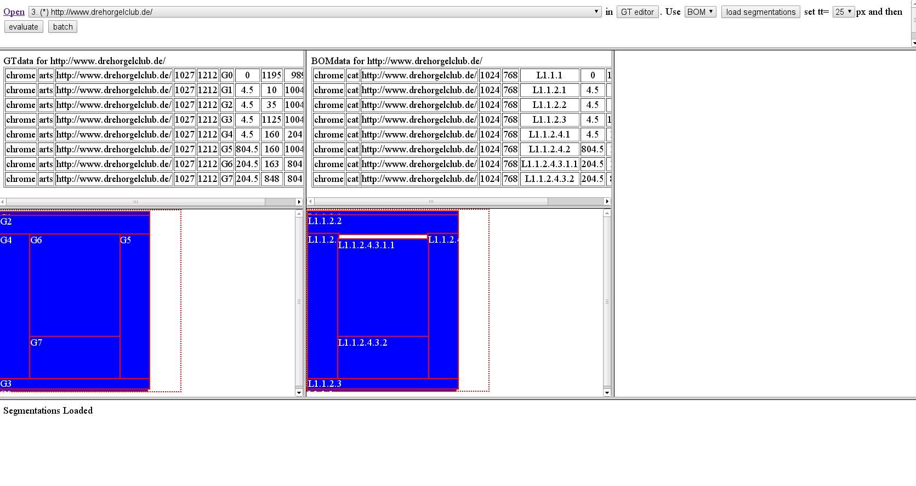
The same procedure has been used to VIPS algorithm:
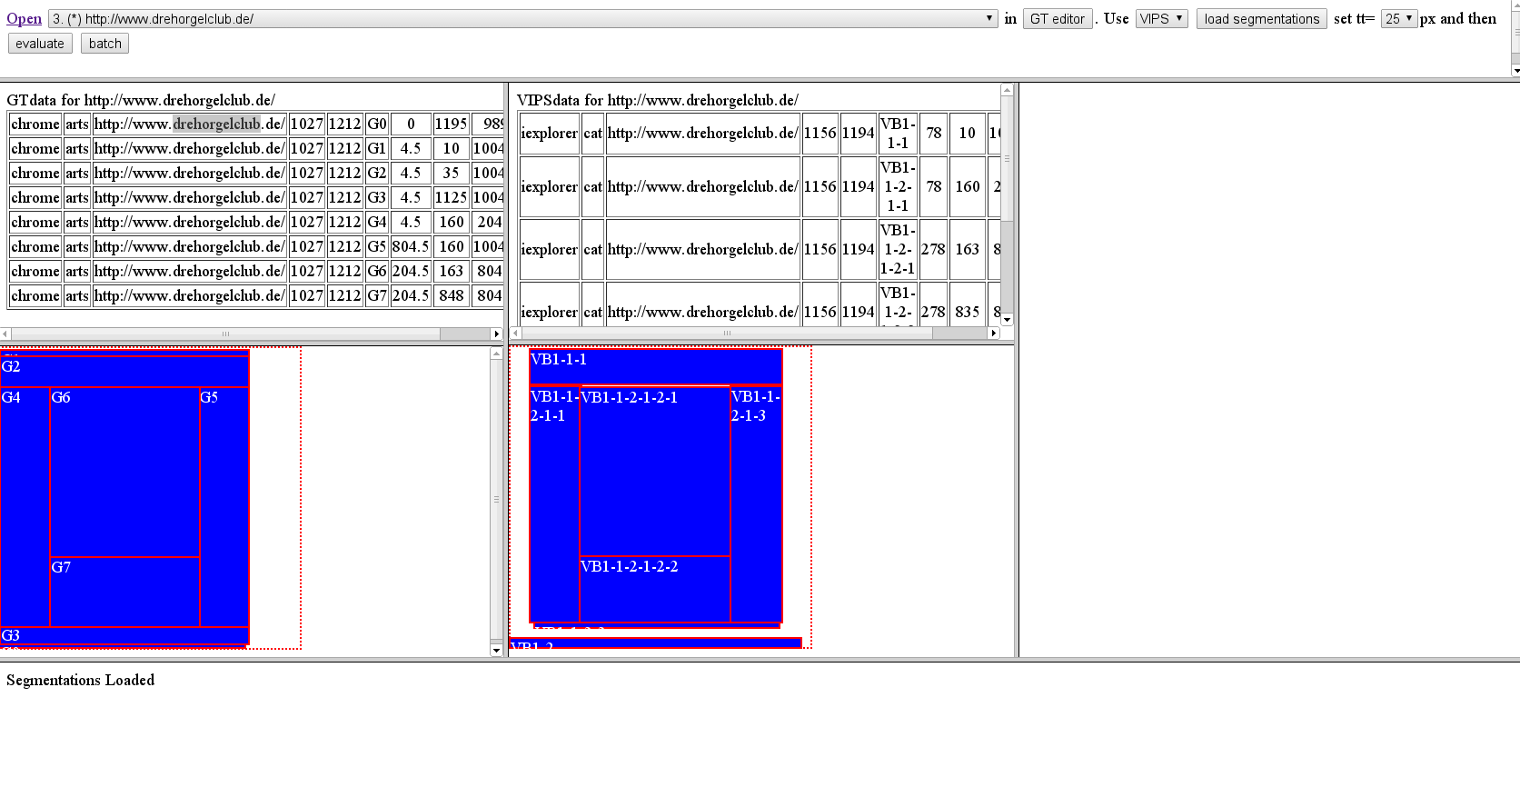

After all data in the category is processed for all threshold values (0px-50px) the results can be processed in tabular form.

For each evaluation we register the following:

Algorithm | Url | Tc | To | Tu | Co | Cu | Cm | Cf | tt | Gt | St

Where:
- Algorithm can be BOM or VIPS
- URL is the web page url been evaluated
- Tc = Total Correct blocks
- To = Total Oversegmented blocks (togheter both G and S)
- Tu = Total Undersegmented blocks (togheter both G and S)
- Co = Oversegmented blocks (affects only G)
- Cu = Undersegmented blocks (affects only S)
- tt, tolerance in pixels
- Gt, total blocks in Ground truth
- St, total found by algorithm

For example,

Alg. | URL | Tc | To | Tu | Co | Cu | Cm | Cf | Tt | Gt | St
BOM | http://www.drehorgelclub.de/ | 6 | 2 | 2 | 2 | 2 | 0 | 0 | 25 | 8 | 8
VIPS | http://www.drehorgelclub.de/ | 5 | 0 | 0 | 0 | 0 | 2 | 3 | 25 | 8 | 7

In the following figures we can see an example for the category society:

