Didgeridata

Adam Santone

2019-07-17

# Introduction

This activity guides groups of students through a brief study of the history and construction of either a didgeridoo, the world’s oldest wind instrument, or a paixiao, a chinese pan flute. Students will work with polyvinyl chloride (PVC) pipe and PVC-cutting tools to design and create a playable musical instrument which will be used by students to compose a custom song related to climate data such as atmospheric CO concentration or global temperature anomalies. In this way, the sonification of climate data will be accomplished with a student musical chorus. The activity will conclude with a group jam session with participants invited to provide percussion for the wind section. An attempt will be made to have expert musicians join the program via teleconference as a guest speaker to provide instruction and background information.

## Author Statement on Activity Origins

To tell the story of how this lesson came into existence, I need to mention that it was built from prior working relationships and my interests in music and data visualization. My background is in science, interactive computer graphics, 3D media, video, and K-12 STEAM outreach. I met some interesting people in my career and this lesson brings some of that experience and exposure together in what I hope is an interesting, fun way.

This activity began as an idea around the theme of air and is based in part on a past professional collaboration I had with a local musician and contemporary flamenco band. I worked in a role combining teacher professional development and creative curriculum development which included some work on documentary-style videos. Through that experience I became familiar with the music of this local band and specifically the use of the didgeridoo by one of the band members. The sound was really interesting to me and I knew something of the relationship of didgeridoo morphology and sound quality from a video I produced with this band member. That’s one inspiration: didgeridoo music! We later decided to add in the paixiao, a type of pan flute, to help boost engagement and regional connections. The paixiao is also a relatively simple instrument that can be constructed from PVC and inexpensive materials. Together we thought these could yield some very interesting sounds!

What I wanted from this activity was hands-on construction, incorporation of data or data visualization, and musical performance. I knew that the didgeridoo was a relatively simple instrument (basically a tube) and that it could be easily and inexpensively constructed from PVC. I also knew that NASA produced high-quality climate data and worked to make this information available to the public. I thought perhaps students could look at the data or even just the visualizations of data to get some ideas about trends in climate. Perhaps they could study carbon dioxide or temperature levels. That’s a second inspiration: climate data visualization. This is something that could help students with scientific literacy but also to see themselves in the world by examining large, important trends.

A third inspiration for this lesson was the concept of data sonification. A former colleague and friend is a geologist and musician who is interested in transforming data into sound. This concept is similar to visualization, but for hearing instead of seeing. I thought maybe the students could take what they know about climate data and make a song or something similar from that knowledge.

After meeting with a small group to “play-test” the activity, we decided it was important to have the student build some kind of simple notation system for their instruments. There would be no pressure to make it “right” but rather to have students be creative and write something that makes sense for their team and perhaps others to read and use to play a song. This is a good addition because it focuses a bit on literacy, logic, and music at the same time.

The big concept for me is Data->Inspiration->Construction->Notation->Performance. I am hopeful students will look at their world in a fresh way, become inspired to tell a story through music, and then bring this concept to life through the use of their own hands and minds. If all goes well, the audience will learn something about climate and the students will learn something about themselves.

Adam Santone, PhD

# Learning Goals and Success

The learning goals for this activity are for students to:

* Develop an awareness of the science and history of the didgeridoo and the paixiao
* Practice hands-on construction methods to create custom, playable PVC musical instruments
* Develop an awareness of long-term trends in climate data
* Design a custom notation system for performance using the PVC instruments
* Create a collaborative musical piece inspired by climate data
* Perform the custom musical piece using the didgeridoo and/or the paixiao

Success will be determined by:

* Creation of playable PVC musical instruments
* Creation of a notation system that can be used to perform a musical piece
* Creation and performance of a musical piece inspired directly by trends in global climate data

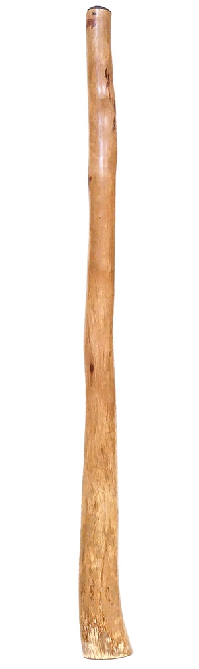

Figure 1: Large Jesse Lethbridge Didgeridoo (4845). Seen at [DidgeridooBreath.com](https://www.didgeridoobreath.com/Large-Jesse-Lethbridge-Didgeridoo-4845-p/d-575-4845.htm)

# Climate Data

## Overview

A wealth of climate change information is available online and students should be encouraged to conduct their own investigations of topics they find interesting. As the theme of this activity is wind, a few NASA resources have been collected for review. Students are expected to draw inspiration from these resources for the purpose of creating a musical piece for performance with their PVC didgeridoo and/or paixiao.

## Data Perceptualization

Quantitative data, in the form of a sea numbers, are usually messy, bloated, and difficult to understand without imposing some kind of order upon them. Humans therefore, tend to take advantage of our exceptional visual-spatial processing capabilities and create colorful visualizations to represent the data in a more meaningful way for easier understanding and communication across groups.

As an example, we can look at a land temperature data visualization presented by Rosenman (2017). In this plot, we see a few notable features. First, the x axis represents each the years 1850 to 2015. The y axis represents the Global Average Temperature in Celcius. Black data points are presented for each year, restricted to only the United States. Each data point is paired with error bars representing uncertainty in that calculated value. We can observe how the uncertainty, or the distance between the maximum and minimum value of the error bars decreases over time. This might be due to our increasing sophistication in measurement tools and perhaps the sheer number of data points collected each year. Another feature we see is the meandering line and blue shaded region. The line represents a smoothed average over time and the blue shaded region represents the 95% confidence interval around that average. This line and shaded region are used to provide an idea about a trend in the data set. Hopefully, this type of scatterplot visualization can more easily inform the viewer about any patterns in the data that might be of interest versus the raw data.

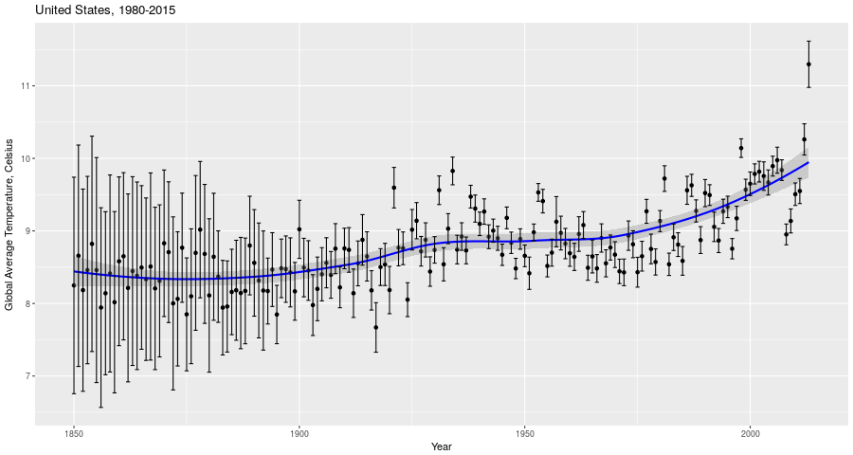

Figure 2: Global Average Temperature by Year, United States

Visualization is not the only method for understanding data, however. We may also use a process called sonification (Nees and Walker (2012)) to transform data into sound. This method offers advantages over visualization for recognition of time-based patterns and changes. This is important when dealing with very long time frames on the geologic time scale.

As an example of a sonfication of climate data for popular consumption, listen to “134 Years of Global Temperature Change in 14 Seconds” by Nelson Guda (Guda (n.d.)) for [Threshold] (<https://nelsonguda.com/project/threshold/>), a data art project about climate change. In this piece, “the piano notes are the annual temperature data from 1850-2015”," and “the orchestra plays chords made of the minimum, mean and maximum temperatures for eight year intervals over that time period.” The data are sourced from the Berkeley Earth Data site (Study (n.d.)).

## Additional resources

Please see the “Data Presentation” in Supplemental Documents for some useful material that may help you get started.

In addition, the following links may be helpful for further exploration of climate data:

* [NASA Prediction of Worldwide Energy Resources](https://power.larc.nasa.gov/)
* [NASA Global Climate Change](https://climate.nasa.gov/evidence/)
* [NOAA Climate Data Online](https://www.ncdc.noaa.gov/cdo-web/)
* [NASA Feature: Wind, Warm Water Revved Up Melting Antarctic Glaciers](https://climate.nasa.gov/news/2631/wind-warm-water-revved-up-melting-antarctic-glaciers/)
* [NASA Feature: A World on Fire](https://climate.nasa.gov/news/2791/a-world-on-fire/)
* [NASA News: Airborne mission to focus on polar winds. Monroe Conner.](https://climate.nasa.gov/news/2284/airborne-mission-to-focus-on-polar-winds/)

# Didgeridoo

## Overview

The theme of 2019 MIT STEAM Camp is wind and perhaps an exploration of climate data and wind instruments can faithfully incorporate the theme as well as help inform the public about information to which they may not have been exposed. This chapter describes a bit about the didgeridoo, a wind instrument of great significance, and presents instruction for construction of a DIY version that can be created inexpensively and with a high degree of customization.

## History and Significance

The didgeridoo, or yidaki, is an ancient wind instrument believed to have originated among the indigenous people of northern Australia over 40,000 years ago (Harris 2013). This instrument is traditionally used for cermonial functions and also for recreational and entertainment purposes. Ramin Yazdanpanah is a modern didgeridoo musician who plays with the [Maharajah Flamenco Trio](https://www.mftrio.com/), a group that incorporates global sounds into their music.

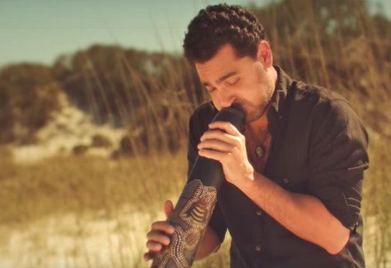

Figure 3: Ramin Yazdanpanah of the Maharajah Flamenco Trio from the official video for “Dariya.” Roughcut Productions, 2017.

## Anatomy

A traditional didgeridoo has essentially three components: the mouthpiece, the body, and the bell or flare. The mouthpiece is a small opening usually formed with beeswax. The body is hollowed out, usually by termites. The flare is a natural widening of the body where a trunk or branch meets the ground or larger section of the tree.

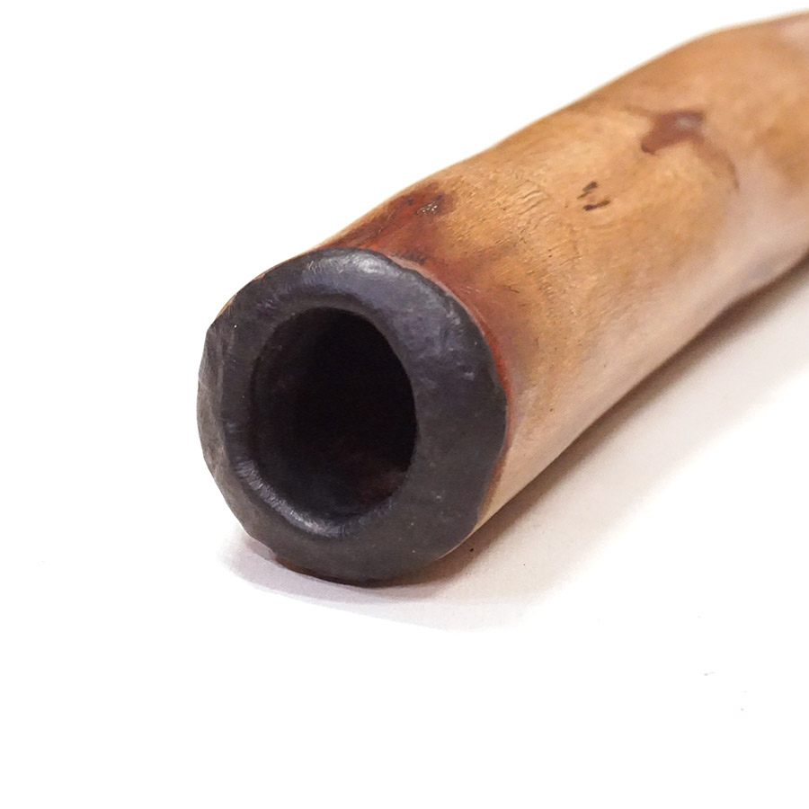

Figure 4: Mouthpiece detail of a Large Jesse Lethbridge Didgeridoo (4845). Seen at [DidgeridooBreath.com](https://www.didgeridoobreath.com/Large-Jesse-Lethbridge-Didgeridoo-4845-p/d-575-4845.htm)

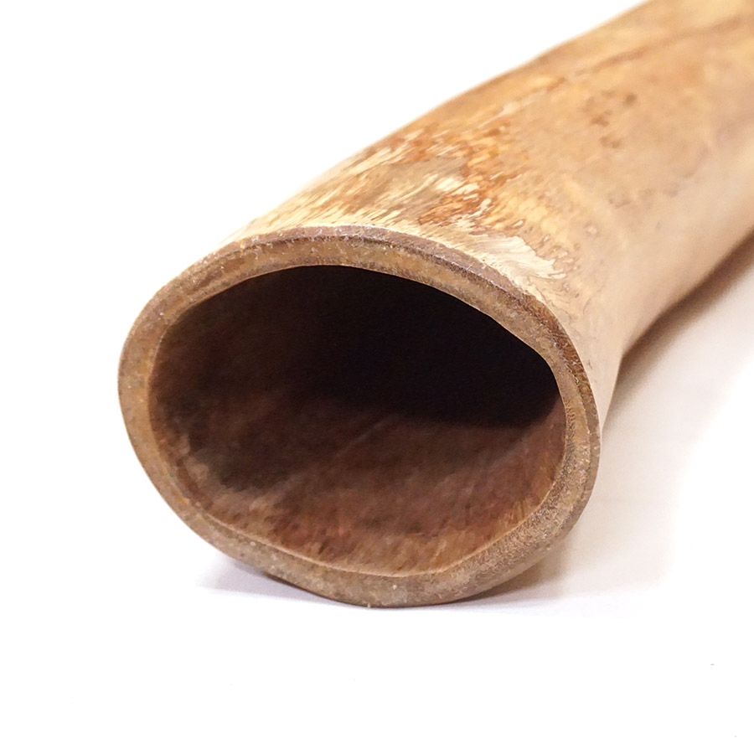

Figure 5: Bell detail of a Large Jesse Lethbridge Didgeridoo (4845). Seen at [DidgeridooBreath.com](https://www.didgeridoobreath.com/Large-Jesse-Lethbridge-Didgeridoo-4845-p/d-575-4845.htm)

## Science

Hopkin (2005) sums up an article by Tarnopolsky et al. (2005) and notes that skilled didgeridoo musicians can adjust their throat anatomy to produce a very wide range of [timbres](https://en.wikipedia.org/wiki/Timbre). Fletcher (1996) provides a summary of the physics of this simple instrument.

## Construction

The didgeridoo will be constructed from three PVC components seen in Figure 6: a reducing coupling (A), a pipe (B) , and a trap adapter (C and D). The length (L) of the pipe is variable and determines the key of the instrument. The mouthpiece is in two pieces. Part D will need to be threaded onto Part C. All other fittings should be pressed on until secure. No adhesives are used in this construction.

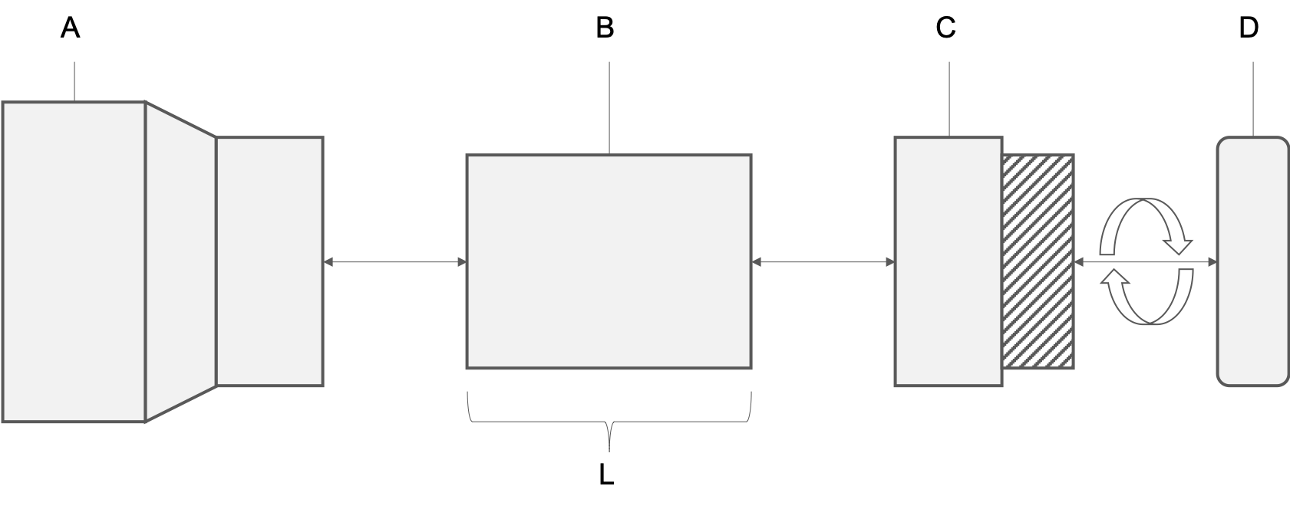

Figure 6: PVC didgeridoo construction

To begin, join the reducing coupling (A) to the pipe (B). 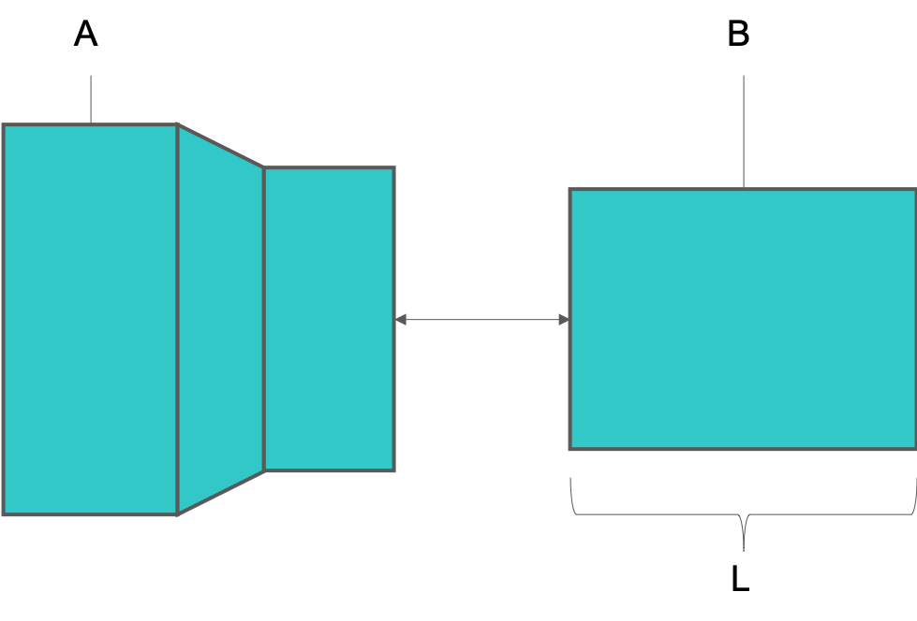

Next, join the pipe (B) to the trap adapter base (C). 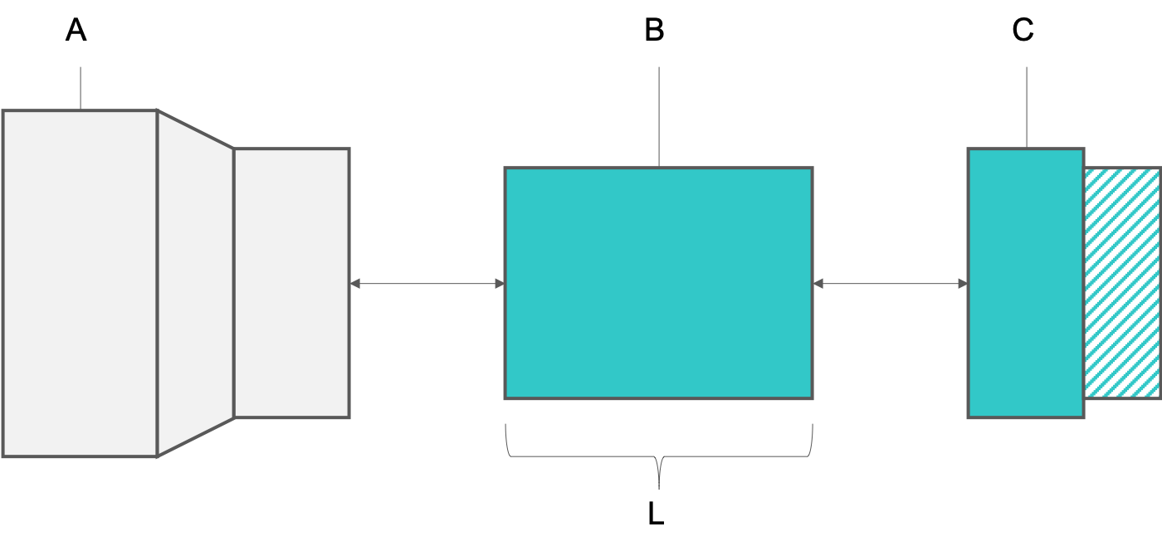

Finally, join the trap adapter base (C) to the trap adapter nut (D) by carefully threading the nut onto the base. 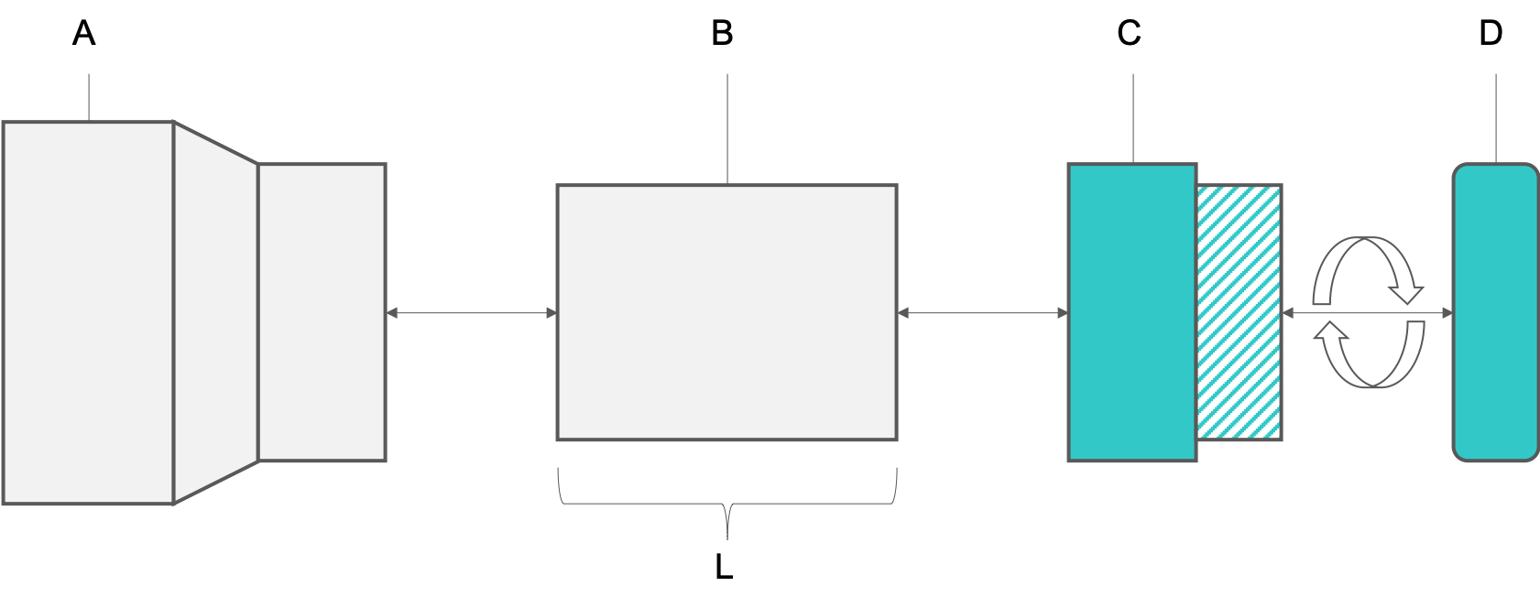

Your PVC didgeridoo should now be fully assembled. Wipe down the trap adapter with an alcohol pad before attempting to play!

## Standard Form

While traditional hollow-branch didgeridoos are generally straight, the PVC didgeridoo can be created in many forms. The standard straight form is the simplest design with a single length of pipe connecting the mouthpiece to the flared bell (our reducing coupling) at the opposite end.



Figure 10: PVC didgeridoo; standard form

## Alternative Forms

Alternative forms can result in more compact, twisted variations. These forms require extensive cutting and the use of angled fittings. One example is presented here for inspiration. With these forms, students can create longer didgeridoos and deeper, more resonant notes while occupying minimal space. What new form can you create?

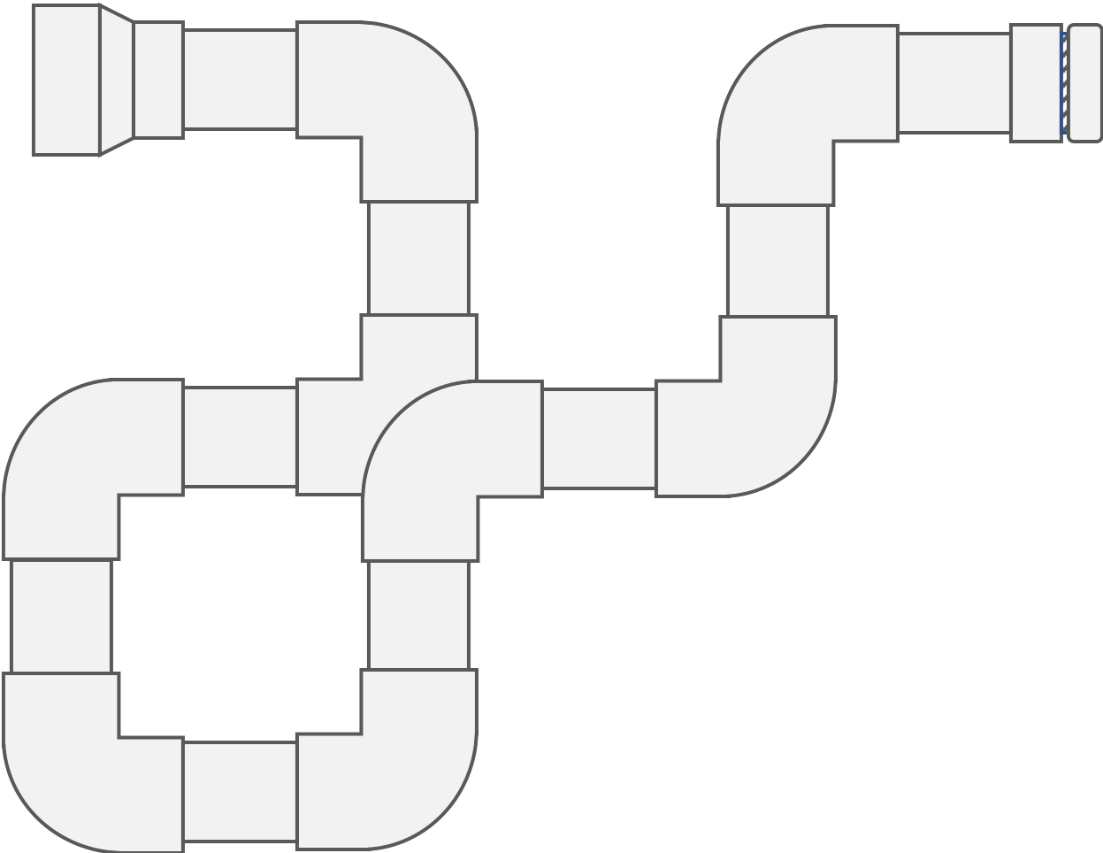

Figure 11: PVC didgeridoo; standard form

## Tuning

According to Didjshop (2016), the length of a didgeridoo for a particular desired frequency (also called the “key” of the didgeridoo) can be found using the formula where is the length in meters, is the speed of sound in meters per second, and is the desired frequency in Hertz (or key). We’ll do our calculations using the metric system so, as an example, let’s find the length of a didgeridoo that will play in the key of E (82.41Hz). We can do this by solving for the equation . We use 344 m/s because that is the speed of sound in dry air at a temperature of 20 degrees C. Solving this gives us a didgeridoo length of or about 1.04 meters. It’s good practice to start with a didgeridoo that is longer than needed and then you can cut and sand the PVC pipe to the desired length and key. See below for a data table of keys, frequencies (Hz), and estimated pipe lengths (mm). To estimate the key for a didgeridoo of a known length, solve the formula for instead to get where is again the length of the didgeridoo in meters.

For a PVC didgeridoo, Didjshop (2016) recommends beginners cut their didgeridoo to 104cm for key of E, 118 cm long for a D, or 132 cm long for a C as these are easier keys with which to begin practicing.

Table 1: Musical key, frequency, and estimated didgeridoo length.

|  |  |  |
| --- | --- | --- |
| Key | Frequency (Hz) | Length (mm) |
| C | 32.70 | 2630 |
| C# | 34.65 | 2482 |
| D | 36.71 | 2342 |
| D# | 38.89 | 2211 |
| E | 41.20 | 2087 |
| F | 43.66 | 1970 |
| F# | 46.25 | 1859 |
| G | 49.00 | 1755 |
| G# | 51.91 | 1657 |
| A | 55.00 | 1564 |
| A# | 58.27 | 1475 |
| B | 61.74 | 1393 |
| C | 65.40 | 1315 |
| C# | 69.30 | 1241 |
| D | 73.42 | 1171 |
| D# | 77.78 | 1106 |
| E | 82.41 | 1044 |
| F | 87.31 | 985 |
| F# | 92.50 | 930 |
| G | 98.00 | 878 |
| G# | 103.82 | 828 |
| A | 110.00 | 782 |
| A# | 116.54 | 771 |
| B | 123.47 | 696 |
| C | 130.81 | 657 |
| C# | 138.59 | 620 |
| D | 146.83 | 586 |
| D# | 155.56 | 553 |
| E | 164.81 | 522 |

## Mouthpiece

The traditional didgeridoo mouthpiece is beeswax. To try this out instead of a plastic fitting, gather a small amount of beeswax, warm it in the sun, microwave (very briefly, ~10 seconds), or oven (very low temperatures). You want the wax to be soft enough to mold, but not close to melting. Make a cylinder with a small diameter and then coil the wax around the end of the didgeridoo. Press it gently and mold it to create an opening around 35mm to start. Try it out and keep working it until it feels comfortable.

You can watch this video from Spirit Gallery to watch how they apply beeswax to a didgeridoo: [How to add a Didgeridoo Beeswax Mouthpiece.](https://www.youtube.com/watch?v=iYilUrkJ9ow)

## Decoration

According to Harris (2013), the didgeridoo may be decorated. Many designs are inspired by nature and traditional pigments contributed an array of earth-tone hues to the instrument. See Figure 12 for some examples.



Figure 12: Didgeridoo decorations. Photo by Bernard Spragg, NZ. Public Domain.

## Play

At the most basic level, the didgeridoo is a very simple tube, traditionally a hollowed-out eucalyptus branch or trunk eaten away from the inside by termites. This wind instrument, also classified as a brass aerophone, is deceptively simple however. The physical characteristics of the instrument, paired with the skill of the musician, allow for a wide variety of sounds that may incorporate percussion, vocalization, and intricate droning techniques. For more information on terminology such as resonance, backpressure, and different types of notes, investigate [the information](https://www.spiritgallery.com.au/didgeridoo-terminology) presented by Gallery (n.d.). These concepts may help students to think of some methods they can try to incorporate into their playing style.

It’s a great idea to watch some videos online to hear musicians play different styles, different instruments in a variety of keys, and to hear artists practice as a band. One popular channel on YouTube is [DidgeridooBreath](https://www.youtube.com/user/DidgeridooBreath/videos).

Here’s [a video of Sanshi providing a good intro to the didgeridoo](https://www.youtube.com/watch?v=W2gwTPPtgPI):

Sanshi plays a lot of didgeridoo demonstrations to provide customers with an idea of how each instrument sounds. Here’s a video entitled “[Ellswood Didge C (No.2202) Didgeridoo Demo.](https://www.youtube.com/watch?v=Kwq6GKDDGXY)”

A didgeridoo is featured in “[Dariya](https://www.youtube.com/watch?v=M45Eh2oZrL8)” performed here as a Tiny Desk Concert entry by [Maharajah Flamenco Trio](https://www.mftrio.com/about-us) from Tallahassee, Florida, USA. Performed by Ramin Yazdanpanah on cajon & didgeridoo, David Cobb on bass, and Silviu Ciulei on guitar.

## Advanced Play: Circular Breathing

If you want to advance your playing, you’ll need to learn circular breathing. This technique allows for very long, continuous droning by providing a constant stream of air into the didgeridoo. Didjshop (2016) provides the following tips for practicing and learning this advanced technique. Essentially, you’ll push air that you stored in your mouth out while you breathe in through your nose to replenish the supply in your lungs.

-Breathe in and out of your nose normally. relax -Fill your mouth with some water and tilt your head back and again breathe in and out of your nose normally. Keep breathing for at least a couple of minutes. relax -Without water, fill your mouth with air at a fair pressure and keep breathing in and out through your nose for a couple of minutes while keeping the air in the mouth. relax -Do the same thing again and this time have your thumb and index finger of one hand just touching your cheeks while breathing in and hovering just above the cheeks when breathing out. Relax -Do the same thing again and this time make the in-breath fast and strong and the out-breath long and constant - still with the fingers and still keeping all the air in while breathing in and out through the nose. Relax -Do the same thing again and this time after taking a few breath, push your cheeks with your fingers to expel the air out of your mouth while breathing in. Bingo. Relax

Here’s Sanshi from the Didgeridoo Dojo giving a brief intro to the technique: [Didgeridoo Circular Breathing: Introduction (Lesson 1 of 8)](https://www.youtube.com/watch?v=tI6qr5amKuE)

# Paixiao

## Overview

The theme of 2019 MIT STEAM Camp is wind and perhaps an exploration of climate data and wind instruments can faithfully incorporate the theme as well as help inform the public about information to which they may not have been exposed. This chapter describes a bit about the paixiao, a wind instrument native to the region around Hong Kong, and presents instruction for construction of a DIY version that can be created inexpensively and with a high degree of customization.

## History and Significance

The paixiao is a traditional wind instrument from China. This type of pan flute was traditionally constructed from bamboo, a common grass from that region. The earliest complete paixiao, an important instrument used in entertainment, military, and orchestra venues, was dated to around 522BC. (Britannica 2019)

## Anatomy

The flute is constructed from a series of (traditionally) bamboo pipes, or short hollow segements of a rigid material. Bamboo, a type of grass, has large, hollow, rigid segments that are ideal for this type of instrument. The pipes may be joined in several ways, including twine or other natural fibers. For this activity, we are substituting bamboo for PVC pipes and natural fibers for common adhesives.

## Science

The science of any musical instrument is complicated and a truly good explanation requires the understanding of many distinct concepts. Very briefly, the paixiao functions properly when air is passed over the open end of a pipe. The air passes down into the pipe and, if everything is correct, the pipe produces a clear note with a frequency closely correlated with the length of the pipe. For more information on panflutes, visit [Sarah Tulga](http://www.sarahtulga.com/panpipes.htm). [Mark Shepard](http://www.markshep.com/flute/Acoustics.html) also has some information on the science of flutes.

## Construction

The paixiao will be constructed from three to five PVC components seen in Figure 13. The length (L) of each pipe (A) is variable and determines the frequency of the emitted note. Each pipe is sealed with a small amount of hot glue (B) and a small coin (C). A small bead of hot glue (B) should be applied along the length of the joint between each pipe. The top of each pipe should be sanded smooth for comfort and level at the time of assembly. In other words, the mouthpiece of each pipe should be level with each of the neighboring pipes.

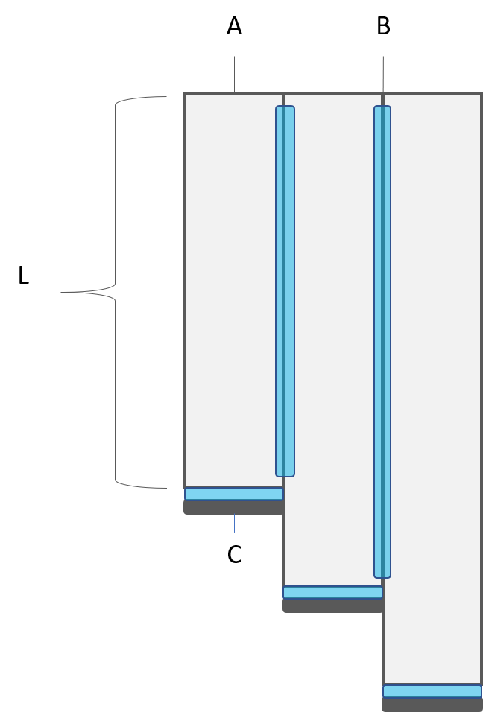

Figure 13: PVC paixiao construction

Assembly steps:

1. Cut PVC pipes to the desired length.
2. Sand each pipe smooth on each end to remove excess plastic and improve comfort when playing.
3. For each pipe, use a hot glue gun to apply a thin bead of glue around one end and attach a small coin to seal the pipe end.
4. Lay all pipes down and align the mouthpiece ends.
5. Apply a small bead of hot glue along the areas between each pipe.
6. Hold the pipes together briefly until the hot glue solidifies.
7. Decorate your paixiao if desired.

Your PVC paixiao should now be fully assembled. Wipe down the pipes with an alcohol pad before attempting to play!

## Tuning

As with the PVC didgeridoo, pipe length determines the frequency of the note. Some recommended pipe lengths and associated notes are provided to get you started, but feel free to experiment and create your own custom tuning! These tuning suggestions are from [Phil Tulga](http://www.philtulga.com/Panpipes.html).

Table 1: Musical key and estimated pipe length.

|  |  |
| --- | --- |
| Key | Length (mm) |
| C | 154 |
| D | 136 |
| E | 120 |
| G | 98 |
| A | 87 |

## Play

To play the paixiao, hold the flute perpendicular to the floor in front of your mouth. You will need to blow air across, and slightly down into, each pipe to achieve a clear note. Practice this method and try alternating between tight and loose lips until you find the “sweet spot” that results in a loud, clear sound.

You can watch this video to pick up some paixiao performance tips: [Paixiao.](https://www.youtube.com/watch?v=A9kZKQeZTIo)

# Music

## Climate Data as Inspiration

Students should look to the suggested climate data resources, or other reputable information, for inspiration to create a musical piece to be performed with their PVC instruments. Students should be allowed maximum creative freedom to interpret their data in musical form but some suggestions include converting wind speed changes into pitch variation, temperature into tempo, or spikes into percussion. Students should brainstorm and work among small teams to document their data source, their method of interpretation, and their data-to-music philosophy.

### Documentation

After studying data and constructing their instrument(s), students should begin their journey toward a musical performance by working out a system of notation for their music. As a simple example, low notes may be indicated by a minus (-) sign. High notes may be indicated by a plus (+) sign. Short notes may be indicated by a dot (.) before the sign and long notes may be indicated by a series of notes following the sign where each dot indicates additional time. That is, the notation could be written as

.- | .- | .- | +…

to indicate three short, low notes followed by one relatively long high note. Students should create a notation system that can be followed by others so be sure they create a key indicating their system meaning and including any notes that would be useful to an outside learner trying to reproduce their musical piece.

Students may also use letter-sized paper or posters to create a document, for public display, that describes their data set and music concept. Students should describe the data, what part(s) of it were used for inspiration, and how they imagined that data as sound. In other words, how did you translate your understanding of data into music? What was your journey and how did you end up where you are now?

## Performance

Students will perform in small teams or pairs. A team leader should announce the piece and include a brief informative talk about the data source and how it was used to inspire the musical performance. Student performances should be brief – perhaps 1-3 minutes. Creativity should be rewarded and students may be evaluated with regard to their integration of climate science, instrument construction, and concept development. Acknowledging that students are likely beginners at playing these instruments, students should not be assessed on their actual performance quality. This should be a fun exercise and is meant to inspire students to develop construction skills and foster interest in music and climate science.

Recordings of each performance may be made to document the results of the work. Recordings could be used for publication on social media if desired.

# Materials and Tools List

This chapter describes the materials and tools needed to construct a basic PVC didgeridoo and a basic PVC paixiao. Please note an optional beeswax mouthpiece may be constructed by molding warm, soft wax around one end of the PVC didgeridoo.

## PVC Didgeridoo

Table 2: Materials for constructing a PVC Didgeridoo.

|  |  |  |  |
| --- | --- | --- | --- |
| Name | Spec | Qty (2) | Qty (100) |
| PVC pipe | 1.5", Schedule 40, ~3m | 1 | 50 |
| PVC trap adapter | 1.5", Schedule 40 | 1 | 100 |
| PVC Reducing Coupling | 3.0“x1.5”, Schedule 40 | 1 | 100 |
| Sandpaper | Medium Grit | as needed | as needed |
| Alcohol Prep Pads | - | as needed | as needed |

## PVC Paixiao

Table 3: Materials for constructing a PVC Paixiao.

|  |  |  |  |
| --- | --- | --- | --- |
| Name | Spec | Qty (2) | Qty (100) |
| PVC pipe | 0.5", Schedule 40, ~1m | 1 | 50 |
| Small coins | ~0.5" diameter | 3 to 5, as needed | 300 |
| Sandpaper | Medium Grit | 1 | 50 |
| Alcohol Prep Pads | - | as needed | as needed |
| Duct tape or hot glue | - | as needed | as needed |

## Suggested Tools

Table 4: Suggested tools for constructing a PVC Didgeridoo and Paixiao.

|  |  |  |  |
| --- | --- | --- | --- |
| Name | Spec | Qty (2) | Qty (100) |
| Hacksaw or pull saw | small | 1 | Up to 50 |
| Digital Tuner | multi-instrument, clip-on or phone app | 1 | Up to 50 |
| Permanent markers, multicolor | any color | any | as needed |
| Safety glasses | polycarbonate, ANSI Z87.1-2015 or similar | 1 per student | 1 per student |

## Materials and Tools Gallery

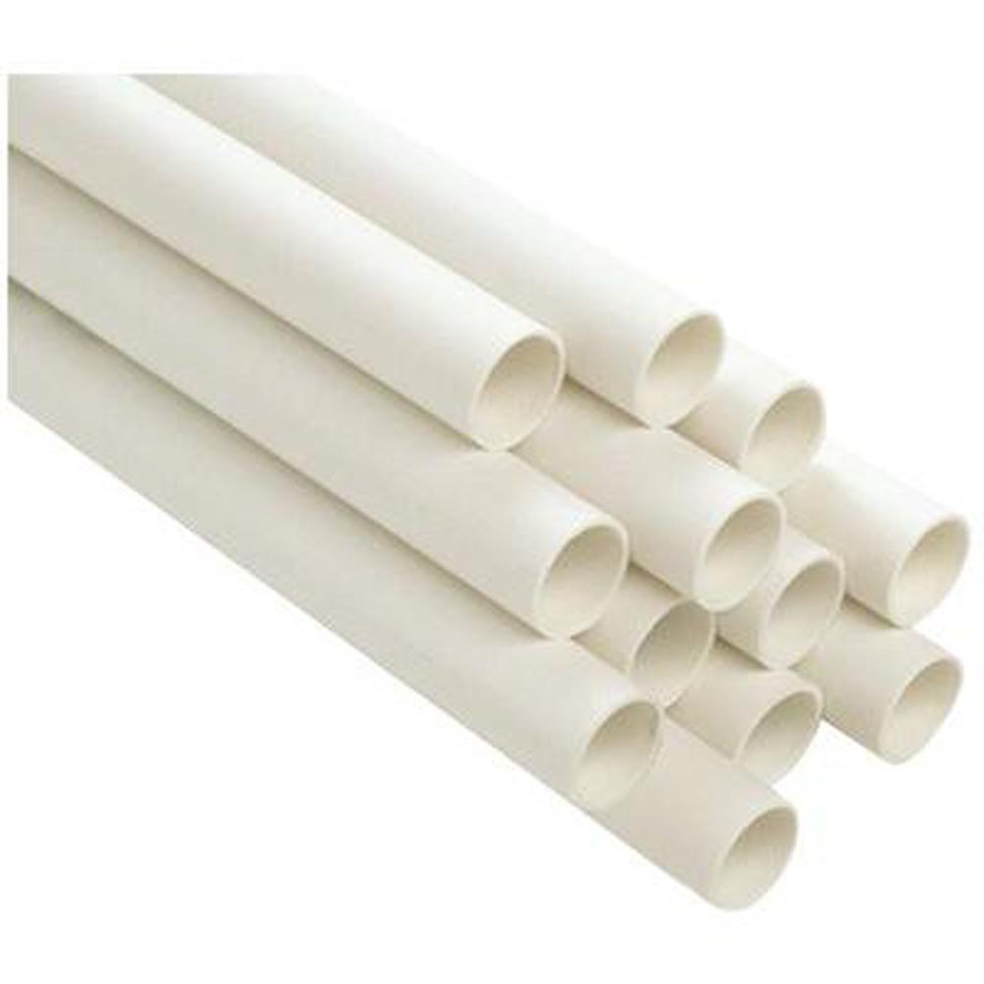

Figure 14: PVC Pipe, [Image Source](https://www.homedepot.com/p/Genova-Products-PVC-Schedule-40-Pressure-Pipe-1-1-2-in-x-10-ft-Plain-End-70011N/300282341)

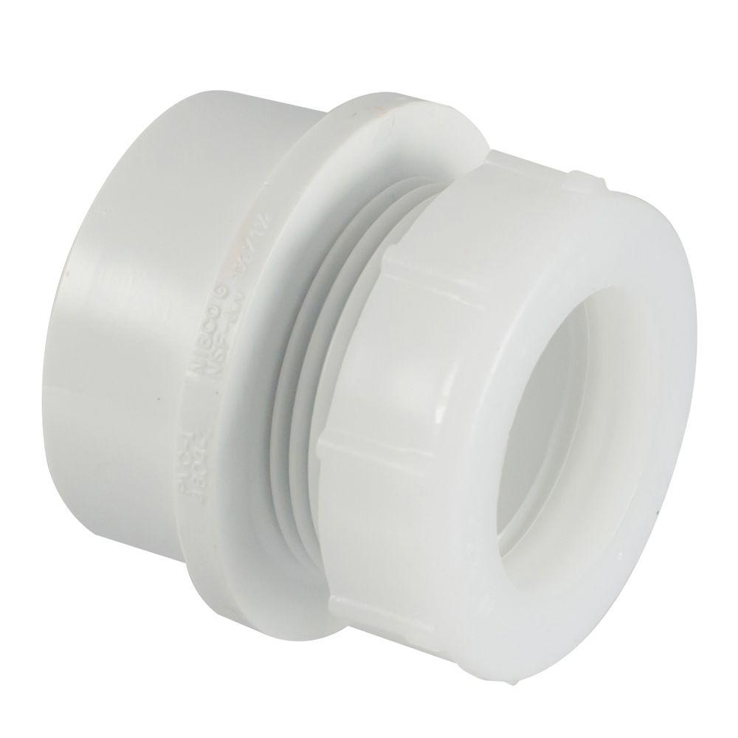

Figure 15: PVC Trap Adapter, [Image Source](https://www.homedepot.com/p/Nibco-1-1-2-in-x-1-1-2-in-PVC-DWV-Trap-Adapter-C480127HD112114/100342402)

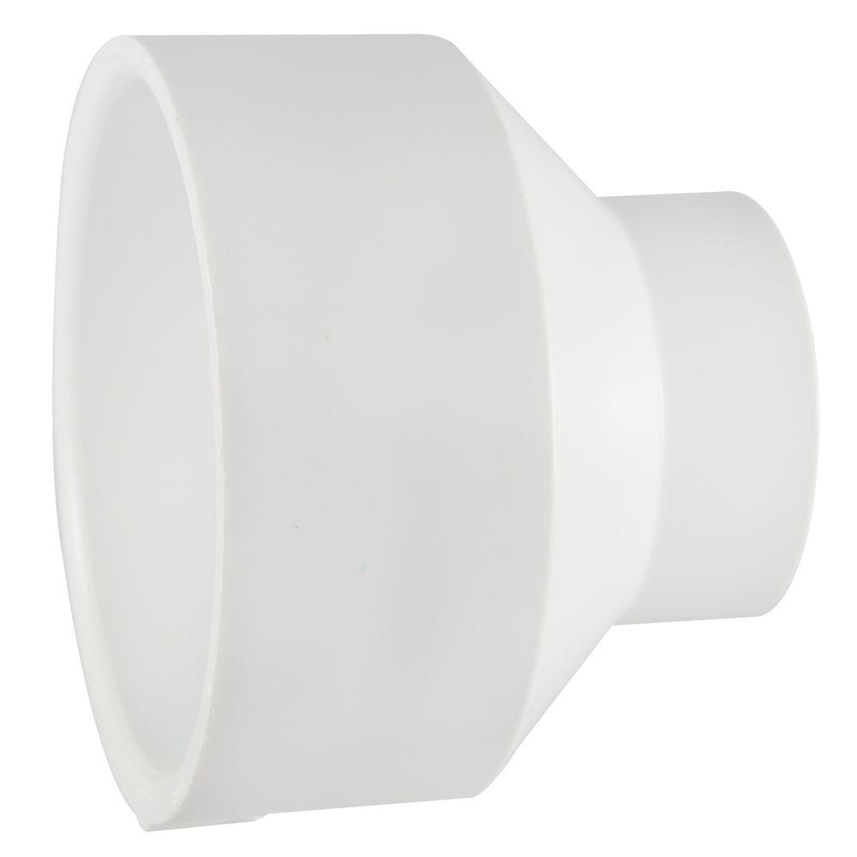

Figure 16: PVC Reducing Coupling, [Image Source](https://www.homedepot.com/p/3-in-x-1-1-2-in-PVC-DWV-Reducing-Coupling-C4801HD3112/100343439)

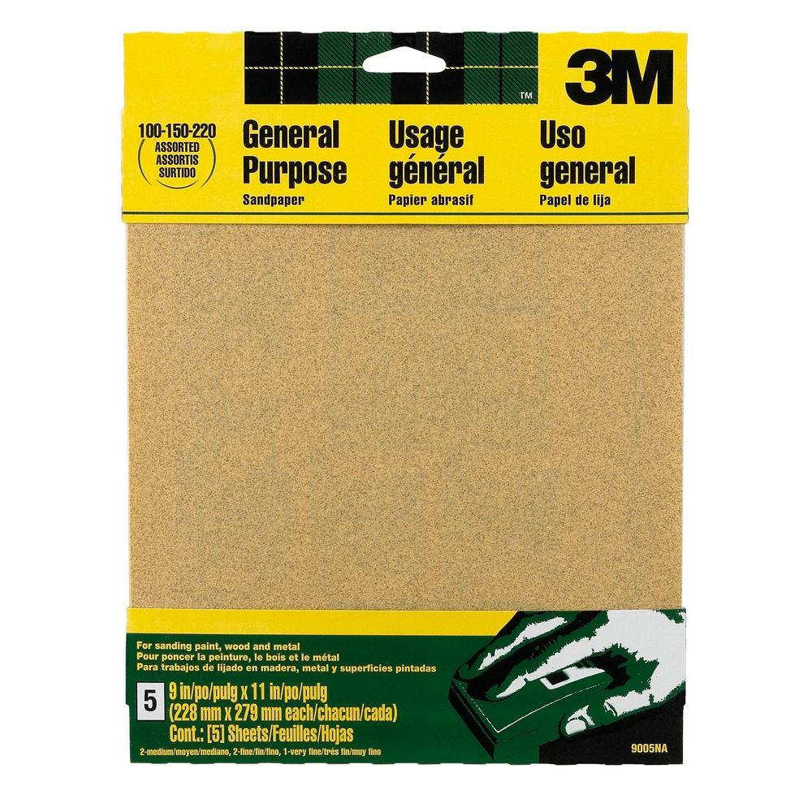

Figure 17: Medium-grit sandpaper, [Image Source](https://www.homedepot.com/p/3M-9-in-x-11-in-100-150-220-Grit-Medium-Fine-and-Very-Fine-Aluminum-Oxide-Sand-Paper-5-Sheets-Pack-9005NA/203783586)



Figure 18: Alcohol prep pads, [Image Source](https://www.amazon.com/Care-Touch-Sterile-Alcohol-Medium/dp/B06XS38XH6)

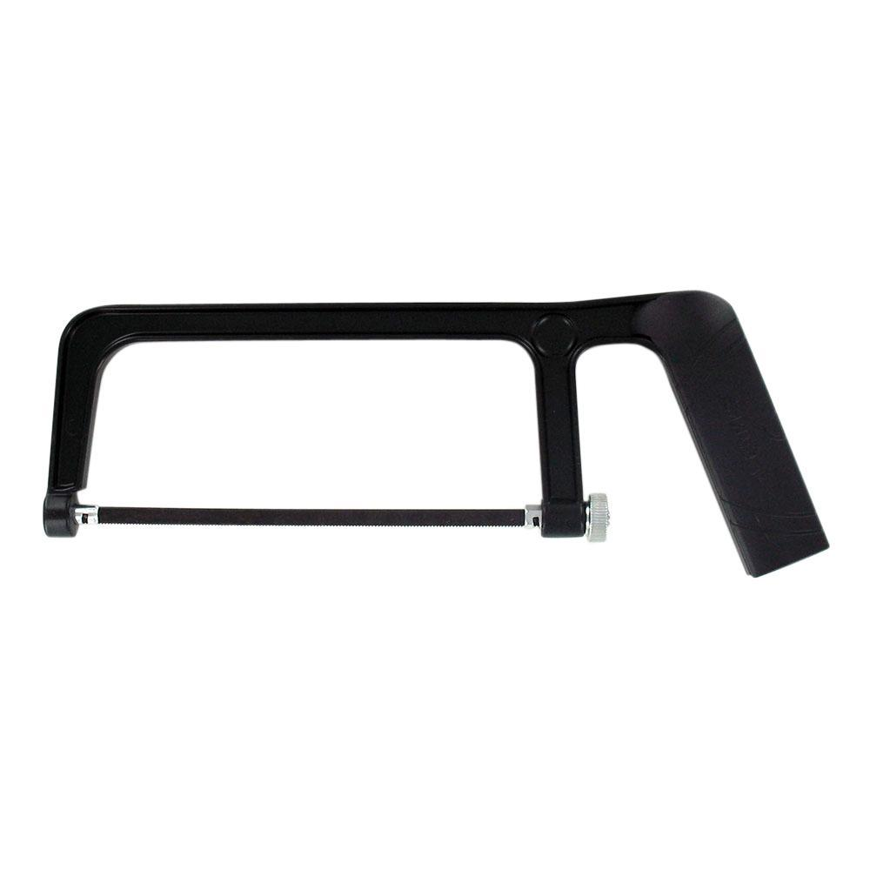

Figure 19: Hacksaw, [Image Source](https://www.homedepot.com/p/Husky-6-in-Hack-Saw-with-Comfort-Grip-Handle-122JHSC/204748808)

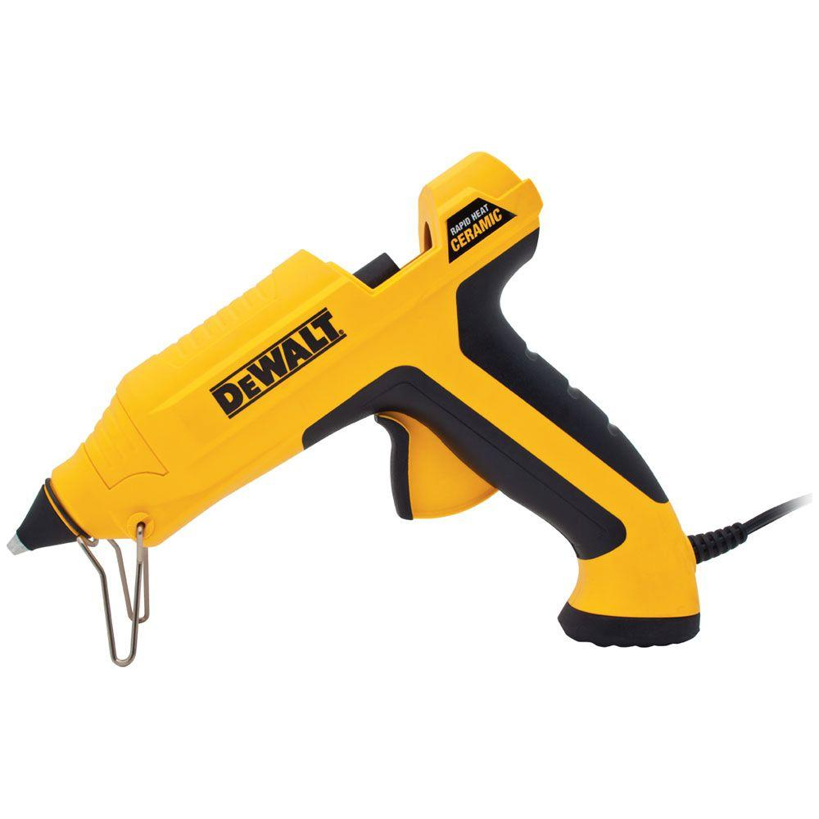

Figure 20: Hot Glue Gun, [Image Source](https://www.homedepot.com/p/DEWALT-Ceramic-Rapid-Heat-Full-Size-Glue-Gun-DWHTGR50/204293086)

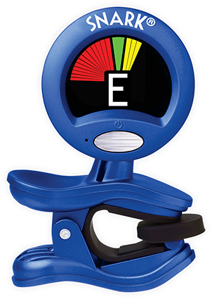

Figure 21: Clip-on tuner, [Image Source](http://www.snarktuners.com/products/original-clip-on)

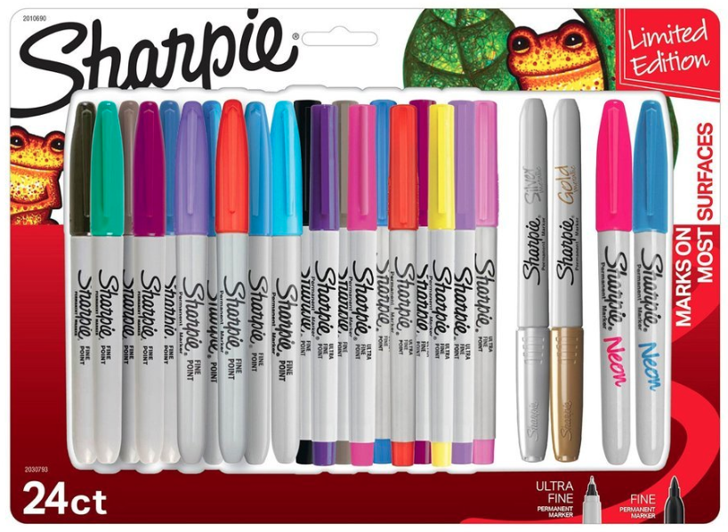

Figure 22: Permanent markers, [Image Source](https://www.amazon.com/Sharpie-Permanent-Marker-Multi-Color/dp/B077TJS66N)

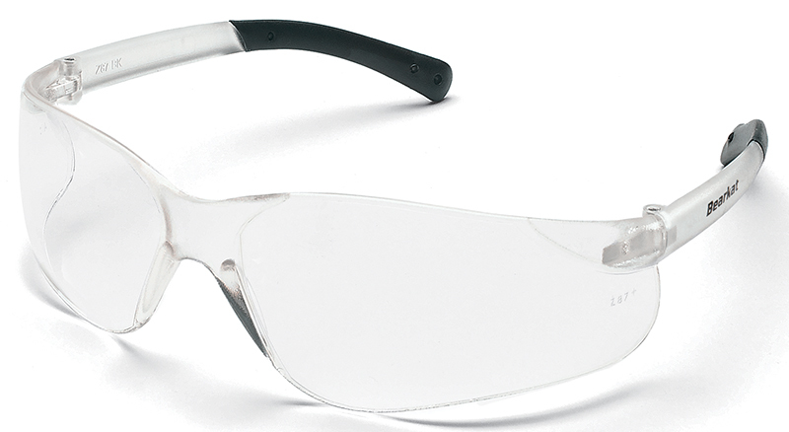

Figure 23: Safety glasses, [Image Source](https://www.safetyglassesusa.com/bk210.html)

# Supplemental Documents

* [Teacher Guide](./supplemental/didgeridata_TG.pdf)
* [Student Handout](./supplemental/didgeridata_SH.pdf)
* [Student Assessment](./supplemental/didgeridata_SA.pdf)
* [Grading Rubric](./supplemental/didgeridata_RU.pdf)
* [Data Presentation (.pptx)](./supplemental/didgeridata.pptx)

# Implementation Guide

## Introduction

This guide is a suggestion for implementation and is intended as a starting point for discussion with the understanding that each learning environment may have unique needs and challenges. Below, a suggested schedule is provided to guide in-class delivery. Additionally, a few notes are provided to assist the faciltiator(s) to help create a positive learning experience for all students and instructors alike.

## Schedule

The following schedule assumes a 5-hour total delivery time with two sessions spanning one lunch/meal period at the midpoint of the delivery.

Table 1: Suggested implementation timeline.

|  |  |  |
| --- | --- | --- |
| Time | Day 1 | Day 2 |
| 09:30 | Welcome | Welcome |
| 09:35 | Data Exploration | Notation & Composition |
| 10:15 | Break | Break |
| 10:30 | Guest Musician | Finalize Construction, Notation, and Composition |
| 11:30 | Instrument Construction | Performances & Summary |
| 12:00 | Lunch | Lunch |

## Facilitator Notes

The following notes may help you in your role as a facilitator.

* You are a facilitator, not an instructor. Guide students to find their own way, their own solutions to problems, and their own learning.
* This should be a creative, fun activity. Make this a priority and learning will follow.
* Students should be engaged in small teams to help each other learn as peer-mentors. Encourage discussion among teams to arrive at solutions. If a team struggles, introduce that team to another group of peers to continue discussions with fresh ideas.
* Students may be challenged with musical aspects of this activity. Look for musically-adept students that may be willing to add their input to discussions around the room. Take advantage of the expertise in the room!
* You may see a wide variety in notation and playing styles. Encourage logic, reproducibility, connections to data, and clarity in justification. As long as students can connect what they play to their data understanding and observations, they have met the challenge presented in this activity. Their musical notation should make sense to not only themselves but to others who may need to play the piece. Ensure the notation systems devised by student teams make sense to others.
* Ask questions frequently to encourage discussion but also to assess the progress of the student teams. Check in with each team to check their understanding of the timeline so no team gets stuck.
* Ask teams to pre-design new solutions if they had more free time to do so. What would the next-generation didgeridoo look like if you could build it again? How would you change your design if you had more (time, materials,…)?

# Playful Assessment

## Introduction

Playful assessment is…

## Gallery Walk as Assessment

# Playful Assessment

## Introduction

Assessment is a powerful tool that allows students and their stakeholders (e.g., caregivers, teachers, school administration) to understand how students are learning and how they might want to proceed with their learning processes. However, traditional summative assessment strategies are not good at capturing or assessing learning in the open-ended, collaborative, cross-disciplinary, iterative, and dynamic nature of hands-on activities like Dedgeridata and other lessons in the STEAM camp.

Playful Journey Lab at MIT has been exploring assessment that captures rich learning happens in such hands-on activities that called playful assessment. Playful assessment is an approach to measure knowledge, skills, attitudes, beliefs, interests, and practices incorporating elements of fun and participation in the process of capturing and understanding learning. Playful assessment allows for multidimensional evaluation of student choices, actions, decisions, and behaviors as they interact with each other in the context of educational activities.

During this module, there will be a number of moments where students are encouraged to capture and reflect on their own learning, specifically on their experiences of social scaffolding, which is a term that represents the practices of helping each other. Using one of the playful assessment tools, students will capture their moments of social scaffolding and will reflect on their interaction at the end of the lesson, along with their experience of being part of this module.

## Social Scaffolding

Social scaffolding in this context boils down to opportunities for students to help each other. This lesson provides substantial opportunities for students to work in pairs, but also to work across teams to provide feedback and encouragement. Here are some examples that may be helpful to consider during implementation.

* Have students provide public feedback at each stage of the module (data, construction, composition, performance)
* Have students “borrow” or swap team members temporarily to force the infusion of new ideas
* Ask students to tell each other what their most/least favorite thing is about the others’ work – these comments will need to be useful comments that can initiate action as needed
* Tell students they can add questions (“Does anyone know how to…” or “Can you help me do…”) to the Question Board and have their peers attempt to help with answers or provide assistance
* Encourage students to promote their interests and talents – does someone know a lot about music? about construction? about data? Where are the resources in the classroom and how can they be leveraged to help everyone?

## Gallery Walk as Moment of Demonstrating Social Scaffolding

Either during a scheduled break or a brief, dedicated session, students may be encouraged to present their current work. For example, they could simply clear their desks and place their musical instruments such that wandering peers could inspect them. During this period, peers would either leave comment notes at the team stations or place comments on a central board for all teams.

An example of this might be a student observing the work of Team 1. They notice that Team 1 has constructed a didgeridoo that has extensive surface texture at one end indicating the irregularity of data during the earliest years of collection. They really like this idea! However, the instrument overall is perhaps too long to play comfortably. Their feedback note might encourage their decoration work by suggesting the addition of color to enhance the texture, but they may also suggest cutting the didigeridoo down to a more manageable size.

What these feedback notes provide is a form of playful formative assessment for the students and classroom teachers. Students will be giving each other feedback that can help them to self-reflect, gain some new ideas, increase confidence in their decisions, and understand the perspective of outside peers.

Britannica. 2019. “Paixiao.” britannica.com. <https://www.britannica.com/art/paixiao>.

Didjshop. 2016. “Physics of the Didgeridoo.” didjshop.com. <https://www.didjshop.com/physicsDidj.html>.

Fletcher, N. 1996. “The Didjeridoo (Didgeridoo).” *Acoustics Australia* 24 (1): 11–15. <https://www.acoustics.asn.au/journal/1996/1996_24_1_Fletcher.pdf>.

Gallery, Spirit. n.d. “Didgeridoo Terminology.” spiritgallery.com.au. <https://www.spiritgallery.com.au/didgeridoo-terminology>.

Guda, Nelson. n.d. “Threshold.” nelsonguda.com. <https://nelsonguda.com/project/threshold/>.

Harris, Matthew. 2013. “The Didgeridoo.” didjiman.com. <http://didjiman.com/didjeridu/>.

Hopkin, Michael. 2005. “Physicists Learn Secrets of Didgeridoo.” nature.com. <https://www.nature.com/news/2005/050704/full/news050704-7.html>.

Nees, Michael, and Bruce Walker. 2012. “Theory of Sonification.” In, 9–39. <http://sonify.psych.gatech.edu/~ben/references/nees_theory_of_sonification.pdf>.

Rosenman, Dave. 2017. “Climate Change: Land Temperature Data, 1850-2015.” kaggle.com. <https://www.kaggle.com/daverosenman/climate-change-land-temperature-data-1850-2015/data>.

Study, The Berkeley Earth Surface Temperature. n.d. “Berkeley Earth Data.” berkeleyearth.org. <http://berkeleyearth.org/data/>.

Tarnopolsky, A., N. Fletcher, L. Hollenberg, B. Lange, J. Smith, and J. Wolfe. 2005. “Acoustics: the vocal tract and the sound of a didgeridoo.” *Nature* 436 (7047): 39. <https://doi.org/10.1038/43639a>.