JV InvenTeams Activity Guides

Lemelson-MIT Program

2018-08-08

# Preface

Brief explanatory text about the program.

# Chill Out

 Unit overview text

## Educator Guide

Educator Guide version

## Student Guide

Student Guide version

# Electronic Textiles

 Unit overview text

## Educator Guide

Educator Guide version

## Student Guide

Student Guide version

# Growing Green

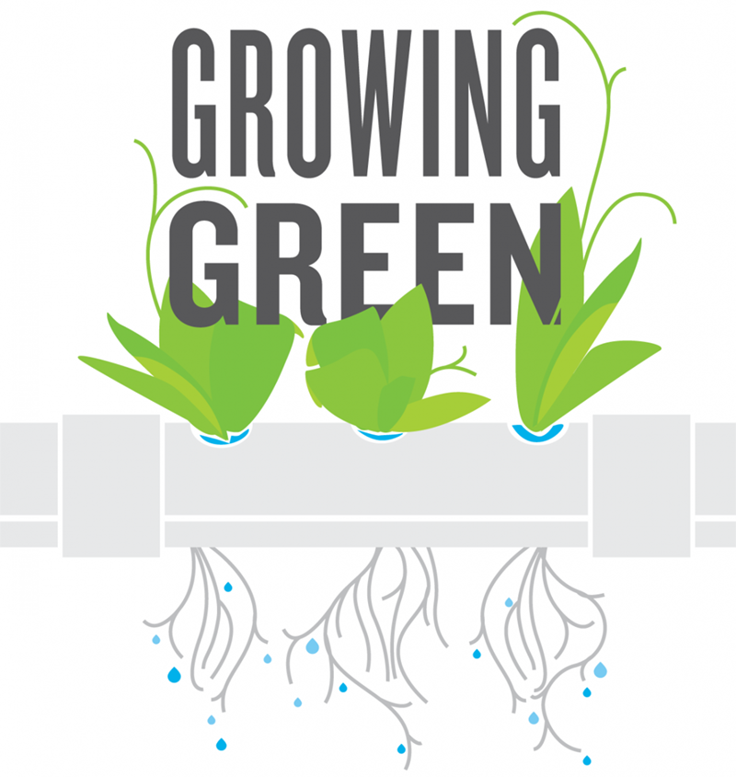 Unit overview text

## Educator Guide

Educator Guide version

## Student Guide

Student Guide version

# Noise Makers

 Unit overview text

## Educator Guide

Educator Guide version

## Student Guide

Student Guide version

# Pump It Up

 Unit overview text

## Educator Guide

Educator Guide version

## Student Guide

Student Guide version

# Shoe Soles

 Unit overview text

## Educator Guide

Educator Guide version

## Student Guide

Student Guide version

# Super Lens

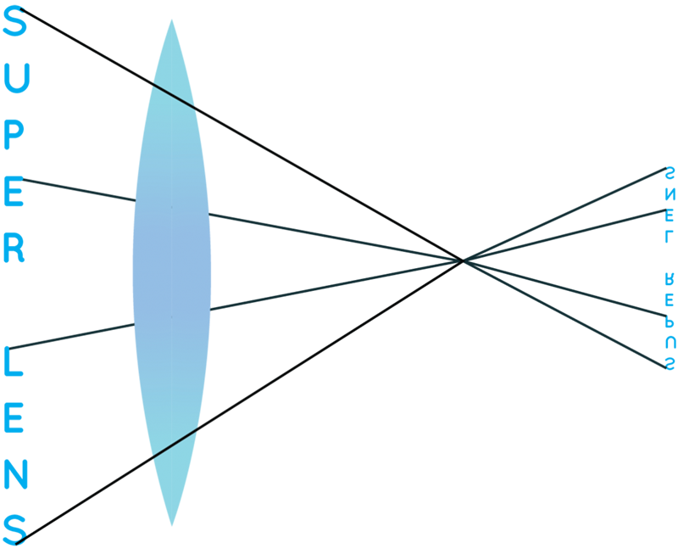 Unit overview text

## Educator Guide

Educator Guide version

## Student Guide

Student Guide version

# U Control

 Unit overview text

## Educator Guide

Educator Guide version

## Student Guide

Student Guide version