Didgeridata

Adam Santone

2019-04-18

# Introduction

This activity guides groups of students through a brief study of the history and construction of either a didgeridoo, the world’s oldest wind instrument, or a paixiao, a chinese pan flute. Students will work with polyvinyl chloride (PVC) pipe and PVC-cutting tools to design and create a playable musical instrument which will be used by students to compose a custom song related to climate data such as atmospheric CO concentration or global temperature anomalies. In this way, the sonification of climate data will be accomplished with a student musical chorus. The activity will conclude with a group jam session with participants invited to provide percussion for the wind section. An attempt will be made to have expert musicians join the program via teleconference as a guest speaker to provide instruction and background information.

# Learning Goals and Success

The learning goals for this activity are for students to:

* Develop an awareness of the science and history of the didgeridoo and the paixiao
* Practice hands-on construction methods to create custom, playable PVC musical instruments
* Develop an awareness of long-term trends in climate data
* Create a collaborative musical piece inspired by climate data
* Perform the custom musical piece using the didgeridoo and/or the paixiao

Success will be determined by:

* Creation of playable PVC musical instruments
* Creation and performance of a musical piece inspired directly by trends in global climate data

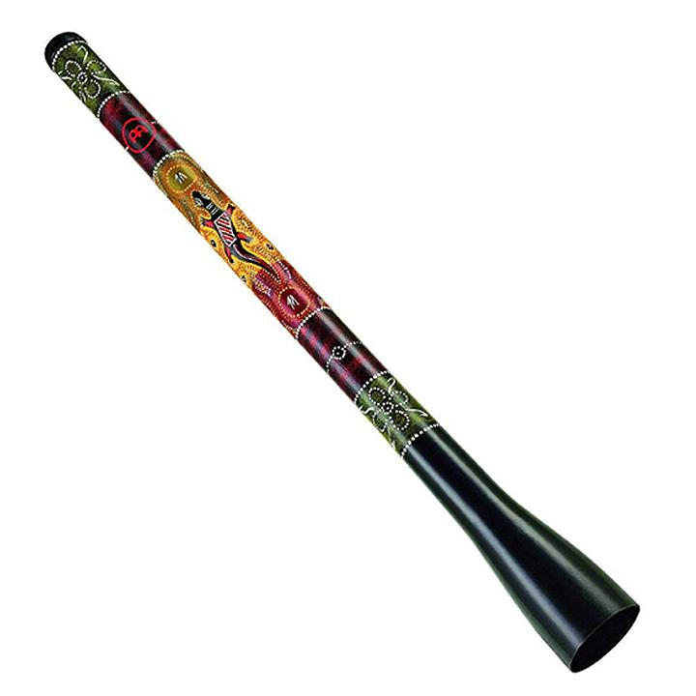

Figure 1 Didgeridoo.



Figure 2 Some caption.

# Didgeridoo

## Overview

TODO

## History and Significance

The didgeridoo, or yidaki, is an ancient wind instrument believed to have originated among the indigenous people of northern Australia over 40,000 years ago (Harris 2013). This instrument is traditionally used for cermonial functions and also for recreational and entertainment purposes. Ramin Yazdanpanah is a modern didgeridoo musician who plays with the [Maharajah Flamenco Trio](https://www.mftrio.com/), a group that incorporates global sounds into their music.

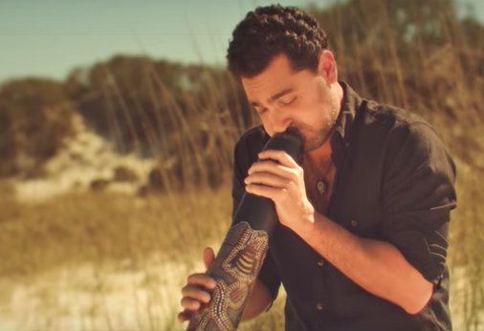

Figure 3 Ramin Yazdanpanah of the Maharajah Flamenco Trio from the official video for “Dariya.” Roughcut Productions, 2017.

## Science

Hopkin (2005) sums up an article by Tarnopolsky et al. (2005) and notes that skilled didgeridoo musicians can adjust their throat anatomy to produce a very wide range of [timbres](https://en.wikipedia.org/wiki/Timbre). Fletcher (1996) provides a summary of the physics of this simple instrument.

## Construction

The didgeridoo will be constructed from three PVC components seen in Figure 4: a reducing coupling (A), a pipe (B) , and a trap adapter (C and D). The length (L) of the pipe is variable and determines the key of the instrument. The mouthpiece is in two pieces. Part D will need to be threaded onto Part C. All other fittings should be pressed on until secure. No adhesives are used in this construction.

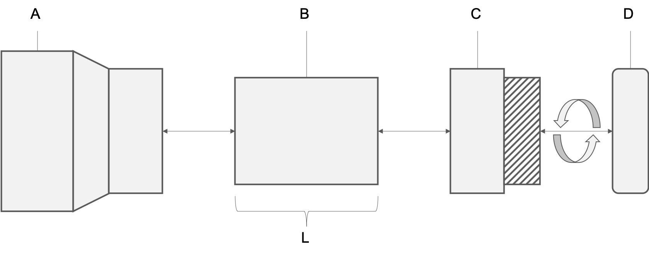

Figure 4 PVC didgeridoo construction

To begin, join the reducing coupling (A) to the pipe (B). 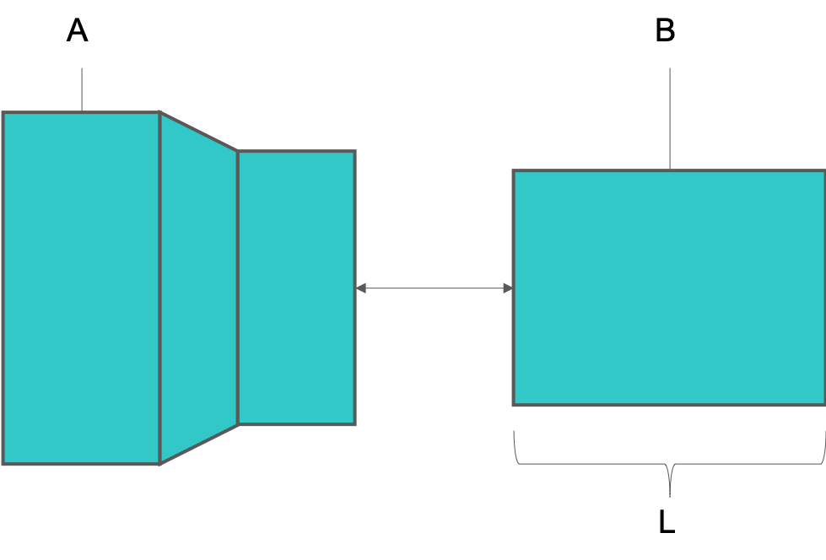

Next, join the pipe (B) to the trap adapter base (C). 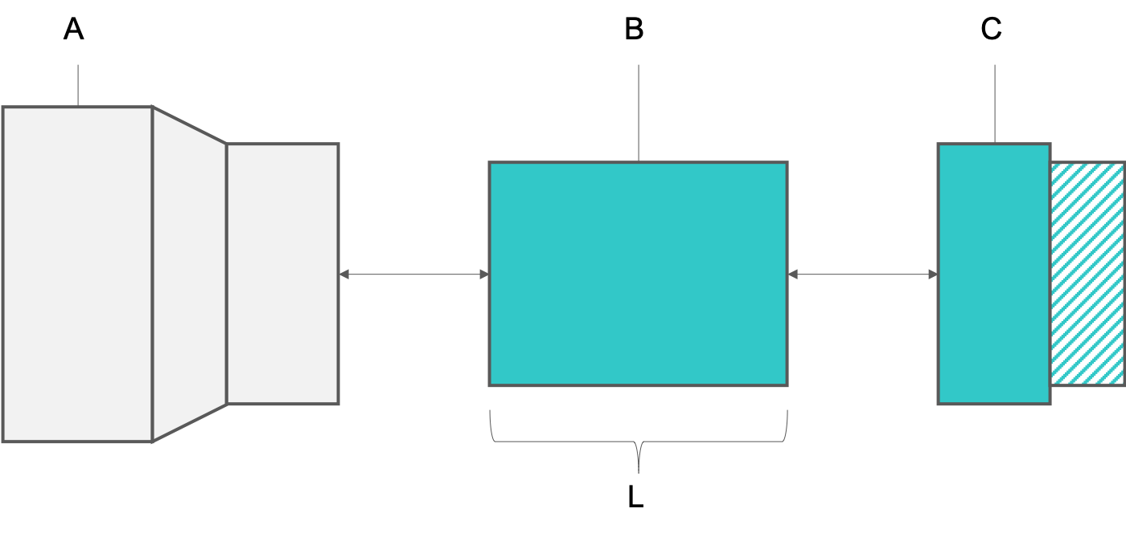

Finally, join the trap adapter base (C) to the trap adapter nut (D) by carefully threading the nut onto the base. 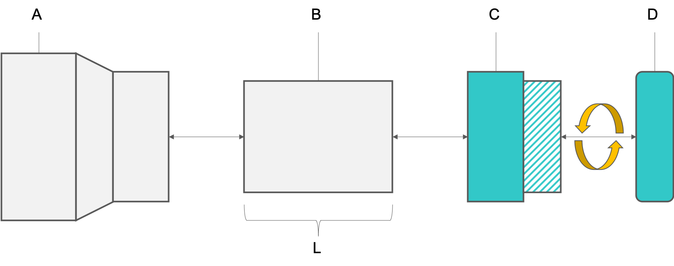

Your PVC didgeridoo should now be fully assembled. Wipe down the trap adapter with an alcohol pad before attempting to play!

## Standard Form

While traditional hollow-branch didgeridoos are generally straight, the PVC didgeridoo can be created in many forms. The standard straight form is the simplest design with a single length of pipe connecting the mouthpiece to the flared bell (our reducing coupling) at the opposite end.



Figure 8 PVC didgeridoo; standard form

## Alternative Forms

Alternative forms can result in more compact, twisted variations. These forms require extensive cutting and the use of angled fittings. One example is presented here for inspiration. With these forms, students can create longer didgeridoos and deeper, more resonant notes while occupying minimal space. What new form can you create?

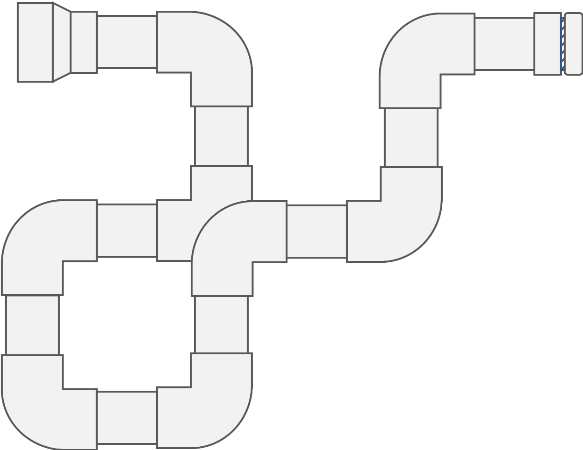

Figure 9 PVC didgeridoo; standard form

## Tuning

According to Didjshop (2016), the length of a didgeridoo for a particular desired frequency (also called the “key” of the didgeridoo) can be found using the formula where is the length in meters, is the speed of sound in meters per second, and is the desired frequency in Hertz (or key). We’ll do our calculations using the metric system so, as an example, let’s find the length of a didgeridoo that will play in the key of E (82.41Hz). We can do this by solving for the equation . We use 344 m/s because that is the speed of sound in dry air at a temperature of 20 degrees C. Solving this gives us a didgeridoo length of or about 1.04 meters. It’s good practice to start with a didgeridoo that is longer than needed and then you can cut and sand the PVC pipe to the desired length and key. See below for a data table of keys, frequencies (Hz), and estimated pipe lengths (mm). To estimate the key for a didgeridoo of a known length, solve the formula for instead to get where is again the length of the didgeridoo in meters.

Table 1 Musical key, frequency, and estimated didgeridoo length.

|  |  |  |
| --- | --- | --- |
| Key | Frequency (Hz) | Length (mm) |
| C | 32.70 | 2630 |
| C# | 34.65 | 2482 |
| D | 36.71 | 2342 |
| D# | 38.89 | 2211 |
| E | 41.20 | 2087 |
| F | 43.66 | 1970 |
| F# | 46.25 | 1859 |
| G | 49.00 | 1755 |
| G# | 51.91 | 1657 |
| A | 55.00 | 1564 |
| A# | 58.27 | 1475 |
| B | 61.74 | 1393 |
| C | 65.40 | 1315 |
| C# | 69.30 | 1241 |
| D | 73.42 | 1171 |
| D# | 77.78 | 1106 |
| E | 82.41 | 1044 |
| F | 87.31 | 985 |
| F# | 92.50 | 930 |
| G | 98.00 | 878 |
| G# | 103.82 | 828 |
| A | 110.00 | 782 |
| A# | 116.54 | 771 |
| B | 123.47 | 696 |
| C | 130.81 | 657 |
| C# | 138.59 | 620 |
| D | 146.83 | 586 |
| D# | 155.56 | 553 |
| E | 164.81 | 522 |

## Decoration

According to Harris (2013), the didgeridoo may be decorated. Many designs are inspired by nature and traditional pigments contributed an array of earth-tone hues to the instrument. See Figures 10 and 11 for some examples.



Figure 10 Didgeridoo decorations. Photo by Bernard Spragg, NZ. Public Domain.



Figure 11 More didgeridoo decorations. Photo by Bernard Spragg, NZ. Public Domain.

# Climate Data

## Overview

TODO

## Data Visualizations

TODO

# Music

## Climate Data as Inspiration

TODO

## Performance

TODO

# Materials and Tools List

This chapter describes the materials and tools needed to construct a basic PVC didgeridoo and a basic PVC paixiao.

## PVC Didgeridoo

Table 2 Materials for constructing a PVC Didgeridoo.

|  |  |  |
| --- | --- | --- |
| Materials | Specifications (Imperial) | Quantity or Length (Imperial) |
| PVC pipe | 1.5", Schedule 40 | 10’ |
| PVC trap adapter | 1.5", Schedule 40 | 1 |
| PVC Reducing Coupling | 3.0“x1.5”, Schedule 40 | 1 |
| Sandpaper Medium Grit | Medium Grit | as needed |
| Sandpaper Coarse Grit | Coarse Grit | as needed |
| Alcohol Prep Pads | - | as needed |

Table 3 Tools for constructing a PVC Didgeridoo.

|  |  |  |
| --- | --- | --- |
| Name | Specifications (Imperial) | Quantity (Imperial) |
| PVC Reamer | > 1.5" | 1 |
| Hacksaw | small | 1 |
| Digital Tuner | multi-instrument, clip-on or phone app | 1 |
| Permanent markers, multicolor | any color | any |
| Safety glasses | polycarbonate, ANSI Z87.1-2015 or similar | 1 pair per student |

## PVC Paixiao

Didjshop. 2016. “Physics of the Didgeridoo.” didjshop.com. <https://www.didjshop.com/physicsDidj.html>.

Fletcher, N. 1996. “The Didjeridoo (Didgeridoo).” *Acoustics Australia* 24 (1): 11–15. <https://www.acoustics.asn.au/journal/1996/1996_24_1_Fletcher.pdf>.

Harris, Matthew. 2013. “The Didgeridoo.” didjiman.com. <http://didjiman.com/didjeridu/>.

Hopkin, Michael. 2005. “Physicists Learn Secrets of Didgeridoo.” nature.com. <https://www.nature.com/news/2005/050704/full/news050704-7.html>.

Tarnopolsky, A., N. Fletcher, L. Hollenberg, B. Lange, J. Smith, and J. Wolfe. 2005. “Acoustics: the vocal tract and the sound of a didgeridoo.” *Nature* 436 (7047): 39. <https://doi.org/10.1038/43639a>.