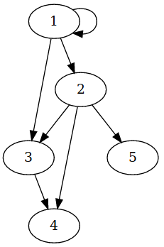 | V = { 1, 2, 3, 4, 5, 6 }  A = { (1,1), (1,2), (1,3), (2,3), (2,4), (2,5) }

