Markdown Slides [EN]

Adolfo Sanz De Diego

@asanzdiego

Table of Contents

# About

## What is it?

* **MarkdownSlides** is a Reveal.js and PDF **slides** generator **from MARKDOWN files**, that also generate HTML, EPUB and DOCX documents.
* The idea is that **from a same MARKDOWN file we can get slides and books** without worrying about style, just worrying about content.

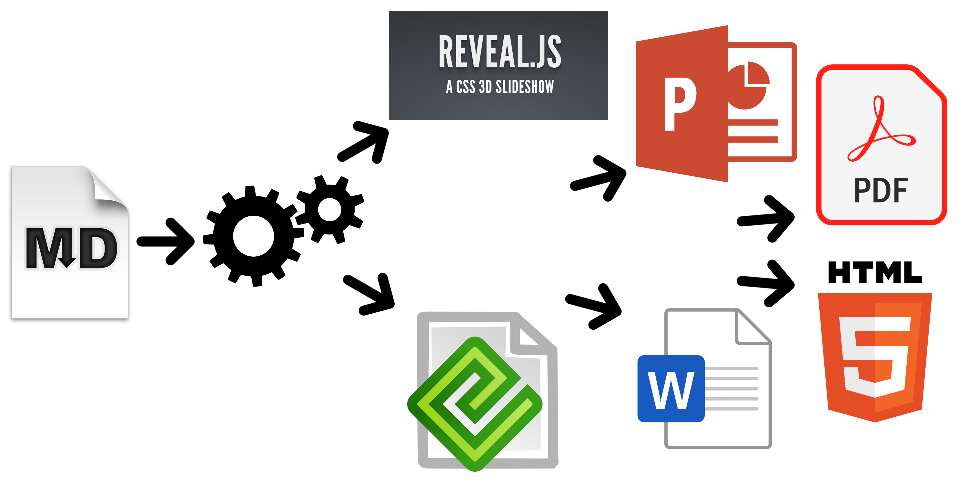

## Samples

* From a [MARKDOWN](https://raw.github.com/asanzdiego/markdownslides/master/doc/md/readme.md) file generate:
  + [reveal-slides](http://asanzdiego.github.io/markdownslides/doc/export/readme-slides.html)
  + [reveal-slides-pdf](http://asanzdiego.github.io/markdownslides/doc/export/readme-slides.pdf)
  + [epub-book](http://asanzdiego.github.io/markdownslides/doc/export/readme-book.epub)
  + [html-book](http://asanzdiego.github.io/markdownslides/doc/export/readme-book.html)
  + [docx-book](http://asanzdiego.github.io/markdownslides/doc/export/readme-book.docx)
  + [pdf-book](http://asanzdiego.github.io/markdownslides/doc/export/readme-book.pdf)

## Samples

* From this same [MARKDOWN](https://raw.github.com/asanzdiego/markdownslides/master/doc/md/readme.md) file **“plus” files** can be generated:
  + [reveal-slides-plus](http://asanzdiego.github.io/markdownslides/doc/export/readme-slides-plus.html)
  + [reveal-slides-pdf-plus](http://asanzdiego.github.io/markdownslides/doc/export/readme-slides-plus.pdf)
  + [epub-book-plus](http://asanzdiego.github.io/markdownslides/doc/export/readme-book-plus.epub)
  + [html-book-plus](http://asanzdiego.github.io/markdownslides/doc/export/readme-book-plus.html)
  + [docx-book-plus](http://asanzdiego.github.io/markdownslides/doc/export/readme-book-plus.docx)
  + [pdf-book-plus](http://asanzdiego.github.io/markdownslides/doc/export/readme-book-plus.pdf)

## Contributors

* Cesar Seoane: <https://github.com/cesarseoane>
* Rubén Gómez García: <https://github.com/kaneproject>
* Raul Jimenez Ortega: <https://github.com/hhkaos>
* Pablo J. Triviño: <https://twitter.com/p_trivino>
* Marcos Chavarría: <https://twitter.com/chavarria1991>

## Licence

* **This work is licensed under a:**
  + [Creative Commons Attribution 3.0](http://creativecommons.org/licenses/by-sa/3.0//)
* **The program source code are licensed under a:**
  + [GPL 3.0](http://www.gnu.org/licenses/gpl.html)

# Instalation

## Dependencies

* It needs to be installed:
  + [Pandoc](http://johnmacfarlane.net/pandoc/)
  + [DeckTape](https://github.com/astefanutti/decktape)
  + [TeX Live](https://tug.org/texlive/)
* It is automaticaly downloaded:
  + [Reveal.js](http://lab.hakim.se/reveal-js/#/)

## Requirements

* Now, only works in Linux (may be on MacOS)
* It can works with Docker, but is in beta.

## Download

<https://github.com/asanzdiego/markdownslides/releases>

## Docker

* Your installation with docker is still **under testing**.
* Any feedback is welcome.

### Building docker image

* It will be at dockerhub soon:

$ docker build -t asanzdiego/markdownslides .

### Launch the container

* Launch the container:

docker run -it -v "${PWD}":/home/markdownslides-master/"${PWD##*/}" \  
 asanzdiego/markdownslides ./build.sh [clean] [mode] [folder]

# How to use

## Creation

* First **copy the doc folder and rename it as you like**. It is important to rename it to prevent errors.
* **Create the md files** that you want to generate in the **md folder**. The md files are [Markdown](http://en.wikipedia.org/wiki/Markdown) files which are nothing more than plain text files with extension md, and a lightweight markup (we should know it but it is very simple).

## Imports

* We can add a file with **@import import/NOMBRE_FICHERO [startLine=NUMERO] [endLine=NUMERO] [showNumberLines]**

Firt example:

@import import/import-2.md

* Line 1 of import-2.md
* Line 2 of import-2.md
* Line 3 of import-2.md
* Line 4 of import-2.md

Second example:

@import import/import-1.md endLine=4

* Line 1 of import-1.md
* Line 2 of import-1.md
* Line 3 of import-1.md
* Line 4 of import-1.md

Third example:

@import import/import-1.md startLine=6

- Line 1 of import-2.md  
- Line 2 of import-2.md  
- Line 3 of import-2.md  
- Line 4 of import-2.md

Fourth example:

@import import/import-1.md startLine=2 endLine=3 showNumberLines

2 - Line 2 of import-1.md  
3 - Line 3 of import-1.md

## Notes

* We can add notes that will be visible in book mode or if **you press the letter ‘s’ on the slides** with **@start-notes** and **@end-notes**.

@start-notes  
 This is only visible in book mode or if you press 's' on the slides.  
 @end-notes

This is only visible in book mode or if you press ‘s’ on the slides.

## Plus notes

* We can create notes with **@plus** that will be only visible in “plus” files as long as in the build.properties we have **GENERATE_PLUS_VERSION=‘yes’**

@plus the lines below will only be available in the plus version  
  
 @plus @import import/import-2.md

the lines below will only be available in the plus version

* Line 1 of import-2.md
* Line 2 of import-2.md
* Line 3 of import-2.md
* Line 4 of import-2.md

## MathJax

* We can use the [MathJax](https://www.mathjax.org/) lib.

So this:

$$x = {-b \pm \sqrt{b^2-4ac}}.$$

Will be converted to:

$$x=−b±\sqrt{b^{2}−4ac}.$$

## Code

function helloWorld() {  
 alert('Hello world');  
}

## Levels

* You can have as many levels as you want. Example:

# Level 1 (on slides and book)  
  
## Level 2 (on slides and book)  
  
### Level 3 (in book but stays level 2 in slides)

But only in books. In slides you can only have 2 levels.

## Numbering

* You can name several slides with, (II), etc. But only the first one will be exported to the book. Example:

## Foo Bar  
  
 ## Foo Bar (II)

In the book will be:

## Foo Bar

## Configuration

We can configure the files that we want to generate from the file **build.properties**

DEFAULT_GENERATION_MODE='min'  
GENERATE_PLUS_VERSION='yes'  
DEFAULT_BUILD='REVEAL_SLIDES_PDF'  
  
BUILD_REVEAL_SLIDES='min'  
BUILD_REVEAL_SLIDES_PDF='med'  
  
BUILD_HTML_BOOK='min'  
BUILD_PDF_BOOK='med'  
BUILD_DOCX_BOOK='max'  
BUILD_EPUB_BOOK='max'

We can also configure some other stufs from the file **build.properties**

CLEAN_LIB_FOLDER='no'  
COPY_IMG_FOLDER='no'  
ZIP_EXPORT_FOLDER='no'  
NUMBER_SECTIONS='no'  
NUMBER_OFFSET='no'  
CURRENT_NUMBER_OFFSET=1  
REMOVE_GENERATE_MD_FILES='yes'

We can also configure some other stufs aboout reveal.js from the file **build.properties**

#THEME='black|white|league|sky|beige|simple|serif|blood|night|moon|solarized'  
REVEAL_JS_THEME='beige'  
REVEAL_JS_SHOW_TITLE_FOOTER='yes'  
REVEAL_JS_DEFAULT_TITLE_FOOTER='yes'  
REVEAL_JS_TITLE_FOOTER="'MarkdownSlides by @asanzdiego :-)'"  
REVEAL_JS_SHOW_MENU='yes'  
REVEAL_JS_SHOW_CHALKBOARD='yes'  
REVEAL_JS_ONLINE='no'

## Build

* In the root folder you have to execute:

./build.sh [mode] [folder]

* [**mode**] can take the next values: **min, med o máx**.
* [**folder**] folder wher to find the md files. If no folder name, it will convert all md files of all the folders.

# Releases notes

## Release 1.0

* Export slides to:
  + reveal-slides
  + reveal-slides-pdf
  + beamer-slides
  + deck-slides
* Export books to:
  + html-book
  + docx-book
  + odt-book
  + pdf-book
* Added generation modes ‘min’, ‘med’ and ‘max’.
* Automatic download the external libraries.
* Numbering, (II), (III) …

## Release 2.0

* Export slides to:
  + reveal-slides
  + reveal-slides-pdf
  + reveal-slides-online
* Export books to:
  + html-book
  + docx-book
  + epub-book
* Deprecated:
  + beamer-slides
  + deck-slides
  + odt-book
  + pdf-book
* Added menu thanks to [Raul Jimenez Ortega](https://github.com/hhkaos).
* Added dockerfile thanks to [Rubén Gómez García](https://github.com/kaneproject).
* Clean zip files from libraries thanks to [Cesar Seoane](https://github.com/cesarseoane).
* Added type ‘online’ thanks to [Cesar Seoane](https://github.com/cesarseoane).
* Fixed bug HTTPS images thanks to [Cesar Seoane](https://github.com/cesarseoane).
* Loading the online libraries with HTTPS thanks to [Cesar Seoane](https://github.com/cesarseoane).
* Configuration PDF resolution thanks to [Cesar Seoane](https://github.com/cesarseoane).
* New format ‘epub’.
* Added ‘bash strict mode’.
* Added ‘build.properties’ to configure file generation.
* Added the command ‘clean’ to clean the lib folder.
* Download a specific version of external library.
* Added notes only visible in book mode or if you press ‘s’ on the slides.
* Normalization of images in slides.

## Release 3.0

* Clean the code.
* Remove deprecated exportation files.
* Improve de configuration in build.properties file.
* Update [Reveal.js](http://lab.hakim.se/reveal-js/#/) dependencies.
* Export to PDF with [DeckTape](https://github.com/astefanutti/decktape).
* Book creation from some md files with enumeration.
* Possibility of adding a footer to the slides.

## Release 4.0

* Fix some bugs.
* Add bookmarks to the slides.
* Improve file names.
* Add [MathJax/](https://www.mathjax.org/) lib thanks to [Pablo J. Triviño](https://twitter.com/p_trivino).

## Release 5.0

* Clean the code.
* Fixed some bugs.
* Removed the command ‘clean’ to clean the lib folder because it can be done via properties file.
* Added again the option to export to PDF in book format.
* Added the possibility to import files or fragments from an external file.
* Added the plugin [chalkboard](https://github.com/rajgoel/reveal.js-plugins/tree/master/chalkboard) thanks to [Marcos Chavarría](https://twitter.com/chavarria1991).
* Added the possibility to create a ‘plus’ version with extra information in slides and books.

## Release 6.0

* Added the possibility to export to PowerPoint.
* Updated all the libraries to the latest version.
* Updated the templates.
* Updated the Dockerfile.

## Release 6.*

* New image of MarkdownSlides.
* Added Bootstrap to the html template.
* Added the DEFAULT_BUILD property.
* Minor changes.

## Release 7.0

* Updated all the libraries to the latest version.
* Updated the templates.
* Updated the Dockerfile.

# Adolfo Sanz De Diego Author

## Adolfo Sanz De Diego

* I started **developing web applications** until I transitioned into teaching.
* Currently, I am the [Head of the Educational Platforms Service at the Digitalization Department of the Community of Madrid](https://www.comunidad.madrid/transparencia/unidad-organizativa-responsable/servicio-plataformas-educativas).
* I collaborate as a teacher at the [University of Alcalá](https://www.uah.es/) and as a trainer at [Pronoide](https://www.pronoide.com/).

## Some projects

*  [Hackathon Lovers](http://hackathonlovers.com): a group created for entrepreneurs and developers who loves hackathons.
* [Password Manager Generator](http://pasmangen.github.io): an online password manager.
* [Extension of Password Manager Generator](https://github.com/pasmangen-extension/pasmangen-extension.github.io): an extension for browsers of Password Manager Generator.
* [MarkdownSlides](https://github.com/asanzdiego/markdownslides): a script to create slides from MD files.

## Where to find me?

* My nick: **asanzdiego**
  + Blog: [asanzdiego.com](http://asanzdiego.com)
  + GitHub: [github.com/asanzdiego](http://github.com/asanzdiego)
  + Twitter: [twitter.com/asanzdiego](http://twitter.com/asanzdiego)
  + LinkedIn: [linkedin.com/in/asanzdiego](http://www.linkedin.com/in/asanzdiego)