Markdown Slides [EN]

Adolfo Sanz De Diego

Septiembre 2019

Table of Contents

# About

## What is it?

**MarkdownSlides** is a Reveal.jsand PDF **slides** generator **from MARKDOWN files**, that also generate HTML, EPUB and DOCX documents.

The idea is that **from a same MARKDOWN file we can get slides and books** without worrying about style, just worrying about content.

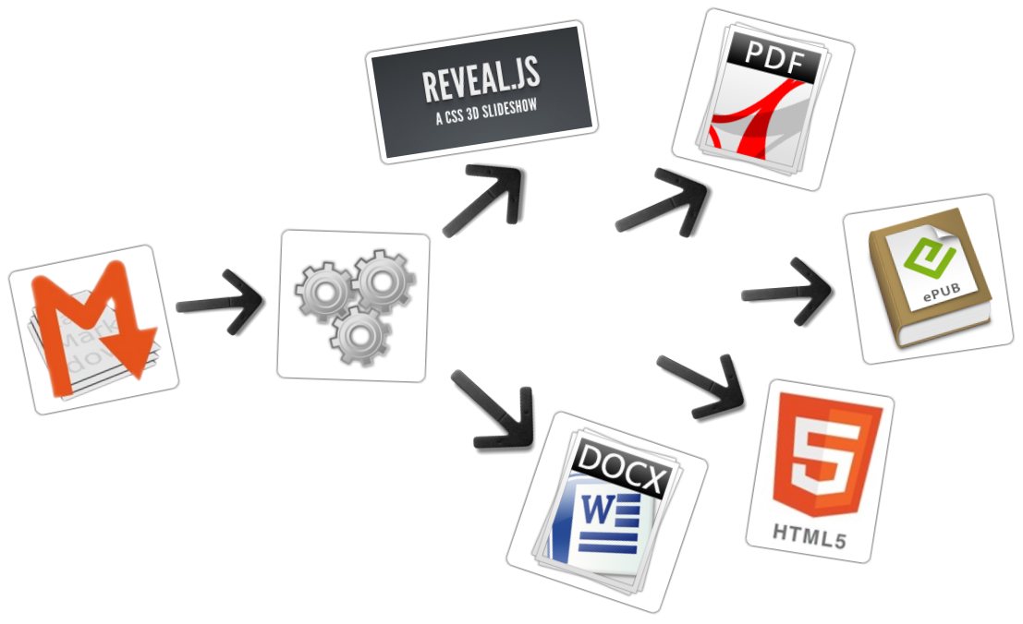

## Samples

From a [MARKDOWN](https://raw.github.com/asanzdiego/markdownslides/master/doc/md/readme.md) file generate:

* [reveal-slides](http://asanzdiego.github.io/markdownslides/doc/export/readme-reveal-slides.html)
* [reveal-slides-pdf](http://asanzdiego.github.io/markdownslides/doc/export/readme-reveal-slides.pdf)
* [epub-book](http://asanzdiego.github.io/markdownslides/doc/export/readme-book.epub)
* [html-book](http://asanzdiego.github.io/markdownslides/doc/export/readme-book.html)
* [docx-book](http://asanzdiego.github.io/markdownslides/doc/export/readme-book.docx)

## Contributors

* Cesar Seoane: <https://github.com/cesarseoane>
* Rubén Gómez García: <https://github.com/kaneproject>
* Raul Jimenez Ortega: <https://github.com/hhkaos>

## Creative Commons Attribution 3.0

* **This work is licensed under a:**
  + [Creative Commons Attribution 3.0](http://creativecommons.org/licenses/by-sa/3.0//)
* **The program source code are licensed under a:**
  + [GPL 3.0](http://www.gnu.org/licenses/gpl.html)

# Instalation

## Dependencies

* It needs to be installed:
  + [Pandoc](http://johnmacfarlane.net/pandoc/)
  + [DeckTape](https://github.com/astefanutti/decktape)
* It is automaticaly downloaded:
  + [Reveal.js](http://lab.hakim.se/reveal-js/#/)

## Requirements

Now, only works in Linux (may be on MacOS)

It can works with Docker, but is in beta.

## Download

<https://github.com/asanzdiego/markdownslides/archive/master.zip>

## Docker

Your installation with docker is still **under testing**.

Any feedback is welcome.

### Building docker image

It will be at dockerhub soon:

$ docker build -t asanzdiego/markdownslides .

### Launch the container

Launch the container, product generated will be as **min** configuration

docker run -it -v ${PWD}/doc:/home/markdownslides/doc \  
 asanzdiego/markdownslides

Changing to **med** configuration

docker run -it -v ${PWD}/doc:/home/markdownslides/doc \  
 asanzdiego/markdownslides ./build.sh med doc

Changing to **max** configuation

docker run -it -v ${PWD}/doc:/home/markdownslides/doc \  
 asanzdiego/markdownslides ./build.sh max doc

# How to use

## Creation

* First **copy the doc folder and rename it as you like**. This is not necessary but helps you organize your documents.
* **Create the md files** that you want to generate in the **md folder**. The md files are [Markdown](http://en.wikipedia.org/wiki/Markdown) files which are nothing more than plain text files with extension md, and a lightweight markup (we should know it but it is very simple).

## Notes

You can add notes that will be visible in book mode or if **you press the letter 's' on the slides** with **@start-notes** and **@end-notes**.

<aside class="notes">  
This is only visible in book mode or if you press 's' on the slides.  
</aside>

This is only visible in book mode or if you press 's' on the slides.

## Levels

You can have as many levels as you want. Example:

# Level 1 (on slides and book)  
  
## Level 2 (on slides and book)  
  
### Level 3 (in book but stays level 2 in slides)

But only in books. In slides you can only have 2 levels.

## Numbering

You can name several slides with, (II), etc. But only the first one will be exported to the book. Example:

## Foo Bar  
  
 ## Foo Bar (II)

In the book will be:

## Foo Bar

## Configuration

We can configure the files that we want to generate from the file **build.properties**

BUILD_REVEAL_SLIDES='min'  
BUILD_REVEAL_SLIDES_PDF='min'  
BUILD_REVEAL_SLIDES_ALTERNATIVE='med'  
BUILD_REVEAL_SLIDES_ALTERNATIVE_PDF='med'  
BUILD_REVEAL_SLIDES_ONLINE='max'  
BUILD_REVEAL_SLIDES_ONLINE_ALTERNATIVE='max'  
  
BUILD_HTML_BOOK='min'  
BUILD_DOCX_BOOK='med'  
BUILD_EPUB_BOOK='max'

We can also configure some other stufs from the file **build.properties**

CLEAN_LIB_FOLDER='no'  
COPY_IMG_FOLDER='no'  
ZIP_EXPORT_FOLDER='no'  
NUMBER_SECTIONS='yes'  
NUMBER_OFFSET='no'  
CURRENT_NUMBER_OFFSET=1  
REMOVE_MD_TO_BOOK='yes'  
REMOVE_MD_TO_SLIDES='yes'

We can also configure some other stufs aboout reveal.js from the file **build.properties**

#THEME='black|white|league|sky|beige|simple|serif|blood|night|moon|solarized'  
REVEAL_JS_THEME='beige'  
REVEAL_JS_SHOW_TITLE_FOOTER='yes'  
REVEAL_JS_DEFAULT_TITLE_FOOTER='yes'  
REVEAL_JS_TITLE_FOOTER="'MarkdownSlides by @asanzdiego :-)'"  
REVEAL_JS_SHOW_MENU='yes'  
REVEAL_JS_ONLINE='yes'

## Build

In the root folder you have to execute:

./build.sh [clean] [mode] [folder]

* [**clean**] clean the folder **lib** and download the dependencies again.
* [**mode**] can take the next values: **min, med o máx**.
* [**folder**] folder wher to find the md files. If no folder name, it will convert all md files of all the folders.

# Releases notes

## Relese 1.0

* Export slides to:
  + reveal-slides
  + reveal-slides-pdf
  + beamer-slides
  + deck-slides
* Export books to:
  + html-book
  + docx-book
  + odt-book
  + pdf-book
* Added generation modes 'min', 'med' and 'max'.
* Automatic download the external libraries.
* Numbering, (II), (III) ...

## Relese 2.0

* Export slides to:
  + reveal-slides
  + reveal-slides-pdf
  + reveal-slides-online
* Export books to:
  + html-book
  + docx-book
  + epub-book
* Deprecated:
  + beamer-slides
  + deck-slides
  + odt-book
  + pdf-book
* Added menu thanks to [Raul Jimenez Ortega](https://github.com/hhkaos).
* Added dockerfile thanks to [Rubén Gómez García](https://github.com/kaneproject).
* Clean zip files from libraries thanks to [Cesar Seoane](https://github.com/cesarseoane).
* Added type 'online' thanks to [Cesar Seoane](https://github.com/cesarseoane).
* Fixed bug HTTPS images thanks to [Cesar Seoane](https://github.com/cesarseoane).
* Loading the online libraries with HTTPS thanks to [Cesar Seoane](https://github.com/cesarseoane).
* Configuration PDF resolution thanks to [Cesar Seoane](https://github.com/cesarseoane).
* New format 'epub'.
* Added 'bash strict mode'.
* Added 'build.properties' to configure file generation.
* Added command 'clean' to clean the lib folder.
* Download a specific version of external library.
* Added notes only visible in book mode or if you press 's' on the slides.
* Normalization of images in slides.

## Relese 3.0

* Clean the code.
* Remove deprecated exportation files.
* Improve de configuration in build.properties file.
* Update [Reveal.js](http://lab.hakim.se/reveal-js/#/) dependencies.
* Export to PDF with [DeckTape](https://github.com/astefanutti/decktape).
* Book creation from some md files with enumeration.
* Possibility of adding a footer to the slides.

# Author

## Adolfo Sanz De Diego

* **Old JEE web developer**.
* Now I'm **Tecnical Teacher Advaisor** in the TIC service of the General Direction of Infrastructure and Services of the Ministry of Education, Youth and Sports of the Community of Madrid.
* In addition I work as **trainer specialized in development technologies**.

## Algunos proyectos

*  [Hackathon Lovers](http://hackathonlovers.com): a group created for entrepreneurs and developers who loves hackathones.
* [Password Manager Generator](http://pasmangen.github.io): an online password manager.
* [MarkdownSlides](https://github.com/asanzdiego/markdownslides): a script to create slides from MD files.

## Where to find me?

* Mi nick: **asanzdiego**
  + Blog: [asanzdiego.com](http://asanzdiego.com)
  + GitHub: [github.com/asanzdiego](http://github.com/asanzdiego)
  + Twitter: [twitter.com/asanzdiego](http://twitter.com/asanzdiego)
  + LinkedIn: [linkedin.com/in/asanzdiego](http://www.linkedin.com/in/asanzdiego)
  + SlideShare: [slideshare.net/asanzdiego](http://www.slideshare.net/asanzdiego)