Wk 2 homework

Student: Mauricio Sanchez

Date: Nov 8th 2015

Prerequisites

• All material presented in the Probability Chapter

1. (a) What is the probability of rolling a pair of dice and obtaining a total score of 9 or more? (6,3) (3,6) (5,4) (4,5) (5,5) (6,4) (4,6) (6,5) (5,6) (6,6) -> n = 10, possible outcomes 36 therefore P(10/36) = 0.278 (b) What is the probability of rolling a pair of dice and obtaining a total score of 7? (3,4) (4,3) (6,1) (1,6) (5,2) (2,5) -> n = 6 -> P(6/36) = 0.167

2. A box contains four black pieces of cloth, two striped pieces, and six dotted pieces. A piece is selected randomly and then placed back in the box. A second piece is selected randomly. What is the probability that:

Probability of Black (4/12) = 1/3 = 0.34

Probability fo Stripped P(2/12) = 1/6 = 0.167

Probability of Dotted P(6/12) = 1/2 = 0.5

n = 12

a. both pieces are dotted? .P( 0.5 * 0.5) = 0.25

b. the first piece is black and the second piece is dotted? P(0.34 * 0.5) = 0.17

c. one piece is black and one piece is striped? P(0.34 * 0.18) = 0.06

3. A card is drawn at random from a deck. (a) What is the probability that it is an ace or a king? P(A) = 4/52 = 0.07 P(K) = 4/52 = 0.07 -> P(A/B) = 0.14 (b) What is the probability that it is either a red card or a black card? P(R) = 26/52 -> 1/2 -> 0.5, P(B) = 0.5 -> P(R/B) = 1

4. The probability that you will win a game is 0.45. (a) If you play the game 80 times, what is the most likely number of wins? What are the mean and standard deviation of a binomial distribution with P = 0.45 and N = 80? a) p = 0.45 and N = 80? P(W) = 0.45 * 80 = 36 times

5. A fair coin is flipped 9 times. What is the probability of getting exactly 6 heads? P(6 heads)

2^9 = 512 different possibilities

P(heads) = P(Ha)+P(Hb)+P(Hc)+P(Hd)+P(He)+ P(Hf)+P(Tg) +P(Th)

= 9 * 8 * 7 * 6 * 5 * 4 = 60480 possibilities to get 6 heads in a row.

# of possible ways to rearrange 6 straight heads = 6 * 5 * 4 * 3 * 2 * 1 = 720

total # of possibilities of getting 6 heads in 9 tries / total number of rearranging those 6 heads

60480/720 = 84

The binomial distribution formula n! / x!(n-x)! -> 84/512 -> 0.1640625

Binomial Distribution -> n! / x!(n−x)!->

6.When Susan and Jessica play a card game, Susan wins 60% of the time. If they play 9 games, what is the probability that Jessica will have won more games than Susan?

9 * 8 * 7 * 6 * 5 = 15120 possible ways of winning

2^9 possibilities total for the entire set = 512

Arrangement of wins by Jessica

6 * 5 * 4 * 3 * 2 * 1 = 320

15120 / 320 = 47.25 possibilities

47.25/512 = 0.09228516

n = 9

x = 6

P(s) = 0.6

P(j) = 0.4

by the quadratic formula -> n! / x! * (n - x)!

9! / (6! * (9 - 6)!)

The probability that Jessica will have won more games than Susan is 0.1476562

7.You flip a coin three times. (a) What is the probability of getting heads on only one of your flips? (b) What is the probability of getting heads on at least one flip? H T T

a) Possibilities = 3 * 2 * 1 = 6

N = 3

P(H) = 1/8 = .875

b) (1/2)(1/2)(1/2) =.125 or 1/8

1 - 1/8 = 7/8

8. A test correctly identifies a disease in 95% of people who have it. It correctly identifies no disease in 94% of people who do not have it. In the population, 3% of the people have the disease. What is the probability that you have the disease if you tested positive?

P(A|B) = (0.03) (0.95) / (0.95) (0.03) + (0.97) (0.05)

= 0.0285 / 0.077

= 0.3701

9. A jar contains 10 blue marbles, 5 red marbles, 4 green marbles, and 1 yellow marble. Two marbles are chosen (without replacement). (a) What is the probability that one will be green and the other red? (b) What is the probability that one will be blue and the other yellow?

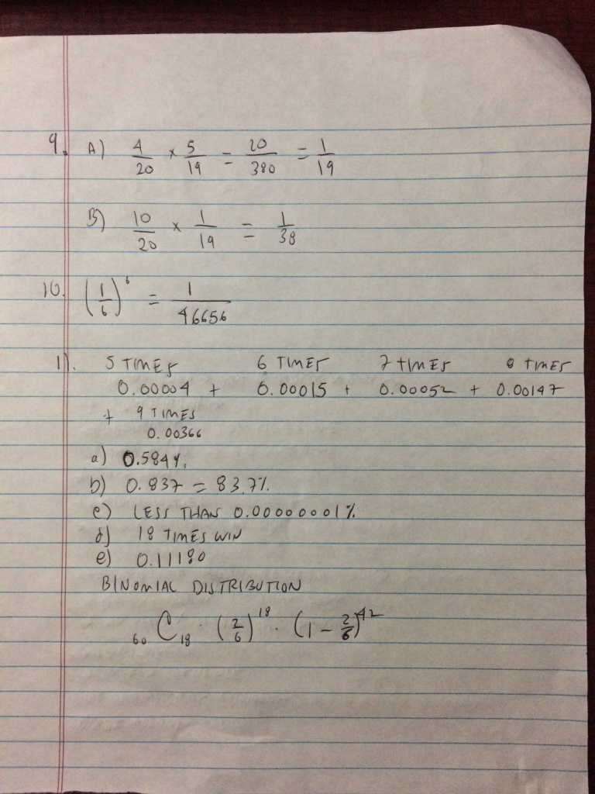pitcher.

