# Text-image generation

DB926940 WONG CHON PAN

DB927178 IAO CHONG HOU

DC027486 ZHANG XING JIAN

DC028067 LIU YUCHENG

DC028058 CHEN ZHUXUAN

# Project description

Text-image generation software which inputs text and then outputs the image.

What we know is that the traditional way of making an image is very costly. Now, this method can highly improve efficiency although it is still unable to function perfectly in some areas like making accurately acg character doing specific action like eating noodles. This method is able to reduce most of the cost of making an image or further animation.

This method would apply stable diffusion model which is trained base on diffusion model. In the website created it would able to change some parameter and input training image to generate images. For example, generate something like city on the mars or anime character.

# Requirement model

## Users:

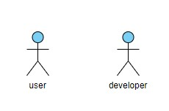

## Functional requirement

For user: User should able to select model that use to generate image. User can train model by input images.

Developer: Developer can create model by mass training. Developer can alter and display the database of the system. Developer can alter and display the structure of the web.