FILINGLENS DOCUMENTATION
FilingLens User Guide
Installation, Interface Reference, Workflows, and Troubleshooting
A practical guide for installing FilingLens, understanding every application control and output, investigating companies, reviewing evidence, generating local analyst briefs, and troubleshooting common conditions.
Document | End-user manual and reference guide
Status | Complete and validated
Validation date | August 21, 2026
Application | FilingLens v0.1.0
Educational financial-analysis software. Not investment advice, an audit opinion, or a fraud-detection system.

Contents
Use this section map for quick orientation. Word's Navigation pane also lets you jump between headings.
1. What FilingLens does
2. Requirements
3. Installation
4. Configuration
5. Optional local AI setup
6. Launching FilingLens
7. First-use walkthrough
8. Sidebar reference
9. Overview tab
10. Financial Trends tab
11. Anomaly Analysis tab
12. Insider Activity tab
13. Ask the Filing tab
14. Analyst Brief tab
15. Methodology tab
16. Common workflows
17. Caching and data freshness
18. Error and status messages
19. Interpreting missing data
20. Privacy and security
21. Running the tests
22. Shutting down and restarting
23. Quick-reference glossary
24. Final user checklist

This guide explains how to install, launch, and use FilingLens, including what every main control, tab, table, and output means.
Responsible-use notice: FilingLens is educational financial-analysis software. It is not investment advice, an audit opinion, or a fraud-detection system.

1. What FilingLens does
FilingLens helps users investigate U.S. public companies through two kinds of official SEC information:
• Structured XBRL facts used for financial statements, ratios, growth, and unusual-change analysis.
• Filing documents used for management commentary, risks, business descriptions, and source-grounded questions.
Python calculates the numerical results. A local LM Studio or Ollama model can explain those results and relevant filing passages, but it is not the source of the calculations.

2. Requirements
The documented quick-start path requires:
• a Mac running macOS 14 or newer (Apple Silicon recommended);
• Python 3.11 or newer;
• an internet connection for package installation and first-time SEC downloads;
• an identifiable SEC automated-access User-Agent;
• LM Studio or Ollama only if you want AI questions and analyst briefs.
LM Studio requires Apple Silicon and officially recommends 16 GB or more RAM. Ollama also supports Intel Macs in CPU-only mode, although generation will be slower. The tested Gemma 4 12B MLX 5-bit model is approximately 7.7 GB before context/KV-cache overhead, so 16 GB is a practical minimum and 24 GB is more comfortable. Smaller models are appropriate for lower-memory systems. Linux and Windows may also work, but this guide focuses on macOS.
You do not need a paid financial-data API or paid cloud-LLM key.

3. Installation
Check Python first:
python3 --version
If it is older than 3.11, install a current build from python.org (https://www.python.org/downloads/macos/) or use Homebrew. Then:
git clone https://github.com/ezdubbot/FilingLens.git
cd FilingLens
./scripts/setup_macos.sh
The helper creates .venv, installs every runtime dependency declared in pyproject.toml, and copies the safe configuration example to .env without overwriting an existing file. Developers can include pytest and coverage tools with:
./scripts/setup_macos.sh --dev
For manual installation and lower-level troubleshooting, see macos_setup.md (macos_setup.md).

4. Configuration
If .env does not already exist, copy the example:
cp .env.example .env
Open .env and configure:
SEC_USER_AGENT=FilingLens/1.0 your-email@example.com
LOCAL_LLM_PROVIDER=auto
LMSTUDIO_BASE_URL=http://127.0.0.1:1234/v1
LMSTUDIO_MODEL=
LMSTUDIO_API_KEY=
LMSTUDIO_TIMEOUT_SECONDS=300
OLLAMA_BASE_URL=http://127.0.0.1:11434
OLLAMA_MODEL=
OLLAMA_TIMEOUT_SECONDS=300

What each setting means
Setting | Meaning
SEC_USER_AGENT | Identifies your automated SEC client and supplies a contact address. Replace the example email.
LOCAL_LLM_PROVIDER | auto checks LM Studio first and Ollama second. Use lmstudio or ollama to force one service.
LMSTUDIO_BASE_URL | Local LM Studio OpenAI-compatible endpoint. The normal default is http://127.0.0.1:1234/v1.
LMSTUDIO_MODEL | Optional exact model ID. Leave blank to discover models automatically.
LMSTUDIO_API_KEY | Optional local authentication key. Normally blank when LM Studio authentication is disabled.
LMSTUDIO_TIMEOUT_SECONDS | Maximum wait for one local generation. Default: 300 seconds. Increase for slower models.
OLLAMA_BASE_URL | Local Ollama service. The normal default is http://127.0.0.1:11434.
OLLAMA_MODEL | Optional exact installed Ollama tag. Leave blank to discover models automatically.
OLLAMA_TIMEOUT_SECONDS | Maximum wait for one Ollama generation. Default: 300 seconds.

The .env file is private and ignored by Git. Do not publish it. The SEC contact address is not printed by the doctor, but it is transmitted to SEC.gov in the request header as required by the SEC's automated-access guidance.

5. Optional local AI setup
You can use all deterministic financial features without a model server. To enable Ask the Filing and Analyst Brief, choose one option.

Option A: LM Studio
1. Install and open LM Studio (https://lmstudio.ai/download).
2. Download an instruction-tuned chat model. On a 16-24 GB Apple Silicon Mac, Gemma 4 12B MLX 5-bit (approximately 7.7 GB) is a practical starting point.
3. Load it with an initial 16K-32K context rather than the maximum theoretical context.
4. Open LM Studio's Developer area.
5. Start the server on port 1234.
6. Leave LMSTUDIO_MODEL blank unless you need to force a specific exposed model ID.
Verify with curl http://127.0.0.1:1234/v1/models. Keep network serving disabled unless you intentionally need LAN access; if you enable it, also enable authentication and restrict the network.

Option B: Ollama
1. Install Ollama for macOS (https://ollama.com/download) and open it.
2. On Apple Silicon, run ollama run gemma4:12b-mlx. The comparable portable tag is gemma4:12b; smaller Macs can use gemma4:e2b-mlx.
3. Type /bye after the initial chat. The model remains installed.
4. Set LOCAL_LLM_PROVIDER=ollama if LM Studio may also be running.
5. Verify with curl http://127.0.0.1:11434/api/tags.
FilingLens discovers available chat-model IDs instead of guessing a filename. The first generation after changing ticker or filing evidence may be slower because the model cannot reuse the previous prompt cache. FilingLens uses a five-minute default timeout and compact prompt contexts; a smaller model will respond faster.

6. Launching FilingLens
From the project directory:
.venv/bin/python scripts/doctor.py
.venv/bin/python -m streamlit run app.py
Open the displayed local address, normally:
http://localhost:8501
To stop FilingLens, return to the terminal and press Control+C.

7. First-use walkthrough
For a straightforward first session:
1. Enter AAPL in the Ticker field.
2. Keep Historical periods set to 5.
3. Confirm that Overview shows Apple, its CIK, latest filing dates, and headline metrics.
4. Open Financial Trends and inspect the charts and statements.
5. Open Anomaly Analysis and review Notable or Significant movements.
6. Open Ask the Filing.
7. Click Load and index latest 10-K.
8. Enter a question such as “What factors did management say affected revenue?”
9. Click Ask the filing and inspect both the answer and each source passage.
10. Open Analyst Brief and generate the report if a local provider is connected.

8. Sidebar reference
The sidebar controls the active company, historical window, cache, local provider, and model.

Ticker
Enter a U.S. public-company ticker such as:
• AAPL
• MSFT
• WMT
• KO
• JPM
FilingLens normalizes lowercase input to uppercase and converts dot-class symbols such as BRK.B to SEC-style BRK-B.
After a ticker is entered, FilingLens uses the SEC company directory to find the company name and zero-padded CIK.
Possible messages:
• Ticker was not found: the symbol may be invalid, delisted, foreign-only, or absent from the SEC directory.
• Enter a valid U.S. ticker symbol: the input contains unsupported characters or is too long.

Historical periods
Selects how many recent annual periods are shown in tables, charts, ratios, and anomaly analysis.
• Minimum: 3
• Maximum: 10
• Default: 5
A longer window provides more history but may expose tag changes and non-comparable periods. The robust anomaly method needs at least four valid year-over-year changes, which generally requires five annual observations.

Refresh SEC cache
Forces FilingLens to bypass both the current Streamlit data cache and the persistent SEC response cache for the active reload.
Use it when:
• a new filing was recently published;
• you suspect a cached response is incomplete;
• you want the latest SEC directory or Company Facts data.
Do not click it repeatedly. Normal reruns should use the cache to avoid unnecessary SEC traffic.

Local AI provider and model
When one or both supported services are reachable, choose LM Studio or Ollama and then choose an available local chat model. With LOCAL_LLM_PROVIDER=auto, LM Studio is listed first when both are available; set the variable to force one provider.
Changing the model does not change SEC data or Python calculations. It changes only generative explanations.

Local AI status
Possible states include:
• Provider: Connected - N model(s): the local service is reachable and chat models were discovered.
• No configured local AI service was detected: neither enabled endpoint could be reached.
• No local chat models: download/load a model in LM Studio or install one with Ollama.
When offline, deterministic features continue working and the Overview model value shows Offline.

9. Overview tab
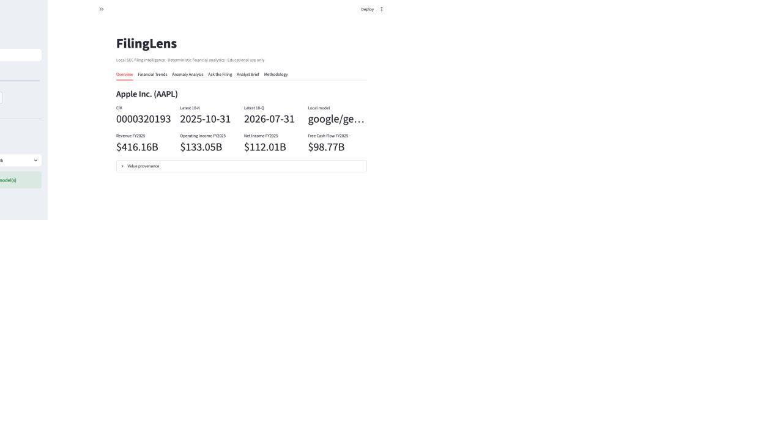
Figure 1. Overview tab with company identity, filing dates, model status, and headline metrics.
Overview is the high-level company summary.

Company heading
Shows the SEC company name and normalized ticker.

CIK
The Central Index Key is the SEC's unique company identifier. FilingLens displays the normalized ten-digit version.

Latest 10-K
Shows the filing date of the most recent annual report found in recent SEC submissions.

Latest 10-Q
Shows the filing date of the most recent quarterly report found in recent SEC submissions.

Local model
Shows the exact selected LM Studio model ID or Ollama model tag, or Offline.

Headline metrics
The latest available annual period displays:
• Revenue: mapped annual sales/revenue fact.
• Operating Income: profit from core operations before interest and taxes, based on the selected XBRL concept.
• Net Income: annual profit after expenses and taxes.
• Free Cash Flow: operating cash flow minus capital expenditures, calculated in Python.
If a reliable mapping is not available, the value appears as Unavailable.

Value provenance
Expand this area to inspect the long-form source table.
Column | Meaning
ticker | Normalized market ticker
company_name | SEC entity name
cik | Ten-digit SEC identifier
form | Filing form supplying the fact, normally 10-K or 10-K/A
accession_number | Unique SEC filing accession
filing_date | Date the supplying filing was submitted
fiscal_year | Annual label derived from the observation period end
fiscal_period | SEC fiscal-period label, normally FY
period_start | Beginning date for duration facts
period_end | End date of the represented observation
metric | FilingLens normalized metric name
value | Raw selected numerical value
unit | XBRL unit, currently normally USD
xbrl_concept | Exact selected US-GAAP concept

Use provenance when a value looks surprising. Confirm the concept, period, filing, and original SEC report before relying on it.

10. Financial Trends tab
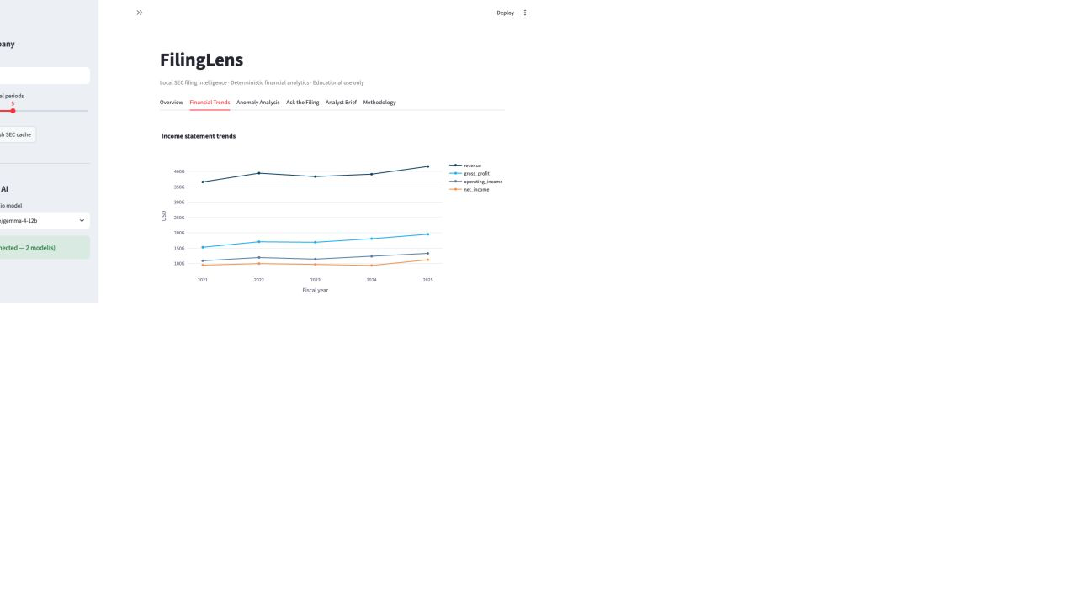
Figure 2. Financial Trends tab with annual income-statement chart and sidebar controls.
This tab provides historical charts, statements, and ratios.

Income statement trends
Plots available annual series for:
• revenue;
• gross profit;
• operating income;
• net income.
Use the chart toolbar to zoom, pan, reset axes, view fullscreen, or download a PNG.

Cash flow and capital trends
Plots available annual series for:
• operating cash flow;
• free cash flow;
• total assets;
• long-term debt.
Because assets and cash flow can be different orders of magnitude, inspect the hover values and tables as well as the line shapes.

Margin trends
Plots gross, operating, and net margins as percentages.
• Gross margin: gross profit ÷ revenue
• Operating margin: operating income ÷ revenue
• Net margin: net income ÷ revenue

Income Statement expander
Shows annual rows/columns for available revenue, cost, and profit metrics. The table can be searched, shown fullscreen, or downloaded as CSV using Streamlit's table toolbar.

Balance Sheet expander
Shows available annual cash, asset, liability, equity, and debt values.

Cash Flow expander
Shows operating cash flow, capital expenditures, and Python-calculated free cash flow.

Ratios and growth expander
Shows calculated ratios by annual period.

Growth fields
Growth is calculated as:
(current value − prior value) ÷ absolute prior value
Using the absolute prior value preserves the direction of change after a negative comparison period.

Profitability fields
• gross_margin
• operating_margin
• net_margin
• return_on_assets
• return_on_equity
ROA and ROE use average beginning-and-ending balances. The first displayed period can be blank when the prior balance is not available.

Liquidity and leverage fields
• current_ratio: current assets ÷ current liabilities
• debt_to_assets: long-term debt ÷ total assets
• debt_to_equity: long-term debt ÷ stockholders' equity
A negative debt-to-equity result can occur when reported equity is negative. It is mathematically defined but requires careful interpretation.

Cash-flow fields
• operating_cash_flow_margin
• free_cash_flow_margin
• operating_cash_flow_growth
• free_cash_flow_growth
Blank values normally mean that an input, comparison period, or valid denominator was unavailable.

11. Anomaly Analysis tab
This tab screens for unusual financial movements. It does not determine fraud, manipulation, misconduct, or deception.

Severity filter
Choose which records to display:
• Normal: below both screening thresholds.
• Notable: absolute economic change of at least 20% or robust-score magnitude of at least 2.5.
• Significant: absolute economic change of at least 40% or robust-score magnitude of at least 3.5.
The default shows Notable and Significant records.

Change coloring
Choose one of three display modes:
• Likely financial impact: green means likely favorable and red likely unfavorable. Increases in costs, expenses, debt, and liabilities are treated as unfavorable; decreases in those metrics are favorable. Other metrics use higher-is-better as a screening assumption.
• Raw increase / decrease: every numerical increase is green and every decrease is red, regardless of economic meaning.
• Off: removes directional cell coloring.
Each direction has three shades: light below 20%, medium from 20% through 39.9%, and deep at 40% or more. The direction is a visual research aid, not an investment conclusion; whether a movement is actually favorable depends on its cause and context.
The Direction column includes a stable rank so its header sorts by meaning instead of alphabetically. In likely-impact mode, ascending order is 1 · Strongly favorable, 2 · Moderately favorable, 3 · Lightly favorable, 4 · Lightly unfavorable, 5 · Moderately unfavorable, then 6 · Strongly unfavorable. Clicking the header again applies the exact reverse order. Raw increase/decrease mode uses the same 1-to-6 structure from strongest gain to strongest loss.

Full explanation
Use the selector above the table to display the complete explanation and detection method for a specific metric and period. This keeps the main grid compact while ensuring that the explanation is not clipped. Currency values, percentages, percentage-point changes, and ratio multiples are formatted in their appropriate units.

Anomaly table fields
Field | Meaning
metric | Financial value or ratio being evaluated
period | Current annual period
prior_value | Value in the prior available annual period
current_value | Value in the current period
absolute_change | Current value minus prior value
percentage_change | Absolute change divided by the absolute prior value
anomaly_score | MAD robust z-score for the change series, when enough history exists
severity | Normal, Notable, or Significant
method | Economic change alone or economic change plus MAD robust z-score
explanation | Plain-language description and responsible-use warning, displayed in full above the grid

How to interpret a flag
A flag answers: “Did this annual movement cross the documented screen?” It does not answer why it happened or whether it was good, bad, intentional, or improper.
Recommended follow-up:
1. Open Financial Trends to view the history.
2. Check Value provenance for comparable facts and periods.
3. Ask the filing what management said about the movement.
4. Read the original SEC source.

12. Insider Activity tab
This tab retrieves recent official SEC Forms 4 and 4/A for the active company. It provides a Finviz-style insider-transaction workflow without scraping a third-party website.

Load insider activity
Choose how many recent ownership filings to review, then click Load insider activity. SEC responses are cached locally, so unchanged filings do not need to be downloaded again.
The summary shows:
• total value of transaction-code P open-market/private purchases;
• total value of transaction-code S open-market/private sales;
• purchase value minus sale value;
• number of distinct reporting insiders.
Grants, awards, option exercises, gifts, tax-related dispositions, conversions, and other transaction codes are displayed separately and excluded from the directional purchase/sale totals. Form 4/A amendments remain visible but are excluded from summary totals.
Each transaction retains the insider name and role, dates, transaction code and description, shares, price, estimated value, ownership after the transaction, direct/indirect status, derivative-security indicator, 10b5-1-plan indicator, and direct SEC filing link. A CSV download is available.
Insider activity is not a standalone buy or sell signal. Review the source footnotes because sales may reflect diversification, taxes, compensation, charitable gifts, or pre-arranged plans.

13. Ask the Filing tab
This tab retrieves passages from the latest 10-K and optionally asks the selected local model to answer using those passages.

Evidence source
Shows the filing form and filing date that will be indexed.

Load and index latest 10-K
Downloads or loads the cached official filing, cleans it, detects sections, creates overlapping chunks, and builds the local TF-IDF index.
This button must be used before asking questions or generating a brief. After indexing, the app shows:
• number of chunks;
• number of detected sections.

Question
Enter a filing-related question. Good questions use language likely to appear in the report.
Examples:
• What factors did management say affected revenue?
• Why did operating margin change?
• What does management say about liquidity?
• What were the major business risks?
• What factors affected operating cash flow?
• How does management describe competitive pressure?
• What changed in capital expenditures?
Avoid overly broad questions such as “Tell me everything.” Focused questions produce more relevant evidence.

Ask the filing
Runs a deterministic scope preflight, ranks the filing chunks, sends the top passages and verified Python metrics to the selected local model, and displays the response. The local generation request disables model reasoning so the output budget is reserved for the visible, cited answer.
Clearly unrelated questions—such as weather or sports questions—and requests for future price predictions or buy/sell recommendations are stopped before local-model generation. The app labels these requests as outside the indexed filing's scope and suggests filing-related topics. This avoids spending local compute on a request that the evidence cannot support.
The button is disabled when no supported local chat model is available. You can still inspect deterministic financial data while offline.

Answer
The model is instructed to use [Source N] markers for filing-derived claims. Numerical values supplied under Verified FilingLens Metrics came from Python and should be distinguished from management commentary.
If the evidence is insufficient, the expected response says so. An unsupported answer should not be treated as established just because it sounds plausible.

Sources
Each expandable source shows:
• source number;
• filing section;
• TF-IDF relevance score;
• filing form and date;
• official SEC hyperlink;
• exact retrieved filing passage.
Always compare important AI claims with the displayed passages. A relevance score measures lexical similarity, not factual correctness.

14. Analyst Brief tab
The Analyst Brief combines verified metrics, unusual-change records, and retrieved filing evidence into a structured report.

Prerequisites
• Load and index the latest 10-K in Ask the Filing.
• Connect LM Studio or Ollama and select a chat model.
If either prerequisite is missing, the tab displays an explanatory message.

Generate local analyst brief
Creates a report with eight sections:
1. Company Overview
2. Financial Trend Summary
3. Key Year-over-Year Changes
4. Anomaly Flags
5. Management Commentary
6. Major Risk Factors
7. Liquidity / Capital Structure
8. Questions for Further Research
Generation is local and can take several minutes depending on model size and hardware. The tested 12B model required roughly three minutes for the full report.

Download Markdown
Downloads the displayed brief as a .md file suitable for GitHub, note-taking tools, or further editing.

Download HTML
Downloads a standalone .html report with simple styling. Model text is escaped during export to prevent injected HTML from being executed.

Reviewing a brief
Before sharing:
1. Confirm all required sections are present.
2. Check numerical statements against Overview and Financial Trends.
3. Match every [Source N] claim to an available source passage.
4. Remove or qualify unsupported conclusions.
5. Retain the educational-use disclaimer.

15. Methodology tab
This tab gives a concise explanation of:
• the three-layer architecture;
• annual XBRL selection;
• Python calculations;
• unusual-change methods;
• TF-IDF retrieval;
• local model grounding;
• privacy and responsible use.
Use it when explaining how a displayed value or AI answer was produced. More detail is available in docs/methodology.md and docs/architecture.md.

16. Common workflows

Investigate a large revenue change
1. Select the company and five or more periods.
2. Review the income statement chart.
3. Check revenue_growth in Ratios and growth.
4. Inspect any revenue anomaly record.
5. Verify the current and prior revenue facts in Value provenance.
6. Ask: “What factors did management say affected revenue?”
7. Open each cited MD&A passage.

Review liquidity
1. Check cash, current assets, and current liabilities.
2. Review current_ratio.
3. Review operating cash flow and free cash flow.
4. Ask: “What does management say about liquidity and capital resources?”
5. Inspect cited credit-facility, debt, or cash-management passages.

Review risk factors
1. Load the latest 10-K.
2. Ask a focused risk question, such as cybersecurity, competition, regulation, or supply chain.
3. Confirm that the top passages come from Risk Factors or relevant Business/MD&A sections.
4. Read the original SEC filing for complete context.

Create a portfolio demonstration
1. Analyze two companies with different industries.
2. Capture screenshots that do not expose private settings.
3. Export one reviewed analyst brief.
4. Cite the official SEC filings.
5. Explain the deterministic-versus-generative separation.
6. State the project's limitations honestly.

17. Caching and data freshness
FilingLens has two cache layers:
• Persistent SEC cache: stored under data/cache/ and reused between application sessions.
• Streamlit cache: keeps company and filing results during application use.
Retrieval indexes and generated briefs are kept in the current browser session state. Changing to another company's filing requires a new index. Closing the browser session can clear session-only results.
Use Refresh SEC cache for newly published filings. Normal use should not repeatedly redownload unchanged data.

18. Error and status messages

SEC_USER_AGENT must identify the application
Your .env value is blank or lacks a contact email. Update SEC_USER_AGENT and restart Streamlit.

Ticker was not found
Confirm the ticker and check whether the issuer files with the SEC under another class symbol.

SEC request failed
Possible causes include internet loss, SEC maintenance, invalid automated-access headers, or a temporary block. Wait before retrying. Do not increase the request rate.

No reliable XBRL concept mapping was found
The issuer may use an extension concept or a different accounting presentation. Treat the metric as unavailable and inspect the filing directly.

No configured local AI service was detected
Start LM Studio on port 1234 or Ollama on port 11434, then confirm the corresponding endpoint with the curl command in the setup section. Deterministic features remain available.

The provider exposes no chat models
For LM Studio, load a chat model or enable JIT model loading. For Ollama, install a model with ollama run gemma4:12b-mlx. Refresh the browser afterward.

Configured model is not exposed
The exact LMSTUDIO_MODEL value in .env does not match the current /v1/models result. Clear it for automatic selection or replace it with the current exact ID.

Question is outside the indexed filing's scope
The app found no adequate filing relationship or detected a request for price predictions or buy/sell advice. Rephrase the question around the company's business, financial performance, liquidity, management discussion, or risk factors. Confirm that the correct ticker's 10-K is indexed.

The local model produced no visible answer
This is a model-generation problem, not an out-of-scope decision. FilingLens disables reasoning/thinking for filing Q&A so the output budget is reserved for the answer. If an empty response still occurs, retry once, reduce other local-model workloads, or select another compatible chat model.

Local model generation exceeded the configured timeout
Changing tickers replaces the filing evidence, so the local provider may need to process a cold prompt instead of reusing its previous prompt cache. Wait for any earlier generation to finish, then retry. If the model is simply slow, increase LMSTUDIO_TIMEOUT_SECONDS or OLLAMA_TIMEOUT_SECONDS in .env and restart FilingLens, or select a smaller model. If the provider reports a context-window limit, configure at least an 8K context window; FilingLens already limits Q&A evidence and compacts anomaly records before generation.

19. Interpreting missing data
Missing values are intentional when FilingLens cannot calculate a result reliably.
Common reasons:
• no mapped XBRL concept;
• missing comparison period;
• non-annual or non-comparable fact;
• zero denominator;
• insufficient observations for a robust score;
• issuer-specific extension or dimension;
• metric not applicable to the company's presentation.
Do not replace an unavailable value with an AI guess.

20. Privacy and security
• Runtime model inference stays at the configured local LM Studio or Ollama loopback address.
• The SEC contact email remains in ignored .env but is transmitted to SEC.gov in the required User-Agent header.
• Streamlit usage-statistics collection is disabled in .streamlit/config.toml.
• Filing text and questions are not sent to a paid cloud model by FilingLens.
• SEC.gov receives the public-data requests and configured User-Agent.
• Filing text is untrusted evidence and is never allowed to override the system prompt.
• Keep .env private.
• Do not commit downloaded filings, SEC caches, local model files, tokens, or personal contact values.

21. Running the tests
Activate the virtual environment and run:
.venv/bin/python -m pytest
The live SEC, LM Studio, and Ollama checks are separate from the unit tests so routine test runs do not repeatedly contact external services or perform slow local generation.

22. Shutting down and restarting
To stop the app, press Control+C in the Streamlit terminal.
To restart:
cd /path/to/FilingLens
.venv/bin/python -m streamlit run app.py
Cached SEC data remains available after restart.

23. Quick-reference glossary
Term | Definition
CIK | SEC Central Index Key identifying a filer
10-K | Annual report filed with the SEC
10-Q | Quarterly report filed with the SEC
XBRL | Structured financial-reporting data and taxonomy
Accession number | Unique identifier for an SEC filing submission
Company Facts | SEC API containing an issuer's XBRL facts
MD&A | Management's Discussion and Analysis
Provenance | Metadata showing where a selected value came from
Free cash flow | Operating cash flow minus capital expenditures in FilingLens
TF-IDF | Local lexical weighting method used to rank filing chunks
Cosine similarity | Similarity score between the question and a filing chunk
MAD | Median absolute deviation, used for robust anomaly scores
Grounding | Restricting model output to supplied evidence and verified metrics
LM Studio | Graphical local model server supported for generative features
Ollama | Command-line-oriented local model server supported for generative features

24. Final user checklist
Before relying on or sharing an analysis:
☐ Confirm the correct company and CIK.
☐ Confirm the filing and annual periods.
☐ Inspect XBRL provenance for important values.
☐ Review missing and non-comparable data.
☐ Treat anomaly flags as screening signals only.
☐ Read the retrieved evidence and original SEC filing.
☐ Verify AI numerical statements against Python tables.
☐ Confirm citations refer to supplied passages.
☐ Retain the educational-use disclaimer.

