What is Bloom's taxonomy and its purpose?

Specific learning **objectives** can be derived from **the taxonomy**, though it is most commonly used to assess learning on **a** variety of cognitive **levels**. ... **The goal** of an educator using **Bloom's taxonomy** is to encourage higher-order thought in **their** students by building up from lower-level cognitive skills.

How do you explain Bloom's taxonomy?

**Bloom's taxonomy is a powerful tool to help develop learning objectives because it explains the process of learning:**

What is Bloom’s Taxonomy

Bloom’s Taxonomy is a classification of the different objectives and skills that educators set for their students (learning objectives). The taxonomy was proposed in 1956 by Benjamin Bloom, an educational psychologist at the University of Chicago. The terminology has been recently updated to include the following six levels of learning. These 6 levels can be used to structure the learning objectives, lessons, and assessments of your course. :

1. **Remembering:** Retrieving, recognizing, and recalling relevant knowledge from long‐term memory.
2. **Understanding:** Constructing meaning from oral, written, and graphic messages through interpreting, exemplifying, classifying, summarizing, inferring, comparing, and explaining.
3. **Applying:** Carrying out or using a procedure for executing, or implementing.
4. **Analyzing:** Breaking material into constituent parts, determining how the parts relate to one another and to an overall structure or purpose through differentiating, organizing, and attributing.
5. **Evaluating:** Making judgments based on criteria and standards through checking and critiquing.
6. **Creating:** Putting elements together to form a coherent or functional whole; reorganizing elements into a new pattern or structure through generating, planning, or producing.

Like other taxonomies, Bloom’s is hierarchical, meaning that learning at the higher levels is dependent on having attained prerequisite knowledge and skills at lower levels. You will see Bloom’s Taxonomy often displayed as a pyramid graphic to help demonstrate this hierarchy. We have updated this pyramid into a “cake-style” hierarchy to emphasize that each level is built on a foundation of the previous levels.

[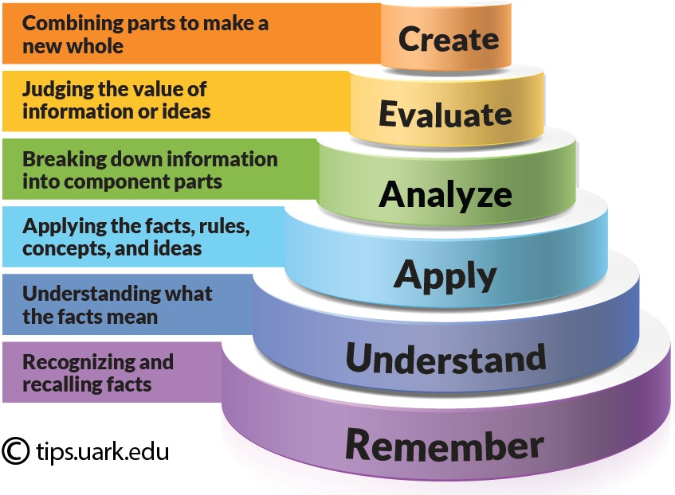](https://wordpressua.uark.edu/wp-content/uploads/sites/315/2013/09/Blooms_Taxonomy_pyramid_cake-style-use-with-permission.jpg)

As I explained in **[What Is Bloom’s Taxonomy? A Definition For Teachers](https://www.teachthought.com/learning/what-is-blooms-taxonomy-a-definition-for-teachers/)**, Bloom’s Taxonomy is simply a way of thinking—a framework. Consider how a ‘diet’ is a way of framing food in order to achieve a specific purpose, whether that purpose is improved sleep, weight loss, added muscle, or any other number of factors, a ‘diet’ ‘frames food’ around a certain way of thinking and a specific purpose. While not exactly functioning the same way a diet does, Bloom’s Taxonomy does provide a kind of structure to think about learning and achieve specific goals.

So below, I’ve listed 50 ways to use Bloom’s Taxonomy in the classroom. Of course, there are literally hundreds, if not thousands. Some would likely require their own post to explain sufficiently, so I don’t expect this to function as a how-to guide, but rather a kind of brainstorming to demonstrate not just the power of Bloom’s Taxonomy, but the utility of learning frameworks in general—including the **[TeachThought Learning Taxonomy](https://www.teachthought.com/critical-thinking/ho-they-get-it-a-new-simple-taxonomy-for-understanding/)**.

**50 Ways To Use Bloom’s Taxonomy in The Classroom**

1. Map curriculum

2. Frame data about learning (wouldn’t necessarily have to be assessment data, but could be)

3. Design an assessment

4. Improve an assessment

5. Design a ‘What now?” after-assessment assignment

5. Personalize learning

6. Support students in self-directed learning

7. Guide inquiry-based learning

8. Create ‘if you finish your work early’ assignments

9. Frame letter grades

10. Create content-based [team-building games](https://www.teacherspayteachers.com/Product/10-Team-Building-Games-For-A-Friendlier-Classroom-2464946?aref=ae1143d2)

11. Provide learning feedback

12.  Promote meta-cognition in students

13. Revise writing with students—or to help them to revise it themselves

14. Use it to group students (one group per Bloom’s level, for example, then rotating based on some criteria or timing)

15. Create literature circles

16. Learning reflection journals

17. Visualize student progress over a period of time

18. Create tiered assignments (what I call a ‘Bloom’s Spiral)

19. Frame choice boards

20. Content-based bell ringers

21. Smarter exit slips

22. Guide research projects

23. Simplify an assessment as a response-to-intervention

24. Increase the complexity of an assessment to challenge high-achieving students

25. Create question stems (to learn or demonstrate learning)

26. Model a skill/competency via given Bloom’s level

27. Frame a mini-lesson

28. Structure a write-around (pass around one sheet of paper per Bloom’s Level, then ask students to write and pass freely based on a given topic or learning target)

29. Differentiate instruction

30. Guide your own [teacher professional developmen](https://www.wegrowteachers.com/)t (e.g. self-assessing the strength of your own understanding on a given topic)

31. Skim and respond to current events

32. Summarize a reading passage

33. Structure a formal classroom discussion

34. Evaluate the winner in a debate

35. Create a Combination Learning blend

36. Organize your own digital teaching materials on Google Drive

37. Evaluate the historical significance of a person or event (by evaluating the relative complexity of a person’s ‘performance’ or the ‘weight’ of an event)

38. Create a digital scavenger hunt (You can find our [Bloom’s Digital Taxonomy cards](https://www.teacherspayteachers.com/Product/Blooms-Taxonomy-New-Edition-Digital-Planning-Verbs-Cards-3390758?aref=ae1143d2) here.)

39. Curate student digital portfolio artifacts

40. Refine and improve questions

41. Help students create their own reading response prompts

42. Combine with a KWL chart before, during, or after a lesson

43. Create a digital citizenship campaign

44. Self-monitor own understanding of a target over the course of a lesson/unit (e.g.,s students would create a visualization of their own understanding at certain checkpoints)

45. Provide ‘sync points’ in Sync Teaching

46. Brainstorm essay topics or ‘angles’

47. Frame the evolution of an argument (in writing or speaking—during pre-writing stages, for example)

48. Plan a podcast or video series around a topic (moving ‘up and down’ Bloom’s Taxonomy)

49. Help support students during student-led conferences

50. Brainstorm ideas for project-based learning