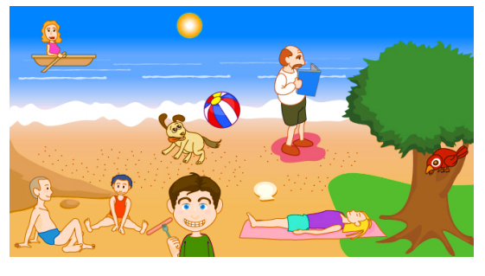

sand woman sausage book tree sky ball bird

**B) Look and read write YES or NO**

1. There are two children sitting on the sand. ___________
2. A woman is riding a bike. ___________
3. A boy is eating a sausage. ___________
4. A man is reading a book. ___________
5. There is a bird flying in the sky. ___________
6. A dog is playing with a cat. ___________
7. A bird is standing on a tree. ___________
8. There is one child sitting on the sand. ___________
9. There is a boy wearing a green t-shirt. ___________
10. A dog is playing with a ball. ___________

<http://www.mysmartcambridge.com/YLE/PDF/SmartCambridge%20-%20Starters%20Reading%20and%20Writing.pdf>