UNIVERSITY OF MINES AND TECHNOLOGY, TARKWA

FACULTY OF ENGINEERING
DEPARTMENT OF ELECTRICAL AND ELECTRONIC ENGINEERING
A THESIS REPORT ENTITLED
INTELLIGENT POWER TRANSFORMER FAULT DIAGNOSIS USING DISSOLVED GAS ANALYSIS AND MACHINE LEARNING: AN INTEGRATED MATLAB/SIMULINK-PYTHON FRAMEWORK
BY
JACOB ADDO TAGOE
SUBMITTED IN FULFILMENT OF THE REQUIREMENT FOR THE AWARD OF THE DEGREE OF MASTER OF PHILOSOPHY IN ELECTRICAL AND ELECTRONIC ENGINEERING
THESIS SUPERVISOR
………………………………………………………………………………
PROF. JOHN ANNAN
TARKWA, GHANA
OCTOBER 2026

DECLARATION
I declare that this thesis is my own work. It is being submitted for the degree of Master of Philosophy in Electrical and Electronic Engineering in the University of Mines and Technology (UMaT), Tarkwa. It has not been submitted for any degree or examination in any other University.

……………………………………………………
(Signature of Candidate)
……… day of ……………………………, 2026
ABSTRACT
Dissolved Gas Analysis (DGA) is the main early warning of incipient faults in oil-immersed power transformers, but its conventional interpretation methods often disagree or give no diagnosis. This thesis developed and evaluated an integrated MATLAB/Simulink–Python framework that produces machine-learning (ML) and conventional diagnoses from the same measured record and compares them statistically. A provenance-audited table of 827 published records with five gases was assembled. The Rogers ratio, IEC 60599 ratio and Duval Triangle 1 methods were implemented in MATLAB and independently in Python with identical answers. Five classifiers were compared by nested cross-validation, and a Random Forest on 18 engineered features was selected (macro-F1 0.850) and tested once on three held-out sets. On the internal test set the model outperformed every conventional method (strict accuracy 0.820 against 0.328–0.557). On the inspection-confirmed IEC TC 10 benchmark it was significantly more accurate than the Rogers method but not significantly different from IEC 60599 or the Duval Triangle (0.724 against 0.776 for Duval), so the research hypothesis was not supported on the main benchmark. Disagreement between ML and the conventional methods was not concentrated near their decision boundaries. Without methane, four gases kept the loss of macro-F1 within 0.05, a panel no conventional method can interpret. A Simscape thermal model of a 40 MVA transformer met its 0.1 K verification tolerance, and a FastAPI service with a MATLAB dashboard reproduced the offline diagnoses for all 388 held-out records, with a 95th-percentile response time of 95.4 ms. ML is therefore a useful complement to, not a replacement for, conventional DGA interpretation.

This work is dedicated to my family, for their love, patience and support.
ACKNOWLEDGEMENTS
I am grateful to the Almighty God for the strength, health and guidance to complete this work.
My sincere thanks go to my supervisor, Prof. John Annan of the Department of Electrical and Electronic Engineering, University of Mines and Technology (UMaT), Tarkwa, for his guidance, encouragement and constructive criticism throughout the research.
I thank the authors who made their data publicly available, in particular M. Duval and A. dePablo for the IEC TC 10 database, T. Dissanayake and E. Li for the data sets published on IEEE DataPort, and the developers of the open-source software used in this work.
I also thank the lecturers and staff of the Department of Electrical and Electronic Engineering, my colleagues, and my family for their support during the study.
TABLE OF CONTENTS
Content Page
DECLARATION i
ABSTRACT ii
DEDICATION iii
ACKNOWLEDGEMENTS iv
TABLE OF CONTENTS v
LIST OF FIGURES x
LIST OF TABLES xiii
LIST OF ABBREVIATIONS xv
LIST OF SYMBOLS xvi
INTERNATIONAL SYSTEM OF UNITS (SI UNITS) xvii
CHAPTER 1 GENERAL INTRODUCTION 1
1.1 Background to the Research 1
1.2 Problem Definition 2
1.3 Objectives of the Research 4
1.4 Research Questions and Hypothesis 4
1.5 Scope of the Research 5
1.6 Research Methods Used 5
1.7 Facilities Used for the Research 6
1.8 Significance of the Research 6
1.9 Limitations of the Research 7
1.10 Definition of Terms and Key Concepts 7
1.11 Organisation of the Thesis 8
CHAPTER 2 LITERATURE REVIEW 10
2.1 Introduction 10
2.2 Power Transformers and Their Failures 10
2.3 Insulation Degradation and Fault Gases 11
2.3.1 Formation of Fault Gases 11
2.3.2 Fault Classes 11
2.4 Conventional DGA Interpretation Methods 12
2.4.1 Overview 12
2.4.2 Rogers Ratio Method 12
2.4.3 IEC 60599 Ratio Method 12
2.4.4 Duval Triangle 1 13
2.4.5 The IEC TC 10 Database 13
2.4.6 Limitations of the Conventional Methods 13
2.5 Machine Learning for DGA Fault Diagnosis 14
2.5.1 Classifiers Used 14
2.5.2 Reported Performance 15
2.5.3 Features and Hybrid Methods 16
2.5.4 Class Imbalance and Small Data 16
2.5.5 Explainability 16
2.6 Validation, Data Leakage and Reproducibility 17
2.7 Online Monitoring and Reduced Gas Sets 17
2.8 Transformer Thermal Modelling and Simulation 18
2.9 Integrated Frameworks, Digital Twins and Deployment 18
2.10 Research Gap and Summary 19
CHAPTER 3 METHODS USED 20
3.1 Introduction 20
3.2 Research Design 20
3.2.1 Overview 20
3.2.2 Principles that Governed the Work 21
3.2.3 Data Roles 22
3.3 Conventional DGA Interpretation Methods 22
3.3.1 Gas Ratios 22
3.3.2 IEC 60599 Ratio Method 23
3.3.3 Rogers Ratio Method 23
3.3.4 Duval Triangle 1 24
3.3.5 Normality Gate 25
3.3.6 Coverage and Distance to the Decision Boundary 26
3.3.7 Verification of the Implementation 26
3.4 Machine-Learning Methods 27
3.4.1 Overview 27
3.4.2 Input Features 27
3.4.3 Classifiers 28
3.4.4 Class Imbalance 30
3.4.5 Validation Design: Nested Cross-Validation 30
3.4.6 Model Selection Rule 31
3.4.7 Final Model and One-Time Testing 32
3.4.8 Explaining the Model 32
3.5 Performance Measures 33
3.6 Statistical Methods 34
3.6.1 Describing the Data 34
3.6.2 Confidence Intervals 34
3.6.3 Comparing the Classifiers 35
3.6.4 Comparing the ML Model with the Conventional Methods 35
3.6.5 Is Disagreement Concentrated near the Boundaries? 36
3.6.6 Research Hypothesis and Decision Criteria 36
3.7 Reduced-Gas Study 37
3.8 Thermal Model of the Transformer 37
3.8.1 Purpose 37
3.8.2 Thermal Equations 38
3.8.3 Insulation Ageing 38
3.8.4 Verification Method 38
3.9 Integration and Evaluation of the Framework 39
3.9.1 Diagnosis Service and Dashboard 39
3.9.2 Fidelity and Response Time 39
3.10 Exploratory Improvement Study 40
3.11 Software and Tools 40
3.12 Summary 40
CHAPTER 4 DATA COLLECTION AND PREPARATION 42
4.1 Introduction 42
4.2 Data Sources 42
4.2.1 Selection of the Data Sets 42
4.2.2 Origin of the Fault Labels 43
4.3 Data Preparation 44
4.3.1 Standardisation 44
4.3.2 Values Not Available 44
4.3.3 Removing Duplicates and Leakage 44
4.3.4 Overlap between the Test Sets 45
4.3.5 Near-Duplicate Groups and Cross-Validation Folds 45
4.3.6 The Result 45
4.4 Evaluation Sets 46
4.5 Threats to Validity 46
4.6 Description of the Data 47
4.6.1 Records per Class 47
4.6.2 Gas Concentrations by Class 48
4.6.3 Correlation between the Gases 49
4.6.4 The Benchmark in the Duval Triangle 50
4.7 Summary 51
CHAPTER 5 DIAGNOSTIC PERFORMANCE OF THE CONVENTIONAL AND MACHINE-LEARNING METHODS 52
5.1 Introduction 52
5.2 Conventional Methods 52
5.2.1 Verification of the Implementation 52
5.2.2 Answers over All Records 52
5.2.3 Performance on the Test Sets 52
5.2.4 Sensitivity to the Normality Gate 54
5.3 Comparison of the Classifiers 55
5.3.1 Cross-Validation Results 55
5.3.2 Rank Comparison 56
5.4 Selection of the Final Model 57
5.5 Performance of the Final Model on the Test Sets 57
5.6 Explaining the Model 58
5.6.1 Which Gases Matter 58
5.6.2 How the Features Push Each Class 59
5.7 Discussion 61
5.8 Summary 62
CHAPTER 6 STATISTICAL COMPARISON AND DISAGREEMENT ANALYSIS 63
6.1 Introduction 63
6.2 Main Comparison 63
6.3 Paired Significance Tests 66
6.4 Sensitivity Analyses 67
6.5 Agreement between the Methods 68
6.6 Is Disagreement Concentrated near the Decision Boundaries? 70
6.7 Verdict on the Research Hypothesis 72
6.8 Discussion 72
6.8.1 Why the Benchmark Gives a Different Picture 72
6.8.2 Why ML and the Conventional Methods Disagree 73
6.8.3 Implications 73
6.9 Summary 73
CHAPTER 7 DIAGNOSIS WITH FEWER GASES AND MODEL IMPROVEMENT 74
7.1 Introduction 74
7.2 Diagnosis with Fewer Gases 74
7.2.1 Performance of Every Gas Subset 74
7.2.2 Conventional Methods with Fewer Gases 76
7.2.3 Implications for Online Monitoring 77
7.3 Exploratory Study: Can the Model Be Improved? 78
7.3.1 Purpose 78
7.3.2 Pooling and the Hybrid Model 78
7.3.3 The Reject Option 79
7.4 Discussion 81
7.5 Summary 81
CHAPTER 8 DEVELOPMENT AND EVALUATION OF THE INTEGRATED FRAMEWORK 82
8.1 Introduction 82
8.2 Architecture 82
8.3 Simulink Operating Model 82
8.3.1 Structure of the Model 82
8.3.2 Model Checks 85
8.3.3 Verification against the IEC 60076-7 Equations 85
8.3.4 Operating Scenarios 87
8.3.5 DGA Sampling Events 89
8.4 Diagnosis Service 90
8.5 Diagnostic Dashboard 91
8.5.1 Reading Order of the Screen 91
8.5.2 Operating Conditions and Sample Sets 92
8.5.3 How Often the Verdict Is Right 93
8.6 End-to-End Test Bench 93
8.6.1 The Test Run 93
8.6.2 Fidelity and Response Time 94
8.7 Discussion 96
8.8 Summary 97
CHAPTER 9 CONCLUSIONS AND RECOMMENDATIONS 98
9.1 Introduction 98
9.2 Conclusions 98
9.3 Answers to the Research Questions 99
9.4 Contributions of the Research 100
9.5 Limitations of the Study 100
9.6 Recommendations 101
9.7 Suggestions for Further Work 102
REFERENCES 103
APPENDICES 112
APPENDIX A Diagrams of the Simulink Subsystems 113
APPENDIX B Additional Results 116
LIST OF FIGURES
Fig. Title Page
1.1 Duval Triangle 1 with the 117 inspection-confirmed cases of the IEC TC 10 database, coloured by the fault found at inspection 3
3.1 The integrated framework: measured data, Python analysis and service, and the MATLAB/Simulink test bench 21
3.2 Nested cross-validation scheme 31
4.1 Flow of records from the source files to the data roles 46
4.2 Number of records per fault class in each data role 48
4.3 Gas concentrations by fault class in the development set 49
4.4 Spearman rank correlation between the five gases, development set (n = 439) 50
4.5 The 117 inspection-confirmed IEC TC 10 cases in the Duval Triangle 1, coloured by the fault found at inspection 51
5.1 Confusion matrices of the conventional methods on the IEC TC 10 power transformers (n = 58) 54
5.2 Macro-F1 of the six models on feature set F4 in each of the 50 outer cross-validation folds; boxes show the median and interquartile range, dots the individual folds 56
5.3 Critical-difference diagram of the six models on F4: models joined by a thick bar do not differ significantly (Nemenyi test, α = 0.05) 57
5.4 Confusion matrices of the final model on the three primary test sets 58
5.5 Permutation importance of the final model on the internal test set (n = 61): (a) whole gases shuffled, (b) single features shuffled; bars show the mean drop over 30 shuffles with its 2.5–97.5 % range 59
5.6 SHAP summary of the final model for each class (development records): each point is one record; its position shows how much the feature raised or lowered the probability of the class, and its colour the feature's own value 61
6.1 Strict accuracy, conditional accuracy and macro-F1 with 95 % confidence intervals on the internal test set (n = 61); the coverage of each method is given below its name 64
6.2 Main comparison on the IEC TC 10 power transformers (n = 58), the main benchmark 64
6.3 Main comparison on the Li (2019) set (n = 86) 65
6.4 F1-score per fault class for the four methods on the three primary test sets, with 95 % bootstrap intervals; n = number of test records of the class 66
6.5 Cohen's kappa between the true class and the four methods on the three primary test sets (1 = perfect agreement, 0 = agreement expected by chance) 69
6.6 Probability that the ML model and each conventional method disagree, against the standardised distance of the record to the method's nearest decision boundary: fitted logistic curve with 95 % band, and observed rates in groups of records with Wilson 95 % intervals (pooled primary test records, answers after the normality gate) 70
6.7 Records on which the ML model and the Duval Triangle disagree (large symbols, coloured by the true class) and agree (small grey points), three primary test sets 71
7.1 Cross-validated macro-F1 against the number of gases measured: grey points are all 31 gas combinations; the line joins the best combination of each size with its 95 % interval; the dashed line marks the five-gas value minus the tolerance of 0.05 75
7.2 Gas-subset matrix: the bars give the cross-validated macro-F1 (95 % interval) of every gas combination from best to worst, the dots show the gases included, and the bottom rows show which conventional methods can still be applied 77
7.3 Macro-F1 with 95 % intervals of the three models and the three conventional methods when each source is held out in turn 79
7.4 Accuracy on the answered records against coverage when the models abstain on their least confident records (lines), with the conventional methods as points 80
8.1 Top level of the Simulink operating model in MATLAB R2025b 84
8.2 Simscape thermal network of subsystem SS6: heat sources, thermal masses and thermal resistances that solve the top-oil and hot-spot equations 85
8.3 Verification of the Simulink thermal model against an independent solution of the IEC 60076-7 equations: (a) rated load from a cold start, (b) load step from 0.6 to 1.2 pu at 6 h; upper panels: temperatures, lower panels: difference between model and reference with the ±0.1 K tolerance 87
8.4 Daily load-cycle scenario (last of three simulated days): load factor, temperatures, and relative ageing rate with the loss of life 88
8.5 Short-overload scenario: 1.3 pu for 2 h on a base load of 0.8 pu 89
8.6 The diagnostic dashboard after a simulated day with seven oil samples (one healthy and one of each fault type) 92
8.7 Test-bench run over the 388 held-out records: (a) simulated hot-spot temperature and the sampling events; (b) ML diagnosis of the record taken at each event; (c) number of conventional methods that agree with the ML diagnosis 94
8.8 Response time of the diagnosis service over the 388 requests of the test bench: (a) every request in run order with the median and the 95th percentile; (b) cumulative distribution with the 1 000 ms target 96
A1 SS1 Grid supply: three-phase 110 kV source with its electrical reference and solver configuration 113
A2 SS2 Power transformer: two-winding 40 MVA, 110/20 kV transformer (Simscape Electrical); impedance and losses from the parameter script 113
A3 SS3 LV measurement: three-phase current sensor; the load factor K is the RMS current divided by the rated current 113
A4 SS4 Variable load: the load profile (per unit) drives a wye-connected variable load 114
A5 SS5 Losses to heat: load and no-load losses converted into the heat inputs of the oil and hot-spot circuits (Simulink arithmetic) 114
A6 SS7 Outputs and ageing: hot-spot temperature, relative ageing rate and logged signals 114
A7 SS8 Sampling events: clock, sampling times and logic that output the record index and the sampling pulse; no block carries a gas value 115
B1 Development records in the Duval Triangle 1, coloured by the true fault class 117
B2 Internal test records in the Duval Triangle 1 118
B3 Li (2019) records in the Duval Triangle 1 119
B4 Confusion matrices of the conventional methods on the internal test set (n = 61) 119
B5 Confusion matrices of the conventional methods on the Li (2019) set (n = 86) 120
B6 Constant rated-load scenario: load factor, temperatures, and relative ageing rate with the loss of life 120
LIST OF TABLES
Table Title Page
2.1 Main Gases Associated with Each Fault Type 12
2.2 Representative Machine-Learning Studies for DGA Fault Diagnosis 15
2.3 Research Gaps and How This Thesis Addresses Them 19
3.1 IEC 60599 Gas Ratio Limits for Fault Interpretation 23
3.2 Rogers Ratio Code Table 24
3.3 Zone Rules of Duval Triangle 1 Used in This Study 25
3.4 IEC 60599 Typical Gas Concentrations Used by the Normality Gate 25
3.5 Feature Sets Compared 27
3.6 Classifiers and Hyper-parameter Search Grids 30
3.7 Software Used 40
4.1 Data Sets Used and Their Roles 42
4.2 Records by Data Role and Fault Class after Cleaning 47
4.3 Gas Concentrations by Fault Class, Development Set 48
5.1 Conventional Methods on the Three Primary Test Sets 53
5.2 Sensitivity of the Conventional Methods to the Normality Gate and the Dual-Answer Rule 55
5.3 Nested Cross-Validation Macro-F1 of the Classifiers (Mean ± SD over 50 Outer Folds) 55
5.4 Performance of the Final Model on the Test Sets 58
5.5 Agreement of the Model's Explanations with the Expected Key Gases 60
6.1 Machine Learning versus the Conventional Methods on the Same Records 63
6.2 Paired Tests of the ML Model against Each Conventional Method 67
6.3 Results on the Full Test Sets, Including Records that Copy Benchmark Cases 68
6.4 Cohen's Kappa between the Methods and the True Label 69
6.5 Logistic Regression of ML–Method Disagreement on Standardised Boundary Distance 70
6.6 Research-Hypothesis Criteria on Each Primary Test Set 72
7.1 Random Forest Macro-F1 for Every Gas Subset and Its Loss against the Full Panel 74
7.2 Study 2 (Exploratory): Leave-One-Source-Out Results 78
7.3 Study 2 (Exploratory): Reject Option at the Coverage of the Ratio Methods 80
8.1 Main Parameters of the Simulink Operating Model 83
8.2 Verification of the Simulink Thermal Model against the IEC 60076-7 Equations 86
8.3 Interface of the Diagnosis Service 90
8.4 Fidelity and Response Time of the Integrated Framework 95
9.1 Answers to the Research Questions 99
B1 Full Nested Cross-Validation Results (Means over 50 Outer Folds) 116
B2 Per-Class F1-Score in Cross-Validation (Feature Set F4) 116
B3 Gas Concentrations by Fault Class, IEC TC 10 Benchmark 117
LIST OF ABBREVIATIONS
Abbreviation | Meaning
AI | Artificial Intelligence
ANN | Artificial Neural Network
CI | Confidence Interval
CIGRE | International Council on Large Electric Systems (Conseil International des Grands Réseaux Électriques)
CV | Cross-Validation
D1 | Discharges of low energy
D2 | Discharges of high energy
DGA | Dissolved Gas Analysis
DT | Mixture of thermal and electrical faults (Duval zone)
ECG | Electricity Company of Ghana
F1 | Feature set 1 (log gases); also the F1-score
GRIDCo | Ghana Grid Company
HTTP | Hypertext Transfer Protocol
IEC | International Electrotechnical Commission
IEEE | Institute of Electrical and Electronics Engineers
JSON | JavaScript Object Notation
k-NN | k-Nearest Neighbours
ML | Machine Learning
MLP | Multilayer Perceptron
ND | No Diagnosis
p95 | 95th percentile
PD | Partial Discharge
ppm | parts per million (µl/l)
PT | Power Transformer (IEC TC 10 equipment codes P and U)
PURC | Public Utilities Regulatory Commission
RBF | Radial Basis Function
RMSE | Root-Mean-Square Error
SDG | Sustainable Development Goal
SHA-256 | Secure Hash Algorithm with a 256-bit digest
SHAP | SHapley Additive exPlanations
SMOTE | Synthetic Minority Over-sampling Technique
SVM | Support Vector Machine
T1 | Thermal fault below 300 °C
T2 | Thermal fault between 300 °C and 700 °C
T3 | Thermal fault above 700 °C
TC 10 | IEC Technical Committee 10 (fluids for electrotechnical applications)
TPE | Tree-structured Parzen Estimator
UMaT | University of Mines and Technology
XGBoost | Extreme Gradient Boosting
LIST OF SYMBOLS
Symbol | Meaning | Unit
A_{strict} | strict accuracy (no-diagnosis counted wrong) | –
A_{cond} | conditional accuracy (records with a diagnosis only) | –
B | number of bootstrap resamples | –
b, c | discordant counts of the McNemar test | –
β₀, β₁ | intercept and slope of the logistic regression | –
CD | critical difference of the Nemenyi test | rank
d_{R}, d_{D} | distance to the nearest decision boundary (ratio methods; Duval) | decades; percentage points
δ | largest acceptable loss of macro-F1 | –
Δ_{S} | loss of macro-F1 with gas subset S | –
e_{max} | largest absolute model–reference difference | K
F | fidelity of the integrated system | –
g_{r} | average winding-to-oil temperature gradient at rated current | K
H | hot-spot factor (thermal model); Kruskal–Wallis statistic (statistics) | –
K | load factor (Simulink model); number of classes (machine learning) | pu; –
κ | Cohen's kappa | –
k₁₁, k₂₁, k₂₂ | thermal model constants | –
L | loss of life over a period | h
N | number of records | –
P₀, P_{k} | no-load loss; load loss at rated current | W
Q | Cochran's Q statistic | –
R | ratio of load loss to no-load loss | –
R₁ … R₅ | gas ratios CH₄/H₂, C₂H₂/C₂H₄, C₂H₂/CH₄, C₂H₆/C₂H₂, C₂H₄/C₂H₆ | –
τ_{o}, τ_{w} | oil and winding time constants | min
θ_{a}, θ_{o}, θ_{h} | ambient, top-oil and hot-spot temperature | °C
Δθ_{or} | top-oil temperature rise at rated load | K
U | unresolved (no-diagnosis) rate | –
V | relative ageing rate of the paper insulation | –
w_{c} | class weight of class c | –
x, y | oil and winding exponents | –
x_{g} | concentration of gas g | ppm
z | standard normal quantile (1.96 for 95 %) | –
INTERNATIONAL SYSTEM OF UNITS (SI UNITS)
Quantity | Unit | Symbol
Concentration of a dissolved gas | parts per million (microlitre per litre) | ppm (µl/l)
Electric current | ampere | A
Electric voltage | volt (kilovolt) | V (kV)
Apparent power | volt-ampere (megavolt-ampere) | VA (MVA)
Power, loss | watt (kilowatt) | W (kW)
Frequency | hertz | Hz
Temperature | degree Celsius | °C
Temperature difference | kelvin | K
Time | second, minute, hour | s, min, h
Response time | millisecond | ms
Thermal resistance | kelvin per watt | K/W
Thermal capacitance | joule per kelvin | J/K

CHAPTER 1
GENERAL INTRODUCTION

1.1 Background to the Research
Reliable electricity supply underpins the economic and social development of every nation, and power transformers sit at the centre of that reliability: they change the voltage at every stage between the generating station and the consumer. A power transformer is one of the most expensive items in a substation, it takes many months to replace, and its failure can interrupt supply to large areas. International surveys carried out by working groups of the International Council on Large Electric Systems (CIGRE) show that major transformer failures are rare but costly. The working group A2.37 survey collected 964 major failures from 58 utilities in 21 countries, with failures related to windings, tap changers and bushings as the main contributors (Tenbohlen, Jagers and Vahidi, 2017), and a later analysis of CIGRE surveys covering 26 533 transformers reported an overall major failure rate of 0.41 % per year (Martin and Tenbohlen, 2026). Because failures are rare in any single utility but expensive when they occur, utilities rely on condition monitoring to find developing faults early (Murugan and Ramasamy, 2019).
Ghana's own power sector illustrates the consequences. On 23 April 2026 a technical problem on the Ghana Grid Company (GRIDCo) line at the Asiekpe bulk supply point, together with a transformer fault in the Tema region, left communities across the Volta, Oti and Tema regions without power (Anon., 2026). In 2024 the Electricity Company of Ghana (ECG) attributed evening outages to some 630 overloaded distribution transformers; the Public Utilities Regulatory Commission (PURC) examined the loading records and found that claim "not factually accurate", tracing most of the outages to load management and to faults unrelated to transformer overloading (Dotse, 2024). Both cases show that the condition of transformers, and reliable information about that condition, are live operational concerns. They bear directly on the affordable and reliable energy that Sustainable Development Goal (SDG) 7 commits nations to deliver (Anon., 2015).
Dissolved Gas Analysis (DGA) has for several decades been the most widely used condition-monitoring technique for oil-immersed power transformers (Suwarno et al., 2024). Thermal and electrical stresses decompose the insulating oil and the cellulose paper, and the resulting gases dissolve in the oil. Hydrogen (H₂), methane (CH₄), ethane (C₂H₆), ethylene (C₂H₄) and acetylene (C₂H₂) are formed in proportions that depend on the type and energy of the fault, so an oil sample taken from a working transformer can reveal an incipient fault long before it becomes a failure (Duval, 2002). The conventional interpretation methods built on this principle, such as the Rogers ratio method, the IEC 60599 three-ratio method and the Duval Triangle, remain in routine use by utilities. They rely on fixed limits and zone boundaries derived from historical fault populations (Rogers, 1978; Duval and dePablo, 2001; Duval, 2002).
Over the past decade, machine learning (ML) has been applied widely to DGA. Support vector machines, artificial neural networks, k-nearest neighbours, random forests and gradient-boosted trees learn the relationship between gas concentrations and confirmed faults directly from data instead of from fixed rules (Rao et al., 2021; Dladla and Thango, 2025a). A systematic review of 124 studies published between 2014 and 2024 found that support vector machines (32 %), artificial neural networks (17 %) and k-nearest neighbours (12 %) dominate the field (Dladla and Thango, 2025a). The same trend appears more widely in power-system asset management, where artificial intelligence is increasingly used for condition monitoring and maintenance planning (Rajora et al., 2024).
Despite this activity, most published ML studies for DGA stay as offline accuracy experiments. They are seldom compared fairly with the conventional methods on records whose fault labels are independent of those methods, and seldom placed in a working tool that an engineer could use next to the methods already trusted. This thesis addresses that gap with an integrated framework: conventional and ML diagnoses are produced from the same measured oil-sample record, compared with rigorous statistics, examined when fewer gases are available, and presented together in a simulated operating environment built in MATLAB/Simulink and Python.

1.2 Problem Definition
Conventional DGA interpretation has two well-documented weaknesses. First, different methods frequently give different diagnoses for the same oil sample, because each was derived from a different population of faults and uses different limits (Suwarno et al., 2024; Doğan et al., 2026). Second, ratio methods may give no diagnosis at all when a ratio falls outside every coded range, and a sample close to a decision boundary can change class after a small change in one gas concentration (Zhang et al., 2022; Suwarno et al., 2024). Fig. 1.1 shows the Duval Triangle 1 with the inspection-confirmed IEC TC 10 cases: many points lie close to zone boundaries, where the method gives a categorical answer without any indication of how near the sample is to a different fault class.
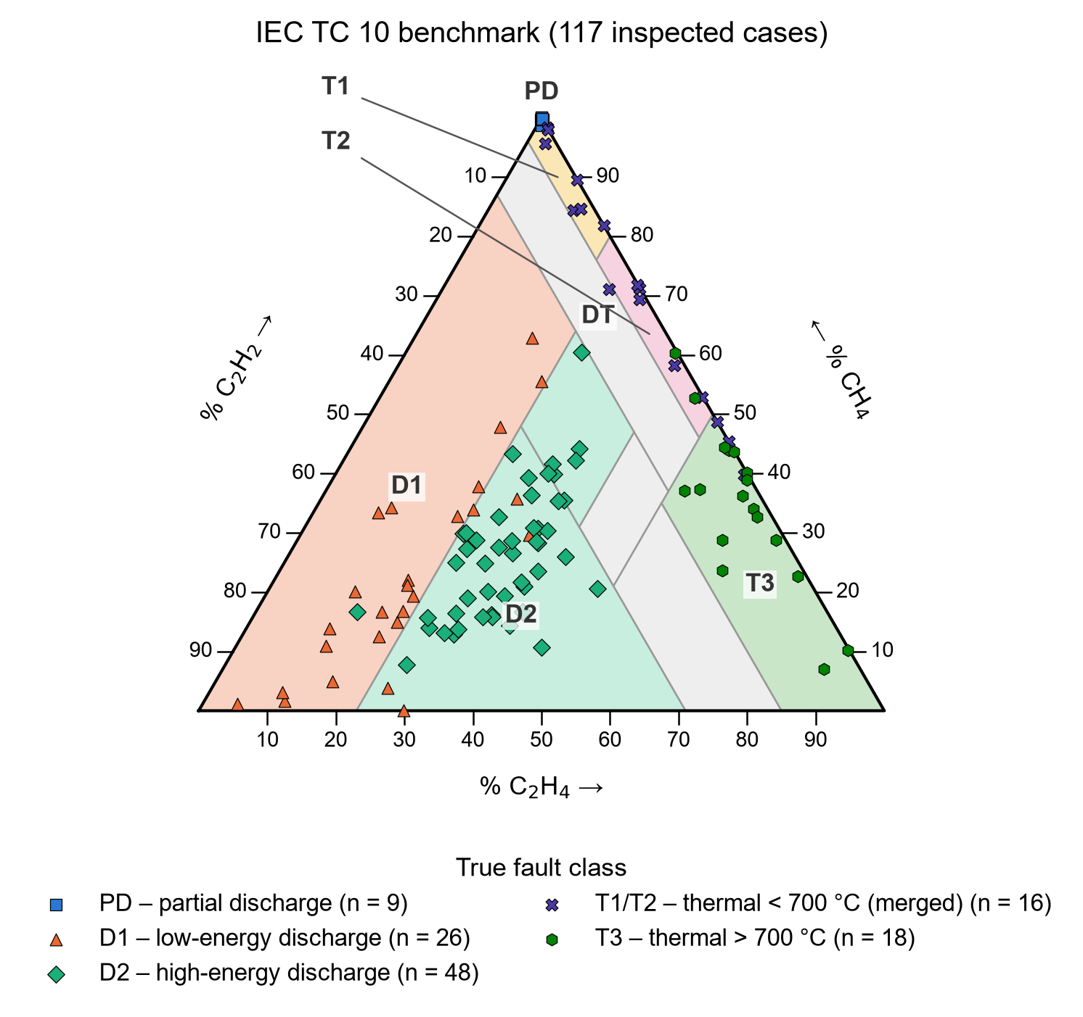
Fig. 1.1 Duval Triangle 1 with the 117 inspection-confirmed cases of the IEC TC 10 database, coloured by the fault found at inspection
Machine learning has been proposed as a remedy, and many studies report accuracies above 90 % (Das et al., 2023; Hechifa et al., 2024; Adekunle et al., 2025). These figures are hard to trust and hard to compare. The data sets are small, imbalanced and often of mixed origin; the origin of the fault labels is frequently undocumented, so labels may themselves come from a conventional method; and validation designs often allow information from the test data to leak into training (Rao et al., 2021; Kapoor and Narayanan, 2023; Dladla and Thango, 2025a). In addition, online monitors installed on transformers often measure fewer gases than a laboratory analysis, which limits both the conventional methods and the models trained on full gas sets (Bustamante et al., 2019). Finally, an ML classifier that exists only as an offline experiment gives an engineer no way to compare its answer with the conventional diagnosis, to see the transformer's operating condition, or to query it during routine work.
The problem addressed in this thesis is therefore the absence of a transparent and reproducible framework in which conventional DGA interpretation and ML diagnosis are produced from the same measured sample, compared statistically on data whose fault labels are independent of both, examined under reduced gas availability, and presented together to the engineer through a single interface.

1.3 Objectives of the Research
The main objective of this research is to develop and rigorously evaluate a framework that diagnoses incipient power-transformer faults from measured dissolved-gas data using both conventional interpretation methods and machine learning, and to demonstrate it on an integrated MATLAB/Simulink–Python test bench. The specific objectives are to:
a. implement the Rogers ratio, IEC 60599 ratio and Duval Triangle 1 methods in MATLAB and verify each implementation against published cases and an independent implementation;
b. assemble a DGA data set from published sources in which the origin of every fault label is documented, and separate the records whose labels are independent of the conventional methods;
c. train and compare five machine-learning classifiers using leakage-free nested cross-validation, and identify the gases that most influence the selected model;
d. determine, by controlled removal of gases, the smallest gas panel with which the machine-learning model keeps an acceptable diagnostic performance;
e. quantify and statistically test the agreement and disagreement between the machine-learning and conventional diagnoses, and test whether disagreement concentrates near the decision boundaries of the conventional methods; and
f. integrate the conventional layer, the machine-learning model and a Simulink transformer operating model into one test bench with a diagnostic dashboard, and evaluate its fidelity and response time.

1.4 Research Questions and Hypothesis
The research questions are:
a. How does the accuracy of machine-learning classifiers compare with that of conventional DGA methods when both are tested on the same samples with independently confirmed faults?
b. Where do the two approaches disagree, and is the disagreement concentrated near the decision boundaries of the conventional methods?
c. How much accuracy is lost when the machine-learning model is given fewer gases, and what is the minimum useful gas panel?
d. Can the conventional layer and the machine-learning model be served through one interface that returns exactly the same results as the offline analysis, with a response time suitable for interactive use?
The research hypothesis is: a machine-learning classifier validated without data leakage will diagnose more samples correctly than any single conventional method on the same data, mainly because it gives an answer where conventional methods give none, and the disagreement between the two will be concentrated near the conventional-method decision boundaries. The criteria that decide the hypothesis were fixed before any test result was computed (Section 3.6.6).

1.5 Scope of the Research
The research covers oil-immersed power transformers and the five hydrocarbon and hydrogen gases H₂, CH₄, C₂H₆, C₂H₄ and C₂H₂, which are the gases available in all the published data sets used. The fault classes are those of IEC 60599: partial discharge (PD), low-energy discharge (D1), high-energy discharge (D2) and thermal faults below 300 °C (T1), between 300 °C and 700 °C (T2) and above 700 °C (T3), together with a Normal class where the data provide one. The study is limited to published, real measured records; no gas concentration is simulated. The Simulink model represents the electrical and thermal operating context of one 40 MVA, 110/20 kV transformer and is used only for demonstration.

1.6 Research Methods Used
The research methods used are:
a. review of relevant literature and standards;
b. data audit, cleaning and de-duplication of published DGA data sets with documented label provenance;
c. implementation of the conventional methods in MATLAB, with an independent Python implementation as a cross-check;
d. machine-learning model development with nested cross-validation and a written model-selection rule;
e. statistical comparison (McNemar and Cochran tests, Cohen's kappa, logistic regression, bootstrap confidence intervals);
f. MATLAB/Simulink and Simscape modelling of the transformer operating condition, verified against the IEC 60076-7 thermal equations; and
g. software integration (FastAPI service and MATLAB App Designer dashboard) and end-to-end testing.

1.7 Facilities Used for the Research
The facilities used are:
a. a personal laptop computer (AMD Ryzen 5 3500U processor, 8 logical processors, about 22 GB of memory);
b. MATLAB R2025b with Simulink, Simscape and Simscape Electrical; and
c. a Python 3.12 environment with scikit-learn, XGBoost, SHAP and the FastAPI web framework, together with the library and internet facilities of UMaT.

1.8 Significance of the Research
The research is significant in the following ways:
a. it gives utility engineers, including those of Ghanaian utilities, a measured and honest picture of what machine learning adds to the conventional DGA methods they already use, based on inspection-confirmed cases rather than on accuracy figures from unclear data;
b. it shows how much diagnostic ability remains when fewer gases are measured, which informs the choice of online monitors;
c. it provides a reproducible template, with every number traceable to a saved file, for integrating data-driven diagnosis with conventional methods and a physical operating model; and
d. it contributes evidence to the academic discussion on validation practice and data leakage in ML-based transformer diagnostics.

1.9 Limitations of the Research
The study relies on published data rather than new utility records: the only data set with inspection-confirmed labels (IEC TC 10) is small, and the label origin of the other sets is not documented. The IEC 60599 ratio limits were refined using the same IEC TC 10 cases (Duval and dePablo, 2001), which gives the conventional methods a home advantage on the main benchmark. Carbon monoxide and carbon dioxide could not be used because most records lack them. The full texts of IEC 60599:2022, IEEE C57.104-2019 and IEC 60076-7:2018 were not available; limits were taken from official previews, the 2008 IEEE guide and peer-reviewed secondary sources, and the thermal constants of the Simulink model are the default values of an open-source implementation of IEC 60076-7 rather than nameplate data. Response times were measured on a personal computer, not on a production server.

1.10 Definition of Terms and Key Concepts
Dissolved Gas Analysis: A condition-monitoring technique that measures the gases dissolved in the insulating oil of a transformer to detect and identify incipient faults.
Fault class: A category of incipient fault defined in IEC 60599 (PD, D1, D2, T1, T2, T3), or Normal when no fault is present.
Conventional method: A rule-based DGA interpretation method that uses fixed gas-ratio limits or graphical zones, such as the Rogers ratio method, the IEC 60599 ratio method and the Duval Triangle 1.
No diagnosis (ND): The result of a conventional method when the sample matches none of its coded cases.
Machine learning: A family of methods in which a model learns the relationship between inputs and outputs from examples rather than from fixed rules.
Nested cross-validation: A validation design in which the settings of a model are tuned inside each training part of an outer cross-validation, so that the outer test folds are never used for tuning.
Data leakage: Any route by which information from the test data reaches the model during training or selection, making the measured performance optimistic.
Macro-F1: The unweighted mean of the per-class F1-scores; it gives every fault class the same importance.
Fidelity: The share of records for which the integrated system returns exactly the same diagnosis as the offline analysis.
Simulink and Simscape: MATLAB environments for block-diagram simulation; Simscape models physical networks (electrical, thermal) from component blocks.

1.11 Organisation of the Thesis
The thesis has nine chapters:
• Chapter 1 introduces the background, problem, objectives, research questions and hypothesis, scope, methods, significance and limitations of the research.
• Chapter 2 reviews the literature on transformer faults and gas formation, the conventional DGA methods, machine learning for DGA, validation practice, online monitoring, thermal modelling and integrated diagnostic frameworks, and identifies the research gap.
• Chapter 3 describes the methods used: the research design, the conventional methods, the machine-learning methods and their validation, the performance measures and statistical tests, the reduced-gas study, the thermal model and the evaluation of the framework.
• Chapter 4 describes the collection, audit and preparation of the data and the data themselves.
• Chapter 5 reports the diagnostic performance of the conventional methods and the machine-learning classifiers, the selection of the final model and its explanation.
• Chapter 6 compares the machine-learning model with the conventional methods statistically, analyses their disagreement and judges the research hypothesis.
• Chapter 7 reports the diagnosis with fewer gases and an exploratory study of how the model can be improved.
• Chapter 8 describes the development and evaluation of the integrated framework: the Simulink model, the diagnosis service, the dashboard and the test bench.
• Chapter 9 gives the conclusions and recommendations.

CHAPTER 2
LITERATURE REVIEW

2.1 Introduction
This chapter reviews the knowledge on which the study builds and the gaps it addresses. It starts with the failure of power transformers and the formation of fault gases in their insulation (Sections 2.2 and 2.3). It then reviews the conventional methods for interpreting dissolved gases and their known weaknesses (Section 2.4), the use of machine learning for DGA (Section 2.5), and the validation practices that determine whether reported results can be trusted (Section 2.6). Online monitoring with reduced gas sets, thermal modelling of transformers and integrated diagnostic frameworks are covered in Sections 2.7 to 2.9. The chapter ends with the research gap that this thesis addresses (Section 2.10).

2.2 Power Transformers and Their Failures
A power transformer consists of copper or aluminium windings on a laminated steel core, insulated by cellulose paper and pressboard and immersed in mineral oil that both insulates and cools. With proper maintenance such units operate for 25 to 50 years, but internal stresses (insulation degradation, partial discharges, local overheating) and external events (lightning, switching surges, overloads) accelerate ageing and increase the risk of failure (Kashiwagi et al., 2025).
Because major failures are rare in any single utility, reliable statistics need surveys that pool many utilities. The CIGRE working group A2.37 collected 964 major failures that occurred between 1996 and 2010 in a population of 167 459 transformer-years from 58 utilities in 21 countries; the failure rates of substation transformers were all below 1 % per year, winding, tap-changer and bushing failures were the main contributors, and dielectric failure modes were the most frequent (Tenbohlen, Jagers and Vahidi, 2017). A later analysis of CIGRE surveys covering 50 utilities, 26 533 transformers and 331 379 operating years reported 1 358 major failures and an overall major failure rate of 0.41 % per year (Martin and Tenbohlen, 2026). National studies give similar pictures: a survey of Australian utilities updated the statistics of failures and retirements of the national fleet (Martin, Marks and Saha, 2017), and an Indian utility study of 343 failures of transformers between 33 kV and 400 kV grouped the causes into electrical, thermal, mechanical and insulation-degradation failures and proposed a health-index approach to maintenance (Murugan and Ramasamy, 2019).
The cost of failure goes beyond the transformer itself. Failures of mineral-oil-filled transformers have been involved in numerous fire and explosion incidents, and insurance loss statistics for 1990 to 2000 recorded close to 1 000 transformer failures at customer facilities with a gross loss of US$492 million (Su, Madan and Purushothaman, 2024). These statistics explain the effort put into condition monitoring, and in particular into DGA, which can detect a developing fault while the transformer is still in service.

2.3 Insulation Degradation and Fault Gases

2.3.1 Formation of Fault Gases
Under thermal and electrical stress both the oil and the paper insulation decompose and release gases that dissolve in the oil (Suwarno et al., 2024). The gases of interest are hydrogen (H₂), methane (CH₄), ethane (C₂H₆), ethylene (C₂H₄), acetylene (C₂H₂), carbon monoxide (CO) and carbon dioxide (CO₂). Partial discharge produces mainly H₂ with a smaller amount of CH₄; overheating of the oil produces CH₄, C₂H₆ and C₂H₄; arcing produces C₂H₂; and CO and CO₂ indicate degradation of the paper (Suwarno et al., 2024).
The link between the temperature of a fault and the mixture of gases has a thermodynamic basis. Thermodynamic calculations of the thermal decomposition of alkane molecules, with temperature-dependent equilibrium constants, reproduce the gas generation observed in transformer oil and link the mixture of gases to the fault temperature (Wang et al., 2024). Gases can also form without a fault: mineral oils can produce gases at relatively low temperatures (100 °C to 200 °C), and this "stray gassing" can be difficult to distinguish from a real thermal fault (Martin et al., 2014). Duval (2002) reviewed the faults that can be detected by gas-in-oil analysis, and this review underlies the fault classes used today.

2.3.2 Fault Classes
IEC 60599 groups the faults detectable by DGA into six basic types (IEC, 2007): partial discharges (PD); discharges of low energy (D1); discharges of high energy (D2); thermal faults below 300 °C (T1); thermal faults between 300 °C and 700 °C (T2); and thermal faults above 700 °C (T3). The same six types are used in most of the literature reviewed below (Ward et al., 2021). Table 2.1 summarises the main gases associated with each fault type.
Table 2.1 Main Gases Associated with Each Fault Type
Code | Fault type | Main gases
PD | Partial discharges | H₂, with a smaller amount of CH₄
D1 | Discharges of low energy | H₂ and C₂H₂
D2 | Discharges of high energy | C₂H₂ and H₂, with C₂H₄
T1 | Thermal fault below 300 °C | CH₄ and C₂H₆
T2 | Thermal fault 300 °C to 700 °C | C₂H₄ and CH₄
T3 | Thermal fault above 700 °C | C₂H₄, with C₂H₂ at very high temperature
Sources: Duval (2002); IEC (2007); Suwarno et al. (2024).

2.4 Conventional DGA Interpretation Methods

2.4.1 Overview
Several interpretation methods are in industrial use: the key gas method, the Doernenburg ratio method, the Rogers ratio method, the IEC 60599 ratio method, the Duval Triangle and the Duval Pentagons (Ali et al., 2023; Rangel Bessa et al., 2023). Ratio methods compare pairs of gases, so that the result does not depend on the total amount of gas; graphical methods place a sample in a triangle or pentagon divided into fault zones. Before any of these methods is applied, IEC 60599 recommends checking whether the gas levels are above typical values for the equipment, because gas ratios of normal equipment have no diagnostic meaning (Duval and dePablo, 2001).

2.4.2 Rogers Ratio Method
The Rogers method maps combinations of gas-ratio ranges to coded diagnoses (Rogers, 1978). The version given in IEEE Std C57.104-2008 uses three ratios, CH₄/H₂, C₂H₂/C₂H₄ and C₂H₄/C₂H₆, and has six cases: normal, low-energy partial discharge, high-energy arcing, and three thermal cases (IEEE, 2009). A sample whose ratios fall in a combination that is not coded receives no diagnosis. Two secondary reproductions of the IEEE table were checked in this study and both contained an error, which shows how easily such tables are mis-transcribed.

2.4.3 IEC 60599 Ratio Method
The IEC 60599 method uses the same three ratios as Rogers, but its limits were made more precise using the cases of the IEC TC 10 database (Duval and dePablo, 2001). Its Table 2 defines the six basic faults; ratios marked "not significant" are ignored for a given fault, and the D1 and D2 zones overlap, so that in some cases a dual attribution "D1 or D2" must be given (IEC, 2007). A simplified scheme is offered for cases that match no row of the main table.

2.4.4 Duval Triangle 1
The Duval Triangle 1 uses only CH₄, C₂H₄ and C₂H₂. Their relative percentages place a sample at one point of an equilateral triangle divided into seven zones: PD, D1, D2, T1, T2, T3 and DT, a mixture of thermal and electrical faults (Duval, 2002). Because every sample falls in some zone, the triangle always gives an answer, and it is regarded as one of the most reliable interpretation methods (Ekojono et al., 2022). It has two limitations. The triangle has no normal zone, so it cannot by itself say that a transformer is healthy (Suwarno et al., 2024). It also ignores H₂, which matters for low-temperature thermal faults and partial discharges (Selim et al., 2025). The Duval Pentagon method was later added to the graphical methods (Ali et al., 2023), and some newer methods combine several Duval triangles (Manoj et al., 2023).

2.4.5 The IEC TC 10 Database
Duval and dePablo (2001) published the IEC TC 10 database: DGA results of faulty equipment that was inspected in service, with the fault identified by visual inspection. Because the labels come from inspection and not from a ratio method, the database is the standard benchmark for interpretation methods, and many studies use it (Rao et al., 2021; Nanfak et al., 2021; Das et al., 2023; Rangel Bessa et al., 2023). However, the same database was used to refine the IEC 60599 limits (Duval and dePablo, 2001). Conventional methods therefore have a "home advantage" on it, a point that is seldom stated when ML results on IEC TC 10 are compared with them.

2.4.6 Limitations of the Conventional Methods
The literature agrees on three limitations. First, the methods may give different conclusions for the same oil sample (Suwarno et al., 2024; Doğan et al., 2026). Second, ratio-based methods may return an out-of-code result when a ratio falls outside the specified ranges, and a large share of fault cases may be left unidentified (Suwarno et al., 2024; Selim et al., 2025). Third, the methods rely on fixed thresholds and give categorical answers; they offer little support for expressing uncertainty, which modern prognostics and health management requires (Kashiwagi et al., 2025). The fixed boundaries also mean that a sample near a boundary can change class after a small change in a measured gas, which is the "boundary problem" mentioned in reviews of intelligent methods (Zhang et al., 2022).
Reported accuracies of the conventional methods vary widely between data sets. In a comparison of seven methods on data from two Pakistani grid stations, the three-ratio method was the most accurate, with 90 % (Wajid et al., 2023). On a pooled data set of 282 samples, the Duval Triangle and Pentagon achieved only 35.8 % and 30.8 % (Dladla and Thango, 2025b). New methods continue to be proposed, such as a method based on subsets of gases tested on IEC TC 10 (Nanfak et al., 2021), a graphical shape in the Cartesian plane that adds H₂ and C₂H₆ (Selim et al., 2025), and fault-specific gas limits (Duval and Paulhiac, 2026). This variety shows that no conventional method is accepted as clearly best.

2.5 Machine Learning for DGA Fault Diagnosis

2.5.1 Classifiers Used
A systematic review of 124 papers published between 2014 and 2024 found that support vector machines (32 %), artificial neural networks (17 %) and k-nearest neighbours (12 %) are the most used algorithms (Dladla and Thango, 2025a). Earlier surveys covered expert systems, fuzzy logic, rough sets, grey systems and swarm-optimised classifiers and concluded that no single intelligent approach resolves all the shortcomings of DGA interpretation (Cheng and Yu, 2018; Zhang et al., 2022). More recent work has moved towards ensembles of decision trees. Using 4 580 DGA samples from five utilities for training and the IEC TC 10 database for testing, Rao et al. (2021) found that non-parametric methods and non-linear SVM suit DGA classification and that ensemble methods performed best. Random forests performed best among six algorithms trained on Duval-triangle fault codes (Ekojono et al., 2022). Random forest, XGBoost and LightGBM consistently outperformed non-ensemble models across four ratio-based feature schemes (Adekunle et al., 2025), and LightGBM and random forest led a benchmark of twelve models under one evaluation protocol (Doğan et al., 2026).
Deep learning has also been applied. A convolutional neural network with hybrid ratio inputs, tested with noise added to the measurements, gave higher accuracy than conventional ratio inputs (Taha, Ibrahim and Mansour, 2021), and a convolutional network for online DGA data classified faults with about 87 % accuracy (Jin et al., 2024). However, a review that re-tested shallow and deep learning on four DGA data sets found that deep learning did not significantly outperform shallow learning and could perform worse, while needing far more parameters (Chen and Zhang, 2025). Logistic regression, a simple linear baseline from statistics, is rarely reported in DGA studies, although such baselines are needed to judge whether complex models add value.

2.5.2 Reported Performance
Table 2.2 summarises representative studies. Reported accuracies are high, often above 90 %, but they are not comparable: the data sets, the fault classes, the label sources and the validation designs differ from study to study.
Table 2.2 Representative Machine-Learning Studies for DGA Fault Diagnosis
Study | Data | Validation | Reported result
Rao et al. (2021) | 4 580 utility samples (training); IEC TC 10 (testing) | separate test database | ensembles ranked best
Das et al. (2023) | local utility data and IEC TC 10; SMOTE | test sets | 98.84 % and 97.43 % accuracy
Prasojo et al. (2023) | Duval Pentagon fault codes; SMOTE | evaluation data set | 96.2 % and 96.5 % accuracy (RF)
Hechifa et al. (2024) | 407 samples + 89 for validation; 22 ratio feature vectors | hold-out + validation set | 98.37 % test; 92.13 % validation (RF)
Al-Sakini et al. (2024) | 628 samples (laboratories, literature, Iraqi stations) | 502 / 126 hold-out | 95.2 % to 100 % (RF, DT)
Dladla and Thango (2025b) | 282 samples (IEC TC 10, literature, manufacturer) | 80:20 hold-out | 92.5 % (k-NN); Duval 35.8 %
Adekunle et al. (2025) | ratio schemes as features; six classifiers | 10-fold CV with grid search | 0.99 to 1 (RF, LightGBM)
Abdelwahab et al. (2025) | 386 samples; four DGA methods combined | hold-out | 89.12 % (hybrid system)
Doğan et al. (2026) | public data set; 12 models | unified protocol, CV | accuracy 0.969, macro-F1 0.924
Nkwambe and Thango (2026) | 595 samples, six IEC classes | hold-out | 68.1 % (PCA-ANN)
Sources: the abstracts of the cited papers.
Two observations follow from Table 2.2. First, studies that test on an independent database or that use a strict protocol tend to report lower figures than studies that split one pooled data set: compare the validation accuracy of Hechifa et al. (2024) with their test accuracy, or the 68.1 % of Nkwambe and Thango (2026) with the near-perfect results elsewhere. Second, few studies report measures that treat all fault classes equally, such as macro-F1 or balanced accuracy, although DGA data sets are strongly imbalanced (Dladla and Thango, 2025a; Doğan et al., 2026).

2.5.3 Features and Hybrid Methods
Engineered inputs strongly affect performance. Gas ratios and percentages from the Duval, Doernenburg and Rogers methods are common inputs (Al-Sakini et al., 2024), and among 22 feature vectors the combination of the Rogers four ratios and the three-ratio technique performed best (Hechifa et al., 2024). Hybrid systems use the conventional methods themselves as inputs or combine their outputs: an integrated scheme of neural networks trained on several DGA techniques (Ghoneim, Taha and Elkalashy, 2016), a random-forest multi-method that integrates existing interpretation methods and is more accurate and consistent than any of them alone (Suwarno et al., 2024), and an intelligent system combining four methods with 89.12 % accuracy against 86.01 % for the best single method (Abdelwahab et al., 2025). Features derived from the coordinates of samples in the Duval Pentagon, Duval Triangle and IEC ratio space have also been used with XGBoost (Li et al., 2026).

2.5.4 Class Imbalance and Small Data
Imbalanced, insufficient and overlapping data are repeatedly named as a main limitation of DGA classification (Al-Sakini et al., 2024; Adekunle et al., 2025). The synthetic minority over-sampling technique, SMOTE (Chawla et al., 2002), is the most common remedy (Das et al., 2023; Prasojo et al., 2023). Over-sampling must be applied only to training data; otherwise synthetic copies of test records enter training. Class weights, which give each class the same total weight during training without creating new records, are an alternative that avoids this risk. Imputation of missing gas values has also been studied for incomplete data (Wang et al., 2023).

2.5.5 Explainability
Explanations of ML decisions are needed if engineers are to trust them. SHAP values (Lundberg and Lee, 2017), and their exact form for tree ensembles (Lundberg et al., 2020), distribute each prediction among the input features. In DGA studies, SHAP showed that engineered relative-concentration features and ratios were among the most influential (Doğan et al., 2026), feature importance highlighted hydrogen and ratio-based features (Tanjim et al., 2026), and SHAP was used to rank the contribution of Duval and IEC coordinate features (Li et al., 2026). Permutation importance (Breiman, 2001) is a simpler, model-agnostic measure, but it underestimates the importance of correlated predictors (Strobl et al., 2008), which is the normal situation for gas features derived from the same five gases. Few studies check whether the explanations agree with the known physics of gas formation.

2.6 Validation, Data Leakage and Reproducibility
Data leakage, any route by which test information reaches training or model selection, is a widespread cause of over-optimistic results across ML-based science (Kapoor and Narayanan, 2023). Common forms include pre-processing fitted on the whole data set, duplicate records split across training and test sets, and the selection of models or settings using test performance. Selecting the settings of a model with the same cross-validation that is used to report its performance biases the estimate upwards; nested cross-validation, in which tuning happens only inside each outer training part, removes this bias (Varma and Simon, 2006). When classifiers are compared on cross-validation folds, the folds are not independent; the corrected resampled t-test allows for this (Nadeau and Bengio, 2003), and rank-based tests are recommended for comparing several classifiers (Demšar, 2006).
These issues are relevant to DGA. Many studies combine records from utilities, the literature and the IEC TC 10 database in one pool (Al-Sakini et al., 2024; Dladla and Thango, 2025b), so the same case may appear more than once, and in some data sets the labels themselves were produced by a combination of conventional methods (Wang, Littler and Liu, 2021). A model trained on labels produced by the Rogers ratio and Duval Triangle can at best reproduce those methods; its accuracy says nothing about real faults. The systematic review of Dladla and Thango (2025a) also found that most studies focus on accuracy, put little effort into other metrics and do not explore regularisation against over-fitting. Released models are rarely documented in a standard way, although structured "model cards" have been proposed for this purpose (Mitchell et al., 2019).

2.7 Online Monitoring and Reduced Gas Sets
Most DGA is still done in laboratories on periodic samples, but online monitors fitted to transformers allow continuous detection of incipient faults (Bustamante et al., 2019). Monitors differ in the number of gases they measure: fault-detection monitors measure only hydrogen and carbon monoxide and can only detect that a fault is present, while fault-diagnosis monitors measure five to nine gases and can identify the fault type (Bustamante et al., 2019). Multi-gas monitors are expensive, so they are often installed only on critical or suspect transformers, and the industry installs cheaper hydrogen monitors across the fleet (Su, Madan and Purushothaman, 2024).
Fewer gases limit the conventional methods directly: the ratio methods need all five gases, and the Duval Triangle needs CH₄, C₂H₄ and C₂H₂. Studies of ML with incomplete DGA data have imputed missing values; one study reported an average accuracy of 89.5 % with up to 20 % of the values missing (Wang et al., 2023). No study found in this review measured systematically, with a pre-set tolerance and confidence intervals, how much diagnostic performance an ML model loses for every possible subset of the five gases.

2.8 Transformer Thermal Modelling and Simulation
The temperature of the winding hot spot governs the ageing of the paper insulation and therefore the life of a transformer. IEC 60076-7 gives differential equations for the top-oil and hot-spot temperatures as functions of the load (IEC, 2018). Susa, Lehtonen and Nordman (2005) developed dynamic thermal models that account for oil viscosity and validated them with fibre-optic measurements on three large units. Comparisons of thermal models with field data, and improvements of the IEC model using optimised parameters, continue to be published (Aslam et al., 2021; Zhang et al., 2024). These models are used in digital twins and in decisions on dynamic loading. In this thesis the thermal model plays a different role: it provides the operating context (load, temperatures, ageing) next to which a DGA diagnosis is shown, not a source of gas data.

2.9 Integrated Frameworks, Digital Twins and Deployment
Several recent studies move from classification experiments towards systems. A transformer digital twin was combined with an optimised kernel extreme learning machine for online diagnosis (Yao et al., 2024); multi-source data fusion predicted load, oil and winding temperatures and fused gas indices from a monitoring platform (Cui et al., 2025); a probabilistic prognostics framework based on Duval's polygons forecast gas trends from sensor data (Kashiwagi et al., 2025); and a deep-learning asset-management approach classified faults from online DGA data (Jin et al., 2024). Artificial intelligence is increasingly part of power-system asset management in general (Rajora et al., 2024). A recent random-forest framework for transformer fault detection and diagnosis from DGA also stressed interpretability and support for predictive maintenance (Owusu, 2026), and in Ghana a random-forest study of DGA records has been reported as a preprint from the Kwame Nkrumah University of Science and Technology (Adu-Gyamfi, 2026).
These systems seldom show the conventional diagnosis that engineers already trust next to the ML answer, and they seldom report whether the deployed system returns exactly the same answers as the offline analysis on which its accuracy claims rest. Where an interface is described, its response time is rarely measured.

2.10 Research Gap and Summary
The review shows that conventional DGA methods are trusted but limited by disagreement, no-diagnosis cases and fixed boundaries, and that ML can classify DGA records with high reported accuracy. It also reveals the gaps in Table 2.3, which this thesis addresses.
Table 2.3 Research Gaps and How This Thesis Addresses Them
Gap in the literature | How this thesis addresses it
Labels of mixed or undocumented origin; ML often tested on data labelled by conventional methods | Every label source is documented; the main benchmark uses only inspection-confirmed IEC TC 10 cases (Chapter 4)
Duplicate records and other leakage between training and test data | Leakage records removed; near-duplicates kept in one fold; nested cross-validation; test sets opened once (Chapters 3 and 4)
ML compared with conventional methods without paired statistical tests, coverage, or the home-advantage caveat | McNemar and Cochran tests with Holm correction, strict and conditional accuracy with coverage, caveat stated (Chapter 6)
Disagreement between methods described but not explained | Logistic regression of disagreement on the distance to the conventional decision boundary (Chapter 6)
No systematic study of performance loss with fewer gases | All 31 gas subsets evaluated with a pre-set tolerance and bootstrap intervals (Chapter 7)
Explanations not checked against gas-formation physics | Permutation importance and TreeSHAP compared with the expected key gases (Chapter 5)
ML results not deployed next to the conventional diagnosis; fidelity of deployment not reported | FastAPI service, MATLAB dashboard and Simulink operating model; fidelity and response time measured on all held-out records (Chapter 8)

CHAPTER 3
METHODS USED

3.1 Introduction
This chapter describes the methods used in the research: the overall research design, the conventional DGA interpretation methods, the machine-learning methods and their validation, the measures and statistical tests, the reduced-gas study, the thermal model of the transformer and the methods used to integrate and evaluate the framework. The data to which the methods were applied are described in Chapter 4, and the results are presented in Chapters 5 to 8. Every equation is followed by the meaning and unit of each of its symbols.

3.2 Research Design

3.2.1 Overview
The research is a quantitative, comparative study carried out on published, measured data and on computer models; no equipment was built or tested in a laboratory. Fig. 3.1 shows the framework. It has three parts:
a. Measured data. Dissolved-gas records of transformers whose fault is known are collected from published sources, audited and cleaned (Chapter 4).
b. Offline analysis in Python. Machine-learning classifiers are trained and compared, one model is selected and tested, and its diagnoses are compared statistically with those of the conventional methods (Chapters 5 to 7).
c. Demonstration test bench in MATLAB and Simulink. The conventional methods run in MATLAB; a Simulink model of a transformer provides the operating context; a dashboard shows the conventional and ML diagnoses side by side; and the released ML model is reached through a web service (Chapter 8).
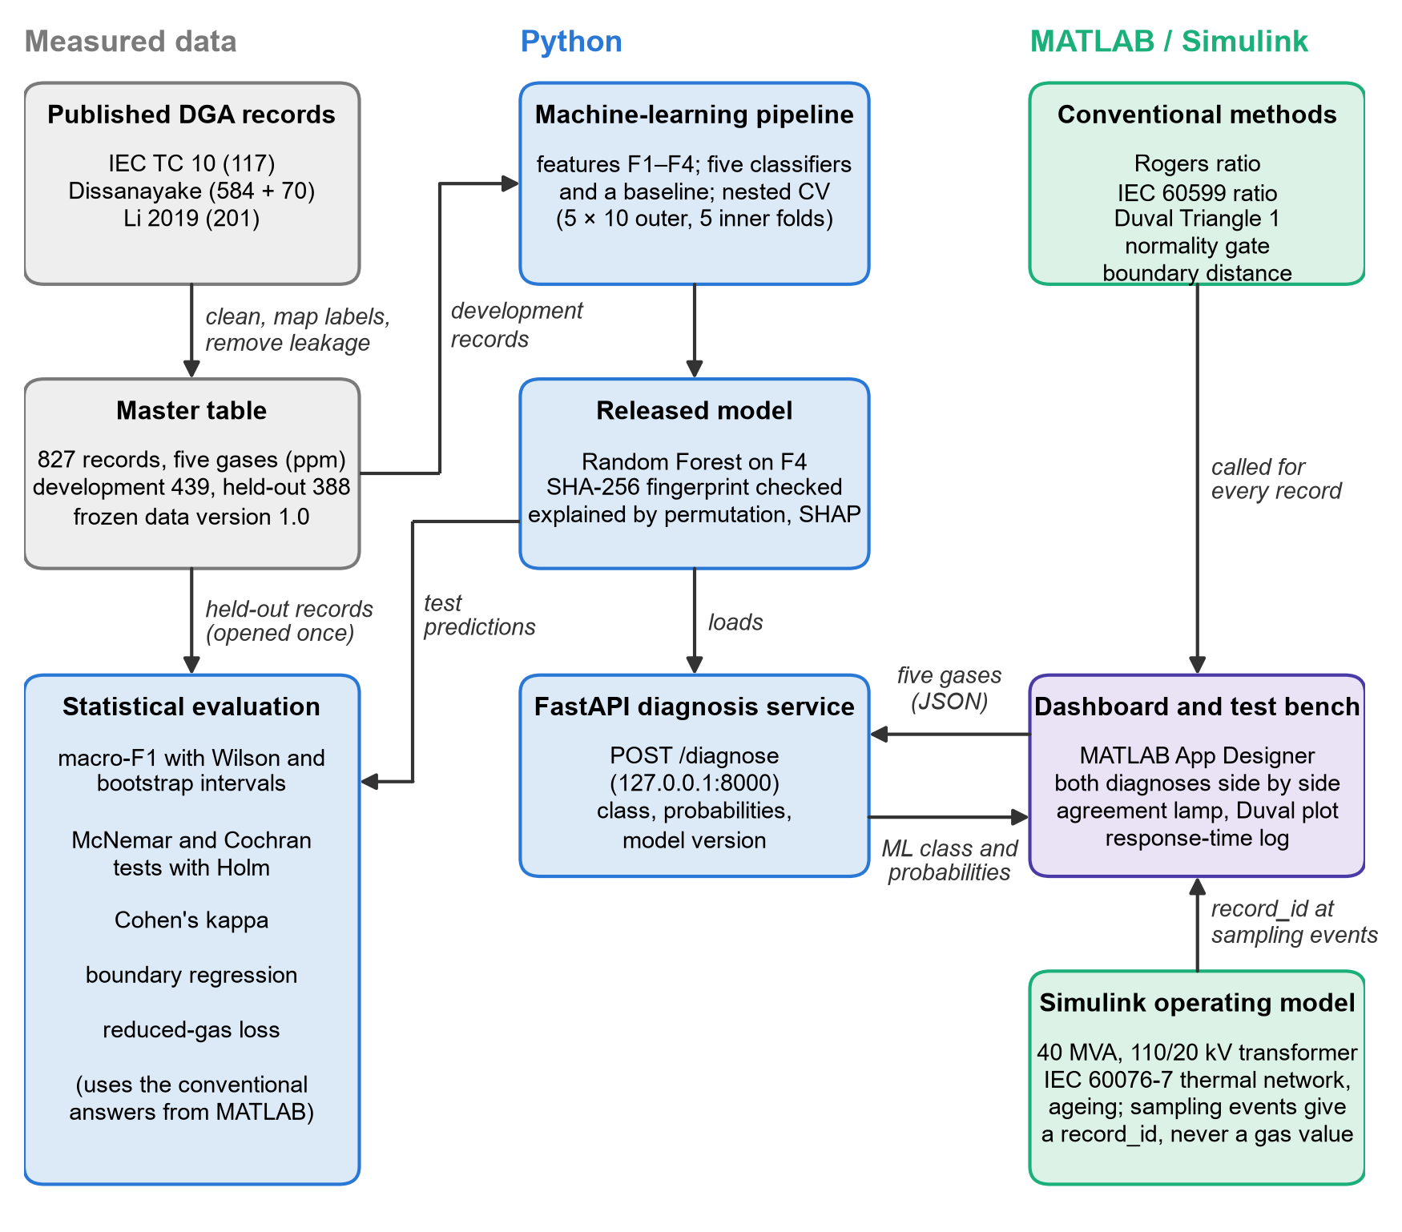
Fig. 3.1 The integrated framework: measured data, Python analysis and service, and the MATLAB/Simulink test bench

3.2.2 Principles that Governed the Work
Four principles were followed throughout, because they decide whether the results can be trusted:
a. Only measured gas values. Every gas concentration used is a published measurement. The Simulink model represents load, temperature and insulation ageing only and never generates a gas value, because a gas-generation model without laboratory validation would amount to inventing data.
b. Labels of known origin. A fault label obtained by a conventional method cannot be used to judge that method. The main comparison therefore uses only cases whose fault was confirmed by inspection of the failed equipment.
c. Analysis rules fixed in advance. The measures, tests, tolerances and decision criteria were written in an analysis plan and approved before any result was computed, and every detail that the plan left open was fixed and recorded before the corresponding computation. In particular, the final model was chosen by a written rule before any test record was seen, and the test records were predicted only once.
d. Traceability. Every number in this thesis is produced by a program from saved files, and every data file is identified by its SHA-256 fingerprint (NIST, 2015), so that the whole analysis can be repeated.

3.2.3 Data Roles
Four groups of records with different roles were used (Chapter 4). The development set is used to train, tune and compare the classifiers by cross-validation. Three test sets are kept closed until the final model has been chosen and are then predicted once: an internal test set from the same source as the development set; the IEC TC 10 benchmark, the main test set, whose faults were confirmed by inspection; and an external test set from a different source, used as a sensitivity check.

3.3 Conventional DGA Interpretation Methods
Three conventional methods were implemented: the Rogers ratio method, the IEC 60599 ratio method and the Duval Triangle 1. They were chosen because they are the most widely used ratio and graphical methods and because their limits are published. The limits were transcribed from the sources given under each table and checked against the worked examples of those sources; no limit is typed into the program code.

3.3.1 Gas Ratios
The two ratio methods use three ratios of gas concentrations:
$$\begin{aligned}R_{1}=\frac{CH_{4}}{H_{2}}, R_{2}=\frac{C_{2}H_{2}}{C_{2}H_{4}}, R_{5}=\frac{C_{2}H_{4}}{C_{2}H_{6}}\#\left(3.1\right)\end{aligned}$$
where:
R₁, R₂, R₅ gas ratios (dimensionless), named as in IEEE Std C57.104
H₂, CH₄, C₂H₂, C₂H₄, C₂H₆ concentrations of hydrogen, methane, acetylene, ethylene and ethane in the oil (ppm)
A ratio whose denominator is zero is undefined. A method gives no diagnosis (ND) for a record when a ratio that the candidate fault class needs is undefined, or when the ratios match none of the coded classes. Ratios that the standard marks "not significant" for a class are not used for that class.

3.3.2 IEC 60599 Ratio Method
Table 3.1 gives the limits of IEC 60599. A record receives a fault class when every significant ratio of that class falls within the printed range. Three implementation rules were needed:
a. Ranges printed as "a – b" include both end points; "<" and ">" are strict.
b. The D1 and D2 rows overlap. Where a record satisfies both, the method returns the dual answer "D1/D2", as the standard allows; it is counted as correct when the true class is D1 or D2.
c. The T1 entry for CH₄/H₂ is printed "> 1 but NS". Read only as "not significant", every partial-discharge record would also satisfy T1 and the method could never answer PD alone. The printed condition CH₄/H₂ > 1 is therefore applied.
Table 3.1 IEC 60599 Gas Ratio Limits for Fault Interpretation
Fault code | Fault | C₂H₂/C₂H₄ | CH₄/H₂ | C₂H₄/C₂H₆
PD | Partial discharges | NS | <0.1 | <0.2
D1 | Discharges of low energy | >1 | 0.1 - 0.5 | >1
D2 | Discharges of high energy | 0.6 - 2.5 | 0.1 - 1 | >2
T1 | Thermal fault, t < 300 °C | NS | >1 but NS | <1
T2 | Thermal fault, 300 °C < t < 700 °C | <0.1 | >1 | 1 - 4
T3 | Thermal fault, t > 700 °C | <0.2 | >1 | >4
NS = not significant whatever the value. Source: IEC 60599:1999+A1:2007, Table 2 (official preview), the T1 entry for CH₄/H₂ (printed "> 1 but NS") is applied as CH₄/H₂ > 1 (see Section 3.3.2).

3.3.3 Rogers Ratio Method
The Rogers method follows Table 6 of IEEE Std C57.104-2008 (Table 3.2). Each case corresponds to one combination of ratio ranges; the last column gives the fault class used in this study. The table has no low-energy discharge (D1) case, so the method cannot diagnose D1.
Table 3.2 Rogers Ratio Code Table
Case | Suggested diagnosis | C₂H₂/C₂H₄ (R2) | CH₄/H₂ (R1) | C₂H₄/C₂H₆ (R5) | Project class
0 | Unit normal | <0.1 | >0.1 to <1.0 | <1.0 | Normal
1 | Low-energy density arcing - PD | <0.1 | <0.1 | <1.0 | PD
2 | Arcing - High-energy discharge | 0.1 to 3.0 | 0.1 to 1.0 | >3.0 | D2
3 | Low temperature thermal | <0.1 | >0.1 to <1.0 | 1.0 to 3.0 | T1
4 | Thermal <700 °C | <0.1 | >1.0 | 1.0 to 3.0 | T2
5 | Thermal >700 °C | <0.1 | >1.0 | >3.0 | T3
Source: IEEE Std C57.104-2008, Table 6 (IEEE, 2009); last column: the fault class used in this study for each case.

3.3.4 Duval Triangle 1
The Duval Triangle 1 uses only methane, ethylene and acetylene. Their shares of the three-gas total are
$$\begin{aligned}\%CH_{4}=100\frac{CH_{4}}{CH_{4}+C_{2}H_{4}+C_{2}H_{2}}\#\left(3.2\right)\end{aligned}$$
where:
%CH₄ share of methane in the total of the three gases (%); %C₂H₄ and %C₂H₂ are defined in the same way, and the three shares add up to 100 %
Because the three shares add up to 100 %, each record is one point of an equilateral triangle. With the triangle drawn with side 1, the point has the coordinates
$$\begin{aligned}x=\frac{\%C_{2}H_{4}+0.5 \%CH_{4}}{100}, y=\left(\frac{\sqrt{3}}{2}\right)\left(\%\frac{CH_{4}}{100}\right)\#\left(3.3\right)\end{aligned}$$
where:
x, y coordinates of the record in the triangle; x = 0 at the 100 % C₂H₂ corner and 1 at the 100 % C₂H₄ corner; y = √3/2 at the 100 % CH₄ corner
The triangle is divided into seven zones by the rules of Table 3.3, which are tested in order; the first rule that holds gives the zone. The rules were taken from a secondary source that cites the zone limits of IEEE Std C57.104-2019 (Moser, 2025) and checked against the zone labels of an open-access figure (Manisha et al., 2022). Together they cover the triangle without gaps or overlaps and reproduce all 39 example diagnoses printed in those sources. The DT zone (a mixture of thermal and electrical faults) has no matching fault class in the data, so a DT answer is counted as a wrong diagnosis and reported separately.
Table 3.3 Zone Rules of Duval Triangle 1 Used in This Study
Rule | Zone | Condition (percentages of CH₄ + C₂H₄ + C₂H₂)
1 | PD | %CH₄ ≥ 98
2 | T1 | %CH₄ < 98; %C₂H₄ < 20; %C₂H₂ < 4
3 | T2 | %C₂H₄ ≥ 20 and < 50; %C₂H₂ < 4
4 | T3 | %C₂H₄ ≥ 50; %C₂H₂ < 15
5 | DT | %C₂H₄ < 50; %C₂H₂ ≥ 4 and < 13
6 | DT | %C₂H₄ ≥ 40 and < 50; %C₂H₂ ≥ 13 and < 29
7 | DT | %C₂H₄ ≥ 50; %C₂H₂ ≥ 15 and < 29
8 | D1 | %C₂H₄ < 23; %C₂H₂ ≥ 13
9 | D2 | %C₂H₄ ≥ 23; %C₂H₂ ≥ 29
10 | D2 | %C₂H₄ ≥ 23 and < 40; %C₂H₂ ≥ 13 and < 29
Rules are tested in this order; the first rule that holds gives the zone. Sources: Moser (2025), citing IEEE Std C57.104-2019, clause 6.2.3, and the zone labels of Manisha et al. (2022).

3.3.5 Normality Gate
Conventional methods cannot by themselves say that a transformer is healthy, and gas ratios of equipment with low gas levels have no diagnostic meaning (Duval and dePablo, 2001). A common normality gate based on the 90 % typical concentrations of IEC 60599 (Table 3.4) was therefore applied in front of all three methods:
$$\begin{aligned}y=\text{Normal} \text{if} x_{g}≤x_{g}^{\text{typ}}\text{for every gas }g\#\left(3.4\right)\end{aligned}$$
where:
y answer of the conventional method
x_{g} measured concentration of gas g (ppm)
x_{g}^{typ} upper end of the 90 % typical range of gas g for the equipment type (ppm)
The upper end of each range is the primary rule; the lower end, and no gate at all, were run as sensitivity analyses.
Table 3.4 IEC 60599 Typical Gas Concentrations Used by the Normality Gate
Gas | Equipment group | 90 % typical range (ppm) | Upper end used by the gate (ppm)
H₂ | All transformers | 50 - 150 | 150
CH₄ | All transformers | 30 - 130 | 130
C₂H₄ | All transformers | 60 - 280 | 280
C₂H₆ | All transformers | 20 - 90 | 90
C₂H₂ | No OLTC | 2 - 20 | 20
C₂H₂ | Communicating OLTC | 60 - 280 | 280
Source: IEC 60599:1999/AMD1:2007, Table A.2. 'Communicating OLTC' applies to IEC TC 10 equipment code U; all other records use the 'no OLTC' range.

3.3.6 Coverage and Distance to the Decision Boundary
The share of records for which a method gives no diagnosis, and its complement, the coverage, are
$$\begin{aligned}U=\frac{n_{\text{ND}}}{N}, \text{Coverage}=1-U\#\left(3.5\right)\end{aligned}$$
where:
U unresolved (no-diagnosis) rate; n_{ND} = number of records without a diagnosis; N = number of records
To test whether ML and the conventional methods disagree mainly near the decision boundaries of the conventional methods, the distance of each record to the nearest boundary was computed. For the ratio methods it is measured in decades of the ratio:
$$\begin{aligned}d_{R}=\min_{j,l}\left|\log_{10}{}R_{j}-\log_{10}{}L_{j,l}\right|\#\left(3.6\right)\end{aligned}$$
where:
d_{R} distance to the nearest ratio limit (decades)
R_{j} value of ratio j of the record; L_{j,l} = the l-th limit of ratio j in the code table
For the Duval Triangle it is the shortest Euclidean distance, in percentage points, from the record's point P to an edge that separates two different zones:
$$\begin{aligned}d_{D}=\min_{e∈E}{\text{dist}\left(P,e\right)}\#\left(3.7\right)\end{aligned}$$
where:
d_{D} distance to the nearest zone boundary (percentage points)
E set of zone edges that separate two different zones; dist(P, e) = shortest distance from P to edge e

3.3.7 Verification of the Implementation
The MATLAB functions were checked by 67 unit tests and against the worked examples of the sources. The three methods were then programmed a second time, independently, in Python from the same tables and rules, with the Duval distance computed by a different geometric procedure. The two implementations were compared on every record (Section 5.2.1).

3.4 Machine-Learning Methods

3.4.1 Overview
A supervised classifier learns, from records whose class is known, a function that maps the five gas concentrations of a sample to one of the fault classes, and returns for each sample the probability of every class. The method has five parts: the input features, the classifiers, the handling of class imbalance, the validation design and the selection rule. All were implemented in Python with scikit-learn (Pedregosa et al., 2011).

3.4.2 Input Features
Gas concentrations are strongly skewed: most records contain a few to a few hundred ppm of each gas, but some contain tens of thousands. Four feature sets were therefore built from the five gases (Table 3.5):
$$\begin{aligned}u_{g}=\log_{10}\left(x_{g}+1\right)\#\left(3.8\right)\end{aligned}$$
$$\begin{aligned}p_{g}=100\frac{x_{g}}{\sum_{h=1}^{5}{x_{h}}}\#\left(3.9\right)\end{aligned}$$
$$\begin{aligned}r_{k}=\log_{10}\left(\frac{a_{k}+1}{b_{k}+1}\right)\#\left(3.10\right)\end{aligned}$$
where:
u_{g} log-transformed concentration of gas g; the offset of 1 ppm keeps a value of zero finite
p_{g} share of gas g in the total of the five gases (%)
r_{k} log-ratio k of the gases a_{k} and b_{k}: R1 = CH₄/H₂, R2 = C₂H₂/C₂H₄, R3 = C₂H₂/CH₄, R4 = C₂H₆/C₂H₂ and R5 = C₂H₄/C₂H₆
Table 3.5 Feature Sets Compared
Set | Features | Number | Purpose
F1 | log10(x + 1) of each gas | 5 | Raw measured information
F2 | Share of each gas in the five-gas total (%) | 5 | Fault fingerprint independent of the gas level
F3 | log10 ratios R1 to R5 with +1 ppm offset, and the three Duval percentages | 8 | Engineering knowledge of the conventional methods
F4 | F1 + F2 + F3 | 18 | All information together

Before training, every feature was standardised with the mean and standard deviation of the training records:
$$\begin{aligned}z=\frac{x-μ}{σ}\#\left(3.11\right)\end{aligned}$$
where:
z standardised feature; x = feature value; μ, σ = mean and standard deviation of the feature over the training records
The Duval percentages are undefined for records in which CH₄, C₂H₄ and C₂H₂ are all zero; such values were replaced by the median of the training records. Every transformation was fitted on the training part only and then applied unchanged to the records being predicted, so that no information from those records could reach the model.

3.4.3 Classifiers
Five classifiers of different families were compared, with a majority-class baseline that always predicts the most common class as a floor (Table 3.6). In the descriptions below, z is the vector of standardised features of a record and K the number of classes.

Multinomial logistic regression
Logistic regression is a linear model and serves as an interpretable baseline. The probability of class c is
$$\begin{aligned}P\left(c | z\right)=\frac{e^{w_{c}^{⊤}z+b_{c}}}{\sum_{k=1}^{K}{e^{w_{k}^{⊤}z+b_{k}}}}\#\left(3.12\right)\end{aligned}$$
where:
w_{c}, b_{c} weight vector and intercept of class c, estimated by maximising the penalised likelihood of the training data; the strength of the L2 penalty is set by the parameter C (smaller C = stronger penalty)

Support vector machine
A support vector machine (SVM) separates two classes by the boundary with the largest margin. With the radial basis function (RBF) kernel, its decision function is
$$\begin{aligned}f\left(z\right)=\sum_{i=1}^{n}{α_{i}y_{i}K\left(z_{i},z\right)}+b, K\left(z_{i},z\right)=e^{-γ{\left\|z_{i}-z\right\|}^{2}}\#\left(3.13\right)\end{aligned}$$
where:
α_{i} weights found in training (non-zero only for the support vectors); y_{i} = ±1 = class of training record i; b = intercept
γ width parameter of the kernel; the penalty C bounds the α_{i} and so balances the margin against training errors
Several classes are handled by one-against-one voting. Class probabilities were obtained by Platt scaling (Platt, 1999), which fits a sigmoid function to the decision values inside the training data.

Random forest
A random forest (Breiman, 2001) averages many decision trees, each grown on a bootstrap sample of the training records and choosing, at every split, the best of a random subset of the features. A split is chosen to reduce the Gini impurity of the two resulting nodes, and the forest's probability is the mean over the trees:
$$\begin{aligned}G=1-\sum_{c=1}^{K}{p_{c}^{2}}, P\left(c | z\right)=\frac{1}{T}\sum_{t=1}^{T}{p_{\left(t,c\right)\left(z\right)}}\#\left(3.14\right)\end{aligned}$$
where:
G Gini impurity of a node; p_{c} = share of training records of class c in the node
T number of trees (500); p_{t,c}(z) = share of class c in the leaf of tree t that the record reaches
The settings tuned were the maximum depth of the trees and the minimum number of records in a leaf.

Gradient-boosted trees (XGBoost)
XGBoost (Chen and Guestrin, 2016) builds trees one after another, each correcting the errors of those before it, by minimising
$$\begin{aligned}L=\sum_{i=1}^{n}{l\left(y_{i},ŷ_{i}\right)}+\sum_{m=1}^{M}{\left(γ_{T}T_{m}+\frac{1}{2}λ{\left\|w_{m}\right\|}^{2}\right)}\#\left(3.15\right)\end{aligned}$$
where:
l multi-class logarithmic loss between the true class y_{i} and the prediction ŷ_{i}, which is the sum of the outputs of the M trees
T_{m} number of leaves of tree m; w_{m} = its leaf weights; γ_{T}, λ = penalties that keep the trees simple
the learning rate shrinks the contribution of each new tree; the number of trees, their depth and the learning rate were tuned

Multilayer perceptron
The multilayer perceptron (MLP) is a feed-forward neural network. With one hidden layer,
$$\begin{aligned}h=\max\left(0,W_{1}z+b_{1}\right), P\left(c | z\right)=\text{softmax}{\left(W_{2}h+b_{2}\right)}_{c}\#\left(3.16\right)\end{aligned}$$
where:
h outputs of the hidden neurons (rectified linear activation); W₁, W₂, b₁, b₂ = weights and biases
softmax the normalised exponential of Equation (3.12); the weights are found with the L-BFGS optimiser (Liu and Nocedal, 1989) with an L2 penalty
Table 3.6 Classifiers and Hyper-parameter Search Grids
Model | Fixed settings | Settings tuned (search values)
Majority-class baseline | always predicts the most common class | none
SVM (RBF kernel) | Platt-calibrated probabilities, 5 internal folds | C in {0.1, 1, 10, 100}; gamma in {0.001, 0.01, 0.1, 1, scale}
Random Forest | 500 trees | maximum depth in {none, 5, 10}; minimum leaf size in {1, 2, 5}
XGBoost | multi-class soft-probability objective, histogram trees | learning rate in {0.03, 0.1, 0.3}; depth in {2, 4, 6}; rounds in {100, 300}
MLP neural network | L-BFGS solver, at most 5 000 iterations | hidden layers in {(16), (32), (32, 16)}; L2 penalty in {0.0001, 0.001, 0.01}
Logistic regression | multinomial, at most 5 000 iterations | C in {0.1, 1, 10}
Class weights w_{c} = N/(K n_{c}) are recomputed in every training fold for all models except the baseline.

3.4.4 Class Imbalance
The fault classes are of unequal size. To stop a classifier from favouring the large classes, every training record received a class weight
$$\begin{aligned}w_{c}=\frac{N}{K n_{c}}\#\left(3.17\right)\end{aligned}$$
where:
w_{c} weight of every training record of class c
N number of training records; K = number of classes; n_{c} = number of training records of class c
With these weights every class carries the same total weight in training. The weights were recomputed from the training records of every fold. Synthetic over-sampling (SMOTE; Chawla et al., 2002) was not used, because synthetic copies can leak test information when they are not confined to the training part.

3.4.5 Validation Design: Nested Cross-Validation
Each of the 24 combinations of classifier and feature set was evaluated by nested cross-validation (Varma and Simon, 2006) on the development set (Fig. 3.2):
a. Outer loop. The development records were divided into 5 folds of similar class composition; each fold served once as the test fold while the other four trained the model. The division was repeated 10 times with different random orders, giving 50 test-fold estimates per pipeline. Records that are near-duplicates of each other were always placed in the same fold, so that a copy of a test record could never be in the training part.
b. Inner loop. Inside each outer training part, a 5-fold grid search chose the settings of the classifier by macro-F1 (Equation (3.21)). The chosen setting was refitted on the whole outer training part and scored on the outer test fold, which therefore never influenced any choice.
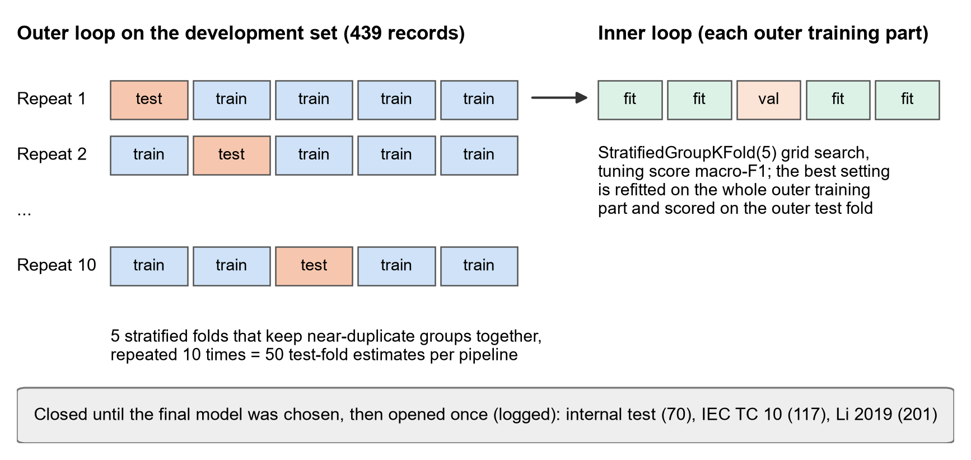
Fig. 3.2 Nested cross-validation scheme

3.4.6 Model Selection Rule
The rule for choosing the final model was written down before any cross-validation result was read. The pipeline (classifier and feature set) with the highest mean macro-F1 is compared with the second best by the corrected resampled t-test (Nadeau and Bengio, 2003), which allows for the overlap of training data between folds:
$$\begin{aligned}t=\frac{\bar{d}}{\sqrt{\left(\frac{1}{k r}+\frac{n_{\text{test}}}{n_{\text{train}}}\right)σ_{d}^{2}}}\#\left(3.18\right)\end{aligned}$$
where:
d̄ mean over the 50 folds of the difference in macro-F1 between the two pipelines; σ_{d}² = variance of those differences
k 5 folds; r = 10 repeats; n_{test}/n_{train} = ratio of test-fold to training-part size (0.2500); t is compared with a t distribution with 49 degrees of freedom
If the difference is not significant at the 5 % level, the simpler pipeline is chosen: first by model family (in the order logistic regression, SVM, random forest, XGBoost, MLP), then by the smaller number of features.

3.4.7 Final Model and One-Time Testing
The selected pipeline was tuned once more on all development records with the same grid and inner procedure, refitted, and saved with its SHA-256 fingerprint before any test record was predicted. All test records were then predicted in a single run. The program records every access to the test sets and refuses to run a second time, so no choice could be changed after the test results were seen. The saved model was released unchanged for the diagnosis service and documented in a model card (Mitchell et al., 2019).

3.4.8 Explaining the Model
Two explanation methods were applied to the final model. Permutation importance (Breiman, 2001) measures how much the macro-F1 falls when the values of one input are shuffled at random:
$$\begin{aligned}I_{j}=s-\frac{1}{R}\sum_{r=1}^{R}{s_{r,j}}\#\left(3.19\right)\end{aligned}$$
where:
I_{j} importance of input j; s = macro-F1 on the original data; s_{r,j} = macro-F1 after shuffling input j in repeat r; R = 30 repeats
Because the 18 features are derived from only five gases and are strongly correlated, shuffling one feature understates information that other features share (Strobl et al., 2008). The main ranking therefore shuffles whole gases, so that every feature derived from a gas moves with it. SHAP values (Lundberg and Lee, 2017), computed exactly for tree models (Lundberg et al., 2020), split each predicted probability into the contributions of the individual features; the mean absolute SHAP value ranks the features for each class. Before the explanations were computed, the gases expected from gas-formation physics were written down for each fault (H₂ for PD; C₂H₂ for D1 and D2; CH₄ or C₂H₆ for T1; C₂H₄ or CH₄ for T2; C₂H₄ for T3), and it was then checked whether the most important features agree with them.

3.5 Performance Measures
All measures are computed from the confusion matrix, which counts, for every true class, how many records received each diagnosis. For class c:
$$\begin{aligned}{\text{Prec}}_{c}=\frac{TP_{c}}{TP_{c}+FP_{c}}, {\text{Rec}}_{c}=\frac{TP_{c}}{TP_{c}+FN_{c}}, {\text{F1}}_{c}=\frac{2 {\text{Prec}}_{c}{\text{Rec}}_{c}}{{\text{Prec}}_{c}+{\text{Rec}}_{c}}\#\left(3.20\right)\end{aligned}$$
where:
Prec_{c}, Rec_{c}, F1_{c} precision, recall and F1-score of class c
TP_{c} records of class c diagnosed as c; FP_{c} = records of other classes diagnosed as c; FN_{c} = records of class c given another answer or no diagnosis
The primary measure is macro-F1, the unweighted mean of the class F1-scores, because it gives every fault class the same importance however few records it has:
$$\begin{aligned}\text{Macro-F1}=\frac{1}{K}\sum_{c=1}^{K}{{\text{F1}}_{c}}, \text{Balanced accuracy}=\frac{1}{K}\sum_{c=1}^{K}{{\text{Rec}}_{c}}\#\left(3.21\right)\end{aligned}$$
where:
K number of classes in the evaluation set
Because conventional methods may give no diagnosis, two accuracies are reported together with the coverage (Equation (3.5)):
$$\begin{aligned}A_{\text{strict}}=\frac{n_{\text{correct}}}{N}, A_{\text{cond}}=\frac{n_{\text{correct}}}{N-n_{\text{ND}}}\#\left(3.22\right)\end{aligned}$$
where:
A_{strict} strict accuracy, in which every no-diagnosis counts as wrong; A_{cond} = conditional accuracy over the records that received a diagnosis; n_{correct} = number of correct diagnoses
Agreement between two raters (two methods, or a method and the true class) beyond chance was measured with Cohen's kappa (Cohen, 1960):
$$\begin{aligned}κ=\frac{p_{o}-p_{e}}{1-p_{e}}\#\left(3.23\right)\end{aligned}$$
where:
p_{o} observed proportion of records on which the two raters give the same answer; p_{e} = proportion of agreement expected by chance from the frequency of each answer
The multi-class Matthews correlation coefficient (Gorodkin, 2004) was also reported. The same scoring rules apply to every method: a no-diagnosis is wrong in strict accuracy and left out of conditional accuracy; the IEC dual answer D1/D2 is correct for a true D1 or D2; a DT answer is wrong; and on test sets without a Normal class a Normal answer is wrong.

3.6 Statistical Methods
All tests are two-sided at the 5 % significance level. Exact p-values and effect sizes are reported, and a non-significant result is described as no evidence of a difference, never as proof that two methods are equal.

3.6.1 Describing the Data
Gas concentrations by class are summarised by the median and the interquartile range. Whether a gas differs between classes was tested with the Kruskal–Wallis test (Kruskal and Wallis, 1952), a rank test that does not assume normal distributions:
$$\begin{aligned}H=\frac{12}{n\left(n+1\right)}\sum_{c=1}^{K}{\frac{R_{c}^{2}}{n_{c}}}-3\left(n+1\right), ε_{R}^{2}=\frac{H\left(n+1\right)}{n^{2}-1}\#\left(3.24\right)\end{aligned}$$
where:
H Kruskal–Wallis statistic, compared with a χ² distribution with K − 1 degrees of freedom; n = number of records; R_{c} = sum of the ranks of the records of class c; n_{c} = number of records of class c
ε_{R}² rank epsilon-squared effect size, the share of the rank variation explained by the class (0 to 1)
The association between pairs of gases was measured with Spearman's rank correlation ρ_{s} (Spearman, 1904).

3.6.2 Confidence Intervals
Proportions such as accuracy and coverage carry Wilson score intervals (Wilson, 1927), which behave well for small samples:
$$\begin{aligned}{\text{CI}}_{95}=\frac{p+\frac{z^{2}}{2n}±z\sqrt{\frac{p\left(1-p\right)}{n}+\frac{z^{2}}{4n^{2}}}}{1+\frac{z^{2}}{n}}\#\left(3.25\right)\end{aligned}$$
where:
p observed proportion; n = number of records; z = 1.96
Macro-F1 and the differences between methods carry stratified percentile bootstrap intervals (Efron and Tibshirani, 1993): B = 2 000 resamples are drawn with replacement within each true class, the measure is recomputed on each, and the 2.5th and 97.5th percentiles form the interval. The same resamples are used for all methods, so that differences are paired.

3.6.3 Comparing the Classifiers
In each of the 50 outer folds the six models were ranked by macro-F1, and the Friedman test (Friedman, 1937) checked whether their average ranks differ. Pairs of models were then compared with the Nemenyi critical difference (Demšar, 2006):
$$\begin{aligned}\text{CD}=q_{α}\sqrt{\frac{k\left(k+1\right)}{6 n_{f}}}\#\left(3.26\right)\end{aligned}$$
where:
CD smallest difference of average ranks that is significant; q_{α} = critical value of the studentised range for k models at α = 0.05, divided by √2; n_{f} = 50 folds
Because the folds share training data, these rank tests are descriptive support; the key pair of pipelines was compared with the corrected t-test of Equation (3.18).

3.6.4 Comparing the ML Model with the Conventional Methods
On each test set every method is either right or wrong on each record. Cochran's Q test (Cochran, 1950) first tests whether the four methods have the same proportion correct:
$$\begin{aligned}Q=\frac{\left(m-1\right)\left(m\sum_{j=1}^{m}{C_{j}^{2}}-T^{2}\right)}{m T-\sum_{i=1}^{N}{a_{i}^{2}}}\#\left(3.27\right)\end{aligned}$$
where:
m 4 methods; C_{j} = number of records method j diagnosed correctly; a_{i} = number of methods correct on record i; T = ∑C_{j}; Q is compared with a χ² distribution with m − 1 degrees of freedom
The ML model was then compared with each conventional method by McNemar's test (McNemar, 1947), which uses only the records on which the two differ:
$$\begin{aligned}χ^{2}=\frac{{\left(\left|b-c\right|-1\right)}^{2}}{b+c}\#\left(3.28\right)\end{aligned}$$
where:
b records diagnosed correctly by the ML model and wrongly by the conventional method; c = the reverse
When b + c < 25 the exact binomial test was used instead. The three p-values of each test set were adjusted by Holm's procedure (Holm, 1979), which keeps the chance of any false positive at 5 %: the i-th smallest p-value is significant while p_{i} ≤ 0.05/(m − i + 1), with m = 3. The effect size is the odds ratio b/c with its 95 % interval.

3.6.5 Is Disagreement Concentrated near the Boundaries?
For each conventional method, the probability that the ML diagnosis and the method's diagnosis disagree was modelled by logistic regression on the standardised boundary distance:
$$\begin{aligned}\ln\left(\frac{π_{i}}{1-π_{i}}\right)=β_{0}+β_{1}d_{i}, \text{OR}=e^{β_{1}}\#\left(3.29\right)\end{aligned}$$
where:
π_{i} probability that the ML and the method's diagnoses differ for record i
d_{i} boundary distance of record i (Equation (3.6) or Equation (3.7)), standardised to zero mean and unit standard deviation
β₁ change of the log-odds of disagreement per standard deviation of distance; OR = odds ratio
A negative β₁, with a 95 % interval that excludes zero, means that records closer to a boundary are more often disputed. Records for which a distance cannot be computed were excluded and counted. Firth's penalised likelihood (Firth, 1993) was available in case of separation but was not needed.

3.6.6 Research Hypothesis and Decision Criteria
The research hypothesis (Chapter 1) is called supported only if all three of the following criteria hold on the main benchmark, the inspection-confirmed IEC TC 10 power transformers; otherwise it is reported as partly supported or not supported:
1. the ML model has a higher strict accuracy than each conventional method, with a Holm-adjusted McNemar p-value below 0.05;
2. the advantage comes mainly from the records on which a method gives no diagnosis, that is, the gap in conditional accuracy is smaller than the gap in strict accuracy; and
3. disagreement between ML and each method becomes more likely closer to the method's decision boundary (β₁ < 0 with a 95 % interval that excludes zero).

3.7 Reduced-Gas Study
With five gases there are 2⁵ − 1 = 31 non-empty gas subsets. For every subset S, the selected pipeline was retrained and evaluated by the same nested cross-validation on the same folds, using only what S allows: the logarithm of each gas in S, the shares within the gases of S, a ratio only when both of its gases are in S, and the Duval percentages only when CH₄, C₂H₄ and C₂H₂ are all present. With all five gases this is exactly the full feature set. The loss of performance is
$$\begin{aligned}Δ_{S}={\text{Macro-F1}}_{\text{full}}-{\text{Macro-F1}}_{S}\#\left(3.30\right)\end{aligned}$$
and the minimum gas panel is the subset with the fewest gases whose loss satisfies
$$\begin{aligned}U_{95}\left(Δ_{S}\right)≤δ\#\left(3.31\right)\end{aligned}$$
where:
Δ_{S} loss of macro-F1 when only the gases in subset S are available
U₉₅ upper limit of the 95 % paired bootstrap interval of the loss (B = 2 000)
δ 0.05 = largest acceptable loss, fixed before the study
For the conventional methods, applicability follows from their formulas: the ratio methods need all five gases, and the Duval Triangle needs CH₄, C₂H₄ and C₂H₂. This was confirmed by running the MATLAB implementations with each removed gas marked as not measured.

3.8 Thermal Model of the Transformer

3.8.1 Purpose
The Simulink model represents the operating condition of one power transformer, namely its load, oil and winding temperatures and the ageing of its paper insulation, so that a DGA diagnosis can be shown in the context in which the oil sample was taken. Its structure and implementation are described in Chapter 8; this section gives the equations it solves and the way it was verified.

3.8.2 Thermal Equations
The model implements the differential equations of the IEC 60076-7 loading guide (IEC, 2018). The top-oil temperature follows
$$\begin{aligned}k_{11}τ_{o}\frac{dθ_{o}}{dt}={\left(\frac{1+K^{2}R}{1+R}\right)}^{x}Δθ_{or}-\left(θ_{o}-θ_{a}\right)\#\left(3.32\right)\end{aligned}$$
and the hot-spot temperature is the top-oil temperature plus the difference of two first-order components:
$$\begin{aligned}k_{21}Δθ_{hr}K^{y}=k_{22}τ_{w}\frac{dΔθ_{h1}}{dt}+Δθ_{h1}, \left(k_{21}-1\right)Δθ_{hr}K^{y}=\frac{\frac{τ_{o}}{k_{22}}\left(dΔθ_{h2}\right)}{dt}+Δθ_{h2}\#\left(3.33\right)\end{aligned}$$
$$\begin{aligned}θ_{h}=θ_{o}+Δθ_{h1}-Δθ_{h2}, Δθ_{hr}=H g_{r}, R=\frac{P_{k}}{P_{0}}\#\left(3.34\right)\end{aligned}$$
where:
θ_{o}, θ_{h}, θ_{a} top-oil, hot-spot and ambient temperature (°C); t = time (min)
K load factor, the load current divided by the rated current (pu); R = ratio of load loss to no-load loss
Δθ_{or} top-oil temperature rise at rated load (K); g_{r} = winding-to-oil gradient (K); H = hot-spot factor
k₁₁, k₂₁, k₂₂ thermal model constants; τ_{o}, τ_{w} = oil and winding time constants (min); x, y = oil and winding exponents
Δθ_{h1}, Δθ_{h2} the two components of the hot-spot-to-top-oil gradient (K); P_{k}, P₀ = load and no-load losses (W)

3.8.3 Insulation Ageing
The relative ageing rate of the paper insulation and the loss of life over a period are
$$\begin{aligned}V=2^{\frac{θ_{h}-98}{6}}, L=\int_{t_{1}}^{t_{2}}{V}dt\#\left(3.35\right)\end{aligned}$$
where:
V relative ageing rate (1 at a hot-spot temperature of 98 °C; it doubles for every 6 K more)
L loss of life over the period from t₁ to t₂, expressed in hours of ageing at 98 °C (h)

3.8.4 Verification Method
The model was verified against an independent numerical solution of Equation (3.32) to Equation (3.34), computed with a stiff differential-equation solver at a tight tolerance and driven by the load factor measured in the model. Two tests were run: rated load from a cold start (ambient 20 °C, 24 h) and a load step from 0.6 to 1.2 pu at 6 h. The measures were
$$\begin{aligned}e_{\text{max}}=\max_{t}\left|θ_{\text{sim}\left(t\right)}-θ_{\text{ref}\left(t\right)}\right|, \text{RMSE}=\sqrt{\frac{1}{M}\sum_{m=1}^{M}{{\left(θ_{\text{sim}\left(t_{m}\right)}-θ_{\text{ref}\left(t_{m}\right)}\right)}^{2}}}\#\left(3.36\right)\end{aligned}$$
where:
θ_{sim}, θ_{ref} top-oil or hot-spot temperature from the model and from the reference (°C); M = number of compared time points after the first 10 min
The acceptance criteria, approved before the tests, were e_{max} ≤ 0.1 K for both temperatures in both tests and a 63 % rise time of the top-oil temperature within 1 min of k₁₁τ_{o}. The model was also checked with the Simulink Model Advisor.

3.9 Integration and Evaluation of the Framework

3.9.1 Diagnosis Service and Dashboard
The released ML model is offered to other programs through a web service: a program sends the five gas concentrations as a JSON message over HTTP and receives the diagnosis and the class probabilities. The service validates every request strictly and refuses invalid input with an explanation, so that a wrong or missing value cannot silently produce a diagnosis. A dashboard built with MATLAB App Designer calls the conventional methods and the service and shows both diagnoses together. Their design is described in Chapter 8.

3.9.2 Fidelity and Response Time
A deployed system is useful only if it returns exactly the results that were evaluated offline. The integrated system was therefore run over all held-out records, and its fidelity was measured as
$$\begin{aligned}F=\frac{n_{\text{match}}}{N}\#\left(3.37\right)\end{aligned}$$
where:
F fidelity; n_{match} = records for which the ML class returned by the system equals the offline prediction; N = records sent
The response time is the time between sending a request to the service and receiving the answer, summarised by the median and the 95th percentile. The requirements, fixed in advance, were F = 1 and a 95th-percentile response time below 1 000 ms, a limit suitable for interactive use.

3.10 Exploratory Improvement Study
After the main results were known, an exploratory study was carried out to see how the model could be improved. Its protocol was registered before any of its models was trained, and the main results were not changed. Records of the four sources were de-duplicated, and leave-one-source-out validation was used: each source in turn was held out and the models were trained on the others. Three models were compared: A, the released model unchanged; B, the same pipeline retrained on the other sources; and C, a hybrid model that adds the conventional diagnoses, the normality-gate flags and the boundary distances to the inputs of B. A reject option (Chow, 1970) was also examined: the hybrid model abstains on its least confident records until its coverage equals that of a ratio method, and its accuracy on the records it answers is compared with that method's conditional accuracy. Because the held-out sources had already been seen in the main study, this study is labelled exploratory.

3.11 Software and Tools
The software used is listed in Table 3.7. All tables and figures were produced by programs from saved files; a single command rebuilds all of them, and a check that deletes and rebuilds them gives identical files.
Table 3.7 Software Used
Component | Version | Use
Python | 3.12.10 | data preparation, machine learning, statistics, service
scikit-learn | 1.9.1 | pipelines, classifiers, cross-validation
XGBoost | pinned in requirements.txt | gradient-boosted trees
SHAP | 0.53.0 | TreeSHAP explanations
FastAPI / Uvicorn / Pydantic | 0.143.0 / 0.54.0 / 2.14.0 | diagnosis web service
MATLAB | R2025b (25.2.0.2998904) | conventional methods, dashboard, test bench
Simulink, Simscape, Simscape Electrical | R2025b | transformer operating model
Microsoft Word | Microsoft 365 | thesis and reports

3.12 Summary
This chapter described the methods: three conventional interpretation methods with a common normality gate and boundary distances; five classifiers on four feature sets, compared by nested cross-validation and chosen by a written rule; a one-time test of the selected model and its explanation; macro-F1, accuracy, coverage and kappa with Wilson and bootstrap intervals; the Friedman, Cochran, McNemar and logistic-regression tests and the three criteria for the hypothesis; the reduced-gas study; the IEC 60076-7 thermal model and its verification; and the measures for the integrated framework. Chapter 4 describes the data to which these methods were applied.

CHAPTER 4
DATA COLLECTION AND PREPARATION

4.1 Introduction
The value of any comparison between diagnostic methods depends on the data used. This chapter describes where the DGA records came from and how the origin of their fault labels was established (Section 4.2), how they were audited, cleaned and divided into a development set and three test sets (Section 4.3 and Section 4.4), the main threats to validity that the data carry (Section 4.5), and what the cleaned data look like (Section 4.6).

4.2 Data Sources

4.2.1 Selection of the Data Sets
Data sets were sought that contain measured concentrations of the five gases H₂, CH₄, C₂H₆, C₂H₄ and C₂H₂ together with the fault found in each transformer, and that are published by a legitimate source with known terms of use. Four data sets met these requirements (Table 4.1).
Table 4.1 Data Sets Used and Their Roles
Data set (source) | Records | Gases | Label origin | Role in this study
IEC TC 10 database, Annex 1 of Duval and dePablo (2001) | 117 | H₂, CH₄, C₂H₆, C₂H₄, C₂H₂ (CO, CO₂) | Visual inspection of the failed equipment | Main benchmark (58 power transformers primary)
Dissanayake (2026) DGA dataset, training file | 584 | H₂, CH₄, C₂H₆, C₂H₄, C₂H₂ | Codes 0-6; origin not documented | Development (training, tuning, cross-validation)
Dissanayake (2026) DGA dataset, unseen test file | 70 | H₂, CH₄, C₂H₆, C₂H₄, C₂H₂ | Codes 0-6 (10 per class) | Internal test
Li (2019) DGA dataset | 201 | H₂, CH₄, C₂H₆, C₂H₄, C₂H₂ | Text labels; origin not documented | External test (sensitivity data set)

a. IEC TC 10 database. Duval and dePablo (2001) published, in an annex to their paper, the DGA results of faulty equipment that was inspected in service, together with the fault found at the inspection. The 117 cases were transcribed from the paper and checked cell by cell. Because the labels come from inspection and not from an interpretation method, this database is the main benchmark of the study. The equipment includes power transformers (codes P and U), instrument transformers and other apparatus; the 58 power transformers form the primary benchmark.
b. Dissanayake (2026) data set. This data set on IEEE DataPort contains a training file (584 records) and an unseen test file (70 records, ten of each of seven classes), with fault classes coded 0 to 6 (Normal, PD, D1, D2, T1, T2, T3). A third file (49 records) is a subset of the IEC TC 10 database. The way the labels were obtained is not documented.
c. Li (2019) data set. This data set on IEEE DataPort contains 201 records with text labels such as "arc discharge" and "high-temperature overheating". The way the labels were obtained is not documented.
All files were stored unchanged, and their SHA-256 fingerprints were recorded so that any later change would be detected.

4.2.2 Origin of the Fault Labels
The origin of the labels decided the role of each data set. A model trained on labels produced by a conventional method can at best imitate that method, and a method cannot be judged fairly on labels that it produced. The audit established three facts:
a. the IEC TC 10 labels were obtained by visual inspection of the failed equipment, independently of any interpretation method;
b. the Dissanayake training file contained 96 cases of the IEC TC 10 database, and for the combined T1/T2 cases among them it gives specific labels (T1, T2, T3 or PD) that the inspection does not support, so at least part of its labelling is not based on inspection; and
c. the Li (2019) file contains 115 of the 117 IEC TC 10 cases, with the inspection labels, and 86 other records.
The data sets were therefore given the roles shown in the last column of Table 4.1. The Dissanayake training file was used for development only, its unseen file served as an internal test set of supporting evidence, the IEC TC 10 database was the main benchmark, and the Li (2019) set was used as an external sensitivity test.

4.3 Data Preparation

4.3.1 Standardisation
Each source was converted to one common table with a record identifier, the five gas concentrations in parts per million (ppm), the fault class and the data role. Carbon monoxide and carbon dioxide were not used, because only the IEC TC 10 database reports them. The fault classes were coded 0 to 6 as Normal, PD, D1, D2, T1, T2 and T3. The IEC TC 10 annex prints the thermal faults below 700 °C in one table, so these cases form a merged class T1/T2. The Li (2019) text labels were mapped as follows: partial discharge to PD, spark discharge to D1, arc discharge to D2, low-, middle- and high-temperature overheating to T1, T2 and T3, and low/middle-temperature overheating to T1/T2.

4.3.2 Values Not Available
Some values are missing in the sources: the IEC TC 10 annex prints a dash, and the Dissanayake files use the placeholder 0.0001 ppm. The pattern of the missing values was examined before a rule was chosen. Acetylene was missing in most T1 records and never in D1 or D2 records, which is what would be expected if the gas had simply not been detected: low-temperature thermal faults produce little or no acetylene, whereas discharges always do. Dropping incomplete records would have removed almost all T1 cases. A value that is not available was therefore treated as not detected and set to 0 ppm, and flags recording the original form of each value were kept with the record. Results on complete records only were computed as a sensitivity analysis.

4.3.3 Removing Duplicates and Leakage
Data leakage occurs when a test record, or a copy of it, is also used for training; it makes the measured performance optimistic (Kapoor and Narayanan, 2023). Three kinds of problem were found and corrected in the development file:
a. 139 records that copy a record of a test set or of the benchmark, exactly or within 1 % or 1 ppm in every gas, were removed;
b. 2 exact copies within the file were removed; and
c. 4 records with identical gases but conflicting labels were removed, because no method can be right on both.
The 49-record IEC subset file of the Dissanayake data set was not used; the full transcription of the IEC TC 10 database replaces it.

4.3.4 Overlap between the Test Sets
The Li (2019) set contains 115 of the IEC TC 10 cases, and the Dissanayake unseen file contains 9 of them. A test set reported as separate evidence must not share records with another, so test records that copy a benchmark case were flagged. Results of the internal and external test sets use only their independent records (61 of 70 and 86 of 201 records); the full sets were evaluated as a sensitivity analysis. No record was deleted from a test set.

4.3.5 Near-Duplicate Groups and Cross-Validation Folds
Records whose five gas concentrations agree within 1 % or 1 ppm were placed in one group, and a group was never split between training and validation folds. The 439 development records were divided into 5 folds of similar class composition, repeated 10 times with different random orders, giving the 50 outer folds of the nested cross-validation described in Chapter 3.

4.3.6 The Result
Fig. 4.1 shows the flow of records from the source files to the final data roles. The master table contains 827 records. All data and standards files were then frozen as one data version, identified by the SHA-256 fingerprint of every file; every later program checks these fingerprints before it reads any data, so the results of the following chapters all refer to exactly the same data.
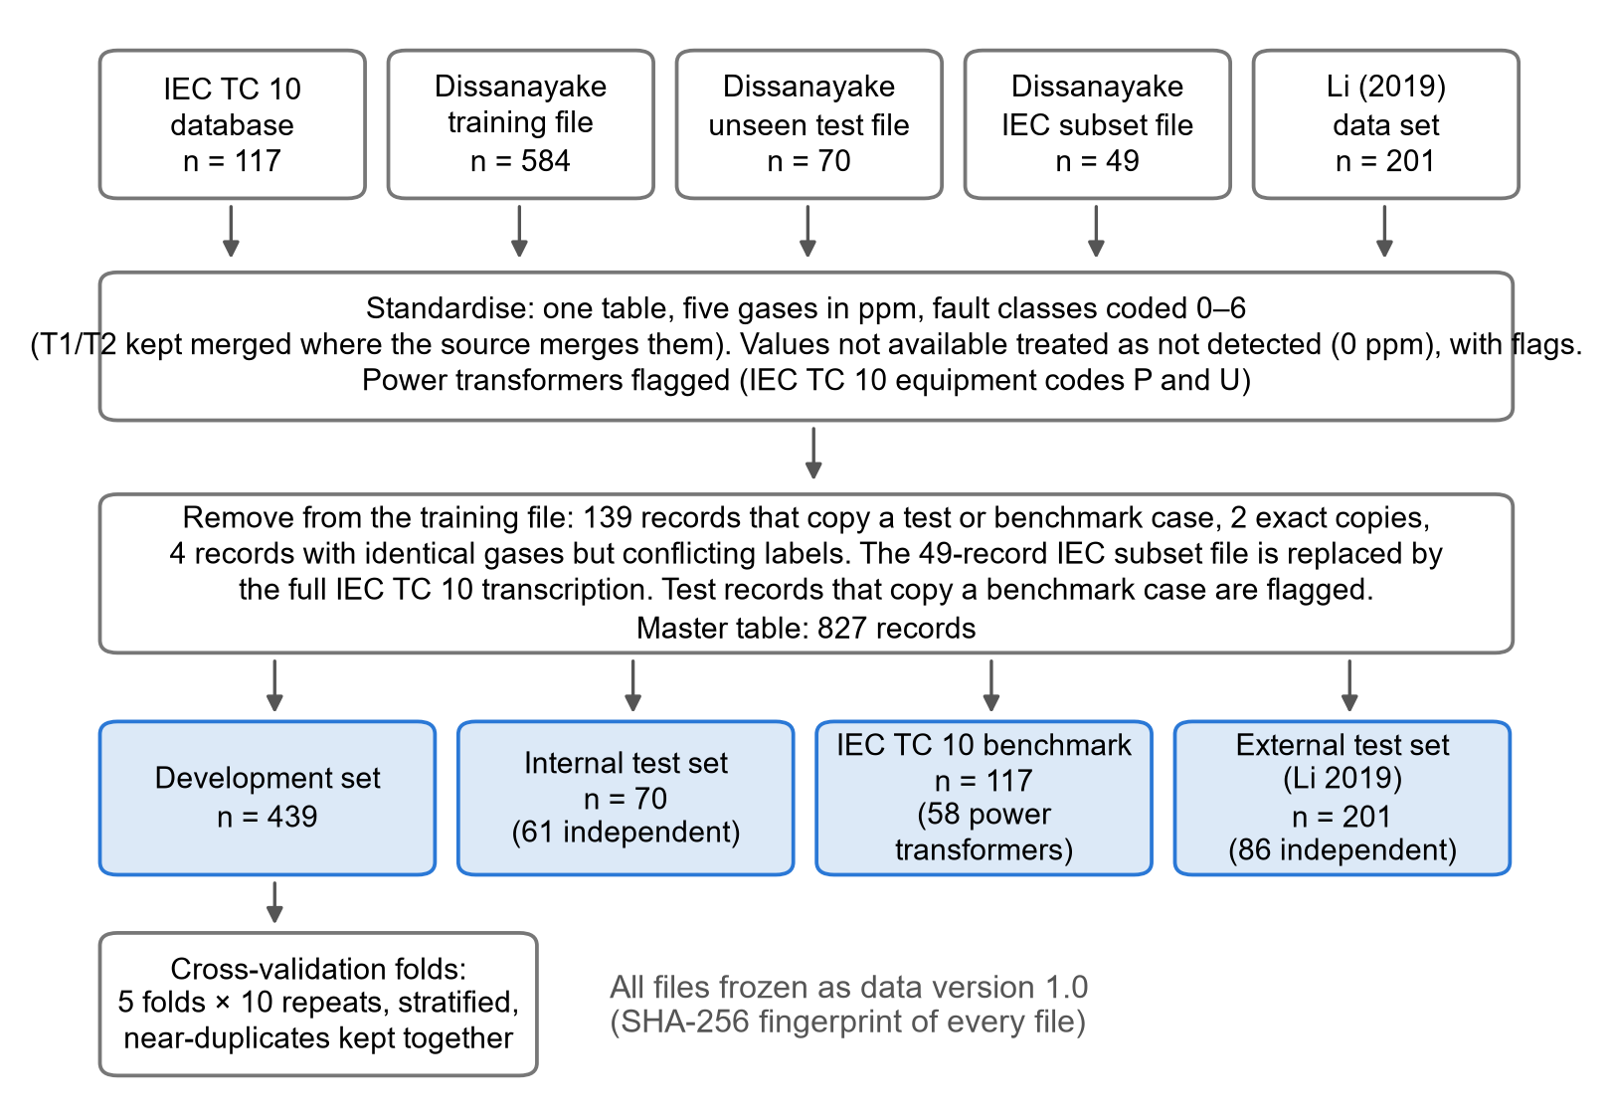
Fig. 4.1 Flow of records from the source files to the data roles

4.4 Evaluation Sets
Three primary evaluation sets were fixed before any test record was predicted:
a. Internal test set: 61 Dissanayake unseen records independent of the benchmark, with seven classes (Normal, PD, D1, D2, T1, T2, T3).
b. IEC TC 10 benchmark (main test set): the 58 power transformers, scored on five merged classes (PD, D1, D2, T1/T2, T3). A prediction of T1 or T2 counts as T1/T2, and a Normal prediction counts as wrong, because every case is a confirmed fault. All 117 cases form a sensitivity analysis.
c. External test set: 86 Li (2019) records independent of the benchmark, with six fault classes.
Together these 205 records are the test records referred to in Chapters 5 and 6.

4.5 Threats to Validity
Three threats to validity were identified in advance and are kept in view when the results are interpreted:
a. Home advantage of the conventional methods. The IEC 60599 ratio limits were refined using the IEC TC 10 cases (Duval and dePablo, 2001), so the conventional methods may perform better on the main benchmark than they would on other data.
b. Labels of unknown origin. The labels of the Dissanayake and Li data sets are not documented; results on them are supporting evidence only. It is also not documented whether the Dissanayake files contain resampled or synthetic records: the data page calls the training file class-balanced, but its class counts are unequal. This is an open point that should be put to the authors; the main benchmark does not depend on it, because it is the inspection-labelled IEC TC 10 set.
c. Small classes. The 58 benchmark power transformers include only one PD case and eight T1/T2 cases, so per-class results on the benchmark carry wide confidence intervals.

4.6 Description of the Data

4.6.1 Records per Class
Table 4.2 and Fig. 4.2 give the number of records per class in each data role. The development set contains all seven classes (Normal 75, PD 37, D1 53, D2 85, T1 80, T2 39, T3 70), and its largest class has about twice as many records as its smallest. The internal test set is balanced by design. Among the IEC TC 10 power transformers, high-energy discharges (D2) dominate and partial discharge has a single case. Because of this imbalance, macro-F1 is the primary measure and every result carries a confidence interval.
Table 4.2 Records by Data Role and Fault Class after Cleaning
Set | Normal | PD | D1 | D2 | T1 | T2 | T1/T2 | T3 | Total
Development | 75 | 37 | 53 | 85 | 80 | 39 | 0 | 70 | 439
Internal test (all) | 10 | 10 | 10 | 10 | 10 | 10 | 0 | 10 | 70
of which independent of benchmark | 10 | 7 | 7 | 8 | 10 | 10 | 0 | 9 | 61
Benchmark IEC TC 10, all equipment | 0 | 9 | 26 | 48 | 0 | 0 | 16 | 18 | 117
of which power transformers (primary) | 0 | 1 | 10 | 27 | 0 | 0 | 8 | 12 | 58
External test Li 2019 (all) | 0 | 16 | 49 | 54 | 19 | 9 | 16 | 38 | 201
of which independent of benchmark | 0 | 8 | 23 | 7 | 19 | 9 | 0 | 20 | 86
T1/T2 = merged thermal class of the IEC TC 10 tables. Removed from the development file: 139 records that leak test cases, 2 exact copies and 4 records with identical gases but conflicting labels.
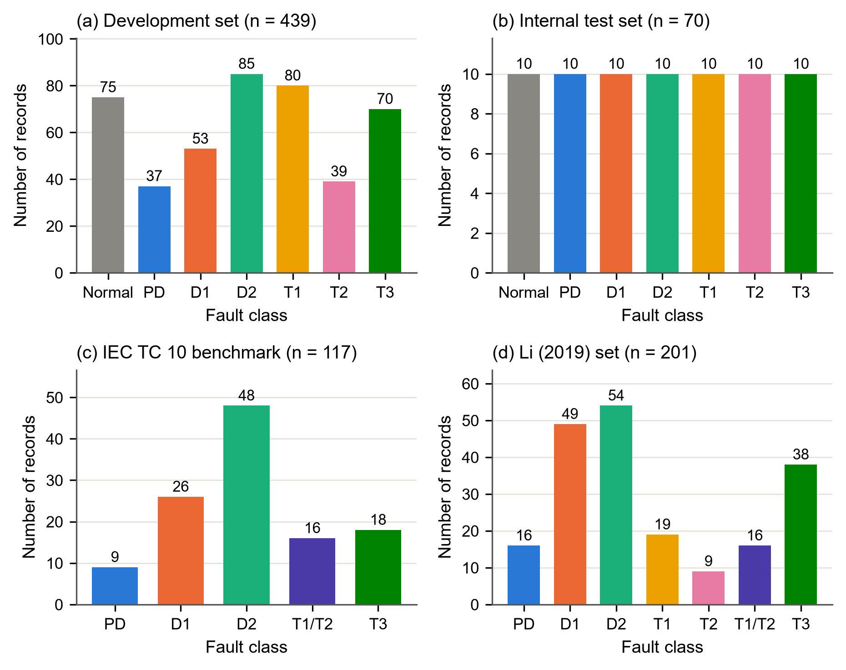
Fig. 4.2 Number of records per fault class in each data role

4.6.2 Gas Concentrations by Class
Table 4.3 and Fig. 4.3 show how the gases differ between the classes of the development set. All five gases differ significantly between the classes (Kruskal–Wallis test, p < 0.001), but by very different amounts. Acetylene separates the classes most strongly (rank epsilon-squared 0.71), followed by ethylene (0.60), ethane (0.44), hydrogen (0.38) and methane (0.35).
Table 4.3 Gas Concentrations by Fault Class, Development Set
Class | H₂ | CH₄ | C₂H₆ | C₂H₄ | C₂H₂
Normal | 7.2 (1.5–13.3) | 7.5 (4.2–14.1) | 1 (0.17–5.3) | 0.78 (0.36–1.4) | 0 (0–0)
PD | 181 (110–625) | 18.0 (6.8–53.0) | 11.6 (1–38.5) | 3.5 (0.02–9) | 0 (0–0)
D1 | 169 (111–315) | 23.3 (8–38.0) | 9 (4–27.5) | 12.7 (6.5–36.0) | 53.9 (13.0–121)
D2 | 77.0 (41.0–243) | 41.0 (18.0–127) | 16.4 (5–70.0) | 43.0 (14.0–130) | 78.0 (40.0–227)
T1 | 29.4 (13.8–95.9) | 62.5 (29.8–124) | 108 (70.2–179) | 13.3 (7–32.0) | 0 (0–0)
T2 | 37.0 (23.8–109) | 120 (60.6–278) | 81.0 (37.5–170) | 185 (72.0–352) | 0 (0–2)
T3 | 51.5 (19.5–136) | 148 (40.5–316) | 58.2 (12.0–146) | 357 (97.2–812) | 0 (0–7)
Kruskal–Wallis H | 164.5 | 153.8 | 191.0 | 263.9 | 311.3
p | 6.7e-33 | 1.2e-30 | 1.5e-38 | 4.3e-54 | 3.0e-64
ε²_{R} | 0.38 | 0.35 | 0.44 | 0.60 | 0.71
Median (first quartile–third quartile) in ppm; n = 439. ε²_{R} = rank epsilon-squared effect size.
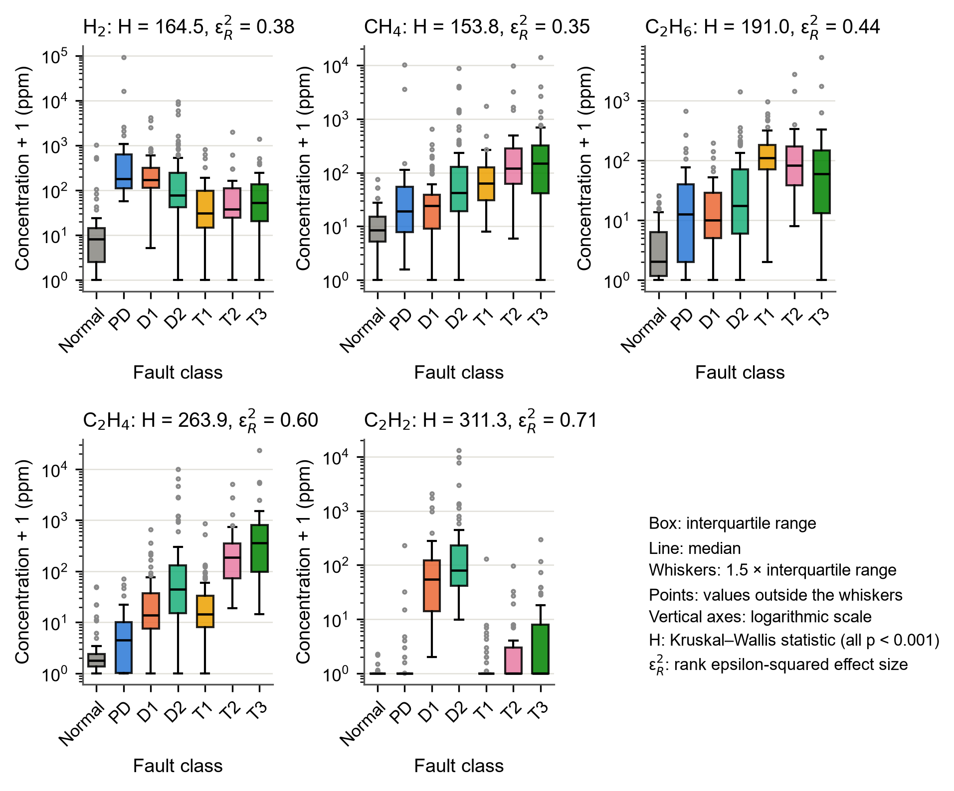
Fig. 4.3 Gas concentrations by fault class in the development set
The pattern agrees with the physics of gas formation reviewed in Chapter 2:
a. acetylene has a median of zero in every class except D1 and D2, the discharge classes, where it reaches tens to hundreds of ppm;
b. partial discharge has the highest hydrogen of all classes;
c. ethylene rises from T1 through T2 to T3 as the fault temperature increases, while ethane is highest in T1; and
d. the Normal records have the lowest concentration of every gas.
The same pattern appears in the IEC TC 10 benchmark (Appendix B).

4.6.3 Correlation between the Gases
The gases are correlated with one another (Fig. 4.4). The three hydrocarbons CH₄, C₂H₆ and C₂H₄ are the most strongly related (Spearman correlation up to 0.74), because thermal decomposition of the oil produces them together, whereas acetylene is almost unrelated to ethane. Correlated gases carry overlapping information; this matters for the explanation of the model (Chapter 5) and for the reduced-gas study (Chapter 7).
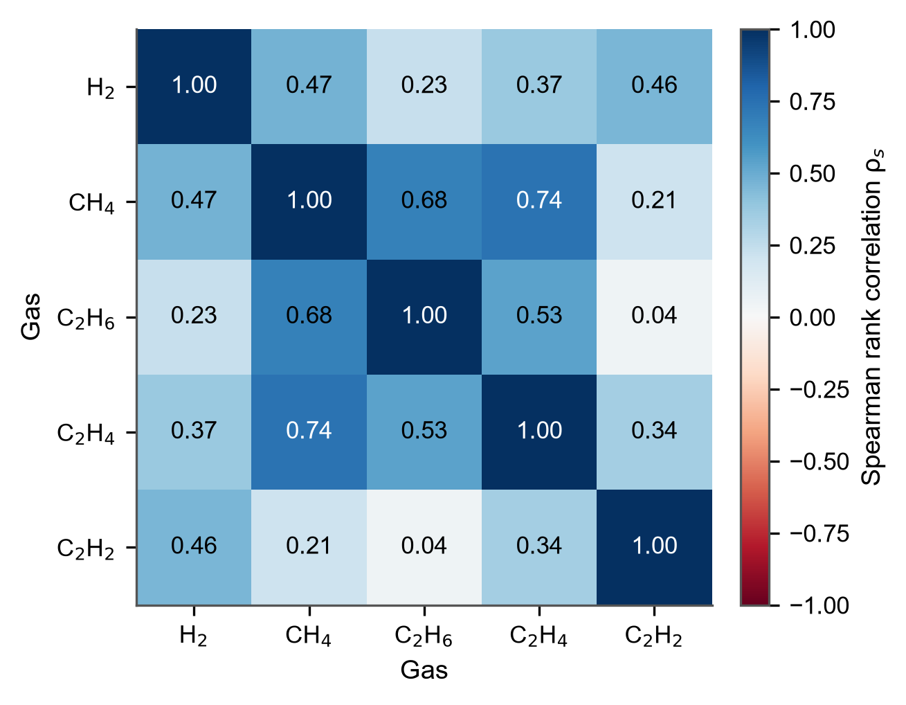
Fig. 4.4 Spearman rank correlation between the five gases, development set (n = 439)

4.6.4 The Benchmark in the Duval Triangle
Fig. 4.5 places the 117 IEC TC 10 cases in the Duval Triangle 1. Most cases lie in the zone of their inspected fault: the discharges in the D1 and D2 zones, the high-temperature thermal faults in T3 and the lower-temperature thermal faults along the right-hand edge. Many points, however, lie close to a zone boundary, especially between D1 and D2 and between the thermal zones; for such points a small change in one gas would change the diagnosis. The triangles of the other data sets are given in Appendix B.
Fig. 4.5 The 117 inspection-confirmed IEC TC 10 cases in the Duval Triangle 1, coloured by the fault found at inspection

4.7 Summary
Four published data sets were audited. Only the IEC TC 10 database has fault labels confirmed by inspection, and it became the main benchmark. The audit removed 139 development records that leaked test cases, together with exact copies and conflicting records, and flagged test records that copy benchmark cases. Values that were not available were treated as not detected. The cleaned master table of 827 records was divided into a development set of 439 records and three primary test sets of 61, 58 and 86 records, and frozen. The gas concentrations differ between the fault classes in the way gas-formation physics predicts, with acetylene and ethylene the most informative gases.

CHAPTER 5
DIAGNOSTIC PERFORMANCE OF THE CONVENTIONAL AND MACHINE-LEARNING METHODS

5.1 Introduction
This chapter reports how well each diagnostic method performs on its own. It first presents the conventional methods (Section 5.2), then the comparison of the five classifiers by cross-validation and the choice of the final model (Section 5.3 and Section 5.4), the performance of that model on the test sets (Section 5.5), and the explanation of its decisions (Section 5.6). The direct statistical comparison of the ML model with the conventional methods follows in Chapter 6.

5.2 Conventional Methods

5.2.1 Verification of the Implementation
The MATLAB implementation of the three conventional methods passed all 67 unit tests and reproduced the worked examples of the sources. The independent Python implementation gave the same answer for every method on every one of the 827 records, 2 481 answers in all, and the boundary distances of the two implementations agreed to within 10⁻⁹. The conventional answers used in the rest of this thesis can therefore be taken as a faithful application of the published rules.

5.2.2 Answers over All Records
Over all 827 records, after the normality gate, the IEC 60599 method gave no diagnosis for 200 records (24.2 %) and the Rogers method for 296 records (35.8 %). The Duval Triangle gave an answer for all but 1 record, but 22 of its answers fell in the DT zone, which has no matching fault class. The IEC method gave the dual answer D1/D2 for 83 records, and the normality gate declared 242 records Normal.

5.2.3 Performance on the Test Sets
Table 5.1 gives the results of the three methods on the three primary test sets, and Fig. 5.1 shows their confusion matrices on the main benchmark.
Table 5.1 Conventional Methods on the Three Primary Test Sets
Test set | Method | Strict accuracy [95 % CI] | Conditional accuracy [95 % CI] | Coverage | ND | DT | D1/D2 | Normal
Internal test | Rogers Ratio | 0.328 [0.223, 0.453] | 0.526 [0.373, 0.675] | 0.623 | 23 | 0 | 0 | 26
Internal test | IEC 60599 ratio | 0.475 [0.355, 0.598] | 0.659 [0.511, 0.781] | 0.721 | 17 | 0 | 1 | 24
Internal test | Duval Triangle 1 | 0.557 [0.433, 0.675] | 0.557 [0.433, 0.675] | 1.000 | 0 | 4 | 0 | 24
IEC TC 10 PT | Rogers Ratio | 0.483 [0.359, 0.608] | 0.667 [0.515, 0.790] | 0.724 | 16 | 0 | 0 | 7
IEC TC 10 PT | IEC 60599 ratio | 0.638 [0.509, 0.750] | 0.726 [0.591, 0.829] | 0.879 | 7 | 0 | 11 | 7
IEC TC 10 PT | Duval Triangle 1 | 0.776 [0.653, 0.864] | 0.776 [0.653, 0.864] | 1.000 | 0 | 1 | 0 | 7
Li 2019 | Rogers Ratio | 0.174 [0.109, 0.268] | 0.254 [0.161, 0.378] | 0.686 | 27 | 0 | 0 | 37
Li 2019 | IEC 60599 ratio | 0.302 [0.215, 0.406] | 0.382 [0.276, 0.501] | 0.791 | 18 | 0 | 4 | 37
Li 2019 | Duval Triangle 1 | 0.454 [0.352, 0.558] | 0.454 [0.352, 0.558] | 1.000 | 0 | 1 | 0 | 37
Answers after the upper normality gate. ND = no diagnosis; DT = Duval mixed thermal/electrical zone (counted wrong); D1/D2 = IEC dual answer (correct for a true D1 or D2); Normal = answers given by the gate. Wilson 95 % intervals.
Three features stand out:
a. The ratio methods often give no diagnosis. Their coverage lies between 0.623 and 0.879, whereas the Duval Triangle always answers.
b. When the ratio methods answer, they are much more often right. On the IEC TC 10 benchmark the Rogers method is correct on 0.667 of the records it diagnoses but on only 0.483 of all records.
c. The Duval Triangle is the best conventional method on every test set. On the IEC TC 10 benchmark its strict accuracy is 0.776.
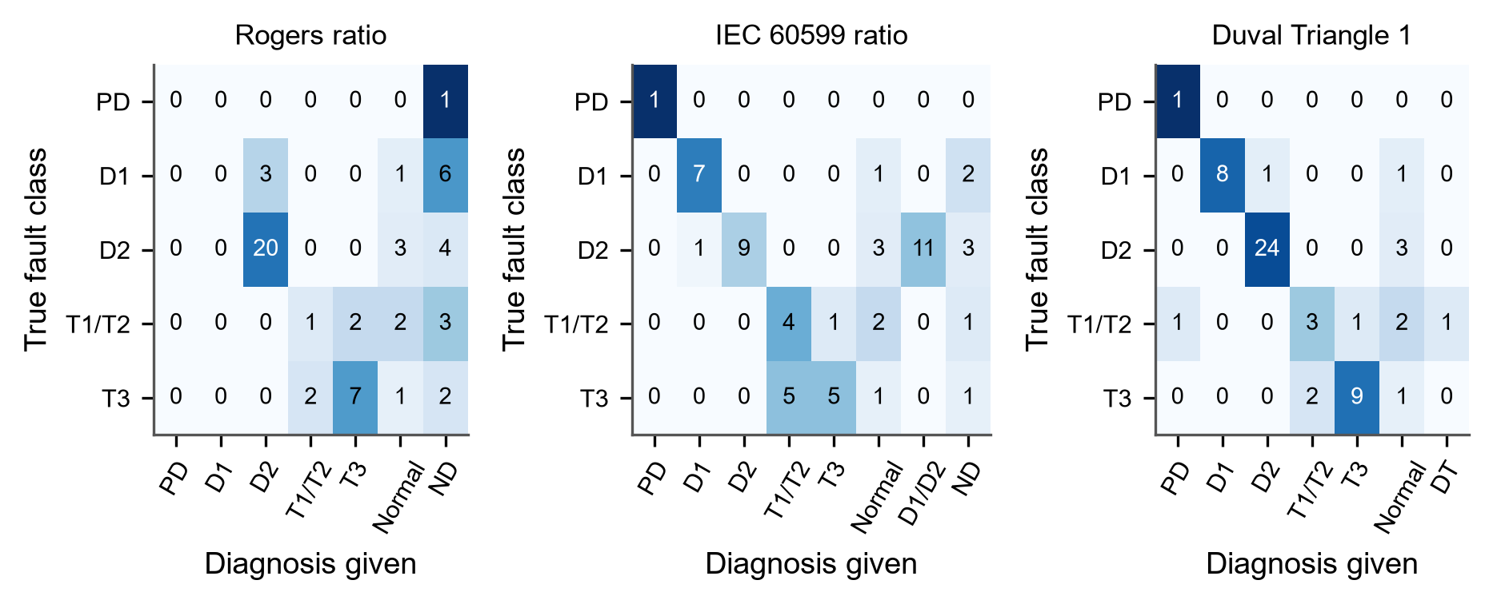
Fig. 5.1 Confusion matrices of the conventional methods on the IEC TC 10 power transformers (n = 58). Rows: fault found at inspection; columns: diagnosis given, including no diagnosis (ND), the IEC dual answer D1/D2 and the Duval DT zone; cells: number of records
The confusion matrices show where the methods fail. The Rogers method has no D1 case, so all D1 records receive another answer or none. Both ratio methods leave many discharge and thermal records undiagnosed. All three methods confuse T3 with the lower-temperature thermal class. On the internal and Li test sets (Appendix B), many fault records fall below the typical gas levels and are declared Normal by the gate.

5.2.4 Sensitivity to the Normality Gate
Table 5.2 shows how the results change when the gate is moved or removed. Without the gate the conventional methods do better on the IEC TC 10 benchmark: the strict accuracy of the Duval Triangle rises from 0.776 to 0.897 and that of IEC 60599 from 0.638 to 0.724. Every benchmark case is a confirmed fault, so a gate that declares some of them Normal can only lower the score; several inspected faults had gas levels within the typical ranges. On the internal test set, which contains Normal records, the gate is needed for the methods to recognise them. The gate with the upper ends of the typical ranges was fixed in advance as the main analysis and is kept as such; the sensitivity results are discussed with the comparison in Chapter 6.
Table 5.2 Sensitivity of the Conventional Methods to the Normality Gate and the Dual-Answer Rule
Method | Variant | Internal test | IEC TC 10 PT | Li 2019
Rogers ratio | upper gate (main) | 0.328 / 0.282 | 0.483 / 0.330 | 0.174 / 0.256
 | lower gate | 0.410 / 0.392 | 0.500 / 0.331 | 0.256 / 0.310
 | no gate | 0.361 / 0.370 | 0.534 / 0.366 | 0.256 / 0.302
IEC 60599 ratio | upper gate (main) | 0.475 / 0.501 | 0.638 / 0.731 | 0.302 / 0.436
 | lower gate | 0.541 / 0.617 | 0.655 / 0.736 | 0.442 / 0.546
 | no gate | 0.426 / 0.506 | 0.724 / 0.775 | 0.442 / 0.530
 | dual answer wrong | 0.459 / 0.463 | 0.448 / 0.602 | 0.256 / 0.354
Duval Triangle 1 | upper gate (main) | 0.557 / 0.528 | 0.776 / 0.752 | 0.453 / 0.564
 | lower gate | 0.623 / 0.616 | 0.828 / 0.788 | 0.709 / 0.701
 | no gate | 0.525 / 0.482 | 0.897 / 0.826 | 0.744 / 0.708
Each cell gives strict accuracy / macro-F1. Upper gate = Normal if every gas is at or below the upper end of its IEC 60599 typical range (main analysis); lower gate = lower end; no gate = raw answer of the method; dual answer wrong = the IEC D1/D2 answer counted as wrong.

5.3 Comparison of the Classifiers

5.3.1 Cross-Validation Results
Table 5.3 and Fig. 5.2 give the results of the nested cross-validation on the 439 development records. Every classifier was far better than the majority baseline (macro-F1 0.046). Three findings stand out:
a. Engineered features help. For every classifier, the ratio-based feature sets F3 or F4 gave a higher mean macro-F1 than the log-gas concentrations (F1) or the gas shares (F2).
b. Tree ensembles perform best. The best pipeline was the random forest on F4 (macro-F1 0.850 ± 0.038), followed by XGBoost on F4 (0.842) and on F3 (0.833).
c. The simple model is close behind. Logistic regression on F3 reached 0.821, less than 0.03 below the best pipeline.
Table 5.3 Nested Cross-Validation Macro-F1 of the Classifiers (Mean ± SD over 50 Outer Folds)
Model | F1 | F2 | F3 | F4 | Average rank (F4)
Random Forest | 0.773 ± 0.049 | 0.805 ± 0.041 | 0.824 ± 0.036 | 0.850 ± 0.038 | 1.76
XGBoost | 0.771 ± 0.049 | 0.788 ± 0.041 | 0.833 ± 0.041 | 0.842 ± 0.039 | 2.28
Logistic regression | 0.807 ± 0.035 | 0.742 ± 0.044 | 0.821 ± 0.038 | 0.820 ± 0.039 | 3.42
SVM (RBF) | 0.804 ± 0.035 | 0.794 ± 0.037 | 0.810 ± 0.041 | 0.819 ± 0.038 | 3.50
MLP neural network | 0.793 ± 0.044 | 0.765 ± 0.032 | 0.795 ± 0.044 | 0.805 ± 0.040 | 4.04
Majority-class baseline | 0.046 ± 0.000 | 0.046 ± 0.000 | 0.046 ± 0.000 | 0.046 ± 0.000 | 6.00
Development set, n = 439; 5 folds × 10 repeats. Rank 1 = best (Friedman ranks on F4; critical difference 1.066).
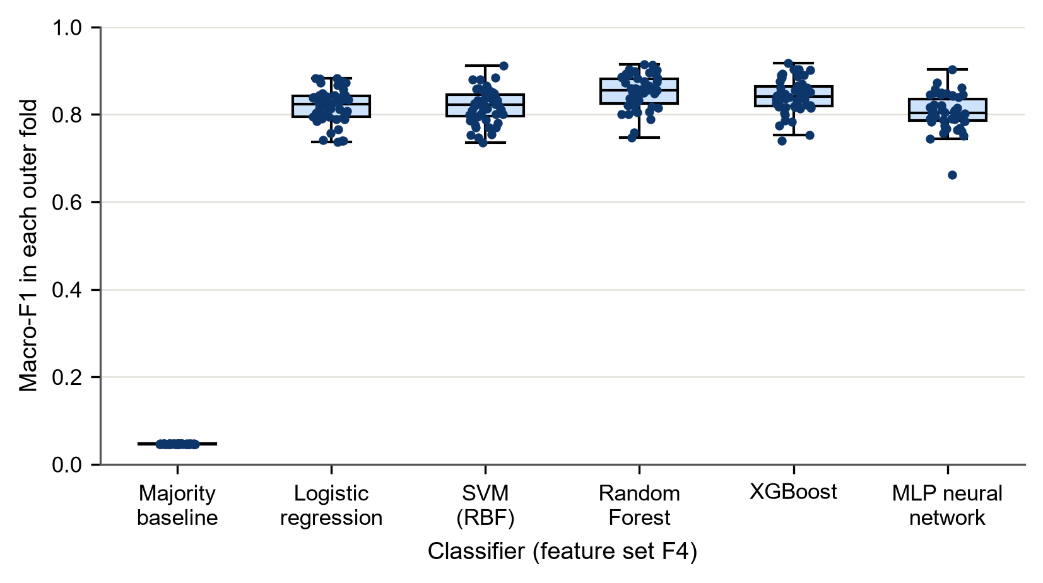
Fig. 5.2 Macro-F1 of the six models on feature set F4 in each of the 50 outer cross-validation folds; boxes show the median and interquartile range, dots the individual folds
The per-class results (Appendix B) show that D1 and T2 were the hardest classes for every classifier (random forest F1 0.78 and 0.76), while T3 and Normal were the easiest (0.94 and 0.90). D1 is easily confused with D2 and PD, and T2 lies between T1 and T3.

5.3.2 Rank Comparison
The Friedman test showed that the six models on F4 differ in their ranks over the 50 folds (χ² = 158.1, p < 0.001). Fig. 5.3 shows the average ranks with the Nemenyi critical difference of 1.066. The random forest (average rank 1.76) and XGBoost (2.28) form the top group and cannot be told apart; both rank significantly better than logistic regression (3.42), the SVM (3.50), the MLP (4.04) and the baseline. Because the folds share training data, these rank tests are descriptive support only.
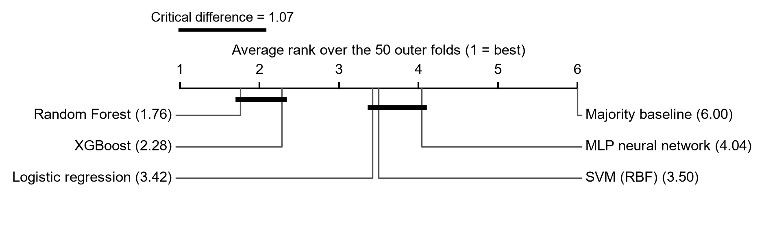
Fig. 5.3 Critical-difference diagram of the six models on F4: models joined by a thick bar do not differ significantly (Nemenyi test, α = 0.05)

5.4 Selection of the Final Model
The written selection rule (Chapter 3) compared the best pipeline, the random forest on F4, with the second best, XGBoost on F4. The corrected resampled t-test gave a mean difference of 0.0077 in macro-F1, t = 0.497, p = 0.621. The difference is not significant, and the random forest is the simpler of the two model families, so the random forest on feature set F4 was selected. Seven other pipelines were also not significantly worse than the best (same test, without correction for multiple comparisons), among them logistic regression on F3; the advantage of complex models on these data is therefore small. The final model was tuned on all development records, which gave 500 trees without a depth limit and a minimum leaf size of one record, and was saved before any test record was predicted.

5.5 Performance of the Final Model on the Test Sets
Table 5.4 gives the performance of the final model on the test sets, including the sensitivity sets. On the internal test set, which comes from the same source as the development data, the macro-F1 of 0.812 is close to the cross-validation estimate. On the IEC TC 10 power transformers it is 0.731, and on the independent Li (2019) records it is 0.595. The drop from the internal to the external sources shows that a model trained on one source loses part of its performance on data collected elsewhere, which is why independent test sets are essential.
Table 5.4 Performance of the Final Model on the Test Sets
Test set | n | Classes | Macro-F1 | Acc. | Bal. acc. | Kappa | MCC
Internal test (independent records) | 61 | Normal, PD, D1, D2, T1, T2, T3 | 0.812 | 0.820 | 0.816 | 0.790 | 0.792
Internal test (all records) * | 70 | Normal, PD, D1, D2, T1, T2, T3 | 0.831 | 0.829 | 0.829 | 0.800 | 0.802
IEC TC 10 (power transformers) | 58 | PD, D1, D2, T1/T2, T3 | 0.731 | 0.724 | 0.726 | 0.597 | 0.603
IEC TC 10 (all equipment) * | 117 | PD, D1, D2, T1/T2, T3 | 0.745 | 0.761 | 0.733 | 0.667 | 0.673
Li 2019 (independent records) | 86 | PD, D1, D2, T1, T2, T3 | 0.595 | 0.628 | 0.587 | 0.547 | 0.554
Li 2019 (all, merged classes) * | 201 | PD, D1, D2, T1/T2, T3 | 0.714 | 0.711 | 0.703 | 0.632 | 0.637
* sensitivity analysis. Acc. = accuracy; Bal. acc. = balanced accuracy. The test records were predicted once, after the model had been chosen.
The confusion matrices (Fig. 5.4) show where the errors lie. On the internal test set the errors are few and spread thinly, mainly between PD and D1 and between D1 and D2. On the IEC TC 10 benchmark the main errors are T3 cases diagnosed as T1/T2 (5 of 12) and confusions between D1 and D2 (6 records). On the Li set the model confuses PD with T1 and the thermal classes with one another.
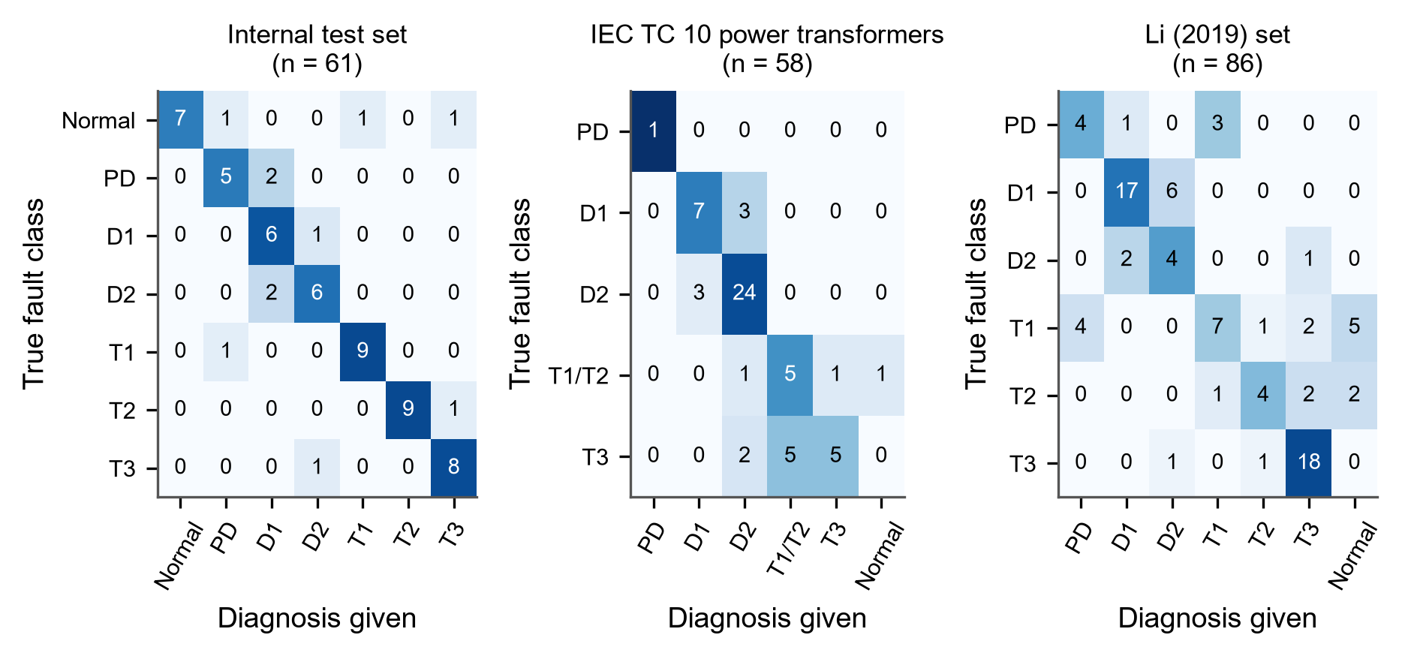
Fig. 5.4 Confusion matrices of the final model on the three primary test sets

5.6 Explaining the Model

5.6.1 Which Gases Matter
At the level of whole gases (Fig. 5.5 a), shuffling C₂H₄ caused the largest drop in macro-F1 on the internal test set (0.360), followed by C₂H₂, H₂ and C₂H₆, while CH₄ mattered least. On the IEC TC 10 benchmark the order was C₂H₂, H₂, C₂H₄, CH₄, C₂H₆; shuffling C₂H₆ there even slightly improved the score, which suggests that the way the model uses ethane, learned from the development data, does not transfer well to these cases. At the level of single features (Fig. 5.5 b) the importances are small and their intervals include zero, because the information of each gas is shared by several correlated features (Section 4.6); this is why the gas-level ranking is the main one.
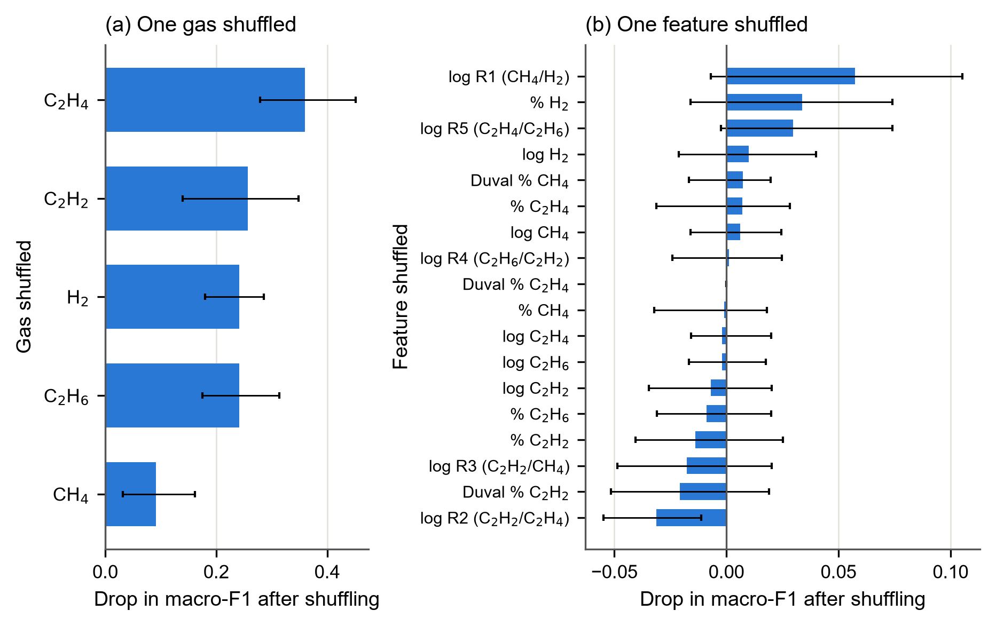
Fig. 5.5 Permutation importance of the final model on the internal test set (n = 61): (a) whole gases shuffled, (b) single features shuffled; bars show the mean drop over 30 shuffles with its 2.5–97.5 % range

5.6.2 How the Features Push Each Class
The SHAP summary (Fig. 5.6) shows how each feature pushes the probability of each class. The model's reasoning agrees with gas-formation physics (Table 5.5): for each of the six fault classes, at least one of the three most important features involves the key gas that was written down in advance (6 of 6 classes). High shares of C₂H₂ push the model towards D1 and D2; a low CH₄/H₂ ratio and a high hydrogen share push it towards PD; and a high C₂H₄/C₂H₆ ratio pushes it towards T2 and T3. The ranking of the features on the test records agreed closely with that on the development records (Spearman correlation 0.96), so the model reasons in the same way on new data.
Table 5.5 Agreement of the Model's Explanations with the Expected Key Gases
Fault class | Expected key gas | Three most important features (SHAP) | Consistent
PD | H₂ | log R1 (CH₄/H₂); log H₂; % H₂ | yes
D1 | C₂H₂ | Duval % C₂H₂; % C₂H₂; log R1 (CH₄/H₂) | yes
D2 | C₂H₂ | Duval % C₂H₂; % C₂H₂; log C₂H₂ | yes
T1 | C₂H₆ or CH₄ | log R1 (CH₄/H₂); log R5 (C₂H₄/C₂H₆); log R4 (C₂H₆/C₂H₂) | yes
T2 | C₂H₄ or CH₄ | log R5 (C₂H₄/C₂H₆); % C₂H₄; log C₂H₄ | yes
T3 | C₂H₄ | log R5 (C₂H₄/C₂H₆); % C₂H₄; log R2 (C₂H₂/C₂H₄) | yes
Expected key gases written down before the explanations were computed (Section 3.4.8).
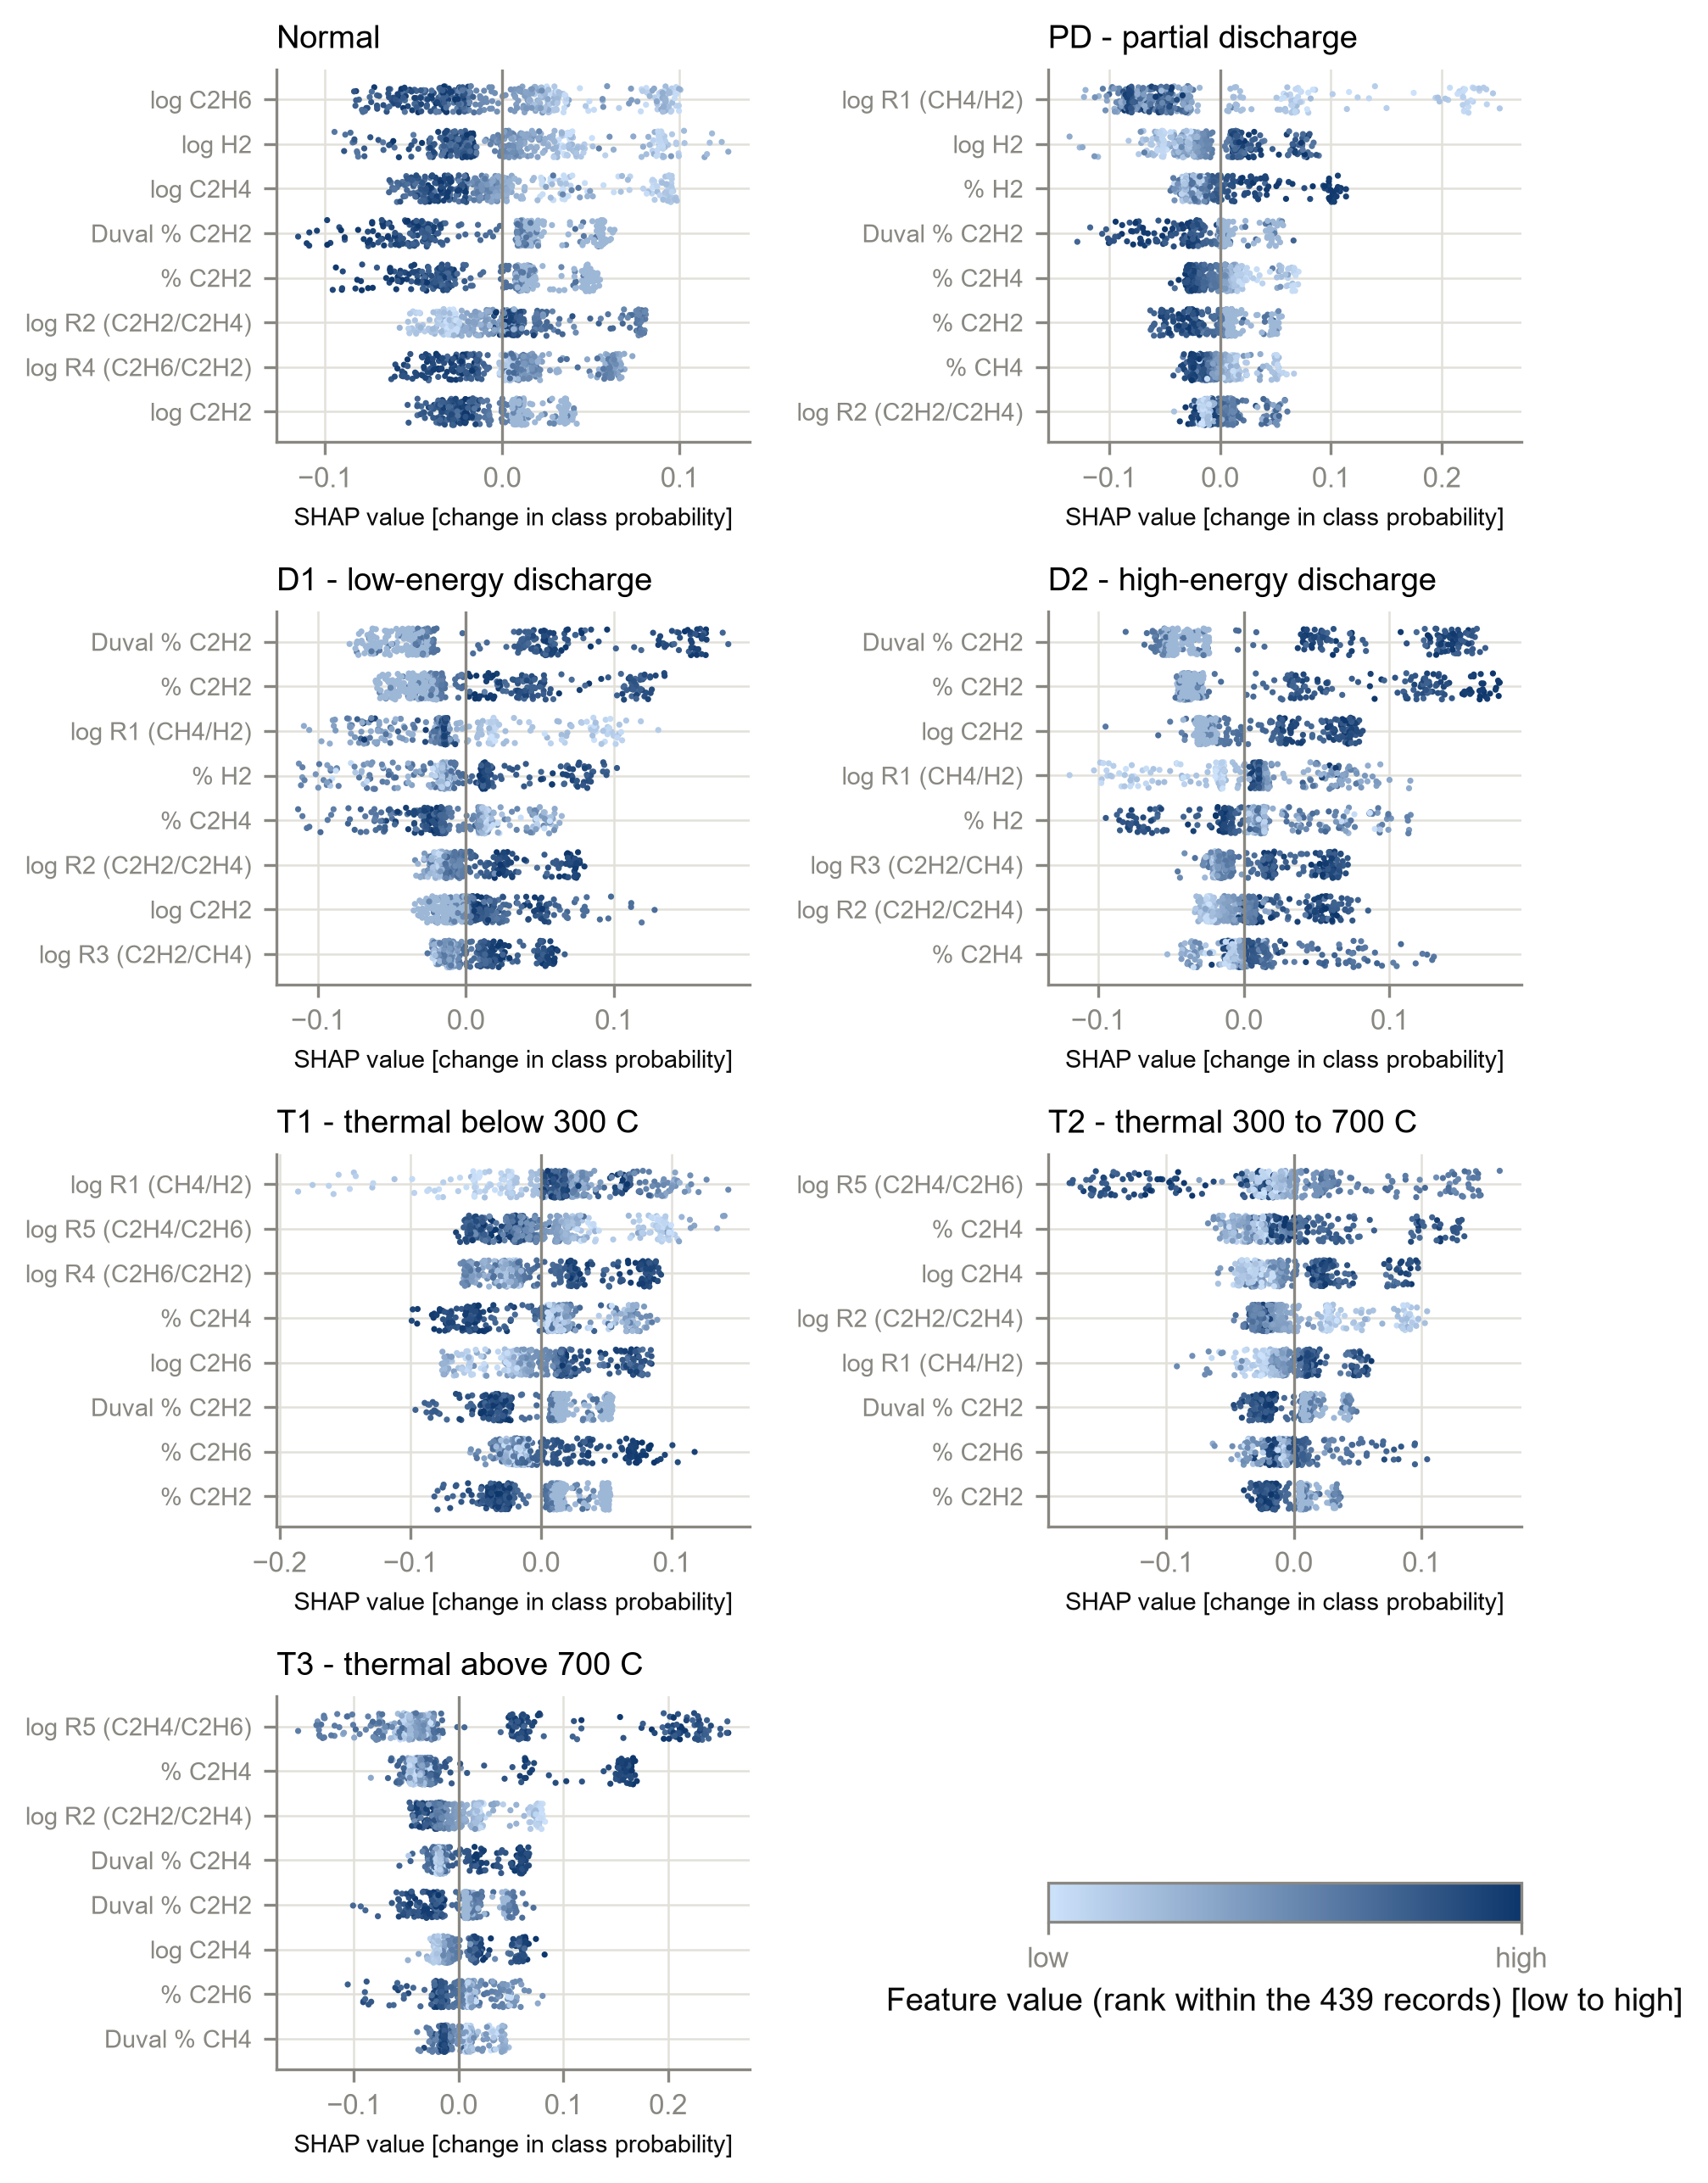
Fig. 5.6 SHAP summary of the final model for each class (development records): each point is one record; its position shows how much the feature raised or lowered the probability of the class, and its colour the feature's own value

5.7 Discussion
The conventional methods behave as the literature describes (Chapter 2): the ratio methods leave many samples without a diagnosis, and the Duval Triangle answers every sample and is the most accurate of the three (Ekojono et al., 2022; Suwarno et al., 2024). Their high conditional accuracy shows that the problem of the ratio methods is mainly coverage, not reliability: when they answer, they are usually right.
The cross-validation macro-F1 of 0.850 is lower than the accuracies above 95 % reported in many studies (Das et al., 2023; Hechifa et al., 2024; Adekunle et al., 2025). Three features of this study explain much of the difference. Macro-F1 over seven classes gives the small and difficult classes D1 and T2 the same weight as the easy ones, whereas accuracy rewards the large classes. Leakage was removed: 139 development records that copied test or benchmark cases were deleted and near-duplicates were kept in one fold. Finally, the test sets were predicted only once, after the model had been chosen. Studies that test on independent data or under a strict protocol also report lower figures (Hechifa et al., 2024; Nkwambe and Thango, 2026), in line with the warning of Kapoor and Narayanan (2023) that leakage inflates reported performance.
The selection of a random forest, with XGBoost statistically indistinguishable, agrees with the literature, in which tree ensembles perform best on DGA data (Rao et al., 2021; Adekunle et al., 2025; Doğan et al., 2026). That logistic regression on gas ratios came within 0.03 of the best model is less often reported; it supports the finding of Chen and Zhang (2025) that more complex models add little on DGA data and shows the value of a simple baseline. The benefit of the ratio features agrees with Hechifa et al. (2024) and Taha, Ibrahim and Mansour (2021). Finally, the agreement of the explanations with gas-formation physics is evidence that the model has learned genuine fault signatures rather than artefacts of the data, which is a precondition for engineers to trust it.

5.8 Summary
The conventional methods were implemented faithfully, with identical answers from two independent implementations. The IEC 60599 and Rogers methods left 24.2 % and 35.8 % of all records without a diagnosis, and the Duval Triangle was the best conventional method. Among the classifiers, the random forest and XGBoost on the full feature set performed best in cross-validation, and the random forest on F4 was selected by the written rule. On the test sets it reached macro-F1 0.812 (internal), 0.731 (IEC TC 10) and 0.595 (Li 2019). Its explanations agree with the known key gases of each fault. Chapter 6 now compares the model and the conventional methods statistically on the same records.

CHAPTER 6
STATISTICAL COMPARISON AND DISAGREEMENT ANALYSIS

6.1 Introduction
This chapter answers the first two research questions: how the accuracy of the machine-learning model compares with that of the conventional methods on the same records, and where and why the two disagree. It presents the main comparison with confidence intervals (Section 6.2), the paired significance tests (Section 6.3), the sensitivity analyses (Section 6.4), the agreement between the methods (Section 6.5) and the boundary analysis (Section 6.6), and then judges the research hypothesis against the three criteria fixed in advance (Section 6.7). The chapter ends with a discussion of the findings against the literature.

6.2 Main Comparison
Table 6.1 compares the ML model with the three conventional methods on the same records of each primary test set, and Fig. 6.1 to Fig. 6.3 show the same results graphically.
Table 6.1 Machine Learning versus the Conventional Methods on the Same Records
Test set | Method | Strict accuracy [95 % CI] | Conditional accuracy | Coverage | Macro-F1 [95 % CI]
Internal test (n = 61) | ML (Random Forest, F4) | 0.820 [0.705, 0.896] | 0.820 | 1.000 | 0.812 [0.711, 0.900]
 | Rogers ratio | 0.328 [0.223, 0.453] | 0.526 | 0.623 | 0.282 [0.190, 0.362]
 | IEC 60599 ratio | 0.475 [0.355, 0.598] | 0.659 | 0.721 | 0.501 [0.359, 0.607]
 | Duval Triangle 1 | 0.557 [0.433, 0.675] | 0.557 | 1.000 | 0.528 [0.414, 0.621]
IEC TC 10 power transformers (n = 58) | ML (Random Forest, F4) | 0.724 [0.598, 0.823] | 0.724 | 1.000 | 0.731 [0.611, 0.827]
 | Rogers ratio | 0.483 [0.359, 0.608] | 0.667 | 0.724 | 0.330 [0.248, 0.411]
 | IEC 60599 ratio | 0.638 [0.509, 0.750] | 0.726 | 0.879 | 0.731 [0.616, 0.820]
 | Duval Triangle 1 | 0.776 [0.653, 0.864] | 0.776 | 1.000 | 0.752 [0.626, 0.891]
Li 2019 (n = 86) | ML (Random Forest, F4) | 0.628 [0.522, 0.723] | 0.628 | 1.000 | 0.595 [0.480, 0.700]
 | Rogers ratio | 0.174 [0.109, 0.268] | 0.254 | 0.686 | 0.256 [0.160, 0.341]
 | IEC 60599 ratio | 0.302 [0.215, 0.406] | 0.382 | 0.791 | 0.436 [0.307, 0.539]
 | Duval Triangle 1 | 0.454 [0.352, 0.558] | 0.454 | 1.000 | 0.564 [0.447, 0.659]
Strict accuracy counts every no-diagnosis as wrong; conditional accuracy uses only the records that received a diagnosis. Wilson intervals for accuracy, stratified bootstrap (B = 2 000) for macro-F1. IEC TC 10 results carry the home-advantage caveat (Section 4.5).
a. Internal test set. The ML model was clearly the most accurate: strict accuracy 0.820 [0.705, 0.896] and macro-F1 0.812, against 0.557 and 0.528 for the best conventional method, the Duval Triangle.
b. IEC TC 10 benchmark. The ML model's strict accuracy of 0.724 [0.598, 0.823] lay between that of IEC 60599 (0.638) and that of the Duval Triangle (0.776). Its macro-F1 (0.731) was close to those of IEC 60599 (0.731) and Duval (0.752), and the confidence intervals of the three overlap widely. Only the Rogers method was clearly worse.
c. Li (2019) set. The ML model again led, with strict accuracy 0.628 against 0.454 for the Duval Triangle.
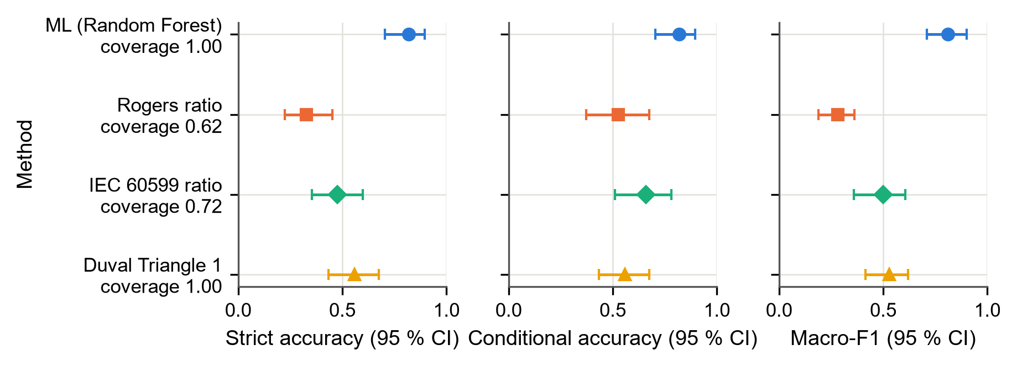
Fig. 6.1 Strict accuracy, conditional accuracy and macro-F1 with 95 % confidence intervals on the internal test set (n = 61); the coverage of each method is given below its name
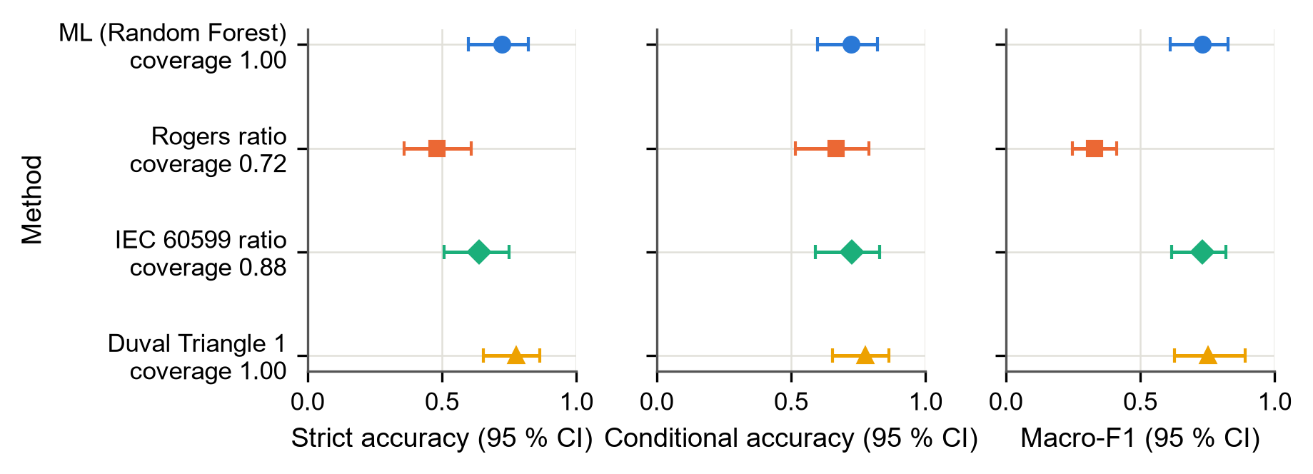
Fig. 6.2 Main comparison on the IEC TC 10 power transformers (n = 58), the main benchmark
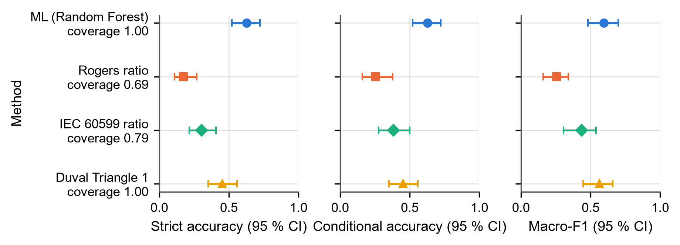
Fig. 6.3 Main comparison on the Li (2019) set (n = 86)
The gap between the strict and the conditional panels shows how much the no-diagnosis cases cost each ratio method. The ML model and the Duval Triangle always answer, so their two accuracies are equal.
Fig. 6.4 breaks the comparison down by fault class. On the internal test set the ML model has the highest F1-score in almost every class, and it is the only method that recognises partial discharge reliably. On the IEC TC 10 benchmark the picture is mixed: the Duval Triangle is best for D1, D2 and T3, while the ML model and IEC 60599 are best for the single PD case. On the Li set the ML model is best for D1 and T3 but not for D2. The per-class intervals are wide, because several classes have fewer than ten records.
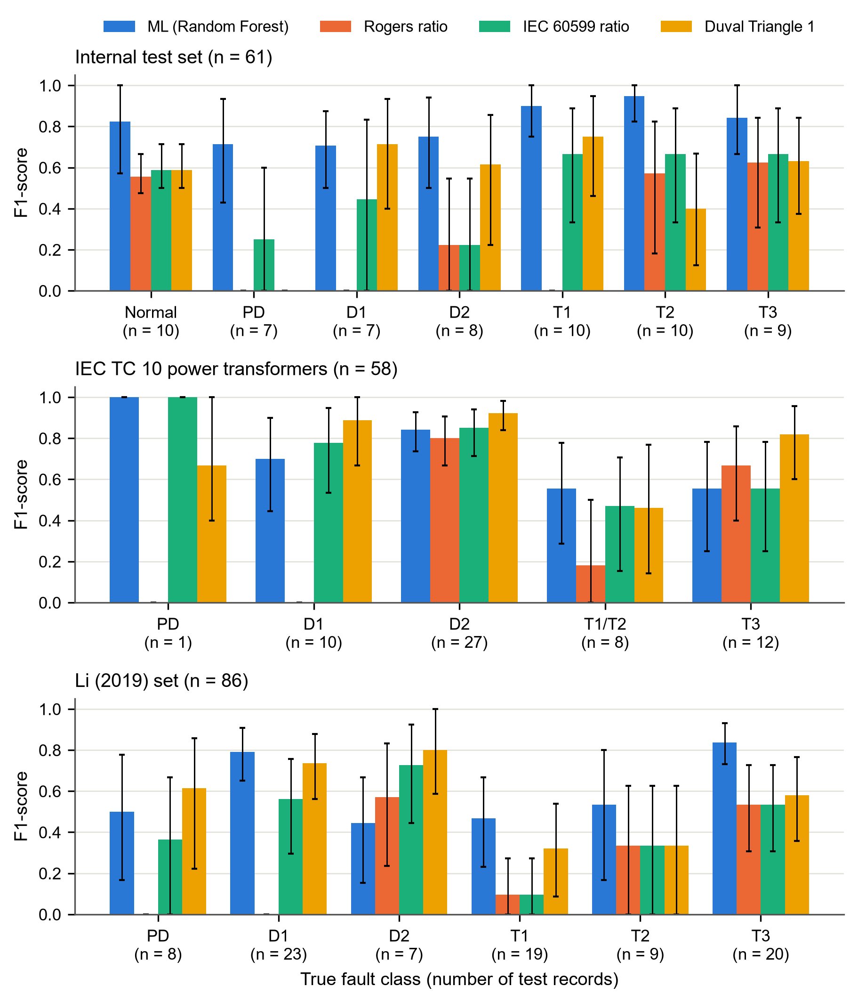
Fig. 6.4 F1-score per fault class for the four methods on the three primary test sets, with 95 % bootstrap intervals; n = number of test records of the class

6.3 Paired Significance Tests
Because all methods were applied to the same records, they were compared with paired tests. Cochran's Q test showed that the four methods differ in accuracy on every primary test set (internal test Q = 42.2; IEC TC 10 Q = 21.7; Li 2019 Q = 57.2; all p < 0.001). Table 6.2 gives the pairwise McNemar tests of the ML model against each conventional method.
Table 6.2 Paired Tests of the ML Model against Each Conventional Method
Test set (Cochran's Q, p) | Comparison | b | c | Test | p | p (Holm) | Odds ratio b/c [95 % CI]
Internal test (n = 61); Q = 42.2, p < 0.001 | ML vs Rogers Ratio | 33 | 3 | χ² (cc) | < 0.001 | < 0.001 | 11.00 [3.37, 35.87]
 | ML vs IEC 60599 ratio | 24 | 3 | χ² (cc) | < 0.001 | < 0.001 | 8.00 [2.41, 26.57]
 | ML vs Duval Triangle 1 | 22 | 6 | χ² (cc) | 0.0046 | 0.0046 | 3.67 [1.49, 9.04]
IEC TC 10 power transformers (n = 58); Q = 21.7, p < 0.001 | ML vs Rogers Ratio | 17 | 3 | exact | 0.0026 | 0.0077 | 5.67 [1.66, 19.34]
 | ML vs IEC 60599 ratio | 8 | 3 | exact | 0.2266 | 0.4531 | 2.67 [0.71, 10.05]
 | ML vs Duval Triangle 1 | 6 | 9 | exact | 0.6072 | 0.6072 | 0.67 [0.24, 1.87]
Li 2019 (n = 86); Q = 57.2, p < 0.001 | ML vs Rogers Ratio | 41 | 2 | χ² (cc) | < 0.001 | < 0.001 | 20.50 [4.96, 84.75]
 | ML vs IEC 60599 ratio | 30 | 2 | χ² (cc) | < 0.001 | < 0.001 | 15.00 [3.58, 62.77]
 | ML vs Duval Triangle 1 | 29 | 14 | χ² (cc) | 0.0328 | 0.0328 | 2.07 [1.09, 3.92]
b = records ML diagnosed correctly and the method did not; c = the reverse (strict scoring, ND wrong). cc = continuity-corrected McNemar; exact = binomial test used when b + c < 25. Holm adjustment within each test set (m = 3).
a. Internal test set. The ML model was significantly more accurate than all three methods after Holm adjustment. Against the Duval Triangle it was right on 22 records on which Duval was wrong, against 6 the other way (adjusted p = 0.005).
b. Li (2019) set. The ML model was again significantly more accurate than all three methods; against Duval the adjusted p-value was 0.033.
c. IEC TC 10 benchmark. The ML model was significantly more accurate than the Rogers method (b = 17, c = 3, adjusted p = 0.008), but not than IEC 60599 (adjusted p = 0.453). Against the Duval Triangle the difference went the other way: Duval was right on 9 records on which ML was wrong, against 6 the other way, but this difference was not significant either (adjusted p = 0.607).

6.4 Sensitivity Analyses
Two sensitivity analyses test whether these conclusions depend on choices made in the main analysis.
Normality gate. Without the gate (Table 5.2 in Chapter 5) the conventional methods do better on the IEC TC 10 benchmark, because the gate declares some inspected faults Normal. The Duval Triangle then reaches a strict accuracy of 0.897, higher than the ML model's 0.724. The conclusion on the benchmark, that ML is not more accurate than the best conventional method, therefore holds even more strongly without the gate. On the internal test set, which contains Normal records, removing the gate makes the conventional methods worse.
Full test sets. Table 6.3 repeats the comparison on the full test sets, including the records that copy benchmark cases and, for IEC TC 10, all equipment types. The ranking is unchanged: on all 117 IEC TC 10 cases the Duval Triangle (strict accuracy 0.795) is again ahead of the ML model (0.761), and on the other two sets the ML model leads.
Table 6.3 Results on the Full Test Sets, Including Records that Copy Benchmark Cases
Test set | Method | Strict accuracy [95 % CI] | Coverage | Macro-F1 [95 % CI]
Internal test, all 70 | ML (Random Forest, F4) | 0.829 [0.724, 0.899] | 1.000 | 0.831 [0.737, 0.915]
 | Rogers ratio | 0.343 [0.242, 0.460] | 0.600 | 0.348 [0.244, 0.439]
 | IEC 60599 ratio | 0.514 [0.400, 0.628] | 0.729 | 0.584 [0.453, 0.684]
 | Duval Triangle 1 | 0.600 [0.483, 0.707] | 1.000 | 0.610 [0.491, 0.711]
IEC TC 10, all 117 | ML (Random Forest, F4) | 0.761 [0.676, 0.829] | 1.000 | 0.745 [0.650, 0.823]
 | Rogers ratio | 0.436 [0.349, 0.526] | 0.641 | 0.396 [0.306, 0.490]
 | IEC 60599 ratio | 0.632 [0.542, 0.714] | 0.795 | 0.678 [0.573, 0.767]
 | Duval Triangle 1 | 0.795 [0.713, 0.858] | 1.000 | 0.799 [0.716, 0.871]
Li 2019, all 201 | ML (Random Forest, F4) | 0.711 [0.645, 0.770] | 1.000 | 0.714 [0.644, 0.776]
 | Rogers ratio | 0.338 [0.276, 0.406] | 0.657 | 0.355 [0.294, 0.413]
 | IEC 60599 ratio | 0.502 [0.434, 0.571] | 0.791 | 0.587 [0.507, 0.654]
 | Duval Triangle 1 | 0.667 [0.599, 0.728] | 1.000 | 0.727 [0.659, 0.786]
Sensitivity analysis. The IEC TC 10 set includes all equipment types; the IEC TC 10 and Li sets are scored on merged classes (T1 and T2 as T1/T2).

6.5 Agreement between the Methods
Table 6.4 and Fig. 6.5 give Cohen's kappa between every pair of methods and between each method and the true class.
Table 6.4 Cohen's Kappa between the Methods and the True Label
Pair | Internal test | IEC TC 10 PT | Li 2019
True label – ML (Random Forest, F4) | 0.79 | 0.60 | 0.55
True label – Rogers ratio | 0.25 | 0.33 | 0.14
True label – IEC 60599 ratio | 0.41 | 0.53 | 0.25
True label – Duval Triangle 1 | 0.48 | 0.69 | 0.39
ML (Random Forest, F4) – Rogers ratio | 0.23 | 0.35 | 0.21
ML (Random Forest, F4) – IEC 60599 ratio | 0.38 | 0.64 | 0.35
ML (Random Forest, F4) – Duval Triangle 1 | 0.38 | 0.54 | 0.31
Rogers ratio – IEC 60599 ratio | 0.75 | 0.67 | 0.73
Rogers ratio – Duval Triangle 1 | 0.43 | 0.47 | 0.51
IEC 60599 ratio – Duval Triangle 1 | 0.51 | 0.69 | 0.62

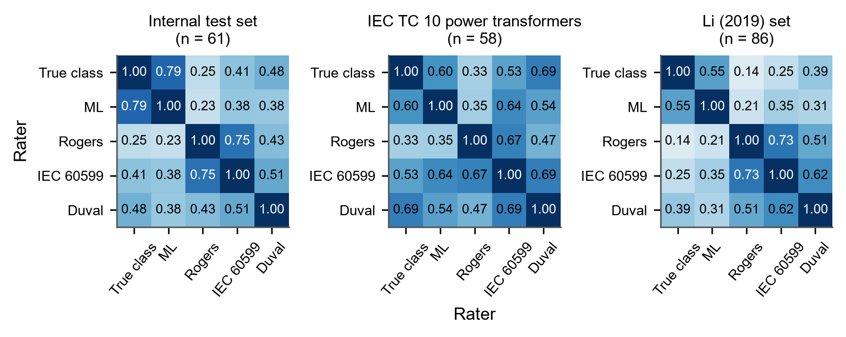
Fig. 6.5 Cohen's kappa between the true class and the four methods on the three primary test sets (1 = perfect agreement, 0 = agreement expected by chance)
Three patterns appear:
a. Agreement with the truth. The ML model agrees best with the true class on the internal and Li sets (kappa 0.79 and 0.55), but on the IEC TC 10 benchmark the Duval Triangle agrees better (0.69) than the ML model (0.60).
b. Agreement among the ratio methods. The Rogers and IEC 60599 methods agree strongly with each other (kappa 0.75 on the internal test set), as expected from two methods that use the same three ratios.
c. Agreement between ML and the conventional methods. The ML model agrees only fairly to moderately with each conventional method (for example 0.23 with Rogers and 0.38 with IEC 60599 on the internal test set). The ML model and the conventional methods therefore reach their answers in different ways, and showing both gives the engineer information that neither gives alone.

6.6 Is Disagreement Concentrated near the Decision Boundaries?
Table 6.5 gives the logistic regression of disagreement on the standardised boundary distance for the 205 pooled test records, and Fig. 6.6 shows the fitted curves.
Table 6.5 Logistic Regression of ML–Method Disagreement on Standardised Boundary Distance
Method | Answers | n (excluded) | Disagreements | β₁ | Odds ratio per SD [95 % CI] | p
Rogers Ratio | with gate | 204 (1) | 133 | -0.222 | 0.80 [0.60, 1.07] | 0.137
IEC 60599 ratio | with gate | 204 (1) | 97 | 0.010 | 1.01 [0.77, 1.33] | 0.945
Duval Triangle 1 | with gate | 205 (0) | 103 | -0.197 | 0.82 [0.62, 1.08] | 0.164
Rogers Ratio | raw (no gate) | 204 (1) | 121 | -0.161 | 0.85 [0.64, 1.13] | 0.268
IEC 60599 ratio | raw (no gate) | 204 (1) | 87 | -0.026 | 0.97 [0.74, 1.29] | 0.858
Duval Triangle 1 | raw (no gate) | 205 (0) | 77 | -0.722 | 0.49 [0.34, 0.69] | < 0.001
The 205 records of the three primary test sets pooled; records without a defined distance are excluded and counted. A negative β₁ means records closer to a boundary are more often disputed (criterion 3).
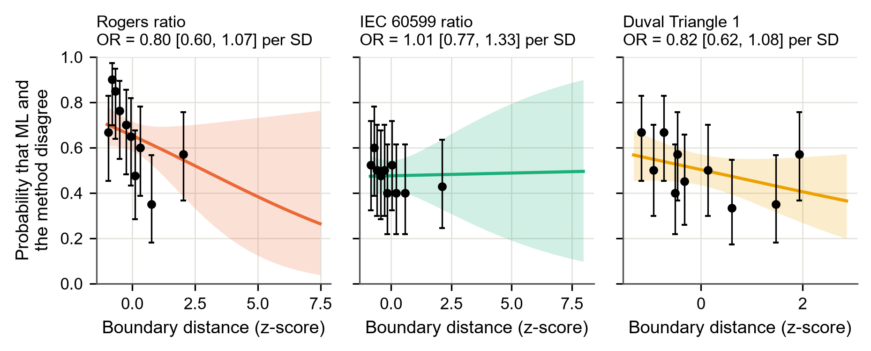
Fig. 6.6 Probability that the ML model and each conventional method disagree, against the standardised distance of the record to the method's nearest decision boundary: fitted logistic curve with 95 % band, and observed rates in groups of records with Wilson 95 % intervals (pooled primary test records, answers after the normality gate)
With the answers of the main analysis (after the normality gate), none of the three methods met the criterion. The odds ratio per standard deviation of distance was 0.80 [0.60, 1.07] for Rogers, 1.01 [0.77, 1.33] for IEC 60599 and 0.82 [0.62, 1.08] for the Duval Triangle; every interval includes 1. The curves of Rogers and Duval fall slightly with distance, but the observed rates scatter widely.
The analysis without the gate tells a different story for the Duval Triangle. With its raw answers, disagreement was strongly related to distance (odds ratio 0.49 [0.34, 0.69], p < 0.001): records near a Duval zone boundary were disputed far more often than records deep inside a zone. The gate converts many low-gas records to Normal wherever they lie in the triangle, and this hides the effect. For the ratio methods the pooled analyses showed no clear effect in either variant, although on the IEC TC 10 power transformers alone the Rogers method did show one (odds ratio 0.36 [0.19, 0.71]).
Fig. 6.7 shows the disagreements in the Duval Triangle. Many lie along the boundary between D1 and D2 and along the right-hand edge, where the thermal zones meet; that is, where a small change in one gas moves a record into another zone.
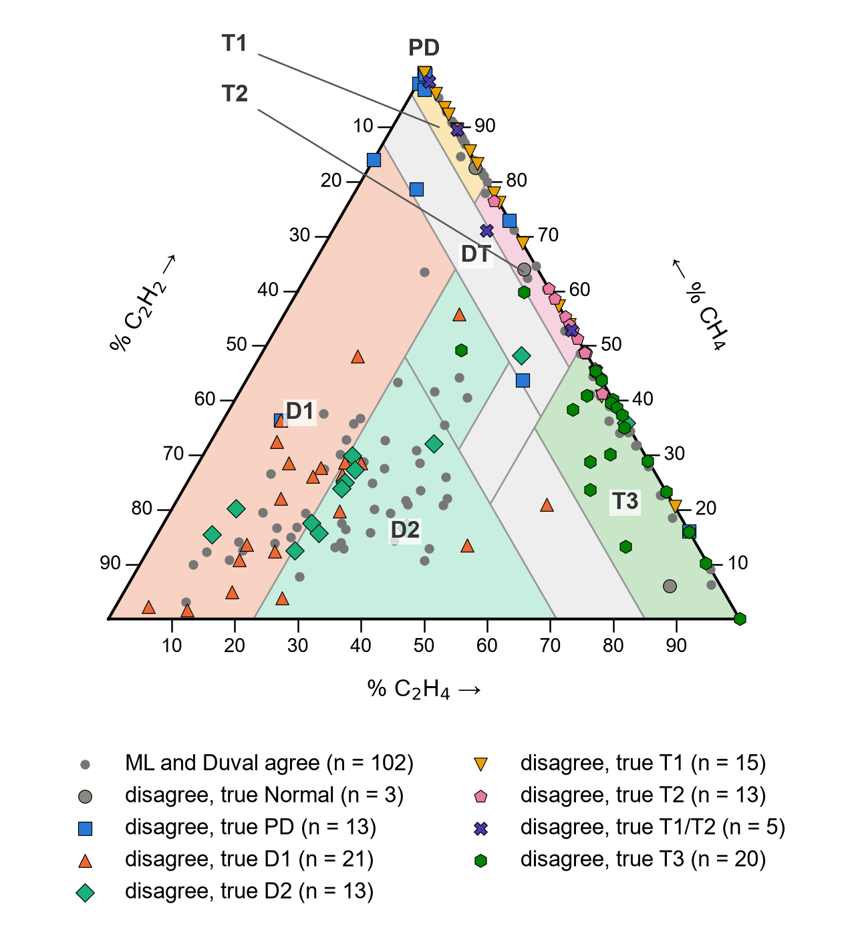
Fig. 6.7 Records on which the ML model and the Duval Triangle disagree (large symbols, coloured by the true class) and agree (small grey points), three primary test sets

6.7 Verdict on the Research Hypothesis
Table 6.6 applies the three criteria fixed in advance (Section 3.6.6) to the main benchmark and, as supporting evidence, to the other two test sets.
Table 6.6 Research-Hypothesis Criteria on Each Primary Test Set
Criterion | Internal test | IEC TC 10 PT (main) | Li 2019
1. ML significantly more accurate than every method (Holm) | met | not met (only vs Rogers) | met
2. Gap in conditional accuracy smaller than in strict accuracy, for every method | not met (not for Duval) | not met (not for Duval) | not met (not for Duval)
3. Disagreement more likely near the boundary, for every method | not met | not met | not met
Verdict | partly supported | not supported | partly supported
Criterion 2 cannot hold for the Duval Triangle, which always gives an answer, so that its strict and conditional accuracy are equal. Criterion 3 is judged on the pooled records with the normality gate (Table 6.5).
The research hypothesis is therefore not supported on the main benchmark. On the inspection-confirmed IEC TC 10 power transformers the ML model is not significantly more accurate than the IEC 60599 method or the Duval Triangle, its advantage over the ratio methods does not come only from the cases they cannot diagnose, and disagreement is not concentrated near the decision boundaries in the main analysis. On the internal and Li sets the hypothesis is partly supported: there the ML model is significantly more accurate than every conventional method.

6.8 Discussion

6.8.1 Why the Benchmark Gives a Different Picture
The strong performance of the Duval Triangle on the IEC TC 10 benchmark contrasts with studies that report very low Duval accuracy on pooled data, such as 35.8 % (Dladla and Thango, 2025b), and with the large ML advantages reported elsewhere (Al-Sakini et al., 2024; Dladla and Thango, 2025b). Two explanations are likely. First, the IEC TC 10 cases are the kind of clear, inspected faults on which the conventional methods were built, and the IEC 60599 limits were refined on these very cases (Duval and dePablo, 2001); the conventional methods therefore enjoy a home advantage. Second, scoring on five merged classes removes the finest thermal distinctions, where the triangle is weakest. On the internal and Li sets, whose labels are of unknown origin, the conventional methods did much worse and the ML model was significantly better than all of them. Which of these pictures is closer to field practice can be decided only with new inspection-confirmed data.

6.8.2 Why ML and the Conventional Methods Disagree
The kappa values show that the ML model and the conventional methods often disagree. The boundary analysis shows that, for the Duval Triangle, much of this disagreement arises near zone boundaries when the raw answers are compared; this agrees with the view that the fixed boundaries of the conventional methods are a main source of their uncertainty (Zhang et al., 2022; Kashiwagi et al., 2025). In the main analysis the normality gate dominates: it declared 26 of the 61 internal-test records and 37 of the 86 Li records Normal, most of them faulty records, and on a faulty record the ML model, which assigns a fault class, disagrees with such a Normal answer whatever the position of the record relative to the boundaries. For the ratio methods, a large share of the disagreements are no-diagnosis answers, which by definition do not lie at a particular boundary.

6.8.3 Implications
The comparison does not show that ML should replace the conventional methods. On the confirmed faults of the main benchmark the best conventional method was at least as accurate. It does show three things in favour of using ML alongside them: the ML model always gives an answer; on the two other sources it was significantly more accurate than every method; and its errors are partly different from theirs. Showing both diagnoses side by side, and treating disagreement as a signal for closer attention, is the use that the evidence supports. Chapter 8 shows how this is done in the integrated framework.

6.9 Summary
On the internal and Li test sets the ML model was significantly more accurate than every conventional method. On the inspection-confirmed IEC TC 10 benchmark it was significantly more accurate than the Rogers method only, did not differ significantly from IEC 60599, and was behind the Duval Triangle in point estimate; without the normality gate the Duval Triangle was clearly ahead. The ML model and the conventional methods agreed only fairly to moderately. Disagreement with the Duval Triangle concentrated near its zone boundaries when the raw answers were compared, but not in the main analysis with the gate. The research hypothesis is therefore not supported on the main benchmark and partly supported on the other two sets.

CHAPTER 7
DIAGNOSIS WITH FEWER GASES AND MODEL IMPROVEMENT

7.1 Introduction
This chapter reports two further analyses. The first answers the third research question: how much diagnostic performance is lost when fewer gases are measured, as happens with many online monitors, and what is the smallest useful gas panel (Section 7.2). The second is the exploratory study, carried out after the main results were known, of whether the model can be improved by pooling the data sources, by adding the conventional diagnoses as inputs, or by letting the model abstain when it is unsure (Section 7.3).

7.2 Diagnosis with Fewer Gases

7.2.1 Performance of Every Gas Subset
Table 7.1 lists the cross-validated macro-F1 of the selected pipeline for all 31 gas subsets, with the loss against the full five-gas panel and the conventional methods that can still be applied. Fig. 7.1 shows the macro-F1 against the number of gases.
Table 7.1 Random Forest Macro-F1 for Every Gas Subset and Its Loss against the Full Panel
Gas subset | Gases | Macro-F1 [95 % CI] | Loss Δ [95 % CI] | Within δ? | Conventional methods usable
H₂ + CH₄ + C₂H₆ + C₂H₄ + C₂H₂ | 5 | 0.851 [0.819, 0.881] | 0 (reference) | reference | Rogers, IEC 60599, Duval
H₂ + C₂H₆ + C₂H₄ + C₂H₂ | 4 | 0.834 [0.801, 0.867] | 0.017 [-0.006, 0.038] | yes | none
H₂ + CH₄ + C₂H₄ + C₂H₂ | 4 | 0.775 [0.739, 0.810] | 0.076 [0.052, 0.103] | no | Duval
H₂ + CH₄ + C₂H₆ + C₂H₄ | 4 | 0.734 [0.695, 0.769] | 0.117 [0.088, 0.149] | no | none
CH₄ + C₂H₆ + C₂H₄ + C₂H₂ | 4 | 0.726 [0.689, 0.760] | 0.125 [0.093, 0.158] | no | Duval
H₂ + CH₄ + C₂H₆ + C₂H₂ | 4 | 0.704 [0.669, 0.740] | 0.147 [0.117, 0.177] | no | none
C₂H₆ + C₂H₄ + C₂H₂ | 3 | 0.736 [0.699, 0.772] | 0.115 [0.081, 0.148] | no | none
H₂ + C₂H₆ + C₂H₄ | 3 | 0.710 [0.670, 0.747] | 0.141 [0.107, 0.177] | no | none
H₂ + C₂H₄ + C₂H₂ | 3 | 0.688 [0.653, 0.725] | 0.163 [0.131, 0.195] | no | none
H₂ + CH₄ + C₂H₄ | 3 | 0.659 [0.618, 0.697] | 0.192 [0.156, 0.232] | no | none
H₂ + CH₄ + C₂H₂ | 3 | 0.636 [0.599, 0.673] | 0.215 [0.179, 0.250] | no | none
CH₄ + C₂H₄ + C₂H₂ | 3 | 0.620 [0.581, 0.658] | 0.231 [0.194, 0.273] | no | Duval
H₂ + C₂H₆ + C₂H₂ | 3 | 0.604 [0.562, 0.644] | 0.247 [0.209, 0.288] | no | none
CH₄ + C₂H₆ + C₂H₄ | 3 | 0.580 [0.541, 0.617] | 0.271 [0.232, 0.309] | no | none
H₂ + CH₄ + C₂H₆ | 3 | 0.577 [0.536, 0.615] | 0.274 [0.233, 0.319] | no | none
CH₄ + C₂H₆ + C₂H₂ | 3 | 0.525 [0.490, 0.561] | 0.326 [0.287, 0.365] | no | none
C₂H₆ + C₂H₄ | 2 | 0.587 [0.547, 0.624] | 0.264 [0.224, 0.305] | no | none
C₂H₄ + C₂H₂ | 2 | 0.556 [0.518, 0.591] | 0.295 [0.255, 0.336] | no | none
H₂ + C₂H₄ | 2 | 0.536 [0.499, 0.572] | 0.315 [0.274, 0.355] | no | none
H₂ + CH₄ | 2 | 0.500 [0.459, 0.540] | 0.351 [0.305, 0.398] | no | none
CH₄ + C₂H₄ | 2 | 0.470 [0.435, 0.503] | 0.381 [0.342, 0.421] | no | none
C₂H₆ + C₂H₂ | 2 | 0.444 [0.409, 0.479] | 0.407 [0.364, 0.448] | no | none
H₂ + C₂H₆ | 2 | 0.440 [0.403, 0.479] | 0.411 [0.367, 0.454] | no | none
CH₄ + C₂H₂ | 2 | 0.440 [0.408, 0.471] | 0.411 [0.369, 0.453] | no | none
H₂ + C₂H₂ | 2 | 0.439 [0.403, 0.474] | 0.412 [0.372, 0.450] | no | none
CH₄ + C₂H₆ | 2 | 0.371 [0.336, 0.405] | 0.480 [0.439, 0.521] | no | none
C₂H₄ | 1 | 0.391 [0.356, 0.425] | 0.460 [0.421, 0.500] | no | none
C₂H₆ | 1 | 0.284 [0.255, 0.314] | 0.567 [0.524, 0.609] | no | none
H₂ | 1 | 0.272 [0.244, 0.300] | 0.579 [0.539, 0.621] | no | none
CH₄ | 1 | 0.251 [0.222, 0.279] | 0.600 [0.561, 0.639] | no | none
C₂H₂ | 1 | 0.245 [0.220, 0.271] | 0.606 [0.565, 0.643] | no | none
Development set, nested cross-validation on the same 50 folds; loss intervals by paired stratified bootstrap (B = 2 000). δ = 0.05. The last column follows from the gases each method needs.
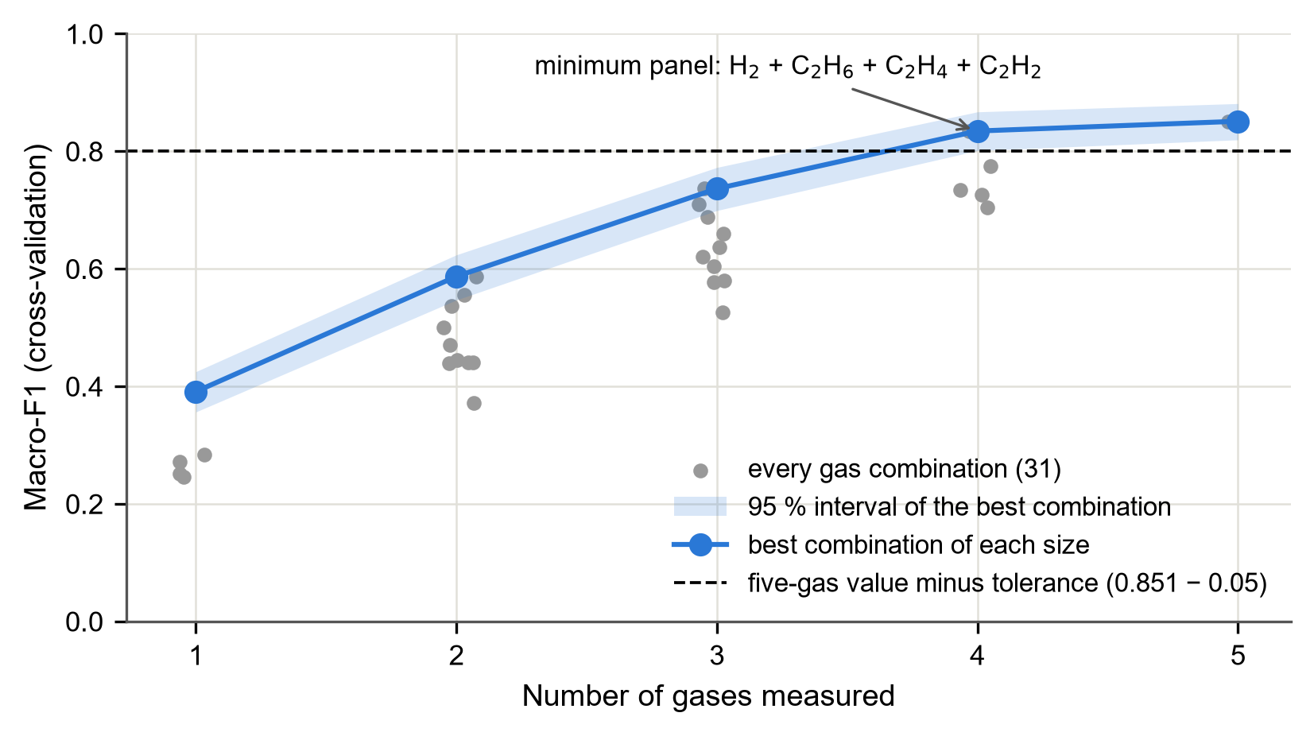
Fig. 7.1 Cross-validated macro-F1 against the number of gases measured: grey points are all 31 gas combinations; the line joins the best combination of each size with its 95 % interval; the dashed line marks the five-gas value minus the tolerance of 0.05
With all five gases the macro-F1 was 0.851 [0.819, 0.881]. Performance fell steadily as gases were removed, but not equally for every gas:
a. Without methane (H₂, C₂H₆, C₂H₄ and C₂H₂) the macro-F1 was 0.834, a loss of only 0.017 [-0.006, 0.038]. This is the only reduced panel whose loss stayed within the tolerance of 0.05, and it is therefore the minimum gas panel.
b. Removing any other single gas cost more: without C₂H₆ the loss was 0.076, without C₂H₂ 0.117, without H₂ 0.125 and without C₂H₄ 0.147.
c. The best three-gas panel (C₂H₆, C₂H₄ and C₂H₂) lost 0.115, the best two-gas panel (C₂H₆ and C₂H₄) 0.264, and the best single gas (C₂H₄) 0.460.
d. Hydrogen alone, the gas measured by the simplest monitors, gave a macro-F1 of only 0.272, a loss of 0.579.
That methane is the least necessary gas agrees with the explanation of the model in Chapter 5, where methane had the smallest permutation importance on the internal and Li test sets, and with the strong correlation of methane with the other hydrocarbons (Section 4.6): much of its information is carried by C₂H₆ and C₂H₄.

7.2.2 Conventional Methods with Fewer Gases
The conventional methods depend on particular gases. The ratio methods need all five gases, and the Duval Triangle needs CH₄, C₂H₄ and C₂H₂; running the MATLAB implementations with removed gases confirmed that each method gives no diagnosis for every record when a gas it needs is missing. Fig. 7.2 shows the consequence: of the 31 gas combinations, IEC 60599 and Rogers can be applied to one and the Duval Triangle to four.
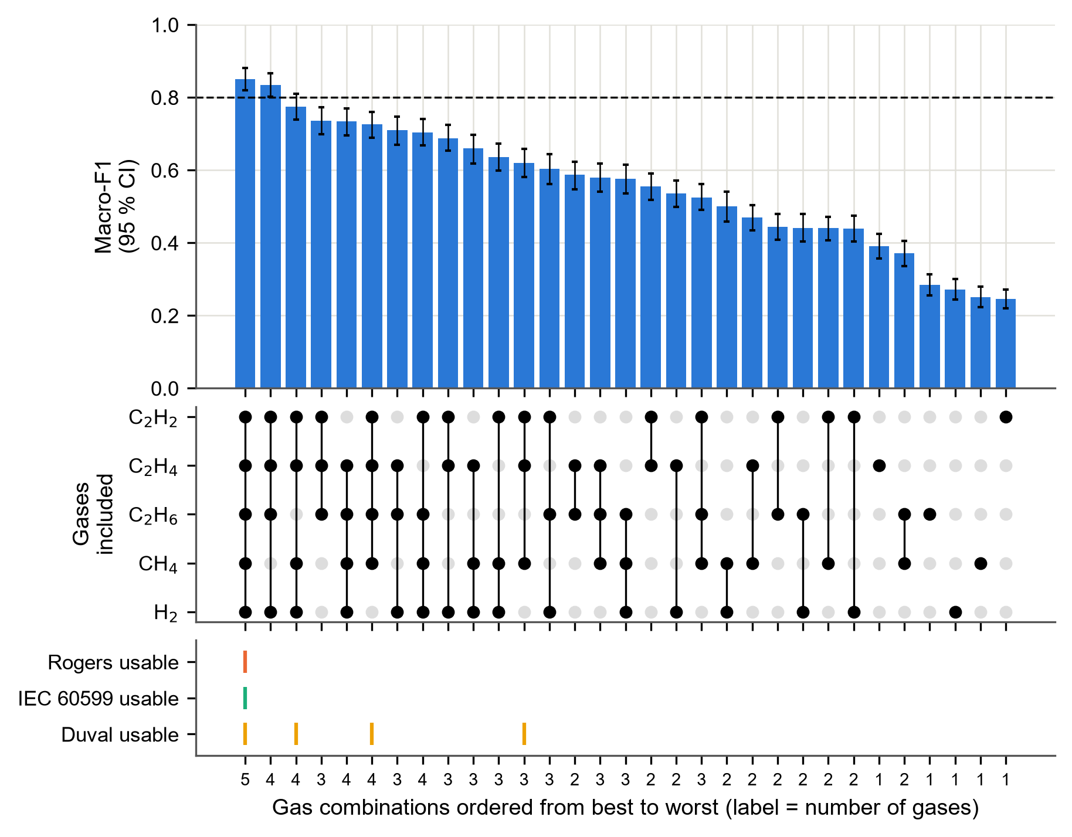
Fig. 7.2 Gas-subset matrix: the bars give the cross-validated macro-F1 (95 % interval) of every gas combination from best to worst, the dots show the gases included, and the bottom rows show which conventional methods can still be applied
The minimum panel therefore has a practical consequence: no conventional method can interpret it, because all of them need methane. The ML model keeps almost its full performance on a panel that the conventional methods cannot use. Conversely, the three gases of the Duval Triangle (CH₄, C₂H₄ and C₂H₂) gave the ML model a macro-F1 of only 0.620.

7.2.3 Implications for Online Monitoring
Online monitors that measure only hydrogen, or hydrogen and carbon monoxide, can detect that a fault is developing but cannot identify it (Bustamante et al., 2019); the very low macro-F1 of hydrogen alone confirms this for the ML model as well. A monitor that measures H₂, C₂H₆, C₂H₄ and C₂H₂ would, according to these results, support an ML diagnosis almost as good as a full laboratory analysis of the five gases. These results come from cross-validation on the development set and should be confirmed on independent data before they guide the choice of monitors.

7.3 Exploratory Study: Can the Model Be Improved?

7.3.1 Purpose
The main results showed that the released model did not beat the best conventional methods on the IEC TC 10 benchmark. The exploratory study examined three possible improvements under a protocol registered in advance (Chapter 3): retraining on the pooled data sources (model B), adding the conventional diagnoses as inputs (hybrid model C) and a reject option. Because the test sources had already been seen in the main study, these results are exploratory and cannot change the main conclusions.

7.3.2 Pooling and the Hybrid Model
Table 7.2 and Fig. 7.3 show the leave-one-source-out results.
Table 7.2 Study 2 (Exploratory): Leave-One-Source-Out Results
Held-out source (n) | Model / method | Macro-F1 [95 % CI] | Strict accuracy | Coverage
Dissanayake training (439) | B: pooled retraining | 0.679 [0.635, 0.722] | 0.699 | 1.000
 | C: hybrid | 0.630 [0.583, 0.673] | 0.656 | 1.000
 | IEC 60599 ratio | 0.483 [0.433, 0.530] | 0.469 | 0.738
 | Rogers ratio | 0.383 [0.336, 0.425] | 0.369 | 0.642
 | Duval Triangle 1 | 0.541 [0.493, 0.586] | 0.560 | 0.998
Dissanayake unseen (61) | A: released model | 0.793 [0.682, 0.895] | 0.820 | 1.000
 | B: pooled retraining | 0.851 [0.753, 0.936] | 0.869 | 1.000
 | C: hybrid | 0.873 [0.777, 0.948] | 0.885 | 1.000
 | IEC 60599 ratio | 0.473 [0.333, 0.589] | 0.475 | 0.721
 | Rogers ratio | 0.289 [0.196, 0.370] | 0.328 | 0.623
 | Duval Triangle 1 | 0.543 [0.430, 0.639] | 0.590 | 1.000
IEC TC 10 PT (58) | A: released model | 0.731 [0.622, 0.831] | 0.724 | 1.000
 | B: pooled retraining | 0.782 [0.678, 0.872] | 0.776 | 1.000
 | C: hybrid | 0.821 [0.721, 0.905] | 0.810 | 1.000
 | IEC 60599 ratio | 0.731 [0.623, 0.828] | 0.638 | 0.879
 | Rogers ratio | 0.330 [0.246, 0.412] | 0.483 | 0.724
 | Duval Triangle 1 | 0.752 [0.627, 0.882] | 0.776 | 1.000
Li 2019 (85) | A: released model | 0.628 [0.519, 0.733] | 0.647 | 1.000
 | B: pooled retraining | 0.651 [0.546, 0.753] | 0.659 | 1.000
 | C: hybrid | 0.654 [0.546, 0.754] | 0.659 | 1.000
 | IEC 60599 ratio | 0.477 [0.350, 0.585] | 0.306 | 0.788
 | Rogers ratio | 0.269 [0.176, 0.354] | 0.188 | 0.682
 | Duval Triangle 1 | 0.626 [0.508, 0.727] | 0.471 | 1.000
T1 and T2 merged (six classes). Model A is not evaluated on the Dissanayake training source, on which it was trained.
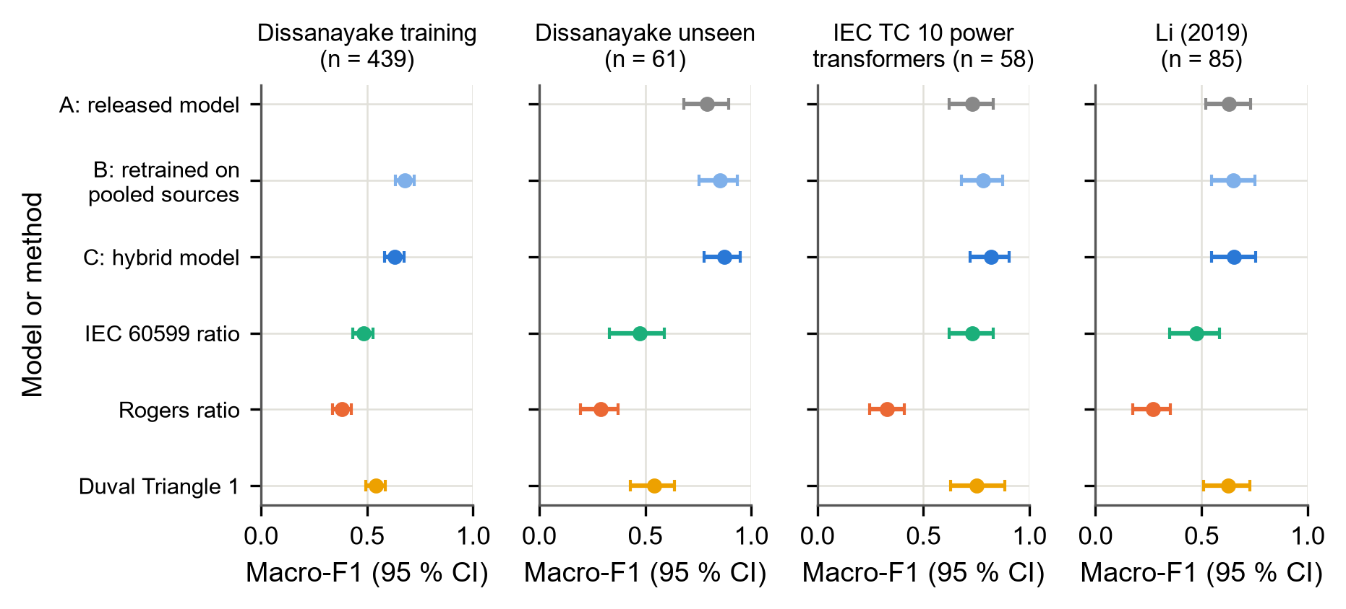
Fig. 7.3 Macro-F1 with 95 % intervals of the three models and the three conventional methods when each source is held out in turn
Retraining on the pooled sources (B) and the hybrid model (C) gave higher point estimates than the released model (A) on every external source. On the IEC TC 10 power transformers the hybrid model reached a macro-F1 of 0.821 against 0.731 for the released model. However, neither of the rules fixed in the protocol was met. The improvement of B over A had a confidence interval that included zero on all three external sources, and C was not significantly better than B on any source; on the Dissanayake training source it was worse. Pooling and the hybrid design are therefore not shown to improve the model.

7.3.3 The Reject Option
A conventional ratio method gives no diagnosis for part of the records and is usually right on the rest. The reject option lets the ML model behave in the same way: it answers only the records on which it is most confident. Table 7.3 and Fig. 7.4 compare the hybrid model with the ratio methods at the same coverage.
Table 7.3 Study 2 (Exploratory): Reject Option at the Coverage of the Ratio Methods
Held-out source | Coverage matched to | Coverage | Hybrid model C: selective accuracy | Method: conditional accuracy | Difference [95 % CI]
Dissanayake training | IEC 60599 | 0.738 | 0.725 | 0.636 | 0.089 [0.029, 0.148]
Dissanayake training | Rogers | 0.642 | 0.777 | 0.575 | 0.202 [0.139, 0.261]
Dissanayake unseen | IEC 60599 | 0.721 | 0.955 | 0.659 | 0.295 [0.161, 0.427]
Dissanayake unseen | Rogers | 0.623 | 0.947 | 0.526 | 0.421 [0.282, 0.550]
IEC TC 10 PT | IEC 60599 | 0.879 | 0.824 | 0.726 | 0.098 [-0.008, 0.212]
IEC TC 10 PT | Rogers | 0.724 | 0.881 | 0.667 | 0.214 [0.064, 0.357]
Li 2019 | IEC 60599 | 0.788 | 0.731 | 0.388 | 0.343 [0.213, 0.466]
Li 2019 | Rogers | 0.682 | 0.776 | 0.276 | 0.500 [0.360, 0.632]
The model abstains on its least confident records until its coverage equals that of the ratio method; the threshold uses the model's probabilities only.
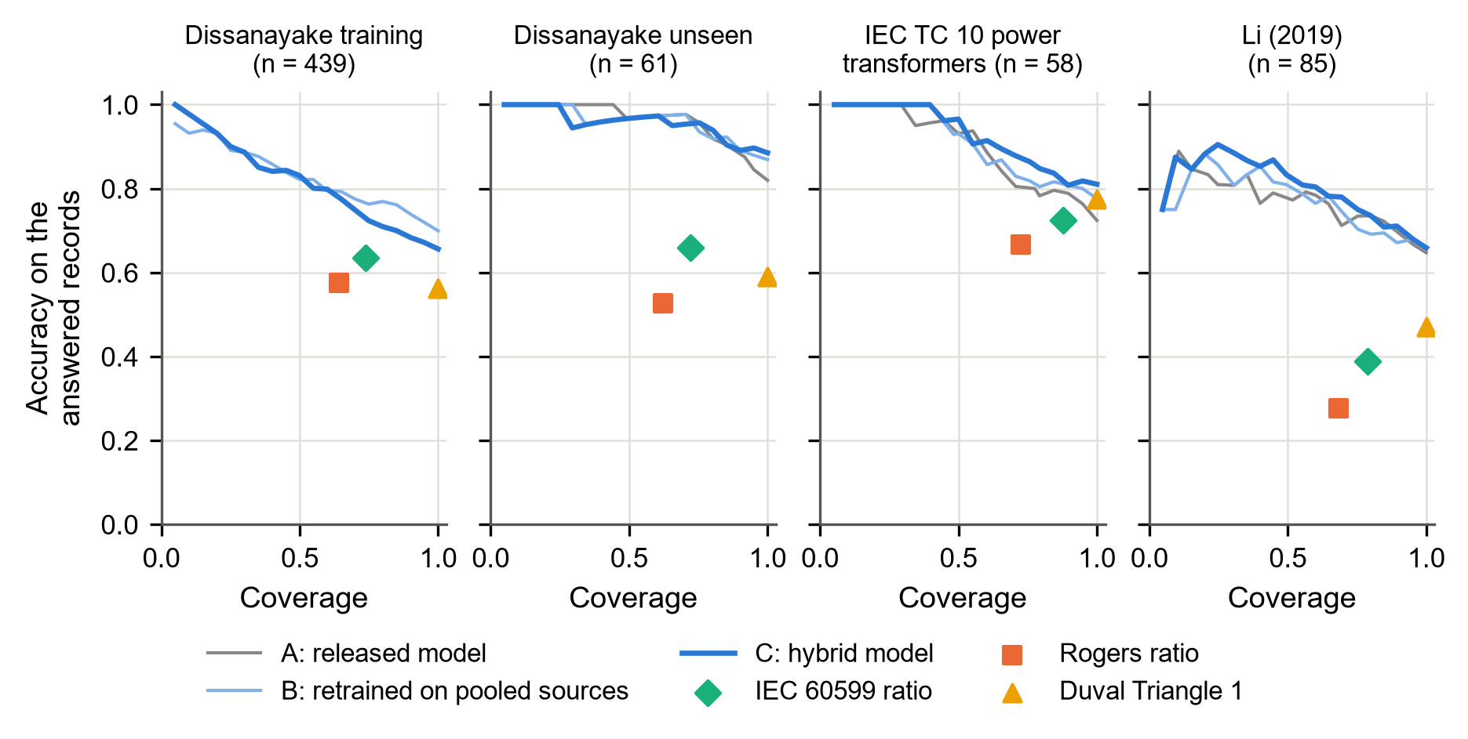
Fig. 7.4 Accuracy on the answered records against coverage when the models abstain on their least confident records (lines), with the conventional methods as points
When the hybrid model abstained until its coverage equalled that of IEC 60599, it was more accurate on the records it answered than IEC 60599 on the records IEC 60599 answered, on every source. The confidence interval of the difference excluded zero on all sources except the IEC TC 10 power transformers, where the model reached 0.824 against 0.726 (difference interval [-0.008, 0.212]). The curves in Fig. 7.4 lie above the points of the ratio methods on every source: at the same coverage the model is more accurate.

7.4 Discussion
The reduced-gas results fill a gap noted in the literature review: earlier studies imputed missing gas values (Wang et al., 2023) or used monitor data with a fixed gas set (Jin et al., 2024), but none measured, with a tolerance fixed in advance and confidence intervals, how much an ML model loses for every possible subset of the five gases. The result that methane is the least necessary gas, and that the minimum panel cannot be interpreted by any conventional method, is a concrete argument for ML in settings with reduced gas measurements.
The exploratory study suggests a practical way of using ML next to the conventional methods: the model answers when it is confident and refers the remaining samples to an expert, just as a ratio method gives no diagnosis. This "confident or refer" mode is safer than forcing an answer on every sample. It is consistent with the call for uncertainty-aware diagnosis in prognostics and health management (Kashiwagi et al., 2025). Confirming it needs fresh inspection-confirmed data; a search of legitimate public sources for such data was carried out but found none that was not already used.

7.5 Summary
Of the 31 gas subsets, only one reduced panel, H₂ with C₂H₆, C₂H₄ and C₂H₂ (without methane), kept the loss of macro-F1 within the tolerance of 0.05; no conventional method can interpret this panel. Hydrogen alone was far from sufficient for diagnosis. In the exploratory study, pooling the sources and adding the conventional diagnoses as inputs did not significantly improve the model, but a reject option made the hybrid model more accurate than the ratio methods at the same coverage on every source.

CHAPTER 8
DEVELOPMENT AND EVALUATION OF THE INTEGRATED FRAMEWORK

8.1 Introduction
This chapter answers the fourth research question: whether the conventional methods and the ML model can be brought together in one system that returns exactly the offline results, quickly enough for interactive use. It describes the architecture of the framework (Section 8.2), the Simulink operating model and its verification (Section 8.3), the diagnosis service (Section 8.4), the dashboard (Section 8.5) and the end-to-end test bench, with its fidelity and response time (Section 8.6).

8.2 Architecture
The framework connects three parts, each built in the environment best suited to it (Fig. 3.1 in Chapter 3):
a. the Simulink operating model of a transformer, which provides the load, temperatures and insulation ageing at any moment of a simulated period and marks the moments at which an oil sample is taken;
b. the conventional methods, programmed in MATLAB, which interpret the gases of a record; and
c. the diagnosis service in Python, which holds the released ML model and returns its diagnosis to any program that sends it the five gases.
The dashboard, built with MATLAB App Designer, brings the three together on one screen. The parts exchange only three kinds of information: the identifier of a record, the five gas concentrations in ppm, and the fault classes coded 0 to 6. No gas value ever passes through the Simulink model.

8.3 Simulink Operating Model

8.3.1 Structure of the Model
The model represents a 40 MVA, 110/20 kV, oil-immersed power transformer with forced-air cooling. It is built by a MATLAB script, so that every block, parameter and connection is recorded and the model can be rebuilt exactly, and all parameters are named variables in one parameter script (Table 8.1). The electrical data are those of a standard 40 MVA, 110/20 kV transformer type of the pandapower library (Thurner et al., 2018), and the thermal constants are the default values of an open-source implementation of IEC 60076-7; they describe a typical unit, not a specific nameplate.
Table 8.1 Main Parameters of the Simulink Operating Model
Quantity | Symbol | Value | Source
Rated power | S_{r} | 40 MVA | pandapower standard type
Rated voltages | V_{HV} / V_{LV} | 110 kV / 20 kV | pandapower standard type
Short-circuit voltage (resistive part) | u_{k} (u_{kr}) | 16.2 % (0.34 %) | pandapower standard type
No-load loss / load loss at rated current | P₀ / P_{k} | 18 kW / 136 kW | pandapower standard type
Top-oil rise at rated load | Δθ_{or} | 60 K | Alliander implementation of IEC 60076-7
Winding-to-oil gradient; hot-spot factor | g_{r}; H | 17 K; 1.3 | Alliander implementation of IEC 60076-7
Oil and winding time constants | τ_{o}; τ_{w} | 150 min; 7 min | Alliander implementation of IEC 60076-7
Thermal model constants | k₁₁; k₂₁; k₂₂ | 0.5; 2; 2 | Alliander implementation of IEC 60076-7
Oil and winding exponents | x; y | 0.8; 1.3 | Alliander implementation of IEC 60076-7
Ambient temperature | θ_{a} | 20 °C | reference ambient (chosen)
Solver relative tolerance; maximum step | – | 10⁻⁴; 60 s | chosen to meet the 0.1 K tolerance
All values are defined as named variables in one parameter script of the model; no number is typed into a block.
Fig. 8.1 shows the top level of the model as it appears in MATLAB R2025b. It has eight subsystems:
a. SS1 Grid supply: a three-phase 110 kV source;
b. SS2 Power transformer: a two-winding 40 MVA, 110/20 kV transformer block;
c. SS3 LV measurement: measures the secondary current and computes the load factor K;
d. SS4 Variable load: a load whose demand follows a load profile;
e. SS5 Losses to heat: converts the load and no-load losses into heat inputs;
f. SS6 Thermal network: solves the IEC 60076-7 equations (Equation (3.32) to Equation (3.34)) as thermal resistance–capacitance circuits;
g. SS7 Outputs and ageing: computes the hot-spot temperature, the ageing rate and the logged outputs; and
h. SS8 Sampling events: marks the times at which an oil sample is taken.
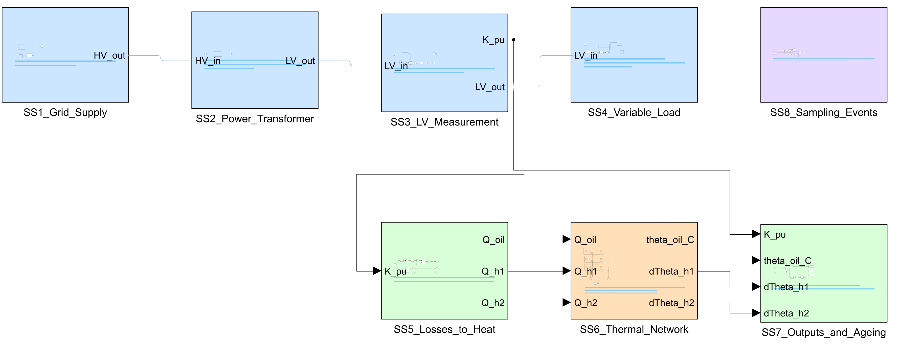
Fig. 8.1 Top level of the Simulink operating model in MATLAB R2025b. Blue: Simscape Electrical network (SS1–SS4); green: Simulink arithmetic (SS5, SS7); orange: Simscape thermal network (SS6); purple: DGA sampling events (SS8). Blue lines are physical connections and black lines Simulink signals
SS1 to SS4 form a Simscape Electrical network and SS6 a Simscape thermal network. The electrical network uses Simscape's frequency-and-time formulation, which accepts only linear equations, so the non-linear arithmetic of SS5 and SS7 is done with ordinary Simulink blocks; the model is therefore a combination of Simscape physical networks and Simulink arithmetic. Fig. 8.2 shows the thermal network. The diagrams of all the other subsystems are given in Appendix A.
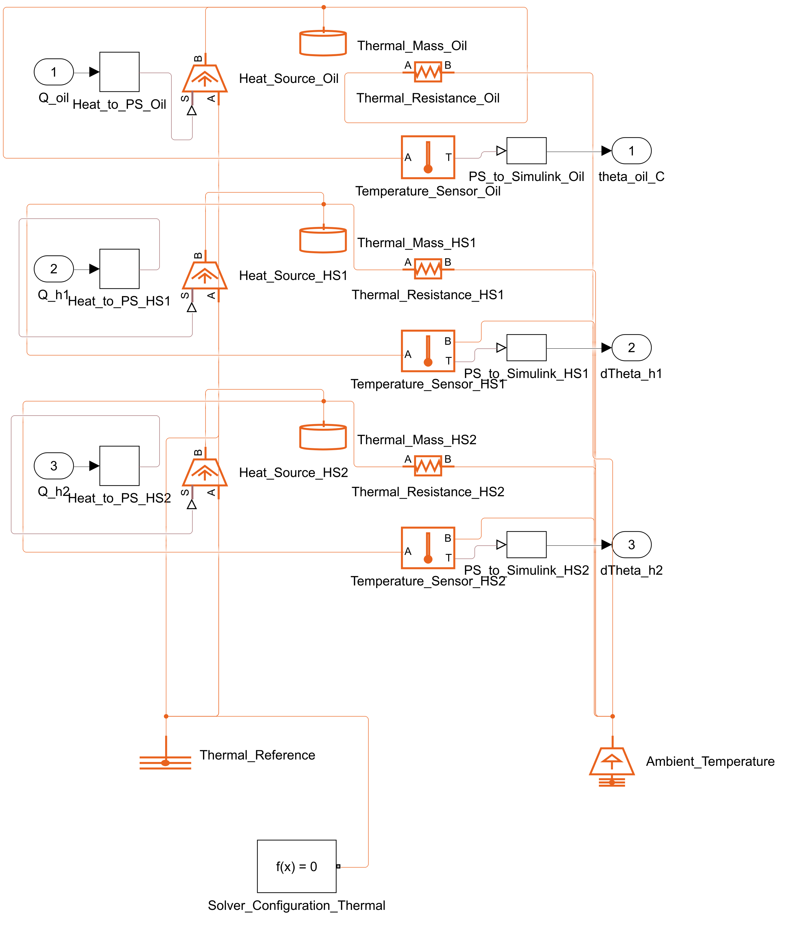
Fig. 8.2 Simscape thermal network of subsystem SS6: heat sources, thermal masses and thermal resistances that solve the top-oil and hot-spot equations

8.3.2 Model Checks
The model was checked with the Simulink Model Advisor, which ran 132 modelling and Simscape checks: 120 passed, 11 gave warnings, 1 could not be completed by the tool and none failed. The check that could not be completed (bus signal names) was replaced by a direct test, since the model contains no bus. The 11 warnings concern style rules for control software and options for code generation, which do not apply to a simulation model of this kind, and each was recorded with its reason. Problems found by the checks were corrected in the build script; for example, a deprecated square-root block was replaced and several diagnostics were set to report errors.

8.3.3 Verification against the IEC 60076-7 Equations
The model passed every verification check (Table 8.2 and Fig. 8.3). Against the independent solution of the IEC 60076-7 equations, the largest difference after the first 10 min was 0.0014 K for the top-oil and 0.0129 K for the hot-spot temperature at rated load, and 0.0015 K and 0.0152 K in the load-step test. All four are far inside the 0.1 K limit. The 63 % rise time of the top-oil temperature differed from k₁₁τ_{o} = 75 min by only 0.0016 min. At rated load from a 20 °C ambient, the top-oil temperature settled at 78.64 °C and the hot-spot temperature at 100.28 °C.
Table 8.2 Verification of the Simulink Thermal Model against the IEC 60076-7 Equations
Test | Quantity | Measure | Value | Limit | Passed
Rated load | top-oil temperature | e_{max} (after 10 min) | 0.0014 K | 0.1 K | yes
Rated load | hot-spot temperature | e_{max} (after 10 min) | 0.0129 K | 0.1 K | yes
Rated load | top-oil temperature | RMSE (after 10 min) | 0.0002 K
Rated load | hot-spot temperature | RMSE (after 10 min) | 0.0007 K
Rated load | top-oil temperature | final value, model | 78.64 °C
Rated load | hot-spot temperature | final value, model | 100.28 °C
Rated load | ageing rate V | largest relative difference | 0.0015 | 0.0116 | yes
Load step | top-oil temperature | e_{max} (after 10 min) | 0.0015 K | 0.1 K | yes
Load step | hot-spot temperature | e_{max} (after 10 min) | 0.0152 K | 0.1 K | yes
Load step | top-oil temperature | RMSE (after 10 min) | 0.0002 K
Load step | hot-spot temperature | RMSE (after 10 min) | 0.0013 K
Load step | top-oil temperature | final value, model | 95.50 °C
Load step | hot-spot temperature | final value, model | 122.70 °C
Load step | ageing rate V | largest relative difference | 0.0018 | 0.0116 | yes
Rated load | top-oil temperature | 63.2 % rise time (difference to k₁₁τ_{o}) | 0.0016 min | 1 min | yes
Reference: the same differential equations solved independently (ode15s, tolerance 10⁻⁸), driven by the load factor measured in the model. Time points after the first 10 min.
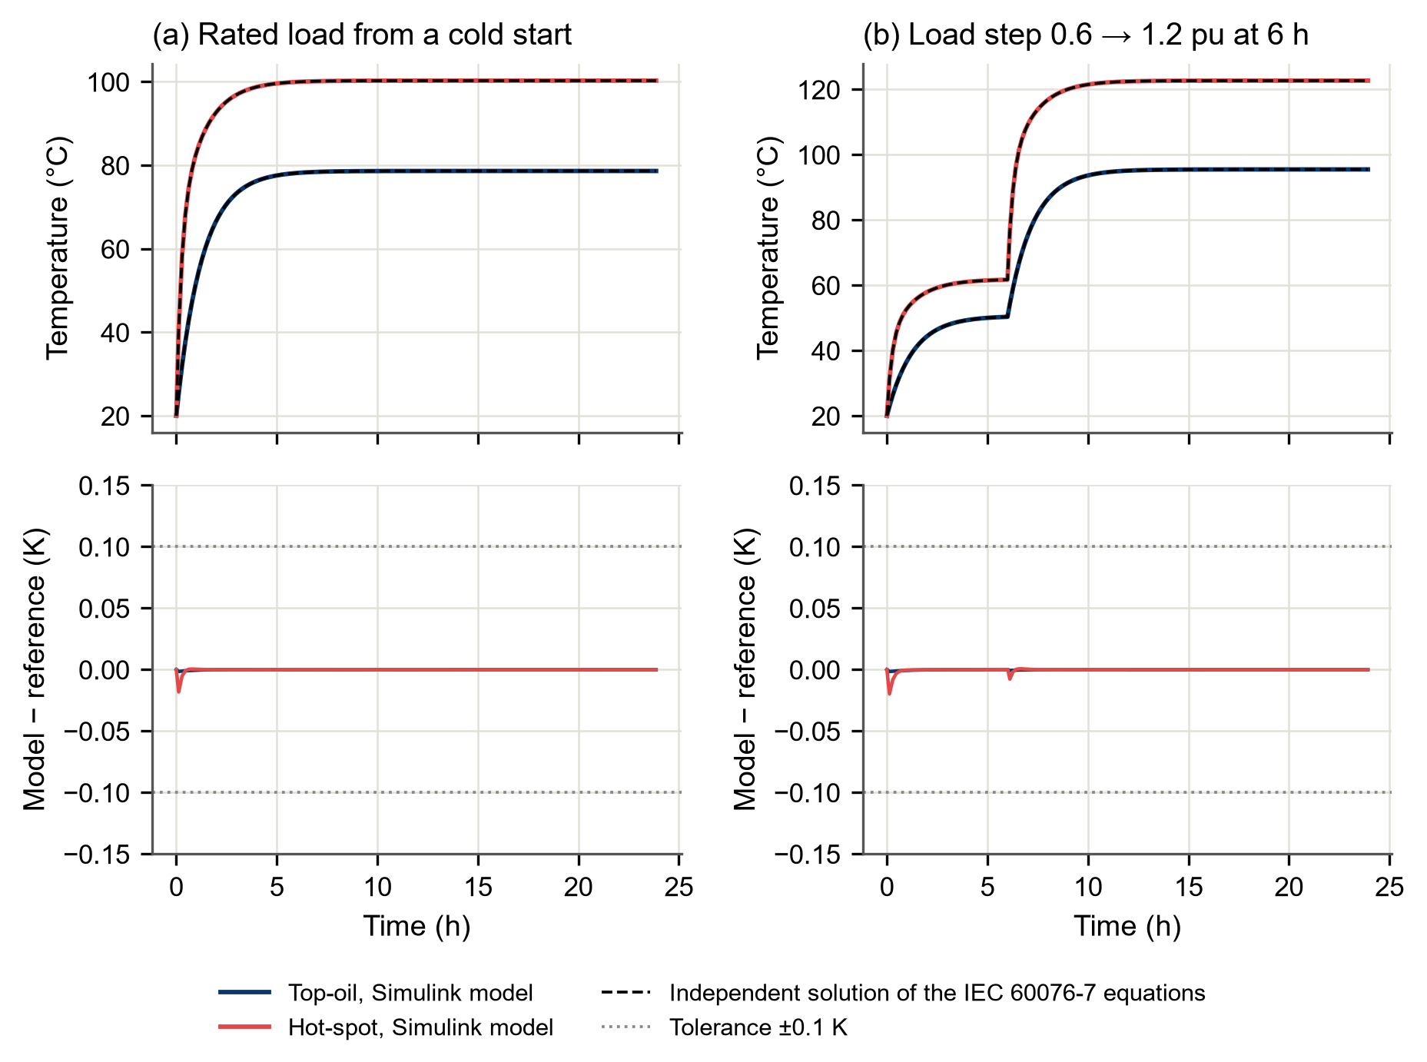
Fig. 8.3 Verification of the Simulink thermal model against an independent solution of the IEC 60076-7 equations: (a) rated load from a cold start, (b) load step from 0.6 to 1.2 pu at 6 h; upper panels: temperatures, lower panels: difference between model and reference with the ±0.1 K tolerance
One finding of the verification is worth noting. With the default solver tolerance (relative tolerance 10⁻³), the hot-spot difference reached about 0.1 K, so that a small change in the solver's time steps could move it across the limit. The tolerance was therefore tightened to 10⁻⁴, after which the difference was about one-tenth of the limit. This shows the value of verifying a simulation against an independent solution rather than assuming that the solver's default settings are adequate.

8.3.4 Operating Scenarios
Three illustrative operating scenarios were simulated: constant rated load for 24 h, a daily load cycle and a short overload (Fig. 8.4 and Fig. 8.5; the rated-load scenario is in Appendix B).
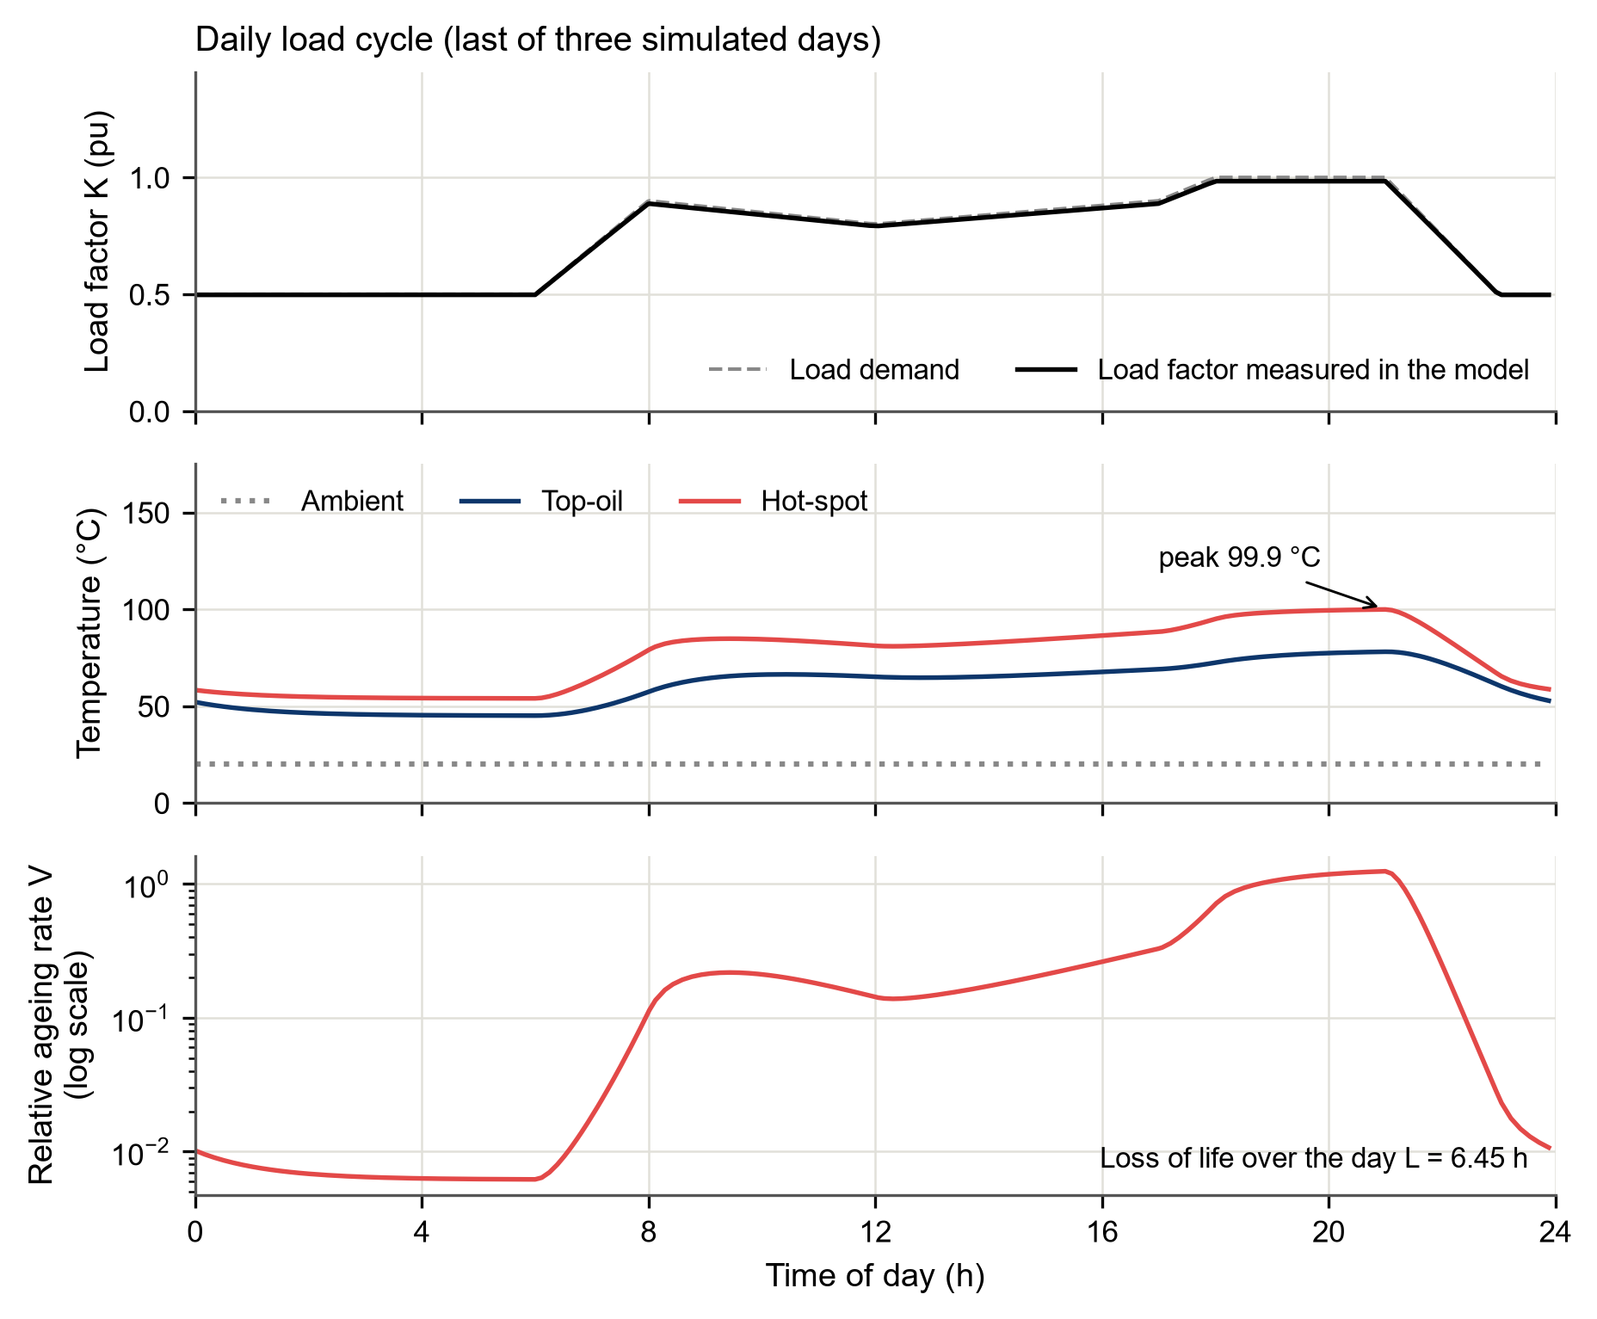
Fig. 8.4 Daily load-cycle scenario (last of three simulated days): load factor, temperatures, and relative ageing rate with the loss of life
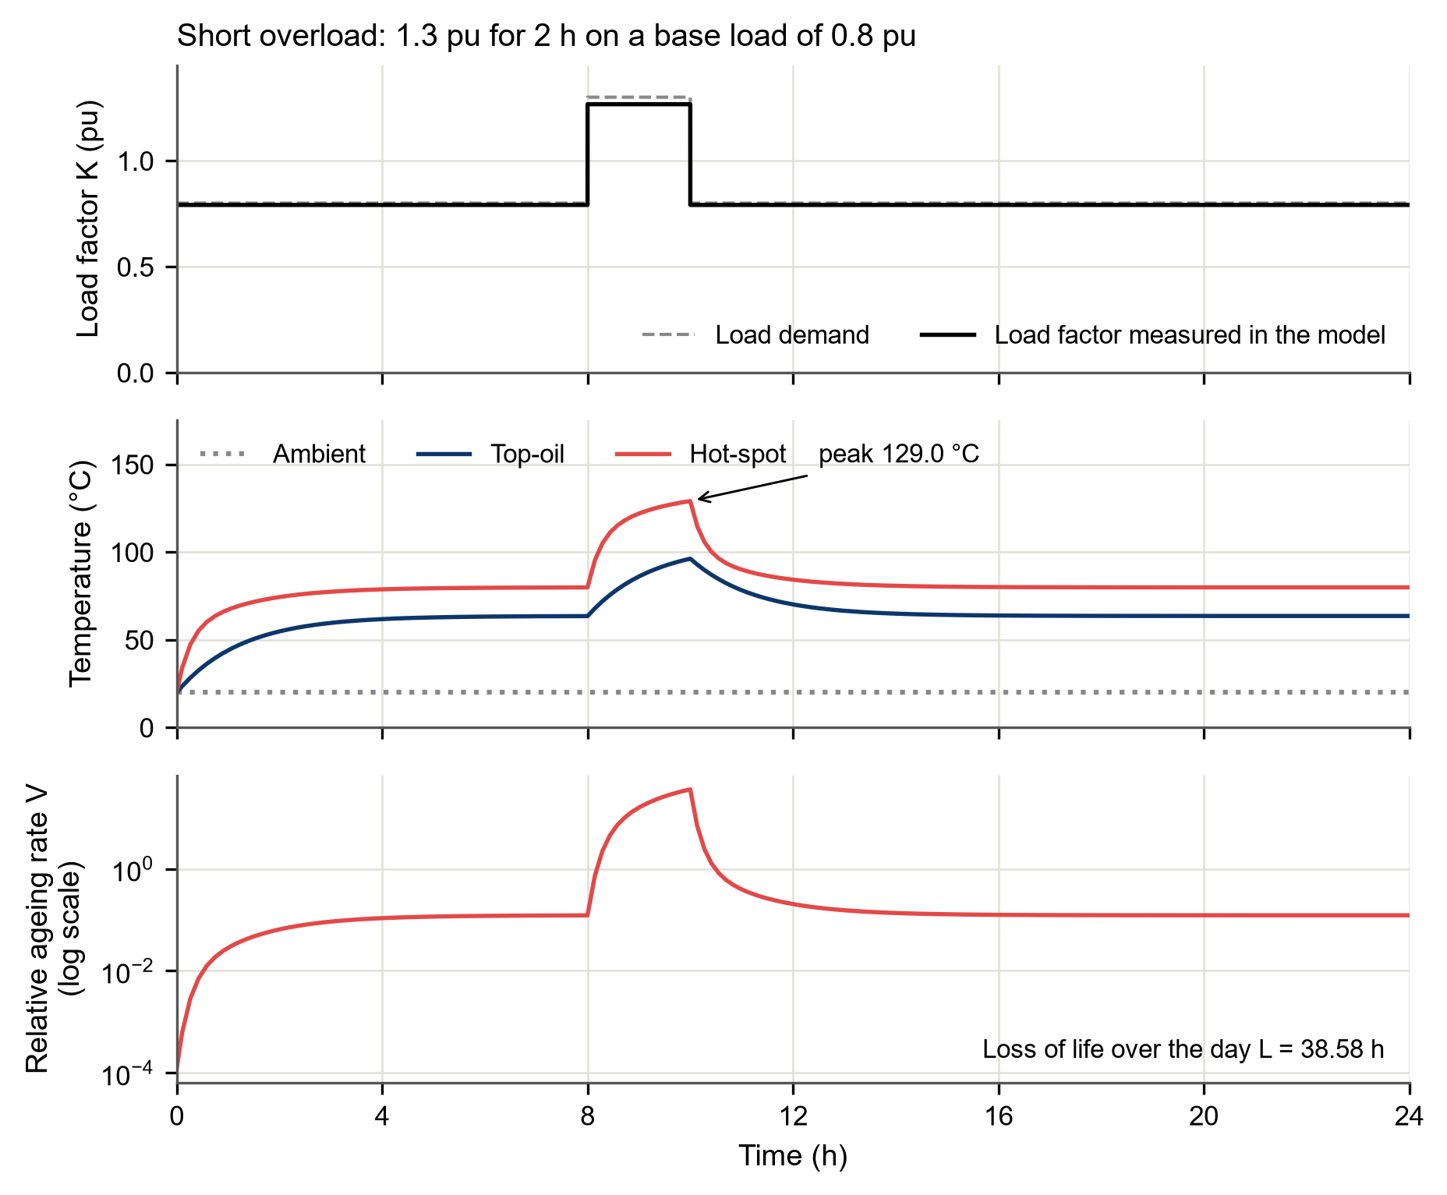
Fig. 8.5 Short-overload scenario: 1.3 pu for 2 h on a base load of 0.8 pu
Under the daily cycle, which rises from 0.5 pu at night to 1.0 pu at the evening peak, the hot-spot temperature peaked at 99.9 °C in the evening and the loss of life over the day was 6.45 h, much less than the 24 h of a day at the reference temperature. Under constant rated load the hot-spot temperature settled near 100.3 °C, slightly above the 98 °C reference, and the loss of life was 27.88 h in 24 h. The 2 h overload of 1.3 pu raised the hot-spot temperature to 129.0 °C, and that day's loss of life of 38.58 h was greater than that of a day at constant rated load. These figures show the operating context that the dashboard displays next to each diagnosis. They are illustrative, because the scenarios are not measured load profiles and the thermal constants are default values.

8.3.5 DGA Sampling Events
Subsystem SS8 marks the moments at which an oil sample is taken (6, 12, 18 and 22 h of a simulated day in the demonstration). A Simulink signal is numeric, so SS8 outputs the number of sampling events passed. Outside the model this number selects the identifier of the next held-out record, and the dashboard reads that record's measured gases from the data file. The parameter script reads only the record identifiers and data roles, so no gas value enters the model's workspace. An automated test confirmed that no block, parameter or logged signal of the model refers to a gas concentration.

8.4 Diagnosis Service
The released ML model is served by a web service written with the FastAPI framework (Table 8.3). A program sends the five gas concentrations, and optionally a record identifier, as a JSON message to the address 127.0.0.1:8000, and the service returns the predicted class, the probabilities of all seven classes, the confidence, and the name, version and SHA-256 fingerprint of the model.
Table 8.3 Interface of the Diagnosis Service
Endpoint | Input | Output
POST /diagnose | JSON: H₂, CH₄, C₂H₆, C₂H₄, C₂H₂ (ppm, numbers ≥ 0); optional record_id | fault_class, probabilities of the 7 classes, confidence, model name, version, SHA-256, data version, notes
GET /health | none | service status and the verified model fingerprint
GET /version | none | model metadata (model card summary)
Invalid input (text, negative, NaN or infinite values, unknown fields) is refused with HTTP status 422 and the reason.
Four design choices make the service safe to use:
a. Strict input checks. Every gas is required and must be a finite number not below zero, and unknown fields are refused, so that a misspelt gas name cannot be ignored silently. Invalid requests receive HTTP status 422, "unprocessable content" (Fielding, Nottingham and Reschke, 2022), with the field and the reason.
b. Model integrity. The model is loaded once at start-up only after its SHA-256 fingerprint has been checked; if the file has changed, the service refuses to start.
c. Exact answers. The probabilities are returned unrounded, so that they can be compared exactly with the offline results.
d. Local use only. The service listens only on the local computer; it is a test bench, not a networked product, and has no user authentication.
Twenty-one automated tests cover input validation, the answers, the start-up check and the published description of the interface.

8.5 Diagnostic Dashboard
The dashboard (Fig. 8.6) is the part of the framework that an engineer sees. A first version showed the four answers as a table of names and numbers. Testing it with the researcher showed that this was not enough: it did not say whether the transformer was healthy or faulty, it did not make the comparison between the methods easy to see, and it always showed the same four records. The dashboard was therefore redesigned so that the screen gives the answer first, then the evidence.

8.5.1 Reading Order of the Screen
The screen follows the order of the procedure of IEC 60599 and IEEE Std C57.104-2008. The five measured gases are first compared with the typical values of IEC 60599 (Annex A); a record whose gases are all at or below those values is shown as healthy. For any other record the three conventional methods and the ML model are asked for the fault type. The parts of the screen are:
a. Verdict banner (5). A coloured banner states the result in one line: green for HEALTHY, red for FAULT with the fault type, amber for WATCH or CHECK. Under it are a sentence that gives the reason and a recommended action.
b. Method cards (6, 7). One card each for the Rogers ratio method, the IEC 60599 ratio method, Duval Triangle 1 and the ML model shows the answer, its plain meaning, and one word: AGREES with the verdict, DIFFERS, NO VERDICT, or NO ANSWER (a method that gives DT or ND). A fifth card shows the known class of the record when the data file has one, so that the viewer can see which method was right.
c. Sample table (8). One row for each oil sample of a run, with the known label, the four answers, the number of conventional methods that agree with ML, and the verdict. A click on a row shows that sample.
d. Charts and text (9 to 12). Each gas as a multiple of its typical value on a logarithmic scale, the sample in the Duval Triangle, the probability that the ML model gives to each class, a "Step by step" tab with the eight steps of the procedure and the numbers of the sample, and a tab with the same result explained in plain words.
The verdict is a display rule for the viewer and not a new classifier. Every method gives one vote; the IEC dual answer D1/D2 votes for both D1 and D2; DT and ND give no vote; and the class with the most votes is the verdict if it has at least two votes and no other class ties with it. When no class has two votes, the banner says CHECK. When the typical-value check says "healthy" but the ML model names a fault, or when a gas is above its typical value but the methods agree that the record is normal, the banner says WATCH. The agreement lamp of the first version is kept: it is green when all three conventional answers agree with the ML class, amber when at least one does not, and grey when the service cannot be reached.
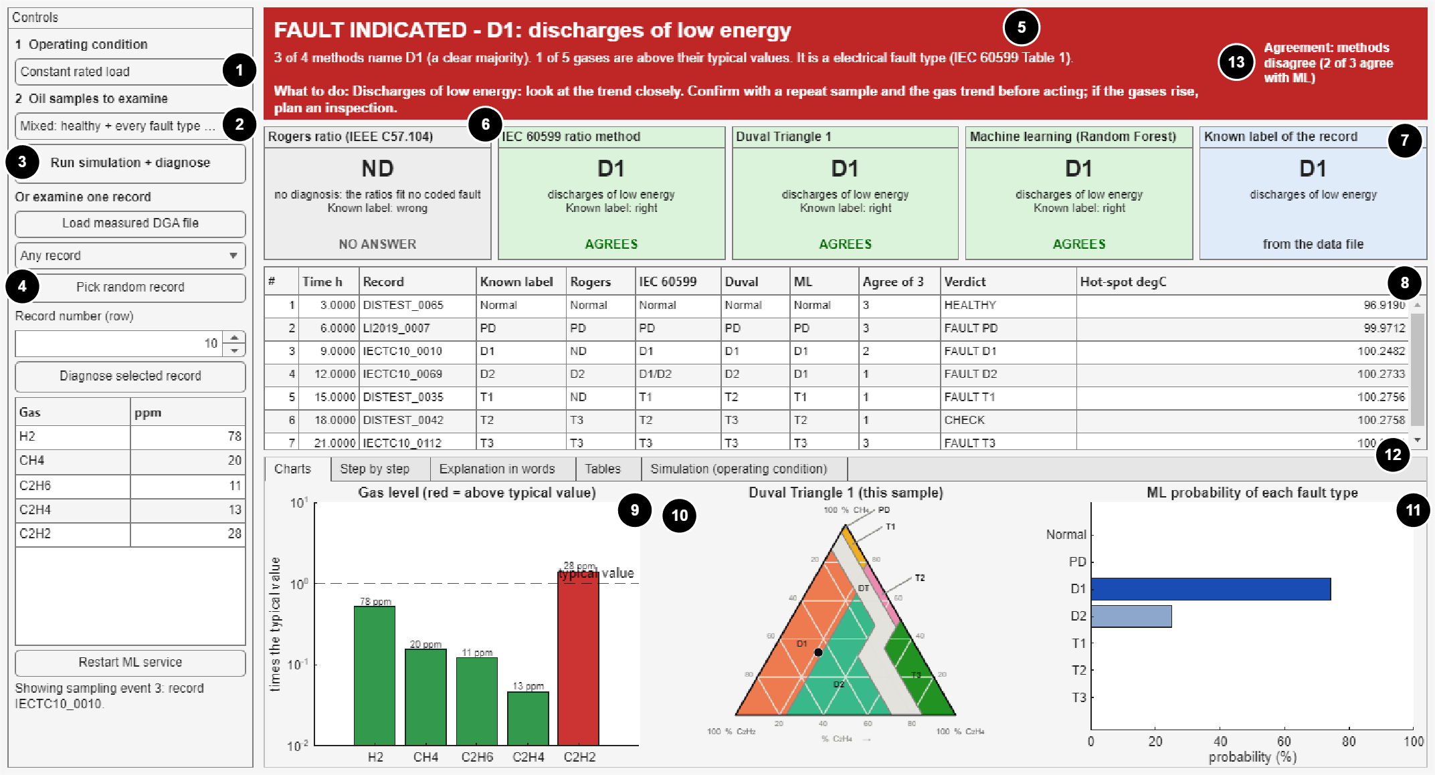
Fig. 8.6 The diagnostic dashboard after a simulated day with seven oil samples (one healthy and one of each fault type). Numbered parts: (1) operating condition of the simulated transformer; (2) which samples to examine; (3) run the simulation and diagnose; (4) pick a random record of a chosen type; (5) verdict banner; (6) method cards; (7) known label of the record; (8) sample table; (9) gas levels against the typical values; (10) the sample in the Duval Triangle; (11) ML class probabilities; (12) tabs; (13) agreement lamp

8.5.2 Operating Conditions and Sample Sets
The researcher can choose between three operating conditions, taken from the three operating scenarios described earlier in this chapter: constant rated load, a daily load cycle (three days are simulated and the last day is shown) and a short overload. The condition changes only the temperatures that the Simulink model calculates; it does not change any gas value. Three sample sets can be chosen. The mixed set takes one held-out record of each class (Normal, PD, D1, D2, T1, T2 and T3) at random, so that a healthy sample and every fault type are seen in one run, and a new set is drawn at each press. The random set takes seven held-out records at random. The first four set is the demonstration of the first version. The sampling times are passed to the Simulink model as values of the run, and the saved model is unchanged; the record that belongs to each sampling event is looked up outside the model, so the model still holds no gas value. A second route lets the user choose a fault type and pick a random record of that type.
The Run simulation button (3) runs the Simulink model and plots the top-oil and hot-spot temperatures as operating context. At each sampling event the dashboard diagnoses the record that belongs to it and adds a row to the sample table (8) with the simulated hot-spot temperature at that moment. In the example of Fig. 8.6 the records came from different published sources, so the gas levels and the answers of the methods differ a great deal from one sample to the next. This variety of states and of agreement between the methods is what the first version could not show.

8.5.3 How Often the Verdict Is Right
The verdict was computed for all 388 held-out records, using the ML answers that the test bench had saved (a descriptive check, not a new statistical test). Of the 346 records with a known fault, the verdict was FAULT for 242, HEALTHY for 7 and WATCH or CHECK for the rest. The 7 faults called healthy have very low gas levels and pass the typical-value check; this repeats the caution of IEC 60599 that the typical values describe what healthy transformers show and are not fault limits. Of the 10 records known to be normal, 7 were called healthy. When the verdict was FAULT and the true class was known (242 records), the exact fault type was right for 217 records and the right family, electrical or thermal, for 240. Where the banner shows WATCH or CHECK, the dashboard is telling the viewer that the evidence is not clear, which is a correct answer for a decision-support tool.

8.6 End-to-End Test Bench

8.6.1 The Test Run
For the formal evaluation, a test bench ran the integrated system over all 388 held-out records. The unchanged Simulink model was simulated with one sampling event every 15 min, about 97 h of simulated time in all. For each event the bench called exactly the functions that the dashboard uses, without drawing, and logged the answers and the response time (Fig. 8.7). The ML classes given at the events were Normal 16, PD 37, D1 72, D2 137, T1 35, T2 35, T3 56. All three conventional methods agreed with the ML class on 140 records (36.1 %), and none agreed on 112 (28.9 %), which shows again how often the methods differ on real records.
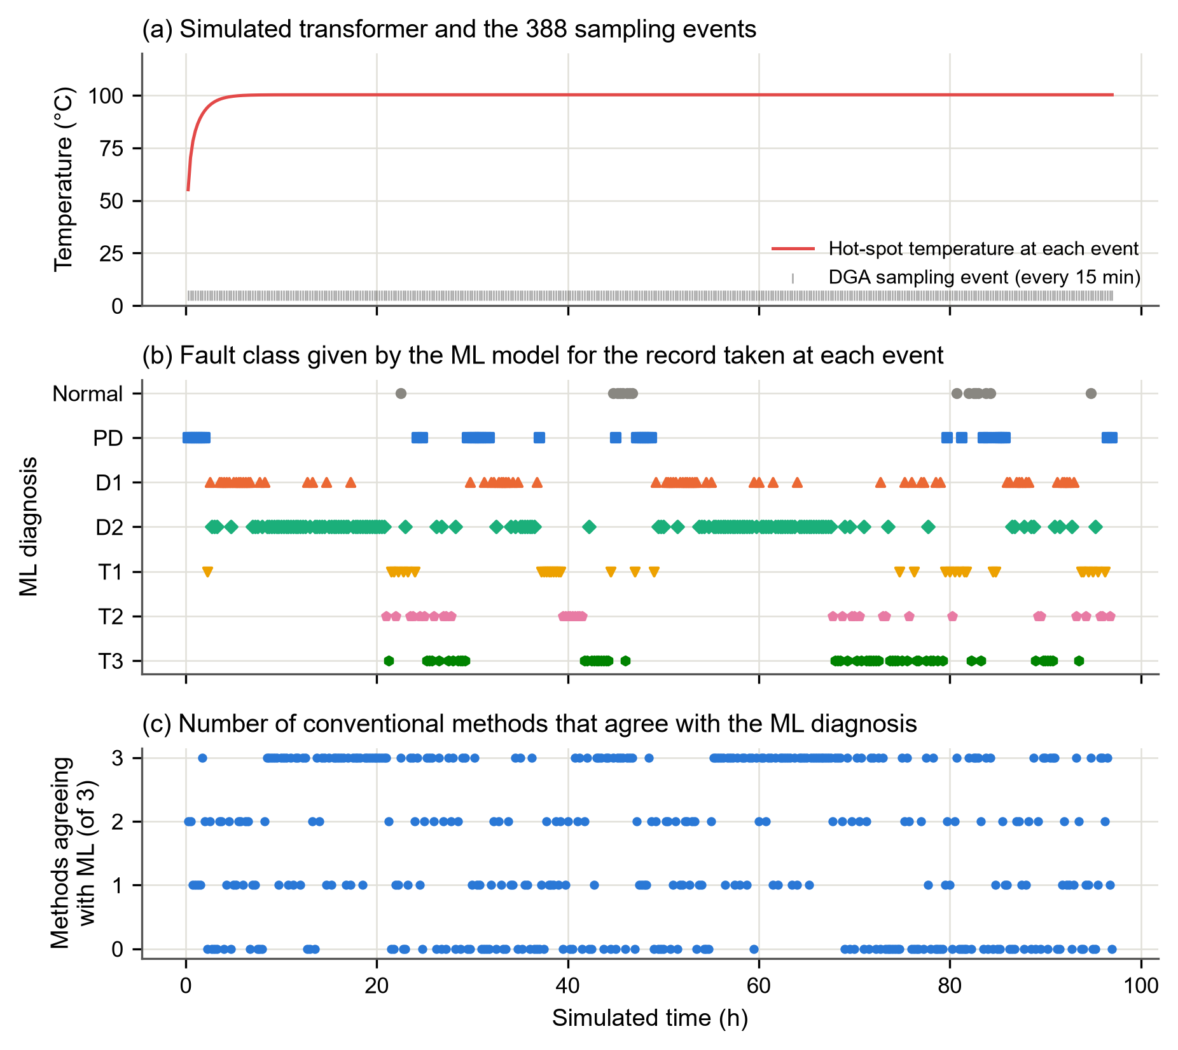
Fig. 8.7 Test-bench run over the 388 held-out records: (a) simulated hot-spot temperature and the sampling events; (b) ML diagnosis of the record taken at each event; (c) number of conventional methods that agree with the ML diagnosis

8.6.2 Fidelity and Response Time
Table 8.4 gives the fidelity and response time, and Fig. 8.8 shows the response time of every request.
Table 8.4 Fidelity and Response Time of the Integrated Framework
Group | Measure | Records | Value | Requirement
Fidelity | ML class identical to the offline prediction (F, Eq. 47) | 388/388 | 1 | F = 1
Fidelity | ML class identical - IEC TC 10 benchmark | 117/117 | 1 | F = 1
Fidelity | ML class identical - internal test | 70/70 | 1 | F = 1
Fidelity | ML class identical - external test (Li 2019) | 201/201 | 1 | F = 1
Fidelity | All 7 class probabilities identical | 388/388 | 1
Fidelity | Rogers Ratio answer identical to the offline result | 388/388 | 1
Fidelity | IEC 60599 ratio answer identical to the offline result | 388/388 | 1
Fidelity | Duval Triangle 1 answer identical to the offline result | 388/388 | 1
Fidelity | Failed service calls | 0/388 | 0 | 0
Response time (service request) | median - all records | 388 | 78.6 ms
Response time (service request) | 95th percentile - all records | 388 | 95.4 ms | < 1000 ms
Response time (service request) | median - without the 5 warm-up calls | 383 | 78.5 ms
Response time (service request) | 95th percentile - without the 5 warm-up calls | 383 | 95.1 ms
Response time (service request) | minimum - all records | 388 | 62.1 ms
Response time (service request) | maximum - all records | 388 | 157.7 ms
Conventional diagnoses in MATLAB | median - all records | 388 | 277.5 ms
Conventional diagnoses in MATLAB | 95th percentile - all records | 388 | 331.8 ms
Total per record (information) | median - all records | 388 | 468.7 ms
Total per record (information) | 95th percentile - all records | 388 | 548.4 ms
All 388 held-out records sent through the test bench; response time = time from sending the request to receiving the answer (client side, project laptop).
The integrated system returned exactly the offline ML class for all 388/388 records (fidelity F = 1), with all seven probabilities identical, and the three conventional answers were identical to the offline results for every record. No call failed. The response time of the service had a median of 78.6 ms and a 95th percentile of 95.4 ms (range 62.1 to 157.7 ms), far below the target of 1 000 ms. Without the first five "warm-up" calls the values were almost the same (78.5 and 95.1 ms). Both requirements of the fourth research question were therefore met.
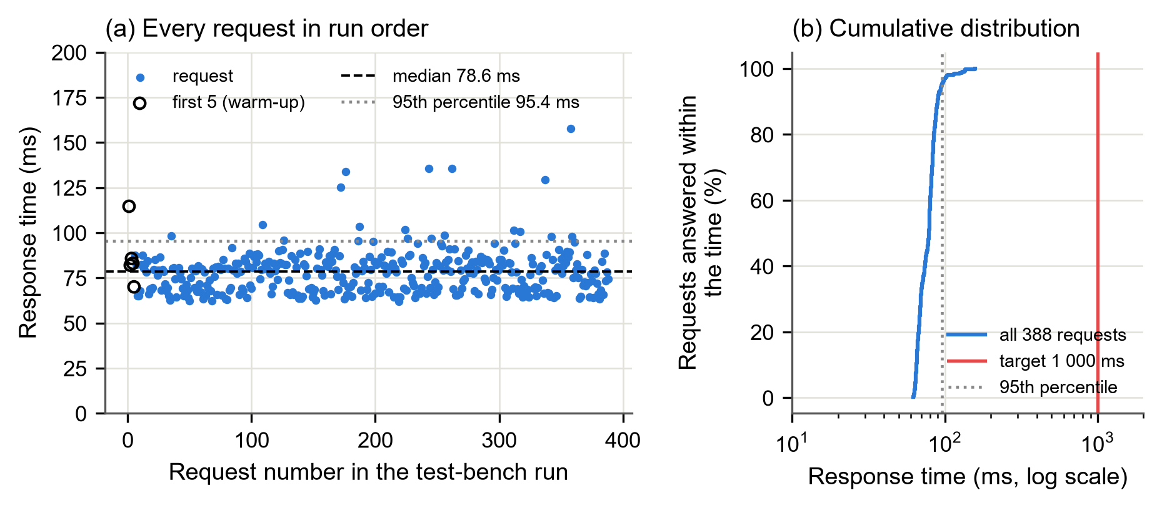
Fig. 8.8 Response time of the diagnosis service over the 388 requests of the test bench: (a) every request in run order with the median and the 95th percentile; (b) cumulative distribution with the 1 000 ms target
The complete processing of one record, including the three conventional diagnoses in MATLAB and the agreement check, took a median of 468.7 ms. 11 of the 388 records took more than 1 s in total, the longest 1964.1 ms; most of this time was spent in MATLAB, not in the service. The time for the whole record was reported for information only, because the requirement concerns the service request.

8.7 Discussion
Several recent studies have moved from classification experiments towards systems, such as digital twins with online diagnosis (Yao et al., 2024), data fusion on monitoring platforms (Cui et al., 2025) and probabilistic prognostics from DGA sensor data (Kashiwagi et al., 2025). These systems seldom show the conventional diagnosis that engineers already trust next to the ML answer, and they seldom report whether the deployed system reproduces the offline results on which its accuracy claims rest. The framework of this thesis does both. Its fidelity of 1 over all held-out records is a necessary condition for trusting a deployed model, because any error introduced by the deployment, such as a different pre-processing, a rounded input or a changed model file, would otherwise go unnoticed. The fingerprint check and the strict input validation make such errors visible.
The response time of under 100 ms at the 95th percentile on an ordinary laptop shows that the service is fast enough for interactive use; the main delay of the integrated system lies in the MATLAB part, which could be reduced if needed. The Simulink model was verified to well within its tolerance, but it represents a typical transformer with default thermal constants and illustrative load scenarios; its temperatures provide context for the diagnosis and are not used to make it.

8.8 Summary
An integrated framework was built in which a verified Simulink model of a 40 MVA transformer provides the operating context, MATLAB functions compute the conventional diagnoses, a FastAPI service provides the ML diagnosis, and a MATLAB App Designer dashboard shows them side by side with a verdict banner, method cards and an agreement lamp. Over all 388 held-out records the system reproduced the offline diagnoses exactly (fidelity 1) with no failed call, and the 95th-percentile response time of the service was 95.4 ms, well below the 1 000 ms target. The fourth research question is therefore answered positively.

CHAPTER 9
CONCLUSIONS AND RECOMMENDATIONS

9.1 Introduction
This research developed and evaluated an integrated MATLAB/Simulink–Python framework for diagnosing incipient faults of power transformers from measured dissolved gases. The framework produces conventional and machine-learning diagnoses from the same record, compares them statistically, and presents both to the engineer next to the simulated operating condition of the transformer. This chapter states the conclusions for each objective, answers the research questions, summarises the contributions and limitations of the work, and gives recommendations and suggestions for further work.

9.2 Conclusions
The conclusions are given objective by objective:
a. Conventional methods. The Rogers ratio, IEC 60599 ratio and Duval Triangle 1 methods were implemented in MATLAB from documented tables and verified against the worked examples of their sources and against an independent Python implementation, which gave identical answers on all 2 481 method–record pairs. The ratio methods left a large share of records without a diagnosis (IEC 60599 24.2 % and Rogers 35.8 % of 827 records), while the Duval Triangle always answered and was the most accurate conventional method on every test set.
b. Data. A table of 827 published records with five gases was assembled with documented label origin. The audit found and removed 139 development records that leaked test or benchmark cases, and it found that one published training file contains IEC TC 10 cases with relabelled faults. Only the 58 inspection-confirmed IEC TC 10 power transformers were therefore used as the main benchmark.
c. Machine learning. Five classifiers were compared by leakage-free nested cross-validation. A random forest on 18 engineered features was selected (macro-F1 0.850); it was statistically indistinguishable from XGBoost, and simple logistic regression came within 0.03. The model's explanations agree with gas-formation physics: acetylene drives the discharge classes, hydrogen and the CH₄/H₂ ratio drive partial discharge, and ethylene drives the high-temperature thermal faults.
d. Reduced gases. Only one reduced panel kept the loss of macro-F1 within the tolerance of 0.05: H₂, C₂H₆, C₂H₄ and C₂H₂, without methane (loss 0.017 [-0.006, 0.038]). No conventional method can interpret this panel, because all of them need methane. Hydrogen alone was far from sufficient for diagnosis.
e. ML versus conventional methods. On the internal and Li test sets the ML model was significantly more accurate than every conventional method. On the inspection-confirmed IEC TC 10 benchmark it was significantly more accurate than the Rogers method only; it did not differ significantly from IEC 60599, and the Duval Triangle had the higher point estimate (0.776 against 0.724). ML and the conventional methods agreed only fairly to moderately. With the normality gate, disagreement was not concentrated near the decision boundaries; without it, disagreement with the Duval Triangle did increase near its zone boundaries.
f. Integration. A Simulink model of a 40 MVA transformer met its verification tolerance by a wide margin (largest hot-spot difference 0.0152 K against 0.1 K). A FastAPI service and a MATLAB App Designer dashboard were linked to it. Over all 388 held-out records the integrated system returned exactly the offline diagnoses, with a 95th-percentile response time of 95.4 ms against the 1 000 ms target.

9.3 Answers to the Research Questions
Table 9.1 summarises the answers to the four research questions.
Table 9.1 Answers to the Research Questions
Research question | Answer
1. How does ML accuracy compare with that of the conventional methods on samples with independently confirmed faults? | On the inspection-confirmed benchmark the ML model was as accurate as IEC 60599 and the Duval Triangle (no significant difference) and better than Rogers. On the two other test sets it was significantly better than all three.
2. Where do the two approaches disagree, and is the disagreement concentrated near the conventional decision boundaries? | They disagree often (kappa only fair to moderate). With the normality gate, disagreement was not concentrated near the boundaries; without it, disagreement with the Duval Triangle was concentrated near its zone boundaries.
3. How much accuracy is lost with fewer gases, and what is the minimum useful panel? | Loss grows as gases are removed. The minimum panel is H₂, C₂H₆, C₂H₄ and C₂H₂ (loss 0.017), which no conventional method can interpret; hydrogen alone loses more than half of the macro-F1.
4. Can one interface return exactly the offline results quickly enough for interactive use? | Yes: fidelity 1 over 388 records, no failed call, 95th-percentile response time below 100 ms.

The research hypothesis, that a leakage-free ML classifier would diagnose more samples correctly than every conventional method, mainly because it answers where they do not, with disagreement concentrated near their boundaries, was not supported on the main benchmark and partly supported on the other two test sets.
The overall conclusion is that machine learning is a useful complement to conventional DGA interpretation, not a replacement for it. On clearly inspected faults the best conventional method is as accurate as a carefully validated ML model. ML, however, always gives an answer, works with gas panels that the conventional methods cannot use, and disagrees with them often enough that showing both answers together gives the engineer real information. The exploratory study suggests that a model that answers only when it is confident could be more accurate than the ratio methods at the same coverage; this needs confirmation on fresh data.

9.4 Contributions of the Research
The research makes the following contributions:
a. a provenance-audited DGA data table in which the origin of every fault label is documented and leakage between training and test data has been removed, with evidence that a widely available training file contains relabelled benchmark cases;
b. a comparison of ML with three conventional methods on the same inspection-confirmed records, using paired tests, coverage-aware accuracy and the home-advantage caveat, with the hypothesis criteria fixed before the results were computed;
c. a systematic study of all 31 gas subsets, identifying a four-gas panel that keeps the ML performance but cannot be interpreted by any conventional method;
d. an analysis of where ML and conventional diagnoses disagree, relating disagreement to the distance from the conventional decision boundaries; and
e. a working, verified framework that shows conventional and ML diagnoses side by side on a simulated transformer and reproduces the offline results exactly.

9.5 Limitations of the Study
The conclusions are limited by the following:
a. Only the IEC TC 10 data have inspection-confirmed labels, and among its 58 power transformers there is only one PD case and eight T1/T2 cases, so per-class results on the benchmark carry wide intervals. The labels of the other data sets are of unknown origin.
b. The IEC 60599 limits were refined on the IEC TC 10 cases, giving the conventional methods a home advantage on the main benchmark.
c. Carbon monoxide and carbon dioxide, which indicate faults involving paper, could not be used because most records lack them.
d. The full texts of IEC 60599:2022, IEEE C57.104-2019 and IEC 60076-7:2018 were not available. The limits come from the official previews of IEC 60599, the 2008 IEEE guide and peer-reviewed secondary sources.
e. The Simulink model represents a typical 40 MVA transformer with default thermal constants and illustrative load scenarios, and the framework was tested on a single laptop computer.
f. The improvement study is exploratory and needs confirmation on fresh data.

9.6 Recommendations
The following are recommended:
a. Utilities that interpret DGA results should show conventional and ML diagnoses side by side, as the dashboard of this study does, and treat samples on which they disagree as candidates for closer surveillance or resampling, rather than replacing the conventional methods.
b. The Duval Triangle should be kept as the reference conventional method. The Rogers ratio method should not be used alone, because it cannot diagnose low-energy discharges and leaves many samples without a diagnosis.
c. When online monitors are chosen for fault diagnosis rather than detection, monitors that measure at least H₂, C₂H₆, C₂H₄ and C₂H₂ should be preferred, and hydrogen-only monitors should be treated as fault detectors, not as diagnostic tools.
d. Researchers who report ML results for DGA should document the origin of their labels, remove duplicate and leaked records, use nested cross-validation and a class-balanced measure such as macro-F1, test on inspection-confirmed cases, compare with the conventional methods by paired tests, and state the home advantage of the conventional methods on the IEC TC 10 database.
e. Ghanaian utilities, such as the Ghana Grid Company, the Electricity Company of Ghana and the Volta River Authority, should be approached through the University for DGA records with inspection-confirmed faults; such data are needed to confirm the findings on local transformers.

9.7 Suggestions for Further Work
Further work could:
a. validate the model and the reject option on new inspection-confirmed data, preferably from Ghanaian utilities, and extend the inputs to CO and CO₂ so that faults involving paper can be identified;
b. replace the default thermal constants and the illustrative scenarios of the Simulink model with the nameplate and heat-run data and the measured load profiles of a real transformer, and confirm the limits of the conventional methods against the current full editions of IEC 60599, IEEE C57.104 and IEC 60076-7;
c. add the trend of gas generation rates and the uncertainty of laboratory measurements to the diagnosis; and
d. harden the service for networked use, with authentication, logging and monitoring, and test it on utility hardware.
REFERENCES
Abdelwahab, S. A. M., Taha, I. B. M., Fahim, R. and Ghoneim, S. S. M. (2025), "Transformer fault diagnose intelligent system based on DGA methods", Scientific Reports, Vol. 15, No. 1, Article 8263. DOI: 10.1038/s41598-024-78293-7.
Adekunle, A. A., Fofana, I., Picher, P., Rodriguez-Celis, E. M., Arroyo-Fernandez, O. H., Simard, H. and Lavoie, M.-A. (2025), "Multiclass Fault Diagnosis in Power Transformers Using Dissolved Gas Analysis and Grid Search-Optimized Machine Learning", Energies, Vol. 18, No. 13, Article 3535. DOI: 10.3390/en18133535.
Adu-Gyamfi, K. (2026), "Dissolved Gas Analysis-Based Power Transformer Fault Diagnosis Using Random Forest: A Comparative Evaluation Against K-Nearest Neighbors, Support Vector Machine, and Artificial Neural Network Classifiers", engrXiv preprint.
Ali, M. S., Abu Bakar, A. H., Omar, A., Abdul Jaafar, A. S. and Mohamed, S. H. (2023), "Conventional methods of dissolved gas analysis using oil-immersed power transformer for fault diagnosis: A review", Electric Power Systems Research, Vol. 216, Article 109064. DOI: 10.1016/j.epsr.2022.109064.
Al-Sakini, S. R., Bilal, G. A., Sadiq, A. T. and Al-Maliki, W. A. K. (2024), "Dissolved Gas Analysis for Fault Prediction in Power Transformers Using Machine Learning Techniques", Applied Sciences, Vol. 15, No. 1, Article 118. DOI: 10.3390/app15010118.
Anon. (2015), "Goal 7: Ensure access to affordable, reliable, sustainable and modern energy for all", United Nations, Department of Economic and Social Affairs – Sustainable Development, https://sdgs.un.org/goals/goal7. Accessed: October 13, 2026.
Anon. (2026), "GRIDCo technical challenge, transformer faults plunge Volta, Oti, Tema regions into darkness", Graphic Online, 23 April 2026, https://www.graphic.com.gh/news/general-news/gridco-technical-challenge-transformer-faults-plunge-volta-oti-tema-regions-into-darkness.html. Accessed: October 13, 2026.
Aslam, M., Haq, I. U., Rehan, M. S., Basit, A., Arif, M., Khan, M. I., Sadiq, M. and Arbab, M. N. (2021), "Dynamic Thermal Model for Power Transformers", IEEE Access, Vol. 9, pp. 71461 – 71469. DOI: 10.1109/access.2021.3078759.
Breiman, L. (2001), "Random Forests", Machine Learning, Vol. 45, No. 1, pp. 5 – 32. DOI: 10.1023/a:1010933404324.
Bustamante, S., Manana, M., Arroyo, A., Castro, P., Laso, A. and Martinez, R. (2019), "Dissolved Gas Analysis Equipment for Online Monitoring of Transformer Oil: A Review", Sensors, Vol. 19, No. 19, Article 4057. DOI: 10.3390/s19194057.
Chawla, N. V., Bowyer, K. W., Hall, L. O. and Kegelmeyer, W. P. (2002), "SMOTE: Synthetic Minority Over-sampling Technique", Journal of Artificial Intelligence Research, Vol. 16, pp. 321 – 357. DOI: 10.1613/jair.953.
Cheng, L. and Yu, T. (2018), "Dissolved Gas Analysis Principle-Based Intelligent Approaches to Fault Diagnosis and Decision Making for Large Oil-Immersed Power Transformers: A Survey", Energies, Vol. 11, No. 4, Article 913. DOI: 10.3390/en11040913.
Chen, H. C. and Zhang, Y. (2025), "Rethinking Shallow and Deep Learnings for Transformer Dissolved Gas Analysis: A Review", IEEE Transactions on Dielectrics and Electrical Insulation, Vol. 32, No. 1, pp. 3 – 10. DOI: 10.1109/tdei.2025.3526080.
Chen, T. and Guestrin, C. (2016), "XGBoost: A Scalable Tree Boosting System", Proceedings of the 22nd ACM SIGKDD International Conference on Knowledge Discovery and Data Mining, pp. 785 – 794. DOI: 10.1145/2939672.2939785.
Chow, C. K. (1970), "On optimum recognition error and reject tradeoff", IEEE Transactions on Information Theory, Vol. 16, No. 1, pp. 41 – 46. DOI: 10.1109/tit.1970.1054406.
Cochran, W. G. (1950), "The Comparison of Percentages in Matched Samples", Biometrika, Vol. 37, No. 3/4, pp. 256 – 266. DOI: 10.2307/2332378.
Cohen, J. (1960), "A Coefficient of Agreement for Nominal Scales", Educational and Psychological Measurement, Vol. 20, No. 1, pp. 37 – 46. DOI: 10.1177/001316446002000104.
Cui, J., Kuang, W., Geng, K. and Jiao, P. (2025), "Intelligent fault diagnosis and operation condition monitoring of transformer based on multi-source data fusion and mining", Scientific Reports, Vol. 15, No. 1, Article 7606. DOI: 10.1038/s41598-025-91862-8.
Das, S., Paramane, A., Chatterjee, S. and Rao, U. M. (2023), "Accurate Identification of Transformer Faults From Dissolved Gas Data Using Recursive Feature Elimination Method", IEEE Transactions on Dielectrics and Electrical Insulation, Vol. 30, No. 1, pp. 466 – 473. DOI: 10.1109/tdei.2022.3215936.
Demšar, J. (2006), "Statistical Comparisons of Classifiers over Multiple Data Sets", Journal of Machine Learning Research, Vol. 7, pp. 1 – 30.
Dissanayake, T. (2026), "DGA dataset", IEEE DataPort, DOI: 10.21227/27vy-h479.
Dladla, V. M. N. and Thango, B. A. (2025a), "Fault Classification in Power Transformers via Dissolved Gas Analysis and Machine Learning Algorithms: A Systematic Literature Review", Applied Sciences, Vol. 15, No. 5, Article 2395. DOI: 10.3390/app15052395.
Dladla, V. M. N. and Thango, B. A. (2025b), "Fault Classification in Power Transformers Using Dissolved Gas Analysis and Optimized Machine Learning Algorithms", Machines, Vol. 13, No. 8, Article 742. DOI: 10.3390/machines13080742.
Doğan, K., Ertarğın, M., Çalışkan, A. and Bakay, A. (2026), "A Unified and Interpretable Benchmark of Classification Models for DGA-Based Power Transformer Fault Diagnosis", Applied Sciences, Vol. 16, No. 17, Article 8818. DOI: 10.3390/app16178818.
Dotse, D. W. (2024), "ECG's attribution of outages to overloaded transformers not true – PURC", Graphic Online, 16 April 2024, https://graphic.com.gh/news/general-news/ecgs-attribution-of-outages-to-overloaded-transformers-not-true-purc.html. Accessed: October 13, 2026.
Duval, M. and dePablo, A. (2001), "Interpretation of gas-in-oil analysis using new IEC publication 60599 and IEC TC 10 databases", IEEE Electrical Insulation Magazine, Vol. 17, No. 2, pp. 31 – 41. DOI: 10.1109/57.917529.
Duval, M. and Paulhiac, L. (2026), "New DGA Interpretation Method Using Specific Gas Limits Versus Type of Faults in Power Transformers", IEEE Transactions on Dielectrics and Electrical Insulation, Vol. 33, No. 4, pp. 3053 – 3060. DOI: 10.1109/tdei.2026.3657732.
Duval, M. (2002), "A review of faults detectable by gas-in-oil analysis in transformers", IEEE Electrical Insulation Magazine, Vol. 18, No. 3, pp. 8 – 17. DOI: 10.1109/mei.2002.1014963.
Efron, B. and Tibshirani, R. J. (1993), An Introduction to the Bootstrap, Chapman and Hall, New York, USA. DOI: 10.1007/978-1-4899-4541-9.
Ekojono, Prasojo, R. A., Apriyani, M. E. and Rahmanto, A. N. (2022), "Investigation on machine learning algorithms to support transformer dissolved gas analysis fault identification", Electrical Engineering, Vol. 104, No. 5, pp. 3037 – 3047. DOI: 10.1007/s00202-022-01532-5.
Fielding, R., Nottingham, M. and Reschke, J. (2022), "HTTP Semantics", RFC 9110, STD 97, RFC Editor. DOI: 10.17487/rfc9110.
Firth, D. (1993), "Bias reduction of maximum likelihood estimates", Biometrika, Vol. 80, No. 1, pp. 27 – 38. DOI: 10.1093/biomet/80.1.27.
Friedman, M. (1937), "The Use of Ranks to Avoid the Assumption of Normality Implicit in the Analysis of Variance", Journal of the American Statistical Association, Vol. 32, No. 200, pp. 675 – 701. DOI: 10.1080/01621459.1937.10503522.
Ghoneim, S. S. M., Taha, I. B. M. and Elkalashy, N. I. (2016), "Integrated ANN-based proactive fault diagnostic scheme for power transformers using dissolved gas analysis", IEEE Transactions on Dielectrics and Electrical Insulation, Vol. 23, No. 3, pp. 1838 – 1845. DOI: 10.1109/tdei.2016.005301.
Gorodkin, J. (2004), "Comparing two K-category assignments by a K-category correlation coefficient", Computational Biology and Chemistry, Vol. 28, No. 5-6, pp. 367 – 374. DOI: 10.1016/j.compbiolchem.2004.09.006.
Hechifa, A., Lakehal, A., Nanfak, A., Saidi, L., Labiod, C., Kelaiaia, R. and Ghoneim, S. S. M. (2024), "Improved intelligent methods for power transformer fault diagnosis based on tree ensemble learning and multiple feature vector analysis", Electrical Engineering, Vol. 106, No. 3, pp. 2575 – 2594. DOI: 10.1007/s00202-023-02084-y.
Holm, S. (1979), "A Simple Sequentially Rejective Multiple Test Procedure", Scandinavian Journal of Statistics, Vol. 6, No. 2, pp. 65 – 70.
IEC (2007), Mineral oil-impregnated electrical equipment in service – Guide to the interpretation of dissolved and free gases analysis, IEC 60599:1999+A1:2007, Edition 2.1, International Electrotechnical Commission, Geneva, Switzerland.
IEC (2018), Power transformers – Part 7: Loading guide for mineral-oil-immersed power transformers, IEC 60076-7:2018, Edition 2.0, International Electrotechnical Commission, Geneva, Switzerland.
IEEE (2009), IEEE Guide for the Interpretation of Gases Generated in Oil-Immersed Transformers, IEEE Std C57.104-2008, Institute of Electrical and Electronics Engineers, New York, USA.
Jin, L., Kim, D., Chan, K. Y. and Abu-Siada, A. (2024), "Deep Machine Learning-Based Asset Management Approach for Oil- Immersed Power Transformers Using Dissolved Gas Analysis", IEEE Access, Vol. 12, pp. 27794 – 27809. DOI: 10.1109/access.2024.3366905.
Kapoor, S. and Narayanan, A. (2023), "Leakage and the reproducibility crisis in machine-learning-based science", Patterns, Vol. 4, No. 9, Article 100804. DOI: 10.1016/j.patter.2023.100804.
Kashiwagi, F. N., Michalski, M. A. D. C., de Souza, G. F. M., da Silva, H. J. B. and Côrtes, H. M. (2025), "Probabilistic Prognostics and Health Management of Power Transformers Using Dissolved Gas Analysis Sensor Data and Duval’s Polygons", Sensors, Vol. 25, No. 21, Article 6520. DOI: 10.3390/s25216520.
Kruskal, W. H. and Wallis, W. A. (1952), "Use of Ranks in One-Criterion Variance Analysis", Journal of the American Statistical Association, Vol. 47, No. 260, pp. 583 – 621. DOI: 10.1080/01621459.1952.10483441.
Li, E. (2019), "Dissolved gas data in transformer oil – Fault Diagnosis of Power Transformers with Membership Degree", IEEE DataPort, DOI: 10.21227/h8g0-8z59.
Li, J., Liao, C., Liu, X., Gong, W., Xie, J. and Yang, J. (2026), "Fault Diagnosis of Power Transformer Based on Centroid Distance Feature and Explainable Machine Learning", IET Electric Power Applications, Vol. 20, No. 1, Article e70195. DOI: 10.1049/elp2.70195.
Liu, D. C. and Nocedal, J. (1989), "On the limited memory BFGS method for large scale optimization", Mathematical Programming, Vol. 45, No. 1-3, pp. 503 – 528. DOI: 10.1007/bf01589116.
Lundberg, S. M. and Lee, S.-I. (2017), "A Unified Approach to Interpreting Model Predictions", Advances in Neural Information Processing Systems 30 (NIPS 2017), Long Beach, USA, pp. 4765 – 4774.
Lundberg, S. M., Erion, G., Chen, H., DeGrave, A., Prutkin, J. M., Nair, B., Katz, R., Himmelfarb, J., Bansal, N. and Lee, S.-I. (2020), "From local explanations to global understanding with explainable AI for trees", Nature Machine Intelligence, Vol. 2, No. 1, pp. 56 – 67. DOI: 10.1038/s42256-019-0138-9.
Manisha, Kaur, K., Sharma, N. K., Singh, J. and Bhalla, D. (2022), "Performance Assessment of IEEE/IEC Method and Duval Triangle technique for Transformer Incipient Fault Diagnosis", IOP Conference Series: Materials Science and Engineering, Vol. 1228, No. 1, Article 012027. DOI: 10.1088/1757-899x/1228/1/012027.
Manoj, T., Ranga, C., Ghoneim, S. S. M., Rao, U. M. and Abdelwahab, S. A. M. (2023), "Alternate and Effective Dissolved Gas Interpretation to Understand the Transformer Incipient Faults", IEEE Transactions on Dielectrics and Electrical Insulation, Vol. 30, No. 3, pp. 1231 – 1239. DOI: 10.1109/tdei.2023.3237795.
Martin, D. and Tenbohlen, S. (2026), "Power Transformer Component Reliability Using CIGRE Large-Scale Data Surveys", Energies, Vol. 19, No. 13, Article 3197. DOI: 10.3390/en19133197.
Martin, D., Lelekakis, N., Wijaya, J., Duval, M. and Saha, T. (2014), "Investigations Into the Stray Gassing of Oils in the Fault Diagnosis of Transformers", IEEE Transactions on Power Delivery, Vol. 29, No. 5, pp. 2369 – 2374. DOI: 10.1109/tpwrd.2014.2316501.
Martin, D., Marks, J. and Saha, T. (2017), "Survey of Australian power transformer failures and retirements", IEEE Electrical Insulation Magazine, Vol. 33, No. 5, pp. 16 – 22. DOI: 10.1109/mei.2017.8014387.
McNemar, Q. (1947), "Note on the Sampling Error of the Difference Between Correlated Proportions or Percentages", Psychometrika, Vol. 12, No. 2, pp. 153 – 157. DOI: 10.1007/bf02295996.
Mitchell, M., Wu, S., Zaldivar, A., Barnes, P., Vasserman, L., Hutchinson, B., Spitzer, E., Raji, I. D. and Gebru, T. (2019), "Model Cards for Model Reporting", Proceedings of the Conference on Fairness, Accountability, and Transparency, pp. 220 – 229. DOI: 10.1145/3287560.3287596.
Moser, A. (2025), "The Duval Triangle for Transformer Fault Diagnosis", HV Assets, published 20 May 2025, updated 20 July 2025. Accessed: October 10, 2026.
Murugan, R. and Ramasamy, R. (2019), "Understanding the power transformer component failures for health index-based maintenance planning in electric utilities", Engineering Failure Analysis, Vol. 96, pp. 274 – 288. DOI: 10.1016/j.engfailanal.2018.10.011.
Nadeau, C. and Bengio, Y. (2003), "Inference for the Generalization Error", Machine Learning, Vol. 52, No. 3, pp. 239 – 281. DOI: 10.1023/a:1024068626366.
Nanfak, A., Eke, S., Kom, C. H., Mouangue, R. and Fofana, I. (2021), "Interpreting dissolved gases in transformer oil: A new method based on the analysis of labelled fault data", IET Generation, Transmission & Distribution, Vol. 15, No. 21, pp. 3032 – 3047. DOI: 10.1049/gtd2.12239.
NIST (2015), Secure Hash Standard (SHS), FIPS PUB 180-4, National Institute of Standards and Technology, Gaithersburg, USA.
Nkwambe, M. S. and Thango, B. A. (2026), "Power Transformer Fault Classification from Dissolved Gas Analysis Using Principal Component Analysis and Artificial Neural Networks", Energies, Vol. 19, No. 13, Article 2947. DOI: 10.3390/en19132947.
Owusu, D. (2026), "Data-driven Fault Detection and Diagnosis of Power Transformers Using Dissolved Gas Analysis and Random Forest Classifiers", Automation, Control and Intelligent Systems, Vol. 14, No. 1, pp. 14 – 28. DOI: 10.11648/j.acis.20261401.13.
Pedregosa, F., Varoquaux, G., Gramfort, A., Michel, V., Thirion, B., Grisel, O., Blondel, M., Prettenhofer, P., Weiss, R., Dubourg, V., Vanderplas, J., Passos, A., Cournapeau, D., Brucher, M., Perrot, M. and Duchesnay, E. (2011), "Scikit-learn: Machine Learning in Python", Journal of Machine Learning Research, Vol. 12, pp. 2825 – 2830.
Platt, J. C. (1999), "Probabilistic Outputs for Support Vector Machines and Comparisons to Regularized Likelihood Methods", In Advances in Large Margin Classifiers, Smola, A., Bartlett, P., Schölkopf, B. and Schuurmans, D. (eds.), MIT Press, Cambridge, USA, pp. 61 – 74.
Prasojo, R. A., Putra, M. A. A., Ekojono, Apriyani, M. E., Rahmanto, A. N., Ghoneim, S. S. M., Mahmoud, K., Lehtonen, M. and Darwish, M. M. F. (2023), "Precise transformer fault diagnosis via random forest model enhanced by synthetic minority over-sampling technique", Electric Power Systems Research, Vol. 220, Article 109361. DOI: 10.1016/j.epsr.2023.109361.
Rajora, G. L., Sanz‐Bobi, M. A., Tjernberg, L. B. and Urrea Cabus, J. E. (2024), "A review of asset management using artificial intelligence‐based machine learning models: Applications for the electric power and energy system", IET Generation, Transmission & Distribution, Vol. 18, No. 12, pp. 2155 – 2170. DOI: 10.1049/gtd2.13183.
Rangel Bessa, A., Farias Fardin, J., Marques Ciarelli, P. and Frizera Encarnação, L. (2023), "Conventional Dissolved Gases Analysis in Power Transformers: Review", Energies, Vol. 16, No. 21, Article 7219. DOI: 10.3390/en16217219.
Rao, U. M., Fofana, I., Rajesh, K. N. V. P. S. and Picher, P. (2021), "Identification and Application of Machine Learning Algorithms for Transformer Dissolved Gas Analysis", IEEE Transactions on Dielectrics and Electrical Insulation, Vol. 28, No. 5, pp. 1828 – 1835. DOI: 10.1109/tdei.2021.009770.
Rogers, R. R. (1978), "IEEE and IEC Codes to Interpret Incipient Faults in Transformers, Using Gas in Oil Analysis", IEEE Transactions on Electrical Insulation, Vol. EI-13, No. 5, pp. 349 – 354. DOI: 10.1109/tei.1978.298141.
Selim, F. F., Hassan, M. A., Azmy, A. M. and Atiya, E. G. (2025), "Graphical Shape in Cartesian Plane Based on Dissolved Gas Analysis for Power Transformer Incipient Faults Discrimination", IEEE Transactions on Dielectrics and Electrical Insulation, Vol. 32, No. 1, pp. 589 – 597. DOI: 10.1109/tdei.2024.3404365.
Spearman, C. (1904), "The Proof and Measurement of Association between Two Things", The American Journal of Psychology, Vol. 15, No. 1, pp. 72 – 101. DOI: 10.2307/1412159.
Strobl, C., Boulesteix, A.-L., Kneib, T., Augustin, T. and Zeileis, A. (2008), "Conditional variable importance for random forests", BMC Bioinformatics, Vol. 9, No. 1, Article 307. DOI: 10.1186/1471-2105-9-307.
Su, P., Madan, R. and Purushothaman, S. (2024), "Testing and approval standard development of online dissolved gas analysis monitors for oil‐filled transformers—Part I hydrogen monitors", Process Safety Progress, Vol. 43, No. 4, pp. 686 – 694. DOI: 10.1002/prs.12636.
Susa, D., Lehtonen, M. and Nordman, H. (2005), "Dynamic Thermal Modelling of Power Transformers", IEEE Transactions on Power Delivery, Vol. 20, No. 1, pp. 197 – 204. DOI: 10.1109/tpwrd.2004.835255.
Suwarno, Sutikno, H., Prasojo, R. A. and Abu-Siada, A. (2024), "Machine learning based multi-method interpretation to enhance dissolved gas analysis for power transformer fault diagnosis", Heliyon, Vol. 10, No. 4, Article e25975. DOI: 10.1016/j.heliyon.2024.e25975.
Taha, I. B. M., Ibrahim, S. and Mansour, D.-E. A. (2021), "Power Transformer Fault Diagnosis Based on DGA Using a Convolutional Neural Network With Noise in Measurements", IEEE Access, Vol. 9, pp. 111162 – 111170. DOI: 10.1109/access.2021.3102415.
Tanjim, R., Ahmed, T., Mostafa, M., Hannan, N., Shufian, A. and Pathik, B. B. (2026), "A CatBoost-based framework for data-driven fault diagnosis in power transformers using dissolved gas analysis", Results in Engineering, Vol. 30, Article 109972. DOI: 10.1016/j.rineng.2026.109972.
Tenbohlen, S., Jagers, J. and Vahidi, F. (2017), "Standardized survey of transformer reliability: On behalf of CIGRE WG A2.37", 2017 International Symposium on Electrical Insulating Materials (ISEIM), pp. 593 – 596. DOI: 10.23919/iseim.2017.8166559.
Thurner, L., Scheidler, A., Schafer, F., Menke, J.-H., Dollichon, J., Meier, F., Meinecke, S. and Braun, M. (2018), "Pandapower—An Open-Source Python Tool for Convenient Modeling, Analysis, and Optimization of Electric Power Systems", IEEE Transactions on Power Systems, Vol. 33, No. 6, pp. 6510 – 6521. DOI: 10.1109/tpwrs.2018.2829021.
Varma, S. and Simon, R. (2006), "Bias in error estimation when using cross-validation for model selection", BMC Bioinformatics, Vol. 7, No. 1, Article 91. DOI: 10.1186/1471-2105-7-91.
Wajid, A., Rehman, A. U., Iqbal, S., Pushkarna, M., Hussain, S. M., Kotb, H., Alharbi, M. and Zaitsev, I. (2023), "Comparative Performance Study of Dissolved Gas Analysis (DGA) Methods for Identification of Faults in Power Transformer", International Journal of Energy Research, Vol. 2023, pp. 1 – 14. DOI: 10.1155/2023/9960743.
Wang, L., Littler, T. and Liu, X. (2021), "Gaussian Process Multi-Class Classification for Transformer Fault Diagnosis Using Dissolved Gas Analysis", IEEE Transactions on Dielectrics and Electrical Insulation, Vol. 28, No. 5, pp. 1703 – 1712. DOI: 10.1109/tdei.2021.009470.
Wang, T., Li, Q., Yang, J., Xie, T., Wu, P. and Liang, J. (2023), "Transformer Fault Diagnosis Method Based on Incomplete Data and TPE-XGBoost", Applied Sciences, Vol. 13, No. 13, Article 7539. DOI: 10.3390/app13137539.
Wang, X., Yang, L., Wang, K., Zhao, Y., Cheng, L., Chen, C., Wang, X. and Liao, R. (2024), "Thermodynamic Computational Method of Thermal Decomposition Gas Content in Transformer Oil Considering Temperature and Competitive Reaction", IEEE Transactions on Dielectrics and Electrical Insulation, Vol. 31, No. 3, pp. 1331 – 1339. DOI: 10.1109/tdei.2024.3351591.
Ward, S. A., El-Faraskoury, A., Badawi, M., Ibrahim, S. A., Mahmoud, K., Lehtonen, M. and Darwish, M. M. F. (2021), "Towards Precise Interpretation of Oil Transformers via Novel Combined Techniques Based on DGA and Partial Discharge Sensors", Sensors, Vol. 21, No. 6, Article 2223. DOI: 10.3390/s21062223.
Wilson, E. B. (1927), "Probable Inference, the Law of Succession, and Statistical Inference", Journal of the American Statistical Association, Vol. 22, No. 158, pp. 209 – 212. DOI: 10.1080/01621459.1927.10502953.
Yao, H., Zhang, X., Guo, Q., Miao, Y. and Guan, S. (2024), "Fault diagnosis method for oil-immersed transformers integrated digital twin model", Scientific Reports, Vol. 14, No. 1, Article 20355. DOI: 10.1038/s41598-024-71107-w.
Zhang, L., Luo, Y., Sheng, G., Ni, Z. and Jiang, X. (2024), "Improving IEC thermal model for oil natural air natural transformers using optimised parameters based on dynamic simulation", High Voltage, Vol. 9, No. 1, pp. 217 – 229. DOI: 10.1049/hve2.12374.
Zhang, Y., Tang, Y., Liu, Y. and Liang, Z. (2022), "Fault diagnosis of transformer using artificial intelligence: A review", Frontiers in Energy Research, Vol. 10, Article 1006474. DOI: 10.3389/fenrg.2022.1006474.
APPENDICES
APPENDIX A
DIAGRAMS OF THE SIMULINK SUBSYSTEMS
The diagrams below were exported from the final Simulink model (MATLAB R2025b) by a read-only script; the SHA-256 fingerprint of the model file was the same before and after the export. The explanatory annotation bars of each subsystem are omitted; their content is summarised in the captions. Subsystem SS6 is shown in Chapter 8 (Fig. 8.2).
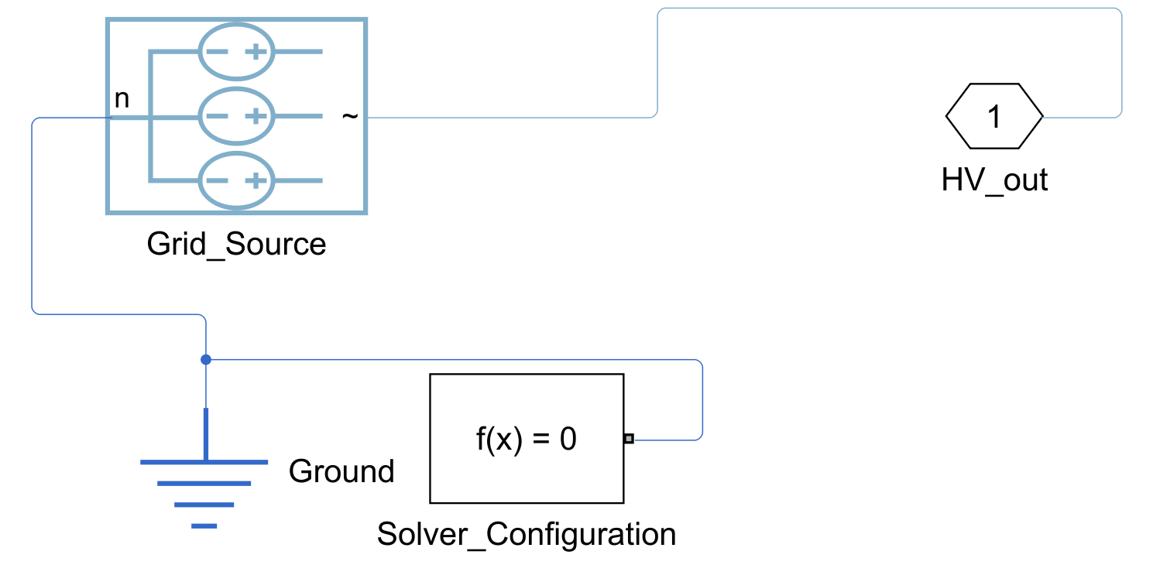
Fig. A1 SS1 Grid supply: three-phase 110 kV source with its electrical reference and solver configuration
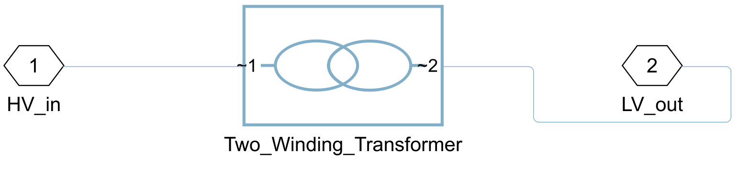
Fig. A2 SS2 Power transformer: two-winding 40 MVA, 110/20 kV transformer (Simscape Electrical); impedance and losses from the parameter script
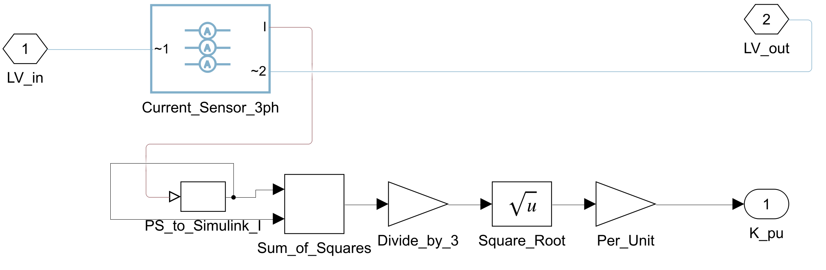
Fig. A3 SS3 LV measurement: three-phase current sensor; the load factor K is the RMS current divided by the rated current
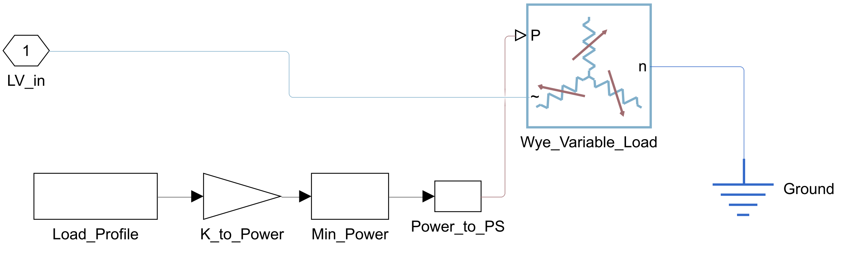
Fig. A4 SS4 Variable load: the load profile (per unit) drives a wye-connected variable load
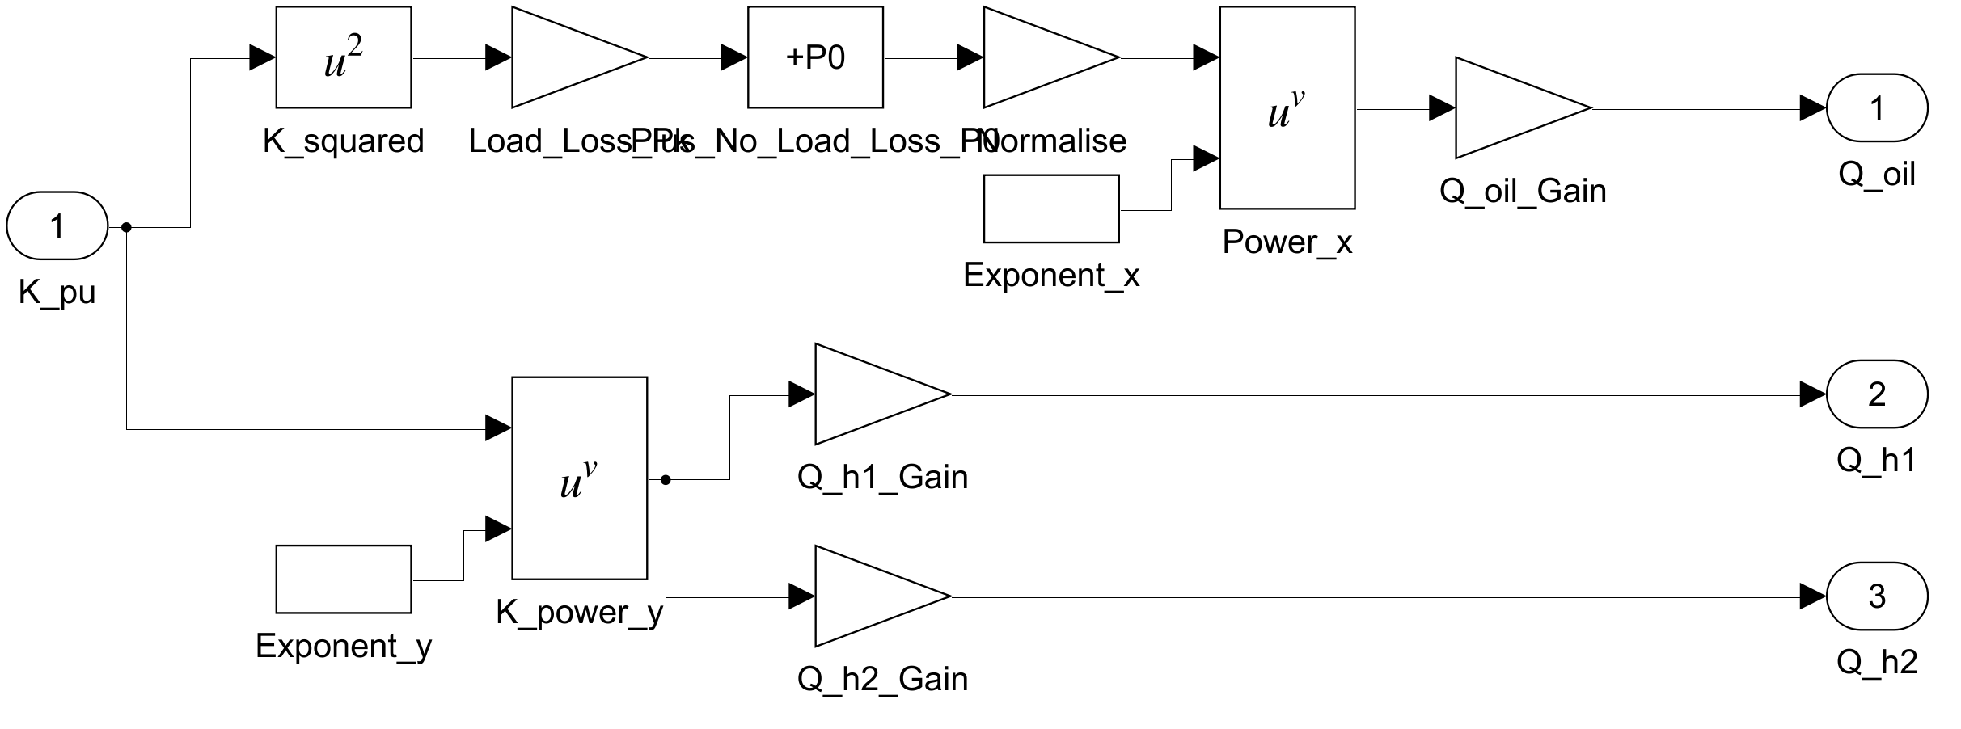
Fig. A5 SS5 Losses to heat: load and no-load losses converted into the heat inputs of the oil and hot-spot circuits (Simulink arithmetic)
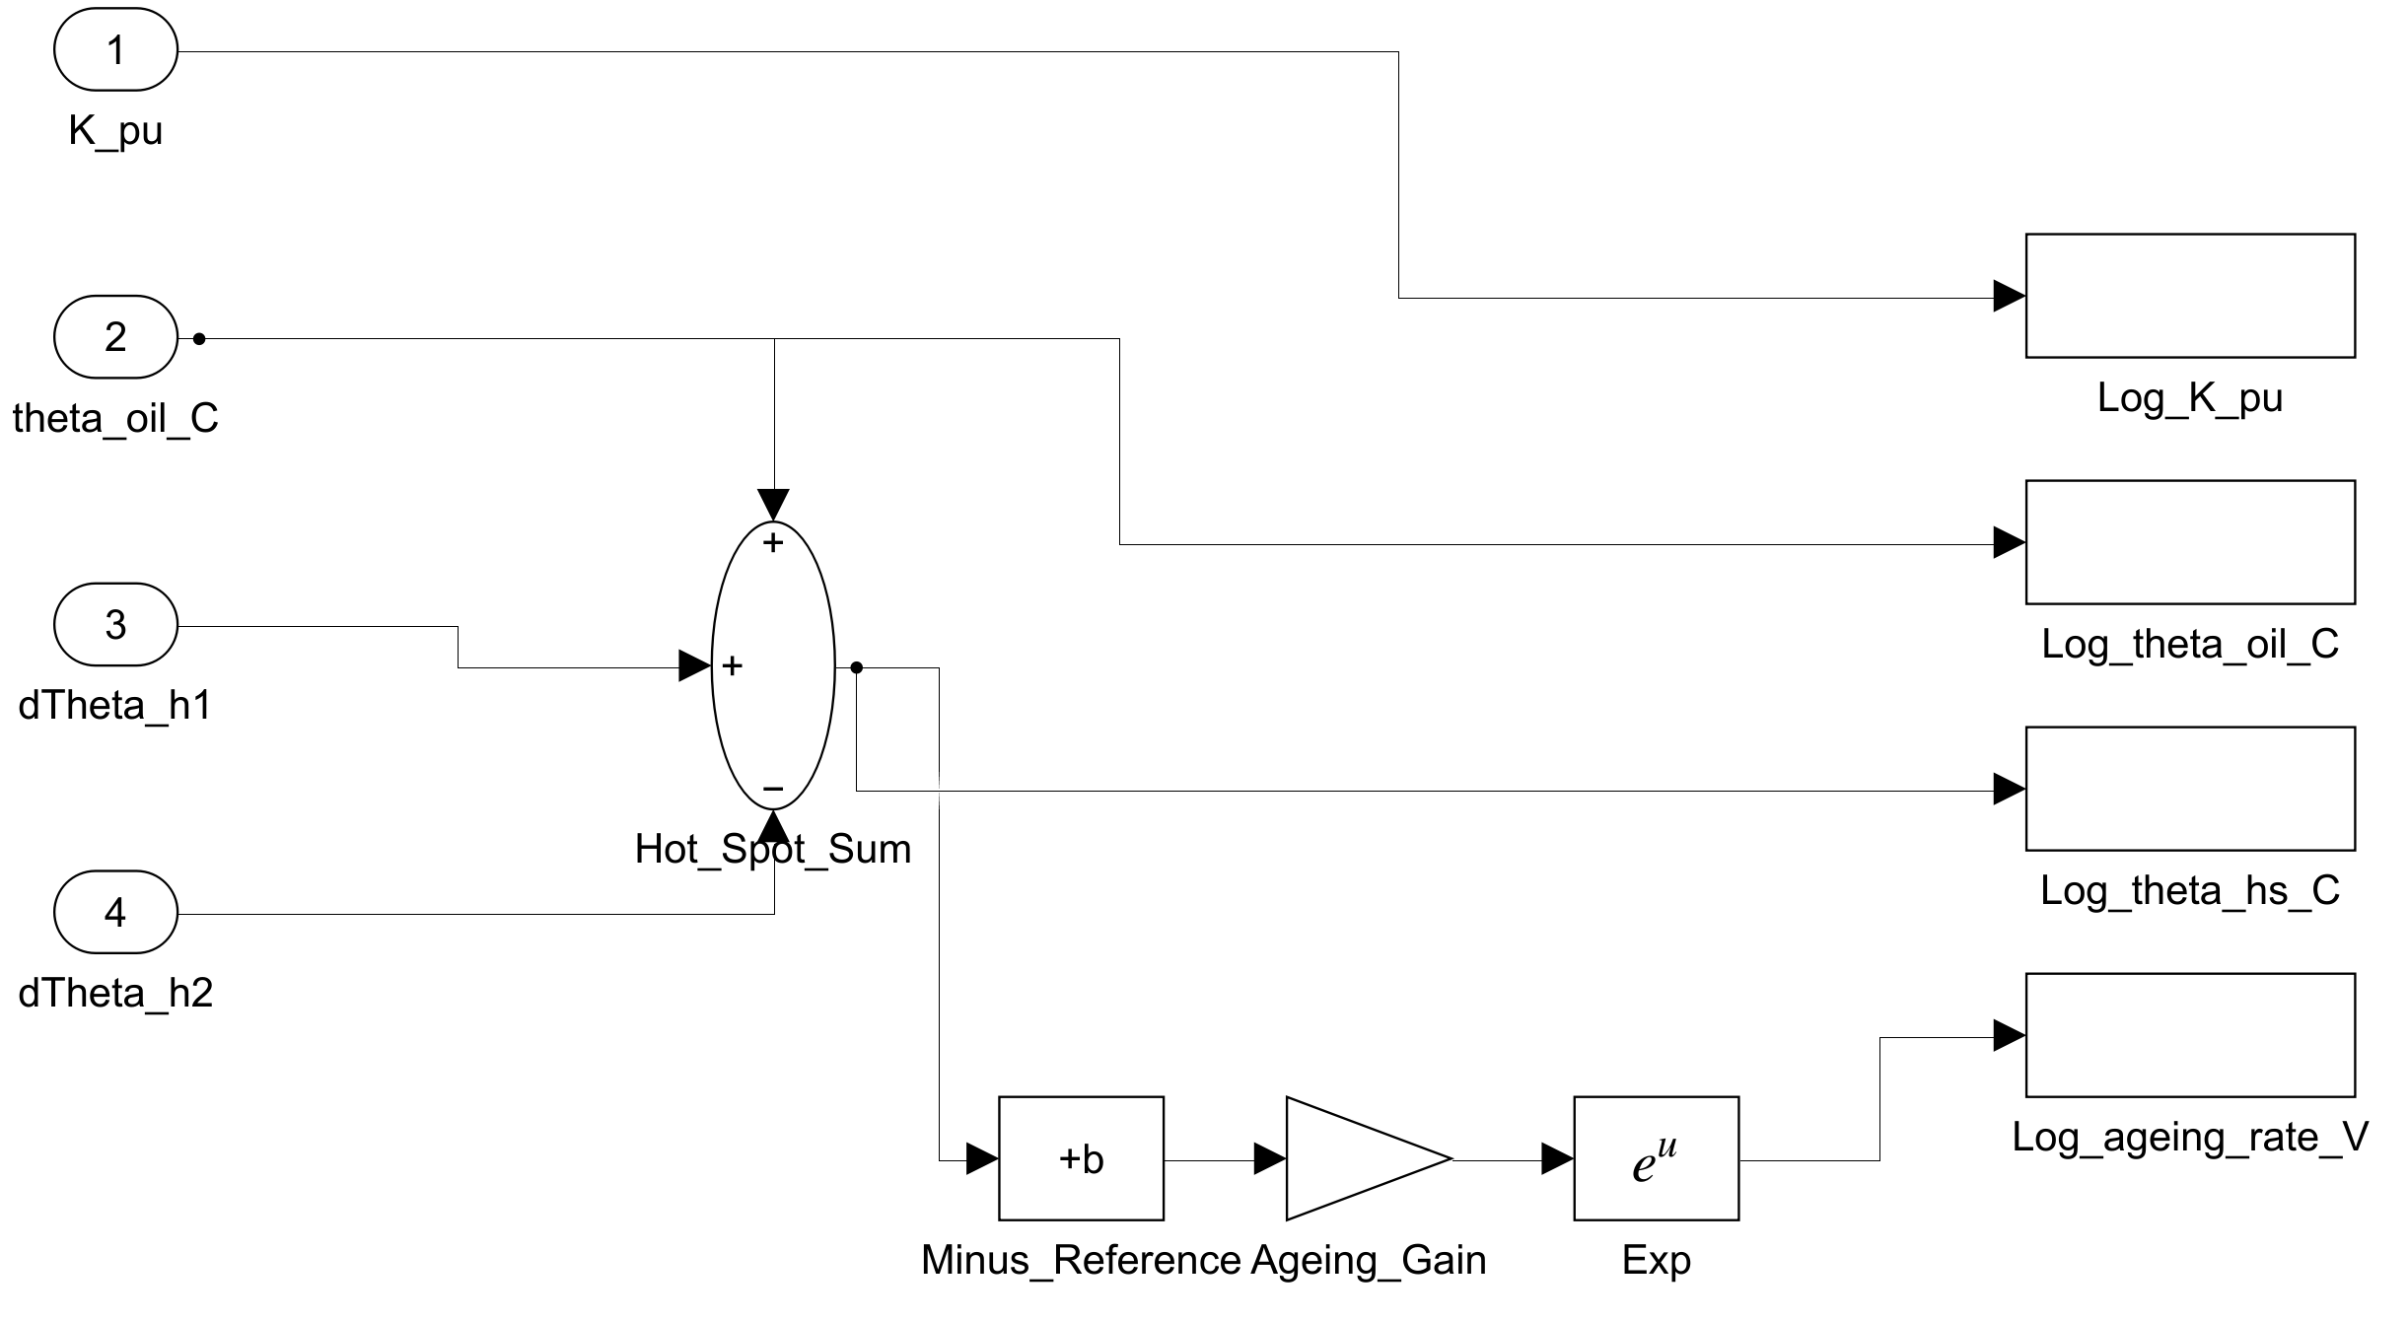
Fig. A6 SS7 Outputs and ageing: hot-spot temperature, relative ageing rate and logged signals
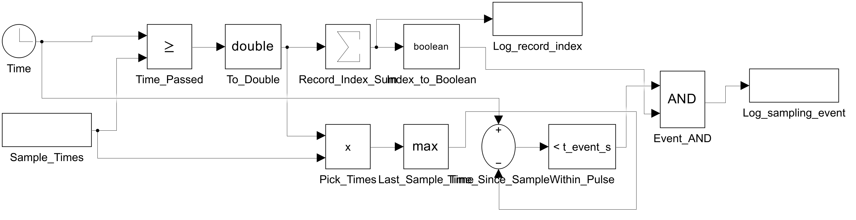
Fig. A7 SS8 Sampling events: clock, sampling times and logic that output the record index and the sampling pulse; no block carries a gas value
APPENDIX B
ADDITIONAL RESULTS
Table B1 Full Nested Cross-Validation Results (Means over 50 Outer Folds)
Set | Model | Macro-F1 | Bal. acc. | Acc. | Kappa | MCC | Most chosen setting
F1 | Majority-class baseline | 0.046 ± 0.000 | 0.143 | 0.194 | 0.000 | 0.000 | –
F1 | Logistic regression | 0.807 ± 0.035 | 0.820 | 0.820 | 0.788 | 0.791 | C: 10
F1 | SVM (RBF) | 0.804 ± 0.035 | 0.817 | 0.815 | 0.783 | 0.785 | C: 100, gamma: 0.01
F1 | Random Forest | 0.773 ± 0.049 | 0.778 | 0.794 | 0.757 | 0.760 | max_depth: 10, min_samples_leaf: 1
F1 | XGBoost | 0.771 ± 0.049 | 0.776 | 0.793 | 0.755 | 0.758 | learning_rate: 0.03, max_depth: 6, n_estimators: 300
F1 | MLP neural network | 0.793 ± 0.044 | 0.798 | 0.812 | 0.777 | 0.779 | alpha: 0.01, hidden_layer_sizes: [32, 16]
F2 | Majority-class baseline | 0.046 ± 0.000 | 0.143 | 0.194 | 0.000 | 0.000 | –
F2 | Logistic regression | 0.742 ± 0.044 | 0.759 | 0.751 | 0.708 | 0.711 | C: 10
F2 | SVM (RBF) | 0.794 ± 0.037 | 0.810 | 0.802 | 0.767 | 0.770 | C: 100, gamma: 0.1
F2 | Random Forest | 0.805 ± 0.041 | 0.811 | 0.817 | 0.784 | 0.786 | max_depth: null, min_samples_leaf: 2
F2 | XGBoost | 0.788 ± 0.041 | 0.790 | 0.803 | 0.767 | 0.770 | learning_rate: 0.1, max_depth: 2, n_estimators: 100
F2 | MLP neural network | 0.765 ± 0.032 | 0.769 | 0.779 | 0.739 | 0.741 | alpha: 0.01, hidden_layer_sizes: [32]
F3 | Majority-class baseline | 0.046 ± 0.000 | 0.143 | 0.194 | 0.000 | 0.000 | –
F3 | Logistic regression | 0.821 ± 0.038 | 0.833 | 0.831 | 0.801 | 0.803 | C: 10
F3 | SVM (RBF) | 0.810 ± 0.041 | 0.823 | 0.822 | 0.790 | 0.793 | C: 100, gamma: 0.01
F3 | Random Forest | 0.824 ± 0.036 | 0.832 | 0.837 | 0.807 | 0.809 | max_depth: null, min_samples_leaf: 1
F3 | XGBoost | 0.833 ± 0.041 | 0.836 | 0.846 | 0.818 | 0.820 | learning_rate: 0.1, max_depth: 2, n_estimators: 300
F3 | MLP neural network | 0.795 ± 0.044 | 0.797 | 0.812 | 0.777 | 0.779 | alpha: 0.01, hidden_layer_sizes: [32]
F4 | Majority-class baseline | 0.046 ± 0.000 | 0.143 | 0.194 | 0.000 | 0.000 | –
F4 | Logistic regression | 0.820 ± 0.039 | 0.832 | 0.830 | 0.800 | 0.802 | C: 1
F4 | SVM (RBF) | 0.819 ± 0.038 | 0.831 | 0.831 | 0.801 | 0.803 | C: 10, gamma: 0.01
F4 | Random Forest | 0.850 ± 0.038 | 0.857 | 0.863 | 0.838 | 0.840 | max_depth: null, min_samples_leaf: 1
F4 | XGBoost | 0.842 ± 0.039 | 0.845 | 0.858 | 0.832 | 0.834 | learning_rate: 0.03, max_depth: 4, n_estimators: 300
F4 | MLP neural network | 0.805 ± 0.040 | 0.808 | 0.825 | 0.792 | 0.794 | alpha: 0.01, hidden_layer_sizes: [32, 16]
Bal. acc. = balanced accuracy; Acc. = accuracy.
Table B2 Per-Class F1-Score in Cross-Validation (Feature Set F4)
Model (F4) | Normal | PD | D1 | D2 | T1 | T2 | T3
Majority-class baseline | 0.00 | 0.00 | 0.00 | 0.32 | 0.00 | 0.00 | 0.00
Logistic regression | 0.91 | 0.79 | 0.70 | 0.79 | 0.86 | 0.77 | 0.93
SVM (RBF) | 0.89 | 0.77 | 0.74 | 0.82 | 0.86 | 0.74 | 0.92
Random Forest | 0.90 | 0.83 | 0.78 | 0.86 | 0.88 | 0.76 | 0.94
XGBoost | 0.91 | 0.79 | 0.77 | 0.86 | 0.88 | 0.76 | 0.93
MLP neural network | 0.89 | 0.71 | 0.70 | 0.82 | 0.86 | 0.75 | 0.91

Table B3 Gas Concentrations by Fault Class, IEC TC 10 Benchmark
Class | H₂ | CH₄ | C₂H₆ | C₂H₄ | C₂H₂
PD | 33046 (26788–37800) | 1740 (1061–4704) | 157 (58.0–554) | 2 (0–6) | 0 (0–7)
D1 | 620 (101–1872) | 83.5 (20.5–560) | 12.0 (3.2–69.5) | 99.5 (26.2–408) | 400 (64.2–1061)
D2 | 805 (239–3242) | 290 (112–1432) | 35.0 (15.0–100) | 374 (163–1442) | 617 (227–1879)
T1/T2 | 720 (39.5–2378) | 775 (127–4598) | 235 (44.0–712) | 431 (7–1432) | 5.5 (0–15.0)
T3 | 630 (185–2340) | 1635 (760–4808) | 256 (53.0–1254) | 2030 (820–12800) | 31.0 (8.8–155)
Kruskal–Wallis H | 24.1 | 24.1 | 21.7 | 39.1 | 50.3
p | 7.6e-05 | 7.6e-05 | 2.3e-04 | 6.6e-08 | 3.1e-10
ε²_{R} | 0.21 | 0.21 | 0.19 | 0.34 | 0.43
Median (first quartile–third quartile) in ppm; n = 117. ε²_{R} = rank epsilon-squared effect size.
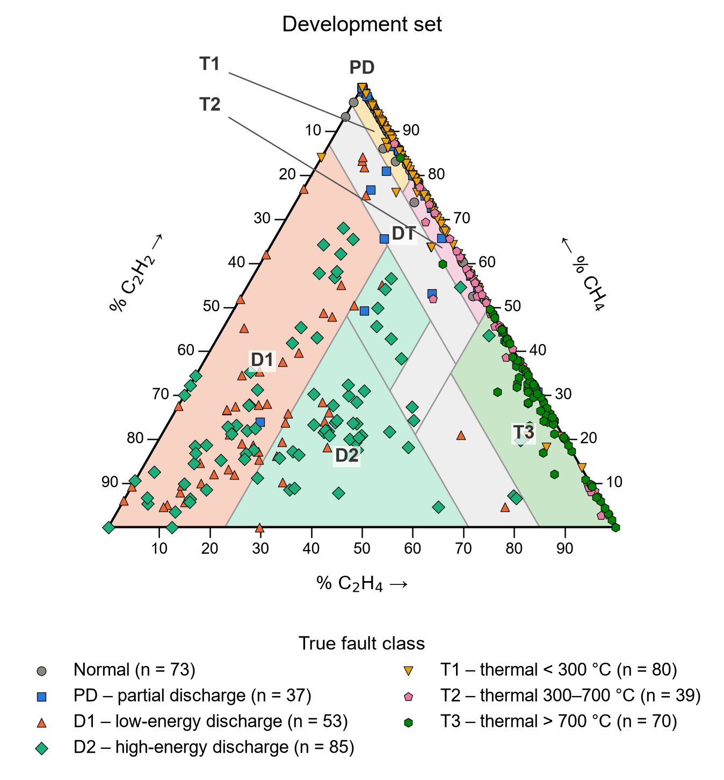
Fig. B1 Development records in the Duval Triangle 1, coloured by the true fault class
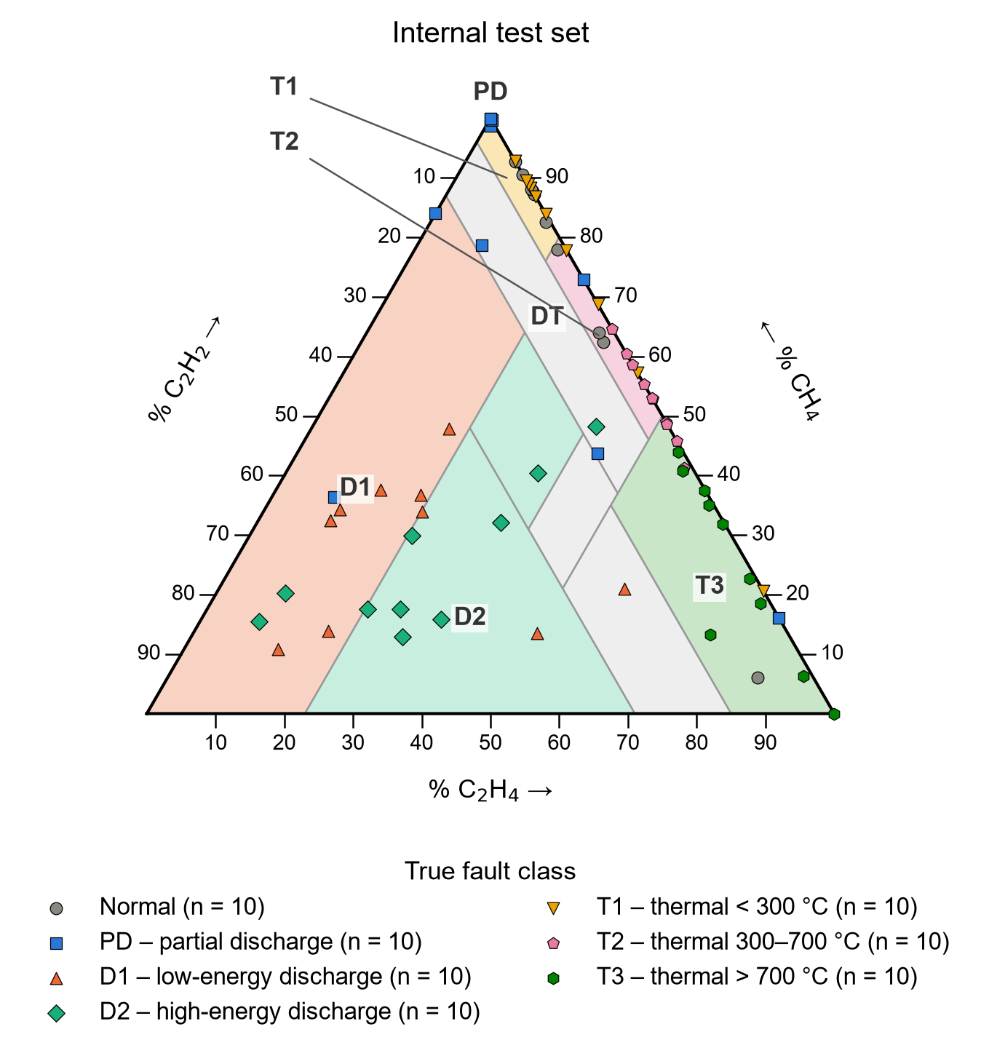
Fig. B2 Internal test records in the Duval Triangle 1
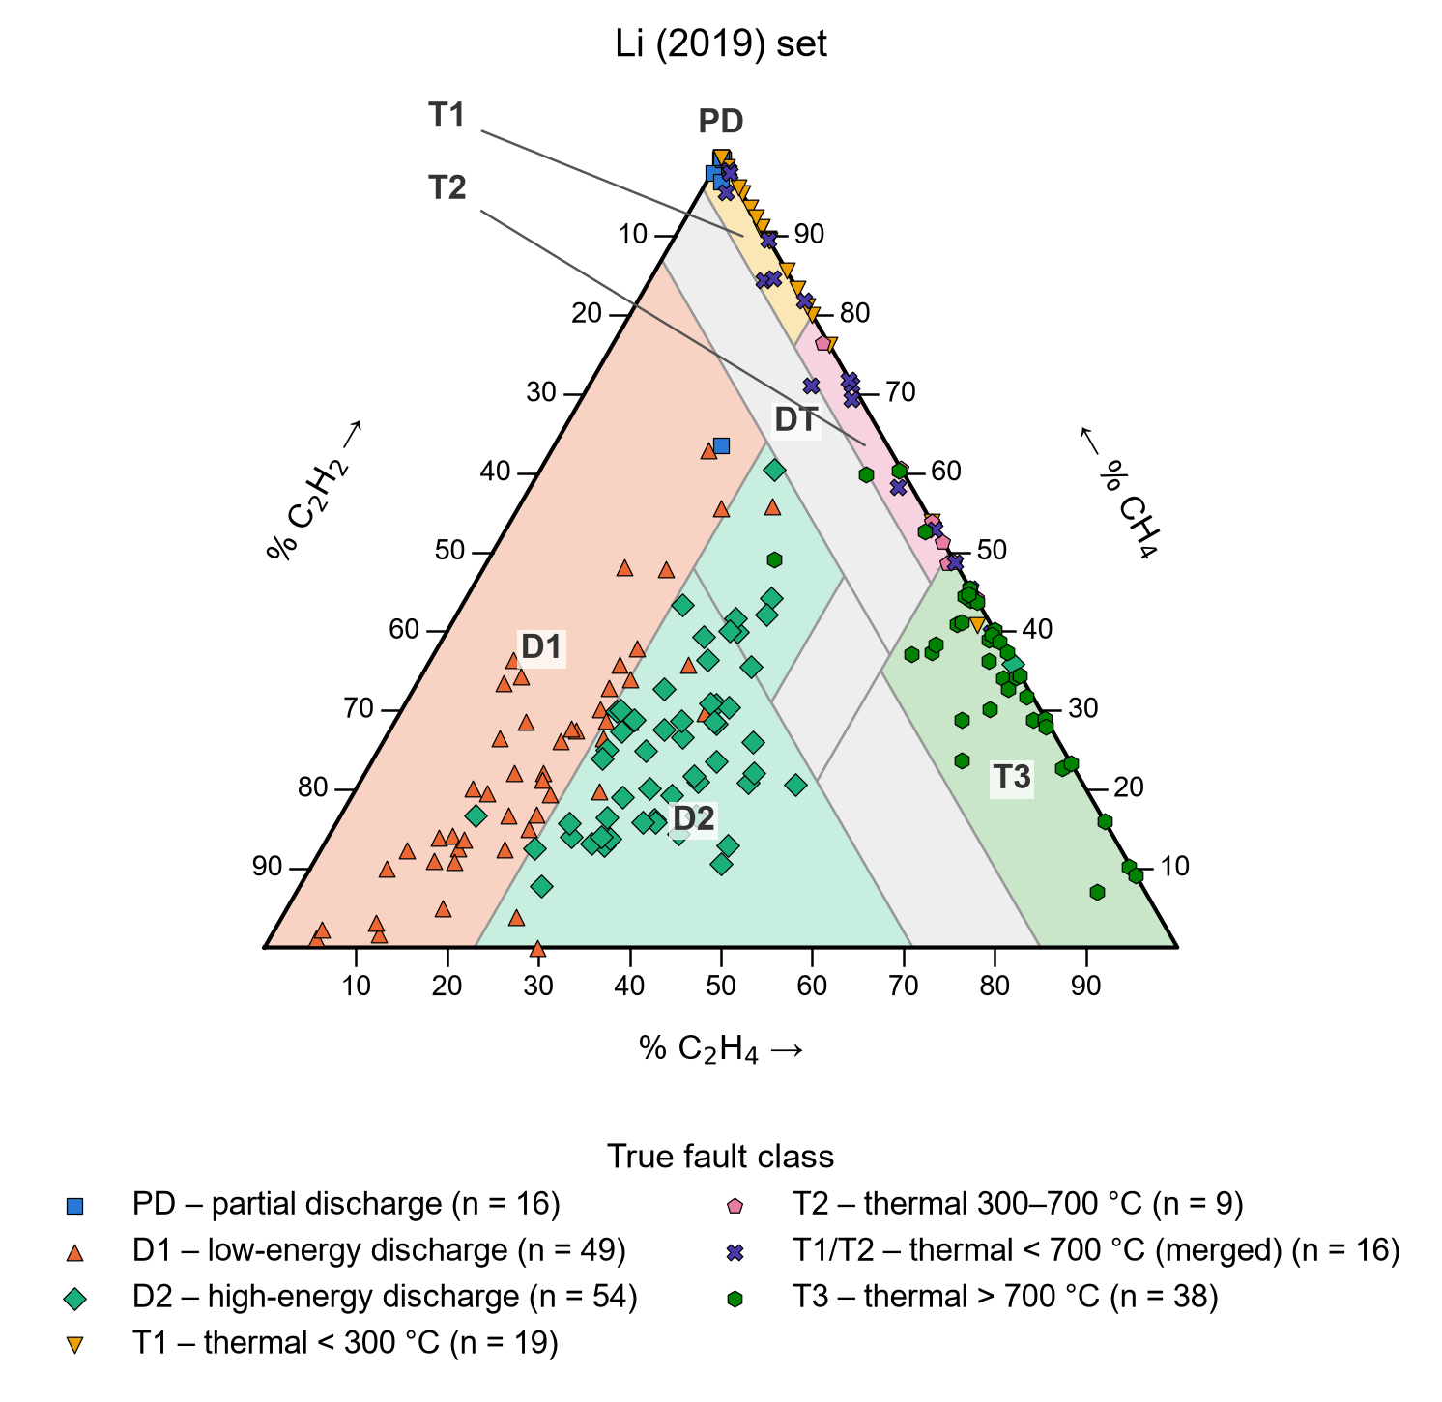
Fig. B3 Li (2019) records in the Duval Triangle 1
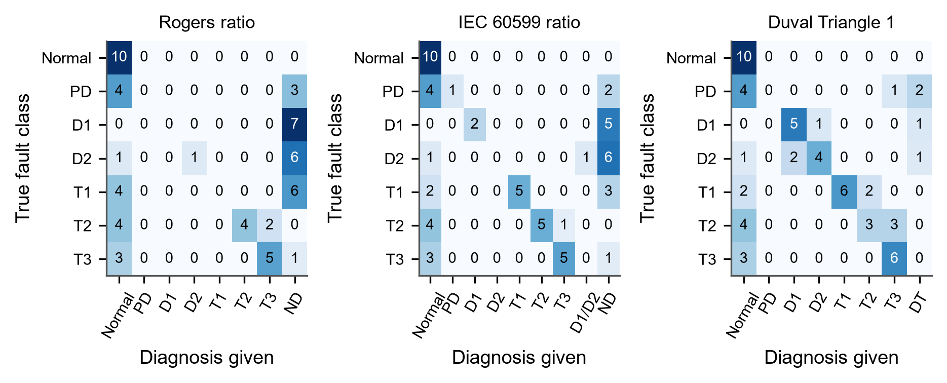
Fig. B4 Confusion matrices of the conventional methods on the internal test set (n = 61)
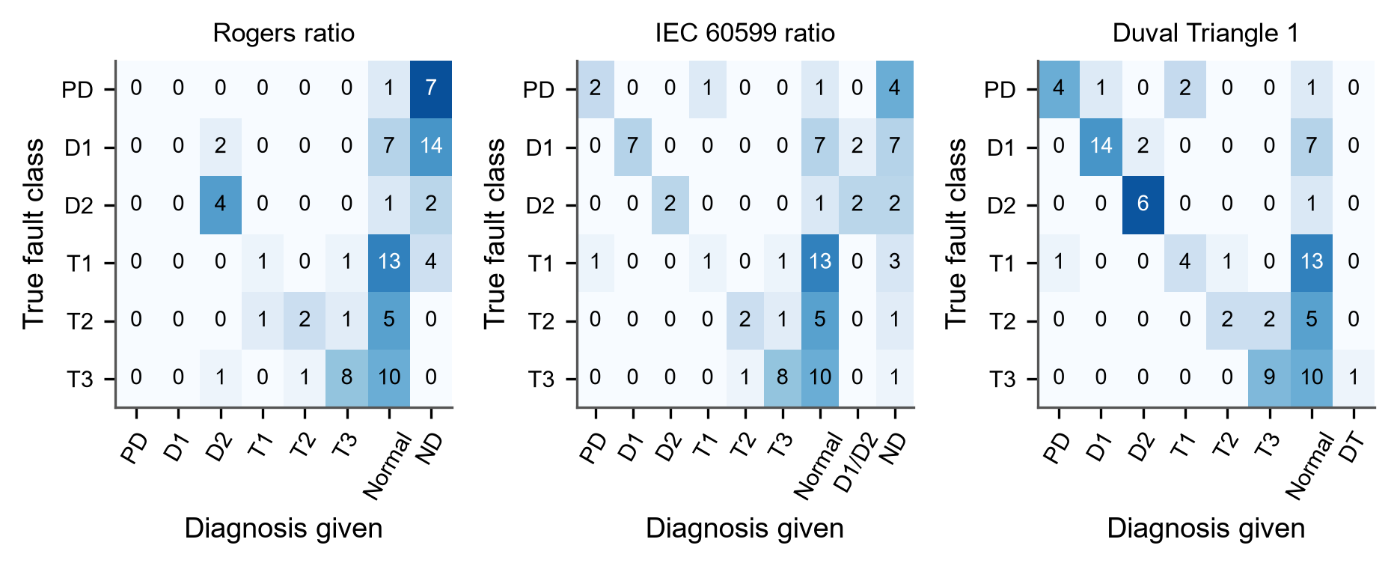
Fig. B5 Confusion matrices of the conventional methods on the Li (2019) set (n = 86)
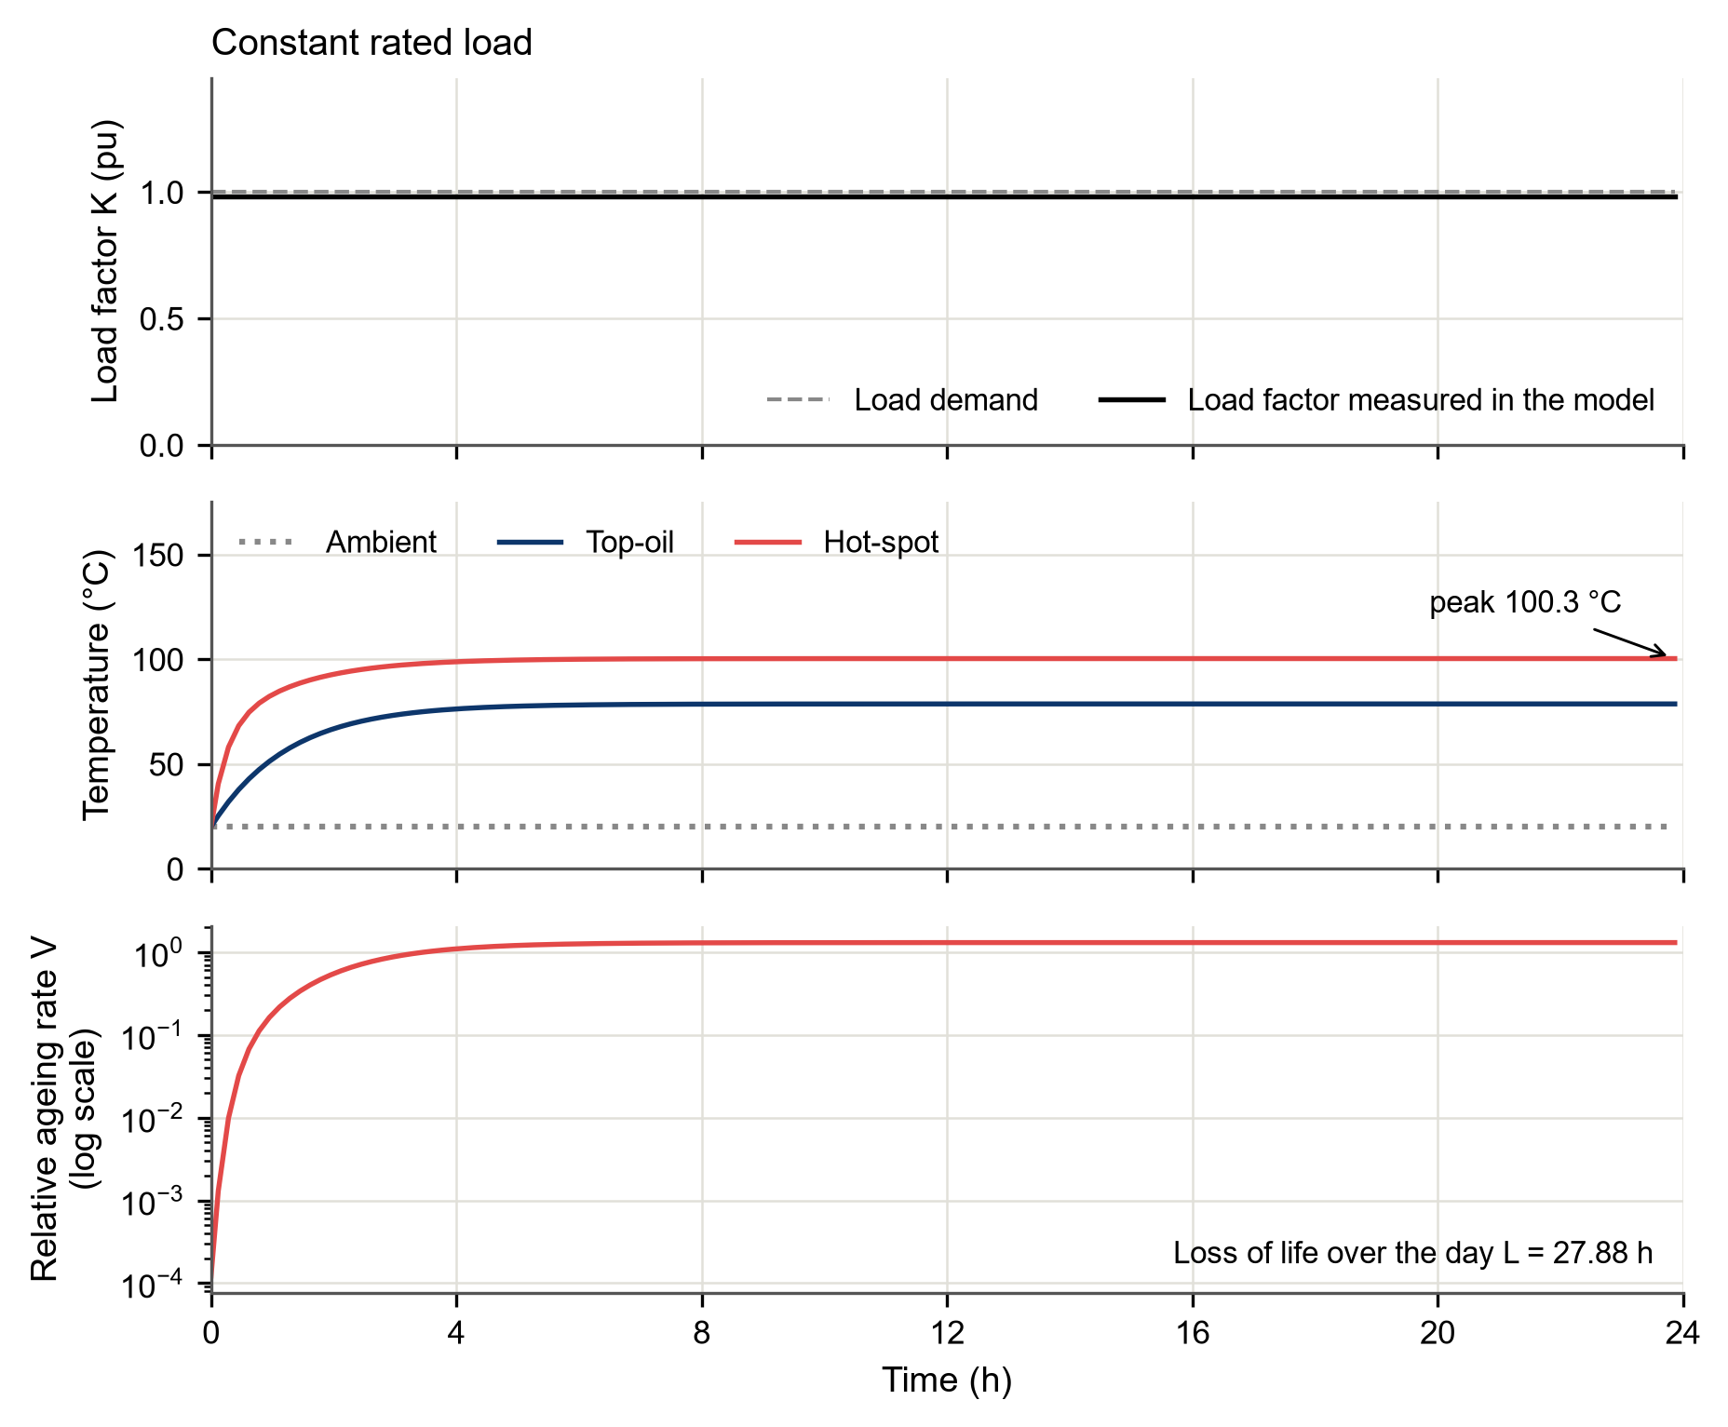
Fig. B6 Constant rated-load scenario: load factor, temperatures, and relative ageing rate with the loss of life

