Step 11 Report
Describe the data
Environment: Claude Code (this chat) | Completed: 10 October 2026 | Report version 2 (11 October 2026)
Thesis: Intelligent Power Transformer Fault Diagnosis Using Dissolved Gas Analysis and Machine Learning (MPhil, UMaT)
Abbreviations (such as PD, D1, T1, ppm) and technical terms are explained in the last section of this report.
In short: The first results tables and figures were produced from the clean data: how many records each set has, and how each gas differs between fault classes. Every gas differs very strongly between classes, most of all acetylene. The patterns agree with what is known about how faults produce gases.

1. Purpose of this step
Before any model is trained, the reader must see what the data contain: how many records of each fault, and how the gas levels look in each fault class (Analysis Plan, Sections 6.3 and 12).

2. Method used

Approach
Descriptive statistics: the median and the first and third quartiles of every gas in every fault class.
Kruskal-Wallis H test for each gas: does the gas differ between the 7 fault classes? The test works on ranks, so it does not assume normally distributed data. The size of the difference is given by the effect size epsilon-squared.
Spearman rank correlation between every pair of gases.
Figures drawn by program with the shared style file: bar charts of class counts, box plots on a logarithmic axis, and a correlation heat map.

Why this method
• Gas concentrations are very skewed and contain many zeros, so rank-based methods are more appropriate than methods that assume a normal distribution.
• With 439 records even small differences give tiny p-values, so the effect size is reported to show how large each difference really is.
• Drawing all figures from saved data with one style file makes them reproducible and consistent across Python and MATLAB.

Settings and rules
Setting | Value
Data | development set, N = 439 records, k = 7 classes (degrees of freedom k - 1 = 6)
Ties | the H statistic is corrected for tied values (SciPy default)
Box plots | whiskers at 1.5 times the interquartile range; axis = concentration + 1 ppm, log scale
Figure files | PNG at 300 dpi and PDF, Arial 9 pt, with the plotted numbers saved as CSV

Equations
$$\begin{aligned}H=\frac{12}{N\left(N+1\right)}\sum_{i=1}^{k}{\frac{R_{i}^{2}}{n_{i}}}-3\left(N+1\right)\#\left(1\right)\end{aligned}$$
where:
$H$ – Kruskal-Wallis statistic (before the tie correction)
$N$ – total number of records (439)
$k$ – number of classes (7)
$n_{i}$ – number of records in class i
$R_{i}$ – sum of the ranks of the records in class i, when all N values of the gas are ranked together
$$\begin{aligned}ε_{R}^{2}=\frac{H\left(N+1\right)}{N^{2}-1}\#\left(2\right)\end{aligned}$$
where:
$ε_{R}^{2}$ – effect size, from 0 (no difference) to 1 (classes completely separated)
Same formula as Equation 24 of the Analysis Plan and as coded in step11_describe.py.
$$\begin{aligned}ρ_{s}=r\left(\text{rank}\left(x\right),\text{rank}\left(y\right)\right)\#\left(3\right)\end{aligned}$$
where:
$ρ_{s}$ – Spearman rank correlation between gases x and y, from -1 to +1
$r$ – the ordinary (Pearson) correlation, applied to the ranks

Tools and programs
• 06_Python_ML/src/analysis/step11_describe.py and plotstyle.py
• SciPy 1.18.1 (stats.kruskal), pandas 3.0.6 (corr, method='spearman'), numpy 2.5.3 (percentiles), matplotlib 3.11.2 (figures)

Method references
[M4] W. H. Kruskal and W. A. Wallis, "Use of ranks in one-criterion variance analysis," Journal of the American Statistical Association, vol. 47, no. 260, pp. 583-621, 1952. doi: 10.1080/01621459.1952.10483441
[M5] M. Tomczak and E. Tomczak, "The need to report effect size estimates revisited. An overview of some recommended measures of effect size," Trends in Sport Sciences, vol. 21, no. 1, pp. 19-25, 2014. https://www.wbc.poznan.pl/dlibra/publication/413565 [TO VERIFY that the paper gives the exact formula used (Analysis Plan Eq. 24)]
[M6] C. Spearman, "The proof and measurement of association between two things," American Journal of Psychology, vol. 15, no. 1, pp. 72-101, 1904. doi: 10.2307/1412159
[M7] P. Virtanen et al., "SciPy 1.0: fundamental algorithms for scientific computing in Python," Nature Methods, vol. 17, pp. 261-272, 2020. doi: 10.1038/s41592-019-0686-2

3. What was done, step by step
1. Created the shared colour file 11_Results/figures/plot_style.csv from the approved colour table, so that Python and MATLAB figures use the same colours.
2. Made Table 4.1 (records by data role and class) and Table 4.1b (records removed in Step 9).
3. Made Table 4.2: median and quartiles of each gas in each fault class (training data), and the Kruskal-Wallis test of whether each gas differs between classes, with its effect size epsilon-squared (Equations 23 and 24).
4. Drew Figures 4.1 to 4.3 following the figure rules: made by program, saved as PNG (300 dpi) and PDF, with the plotted numbers saved beside each figure.

4. What we found
Gas | Kruskal-Wallis H | p-value | Effect size (epsilon-squared)
H2 | 164.5 | 6.7e-33 | 0.38
CH4 | 153.8 | 1.2e-30 | 0.35
C2H6 | 191.0 | 1.5e-38 | 0.44
C2H4 | 263.9 | 4.3e-54 | 0.60
C2H2 | 311.3 | 3.0e-64 | 0.71
Training data, n = 439 records, 7 classes (6 degrees of freedom). In plain words: every gas differs strongly between the fault classes; acetylene (C2H2) differs the most (it explains about 71 percent of the variation in ranks), and ethylene (C2H4) next.
The patterns in Figure 4.2 match known fault physics, which is a useful sanity check of the data: acetylene is high only for the electrical discharges D1 and D2; ethylene rises from T1 to T2 to T3 as thermal faults get hotter; hydrogen is highest for partial discharge. These are descriptions, not yet conclusions.
Figure 4.1 - Records per fault class in each data role
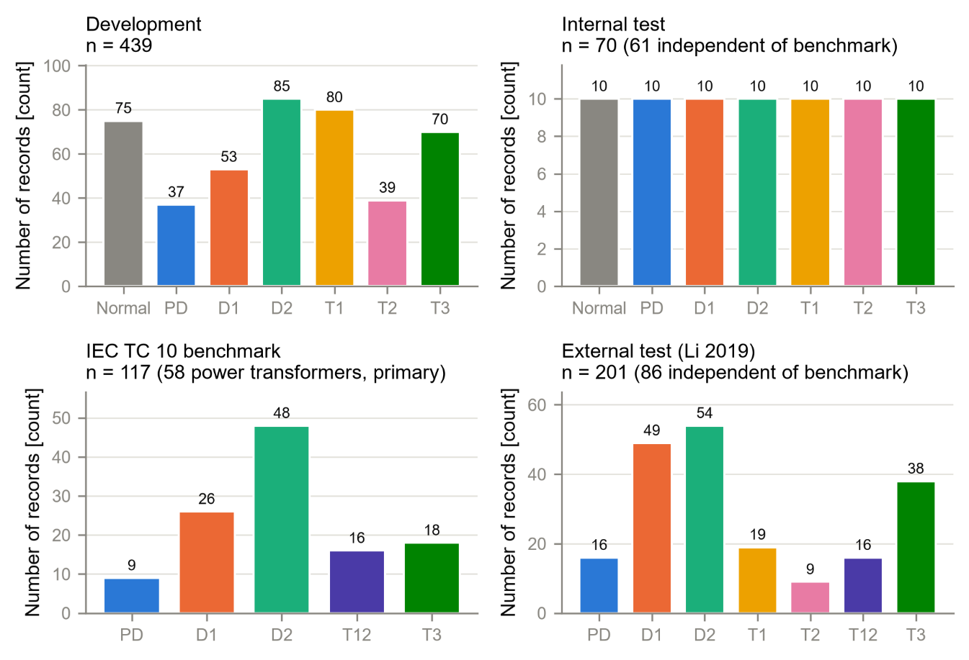
Figure 4.2 - Gas concentrations by fault class, training data (log scale of concentration + 1 ppm, because not-detected values are 0 ppm)
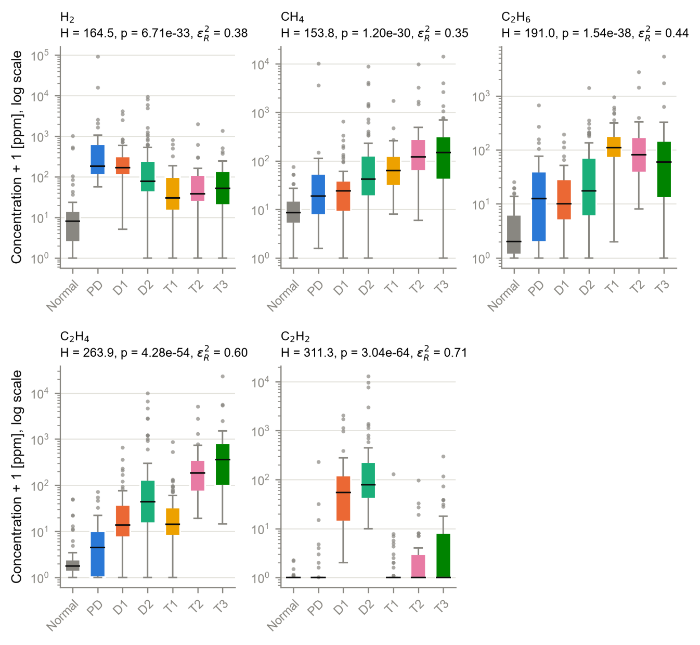
Figure 4.3 - Spearman rank correlation between the gases, training data
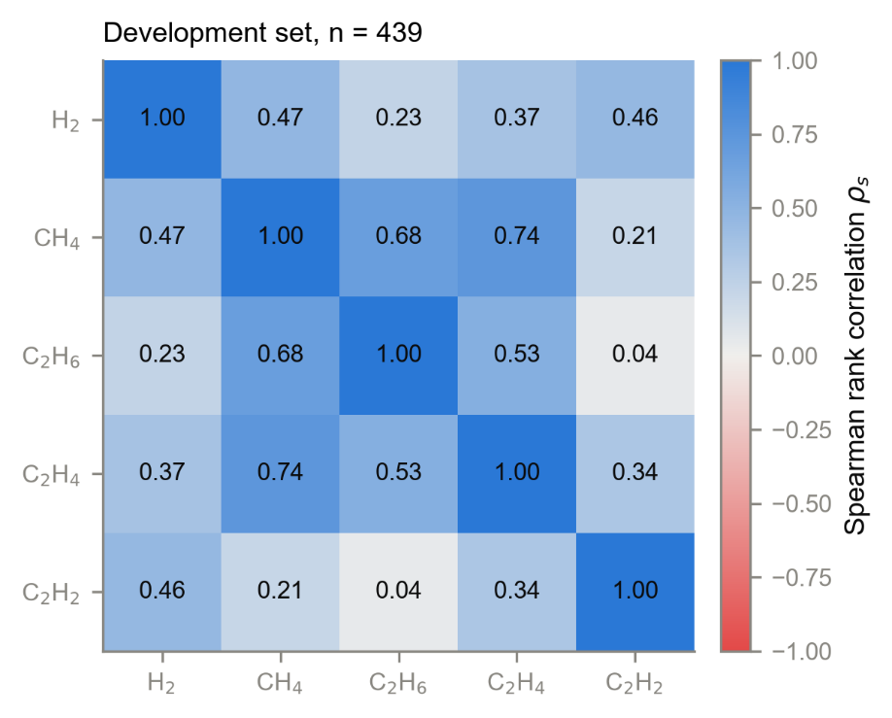

5. Checks
The totals in Table 4.1 equal the master table for every data role - PASS. All numbers come from the program; none was typed by hand.

6. Problems and fixes
• The first version of Figure 4.2 had panel titles running into each other and overlapping class names on the axis. The layout was fixed (two-line titles, angled class names, one axis label per row) and the figure re-checked.
• A logarithmic axis cannot show 0 ppm. Because not-detected values are 0 ppm (decision D8), Figure 4.2 plots 'concentration + 1 ppm', the same shift used for the machine-learning features (Equation 11), and the axis label says so.

7. Files produced
• 11_Results/tables: T4_1, T4_1b, T4_2 and appendix A4_2 (benchmark version)
• 11_Results/figures: F4_1, F4_2, F4_3 (PNG, PDF, CSV) and plot_style.csv
• 03_Data/interim/step11_report.md; programs analysis/step11_describe.py and analysis/plotstyle.py

8. What was achieved
• The first thesis tables (4.1, 4.1b, 4.2 and appendix A4.2) and figures (4.1-4.3) were produced by program from the clean data.
• It was shown that every gas differs strongly between fault classes (effect sizes 0.35 to 0.71), most of all acetylene.
• The gas patterns agree with known fault physics, which is a sanity check on the data.
• A shared colour file (plot_style.csv) was created so that Python and MATLAB figures look the same.

9. Record of this step
Item | Record
Step | 11 - Describe the data
Environment | Claude Code (this chat)
Completed | 10 October 2026
Status | Done
Main inputs | 03_Data/processed/dga_master.csv; approved colour table
Main outputs | 11_Results/tables (T4_1, T4_1b, T4_2, A4_2); 11_Results/figures (F4_1-F4_3, plot_style.csv)
Checks | Table 4.1 totals equal the master table - PASS
Decisions | None

10. Data and sources used in this step
Every dataset, document and file this step used is listed below with its full reference, link and fingerprint (SHA-256, first 16 characters shown). Method references are listed in the 'Method used' section. The complete record, with access dates, licences and full fingerprints, is the Data and Source Register (00_Project_Admin/Step_Reports/Data_and_Source_Register.docx and 03_Data/provenance/data_and_source_register.csv).
ID | Reference and use in the project | Link, DOI and local file
DF2 | Made in Step 9 from DS1-DS5 (Steps 5-9 programs). Use: All clean records with role, class, flags and original values. | File: 03_Data/processed/dga_master.csv; SHA-256 AE9E6C0C84CF7180...
DF4 | Made in Step 11 from the approved colour table (Analysis Plan). Use: Shared colours for Python and MATLAB figures. | File: 11_Results/figures/plot_style.csv; SHA-256 041FE94B9DB6D78A...
SW1 | Python 3.12.10 with 55 pinned packages (06_Python_ML/requirements.txt). Use: Runs every data-preparation, statistics and checking program. | https://www.python.org/downloads/release/python-31210/; File: 06_Python_ML/requirements.txt; SHA-256 594BC0CB122EED99...

11. How this helps the next steps
Next step: Step 12: obtain the standards (IEC 60599, IEEE C57.104-2019, Duval Triangle 1 zones) from legitimate sources and transcribe their decision tables, twice, with clause and page.
• The opening tables and figures of the results chapter are ready.
• The strong differences confirm that the five gases carry fault information, which supports using them as the model inputs.
• plot_style.csv will be used by the MATLAB figures of the conventional methods (Steps 14-17), and its fingerprint is frozen in Step 13.

12. Open items and limitations
• These results are descriptive only; nothing has yet been concluded about which diagnosis method is better.
• Correction recorded on 11 October 2026: Table 4.1b (records removed in Step 9) first showed 137 leakage removals and listed 96 IEC TC 10 benchmark records as removed. The program counted the wrong column of the duplicate report. The corrected table shows 2 exact copies, 4 conflicting labels and 139 leakage removals, all from the training file, matching the Step 9 report. No other table or figure changed.

13. Abbreviations and terms used in this report
Every abbreviation and technical term that appears in this report is explained below. The fault types follow the definitions of IEC 60599 (clause 5.2). The full list for the whole project is kept in 00_Project_Admin/abbreviations_glossary.csv.
Abbreviation or term | Meaning | Plain explanation
MPhil | Master of Philosophy | The research degree this thesis is written for.
UMaT | University of Mines and Technology, Tarkwa | The university where the thesis is submitted.
DGA | Dissolved Gas Analysis | Measuring the gases dissolved in transformer oil to find faults inside the transformer without opening it.
ppm | parts per million | Amount of gas in the oil; 1 ppm = 1 microlitre of gas in 1 litre of oil.
H2 | hydrogen | Gas formed mainly by partial discharges (low-energy electrical activity) in the oil.
CH4 | methane | Hydrocarbon gas formed when oil is overheated, mainly at the lower fault temperatures.
C2H6 | ethane | Hydrocarbon gas formed when oil is overheated, mainly at the lower fault temperatures.
C2H4 | ethylene | Hydrocarbon gas favoured above about 500 °C; it rises as thermal faults get hotter.
C2H2 | acetylene | Gas that needs at least 800 to 1 200 °C; formed in significant amounts mainly in electrical arcs.
D1 | discharges of low energy | Sparking or tracking: larger punctures in paper, carbonised paper surface or carbon particles in oil.
D2 | discharges of high energy | Arcing with power follow-through: extensive carbonisation, metal fusion, sometimes tripping of the equipment.
T1 | thermal fault below 300 °C | Overheating in which the paper has turned brownish.
T2 | thermal fault 300 to 700 °C | Overheating in which the paper has carbonised.
T3 | thermal fault above 700 °C | Very hot fault: carbonised oil, metal colouring (800 °C) or metal fusion (above 1 000 °C).
IEC | International Electrotechnical Commission | The world body that publishes electrical standards, such as IEC 60599.
IEC 60599 | IEC guide to the interpretation of dissolved and free gas analysis | The international standard that defines the fault types and the IEC gas-ratio method.
IEC TC 10 | IEC Technical Committee 10 (fluids for electrotechnical applications) | The committee that wrote IEC 60599; its database of 117 inspected faulty units is this thesis's main benchmark.
IEEE | Institute of Electrical and Electronics Engineers | A professional body that publishes engineering standards and journals.
IEEE C57.104 | IEEE guide for the interpretation of gases generated in oil-immersed transformers | The IEEE standard that contains the Duval Triangle 1 (2019 edition) and the Rogers ratio table (2008 edition).
Duval Triangle 1 | graphical DGA method by M. Duval | The shares of CH4, C2H4 and C2H2 are plotted as one point in a triangle divided into fault zones.
ML | machine learning | Computer methods that learn the link between gas values and fault type from labelled examples.
Benchmark | fixed reference test set | The IEC TC 10 cases whose faults were confirmed by inspection; every method is scored on them.
Training (development) set | records used to build the models | 439 clean records from the Dissanayake training file.
Not detected | gas below the laboratory's detection limit | Treated as 0 ppm in this thesis (decision D8).
Leakage | test cases hidden in the training data | If a model has already seen a test case, its score is falsely high.
SHA-256 | Secure Hash Algorithm, 256-bit | A file's digital fingerprint: if one byte of the file changes, the fingerprint changes.
Kruskal-Wallis test | rank-based test for differences between groups | Tests whether a gas differs between the fault classes without assuming a normal distribution.
H | Kruskal-Wallis test statistic | The larger H is, the more the classes differ.
p-value | probability value | The chance of seeing differences at least this large if there were really no difference; very small means a real difference.
ε² (epsilon-squared) | effect size of the Kruskal-Wallis test | How big the difference is, from 0 (none) to 1 (complete separation).
Degrees of freedom | number of classes minus one here | Needed to judge the H statistic (7 classes give 6).
Median, quartiles | middle value and the values a quarter and three quarters of the way up | Describe typical gas levels without being pulled by extreme values.
Spearman correlation | rank correlation | How strongly two gases rise and fall together (from -1 to +1).
Log scale | logarithmic axis | Each step on the axis is ten times the previous one, so very small and very large values fit on one chart.
CSV | comma-separated values | A plain-text table file that any program can read.
PNG, PDF, dpi | image file, printable document file, dots per inch | Figures are saved as PNG at 300 dpi (sharp for printing) and as PDF.
docx | Microsoft Word document | The format of these reports.
Python | programming language | Used for data preparation, machine learning and statistics (Claude Code).
MATLAB | MATLAB (MathWorks) | Numerical programming environment; used for the conventional methods and the dashboard (MATLAB Agentic Toolkit).
D1-D11 (decisions) | numbered project decisions | Decisions recorded in 00_Project_Admin/decisions_log.md; not the same as the fault codes D1 and D2.
Analysis Plan | Expected Results and Analysis Plan | The approved document that fixes the measures, tests, tables and figures before results are seen.

